Typical equipment and configuration for the AOML SEAS TSG unit

- Computer Shuttle P4 XPC SS51G: complies with Part 15 of the FCC rules.
- Monitor Sharp model LL-T15G4-B 15" LCD Monitor. This equipment has been tested and found to comply with the limits for a Class B digital device pursuant to Part 15 of the FCC Rules.
- Mitsuko Computer keyboard, tested to comply with FCC standards
- Computer mouse Mitsuko model MO-P033PS00400
- Seabird Micro-TSG (Thermosalinograph Model SBE45) with PC controller box
- Seabird Remote Temperature sensor (Model SBE38)
- Thrane & Thrane A/S, Model TT-3026L/M/S, Std. C Transceiver (non GMDSS). Installed at a compass safe distance that has been measured in accordance with the standards specified in ISO/R 694, Method B. The safe distance found is 50cm. Antenna interface, Times Microwave cable LMR200DB to TT-3026 Maritime Antenna with Elpac DC power supply.
  - Inmarsat Frequencies:
  - Transmission frequency - 1626.5 to 1660.5 MHz.
  - Receive frequency - 1525.0 to 1559.0 MHz.
  - Channel Spacing - 5/2.5/1.25 kHz
- The TT-3026 Maritime Antenna cable is usually run via a thru-hull fitting (which we can install ourselves) to the railing above the bridge where it is mounted in accordance with approved antenna installation procedures. Far enough away from obstructions so that no more than 2 degrees of arc along the horizon is obstructed. Minimum distance to HF antennas >5m. Minimum distance to VHF antennas >4m. Minimum distance to magnetic compass >0.3m.

System Overview

The TSG data acquisition system is extremely flexible and can be configured to support multiple data sources (e.g. PCO2, XBT) and multiple GPS interfaces.

The most basic configuration consists of the TSG and remote temperature sensor mounted in the engine room near the saltwater intake system. The saltwater supply lines for the Micro TSG (SBE45) can be plumbed from any source provided that the flow volume is confined to between 10-30 GPH (0.63-1.9 liters per minute). The closer the TSG supply line is to the seawater intake, the more accurate the temperature measurements will be. The remote temperature sensor must be as close to the intake as possible. Ideally, the remote temperature sensor (SBE38) would be mounted in or just downstream of the sea chest. Installing the SBE38 requires a through hull penetration or a penetration into the main pipes out of the sea chest. Consequently, this installation must be done under the close supervision of the ship's engineering staff. Often the engineering staff actually performs this part of the installation. The data from the two devices are transmitted via an RS-232 serial interface to an interface box which is also mounted somewhere in the engine room or the engine control room. The interface box marries the data from the two devices (and possibly from a GPS input) into one data stream that is then transmitted via RS-232 or RS-422 to a SEAS PC. The PC can reside in the engine room or on the bridge depending on the distance between the PC and interface box. Limitations in the length of cable over which serial data can be effectively transmitted often necessitate a computer in the engine room handling data logging duties and a second PC on the bridge handling satellite transmission duties. The PC and data collection equipment can be powered from any ordinary engine room outlet (230 or 115 VAC). If necessary a marine grade outlet strip and extension cord run inside metal or plastic coving will be installed.

On the bridge a SEAS PC will be connected to the data interface box or the data logging pc. Additionally, the satellite transmission hardware will be located on the bridge attached to the SEAS PC. The technology for satellite transmission of TSG data will be either Inmarsat-C (detailed in the equipment list above) or Iridium modem. The equipment needed for both transmission mechanisms are comparable in size and power needs. The PC and transmission equipment can be powered from any ordinary bridge outlet (230 or 115 VAC). If necessary, a marine grade outlet strip and extension cord run inside metal or plastic coving will be installed.

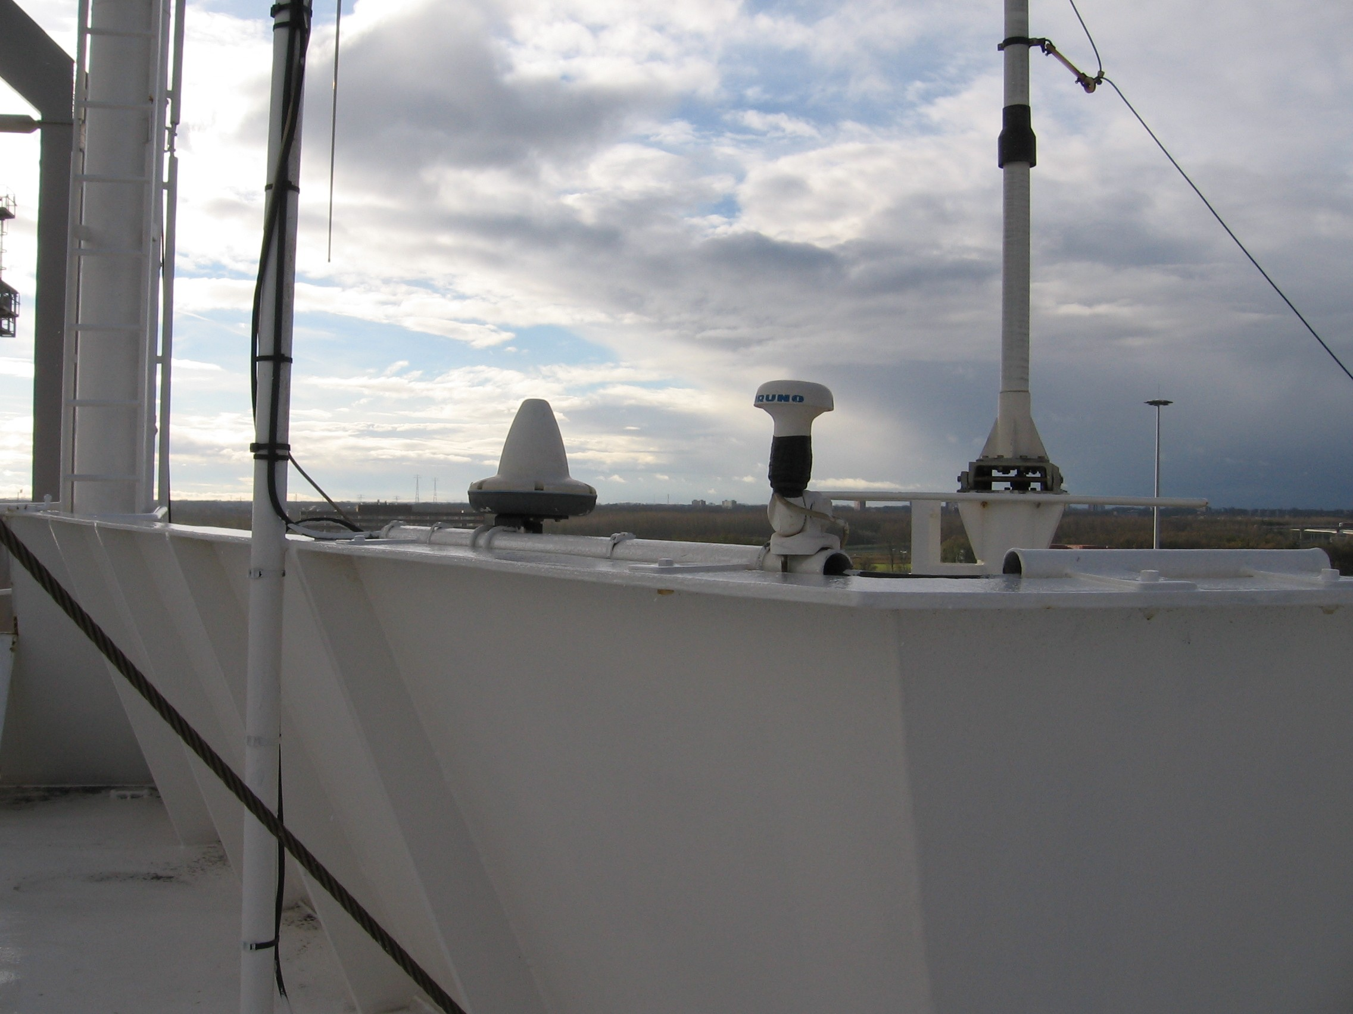
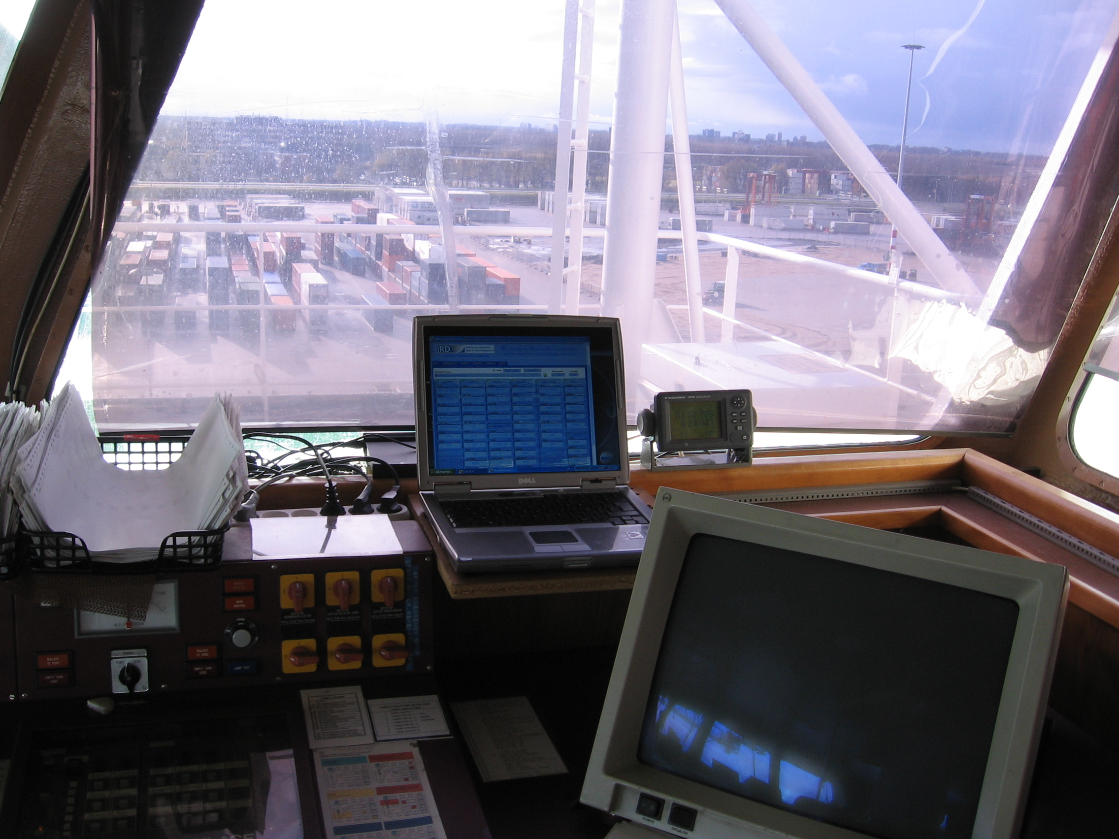
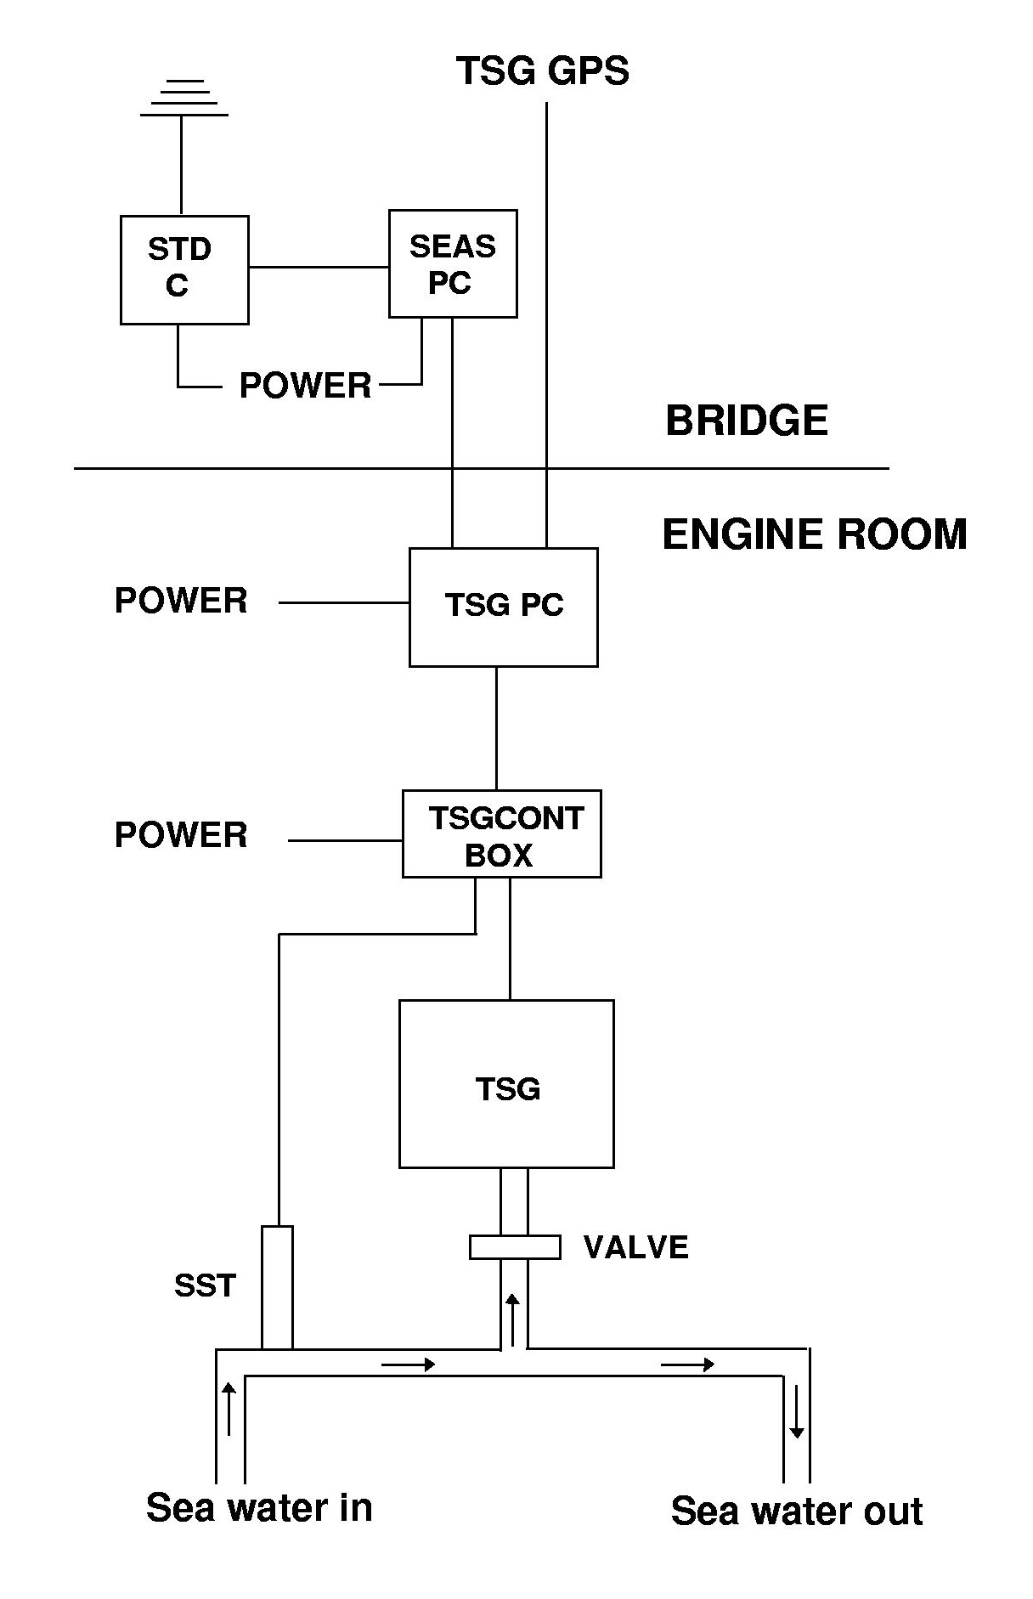
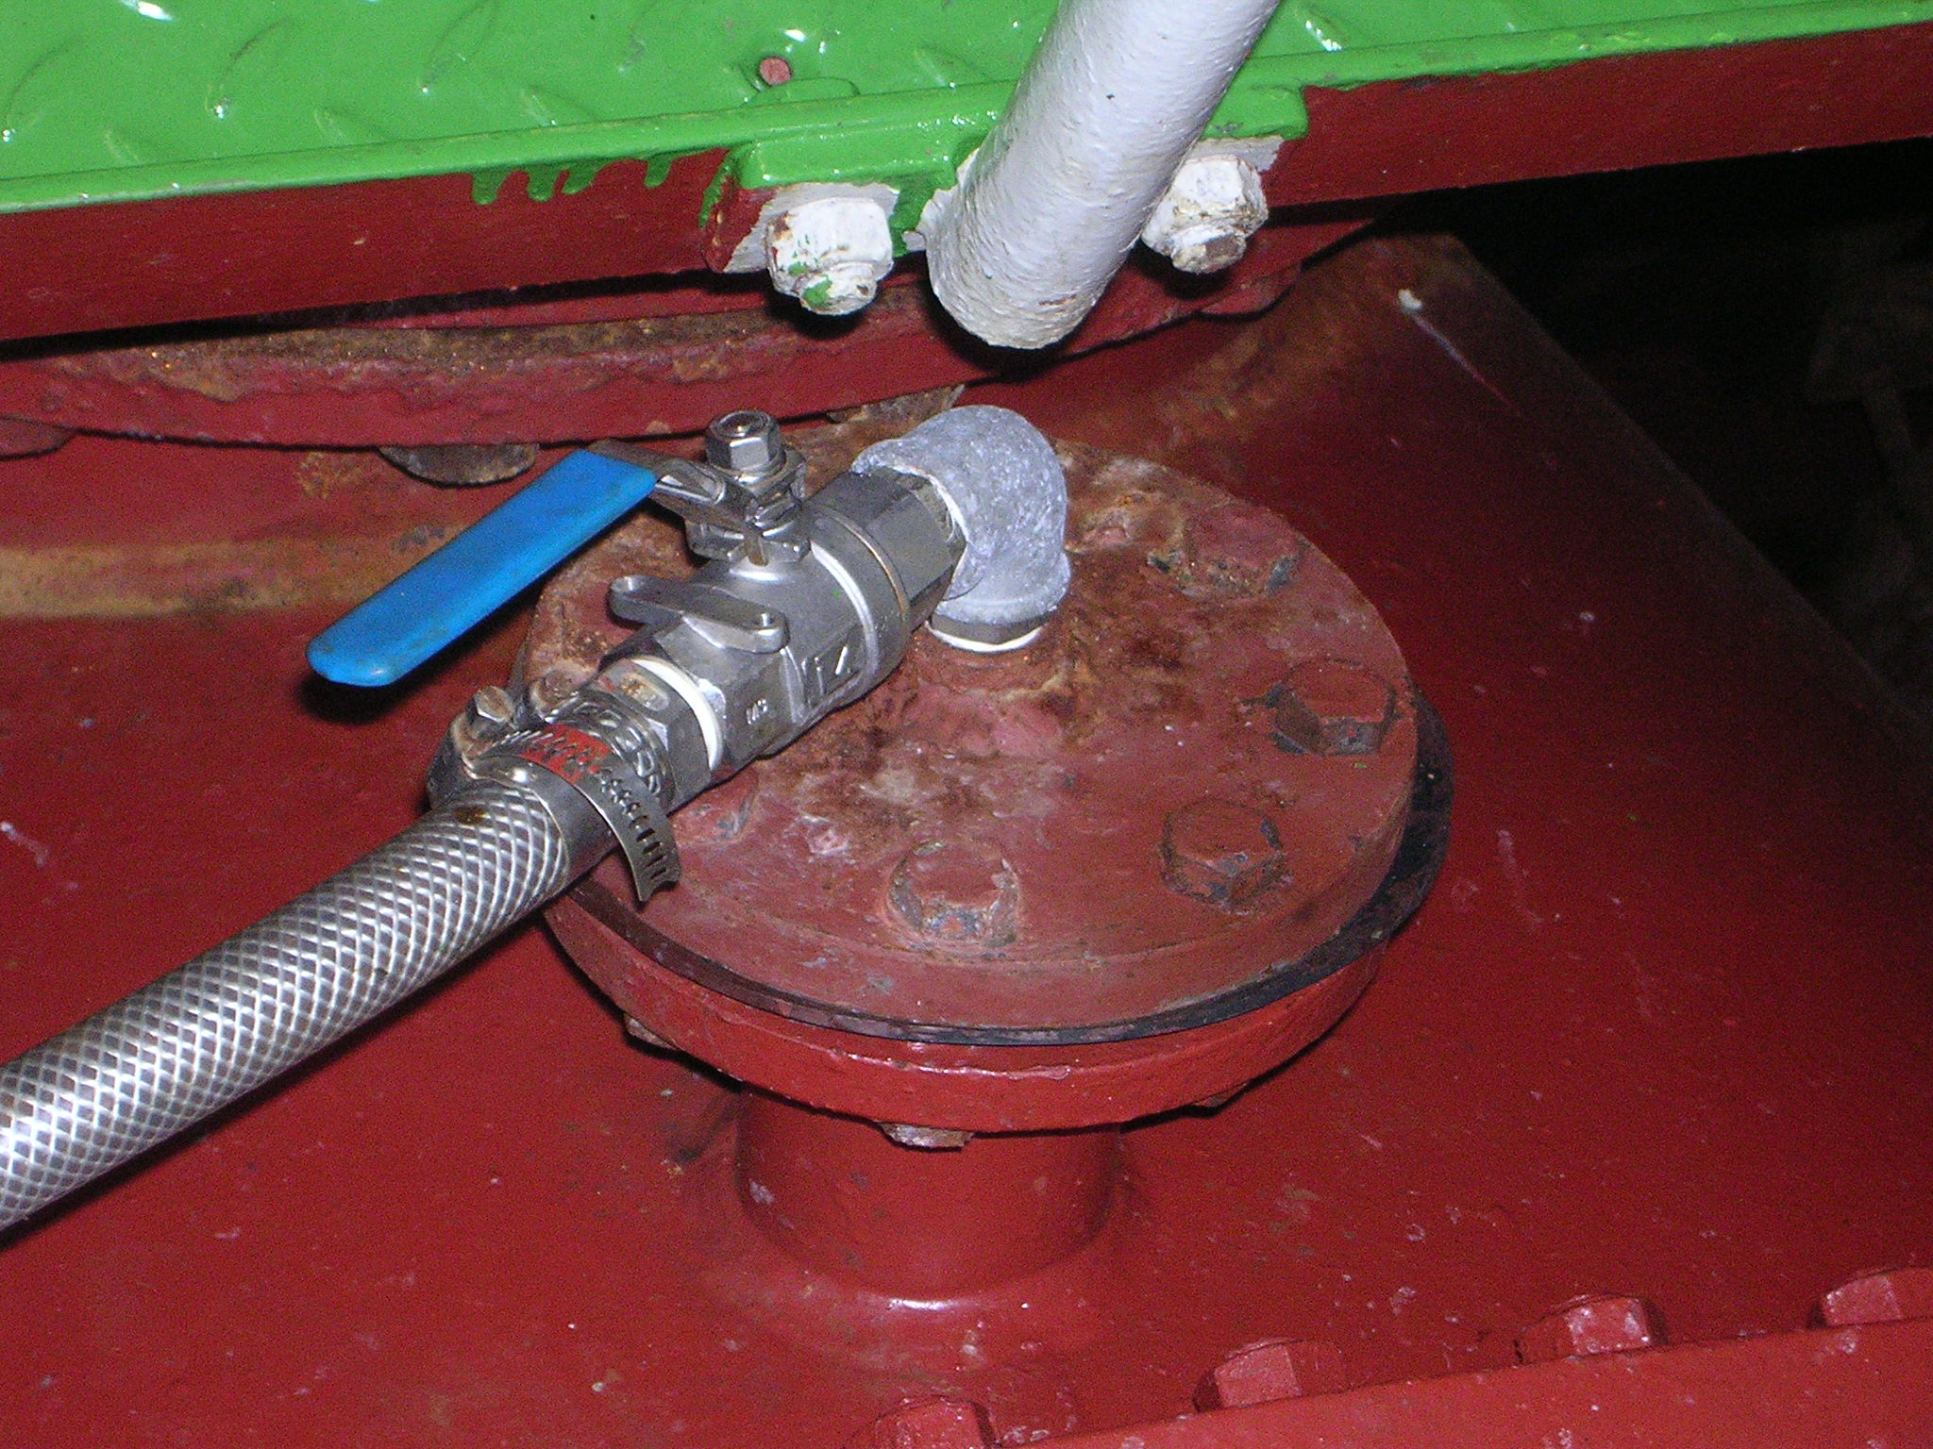
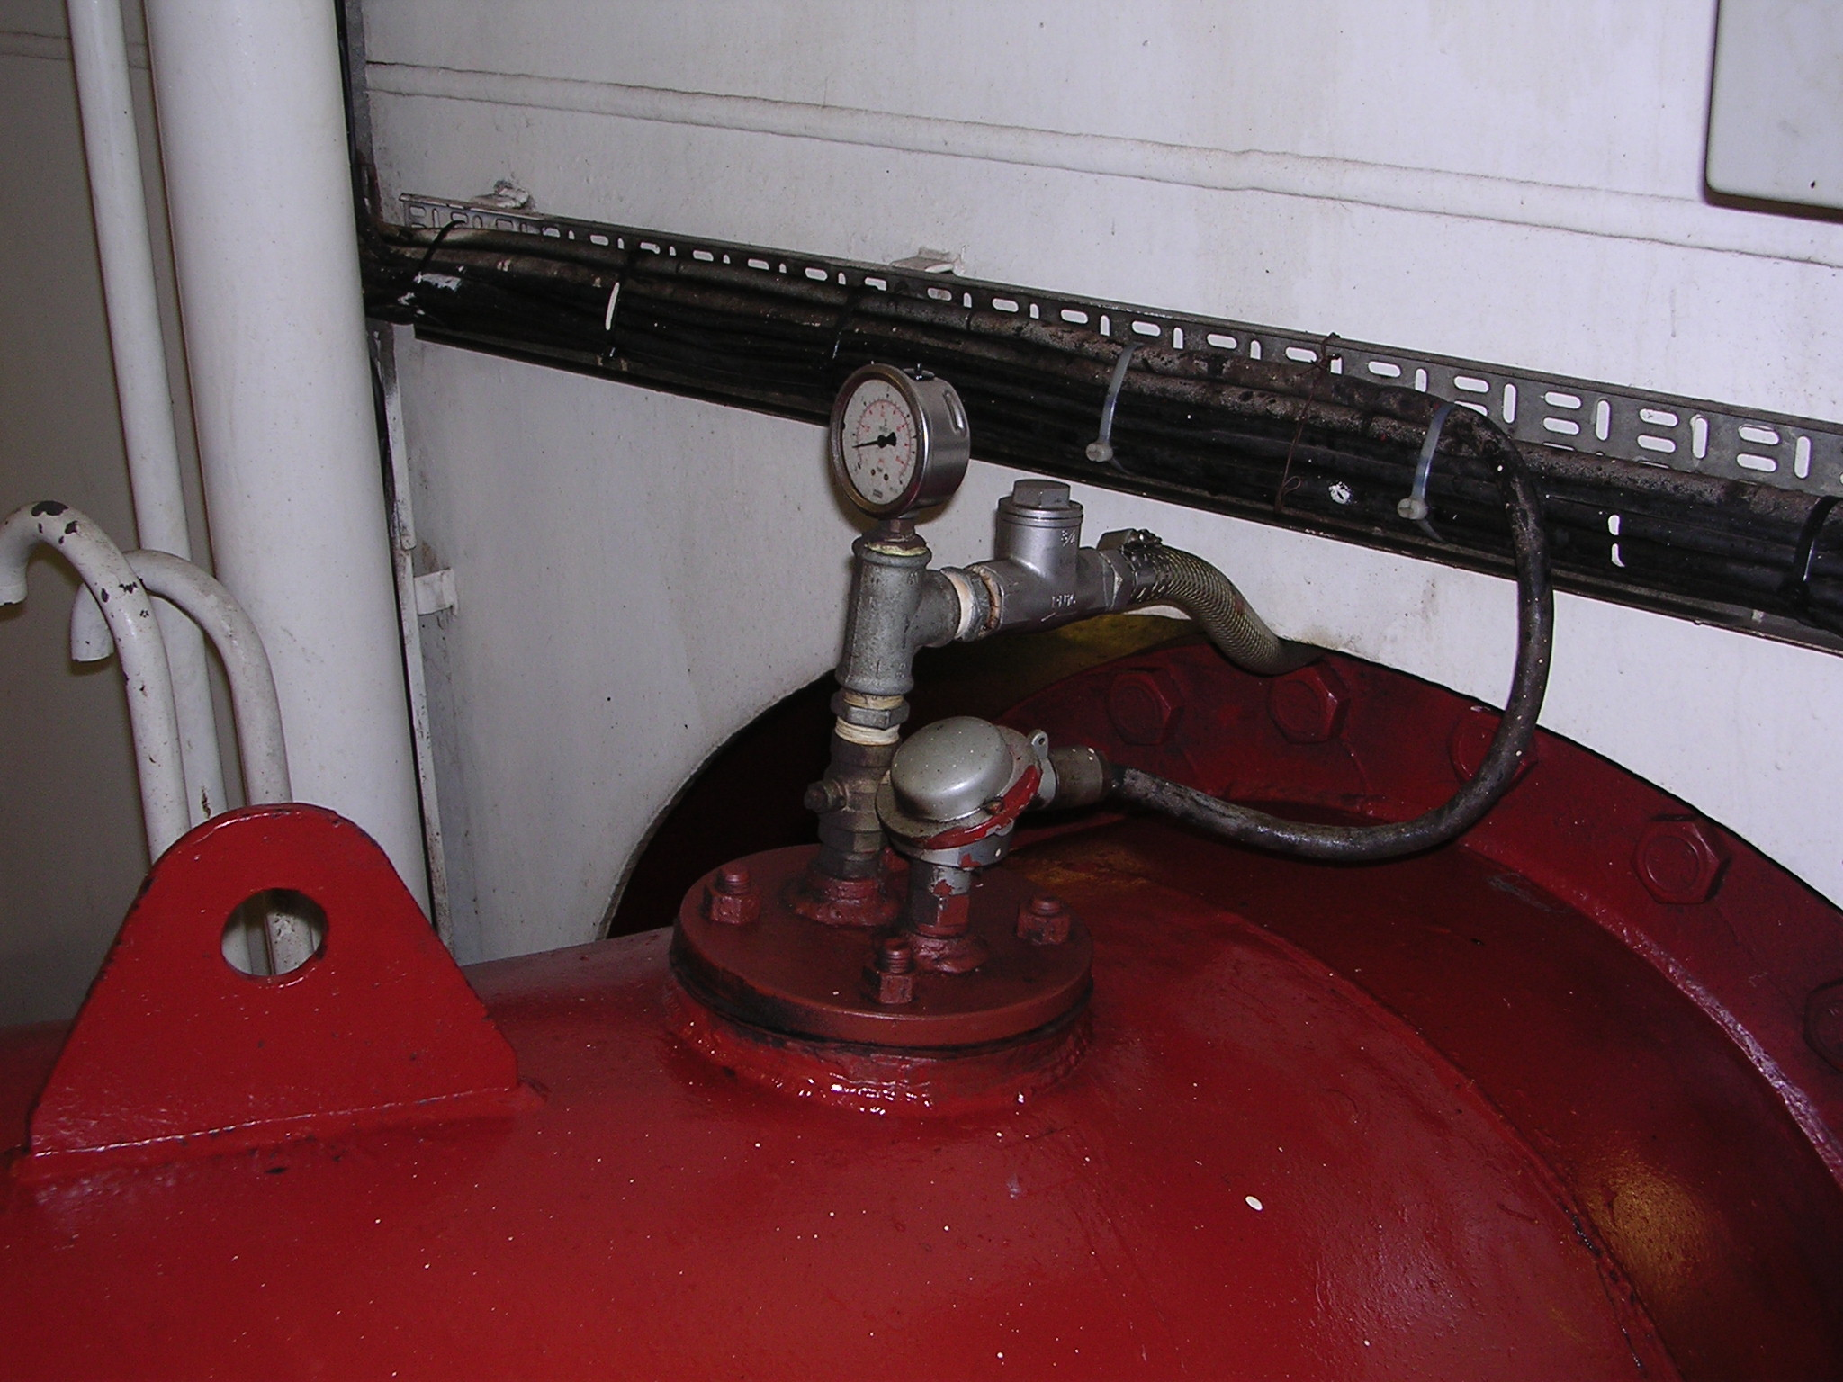
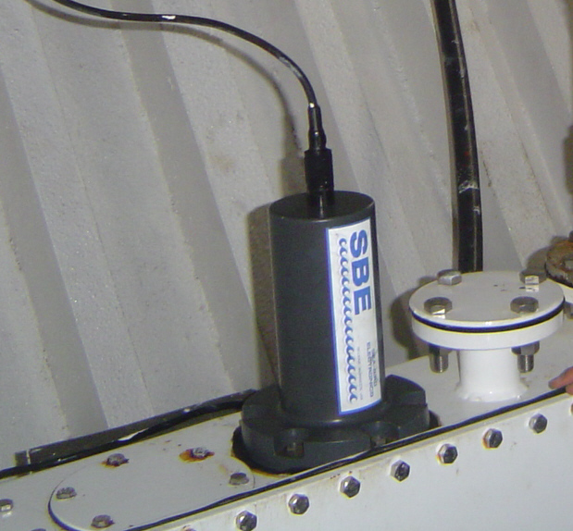
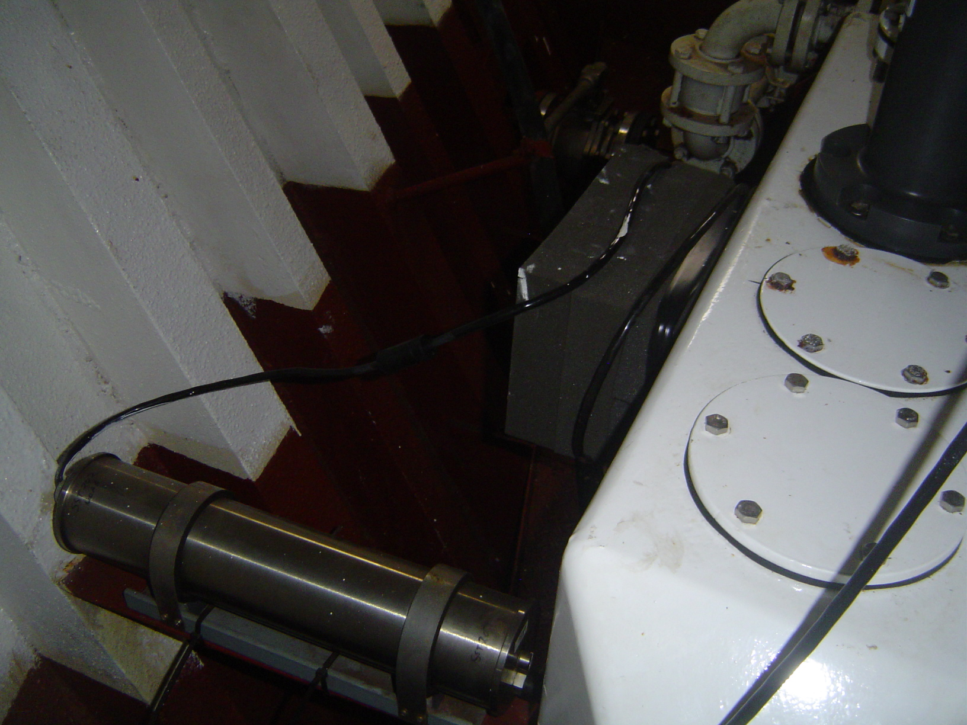

Figure. Diagram of a typical NOAA/AOML TSG configuration

