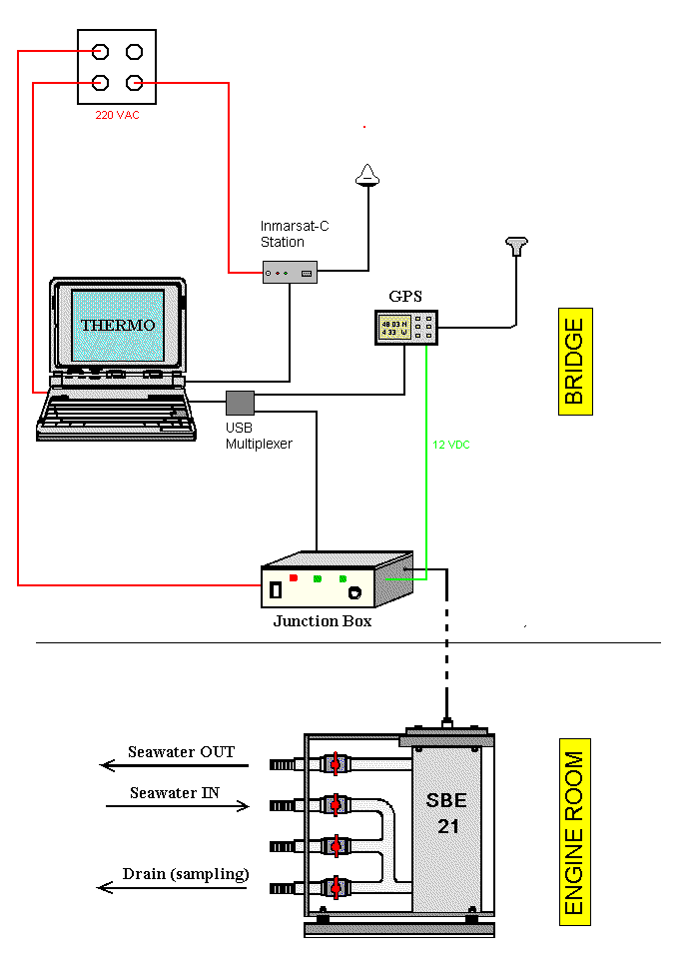
Figure 1 TSG System schematic
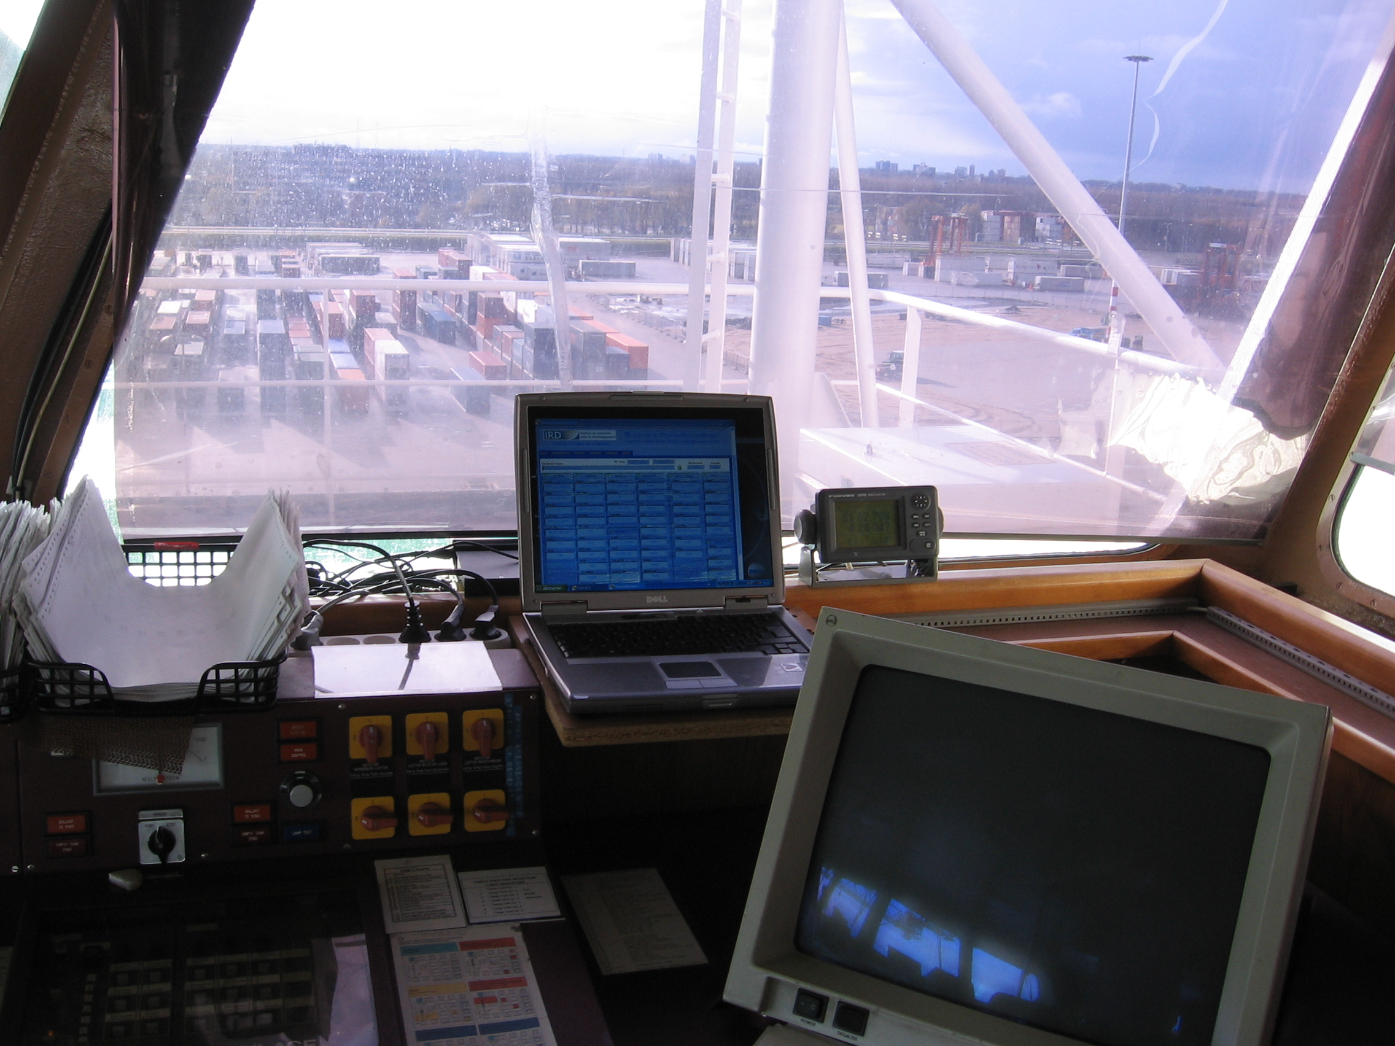
Figure 2 Cap Trafalgar TSG bridge computer

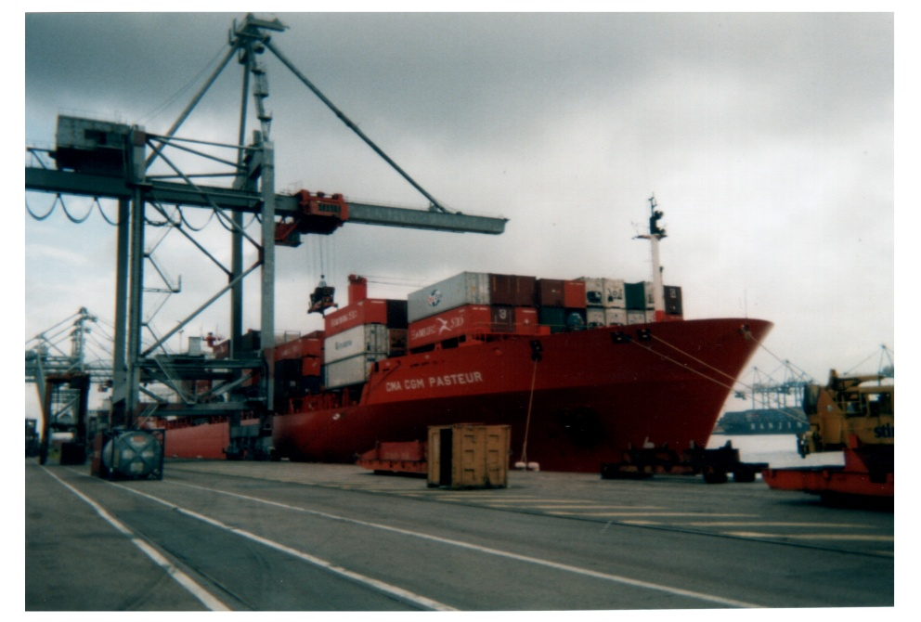
Figure 3 Cap Trafalgar (formerly CGM Pasteur)
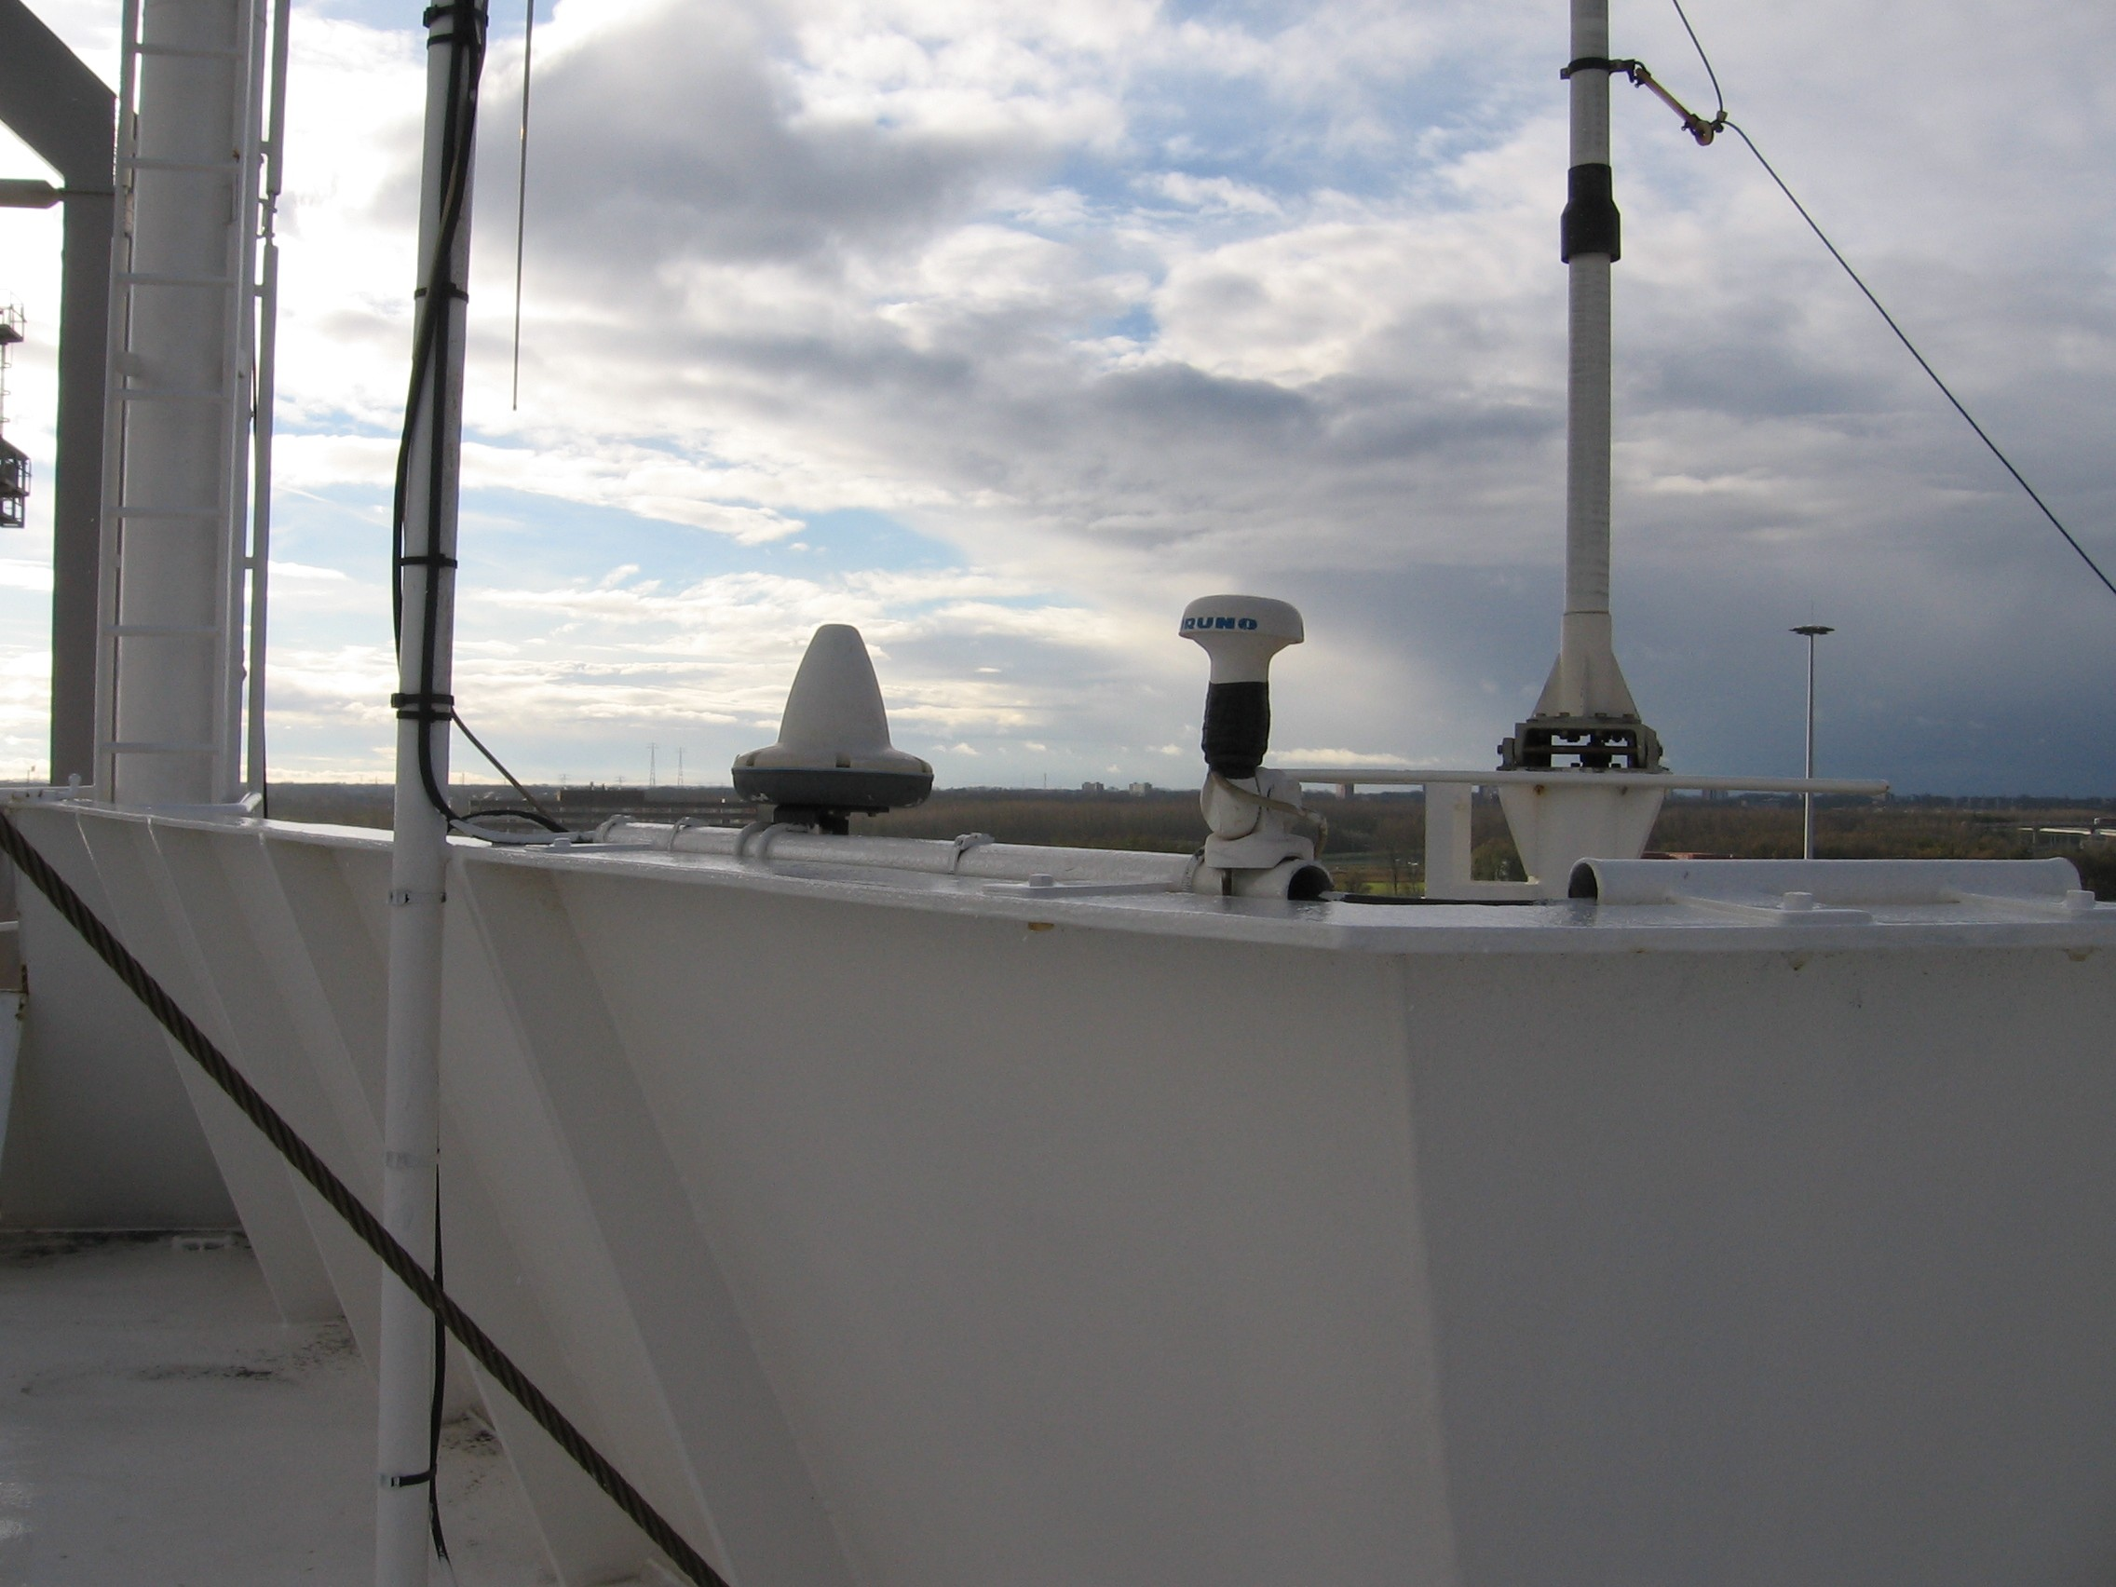
Figure 4 Cap Trafalgar GPS antennae

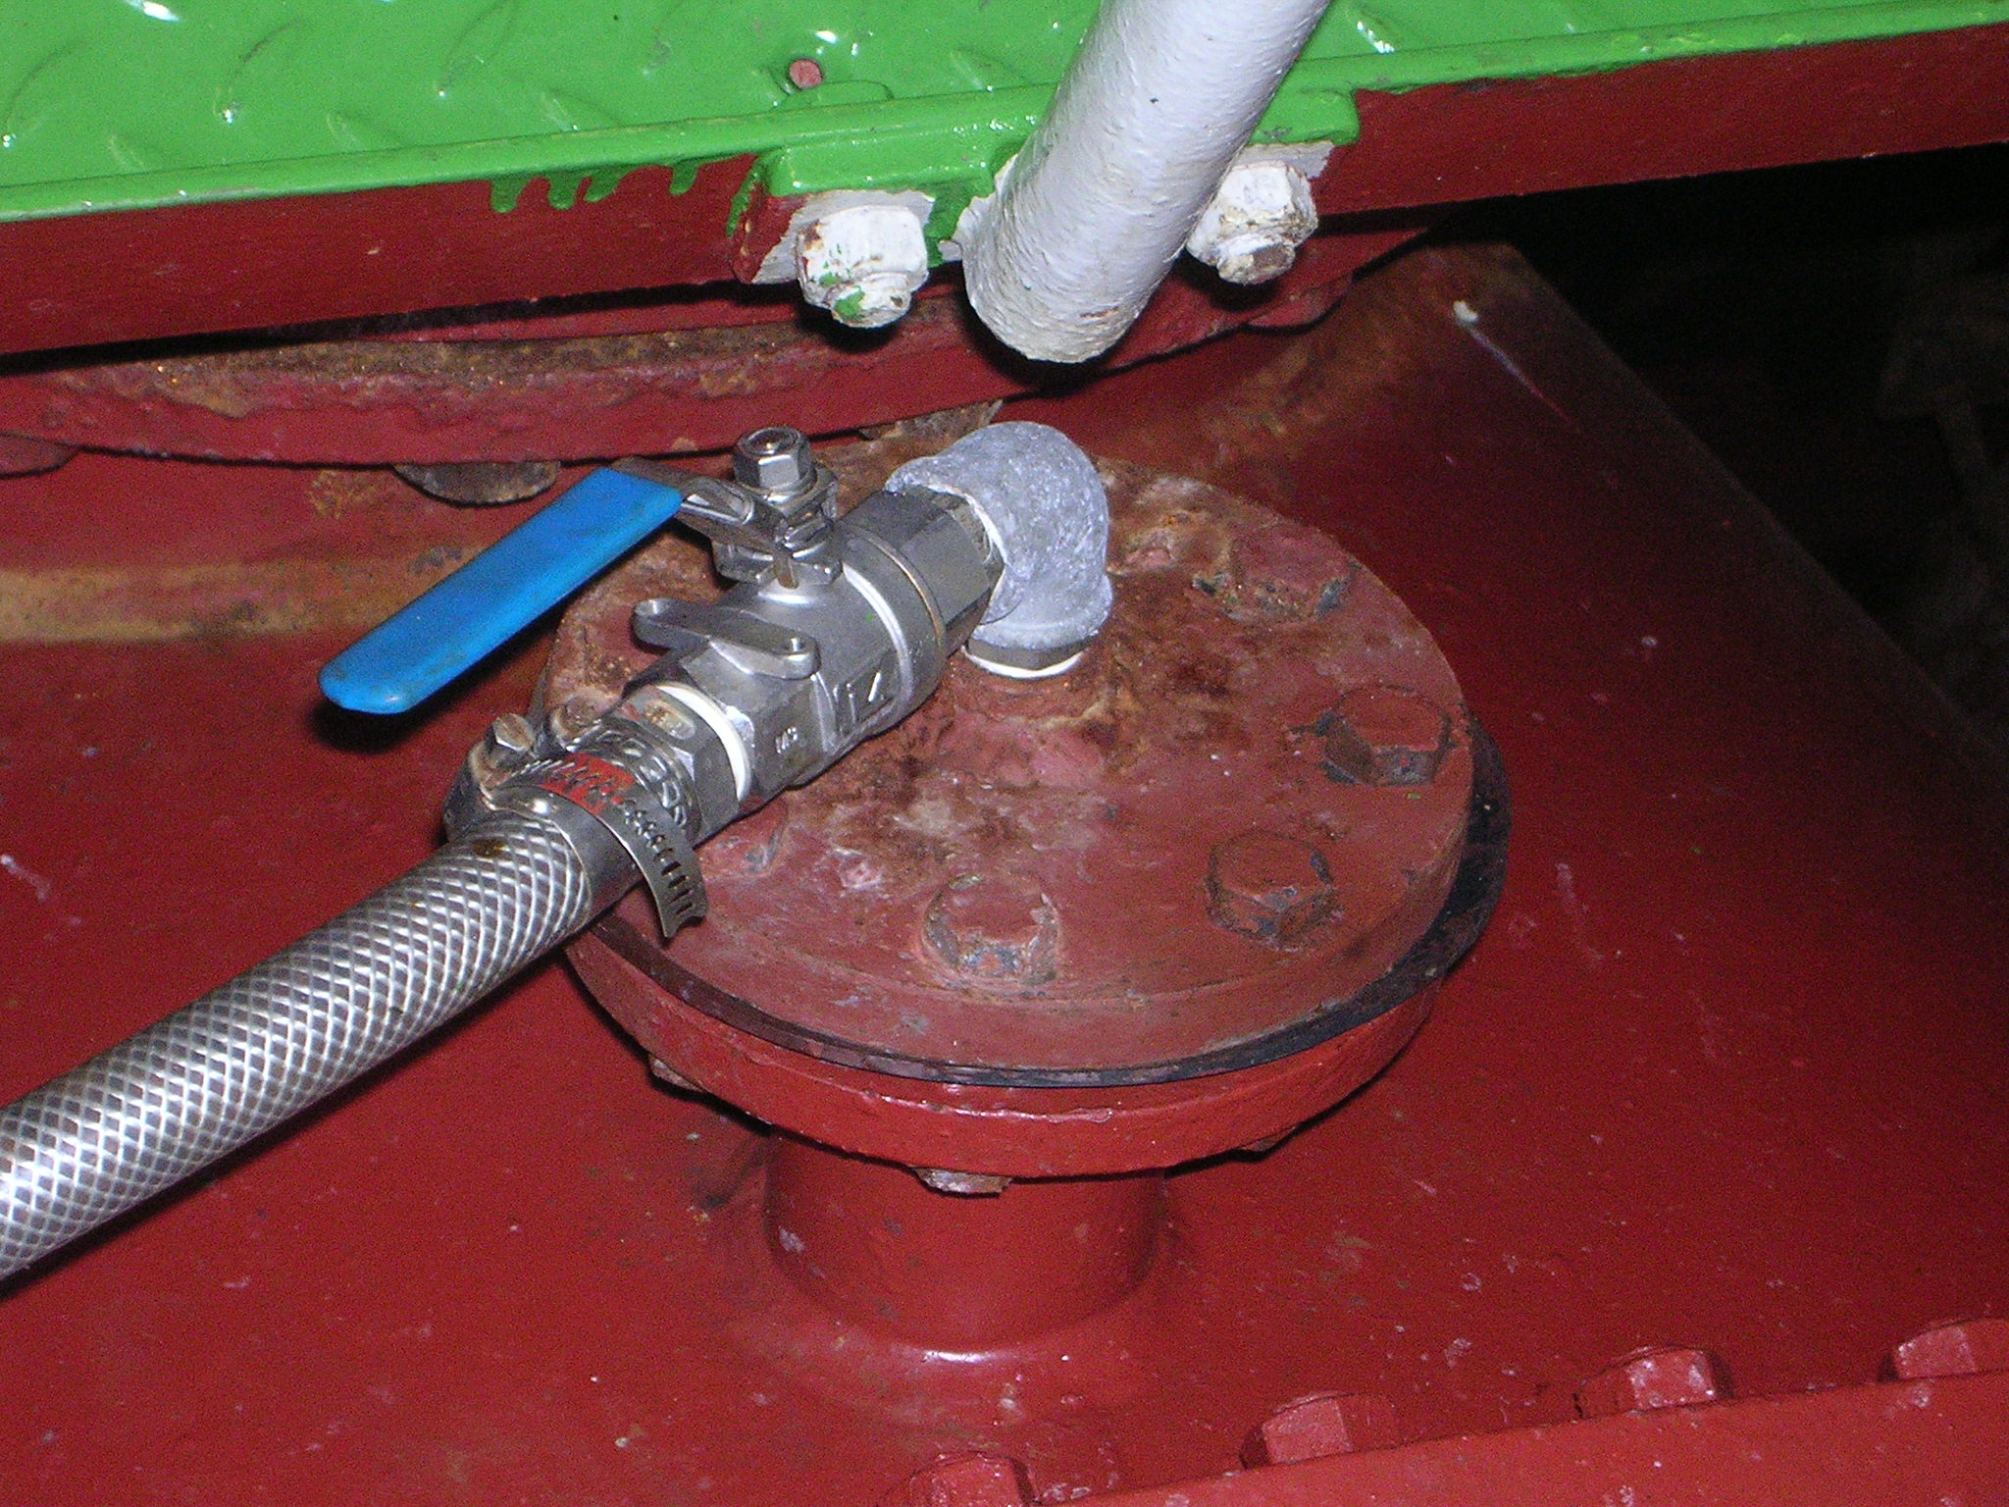
Figure 5 Seawater inlet

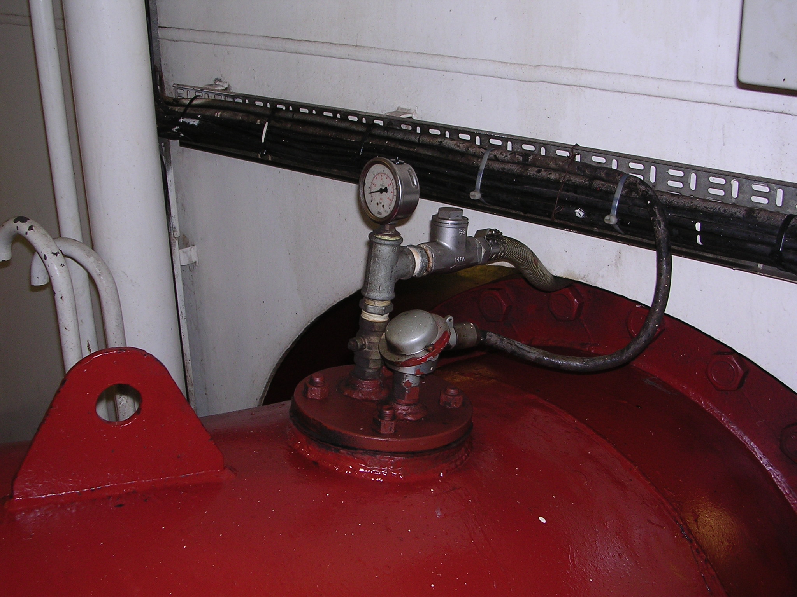
Figure 6 Sewater outlet

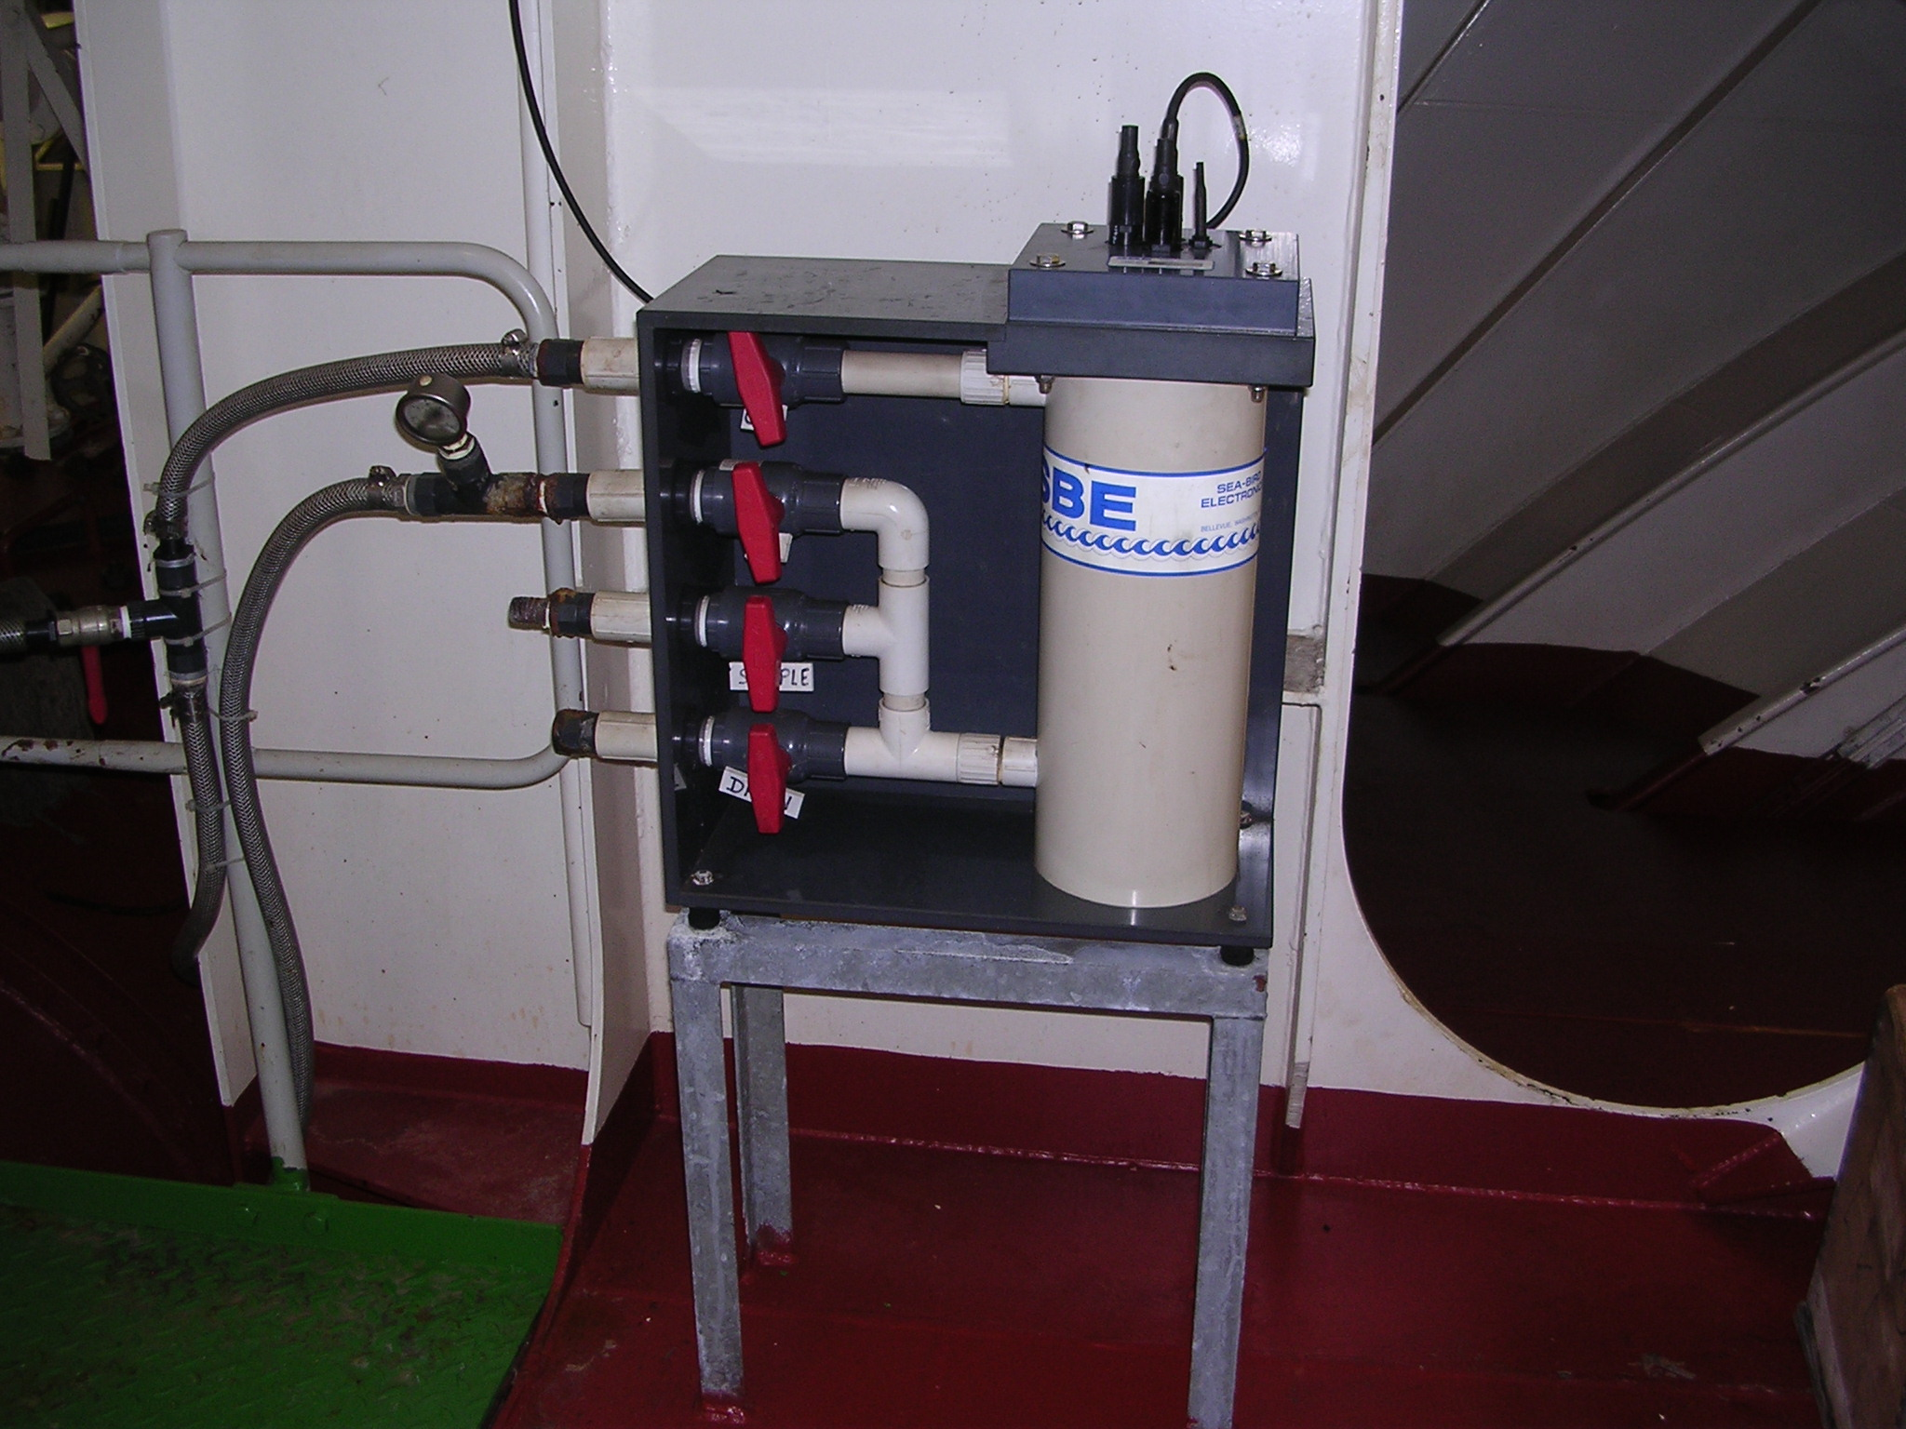
Figure 7 Thermosalinograph in engine room

