Applications of satellite-derived ocean measurements to
tropical cyclone intensity forecasting

Gustavo Goni ¹, Mark DeMaria ², John Knaff ², Charles Sampson ³, Isaac Ginis ⁴, Francis Bringas ⁵, Alberto Mavume ⁶, Chris Lauer ⁷, I-I Lin ⁸, M. M. Ali ⁹, Paul Sandery ¹⁰, Silvana Ramos-Buarque ¹¹, KiRyong Kang ¹² , Avichal Mehra ¹³, Eric Chassignet ¹⁴, and George Halliwell ^{1,15}

(1) NOAA Atlantic Oceanographic and Meteorological Laboratory, Miami, FL, USA. (2) NOAA Regional and Mesoscale Meteorology Branch, Fort Collins, CO, USA . (3) Naval Research Laboratory, Monterey, CA, USA. (4) University of Rhode Island, Graduate School of Oceanography, RI, USA. (5) University of Miami, CIMAS, Miami, FL, USA. (6) Eduardo Mondlane University, Maputo, Mozambique. (7) NOAA Tropical Prediction Center, Miami, FL, USA. (8) Department of Atmospheric Sciences, National Taiwan University, Taipei, Taiwan. (9) Oceanography Division, National Remote Sensing Centre, Hyderabad, India. (10) Center for Australian Weather and Climate Research, Melbourne, Australia. (11) Mercator Ocean, Ramonville St. Agne, France. (12) National Typhoon Center/KMA, Jeju, South Korea. (13) NOAA National Centers for Environmental Prediction, Camp Spring, MD, USA. (14) Florida State University, COAPS, Tallahassee, FL, USA. (15) University of Miami, RSMAS/MPO, Miami, FL, USA.

Abstract

Tropical cyclones (TCs) occur in seven ocean basins: tropical Atlantic, northeast Pacific, northwest Pacific, southwest Indian, north Indian, southeast Indian, and south Pacific. Sudden TC intensification has been linked with high values of upper ocean heat content contained in mesoscale features particularly warm ocean eddies, provided that atmospheric conditions are also favorable. This manuscript reports a summary of some of the current work being carried out to investigate the role that the upper ocean plays in TC intensification and on the use of ocean parameters in TC intensity forecast. The TC intensity forecast in some of these basins has already incorporated upper ocean thermal information either in research or operational mode.

- Introduction
The intensification of TCs includes the interaction of very complex mechanisms, such as TC dynamics, upper ocean interaction, and atmosphere circulation. In general, the forecast of TC intensity has lagged behind the TC track because of the complexity of the problem and because many of the errors introduced in the track forecast are translated into the intensity forecast (DeMaria et al., 2005). The importance of the ocean thermal structure in TC intensification was first recognized by Leipper and Volgenau (1972). While sea surface temperature (SST) plays a role in the genesis of TCs, the ocean heat content contained between the sea surface and the depth of the 26°C isotherm (D26), also referred as Tropical Cyclone Heat Potential (TCHP), has been shown to play a more important role in TC intensity changes (Shay et al., 2000). The TCHP shows high spatial and temporal variability associated with oceanic mesoscale features. TC intensification has been linked with high values of TCHP contained in these mesoscale features, particularly warm ocean eddies, provided that atmospheric conditions are also favorable. Since sustained in situ ocean observations alone cannot resolve global mesoscale features and their vertical thermal structure, different indirect approaches and techniques are used to estimate the TCHP. One of these techniques includes sea surface height observations derived from satellite altimetry, a parameter that provides information on the upper ocean dynamics and vertical thermal structure. This manuscript highlights the importance of integrated data and, particularly, of satellite derived observations and their concurrent analysis with hydrographic observations and within numerical air-sea coupled and forced ocean models.

- North Atlantic Ocean
An operational satellite altimetry-based TCHP analysis was implemented at the National Oceanic and Atmospheric Administration (NOAA) National Hurricane Center (NHC) in 2004 (Mainelli et al., 2008). This approach uses sea height anomaly fields derived from altimetry and historical hydrographic observations in a statistical analysis to determine the depth of the main thermocline, usually the 20°C in tropical regions (Goni et al, 1996) and climatological relationships are used to determine D26 from the depth of the 20°C isotherm. These TCHP fields are used qualitatively by the NHC forecasters for their subjective TC intensity forecasts and quantitatively in the Statistical Hurricane Intensity Prediction Scheme (SHIPS, DeMaria and Kaplan, 1994). SHIPS is an empirical model that uses a multiple regression method to forecast intensity changes out to 120 h. The 2008 version of SHIPS includes 21 predictors, mostly related to atmospheric conditions. The ocean predictors are the SST and the TCHP. Despite its simplicity, the SHIPS forecasts are comparable to or more accurate than those from much more general models. For recent category 5 hurricanes, the TCHP input improved the SHIPS forecasts by about 5%, with larger improvements for individual storms (Mainelli et al., 2008). A validation performed on 685 Atlantic SHIPS forecasts from 2004-2007 shows that the average improvement of SHIPS due to the inclusion of the TCHP and (Geostationary Operational Environmental Satellite) GOES SST data reached up to 3% for the 96 h forecast (Figure 1, left) with nearly all of the improvements at the longer forecast intervals are due to the TCHP because that input is averaged along the storm track. Although not as large as the sample of just the category 5 hurricanes, this result indicates that the TCHP input improved the operational SHIPS forecasts, especially at the longer forecast intervals.

Altimetry observations are also used to initialize the ocean component of a couple hurricane prediction model with fields extracted from data-assimilative ocean hindcasts generated as part of the Global Ocean Data Assimilation Experiment (GODAE). These hindcasts rely heavily on altimetry to properly locate mesoscale features, such as ocean currents and eddies. This initialization approach was examined in ocean model simulations of the response to hurricane Ivan (2004) in the northwest Caribbean and Gulf of Mexico (Halliwell et al., 2008). This simulation was driven by quasi-realistic forcing generated by blending fields extracted from the Navy COAMPS (Coupled Ocean/Atmospheric Mesoscale Prediction System) atmospheric model with higher-resolution fields obtained from the NOAA/AOML-Hurricane Research Division (HRD) H*WIND product (Powell et al., 1998) to resolve the inner-core structure of the storm. For the ocean component of HWRF (Hurricane Weather Research and Forecast System, Surgi et al., 2006) to correctly forecast intensity, it was concluded that it must correctly forecast the rate of cooling of SST in the coupled forecast runs. This capability can only be realized if ocean features are correctly initialized in the ocean model.

A new feature-based ocean initialization procedure was created to account for spatial and temporal variability of mesoscale oceanic features in the Gulf of Mexico, including the Loop Current (LC) and eddies (Yablonsky and Ginis, 2008). Using this methodology, near real-time maps of sea surface height and/or D26 derived from altimetry, are used to adjust the position of the LC and insert these eddies into the background climatological ocean temperature field prior to the passage of a hurricane. For the 2008 Atlantic hurricane season, the full version of this procedure was implemented in the NOAA Geophysical Fluid Dynamic Laboratory (GFDL) and HWRF models, which can also assimilate real-time in situ data, such as AXBT profiles. GFDL coupled hurricane-ocean model sensitivity experiments for selected hurricanes were run with and without altimeter data assimilation to evaluate the impact of assimilating mesoscale oceanic features on both the SST cooling under the storm and the subsequent intensity change of the storm. For hurricane Katrina (2005) the presence of the LC and of a warm ring, as given by the assimilated altimeter data, reduced the SST cooling along the hurricane track and allowed the storm to become more intense (Figure 2, left panel). This assimilation improved the intensity forecast of the actual storm with respect to that obtained without assimilating the altimetry fields.

The investigation of global ocean trends and in particular of sea height and SST has become increasingly important. These trends vary regionally and, for example, time series of TCHP show that the North Atlantic and the Gulf of Mexico exhibit a positive trend of (2.0 ± 0.5) kJ cm⁻² per decade since 1993 (Goni, 2008). This increase of TCHP values (Figure 2, right panel) could be related to a more pronounced intrusion of the Loop Current into the Gulf of Mexico and to the generation of a larger number of rings. As it is known that the warm rings in the Gulf contribute to the intensification of TC, further investigation needs to be done if this trend also contributes to more occurrences of intensification.

3. Other Ocean Basins.
Thirty northwest Pacific category 5 typhoons that belong to the typhoon season of 1993-2005 were examined using observations corresponding to 13 years of satellite altimetry, in situ, and climatological upper ocean thermal structure data, best track typhoon data of the U.S. Joint Typhoon Warning Center (JTWC), and an ocean mixed layer model (Lin et al., 2008). Results show that the background climatological upper ocean thermal structure is an important factor in determining how warm mesoscale ocean features affect the intensification of category 5 TCs. Two different conditions were found. The first is in the western North Pacific south eddy zone (127°E-170°E, 21°N-26°N) and the Kuroshio (127°E-170°E, 21°N-30°N) region, where the background climatological warm layer is relatively shallow. Here D26 is typically 60 m and the TCHP approximately 50 kJ cm⁻². Therefore, ocean features become critical for typhoon intensification to category 5 because they can effectively deepen the warm layer (D26 reaching 100 m and the TCHP ~ 110 kJ cm⁻²) to restrain typhoon’s self-induced ocean cooling. In the past 13 years, 8 out of the 30 category-5 typhoons (i.e., 27%) corresponded to this type. The second is in the central region of the subtropical gyre (121°E-170°E, 10°N-21°N), where the background climatological warm layer is deep (typically D26 ~ 105-120 m and the TCHP ~ 80-120 kJ cm⁻²). In this region, it is possible that a typhoon may intensify to category 5 when travelling above waters with cyclonic or anticyclonic mesoscale features.

In the NE Pacific basin, a statistical-dynamical model similar to SHIPS (section 2), called the Statistical Typhoon Intensity Prediction Scheme (STIPS; Knaff et al.,. 2005) was utilized. STIPS is run at the Naval Research Laboratory in Monterey and is provided to the JTWC who make TC intensity forecasts in the western North Pacific, South Pacific, and Indian oceans. The version of the STIPS model used in the Northwest Pacific and North Indian Oceans uses the square root of the global TCHP fields (www.aoml.noaa.gov/phod/cyclone) calculated along the forecast track as a predictor. This updated 13 predictor-version of the STIPS model was run in parallel for the last three years with its predecessor, which does not use the TCHP information. A independent and homogeneous sample of these parallel forecasts of 63 Northwest Pacific TCs showed modest improvements in intensity prediction were achieved when TCHP information was used (Figure 1, right). Forecast improvements achieved by using TCHP information were statistically significant in the 24 h to 120 h forecast times.

Another study of the relationship between typhoon intensification and the ocean heat content in the northwestern Pacific Ocean was carried out by the National Typhoon Center in Korea with TCHP fields using profiling float data. Results indicated that the horizontal distribution of the TCHP values matched well the typhoon intensity change pattern, showing that the typhoons were intensified with some time lag after travelling over the regions of higher ocean heat content. The ocean heat effect to typhoon intensity at different time lags for each ocean heat energy level indicated that the average decrease of core pressure per 24, 48, and 72 hours under 80-100 kJcm⁻², were 13, 26, and 37 hPa, respectively.

The BLUElink operational Ocean Model, Analysis and Prediction System (OceanMAPS) (Brassington et al., 2007) at the Australian Bureau of Meteorology (BOM) is performing routine monitoring, analyses and forecasts of various measures of ocean heat content and their respective climatological anomalies
(http://godae.bom.gov.au/oceanmaps_analysis/ocean_hc/ocean_hc.shtml). These include ocean heat content in the upper 50 and 200 m, fields of TCHP, and D26. A Coupled Limited Area Modeling (CLAM) system was recently developed to carry out research on the impact of coupling on TC intensity forecasting skill in the region. The coupled system comprises the BOM TC forecasting model TCLAPS (Davidson and Weber, 2000), the Ocean-Atmosphere-Sea-Ice-Soil (OASIS) coupler (Valcke et al., 2003) and a regional version of the BLUElink ocean forecasting system. Results show that TC intensity is sensitive to OHC, with fluctuations in lowest central pressure (LCP) between 10-20 hPa being related to variability of mesoscale upper ocean thermal structure and feedback into the storm via air-sea heat fluxes. The use of more accurate SSTs from the reanalysis is also shown to be important in improving the TC intensity. The coupled simulation produced a less intense and faster moving storm than the uncoupled simulation due to feedback of cool SSTs. The rapid rise of LCP after 50 h occurs when the storm made landfall over Cape York Peninsular. Further work is being done with the CLAM system to couple a wave model and to improve ocean initialization and model physics at the air-sea interface and in the oceanic mixed layer.

The link between TC intensification and TCHP has also been identified in the north Indian Ocean, showing that TCs intensify (dissipate) after travelling over anticyclonic (cyclonic) eddies. A good correspondence is observed between the intensification/dissipation of the TCs and the SHA fields. In contrast, this relationship is not observed with the SST fields. Additionally, the inclusion of SHA in the visual analysis (Ali et al, 2007) and into the fifth generation National Centre for Atmospheric Research Mesoscale Model (MM5) has shown to reduce the intensity and track errors.

Recent analyses of cyclone track data in the Mozambique Channel for 1994-2007 (Mavume et al. 2008) allowed identifying 15 intense cyclones, with landfall in Mozambique or Madagascar. However, although there is no doubt about the general importance of high values of TCHP in the region, an assessment of these 15 TCs did not show a clear tendency for intensification over warm eddies as intensification took place also over cyclonic eddies, similar to what was found in the northwest Pacific Ocean. It was hypothesized that improved knowledge of the vertical density profile is necessary to further understand the role of the ocean in TC intensification in this region.

The role of the ocean on TC intensification can be investigated globally using high horizontal resolution global GODAE analyses and forecasts in near-real time (i.e. Mercator Ocean, HYCOM). These systems are forced with atmospheric conditions supplied by ECMWF (European Centre for Medium-range Weather Forecasts), NCEP (National Centers for Environmental Prediction), or NOGAPS (Navy Operational Global Atmospheric Prediction System) and assimilate the altimeter-derived SHA fields (Chassignet et al., 2007, 2009; Drévillon et al., 2008). A first evaluation of the Mercator Ocean global ocean forecast system’s (MERCATOR) ability to simulate realistic variability of ocean heat content fields during TC events was made by processing the point-to-point correlations between the atmospheric pressure (P_{a}) and the MERCATOR-derived TCHP values (Ramos-Buarque and Landes, 2008). The P_{a} is predicted from satellite observations in the center of TC. Twenty TC were considered mostly positioned in the North Atlantic and North West Pacific. The correlation reaches 14% for 119 days (points). The delayed correlation between P_{a} for the day J and TCHP for any day J-1 over 62 days is 11%. The difference between the correlations for J:J and J:J-1 is not significant because the TCHP is associated with low-frequency of the ocean processes. Also a parameter proportional to the temperature difference above 26°C integrated over the MERCATOR Oceanic Mixed Layer (OML), called Interacting Tropical Cyclone Heat Content (ITCHC) (Vanroyen at al., 2008), was evaluated. While the TCHP quantifies the energy contained between the sea surface and D26, the ITCHC quantifies the energy available in the OML. Correlations were carried out between P_{a} and the averaged ITCHC over the inner circle of the TC related to the upper ocean heat loss primarily due to the wind stress (radius of 110 km). These correlations for J:J and J:J-1 are respectively 22% and 42%. If the atmospheric surface forcing is realistic, the MERCATOR averaged ITCHC can be used as a powerful predicator for TC intensification. Otherwise, when the surface forcing is not realistic a very useful TCHP preserves an acceptable level of predictability related to the low-frequency of ocean processes.

4. Future Work
The current open ocean observing system was mainly designed for climate and not for TC intensification studies. Although there are efforts underway to improve this system to investigate regions of TC genesis, current sustained in situ ocean observations (XBTs, Argo floats, moorings, surface drifters, etc.) do not fully support TC intensification studies. Therefore, indirect methodologies using satellite observations and numerical modeling are being used to monitor the upper ocean for TC intensification research. Studies performed in all ocean basins indicate that the ocean plays a role that still needs to be adequately quantified in TC intensification, which is highly dependant on upper ocean stratification. Future work will include a detailed analysis of other upper ocean parameters, such as heat content, and mean temperature in the mixed layer to different depths or isotherms, including isotherms below 26°C. Models based on statistical methodologies have shown that there is a correlation between the upper ocean thermal structure and the intensification of TCs, where mesoscale ocean features with a minimum value of TCHP of ~50 kJ cm⁻² may contribute to the intensification of intense storms. It is clear that improved estimates of TCHP in ocean and ocean-atmospheric coupled models are critical for improvement in TC intensity forecasting. Results from some of the current efforts presented here highlight the importance of the continuous support of altimetric missions able to resolve mesoscale features.

Several research observational efforts are also underway to better understand the boundary layer of TCs and air-sea interaction. For example, one of the goals of the Intensity Forecast Experiment (IFEX) is to develop and refine technologies to improve real-time monitoring of TC intensity, structure and environment (Rogers et al, 2006). Other observational efforts have revealed the importance of the inner core SST with regards to intensification (Cione and Uhlhorn, 2003). The improvement of numerical models and understanding of the role of the ocean in TC intensification will help set up the requirements for observations through the execution of an OSSE (Observations System Simulation Experiment). Improved TC monitoring will also aid in storm surge prediction, whose errors decrease if the track and intensity are of TCs are correctly forecasted.

Acknowledgements
Some of the work of GG, MDM, JK, CS and FB was supported by NOAA/NESDIS through the Research to Operations Program. Part of GG work was done during a rotational assignment at the NOAA/IOOS Program Office. Research and development of OceanMAPS and CLAM is supported by the BLUElink project, Australian Bureau of Meteorology, CSIRO and the Royal Australian Navy. The Indian National Centre for Ocean Information Services sponsored the project on North Indian Ocean tropical cyclone studies. Analysis carried out by PSV Jagadeesh and Sarika Jain in this project is gratefully acknowledged. NOAA grant NOAA4400080656, awarded to the Graduate School of Oceanography at URI.

References –
Ali, M.M, PSV Jagadeesh and Sarika Jain (2007), Effects of Eddies and Dynamic Topography on the Bay of Bengal Cyclone Intensity, EOS, 88: 93-95.
Brassington, G.B., T. Pugh, C. Spillman, E. Schulz, H. Beggs, A. Schiller and P. R. Oke (2007) BLUElink> Development of operational oceanography and servicing in Australia, Journal of Research and Practice in Information Technology, 39: 151-164.
Chassignet, E.P., H.E. Hurlburt, O.M. Smedstad, G.R. Halliwell, P.J. Hogan, A.J. Wallcraft, R. Baraille, and R. Bleck (2007) The HYCOM (HYbrid Coordinate Ocean Model) data assimilative system. J. Mar. Sys., 65, 60-83.
Cione, J.J., and E. W. Uhlhorn (2003) Sea surface temperature variability in hurricanes: Implications with respect to intensity change. Mon. Wea. Rev., 131: 1783-1796.
DeMaria, M., M. Mainelli, L. K. Shay, J. A. Knaff, and J. Kaplan (2005) Further improvements to the Statistical Hurricane Intensity Prediction Scheme (SHIPS), Wea Forecasting, 20: 531-543.
DeMaria, M., and J. Kaplan (1994) A statistical hurricane prediction scheme (SHIPS) for the Atlantic basin, Weath. Forecasting, 9: 209-220.
Drévillon, M, R. Bourdallé-Badie, C. Deval, Y. Drillet, J-M. Lellouche, E. Rémy, B. Tranchant, M. Benkiran, E. Greiner, S. Guinehut, N. Verbrugge, G. Garric, C-E. Testut, M. Laborie, L. Nouel, P. Bahurel, C. Bricaud, L. Crosnier, E. Dombrowsky, E. Durand, N. Ferry, F. Hernandez, O. Le Galloudec, F. Messal and L. Parent (2008) The GODAE/Mercator-Ocean global ocean forecasting system : results, applications and prospects. Journal of Operational Oceanography, 1: 51-57.
Goni, G., S. Kamholz, S. Garzoli and D. Olson (1996) Dynamics of the Brazil-Malvinas Confluence Based on Inverted Echo Sounders and Altimetry, J. Geophys. Res., 101, 16273-16289.
Goni, G. J., Mavume, A. F., Rouault, M., Lutjeharms, J. R. E. and Rydberg, L. (2008) Intensification and sea surface cooling in relation to tropical cyclones in the Mozambique Channel, J. Geophys. Res, submitted.
Goni, G. J. (2008) Tropical Cyclone Heat Potential, in State of the Climate in 2007, Bull. Am. Met. Soc., D.H. Levinson and J.H. Lawrimore (eds), 89: 43-45.
Halliwell Jr. G. R., L.K. Shay, S. D. Jacob, O.M. Smeadstad, E. W. Uhlhorn (2008) Improving ocean model initialization for coupled tropical cyclone forecast models using GODAE nowcasts, Mon. Wea. Rev., 136: 2576-2591.
Knaff, J.A., C.R. Sampson, M. DeMaria (2005) An operational statistical typhoon intensity prediction scheme for the Western North Pacific, Weather and Forecasting, 20: 688–699.
Leipper, D. and D. Volgenau (1972) Hurricane heat potentical in the Gulf of Mexico, J. Phys. Ocean., 2: 218-224.
Lin, I. I., C. C. Wu, and I.-F. Pun (2008) Upper ocean thermal structure and the Western North Pacific category-5 typhoons, part I: ocean features and category-5 typhoons’ intensification. Mon. Wea. Rev., 136, 3288-3306.
Mainelli, M., M. DeMaria, L.K. Shay and G. Goni (2008) Application of oceanic heat content estimation to operational forecasting of recent Atlantic category 5 hurricanes. Wea. Forecasting, 23: 3-16.
Mavume, A. F., Rydberg, L. and Lutjeharms, J.R.E. (2008) Climatology of tropical cyclones in the South-West Indian Ocean; landfall in Mozambique and Madagascar, The Western Indian Ocean Journal of Marine Science, submitted.
Ramos Buarque, S and V Landes (2008) Aptitude du système global de prévision océanique PSY3V2 pour le monitoring des Cyclones tropicaux: un chemin vers le développement d'indicateurs croisés. Ateliers de Modélisation de l’Atmosphère (AMA), 22-24 janvier, Toulouse, 10 pp.
Rogers, R., S. Aberson, M. Black, P. Black, J. Cione, P. Dodge, J. Dunion, J. Gamache, J. Kaplan, M. Powell, N. Shay, N. Surgi, and E. Uhlhorn (2006), The Intensity Forecasting Experiment, Bull Met. Soc. Am., 1523-1537.
Shay, L. K., G. J. Goni, and P. G. Black (2000) Effects of a warm oceanic feature on Hurricane Opal. Mon. Wea. Rev., 128: 1366-1383.
Surgi, N. S. Gopalkrishnan, Q. Liu, R. E. Tuleya, and W. O’Connor (2006) The Hurricane WRF (HWRF): Addressing our nation’s next generation hurricane forecast problems, 27th Conf. On Hurricanes and Tropical Cyclone Meteorology, CD-ROM, 7A.2.
Valcke, S., A. Caubel, D. Declat, and Terray, L., (2003) OASIS3 Ocean Atmosphere Sea Ice Soil User's Guide, Technical Report TR/CMGC/03-69, CERFACS, Toulouse, France.
Yablonsky, R. M., and I. Ginis (2008) Improving the ocean initialization of coupled hurricane-ocean models using feature-based data assimilation. Mon. Wea. Rev., 136: 2592-2607.

Figure 1. (left) Percent improvement of the 2004-2007 operational Statistical Hurricane Intensity Prediction Scheme (SHIPS) forecasts for the Atlantic sample of over-water cases west of 50ºW due to the inclusion of input from TCHP-derived altimetry and SST-derived GOES field. (right) Percent improvement resulting from the use of TCHP information in the Statistical Typhoon Intensity Prediction Scheme (STIPS). This homogeneous comparison between STIPS with TCHP and STIPS without TCHP is based on forecasts of 63 western North Pacific tropical cyclone. The number of cases used at each forecast time is given at the top of each bar.

Figure 2. (left)) Monthly residuals (anomalies with the seasonal cycle removed) of TCHP values in the Gulf of Mexico during October 1992-July 2008. These values exhibit a trend that may be partly related to a more western intrusion of the Loop Current into the Gulf of Mexico as revealed by contours of the jet of this current and associated rings obtained from altimetry observations for 1996 and 2004 (two maps of the upper panels). (right) Minimum atmospheric pressure at sea level during the passage of hurricane Rita in the Gulf of Mexico in 2005; showing the actual observations (black), and the reduction of error in the GFDL model output with (red) and without (green) initializing the model with the TCHP produced at NOAA/NHC.

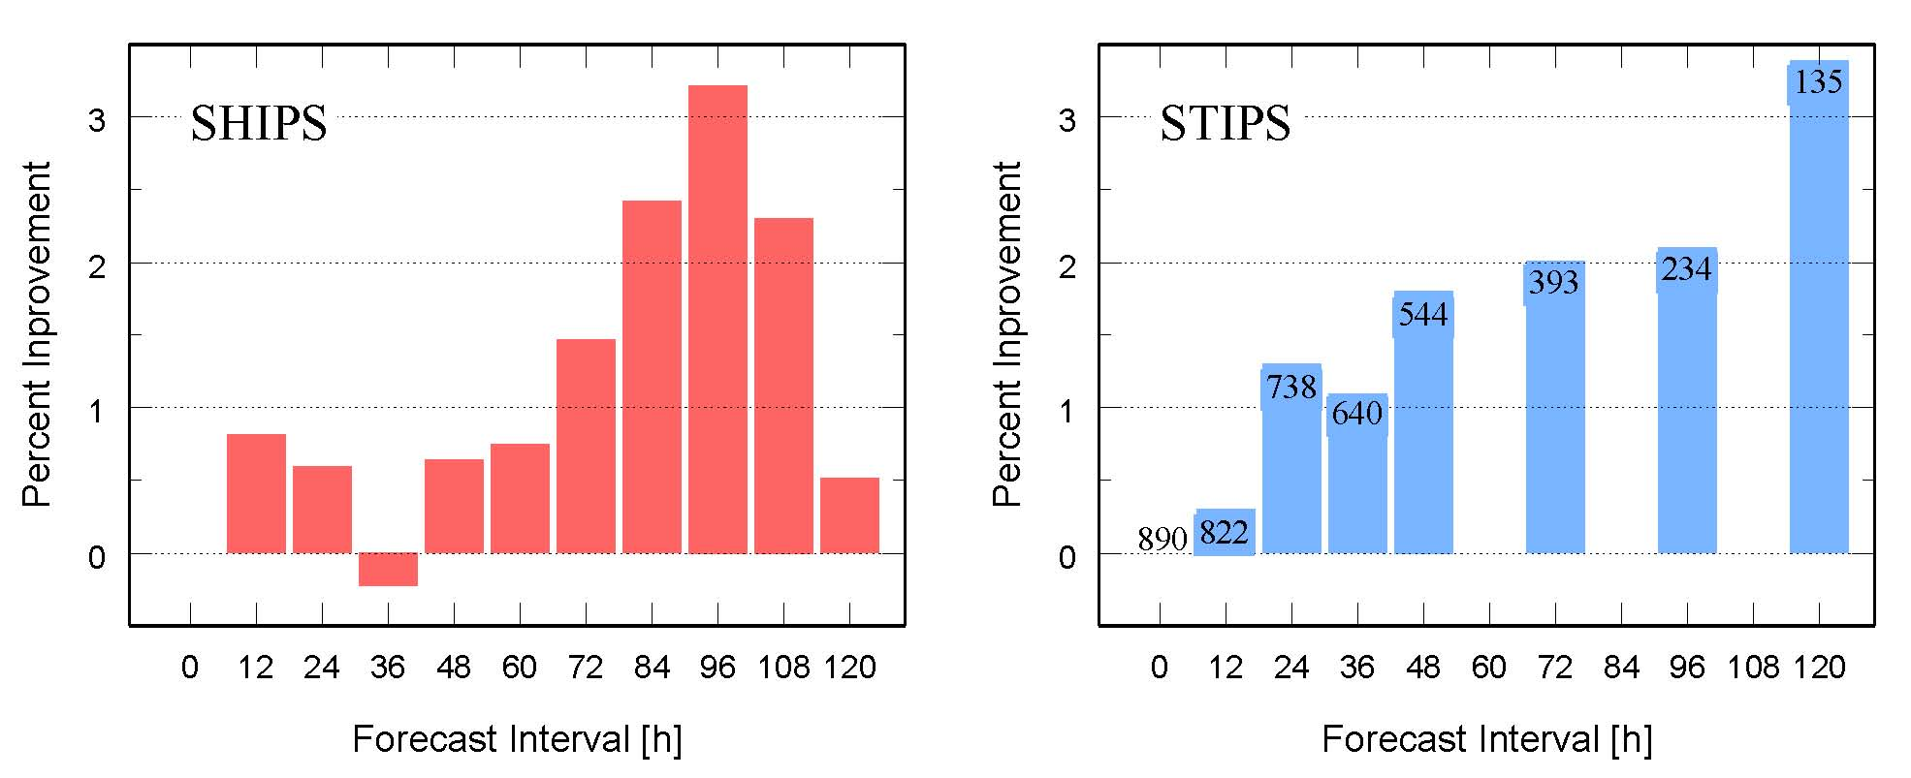

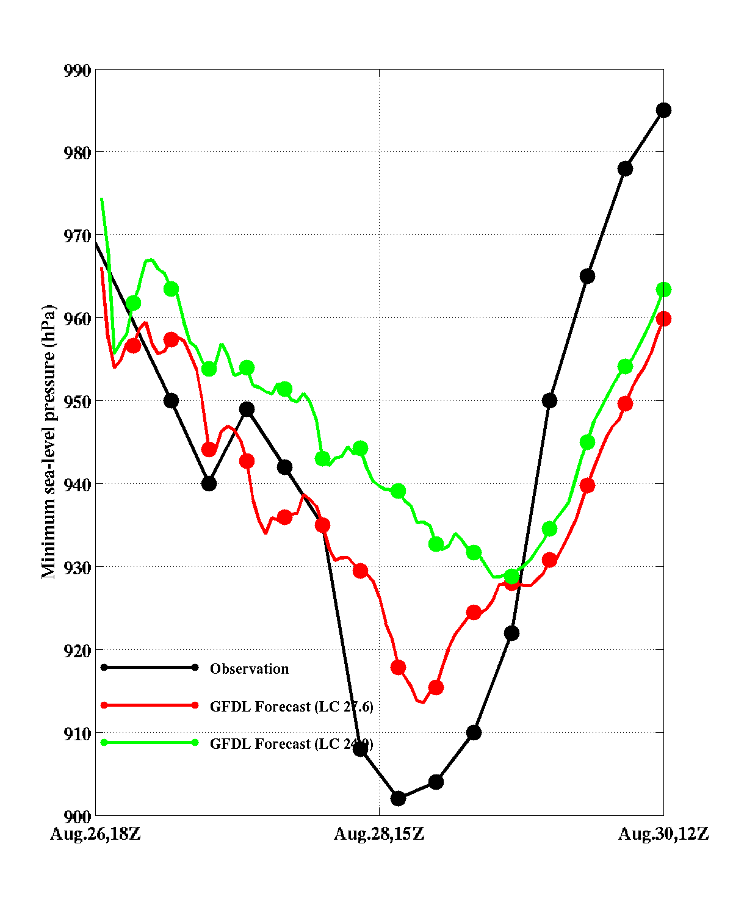
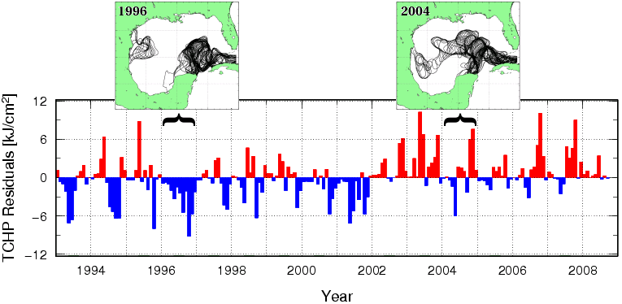
Figure 1.

Figure 2.

