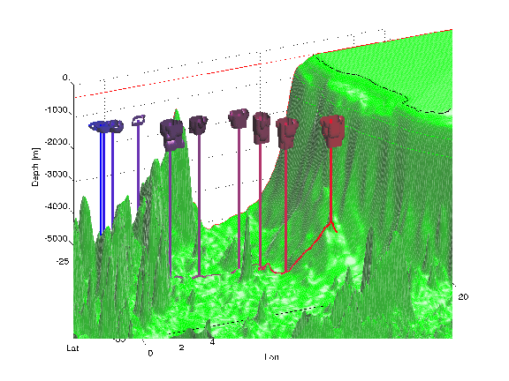
South Atlantic is the distributor of NADW to the global ocean and the receptor from the rest of the world ocean of the upper and bottom water layers flowing to the North Atlantic to balance the NADW outflow. These outflows and inflows happen through very active boundaries in terms of nonlinear processes involving mesoscale and submesoscale dynamics. Indeed, while early WOCE analyses were able to estimate a possible structure of the mean circulation, they did not address the variability and nonlinearity of the exchanges issues. Since the WOCE decade, global and regional models with higher and higher resolution have been developed and analyzed. Also, the altimetry-derived time series is now relatively long and, both the higher-resolution period while Jason1 and TP were flying together along parallel tracks, and the various available mean-sea topography fields, are adding values to the actual time series. At the same time the international ARGO programme started and NOAA and SIO HD XBT lines, as well as dedicated Drake Passage and South Africa choke-points studies have been developing. All these numerical and real ocean studies are enlightening the very high variable and complex character of the ocean circulation that looks more and more to a turbulent ocean, interacting with both, water from the “open” Pacific, Indian and Southern oceans and water close or shed to the continental boundaries. Understanding interocean exchanges and how they vary in a changing climate and how they are linked to the MOC is therefore a challenge. Indeed, we need to understand small to large scales ocean interactions. Lagrangian data integration together with hydrology and Lagrangian analyses of model outputs show to be an helpful tool to integrate such scale interactions. ARGO floats, because of their semi-Lagrangian character are potentially interesting also in term of such effort to such a Lagrangian/hydrology combined analysis, and continue to maintain and eventually increase the ARGO sampling in the South Atlantic and boundaries regions.

