Collaborative Research: Observing the Meridional Overturning Circulation in the South Atlantic
1. Introduction
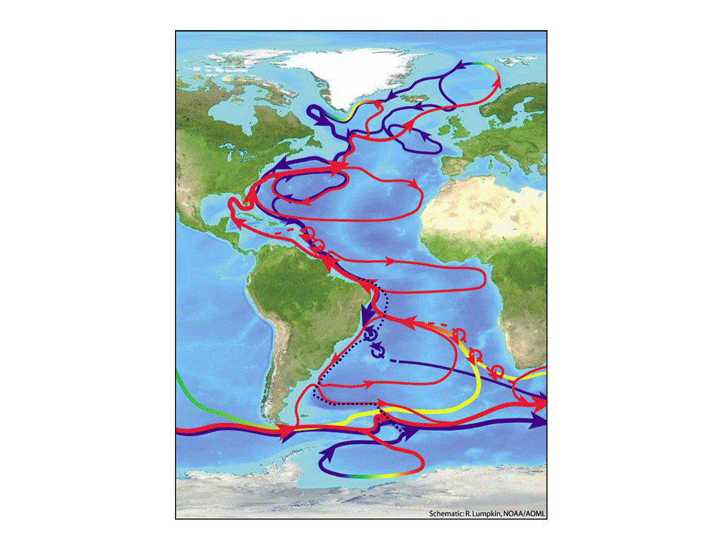
The Atlantic component of the Meridional Overturning Circulation (AMOC) is characterized by a northward flow of warm water in the upper layers from the South Atlantic into the North Atlantic, sinking and formation of North Atlantic Deep Water (NADW) at high latitudes, and a southward return flow of cold water at depth (Fig. 1). The AMOC carries 25% of the total global ocean-atmosphere northward heat flux (e.g. Trenberth and Caron, 2001). The majority of this heat is lost to the atmosphere in the mid-latitudes where warm water meets cold, dry continental air masses. The AMOC regulates and maintains the meridional temperature distribution in the Atlantic. Variations in the AMOC and its associated ocean heat transport are coupled to atmospheric heat transport variations through the mechanism of Bjerknes compensation (Shaffrey and Sutton, 2006; van der Swaluw et al., 2007). As a result, changes in AMOC can have a direct and pronounced impact on a variety of climate phenomena (e.g., Vellinga and Wood, 2002), such as African and Indian monsoon rainfall, hurricane activity, and climate variability over North America and Western Europe. Thus, understanding and monitoring the AMOC variability are crucial for improving our knowledge of important climate processes and for assessing future climate change.
Figure 1. Schematic diagram of the overturning circulation in the Atlantic Ocean that represents the large-scale conversion of surface waters (red arrows) to deep waters (blue arrows in the Southern Ocean; dashed blue line arrows for the North Atlantic Deep Water), adapted from “charting and course of the Ocean Science in the United States for the next decade”, 2007, R. Lumpkin, NOAA/AOML. The South Atlantic circulation includes water mass transformations including intermediate water (yellow and green arrows) and considerable uncertainty in the mean pathways (dashed lines) and eddy processes (red and blue circular rings).
Observational study of MOC variability has historically been focused in the North Atlantic in part because NADW is believed to be a driver for the long-term MOC fluctuations (e.g., Stommel, 1961; Weaver and Hughes, 1992; Stouffer et al., 2006). However, the South Atlantic is known to be particularly important as a region where oceanic properties are exchanged, mixed, and redistributed between different ocean basins (e.g., Saunders and King, 1995; Schouten and Matano, 2006; Biastoch et al., 2008b; Garzoli and Matano, 2011). These water mass modification and redistribution processes will impact the AMOC and global climate (Weijer et al., 1999; Sloyan and Rintoul, 2001; Sarmiento, 2004). The circulation pattern in the South Atlantic also makes it unique in that it is the only major ocean basin that transports heat from the poles towards the equator (e.g., Talley et al., 2003). The strength of this net northward heat transport depends on the ratio of the water mass contributions from the South Indian Ocean (warm, salty) and from the South Pacific Ocean (cold, fresh) (Garzoli and Gordon, 1996). Thus, to describe the characteristics of the water transported to the north, and to understand how these characteristics change on interannual-to-decadal time scales, it is important to observe the water masses in the South Atlantic. Although efforts have been made to estimate the inter-ocean exchanges in the past (e.g., de Ruijter et al. 1999), the limited number of observations available in the Southern Hemisphere has prevented a comprehensive examination. There is still some debate about how much of the water transported to the north in the upper layer of the AMOC comes from the Pacific through the Drake Passage – the cold-path theory (Rintoul, 1991), or from the Indian Ocean through rings shed in the Agulhas Retroflection Region – the warm-path theory (Gordon, 1986), although the warm-path theory has garnered more support in recent years. Model studies suggest that inter-ocean exchanges of heat and salt in the South Atlantic can significantly alter the long-term MOC response (e.g., Weijer et al. 2002; Peeters et al. 2004; Schouten and Matano 2006; Biastoch et al. 2008a, 2009; Garzoli and Matano, 2011; Dong et al., 2011). Hence, understanding both the North and South Atlantic MOC variability is important for interpreting long-term climate variations (Weijer et al., 2002; Marsh et al., 2007).
At present, the only existing full-depth, trans-basin monitoring effort is the RAPID/MOCHA/WBTS array at 26.5°N in the North Atlantic (USA-NSF/NOAA and UK-NERC). This array started in March 2004 and has already provided valuable new insight on the variability of the AMOC at various time scales (e.g., Cunningham et al., 2007; Kanzow et al., 2007, 2010) and its meridional heat transport (MHT, Johns et al., 2011). Despite advances in our understanding of the AMOC behavior at 26.5°N, little is known about the meridional connectivity of the AMOC on different time scales. Thus, the U.S. CLIVAR AMOC implementation strategy has recommended additional trans-basin measurements in the subpolar North Atlantic and in the South Atlantic as high priorities.
Efforts to establish an observational system to improve our understanding of the South Atlantic MOC (SAMOC) have been the subject of four international workshops (2007-2011, http://www.aoml.noaa.gov/phod/SAMOC/). The goals of these workshops were to foster international collaborations and open-up a wider dialogue as to what observational components are needed to resolve the mean and varying components of the MOC, as well as the heat and salt carried by the MOC in the South Atlantic (Garzoli et al., 2010). Rigorous scientific debate by both the observational and modelling communities led to the recommendation to establish a trans-basin array at 34°S (see Section 3). Moorings have been funded and in some cases already deployed nominally at 34°S on the continental shelf break and slope region of the eastern and western boundaries by SAMOC collaborators (Fig. 2a; See Letters of Support), with a goal to assess transports by South Atlantic boundary currents and Agulhas rings. However, these boundary measurements alone will not provide a complete measurement of the South Atlantic MOC and its MHT. In particular, they will not resolve the recirculation of the Deep Western Boundary Current (DWBC) that plays a crucial role in the MOC (Fig. 1) nor the interior flow.
Transport characteristics of the MOC (Dong et al., 2009) and MHT (Baringer and Garzoli, 2007; Garzoli and Baringer, 2007) at 34°S have been examined through XBT and CTD data collected along AX18 (Fig. 2). Studies of the South Atlantic using quarterly XBT transect data and numerical model output (Dong et al., 2009; 2011) show that the transports in the ocean interior region are more variable than transports from the boundary currents, and that the total MOC has the highest correlation with the interior transports. However, a major source of error in the XBT estimates was the lack of information about the magnitude and variability of the DWBC near the South American coast (Baringer and Garzoli, 2007). These studies highlight the importance of measuring both the DWBC and the interior flow at 34°S.
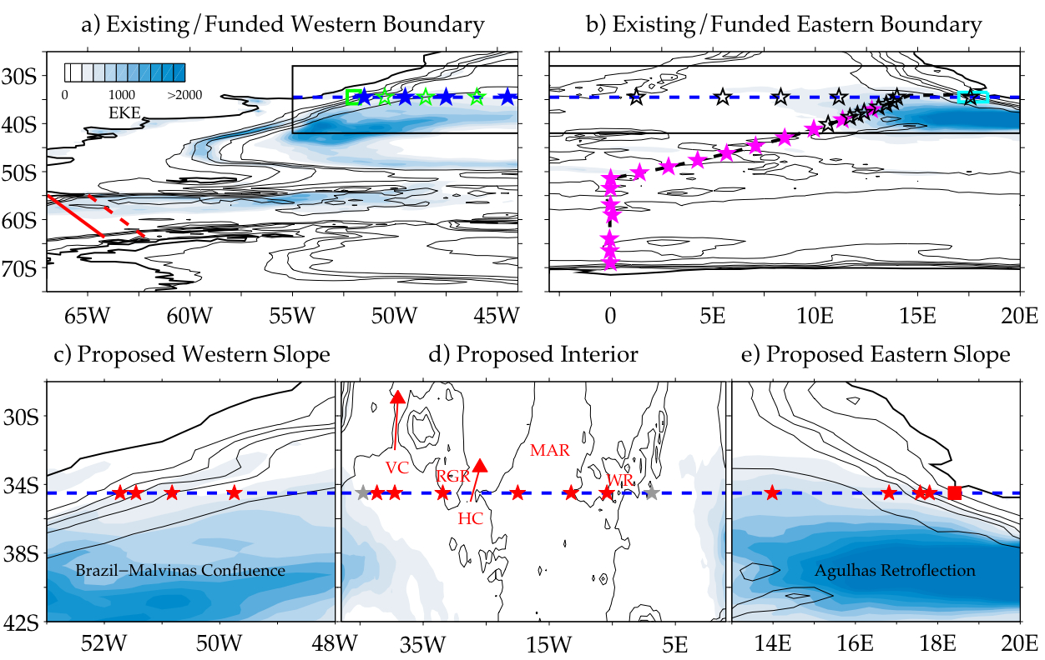
This proposal specifically seeks funds for a slope-to-slope interior mooring array and hydrographic cruise to complete the trans-basin array along 34°S and assess the relative importance of the interior and boundary current contributions to the MOC volume and heat transports. The proposed trans-basin array (to be known as the South Atlantic MOC Basin-wide Array - SAMBA) and hydrographic survey will provide a framework to observe future changes in the relative contributions of different water masses to the upper ocean return flow of the MOC in the South Atlantic, which could significantly impact the properties of the North Atlantic MOC waters over time.
Figure 2. Schematic of the a-b) existing (filled symbols) and funded (open symbols) moorings over the western and eastern half of the SAMOC region, respectively and c-e) proposed slope-to-slope interior array along 34°S. Note the x-axis scale is stretched in the different panels. The cDrake program (red solid line), AX18 (blue dashed line), AX22 (red dashed line), and AX25 (black dashed line) are indicated. Panel a) shows PIES deployed by USA-NOAA (blue stars), and BPR and ADCP mooring (green square) and CPIES (green stars) funded by Brazil. Panel b) shows PIES/CPIES funded by France (black stars), South African ADCP array (cyan square), and PIES/CPIES funded by Germany (magenta stars). Panel c) and e) show the locations of the proposed dynamic height moorings/BPRs (red stars) and BPR (red square) on the western and eastern slopes, respectively. Panel d) shows the locations of the proposed interior PIES/PIES-DP (red stars), and the most offshore existing/funded moorings (gray stars) from panel a-b). Blue color contours are eddy kinetic energy (in cm²/sec²) derived from AVISO sea level anomalies.

2. Objectives
Our working hypothesis is that the interior contribution to the MOC volume, heat, freshwater and ventilation component transports is of the same magnitude as the boundary transports in the South Atlantic. To test this hypothesis, we propose to assess the contribution of various components to the MOC in the South Atlantic. The study will include a full-depth, trans-basin hydrographic cruise measuring physical and ventilation-related parameters, and a 3-year deployment of a slope-to-slope interior array that will complete the trans-basin array at 34°S. The proposed work will be accomplished in close collaboration with SAMOC partners (See Section 4, Letters of Support, and Data Management Plan). Specific objectives are to:
- Characterize the time-mean and time-varying components (and their uncertainties) of the MOC, as well as heat and ventilation components carried by the MOC at 34°S.
- Evaluate the relationship and relative contributions of the boundary current flow (including the DWBC) and the interior flow to the MOC at 34°S. Determine which components (Ekman/geostrophic, gyre/overturning, boundary currents/interior, eddies/large-scale flow) dominate MOC and MHT variability.
- Observe the ventilation characteristics and assess the relative contributions of different water masses to ventilation of the MOC at 34°S. Using the full-depth hydrographic and tracer section, SAMBA, and available in situ data, we will identify the water masses of importance to the MOC and the MHT, and evaluate contributions from the warm-water or cold-water pathways at 34°S.
- Determine the streamlined moored array and instrumentation that are needed to best monitor the South Atlantic MOC and MHT and their uncertainties on longer time scales. Determine whether proxy measurements of the South Atlantic MOC and MHT can be developed.
3. Background
Our current understanding of the MOC and its governing mechanisms depends heavily on the use of numerical models (e.g., Manabe and Stouffer, 1994; Thorpe et al., 2001; Stouffer et al., 2006; Smith and Gregory, 2009; Farneti et al., 2010; Gent and Danabasoglu, 2011), which have provided important insights into MOC behavior. However, before we can rely on models to accurately simulate and predict the MOC and its impact on climate, continuous-in-time measurements of trans-basin full-water column mass, heat, freshwater and ventilation fluxes are needed to test and improve these models. In the North Atlantic, analyses of the first 4-years of measurements from the trans-basin array at 26.5°N have recently provided fresh insight as to the variability of the MOC and MHT at various time scales (see Carton and Hakkinen, 2011 and references therein). The MOC was shown to experience large intra-annual variability, with MOC ranging from 3 Sv to 32 Sv and MHT ranging from 0.2 to 2.5 PW, and a strong annual cycle with peak-to-peak amplitudes of 6.7 Sv for the MOC and 0.6 PW for the MHT (Kanzow et al., 2010; Johns et al., 2011). Measurements from the 26.5°N array also show that the mid-ocean transport experiences similar variability to the Ekman and Gulf Stream transports (Rayner et al., 2011). Furthermore, the annual cycle of the MOC and MHT suggest the geostrophic and wind-driven components at 26.5°N differ from those predicted by numerical models (Kanzow et al., 2010; Johns et al., 2011).
Efforts to extend our knowledge of the variability of the MOC and MHT and its governing mechanisms in the South Atlantic have been delayed by scientific debate about where to sample in the South Atlantic, near the southern limit of the South African continent (30°S to 34°S) where the warm-water path can best be observed, or at lower latitudes (nominally 24°S) where eddy variability is diminished (Fig. 2a). Recent numerical model studies indicate that the higher latitudes (30°S to 34°S) are most likely to produce more robust estimates of the MOC for several reasons (Drijfhout et al., 2011; Garzoli and Matano, 2011; Hawkins et al., 2011; Perez et al., 2011), although this still remains to be tested through observations. First, higher latitudes provide larger dynamic range in the zonal density gradients, leading to improved signal-to-noise characteristics for meridional geostrophic velocity calculations (Perez et al., 2011). Second, ocean model studies indicate that at higher latitudes it is possible to utilize less expensive mooring technologies, such as pressure equipped inverted echo-sounders (PIES), more effectively in some locations, reducing the cost of the overall measurements (Perez et al., 2011). Third, measurement of the stability of the MOC, a function of the baroclinic salt flux, can best be accomplished at the southern boundary of the Atlantic (Drijfhout et al., 2011), nominally along 34°S. Indeed, recent model results suggest that the direction of the net freshwater transport at the southern boundary of the Atlantic provides a useful indicator of the stability regime of the MOC (Hawkins et al., 2011).
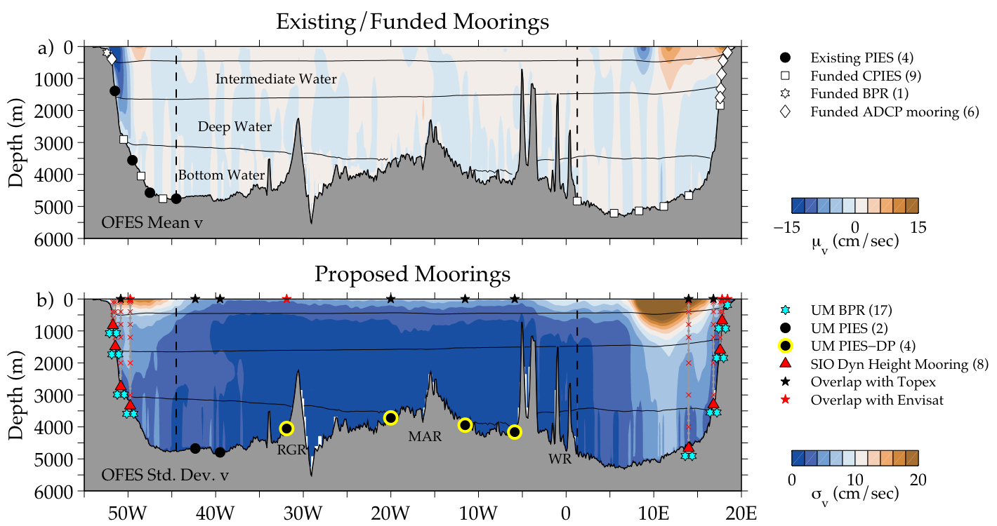
Along 34°S the Atlantic has a complicated bathymetry as it is split into four basins: Western boundary to the Rio Grande Ridge (RGR); RGR to the Mid-Atlantic Ridge (MAR); MAR to the Walvis Ridge (WR); WR to the Eastern boundary (Fig. 3). There is additional complexity as the South Atlantic MOC consists of a strong five-layered system of water masses and flows (e.g., Rintoul, 1991; Saunders and King, 1995; Lumpkin and Speer, 2007). From seafloor to surface, these layers consist of northward flowing Antarctic Bottom Water (AABW), southward flowing NADW, and northward flowing Upper Circumpolar Deep Water (UCDW), Antarctic Intermediate Water (AAIW), and warmer thermocline waters including Subantarctic Mode Water (SAMW) make up the top layer. Using an inverse model, Lumpkin and Speer (2007) estimated about 17.9 Sv of NADW flows south and 5.6 Sv AABW flows north across 32°S. Downes et al. (2011) compared model and observational based estimates and suggested a 15 Sv southward transport of NADW and a 5 Sv northward transport of AAIW at 32°S. Schmid and Garzoli (2009) found that at 35°S AAIW (2.8 Sv) accounts for 16% of the MOC (18 Sv).
Figure 3. Schematic of (a) existing (filled symbols) and funded (open symbols) moorings on the boundaries, and (b) proposed slope-to-slope interior array along 34°S. The proposed array consists of dynamic height moorings (red triangles) with full-water column T, S, p (roughly every 50 m in upper 200 m, every 200 m below) and discrete current measurements (roughly every 400 m in upper 1200 m, every 1000 m below), BPRs at the base of the dynamic height moorings and on the eastern slope (cyan stars), PIES (black circles) and PIES-DP (yellow circles) in the interior. Mean and standard deviation of OFES meridional velocity are shown in panels a and b), respectively. Boundaries between water masses are indicated by σ₁=26.8, σ₁=32.26, and σ₂=41.58 kg/m³ isopycnals (McDonagh and King, 2005).
Potentially important contributions to volume and heat transports in the South Atlantic by these water masses and flows are better constrained by topography at 34°S. For example, Agulhas rings are more tightly confined to the eastern boundary near 34°S (e.g., EKE shown in Fig. 2b). This implies that the important contributions to the transport by the warm-water pathway can be accomplished by an intensely sampled array over a smaller region. On the western boundary, moored and shipboard measurements collected during the Deep Basin Experiment in the early 1990s, demonstrate relatively strong northward flows of AABW of 4.0 Sv and 2.9 Sv through the Vema Channel on the western side of Rio Grande Plateau (near 30°S, 40°W) and Hunter Channel on the eastern side of the RGR (near 34°S, 30°W), respectively (see Hogg et al., 1999; Zenk et al., 1999, and references therein). By situating the array at 34°S, much of the complex topography associated with the Vema Channel can be avoided and more of the AABW flow west of the RGR can be observed.
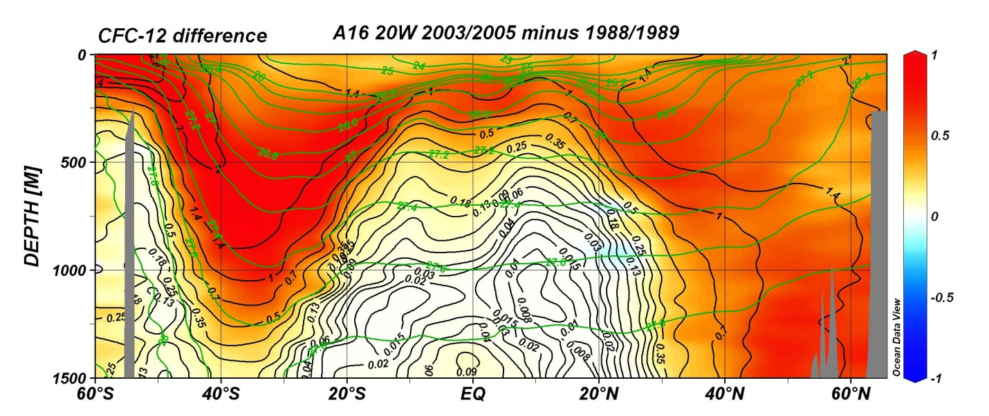
Tracers have provided essential information to follow newly-ventilated Labrador Sea Water down the western boundary into the tropical Atlantic (e.g., Smethie et al., 2000; Fine et al., 2002) and examine the South Atlantic water contribution to the upper limb of the MOC (Rhein et al., 2005). Transient tracer inventories (Willey et al., 2004) yield integral water mass formation rates (Orsi et al., 1999, 2002; Smethie and Fine, 2001; Rhein et al., 2002; LeBel et al., 2008). Recently, inventories have been used to study temporal variability in AMOC water mass formation rates (Kieke et al., 2006, 2007). A challenge is to measure and understand how this ventilation changes over time. Examination of differences in chlorofluorocarbon (CFC) concentrations over time highlights regions where anomalies penetrate into the oceans, and provide data for calculating the time scales of these penetrations. For example, in the nearly 15 years between the WOCE and CLIVAR occupations of A16 (20°W), CFC-11 concentration differences show the large scale downward and equatorward penetration of the transient tracer from high latitude source regions of both hemispheres (Fig. 4). There are increases in CFCs related to the MOC below 1000 m in the North Atlantic. Concentration increases are largest (red/orange/yellow) in subtropical gyre thermocline and intermediate waters. In the upper 1000 m, there are large increases in the South Atlantic than cannot be accounted for based on the atmospheric source (Fine, 2011). These increases are coincident with the strong SAMW and AAIW (e.g., Fine et al., 2001; Fine, 2011), and correspond to a recent increase in southern subtropical gyre circulation (Roemmich et al., 2007). Larger CFC increases in southern hemisphere subtropical gyres since WOCE are also observed in the Pacific and Indian Ocean, and observed in oxygen (see Fine, 2011 and references within). It is unknown whether these changes are affecting the upper ocean return flow of the AMOC.
Figure 4. CLIVAR section of dissolved CFC-12 along 20°W (the A16 sections) collected in 2003 and 2005 in black contours, and in color shading difference from WOCE 1988/1989. Green contours are neutral density. Data were plotted using Ocean Data View.

4. A Field Program to Measure the South Atlantic MOC and MHT
Experience gained in the implementation of the North Atlantic 26.5°N array suggests that to successfully sample the MOC and MHT it is critical and necessary to 1) obtain density measurements at a very high sampling rate (i.e. daily) to avoid aliasing high-frequency fluctuations into the semi-annual, annual, and longer periods that are of significant interest to climate studies (Kanzow et al., 2007), and 2) obtain reliable density measurements near the coasts where zonal variations in sea surface height are a poor proxy for upper ocean transport variations (Kanzow et al., 2009). Tests of prospective array types in a variety of ocean models, as well as the success of the 26.5°N array, suggest that a ‘geostrophic-style’ moored array (i.e. one that provides an estimate of the full-water-column density profiles) is likely to yield very accurate transport estimates for calculating the MOC and MHT in the South Atlantic (e.g., Hirschi et al., 2003; Meinen et al., 2004; Baehr et al., 2009; Perez et al., 2011; Meinen et al., 2012).
An extremely dense array of dynamic height moorings would likely yield a better estimate of the volume and heat transports, but such an array is not logistically or financially feasible. Perez et al. (2011) found that the more-cost effective PIES moorings and PIES equipped with a current meter 50 m above the sea floor (CPIES) virtually deployed with the OGCM For the Earth Simulator (OFES) and the Parallel Ocean Circulation Model (POCM) produce similar estimates of the time-mean and time-variability of the MOC when compared with virtually deployed dynamic height moorings. However, while they reproduce volume transport well, PIES are comparatively less successful at reproducing water mass and property variability in the DWBC (e.g., Meinen et al., 2004). This supports a balanced trans-basin array for the heat transport calculations consisting of dynamic height moorings close to the coast to resolve key water mass changes, and PIES/CPIES measurements in the interior.
Table 1. Instruments proposed to be deployed along the trans-basin array and their approximate locations. (T-S: microcat temperature, salinity, and pressure sensors; CM: current meters, BPR: bottom pressure recorder, PIES-DP: PIES with data pods). Instrumentation requested as part of this proposal is highlighted in yellow.
Western Boundary |  | Interior |  | Eastern Boundary
Instrument (#) | Location | Instrument (#) | Location | Instrument (#) | Location
BPR (1) | 200 m isobath | PIES (2) | 42°W and 39°W | BPR (1) | 200 m isobath
Mooring with upward-looking ADCPs (1) | 400 m isobath | PIES-DP (1) | West of Rio Grande Rise | Mooring with upward-looking ADCPs (4-5) | 200 m to 2000m isobath
Dynamic height mooring (T-S and CM) and BPRs (4) | 800m,1600m, 2700m, and 3300m isobath | PIES-DP (2) | West and east of the mid-ocean ridge | Dynamic height mooring (T-S and CM) and BPRs (4) | 800m, 1600m, 3300m, and 4700m isobath
CPIES (3)  PIES (4) | 1400m isobath to 45°W | PIES-DP (1) | West of Walvis Ridge | CPIES (6) | East of 1°E to 1600 m isobath

As noted in Section 3, models suggest 34°S as an advantageous location for a trans-basin array to measure the MOC and MHT, and there are a number of other strong reasons to support this choice of latitude. First, 34°S lies north of the elevated EKE found in the Agulhas Retroflection region (Fig. 2d) and Brazil-Malvinas Confluence (Fig. 2c). Second, at 34°S the distinctive property characteristics of water masses entering via the choke points of Drake Passage and the Agulhas system, as well as those water masses such as SAMW and AAIW that are formed within the Southern Ocean, will still be readily identifiable (Fig. 3). Third, the deep basin exchange is much less complicated at 34°S compared with the higher or lower latitudes where bathymetry is more complex (Zenk et al., 1999). Finally, international SAMOC partners are funded (and some resources are already in place) to measure the mean and variability in the shelf boundary current regimes at 34°S (Fig. 2; Table 1; see Letters of Support). At present, the western boundary current measurement system is comprised of 4 PIES deployed between 51.5° and 44.5°W since March 2009 (USA-NOAA, Argentina-SHN, Brazil-USP&Navy). Brazil and France were recently awarded funds (Brazil-FAPESP/FACEPE and France-ANR) to deploy 3 CPIES on the western boundary and 6 CPIES on the eastern boundary (Fig. 2; Table 1). As part of this project, funds were also given to deploy a bottom pressure recorder (BPR) near the shelf break (200 m isobath), an upward looking ADCP mooring near the 400 m isobath in the western boundary off of the South American coast (Fig. 2a), and seven PIES along the oblique Goodhope transect (Fig. 2b). On the eastern boundary shelf region, five ADCP moorings have been funded and planned for deployment by South African colleagues (Fig. 2b). All these instruments are planned for deployment in 2012 for periods of 3-5 years and longer. These funded boundary current measurement systems provide the building blocks for the implementation of a trans-basin array to determine the feasibility of measuring the MOC and MHT at 34°S, as suggested by models and available upper ocean measurements. However, measurements are needed of the full-depth hydrography and the slope-to-slope interior to complete the full-depth trans-basin array at 34°S.
This proposal seeks funds from USA-NSF for 1) eight dynamic height moorings (with dual BPRs) to be deployed on the western and eastern slopes and six PIES to complete the slope-to-slope interior of the trans-basin array at 34°S, and 2) a 50-day mooring deployment and trans-basin hydrographic cruise to document the full-depth property characteristics. The proposed slope-to-slope interior array forms an extremely vital part of the complete trans-basin SAMBA array, as it will not only provide information on the contribution of the interior flow. It will also provide important information on the contribution of the DWBC. The proposed work will be accomplished in close collaboration with national and international partners responsible for the boundary sub-arrays. All PIs have agreed to make their data available to each other in a timely manner (see Data Management and Letters of Support), and a website is already in place to facilitate exchange of data and ideas (http://www.aoml.noaa.gov/phod/SAMOC_international/). Specifically, the complete top-to-bottom array will be used to examine the relationship of the MOC and MHT to transports from boundary currents. This will contribute to an assessment of whether the boundary array can be used for long-term MOC and MHT monitoring and needs to be augmented by measurements of the interior. The proposal is designed to span five years including a three-year deployment (2013 - 2015) of the array.
The full trans-basin array along 34°S will consist of a combination of instruments (ADCPs, point current meters, dynamic height moorings, BPRs, PIES/CPIES) to estimate the variability of the volume and heat transports (Fig. 3; Table 1). Details of the USA-NSF requested mooring instrumentation, hydrographic measurements and analysis to be carried out under this proposal are found in the following sections. The mooring locations and instrumentation were determined through model-based observing system experiments (Perez et al., 2011), analysis of data collected from PIES/CPIES deployed on the western boundary (Meinen et al., 2012), hydrographic data (Zenk et al., 1999; Garzoli and Baringer, 2007; Dong et al., 2009, 2011), and satellite altimetry. Following Perez et al. (2011) methodology, the proposed ‘geostrophic-style’ moored array reproduced MOC and MHT temporal variability with rms errors of 1.5 Sv and 0.1 PW, respectively.
4.1 Dynamic Height Moorings and BPRs
Eight dynamic height moorings will be deployed on the eastern and western boundary slope regions (red triangles in Fig. 3b) with full-water column temperature (T), salinity (S), and pressure (p) and limited point current measurements distributed throughout the water column. Dynamic height moorings are necessary in these slope regions in order to fully resolve the MHT (Perez et al., 2011) and the DWBC. On the western boundary, the dynamic height moorings will be located near the 800 m, 1600 m, 2700 m and 3300 m isobaths to capture the volume and heat transport by the relatively narrow Brazil Current and the DWBC over the slope (Fig. 3). On the eastern boundary, the dynamic height moorings will be spaced further apart near the 800 m, 1600 m, 3300 m and 4700 m isobaths to capture the volume and heat transports of the broader Benguela Current over the slope. The T, S profiles are used to produce geopotential height anomaly (Φ) profiles, which then will be used to estimate the meridional geostrophic velocity (v_{g}) between adjacent sites at each depth level.
Seabird 37-SM MicroCATs (measuring T-S-p) will be deployed every 50 m in the upper 200 m (e.g., the wind-driven mixed layer) with 200 m spacing below 200 m. Mooring blow-over and draw-down from strong currents can be assessed using the pressure measurements so that the property measurements can ultimately be correctly interpolated to uniform depths for accurate transport calculations (Johns et al., 2005; Kanzow et al., 2006; Sprintall et al., 2009). Nortek Aquadopp point current measurements will be made at 3 to 8 depths (depending on the bathymetric depth) deployed at 100 m, 400 m, (800 m, 1200 m, 2000 m, 3000 m), and 100-200 m above the seafloor. Besides providing some direct measurements of the boundary current on the slope, the current meters will provide velocity references for the geostrophic flow calculations. All instruments will be set to measure hourly data.
To measure variations in barotropic flow, the dynamic height moorings will have two BPRs deployed within 1 nautical mile of the base of the mooring (Fig. 3b). This dual deployment is required to correct for drift of the pressure measurements that can be largest source of error in geostrophic transport estimates (e.g., Johns et al., 2005). On the slopes the dynamic height moorings and the BPRs will be interleaved with the existing and funded boundary sub-arrays. This interleaving of instruments (Fig. 3a) will be used to augment the basin-wide transport calculations, provide redundancy in the case of tall mooring failure or loss, and allow for determination of whether a future moored array comprised solely of PIES/CPIES can be used to monitor the MOC and MHT or proxies of the MOC and MHT in the South Atlantic.
4.2 PIES and PIES with data-pods
As part of this proposal, six PIES will be deployed in the interior array, to augment the existing and funded PIES deployed on the slope by our international partners (Fig. 3). Bottom-mounted PIES make two measurements: 1) the round-trip travel time required for a 12 kHz acoustic pulse to travel from the instrument to the sea-surface and back, and 2) bottom pressure and temperature (e.g., Rossby, 1969; Watts and Rossby, 1977; Donohue et al., 2010). The travel time measurements are calibrated into daily, full-water-column profiles of T, S, and δ via hydrography-derived look-up tables using the Gravest Empirical Mode (GEM) technique (e.g., Meinen and Watts, 2000; Watts et al., 2001). This empirical technique does not require that isolines between adjacent sites are parallel as a function of depth, and allows for higher modal structures in meridional geostrophic velocities and can be used to monitor the deep cell below the NADW cell (see Fig. 13 in Perez et al., 2011). The bottom pressure measurements will be used to measure variations in the barotropic flow (e.g., Donohue et al., 2010), and the ancillary temperature measurements (used to calibrate pressure) will be used to observe variations in water mass properties.
Based on the modeling analysis of Perez et al. (2011), it was found that full-water column T and S measurements were needed at six sites between the western and eastern boundary sub-arrays: at 42°W and 39°W, west of the RGR, on either flank of the MAR, and west of WR (Fig. 2d and 3b). This could be achieved through a full-depth dynamic height mooring; however, this is logistically complex, and a significant concern for any trans-basin array is the ship time required to support and maintain the system. PIES cost significantly less than dynamic height moorings, have a 4-year life-time, and their data can be downloaded from the deck during turn-over cruises without having to recover the instrument. As one effort to reduce this cost of ship time, PIES will be deployed at each interior site.
To further reduce ship-time costs, the PIES near the RGR, MAR, and WR (Fig 3b), will be equipped with data pod technology (PIES-DP, developed at NOAA/AOML). Data pod capsules will be released from the bottom-mounted PIES periodically, and when they reach the sea surface data are transmitted via the Iridium Satellite System (8 capsules are planned at each site). Thus, the PIES-DP moorings need only be deployed and then recovered at the end of the field program, greatly reducing ship time requirements and allowing ongoing assessment and analysis of data during the total duration of the field program.
4.3 Trans-Basin Hydrographic Cruise
As described above, along 34°S the Atlantic has a four basin bathymetry and strong five-layer system of water masses and flows (e.g., Saunders and King, 1995). To determine how these four basins and five layers impact reconstruction of the MOC and ventilation fluxes - a hydrographic section with LADCP and tracers is needed. It is important that the 34°S section be occupied over the boundary sub-arrays funded or already in place - to provide the critical interior contributions to the MOC fluxes. Various physical and ventilation-related parameters will be measured during the hydrographic cruise. Of these parameters, T, S, O₂, CFCs, and SF₆ are proposed to USA-NSF. The tracers (CFC-11, CFC-12, and SF₆) will be measured on board ship using well-known analytical techniques (Bullister and Wisegarver, 2008). Also proposed to USA-NSF, the CTD/LADCP component of the cruise will be used to provide concurrent estimates of the volume, heat, salt, O₂, and transient tracer fluxes; information about the zonal and vertical scales of variability and how eddies/rings and deep basin exchange impact the transport calculations; and additional data to help build a better T, S GEM climatology and calibration for the PIES/CPIES. LADCP will also be used to choose the velocity reference level. It is critical - for meeting the SAMBA objectives - to obtain the proposed data along 34°S at the time the mooring arrays are out. In addition, occupation of 34°S in 2013 will complement data from the 2011 CLIVAR 30°S section, and allow a limited assessment of flux variability by comparison of the two sections and with historical data.
The proposed three transient tracers, chlorofluorocarbons (CFC-11, CFC-12), and sulfur hexafluoride (SF₆) will contribute to the objectives by providing observations to evaluate ventilation fluxes and relative contributions of cold and warm path water masses to the MOC at the time of trans-basin cruise. In general, highest transient tracer concentrations and youngest ages are coincident with upper layers, substantially lower concentrations in AAIW and even lower in UCDW. At this latitude NADW will have still lower concentrations, and there will be slightly higher concentrations in AABW. In addition to their time scale information the temporal penetration of transient tracers offers a direct and unequivocal measure of ocean ventilation of the MOC since the middle-to-late 20th century, during which time the ocean took up about two-thirds of its anthropogenic carbon inventory.
4.4 Ship-time Requirements
A ship-time request for a UNOLS vessel for the 50-day mooring deployment and hydrographic trans-basin cruise has been submitted for August-September 2013. Our international partners Brazil and Argentina will contribute ship-time for the western boundary turn-around and recovery cruises, and South Africa for the eastern boundary turn-around and recovery cruises (see Campos, Piola and Ansorge Letters of Support). Additional hydrographic work is also planned by our international partners during these cruises. Turn-around cruises are planned for March and April 2015 (25 days each). During these turn-around cruises, the dynamic height moorings and BPRs will be recovered, data downloaded, and batteries and instruments refurbished if needed and replaced by spares. The PIES without data-pods will be interrogated and assessed for battery life and data quality, and again if needed, replaced by spare PIES. The 30-day western boundary recovery cruise planned for September 2016 will recover all proposed moorings west of the MAR, while the 30-day eastern boundary cruise planned for October 2016 will recover moorings east of the MAR.

4.5 Synergistic Measurements and Analysis of the South Atlantic MOC
The SAMBA measurements are central to our objectives to observe and explore the time-mean and time-varying components of the MOC and MHT and their uncertainties. In addition, a number of other measurements exist or are proposed that are highly complementary to SAMBA goals.
Remotely-sensed data will allow the in situ observed MOC fluctuations to be related to the regional wind and sea surface height anomaly patterns, thus providing insight as to the driving mechanisms for the observed behavior. In particular, we will make use of the NASA Cross-Calibrated Multi-Platform (CCMP) ocean surface wind and NWP wind products (e.g. NCEP/NCAR) for Ekman flux calculation, the AVISO altimetric data, sea surface salinity (SMOS and Aquarius), and SST from various satellites (e.g. NOAA-9, NOAA-GEOS, MODIS). The relationship of satellite information to the in situ SAMBA transect data is likely to prove of value in setting up a long-term cost-effective monitoring program of the MOC and MHT, as has been suggested by other studies (e.g. van Sebille et al., 2010; Hobbs and Willis, 2012). However, these studies primarily used sea surface height relationships to model output and Argo float and/or historical climatological data, and were not compared to full-depth estimates such as will be made during SAMBA. Note that the majority of the proposed mooring sites are strategically placed under JASON and Envisat altimetry ground tracks to facilitate the development of proxy monitoring techniques (Fig. 2b).
Publicly available data from the broader Atlantic observational systems (e.g., XBT transects and Argo floats) will provide crucial ancillary information for analysis and interpretation of observations by the SAMBA field program. Existing high-density XBT transects in the choke-points across Drake Passage (AX22) and south of South Africa (AX25), will measure properties and transport exchanges through both the warm and cold pathways. In addition, the high-density XBT transect AX18 will continue to provide independent snapshots of MOC and MHT over the upper 850 m near 34°S (e.g. Baringer and Garzoli, 2007; Garzoli and Baringer, 2007; Dong et al., 2009). Argo float profiles and the monthly Argo gridded property maps (Roemmich and Gilson, 2011) can provide independent estimates of the MOC and MHT over the upper 2000 m.
As part of the larger SAMOC effort, a number of other efforts are either ongoing or proposed so as to be concurrent with the mooring deployment period. In particular, one component of the broader SAMOC field program will be to continuously monitor the Agulhas ring activity and measure the associated volume, heat and salt fluxes along the meridional oblique transect known as the Goodhope (AX25) line (Fig. 2b, France-ANR, Germany). Recently France-ANR provided additional funding to supplement the existing PIES array on the GoodHope line with an additional seven PIES/CPIES to be deployed in 2012 (see Speich and Flierl Letters of Support). A complementary USA-NSF proposal led by MIT (Flierl) has also been submitted to implement a line of PIES along the altimeter track parallel to the west of Goodhope, with a goal to provide high resolution eddy fields of potential vorticity and eddy parameterizations. It is also intended that the SAMBA moored and shipboard measurements will be used to improve regional and global ocean general circulation models and coupled climate models. Model analysis is an important component of the MIT proposal to simulate the tracer evolution and mixing of different types of Agulhas rings to predict the evolution of the interior and surrounding tracer field. Another modelling proposal closely linked to SAMOC will be submitted to NSF in August 2012 by OSU and UM (Matano and Perez) to examine the dynamical and thermodynamical processes controlling the South Atlantic interocean exchanges and their sensitivity to climate change. Both of these modeling efforts are expected to support and benefit from the measurements collected by SAMBA.
It is important to emphasize that SAMBA and the larger SAMOC field program are designed so that each major component will ‘stand alone’ to provide highly valuable data about the volume, heat, salt and ventilation transport and water mass circulation in the South Atlantic. Nonetheless, the combined data set from the integrated international field program and the supporting observational network will undoubtedly leverage our individual measurements to understand the broad spectrum of variability of the MOC, and the contribution of the South Atlantic volume, heat, salt and ventilation transports carried by the MOC.
5. Proposed Analyses
5.1 Estimation of the MOC and MHT (Objective 1)
The meridional transport of mass and heat across the trans-basin section can be divided into geostrophic and Ekman components. The Ekman transport of volume and heat is a function primarily of wind and SST and will be determined using remotely-sensed SST and wind data (see section 4.5). SAMBA data will be used to estimate the geostrophic component of the MOC and MHT. The meridional velocities v_{g} derived from dynamic height moorings and PIES give only the baroclinic component. The BPRs will be used to compute the barotropic component. Discrete velocity measurements made on the shelves (ADCPs) and on the slopes on the dynamic height moorings (discrete current meters) will be used to level/reference the mean flow (Johns et al., 2008).
Temperature profiles observed from the dynamic height moorings and reconstructed from PIES will be used to estimate heat transport in the boundaries. In the interior the mooring array is too sparse to resolve the thermal structure for heat transport calculation. As in Johns et al. (2011), we will divide the interior geostrophic heat transport into two components: an overturning component from zonally averaged transport per unit depth and temperature fields Q_{ov} $(Q_{\text{ov}}=\int{{ρc}_{p}V\left\langle θ\right\rangle \text{dz}})$ and an eddy component from spatially covarying velocity and temperature anomalies with respect to their zonal averages Q_{eddy} $(Q_{\text{eddy}}=\iint{{ρc}_{p}v^{'}θ^{'}\text{dxdz}})$. We will estimate <θ> using monthly gridded Argo maps with Levitus climatology below 2000 m. On the slopes, the eddy component will be estimated for each segment formed by two adjacent moorings.
From the 3-year continuous SAMBA data set, we will be able to estimate the amplitude and phase of the seasonal cycle of the MOC and MHT. We will compare our measurements with those obtained by the 26.5°N array. Is the intra-annual variability as large as that found at 26.5°N? The annual cycle of geostrophic and Ekman components of the MOC and MHT estimated from the roughly quarterly AX18 transects along 35°S are comparable in magnitude and out of phase (Garzoli and Baringer, 2007; Dong et al., 2009). What is the relative balance between the geostrophic and wind-driven components from the continuous-in-time SAMBA data?
5.2 Assessing Regional Contributions to MOC and MHT (Objective 2)
One of our main objectives is to assess whether the boundary mooring array provides a sufficient means for long-term monitoring the MOC and MHT in the South Atlantic, and which direct measurements of the interior are also required for accurate determination. To accomplish this goal, we will separate the volume and heat transports into three regions: the western boundary (west of where current changes from southward to northward, ~48°W), the eastern boundary (east of the western edge of the Walvis Ridge, ~3°E), and interior region (48°W~3°E). The relative contribution of each region to the MOC and MHT will be examined. The data from the complete three-year array will be used to assess which SAMBA mooring site locations are crucial for possible sustained measurements of the MOC and determine whether proxy measurements of the South Atlantic MOC and MHT can be developed. Recent observational studies have demonstrated that the subtropical gyre has gone through large changes in the past two decades (Roemmich et al., 2007; Lumpkin and Garzoli, 2011; Goni et al., 2011). Do those changes imprint and have an impact on the net MHT? To answer this question, we will also separate the MHT into the gyre and overturning components to investigate whether the net MHT is related to gyre circulation.
5.3 Ventilation Flux and Water Mass Contributions to MOC and MHT (Objective 3)
The measurements from the trans-basin hydrographic survey and from the turn-around and recovery cruises will be analyzed to assess the contributions of cold and warm path water masses to the MOC and MHT across 34°S. In particular, the tracer concentrations and calculated ages will play a major role in quantifying the ventilation fluxes and relative contributions of different water masses to the MOC and MHT. We will estimate water mass ages (pCFC, pSF₆ and pSF₆/pCFC, see review by Fine, 2011) and their uncertainties (e.g., Fine et al., 2011). We are proposing two approaches for evaluating the contributions of the cold and water path water masses to the upper MOC. First, we will separate into density layers volume transports corresponding to the major water masses to assess their contributions to MOC and MHT, and to quantify transient tracer and oxygen fluxes along 34°S and along 30°S in 2011 (e.g., Saunders and King, 1995; Ganachaud and Wunsch, 2002). These ages, oxygen utilization rates, and ventilation fluxes will be compared with historical data from the South Atlantic (e.g., Holfort and Siedler, 2001). Second, using methods similar to those used in Smethie and Fine (2001), LeBel et al. (2008), and Hartin et al. (2011), we will make use of available data to calculate tracer inventories within water mass layers above NADW over the larger South Atlantic basin.
5.4 Developing Proxy MOC and MHT Estimates (Objective 4)
The majority of the mooring sites are strategically placed under altimetry ground tracks (Fig. 3b). Blended bottom pressure observations and sea height anomalies will serve to evaluate the dynamic height estimates and to produce continuous and unambiguous monitoring of the baroclinic and barotropic contributions to the MOC and MHT. These estimates will be extrapolated back in time using the nearly 20 years altimetry record, to help produce the longest time series of MOC and MHT across 34°S. This effort will allow for more streamlined processing in the second half of the data record once the mooring recovery cruises are completed in year 4. We will examine whether a combination of the existing and funded boundary current measurements, combined with altimetry and Argo data, can give a reliable estimates of MOC and MHT at 34°S.
6. Time Line and Work Plan
The proposed work will be accomplished in close collaboration with national and international SAMBA partners (see all Letters of Support) and also from the larger SAMOC community (http://www.aoml.noaa.gov/phod/SAMOC_international/). For this proposed effort, Sprintall will be responsible for preparation of all dynamic height moorings, and the calibration and quality control of data collected from the moorings. Dong and Perez will be responsible for the preparation of all PIES, PIES-DP, and BPRs, and the calibration and quality control of data collected from those instruments. Fine, with the help of a graduate student, will be responsible for measurement of tracers and lead analysis of hydrography (trans-basin, Argo and with oxygen), tracer and oxygen data collected and evaluate distribution of water masses. The PIs will participate in the mooring deployments and hydrographic survey and subsequent analyses. Dong, Perez, and Sprintall will participate in the turn-around and recovery cruises. All PIs will participate in the estimation and analyses of MOC and MHT, in collaboration with national and international partners. The PIs expect to have frequent communication and have scheduled annual meetings to discuss, assess, and address fieldwork and data analysis issues. During the data analysis effort, we will schedule workshops with our national and international partners in conjunction with SAMOC workshops and EGU meetings to facilitate collaboration.
Year 1: 10/1/12 – 9/30/13: Purchase and prepare instruments. Continue ongoing model and data analysis to further optimize mooring locations prior to deployment. Conduct the trans-basin mooring deployment and hydrographic cruise (August-September 2013).
Year 2: 10/1/13 – 9/30/14: Begin analysis of tracer data collected from trans-basin section and evaluate distribution of water masses. Analyze the trans-basin hydrographic measurements for volume, heat, and freshwater fluxes. Construct the GEM fields necessary for estimating T, S, and δ profiles from PIES/CPIES measurements. Analyze the data collected from interior PIES-DP systems as data are transmitted via the Iridium Satellite System.
Year 3: 10/1/14 – 9/30/15: Turn-around cruises on the western (March 2015) and eastern (April 2015) boundaries. Analyze hydrographic data collected at mooring sites. Calculate tracer ages and their uncertainties and inventories from regional trans-basin sections (30°S to 34°S). Calibrate mooring measurements. Estimate transports derived from the first half of the moored record. Attribute signals seen along 34°S with data from oblique Goodhope PIES, XBT transects, and Argo floats, and altimetry, and develop proxy MOC and MHT estimates.
Year 4: 10/1/15 – 9/30/16: Mooring-recovery cruise on the western boundary up to the western side of the mid-ocean ridge (September 2016), and mooring-recovery cruise on the eastern boundary up to the eastern side of the mid-ocean ridge (October 2016). Analyze hydrographic data collected at mooring sites. Using various flux products from SAMBA, analyze regional trans-basin sections (30°S to 34°S) for ventilation fluxes. Calibrate mooring measurements.
Year 5: 10/1/16 – 9/30/17: Compare ventilation fluxes with historical data. Estimate time-mean and variability of the MOC and MHT from the full moored record. Examine seasonal variations in the MOC and MHT and in the contributions from geostrophic and Ekman transports. Estimate contributions of boundary currents and interior region to the MOC and MHT, as well as contributions from gyre and overturning components. Examine how the variability at 34°S differs from the variability observed at 26.5°N. Evaluate what is the streamlined moored array and instrumentation that are needed to best monitor the South Atlantic MOC and MHT and their uncertainties on longer time scales.
7. Broader Impacts
As a major component of the international SAMOC field program, SAMBA provides a means to characterize the time-mean and time-varying components of the MOC and MHT, and observe the changes in the relative contributions of different water masses to the MOC along 34ºS in the South Atlantic. Aligned with NSF policy, our Data Management Plan is to use the SAMOC website to allow all international investigators to post and exchange data collected as part of the field program (see Data Management Plan for full details). All data will be made publicly available to the research community within 2 years of completion of the field program, and the tracer data within 6 months of cruise completion. In particular, our aim is to directly interact with and provide data to the modeling community, to expand our skill in reproducing the observed MOC variability, diagnose the mechanisms that produce MOC variability, and predict the future evolution of the MOC. This program is motivated by the need to understand the impact of the MOC on global climate.
Enhancement of research infrastructure will be achieved through participation in a coordinated international research program. The collective merit for an internationally coherent program has become strongly apparent given the complexity and scope of the field program. While the USA-NSF component will primarily focus on the moored array SAMBA measurements and the hydrographic/tracer survey, we will work closely with our international colleagues in a fully integrated co-operative effort towards meeting the SAMBA objectives through a series of planned workshops. We will broadly disseminate our results within and beyond the scientific community. Workshops and presentations to the oceanographic community will be scheduled in conjunction with SAMOC workshops and EGU meetings. The SAMOC website will serve as an additional forum for the exchange of ideas.
We will promote training and learning through the involvement of graduate students and a postdoctoral fellow, both in the research and on the cruises. Opportunities to participate in the cruises will also be offered to students of our international collaborators. The PIs participate in the Mentoring Physical Oceanography Women to Increase Retention (MPOWIR) program, and MPOWIR 10-week internships would be offered through the NOAA/AOML laboratory. R. Fine is on the implementation committee of the University of Miami’s NSF Advance program.
8. Prior NSF Support
S. Dong Collaborative Research: Dynamics of Eighteen Degree Water (EDW) from CLIMODE Observations and its Climate Implications. NSF-OCE-0958548, 04/01/10-03/31/13, $254,671. The proposed research is to examine the interannual variability in EDW volume and its dependence on ocean processes and atmospheric forcing, to parameterize the relationship between EDW and variables that have or can be observed over longer time periods, and to use that parameterization to examine the ability of IPCC-class models to simulate the role of EDW in climate variability. The goal of the research is to extend the results of the CLIMODE field program to longer time scales to better understand the climate implications of EDW and to provide metrics with which to evaluate the ability of climate models to simulate these processes.
R. C. Perez Collaborative Research: Global Impact of Eddies on Inertial Oscillations of the Mixed Layer. NSF- OCE-1031278, 10/01/10-09/30/14, $66,313. The goal of this project is to obtain improved estimates of wind-driven near-inertial energy flux into the interior ocean. The hypothesis is that global near-inertial energy flux from the mixed layer to the interior is substantially shaped and accelerated by interactions with the mesoscale eddy field. The work involves the development of a high-resolution surface drifter dataset, supplemented with process-oriented modeling.
J. Sprintall Collaborative Research: Analysis of the INSTANT Observations of the Indonesian Throughflow, 9/1/2007-8/31/2010,OCE07-25476, $271,449. The Indonesian Throughflow (ITF) leakage of western tropical Pacific water into the Indian Ocean through the Indonesian seas is an important pathway for the transfer of climate signals. The award covered the analysis of the INSTANT field program: a 3-year deployment (2004-06) of moorings and coastal pressure gauges in the major inflow and outflow passages of the ITF (Sprintall et al., 2009; 2010). Collaborative efforts with modeling groups led to a special edition of Dynam. Atmosph. Oceans. INSTANT data formed the basis of SIO student Kyla Drushka’s PhD thesis. (See www.marine.csiro.au/~cow074/index.htm)
R. A. Fine Collaborative Research: Global Ocean Repeat Hydrography, Carbon and Tracer Measurements. NSF-OCE-0223951, 01/01/03 – 12/31/08; $884,177. Chlorofluorocarbons (CFC-11, CFC-12, CFC-113) and CH₄ were measured on sections A20/A22 in the Atlantic, P2 and P16S in the Pacific Ocean. Our group consistently analyzed samples at 85-90% of the stations, and met WOCE relaxed standards for precision of <3%. Our data were submitted as required within six months to the CLIVAR/Carbon Hydrographic Data Office at Scripps. We were not funded for analysis, still, three manuscripts have resulted (Smethie et al., 2007; LeBel et al., 2008; Fine et al., 2008).

