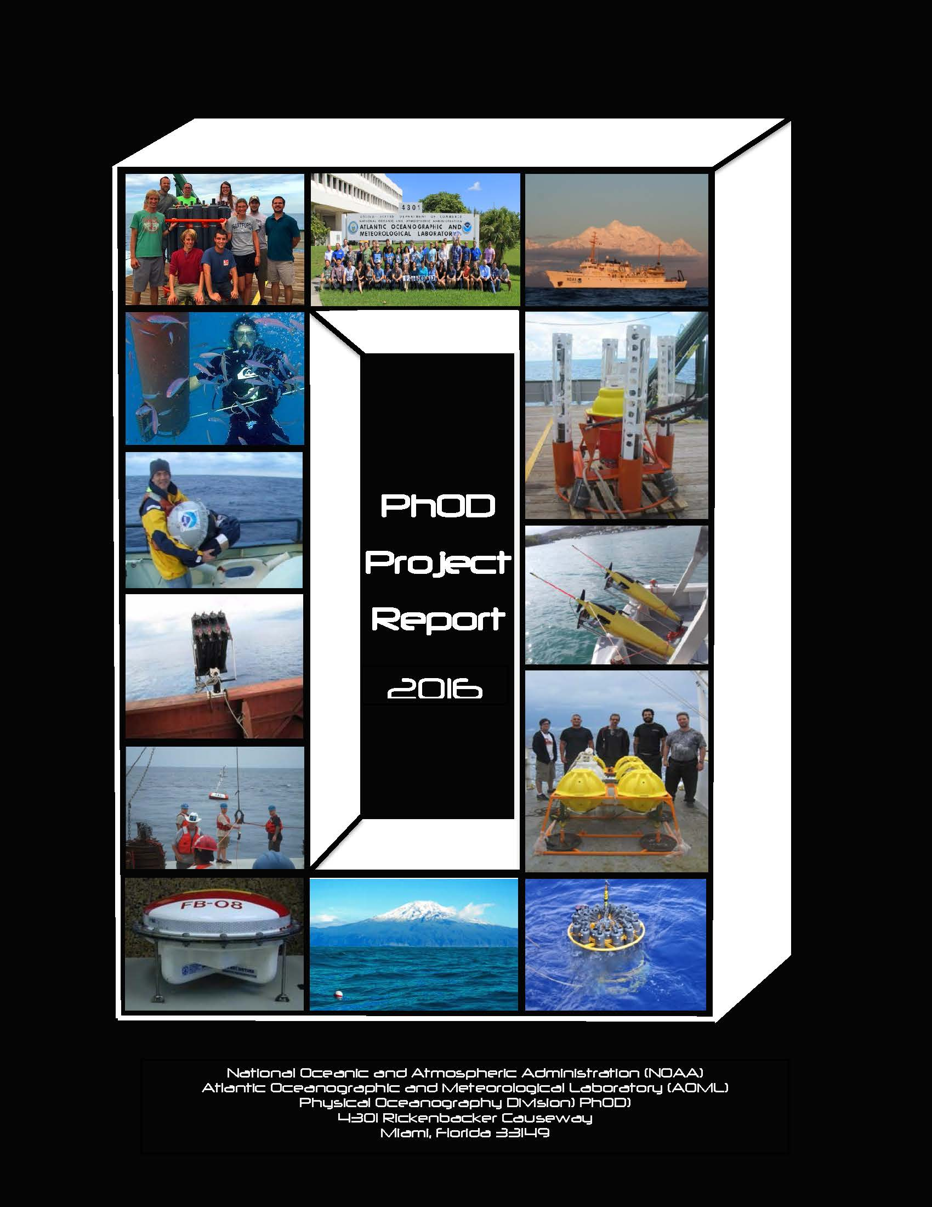

Physical Oceanography Division

The Physical Oceanography Division (PhOD) is part of the Atlantic Oceanographic and Meteorological Laboratory (AOML) together with the Ocean Chemistry and Hurricane Research Divisions. The Physical Oceanography Division carries out interdisciplinary scientific investigations of the physics of ocean currents and water properties to assess and monitor the state of the ocean. The goal of PhOD is to strengthen our scientific understanding of the state of the ocean and its link to ocean dynamics, extreme weather events, fisheries, and ecosystems, by enhancing our observational work, research, technological development, and science communications. The tools used to carry out these studies range from sensors on deep ocean moorings to satellite-based instruments to measurements made on research and commercial shipping vessels and autonomous vehicles, and include data analyses and numerical modeling as well as theoretical approaches.

Some of the major areas of research are in PhOD:

* The dynamics and variability of ocean currents;
* The redistribution of heat, salt, and momentum through the oceans;
* The interactions between oceans, atmosphere, and coastal environments
* The link of the state of the ocean on hurricanes and tornadoes;

To learn more about the work we do, please see the PhOD web site:

http://www.aoml.noaa.gov/phod/index.php

The following pages provide highlights of PhOD ongoing research projects that are either led by or involve PhOD investigators together with essential science support personnel from NOAA and from University of Miami/Cooperative Institute for Marine and Atmospheric Studies (CIMAS). Many of these projects are also led by or involve investigators from other AOML Divisions and national and international institutions. For additional details about these projects, please contact the AOML investigators working on the projects, the PhOD website, or the list of publications at the end of this report.

National Oceanic and Atmospheric Administration (NOAA)
Atlantic Oceanographic and Meteorological Laboratory (AOML)
Physical Oceanography Division (PhOD)
4301 Rickenbacker Causeway
Miami, Florida 33149

305.361.4420

PhOD Administration

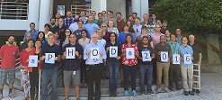
Gustavo Goni, Division Director

Rick Lumpkin, Deputy Director

Roberta Lusic, Division Assistant

Research Scientists

Molly Baringer AOML Deputy Director NOAA
Shenfu Dong NOAA
Gregory Foltz NOAA
Silvia Garzoli CIMAS/UM
Marlos Goes CIMAS/UM
Gustavo Goni NOAA
George Halliwell NOAA
Elizabeth Johns NOAA
Sang-Ki Lee NOAA
Matthieu Le Hénaff CIMAS/UM
Yanyun Liu CIMAS/UM
Hosmay Lopez CIMAS/UM
Rick Lumpkin NOAA
Sudip Majumder CIMAS/UM
Christopher Meinen NOAA
Renellys Perez CIMAS/UM
Nathan Putman CIMAS/UM
Claudia Schmid NOAA
Denis Volkov CIMAS/UM

Instrumentation Group

Pedro Peña NOAA
Grant Rawson CIMAS/UM
Ulises Rivero NOAA
Robert Roddy NOAA
Thomas Sevilla CIMAS/UM
Andrew Stefanick NOAA

Administrative Support

Research and Operational Support

Charita Atluri CIMAS/UM
Zachary Barton CIMAS/UM
Francis Bringas NOAA
Paul Chinn CIMAS/UM
Jonathan Christophersen CIMAS/UM
Yeun-Ho Daneshzadeh NOAA
Shaun Dolk CIMAS/UM
Ricardo Domingues CIMAS/UM
James Farrington NOAA
Elizabeth Forteza CIMAS/UM
Rigoberto Garcia CIMAS/UM
Caridad Gonzalez CIMAS/UM
Vicki Halliwell CIMAS/UM
Patrick Halsall CIMAS/UM
James Hooper CIMAS/UM
Michel Mehari CIMAS/UM
Jayalekshmi Thottiyilthazhe Sadanandan Nair (Jaya) CIMAS/UM
Mayra Pazos NOAA
Reyna Sabina CIMAS/UM
Ryan Smith NOAA
Joaquin Trinanes Contractor
Eric Valdes CIMAS/UM

IT Specialists

Jay Harris NOAA

Carla Stephens NOAA Visiting Scientists
John Festa CIMAS/UM
David Enfield NOAA Visiting scholar (OD)
Fabian Gomez USM
Edmo Campos USP, Brazil

CIMAS/UM - The Cooperative Institute for Marine and Atmospheric Studies (CIMAS) is a research institute of the University of Miami
Index of Project Pages

Ocean Observing System

5 Selected key applications on divisional work
8 Argo Profiling Floats
9 The Global Drifter Program
10 Western Boundary Time Series Program
11 CLIVAR Repeat Hydrography/CO₂ Inventories
12 The XBT Network
13 Thermosalinograph Operations
14 AMVER SEAS Program
15 The Mandatory Ship Reporting System
16 Meridional Overturning Circulation and Heat Transport Array / Rapid Watch Climate
Change Program
17 Southwest Atlantic Meridional Overturning Circulation Array
18 The PIRATA Northeast Extension: Observing Tropical Atlantic Ocean Variability
19 Hurricane Underwater Gliders in the Caribbean Sea and Tropical North Atlantic Ocean
20 AOML South Florida Studies
21 Connectivity of the Pulley Ridge and the South Florida Coral Reef Ecosystem
22 Biophysical Connectivity in the Intra-Americas Sea
23 Satellite Ocean Monitoring
24 The Use of Satellite Derived Oceanographic Data for Fish Stock Assessment in the Gulf of Mexico
25 Dual Salinity Drifters: Investigating the Processes Contributing to the Salinity Differences between Aquarius and in situ Measurements
26 Monitoring of the Gulf of Mexico Conditions during the Deepwater Horizon Oil Spill
27 Ocean Stratification and the Intensification of Tropical Cyclones
28 An Enhanced XBT probe
29 Expendable Bathythermograph Fall Rate Equation
30 Tropical Atlantic Current Observations Study

Analyses

31 Meridional heat Transport in the South Atlantic reveals links with global monsoons
32 Assessment of the Meridional Overturning Circulation and Meridional Heat Transport and their Meridional Variability in the South Atlantic Ocean
33 Meridional Heat Transport Variability in the Atlantic Ocean
34 Meridional Volume and Heat Transport in the South Atlantic
35 Tropical Atlantic
36 Changes of the salinity in the upper ocean
37 Variability of the South Atlantic Subtropical Gyre
38 Transports in the eastern and western boundary regimes of the subtropical South Atlantic
39 The Brazil Current variability and basin-scale interactions
40 Extratropical Triggering of El Niño Events Through the Trade-Wind Charging Mechanism
41 Near-inertial Energy Pathway
42 Intra-American study of Climate Processes
43 Atlantic Warm Pool and Tropical Cyclone Activity in the North Atlantic
44 Tropical cyclone Heat Potential
45 Origins of African Dust over the Atlantic Ocean
46 South Atlantic Meridional Overturning Circulation: Pathways and Modes of Variability
47 Inter-Ocean Exchanges and Regional Sinks of Heat during the Warming Hiatus

Numerical Modeling

48 The Mediterranean and Black Seas: Analysis of Large Sea Level Anomalies
49 Formation and variability of the Lofoten Cortex in the Norwegian Sea
50 Management and Conservation of Atlantic Bluefin Tuna (Thunnus Thynnus) and other Highly Migratory Fish In the Gulf of Mexico under IPCC Climate Change Scenarios: A Study Using Regional Climate and Habitat Models
51 Toward Developing a Seasonal Outlook for the Occurrence of Major U.S. Tornado
Outbreaks
52 High-Resolution Ocean-Biogeochemistry Modeling for the east and Gulf Coast of the U.S. in Support of the Coastal Monitoring and Research Objectives of the NOAA OA Program
53 Predicting the impact of anthropogenic climate change on physical and biogeochemical processes in the northern Gulf of Mexico
54 Variability and Predictability of the Atlantic Warm Pool and Its Impacts on Extreme Events in North America
55 Evaluation of Gulf of Mexico oceanographic observation networks impact assessment on ecosystem management and recommendation

56 Development of an Earth System component for Medium-Range Predictability in Coastal Seas: application on Gulf of Mexico Harmful Algal Blooms and Hypoxia Episodes
57 Ocean OSSEs: System Development and Applications
58 Ocean Model Evaluation and Improvement in Support of the Next Generation HWRF Regional Tropical Cyclone Prediction System
59 2km resolution data-assimilative simulation of the Gulf of Mexico

Engineering

60 Deep Ocean Data Retrieval System
61 Automatic Shortwave Radiometer Cleaner

Additional PhOD information

62 Shipboard Surveys of Regional and Worldwide Field Operations
64 National and International Partners
65 Publications

Selected key applications on divisional work

Improved prediction of extreme weather events in the continental US

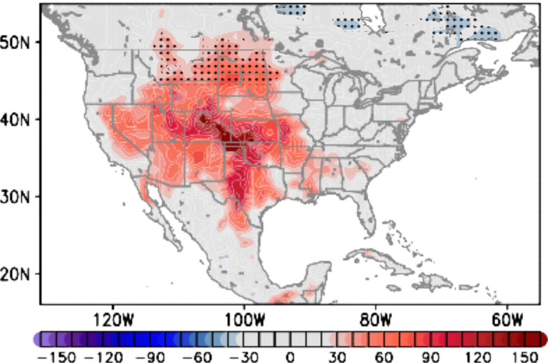

Together with national and international partners, AOML physical oceanographers lead efforts to investigate how the oceans transport heat and to assess their links with extreme weather events. Most recent research reveals the key role that the ocean currents play in US wether.

Improved tropical cyclone genesis and intensification forecasts

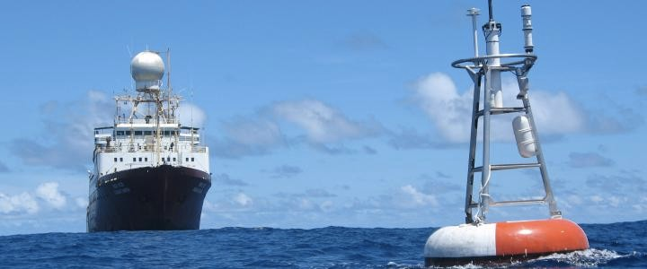
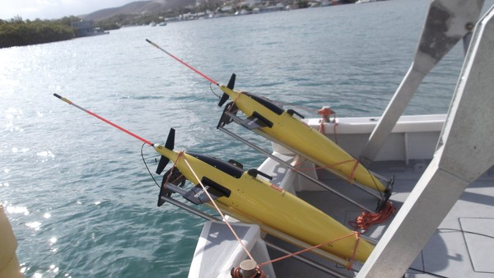

The ocean plays a critical role in the genesis, development, and intensification of Atlantic hurricanes. AOML physical oceanographers partner with the National Weather Service to lead sustained observations from moorings, research ships, drifters, and underwater gliders and to assess numerical model studies that have been shown to improve hurricane seasonal and intensity forecasts.

Improved estimates of fish stock assessments of highly commercial species
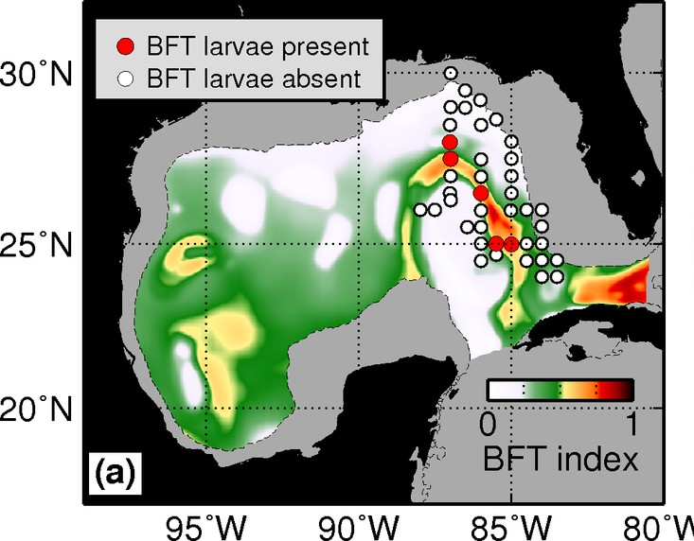

AOML physical oceanographers partner with NOAA National Fisheries Service scientists to provide ocean environmental conditions critical for determining favorable conditions of species, such as the Atlantic Bluefin tuna.

Provide rapid response in support of environmental emergencies
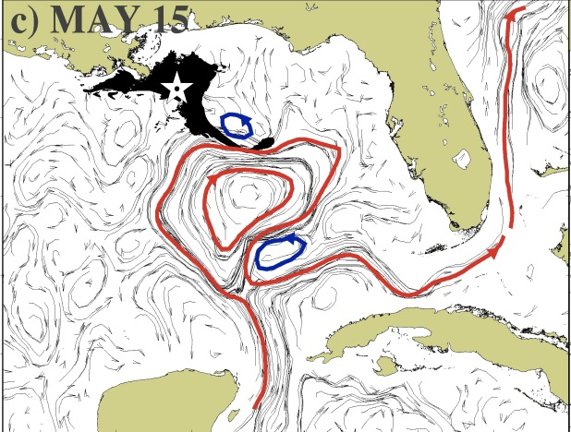
AOML carried out one of the only research cruises outside the immediate oil spill region during the Deepwater Horizon incident in order to assess the large-scale circulation patterns in the Gulf. In partnership with NOOA/NESDIS, AOML physical oceanographers provide daily global ocean currents to the NOAA National Ocean Service Office of Response and Restoration for debris tracking, oil spills, search and rescue, etc.

Research in Support of Service

Protecting marine life
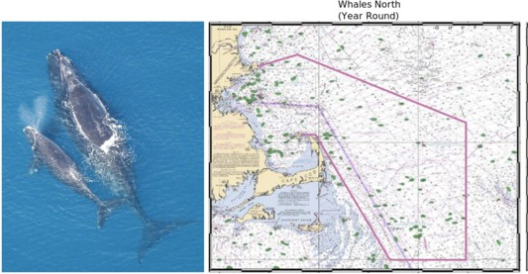
In partnership with the NOAA National Fisheries Service AOML physical oceanographers conduct work to maintain the Mandatory Ship Reporting System to reduce the risk of ship strikes with northern Right Whales (see page 15).

Search and Rescue
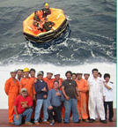
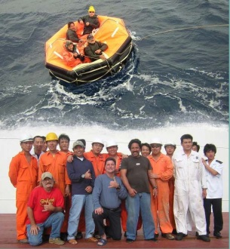

Crew of the M/V Cape Nelson and survivors from the fishing vessel Abound that sank 625 miles off the coast of San Francisco on October 26, 2005. This rescue was facilitated by a partnership project between AOML physical oceanographers and the National Weather Service and the US Coast Guard.

Marine weather
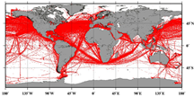
Together with the National Weather Service, AOML physical oceanographers contribute with the acquisition and transmission of global marine weather observations from volunteer ships, the largest source of in situ marine weather conditions. These observations are routinely used by the Tropical Analysis and Forecasting Branch of the National Hurricane Center (see page 14).
Argo Profiling Floats
Physical Oceanography Division
Molly Baringer, Claudia Schmid and Silvia Garzoli

Argo is an international program designed to deploy and maintain an array of 3,000 profiling floats to monitor the upper 2 km of the global ocean. Argo is an international program designed to monitor quantitative changes in the state of the upper-ocean and patterns of ocean climate variability from months to decades using an array of more than 3,000 profiling floats. Argo data is used to initialize and assimilate into ocean-atmospheric forecast models, model testing and verification as well as direct quantitative estimates of oceanic heat and freshwater storage and transport. AOML uses this data to examine water circulation pathways and diagnose the dynamics of the circulation in order to better understand the processes of air-sea interaction and climate variability. AOML plays several roles in the Argo project: a) AOML is the US Argo Data Assembly Center (DAC); b) AOML contributes to logistical efforts related to the deployment of Argo floats in the Atlantic Ocean, and c) AOML performs the last stage of the scientific quality control. The DAC collects all the US Argo data, processes them in real-time and makes them available to the operational centers and scientists in real-time through Global Telecommunication System (GTS) and the two Argo Global DACs. To achieve this, the US DAC has developed and maintained an automatic system for decoding, quality control, and distribution of data obtained from the US Argo floats, which runs in a 24/7 mode. The US DAC participates in the International Argo Data Management Team, which is in charge of issues related to developing standards for ensuring a high quality of the data, and in the International Argo Steering Team.
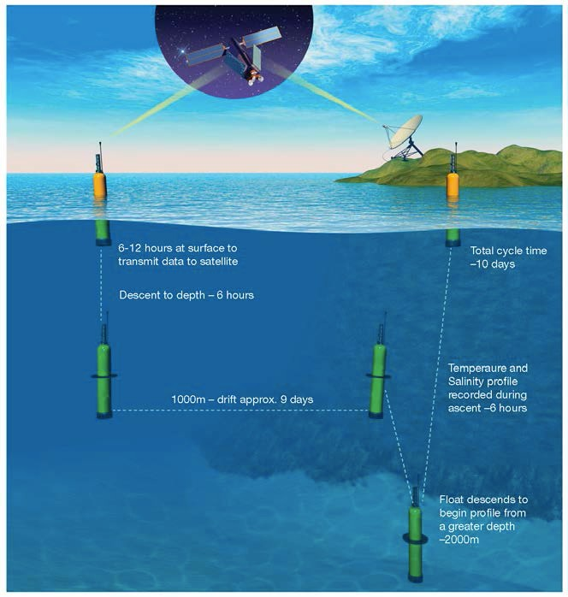

In the cycle typical of an Argo float, a float starts at the surface and dives to a depth of 1000 meters (the parking depth) where it rests for 9 to 10 days. After 9 days at rest it dives to a depth of 2000 m, turns on its sampling equipment and measures ocean properties as it rises to the surface where it rests for sufficient time to transmit the data collected to Argos or Iridium satellite systems. It then returns to the parking depth to start another cycle, the typical duration of a complete cycle is 10 days.
The Global Drifter Program
Satellite-tracked Surface Drifting Buoys
Rick Lumpkin and Renellys Perez

NOAA’s Global Drifter Program (GDP) is the principal component of the Global Surface Drifting Buoy Array, a branch of NOAA's Global Ocean Observing System and a scientific project of the Data Buoy Cooperation Panel. Its objectives are to:
1. Maintain a global 5°x5° array of ~1300 satellite-tracked surface drifting buoys to meet the need for an accurate and globally dense set of in-situ observations of mixed layer currents, sea surface temperature, atmospheric pressure, winds and salinity, and
2. Provide a data processing system for scientific use of these data.
These data support short-term (seasonal to interannual) climate predictions as well as climate research and monitoring. These surface drifters are also used to collect barometric pressure observations for improved weather forecasting.
NOAA's Atlantic Oceanographic and Meteorological Laboratory houses two vital components of the Global Drifter Program: the drifter Data Assembly Center and the Drifter Operations Center. These components of the GDP coordinate deployments, process the drifter data, archive the data, maintain metadata files describing each drifter deployed, develop and distribute data-based products, and maintain the GDP website at: http://www.aoml.noaa.gov/phod/dac.

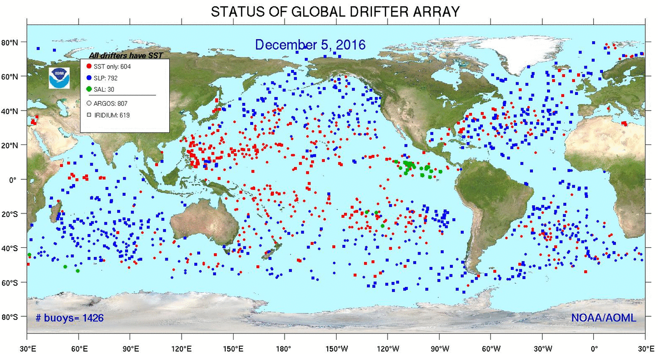

Recent status of the global drifter array. The instantaneous size of the array varies according to regional deployments and fluctuations in death rate, while the annual average is maintained at close to ~1300 drifters.

Western Boundary Time Series Program
Molly Baringer, Christopher Meinen, and Silvia Garzoli

Climate studies using observational data require long time series in order to capture the interannual and decadal fluctuations associated with climate variability. One of the premier long-term time series for study of the Atlantic Meridional Overturning Circulation (AMOC) phenomenon is the record of transport and water mass variability in the Florida Current/Gulf Stream and the Deep Western Boundary Current (DWBC) collected as part of the NOAA Western Boundary Time Series (WBTS) program. This program began in 1982 by collecting daily estimates of the Florida Current transport via a submarine cable and via regular shipboard sections near 27°N in the Straits of Florida. In 1984 the program expanded to begin monitoring the DWBC east of the Bahamas along 26.5°N. Some of the technologies used in the intervening 25+ years have changed with time, but this program has produced a critical nearly-continuous time series of ocean transport that is used in validating nearly all ocean models used for study of climate variability. The important long records collected by this program have also proven invaluable for determining time scales of variability for phenomenon such as the AMOC – the bulk of which is carried in the Florida Current and DWBC at these latitudes. The Florida Current is presently still monitored using a submarine cable and routine shipboard measurements, while the DWBC is monitored using a line of four pressure-equipped inverted echo sounders (PIES) and one current-and-pressure-equipped inverted echo sounder (CPIES) along with annual hydrographic cruises. Furthermore, the WBTS project has served as the cornerstone of the international RAPID/MOCHA program to measure the basin-wide, full-water-column, transport of the AMOC at 26.5°N using a combination of cable, PIES/CPIES, tall subsurface moorings, and hydrographic sections..
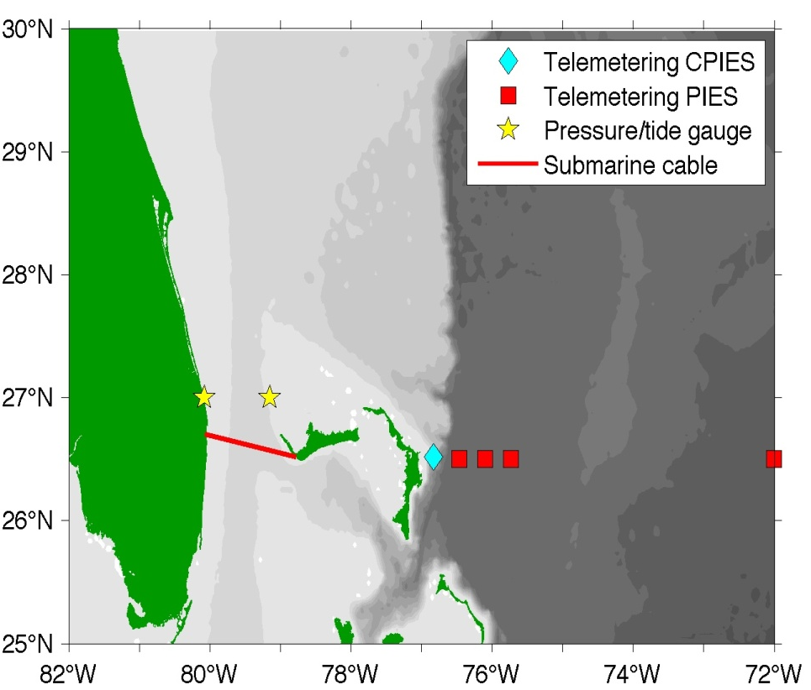
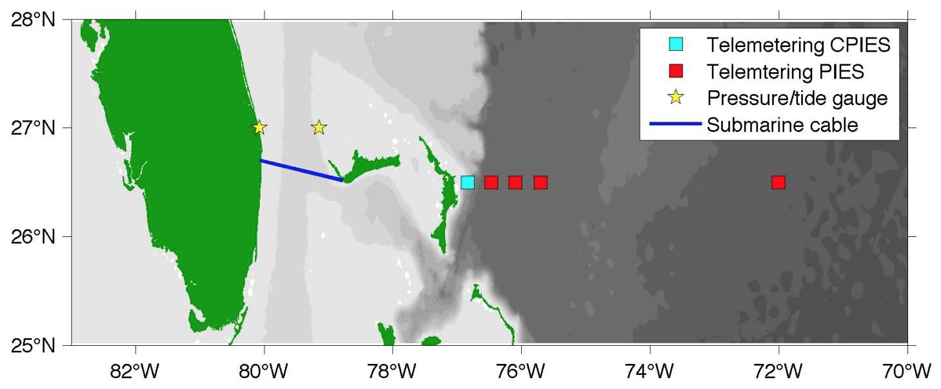

Summary locations of continuous time series components of the Western Boundary Time Series program

CLIVAR Repeat Hydrography/CO₂ Inventories
Molly Baringer

Together with Drs. Rick Wanninkhof and Jia-Zhong Zhang of the Ocean Chemistry Division, this program aims to reoccupy selected trans-basin sections previously occupied over the last 50 years to document changes in heat, fresh water, carbon, nutrients, oxygen, and trace gases in the ocean. Sections, selected based on their historical record and geographic importance for capturing ocean circulation features, are occupied by NOAA and NSF investigators with the aim of approximately decadal repeats along each line. Despite numerous technological advances over the last several decades, ship-based hydrography remains the only method for obtaining high-quality, high spatial and vertical resolution measurements of a suite of physical, chemical, and biological parameters over the full water column.

Ship-based hydrography is essential for documenting ocean changes throughout the water column, especially for the deep ocean below 2 km (52% of global ocean volume). Hydrographic measurements are needed to:
• reduce uncertainties in global fresh water, heat, property and sea-level budgets,
• determine the distributions and controls of natural and anthropogenic carbon (both organic and inorganic),
• determine ocean ventilation and circulation pathways and rates using chemical tracers,
• determine the variability and controls in water mass properties and ventilation,
• determine the significance of a wide range of biogeochemically and ecologically important properties in the ocean interior, and
• maintain the historical database of full water column observations necessary for the study of long-timescale changes (figure).
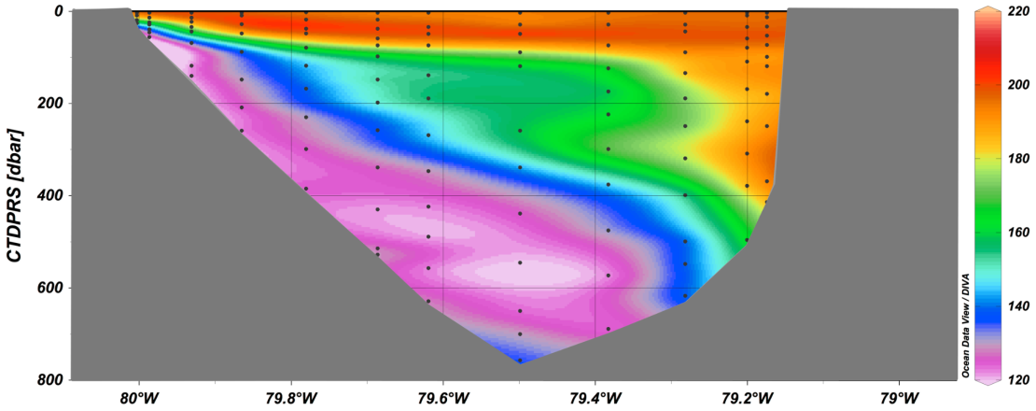
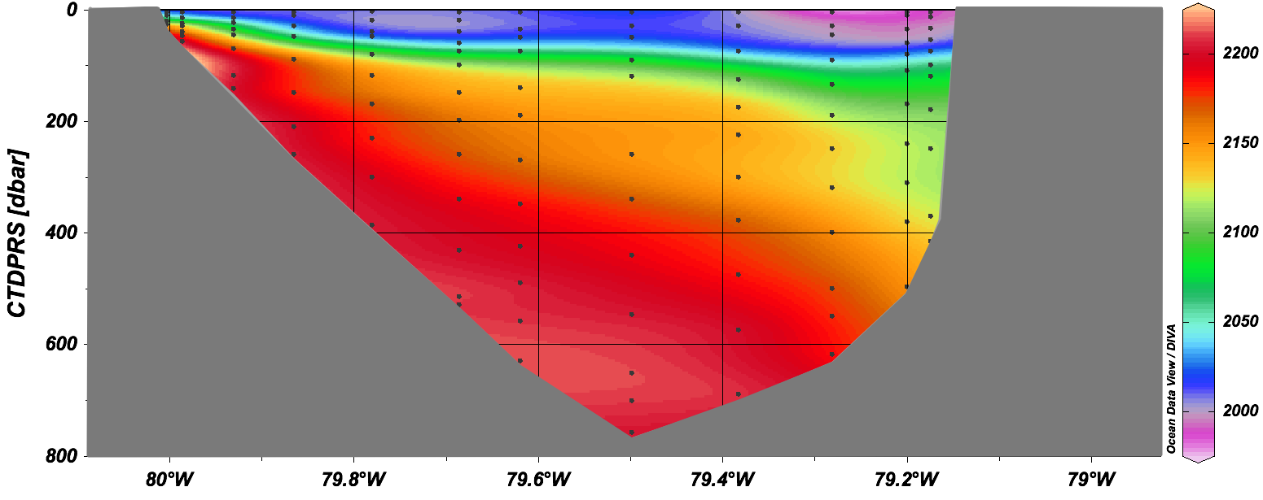

Contour plots of O₂ (top); Dissolved Inorganic Carbon (DIC) in the Florida Straits along 27N. These are the types of measurements obtained in the Clivar/Go-Ship program that help to provide estimates of the amount of carbon and oxygen that are transported in the ocean. Note the ‘uplift’ of low oxygen and high DIC towards the east coast of Florida.
The XBT Network
Gustavo Goni, Shenfu Dong and Molly Baringer

The Ship Of Opportunity Program (SOOP) is an international effort that supports the implementation of a network of cargo vessels, cruise ships, and research vessels to deploy scientific instruments that collect oceanographic observations. The most important component of this effort is the Expandable Bathy Thermograph (XBT) network. XBTs are deployed along fixed pre-established transects, which are repeated at least 4 times per year, to measure water temperature profiles from the sea surface to a maximum depth of 850 m. The XBT network currently in place has been recommended by the international scientific community during. The countries that provide the largest contributions to this program are the United States, Australia, France, South Africa, Brazil, Germany, Italy, and Japan. In average, approximately 20,000 are deployed per year, of which AOML is involved in some aspect of the logistics, operations, data processing, etc, of about 90% of them. AOML leads or co-leads with its international collaborators the implementation and operations of 12 Atlantic Ocean transects.

These XBT temperature measurements are used to monitor changes of key surface and subsurface currents, to study meridional heat transport in all ocean basins, and to supplement other observational platforms to assess the variability of the upper ocean heat content. All XBT transects have been justified base on our understanding of how the upper ocean dynamics and thermal structure may be linked to long-term climate signals, extreme weather events, ecosystem assessments, etc. Most of the data obtained though this project are distributed into the GTS within 24 hours of its acquisition, providing critical input for weather and climate forecasts models and scientific applications. XBT data are distributed to NOAA/NODC and to other data distribution centers.

This project also involves activities aimed to the continuous development of new technologies in support of the operations carried out as part of the XBT network. During recent years the engineering group at AOML has developed new equipment for the automatic deployment of several models of XBTs during cruises with high rate of deployments, for the transmission of data in real-time using different satellite networks, and for the substitution of several components to carry out cost-effective operations. In addition, AOML scientists continue working on XBT fall rate studies and collaborating with Lockheed Martin Sippican to develop a new, upgraded, XBT probe that will be able to provide climate quality observations.
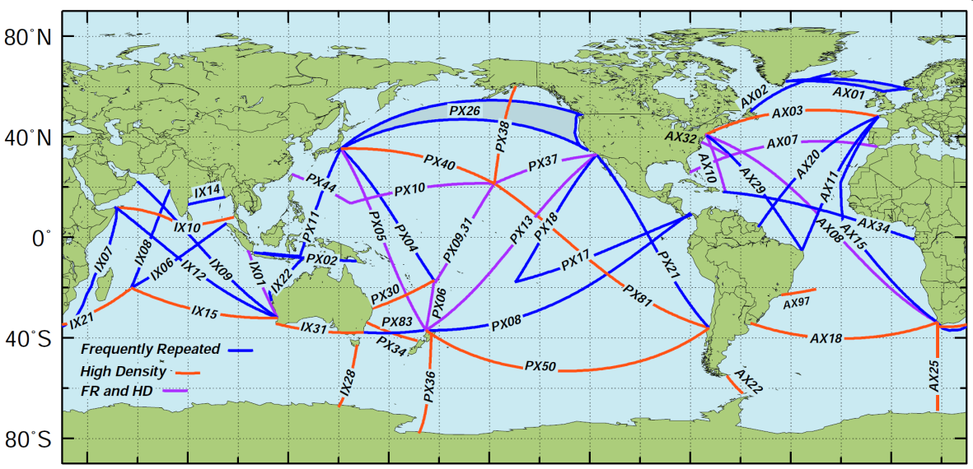

Recommended XBT network
Thermosalinograph Operations
Gustavo Goni and Francis Bringas

The Thermosalinograph (TSG) operation is one of the components of the Ship Of Opportunity Program (SOOP) at AOML. TSGs are instruments that continuously measure the sea surface temperature and sea surface salinity along a ship’s track. Research vessels gather TSG observations from various regions of the global ocean, while ships of opportunity – cruise and cargo vessels – obtain long time series of temperature and salinity data for frequently-repeated transects. AOML’s TSG operations are based on obtaining data from NOAA’s fleet of research vessels, and from ships of opportunity. TSG data have enhanced global data collection efforts for close to 20 years and have been critical to understanding long-term changes in the marine environment. SOOP’s TSG observations have many applications, in climate and ocean dynamics research, determination of boundary regions in ocean currents, and as input for climate and weather forecast models. One component of the TSG operation supports efforts of the global inventory of carbon dioxide in the oceans, a project led at AOML by Dr. Rik Wanninkhof. In collaboration with other NOAA laboratories, universities, and the international partners, AOML acquires and distributes TSG data of more than 20 ships.

Data are received in real-time mode, typically one file per day containing 24 hours of data, and are subjected to quality-control procedures. Quality-control approved TSG records are distributed on the Global Telecommunication System (GTS) in real-time. The data are archived at the National Oceanographic Data Center (NODC) and at the French Research Institute for Exploration of the Sea (IFREMER), France.

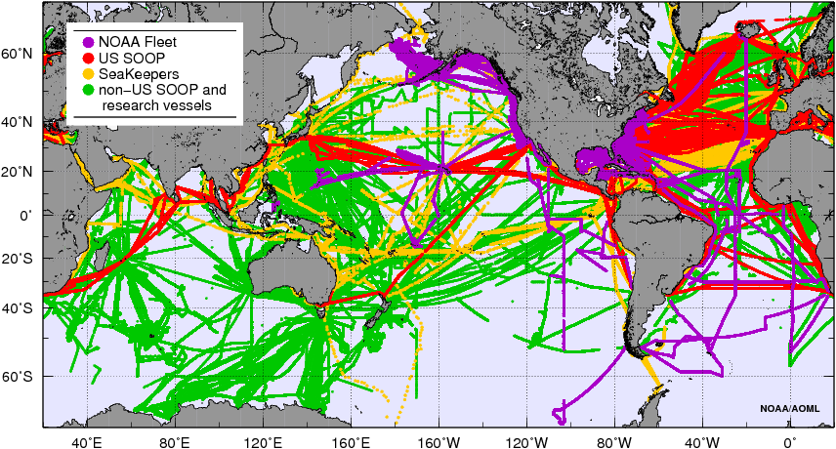

Location of TSG observations by AOML and other institutions during 2001-2014. TSG observations obtained from the NOAA fleet are predominantly gathered off U.S. coastal regions and represent more than 5.5 million records, of which more than 35% are located at latitudes above 45N. TSG observations obtained from ships of opportunity comprise more than 10.5 million records in the Atlantic Ocean, with more than 2 million records obtained at high latitudes
AMVER SEAS Program
Gustavo Goni, Caridad Gonzalez, Francis Bringas, and Pedro Peña

The Shipboard Environmental (data) Acquisition System (SEAS) is a Windows-based, real-time data acquisition and transmission system developed at AOML in 2001 with the assistance of NOAA’s Office of Marine and Aviation Operations. This software enables various types of atmospheric and oceanographic data to be obtained from ships and transmitted in real-time to AOML for quality control. The data are subsequently transmitted to the Global Telecommunication System and several operational databases for use by scientists as input to weather and climate forecast models. A major component of SEAS is the acquisition of ocean data using Expendable BathyThermographs (XBTs). AOML, the National Weather Service (NWS), and the Scripps Institution of Oceanography are the principal users of the SEAS software.

The NWS uses SEAS software to generate and transmit marine meteorological (MET) observations. Over 400 vessels operated by NOAA, the University-National Oceanographic Laboratory System (UNOLS), the Coast Guard, and vessels participating in NOAA’s Volunteer Observing Ship Program, participate in reporting MET observations, which contain atmospheric, oceanographic, and position data acquired both manually and automatically by shipboard sensors. More than 200,000 SEAS MET observation bulletins are transmitted annually.

Additionally, the Coast Guard uses AMVER reports, along with SEAS MET observations, to support their AMVER vessel search and rescue program. The SEAS software creates a series of reports that include a ship’s medical personnel, point of departure, route, positions underway, and arrival to help locate able vessels near vessels in distress. Over 14,000 AMVER reports are transmitted annually to the Coast Guard. These reports have helped rescue more than 2,100 people during the last seven years; SEAS accounts for nearly 20% of the Coast Guard’s AMVER reports. The SEAS is used for data transmissions by different NOAA line offices with applications to physical, biological, and meteorological marine studies.
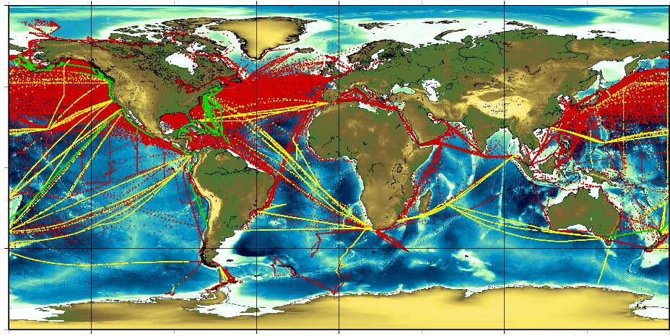

Location of oceanographic (yellow=XBTs, green=TSGs) and meteorological (red) observations transmitted with SEAS during 2007.
The Mandatory Ship Reporting System
Paul Chinn, Ricardo Domingues and Gustavo Goni

The North Atlantic right whale has shown no significant signs of recovery over the past 60 years despite being a protected species. Ship strikes account for nearly one third of all known right whale mortality. In an effort to reduce the number of whales killed or injured by ship strikes, the United States proposed the creation of the Mandatory Ship Reporting system (MSR) to educate merchant mariners on the plight of the right whale, and to provide information about reducing the risk of ship strikes. The MSR was formally adopted in December, 1998, through the Resolution A.858(20), and commenced its operation on 1 July 1999. It requires all commercial vessels heavier than 300 gross tons to report to the Coast Guard upon entering two designated report areas: (1) the northeast area includes the waters off Cape Cod Bay, Massachusetts Bay, the Great South Channel, and the Stellwagen Bank National Marine Sanctuary; (2) the southeast area includes waters within 25 nautical miles of the coast along a 90 nautical mile stretch of the Atlantic seaboard in the vicinity of the Florida/Georgia border.
AOML houses the SEAS Programs, which is used for oceanographic and meteorological observations transmissions. This program structure is now being used as the basis for the new MSR. AOML has been awarded with the development, management and housing of the MSR, version 2.0. Reports sent by ships upon approaching the two designated areas are received through e-mail (RightWhale.MSR@noaa.gov) or Telex (236737831), processed and stored in the MSR 2.0 database, and the system immediately returns a whale location report providing the mariner with information on how to reduce the risk of collisions with whales. The outgoing message also provides latest right whale sighting information derived from NOAA-operated whale surveys.
The information collected by the MSR 2.0 database yields data on ship traffic volume, routes, and ports of call and assists in tailoring any necessary future ship strike mitigation measures. It also enables the generation of reports about the ship compliance with the U.S. MSR.

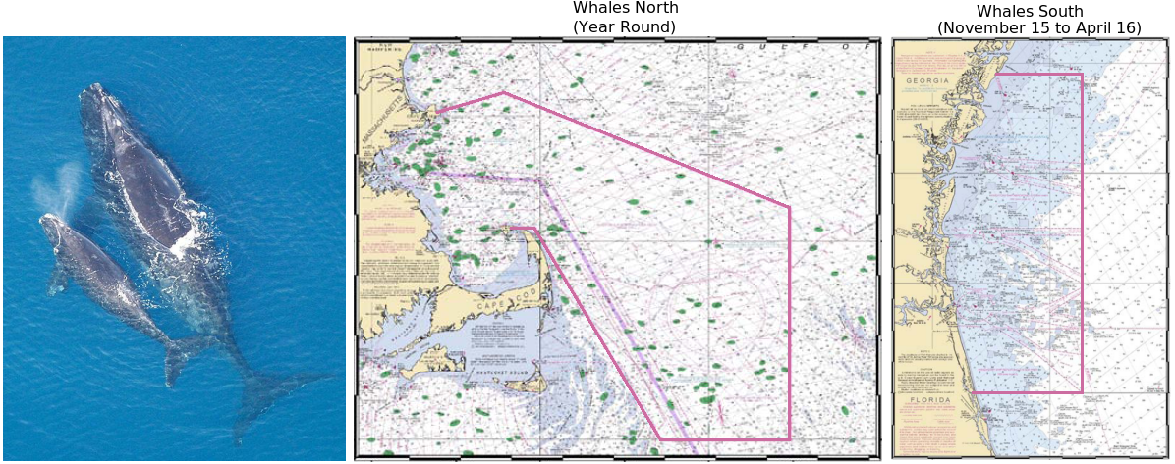

On the (left) North Atlantic right whale with calf, (center) Whales North area, and (right) Whales south area

Meridional Overturning Circulation and Heat Transport Array / Rapid Watch Climate Change Program
Molly Baringer and Christopher Meinen

"An outstanding problem in the oceanic sciences is the rate of heat and freshwater transport from the equator to the poles, for it is this transport which powers the Earth's weather and climate system." Keffer and Holloway, Nature (1988).

The Meridional Overturning Circulation (MOC) and Heat-flux Array (MOCHA) is a collaborative project, partnered with the Rapid Watch Climate Change Program (UK RAPID), to measure the MOC and ocean heat transport in the North Atlantic Ocean (see figure). These transports are primarily associated with the thermohaline circulation. Simply put, warm waters move poleward at the surface of the ocean, where they cool and sink, to return equatorward in the deep ocean. Climate models suggest that the MOC in the Atlantic, and the accompanying oceanic heat flux, vary considerably on interannual time scales. In addition to abrupt climate change scenarios in which the MOC can virtually shut off (Manabe and Stouffer, 1993; Vellinga and Wood, 2002), the “natural” interdecadal variation may range from 20% to 30% of its long-term mean value, according to some models (e.g., Hakkinen, 1999). However, until recently no direct measurement system had been put in place that could provide regular estimates of the Meridional Overturning Circulation to determine its natural variability or to assess these model predictions. Such a system is now deployed along 26.5°N in the Atlantic as part of the joint U.K./U.S. RAPID-MOCHA program, which has been continuously observing the MOC since March 2004.

Estimates of Atlantic Ocean meridional overturning circulation from the Argo/Altimetry estimate at 41°N (black; Willis 10), the RAPID-WATCH/MOCHA/WBTS 26°N array (red; McCarthy et al. 2015), and the German/NOAA MOVE array at 16°N (blue; end et al. 2011) shown versus year. All time series have a three-month second-order Butterworth low-pass filter applied. Horizontal lines are mean transports during similar time periods as listed in the corresponding text. Dashed lines are trends for each series over the same time period. For the MOVE data, the net zonal and vertical integral of the deep circulation represents the lower limb of the MOC (with a negative sign for southward flow) and hence a stronger negative southward flow represents an increase in the MOC. The light grey lines show the ECCO2-derived transports: (top) thin grey is the 41°N transport, thick grey is the 26°N transport, (bottom) shows the negative meridional overturning circulation in the model for ease of comparison with the 16°N

Southwest Atlantic Meridional Overturning Circulation Array
Christopher Meinen, Silvia Garzoli, Renellys Perez and Shenfu Dong

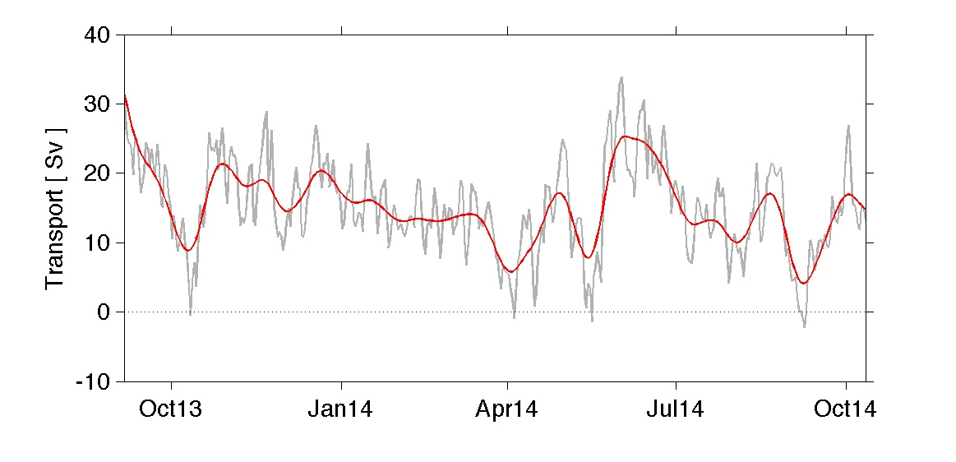
Variations in the Atlantic Meridional Overturning Circulation (AMOC) in both the North and South Atlantic have been shown to relate to changes in important climate variables including precipitation and surface air temperatures as well as hurricane intensification, heat waves, and other extreme weather events. The AMOC consists primarily of vertical and north-south flow in the oceans, with new deep waters forming in the high latitudes, particularly in the northern North Atlantic, and surface waters flowing from around the globe to replace the sinking deep waters. Direct knowledge of how the AMOC varies is limited due to the difficulty in making the necessary basin-wide measurements. Scientists in PhOD have been at the forefront of this challenging field, working with national and international partners to develop and implement several critical measurement systems that provide data on the AMOC at important locations. One such project is the Southwest Atlantic Meridional Overturning Circulation (“SAM”) array; the SAM project involves a line of moored pressure-equipped inverted echo sounders (“PIES”) deployed along 34.5°S near the continental slope of South America. This project, funded by the NOAA Climate Program Office – Climate Observations Division, has been measuring the key western boundary components of the AMOC at 34.5°S since March 2009. AOML-PhOD has been maintaining the SAM PIES array together with partners in Argentina and Brazil, and the initial successes have led to a broader coalition of countries including France and South Africa who have augmented the SAM array with both additional western boundary moorings and with eastern boundary moorings, producing a true trans-basin AMOC array.
Time series of the volume transport of the upper limb of the AMOC across 34.5°S calculated following the methods described in Meinen et al. (2013). Data from the AOML-PhOD SAM project are used together with the parallel French-South African “GoodHope” project to produce these daily (gray) and 30-day low-pass filtered (red) time series. Other data from the global ocean observing system, including Argo profiles and satellite observations, are used to augment the moored instruments in creating this time series.
The PIRATA Northeast Extension:
Observing Tropical Atlantic Ocean Variability
Rick Lumpkin, Claudia Schmid, Gregory Foltz and Renellys Perez

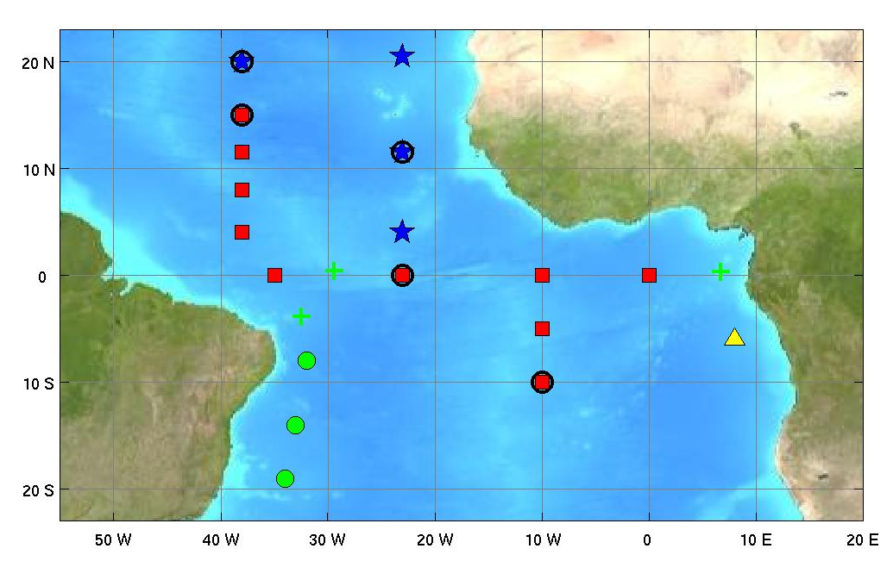
The Prediction and Research moored Array in the Tropical Atlantic (PIRATA) is a joint project of Brazil, France, and the United States. PIRATA aims to improve our knowledge and understanding of ocean-atmosphere variability in the tropical Atlantic. Implementation of PIRATA started in 1997 with an array of backbone moored ATLAS buoys, similar to the Tropical Atmosphere-Ocean (TAO) array of the equatorial Pacific. Starting in late 2005, extensions were added to the backbone array in key regions, including the US-led PIRATA Northeast Extension (PNE).
The PIRATA backbone of buoys (red squares), the Northeast Extension (blue stars) led by the United States, the Southwest Extension (green circles) led by Brazil, the Southeast Extension serviced with French ship time (yellow triangle), and island-based observation sites (green crosses). Buoys with barometers and longwave radiometers, capable of estimating net ocean/atmosphere heat fluxes, are indicated with black circles.

PNE is a joint AOML and PMEL effort that has extended the array into the tropical North Atlantic, a region of strong climate variations with impacts upon rainfall rates and storm landfalls for the surrounding regions of Africa and the Americas. Important processes in this region include the formation of Cape-Verde type hurricanes, seasonal migration of the Intertropical Convergence Zone (ITCZ) and the Guinea Dome, interannual to decadal variations of the ITCZ migration associated with rainfall anomalies in Africa and the Americas, off-equatorial heat advection by Tropical Instability Waves, and overturning-related ventilation of the oxygen minimum zone. AOML organizes and leads the annual cruises to maintain the buoy and collect a suite of meteorological and oceanographic observations in the region, while PMEL provides the equipment and technicians for the mooring operations.
Hurricane Underwater Gliders in the Caribbean Sea and Tropical North Atlantic Ocean
Gustavo Goni and Sang-Ki Lee

This is a multi-institutional effort that brings together the research and operational components within NOAA and members of the university community to implement and carry out sustained and targeted ocean observations using underwater gliders in the Caribbean Sea and the southwestern tropical North Atlantic Ocean. The upper ocean thermal structure in this region has been linked to rapid intensification of hurricanes, and to the seasonal Atlantic hurricane activity. However, there are only a few (<300) upper ocean thermal observations carried out per year in this region. This project provides 4,500 to 5,500 profile observations per year. The main objectives of this work are to implement upper ocean observations using underwater gliders to evaluate their impact on and to improve: (1) hurricane intensity forecasts and (2) hurricane seasonal forecasts; using a combination of these new sustained observations, targeted observations, data analysis, and current NOAA operational forecast models. The first mission of the AOML underwater glider operations was successfully carried out between July-November 2014. During this mission, 2800 temperature and salinity profiles were collected including observations obtained under hurricane wind conditions.
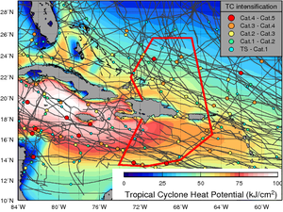
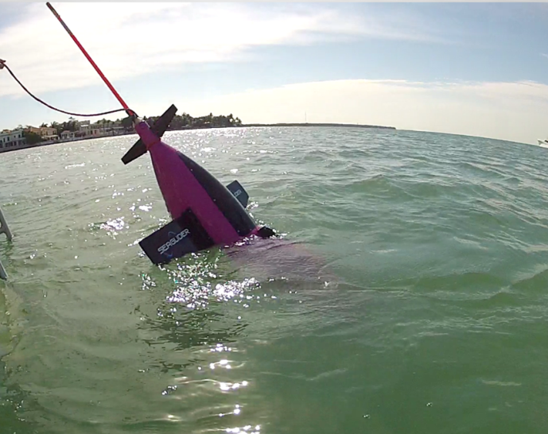

(left) Underwater Glider. (right) The two regions (bounded with red lines) where Seagliders will be deployed. Tracks of Cat. 1-5 cyclones (in grey) in a region of the Atlantic Warm Pool during 1993-2011, with circles indicating the location of their intensification. The background color is the Tropical Cyclone Heat Potential (proportional to the upper ocean heat content).

AOML S`outh Florida Studies
Elizabeth Johns and Ryan Smith

AOML's Physical Oceanography and Ocean Chemistry and Ecosystems Divisions (PhOD and OCED) have conducted regular interdisciplinary shipboard observations of south Florida coastal waters since the early 1990's as part of the AOML South Florida Program (SFP). The collaboration has enabled scientists and resource managers to keep a watchful eye on the sensitive marine habitats found in the region and has served as a sentinel during periods when the ecosystem has been subjected to extreme events such as hurricanes, harmful algal blooms (HAB), and more recently, potential oil spill contaminants and Mississippi River intrusions. Additionally, the AOML SFP has produced a comprehensive, long-term baseline regarding regional circulation, salinity, water quality, and biology for the ecosystem. These data have been the only regular, synoptic measurements of these inter-related parameters throughout the southwest Florida shelf, Biscayne and Florida Bays, and the Florida Keys reef tract. The AOML SFP integrates data from environmentally and economically important areas, including three national parks (Biscayne, Everglades, and the Dry Tortugas) as well as the Florida Keys National Marine Sanctuary (FKNMS).

The SFP field program has provided NOAA the ability to quickly sample extreme events, which have originated both locally (e.g. "black-water", HABs) and remotely (e.g. tropical cyclones, oil spills), by adapting/modifying routine sampling via ships and small boats. Originally designed to fulfill NOAA's responsibility to South Florida Ecosystem Restoration and the ongoing Comprehensive Everglades Restoration Plan (CERP), the AOML SFP remains a key component of NOAA's contribution to CERP and more recently has served as an important element in NOAA's response to the Deepwater Horizon oil spill.

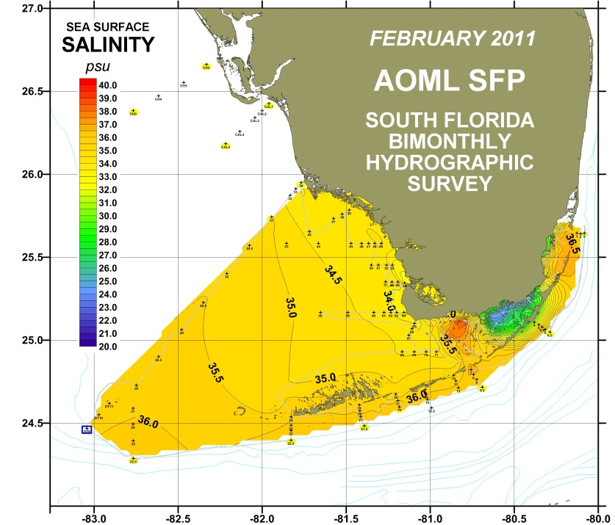
As NOAA develops a new coordinated long-term science plan for the Gulf of Mexico, it will be important to incorporate regional coastal components such as the AOML SFP into the larger mosaic. The development of baseline metrics for the larger region will have to rely heavily on existing data assembled from the few observational programs already operating throughout the Gulf. Management and maintenance of long-term environmental records such as the AOML SFP data time-series is critical. These data are required to determine the natural system spatial and temporal variability, and are a precursor to quantifying and assessing the impacts of the more intermittent, extreme events which can affect the region.
Continuous shipboard measurements of sea surface salinity gathered over the SFP domain for a representative cruise conducted in February 2011.

Connectivity of the Pulley Ridge and the South Florida Coral Reef Ecosystem
Ryan Smith and George Halliwell

Scientists from AOML’s Physical Oceanography Division (PhOD), in conjunction with more than 30 researchers from multiple universities and two NOAA Cooperative Institutes, are studying the connectivity between Pulley Ridge and the larger south Florida coral reef ecosystem. West of the Dry Tortugas in the Florida Keys, Pulley Ridge is a mesophotic reef on the southwest Florida shelf (Fig. 1). Until recently, the physical and biological connections of deeper reefs, such as Pulley Ridge, with the shallower reefs of the Dry Tortugas and Florida Keys National Marine Sanctuary (FKNMS) have not been considered when planning management strategies for the region. PhOD collaboration in this multi-year project is supported by AOML and NOAA’s Center for Sponsored Coastal Ocean Research (CSCOR).

This interdisciplinary research program is led by the University of Miami and focused on three principal themes: population connectivity, community structure, and ecosystem value. The population connectivity theme is comprised of four subgroups: the regional physical oceanography (model and observations), a biophysical model, population genetics, and a population dynamics model. PhOD scientists are involved with the physical oceanography subgroup. This arm of the project is tasked with the management and subsequent data processing and analysis of a moored current meter array deployed at Pulley Ridge and the Dry Tortugas between August 2012 and June 2015 (34 months). The subgroup is also responsible for the development of a new 900-meter resolution HYCOM-based model for the project (extended Florida Keys, eFKEYS-HYCOM). The in situ mooring data are being used for model validation. In turn, many of the products obtained from the eFKEYS-HYCOM, which include real-time 7-day forecasts of circulation, sea surface height (SSH), and sea surface temperature (SST), are supporting the other program subgroups (including the biophysical model) with the data needed to further examine the biological connections between Pulley Ridge and the FKNMS.
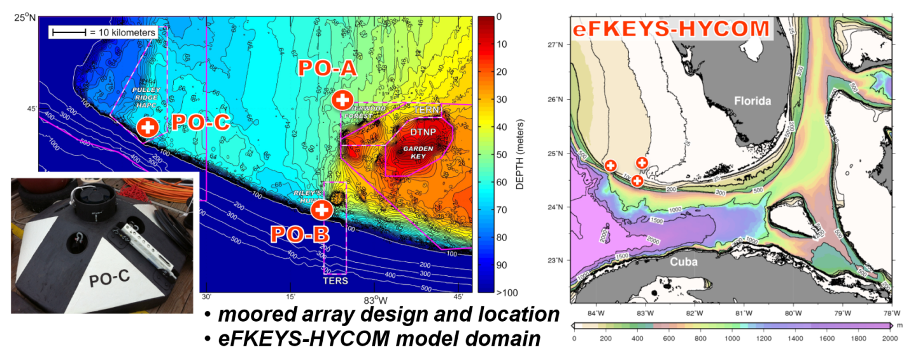
Figure 1. Left panel: a project acoustic Doppler current profiler (ADCP) mooring and mooring site locations at PO-A (northern Dry Tortugas), PO-B (southern Dry Tortugas), and PO-C (Pulley Ridge). Right panel: the eFKEYS-HYCOM model domain with markers indicating project mooring site locations. The model, nested within a larger Gulf of Mexico (GOM) HYCOM, has 26 layers and a resolution of 900-meters.

Biophysical Connectivity in the Intra-Americas Sea
Ryan Smith and Elizabeth Johns

Over the past 14 years, AOML/PhOD and the Southeast Fisheries Science Center - Early Life History laboratory (SEFSC/ELH) have worked in collaboration to study regional biophysical linkages at several locations within the Caribbean Sea and Gulf of Mexico (Intra-Americas Sea). PhOD - ELH partnered field programs typically include biological sampling combined with standard physical sampling methods. This approach provides greater insight to scientific and management questions regarding larval recruitment pathways than biological sampling alone.

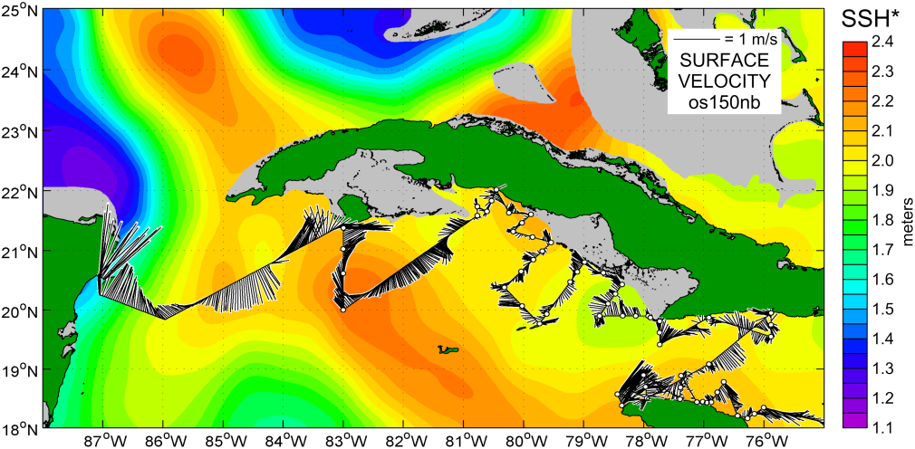
Many of these partnerships have included work in the western Caribbean and Gulf of Mexico (GOM) targeted at improving our understanding of regional larval dispersal and recruitment connections for important pelagic (e.g. Atlantic Bluefin tuna, ABT) and reef fish (e.g. grouper, snapper, and parrotfish) species. By expanding the search for larval ABT outside of their known spawning grounds in the GOM, scientists will be able to improve larval habitat models for the species. Additionally, gaining a better understanding of the biophysical connectivity of coastal resources, such as the Mesoamerican reef system, the reefs of northwestern and southwestern Cuba, and the Florida Keys reef tract will help scientists determine what component of recruitment of reef fish species to these areas is due to regional biophysical connections versus self-recruitment within an individual site.
Figure 1. A 10-day composite of sea surface height, overlaid with surface current velocity vectors from hull-mounted acoustic Doppler current profiler (ADCP) measurements, is shown above for April 26 through May 5, 2015. Velocity vectors are show in black along the NOAA Ship Nancy Foster NF-15-02/03 cruise track for the period. Over the western portion of the map, meso-scale eddy circulation and dominant current systems (Yucatan, Loop, and Florida) are prevalent, while the surface conditions offshore southeastern Cuba are characterized by lower velocity small-scale eddy circulation.

These collaborative endeavors have also focused on the northeastern Caribbean Sea, where transport of larval reef fish across the Puerto Rico and US Virgin Islands (PR/USVI) shelf and through passages between the islands is poorly understood. The natural dispersal of these newly spawned larvae is affected by many factors, including bottom regime, island/shelf/bank geometry, tides, small-scale retention mechanisms, mesoscale eddies, and larger-scale mean fields such as wind-driven transport. This work is designed to help scientists and resource managers gain a better understanding of how managed and non-managed areas of the US Caribbean and surrounding region (British Virgin Islands and Leeward Islands) are linked via the highly variable flow across this region, and to determine what economically important larval reef fish dispersal and recruitment pathways exist as a result. An improved understanding of region-wide coral reef ecosystem connectivity is required for the development of effective long-term adaptive fisheries management strategies in the US Caribbean.
Satellite Ocean Monitoring
Gustavo Goni, Joaquin Trinanes, and Francis Bringas

PhOD distributes on its web server (www.aoml.noaa.gov/phod/satprod) several products for climate and weather studies. The data used to derive these products come from a wide array of observing platforms such as satellite-derived sea height anomaly and sea surface temperature, temperature profiles from profiling floats and expendable bathythermographs, and surface currents from drifters. Real-time global geostrophic surface currents, tropical cyclone heat potential, and long term time series of important oceanographic variables are available through the PhOD website.

CoastWatch to OceanWatch

CoastWatch is a National Oceanic and Atmospheric Administration program that provides remotely sensed satellite and other environmental data to government decision makers and academic researchers. In a collaborative effort with NOAA/NESDIS, the Caribbean/Gulf of Mexico Regional Node is hosted at NOAA/AOML. This node is one of several sites throughout the United States set up for the processing and distribution of information in near real-time. The primary data source for CoastWatch data is the Advanced Very High Resolution Radiometer on the NOAA series polar orbiting weather satellites.

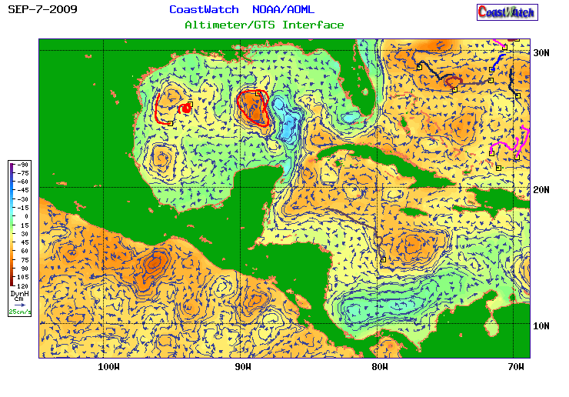

Altimeter-derived geostrophic currents are posted in real-time with surface drifter trajectories superimposed. These fields can be obtained from:
http://www.aoml.noaa.gov/phod/dataphod/work/trinanes/INTERFACE/index.html
Altimeter-derived geostrophic currents overlaid over the dynamic height field for September 7, 2009. Drifter trajectories for the period UGUST 25 – September 7, 2009, are superimposed.
The Use of Satellite Derived Oceanographic Data for Fish Stock Assessment in the Gulf of Mexico
Gustavo Goni, Francis Bringas and Ricardo Domingues

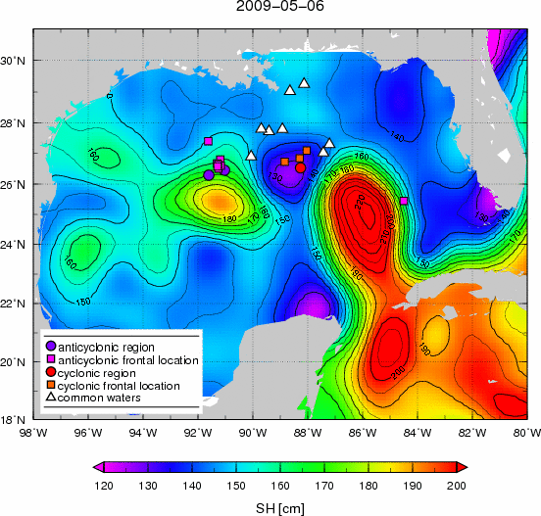
In collaboration with Dr. David Lindo (RSMAS) and researchers from NOAA’s Southeast Fisheries Science Center (SEFSC), ocean parameters and data of fish catches are being used to investigate the link between ocean dynamics and stock assessment of several species in the Gulf of Mexico. The oceanographic data includes sea surface temperature (SST), sea height anomaly (SHA), chlorophyll a and derived products, such as eddy kinetic energy (EKE) and sea surface height (SH). The data of catches correspond to bluefin tuna (BFT), yellowfin tuna (YFT) and swordfish (SWO) and were obtained from a U.S. longline fleet operating in the Gulf of Mexico. A methodology based on the oceanographic observations was developed to determine whether captures occurred in regions of anticyclonic or cyclonic features, frontal locations, or in Gulf common waters. Results show that catches of BFT, YFT and SWO were not homogeneous in space and time as reflected by their Catch-Per-Unit-of-Effort (CPUE). BFT catches seem to be associated with temperatures below 27.2°C, while YFT catches were associated with higher temperatures. BFT CPUE showed a ‘dome shape’ response to SHA, SH, SH gradient, ocean color, and EKE with highest values associated with the frontal areas of the cyclonic rings. BFT CPUE was zero in areas associated with anticyclonic rings. Lower fishing effort in areas dominated by anticyclonic features diminished the capability of drawing sound conclusions from the relationship between CPUE and these features. The qualitatively different responses of the CPUE of BFT, YFT and SWO to oceanographic features could be used to locate specific areas where the catches of a certain target species could be enhanced while reducing the incidental catch of non-target species. At the present time, estimation procedures used to standardize catch rates (CPUE) for the US pelagic longline fleet do not include environmental observations. Identifying the oceanographic features that affect catch rates is the first step towards the incorporation of environment effects in the process of stock assessment and ecosystem based management.

Captures of bluefin tuna, yellowfin tuna and swordfish are linked with the oceanographic features in the region. Each location is labeled according to the ocean dynamics: anticyclonic feature, cyclonic feature, frontal region, or common waters, based on values of sea height and on the horizontal gradient of sea height. The most important features of the region are revealed by the field of sea height, where cyclonic and anticyclonic rings and the main location of the Loop Current can be observed.

Dual Salinity Drifters: Investigating the Processes Contributing to the Salinity Differences between Aquarius and in situ Measurements

Shenfu Dong, Denis Volkov, Gustavo Goni, Rick Lumpkin, and Gregory Foltz

Sea surface salinity (SSS) measurements provide valuable observations to study the global hydrological cycle and, thus, advance our understanding of the Earth’s climate system as a whole. Prior to their application in climate studies, space-borne SSS measurements need to be compared with in situ salinity in order to assess the accuracy of remote sensing products and, ultimately, to improve the satellite SSS retrieval algorithms. The direct comparison, however, is challenged by the fact that microwave radiometers onboard satellites measure salinity at a depth of 1 cm, whereas in situ measurements of SSS are taken at depths from 1 to 5 m. Knowledge of the near-surface salinity structure is, therefore, fundamental for interpreting the differences between satellite and in situ SSS measurements.

The ultimate goal of this project is to maximize the value of the SSS measurements provided by satellites. In order to reach this goal, we have established the following two specific objectives: (1) validate satellite SSS retrievals, and (2) investigate the surface salinity stratification in the upper 5 m of the ocean. In particular, we aim to explore the effect of salinity differences at the two measurement depths on the salinity differences between satellites and Argo.

To accomplish the two objectives of our investigation, we deployed an array of salinity drifters in the subtropical South Pacific (3), and the South Atlantic (3). Additional six salinity drifters will be deployed in the Eastern Tropical Pacific in 2016 and 2017. Each drifter is equipped with two conductivity/temperature probes at 15-20 cm and 5 m depth. These drifters are specifically designed for this project. The drifter records will provide a valuable data set to validate satellite SSS retrievals and to improve our knowledge of the near-surface salinity structure. Ultimately, better SSS product will advance our understanding of the global climate system. In total, we will deploy 12 drifters. Eight out of these 12 drifters are contributed by NOAA/AOML.
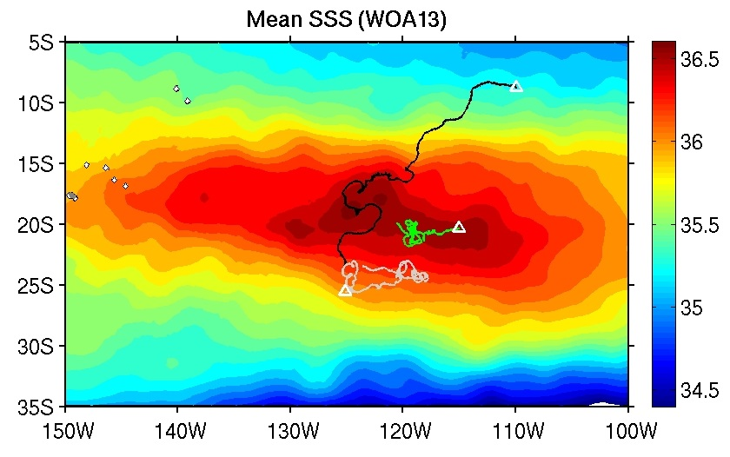

Trajectories of the three salinity drifters deployed in the subtropical South Pacific in April/May 2015. White triangles indicate the location of deployments. Color map shows the mean sea surface salinity from the World Ocean Atlas 2013.
Monitoring of the Gulf of Mexico Conditions during the Deepwater Horizon Oil Spill
An AOML - wide effort

As part of NOAA's mission to study the role of the ocean in climate and ecosystems, AOML scientists have for many years been devising methods and tools to allow for the real-time monitoring of ocean conditions. Following the Deepwater Horizon explosion in April 2010, AOML mounted a scientific response effort building upon these capabilities. A web portal (http://www.aoml.noaa.gov/phod/dhos) was designed to provide data and graphical products about ocean currents, sea surface temperature, sea level, ocean color, and particle displacement, obtained using direct ocean measurements, remote observations collected via satellite, and outputs from numerical models. AOML and NMFS/SEFSC organized an oceanography workshop in Miami on July 1-2, 2010, where observations, methods, and strategies were discussed. AOML scientists also participated on spill related research panels lead research cruises focused on assessing the extent of the spill in the greater Gulf of Mexico and the potential for entrainment via the Loop Current to downstream ecosystems, and published scientific manuscript related to the ocean conditions during the oil spill.
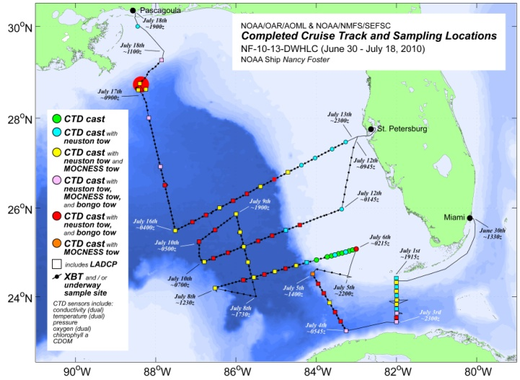
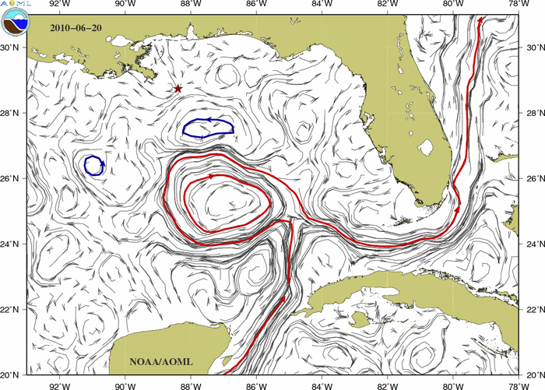

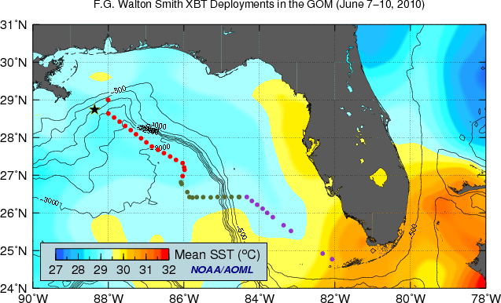
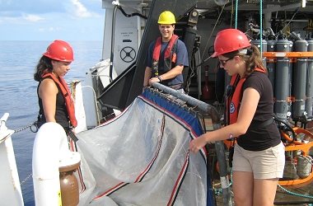

Upper left: Altimetry-derived Gulf of Mexico surface currents, available via the web portal. Upper right and lower left: Cruise tracks and sampling operations conducted on AOML oil spill response cruises. Lower right: AOML and SEFSC personnel prepare a neuston net to sample for tar balls.
Ocean Stratification and the Intensification of Tropical Cyclones
Gregory Foltz

This project is in collaboration with scientists at Pacific Northwest National Laboratory. Traditional metrics of tropical cyclone heat potential are based on a vertical average or integral of temperature down to a fixed depth or isotherm, respectively. These static methods however do not accurately account for tropical cyclone-induced vertical mixing, which depends critically on the upper-ocean stratification and wind strength. In this project, a simple new “dynamic heat potential” was derived that is based on considerations of stratified fluid turbulence. An analysis of tropical cyclones for the 10-year period 2004-2013 and spanning the entire Northern hemisphere shows that while previous methods explain 0%-16% of the variance in tropical cyclone intensification rates, the dynamic heat potential explains 11%-32%. Furthermore, it was found that if salinity is removed from the dynamic heat potential the variance explained for major tropical cyclones decreases by as much as 7%. Future work will involve developing methods to obtain near-real-time subsurface temperature and salinity profiles from satellite-based surface temperature, salinity and sea level with the goal of introducing dynamic heat potential into operational tropical cyclone intensity forecasts.

(A) Dynamic heat potential, (B) comparison to traditional heat potential, and (C) contribution of salinity to dynamic heat potential.

An Enhanced XBT probe
Marlos Goes and Gustavo Goni

Expendable BathyThermograph (XBT) observations account for a large percentage of the existing global ocean temperature record. Historical temperature differences between XBT and conductive- temperature-depth (CTD) profiles are found in the historical record, which are mostly due to time variable XBT depth biases. These biases account for most of the apparent interannual variation of heat content in the ocean, and therefore, may influence the ability of climate models to better simulate the ocean heat uptake.
Traditional XBT probes do not contain pressure sensors. Depth is estimated according to a semi-empirical quadratic relationship between the time of descent and depth, known as the fall rate equation (FRE). According to the manufacturer, systematic errors associated with XBT temperature measurements are typically a linear bias of ± 2% of depth, a depth offset of ± 5m, and a temperature accuracy of ±0.15°C. The objective of this work is to produce a new XBT probe which will produce temperature profiles with a temperature precision of ~ 0.02°C and a maximum depth bias of ~ 2m, comparable to Argo measurements. Scientists and engineers from NOAA/AOML along with Lockheed Martin Sippican engineers are carrying out theoretical and sea experiments to design a new Climate Quality XBT (CQ-XBT) system. The CQ-XBT system will consist of three main improvements upon its predecessor:
1) The inclusion of pressure switches in the XBT probes (Figure) will reduce the depth biases associated with the FRE. Results from a theoretical study (Goes et al., 2013) show that given the typical XBT depth biases, using two pressure switches is a reliable strategy for reducing depth biases, and that the measurements should be taken in the lower thermocline and deeper in the profile.
2) Improved thermistor calibration to reduce pure temperature errors. Several sea trials have already been carried out in the tropical and North Atlantic oceans aiming at testing different thermistor calibration methods.
3) An updated firmware to accommodate all the changes, as well as be capable to work with previous systems.
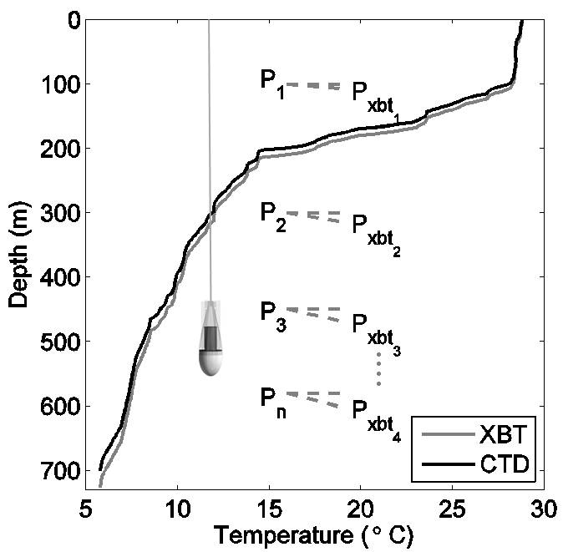
Schematic of the depth correction using pressure switches. During the descent of the XBT probe (probe not to scale), a temperature profile is produced. Pressure switches installed in the probe are triggered at various depths, and the recorded measurements P1, P2,..., Pn correct the profile to the actual depths
Expendable Bathythermograph Fall Rate Equation
Marlos Goes, Gustavo Goni, and Francis Bringas

Analyses of concurrent Expendable Bathythermograph (XBT), Conductivity, Temperature, and Depth (CTD) and Argo float observations are being carried out, to systematic differences in temperature to assess profiles, which is likely due to an error in the XBT fall-rate equation. This error has introduced a warm bias in the global XBT data base. AOML is participating with the international community to evaluate these biases. Results obtained from this and other studies indicated that new coefficients the XBT fall rate equation may need to be used. A methodology was developed at AOML to identify and estimate systematic biases between XBT and Argo observations using satellite altimetry. Pseudo-climatological fields of isotherm depths are computed by least squares adjustment of in–situ XBT and Argo data to altimetry–derived sea height anomaly (SHA) data. In regions where the correlations between isotherm depth and SHA are high, this method reduces sampling biases in the in-situ observations by taking advantage of the high temporal and spatial resolution of satellite observations. The increase in XBT minus Argo differences with depth is consistent with known problems in the XBT fall rate equation. Least-squares fit of the depth-dependent XBT minus Argo differences suggests a global 3% bias in the XBT depths with respect to Argo. The depth-dependent 3% error is robust among the different ocean basins confirming that the terminal velocity is a problem in the XBT instruments.

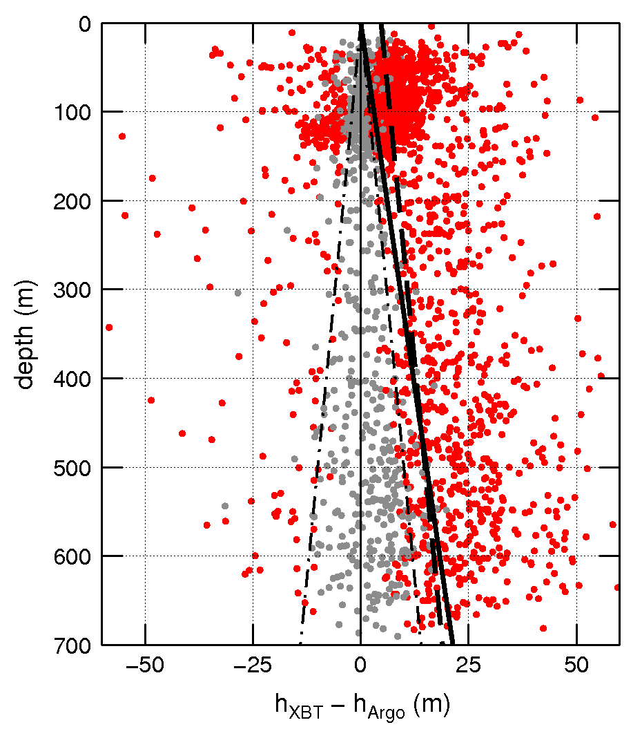

Scatter plot of the differences between the pseudo-climatological isotherm depth estimates as a function of depth for the global ocean. The depth axis corresponds to the pseudo-climatological isotherm depth derived from Argo. Positive h_{XBT} – h_{Argo} differences indicate that the XBT estimates result in deeper isotherms for the period 2000–2007. Red dots correspond to significant biases, while gray dots to not significant biases.

Tropical Atlantic Current Observations Study
Renellys C. Perez, Gregory Foltz, Rick Lumpkin, Claudia Schmid

Hurricane activity in the Atlantic Ocean and rainfall over the neighboring continents are strongly impacted by coupled ocean-atmosphere interactions in the tropics. Fine-vertical-scale (less than 10 m) variations in the upper ocean velocity impact sea surface temperature and air-sea fluxes in the tropical North Atlantic through their contributions to vertical turbulent mixing and horizontal advection of heat and salinity. It is therefore critical to understand how the upper ocean velocity is modified by wind forcing events on daily to interannual (year-to-year) timescales, and by ocean phenomena such as tropical instability waves on daily to monthly timescales.

As part of the Tropical Atlantic Current Observations Study (TACOS), the PIRATA Northeast Extension (PNE) mooring at 4°N, 23°W in the tropical Atlantic will be augmented with ten acoustic current meters. The current meters will begin collecting data in February 2017. The instruments will collect velocity measurements at 5 m intervals from the surface to 40 m depth and with larger spacing (10 to 20 m intervals) between 40 m and 100 m depth. With the real-time data collected during this experiment, we will be able to measure for the first time the fine vertical structure and shear of surface mixed layer currents at 4°N, 23°W and examine their connections to local air-sea fluxes and upper-ocean heat and salinity changes, using near-surface meteorological and subsurface temperature and salinity data already collected by the buoy.
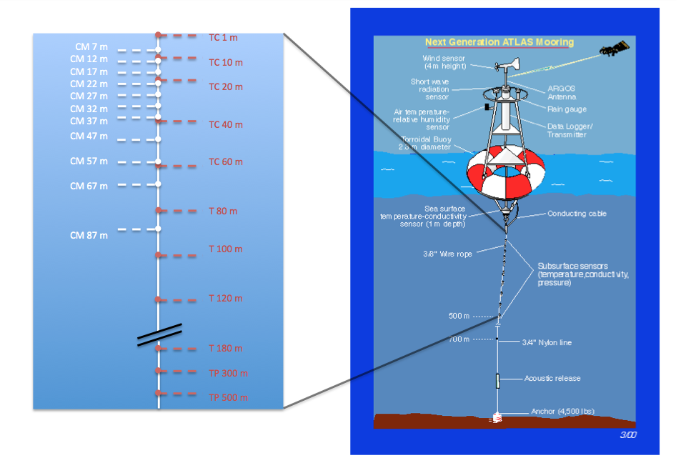

Schematic of the depths of the Tropical Atlantic Current Observations Study (TACOS) current meters (CM) relative to the depths of temperature (T), conductivity (C), and pressure (P) measurements made by the standard PNE ATLAS mooring.
Meridional heat Transport in the South Atlantic reveals links with global monsoons
Hosmay Lopez, Shenfu Dong, Sang-Ki Lee and Gustavo Goni

Although the majority of efforts to understand the dynamics of the Atlantic Meridional Overturning Circulation (AMOC) and its climate and weather impact are focused on the North Atlantic, recent studies have suggested the possibility of the southern origin of the anomalous AMOC and associated meridional heat transport in the Atlantic. The objective of this study is to illustrate that multi-decadal variability of South Atlantic meridional heat Transport (SAMHT) plays a key role in modulating global atmospheric circulation via its influence on interhemispheric redistributions of momentum, heat, and moisture. Weaker SAMHT at 30°S produces anomalous ocean heat divergence over the South Atlantic, resulting in cooler ocean surface temperature about 20 years later. This drives an anomalous Hadley circulation, transporting atmospheric heat from the Northern Hemisphere (NH) to the Southern Hemisphere (SH) and moisture from the SH to the NH, thereby modulating global monsoons. This study illustrates that decadal variations of SAMHT could modulate the strength of global monsoons with about 20 years in advance, suggesting that SAMHT is a potential predictor of global monsoon variability. In summary, all NH summer monsoons are enhanced during a weaker SAMHT. The results presented in this study highlight the need and value of sustained ocean observational efforts, necessary to improve our knowledge of the complex interaction between the South Atlantic Ocean and global climate variability and monsoons.
a)  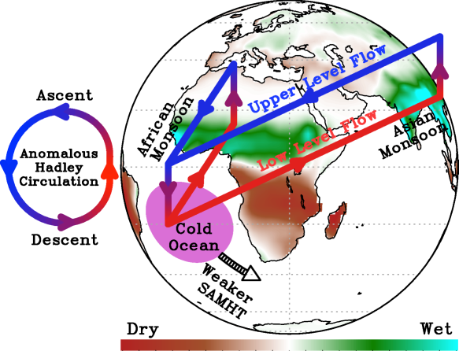 | b)  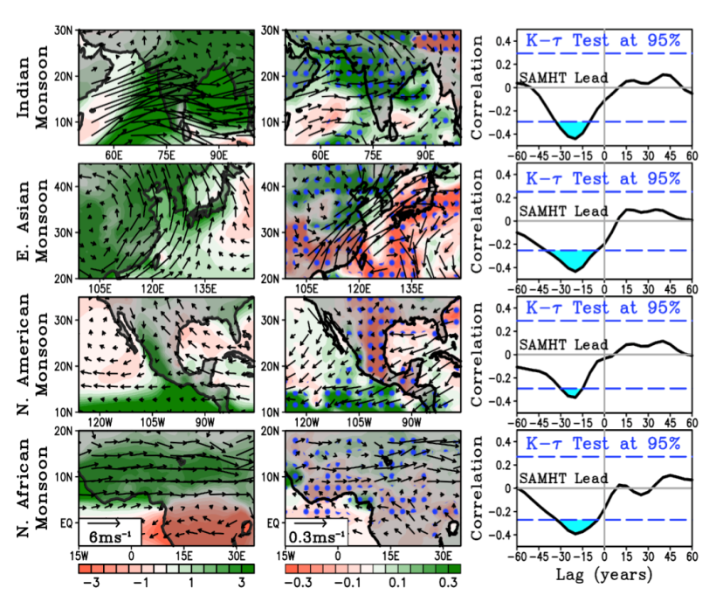
a) Illustration of the role of weaker-than-normal SAMHT in atmospheric circulation at 20 years lead-time. Weakened SAMHT is shown by thick black arrow. This results in a cooler than normal South Atlantic Ocean (purple shade) which produce an anomalous Hadley circulation labeled by counterclockwise circulation. The lower branch of the circulation (red arrow) brings warm and moist air from the Southern Hemisphere (SH) to the Northern Hemisphere (NH). This circulation sense produces ascent and precipitation in the NH thus enhancing the NH monsoons. b) (left-column) seasonality of precipitation and 850mb winds for the monsoon regions. (middle-column) composite difference of JJAS precipitation (shaded) and 850mb wind for each monsoon region with respect to weak minus strong SAMHT at lead-time 20 years after the anomalous SAMHT. Blue stipples indicate regions where n differences are significant at 95% confidence level. (right-column) Lag-lead Spearman ranked correlation between SAMHT and NH monsoon index. The blue dashed lines depict the 95% significance level. Negative lag indicates periods when SAMHT leads the NH monsoon index. Periods with significant correlation between the SAMHT and monsoon are shaded blue.
Assessment of the Meridional Overturning Circulation and Meridional Heat Transport and their Meridional Variability in the South Atlantic Ocean
Gustavo Goni and Shenfu Dong

This project is geared towards making use of the 20+ years of continuous altimetry measurements combined with satellite-derived sea surface temperature (SST) and in situ data to estimate the MOC and MHT in the South Atlantic and to investigate their latitudinal and temporal changes in the South Atlantic.

To accomplish these goals, this work includes several well-defined components:
- Estimation of the temporal evolution of the MOC/MHT at every 5° of latitude from 20°S to 35°S since 1993;
- Assessment of the error of the above estimates through comparisons with XBT-derived estimates at 35°S and with CLIVAR A10 section estimates at 30°S;
- Assessment of the individual contributions of the geostrophic and Ekman components to the MOC/MHT at different latitudes;
- Investigation of year-to-year and inter-annual variability of the MOC/MHT and of their components (e.g., Ekman/geostrophic, gyre/overturning, boundary currents/interior, eddies/large-scale flow) and investigate potential links with wind forcing;
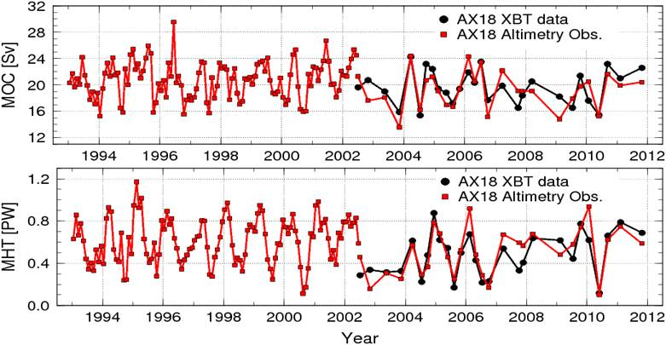
- evelopment of South Atlantic 20-year proxies against which the performance of ocean general circulation models (e.g. HYCOM) and coupled climate models (e.g. CCSM4 and GFDL CM 2.1 and 2.4) can be evaluated;

MOC and MHT estimated from high-density XBT line (AX18, black line) and satellite altimeter measurements (red line).

Meridional Heat Transport Variability in the Atlantic Ocean
Shenfu Dong, Molly Baringer, Silvia Garzoli, and Gustavo Goni

The Atlantic Ocean Heat Transport is estimated and monitored to diagnose and understand ocean circulation variability, identify changes in the Meridional Overturning Circulation (MOC) and to monitor for indications of possible abrupt climate change. The Atlantic Ocean is the major ocean basin involved in large-scale northward transports of heat typically associated with the MOC where warm upper layer water flows northwards, and is compensated for by southward flowing North Atlantic Deep Water. This large-scale circulation is responsible for the northward heat flux through the entire Atlantic Ocean.

In recent results, the variability of the Atlantic Meridional Overturning Circulation (AMOC) and its effect on the net northward meridional heat transport (MHT) in the South Atlantic are examined using a trans-basin expendable bathythermograph (XBT) High Density transect at 35°S (AX18). An update to this time series is shown in the Figure below. The mean MHT is 0.59 ± 0.15PW and no significant trend is observed from 2002 to 2011. The MOC varies from 13.7 to 25.6Sv with a mean value of 19.3 ± 2.8Sv and the maximum overturning transport is found at a depth that is deeper than that in the North Atlantic (mean depth of 1250m). Statistical analysis suggests that an increase of 1 Sv in the MOC leads to an increase of the MHT of 0.04 ± 0.01 PW.

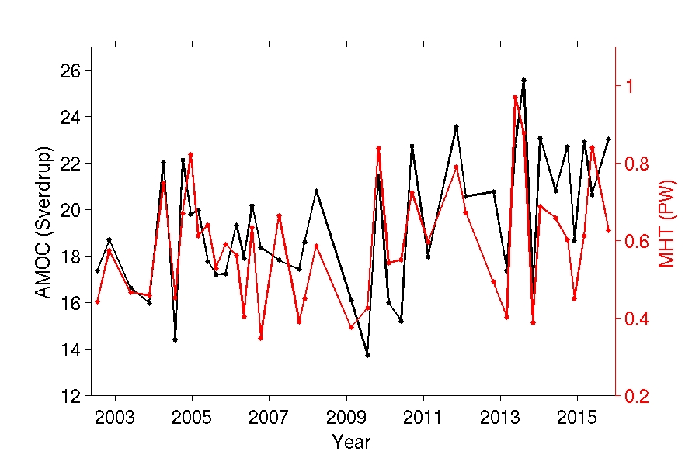

Time series of the MHT (black) and the AMOC (red) along nominally 35°S for the time period 2002 to 2011.

Meridional Volume and Heat Transport in the South Atlantic
Claudia Schmid, George Halliwell and Sudip Majumder

The Atlantic Meridional Overturning Circulation (MOC), consisting of a northward flow
of warm water in the upper layer and southward flow of cold water in the deeper layers, plays an
important role in the global energy balance. The Atlantic MOC transfers heat from the tropics and southern hemisphere to the north, and is believed to be linked to several climate phenomena such as past climate change, hurricane intensity in the North Atlantic and anthropogenic climate forcing. Even though the South Atlantic plays a key role by transporting heat from the south towards the equator, and includes large areas where water masses from different oceans mix, this ocean is historically poorly sampled compared to the North Atlantic.

This project aims at understanding the variability of Meridional Overturning volume and heat transports (MHT) across four different latitudes in the South Atlantic using Argo observations, satellite altimetry and wind products. Results from the observations are analyzed in conjunction with model-based estimates from three different models with data assimilation. Time series and mean values of transports are obtained, seasonality (Figure 1), interannual variations and correlations between the overturning volume and heat transports (Figure 2) are examined.

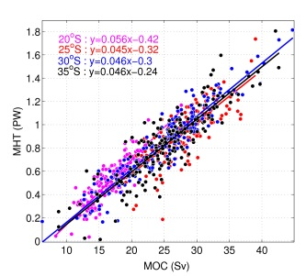
Results reveal differences in seasonality of MOC in observations and model-based estimates. Mean transports from the observations are often higher than the model estimates; the main exception of this are transports from HYCOM. Estimates from the models not only differ observations in mean strengths and seasonality, but the MOC strengths at the boundary and the interior vary greatly in different models.
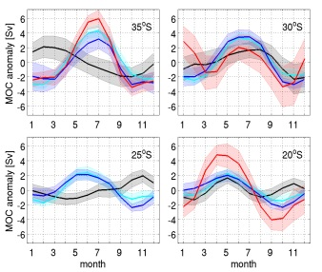
HYCOM are not shown for 25ºS.
Figure 1 Figure 2
Climatological annual ccyle of anomalies of MOC strengths Scatter plot of MOC strengths against MHTs from across 35ºS, 30ºS, 25ºS, and 20ºS from Argo & SSH (black), Argo & SSH. Straight lines are the corresponding
NCEP/GODAS (blue), SODA (cyan) and HYCOM linear fits. latitudes: 20ºS (magenta), 25ºS (red),
(red). Shading indicates 95% confidence interval. Results from 30ºS (blue) and 35ºS (black).
HYCOM are not shown for 25ºS.

Continuous Records of the Mixed Layer Heat Budget in the

Tropical Atlantic
Gregory Foltz, Claudia Schmid, and Rick Lumpkin

The tropical Atlantic Ocean and surrounding continents have experienced several extreme climate events during the past two decades that have resulted in once-in-a-century droughts in the Amazon, extreme drought and flooding in Northeast Brazil, and unprecedented hurricane activity in the Atlantic basin. Almost all of these extreme events have been connected to highly anomalous sea surface temperatures in the tropical Atlantic. However, the mechanisms driving the extreme SST fluctuations are poorly known.
Empirical analyses of SST variability in the tropical Atlantic usually rely heavily on data from satellites, atmospheric reanalyses, and global hydrographic profiles. Direct measurements from the Prediction and Research Moored Array in the Tropical Atlantic (PIRATA) are used much less frequently, despite the generally higher quality of the atmospheric measurements compared to those from satellites and reanalyses, and the enhanced temporal sampling rate of all PIRATA data. Part of the reason is that data from the PIRATA moorings is more difficult to interpret because of the presence of occasional gaps and biases in the time series.
A powerful quantitative tool for assessing the mechanisms responsible for SST variability is mixed layer heat budget analysis. In this project we aim to address gaps and biases in the PIRATA records and avoid inconsistencies in the parameters chosen for heat budget analyses. The resulting product will be a consistent and continuous data set containing the main terms in the mixed layer heat budget of the tropical Atlantic Ocean during 1998-2015. The data set will consist of daily time series of each heat budget component from each of the 17 moorings of PIRATA. The product will be valuable for assessing the causes of extreme climate events in the tropical Atlantic, for validating ocean and climate models, and for diagnosing biases in coupled climate model simulations.
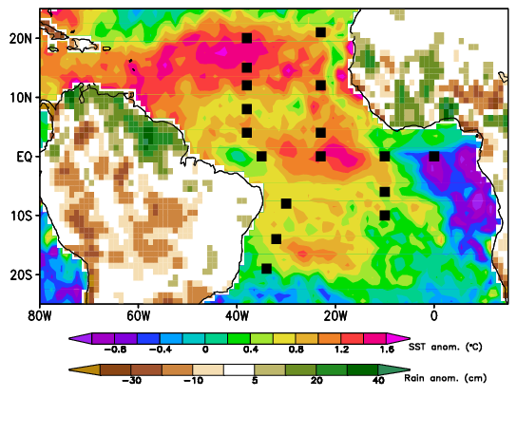
June 2010 SST anomaly (shaded over ocean) and JJAS 2010 rainfall anomaly (shaded over land). Black squares show the positions of the PIRATA moorings.
Changes of the salinity in the upper ocean
Claudia Schmid

This project is a collaborative effort between AOML and colleagues from NCEI and PMEL (G. C. Johnson, J. Reagan, J. M. Lyman, T. Boyer and R. Locarnini).

Salinity patterns, both long-term means and their variations, reflect ocean storage and transport of freshwater, a key aspect of global climate (e.g., Rhein et al. 2013). Ocean salinity distributions are largely determined by patterns of evaporation, precipitation and river run off (e.g., Schanze et al. 2010). In some high latitude regions, sea ice formation, advection and melting are important (e.g., Petty et al. 2014). The result is relatively high surface salinity in the subtropics where evaporation dominates and fresher SSS values under the Intertropical Convergence Zones and in the subpolar regions where precipitation is stronger. These fields are further modified by ocean advection (e.g., Yu 2011). In the subsurface, fresher subpolar waters slide to intermediate depths, underneath saltier subtropical waters, which are in turn capped at low latitudes by fresher tropical waters (e.g., Skliris et al. 2014). Salinity changes in these layers quantify the increase of the hydrological cycle with global warming over the recent decades, likely more accurately and directly than analysis of E–P estimates (Skliris et al. 2014).

The project aims to detect and analyze changes of the salinity in the world oceans. For example, in 2005-2015 the near surface salinity in the Pacific gradually increased resulting in a transition from a negative anomaly to a positive anomaly in 2008. A reversal of this trend is detected in 2014 to 2015. This and other features are discussed in the salinity section of the BAMS issue on the state of the ocean.
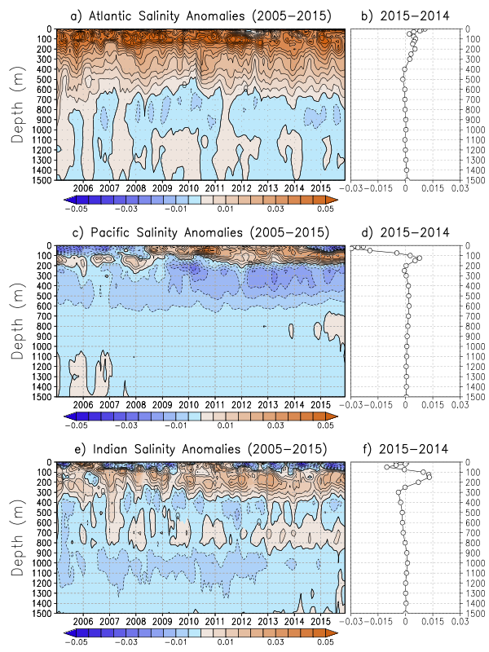

Average monthly salinity anomalies from 0-1500m depths for the Atlantic a) from 2005-2015 and b) the change from 2014 to 2015, Pacific c) from 2005-2015 and d) the change from 2014 to 2015, and Indian e) from 2005-2015 and f) the change from 2014 to 2015. The data was smoothed using a 3 month running mean. The anomalies are relative to the World Ocean Atlas 2009 monthly salinity climatology (Antonov et al. 2010).
Variability of the South Atlantic Subtropical Gyre
Renellys C. Perez

The rate at which heat is transported northward vs. stored by the South Atlantic (SAtl) subtropical gyre is of great importance, as the gyre plays a significant role in the establishment of oceanic teleconnections, and changes occurring in the South Atlantic alter the Atlantic Meridional Overturning Circulation (AMOC). As part of this study, the time-variability of the SAtl subtropical gyre through analysis and interpretation of satellite and in situ data, synthesis products, and ocean-only and coupled climate models will be investigated. The overall goals of this project are two-fold: a) to describe the evolution of the SAtl subtropical gyre over the past two decades in the surface and intermediate waters; and b) to improve our understanding of the mechanisms that control the variability of the SAtl subtropical gyre, and the currents that delineate the boundaries of the gyre, on interannual to decadal timescales. Specifically, we will characterize the time-mean and time-varying components of the Brazil Current, South Atlantic Current, Benguela Current, Agulhas leakage, and South Equatorial Current, and ascertain whether the primary mechanisms and sources responsible for the variability of each of those currents are the same as the mechanisms that govern the gyre variability. This work is done in collaboration with Rym Msadek (CERFACS, France) and Ricardo Matano (OSU/CEOAS).
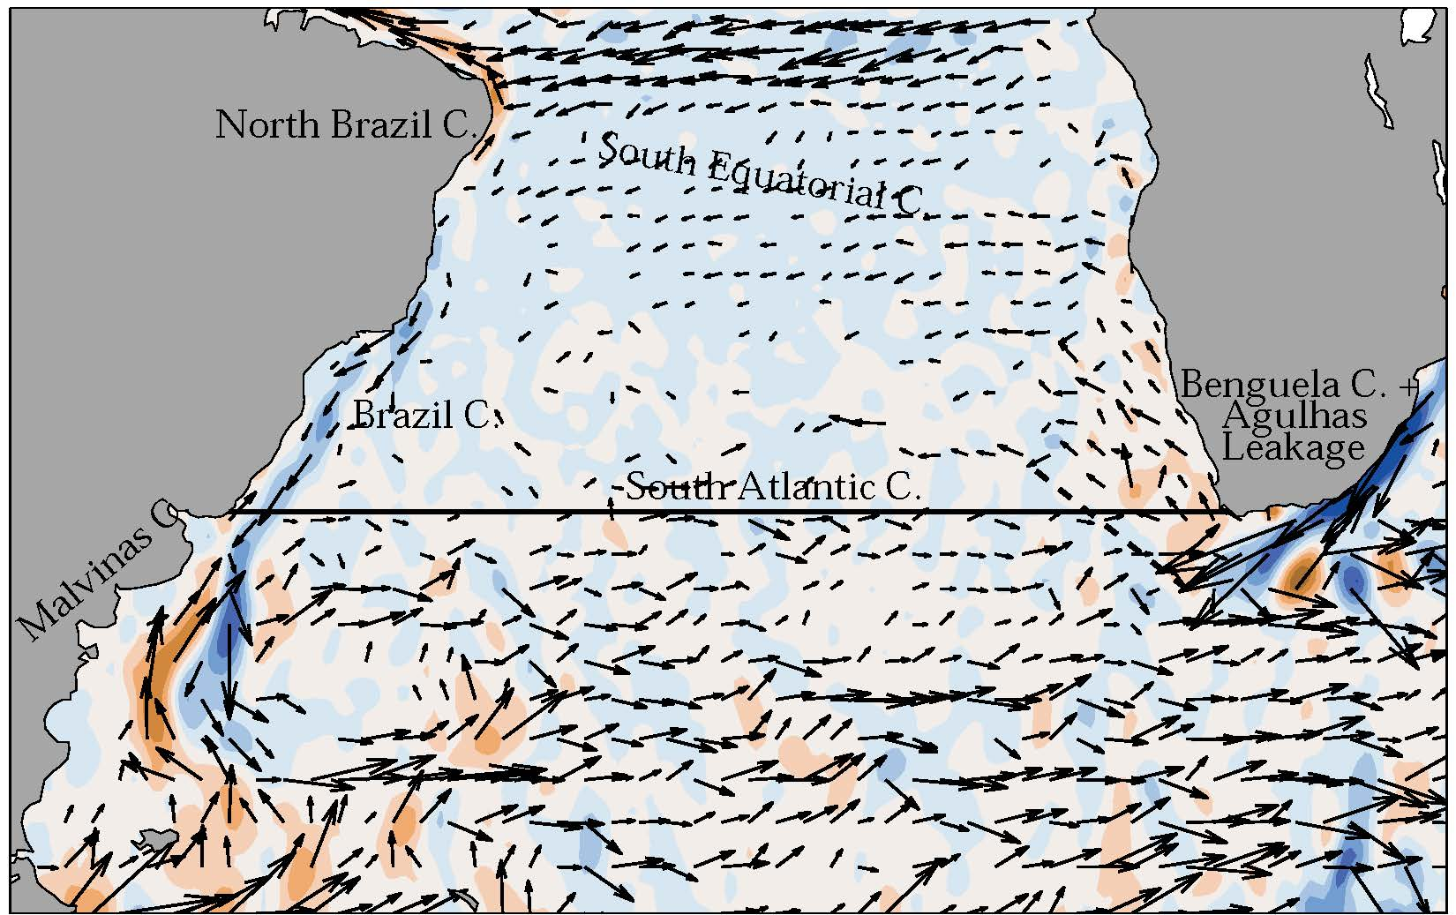
Map of mean near-surface (15-m) currents delineating the boundaries of the South Atlantic subtropical gyre from the Lumpkin and Garzoli (2011) drifter-altimetry synthesis product. Color shading: meridional currents (blue indicates southward and brown indicates northward). Vectors show horizontal currents with magnitudes in excess of 10 cm/sec. Labels indicate major circulation features.

Transports in the eastern and western boundary regimes of the subtropical South Atlantic
Claudia Schmid

The goal of this project is to improve the knowledge and understanding of the meridional circulation along the boundaries of the subtropical South Atlantic, which is an important component of the Meridional Overturning Circulation. Monthly three-dimensional fields of the horizontal velocity for the years 2000 to 2014 were derived from Argo profiles, AVISO satellite sea surface height, and subsurface trajectories from Argo and other floats (Argo & SSH; Schmid, 2014) for the purpose of studying the circulation in the South Atlantic. Due to space limitations, this summary focuses on the Brazil Current.

The mean annual cycle of the Brazil Current is characterized by high (low) southward transports in austral summer (winter), both in Argo & SSH and in data assimilation models. The best agreement is visible at 24ºS. At 35S NCEP has smaller transports and both at 35ºS and 38ºS SODA has larger transports. The full time series also reveals interesting signs of interannual variability, both in terms of magnitude and in terms of variations of the annual cycle. Periods exceeding a year with relatively low/high transports are observed at 24ºS and 35ºS (e.g. 24ºS: 5/2008-8/2009 with 2.7±0.3 Sv and 12/2013-5/2014 with 5.0±0.8 Sv).
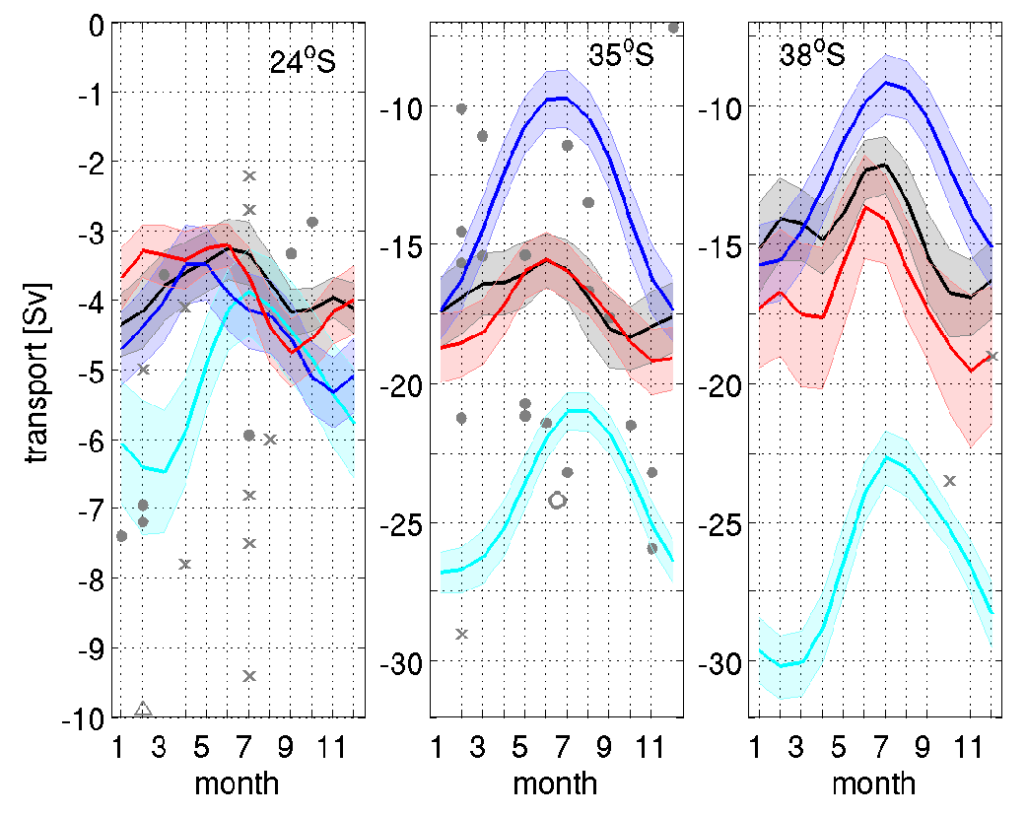

Mean annual cycle of the meridional transports in the Brazil Current at three latitudes. Red, blue and cyan lines are from HYCOM reanalysis, NCEP/GODAS and SODA, respectively. Shading indicates standard errors. Gray dots are based on transport estimates by Garzoli et. (:2013). Gray crosses indicate estimates from other studies.
The Brazil Current variability and basin-scale interactions
1a)

Gustavo Goni, Molly Baringer, Marlos Goes, and Shenfu Dong

The Brazil Current (BC) closes the circulation of the South Atlantic subtropical gyre as a western boundary current,. Although much weaker than the Gulf Stream, its North Atlantic counterpart, the BC is also subject to strong mesoscale variability. South of 30ºS, the BC encounters the Malvinas Current, producing a highly energetic system, the Brazil-Malvinas Confluence. Recent studies show that the confluence region is highly variable, including a latitudinal migration of the Brazil Current front to the south. The association of these changes with the large scale features such as the South Atlantic subtropical gyre and the meridional overturning circulation is still an open question.

This work aims at assessing the link between the BC variability and large scale features in the South Atlantic. In order to accomplish this, we use a suite of hydrographic and satellite observations in the South Atlantic, which include three high-density XBT transects (namely AX08, AX18 and AX97), satellite altimetry, wind products, and Argo data, to bring a large scale view of the South Atlantic changes.

One key finding includes a southward shift of the BC front separation from the continental shelf break of approximately 1.5° during the last 20 years. Additional results, obtained in partnership with researchers from the Federal University of Rio Grande, Brazil, indicate that there is a strong relationship between the BC current and the extent and intensity of the subtropical gyre. A stronger BC has been linked to the northward migration of the subtropical gyre in seasonal scales.
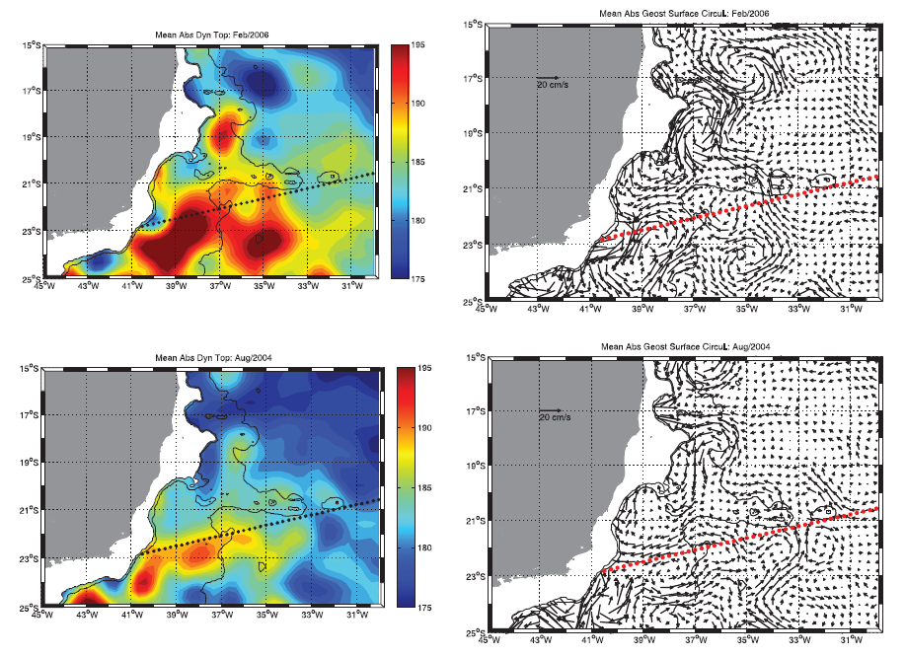

Regional absolute dynamic height fields in dyn.cm (left) and the corresponding geostrophic circulation in cm/s (right) during the February 2006 and August 2004 AX97 XBT
Extratropical Triggering of El Niño Events Through the Trade-Wind Charging Mechanism
Renellys C. Perez

This project is a collaborative effort between AOML, Bruce Anderson (Boston University), Benjamin Giese (Texas A&M University). This work investigates the relationship between year-to-year variations in the extratropical atmosphere and their influence on the initiation and evolution of El Nino/Southern Oscillation (ENSO) events using data taken from observationally constrained reanalyses and numerical model experiments. Previous results indicate variations in subtropical North Pacific sea-level pressures (SLP) influence the state of the tropical Pacific 12-15 months prior to mature boreal-winter ENSO events. Research has also shown that these SLP anomalies associated with the southern lobe of the North Pacific Oscillation (NPO) and the accompanying changes in central Pacific trade winds modify sea surface temperatures (SST) across the tropical/subtropical North Pacific that subsequently shift equatorward via anomalous air-sea interactions. Less well understood is how these trade-wind changes modify subsurface temperatures across the tropical Pacific, despite the fact that temperature variations along the equatorial thermocline are a key initiator of ENSO events. For this project we will develop a numerical model framework designed to estimate the response of the ENSO system to observationally-constrained estimates of NPO-induced changes in the atmosphere. The oceanic response to these changes will be determined using an ocean-only model. The output from this model will be used to initialize a coupled ocean-atmosphere model, which will be integrated forward to determine the resulting evolution of the tropical Pacific, with a focus on the state of the ENSO approximately 12-15 months after the boreal winter NPO variations.
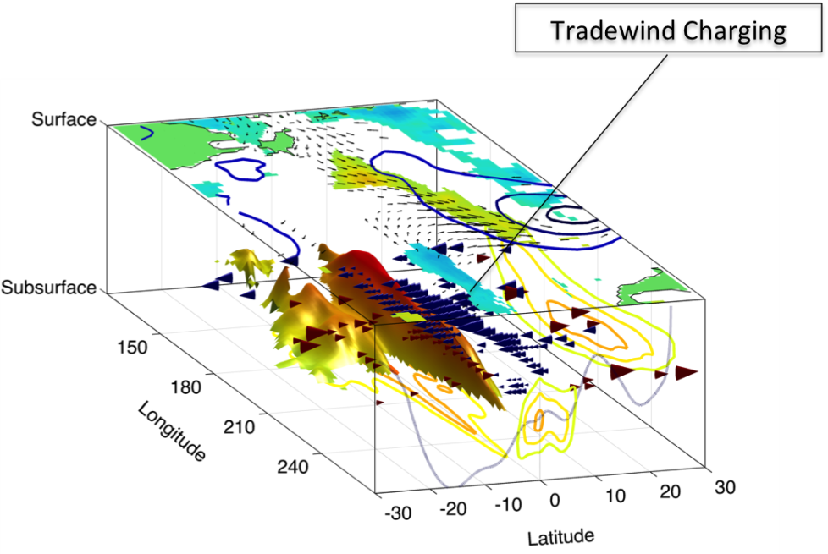

Schematic of surface and subsurface changes in the tropical Pacific linked to weakened North Pacific trade winds during Boreal Winter (Courtesy of B. Anderson). Black Vectors: Wind-stress anomalies. Surface Shading: Sea surface temperature anomalies. Subsurface Shading: Vertically-averaged temperature anomalies from 0-300m. Cones: Vertically-integrated meridional mass transport anomalies derived from the curl of the wind stress anomalies and vortex stretching. The cones represent the key feature of the Trade Wind Charging (TWC) mechanism linking the tradewind variations to the subsurface ocean temperatures.
Near-inertial Energy Pathways
Renellys Perez and Rick Lumpkin

Wind stress fluctuations acting at the surface of the ocean cause the mixed layer to “ring" with strong near-inertial oscillations. Some fraction of this energy is locally dissipated within the mixed layer or in the strongly stratified zone at its base. A large portion, however, makes its way into the ocean interior as propagating near-inertial waves, which eventually break and drive small-scale mixing. The near-inertial energy pathways, far from being controlled by linear processes, appear to be shaped at first order by interactions with the mesoscale eddy field. The nature of these interactions may be more complex than previously thought, involving several distinct mechanisms of energy transfer.

In this study, we investigate fundamental aspects of the near-inertial pathways through a combination of data analysis and numerical modeling in collaboration with principal investigators from the University of Miami (UM), Northwest Research Associates, Inc. (NWRA), Earth and Space Research (ESR) and international scientists. Our strategy is built around accessing and interpreting data from the Global Drifter Program network of surface buoys, available globally at approximately hourly resolution since 2005. Analysis of the surface drifter dataset will quantify previously unobservable details of the near-inertial variability in the surface mixed layer. At the same time, outstanding dynamical questions of wave/eddy interactions will be explored with high-resolution numerical experiments and dynamical models. The net result will be an improved and quantitative understanding of the near-inertial energy flux from the mixed layer to the ocean interior, an important element of the ocean's energy budget. Through this effort, a new hourly-interpolated drifter product with an explicit near-inertial component has been generated and made available to the science community.
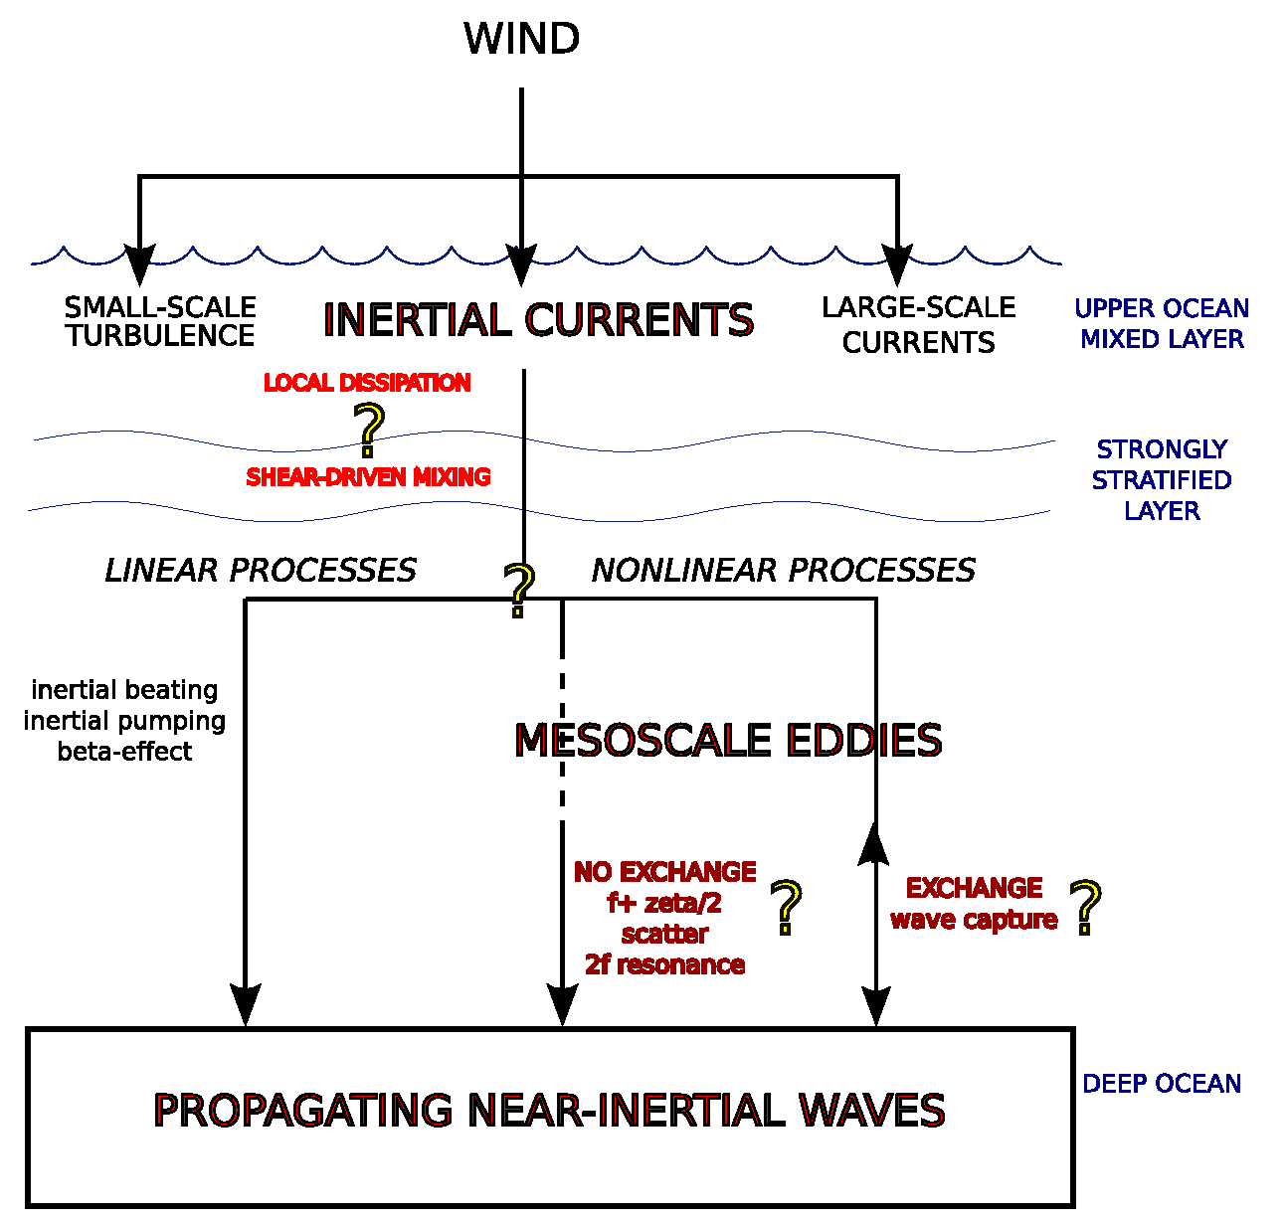

A schematic detailing the processes by which energy input by the wind is converted into propagating internal waves (courtesy of Jonathan Lilly, NWRA).
Intra-American Study of Climate Processes
Sang-Ki Lee

The Intra-American Study of Climate Processes (IASCLIP) is scheduled to run from 2009 through 2014, as a new component of CLIVAR VAMOS. The geographic milieu of IASCLIP is the Western Hemisphere warm pool (WHWP) comprised of the Caribbean and Gulf of Mexico, the eastern North Pacific warm waters off the Pacific coast of Central America and the western tropical Atlantic immediately east of the Lesser Antilles, including the islands and land regions in and around the WHWP. The overarching goal of IASCLIP is to estimate and exploit potential predictability of warm-season weather and climate in the region, mainly on intraseasonal to interannual timescales, with an aim to improve our understanding and modeling of relevant physical and dynamical processes. IASCLIP will also seek to link research to societal applications in the region.

Almost yearly, extreme weather and climate events cause damage to economies in the Western Hemisphere mounting in the millions, sometime billions of US dollars. In the United States they occur most often during summer in the form of droughts and tropical cyclones and in late springtime as tornadoes and floods. There is mounting evidence that summer climate depends on tropical Atlantic even more than on the Pacific. The WHWP is the boreal summer heating center for the Western Hemisphere; it is responsible for funneling moisture to all the surrounding regions during the summer season, and controls the summer environment for Atlantic hurricanes.

By orchestrating the efforts of scientists in the U.S., Mexico, Caribbean and Central/South American countries over the 2009-2014 time period, IASCLIP aims to: (1) Promote, coordinate, and organize research activities that aim to understand better the climate and hydrological processes in the IAS region, (2) Improve our ability to represent these processes in global climate models and predict them on subseasonal to interannual timescales, and (3) Facilitate applications of climate forecast products in the IAS region. Scientists at AOML have contributed greatly to IASCLIP.
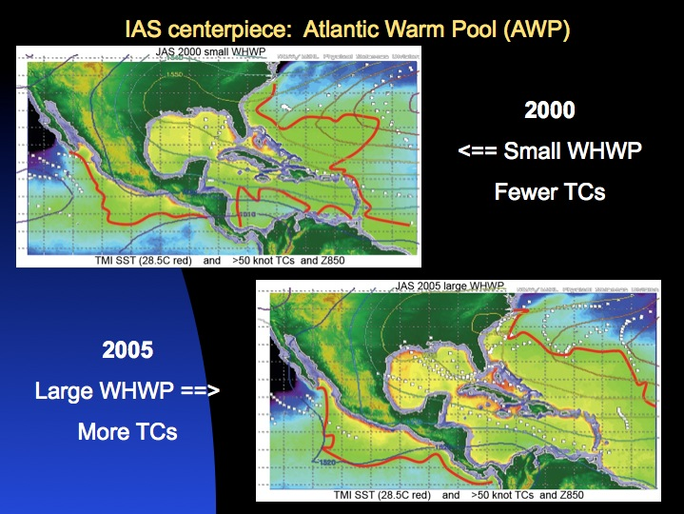

The tropical Atlantic SST varies in proportion to the size of the pool of water greater than about 28°C (red contour). Climate impacts accrue as well, the example shown here being the number of tropical cyclone tracks in a hurricane season. Upper left: smaller warm pool (2000) and fewer storm tracks (small dots). Lower right: larger warm pool (2005) and more storm tracks.

Atlantic Warm Pool and Tropical Cyclone Activity in the North Atlantic
Sang-Ki Lee

The 2010 Atlantic hurricane season was extremely active, but no hurricanes made landfall in the United States, raising a question of what dictated the hurricane track. Work done in collaboration with Dr. Robert Atlas (AOML/OD) indicates that the Gulf of Mexico, the Caribbean Sea and the western tropical North Atlantic play an important role in determine hurricane tracks. An eastward expansion of the AWP all shifts the hurricane genesis location eastward, decreasing the possibility for a hurricane to make landfall. A large AWP also induces barotropic stationary wave patterns that weaken the North Atlantic subtropical high and produce eastward steering flow anomalies along the eastern seaboard of the United States. Due to these two mechanisms, hurricanes are steered toward the northeast without making landfall in the United States. Although the La Niña event in the Pacific may be associated with an increased number of Atlantic hurricanes, its relationship with land-falling activity has been offset in 2010 by the effect of the extremely large AWP. We continue to work on influences of climate variability and changes on hurricane activity. In addition, we also investigate climate/oceans and tropical cyclone activity in the western North Pacific. In particular, we will focus on how climate/oceans and global warming affect the number, tracks and intensification of tropical cyclones in both the North Atlantic and the western North Pacific.

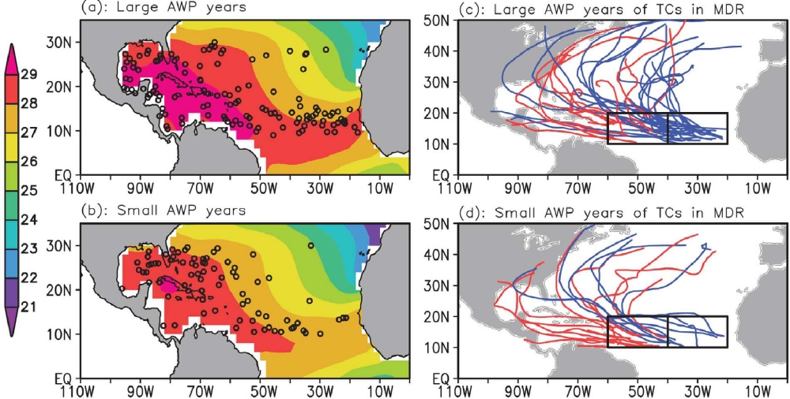

Tropical Cyclone genesis location (dots) and sea surface temperature (color shading) for (a) large and (b) small Atlantic warm pool years and the tracks of TCs that formed in the main development region for (c) large and (d) small Atlantic warm pools. pools.

Tropical Cyclone Heat Potential

Gustavo Goni, Joaquin Trinanes, and Francis Bringas

Sudden tropical cyclone (TC) intensification has been linked with high values of upper ocean heat content contained in mesoscale features, particularly warm ocean eddies, provided that atmospheric conditions are also favorable. Tropical cyclones occur in seven ocean basins: tropical Atlantic, northeast Pacific, northwest Pacific, southwest Indian, north Indian, southeast Indian, and south Pacific. The intensification of TCs is very complex with influences from TC dynamics, upper ocean interaction, and atmosphere circulation. In general, the accuracy of TC intensity forecasts has lagged behind TC track forecasts because of the complexity of the problem and because many of the errors introduced in the track forecast are translated into the intensity forecast (DeMaria et al., 2005). The importance of the ocean thermal structure in TC intensification was first recognized by Leipper and Volgenau (1972). While sea surface temperature (SST) plays a role in the genesis of TCs, the ocean heat content contained between the sea surface and the depth of the 26°C isotherm, also referred as Tropical Cyclone Heat Potential (TCHP), has been shown to play a more important role in TC intensity changes (Shay et al., 2000). The TCHP shows high spatial and temporal variability associated with oceanic mesoscale features. TC intensification has been linked with high values of TCHP contained in these mesoscale features, particularly warm ocean eddies, provided that atmospheric conditions are also favorable. Since sustained in-situ ocean observations alone cannot resolve global mesoscale features and their vertical thermal structure, different indirect approaches and techniques are used to estimate the TCHP. Most of these techniques use sea surface height observations derived from satellite altimetry, a parameter that provides information on the upper ocean dynamics and vertical thermal structure. AOML posts real-time fields of TCHP at:

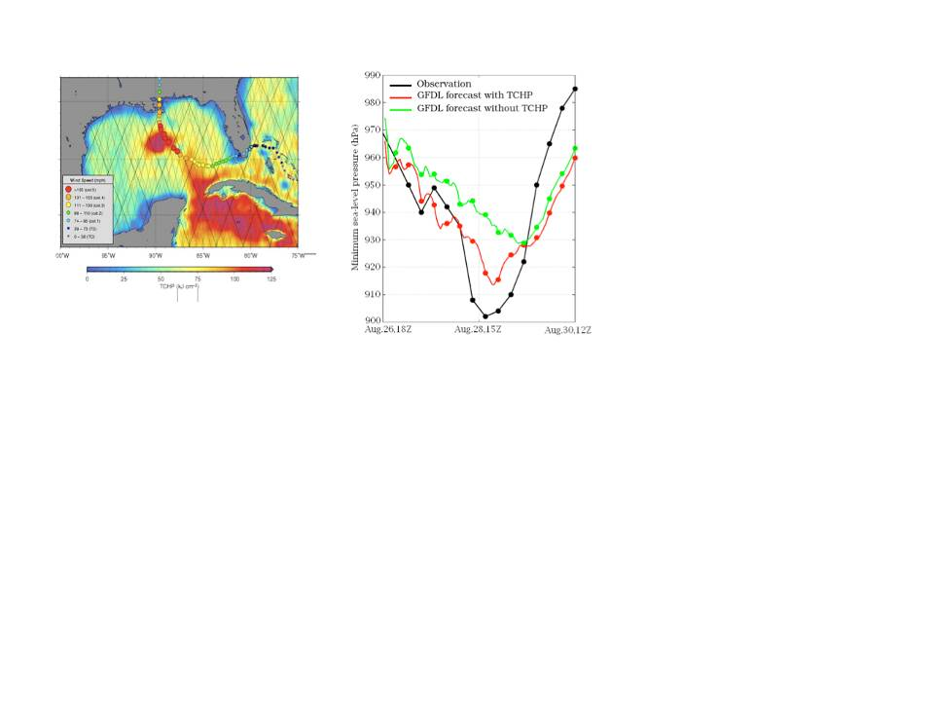
http://www.aoml.noaa.gov/phod/cyclone/data/.

(left) Track of Hurricane Katrina (2005) in the Gulf of Mexico superimposed on the altimetry-derived tropical cyclone heat potential field. The path of this TC shows an intensification when the hurricane traveled over a warm ring. (right) Minimum atmospheric pressure at sea level during the passage of hurricane Katrina in the Gulf of Mexico in 2005, showing the actual observations (black), and the reduction of error in the GFDL model output with (red) and without (green) initializing the model with the TCHP produced at NOAA National Hurricane Center.
Origins of African Dust over the Tropical Atlantic Ocean
Gregory Foltz, Rick Lumpkin and Claudia Schmid

The goal of this project is to determine the source regions of African dust that is transported across the tropical Atlantic Ocean. Improving our knowledge of the continental origins of dust aerosols will enhance our understanding of ocean biogeochemistry, sea surface temperature variability, and tropical cyclone formation and intensification.

Previous work identified six moorings of the PIRATA array that are subject to significant dust buildup during their yearlong deployment in the tropical North Atlantic (see Figure 1). During the PIRATA Northeast Extension cruise in early 2013, dust sample were collected from the radiometers on three buoys and send to Max Planck Institute for isotope analysis. By comparing the ratios of different elemental isotopes present in the dust, the regions in Africa from which the dust originated were determined. For example, the samples from the 2013 cruise indicate that some of the dust came from the Bodélé depression in Chad (Figure 2). Dust samples will continue to be obtained from PIRATA mooring during each Northeast Extension cruise (run by AOML and PMEL) and 38°W cruise (run by Brazil) with the goal of building up a robust database of isotope ratios that can be used to trace African dust aerosol to their geographic origins.

Currently we are collecting dust aerosols that accumulate on the buoy’s meteorological sensors. The ability to obtain samples therefore depends on the time of year in which the PIRATA cruise took place because there is strong seasonality in dust buildup on the sensors. During some years there is no dust buildup on a particular buoy because recent rainfall has washed it away. Future plans include building simple aerosol collectors that can be mounted to the PIRATA moorings to ensure consistent sampling.

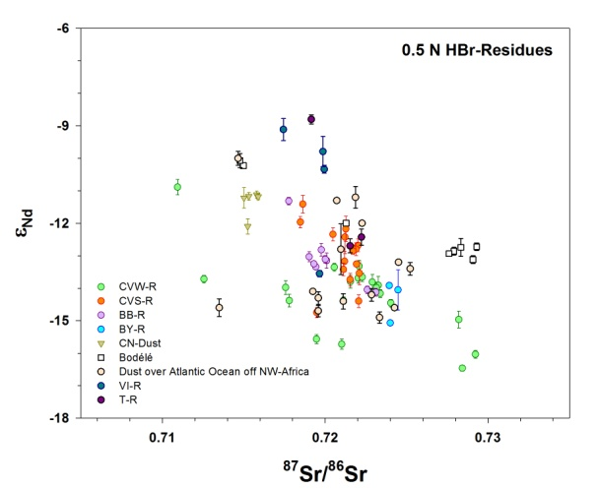

Annual mean aerosol optical depth (shaded) and locations of PIRATA moorings with significant dust buildup.
Scatter-plot of Sr and Nd isotopes from various dust samples in the tropical Atlantic. Samples from the 2013 PIRATA Northeast Extension cruise are shown in light blue.

South Atlantic Meridional Overturning Circulation: Pathways and Modes of Variability
Renellys Perez and Silvia Garzoli

This project is a collaborative effort between AOML, Ricardo Matano (OSU/CEOAS), and Rym Msadek (CERFACS, France and NOAA/GFDL). Previous observational and modeling efforts on the meridional overturning circulation (MOC) have been focused on the North Atlantic and the Southern Oceans, which are the preferential sites for deep-water formation. To understand the feedbacks between the North Atlantic and the Southern Oceans we need to improve our understanding of the pathways of the upper and lower limbs of the MOC in the South Atlantic (SA) Ocean, which are the most important links between them. The SA is not just a passive conduit for the transit of remotely formed water masses, but actively influences them through air–sea interactions, mixing, subduction, and advection. Therefore, we are characterizing the pathways of the upper and lower limb of the MOC in the SA and identifying the dynamical mechanisms that control these pathways. The study focuses on identifying the natural modes of variability in the SA and their impact on the MOC. We are also determining the response of the SA pathways to predicted climate change scenarios and assessing the impact of this response on the MOC. Our research focuses on the analysis of state-of-the-art eddy-permitting and eddy-resolving NOAA/GFDL climate model simulations. Specifically, we are using a suite of experiments done with the CM2.5 and CM2.6 coupled models, which were forced with present day conditions and different climate change scenarios. We are to comparing those simulations against the non-eddying Coordinated Model Intercomparison Project and Intergovernmental Panel on Climate Change Fifth Assessment Report models including the NOAA/GFDL coarse resolution models (CM2.1, CM3), a suite of process-oriented numerical experiments using regional ocean models, and global in-situ and satellite observations.

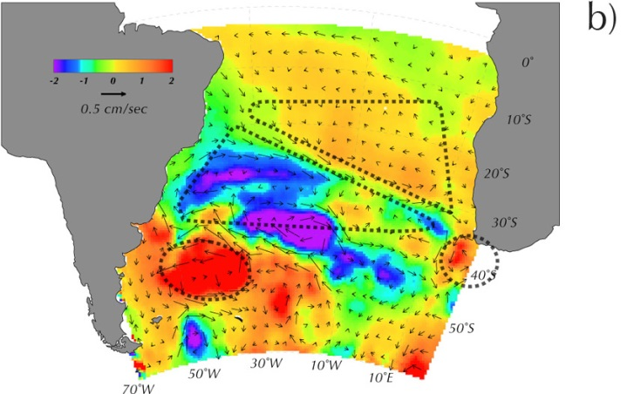
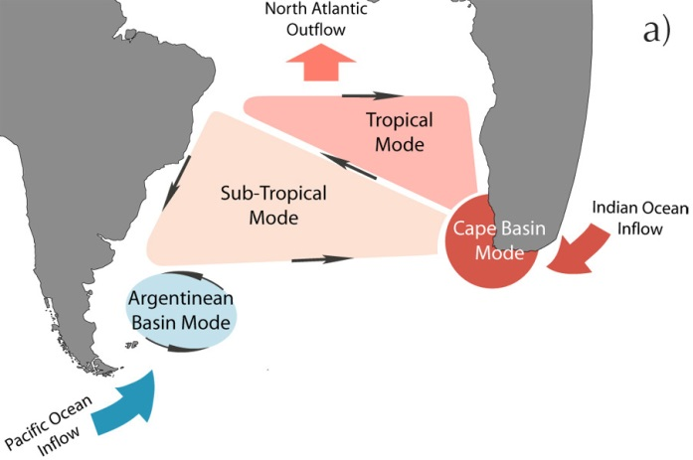

The low-frequency modes of variability in the SA: a) schematic of the proposed modes; b) first EOF of the SSH AVISO data and its associated geostrophic circulation.

Inter-Ocean Exchanges and Regional Sinks of Heat during the Warming Hiatus
Denis Volkov, Sang-Ki Lee and Rick Lumpkin

Global warming is a consequence of the Earth’s radiative imbalance: our planet is absorbing more energy from the Sun than it radiates back to space. The imbalance can be due to natural variability as well as to anthropogenic influence (emission of greenhouse gases, landscape transformation that changes the reflectivity of the earth’s surface, etc.). The ocean, covering 71% of the Earth’s surface, serves as the main energy reservoir. The well-established global mean sea level rise is one of the most certain indicators of global warming. The sea level rise reflects both the thermal expansion of the entire water column (due to ocean warming) and the freshwater input from melting glaciers (mainly in Greenland and Antarctica). The latest reports based on high-accuracy satellite altimetry measurements available since 1992 indicate that sea level has been steadily increasing at the rate of 3.3±0.4 mm yr⁻¹. In contrast to sea level, the global surface temperature rise reportedly slowed down after 1998 and entered a more stable period termed “hiatus”. A suite of studies has attempted to explain this slowdown by redistribution of heat between the near-surface and deeper layers of the ocean and between different oceanic basins. A more recent study, however, claims that the apparent “hiatus” is a possible artifact of data biases. Regardless of whether “hiatus” is real or not, the question of surplus heat sequestration, in particular, by the deep ocean remains actual. The focus of this research project is to better understand the inter-ocean exchanges of heat, freshwater and carbon using global ocean-sea ice coupled models, in-situ hydrographic data and satellite-based sea level data.
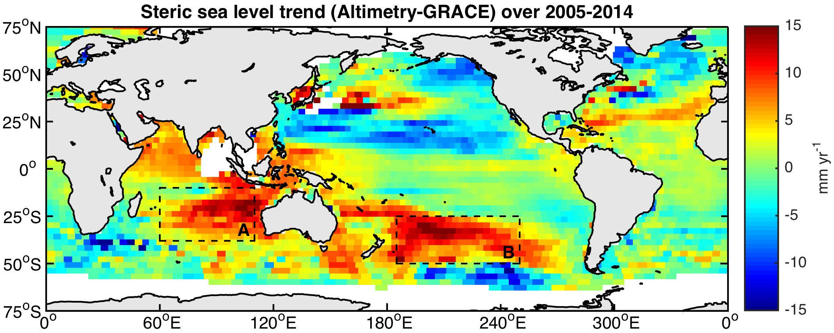

Satellite-based steric sea level trend over 2005-2014 obtained by subtracting GRACE Mascons data from altimetry records. Prior to computing the difference, altimetry fields were smoothed over 3°×3° Mascons and interpolated onto a 0.5° grid. Dashed rectangles A and B outline two regions in the South Pacific Ocean and Indian Ocean where the sea level increased much faster than other regions; the surface area of each region is about 16 million km².

The Mediterranean and Black Seas: Analysis of Large Sea Level Anomalies
Denis Volkov

Satellite altimetry observations by OSTM/Jason-2 and Envisat missions have revealed extremely large sea level fluctuations that occurred in the Mediterranean and Black seas in the winters of 2010 and 2011. During this time the basin-wide non-seasonal sea level in the Mediterranean Sea increased by about 10 cm reaching the record maximum during the observational period. Similar anomalies were observed in bottom pressure derived from the gravity field measurements by the NASA's GRACE twin satellites. In the Black Sea, the associated sea level anomalies exceeded 20 cm lagging behind the sea level anomalies in the Mediterranean Sea by about 1 month. Understanding and quantifying the dynamics of sea level variations in these semi-enclosed seas is important because of the possible amplified sea level response to climate forcing, and because of the densely populated coasts in the region. This research is being conducted in collaboration with Dr. Felix Landerer from Jet Ppropulsion Laboratory, California Institute of Technology, as a contribution to NASA Ocean Surface Topography Science Team. Using satellite altimetry and gravity observations and an atmospheric re-analysis product we have found that the non-seasonal sea level and ocean mass fluctuations in the Mediterranean Sea are driven by concurrent wind stress anomalies over the adjacent subtropical North Atlantic Ocean, just west of the Strait of Gibraltar, and extending into the strait itself. Coupling satellite data to tide and river discharge gauges as well as to surface heat and freshwater fluxes we have provided a comprehensive up-to-date analysis of sea level variability in the Black Sea and quantified the role of different environmental factors that force the variability. In addition to the effect of freshwater fluxes, sea level in the Black Sea is found to respond to the non-seasonal fluctuations of the Mediterranean Sea level. The observed time lag of the response is due to friction that constrains the exchange through the Bosphorus Strait.

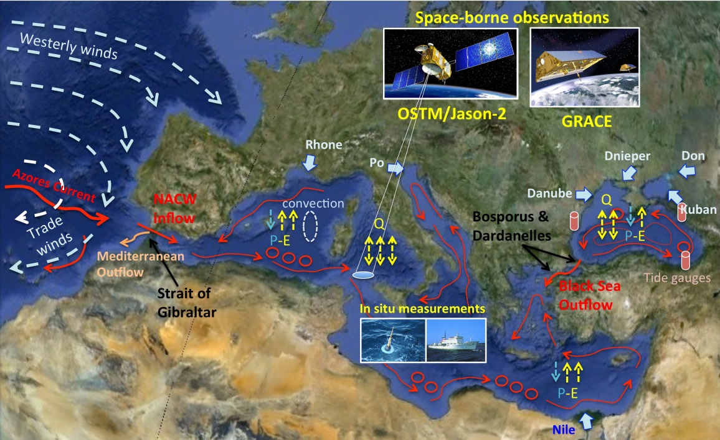

Scheme illustrating physical processes driving the variability of sea level in the Mediterranean and Black seas. Abbreviations: NACW – North Atlantic Central Water, Q – net surface heat flux, P-E means Precipitation-Evaporation. Red arrows illustrate surface circulation.
Formation and Variability of the Lofoten Vortex in the Norwegian Sea
Denis Volkov
The Lofoten Basin (LB) is a well defined topographic depression of about 3250 m depth situated in the northern part of the Norwegian Sea. The Norwegian Atlantic Current – a direct extension of the North Atlantic Current – dominates the upper-ocean circulation in the Norwegian Sea. The LB is the major heat reservoir in the Nordic Seas (common name for the Norwegian, Greenland, and Iceland Seas together), characterized by large ocean–atmosphere interactions. It has attracted much scientific attention because of its peculiar thermodynamical characteristics and possible importance in the global climate system. Being a transit region for the warm and saline Atlantic Water (AW), which occupies the upper 800 m, on its way to the Arctic Ocean, the LB is likely to play an important role in sustaining the Atlantic Meridional Overturning Circulation. Here, the AW loses heat to the atmosphere, mixes with ambient water masses, and thus undergoes a transformation that ultimately facilitates deep-water formation. Satellite altimetry observations show a local maximum of sea surface height (SSH) variability and eddy kinetic energy. The LB eddies are mainly generated through the instability of the Norwegian Atlantic Slope Current, propagate cyclonically around the center of the LB, and they are found to play an important role in heat exchanges and dense water formation. We addressed the problem of the Lofoten Vortex formation using three numerical experiments at different eddy-permitting horizontal resolutions(average grid spacing of 18, 9, and 4 km). By initializing the experiments with climatological fields of temperature and salinity we monitored the evolution of the eddy field in the LB and the generation of the vortex. The main focus of this study was to investigate the role of eddies in the dynamics of the vortex. Benefiting from a high-resolution model run we also estimated the kinematic properties of the Lofoten Vortex and other eddies in the LB. In addition, we investigated what processes drive the variability of the vortex strength. This study was part of the project “Investigating the variability of sea level in the Arctic and sub-Arctic seas” funded by NASA Physical Oceanography program.
Bottom topography (color) and general circulation (arrows) of the study region. The red circle marks the approximate Lofoten Vortex location. The magenta line indicates the transect along which the vertical profiles of temperature, salinity, and velocity are analyzed. Abbreviations: NCC – Norwegian Coastal Current, NwASC – Norwe- gian Atlantic Slope Current, NwAFC – Norwegian Atlantic Frontal Current. (For interpretation of the references to color in this figure legend, the reader is referred to the web version of this article.)

Management and Conservation of Atlantic Bluefin Tuna (Thunnus Thynnus) and other Highly Migratory Fish In the Gulf of Mexico under IPCC Climate Change Scenarios: A Study Using Regional Climate and Habitat Models
Sang-Ki Lee, Yanyun Liu and Gustavo Goni

Increasing water temperatures due to climate change will likely have significant impacts on distributions and life histories of Atlantic tunas. A team of scientists from CIMAS, SEFSC and AOML/PhOD combined predictive habitat models with a downscaled climate model to examine potential impacts on adults and larvae of Atlantic bluefin tuna (Thunnus thynnus) and skipjack tuna (Katsuwonus pelamis) in the Intra-Americas Sea (IAS). An additional downscaled model covering the 20th century was used to compare habitat fluctuations from natural variability to predicted future changes under two climate change scenarios: Representative Concentration Pathway (RCP) 4.5 (medium-low) and RCP 8.5 (high). Results showed marked temperature-induced habitat losses for both adult and larval bluefin tuna on their northern Gulf of Mexico spawning grounds (Figure). In contrast, habitat suitability for skipjack tuna increased as temperatures warmed. Model error was highest for the two skipjack tuna models, particularly at higher temperatures. While impacts on fish populations remain uncertain, these changes in habitat suitability will likely alter the spatial and temporal availability of species to fishing fleets, and challenge equilibrium assumptions of environmental stability, upon which fisheries management benchmarks are based.

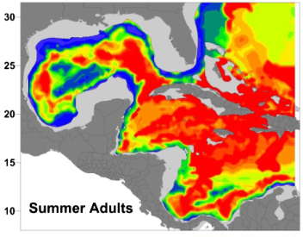
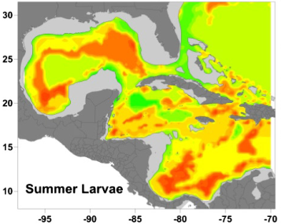
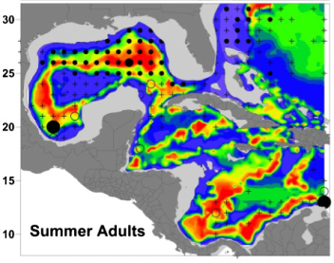
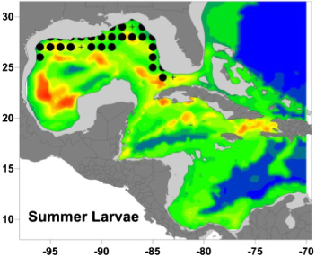
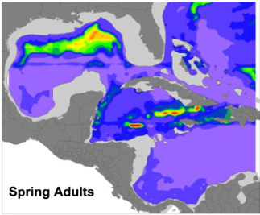
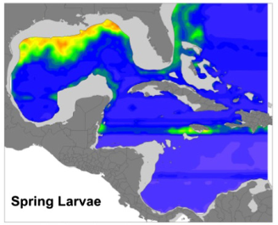
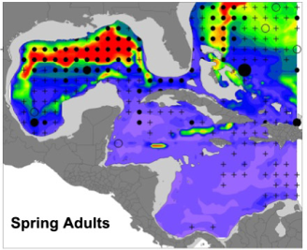
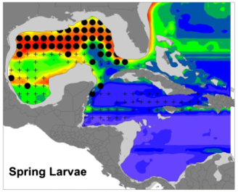
Bluefin tuna
Present day
2090 RCP8.5
Skipjack tuna
Present day
2090 RCP 8.5

Probabilities of occurrence for adult and larval (left panels) bluefin tuna in spring and (right panels) skipjack tuna in summer. Results are shown for the 2000s, and for 2090, under RCP 8.5. Observed data from the ICCAT Task II database (adults) and SEAMAP plankton surveys (larvae) are also shown for the same time period (postmaps). Locations where adults were recorded, but effort was low, are shown as open circles. Reproduced from Muhling et al. (2015).

Toward Developing a Seasonal Outlook for the Occurrence of Major U.S. Tornado Outbreaks
Sang-Ki Lee and Robert Atlas

Recent violent and widespread tornado outbreaks in the U.S., such as occurred in the spring of 2011, have caused devastating societal impact with significant loss of life and property. At present, our capacity to predict U.S. tornado and other severe weather risk does not extend beyond seven days. In an effort to advance our capability for developing a skillful long-range outlook for U.S. tornado outbreaks, this project aims to investigate the spring risk patterns of U.S. regional tornado outbreaks during 1950-2014. We show that the dominant springtime El Niño-Southern Oscillation (ENSO) phases and the North Atlantic sea surface temperature tripole variability are linked to distinct and significant U.S. regional patterns of outbreak risk (figure). These changes in outbreak risk are shown to be largely consistent with remotely forced regional changes in the large-scale atmospheric processes conducive to tornado outbreaks. An implication of these findings is that the springtime ENSO phases and the North Atlantic SST tripole variability may provide seasonal predictability of U.S. regional tornado outbreaks.
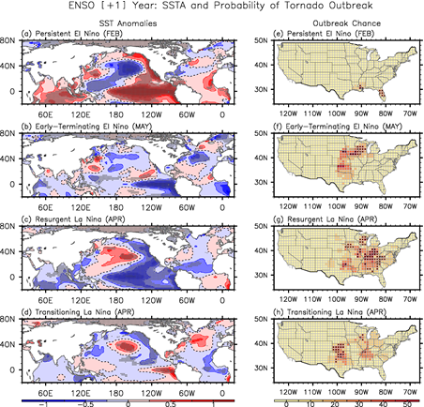

.

SSTA and the probability of U.S. regional tornado outbreaks linked to the four dominant springtime ENSO phases. Composite (a-d) SSTAs for the four dominant phases of springtime ENSO evolution and (e-h) the corresponding probability of U.S. regional tornado outbreaks for the month in which each of the four springtime ENSO phases has the strongest influence. The gray dots in panels a-d indicate that the SSTAs are statistically significant at 90% based on a student-t test. The black dots in panels e-h indicate that the probability of tornado outbreaks is statistically significant at 90% based on a binomial test. The units are in °C for the SSTAs and in % for the probability of tornado outbreaks.
High-Resolution Ocean-Biogeochemistry Modeling for the East and Gulf Coasts of the U.S. in Support of the Coastal Monitoring and Research Objectives of the NOAA OA Program

Sang-Ki Lee, Rik Wanninkhof, Yanyun Liu, Leticia Barbero and Ruben Hooidonk

Analysis of the data collected during the first (2007) and the second (2012) Gulf of Mexico and East Coast Carbon (GOMECC) cruises showed measurable temporal pH and aragonite saturation state (Ω_{Ar}) changes along the eight major transects. However, it is challenging to determine how much of this temporal change between the two cruises is due to global ocean acidification and how much is due to variability on seasonal to interannual scales. Indeed, the expected 2% average decrease in Ω_{Ar} due to increasing atmospheric CO₂ levels over the 5-year period was largely overshadowed by local and regional variability from changes in ocean circulation, remineralization/respiration and riverine inputs. Therefore, in order to provide useful products for the ocean acidification (OA) research community and resource managers, it is important to filter out seasonal cycles and other variability from the multi-annual trend. Here, we propose to use a high-resolution regional ocean-biogeochemistry model simulation for the period of 1979 - present day (real-time run) to fill the temporal gap between the 1st and 2nd GOMECC cruise data. In addition we will fine-tune and validate the model by using extensive surface water pCO₂ observations from the ships of opportunity in the coastal region (SOOP-OA), and using the carbon observations from the East Coast Ocean Acidification Cruises (ECOA-1) and OAP mooring stations and from remotely sensed data. Then, we will use the real-time model run to estimate the 5-year trends (2012 – 2007) of OA and the carbon and biogeochemical variables along the East and Gulf coasts of the U.S. We will also examine the future OA variability in the East and Gulf coasts of the U.S. by downscaling the future climate projections under different emission scenarios developed for the IPCC-AR5. Based on the results obtained from the proposed model simulations, we will contribute to an observational strategy suitable for elucidating multi-annual trend of carbon and biogeochemical variables along the East and Gulf coasts of the U.S.

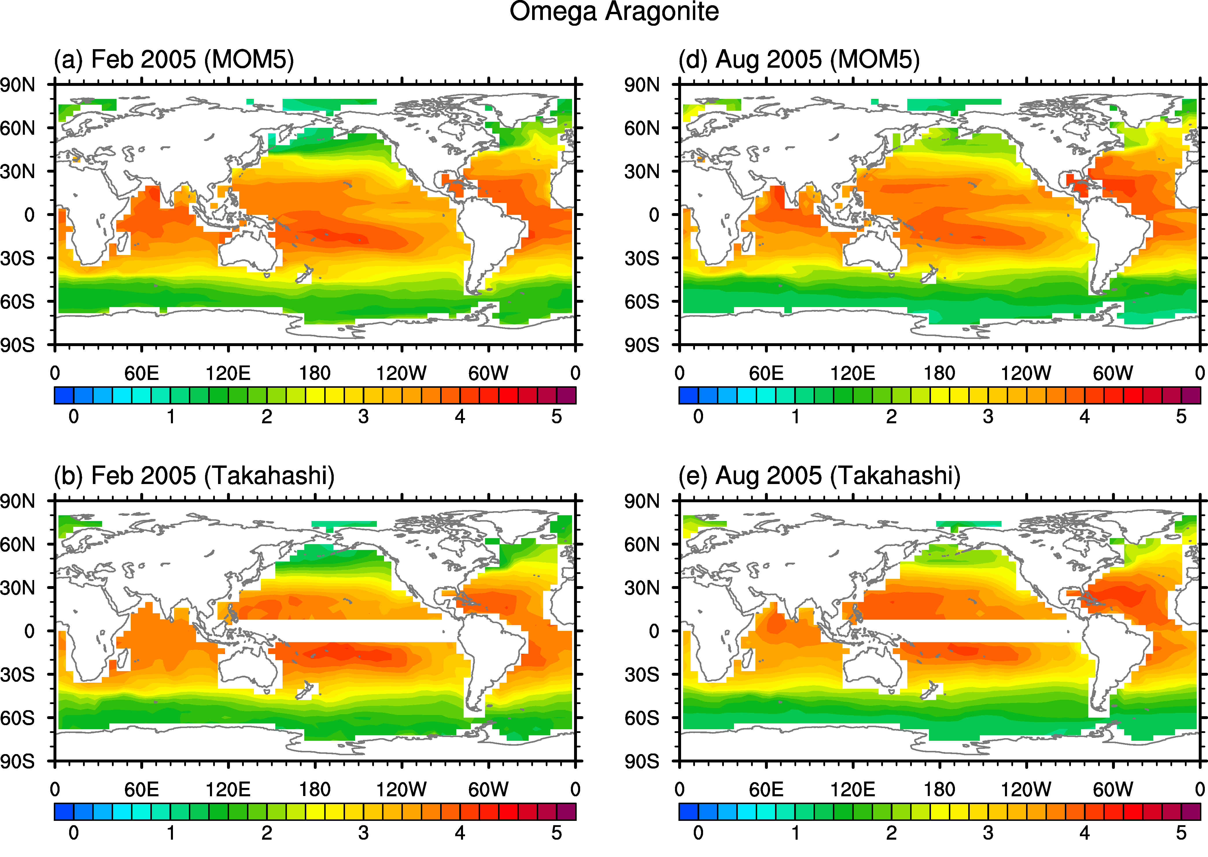

Surface aragonite saturation state in February and August of 2005 derived from
(Upper panels) the global MOM-TOPAZ simulation and (Lower panels) observation based estimates by Takahashi et al. (2014).

Predicting the impact of anthropogenic climate change on physical and biogeochemical processes in the northern Gulf of Mexico
Sang-Ki Lee and Yanyun Liu

Recent studies examined the potential impact of anthropogenic greenhouse warming on the Intra-Americas Sea (IAS, Caribbean Sea and Gulf of Mexico) by downscaling the Coupled Model Intercomparison Project phase-5 (CMIP5) model simulations under historical and future CO₂ emission scenarios using an eddy-resolving resolution regional ocean model. The simulated volume transport by the western boundary current system in the IAS, including the Caribbean Current, Yucatan Current and Loop Current, reduced by 20-25% during the 21st century, consistent with a similar rate of reduction in the Atlantic Meridional Overturning Circulation. The projected weakening of the ocean circulation in the Gulf of Mexico (GoM) suggests that the shallow (≤ 180 m) northern shelf of the GoM may experience lower rates of upwelling from deep cool water onto the shelf and toward the coast. Consistent with this hypothesis, the downscaled model predicts an intense warming over the northern shelf of the GoM especially during boreal summer. This warming trend can have several implications for the region, which borders the US states of Texas, Louisiana, Mississippi, Alabama and Florida. For one, this may increase the chance for hurricane intensification during landfall in the northern and eastern Gulf. The warming may also have a deleterious impact upon one of the richest fishing grounds in the US, exposing marine life living in the northern Gulf of Mexico shelf regions, such as fish, shrimp, marine mammals, and turtles as well as coral reefs and sponges, to increasing frequency of thermal stress and hypoxia. The main objective of this project is to provide a range of realistic scenarios of future environmental changes in the region for the research community and fisheries resource managers. To achieve that goal, this project aims to use a high-resolution regional ocean-biogeochemistry model to downscale the CMIP5 model projection of the carbon and biogeochemical parameters along the northern GoM for the 21st century.

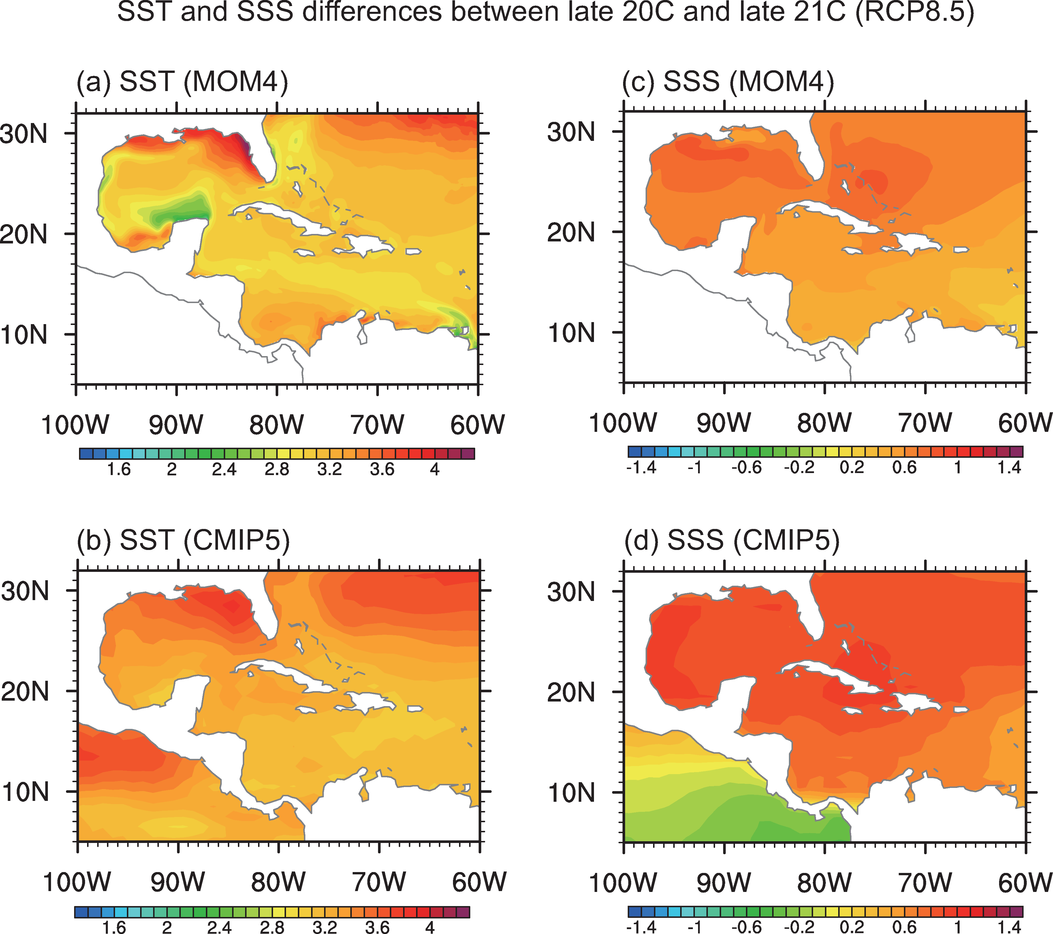
SST differences in the IAS between the late 21st century (2090 ~ 2098) and late 20th century (1990 ~ 1998) during the boreal summer months of ASO obtained from (a) the downscaled MOM4.1 simulation and (b) the weighted ensemble of 18 CMIP5 models simulations. Annual mean SSS difference in the IAS between the late 21st century and late 20th century obtained from (c) the downscaled MOM4.1 simulation and (d) the weighted ensemble of 18 CMIP5 models simulations. The units for temperature and salinity are °C and psu.

Variability and Predictability of the Atlantic Warm Pool and Its Impacts on Extreme Events in North America
Sang-Ki Lee

This work is done in collaboration with David Enfield (UM), Liping Zhang (Princeton) and Zhenya Song (The First Institute in China. Our previous research has pointed out the importance of the Atlantic Warm Pool (AWP) for summer climate and extreme events in the Western Hemisphere. Despite its importance, almost of all state-of-the-art uncoupled/coupled models exhibit serious biases (Figure) in the AWP region, which limit the seasonal prediction of AWP-related climate and extreme events. In the current project, we will continue our investigation of the AWP using fully coupled climate models. Two specific areas of proposed work are: (1) diagnosing the CMIP5 outputs to assess model biases near the AWP region and to understand their skill in simulating the mechanisms and climate impacts of AWP variability, and (2) performing coupled model experiments using CESM1 and analyzing the Climate Forecast System version 2 reforecasts to assess and improve predictability of the AWP and its impacts on climate and extreme events such as hurricanes, flood and drought in North America. It is hoped that over a longer time frame, this project will result in the regional implementation of data- and model-based outlooks for flood/drought in the United States, hurricanes and climate variability, when successfully combined with land-based models.
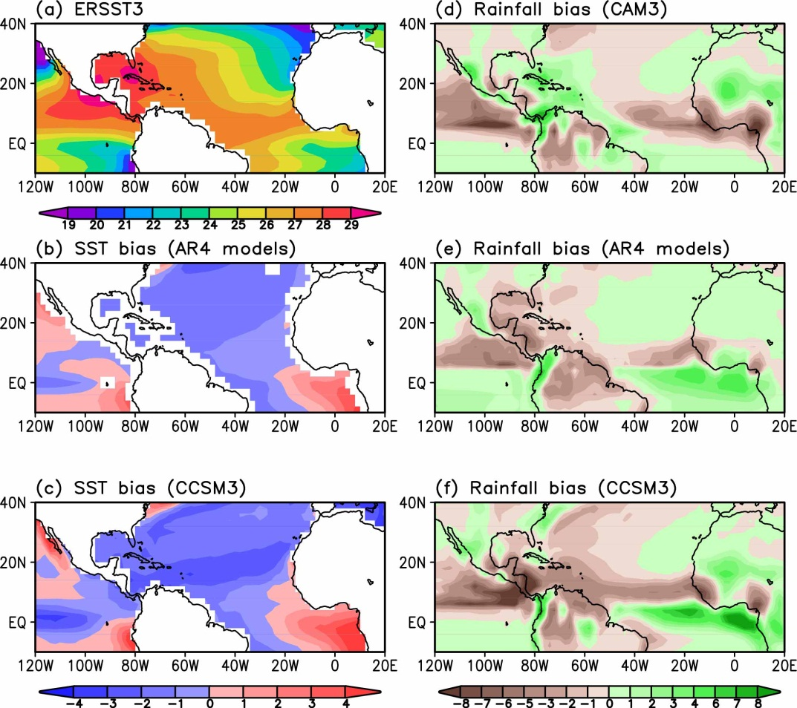

The observed SST and long-term averaged model biases in the summer months of June-August (JJA). Shown are (a) the ERSST, (b) the model SST bias of the 22 IPCC-AR4 coupled model ensemble, (c) the model SST bias of CCSM3, (d) the model rainfall bias of the atmospheric GCM (CAM3), (e) the model rainfall bias of the 22 IPCC-AR4 coupled model ensemble, and (f) the model rainfall bias of CCSM3.

Evaluation of Gulf of Mexico oceanographic observation networks impact assessment on ecosystem management and recommendation
Matthieu Le Hénaff

This project, led by Matthieu Le Hénaff from the Cooperative Institute for Marine and Atmospheric Studies (CIMAS) and member of AOML’s Physical Oceanography Division (PhOD), is assessing Gulf of Mexico observation networks from an ecosystem management perspective. The NOAA RESTORE Act Science Program funded this 2-year project, which also involves 3 scientists from the University of Miami (UM), the University of South Florida (USF) and the Florida Fish and Wildlife Conservation Commission (FWC). The project is based on applying a rigorous ocean observing system evaluation methodology, developed for regional networks by the joint UM and NOAA/AOML “Ocean Modeling and OSSE Center” (OMOC), and to expand it to study the impact of observations on the estimation of biological activity. The project includes three objectives: 1) assess the performance of existing observation networks to monitor the Gulf of Mexico from an ecosystem monitoring and management perspective, expanding the evaluation approach implemented for physical oceanography monitoring; 2) investigate the connections between ocean physics, biogeochemistry and ecosystem dynamics; and 3) make recommendations to improve existing observing networks to address particular resource management objectives.

The investigators are using existing ocean circulation and biogeochemical models, as well as observations of ocean circulation, chemistry, and biology from satellites and existing observing platforms in the water. In collaboration with ecosystem and resource managers, Le Hénaff and co-investigators establish realistic observation and management scenarios, which form the foundation for Observing System Experiments that quantify the impact of various components of the existing Gulf of Mexico observing system and help identifying observational gaps. An important project outcome will be recommendations on how to improve observing networks in the Gulf of Mexico to better support effective and sustainable resource management
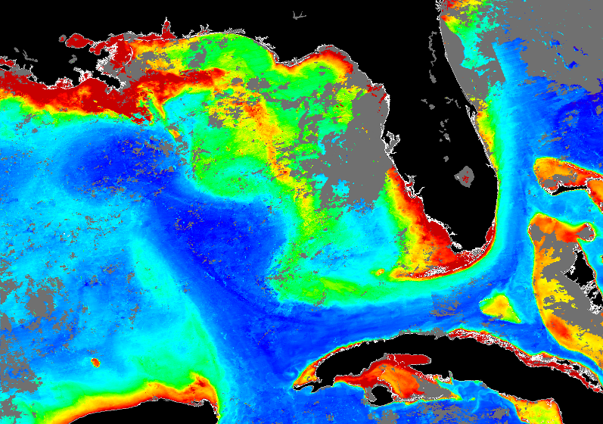

The project will quantify, for example, the ability of the existing Gulf of Mexico observing system to monitor episodes of export of nutrient-rich waters from the Mississippi River Delta to the Florida Keys reefs (ocean color image from August 13, 2014, USF).

Development of an Earth System component for Medium-Range Predictability in Coastal Seas: Application on Gulf of Mexico Harmful Algal Blooms and Hypoxia Episodes
George Halliwell, Robert Atlas with Chris Kelble (OCED) and colleagues from RSMAS and NRL-Stennis

This project supports coupling of the HYbrid Coordinate Ocean Model (HYCOM) hydrodynamic model to the Carbon, Silicate, Nitrogen Ecosystem (CoSiNE) biochemical model, and then using this new tool to study medium-range predictability of harmful algal blooms (HAB) and hypoxia episodes. This work is carried out by the Naval Research Laboratory Stennis Space Center in collaboration with RSMAS and AOML. The Gulf of Mexico (GoM), and particularly the Northern GoM shelf, is used as a test case study area due to the frequent Harmful Algal Bloom (HAB) and hypoxia episodes associated with Mississippi River (MR) nutrient loads. Initial model simulations and analyses have been conducted in this region (see Figure). Analyses emphasize coastal to offshore interactions that influence broader biophysical connectivity. These interactions are controlled by fronts and eddies associated with the Loop Current, which further influence cross-shelf nutrient exchanges and the ventilation of shelf waters. The version of HYCOM that is used is run at high (1/50⁰) resolution and contains an advanced parameterization of river plume dynamics that includes both salinity and momentum fluxes (NGoM-HYCOM).

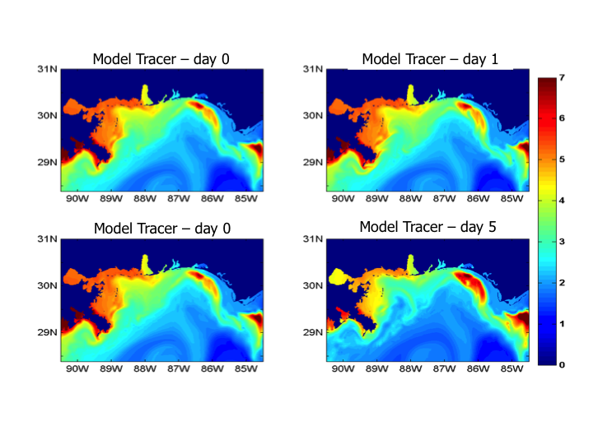

Illustration of the evolution of a passive plankton concentration tracer (mg/m3) in the biophysical model. Top (Bottom) 24 (120) hours from initialization. The coupling implementation is working properly as the tracer is clearly advected (and diffused) by the physical model.

Ocean OSSEs: System Development and Applications

George Halliwell, Matthieu Le Hénaff, Robert Atlas, and RSMAS colleagues

In collaboration with RSMAS colleagues through the Joint AOML/CIMAS/RSMAS Ocean Modeling and OSSE Center (OMOC), ongoing development of, and new applications for, the OMOC ocean OSE/OSSE system continue to be realized. Observing System Experiments (OSEs) use data denial to determine the impact of existing observing systems while Observing System Simulation Experiments (OSSEs) use data denial to determine the impact of new observing systems and alternate deployment strategies for existing systems. The OSSE system was originally validated and successfully applied in the Gulf of Mexico to evaluate alternate airborne ocean profile survey strategies during the DeepWater Horizon oil spill. The system has now been successfully validated in a larger Atlantic Ocean domain spanning 5ºS to 45ºN east to 20ºW and used to evaluate ocean observing systems for improving coupled hurricane intensity prediction. The Atlantic region Nature Run realistically reproduces mean ocean climatology and synoptic variability (see Figure). Validation by OSE-OSSE comparisons demonstrates that realistic OSSE impact assessments are realized with a small (~10-15%) tendency to overestimate intensity based on skill score analysis. Initial application in the Atlantic has evaluated observing system impacts based on their contribution to error reduction in ocean analyses used to initialize the ocean component of coupled prediction systems. Ocean analyses produced by the OSSE system can now be used to initialize the HYCOM-HWRF coupled forecast model at EMC, enabling the impact of ocean observations on intensity forecasts to be quantitatively assessed. Planned development includes evaluating impacts with regard to other oceanographic applications and expanding to larger ocean domains.

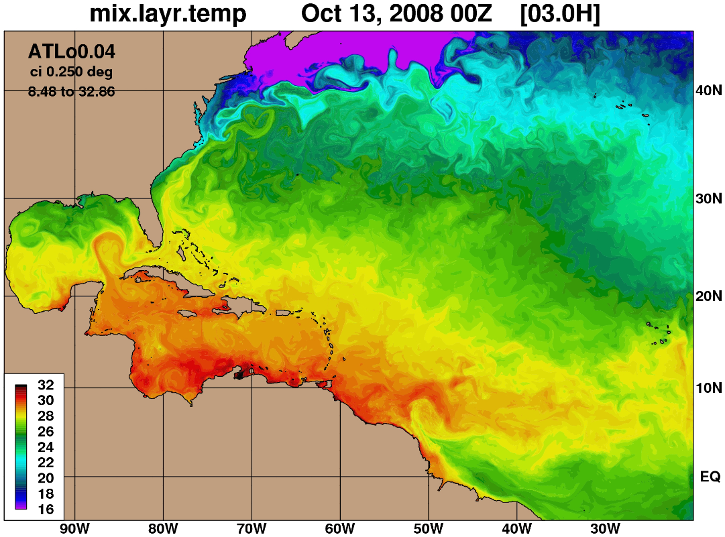

Mixed layer temperature map in the new Atlantic Ocean domain from the OSSE system Nature Run.

Ocean Model Evaluation and Improvement in Support of the Next-Generation HWRF Regional Tropical Cyclone Prediction System
George Halliwell and hurricane modelers from AOML/HRD and NCEP/EMC

This project combines the capabilities of PhOD ocean modelers and coupled Tropical Cyclone (TC) modelers to improve coupled forecasts as part of the Hurricane Forecast Improvement Project (HFIP). Accurate intensity forecasts require that the coupled model accurately predict the cooling rate of sea surface temperature (SST) in response to storm forcing, which in turn requires the ocean model to accurately predict mixed layer deepening and entrainment cooling. There are three primary components to this work. In the first component, a one-dimensional version of the HYbrid Coordinate Ocean Model (HYCOM) was coupled to the multiple-nest experimental Hurricane Weather Forecast Model (HWRF). A set of idealized experiments was run with this configuration to isolate the impact of initial ocean heat content, storm translation speed, and storm size on predicted intensity. In the second component, idealized ocean model response experiments run with HYCOM are being compared to observations. The figure illustrates a depth-time series of several fields during the passage of Hurricane Frances (2004), demonstrating that the ocean model can potentially perform well in an idealized setting when provided with accurate atmospheric forcing and quasi-optimal choices of numerical algorithms and sub-grid scale turbulence closure schemes. In the third component, G. Halliwell is collaborating with NCEP/EMC as co-lead of the HFIP Ocean Model Impact Tiger Team to evaluate ocean model performance and document the impact of ocean coupling on intensity forecasts produced by the HYCOM-HWRF coupled prediction system.
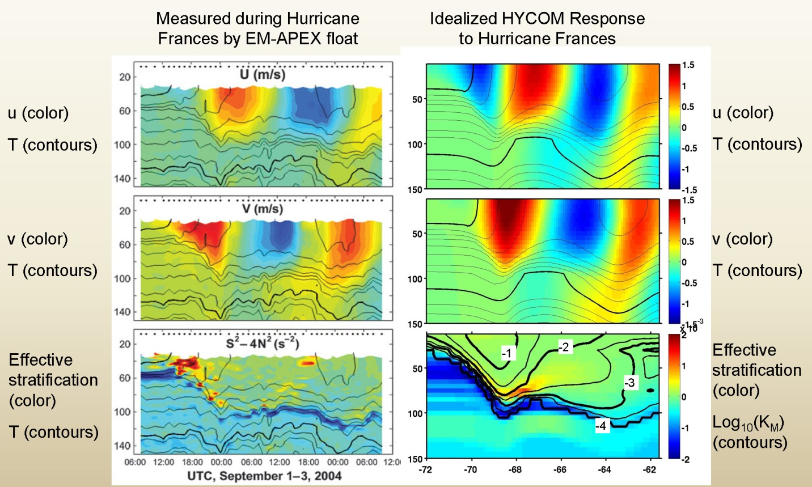
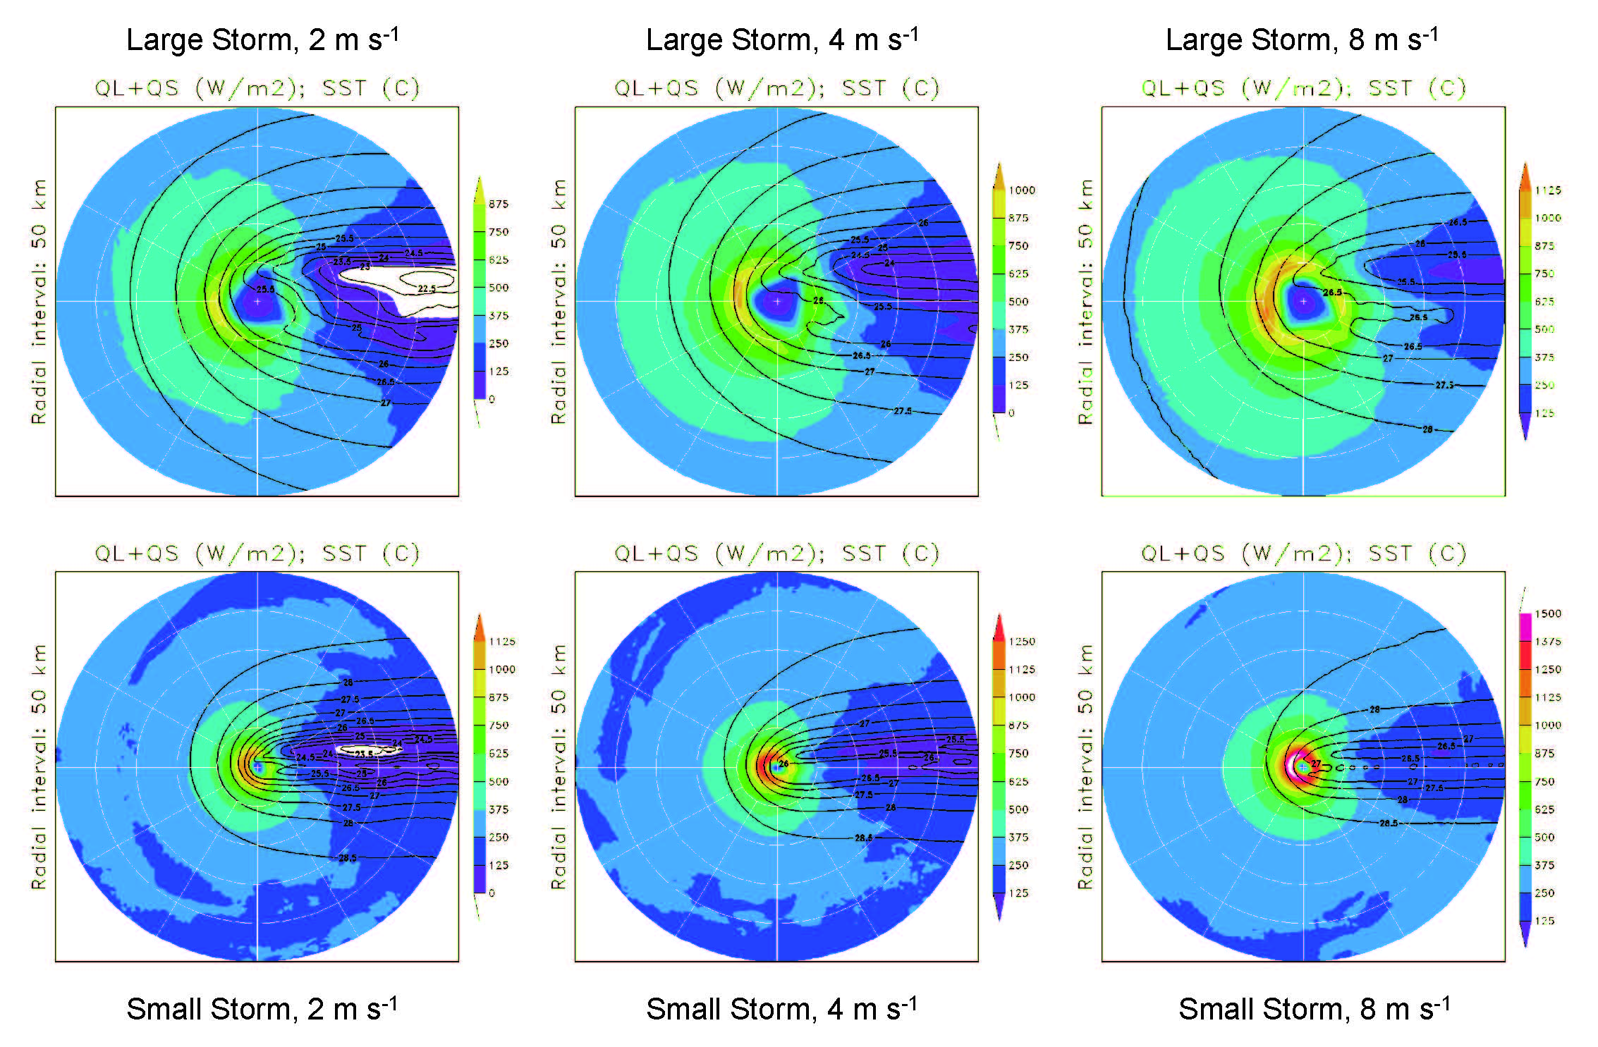
Depth-time plots of several upper ocean fields during the passage of Hurricane Frances (2004). Panels at left show fields measured at two radii of maximum winds to the right of the storm track by EM-APEX profiling floats (From Sanford et al., 2011, J. Phys. Oceanogr.).Panels at right illustrate ocean fields from an idealized ocean response experiment to forcing by the same storm.

2 km resolution data-assimilative simulation of the Gulf of Mexico
Matthieu Le Hénaff, George Halliwell, Michael Mehari

The development and implementation of a high resolution, data assimilative simulation of the Gulf of Mexico is part of the joint UM and NOAA/AOML “Ocean Modeling and OSSE Center” (OMOC) activities. This simulation uses the HYCOM model and combines the best practices of the group’s modeling activities in subparts of the Gulf, in the Florida Straits and in the Northern Gulf especially, which it expands to the full Gulf region. In particular, it benefits from high-frequency nesting into the operational Navy HYCOM simulation, and from realistic daily river forcing. In addition, the simulation incorporates data-assimilative capabilities developed for HYCOM as part of the OMOC activities.

This new GoM-HYCOM modeling system has been used to study connectivity processes at the Gulf scale, for example during episodes of Mississippi River water export away from the Northern Gulf. It is employed in observing system experiments to study the impact of observations on the biology and ecosystem estimates in the Gulf of Mexico and the Florida Keys. It is the ocean physics component of oil spill modeling experiments that study the influence of river plume on oil slick evolution. The GoM-HYCOM modeling system is planned to soon deliver near-real time nowcast-forecast of the Gulf of Mexico state, as a demonstration. The free running high-resolution GoM-HYCOM simulation is planned to be used as the Nature Run in Observing System Simulation Experiments. The GoM-HYCOM modeling system can also be used to test data assimilation techniques, in the context of high-resolution, topographically driven regional processes, or of strong river influence.

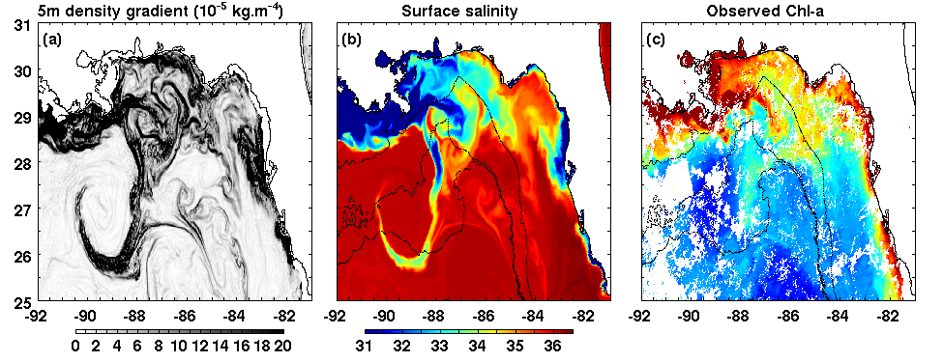

Example of details from the high-resolution, data assimilative GoM-HYCOM in representing the interaction of Mississippi River plume with the Loop Current: (a) 5-m density gradients from the simulation (10⁻⁵ kg.m⁻⁴) a proxy for submesoscale activity, on 24 July 2014. (b) Modeled surface salinity, on the same day. (c) Observed Chlorophyll-a, on the same day (data USF).

Deep Ocean Data Retrieval System
Ulises Rivero, Christopher Meinen and Silvia Garzoli

Retrieval of important data from deep ocean moored instruments is challenging and expensive, historically involving many days at sea on dedicated research vessels. Engineers and scientists at AOML are developing technology for obtaining data from these moored instruments in near real time with less reliance on research ships. This prototype system, called the “Adaptable Bottom Instrument Information Shuttle System (ABIISS)”, has been under development at AOML for several years. This system is designed to allow scientific instruments anchored on the ocean bottom to send data back via expendable data pods that will release from the ocean floor on a programmable schedule. The buoyant pods will then surface and send the data from the ocean bottom instrument back to land stations via satellite. AOML engineers have successfully demonstrated several key aspects of the ABIISS via ocean trials in the Straits of Florida. A critical new trial of the ABIISS was started in October 2015 east of the Bahamas Islands; this represents the first test of the system in open ocean depths greater than 4000 meters. The first pod surfaced successfully in November 2015, and three additional pods are scheduled to surface throughout 2016 during this 18-month test. The ABIISS technology has the potential to save significant amounts of financial and personnel resources by reducing the amount of ship time needed to support and maintain ocean time series measurement sites.

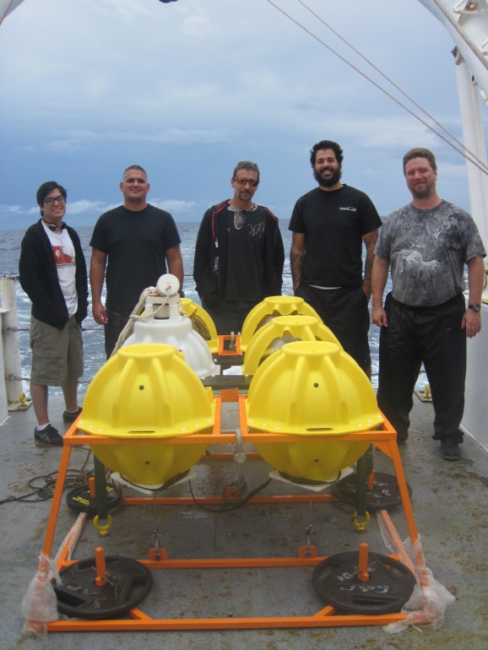
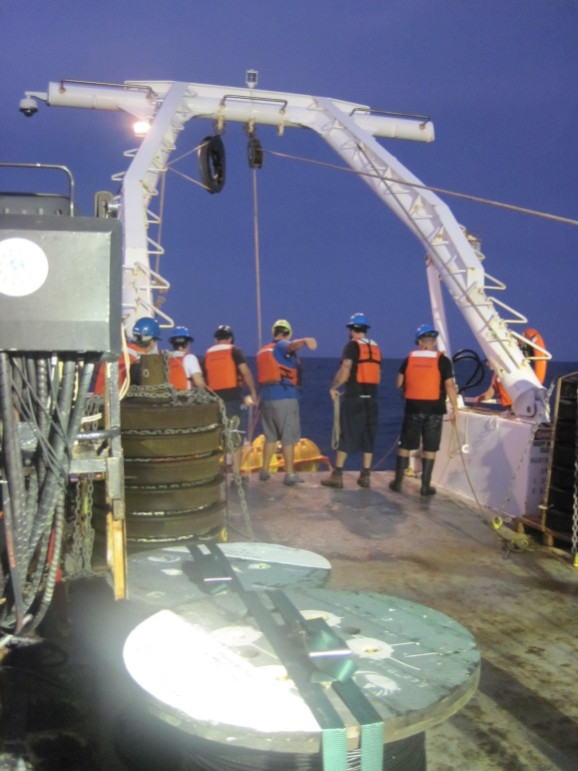

Prototype of the 4000+ m ABIISS system. Deployment of the 4000+ m ABIISS system in October 2015

Automatic Shortwave Radiometer Cleaner
Ulises Rivero and Gregory Foltz

This project is in collaboration with engineers and technicians at NOAA/PMEL. The Prediction and Research Moored Array in the Tropical Atlantic (PIRATA) consists of 17 moorings spanning the tropical Atlantic Ocean. Several of the moorings are directly downwind from the Sahara and Sahel regions of Africa, which together represent the largest source of mineral dust on the planet. Dust aerosols accumulate on the moorings’ solar radiometer domes, leading to biases as large as -150 W m⁻². Scientists and engineers at AOML have developed an automated radiometer dome cleaner that will rinse aerosols from the moorings’ radiometer domes at regular 24-hour intervals while deployed at sea. After successful tests at AOML, the first dome rinser was deployed at 11.5°N, 23°W during the December-February 2015 PIRATA Northeast Extension cruise alongside a radiometer without a rinser. A comparison between the solar radiation time series from the rinsed and unrinsed radiometers will be performed in early 2016 to verify that the rinser worked as intended and to make any necessary adjustments for the future deployments.

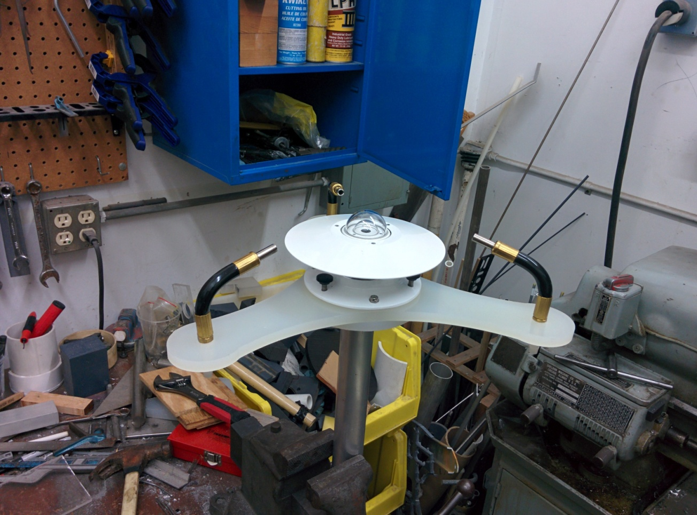

Photo of the prototype radiometer rinser. Fresh water is pumped from a large container and through each nozzle, rinsing the radiometer’s glass dome.

Shipboard Surveys of Regional and Worldwide Field Operations

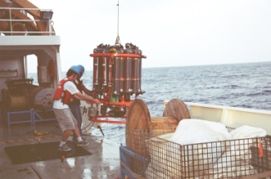
PhOD personnel spend on average a total of 420 days at sea every year. The following is a summary of the divisional led effort at sea.

CLIVAR CO2/Repeat Hydrography: Goals – To monitor changes in water properties on a decadal time scale. The program is a collaboration between NOAA and NSF with many partners nationally and internationally. Within NOAA, the program is a collaboration between AOML/OCD, AOML/PHOD and Pacific Marine Environmental Laboratory (PMEL). PhOD responsibilities includes support for CTD observations and discrete salinity and oxygen measurements. The operational components include: Typically two major cruises every three years are conducted on a subset of the global historical survey lines. PhOD is responsible for a sending 2 discrete oxygen analysts, 1 salinity analyst and CTD engineer. Cruises are generally 30 to 60 days long.

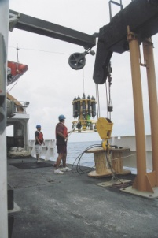
PIRATA Northeast Extension (PNE): Goals – To study both ocean and atmosphere in the tropical eastern Atlantic. The program routinely has partner/piggy-back programs from Earth System Research Laboratory (ESRL), University of Miami, and Howard University. Number of PhOD people going on each cruise: 3 – 5. Operations typically involve a CTD survey along 23ºW and the annual servicing of the four PIRATA Northeast Extension moorings. Normally there is one cruise per year of ~31 days depending on the ports of call.

Western Boundary Time Series (WBTS): Goals – To study the components of the Meridional Overturning Circulation (MOC) near the western boundary of the Atlantic basin at 26.5ºN. Presently, the WBTS program includes the following two sea-going components:

Florida Current measurements along 27ºN: These cruises have several goals that include determining the volume and heat transport in the Florida Straits to use for calibration of the submarine cable voltage measurements, and providing boundary current transports for the determination of the meridional heat and volume transport associated with the XBT transect AX07 and the MOCHA/Rapid/WBTS program (see below). These measurements include:
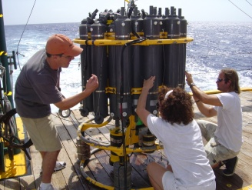
1. Small charter boat 1 day cruises: These cruises are done on a chartered fishing boat from the Sailfish Marina in West Palm Beach and involve sending one person with an AOML designed dropsonde that provides the vertically averaged horizontal velocity. Eight to ten cruises each year are timed to occur within a two week period quarterly, coinciding with the high density XBT transect AX07.

2. Coastal Survey Vessel: 2 to 3 day cruises, typically using the R/V Walton Smith. These cruises are planned for quarterly occupation (subject to ship time charter funding) and involve 3 PhOD personnel. Data resulting from these cruises include profiles of temperature, salinity, oxygen and velocity (from lowered and shipboard ADCP measurements). Starting in 2009, most of these cruises have included net tows in collaboration with the NOAA Southeast Fisheries Science Center.

Deep Western Boundary Current cruises along 26.5ºN: These cruises seek to quantify water mass variability in the Deep Western Boundary Current east of the Bahamas and to provide an estimate of the volume flow. Since 2004 in-situ PIES and CPIES moorings provide time series estimates of the DWBC (and the smaller northward-flowing Antilles Current) and cruises include servicing (as appropriate) and downloading the subsurface data (via telemetry). In addition to travel time series data, these cruises provide full water column estimates of temperature, salinity, oxygen, and velocity east of the Bahamas, along 26ºN, 27ºN in the Florida Straits, and near 78ºW across the Northwest Providence Channel (time permitting). This component of WBTS is collaboration between NOAA, NSF and the United Kingdom Natural Environment Research Council (NERC). The NSF funded part of the program is called MOCHA, while the UK funded part is called RAPID-MOC.

Expendable Bathythermograph (XBT) network: Goals - To measure the upper ocean mesoscale temperature and current variability in the Atlantic Ocean using expendable bathythermographs deployed with horizontal separation of 10-50 km. Ten High Density XBT transects are maintained by AOML with sampling typically quarterly for a total of 32 sections each year, with the notable exceptions that AX25 is repeated twice each year and AX97 is repeated six times per year. Each transect requires 1 ship rider to deploy XBTs, drifters, and Argo floats. International collaborators work with AOML personnel on the vast majority of these sections, covering two of the North Atlantic transects AX07 and AX10. The length of these cruises ranges from as many as 35 days (AX25 and AX08) to 3-4 days (AX10 and AX97).

Southwest Atlantic Meridional Overturning Circulation (SAM) array: Goals - To measure the western Atlantic components of the Meridional Overturning Circulation (MOC) at 34.5°S. The SAM project supports annual and/or semiannual research cruises to study the water masses in this region and to acoustically download daily data from moored instruments. The international project is collaboration between NOAA, the Argentine Naval Hydrographic Service, and the Universities of Buenos Aires and Sao Paulo. The SAM array also represents the western boundary cornerstone of the trans-basin MOC array at this latitude.

Hurricane Underwater Glider: To carry out underwater glider observations and obtain temperature and salinity profiles to 1000m deep to provide data as input to tropical cyclone forecast models. This project maintains a network of 2 to 4 underwater gliders, which are deployed twice a year in the Caribbean Sea and tropical North Atlantic Ocean. The deployments and recoveries are performed from the R/V La Sultana from the University of Puerto Rico Mayaguez. Approximately 2500 profiles are obtained during each mission, which run from February to May and from June to November (hurricane) season every year.

Some of our National and International Partners


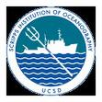
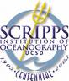











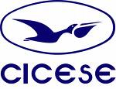


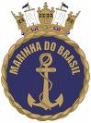






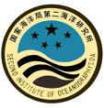


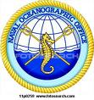


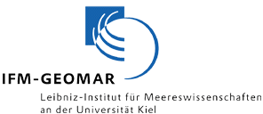
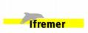








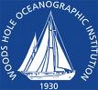

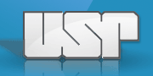
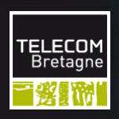





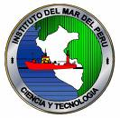
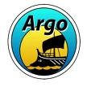




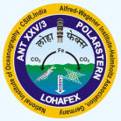
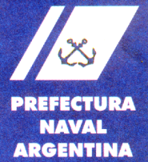







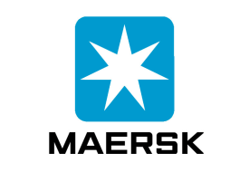





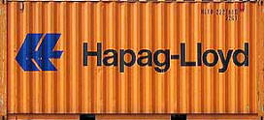












Recent PhOD Publications
(PhOD personnel in bold)
PDF of these publications can be obtained at: http://www.aoml.noaa.gov/phod/docs.php

Androulidakis, Y.S., V.H. Kourafalou, G.R. Halliwell, M. Le Henaff, H.S. Kang, M. Mehari, and R. Atlas, 2016: Hurricane interaction with the upper ocean in the Amazon-Orinoco plume region. Ocean Dynam., (doi:10.1007/s10236-016-0997-0), in press.
Baker-Austin, C., J.Trinanes, N. Gonzalez-Escalona, and J. Martinez-Urtaza, 2016: Non-Cholera Vibrios: The Microbial Barometer of Climate Change. Trends in Microbiology, accepted.
Balaguru, K., L.R. Leung, J. Lu, and G.R. Foltz, 2016: A meridional dipole in pre-monsoon Bay of Bengal tropical cyclone activity induced by ENSO. J. Geophys. Res. -Atmosp., 121(12):6954-6968 (doi:10.1002/2016JD024936).
Balaguru, K., G. R. Foltz, L. R. Leung, and K. A. Emanuel. Global warming-induced upper-ocean freshening and the intensification of super typhoons. Nature Communications, accepted.
Baringer, M.O., M. Lankhorst, D. Volkov, S. Garzoli, S. Dong, U. Send, and C.S. Meinen, 2016:. Meridional overturning circulation observations in the North Atlantic Ocean. In State of the Climate in 2015, J. Blunden and D.S. Arndt (eds.). Bull. Am. Meteorol. Soc., 97(8):S84S87.
Beron-Vera, F.J., M.J. Olascoaga, and R. Lumpkin, 2016: Inertia-induced accumulation of flotsam in the subtropical gyres. Geophys. Res. Lett., accepted.
Caillouet, C.W., N.F. Putman, D. J. Shaver, R. A. Valverde, E. E. Seney, K. J. Lohmann. K. L. Mansfield, B. J. Gallaway, J. P. Flanagan, and M. H. Godfrey, 2016: Recommendations for a plan to evaluate the contribution of Kemp’s ridley sea turtle ( Lepidochelys kempii ) rescue, resuscitation, rehabilitation and release translocations to population recovery. Herpetological Conservation and Biology, accepted.
Carrillo, L., E. M. Johns, R. H. Smith, and J.T. Lamkin, 2016: Pathways and hydrography in the Mesoamerican Barrier Reef System, Part 2: Thermohaline structure. Cont. Shelf Res., 120, 41-58, (doi:10.1016/j.csr.2016.03.014).
Centurioni, L., A. Horanyi, C. Cardinali, E. Charpentier, and R. Lumpkin, 2016: A global ocean observing system for measuring sea level atmospheric pressure: Effects and impacts on numerical weather prediction. Bull. Am. Meteorol. Soc., (doi:10.1175/BAMSD1500080.1), in press.
Cheng, L., J. Abraham , G. Goni, T. Boyer, S. Wijffels, R. Cowley, V. Gouretski, F. Reseghetti, S. Kizu, S. Dong, F. Bringas, M. Goes, L. Houpert, J. Sprintall, and J. Zhu, 2016: XBT science: Assessment of instrumental biases and errors. Bull. Am. Meteorol. Soc., 97(6):924-933, (doi:10.1175/BAMS-D-15-00031.1).
Christiansen, F., N. F. Putman, R. Farman, D.M. Parker, M.R. Rice, J.J. Polovina, G.H. Balazs, and G.C. Hays. Spatial variation in directional swimming leads juvenile sea turtles to productive waters. Marine Ecology Progress Series, 557:247 - 259, (doi:10.3354/meps11874).
Dmitrenko, I.A., S.A. Kirillov, A. Forest, Y. Gratton, D. L. Volkov, W.J. Williams, J.V. Lukovich, C. Belanger, and D.G. Barber, 2016: Shelfbreak current over the Canadian Beaufort Sea continental slope: Wind-driven events in January 2005. J. Geophys. Res. -Oceans,121(4);2447-2468, (doi:10.1002/2015JC011514).
Domingues, R., G. Goni, F. Bringas, B. Muhling, D. Lindo-Atichati, and J. Walter, 2016: Variability of preferred environmental conditions for Atlantic bluefin tuna (Thunnus thynnus) larvae in the Gulf of Mexico during 1993-2011. Fish. Oceanogr., 25(3):320-336, (doi:10.1111/fog.12152).
Domingues, R., M. Baringer, and G. Goni, 2016: Remote sources for year-to-year changes in the seasonality of the Florida Current transport. J. Geophys. Res. -Oceans, (doi:10.1002/2016JC012070), in press.
Elipot, S., R. Lumpkin, R. C. Perez, J. M. Lilly, J. Early, and A. Sykulski, 2016: A global surface drifter dataset at hourly resolution. J. Geophys. Res.-Ocean, 121(5):2937-2966 (doi:10.1002/2016JC011716.
Feely, R.A., R. Wanninkhof, B.R. Carter, J.N. Cross, J.T. Mathis, C.L. Sabine, C.E. Cosca, and J.A. Trinanes, 2016: Glob al ocean carbon cycle. In S tate of the Climate in 2015, J. Blunden and D.S. Arndt (e ds.). Bull. Am. Meteorol. Soc., 97(8):S89S92.
Foltz, G. R., and K. Balaguru, 2016: Prolonged El Nino conditions in 2014-15 and the rapid intensification of Hurricane Patricia in the eastern Pacific. Geophys. Res. Lett., 43(19):10,347-10,355, (doi:10.1002/2016GL070274).
Frajka-Williams, E., C. S. Meinen, W.E. Johns, D.A. Smeed, A. Duchez, A.J. Lawrence, D.A. Cuthbertson, G.D. McCarthy, H.L. Bryden, M.O. Baringer, B.I. Moat, and D. Rayner, 2016: Compensation between meridional flow components of the AMOC at 26°N. Ocean Sci., 12, 481-493, (doi:10.5194/os-12-481-2016).
Goni, G.J., J.A. Knaff, and I.I. Lin, 2016: Tropical cyclone heat potential. In State of the Climate in 2015, J. Blunden and D.S. Arndt (eds.). Bull. Am. Meteorol. Soc., 97(8):S120S123.
Hooper, J. A., M. O. Baringer, L. C. St. Laurent, W. K. Dewar, D. Nowacek, 2015. Dissipation Processes in the Tongue of the Ocean. J. Geophys. Res., 121(5):3159-3170, (doi: 10.1002/2015JC011165).
Iskandarani, M., M. Le Hénaff, W.C. Thacker, A. Srinivasan, and O.M. Knio, 2016: Quantifying uncertainty in Gulf of Mexico forecasts stemming from uncertain initial conditions. J. Geophys. Res.-Ocean, 121(7):4819-4832, doi:10.1002/2015JC011573.
Johnson, G.C., J. Reagan, J.M. Lyman, T. Boyer, C. Schmid, and R. Locarnini, 2016:. Salinity. In State of the Climate in 2015, J. Blunden and D.S. Arndt (eds.). Bull. Am. Meteorol. Soc., 97(8):S70S74.
Kourafalou , V.H., Y.S. Androulidakis, G.R. Halliwell, H.-S. Kang, M. Mehari, M. Le Henaff, R. Atlas, and R. Lumpkin, 2016:. North Atlantic Ocean OSSE system development: Nature Run evaluation and application to hurricane interaction with the Gulf Stream. Prog.Oceanogr., 148, 1-25, (doi:10.1016/j.pocean.2016.09.001).
Lamouroux, J., G. Charria, P. De Mey, S. Raynaud, C. Heyraud, P. Craneguy, F. Dumas and M. Le Hénaff, 2016: Objective assessment of the contribution of the RECOPESCA network to the monitoring of 3D coastal ocean variables in the Bay of Biscay and the English Channel. Ocean Dynam.,66(4):567-588, (doi:10.1007/s10236-016-0938-y).
Le Hénaff, M., and V.H. Kourafalou, 2016: Mississippi waters reaching South Florida reefs under no flood conditions: Synthesis of observing and modeling system findings. Ocean Dynam., 66(3):435-459, (doi:10.1007/s10236-016-0932-4).
Lee, S.-K., A.T. Wittenberg, D.B. Enfield, S.J. Weaver, C. Wang, and R. Atlas, 2016: U.S. regional tornado outbreaks and their links to the springtime ENSO phases and North Atlantic SST variability. Environ. Res. Lett., 11(4):044008, (doi:10.1088/1748-9326/11/4/044008).
Lee, T.N., N. Melo, N. Smith, E.M. Johns, C.R. Kelble, R.H. Smith, and P.B. Ortner, 2016: Circulation and water renewal of Florida Bay. Bull. Am. Meteorol. Soc., 92(2):153-180, (doi:10.5343/bms.2015.1019).
Li, H., R.L. Sriver, and M. Goes, 2016: Modeled sensitivity of the northwestern Pacific upper-ocean response to tropical cyclones in a full coupled climate model with varying ocean grid resolution. J. Geophys. Res. Lett.-Oceans, 121(1):586-601, (doi:10.1002/2015JC011226).
Li, G., M. Iskandarani, M. Le Henaff, J. Winokur, O.P. Le Maitre, and O.M. Knio, 2016: Quantifying initial and wind forcing uncertainties in the Gulf of Mexico. Computational Geosciences, 20(5):1133-1153, (doi:10.1007/s10596-016-9581-4).
Lima, M.O., M. Cirano, M. Mata, M. Goes, G. Goni, and M.O. Baringer, 2016: An assessment of the Brazil Current baroclinic structure and variability near 22°S in distinct ocean forecasting and analysis systems. Ocean Dynamics, 66(6):893 - 916, (doi: 10.1007/s10236-016-0959-6).
Lopez, H., S. Dong, S.-K. Lee, and E. Campos. Remote influence of interdecadal Pacific Oscillation on the South Atlantic Meridional Overturning Circulation variability. Geophys. Res. Lett., 43(15):8250 - 8258, doi:10.1002/2016GL069067.
Lopez, H., S. Dong, S.-K. Lee, and G. Goni, 2016: The role of the South Atlantic Meridional Overturning Circulation variability on modulating interhemispheric atmospheric circulation and monsoons. J. Clim., 29(5):1831 - 1851, (doi:10.1175/JCLI-D-15-0491.1).
Lopez, H., and B. P. Kirtman, 2016: Investigating the seasonal predictability of significant wave height in the west Pacific and Indian Oceans. Geophys. Res. Lett., 43(7):3451-3458, (doi:10.1002/2016GL068653).
Lumpkin, R., 2016: Global characteristics of coherent vortices from surface drifter trajectories. J. Geophys. Res. -Oceans, 121, (2):1306-1321, (doi:10.1002/2015JC011435).
Lumpkin, R., L. Centurioni and R. Perez, 2016: Fulfilling Observing System Implementation Requirements with the Global Drifter Array. J. Atmos.Oceanic Tech.,33(4):685-695, (doi:10.1175/JTECH-D-15-0255.1.)
Lumpkin, R., G. Goni, and K. Dohan, 2016: Surface currents. In State of the Climate in 2015, J. Blunden and D.S. Arndt (eds.). Bull. Am. Meteorol. Soc., 97(8):S82S84.
Lumpkin R., T. Ozgokmen, and L. Centurioni 2016: Advances in the applications of surface drifters. Annu. Rev. Mar. Sci., accepted.
Majumder, S., C. Schmid, and G. Halliwell, 2016: An observation and modelbased analysis of meridional transports in the South Atlantic. J. Geophys. Res. Lett.-Oceans, 121(8):5622-5638, (doi:10.1002/2016JC011693).
Martinez-Urtaza, J., A. Powell, J. Jansa, J.L. Castro Rey, O. Paz Montero, M. Garcìa Campello, J. Zamora Lopez, A. Pousa, J. Faraldo Valles, J. Trinanes, D.Hervio-Heath, W. Keay, A. Bayley, R. Hartnell and C. Baker-Austin, 2016: Epidemiological investigation of a foodborne outbreak in Spain associated with U.S. West Coast genotypes of Vibrio parahaemolyticus. SpringerPlus, 5:87, 1-8, (doi: 10.1186/s40064-016-1728- 1).
Martinez-Urtaza, J., Joaquin Trinanes, N. Gonzalez-Escalon, and C. Baker-Austin, 2016: Is El Niño a long distance corridor for waterborne disease? Nat. MicroBiol., 1(3):16018, (doi:10.1038/nmicrobiol.2016.18).
Meinen, C. S., and D.S. Luther, 2016: Structure, transport, and vertical coherence of the Gulf Stream from the Straits of Florida to the Southeast Newfoundland Ridge. Deep-Sea Res. I, 112, 137-157, (doi:10.1016/j.dsr.2016.02.002).
Muhling, B. A., R. Brill, J. T. Lamkin, M. A. Roffer, S.-K. Lee, Y. Liu, and F. Muller-Karger, 2016: Projections of future habitat use by Atlantic bluefin tuna: mechanistic vs. correlative distribution models. ICES. J. Marine Science, accepted.
Putman, N.F., R. Lumpkin, A.E. Sacco and K.L. Mansfield, 2016: Passive drift or active swimming in marine organisms. Proceedings of the Royal Society, accepted.
Putman, N.F, 2016: An ecological perspective on the migration of marine fishes. Environmental Biology of Fishes, 90(10):801-804, (doi: 10.1007/s10641-016-0512-yin).
Reagan, J., T. Boyer, C. Schmid, and R. Locarnini, 2016: Subsurface salinity. In State of the Climate in 2015, J. Blunden and D.S. Arndt (eds.). Bull. Am. Meteorol. Soc., 97(8):S72S74.
Riser, S.C., H.J. Freeland, D. Roemmich, S. Wijffels, A. Troisi, M. Belbeoch, D. Gilbert, J. Xu, S. Pouliquen, A. Thresher, P.-Y. Le Traon, G. Maze, B. Klein, M. Ravichandran, F. Grant, P.-M. Poulain, T. Suga, B. Lim, A. Sterl, P. Sutton, K.-A. Mork, P.J. Veèlez-BelchÃ, I. Ansorge, B. King, J. Turton, M. Baringer, and S.R. Jayne, 2016: Fifteen years of observations with the global Argo array. Nat. Clim.Change , 6(2):145-153, (doi:10.1038/nclimate2872).
Rugg, A., G.R. Foltz, and R.C. Perez. Role of mixed layer dynamics in tropical North Atlantic interannual sea surface temperature variability. J.Clim., 29(22):8083-8101, (doi:10.1175/JCLID1500867.1).
Shamblin, B.M., P.H. Dutton, D.J. Shaver, D.A. Bagley, N.F. Putman, K.L. Mansfield, L.M. Ehrhart, L.J. PeÃ±ag, and C.J. Nairna, 2016: Mexican origins for the Texas green turtle foraging aggregation: A cautionary tale of incomplete baselines and poor marker resolution. Journal of Experimental Marine Biology and Ecology, accepted.
Talley, L.D., R.A. Feely, B.M. Sloyan, R. Wanninkhof, M.O. Baringer, J.L. Bullister, C.A. Carlson, S.C. Doney, R.A. Fine, E. Firing, N. Gruber, D.A. Hansell, M. Ishii, G.C. Johnson, K. Katsumata, R.M. Key, M. Kramp, C. Langdon, A.M. Macdonald, J.T. Mathis, E.L. McDonagh, S. Mecking, F.J. Millero, C.W. Mordy, T. Nakano, C.L. Sabine, W.M. Smethie, J.H. Swift, T. Tanhua, A.M. Thurnherr, M.J. Warner, and J.Z. Zhang. Changes in ocean heat, carbon content, and ventilation: A review of the first decade of GOSHIP global repeat hydrography. Annual Review of Marine Science, 8:185215 (doi:10.1146/annurevmarine052915100829).
Tan, W., X. Wang, W. Wang, C. Wang, and J. Zuo. Different responses of sea surface temperature in the South China Sea to various El Nino events during boreal autumn. J. Climate., 29(3):11271142 (doi:10.1175/JCLID150338.1).
Trinanes, J., M.J. Olascoaga, G. Goni, N.A. Maximenko, D.A. Griffin, and J. Hafner, 2016: Analysis of potential MH370 debris trajectories using ocean observations and numerical model results. Journal of Operational Oceanography, accepted.
Volkov, D.L., W.E. Johns, and T.V. Belonenko, 2016: Dynamic response of the Black Sea elevation to intraseasonal fluctuations of the Mediterranean sea level. Geophys. Res. Lett., 43(1):283-290, (doi:10.1002/2015GL066876).
Wang, C., 2016: Atlantic warm pool. In State of the Climate in 2015, J. Blunden and D.S. Arndt (eds.). Bull. Am. Meteorol. Soc., 97(8):S123S124.
Wang, X., and H. Liu. PDO modulation of ENSO effect on tropical cyclone rapid intensification in the western North Pacific. Clim. Dyn., 46(12): 1528 (doi:10.1007/s0038201525638).
Wang, C ., C. Deser, J.-Y. Yu, P. DiNezio, and A. Clement, 2016: El Niño-Southern Oscillation (ENSO): A review. Coral Reefs of the Eastern Tropical Pacific: Persistence and Loss in a Dynamic Environment, Glynn PW, Manzello DP, Enochs IC (eds). Springer, Netherlands, (doi: 10.1007/978-94-017-7499-4), 85 - 106.

2015
Ali, M.M., P.V. Nagamani, N. Sharma, R.T. Venu Gopal, M. Rajeevan, G.J. Goni, and M.A. Bourassa, 2015: Relationship between ocean mean temperatures and Indian Summer monsoon rainfall. Atmos. Sci. Let., 16(3):408-413, (doi:10.1002/asl2.576).
Anderson, B.T., and R.C. Perez, 2015: ENSO and non-ENSO induced charging and discharging of the equatorial Pacific. Clim. Dynam., 45, 2309 - 2327, (doi:10.1007/s00382-015-2472-x).
Balaguru, K., G.R. Foltz, L.R. Leung, E. D’Asaro, K.A. Emanuel, H. Liu, and S.E. Zedler, 2015: Dynamic potential intensity: An improved representation of the ocean’s impact on tropical cyclones. Geophys. Res. Lett., 42(16):6739-6746, (doi: 10.1002/2015GL064822).
Baringer, M. O., G. McCarthy, J. Willis, D. A. Smeed, D. Rayner, W. E. Johns, C. S. Meinen, M. Lankhorst, U. Send, S. A. Cunningham, and T. O. Kanzow, 2015: [Global Oceans] Meridional overturning circulation observations in the North Atlantic Ocean [in "State of the Climate in 2014"]. Bull. Amer. Meteor. Soc., S81-S82, 96, (7).
Baringer, M. O., W. E. Johns, W. R. Hobbs, S. Garzoli, S. Dong, and J. Willis, 2015: [Global Oceans] Meridional oceanic heat transport in the Atlantic Ocean [in "State of the Climate in 2014"]. Bull. Amer. Meteor. Soc., S78-S80, 96,(7).
Beron-Vera, F.J., M.J. Olascoaga, G. Haller, M. Farazmand, J. Trinanes, and Y. Wang, 2015: Dissipative inertial transport patterns near coherent Lagrangian eddies in the ocean. Chaos, 25:087412, (doi:10.1063/1.4928693).
Boyer, T., J. Antonov, J. Reagan, C. Schmid and R. Locarnini, 2015: [Global Oceans] Subsurface salinity [in "State of the Climate in 2014"]. Bull. Amer. Meteor. Soc., 96, (7), S74-S76.
Bringas, F., and G. Goni. Early dynamics of deep blue XBT probes. J. Atmos. Ocean. Technol., 32, 2253 - 2263, (doi:10.1175/JTECH-D-15-0048.1)
Carrillo, L., E. M. Johns, R. H. Smith, J. T. Lamkin, and J. L. Largier. Pathways and hydrography in the Mesoamerican Barrier Reef System Part 1: Circulation. Continental Shelf Research, 109:164-176, (doi:10.1016/j.csr.2015.09.014).
Cheng, L., J. Abraham , G. Goni , T. Boyer, S. Wijffels, R. Cowley, V. Gouretski, F. Reseghetti, S. Kizu, S. Dong , F. Bringas, M. Goes, L. Houpert, J. Sprintall, J. Zhu, 2015: XBT Science: assessment of instrumental biases and errors. Bull. Amer. Meteor. Soc., (BAMS), (doi:10.1175/BAMS-D-15-00031.1).
Cheon, W.G., S.-K. Lee, A.L. Gordon, Y. Liu, C.-B. Cho, and J.J. Park, 2015: Replicating the 1970s Weddell Polyna using a coupled ocean-sea ice model with reanalysis surface flux fields. Geophys., Res. Lett., 42, 5411-5418, (doi:10.1002/2015GL064364).
Dohan,K., G. Goni, and R. Lumpkin, 2015: [Global Oceans] Surface currents [in "State of the Climate in 2014"]. Bull. Amer. Meteor. Soc., 96(7):S76-S78.
Domingues, R ., G. Goni , F. Bringas , S.-K. Lee , H-S Kim, G. Halliwell , J. Dong , J. Morell, and L. Pomales, 2015: Upper ocean response to Hurricane Gonzalo (2014): Salinity effects revealed by sustained and targeted observations from underwater gliders. Geophys. Res. Lett., 42(17):7131-7138, (doi:10.1002/2015GL065378).
Dong, S., G. Goni, and R. Lumpkin, 2015: Mixed-lyer salinity baudget in the SPURS (Salinity Processes in the Upper ocean Regional Study) region on seasonal to interannual time scales. Oceanography, 28, (1), 78-85, (doi:10.5670/oceanog.2015.05).
Dong, S ., G. Goni , and F. Bringas . Temporal variability of the Meridional Overturning Circulation in the South Atlantic between 20S and 35S. Geophys. Res. Lett., 42, 7655 - 7662, (doi:10.1002/2015GL065603).
Foltz, G. R., K. Balaguru, and L. R. Leung, 2015: A reassessment of the integrated impact of tropical cyclones on surface chlorophyll in the western subtropical North Atlantic. Geophys. Res. Lett., 42, 4, 1158-1164, (doi:10.1002/2015GL063222).
Foltz, G. R., C. Schmid, and R. Lumpkin, 2015: Transport of surface freshwater from the equatorial to the subtropical North Atlantic Ocean. J. Phys. Oceanogr.,45(4):1086-1102, (doi:10.1175/JPO-D-114-0189.1).
Garzoli, S.L., S. Dong, R. Fine, C. Meinen, R.C. Perez, C. Schmid, E. van Sebille, and Q. Yao, 2015: The fate of the Deep Western Boundary Current in the South Atlantic. Deep-Sea Res. I, (doi: 10.1016/j.dsr.2015.05.008).
Goes, M., G. Goni, and S. Dong, 2015: An optimal XBT-based monitoring system for the South Atlantic meridional overturning circulation at 34°S. J. Geophys. Res. -Oceans, 120, 1,161-181, (doi:10.1002/2014JC010202).
Goes, M., M. Baringer, and G. Goni, 2015: The impact of historical biases on the XBT-derived meridional overturning circulation estimates at 34°S. Geophys. Res. Lett., 42(6):1848-1855, (doi:10.1002/2014GL061802).
Goni, G., J. Trinanes, A. MacFadyen, D. Streett, M.J. Olascoaga, M.L. Imhoff, F. Muller-Karger, and M.A. Roffer, 2015: Variability of the Deepwater Horizon surface oil spill extent and its relationship to varying ocean currents and extreme weather conditions. In Mathematical Modelling and Numerical Simulation of Oil Pollution Problems , M. Ehrhardt (ed.), Springer-Verlag, New York, 1-22, (doi:10.1007/978-3-319-16459-5_1).
Goni, G. J., J. A. Knaff, and I-I Lin, 2015: [Global Oceans] Tropical cyclone heat potential [in "State of the Climate in 2014"]. Bull. Amer. Meteor. Soc., 96, (7), S121-S122.
Halliwell, Jr. G.R., V. Kourafalou, M. Le Henaff, L.K. Shay, and R. Atlas, 2015: OSSE impact analysis of airborne ocean surveys for improving upper-ocean dynamical and thermodynamical forecasts in the Gulf of Mexico. Prog. Oceanogr.,130, 32-46, doi:10.1016/j.pocean.2014.09.004.
Halliwell, G.R., S. Gopalakrishnan, F. Marks, and D. Willey, 2015: Idealized study of ocean impacts on tropical cyclone intensity forecasts. Mon. Weather Rev., 143(4):1142-1165, (doi:10.1175/MWR-D-14-00022).
Jo, H.-S., S.-W. Yeh, and S.-K. Lee, 2015: Changes in the relationship in the SST variability between the tropical Pacific and the North Pacific across the 1998/99 regime shift. Geophys. Res. Lett., 42(17), (doi:10.1002/2015GL065049).
Karnauskas, M., M.J. Schirripa, J.K. Craig, G.S. Cook, C.R. Kelble, J.J. Agar, B.A. Black, D.B. Enfield, D. Lindo-Atichati, B.A. Muhling, K.M. Purcell, P.M. Richards, and C. Wang. 2015: Evidence of climate-driven ecosystem reorganization in the Gulf of Mexico. Global Change Biology, 21(7):2554-2568, (doi:10.1111/gcb.12894).
Lee, S.-K., W. Park, M.O. Baringer, A.L. Gordon, B. Huber, and Y. Liu, 2015: Pacific origin of the abrupt increase in Indian Ocean heat content and its link to recent global surface warming hiatus. Nature Geosci., 445-449, (doi:10.1038/ngeo2438).
Legler, D., H. J. Freeland, R. Lumpkin, G. Ball, M. J. McPhaden, S. North, R. Cowley, G. Goni, U. Send and M. Merrifield, 2015: The current status of the real-time in situ global ocean observing system for operational oceanography. J. Oper. Oceanogr., 8(S2):s189-s200 (doi:10.1080/1755876X.2015.1049883).
Liang, Y.-C., J.-Y. Yu, M.-H. Lo, and C. Wang, 2015: The changing influence of El NiÃ±o on the Great Plains low-level jet. Atmo.Sci.Lett., 16(4):512-517, (doi: 10.1002/asl.590).
Ling, Z., G. Wang, and C. Wang, 2015: Out-of-phase relationship between tropical cyclones generated locally in the South China Sea and non-locally from the northwest Pacific Ocean. Clim. Dynam., 45(3-4):1129-1136, (doi:10.1007/s00382-014-2362-7.).
Liu, Y., S.-K. Lee, D.B. Enfield, B.A. Muhling, J.T. Lamkin, F. Muller-Karger, and M.A. Roffer, 2015: Potential impact of climate change on the Intra-Americas Seas: Part 1: A dynamic downscaling of the CMIP5 model projections. J. Mar. Syst., 148, 56-69, (doi:10.1016/j.marsys.2015.01.007.).
Liu, H ., C. Wang , S.-K. Lee , and D.B. Enfield, 2015: Inhomogeneous influence of the Atlantic warm pool on United States precipitation. Atmos. Sci. Let., 16(1):63-69, (doi:10.1002/asl2.521).
Majamder, S ., A. Tandon, D.L. Rudnick, and J.T. Farrar. Near-inertial kinetic budget of the mixed layer and shear evolution in the transition layer in the Arabian Sea during the monsoons. J. Geophys. Res.-Oceans, (doi:10.1002/2014JC010198).
McCarthy, G.D., D.A. Smeed, W.E. Johns, E. Frajka-Williams, B.I. Moat, D. Rayner, M.O. Baringer, C.S. Meinen, J. Collins, and H.L. Bryden, 2015: Measuring the Atlantic Meridional Overturning Circulation at 26°N. Progr. Oceanogr., 130:91-111 (doi:10.1016/j.pocean.2014.10.006).
McDonagh, E.L., B.A. King, H.L. Bryden, P. Courtois, Z. Szuts, M. Baringer , S.A. Cunningham, C. Atkinson, and G. McCarthy. Continuous estimate of Atlantic oceanic freshwater flux at 26Â°N. J. Clim., 28(22):8888-8906, doi:10.1175/JCLI-D-14-00519.1.
Moon, I.-J., S.-H. Kim, and C. Wang. Reply: El NiÃ±o and intense tropical cyclones. Nature, 526(7575):E4-E5 ( doi:10.1038/nature15546 ).
Muhling, B.A., Y. Liu, S.-K. Lee, J.T. Lamkin, M.A. Roffer, F. Muller-Karger, and J.W. Walter, 2015: Potential impact of climate change on the Intra-Americas Seas: Part 2: Implications for Atlantic bluefin tuna and skipjack tuna adult and larval habitats. J. Mar. Syst., 148:1-13, (doi:10.1016/j.marsys.2015.01.010).
Muller-Karger, F.E., J.P. Smith, S. Werner, R. Chen, M. Roffer, Y. Liu, B. Muhling, D. Lindo-Atichati, J. Lamkin, S. Cerdeira-Estrada, and D.B. Enfield. Natural variability of surface oceanographic conditions in the offshore Gulf of Mexico. Prog. in Oceanogr., 134:54-76, (doi:10.1016/j.pocean.2014.12.007).
Nagamani, P.V., M.M. Ali, G.J. Goni, T.V.S. Udaya Bhaskar, J.P. McCreary, R.A. Weller, M. Rajeevan, V.V. Gopala Krishna, and J.C. Pezzullo. Heat content of the Arabian Sea mini warm pool is increasing. Atmos. Sci. Lett., (doi: 10.1002/asl.596.).
Oke, P., G. Larnicol, E. M. Jones, V. Kourafalou, A. K. Sperrevik, F. Carse, C. A. S. Tanajura, B. Mourre, M. Tonani, G. B. Brassington, M. Le HÃ©naff, G. R. Halliwell, Jr., R. Atlas, A. M. Moore, C. A. Edwards, M. J. Martin, A. A. Sellar, A. Alvarez, P. De Mey, and M. Iskandarani, 2014: Assessing the impact of observations on ocean forecasts and reanalyses: Part 2, regional applications. J. Operational Oceanogr., 8(1):s63-s79, (doi:10.1080/1755876X.2015.1022080.)
Peng, S., Y. Li, X. Gu, S. Chen, D. Wang, H. Wang. S. Zhang, W. Lv, C. Wang, B. Liu, D. Liu, Z Lai, W. Lai, S. Wang, Y. Feng, and J. Zhang, 2015: A real-time regional forecasting system established for the South China Sea and its performance in the track forecasts of tropical cyclones during 2011-2013. Weather Forecast., 30(2):471-485, (doi:10.1175/WAF-D-14-00070.1).
Peng, S., Y.-K. Qian, R. Lumpkin, Y. Du, D. Wang, and P. Li, 2014: Characteristics of the near-surface currents in the Indian Ocean as deduced from satellite-tracked surface drifters. Part I: Pseudo-Eulerian statistics. J. Phys.Ocean., 45(2):441-458, (doi:10.1175/JPO-D-14-0050.1).
Peng, S., Y.-K. Qian, R. Lumpkin, P. Li, D. Wang, and Y. Du, 2014: Characteristics of the near-surface currents in the Indian Ocean as deduced from satellite-tracked surface drifters. Part II: Lagrangian statistics. J. Phys.Ocean., 45(2):459 -477, (doi:10.1175/JPO-D-14-0049.1).
Perez, R. C., M. O. Baringer, S. Dong, S. L. Garzoli, M. Goes, G. J. Goni, R. Lumpkin, C. S. Meinen, R. Msadek, and U. Rivero, 2015: Measuring the Atlantic meridional overturning circulation. Mar. Tech. Soc. J., 49(2):167-177, (doi:10.4031/MTSJ.49.2.14.).
Reverdin, G., et al. [incl. R. Lumpkin], 2015: Surface salinity in the North Atlantic subtropical gyre during the STRASSE/SPURS summer 2012 cruise, Oceanography, 28(1):114-123, (doi:10.5670/oceanog.2015.09).
Song, Z. S .-K. Lee , C. Wang , B. Kirtman and F. Qiao, 2015: Contributions of the atmosphere-land and ocean-sea ice model components to the tropical Atlantic SST bias in CESM1. Ocean Modelling., 96(2):280-290, (doi:10.1016/j.ocemod.2015.09.008).
Talley,L.D., R.A. Feely, B.M. Sloyan, R. Wanninkhof, M.O. Baringer, J.L. Bullister, C.A. Carlson, S.C. Doney, R.A. Fine, E. Firing, N. Gruber, D.A. Hansell, M. Ishii, G.C. Johnson, K. Katsumata, R.M. Key, M. Kramp, C. Langdon, A.M. Macdonald, J.T. Mathis, E.L. McDonagh, S. Mecking, F.J. Millero, C.W. Mordy, T. Nakano, C.L. Sabine, W.M. Smethie, J.H. Swift, T. Tanhua, A.M. Thurnherr, M.J. Warner, and J.-Z. Zhang, 2015. Changes in Ocean Heat, Carbon Content, and Ventilation: Review of the First Decade of Global Repeat Hydrography (GO-SHIP), Annual Review of Marine Science, 8, DOI: 10.1146/annurev-marine-052915-100829.
Tan, W., X. Wang, W. Wang, C. Wang, and J. Zuo. Different responses of sea surface temperature in the South China Sea to various El Nino events during boreal autumn. J. Climate, (doi:10.1175/JCLI-D-15-0338.1).
van Hooidonk, R., J.A. Maynard, Y. LIU, and S.-K. Lee, 2015: Downscaled projections of Caribbean coral bleaching that can inform conservation planning. Global Change Biology, 21(9):3389-3401, (doi:10.1111/gcb.12901).
van Sebille, E., S. Waterman , A. Barthel , R. Lumpkin , S. Keating, C. Fogwill, and C. Turney. Pairwise surface drifter separation in the Western Pacific Sector of the Southern Ocean. J. Geophys. Res.-Ocean., 120(10):6769-6781, (doi.10.1002/2015JC010972).
Volkov, D.L., and F.W. Landerer, 2015: Internal and external forcing of sea level variability in the Black Sea. Clim. Dynam., 105:142-157, (doi:10.1007/s00382-015-2498-0).
Volkov, D.L ., A.A. Koubryakov, and R. Lumpkin . Formation and variability of the Lofoten Basin vortex in a high-resolution ocean model. Deep-Sea Res.-I, 105:142-157, (doi:10.1016/j.dsr.2015.09.001).
Wang, C., 2015: [The Tropics] Atlantic warm pool [in "State of the Climate in 2014"]. Bull. Amer. Meteor. Soc., 96, (7), S123-S124.
Wang, C ., C. Deser, J.-Y. Yu, P. DiNezio, and A. Clement, 2014: El Niño-Southern Oscillation (ENSO): A review. In Coral Reefs of the Eastern Pacific , P. Glymn, D. Manzello, and I. Enochs, Eds., Springer Science Publisher, in press.
Wang, X., and H. Liu, 2015: PDO modulation of ENSO effect on tropical cyclone rapid intensification in the western North Pacific. Climate Dynam., (doi:10.1007/s00382-015-2563-8.)
Wang, X.D., C. Wang, L. Zhanng, and X. Wang, 2015: Multidecadal variability of tropical cyclone rapid intensification in the western North Pacific. J. Climate, 28(9):3806-3820, (doi:10.1175/JCLI-D-14-00400.1.)
Wanninkhof, R., L. Barbero, R. Byrne, W.-J. Cai, W.-J. Huang, J.-Z. Zhang, M. Baringer, and C. Langdon, 2015: Ocean acidification along the gulf coast and east coast of the USA. Cont.Shelf Res., 98:54-71, (doi:10.1016/j.csr.2015.02.008).
Yan, Y., G. Wang, C. Wang, and J. Su, 2015: Low-salinity water off western Luzon Island in summer. J. Geophys. Res., 120(4):3011-3021, (doi:10.1002/2014JC010465).
Yang, L., Y. Du, D. Wang, C. Wang, and X. Wang. Impact of intraseasonal oscillation on the tropical cyclone track in the South China Sea. Climate Dynam., 44(5-6):1505-1519, (doi:10.1007/s00382-014-2180-y).
Yeh, S.-W., X. Wang, C. Wang, and B. Dewitte, 2015: On the relationship between the North Pacific climate variability and the Central Pacific El Nino. J. Clim., 28(2):663-677, (doi:10.1175/JCLI-D-14-00137.1).
Zhao, H., and C. Wang, 2015: Interdecadal modulation on the relationship between ENSO and typhoon activity during the late season in the western North Pacific. Clim. Dyn., (doi:10.1007/s00382-015-2837-1).

2014
Ansorge I., M. Baringer, E. Campos, S. Dong, Rana A. Fine, S. Garzoli, G. Goni, C. Meinen, R. Perez, A. Piola, M. Roberts, S. Speich, J. Sprintall, T. Terre, and M. Van den Berg, 2014: Basin-wide oceanographic array bridges the South Atlantic. Eos, Transactions, AGU, 95(6):53-54, doi:10.1002/2014EO060001, 2014.
Amaya, D. J., and G. R. Foltz, 2014. Impact of canonical and Modoki El Niño on tropical Atlantic SST. J. Geophys., Res., 119, 777-789, doi:10.1002/2013JC009476.
Balaguru, K., S. Taraphdar, L. R. Leung, and G. R. Foltz, 2014: Increase in the intensity of post-monsoon Bay of Bengal tropical cyclones. Geophys. Res. Lett., 41, 3594 - 3601, doi:10.1002/2014GL06
Balaguru, K., S. Taraphdar, L. R. Leung, G. R. Foltz, and J. A. Knaff, 2014: Cyclone-cyclone interactions through the ocean pathway. Geophys. Res. Lett., 41, 6855-6862, doi:10.1002/2014GL061489.
Baringer, M. O., W. E. Johns , S. Garzoli, S. Dong, D. Volkov, W. R. Hobbs, J. Willis, 2014: [Global Oceans] Meridional Oceanic Heat Transport in the Atlantic Ocean [in "State of the Climate in 2013"]. Bull. Amer. Meteor. Soc., 95(7), 69.
Baringer, M. O., G. McCarthy, J. Willis, M. Lankhorst, D. A. Smeed, U. Send, D. Rayner, W. E. Johns, C. S.Meinen, S. A. Cunningham, T. O. Kanzow, E. Frajka-Williams, and J. Marotzke, 2014: [Global Oceans] Meridional overturning circulation observations in the North Atlantic Ocean [in "State of the Climate in 2013"]. Bull. Amer. Meteor. Soc., 95(7), 67 -69.
Boyer, T., J. Antonov, J. Reagan, C. Schmid, and R. Locarnin, 2014: [Global Oceans] Subsurface salinity, [in "State of the Climate in 2013"]. Bull. Amer. Meteor. Soc., 95(7), 62 -65.
Cheon, W. G., Y.-G. Park, J. R. Toggweiler, and S.-K. Lee, 2014: The relationship of Weddell polynya and open-ocean deep convection to the Southern Hemisphere westerlies. J. Phys. Oceanogr., 44, 694-713. doi: http://dx.doi.org/10.1175/JPO-D-13-0112.1
Domingues, R., G. J. Goni, S. Swart, and D. Dong, 2014: Atmospherically forced variability of the Antarctic Circumpolar Current south of Africa between 1993 – 2010, J. Geophys. Res,. 119, 1123- 1145, Doi:10.1016/j.csr.2013.12.009.
Dong, S., M. O. Baringer, G. J. Goni, C. S. Meinen, and S. L. Garzoli, 2014: Seasonal variations in the South Atlantic Meridional Overturning Circulation from observations and numerical models , Geophys. Res. Lett., 41, 4611 - 4618, doi: 10.1002/2014GL060428
Garcia, R. F., and C. S. Meinen, 2014: Accuracy of Florida Current volume transport measurements at 27°N using multiple observational techniques, J. Atmos. Ocean. Tech., 31 (5), 1169-1180, 10.1175/JTECH-D-13-00148.1.
Goes, M., I. Wainer, N. Signorelli, 2014: Investigation of the causes of historical changes in the sub-surface salinity minimum of the South Atlantic, J. Geophys. Res.-Oceans., 119, doi:10.1002/2014JC00981.
Goni, G., J. A. Knaff, and I-I Lin, 2014: [Global Oceans] Tropical cyclone heat potential, [in "State of the Climate in 2013"]. Bull. Amer. Meteor. Soc., 95(7), 99 -101.
Goni, G., J. Sprintall, D. Roemmich, A. Gronell Thresher, R. Couley, and M. Baringer, 2013: The global network of XBT temperature sections in support of Oceanographic and climate studies. Chapter 5: Oceans and Society: Blue Planet, ed. Samuel Djavidnie, Cambridge Scholars Publishing, 2014. ISBN: 978-1-4438-5639-3.
Halliwell, Jr., G. R., A. Srinivasan, V. Kourafalou, H Yang, D. Willey, M. Le Henaff, and R. Atlas, 2014: Rigorous evaluation of a fraternal twin ocean OSSE system in the open Gulf of Mexico. J. Atmos. Ocean. Technol., 31, 105-130, doi:10.1175/JTECH-D-13-00011.1.
Halliwell, Jr. G.R., V. Kourafalou, M. Le Henaff, L.K. Shay, and R. Atlas, 2014: OSSE impact analysis of airborne ocean surveys for improving upper-ocean dynamical and thermodynamical forecasts in the Gulf of Mexico. Progress in Oceanography, doi:10.1016/j.pocean.2014.09.004, 130:32-46.
Halliwell, G.R., S. Gopalakrishnan, F. Marks, and D. Willey, 2014: Idealized study of ocean impacts on tropical cyclone intensity forecasts. Mon. Wea. Rev., doi:10.1175/MWR-D-14-00022.1, in press.
Ji,X., D. Neelin, S.-K. Lee and C. Mechoso, 2014: Interhemispheric teleconnections from tropical heat sources in intermediate and simple models. J. Clim., doi: 684 - 697,doi: http://dx.doi.org/10.1175/JCLI-D-13-00017.1.
Johns, E. M., B. A. Muhling, R. C. Perez, F. E. Muller-Karger, N. Melo, R. H. Smith, J. T. Lamkin, T. L. Gerard, and E. Malca, 2014: Amazon River water in the northeastern Caribbean Sea and its effect on regional larval reef fish assemblages during April 2009. Fisheries Oceanogr., 23(6), 472-494, doi:10.1111/fog.12082.
Kumar, B. P., J. Vialard, M. Lengaigne, V. S. N. Murty, G. R. Foltz , M. J. McPhaden, S. Pous, and C. de Boyer Montegut, 2014: Processes of interannual mixed layer temperature variability in the thermocline ridge of the Indian Ocean. Clim. Dyn., doi:10.1007/s00382-014-2059-y.
Lee, S.-K., B. E. Mapes, C. Wang , D. B. Enfield and S. J. Weaver, 2014: Springtime ENSO phase evolution and its relation to rainfall in the continental U.S., Geophys. Res. Lett., 41, 1673-1680, doi:10.1029/2013GL059137.
Lee, S.-K. P. N. DiNezio, E.-S. Chung, S.-W. Yeh, A. T. Wittenberg, and C. Wang, 2014: Spring persistence, transition and resurgence of El Nino. Geophys. Res. Lett., doi:10.1002/2014GL062484.
Le Hénaff, M., V. H. Kourafaloua, R. Dussurget, R. Lumpkin, 2014: Cyclonic activity in the eastern Gulf of Mexico: Characterization from along-track altimetry and in situ drifter trajectories. Prog. in Oceanogr., 120, 120–138.
Li, C. and C. Wang, 2014: Simulated impacts of two types of ENSO events on tropical cyclone activity in the western North Pacific: Large-scale atmospheric response. Clim Dyn., 42, 2727 – 2743, DOI 10.1007/s00382-013-1999-y.
Li, Y., W. Han, T . Shinoda , C. Wang, M. Ravichandran, and J.-W. Wang, 2014: Revisiting the wintertime intraseasonal SST variability in the tropical South Indian Ocean: Impact of the ocean interannual variation. J. Phys. Oceanogr., 44, 1886-1907.
Ling, Z., G. Wang, and C. Wang, 2014: Out-of-phase relationship between tropical cyclones generated locally in the South China Sea and non-locally from the northwest Pacific Ocean. Clim. Dyn., doi:10.1007/s00382-014-2362-7, in press.
Liu, H., C. Wang, S.-K. Lee, and D. B. Enfield, 2014: Inhomogeneous influence of the Atlantic warm pool on United States precipitation . Atmos. Sci. Lett ., DOI: 10.1002/asl2.521.
Lumpkin R., G. Goni, and K. Dohan, 214: [Global Oceans] Surface currents, [in "State of the Climate in 2013"]. Bull. Amer. Meteor. Soc., 95(7), 65 - 67.
Maloney, E. D., S. J. Camargo, E. Chang, B. Colle, R. Fu, K. L. Geil, Q. Hu, X. Jiang, N. Johnson, K. B. Karnauskas, J. Kinter, B. Kirtman, S. Kumar, B. Langenbrunner, K. Lombardo, L. N. Long, A. Mariotti, J. E. Meyerson, K. C. Mo, J. D. Neelin, Z. Pan, R. Seager, Y. Serra, A. Seth, J. Sheffield, J. Stroeve, J. Thibeault, S.-P. Xie, C. Wang , B. Wyman, and M. Zhao, 2014: North American climate in CMIP5 experiments: Part III: Assessment of 21st Century projections. J. Climate, 27, 2230-2270.
Meinen C. S. and S. L. Garzoli, 2014: Attribution of Deep Western Boundary Current variability at 26.5°N. Deep-Sea Res.I,, 90, 81-90, doi:10.1016/j.dsr.2014.04.016.
McCarthy, G.D., D.A. Smeed, W.E. Johns, E. Frajka-Williams, B.I. Moat, D. Rayner, M.O. Baringer, C.S. Meinen, J. Collins, and H.L. Bryden. Measuring the Atlantic Meridional Overturning Circulation at 26°N. Progress in Oceanography, DOI: 10.1016/j.pocean.2014.10.006, in press.
Muller-Karger, Frank E., M. T. Kavanaugh, E. Montes, W. M. Balch, M. Breitbart, F. P. Chavez, S. C. Doney, E. M. Johns, R. M. Letelier, M. W. Lomas, H. M. Sosik, and A. E. White (2014). A framework for a marine biodiversity observing network within changing continental shelf seascapes. Oceanography, 27(2), 18–23, http://dx.doi.org/10.5670/oceanog.2014.56.
Oke, P., G. Larnicol, E. M. Jones, V. Kourafalou, A. K. Sperrevik, F. Carse, C. A. S. Tanajura, B. Mourre, M. Tonani, G. B. Brassington, M. Le Hanaff, G. R. Halliwell, Jr., R. Atlas, A. M. Moore, C. A. Edwards, M. J. Martin, A. A. Sellar, A. Alvarez, P. De Mey, and M. Iskandarani, 2014: Assessing the impact of observations on ocean forecasts and reanalyses: Part 2, regional applications. J. Operational Oceanogr., in press.
Peng, S., Y.-K. Qian, R. Lumpkin, Y. Du, D. Wang, and P. Li, 2014: Characteristics of the near-surface currents in the Indian Ocean as deduced from satellite-tracked surface drifters. Part I: Pseudo-Eulerian statistics. J. Phys.Ocean., doi:10.1175/JPO-D-14-0050.1, in press.
Peng, S., Y.-K. Qian, R. Lumpkin, P. Li, D. Wang, and Y. Du, 2014: Characteristics of the near-surface currents in the Indian Ocean as deduced from satellite-tracked surface drifters. Part II: Lagrangian statistics. J. Phys.Ocean., doi:10.1175/JPO-D-14-0049.1, in press.
Perez, R. C., V. Hormann, R. Lumpkin , P. Brandt, W. E. Johns, F. Hernandez, C. Schmid, and B. Bourlas, 2014: Mean meridional currents in the central and eastern equatorial Atlantic. Clim. Dyn., 42, 2943 – 2962, doi 10.1007/s00382-013-1968-5.
Qian, Y.-K., S. Peng, C.-X. Liang, and R. Lumpkin, 2014: On the estimation of Lagrangian diffusivity: Influence of nonstationary mean flow. J. Phys. Ocean., doi:10.1175/JPO-D-14-0058.1.
Schmid, Claudia, 2014: Mean vertical and horizontal structure of the subtropical circulation in the South Atlantic from three-dimensional observed velocity fields. Deep-Sea Res.I,, 91 (9), 50-71, doi: 10.1016/j.dsr.2014.04.015.
Smeed, D. A., McCarthy, G. D., Cunningham, S. A., Frajka-Williams, E., Rayner, D., Johns, W. E., Meinen, C. S., Baringer, M. O., Moat, B. I., Duchez, A., and Bryden, H. L., 2014: Observed decline of the Atlantic meridional overturning circulation 2004-­2012, Ocean Sci., 10, 29-38, doi:10.5194/os-10-29-2014.
Smith, R.H., E.M. Johns, G.J. Goni, J. Trinanes, R. Lumpkin, A.M. Wood, C.R. Kelble, S.R. Cummings, J.T. Lamkin and S. Privoznik, 2014: Oceanographic conditions in the Gulf of Mexico in July 2010, during the Deepwater Horizon oil spill. Cont. Shelf Res., 77, 118-131.
Song, Z., H. Liu, C. Wang, L. Zhang, and F. Qiao. Evaluation of the eastern equatorial Pacific SST seasonal cycle in CMIP5 models. Ocean Sci., 10(5):837-843, doi:10.5194/os-101837-2014.
Sraj, I., M. Iskandarani, W.C. Thacker , A. Srinivasan, and O.M. Knio, 2014: Drag parameter estimation using gradients and Hessian from a polynomial chaos model surrogate. Mon. Wea. Rev., 142 (2):933-941, doi:10.1175/MWR-D-13-00087.1.
Volkov D.L., 2014: Do the North Atlantic winds drive the nonseasonal variability of the Arctic Ocean sea level?, Geophys. Res. Lett., 41, 2041-2047, doi:0.1002/2013GL059065.
Wang, C., 2014: [Global Oceans] Atlantic warm pool, [in "State of the Climate in 2013"]. Bull. Amer. Meteor. Soc ., 95(7), 105 -109.
Wang, C ., C. Deser, J.-Y. Yu, P. DiNezio, and A. Clement, 2014: El Niño-Southern Oscillation (ENSO): A review. In Coral Reefs of the Eastern Pacific , P. Glymn, D. Manzello, and I. Enochs, Eds., Springer Science Publisher, in press.
Wang, W., X. Zhu, C. Wang, and A. Köhl, 2014: Deep meridional overturning circulation in the Indian Ocean and its relation to Indian Ocean dipole. J. Clim., in press.
Wang, C., L. Zhang, S.-K. Lee., L. Wu, and C. R. Mechoso, 2014: A global perspective on CMIP5 climate model biases. Nature Clim. Change, 4, 201-205.
Wang, X., and C. Wang, 2014: Different impacts of various El Niño events on the Indian Ocean dipole. Climate Dynam., 42, 991-1005, DOI 10.1007/s00382-013-1711-2.
Wang, X. D., C. Wang, G. Han, W. Li, and X. Wu, 2014: Effects of tropical cyclones on large-scale circulation and ocean heat transport in the South China Sea. Climate Dynam., 43(12):3351-3366 (doi:10.1007/s00382-014-2109-5).
Yang, L., Y. Du, D. Wang, C. Wang, and X. Wang, 2014: Impact of intraseasonal oscillation on the tropical cyclone track in the South China. Sea . Clim Dyn, doi 10.1007/s00382-014-2180-y.
Yeh, S.-W., X. Wang, C. Wang, and B. Dewitte, 2014: On the relationship between the North Pacific climate variability and the Central Pacific El Nino. J. Clim. doi:10.1175/JCLI-D-14-00137.1, in press.
Zhang L., C. Wang and S.-K. Lee, 2014: Potential role of Atlantic warm pool-induced freshwater forcing in the Atlantic meridional overturning circulation: Ocean-sea ice coupled model simulations. Climate Dynam., doi:10.1007/s00382-013-2034-z., in-press.
Zhang, L.,C. Wang, Z. Song, and S.-K. Lee, 2014: Remote effect of the model cold bias in the tropical North Atlantic on the warm bias in the tropical southeastern Pacific. Journal of Advances in Modeling Earth Systems, doi:10.1002/2014MS000338, in press.

2013
Anderson, B.T., R. C. Perez, and A. Karspeck, 2013: Triggering of El Niño onset through the trade-w nd induced charging of the equatorial Pacific. Geophys. Res. Lett., 40(6):1212-1216 doi:10.1002/grl.50200.
Abraham J. P., M. O. Baringer, N.L. Bindoff, T. Boyer, L.J. Cheng, J.A. Church, J.L. Conroy, C.M. Domingues, J.T. Fasullo, J. Gilson, G. Goni, S.A. Good, J. M. Gorman, V. Gouretski, M. Ishii, G.C. Johnson, S. Kizu, J.M. Lyman, A. M. Macdonald, W.J. Minkowycz, S.E. Moffitt, M.D. Palmer, A. Piola, F. Reseghetti, K. Schuckmann, K.E. Trenberth, I. Velicogna, J.K. Willis, 2013: Monitoring systems of global ocean heat content and the implications for climate change, a review. Rev Geophy, doi: 10.1002/rog.20022.
Baringer, M. O., W. E. Johns, G. McCarthy, J. Willis, S. Garzoli, M. Lankhorst, C. S. Meinen, U. Send, W. R. Hobbs, S. A. Cunningham, D. Rayner, D. A. Smeed, T. O. Kanzow, P. Heimbach, E. Frajka-Williams, A. Macdonald, S. Dong and J. Marotzke, 2013: Meridional Overturning Circulation and Heat Transport Observations in the Atlantic Ocean. [Global Oceans] Meridional Overturning Circulation and Heat Transport Observations in the Atlantic Ocean [in State of the Climate in 2012], Bull. Am. Met. Soc.,94 (8) S65-68.
Beal, L., V. Hormann, R. Lumpkin and G. R. Foltz, 2013: The surface monsoon circulation of the Arabian Sea. J. Phys. Oceanogr., 43 (9), 2008-2022,doi:10.1175/JCLI-D-13-00037.1.
Beron-Vera F., J. Olascoaga, G. Haller, G. Goni, and Y. Wang, 2013: Objective detection of oceanic eddies and the Agulhas leakage. J. Phys. Oceanogr., 43, 1426–1438.
doi: http://dx.doi.org/10.1175/JPO-D-12-0171.1
Boyer, T., S. Levitus, J. Antonov, J. Reagan, C. Schmid, and R. Locarnini, 2013: Subsurface salinity. [in "State of the Climate in 2012"]. Bull. Amer. Meteor. Soc., 94 (8) S60-61.
Cannizzaro, J. P., C. Hu, K.L. Carder, C. R. Kelble, N. Melo, E. M. Johns, G.A. Vargo, C.A. Heil, 2013: On the accuracy of SeaWiFS ocean color data products on the west Florida shelf, J. Coastal Res., Res., 29(6), 1257 – 1272.
Cheon, W. G., Y.-G. Park, J. R. Toggweiler, and S.-K. Lee, 2013: The relationship of Weddell polynya and open-ocean deep convection to the Southern Hemisphere westerlies. J. Phys. Oceanogr.

Dong, S., and K. A. Kelly, 2013: How Well Do Climate Models Reproduce North Atlantic Subtropical Mode Water? J. Phys. Oceanog., 43, 2230 -2244,doi: http://dx.doi.org/10.1175/JPO-D-12-0215.1

Foltz, G.R, A.T. Evan, H.P. Freitag, S. Brown, and M.J. McPhaden, 2013: Dust accumulation biases in PIRATA shortwave radiation records. J. Atmos. Ocean. Techn., 30(4), 810-824, doi:10.1175/JTECH-D-12-00169.1.

Foltz, G. R., C. Schmid and R. Lumpkin, 2013: Seasonal cycle of the mixed layer heat budget in the northeastern tropical Atlantic Ocean. J. Clim., 26, 8169 – 8188, doi: 10.1175/JCLI-D-13-00037.1
Fox-Kemper, B., R. Lumpkin and F. Bryan, 2013: Lateral Transport in the Ocean. Chapter 3.5 of "Ocean Circulation and Climate (Second edition), ed. G. Siedler, J. Church, J. Gould and S. Griffies, Academic Press (Elsevier).

Frajka-Williams, E., W. E. Johns, C. S. Meinen, L. M. Beal, and S. A. Cunningham, 2013: Eddy impacts on the Florida Current. Geophys. Res. Lett., 40(2):349-353, doi:10.1002/grl.50115.
Goes, M., G.J. Goni, and K. Keller, 2013: Reducing Biases in XBT Measurements by IncludingDiscrete Information from Pressure Switches. J. Atmos. Ocean. Techn., 30, 810-824, doi:10.1175/JTECH-D-12-00126.1.
Goes, M., G. J. Goni, V. Hormann, and R. C. Perez, 2013: Variability of eastward currents in the equatorial Atlantic during 1993-2010. J. Geophys. Res., 118, 3026-3045, doi:10.1002/jgrc.20186.
Goni, J. G., J. A. Knaff, and I-I Lin, 2013: Tropical cyclone heat potential. [in "State of the Climate in 2012"]. Bull. Amer. Meteor. Soc., 94 (8) S99-100.
Goni, G., J. Sprintall, D. Roemmich, A. Gronell Thresher, R. Couley, and M. Baringer, 2013: The global network of XBT temperature sections in support of Oceanographic and climate studies. Chapter 5: Oceans and Society: Blue Planet, ed. Samuel Djavidnie, Cambridge Scholars Publishing.
Hormann, V., R. Lumpkin, and R. C. Perez, 2013: A generalized method for estimating the structure of the equatorial Atlantic cold tongue: Application to drifter observations. J. Atmos. Oceanic Technol., 30, 1884-1895, doi:10.1175/JTECH-D-12-00173.1.
Howard, J., E. Babij, R. Griffis, B. Helmuth, A. Himes-Cornell, P. Niemier, M. Orbach, L. Petes, S. Allen, G. Auad, R. Beard, M. Boatman, N. Bond, T. Boyer, D. Brown, P. Clay, K. Crane, S. Cross, M. Dalton, J. Diamond, R. Diaz, Q. Dortch, E. Duffy, D. Fauquier, W. Fisher, M. Graham. B. Halpern, L. Hansen, B. Hayum, S. Herrick, A. Hollowed, D. Hutchins, E. Jewett, D. Jin, N. Knowlton, D. Kotowicz, T. Kristiansen, P. Little, C. Lopez, P. Loring, R. Lumpkin , A. Mace, K. Mengerink, J. Morrison, J. Murray, K. Norman, J. O'Donnell, J. Overland, R. Parsons, N. Pettigrew, L. Pfeiffer, E. Pidgeon, M. Plummer, J. Polovina, J. Quintrell, T. Rowles, J. Runge, M. Rust, E. Sanford, U. Send, M. Singe, C. Spei, D. Stanitsk, C. Thornber, C. Wilson, and Y. Xue. Oceans and marine resources in a changing climate. In Oceanography and Marine Biology: Annual Review, R.N. Hughes, D.J. Hughes, and I.P. Smith (eds.). CRC Press, 51 :71-192 (2013).
Hutchinson K., S. Swart, I. J. Ansorge, and G. J. Goni, 2013: Exposing XBT bias in the Atlantic sector of the Southern Ocean. Deep-Sea Res., 80, 11–22, doi:10.1016/j.dsr.2013.06.001.
Kelly, K. A., and S. Dong, 2013: Sources and Predictability of Anomalies in North Atlantic Subtropical Mode Water Volumes. Deep-Sea Res, 91:111-127(doi:10.1016/j.dsr2.2013,02.020).
Lee, S.-K., R. Atlas, D.B. Enfield, C. Wang and H. Liu, 2013: Is There An Optimal ENSOPattern That Enhances Large-scale Atmospheric Processes Conducive to Major Tornado Outbreaks in the U.S.? J. Clim., 26(5):1626-1642, doi:10.1175/JCLI-D-12-00128.1.
Lee, S.K., C. R. Mechoso, C. Wang, and J. D. Neelin, 2013: Interhemispheric influence of the northern summer monsoons on the southern subtropical anticyclone. J. Clim., 26, 10193-10204. doi:http://dx.doi.org/10.1175/JCLI-D-13-00106.1.
Letscher, R. T., D. A. Hansell, C. A. Carlson and R. Lumpkin, 2013: Distribution and fate of dissolved organic nitrogen in the global surface ocean. Global Biogeochem. Cycles, doi: 27(1):141-153, 10.1029/2012GB004449.
Li, C. and C. Wang, 2013: Simulated impacts of two types of ENSO events on tropical cyclone activity in the western North Pacific : Large-scale atmospheric response. Climate Dynamics.
Li, W., L. Li, M. Ting, Y. Deng, Y. Kushnir, Y. Liu, Y. Lu, C. Wang, and P. Zhang, 2013: Intensification of the Southern Hemisphere summertime subtropical anticyclones in a warming climate. Geophys. Res. Lett., 40, 5959–5964, doi:10.1002/2013GL058124.
Li, Y., W. Han, T. Shinoda, C. Wang, R.-C. Lien, J. N. Moum, J.-W. Wang, 2013: Effects of solar radiation diurnal cycle on the tropical Indian Ocean mixed layer variability during wintertime Madden-Julian Oscillation events. J. Geophys. Res., 118, 4945-4964, doi:10.1002/jgrc.20395 .
Lindo-Atichati, D. F. Bringas, and G. Goni, 2013: Loop Curent excursion and ring detachments during 1993-2009. Int. J. Rem. Sens., 34(14):5042-5053 doi:10.1080/01431161.2013.787504.
Liu, H., C. Wang, S.-K. Lee, and D.B. Enfield, 2013: Atlantic warm pool variability in the CMIP5 simulations. J. Clim., 26: 5315-5336.
Liu, Y., L. Xie, J.M. Morrison, and D. Kamykowski, 2013: Dynamic downscaling of the impact of climate change on the ocean circulation in the Galapagos Archipelago. Advances in Meteorology, 18 pp., 2013:837432, doi:10.1155/2013/837432.
Lumpkin, R., and P. Flament, 2013: Extent and energetics of the Hawaiian Lee Countercurrent. Oceanogr. 26(1):58-65, doi:10.5670/oceanog.2013.05.
Lumpkin R., G. Goni and K. Dohan, 2013: Surface Currents. [in "State of the Climate in 2012"]. Bull. Amer. Meteor. Soc., 94 (8) S62-65.
Lumpkin, R., S. Grodsky, M.-H. Rio, L. Centurioni, J. Carton and D. Lee, 2013: Removing spurious low-frequency variability in surface drifter velocities. J. Atmos. Oceanic. Techn., 30(2):353-360, doi:10.1175/JTECH-D-12-00139.1.
Lumpkin, R. and G. C. Johnson, 2013: Global Ocean Surface Velocities from Drifters: Mean, Variance, ENSO Response, and Seasonal Cycle. J. Geophys. Res.-Oceans, 118, in press, doi:10.1002/jgrc.20210.
Macdonald, A., and M.O. Baringer, 2013: Observed Ocean Transport of Heat. Chapter 6.3 of "Ocean Circulation and Climate (Second edition)", ed. G. Siedler, J. Church, J. Gould and S. Griffies, Academic Press (Elsevier).
Maximenko, N., R. Lumpkin and L. Centurioni, 2013: Ocean Surface Circulation. Chapter 4.2 of "Ocean Circulation and Climate, 2nd Ed. A 21st century perspective", ed. G. Siedler, S. Griffies, J. Gould and J. Church, Academic Press.
McPhaden, M.J., and G.R. Foltz, 2013: Intraseasonal variations in the surface layer of the central equatorial Indian Ocean: The importance of horizontal advection and vertical mixing. Geophys. Res. Lett., 40(11):2737-2741, doi:10.1002/grl.50536.
Meinen, C, S., S. Speich, R. C. Perez, S. Dong, A. R. Piola, S. L. Garzoli, M. O. Baringer, S. Gladyshev, and E. J. D. Campos, 2013: Temporal variability of the Meridional Overturning Circulation at 34.5°S: Results from two pilot boundary arrays in the South Atlantic, submitted to J. Geophys. Res.-Oceans, 118, 6461–6478, doi:10.1002/2013JC009228.
Menary M. B., C. D. Roberts, M. D. palmer, P. R. Halloran, L. Jackson, R. A. Wood, W. A. Mueller, D. matei and S.K. Lee , 2013: Mechanisms of aerosol-forced AMOC variability in a state of thr art climate model. J. Geophys. Res., 118 , 2087-2096, doi:10.1002/jgrc.20178.
Muhling, B., R. H. Smith, L. Vásquez –Yeomans, J. Lamkin, E. M. Johns, L. Carrillo, E. Sosa-Cordero, and E. Malca, 2013: Larval fish assemblages and mesoscale oceanographic structure along the Mesoamerican Barrier Reef System. Fish. Ocean., 22(5):409-428 doi:10.1111/fog.12031.
Muller-Karger, F., M. Roffer, N. Walker, M. Oliver, O. Schofield, M. Abbott, H. Graber, R. Leben, and G. Goni, 2013: Satellite Remote Sensing in support of an integrated ocean observing system. Geosc. Remote. Sens., 1(4):8-18, doi:10.1109/MGRS.2013.2289656.
Olascoaga, M.J., F.J. Beron-Vera, G. Haller, J. Trinanes, M. Iskandarani, E.F. Coelho, B.K. Haus, H.S. Huntley, G. Jacobs, A.D. Kirwan, B.L. Lipphardt, T.M. Ozgokmen, A.J.H.M. Reniers, and A. Valle-Levinson. Drifter motion in the Gulf of Mexico constrained by altimetric Lagrangian coherent structures. Geophys. Res. Lett., 40(23):6171-6175, doi:10.1002/2013GL058624.
Sheffield, J., B. Langenbrunner , J. E. Meyerson , J. D. Neelin, S. J. Camargo, R. Fu, Qu Hu, Xianan Jiang, Kristopher B. Karnauskas, Seo Tae Kim, Sanjiv Kumar , Jim Kinter, E. D. Maloney, A. Mariotti, Z. Pan, A. Ruiz-Barradas, S. Nigam, R. Seager, Y. L. Serra, D.Z. Sun, C. Wang, J.Y. Yu, N. Johnson, S.P. Xie, T. Zhang, and M. Zhao . North American climate in CMIP5 experiments. Part II: Evaluation of historical simulations of intra-seasonal to decadal variability 2013: North American climate in CMIP5 experiments. Part II: Evaluation of historical simulations of intra-seasonal to decadal variability . J. Clim., 26 , 9247-9290, doi: 10.1175/JCLI-D-12-00593.1.
Shinoda, T., T. Jensen, M. Flatau, S. Chen, W. Han, and C. Wang, 2013: Large-scale oceanic variability associated with the Madden-Julian oscillation during the CINDY/DYNAMO field campaign from satellite observations. Remote Sensing, 5:2072-2092.
Smeed, D. A., G. McCarthy, S. A. Cunningham, E. Frajka-Williams, D. Rayner, W. E. Johns, C. S. Meinen, M. O. Baringer, B. I. Moat, A. Duchez, and H. L. Bryden, 2013: Observed decline of the Atlantic Meridional Overturning Circulation 2004 to 2012. Ocean Sci. Discuss., 10, 1619 - 1645, doi:10.5194/osd-10-1619-2013.
Sraj, I., M. Iskandarani, A. Srinivasan, W.C. Thacker , J. Winokur, A. Alexanderian, C.-Y. Lee, S.S. Chen, and O.M. Knio, 2013: Bayesian inference of drag parameters using AXBT data from Typhoon Fanapi. Monthly Weather Review, 141(7):2347-2367, doi:10.1175/MWR-D-12-00228.1.
Szuts, Z.B., and C. Meinen, 2013: Salinity transport in the Florida Straits, J. Atmos. Oceanic. Technol., 30, 971 - 983, doi:10.1175/JTECH-D-12-00133.1.

Volkov D.L., F.W. Landerer, 2013: Non-seasonal variability of the Arctic Ocean mass observed by GRACE. J. Geophys. Res., 118, doi:10.1002/2013JC009341.

Volkov D.L., F.W. Landerer, S.A. Kirillov, 2013: The genesis of sea level variability in the Barents Sea. Continental Shelf Res., 66, 92-104, doi:10.1016/j.csr.2013.07.007.

Wang, C., 2013: Atlantic warm pool (AWP) [in “State of the Climate in 2012”]. Bull. Amer. Meteor. Soc., 94 (8), S103-S106.

Wang, C., and X. Wang, 2013: Classifying El Niño Modoki I and II by Different Impacts on Rainfall in Southern China and Typhoon Tracks. J. Clim., 26:1322-1338, doi:10.1175/JCLI-D-12-00107.1.

Wang, C., C. Deser, J.-Y. Yu, P. DiNezio, and A. Clement, 2013: El Nino-Southern Oscillation (ENSO): A review. In Coral Reefs of the Eastern Pacific, P. Glymn, D. Manzello, and I. Enochs, Eds., Springer Science Publisher.

Wang, C., and L. Zhang, 2013: Multidecadal ocean temperature and salinity variability in the tropical North Atlantic: Linking with the AMO, AMOC and subtropical cell. J. Climate, 26, 6137-6162.

Wang, C., L. Zhang, S-K Lee, 2013: Response of Freshwater Flux and Sea Surface Salinity to Variability of the Atlantic Warm Pool. J. Clim., 26:1249-1267, doi:10.1175/JCLI-D-12-00284.
Wang X. and C. Wang, 2013: Different impacts of various El Niño events on the Indian Ocean dipole. Clim. Dyn..
Wang, X., C. Wang, W. Zhou, L. Liu, and D. Wang, 2013: Remote influence of North Atlantic SST on the equatorial westerly wind anomalies in the western Pacific for initiating an El Niño event: An atmospheric general circulation model study. Atmo. Sci. Lett., 14(2):107-111 doi:10.1002/asl2.425.

Wang, X., W. Zhou, D. Wang, and C. Wang, 2013: The impacts of the summer Asian Jet Stream biases on surface air temperature in mid-eastern China in IPCC AR4 models. Int. J. Clim., 33(2):265-276, doi:10.1002/joc.3419.

Wang, C., C. Li, M. Mu, and W. Duan, 2013: Seasonal modulations of different impacts of two types of ENSO events on tropical cyclone activity in the western North Pacific. Clim. Dyn., 40:2887-2902.
Winokur, J., P. Conrad, I. Sraj, O. Knio, A. Srinivasan, W.C. Thacker, Y. Marzouk, and M. Iskandarani, 2014: A priori testing of sparse adaptive polynomial chaos expansions using an ocean general circulation model database. Computational Geosciences, 17(6):899-911 doi:10.1007/s10596-013-9361-3.
Zhang, L., and C. Wang, 2013: Multidecadal North Atlantic sea surface temperature and Atlantic meridional overturning circulation variability in CMIP5 historical simulations. J. Geophys. Res..
Zhao J., B. Barnes, N. Melo, D. English, B. Lapointe, F. Muller-Karger, B. Schaeffer, C. Hu 2013: Assessment of satellite-derived diffuse attenuation coefficients and euphotic depths in south Florida coastal waters. Remote Sens. Envir., 131(1):38-50 doi:10.1016/j.res.2012.12.009.
Zhao, J., C. Hu, B. LaPointe, N. Melo, E. Johns, and R. Smith, 2013: Satellite observed "black water" events off Southwest Florida: Implications for coral reef health in the Florida Keys National Marine Sanctuary. Remote Sens., 5, 415-431; doi:10.3390/rs5010415.

Zheng, J., Q. Liu, C. Wang, and X.-T. Zheng, 2013: Impact of heating anomalies associated with rainfall variations over the Indo-Western Pacific on Asian atmospheric circulation in winter. Clim. Dynam., 40, 2023-2033.

