CRUISE REPORT

RRS Discovery Cruise No. D345

RAPID/MOCHA Program
November 21 – December 6, 2009
Freeport, Bahamas to Freeport, Bahamas

1. Introduction and Objectives

The RAPID/MOCHA program is a joint research effort between the National Oceanography Centre (Southampton, U.K.), the University of Miami’s Rosenstiel School of Marine and Atmospheric Science (RSMAS), and NOAA’s Atlantic Oceanographic and Meteorological Laboratory (AOML). The objective of this program is to establish an operational measurement system to continuously observe the strength and structure of the Atlantic meridional overturning circulation across the basin at 26.5º N. The U.K. program is referred to as “RAPID-WATCH” and is a part of the U.K. Rapid Climate Change Program (RAPID) funded by the National Environmental Research Council (NERC). The U.S. program is referred to as “MOCHA” (Meridional Overturning Circulation and Heat-flux Array) and is funded by the National Science Foundation (NSF). NOAA contributes significantly to the effort through its Western Boundary Time Series Program.

The goals of cruise D345 were to:
- Service the U.S. moorings within the western boundary array of the RAPID/MOCHA transbasin observing system. This includes three taut wire subsurface current meter/CTD moorings, and two “bottom-lander” moorings containing high-precision bottom pressure gauges.
- Conduct hydrographic (CTDO₂) and direct current profiling (lowered-ADCP, “LADCP”) stations along the 26.5º N mooring section off Abaco, Bahamas; and across the Northwest Providence Channel, including continuous shipboard ADCP observations; and
- Service three bottom pressure/inverted echo sounder (PIES) moorings and retrieve data from two additional PIES moorings via acoustic telemetry.

2. Cruise Synopsis

The cruise departed from Freeport at 1900 local time, delayed from the intended departure time of 0900 local owing to repairs to the ships anchor windlass that needed to be completed before sailing. The CTD/LADCP section across Northwest Providence Channel was accomplished without any problems, with both CTD and LADCP systems functioning well. The NOAA/AOML CTD/LADCP system was used, with NOAA’s CTD frame interfaced to the Discovery’s Seabird deck unit. A “chinese finger” wire clasp system with a safety strap was attached to the CTD cable just above the termination for added deployment security of the system.

Once in deep water east of Abaco, three deep “cal-dip” CTD stations were done to obtain in-situ calibration data for all the Seabird instruments to be deployed on the moorings. Following this, the Abaco 26.5º N CTDO₂/LADCP section was commenced. Problems with the LADCP system became evident on the first deep (3500m) station (CTD 11), with both the 150kHz downward looking ADCP and the upward looking 300kHz ADCP stopping prior to the end of the cast. Several changes of cables and of rechargeable battery systems failed to solve the problem, and after losing more than a half a day of time it was concluded that the root of the problem was the 150kHz ADCP, which was having a failure of one of its beams at depth and apparently drawing excessive current, resulting in several blown fuses. As no repair could be implemented onboard, and with no spare 150kHz ADCP available, the LADCP operations were discontinued for the remainder of the section. It was determined at this time that the last several stations on the 26.5º line (those to the east of 72ºW) would have to be cut to ensure sufficient time on the cruise to complete the mooring operations.

The 26.5º section was paused early on Nov. 28 after completing CTD 29, in order to take advantage of good weather and daylight for mooring operations at sites WB5/WBL5 on Nov. 28 and 29th. The remaining two CTD stations (Sta. 30 and 31) were completed during the night of Nov. 28. Mooring number M383 (site WB5) was successfully recovered on Nov. 28, but the bottom lander mooring (M384/WBL5) could not be recovered. Only one of its acoustic releases was communicating, and although it replied with a successful release response it never left the bottom. Several further attempts to release the lander over the next 24 hours proved unsuccessful, and the mooring is assumed lost.

Mooring M392 was successfully deployed at site WB5 on Nov. 29th during ideal weather conditions, and confirmed on bottom. The surface telemetry buoy popped to the surface about an hour after deployment and was visually inspected from the ship and confirmed in good shape. Bottom lander M393 (WBL5) was also successfully deployed Nov. 29th, and acoustic telemetry at PIES site E was successfully performed. Successful telemetry messages were received from M392 at 0000Z Nov 30, with all instruments on M392 online and reporting data.

PIES “D” (a C-PIES instrument) was successfully recovered just after dark on November 30, and a new PIES redeployed in its place. A cal-dip CTD cast (CTD 032) was performed at the PIES “D” site during the evening of Nov. 30 to obtain post-deployment calibration data for 12 of the Seabird Micro-cat instruments recovered from mooring M383. This cast also served as the post-deployment CTD cast for PIES “D”.

Mooring recovery operations were commenced at site WB3 (M382) on Dec. 1. This mooring had lost its top float and upper portion in February 2009 to a cut-off (that part having been fortunately recovered in a charter boat operation out of Hope Town), and therefore no radio or strobe were present on the mooring. The mooring was successfully released from the bottom but took much longer to come to the surface than expected, and its top part surfaced nearly a mile to the south of the anchor location. It was successfully recovered in full after waiting for all mooring components to come to the surface. We later determined, after looking at the moored instrument data, that the delayed surfacing time and large distance from the mooring site was explained by the mooring being vertically depressed by very strong deep southward currents at the time of release, in addition to the impact of its reduced positive buoyancy.

PIES “A” was successfully recovered, and a new C-PIES deployed in its place, during the night of December 1. This was followed by data telemetry operations at PIES site “C”, which, however, proved unsuccessful. (An earlier attempt at data telemetry from this site, during the outbound CTD section, was also unsuccessful, but it was determined that the instrument itself was otherwise healthy and sampling on schedule and so no recovery was attempted.) The ship then returned to mooring site WB3 to await daytime deployment operations.

Mooring WB3 (M391) was successfully deployed in the morning of Dec. 2. Attempts to recover the PIES at site “B” were unsuccessful – nothing was heard from it in response to multiple release attempts, nor could it be heard sampling, and no radio signal was heard after waiting on-site for several hours; therefore it is presumed lost. Bottom lander WBL3 (M394) was successfully deployed during the evening of Dec. 2, followed by the bottom survey of M391. A new PIES was successfully deployed at site “B” during the night of Dec. 2.

On the morning of Dec. 3 a deep cal-dip CTD cast was performed at the PIES “B” site, where the remaining Seabird micro-cats recovered from M383 and M382 were lowered; this also served as the post-deployment CTD cast for PIES “B”. Following this, the ship proceeded to mooring site WB0 where M381 was successfully recovered. The top float of the mooring proved difficult to approach safely and so the mooring was recovered in reverse order, starting from the release cluster first. Despite some tangles the mooring was successfully recovered in full, with no damage to any of the instruments. A shallow CTD cast (CTD034) was done at PIES “A” to provide the post-deployment CTD cast at that site, and to obtain cal-dip data for a SeaBird microcat recovered from M381 that had a limited (3000 psi) pressure range. The rest of the evening was spent offshore in deeper water where a final CTD/LADCP cast was done (CTD035) to obtain further diagnostic data on the failure mode of the 150 kHz ADCP.

M390 (site WB0) was successfully deployed on the morning of Dec. 4 and surveyed. This completed the scientific work and the ship then began its transit to Freeport for disembarkation. During the transit to Freeport the ship followed a shallow-water track along the south side of Northwest Providence Channel to obtain additional bottom track calibration data for the shipboard ADCP system. Ship arrived at Freeport and docked at 1000 local on Dec. 5.

3. Scientific Personnel

Name Position Organization

Bill Johns Ch. Sci. RSMAS/ U. Miami
Adam Houk Scientist RSMAS/ U. Miami
Mark Graham Technician RSMAS/ U. Miami
Ben Shaw Student RSMAS/ U. Miami
Chris Meinen Scientist NOAA/ AOML
Carlos Fonseca Scientist CIMAS/ U. Miami
Pedro Pena Technician NOAA/ AOML
Rigoberto Garcia Scientist CIMAS/ U. Miami
Stuart Cunningham Scientist NOC Southampton
Paul Wright Scientist NOC Southampton
Paul Duncan Technician NOC Southampton
Christian Crowe Technician NOC Southampton
Dave Childs Technician NOC Southampton
Stephen Whittle Technician NOC Southampton
John Wynar Technician NOC Southampton

3. Cruise Operations

3.1 Mooring Operations

Mooring Recoveries

Three taut-line subsurface moorings were successfully recovered from the locations listed in Table 1 and shown in Figure 1. These moorings contained a mixture of current meters, Acoustic Doppler Current Profilers (ADCPs), and temperature/salinity recorders. These moorings had been deployed previously in April 2008 aboard the R/V Seward Johnson. A bottom lander mooring previously deployed at site WBL5 could not be released from the bottom, and is presumed lost.
Note: the bottom lander at site WBL3 deployed in April 2008, that had been initially planned for recovery on this cruise, was left in the water to continue recording data until Spring of 2010 to provide overlapping bottom pressure data with the newly deployed lander at this site.

Table 1. Mooring Recoveries
Mooring Site | Mooring Number | Latitude  (ºN) | Longitude (ºW) | Depth (m) | Date of Recovery
WB0 | M381 | 26° 30.34' | 76° 50.49' | 1001 | 12/03/2009
WB3 | M382 | 26° 29.53' | 76° 30.04' | 4858 | 12/01/2009
WB5 | M383 | 26° 30.33' | 71° 58.23' | 5293 | 11/28/2009

Mooring Deployments

A total of 5 moorings (3 taut-wire moorings and 2 bottom landers) were deployed at the locations listed in Table 2 and shown in Figure 1. Surveying of the on-bottom position of all moorings (except for the bottom landers) was successfully completed after each mooring deployment.

Mooring WB5 contained a surface telemetry buoy intended to provide near-real time data from all of the instruments on the mooring. The instrument data is relayed via inductive up-wire telemetry to a subsurface controller/logger in the main subsurface flotation unit at 50 m depth, which then relays the data via conducting S-tether cable to a surface telemetry buoy. The other moorings contain only internally recording instruments whose data is recovered after the moorings are retrieved.

Table 2. Mooring Deployments

Mooring Site | Mooring Number | Latitude (ºN) | Longitude (ºW) | Depth (m) | Date of Deployment
WB0 | M390 | 26° 30.41' | 76° 50.45' | 1004 | 12/04/2009
WB3 | M391 | 26° 29.37' | 76° 30.02' | 4840 | 12/02/2009
WB5 | M392 | 26° 30.16' | 71° 58.70' | 5294 | 12/29/2009
WBL3 | M394 | 26° 29.42' | 76° 29.64' | 4843 | 12/02/2009
WBL5 | M393 | 26° 30.05' | 71° 59.20' | 5240 | 12/29/2009

3.2 Inverted Echo Sounders

NOAA maintains a line of inverted echo sounders (IES) along 26° 30’ N as part of its Western Boundary Time Series project. Most of the instruments are also equipped with bottom pressure sensors (PIES), and one has both a bottom pressure sensor and a single point current meter 50 m above the bottom (C-PIES). The activities involving inverted echo sounders are summarized in Table 3.

Table 3. PIES Operations

IES Site name | Latitude (°N) | Longitude (°W) | Date and Time (UTC) | Depth (m) | Operation performed
PIES A | 26 30.9 | 76 50.0 | Dec. 1, 2009 19:25 | 1065 | PIES Recovery
PIES A | 26 31.0 | 76 50.0 | Dec. 1, 2009 19:42 | 1137 | CPIES Deployment
PIES B | 26 29.6 | 76 28.3 | Dec. 2, 2009 20:00 | 4811 | Failed IES recovery
PIES B | 26 29.6 | 76 28.4 | Dec. 3, 2009 02:13 | 4827 | PIES Deployment
PIES C | 26 30.1 | 76 05.3 | Nov. 25, 2009 10:57 | 4766 | Failed PIES Telemetry
PIES C | 26 30.1 | 76 05.3 | Dec. 2, 2009 01:41 | 4766 | Failed PIES Telemetry
PIES D | 26 30.2 | 75 42.3 | Nov. 30, 2009 22:42 | 4690 | CPIES Recovery
PIES D | 26 30.2 | 75 42.3 | Dec. 1, 2009 00:31 | 4656 | PIES Deployment
PIES E | 26 30.0 | 72 00.0 | Nov. 30, 2009 02:39 | 5233 | PIES Telemetry

4. CTDO₂/LADCP Stations

A total of 35 CTDO₂ stations were conducted during the cruise (Table 4, Figure 2). At each station, profiles of temperature, salinity (conductivity), and dissolved oxygen concentration were collected from the surface to within approximately 20 m of the bottom, using a Sea-Bird SBE-911plus CTD system. Water samples for calibration of the salinity and dissolved oxygen profiles were collected using a 24-bottle Rosette system containing 10 liter Niskin bottles. Current profiles were also measured using a paired downward-looking 150 kHz Broadband and upward-looking 300 kHz Workhorse Acoustic Doppler Current Profiling ‘hybrid” system (LADCP) for the stations on the Northwest Providence Channel line (stations 1-5), and for the first two stations on the Abaco line (stations 9 and 10). Thereafter no useful LADCP profiles were acquired due to a failure of the downward looking 150 kHz system.

Some of the CTD casts were used to perform calibration checks on the temperature, salinity, and pressure measurements obtained from various moored instruments (SBE micro-cats) after their recovery or prior to deployment. During these casts, the outer rack of Niskin bottles was removed from the Rosette to accommodate the moored instruments and the CTD package was lowered to 3500 m with 5 minute bottle stops during the package retrieval. These casts were not part of the regular CTDO₂ /LADCP hydrographic sampling performed on the cruise and are indicated by an asterisk (*) in Table 4.

Table 4. CTDO₂ Station Locations

Station | Date | Time (UTC) | Latitude ( ºN ) | Longitude ( ºW ) | Depth (m)
1 | 11/22/2009 | 0221 | 26º 25.85’ | 78º 39.85’ | 764
2 | 11/22/2009 | 0423 | 26º 19.99’ | 78º 43.15’ | 683
3 | 11/22/2009 | 0606 | 26º 15.22’ | 78º 46.06’ | 522
4 | 11/22/2009 | 0750 | 26º 10.30’ | 78º 47.97’ | 452
5 | 11/22/2009 | 0917 | 26º 03.86’ | 78º 50.99’ | 299
6* | 11/22/2009 | 2304 | 25º 57.49’ | 76º 53.84’ | 4361
7* | 11/23/2009 | 0256 | 25º 57.61’ | 76º 53.64’ | 4373
8* | 11/23/2009 | 0645 | 25º 57.97’ | 76º 53.79 | 4450
9 | 11/23/2009 | 1248 | 26º 30.48’ | 76º 52.94’ | 463
10 | 11/23/2009 | 1422 | 26º 30.80’ | 76º 49.80’ | 1148
11 | 11/23/2009 | 1738 | 26º 30.02’ | 76º 44.65’ | 3848
12 | 11/23/2009 | 2320 | 26º 29.89’ | 76º 39.29 | 4547
13 | 11/24/2009 | 1552 | 26º 30.07 | 76º 34.01’ | 4830
14 | 11/24/2009 | 2057 | 26º 29.94’ | 76º 28.58’ | 4810
15 | 11/25/2009 | 0159 | 26º 30.04’ | 76º 20.71’ | 4806
16 | 11/25/2009 | 0649 | 26º 29.50’ | 76º 12.64’ | 4813
17 | 11/25/2009 | 1400 | 26º 29.78’ | 76º 05.12’ | 4800
18 | 11/25/2009 | 1935 | 26º 29.59’ | 75º 54.01 | 4715
19 | 11/26/2009 | 0021 | 26º 29.58’ | 75º 42.68’ | 4662
20 | 11/26/2009 | 0507 | 26º 29.72’ | 75º 29.82’ | 4686
21 | 11/26/2009 | 0959 | 26º 29.90’ | 75º 18.00’ | 4612
22 | 11/26/2009 | 1508 | 26º 30.52’ | 75º 04.78’ | 4608
23 | 11/26/2009 | 2002 | 26º 30.59’ | 74º 48.09 | 4523
24 | 11/27/2009 | 0114 | 26º 30.31 | 74º 31.00’ | 4469
25 | 11/27/2009 | 0616 | 26º 30.76’ | 74º 14.51’ | 4523
26 | 11/27/2009 | 1145 | 26º 29.93’ | 73º 52.35’ | 4740
27 | 11/27/2009 | 1743 | 26º 29.28’ | 73º 30.88’ | 4898
28 | 11/27/2009 | 2355 | 26º 29.99’ | 73º 08.19’ | 5009
29 | 11/28/2009 | 0552 | 26º 30.25’ | 72º 46.69’ | 5090
30 | 11/29/2009 | 0039 | 26º 29.96’ | 72º 23.38 | 5137
31 | 11/29/2009 | 0655 | 26º 29.79’ | 71º 59.45’ | 5236
32* | 12/01/2009 | 0349 | 26º 30.10’ | 75º 42.02’ | 4674
33* | 12/03/2009 | 1454 | 26º 28.99’ | 76º 28.42’ | 4850
34* | 12/04/2009 | 0005 | 26º 30.87’ | 76º 49.92’ | 1098
35 | 12/04/2009 | 0407 | 26º 31.48’ | 76º 46.02’ | 3572
* Instrument calibration casts
5. Underway Measurements

Thermosalinograph

Values of surface temperature and salinity were continuously monitored using a Sea-Bird temperature-conductivity recorder installed in the ship’s seawater intake line, and logged by the vessels’s underway recording system. Seawater samples for calibration of the sensor were taken from the intake line periodically throughout the cruise and analyzed on the ship’s salinometer.

Shipboard Acoustic Doppler Current Profiler

Upper ocean currents were continuously measured with a 150 kHz Ocean Surveyor Acoustic Doppler Current Profiler (ADCP) system mounted in the ship’s transducer well. The depth range of good velocity data typically extended to 220 m below the vessel, depending on sea state conditions.

6. Release of Project Data

In accordance with the provisions specified in the cruise prospectus and application for Bahamian clearance, the full data results from this experiment will be provided to the Commonwealth of the Bahamas according to the following schedule:

Shipboard Measurements

All shipboard measurements, including underway data records and CTDO₂/LADCP station data, will be provided within 1 year of the termination of the cruise (December, 2010).

Moored Instrumentation

Time series data records from the moored instruments will be provided within 2 years of recovery of the instruments (nominally May, 2012).

7. Acknowledgements

The support and able assistance provided by the Captain and crew of the RRS Discovery is gratefully acknowledged. Support for the scientific research was provided by the U.S. National Science Foundation, the NOAA Office of Climate Observations, and the U.K. National Environmental Research Council. The Commonwealth of the Bahamas graciously granted privileges to conduct scientific research in their territorial waters.

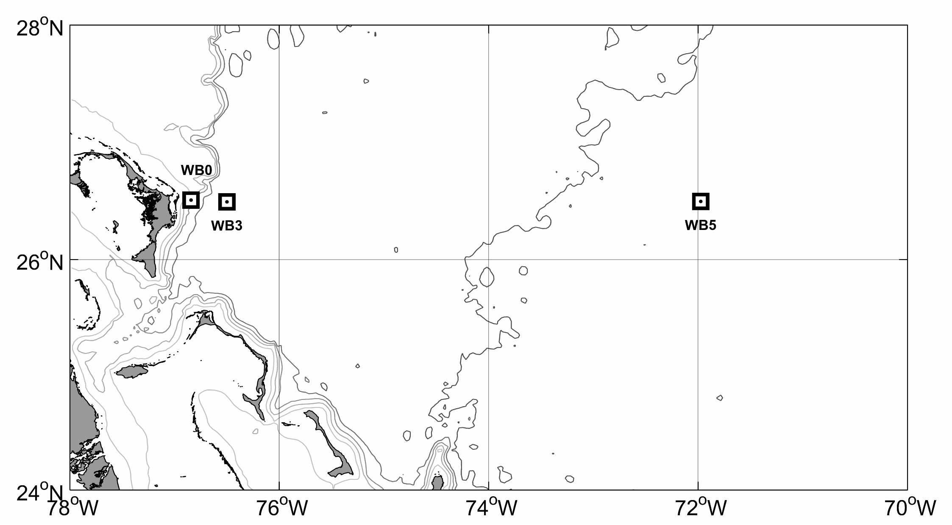
Figure 1. Moorings serviced during RRS Discovery cruise D345. Additional "bottom lander" moorings deployed at sites WB0 and WB3 are not shown.

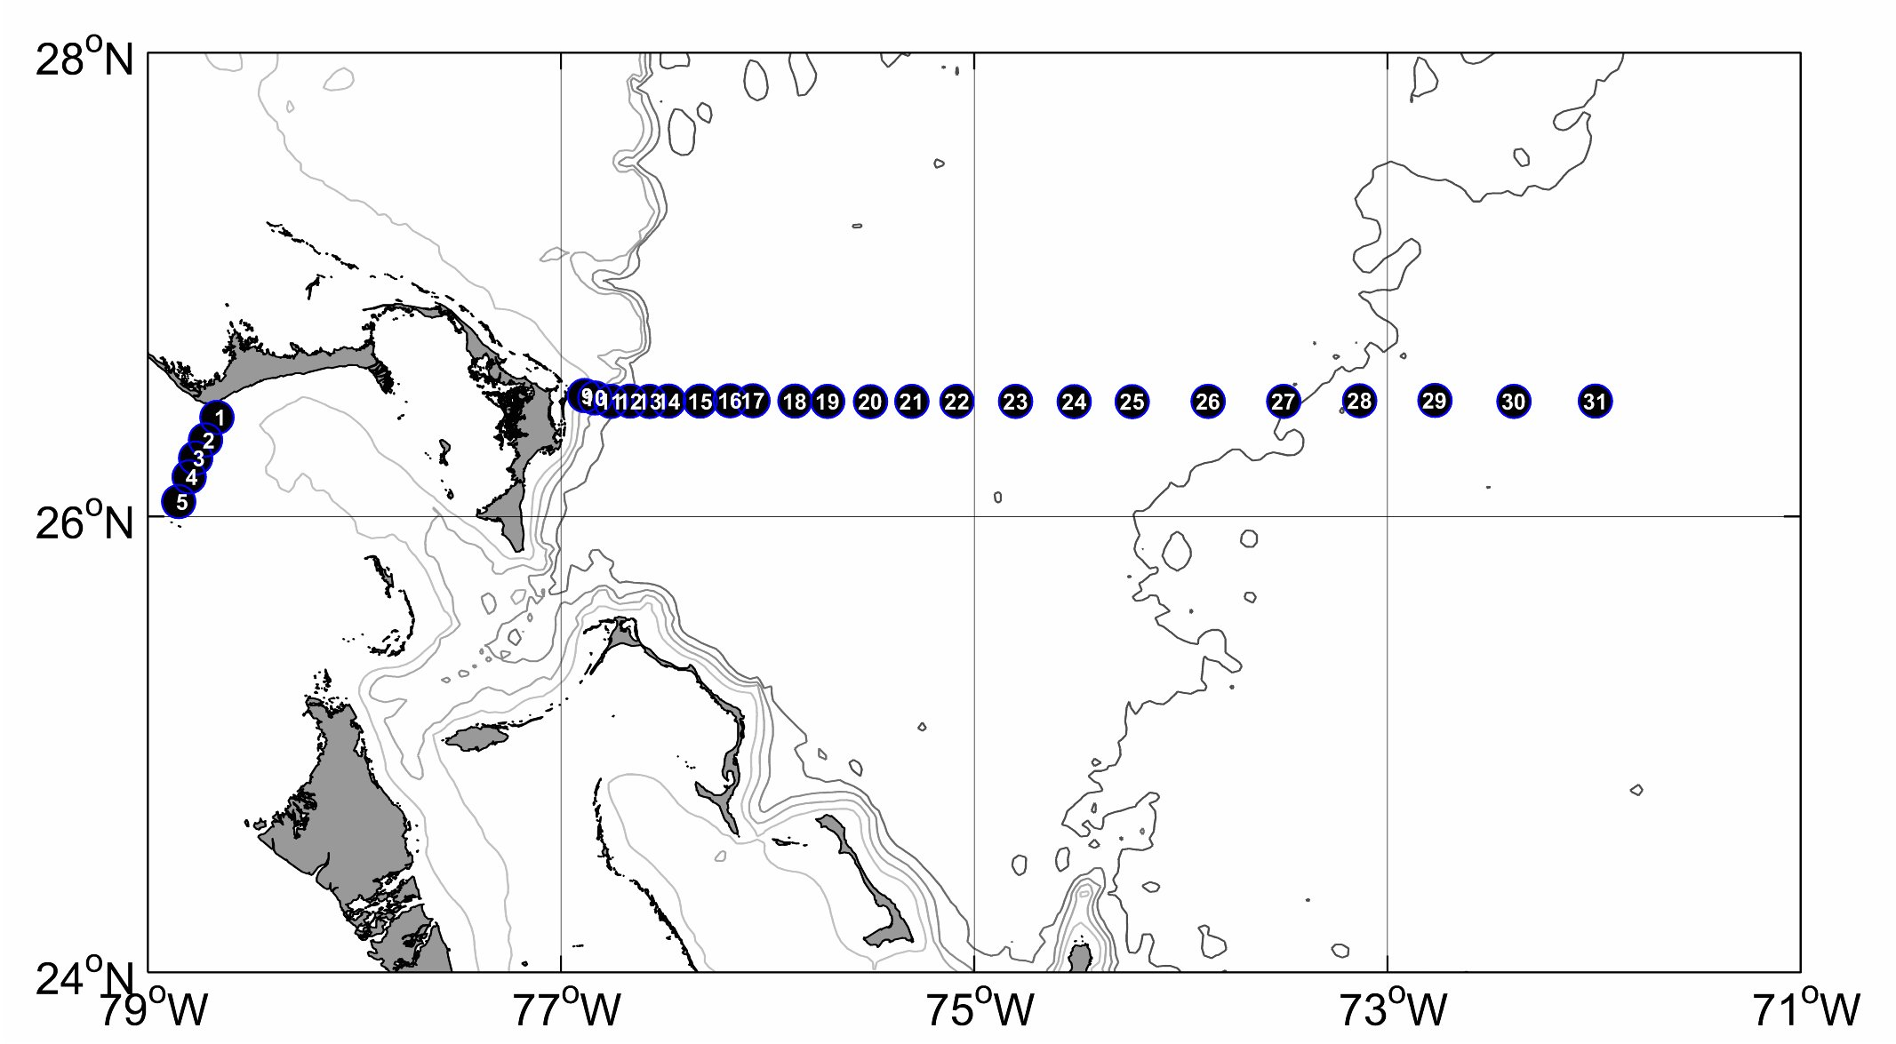

Figure 2. CTD stations occupied on the Northwest Providence Channel and Abaco lines.

