**How to Install and Configure HyperTerminal on to Windows 7**

1. Copy Files from XP to Win 7

From a valid installation of Windows XP, Copy the main HyperTerminal files:

C:\Program Files\Windows NT\ hypertrm.exe

C:\Windows\System32\hypertrm.dll

C:\Windows\Help\ hypertrm.chm (Optional)

C:\Windows\Help\ hypertrm.hlp (Optional).

  On the Windows 7 computer,

Make a new folder C:\Program Files (x86)\HyperTerminal and

Copy the Hypertrm files into the new folder.

2. Create Shortcut for HyperTerminal

If you want to have HyperTerminal on your Start Menu, create a shortcut to hypertrm.exe and put it in “C:\ProgramData\Microsoft\Windows\Start Menu\Programs”.

When a user goes to All Programs under the Start Menu, HyperTerminal will be there.

3. Configure HyperTerminal to automatically open an “.ht” file

a. Create and Associate “.ht” files with HyperTerminal

Open Hyperterm program.

Set the file properties to read from the COM port of interest.

Save the session as an “.ht” file, then Exit Hyperterm.

In “Windows Explorer”, right click on this “.ht” file and associate it with the

“hypertrm.exe” file (afterwards it will be displayed as “HyperTerminal Applet”).

Check the box to “Always use the selected program to open this kind of file”.

This activity creates an entry in the system Registry that will need to be edited.

b. Edit the system Registry

Click on the Start Button (bottom left corner of the screen).

Type “regedit” in the entry box labeled “select programs and files” , then press Enter.

In the left section of Registry Editor window, expand the “HKey_Classes_Root” entry.

Find the “ht_auto_file ” entry and expand each element.

Select the “ht_auto_file \ shell \ open \ command” entry.

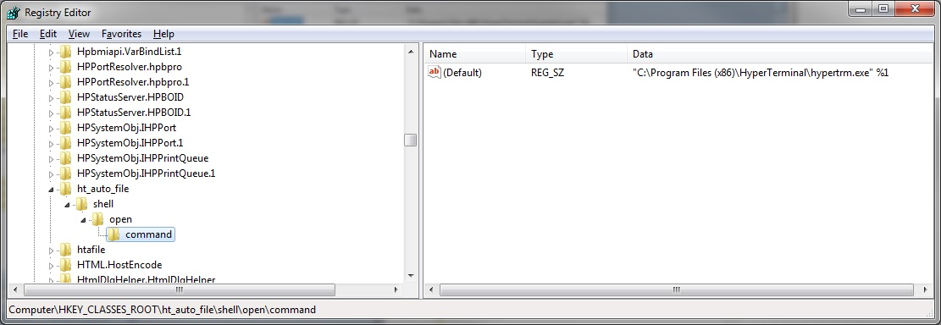

This “Default” command will likely have the value of

“C:\Program Files (x86)\HyperTerminal\hypertrm.exe” “%1” (red font added).

This “Default” command should have the value of

“C:\Program Files (x86)\HyperTerminal\hypertrm.exe” %1 .

Right-click on the “Default” command, and modify it.

Delete the quote marks around %1 , Click OK, and Exit Registry Editor.

To confirm success, Double-click on an “.ht” file with specific configuration.

Hyperterminal should open automatically with all the session information from the “.ht” file.