The Experimental HWRF System: A Study on the Influence of Horizontal Resolution on the Structure and Intensity Changes in Tropical Cyclones using an Idealized Framework

Sundararaman G. Gopalakrishnan¹, Frank Marks, Jr¹, Xuejin Zhang², Jian-Wen Bao³,
Kao-San Yeh², and Robert Atlas⁴

¹ NOAA/Hurricane Research Division
Atlantic Oceanographic Meteorological Laboratory
Miami, Florida

² University of Miami
Cooperative Institute for Marine and Atmospheric Studies
Miami, Florida

³ NOAA/Earth System Research Laboratory
Boulder, Colorado

⁴Atlantic Oceanographic Meteorological Laboratory
Miami, Florida

(Revised Version
Submitted to the Monthly Weather Review
Aug 30, 2010)

--------------
Corresponding author address: S.G. Gopalakrishnan, AOML/HRD, 4301 Rickenbacker Causeway, Miami, Florida 33149 <E-mail: gopal@noaa.gov>

Abstract
Forecasting intensity changes in tropical cyclones (TCs) is a complex and challenging multi-scale problem. While cloud-resolving numerical models using a horizontal grid resolution of 1-3 km are starting to show some skill in predicting the intensity changes in individual cases, it is not clear at this time what may be a reasonable horizontal resolution to forecast TC intensity changes on a day-to-day-basis. The Experimental Hurricane Weather Research and Forecasting System (HWRFX) was used in an idealized framework to gain a fundamental understanding of the influence of horizontal grid resolution on the dynamics of TC vortex intensification in three dimensions. HWFRX is a version of the National Centers for Environmental Prediction’s (NCEP) Hurricane Weather Research and Forecasting (HWRF) model specifically adopted and developed jointly at NOAA’s Atlantic Oceanographic and Meteorological Laboratory (AOML) and Earth System Research Laboratory (ESRL) for studying the intensity change problem at a model grid resolution of about 3 km. Based on a series of numerical experiments at the current operating resolution of about 9 km and at a finer resolution of about 3 km, it was found that improved resolution had very little impact on the initial spin up of the vortex. An initial axisymmetric vortex with a maximum wind speed of 20 ms⁻¹ rapidly intensified to 50 ms⁻¹ within about 24 hours in either case. During the spin-up process, buoyancy appears to have a pivotal influence on the formation of the warm core and the subsequent rapid intensification of the modeled vortex. The high-resolution simulation at 3 km produced updrafts as large as 48 ms⁻¹. However, these extreme events were rare, and our study indicated that these events may not contribute significantly to rapid deepening. Additionally, although the structure of the buoyant plumes may differ at 9- and 3-km resolution, interestingly, the axisymmetric structure of the simulated TCs exhibited major similarities. Specifically, the similarities included a deep inflow layer extending up to about 2 km in height with a tangentially-averaged maximum inflow velocity of about 12-15 ms⁻¹, vertical updrafts with an average velocity of about 2 ms⁻¹, and a very strong outflow produced at both resolutions for a mature storm. It was also found in either case that the spin-up of the primary circulation occurred not only due to the weak inflow above the boundary layer but also due to the convergence of vorticity within the boundary layer. Nevertheless, the mature phase of the storm’s evolution exhibited significantly different behavior at 9 and 3 km. While the minimum pressure at the end of 96 hours was 934 hPa for the 9-km simulation, it was about 910 hPa for the 3-km run. The maximum tangential wind at that time showed a difference of about 10 ms⁻¹. Several sensitivity experiments related to initial vortex intensity, initial radius of the maximum wind, and physics were performed. Based on ensembles of simulations, it appears that radial advection of the tangential wind and, consequently, radial flux of vorticity become an important forcing terms in the momentum budget of the mature storm. Stronger convergence in the boundary layer leads to a larger transport of moisture fluxes and, subsequently, a stronger storm at higher resolution.

- Introduction:
Forecasting intensity changes in tropical cyclones (TCs) is a complex and challenging problem. The factors that are known to influence these changes vary in scale ranging from several hundreds of kilometers (e.g., environmental shear, dry air, and upper ocean structure) to a few kilometers (e.g., vortex and convective scale asymmetries and ocean waves) and, sometimes, even down to a few hundred meters (e.g., wind gusts, aerosols, and microphysical processes). The Experimental Hurricane Weather Research and Forecasting System (HWRFX) is a version of the National Centers for Environmental Prediction’s (NCEP) Hurricane Weather Research and Forecasting (HWRF) system specifically adopted and developed at the Hurricane Research Division of the Atlantic Oceanographic and Meteorological Laboratory and Earth System Research Laboratory to study the intensity change problem at the finest model grid resolution feasible at this time for forecasting. In this paper, we seek a fundamental understanding of the intensification process of an initially cloud-free, axisymmetric, baroclinic vortex on an f-plane in a shear-free environment over a warm ocean with fixed sea surface temperatures in a weak easterly current of 4 ms⁻¹ (henceforth the ideal vortex) using the HWRFX system.
Past studies, starting with the pioneering theoretical work of Riehl (1954), Ooyama (1969, 1982), and Emanuel (1986), supported with inner core observations (Willoughby, 1979, 1990a, 1990b), have all led to a well-accepted understanding of the axisymmetric inner-core structure and evolution of the TC. In a shear-free, semi-ideal environment, the intensification of TCs occurs by means of cooperative interaction between the primary and secondary circulation. While the tangential wind (i.e., along the tangential direction in the cylindrical polar coordinate system) constitutes the primary circulation and angular momentum is approximately conserved above the boundary layer in this direction, the secondary circulation includes the radial inflow, upward motion, outflow, diabatic and, to some extent, adiabatic heating in the mid-to-upper troposphere and the subsequent core warming (Riehl, 1954; Ooyama, 1982). Typically, the warm core is supported by the evaporation and sensible heat supply from the warm ocean and inward enthalpy flux in the boundary layer. Furthermore, when the near-surface heat and moisture fluxes are transported upward by the secondary circulation, cumulus convection being the agent, a continual positive feedback is produced between the upward transport of near-surface fluxes, the deepening of pressure gradients primarily between the center and the eyewall, and the further increase in wind near the surface and deeper layer of the atmosphere until an equilibrium is attained (Emanuel, 1986). As indicated by observational analysis (e.g., Willoughby, 1990) and some earlier models (e.g., Sundqvist, 1970), the gradient wind relationship also holds fairly well above the boundary layer in mature TCs. Several axisymmetric models have been developed to understand the intensity changes in TCs (e.g., Yamasaki, 1977; Kurihara, 1975). A detailed review of the earlier works until 1967 is provided in Ooyama (1969). A review of more recent findings and a century of scientific progress in understanding the hurricane problem is reported in Emanuel (2003).
It should be noted that in all of the above studies the evolution of the axisymmetric vortex is comprised of a rapidly evolving phase followed by a mature stage where the intensification is slow (e.g., Figs. 2 and 3 in Sundqvist, 1970). While axisymmetric models may be able to explain rapid intensification to some extent and slow evolution to a larger extent, especially when the vortex is neutral to slantwise convection (Rotunno and Emanuel, 1987) as shown in our present work and that of Nguyen et al. (2008) and Montgomery et al. (2009), rapidly intensifying tropical cyclones are highly asymmetric. It is not clear how these asymmetries may influence the initial evolution of the storm. For instance, Rotunno and Emanuel (1987) explained the evolutionary phase of the storm as follows: “As the vortex wind passes over the ocean surface, θ_{e} is transferred to the interior and leads locally to conditional instability, cumulus convection, and subsequent precipitation.” While their conclusions may be correct for the case under consideration, the implicit assumption is that convection is symmetric around the eyewall region. Axisymmetric models also have limited applications for the forecasting problem.
Over the past 20 years, significant advances have been made in the numerical prediction of TCs. Much of this progress is due to advances in the development of three-dimensional models that approximate the fluid motion of the atmosphere to create forecasts of the weather at some time in the future. Since 1995, the Geophysical Fluid Dynamic Laboratory’s (GFDL) hydrostatic hurricane prediction system has been used operationally by the National Hurricane Center (NHC) and has proved to be the first numerical model to beat statistical models in track forecast skill. It has recently illustrated improved skill in intensity predictions, especially with increases in vertical and horizontal resolution (Bender et al., 2007). Apart from forecasting, a version of this modeling system has also been used for the purpose of understanding the hurricane problem (e.g., Kurihara and Tuelya, 1974; Tuleya and Kurihara, 1975, 1978, 1982; Shen et al., 2000). For instance, Kurihara and Tuleya (1974) used an 11-level primitive equation model with a horizontal resolution of about 20 km near the eye of the storm and studied the structure and development of an idealized TC in three dimensions. They obtained intensity changes and axisymmetric structure consistent with our current understanding of TCs. They also found that the energy and angular momentum budgets are primarily controlled by the axisymmetric mean around the vortex (Tuleya and Kurihara, 1975.) Nevertheless, the hurricane intensity change problem is a multi-scale problem and, as seen later in this text, may require cloud-scale resolutions (of 1-3 km) for simulating and understanding the inner core processes (Rogers, 2010). The Hurricane Weather Research and Forecasting (HWRF) system is a high-resolution, non-hydrostatic forecast system developed at NCEP’s Environmental Modeling Center (EMC) to address the intensity change problem (http://www.emc.ncep.noaa.gov/HWRF/index.html). This system is expected to replace the GFDL modeling system.
Cloud-resolving models have been used by the research community to understand the TC intensity change problem. In a series of explicit simulations, Michael Montgomery and Roger Smith and their colleagues used the fifth generation PSU/NCAR mesoscale model (known as MM5) at a resolution of about 1.67 km to examine the basic process of intensification of an idealized vortex (Nguyen et al., 2008; Montgomery et al., 2008; Smith et al., 2008, 2009). Their studies point out that (i) the intensification process is asymmetric and vortical hot towers may be an intensification pathway (Nguyen et al., 2008; Montgomery et al., 2008), and (ii) the axisymmetric aspects of intensification involves not only the convergence of absolute angular momentum above the boundary layer but also the convergence of absolute angular momentum within the boundary layer. The latter is aided by super-gradient winds (Smith et al., 2008, 2009). In the current work, we use the HWRFX system to provide new and additional insights on the idealized vortex intensification problem. Specifically, we seek to answer the following questions: (i) Does the new forecasting system produce the fundamental features of vortex spin-up consistent with some of the observations and theoretical works mentioned above? (ii) What is the role of convective asymmetries on the initial intensification of the storm? (iii) What is the impact of model grid resolution on the evolution of the TCs? To the best of our knowledge this is the first extensive effort that objectively investigates the effect of model grid resolution on the rapid intensity change in TCs and the subsequent evolution of the matured storm. We also believe that the third aspect of this problem may be useful to the forecasting community as well. In the next section, we provide a brief summary of model dynamics, especially the moving telescopic grid, because it has not been reported elsewhere. Section 2.2 deals with model configurations, initial conditions, and physics. Section 2.3 describes the methodology of analysis of the results. We discuss the results in section 3 and provide our conclusions in section 4.

2.1 The HWRFX moving nested grid system

A novel numerical approach (Janjic et al., 2001; Janjic, 2003) was applied to the NCEP Nonhydrostatic Meso Model (NMM) that is currently a dynamical core option within the Weather Research and Forecasting (WRF) model initiative. With this approach, instead of extending cloud models to larger spatial and temporal scales, the hydrostatic approximation is relaxed in a hydrostatic system of equations so as to extend the applicability of the model to non-hydrostatic motions. At the same time, the favorable features of the hydrostatic formulation are preserved within the range of validity of the hydrostatic approximation. The NMM-WRF non-hydrostatic system of equations is formulated on a rotated latitude-longitude Arakawa E-grid, while in the vertical a pressure-sigma hybrid coordinate is used. The latitude-longitude coordinate is simply transformed in such a way that the coordinate origin is located in the center of the integration domain. This kind of transformation provides a more uniform grid size all over the domain and, consequently, avoids the need for an excessively small time step as the model boundaries approach the northern/southern latitudes. The dynamical system of equations and the numerical techniques are described for a uniform domain in Janjic et al. (2001) and Janjic (2003). The HWRFX uses the same dynamics as the WRF-NMM system. In order to deal with TC forecasting, a horizontal mesh refinement capability was developed for this dynamical core. The refinement capability commonly referred to as telescopic mesh supports one- and two-way interaction between a lower-resolution parent domain and one or more higher-resolution nests. It also controls the motion of the higher-resolution nests (Fig. 1).

All interpolations from the parent to the nested domain are performed on a rotated latitude-longitude E-grid with the reference latitude-longitude located at the center of the parent domain (Fig. 1a). Consequently, the nested domain can be freely moved anywhere within the grid points of the parent domain, yet the nested domain latitude-longitude lines will coincide with the latitude-longitude lines of the parent domain at an integer parent-to-nest grid-size ratio (Fig. 1b). Terrain is an important forcing term in the dynamics of hurricane forecasting. Careful treatment of static terrestrial conditions is necessary to avoid contamination and possible noise in the modeled solution due to improper adjustment between mass and high-resolution terrestrial information. The WRF Pre-Processor (WPS) is used to generate terrain data sets over multiple domains at the required grid resolution. For instance, in a typical operational forecast at 27 km with a moving nest at 9 km resolution, terrestrial data are generated at both of the resolutions for the entire parent domain shown in Fig. 1a. The nested domain does not use any of the terrain information from the parent domain and, subsequently, pressure information is not directly interpolated from the hybrid surfaces of the parent domain onto the high-resolution nested domain either. The height, temperature, and moisture fields from the parent domain are vertically interpolated onto standard pressure surfaces. The above meteorological fields from the parent domain are further interpolated in the horizontal direction onto the nested grid on the same pressure surface. Finally, by using high-resolution topography over the nested domain, hydrostatic mass balancing is carried out to prescribe the initial values in the nested domain. The surface pressure, interface pressure, hydrostatic surface pressure, temperature, and moisture are recovered on the hybrid surfaces of the nested domain by using cubic spline interpolation. This approach seems to be simple yet produces an effective way of initializing the nested domain and updating the interface for the initial conditions without much distortion or noise, even while moving the telescopic nest. Simple bi-linear interpolation is used for initializing all meteorological fields in the horizontal. The nearest neighbor approach is adopted for prescribing most of the land state variables. For the current idealized study, the terrain is set to zero.
Figure 1c illustrates a sample E-grid structure with the outermost rows and columns representing the external interface. The fine grid data at this interface are prescribed by downscaling the coarse grid data at every time step of the parent domain (i.e., interpolation and hydrostatic adjustment mentioned above). Fine-grid integration starts from the third internal column/row that is called the dynamic interface in the figure. The data in the penultimate rows and columns are a blend of prescribed and dynamic interfaces. While bi-linear interpolation from the parent onto the nested domain is used to prescribe the wind and the total condensate, the mass adjustment procedure adopted for initialization is repeated, but this time only at the outermost boundaries. This approach is a simple, yet effective technique of updating the interface without excessive distortion or noise. For the two-way interactive technique, 9-point averaged mass, momentum, and scalar fields from the high resolution nest are weighed and fed back into the parent domain. Currently, the weighting factor is 0.5.
The nest motion for the TCs is based on the concept of dynamic pressure (Gopalakrishnan et al., 2002). At the end of every time step of the nested domain, the dynamic pressure within this domain is determined. The minimum dynamic pressure determines the storm center. If the storm center is advected beyond one grid point of the parent domain (three grid points from the center of the nested domain for a 3:1 parent to nest grid ratio that is usually used), the nested domain is moved to a new position within the parent domain to maintain the storm at the center of the nested domain. The nested domain cannot be moved by more than two parent domain grid points at a particular time step. While data are exchanged at a given time step before and after the grid motion in most parts of the domain (i.e., modified through the revision of horizontal indices), the interpolation and hydrostatic balancing procedures discussed earlier are applied to the leading edge of the moving nest (where there is no data to exchange). Additionally, if the pressure difference between the center and the point of maximum dynamic pressure is less than 2 hPa, the grid motion is terminated. This nest motion algorithm has been routinely used in the operational version of the HWRF system since 2006. If a storm is successfully located initially (i.e., at the start of a forecast) somewhere within the nested domain, the algorithm is sufficiently robust to provide automatic grid motion at subsequent times.
2.2 Configuration, Model Physics, and Initial Conditions
The domain of simulation along the horizontal direction was set to about 50 x 50 degrees with a moving nest of about 8 x 8 degrees. There were 40 hybrid levels along the vertical with the top level set to 50 hPa. The simulations reported here were run with two kinds of horizontal resolution, namely, (i) a parent domain at a resolution of about 27 km with a 9 km moving nest (27:9 henceforth) and (ii) a parent domain at a resolution of 9 km with a moving nest at 3 km (09:03 henceforth). While the former was designed to be consistent with the current operational resolution, the latter could be the possible choice in the near future. All the results reported in this work are products from the moving nest at either 9-km resolution or 3-km resolution. The model was run for 96 hours (4 days).
As discussed in Yeh et al. (2010), the physics options used here are configured as close as possible to the operational HWRF system. The so-called GFDL surface and boundary layer formulations are used to parameterize the flux transport and the subsequent mixing in the atmosphere. The Ferrier scheme is used to provide latent heating due to the microphysical processes in the atmosphere, and the Simplified Arakawa and Schubert scheme (SAS) is used to parameterize subgrid cumulus-cloud activity. Cumulus parameterization, e.g., Pan and Wu (1995), in combination with the Ferrier microphysical scheme have been found to have some value in operational models in scales down to less than 5 km. However, the contribution to heating from SAS has diminishing returns, i.e., an increase in resolution and the grid volume in the inner core region quickly becoming saturated with the use of an explicit microphysics scheme alone. To maintain consistency in the comparison of our results at 9 and 3 km, we retain the SAS convection scheme at 3 km resolution as well. Nevertheless, we have performed a sensitivity experiment without SAS convection at 3-km resolution which is reported in section 3. Finally, to keep the radiation option simple, the effect of radiation on the atmosphere is approximated with the NCAR long- and short-wave radiation scheme available in the WRF framework. Detailed descriptions of the physics options in HWFX with appropriate references are reported in Yeh et al. (2010).
Although the physics options in HWRFX were kept as close as possible to the operational physics, apart from the difference in the radiation scheme, there were several subtle but significant changes adopted in this ideal case study. As pointed out by one of the reviewers, we believe that it may be worthwhile to contrast these differences. Fortunately, the operational suite of physics has been recently published as a technical document at the Development Testbed Center, NCAR, Boulder. This documentation is edited by Bernardet and co-authored by Gopalakrishnan et al. (2010; http://www.dtcenter.org/HurrWRF/users/docs/scientific_documents/HWRF_final_2-2_cm.pdf and http://www.dtcenter.org/HurrWRF/users/online_tutorial/tutorial02222010.php). In Table 2, we specify some main differences in physics between the control simulation (C09) and the operational HWRF physics.
A full description of the idealized vortex initialization procedure for the HWRFX will be provided in a complementary publication (Bao et al., under preparation). In brief, the non-linear balance equation in the pressure-based sigma coordinate system described in Wang (1995) was solved within the rotated latitude-longitude E-grid framework, where the mass field was obtained from the wind field. The model is initialized with an axisymmetric cyclonic vortex embedded in a uniform easterly flow of 4 ms⁻¹. The far field temperature and humidity are based on Jordan’s Caribbean sounding (Gray et al., 1975). In all of the experiments, the sea surface temperature was set to 302 K. Several experiments were performed at 27:09 and 09:03 with different configurations of the ideal vortex and are reported in Table 1.
2.3 Methodology of analysis of the results
Apart from time traces of minimum mean sea-level pressure and 10-m wind speeds in the core that were simply isolated from the raw hourly output on the native grid system, we divided our analysis into two parts. The first part deals with instantaneous model outputs that were taken at an interval of 6 minutes on the native grid and interpolated to a height coordinate system. The instantaneous output was used to perform a qualitative study of the development of the warm core between hours 0-24 in C09 and C03. The second part deals with the axisymmetric mean created from hourly outputs for the entire period of the simulation. As illustrated in Liu et al. (1999) and Zhang et al. (2001), it is convenient to discuss the axisymmetric inner-core dynamics in cylindrical coordinates (r, λ,  z), where r is the distance from the center of the vortex, λ  is the azimuthal angle, and z is the vertical height. The hourly output on the native grid from the model was transformed to the cylindrical polar height coordinate system. Further, for the sake of analysis, we recast the horizontal equations of motion into radial and tangential momentum components similar to the work of Zhang et al. (2001) but in a simplified form appropriate for the HWRFX system. We provide these equations below.
$\frac{\text{du}r}{\text{dt}}= − \frac{1}{ρ}\frac{∂p}{∂r}\text{ + }\frac{vλvλ}{r}\text{ + }\text{fv}λ\text{ + }Dur$ (1)
Term A
$\frac{\text{dv}λ}{\text{dt}}= − \frac{1}{ρr}\frac{∂p}{∂λ} − \frac{urvλ}{r} − \text{fu}r\text{ + }Dvλ$ (2)
Term B
Where $\frac{d}{\text{dt}}= \frac{∂}{∂t} +ur\frac{∂}{∂r}\frac{vλ}{r}\frac{∂}{∂λ}\frac{∂}{∂z}$ (3)
In equations 1, 2, and 3, u_{r}, v_{λ}, and w are, respectively, the radial, tangential, and vertical winds in the earth-relative transformed coordinate system, p is the pressure, and Du_{r} and Dv_{λ} are, respectively, the diffusion (frictional) terms in the radial and tangential directions. In the absence of friction and the forces that constitute balance, equation 1 reduces to the gradient wind equation (Term A). Equation 2 represents the net forcing. Term B in equation 2 is known as the generalized Coriolis term, and its significance is discussed later in the text.
- Results and Discussion
3.1 Time Series of the Vortex Developments
Figure 2 provides the time history of the intensification on the inner nests at 9- and 3-km resolution (C09 and C03, respectively). The maximum potential intensity in terms of the maximum 10-m wind derived from the Statistical Hurricane Intensity Prediction Scheme (SHIPS) and Emanual’s potential intensity theory is also provided for reference. After an initial period of gestation where the “cold-start” spin up of the modeled vortex takes place, a period of rapid intensification is observed starting at about 8 hours in C09 and about 6 hours in C03 and continuing almost up to 24-30 hours. During this time, the mean sea level pressure (MSLP) is reduced by at least 60 hPa (Fig. 2a), and the maximum 10 m wind speed increases by 42 ms⁻¹ in both cases (Fig. 2b). Such rapid deepening is not uncommon in Atlantic hurricanes (Kaplan et al., 2010). Further intensification is slow; however, significant differences can be seen in the deepening process between C09 and C03.
Figures 2c and 2d provide Hovemoller diagrams of the mean tangential winds at a height of 10 m for C09 and C03. The contour lines from the outer to the inner core region are respectively, 17.2 ms⁻¹, 33 ms⁻¹, 43 ms⁻¹, 50 ms⁻¹, and 59 ms⁻¹ depicting the radius of gale-force winds and the core of hurricane winds starting from a minimal category of 1 to a minimal category of 4. In general, the radius of maximum wind between 24-96 hours is approximately 50 km, whereas the radius of gale-force wind keeps expanding during the same period of time. This is consistent with the known behavior of some of the intense Atlantic hurricanes (e.g., Hurricane Katrina, 2005; http://www.nhc.noaa.gov/pdf/TCR-AL122005_Katrina.pdf). The inner core is consistently stronger in C03 than in C09, especially during the mature phase. A simulation of C03 attains a strength corresponding to category 4 at the end of the simulation, whereas C09 is barely a category 3 hurricane. Nevertheless, the evolution of the radius of the gale-force winds, which have a slower time scale (Smith et al., 2009) than the spin up of the inner core, is nearly identical in both runs. As shown later, it appears that the resolution within the eyewall region may be more important than having a uniformly large, very-high resolution nested domain in precisely forecasting the intensity changes in TCs.
3.2 Rapid Intensification Stage: Warm Core Development
Central to the problem of intensification is the development of the warm core and the subsequent decrease in hydrostatic surface pressure. Figure 3 depicts various aspects of the warm core development at 9- and 3-km resolution (C09 and C03, respectively). As shown in Fig. 3a, the maximum tangentially-averaged temperature anomaly within the nested domain is very well correlated with the evolution of the MSLP (Fig. 2a). Nevertheless, to further understand the warm core development from an initial temperature anomaly of about 2 K that was produced from the non-linear balance method, we analyzed the three-dimensional evolution of instantaneous output obtained on the native rotated latitude-longitude system, but interpolated on the z coordinate system at a 6-minute interval between 0 and 24 hours. During this time period, the MSLP decreased from about 1000 hPa to 954 hPa (46 hPa in 24 hours) for C09 and from about 1000 hPa to 961 hPa (39 hPa in 24 hours) for C03. The corresponding maximum tangentially-averaged temperature anomaly was 8.9 K in C09 and 8.2 K in C03 (Fig. 3a).
The rapid warming of the core was closely associated with the development of organized moist, thermal plumes around the eyewall region. Figures 3b and 3c show an example of the 2 ms⁻¹ vertical velocity isosurface in C09 and C03, respectively, during the start of the rapid intensification period. These “organized plumes” bear some analogy with the dry thermals in the boundary layer (Gopalakrishnan and Avissar, 2000), but are moist, have a depth scale several times larger than those observed in the boundary layer, and are characterized by stronger vertical velocities in the mid-to-upper troposphere. A qualitative comparison between C09 and C03 indicates that horizontal resolution has a pronounced impact on the structure of these plumes. The plumes occupy a larger area but are fewer in number for simulation C09 than in C03.
We examined the thermal anomaly associated with each of the plumes by differencing the instantaneous temperature at a given grid point with respect to the far field environmental temperature profile within the nested domain. Such an analysis may be valid at least during the rapid intensification period where the thermal plume can be distinguished from the environment. Figures 4a and 4b, for example, depict the x-z cross-section of the instantaneous anomaly (color shaded) across an arbitrary plane in the eyewall region for C09 at about 9 hours (Fig. 4a) and 24 hours (Fig. 4b). The initial anomaly is 2 K and is also seen in the background. In this example, an average 6-9 K temperature anomaly is carried by individual updrafts with a vertical velocity of 4-5 ms⁻¹ during the rapid intensification period that is consistent with the average warming in the mid-to-upper troposphere (Fig. 3a). As depicted by the temperature anomaly and θ_{e} contours (indicated by black color), updrafts with a life cycle of about 15 minutes and an origin near the top of the boundary layer transport moisture and heat (higher θ_{e} air) into the upper troposphere (Emanuel, 2003). In addition, heat is also added by cumulus convection. Willoughby (1979) showed that the radial gradient of convective heating alone is sufficient to create weak subsidence and radial motion (w and u_{r}). Consistent with Willoughby’s findings, aided by weak subsidence and by radial advection (not shown and the subject of future investigation), an initially weak warm core strengthens rapidly within the first 24 hours (Figs. 3a, 4b, and 4d). Finally, although the structure of buoyant plumes may be different between C09 and C03 (Figs. 3c and 3d), interestingly, the intensification process was similar for this case (Table 1). At the end of the rapid intensification period, the maximum temperature anomaly was about 8-9 K, and the structure of the warm core exhibited major similarities (Figs. 4b and 4d). These estimates agree with those reported by Ritchie et al. (2003) for the case of Hurricane Floyd (1999).
3.3 Asymmetries and Extreme events
A qualitative illustration of the warm core development leading to rapid intensification of the TC vortex was provided above. While in a fully three-dimensional model it may not be possible to assess the influence of each of the thermal plumes on the intensification process, a statistical description may be useful. A simple diagnostic package was developed to find the mean, deviation and maximum value of the extreme event associated with the plumes discussed in the previous section (Figs. 5a and 5b). Extreme events were determined by tracking the number of updrafts in the domain exceeding 5 ms⁻¹. The threshold value of 5 ms⁻¹ is approximately the maximum standard deviation for the 3-km run (Fig. 5b). The thermal anomaly associated with these extreme events was also examined (Fig. 5c). Several features are worth noting:
- The tangentially-averaged updrafts are characterized by a velocity of about 2 ms⁻¹, a range also consistent with simple axisymmetric models (Rotunno and Emanuel, 1987). While the mean did not differ significantly between the C09 and C03 simulations, the latter simulation showed larger variance, especially during the rapid intensification period (Fig. 5a).
- The instantaneous maximum vertical velocity in C09 was about 22 ms⁻¹ and as high as 48 ms⁻¹ in C03 (Fig. 5a). However, at best, only 15% of the population of thermal plumes exceeded a speed of 5 ms⁻¹ during the rapid intensification period in C03 (Fig. 5b). Interestingly, after the 9th hour where some extreme events were located in C09, these events became insignificant after 12 hours (< 5% of the population), indicating that the bulk of the moisture and heat from near the boundary layer were carried by thermal plumes with a tangentially-averaged vertical velocity of 2 ms⁻¹ (and a standard deviation of +2-3 ms⁻¹ at about 10 km height). Except for the delay in the onset of intensification, most low-resolution models (Kurihara and Tuleya, 1975), as well as axisymmetric models (e.g., Rotunno and Emanuel, 1987), have been able to capture the rapid strengthening of an initially axisymmetric vortex consistent with the current framework.
- Recently, Rogers (2010) used MM5 model simulations at 1.67 km horizontal resolution from Hurricane Dennis and found that rapid intensity changes in TCs may not be tied to a dramatic increase in the number of convective bursts nor in the characteristics of the bursts, such as the burst intensity. The updrafts that represent the bulk of the vertical motion distributions rather than those at the extreme end of the spectrum and contribute the most to the rapid intensification process. These results are also consistent with our current findings.
- Although the concept of local buoyancy is an issue of debate which we will explore in detail in a subsequent publication, it appears that some useful information about its thermal statistics may be extracted, at least during the initial phase of intensification when the thermal plumes can be distinctly identified even in the background of a warmer environment (Figs. 4a-4d). Clearly, to produce the same type of warm core in C09 and C03 during the spin-up process (Fig. 3a) these plumes should carry an equivalent amount of the thermal anomaly in either case. Evidently, the plumes with an average velocity of 2 ms⁻¹, which are approximately the same in C09 and C03 (Fig. 5a), should carry the bulk of the thermal anomaly to produce an equivalent warm core at either resolution. Additionally, as shown in Fig. 5c, extreme events carry a maximum of about 19 K for C03 during the initial spin-up of the vortex. Interestingly, an updraft of 15-20-ms⁻¹ in C09 also carries an equivalent amount of thermal anomaly (about 15 K).
  - Mature Stage: Axisymmetric Evolution
A finer horizontal model grid resolution (of 9 and 3 km) had minimum impact on the rapid intensification. However, the slower evolution of the mature storm (after about 2 days) is significantly influenced by resolution (Figs. 2a, 2b, and 3a). As will become evident in this section, axisymmetric reasoning can be used to explain the slow evolution of the storm in 9- and 3-km runs (C09 and C03, respectively). We made an hourly analysis of the mean structure of the storm for 93 hours starting at hour 3. However, for the sake of brevity we only present the salient features of that analysis here.
Figure 6, for instance, shows the tangentially-averaged, 6-hourly time averaged, radius-height cross section of the secondary circulation at 21 and 93 hours, respectively, representing the mean structure near the end of the rapid intensification period and mature storm stage for C09 and C03. As indicated by the vectors and contours in Fig. 6, the circulation is characterized by a deep layer of radial inflow almost a couple of kilometers deep in the lower troposphere and a layer of intense outflow (shown in dotted contours) characterizing the upper-level divergence at about 14 km height. The rising branch of the secondary circulation, depicted in color shading and located in the eyewall region, slopes radially outward. A weak outflow is observed above the shallow inflow layer due to the return flow and becomes more evident as the storm intensifies (Figs. 6b and 6d). The model is able to reproduce some of the observed axisymmetric features of the secondary circulation that are well documented in Marks and Houze (1987). Of specific significance to the intensification problem is the weak inflow in the mid-to-upper troposphere. Several axisymmetric model studies (e.g., Ooyama, 1982; Willoughby, 1979; Yamasaki, 1977) have illustrated the importance of this inflow layer to the slow evolution of a TC vortex. Ooyama (1982) pointed out that the deep-layer inflow is, in essence, all that is needed for intensification of cyclonic rotation because at that level surface friction may not affect the evolution process. Willoughby (1979) pointed out that the development of this weak inflow may be related to inner core warming. Minor differences between C09 and C03 may be linked to a stronger thermal anomaly in C03 than in C09 (Fig. 3a). Additionally, as illustrated in Figs. 6a and 6c, the secondary circulation is well established even around 21 hours in either case (C09 and C03), and the radial inflow intensifies with time. The secondary circulation is characterized by more organized updrafts that have an average velocity of 2-3 ms⁻¹ in the eyewall region (red color shades) and weak subsidence in the central core (blue shades in Figs. 6a-6d). Although there is no accepted theory at this time to explain the formation and maintenance of a hurricane eye, as in the case of an evolving storm, radial gradients in convective heating that are primarily driven by the updrafts in the eyewall region may be associated with the formation of the eye (Willoughby, 1979). Significant subsidence is observed close to the inner edge of the eyewall. This pronounced subsidence near the eyewall is supported by observations (e.g., Jorgensen 1984; Marks et al., 1992). Interestingly, very small differences are observed in the strength of the mean secondary circulation between C09 and C03, a fact that will be emphasized later in this section as well.
Figure 7 depicts the tangentially-averaged, 6-hourly time averaged, radius-height cross section of the net radial force in the governing equation for the secondary circulation without including frictional effects (i.e., Term A in equation 1) at 21 and 93 hours for C09 and C03. Several features are worth noting:
- Starting with the earliest work on the evolution of a balanced vortex by Eliassen (1951), several theoretical models have assumed that the acceleration and frictional terms in equation 1 that describe the secondary circulation may be neglected so that the vortex is in a state of gradient wind balance (e.g., Emanuel, 1986; Willoughby, 1990a, 1990b; Willoughby, 2009; Pendergrass and Willoughby, 2009). Willoughby (1990b) used numerous aircraft observations and found that such an approximation was indeed valid and useful in describing the tangentially-averaged tangential wind above the boundary layer (Zhang, 2001). Clearly, gradient wind balance prevails at least in the region of weak inflow (indicated by 3-6 ms⁻¹ contour lines between 8-9 km in Fig. 6) above the atmospheric boundary layer (ABL).
- In general, the ABL and eyewall region are characterized by very strong imbalances of the gradient wind. Additionally, some imbalance prevails in the region of the outflow.
- Within the ABL, winds are sub-gradient in the outer radii but become super gradient in the eyewall region where the inflow diminishes in magnitude and the convective updraft erupts. Zhang et al. (2001) and Smith et al. (2009) attributed the inner core spin-up to the existence of the unbalanced flows. Specifically, the super gradient tangential winds in the region of decelerating inflow are carried upward and outward to feed into the eyewall cloud. Our studies also show the presence of super gradient wind both for C09 and C03 (Fig. 7).
- It is not clear at this time what the impact may be of imbalance in the statically-stable region of the outflow. However, imbalance in the inner edge of the eyewall region may be a result of adverse axial pressure gradients (Smith, 1980). The maximum tangential wind tilts and decreases with height, whereas the pressure gradient force (in equation 1) has an upright distribution (not shown). The net effect leads to the pressure gradient force acting inward (from the eyewall to the eye). Nevertheless, Smith (1980) found that the buoyancy force due to adiabatic warming almost exactly counteracted this pressure gradient. The stronger subsidence close to the eyewall in the mid-upper troposphere in Fig. 6 is consistent with the above argument.
- At about 21 hours, C09 illustrates a more evolved structure than C03 (Figs. 6a and 6c). Nevertheless, there are no significant differences in the structure of the agradient forcing term in a mature storm (Figs. 7b and 7d), nor could we notice any significant effect of resolution in either case (Figs. 7a-7d).
- Figure 8 provides a Hovemoller diagram of the tangentially-averaged, 6-hourly time averaged net radial forcing term in the governing equation for the secondary circulation with friction (i.e., the sum of the pressure gradient, Coriolis, centrifugal, and frictional forces) for the 9- and 3-km runs at the 30-m level. The blue end of the spectrum represents radial acceleration, and the red end of the spectrum represents deceleration. Superposed on the colored shades are the contours of the radial component of velocity (in m/s). Clearly, although the super gradient wind appears to be broader in C09, resolution has very little impact on the intensity of the secondary circulation (i.e., on the radial component of velocity) near the surface. Additionally, the contributions from the imbalances (subgradient flow) are diminished due to friction for both C09 and C03.
Figure 9 depicts the tangentially-averaged, 6-hourly time averaged radius-height cross section of the tangential wind contours superposed net forcing in the tangential direction (i.e., equation 2) at 21, 45, and 93 hours for C09 and C03. It should be emphasized that the frictional terms were included in this computation. Several features are worth noting:
- The maximum tangential wind speed occurs within the inflow layer and, following the contours for gale-force wind (black contours between 15-20 ms⁻¹), the circulation expands with time for both C09 and C03, consistent with the behavior of the near surface winds (Figs. 2c and 2d). Interestingly, the maximum wind contour is observed to be located between 30-50 km for both C09 and C03 (Figs. 9a-9f). However, the tilt of the maximum wind with height is observed to be larger for C09 than for C03 at both 45 and 93 hours, indicating a tighter and deeper vortex in C03. This is again consistent with Figs. 2c and 2d and with Fierro et al. (2010). Nevertheless, it appears that the differences are more or less restricted to the inner core. For instance, during 90-96 hours, the maximum tangential wind for C09 in the inner core is about 60 ms⁻¹, whereas it is about 75 ms⁻¹ in C03. However, at a radius of 210 km, the strength of the wind varies between 15-20 ms⁻¹ up to about 12 km altitude in either case.
- The weak inflow above the boundary layer contributes to the net intensification process. However, the strongest forcing that results in tangential acceleration and spin up of the vortex is seen to occur near the surface despite the effects of friction that acts in the tangential direction. Clearly, in both cases the positive contribution towards the vortex spin up grows with time. However, the near surface contribution for C03 is stronger at 45 and 93 hours (Figs. 9e and 9f) when compared to C09 (Figs. 9b and 9c).
- Currently, intensity-forecasting models for TCs show a great deal of sensitivity to boundary layer parameterization schemes. Considering the above results, which illustrate the importance of convergence around the eyewall boundary layers in TCs, it is not surprising that different boundary layer parameterization schemes in models produce different results for intensity forecasting (see, for example, Braun and Tao, 2000). A careful re-evaluation of the boundary layer processes and the agradient terms within the context of the ideal vortex is important and will be a part of our follow-up study (Bao et al., under preparation).
To isolate the major contribution to the tangential acceleration in the boundary layer, we examined the individual terms in equation 2. Figures 10a and 10b show the Hovemoller plot of the tangentially-averaged, time-averaged generalized Coriolis term including the effect of a frictional term at the 30-m level for both C09 and C03. In either case, the spin-up process was restricted to the inner core region. However, significant differences in the evolution of the inner core can be observed between C09 and C03. C03 is consistently stronger than C09, leading to stronger wind in the inner core as shown in Figs. 2c and 2d. Although the secondary circulation near the surface (Figs. 8a and 8b) showed little sensitivity to resolution, the coupled term (Term B) in equation 2 showed more sensitivity, especially in the mature phase of the storm (24-96 hours). Further examination of the local tendency budget term shows that the radial advection of tangential wind exhibited a significant difference in evolution between C09 and C03 (Figs. 10c and 10d). Although the radial velocity evolution is insensitive to resolution, the tangential gradients are better resolved with finer resolution. In other words, intensification in TCs occurs by means of cooperative interaction between the primary and the secondary circulations. The radial flux of absolute vorticity, which is the sum of the generalized Coriolis term and radial advection of tangential velocity, becomes an important forcing term in the momentum budget equations for the mature storm (equations 1 and 2).
Figure 11 provides an overview of the thermodynamic structure at 69 and 93 hours for C09 and C03. These hours were chosen as an indictor for analysis of a mature storm. Nevertheless, the results can be generalized. The tangentially-averaged, 6-hourly time averaged, radius-height cross section of θ_{e} and the advected moisture fluxes are provided here. The mean θ_{e} is illustrated in shaded colors, and the moisture fluxes are indicated by blue-colored contour lines. Several features in this figure are noteworthy:
- The mean θ_{e} cross section exhibits classic characteristics of a warm core system that is well supported by observations and documented in several works (e.g., Hawkins and Imbembo, 1976).
- Eyewall convection is the main agent transferring higher θ_{e} air from the ocean-surface to the upper troposphere (see Plate 1b in Emanuel, 2003, for a classic view of this transport). The radial gradient of θ_{e} during the initial stage of the storm initiates subsidence (Figs. 4a and 4c). Subsidence is enhanced with the formation of a well-defined eye and this, in turn, leads to strengthening of the storm at a subsequent time (e.g., Figs. 6b and 6d). The warmer the core, the larger the pressure drops at the surface. Malkus and Riehl (1960) illustrated that the θ_{e} anomaly is proportional to the pressure deficit at the center of the storm. They found that the proportionality constant may be on the order of 2.5. The warm core in C09, as well as in C03, is consistent with the central pressure in either case. Additionally, the mean θ_{e} in the eyewall for C09 at 69 hours is about 350 K; it increases to 355 K at 93 hours for the same run. However, for C03 it is 355 K at 69 hours and 360 K at 93 hours. Clearly, C03 has a warmer core than C09 and, consequently, there is at least a 20 hPa pressure difference between C09 and C03 in the case of a mature storm.
- The process of intensification occurs through the feedback between the mass and wind fields. The warmer the core (Fig. 11c), the deeper the pressure (Fig. 2a) and the stronger the wind at the surface (Fig. 2b). Finer resolution in the eyewall region not only produces stronger convergence, stronger tangential winds near the surface (Figs. 9e and 9f), and larger ocean fluxes (not shown), but also provides higher and better-defined moisture flux gradients above the air-sea layer. This can be illustrated by a comparison between C09 and C03 in terms of moisture fluxes (Figs. 11a-11d). The moisture fluxes are not only higher for C03 but also the radial gradient of these fluxes are sharper, concentrating the imbalance of forces along the eyewall edge as in a frontal boundary (Emanuel, 1997). This leads to transport of higher θ_{e} air and the subsequent intensification process continues.
4 Sensitivity Experiments
In this section, we performed a few sensitivity experiments to seek answers to the following questions: (i) What is the model sensitivity to an initially stronger storm? (ii) How does the model respond to an initially bigger storm? (iii) What is the sensitivity of the above results to convective parameterization at 9- and-3 km resolution? Sensitivity experiments related to surface, boundary layer, microphysical, and radiation parameterization schemes will be reported in a complementary paper.
Figure 12 depicts the impact of the initial strength of the vortex (Table 1). Figure 12a provides the time history of the intensification on the inner nests at 9- and 3-km resolution (S09 and S03, respectively). Clearly, a stronger initial vortex produces a uniformly stronger storm. The storm in S03, for instance, reaches the potential intensity more rapidly than C03. A comparison between C09 (Fig. 2c) and S09 (Fig. 12b) indicates that the inner core of the mature storm is much stronger in S09 than in C09. The strength of the inner core in S03 (Fig. 12c) also shows a corresponding increase when compared to C03 (Fig. 2d). In general, the size of the storm is bigger than those observed in the control simulations. Nevertheless, as indicated by the maximum 10-m-wind (Fig. 12a), although the rapid intensification phase is uninfluenced by resolution, the mature storm in S03 is stronger than S09, consistent with our earlier results.
Figure 13 illustrates the importance of the initial radius of the maximum wind. Figure 13a provides the time history of the intensification on the inner nests at 9- and 3-km resolution (R09 and R03, respectively). Clearly, an initially larger storm of radius 120 km is as well resolved with a horizontal grid spacing of 9 km as those with a horizontal grid spacing of 3 km. The core heating in either case is nearly the same (Fig. 13a). Subsequently, the storm evolution, as depicted by the 10-m wind in R09 and R03, is comparable (Figs. 13b and 13c). For this case, we also examined the extreme event statistics similar to those discussed in section 3.3. Interestingly, the ratio of extreme events determined by a vertical velocity exceeding 5 m/s to those between 0.5-5 m/s in a column in R03 was consistently higher than for R09 during 1-96 hours of simulation. Nevertheless, both the runs intensified to the same strength, indicating that the asymmetries related to extreme events had little influence in the growth of the storm (Figs. 13b and 13c).
Figure 14 illustrates the importance of convective parameterization within the nested domain at 9- and 3-km resolution (Table 1; SAS09 and SAS03). The SAS convection scheme was switched off for the nested domain for SAS03 and SAS09. The tangentially-averaged maximum temperature anomaly (in K) with respect to the far field environmental temperature profile within the nested domain is plotted hourly for these runs in Fig. 14a. The Hovemoller diagram of the mean tangential winds for the SAS09 simulation (Fig. 14b) and the SAS03 simulation (Fig. 14c) are also shown. A comparison between Figs. 3a and 14a indicates that the resolvable scale microphysical heating is too weak to sustain a strong storm for the SAS09 simulation. Interestingly, for the C03 simulation, it appears that SAS convection provides additional heating, even at 3-km resolution for the rapid intensification event (Fig 3a). However, by switching off this additional heating the rapid intensification phase is significantly modified in SAS03 (Fig. 14a). Nevertheless, the storm slowly intensifies to a category 4 (Fig. 14c). To obtain the same rapid intensification as C03, it appears that for the current microphysics parameterization used in the model the SAS convection scheme may not be neglected, even at the 3-km resolution.
- Conclusions
Although significant improvements in hurricane track forecasting with numerical models have been made in the last decade, intensity forecasts need to be improved substantially. NOAA’s Hurricane Forecast Improvement project (HFIP) is the next generation effort in this direction. The first step towards this effort is to quantify the impact of increased horizontal resolution in numerical models on intensity forecast. HFIP established in early 2009 the High Resolution Hurricane (HRH) tests. The plan for this test was developed jointly by several segments of the community including specialists in hurricanes, numerical modeling, and forecast verification. The goal of the HRH tests was to evaluate the performance of various research models on a total of 69 forecast cycles of selected storms from the 2005 and 2007 seasons (please refer to http://www.dtcenter.org/plots/hrh_test/HRH_Report_30Sept.pdf for details). HWRFX participated in HFIP’s HRH tests and the performance of HWRFX for these test cases is described in Zhang et al. (2010). Nevertheless, none of the cases included an idealized suite of tests that we believe is very important for understanding the intensity change problem. In this paper, we seek a basic understanding of the intensification process of an initially cloud-free, axisymmetric, baroclinic vortex on an f-plane in a shear-free environment over a warm ocean with fixed sea surface temperatures in a weak easterly current of 4 ms⁻¹ (ideal vortex, henceforth) using the HWRFX system. Specifically, we looked at three issues, namely: (i) Does the new forecasting system produce the fundamental features of vortex spin-up consistent with some of the observations and theoretical works? (ii) What is the role of convective asymmetries on the initial intensification of the storm? (iii) What is the impact of model grid resolution on the evolution of the TCs? We believe that the third aspect of this problem may be useful to the forecasting community as well. HWRFX was run for 96 hours (4 days) with two kinds of horizontal resolution, namely, (i) a parent domain at a resolution of about 27 km with a 9 km moving nest and (ii) a parent domain at a resolution of 9 km with a moving nest at 3 km. While the former was more consistent with the current operational resolution, the latter could be the possible choice in the future. From our studies it appears that:
- The HWRFX produces vortex intensification consistent with other theoretical and numerical studies. After an initial period of gestation that lasts for about 6 hours, the intensification of the vortex may be classified into a rapid intensification period (between 6 and 36 hours) and a mature phase where the evolution is slow (i.e., between 36 and 96 hours).
- Buoyant updrafts appear to play a major role in the rapid intensification process. Thermal, moist plumes which have an origin in the ABL transport moisture and heat into the upper troposphere. In addition, heat is also added by cumulus convection. Aided by subsidence and, very likely, by radial advection, an initially weak warm core strengthens rapidly. Although the structure of buoyant plumes may be different at 9- and 3-km resolution, it appears that organized updrafts with a tangentially-averaged velocity of about 2 ms⁻¹ (with a standard deviation of +2-3 ms⁻¹) rather than the those at the extreme end of spectrum may be responsible for providing the core warming, a consequent decrease in the hydrostatic surface pressure, and a subsequent increase of surface winds that result in a further increase in the ocean fluxes.
- Convective asymmetries as quantified by extreme events here are significantly influenced by resolution. The high-resolution simulation at 3 km produced updrafts as large as 48 ms⁻¹, whereas at 9-km resolution the maximum did not exceed about 22 ms⁻¹. However, the corresponding thermal anomaly did not scale accordingly (a 48 ms⁻¹ updraft was warmer than the environment by 19 K, whereas a 22 ms⁻¹ updraft was warmer than the environment by about 15 K). Additionally, the rapid spin up of the vortex at 3-km resolution was dominated by extreme events, whereas larger (in terms of areal coverage) and less intense updrafts were observed in the 9-km run during the same period of time. Nevertheless, interestingly, the 3- and 9-km-simulations produced a warm core of equivalent strength at the end of the rapid intensification period indicating that, at least for an initially axisymmetric vortex, the initial spin up in the models may not be critically dependent on these extreme events.
- Although resolution had minimum impact on the rapid intensification of an idealized TC, significant deviations were observed in the subsequent evolution of the storm. For instance, while the minimum pressure at the end of 96 hours was 934 hPa for the 9-km simulation, it was about 910 hPa for the 3-km run. The axisymmetric budgets of radial and tangential momentum reveal that the evolution of a mature TC occurs through cooperative interaction between the primary and secondary circulation. Radial advection of angular momentum within the boundary layer is an important forcing term in the dynamical budget and is dependent on the model grid resolution. Stronger convergence in the boundary layer leads to improved transport of moisture fluxes and, subsequently, a stronger storm at higher resolution.
The above set of conclusions is based on the evolution of an initially axisymmetric vortex on an f-plane in a shear-free environment over a warm ocean with fixed sea surface temperatures. Kaplan and DeMaria (2003) and Kaplan et al. (2010), using the SHIP database, identified several environmental and vortex conditions that could especially affect the rapid intensification of the TCs. The impacts of shear, the spatial variations in SSTs and tropospheric relative humidity, the dynamics of the upper atmosphere (e.g., upper level divergence) and initial convective asymmetries all make the intensity problem challenging. The findings of Kaplan and DeMaria indicate that almost 35% of intensity variance related to intensity changes in TCs may be attributed to environmental factors. Interestingly, the authors also find that an initially symmetric vortex has more chances to rapidly intensify (Kaplan et al., 2010). Additionally, in the recent literature several simulations of model sensitivities especially related to the parameterization of boundary layer processes and microphysical schemes have been reported. For instance, using a Triply Nested Movable Mesh, Tropical Cyclone Model (TCM) developed at the University of Hawaii, Wang (2002a, 2002b, 2002c, 2009) has provided several insights on the impact of cloud-scale asymmetries on the evolution of an idealized vortex similar to the one discussed here. In his idealized experiment, he showed that the outer rainbands most frequently form and develop between 80 and 150 km from the TC center. Wang (2009) also showed that the cooling produced in the outer spiral rainbands maintains both intensity of the tropical cyclone and compactness of its inner core. However, in our current work the idealized TC did not produce significant outer rainbands. This finding is consistent with those of Reviewer-A, who mentioned the lack of persistent outer rainbands in idealized simulations from other models (e.g., COAMPS-TC). Nevertheless, past works of Willoughby et al. (1978, 1984), Guinn and Schubert (1993), and Wang (2009) have shown that the dynamics of the outer rainbands differ from the inner rainbands. For instance, Guinn and Schubert (1993) presented evidence that the outer bands form as the result of nonlinear effects during the breakdown of the Inter-Tropical Convergence Zone through barotropic instability. If these rainbands are indeed driven by the larger scale environment, it is not surprising that the present work with a simplified large-scale environment may not produce significant outer bands. An idealized study that includes some of the complexities of a larger scale environment and vortex asymmetries may be helpful in understanding the intensity change problem and is proposed as a future work. As the research and operational communities work together under the auspices of NOAA’s HFIP to understand the degree to which tropical cyclone intensity forecasts can be improved by increasing the horizontal grid spacing of operational numerical weather prediction (NWP) models, it remains a great challenge for these communities to reach a consensus on vertical resolution and whether the current physics parameterizations in operational NWP models are suitable for horizontal grid spacing of 3 km or smaller. Part II of this work will address some of the above issues.

Acknowledgments:
The authors acknowledge funding from the Hurricane Forecast Improvement Project that supported this work. The model was primarily developed at the NCEP. The first author wishes to acknowledge several of the scientists at NCEP for their help during the development of this modeling system. The authors acknowledge Dr. Paul Reasor for providing useful comments on improving the original version of this manuscript. Thanks are also due to Gail Derr for offering editorial support. The authors also wish to thank both the reviewers for providing us with encouraging and insightful comments that led to further improvements of this manuscript.

List of References

Bender, M.A., I. Ginis, R.E. Tuleya, B. Thomas, and T. Marchok, 2007: The operational GFDL coupled hurricane-ocean prediction system and a summary of its performance. Mon. Wea. Rev., 135, 3965-3965.

Braun, S., and W.-K. Tao, 2000: Sensitivity of high-resolution simulations of Hurricane Bob (1991) to planetary boundary layer parameterizations. Mon. Wea. Rev., 128, 3941-3961.

Eliassen, A., 1951: Slow thermally or frictionally controlled meridional circulation in a circular vortex. Astrophys. Norv., 5 (2) 19-60.

Emanuel, K.A., 1986: An air-sea interaction theory for tropical cyclones. Part I: Steady-state maintenance. J. Atmos. Sci., 43, 585–604.

Emanuel, K.A., 1997: Some aspects of hurricane inner-core dynamics and energetics. J. Atmos. Sci., 54, 1014-1026.

Emanuel, K.A., 2003: A century of scientific progress. In Hurricane! Coping with Disaster, pp. 177-216, R. Simpson, Ed., Amer. Geophys. Union, Washington, D.C.

Fierro, A.O., R.F. Rogers, F.D. Marks, and D.S. Nolan, 2009: The impact of horizontal grid spacing on the microphysical and kinematic structures of strong tropical cyclones simulated with the WRF-ARW model. Mon. Wea. Rev., 137, 3717-3743.

Gopalakrishnan, S.G., and R. Avissar, 2000: LES study of the impacts of land surface heterogeneity on dispersion in the convective boundary layer. J. Atmos. Sci., 57, 352-371.
Gopalakrishnan, S.G., D.P. Bacon, N. Ahmad, Z. Boybeyi, T.J. Dunn, M.S. Hall, Y. Jin, P.C.S. Lee, R.V. Madala, R.A. Sarma, M.D. Turner, and T. Wait, 2002: An operational multi-scale atmospheric model with grid adaptivity for hurricane rorecasting. Mon. Wea. Rev., 130 (7), 1830-1847.
Gopalakrishnan, S., Q. Liu, T. Marchok, D. Sheinin, N. Surgi, R. Tuleya, R. Yablonsky, and X. Zhang, 2010: Hurricane Weather and Research and Forecasting (HWRF) Model scientific documentation. L. Bernardet, Ed., 75 pp.
Gray, W.M., E. Ruprecht, and R. Phelps, 1975: Relative humidity in tropical weather systems. Mon. Wea. Rev., 103, 685-690.
Guinn, T. A., and W. H. Schubert, 1993: Hurricane spiral bands. J. Atmos. Sci., 50, 3380–3403.

Hawkins, H.F., and S.M. Imbembo, 1976: The structure of a small, intense hurricane, Inez (1966). Mon. Wea. Rev., 104, 418-442.
Holland, G.J., 1997: The maximum potential intensity of tropical cyclones. J. Atmos. Sci, 54, 2519-2541.
Janjic, Z.I., J.P. Gerrity Jr., and S. Nickovic, 2001: An alternative approach to non-hydrostatic modeling. Mon. Wea. Rev., 129 (5), 1164-1178.

Janjic, Z.I., 2003: A non-hydrostatic model based on a new approach. Meteor. Atmos. Physics, 82, 271-285.

Jorgensen, D.P., 1984: Mesoscale and convective scale characteristics of nature hurricanes. Part I: General observations by aircraft. J. Atmos. Sci., 41, 1268–1285.

Kaplan, J., and M. DeMaria, 2003: Large-scale characteristics of rapidly intensifying tropical cyclones in the North Atlantic basin. Wea. Forecast., 18, 1093-1108.

Kaplan, J., M. DeMaria, and J.A. Knaff, 2010: A revised tropical cyclone rapid intensification index for the Atlantic and eastern North Pacific basins. Wea. Forecast., 25, 220-241.

Kurihara, Y., and R.E. Tuleya, 1974: Structure of a tropical cyclone developed in a three-dimensional numerical simulation model. J. Atmos. Sci., 31 (4), 893-919.

Kurihara, Y., 1975: Budget analysis of a tropical cyclone simulated in an axisymmetric numerical model. J. Atmos. Sci., 32, 25-59.

Liu, Y., D.-L. Zhang, and M.K. Yau, 1999: A multiscale numerical study of Hurricane Andrew (1992). Part II: Kinematics and inner-core structures. Mon. Wea. Rev., 127, 2597-2616.

Malkus, J.S., and H. Riehl, 1960: On the dynamics and energy transformations in steady-state hurricanes. Tellus, 12, 1-20.

Marks, F.D., and R.A. Houze, 1987: Inner core structure of Hurricane Alicia from airborne Doppler radar observations. J. Atmos. Sci., 44, 1296-1317.

Marks, F.D., R.A. Houze, and J.F. Gamache, 1992: Dual-aircraft investigation of the inner core of the Hurricane Norbert. Part I: Kinematic structure. J. Atmos. Sci., 49, 919–942.

Montgomery, M.T., V.S. Nguyen, J. Persing, and R.K. Smith, 2009: Do tropical cyclones intensify by WISHE? Q. J. R. Meteorol. Soc., 135, 1697-1714.

Nguyen, V.S., R.K. Smith, and M.T. Montgomery, 2008: Tropical-cyclone intensification and predictability in three dimensions. Q. J. R. Meteorol. Soc., 134, 563-582.

Ooyama, K.V., 1969: Numerical simulation of the life cycle of tropical cyclones, J. Atmos. Sci., 26, 3-40.

Ooyama, K.V., 1982: Conceptual evolution of the theory and modeling of the tropical cyclone. J. Meteor. Soc. Japan, 60, 369-379.

Pan, H.-L. and W.-S. Wu, 1995: Implementing a mass flux convective parameterization package for the NMC Medium-Range Forecast model. NMC Office Note 409, 40 pp. [Available from NOAA/NWS/NCEP, Environmental Modeling Center, WWB, Room 207, Washington, DC 20233.].

Pendergrass, A.G., and H.E. Willoughby, 2009: Diabatically induced secondary flows in tropical cyclones. Part I: Quasi-steady forcing. Mon. Wea. Rev., 137, 805-821.

Riehl, H., 1954: Tropical Meteorology. McGraw Hill, New York, 342 pp.

Ritchie, E.A., J. Simpson, W.T. Liu, J. Halverson, C. Velden, K.F. Brueske, and H. Pierce. 2003. In: Hurricanes! Coping with Disaster, R. Simpson, ed. American Geophysical Union, Washington, D.C., 10.1029/055SP02.

Rogers, R., 2010: Convective-scale structure and evolution during a high-resolving simulation of tropical cyclone rapid intensification. J. Atmos. Sci., 67, 44-70.

Rotunno, R., and K.A. Emanuel, 1987: An air-sea interaction theory for tropical cyclones. Part II: Evolutionary study using a nonhydrostatic axisymmetric numerical model. J. Atmos. Sci., 44, 542-561.

Schubert W.S., C.M. Rozoff, J.L. Vigh, B.D. McNoldy, and J.P. Kossin, 2007: On the distribution of subsidence in the hurricane eye. Q. J. R. Meteorol. Soc., 133, 595-605.

Shen, W., R. E. Tuleya, and I. Ginis. 2000. A sensitivity study of the thermodynamic environment on GFDL model hurricane intensity: Implications for global warming. J. Climate 13:109–121.

Smith, R.K., 1980: Tropical cyclone eye dynamics. J. Atmos. Sci., 37, 1227-1232.

Smith, R.K., M.T. Montgomery, and S. Vogl, 2008: A critique of Emanuel’s hurricane model and potential intensity theory. Q. J. R. Meteorol. Soc., 134, 551-561.

Smith, R.K., M.T. Montgomery, and N.V. Sang, 2009: Tropical cyclone spin-up revisited. Q. J. R. Meteorol. Soc., 135, 1321-1335.

Sundqvist, H., 1970: Numerical simulation of the development of tropical cyclones with a ten-level model. Part II. Tellus, 22, 504-510.

Tuleya, R.E., and Y. Kurihara, 1975: The energy and angular momentum budgets of a three-dimensional tropical cyclone model. J. Atmos. Sci., 32, 287-301.

Tuleya, R.E., and Y. Kurihara, 1978: A numerical simulation of the landfall of tropical cyclones. J. Atmos. Sci., 35, 242-257.

Tuleya, R.E., and Y. Kurihara, 1982: A note on the sea surface temperature sensitivity of a numerical model of tropical storm genesis. Mon. Wea. Rev, 110, 2063-2069.

Wang Y., 1995: On an inverse balance equation in sigma-coordinates for model initialization. Mon. Wea. Rev., 123, 482-488.

Wang, Y., 2002a: An explicit simulation of tropical cyclones with a triply nested movable mesh primitive equations model-TCM3. Part II: Model refinements and sensitivity to cloud microphysics parameterization. Mon. Wea. Rev., 130, 3022-3036.

Wang, Y., 2002b: Vortex Rossby waves in a numerically simulated tropical cyclone. Part I: Overall structure, potential vorticity and kinetic energy budgets. J. Atmos. Sci., 59, 1213-1238.

Wang, Y., 2002c: Vortex Rossby waves in a numerically simulated tropical cyclone. Part II: The role in tropical cyclone structure and intensity changes. J. Atmos. Sci., 59, 1239-1262.

Wang, Y., 2009: How do outer spiral rainbands affect tropical cyclone structure and intensity? J. Atmos. Sci., 66, 1250-1273.

Willoughby, H. E., 1978: A possible mechanism for the formation of hurricane rainbands. J. Atmos. Sci., 35, 838–848

Willoughby, H.E., 1979: Forced secondary circulations in hurricanes. J. Geophys. Res., 84, 3173-3183.

Willoughby, H.E., H.-L. Jin, S. J. Lord, and J. M. Piotrowicz, 1984: Hurricane structure and evolution as simulated by an axisymmetric, nonhydrostatic numerical model. J. Atmos. Sci., 41, 1169–1186.

Willoughby, H.E., 1990a: Temporal changes of the primary circulation in tropical cyclones. J. Atmos. Sci., 47, 242-264.

Willoughby, H.E., 1990b: Gradient balance in tropical cyclones. J. Atmos. Sci., 47, 265-274.

Willoughby, H.E., 2009: Diabatically induced secondary flows in tropical cyclones. Part II: Periodic forcing. Mon. Wea. Rev., 137, 822-835.

Yamasaki, M., 1977: A preliminary experiment of the tropical cyclone without parameterizing the effects of cumulus convection. J. Meteor. Soc. Japan, 55, 11–30.

Yeh, K.-S., X. Zhang, S. Gopalakrishnan, S. Aberson, R. Rogers, F.D. Marks and R. Atlas, 2010: Performance of the experimental HWRF in the 2008 hurricane season. J.Natural Hazards (under revision.)

Zhang, D.-L., Y. Liu, and M.K. Yau, 2001: A multiscale numerical study of Hurricane Andrew (1992). Part IV: Unbalanced flows. Mon. Wea. Rev., 129, 92-107.

Zhang, X, T.S. Quirino, S. Gopalakrishnan, K.S. Yeh, F.D. Marks, Jr., and S.B. Goldenberg, 2010: Toward improving hurricane forecast with high resolution model (communicated to Computing in Science and Engineering).
List of Figures

Figure 1: Moving Nest Configuration; (a) the HWRFX telescopic nest as it appears on a true latitude-longitude coordinate system; (b) Nested E-grid configuration for 3:1 parent to nest ratio. In the figure, “wb” and “sb” are the western and southern boundaries. The NMM grid indexing is also shown for the parent domain where “im” and “jm” are maximum i and j indices; and (c) Nested boundary conditions showing the grid index. External data in this case are obtained from the parent domain at every parent-domain- time step. In the figure, “d” is the nearest distance between two mass or velocity points and lies along the diagonal. Additionally, dlamda and dphd are equivalent to dx and dy but in degrees. Please note that this is a highly truncated grid configuration. In practice the parent and the nested domains span many more grid points.

Fig 2: Time history of the intensification process in an idealized storm for a horizontal grid resolution of 9 and 3 km: (a) minimum mean sea level pressure in hPa; (b) maximum 10-m level wind speed in ms⁻¹, Hovemoller diagram of the axisymmetric mean tangential winds at a height of 10 m for the (c) 9-km run and (d) 3-km run. The contour lines from the outer to the inner core region are, respectively, 17.2 ms⁻¹, 33 ms⁻¹, 43 ms⁻¹, 50 ms⁻¹, and 59 ms⁻¹, representing the radius of gale-force winds and the core of hurricane winds starting from a minimal category 1 to a minimal category 4. The maximum potential intensity derived from SHIPS and Emanual’s potential intensity theory are provided for reference in (b).

Figure 3: Initial development. (a) The tangentially-averaged maximum temperature anomaly (in K) with respect to the far field environmental temperature profile within the nested domain plotted hourly for the 9- and 3-km runs. Instantaneous plots of isosurfaces connecting the vertical velocity field of 2 m/s at (b) 9-km resolution and (c) 3-km resolution. Figures 3b and 3c are only used to provide a qualitative description of the vertical acceleration of the thermal plumes discussed in the text.

Figure 4: Warm core development. Depicts the x-z cross-section of instantaneous temperature anomaly (color shaded) across an arbitrary plane in the eyewall region (a) at about 9 hours and (b) 24 hours for the 9-km run and (c) and (d) at the same time for the 3-km run. The white contours are used to emphasize the nature of thermal plumes within the warmer environment discussed in the text. As depicted by the temperature anomaly and θ_{e} (in K and contours indicated by black color), both moisture and heat are carried to the mid and upper troposphere by the thermal plumes shown in Figures 3b and 3c. The vector indicates the direction of the vertical motion. Although the model top extends to about 18 km, we have zoomed in on the region of interest, which for the description in this text is about 15 km.

Figure 5: Depicts updraft statistics for the 9- and 3-km runs where the tangentially-averaged maximum vertical velocity, standard deviation, and the maximum values are shown in (a), the percentage of extreme events at a given time is determined by vertical velocity exceeding 5 m/s to those between 0.5-5 m/s in a column are shown in (b), and the thermal anomaly (in K) corresponding to the maximum updraft velocity is provided in (c).

Figure 6: Shows the tangentially-averaged, 6-hourly time averaged, radius-height cross section of the secondary circulation at 21 and 93 hours for the 9-km run (a and b) and 3-km run (c and d). The black solid contour indicates the inflow, and the dotted contours show the outflow of the radial wind component (in m/s). The vertical velocity (in m/s) is shaded with positive upward motion indicated by the red end of the spectrum and weak subsidence indicated by the blue end of the spectrum. Because the distribution of vertical velocity is skewed, please note that the scales are unequally spaced. For convenience, the vector field obtained that compounded the tangentially-averaged vertical and the radial velocity components is also provided here. Although the model top extends to about 18 km, we have zoomed in on the region of interest, which for the description in this text is about 15 km.

Figure 7: Depicts the tangentially-averaged, 6-hourly time averaged, radius-height cross section of the net radial force in units of ms⁻¹ h⁻¹, excluding frictional effects (Term A in equation 1) at 21 and 93 hours the (a) 9-km run and (b) 3-km run. Red end of the spectrum indicates super-gradient” and blue end of the spectrum indicates sub-gradients.

Figure 8: Provides the Hovemoller diagram of the tangentially-averaged, 6-hourly time averaged net radial forcing term (units of ms⁻¹ h⁻¹) in the governing equation for the secondary circulation with friction (i.e., sum of pressure gradient, Coriolis, centripetal, and frictional forces) for the (a) 9-km run and (b) 3-km run at the 30-m level. The blue end of the spectrum represents radial acceleration, and the red end of the spectrum represents deceleration. Superposed on color shades are the contours of the radial component of velocity (in m/s).

Figure 9: Depicts the tangentially-averaged, 6-hourly time averaged, radius-height cross section of the tangential wind contours (in red color) superposed on top of the net tangential forcing (frictional effect included) in units of ms⁻¹ h⁻¹ (color shaded) related to the primary circulation term in equation 2 at 21, 45, and 93 hours for the 9-km run (a, b, and c) and 3-km run (d, e, and f). In general, the positive contribution towards the spin-up process is indicated by the blue end of the spectrum. It should be emphasized that the frictional terms were included in this computation. The radius of gale-force wind (between 15-20 ms⁻¹) and the 50 ms⁻¹ contours are depicted in black.

Figures 10a and 10b show the Hovemoller plot of a tangentially-averaged, 6-hourly time averaged generalized Coriolis term with the addition of a frictional effect at the 30-m level for the (a) 9-km run and (b) 3-km run and the radial advection of tangential wind for the (c) 9-km run and (d) 3-km run. Units are in ms⁻¹ h⁻¹.

Figure 11: Provides an overview of the thermodynamic structure in a mature storm around 69 and 93 hours for the 9-km run (a and b) and 3-km run (c and d). The tangentially-averaged, 6-hourly time averaged, radius-height cross section of _{e} and moisture fluxes are provided here. The mean θ_{e} is illustrated in shaded colors, and moisture fluxes are indicated by blue colored contour lines.

Figure 12: Sensitivity experiments with initial conditions: Stronger vortex starting at about 30 m/s. maximum 10-m level wind speed in ms⁻¹ (a) and Hovemoller diagram of the mean tangential winds for the (b) 9-km run and (c) 3-km run are shown here. The maximum potential intensity derived from SHIPS and Emanual’s potential intensity theory is provided for reference in (a).

Figure 13: Sensitivity experiments with initial conditions: Larger vortex starting at about 120 km. The tangentially-averaged maximum temperature anomaly (in K) with respect to the far field environmental temperature profile within the nested domain plotted hourly for the 9- and 3-km runs in (a) and Hovemoller diagram of the mean tangential winds for the (b) 9-km run, (c) 3-km run are shown here and (d) the ratio of extreme events determined by vertical velocity exceeding 5 m/s to those less than 5 m/s in a column.

Figure 14: Sensitivity experiments with cumulus parameterization scheme: SAS convection scheme switched off for the nested domain at 9 km and 3-km resolution. The tangentially-averaged maximum temperature anomaly (in K) with respect to the far field environmental temperature profile within the nested domain plotted hourly for the 9- and 3-km runs in (a) and Hovemoller diagram of the mean tangential winds for the (b) 9-km run and (c) 3-km run are shown here.

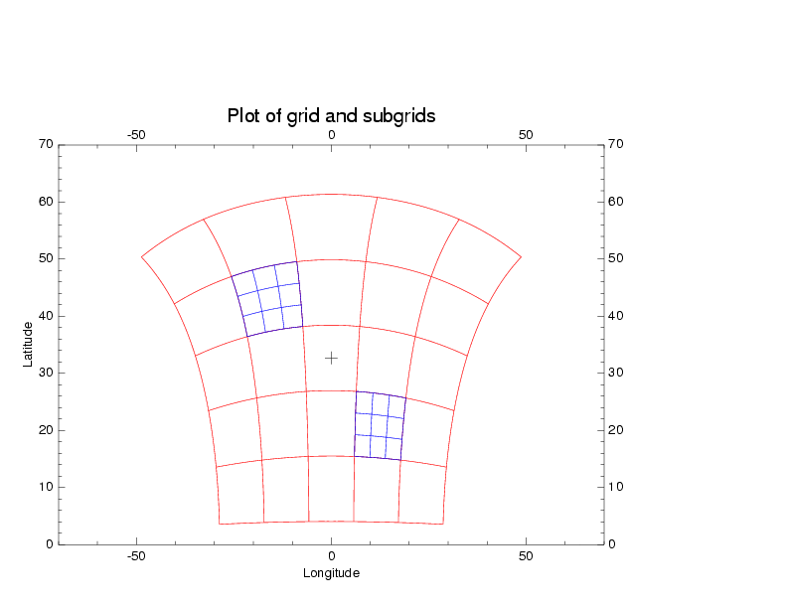
a
b
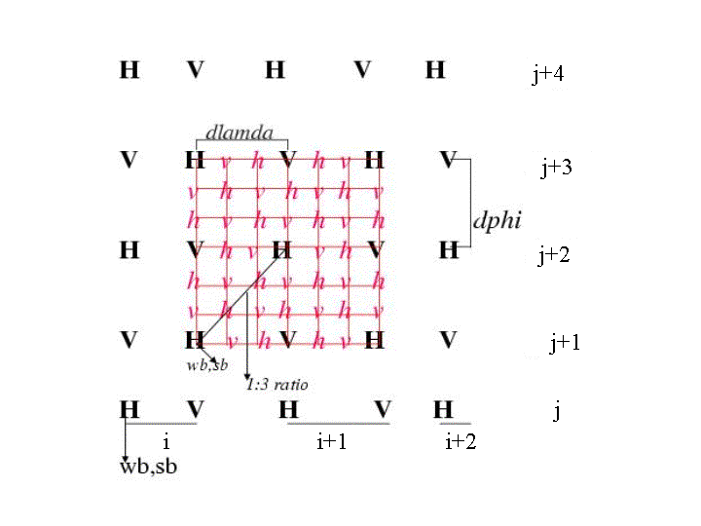
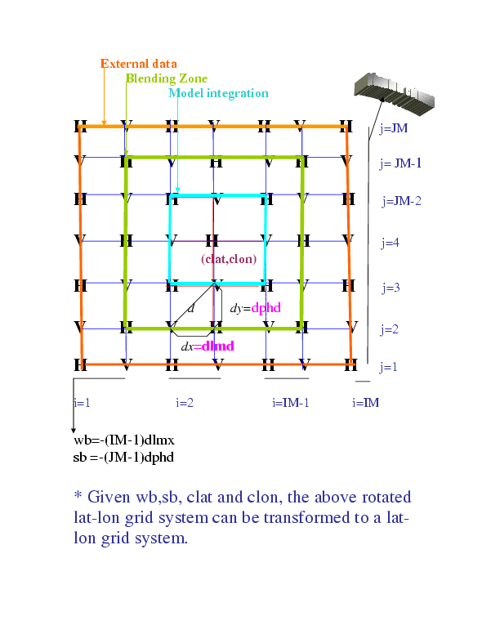
c

Figure 1: Moving Nest Configuration; (a) the HWRFX telescopic nest as it appears on a true latitude-longitude coordinate system; (b) Nested E-grid configuration for 3:1 parent to nest ratio. In the figure, “wb” and “sb” are the western and southern boundaries. The NMM grid indexing is also shown for the parent domain where “im” and “jm” are maximum i and j indices; and (c) Nested boundary conditions showing the grid index. External data in this case are obtained from the parent domain at every parent-domain- time step. In the figure, “d” is the nearest distance between two mass or velocity points and lies along the diagonal. Additionally, dlamda and dphd are equivalent to dx and dy but in degrees. Please note that this is a highly truncated grid configuration. In practice the parent and the nested domains span many more grid points.
a
b

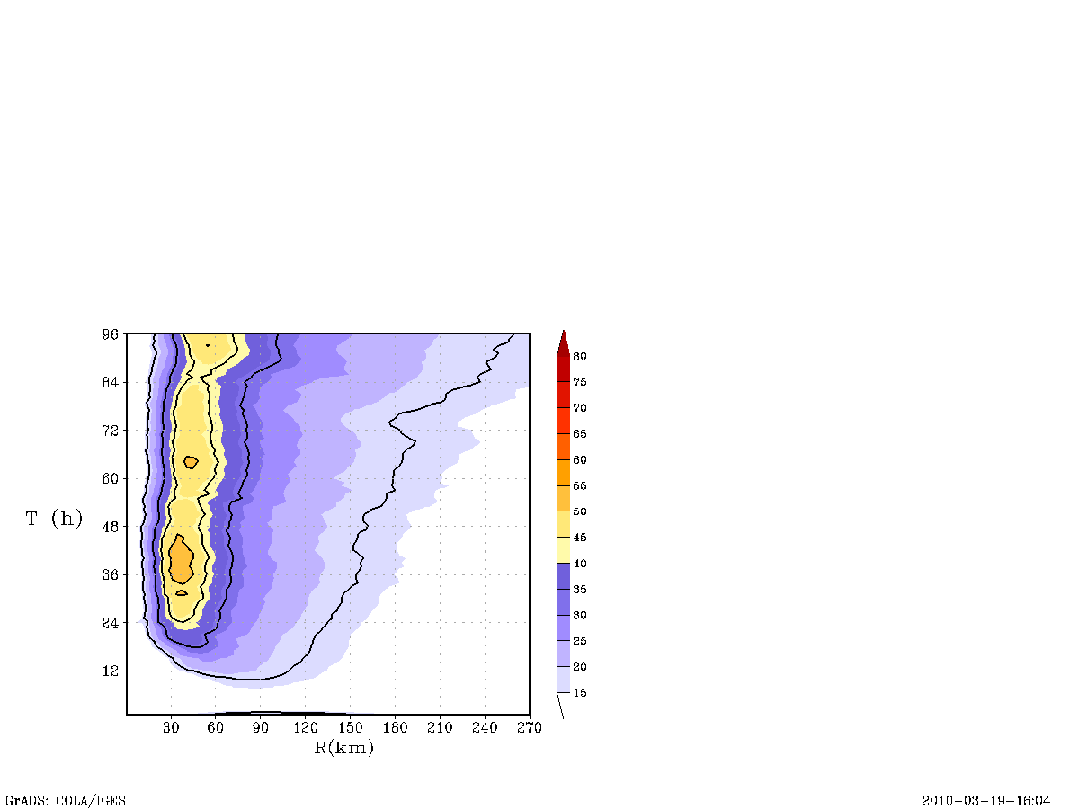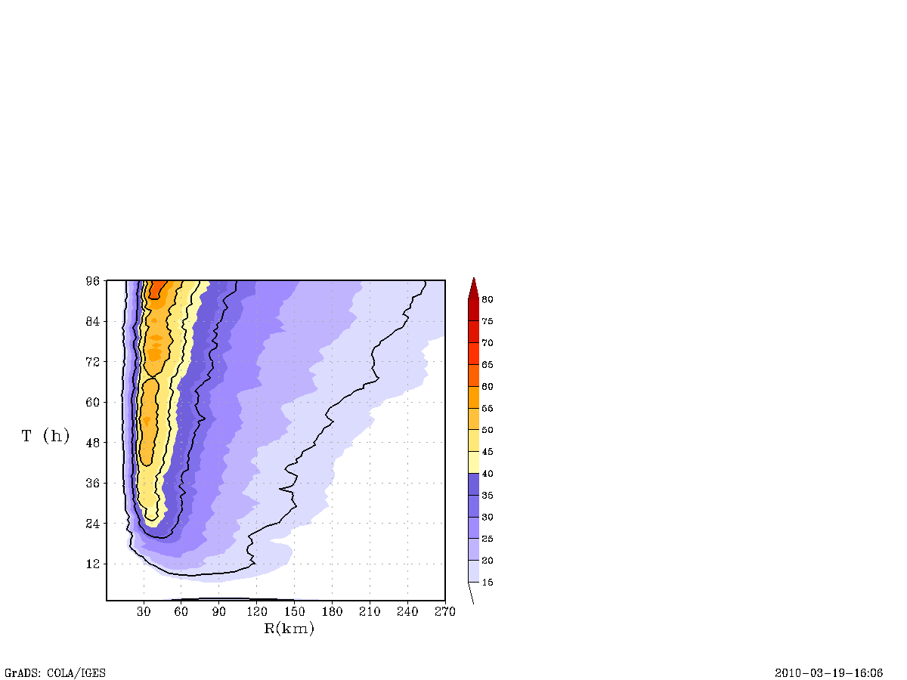
9 km
3 km
c
d

Fig 2: Time history of the intensification process in an idealized storm for a horizontal grid resolution of 9 and 3 km: (a) minimum mean sea level pressure in hPa; (b) maximum 10-m level wind speed in ms⁻¹, Hovemoller diagram of the axisymmetric mean tangential winds at a height of 10 m for the (c) 9-km run and (d) 3-km run. The contour lines from the outer to the inner core region are, respectively, 17.2 ms⁻¹, 33 ms⁻¹, 43 ms⁻¹, 50 ms⁻¹, and 59 ms⁻¹, representing the radius of gale-force winds and the core of hurricane winds starting from a minimal category 1 to a minimal category 4. The maximum potential intensity derived from SHIPS and Emanual’s potential intensity theory are provided for reference in (b).

a

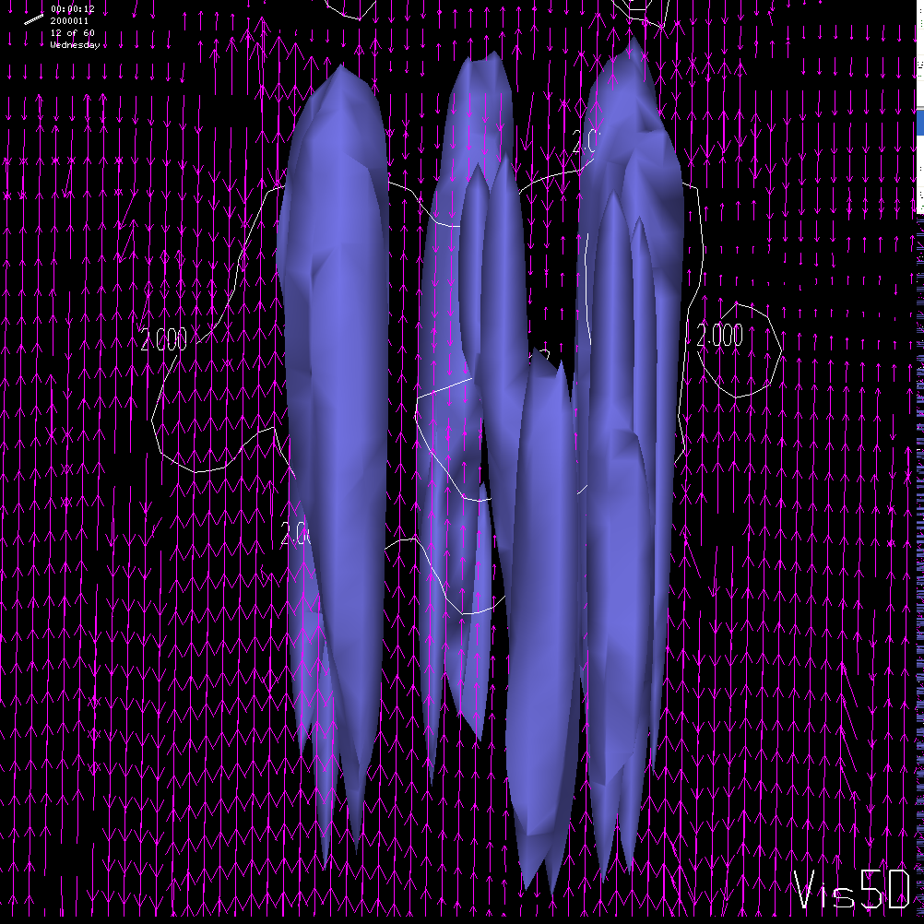
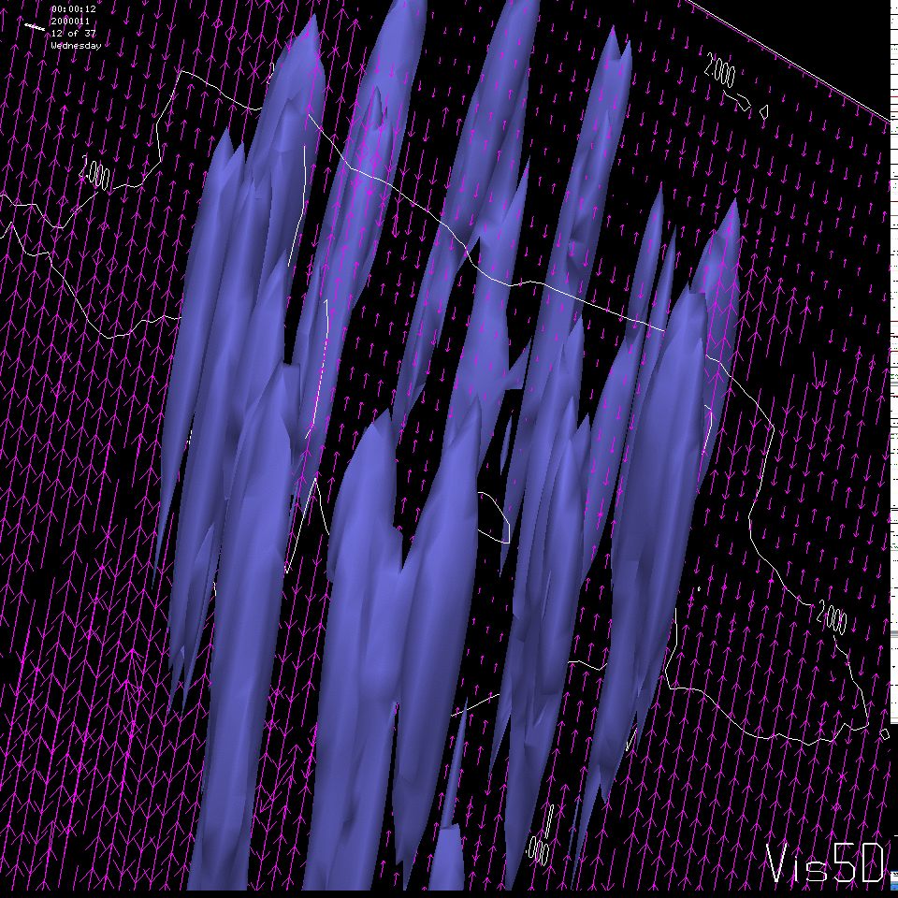
9 km
3 km
b
c

Figure 3: Initial development. (a) The tangentially-averaged maximum temperature anomaly (in K) with respect to the far field environmental temperature profile within the nested domain plotted hourly for the 9- and 3-km runs. Instantaneous plots of isosurfaces connecting the vertical velocity field of 2 m/s at (b) 9-km resolution and (c) 3-km resolution. Figures 3b and 3c are only used to provide a qualitative description of the vertical acceleration of the thermal plumes discussed in the text.

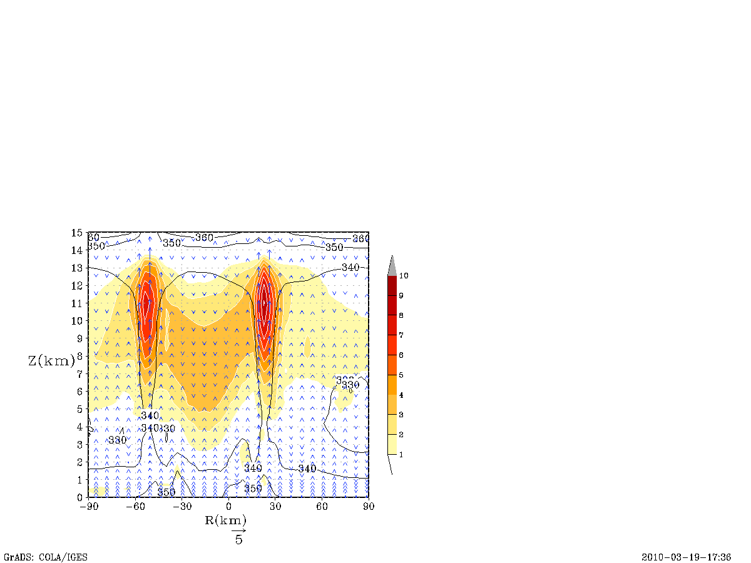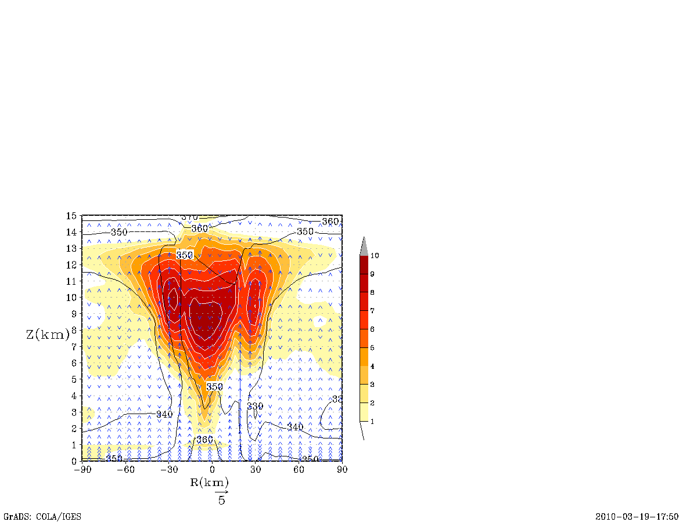
b
a
9 km
9 km

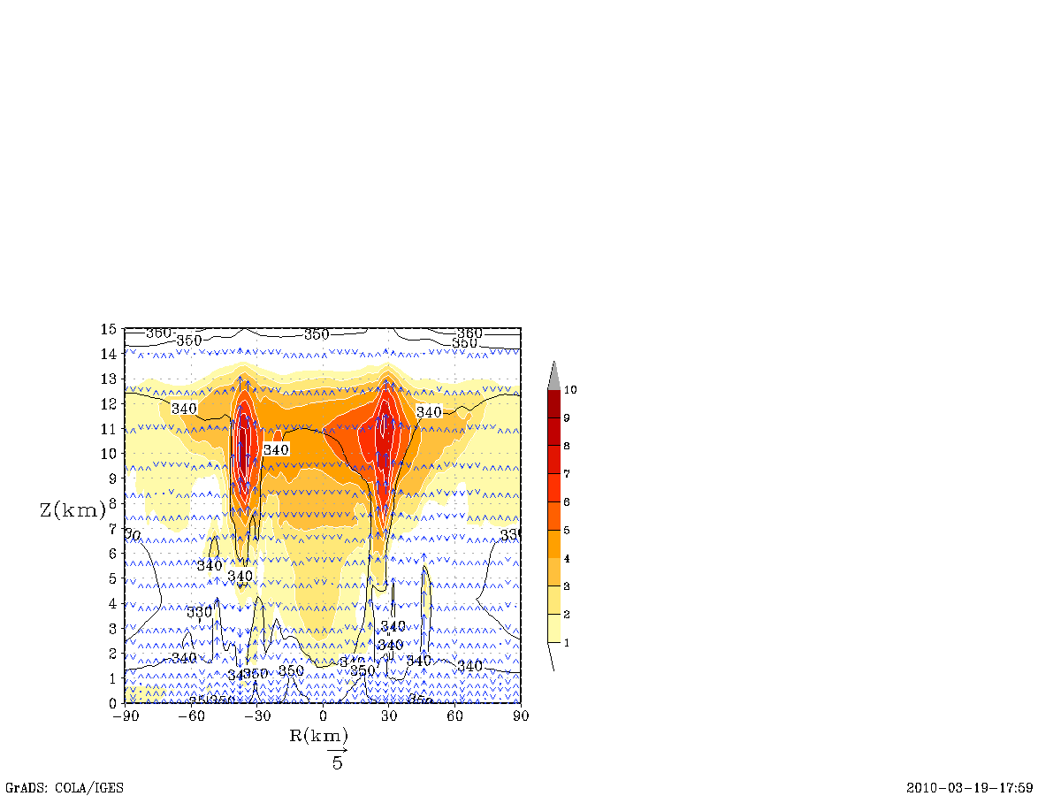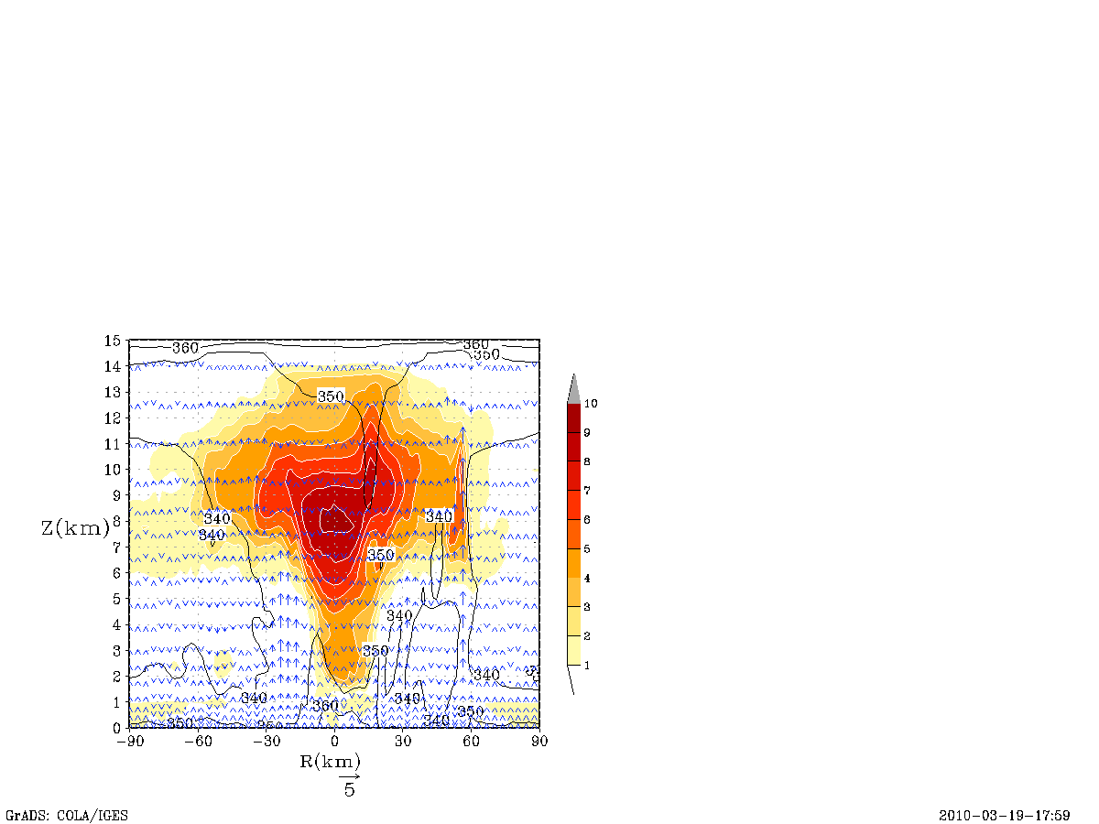
c
d
3 km
3 km

Figure 4: Warm core development. Depicts the x-z cross-section of instantaneous temperature anomaly (color shaded) across an arbitrary plane in the eyewall region (a) at about 9 hours and (b) 24 hours for the 9-km run and (c) and (d) at the same time for the 3-km run. The white contours are used to emphasize the nature of thermal plumes within the warmer environment discussed in the text. As depicted by the temperature anomaly and θ_{e} (in K and contours indicated by black color), both moisture and heat are carried to the mid and upper troposphere by the thermal plumes shown in Figures 3b and 3c. The vector indicates the direction of the vertical motion. Although the model top extends to about 18 km, we have zoomed in on the region of interest, which for the description in this text is about 15 km.

Figure 5: Depicts updraft statistics for the 9- and 3-km runs where the tangentially-averaged maximum vertical velocity, standard deviation, and the maximum values are shown in (a), the percentage of extreme events at a given time is determined by vertical velocity exceeding 5 m/s to those between 0.5-5 m/s in a column are shown in (b), and the thermal anomaly (in K) corresponding to the maximum updraft velocity is provided in (c).
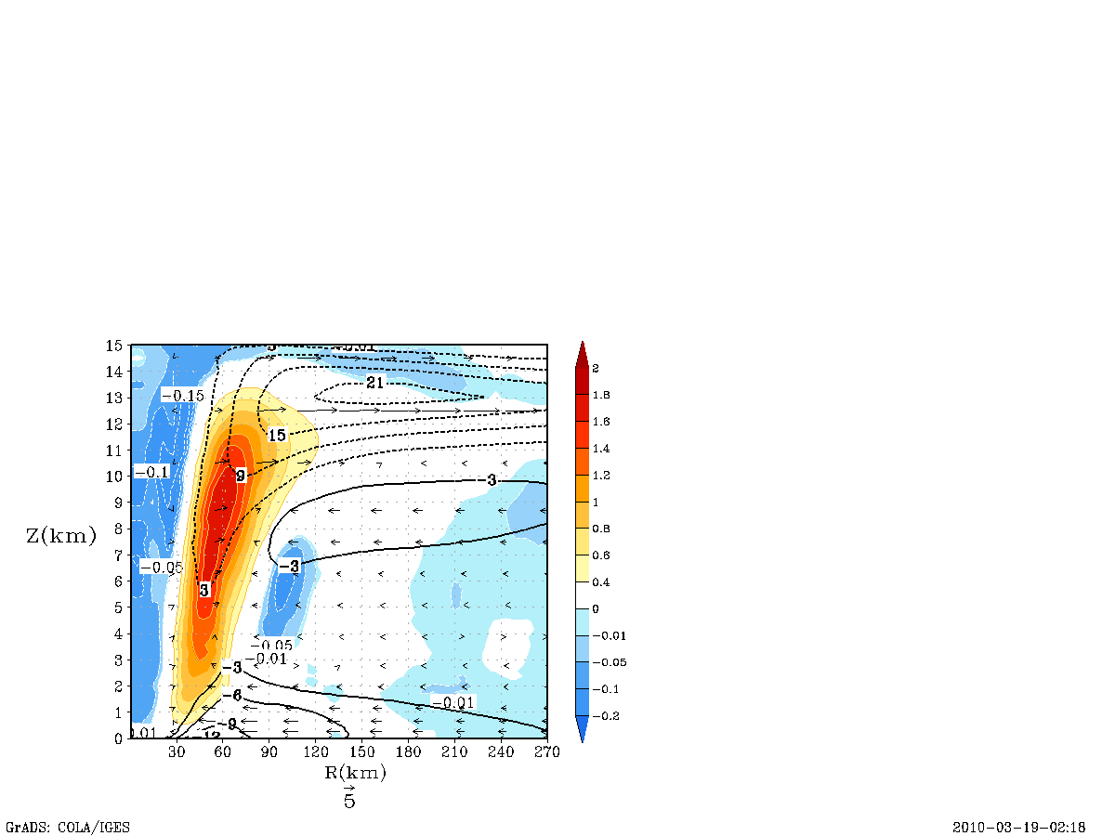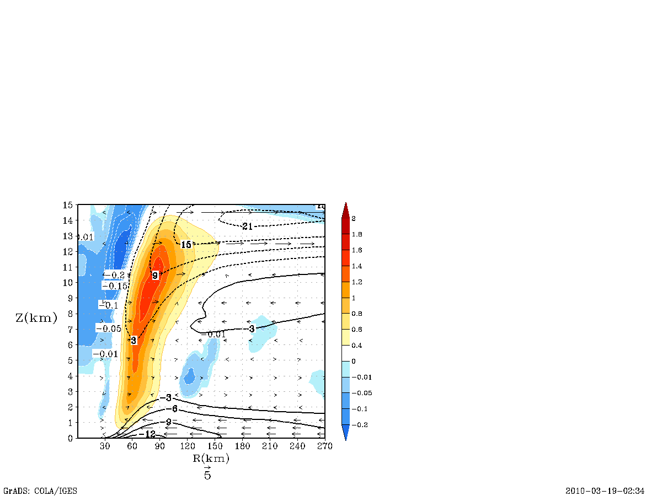
a
b
9 km
9 km

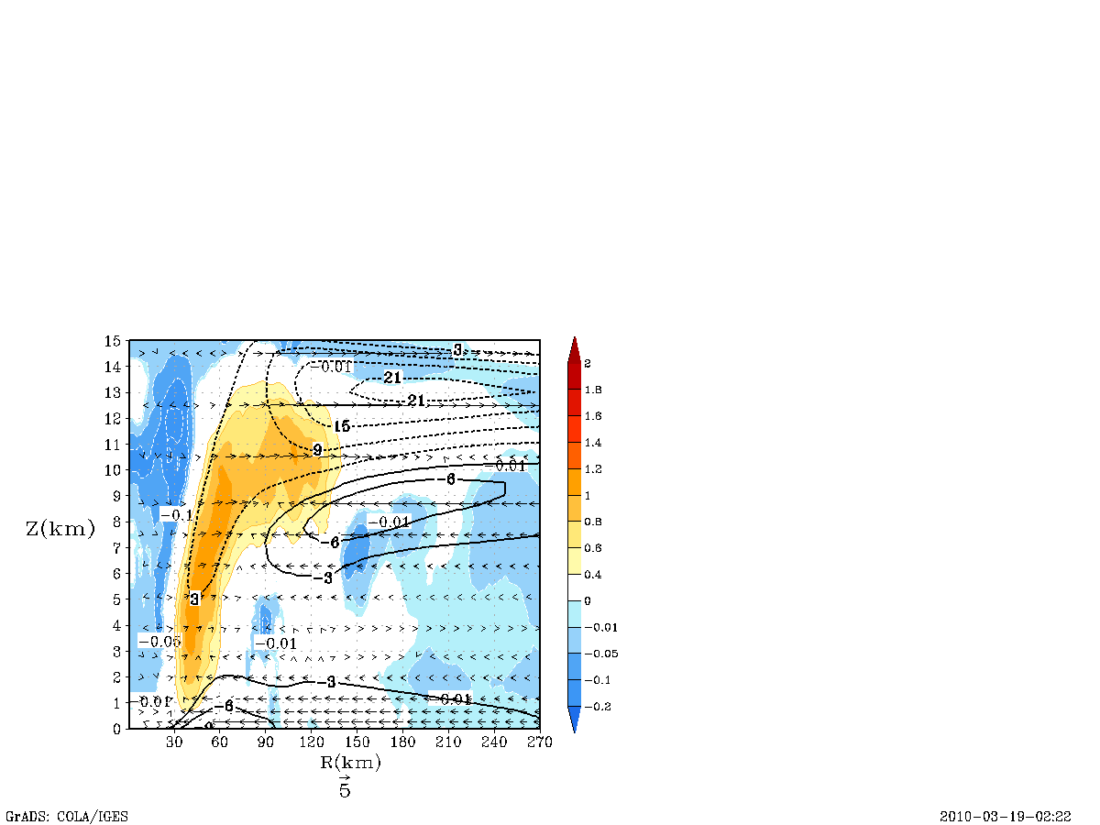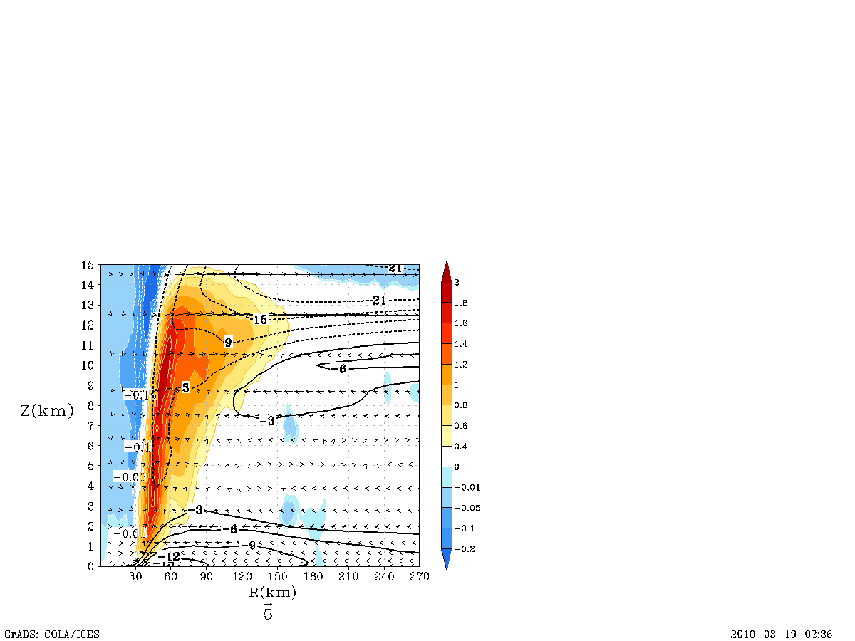
c
d
3 km
3 km

Figure 6: Tangentially-averaged, 6-hourly time averaged, radius-height cross section of the secondary circulation at 21 and 93 hours for the 9-km run (a and b) and 3-km run (c and d). The black solid contour indicates the inflow, and the dotted contours show the outflow of the radial wind component (in m/s). The vertical velocity (in m/s) is shaded with positive upward motion indicated by the red end of the spectrum and weak subsidence indicated by the blue end of the spectrum. Because the distribution of vertical velocity is skewed, please note that the scales are unequally spaced. For convenience, the vector field obtained that compounded the tangentially-averaged vertical and the radial velocity components is also provided here. Although the model top extends to about 18 km, we have zoomed in on the region of interest, which for the description in this text is about 15 km.

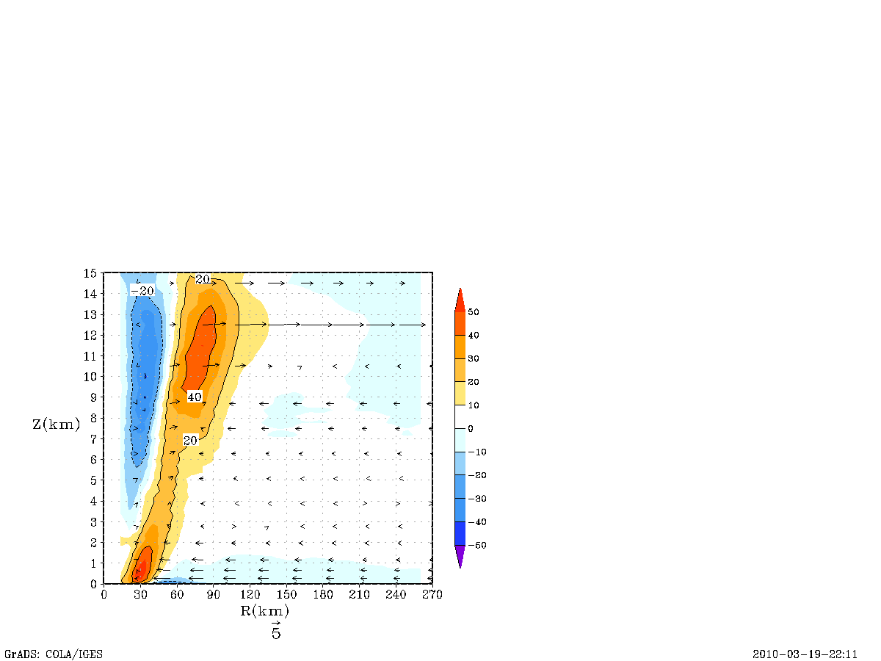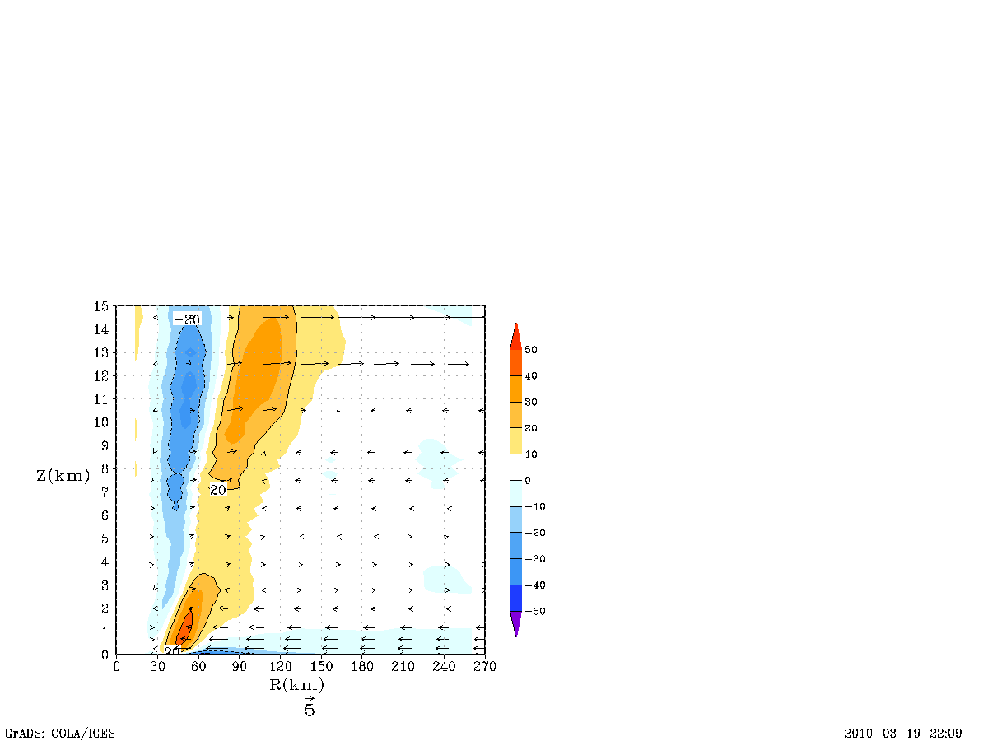
9 km
9 km
a
b

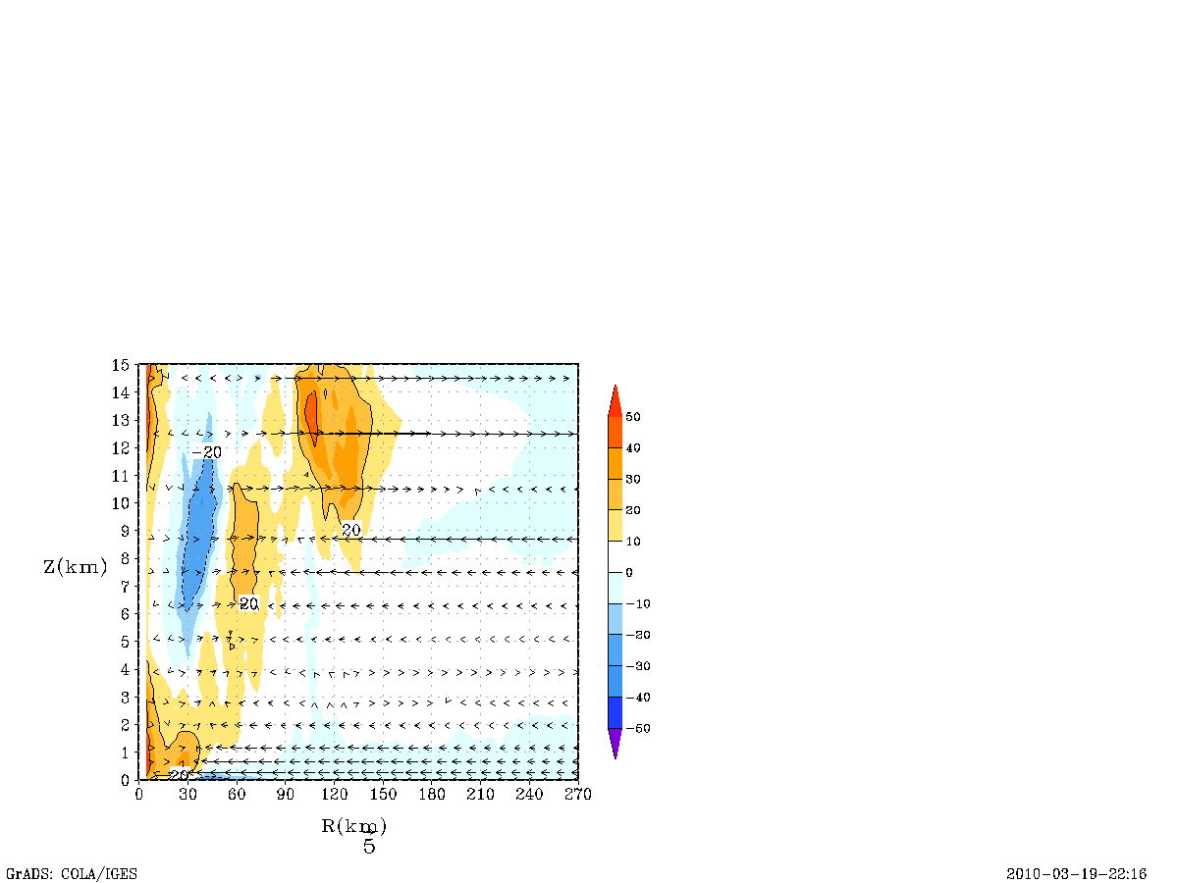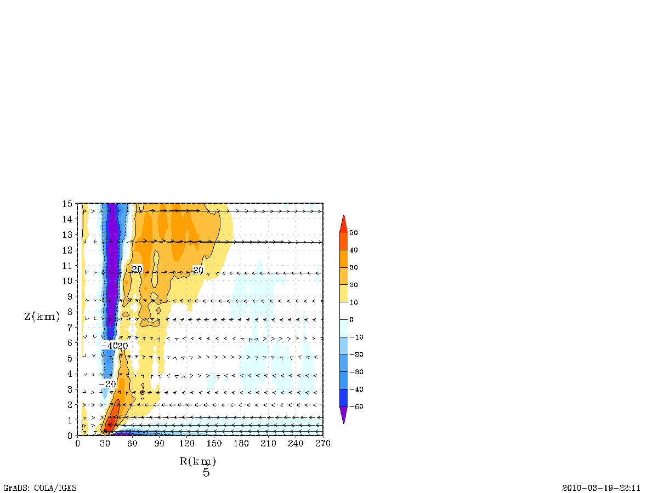
3 km
3 km
c
d

Figure 7: Tangentially-averaged, 6-hourly time averaged, radius-height cross section of the net radial force in units of ms⁻¹ h⁻¹, excluding frictional effects (Term A in equation 1) at 21 and 93 hours the (a) 9-km run and (b) 3-km run. Red end of the spectrum indicates super-gradient” and blue end of the spectrum indicates sub-gradients.

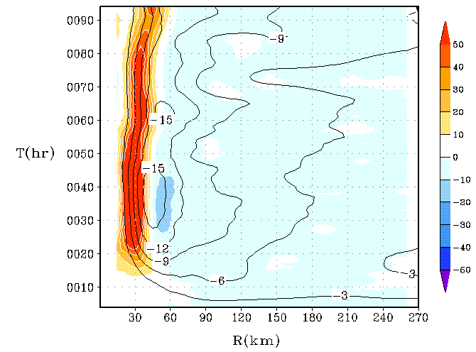
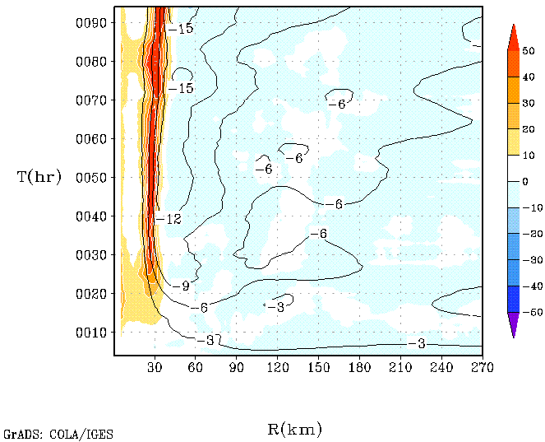
a
b
9 km

3 km

Figure 8: Hovemoller diagram of the tangentially-averaged, 6-hourly time averaged net radial forcing term (units of ms⁻¹ h⁻¹) in the governing equation for the secondary circulation with friction (i.e., sum of pressure gradient, Coriolis, centripetal, and frictional forces) for the (a) 9-km run and (b) 3-km run at the 30-m level. The blue end of the spectrum represents radial acceleration, and the red end of the spectrum represents deceleration. Superposed on color shades are the contours of the radial component of velocity (in m/s).

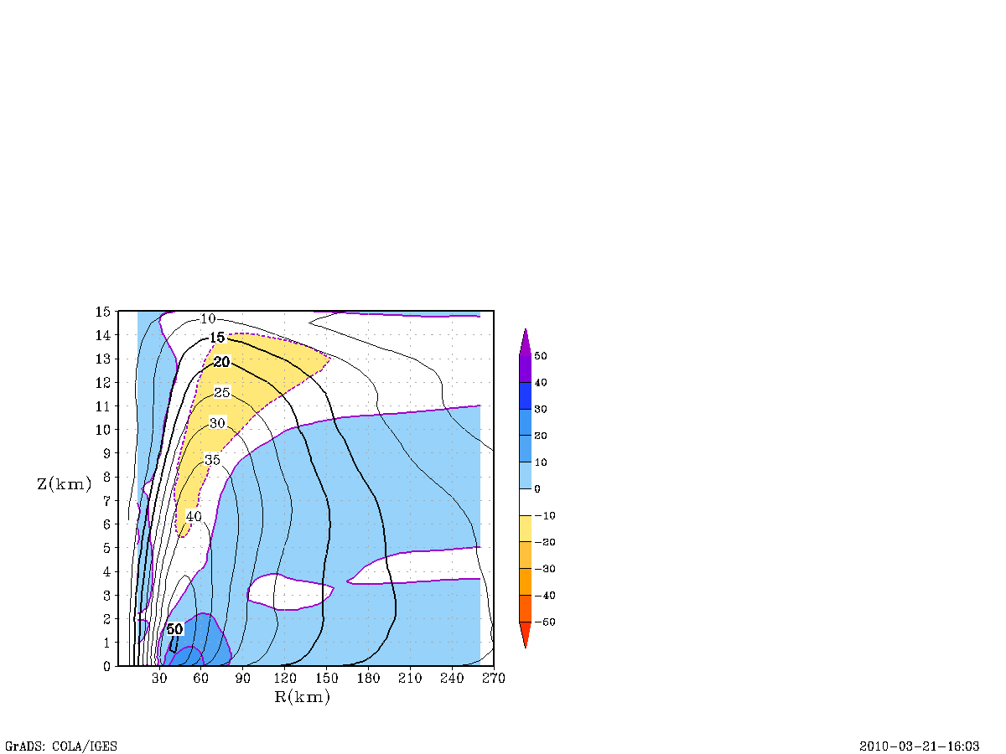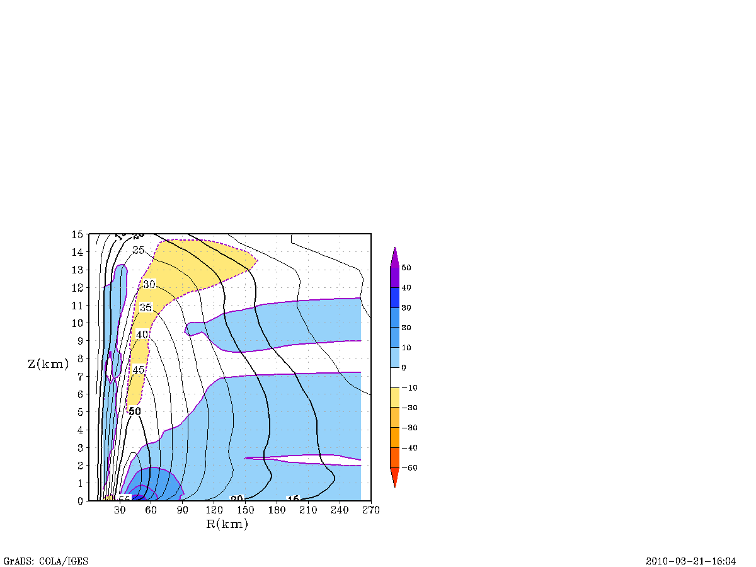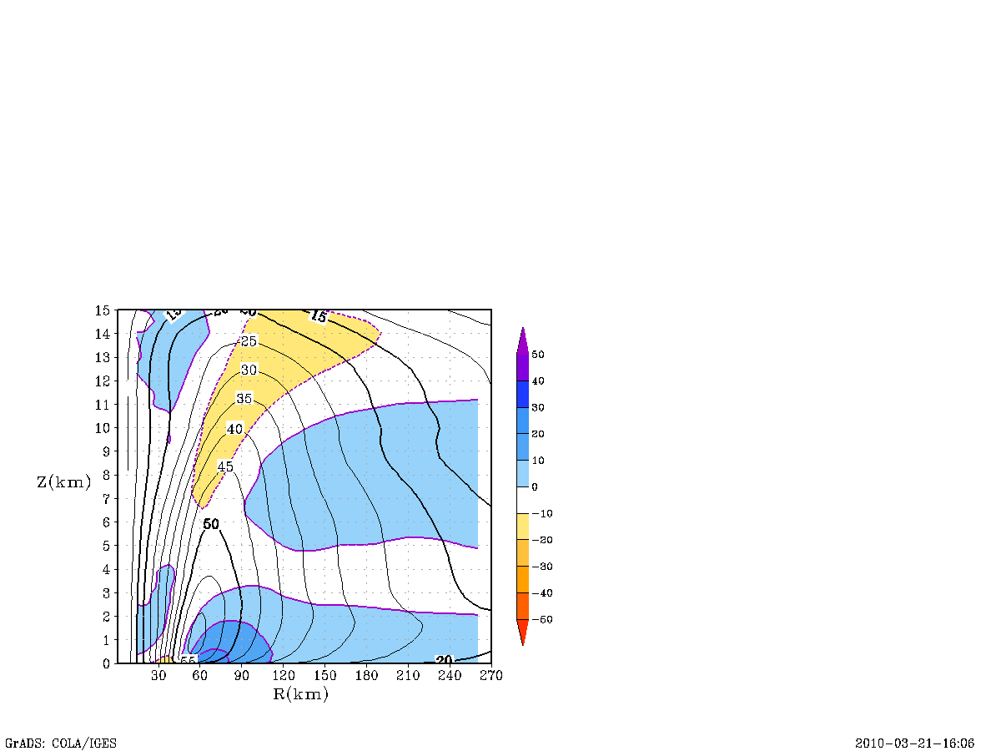
9 km
9 km
9 km
b
c
a
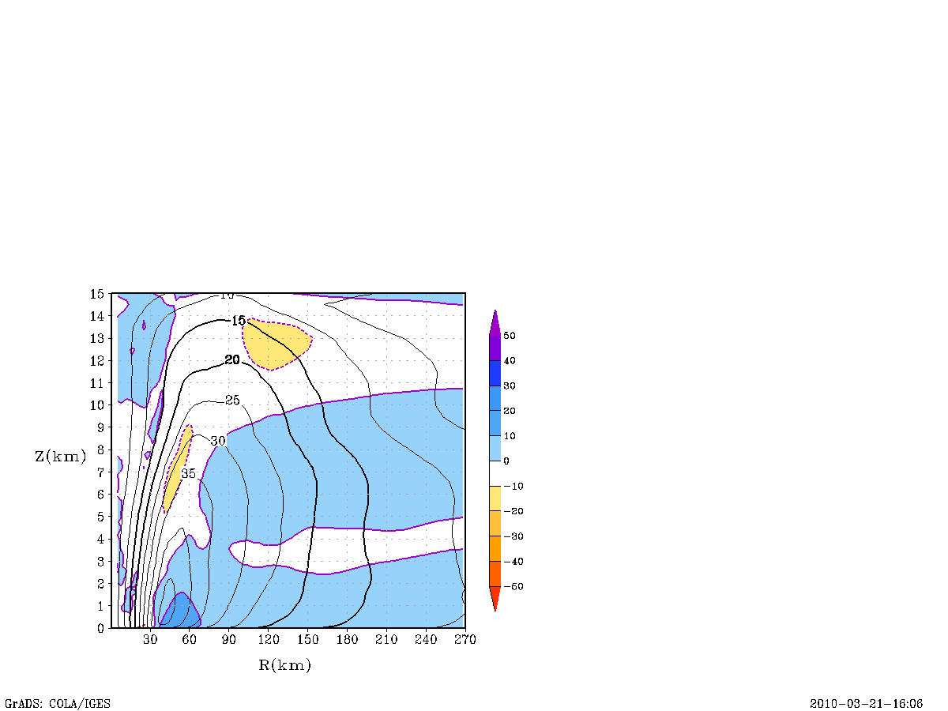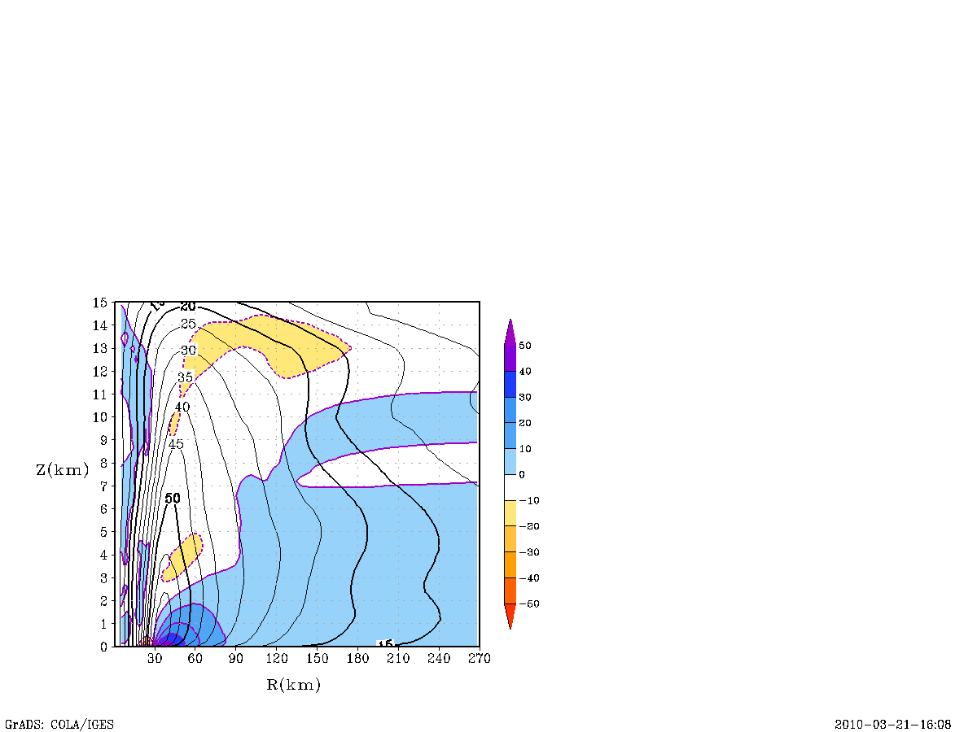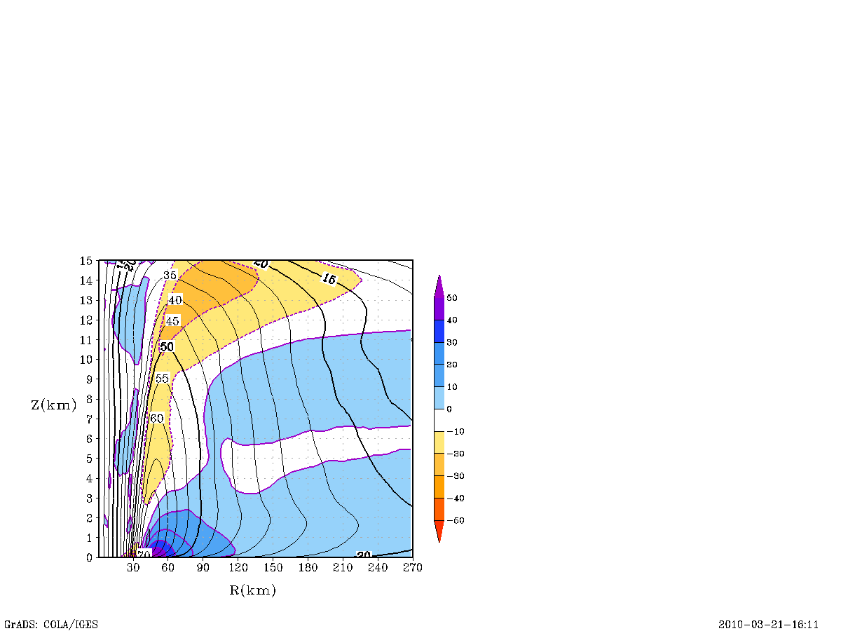
3 km
3 km
d
e
f
3 km

Figure 9: Tangentially-averaged, 6-hourly time averaged, radius-height cross section of the tangential wind contours (in red color) superposed on top of the net tangential forcing (frictional effect included) in units of ms⁻¹ h⁻¹ (color shaded) related to the primary circulation term in equation 2 at 21, 45, and 93 hours for the 9-km run (a, b, and c) and 3-km run (d, e, and f). In general, the positive contribution towards the spin-up process is indicated by the blue end of the spectrum. It should be emphasized that the frictional terms were included in this computation. The radius of gale-force wind (between 15-20 ms⁻¹) and the 50 ms⁻¹ contours are depicted in black.

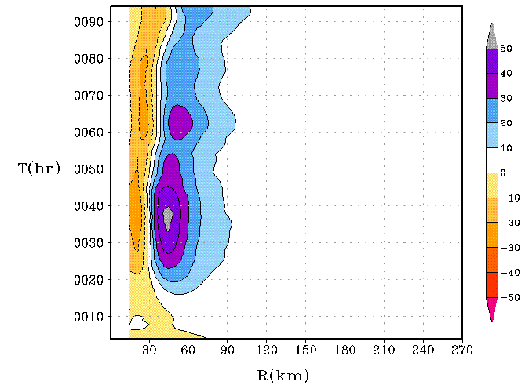
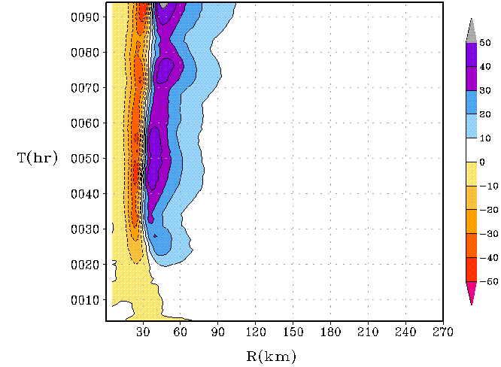
a
b

9 km
3 km

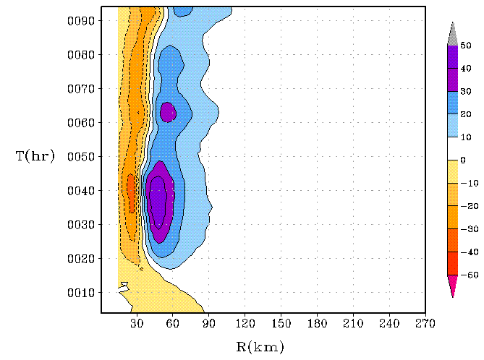
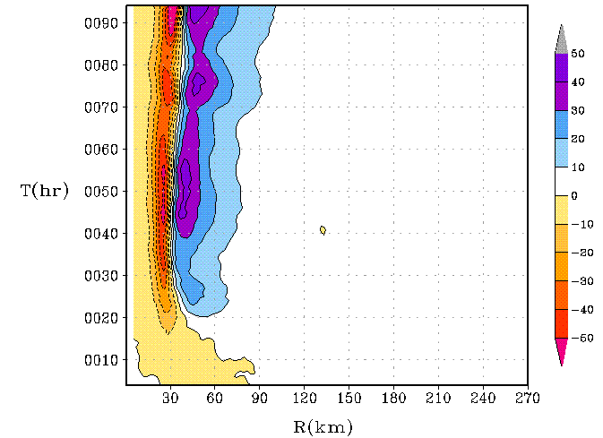
c
d

9 km
3 km

Figures 10: Hovemoller plot of a tangentially-averaged, 6-hourly time averaged generalized Coriolis term with the addition of a frictional effect at the 30-m level for the (a) 9-km run and (b) 3-km run and the radial advection of tangential wind for the (c) 9-km run and (d) 3-km run. Units are in ms⁻¹ h⁻¹.

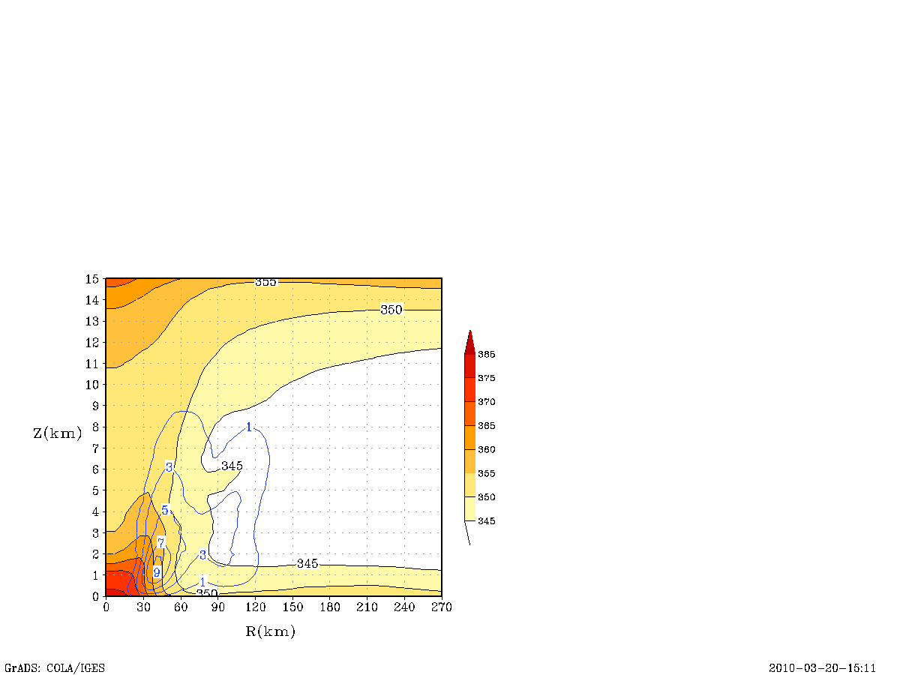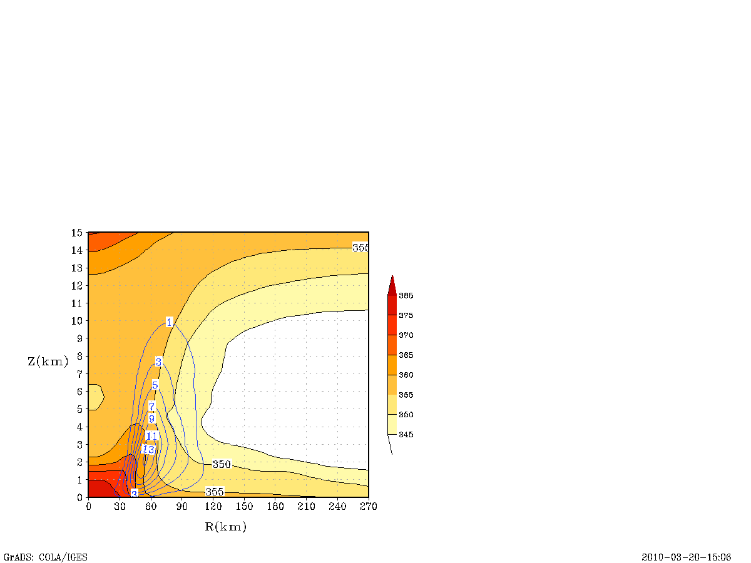
9 km
9 km
a
b

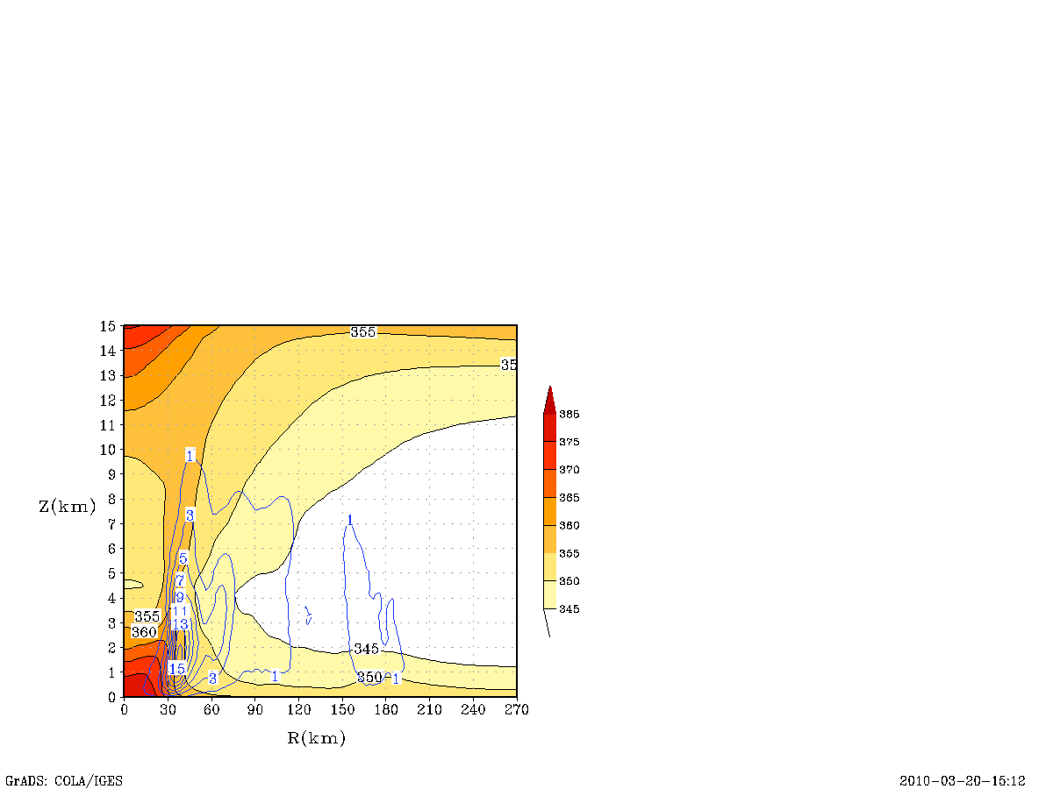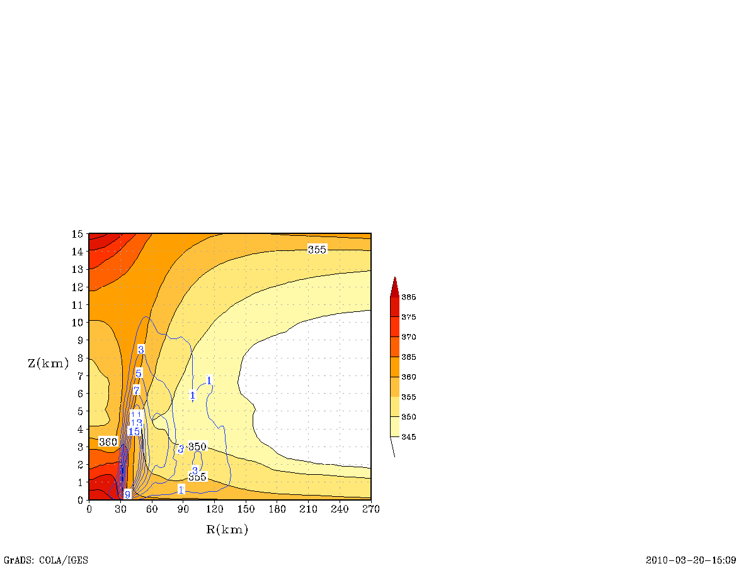
3 km
c
d
3 km

Figure 11: Overview of the thermodynamic structure in a mature storm around 69 and 93 hours for the 9-km run (a and b) and 3-km run (c and d). The tangentially-averaged, 6-hourly time averaged, radius-height cross section of θ_{e} and moisture fluxes are provided here. The mean θ_{e} is illustrated in shaded colors, and moisture fluxes are indicated by blue colored contour lines.
a

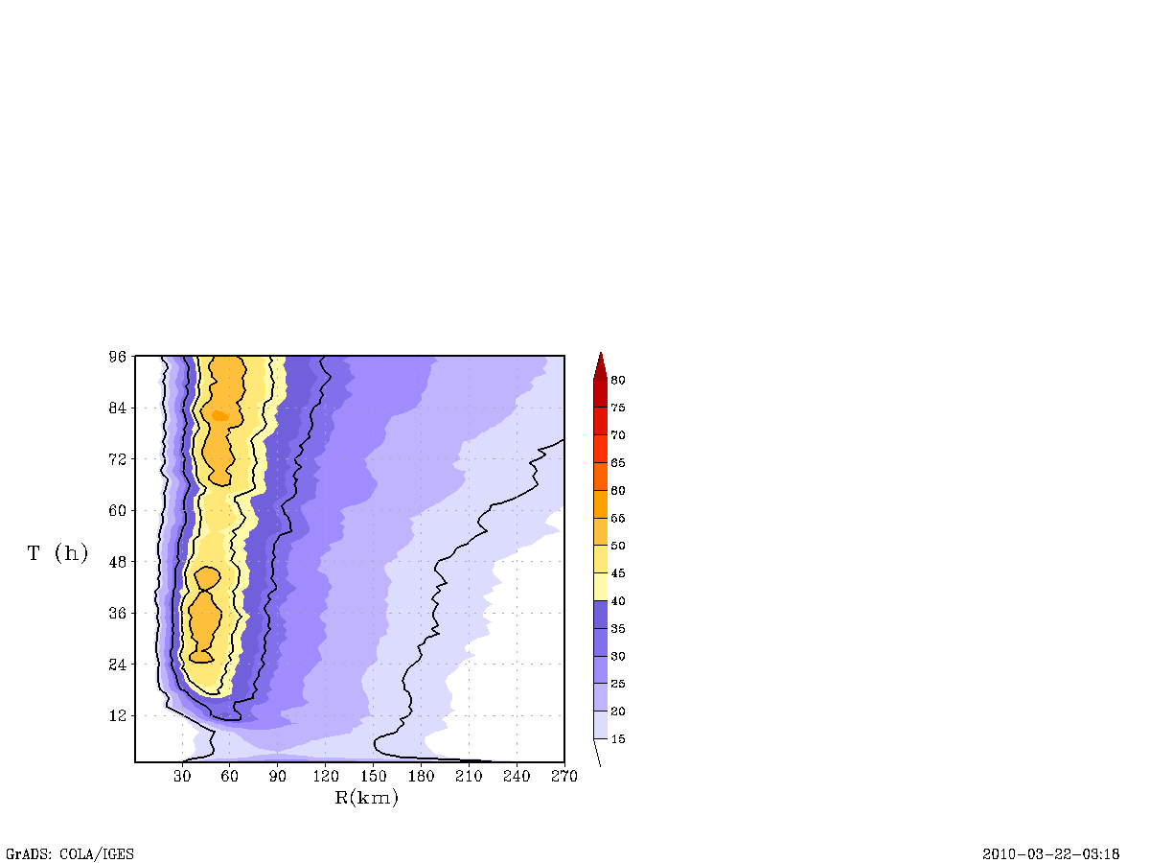
b
9 km
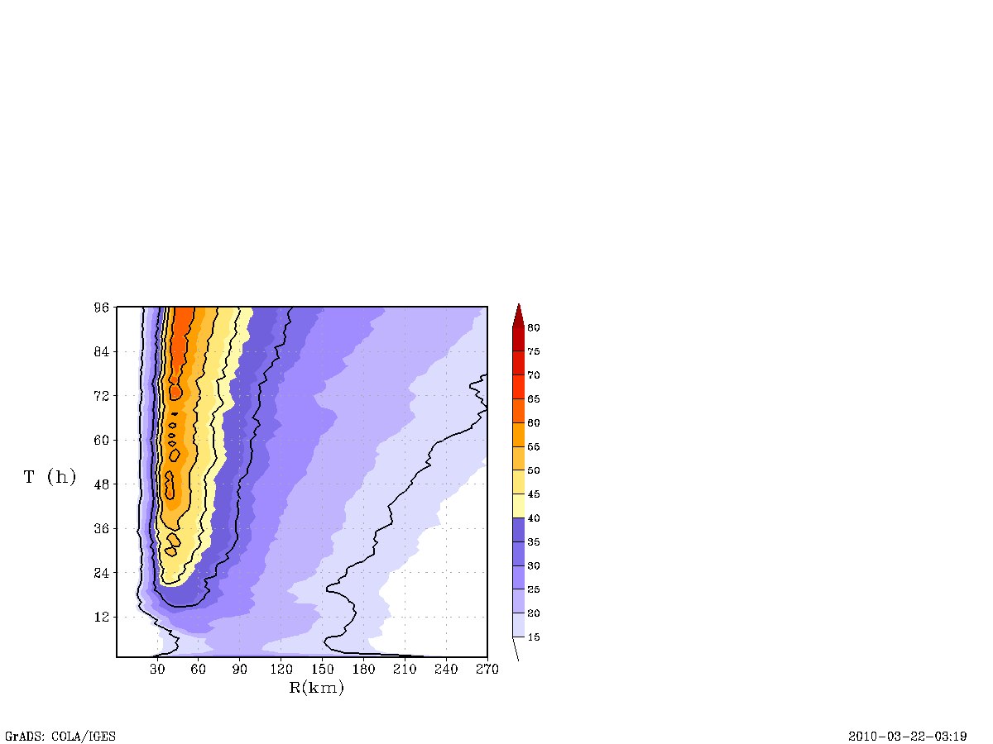
c
3 km

Figure 12: Sensitivity experiments with initial conditions: Stronger vortex starting at about 30 m/s. maximum 10-m level wind speed in ms⁻¹ (a) and Hovemoller diagram of the mean tangential winds for the (b) 9-km run and (c) 3-km run are shown here. The maximum potential intensity derived from SHIPS and Emanual’s potential intensity theory is provided for reference in (a).

a

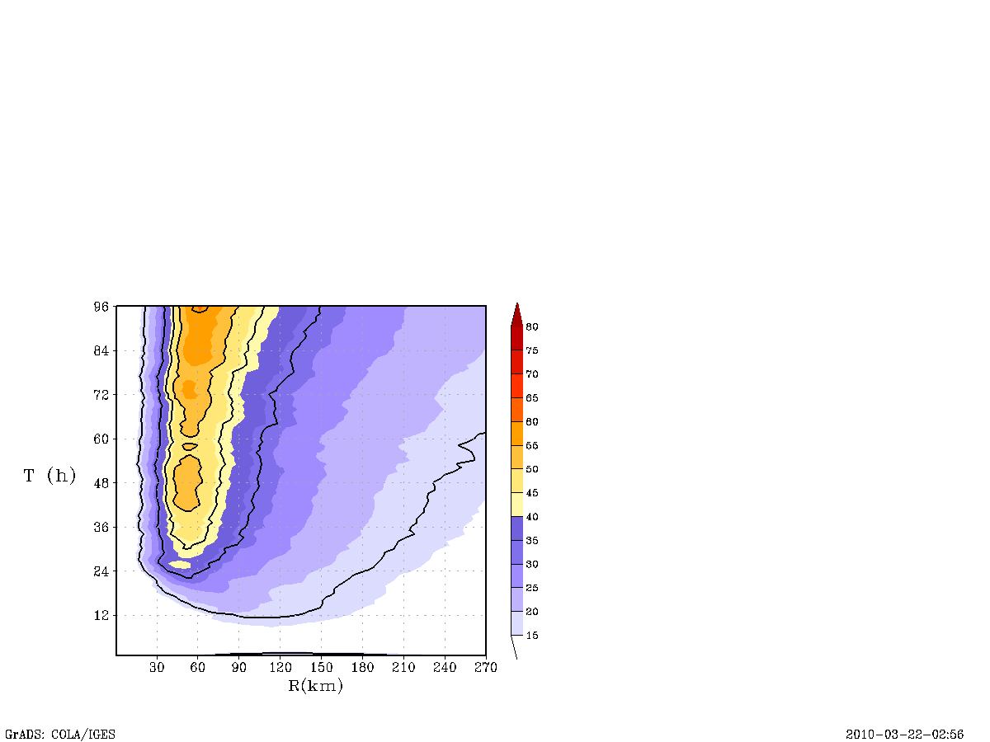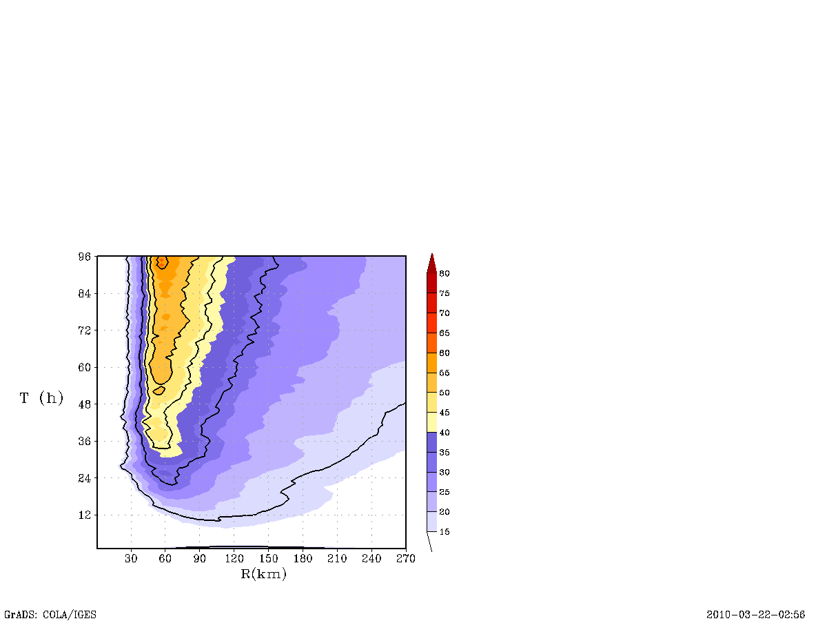
b
9 km
c
3 km

Figure 13: Sensitivity experiments with initial conditions: Larger vortex starting at about 120 km. The tangentially-averaged maximum temperature anomaly (in K) with respect to the far field environmental temperature profile within the nested domain plotted hourly for the 9- and 3-km runs in (a) and Hovemoller diagram of the mean tangential winds for the (b) 9-km run, (c) 3-km run are shown here and (d) the ratio of extreme events determined by vertical velocity exceeding 5 m/s to those less than 5 m/s in a column.
a
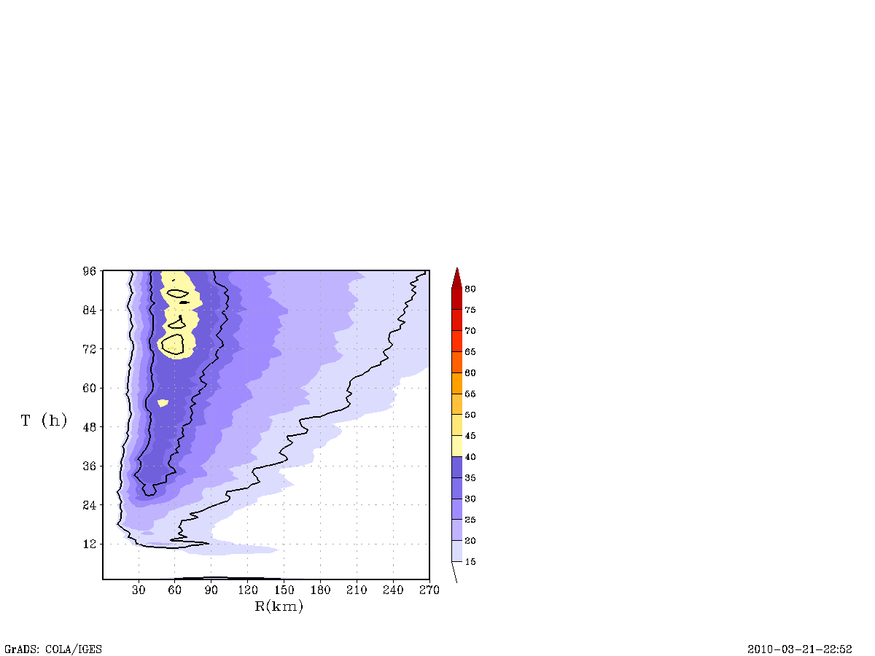
b
9 km
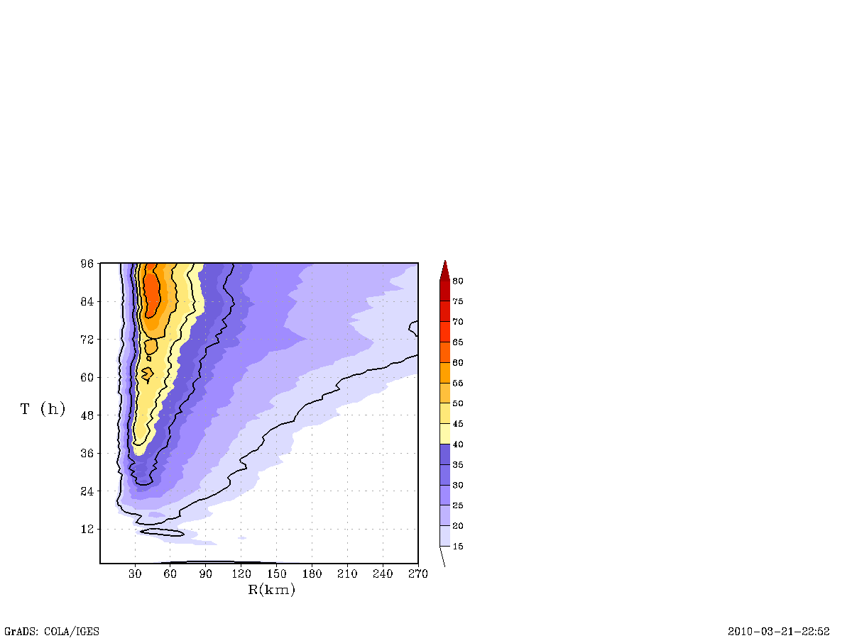
c
3 km

Figure 14: Sensitivity experiments with cumulus parameterization scheme: SAS convection scheme switched off for the nested domain at 9 km and 3-km resolution. The tangentially-averaged maximum temperature anomaly (in K) with respect to the far field environmental temperature profile within the nested domain plotted hourly for the 9- and 3-km runs in (a) and Hovemoller diagram of the mean tangential winds for the (b) 9-km run and (c) 3-km run are shown here.
No. | Description | Initial vortex strength (ms⁻¹) | Convection scheme for the 3 km nest | Initial radius of maximum wind (km) | Specification
1  2  3  4 | Control  Strong  R0  No SAS | 20  30  20  20 | Yes  Yes  Yes  No | 90  90  120  90 | C09 & C03  S09 & S03  R09 & R03  SAS09 & SAS03

Table 1: List of experiments performed at 9 and 3 km resolutions.

 | Grid  Configuration | convection | microphysics | Boundary and surface  layer | Dissipative  heating | Radiation
operational  HWRF | 2 grids  27/9 km | SAS with momentum mixing | Ferrier | GFS boundary layer and  GFDL hurricane model surface layer scheme  (uses modification  to surface  roughness) | Switched on | GFDL  radiation scheme
HWRFx  C09 | 2 grids  27/9 | SAS without momentum mixing | Ferrier | GFS boundary layer and  GFDL hurricane  model scheme  with the original Charnock’s approximation for surface roughness | Switched  off | NCAR

Table 2: List of differences between operational HWRF and HWRFX physics for the Idealized configuration at 27:09 (i.e, C09 configuration).

Although temperature may be hydrostatically related to pressure, θ_{e}, as advocated in Holland’s maximum potential intensity theory (Holland, 1997), it may be more accurately related to the pressure depressions in the eye of TCs. However, for practical purposes (see Ritchie et al., 2003) and for the ease of illustration, we simply correlate here maximum temperature deviations in the warm core region with pressure.

