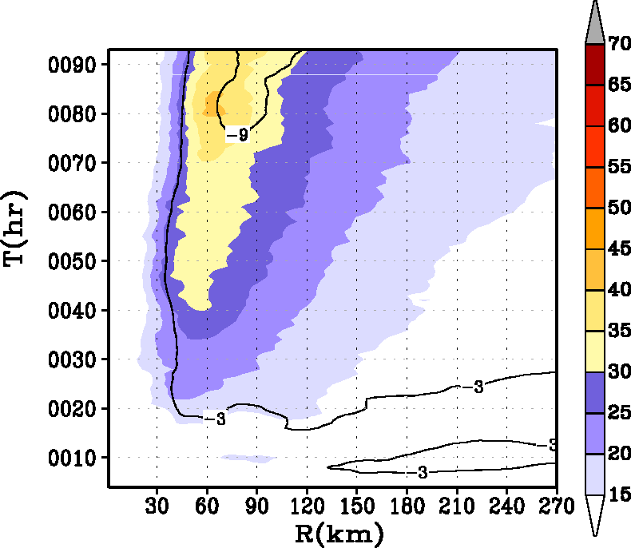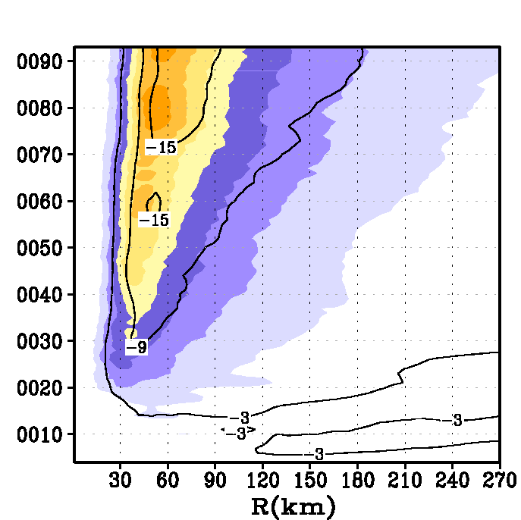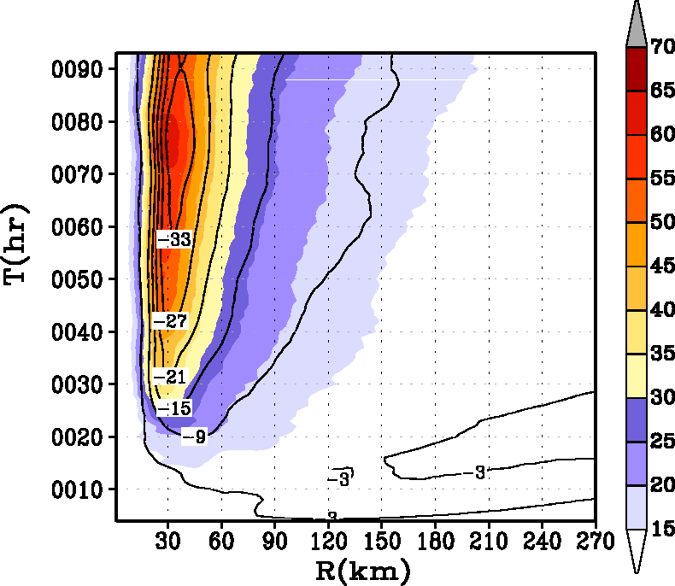
a
b
c

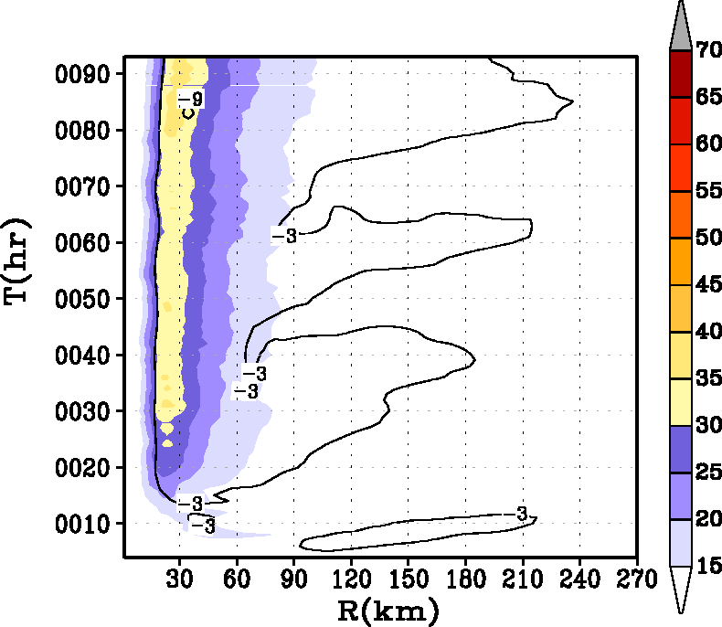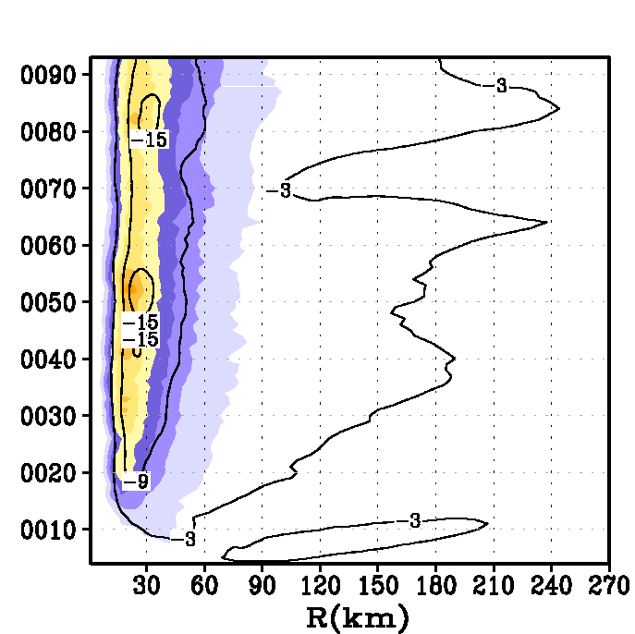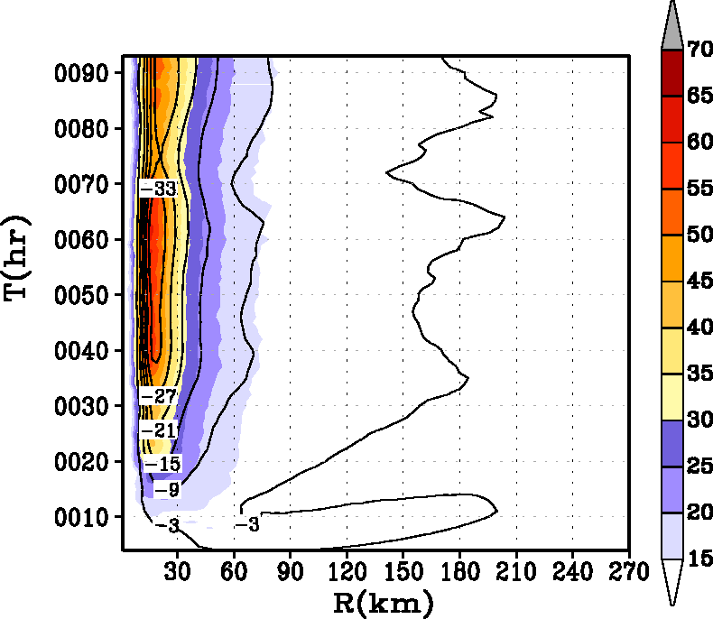
d
e
f

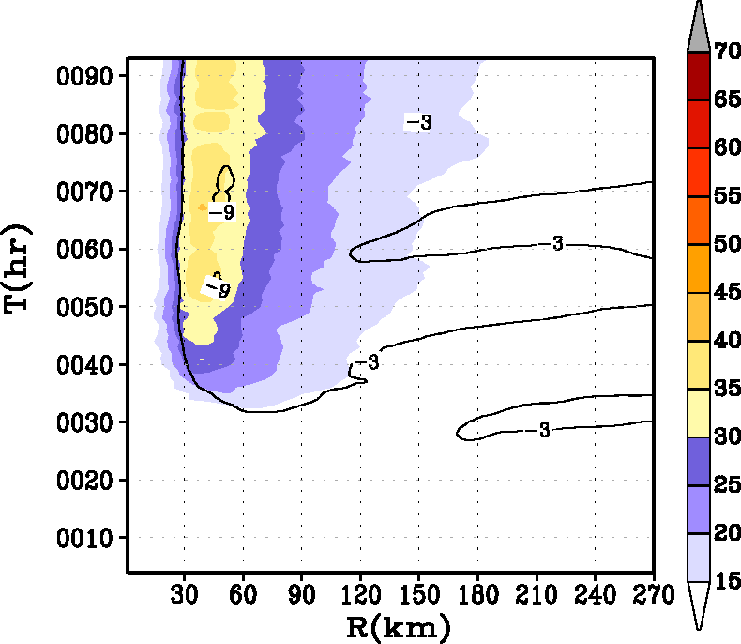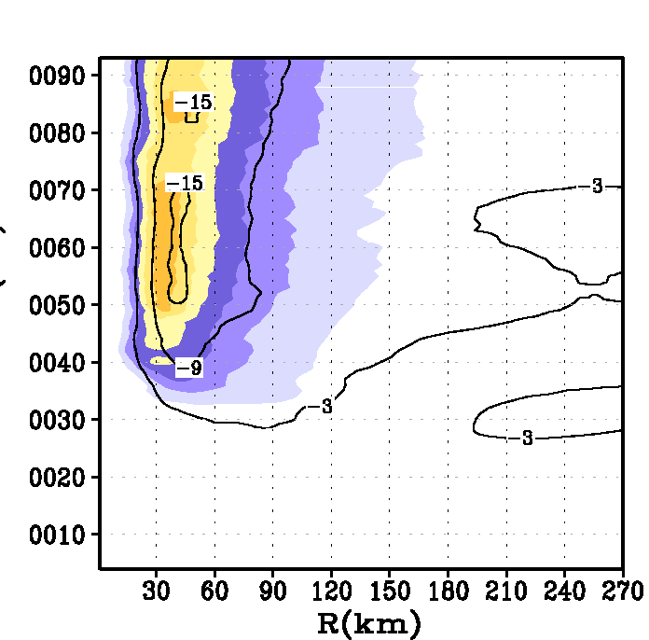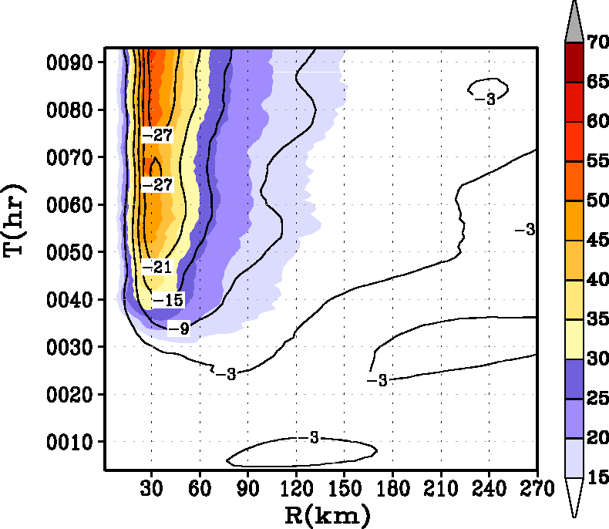
g
h
i

Fig. 10. Hovemoller diagram of the axisymmetric mean winds (m s⁻¹) at a height of 10 m. Contour lines representing the tangentially averaged, 6-hourly time averaged radial component of velocity (in m s⁻¹) at 30-m level are superposed. Top row (a), (b), and (c) are sensitivity experiments for an initially big vortex (experiments 4, 5, and 6 in Table 1). Middle row (d), (e), and (f) are sensitivity experiments for initially small vortex (experiments 7, 8, and 9 in Table 1) and bottom row (g), (h), and (i) are sensitivity experiments in which the relative humidity of the large scale environment was reduced to about 50% from the baseline Jordan sounding. The radius of the initial vortex size for the experiments illustrated in the bottom row (g, h, and i) was set to the base value, i.e., 90 km (Table 1).

