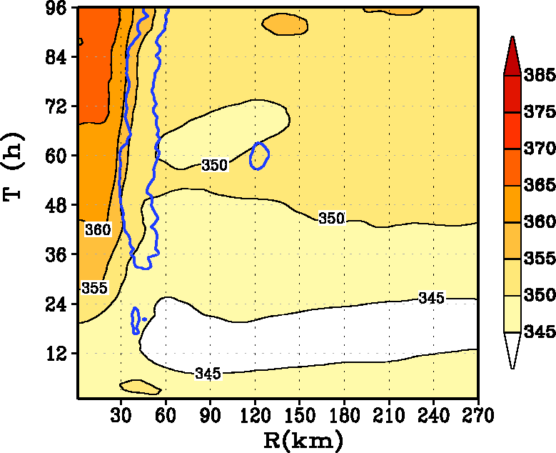
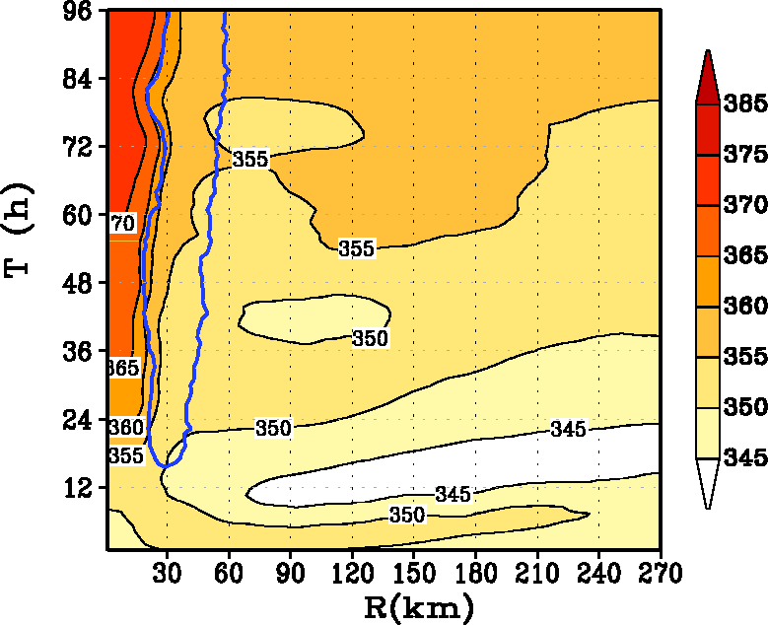
a
b
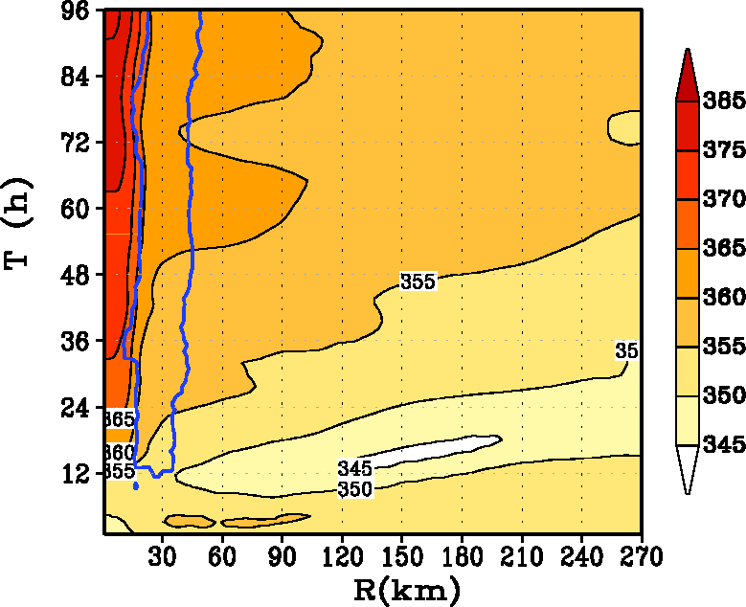
c

Fig. 8. Hovemoller diagram of the tangentially averaged, 6-hourly time averaged θ_{e} at the 30-m level for the HWRF runs with (i) α=1 (A100), (ii) α=0.5 (A050), and (iii) α=0.25 (A025). The region of vertical motion exceeding the 0.2 m s⁻¹ contour line at the top of the boundary layer is shown to indicate the approximate region of eyewall convection.

