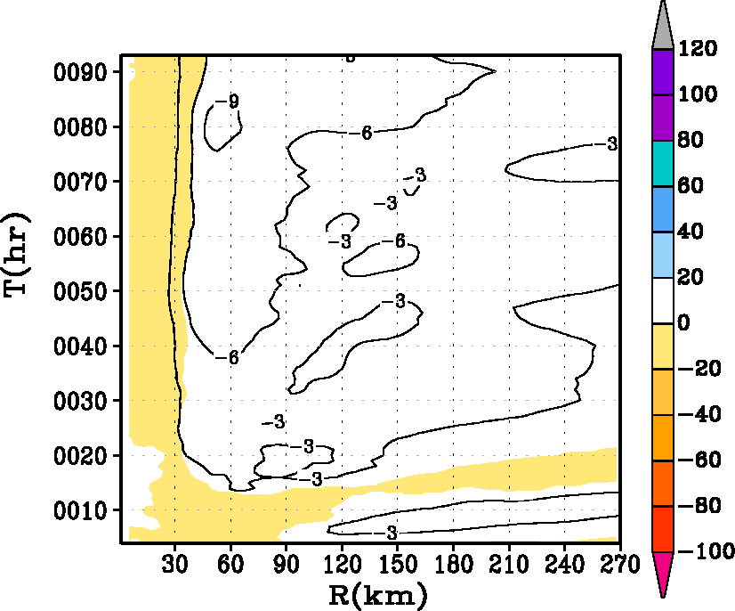
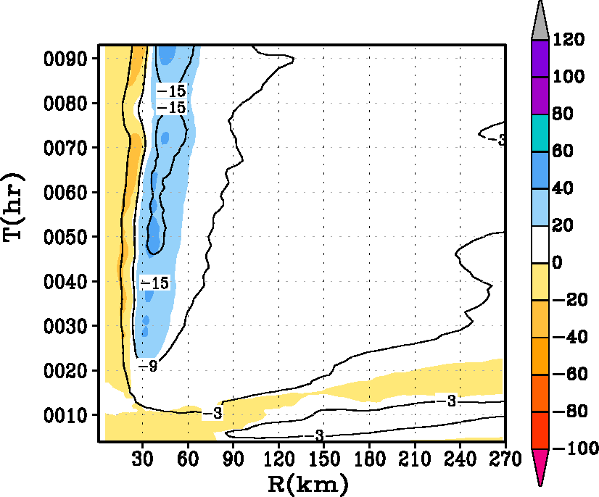
a
b
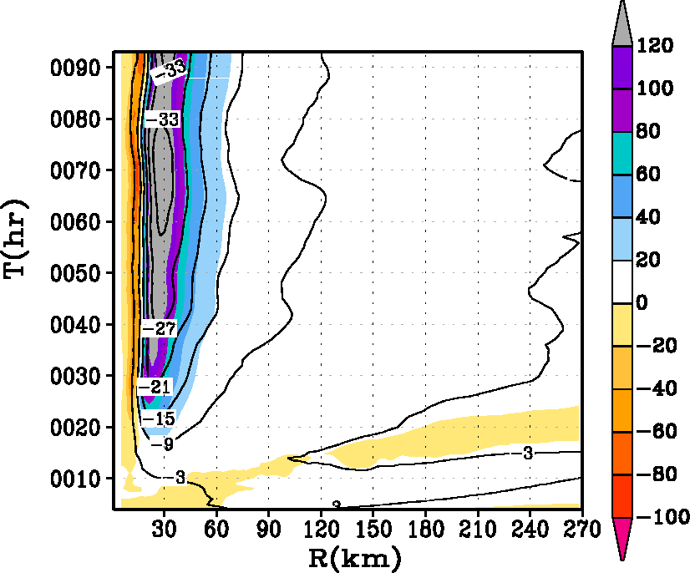
c

Fig. 7. Hovemoller diagram of the tangentially averaged, 6-hourly time averaged radial component of velocity (in m s⁻¹). Superposed on the contour lines is the generalized Coriolis term (i.e., term A in equation 2 in text) with the addition of a frictional effect shaded in color for the HWRF runs with (i) α=1, (ii) α=0.5, and (iii) α=0.25 runs at the 30-m level. The blue end of the spectrum represents tangential acceleration (contributing towards the “spin up”), and the red end of the spectrum represents deceleration within the inner eyewall region. Units of the forcing term are in m s⁻¹ h⁻¹.

