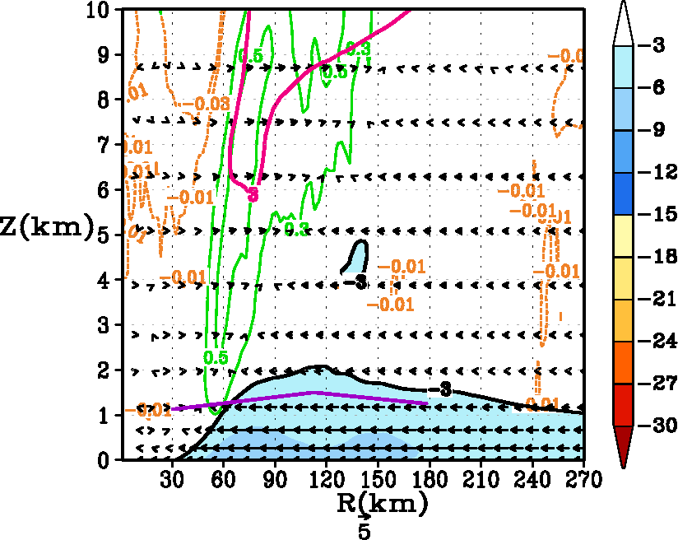
a
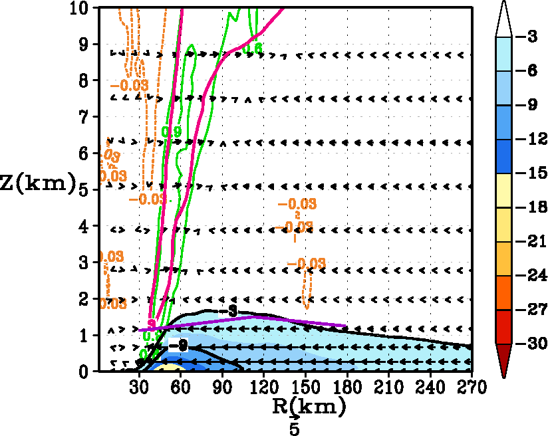
b
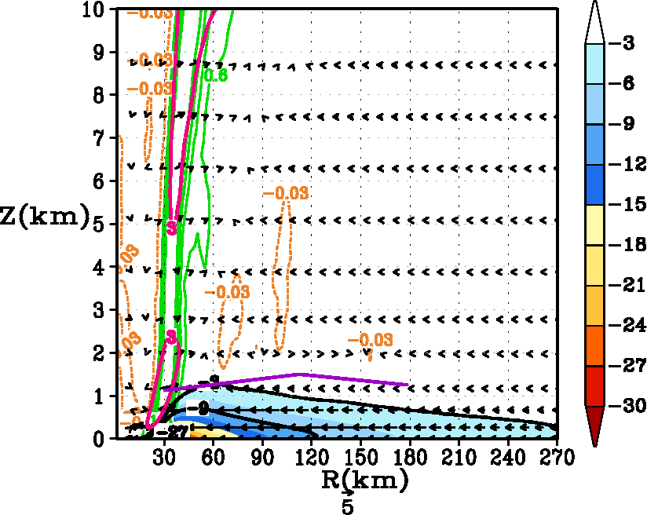
c
Fig. 4. Tangentially averaged, 6-hourly time averaged, radius-height cross-section of the secondary circulation at 93 hours for (a) control (α=1), (b) Km reduced to half (α=0.50), and (c) Km reduced to a quarter (α=0.25). The black solid contour indicates the inflow, and the magenta contours show the outflow of the radial wind component (in m s⁻¹). Inflow is also shaded in colors. Only the lower 10 km has been expanded for convenience. The vertical velocity (in m s⁻¹) is shown by contour lines with updrafts indicted by green and weak subsidence indicated by yellow. Because the distribution of vertical velocity is skewed, please note that the scales are unequally spaced. For convenience, the vector field obtained that compounded the tangentially averaged vertical and the radial velocity components is also provided here. Presented in purple color are the estimates of the inflow layer depth from Zhang et al. (2011b).

