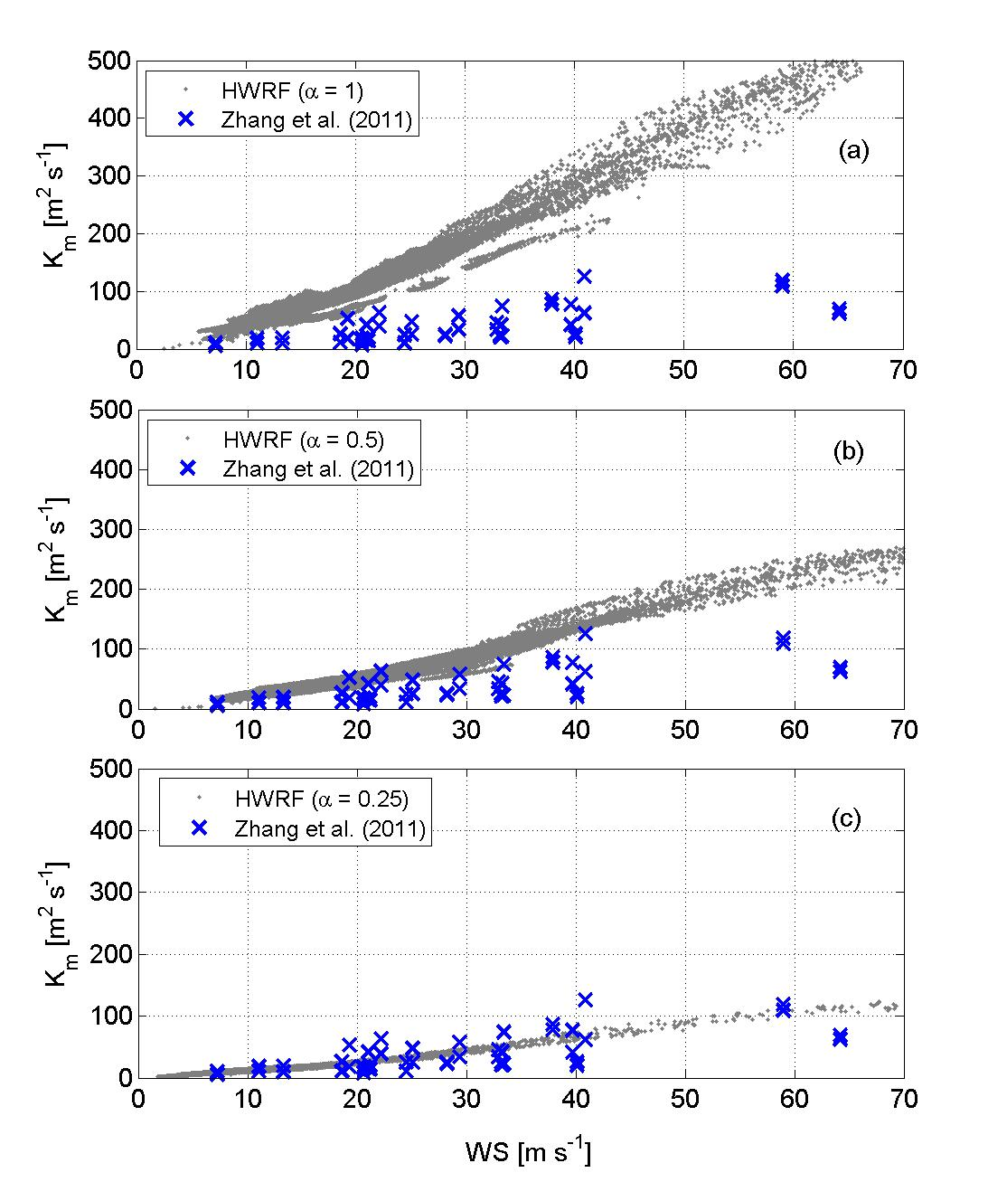
a

Fig. 3. The variation of the eddy diffusivity coefficient, Km, with 10-m wind speeds; high resolution HWRF model outputs from the (a) control experiment (α=1), (b) Km reduced to half (α=0.50), and (c) Km reduced to a quarter (α=0.25) compared with data from Zhang et al. (2011a) obtained from flight-level data between 450-500 m. Modeled outputs were compared between the same levels.

