b
a

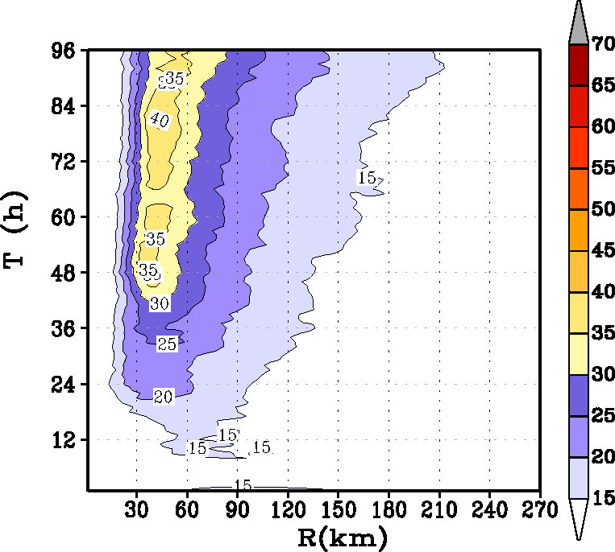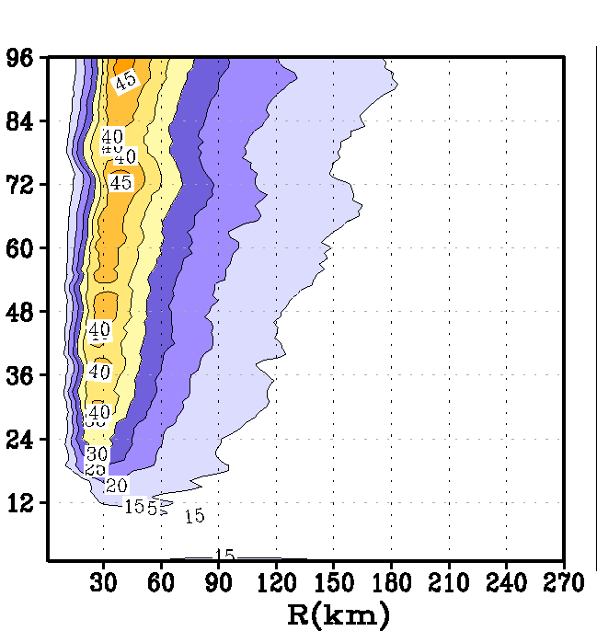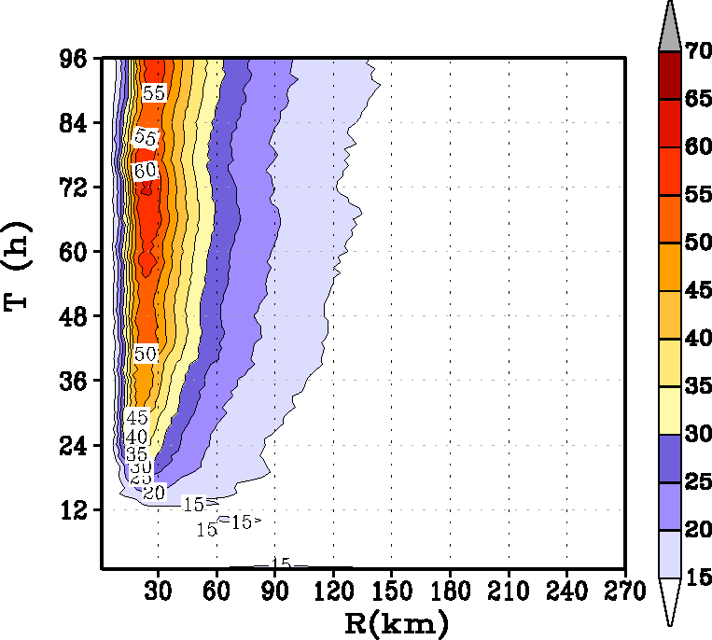
d
e
c

Fig 2. Time history of the intensification process in an idealized storm for the three simulations provided in Table 1: (a) minimum mean sea level pressure in hPa, (b) radius of maximum wind at the first model level; Hovemoller diagram of the axisymmetric mean wind at a height of 10 m for (c) baseline simulation (α=1), (d) Km reduced to half (α=0.50), and (e) Km reduced to a quarter (α=0.25).

