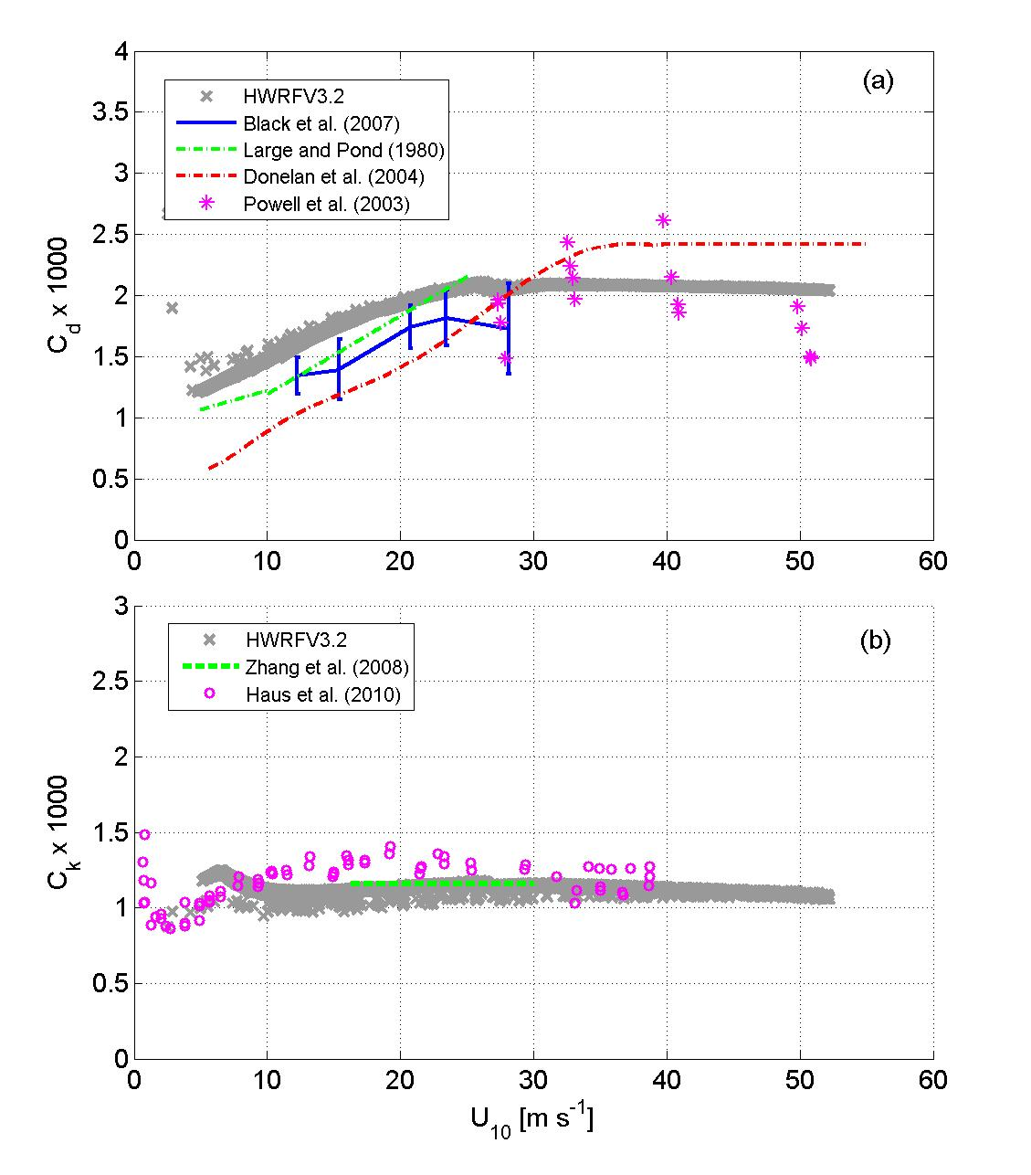
Fig. 1. The variation of (a) drag coefficient (C_{d}) and (b) heat and moisture exchange coefficient (C_{k}) with 10-m wind speeds; high resolution HWRF model with 2010 upgrades (thick gray dots) from the control experiment (for α=1 in Table 1) compared with data from Large and Pond (1981), Powell et al. (2003), Donelan et al. (2004), Black et al. (2007), Zhang et al. (2008), and Haus et al. (2010).

