Impact of Physics Representations in the HWRFX Model on Simulated Hurricane Structure and Wind-Pressure Relationships

J.-W. Bao⁽¹⁾, S. G. Gopalakrishnan⁽²⁾, S. A. Michelson^{(1)&(3)},
F. D. Marks⁽²⁾, M. T. Montgomery^{(2)&(4)}

⁽¹⁾NOAA/ESRL, Boulder, Colorado
⁽²⁾NOAA/AOML, Miami, Florida
⁽³⁾CIRES, University of Colorado, Boulder, Colorado
⁽⁴⁾Naval Postgraduate School, Monterey, California

February 2012

____________________
Corresponding author address: Jian-Wen Bao, NOAA/ESRL, 325 Broadway, Boulder, CO 80305.
E-mail: Jian-Wen.Bao@noaa.gov
ABSTRACT
A series of idealized experiments with the NOAA Experimental Hurricane Research and Forecasting Model (HWRFX) are performed to examine the sensitivity of idealized tropical cyclone (TC) intensification to various parameterization schemes of the boundary layer, subgrid convection, cloud microphysics and radiation. Results from all the experiments are compared in terms of the maximum surface 10-m wind (VMAX) and minimum sea level pressure (PMIN) — operational metrics of TC intensity — as well as the azimuthally-averaged temporal and spatial structure of the tangential wind and its material acceleration.
The conventional metrics of TC intensity (VMAX and PMIN) are found to be insufficient to reveal the sensitivity of the simulated TC to variations in model physics. Comparisons of the sensitivity runs indicate that (1) different boundary layer (BL) physics parameterization schemes for vertical sub-grid turbulence mixing lead to differences not only in the intensity evolution in terms of the VMAX and PMIN, but also in the structural characteristics of the simulated tropical cyclone; (2) the surface drag coefficient is a key parameter that controls the VMAX-PMIN relationship near the surface; and (3) different microphysics and subgrid convection parameterization schemes, due to different realizations of vertical diabatic heating distribution, lead to significant variations in the vortex structure.
The quantitative aspects of these results indicate that the current uncertainties in the BL mixing, surface drag, microphysics parameterization schemes have comparable impacts on the intensity and structure of simulated TCs. The results indicate also that there is a need to include structural parameters in the HWRFX model evaluation.

1. Introduction
The structure and intensification of tropical cyclones as simulated by numerical models are found to be quite sensitive to the details in the physics parameterizations (e.g., Hausman 2001). A recent study conducted by Smith and Thomsen (2010) showed that the prediction of tropical cyclone intensification is sensitive to the variations in the Boundary layer (BL) physics schemes. Specifically, the onset time of rapid intensification, the low-level wind structure in the eyewall region and the overall intensity after a few days of numerical integration are sensitive to the differences in the determination of the vertical eddy diffusivity in the model. In addition to the sensitivity to the vertical eddy diffusivity, Smith et al. (2011) found that the change in the model-simulated tropical cyclone intensification is sensitive to the surface drag coefficient, but this sensitivity depends also on the BL scheme used. The prediction of tropical cyclone intensification has been shown also to be sensitive to the treatment of the physics in resolved and unresolved convective clouds (Zhu and Smith 2002).
Observations and modeling studies are beginning to provide a consistent picture of the tropical cyclone intensification process in which deep convective features growing in the rotation-rich environment of the incipient vortex core amplify the local vertical rotation. These deep convective features have been suggested to be the basic coherent structures of the intensification process, which itself is intrinsically asymmetric and possesses a stochastic component. Nguyen et al. (2008) found that the progressive segregation, merger and axisymmetrization of these features and the low-level convergence they generate are fundamental to the intensification process. If this picture is correct, then a logical outcome is that the model-simulated tropical cyclone intensification and structure should be sensitive to small perturbations in the BL mixing of enthalpy and variations in the treatment of cloud physics (e.g., Wang 2002; Bryan and Rotunno 2009). However, it is still unclear which of these effects (BL mixing, surface drag, microphysics) has the most significant impact. The intrinsic sensitivity of numerically simulated intensification and structure of tropical cyclones to variations in model physics needs to be physically understood in order to meaningfully evaluate the quality of a numerical model’s prediction using observations.
Historically, the maximum surface (10-m) wind (VMAX) and minimum sea level pressure (PMIN) of tropical cyclones are used as key parameters, along with the location of storm center, in the verification of operational tropical cyclone forecasts. They are also commonly used to evaluate numerical model performance. Observations from reconnaissance flights have produced statistically independent estimates of PMIN and VMAX. Such measurements are widely used to provide information on the pressure–wind relationship (PWR) for documenting tropical cyclones and evaluating operational prediction models (e.g., Koba et al. 1990; Harper 2002; Kossin and Velden 2004; Knaff and Zehr 2007; Holland 2008; Brown et al. 2010). It is widely accepted in the operational community that, despite large uncertainty in the datasets used in its derivation, the PWR of tropical cyclones provides a statistically meaningful relationship between the surface pressure deficit between the environment and the center of the cyclone and the increase in the maximum surface wind around the cyclone.
The gradient-wind balance of an inviscid circular vortex is a three-way force balance in the radial direction between the pressure gradient, Coriolis and centrifugal forces. This force balance is fundamental to intense geophysical vortices, such as hurricanes. The gradient balance involves implicitly an important structural parameter, the radius of maximum wind (RMW), which is unfortunately less reliably observed than either VMAX or PMIN. The lack of reliable observations on the RMW in real hurricanes makes it difficult to relate the PWRs directly to the individual components comprising the gradient wind balance equation. Although the gradient-wind balance embedded in the PWRs appears to contain much of the essential dynamics of the vortex tangential wind above the BL, such a zero-order balance relationship is not valid in the BL where the radial inflow is no longer negligible in the radial force balance (Smith and Montgomery 2008).
In contrast to the traditional evaluation of a model-simulated intensity using VMAX and PMIN, a complimentary evaluation of the structure of simulated tropical cyclones has emerged in the literature. Such an evaluation is often conveniently performed using the time-radius Hovmoller and/or the time-mean height-radius diagrams of azimuthally averaged tangential velocity and radial wind velocity (see, e.g., Smith et al. 2009, Wang 2009, Hill and Lackmann 2009, Xu and Wang 2010a and 2010b, and Fudeyasu and Wang 2011) of the vortex. The former is a diagnostic of the quasi-symmetric horizontal circulation and the latter is a diagnostic of the thermally-direct vertical (transverse) circulation. These circulations are traditionally referred to as the "primary circulation" and "secondary circulations", respectively, following, e.g., Ooyama (1982). The combination of these two components gives rise to the picture of air parcels spiraling inwards, upwards and outwards.
Since the model-simulated radial inflow in the BL and above are driven by non-conservative processes (such as convection and surface friction) that tend to drive the flow away from gradient wind balance, an important question is how sensitive is the PWR and the vortex structure simulated by a given tropical cyclone prediction model to uncertainties in physics parameterization schemes? In particular, as the research and operational communities work together under the auspices of NOAA’s Hurricane Forecast Improvement Project (HFIP) to understand the degree to which a tropical cyclone intensity forecast can be improved in operational numerical weather prediction (NWP) models, it still remains a great challenge for the research community to reach a consensus on whether the current physics parameterizations in operational NWP models are suitable for horizontal grid spacing of ≤ 3 km. To deal with these challenges, it is important to first understand how sensitive operational NWP models for hurricane forecast are to different physics parameterizations, in terms of the standard PWR and vortex structure metrics discussed in the foregoing paragraph.
In this study, a series of idealized experiments with the NOAA Experimental Hurricane Research and Forecasting Model (HWRFX) are performed for the purpose of evaluating the sensitivity of HWRFX to commonly used BL and cloud microphysics parameterization schemes. The HWRFX model is a version of the National Centers for Environmental Prediction’s (NCEP) Hurricane Weather Research and Forecasting (HWRF) system specifically modified at the Hurricane Research Division (HRD) of the Atlantic Oceanographic and Meteorological Laboratory (AOML) and the Earth System Research Laboratory (ESRL) to study the intensity change problem at the finest model grid resolution operationally feasible at this time for forecasting. The model is initialized with a weak axisymmetric vortex disturbance in an idealized tropical environment that is favorable for the vortex amplification. The initial mass and wind fields associated with the weak vortex disturbance are obtained by solving the nonlinear balance equation for the given wind distributions of the initial vortex, and the prescribed background thermal profile. We employ the forgoing metrics, VMAX and PMIN as well as the azimuthally-averaged structure of the simulated tropical cyclone, as a way of quantifying the sensitivity of the intensification process to variations in physics parameterization schemes.
The remaining paper is organized as follows. The setup of the HWRFX sensitivity experiments is described in section 2. Our current understanding of the basic dynamics of tropical cyclone intensification is reviewed in section 3 to provide a meaningful context for the sensitivity experiments. The results from the various sensitivity experiments are presented and compared in section 4. One of the outcomes of this section is the demonstration of the advantage of using the azimuthally averaged structural metrics over the VMAX and the PMIN metrics used traditionally. A summary and discussion of the results are provided in section 5, along with their implication for tropical cyclone model evaluation.

2. Experimental Design
The sensitivity experiments presented here are run with a parent domain (about 55 × 55 degrees) at a horizontal resolution of 9 km with a single moving nest (about 8 × 8 degrees) at 3 km horizontal resolution. There are 43 stretched pressure-sigma hybrid levels in the vertical direction with the top level set to 50 hPa.
To initialize the idealized vortex in all the experiments, the non-linear balance equation in the pressure-based sigma coordinate system described in Wang (1995) is solved within the rotated latitude-longitude E-grid framework on an f plane located at 12.5ºN. The mass field is derived from the wind field corresponding to an axisymmetric cyclonic vortex of maximum surface tangential wind set to 15 ms⁻¹ at 90 km from the vortex center that is embedded in a quiescent flow. The temperature and humidity profiles of the far-field are based on Jordan’s Caribbean sounding (Gray et al., 1975). In all of the experiments, the sea surface temperature is set to 302 K (approximately 29 degrees Celsius).
The physics configurations used in all the sensitivity experiments are summarized in Table 1. One of these configurations (Experiment 1) is very close to the operational HWRF system, in which the HWRF version of the Global Forecast System (GFS) surface and BL formulations are used to parameterize the sea-to-air flux transport and the subsequent mixing in the atmosphere. The Ferrier scheme is used to provide latent heating due to the microphysical processes of clouds in the atmosphere, and the Simplified Arakawa and Schubert scheme (SAS, see Pan and Wu 1995) is used to parameterize sub-grid-scale cumulus-cloud activity. The National Center for Atmospheric Research (NCAR) long- and short-wave radiation schemes are used. To maintain consistency between our results at 9 and 3 km and those in Gopalakrishnan et al. (2010), the SAS convection scheme is used at 3 km resolution along with the Ferrier scheme for grid-resolved cloud microphysics processes. While it remains a research subject whether a SCP scheme should be turned on in the 3-km grid and, if it should, whether the SAS scheme is an appropriate one to use remains a subject of research. As shown by one of the sensitivity experiments in this study, turning on the SAS scheme in the 3-km grid basically modifies the latent heating distribution that is realized by the explicit microphysics scheme only and, thus, influences the intensity and structure and simulated TC. The effect of radiation is investigated by changing the long- and short-wave radiation scheme from the NCAR scheme to the Geophysical Fluid Dynamics Laboratory (GFDL) scheme.
The results from all the experiments listed in Table 1 are divided into 3 groups to allow for the examination of the sensitivity of the simulated tropical cyclone development (i) to BL-mixing, subgrid convection and radiation (Experiments 1-5), (ii) to the surface drag (Experiments 6 and 7), and (iii) to the bulk microphysics and subgrid convection schemes (Experiments 8-11). The BL mixing schemes determine the vertical subgrid turbulence mixing and vertical diffusion within the atmospheric boundary layer and the free atmosphere above. The two schemes used in this study, i.e., the MYJ and the GFS BL schemes, are both one-dimensional, and representative of two types of BL mixing parameterizations widely used in numerical weather prediction models: the turbulent kinetic energy (TKE) scheme and the flux scaling scheme. The drag and enthalpy exchange coefficients used in the MYJ BL scheme are calculated using the surface layer scheme developed by Janjic (1996, 2002), and is based on the Monin-Obukhov similarity theory and includes parameterizations of a viscous sub-layer. In the GFS BL scheme, on the other hand, the drag and enthalpy exchange coefficients are calculated in a nearly identical way as in the operational GFDL hurricane model, which is a bulk parameterization based on the Monin-Obukhov similarity theory. In both of the BL schemes, the drag and enthalpy exchange coefficients increase with 10-m wind speed. Two subgrid convection schemes are permutated in the experiments: the SAS scheme and the Betts-Miller-Janjic (BMJ) scheme (Janjic 1994, 2000). In addition to the NCAR long- and short-wave radiation schemes, the GFDL schemes for long- and short-wave radiation are used in the sensitivity experiments. The surface drag coefficient calculation for the sensitivity experiments is described in section 4.2.
A total of four different microphysics schemes are used in the sensitivity experiments: the Ferrier scheme, the WRF single-moment 5-class (WSM5) scheme, the WRF single-moment 6-class (WSM6) scheme, and the Thompson double-moment 6-class scheme (Skamarock et al. 2008). The Ferrier scheme predicts changes in water vapor and condensate in the forms of cloud water, rain, cloud ice, and precipitation ice (snow/graupel/sleet) (see Skamarock et al. 2008). The individual hydrometeor fields are combined into total condensate. The WSM5 scheme has five prognostic equations of microphysical processes for vapor, rain, snow, cloud ice, and cloud water, and allows super-cooled water to exist, and a gradual melting of snow as it falls below the melting layer. The WMS6 scheme extends the WSM5 scheme to include graupel and its associated processes. The Thompson double-moment scheme includes six prognostic equations of moisture species plus number concentration for ice as prognostic variables. Since only water vapor and total condensate are advected in Ferrier scheme, the horizontal and vertical advection of hydrometeor species in all the non-Ferrier schemes is consistently treated in accordance with the assumptions made in the Ferrier scheme (i.e., keeping the partition of hydrometeors unchanged during the advection of the total condensate) such that the differences in all the microphysics schemes are kept in the parameterization of cloud microphysical processes.

3. Metrics for Comparing the Sensitivity Experiments
In order to understand the salient characteristics of the model solution and improve the model performance, it is important to choose metrics that carry dynamical information for the examination of sensitivity experiments. The results from all the sensitivity experiments summarized in Table 1 will be first compared in terms of the intensity of the simulated tropical cyclone using the VMAX, PMIN, and PWR. Then, the structures of the simulated tropical cyclone in the sensitivity experiments will be compared in terms of azimuthally-averaged winds and acceleration. The latter metrics for comparison are necessary to complement the intensity comparison. This is because observations suggest that the intensity in terms of the VMAX and the PMIN of tropical cyclones are not strongly correlated with their size (e.g., Weatherford and Gray 1988), and simply using the intensity metric to compare the sensitivity experiments is insufficient to provide useful information for understanding and improving the model performance. Thus, in this section, a brief review is provided to summarize the advantage and weakness of these metrics.
The intensity of tropical cyclones is operationally described in terms of minimum sea-level pressure of the cyclone center (i.e., PMIN) and the local maximum surface wind speed (i.e., VMAX). The advantage of using the PMIN in operational forecasts and climatological records is that it can be obtained reliably from dropsonde measurements or direct observations at aircraft reconnaissance flight level. On the other hand, the VMAX is a difficult quantity to measure by its definition (i.e., 10-m level, 1-min sustained), despite the fact that it is often related to the destructive energy and the societal impact of tropical cyclones due to its close link to the structure of tropical cyclones. For this reason, pressure-wind relationships (i.e., PWRs) were developed to facilitate the need for describing tropical cyclone intensity in terms of the VMAX in accordance with the PMIN (for useful historical perspectives see Knaff and Zehr 2007 and Holland 2008). Although these PWRs were attempts to describe the mean relationship between the PMIN and the VMAX, the actual relationship between them is a function of multiple factors related to the tropical cyclone environment and structure that varies from case to case. Consequently, there is considerable scatter about any given PWR derived from observations (see, e.g., Fig. 7 and Table 1 in Holland 2008 for a statistical summary). This hinders the effectiveness of using the observationally-derived PWRs to gain insight into the scattering of the PWRs from the sensitivity experiments, particularly when the sensitivity spread lies within the uncertainties associated with the observed PWR.
There is also a fundamental weakness in using the observationally-derived PWRs to compare with those from the sensitivity experiments. The development of the PWRs based on observations is, historically, motivated by the assumption that the gradient-wind balance is dominant in the overall dynamics of tropical cyclone intensification. Although the gradient-wind balance embedded in the observationally derived PWRs appears to contain all of the essential dynamics of the vortex tangential wind above the BL, it is fundamentally invalid in the BL. The gradient-wind balance is formally invalid in the BL because, firstly, it assumes that the radial inflow makes a negligible impact to the dynamics there. This is not the case in the BLs of tropical cyclones (see, e.g., Montgomery et al. 2006 and also the scale analysis by Smith and Montgomery 2008 and Smith and Vogl 2009). Secondly, the VMAX in the PWR is the locally, instantaneous maximum wind near the surface, while the wind required by the gradient-wind balance is axisymmetric. Thus, it seems inherently problematic to seek a physically meaningful understanding of the sensitivity experiments if only the model-simulated PWRs are compared.
On the other hand, since the gradient-wind balance is a good approximation to the azimuthally averaged dynamics above the BL (e.g., Bui et al. 2009 and refs. therein), it seems physically appropriate to use the azimuthally-averaged structure of the simulated tropical cyclone to compare the sensitivity experiments. Examples of useful parameters for illustrating the cyclone structure are the azimuthally-averaged radius of the 15 ms⁻¹ (slightly less that the lower threshold of gale force winds, 17 ms⁻¹) and radius of the 35 ms⁻¹ tangential velocity (slightly greater than the 33 ms⁻¹ definition of hurricane strength). In fact, in some of previous studies (e.g., Xu and Wang 2010a and 2010b), the radius of the damaging force (50 knots) wind is used often as a size parameter of the simulated vortex.
Using the azimuthally-averaged structure to compare the sensitivity experiments takes advantage of the current understanding of the dynamics of the primary and secondary circulations associated with an axisymmetric vortex. The essential premise of this understanding is that the primary circulation of a tropical cyclone vortex is so strong that the mean axisymmetric dynamics broadly control the dynamics of tropical cyclone intensification and structural evolution (see Willoughby 1995, Bui et al. 2009 and section 2 of Montgomery and Smith 2011). These two spin-up mechanisms have been identified to coexist during the intensification of the primary circulation (see section 7 in Montgomery and Smith 2011).
In the first spin-up mechanism, the intensification of the primary circulation can be explained by the convergence driven by the aggregate diabatic heating in the eyewall region associated with the rotating deep convection and the material conservation of the absolute angular momentum. The secondary circulation of tropical cyclones can be understood dynamically as the response of a balanced axismmetric vortex above to lateral and vertical forcing distributions associated with diabatic processes and their interaction with the environment and the lower boundary. Such a response can be described by diagnostic solutions of Eliassen's balanced vortex equations (see, e.g., Shapiro and Willoughby 1982, Bui et al. 2009 and section 2 of Montgomery and Smith 2011). The surface forcing associated with the surface drag and the turbulent sensible and latent heat fluxes can further distort the primary and secondary circulations that intensify with this spin-up mechanism, as seen in work of Willoughby (1979), Schubert and Hack (1982), Shapiro and Willoughby (1982) and Bui et al. (2009).
The second spin-up mechanism is associated with the intensification of the primary and secondary circulations within the BL. It requires that the radial pressure gradient increases with time, which, in turn, requires spin up of the tangential wind at the top of the BL by the first mechanism. This mechanism becomes progressively important in the eyewall region as the vortex intensifies. During the intensification, although absolute angular momentum is not conserved in the BL, the largest wind speeds anywhere in the vortex can be achieved in the boundary layer. This occurs when the radial inflow is sufficiently large enough to move air parcels close to the vortex center without a large loss of absolute angular momentum. This mechanism is coupled to the first one through BL dynamics because the radial pressure gradient of the BL is determined by the overall vortex flow above the BL as discussed in section 2.6 of Montgomery and Smith (2011). This spin-up mechanism explains why the maximum azimuthally-averaged tangential wind speeds in the model simulations (e.g., Smith et al. 2009) are located near the top of the boundary layer.
The major caveat of using other metrics such as those proposed in the forgoing discussion for comparing the sensitivity experiments is that it requires more observational information about the azimuthally averaged structure of real tropical cyclones (e.g., see Rogers et al. 2011, personal communication, also see http://www.ofcm.gov/ihc10/Presentations/Session08/s08-03HWRFx_update_Marks_v3.ppt) to help discriminate which of the sensitivity experiments is more realistic. Although general structural information about tropical cyclones have been reasonably well documented now (e.g., Houze 2010), information about the structure of individual tropical cyclones are not as readily available as estimates of VMAX and PMIN. However, information on historical tropical cyclones events derived from aircraft observations is available at AOML/HRD to provide the needed structural evaluation of the HWRFX model simulations in future studies.

4. Results
In this section, we focus on the results from the sensitivity experiments for the idealized tropical cyclone intensification scenario. The results of the sensitivity experiments are compared in terms of time series of the minimum mean sea-level pressure (PMIN) at the center of the cyclone, the spatially local maximum 10-m wind speeds (VMAX) around the center and the PWR from the 3-km grid. The structures of the simulated tropical cyclone from the sensitivity experiments are compared also in terms of the axisymmetric mean primary and secondary circulations created from hourly model output for the entire period of the simulation.

a. Sensitivity to boundary layer mixing, subgrid convection and radiation (Experiments 1-5)
During intensification, the enthalpy from the sea surface driven by thermal disequilibrium across the air-sea interface is transported upward and consumed by the tropical cyclone. Such transport is accomplished primarily by turbulence- and some convection-induced vertical mixing processes in the BL. In view of these, the first set of five sensitivity experiments (Experiments 1-5 in Table 1) are used to reveal the dependency of the HWRFX-simulated tropical cyclone intensification on the choice of BL mixing, subgrid convection and radiation parameterization schemes. Figure 1 depicts the time series of PMIN and VMAX from these experiments. The time series indicates the relative sensitivity of the simulated intensification to variation in the BL scheme (Experiments 1 and 2), the subgrid convective scheme (Experiments 1 and 5, 2 and 3) and the radiation scheme (Experiments 4 and 5).
Figure 1 shows that Experiments 1 and 2, which differ only in BL schemes, have similar development trends in the spin-up stage of the first 36 h. However, after 36 h, the simulation with the GFS scheme persistently produces a greater VMAX than the simulation using the MYJ scheme. Although the differences between the two schemes are not only in the formulations of the vertical diffusion but also in the details of how the surface momentum and enthalpy flux are calculated, a separate study (Bao et al. 2011) has shown that the differences in the intensity are more associated with the differences in the surface flux calculation, while the differences in the structure are more associated with the differences in the vertical diffusion. Figure 1 shows also that the differences in the subgrid convection scheme produce more differences in the simulated tropical cyclone intensification than the differences in the BL schemes (see the differences between Experiments 1 and 5 versus Experiments 1 and 2, or Experiments 2 and 3 versus Experiments 1 and 2). Also, when the BMJ convective parameterization scheme is used, the tropical cyclone develops much more slowly than when the SAS scheme is used, although both simulations reach similar intensities toward the end of the simulations. The differences made by the two different radiation schemes (Experiments 4 and 5) are the smallest among the five experiments. It is interesting to note in Fig. 1 that due to the differences in the inner-core size of the simulated tropical cyclone (defined as RMW), the intensity looks more similar in terms of PMIN than VMAX.
It is important to note that the two different BL schemes produce a significant difference in the asymptotic behavior of PMIN. Figure 1 shows that VMAX from all five experiments levels off and becomes quasi-steady after 60 h into the simulation. While PMIN from all the experiments continues to decrease after 60 h, the decrease slows down in the two experiments using the MYJ BL scheme, but remains almost the same in all the experiments using the GFS BL scheme. It is expected that for a steady environment such as the one prescribed in all the experiments herein, the simulated cyclone should eventually reach a quasi-steady state in which the inner-core size and intensity of the simulated cyclone undulate with small amplitudes and the overall intensification of the simulated cyclone ceases.
Since the major difference in the asymptotic behavior of PMIN shown in Fig. 1 occurs with the different BL schemes, this would suggest that the BL scheme plays an important role in determining how the simulated cyclone reaches the quasi-steady state. It is obvious that the experiments using the GFS BL scheme takes longer to approach a quasi-steady state than those using the MYJ BL scheme. The implication of this particular result to the evaluation of hurricane prediction models is believed to be non-trivial since it is unknown in theory how long it takes for a weak initial vortex, such as the one used in this study, to reach the quasi-steady state corresponding to the prescribed environment. It is unknown also what primary structural characteristics (e.g., spatial distributions of wind and thermal properties) the quasi-steady cyclone should have. These considerations suggest that other metrics are necessary to evaluate the behavior of the HWRF model with changes in physics, particularly when PMIN continues to decrease with time while VMAX becomes quasi-steady.
Figure 2 compares the five experiments in terms of the PWR. Until VMAX > 55 ms⁻¹ and PMIN < 940 hPa, Experiment 1 produces a correspondence in the trend of VMAX and PMIN that is close to the statistical mean obtained by Knaff and Zehr (2007) and within the spread of uncertainty (see more discussion below). The two experiments with a different subgrid convection scheme (Experiment 5) and a different radiation scheme (Experiment 4) than the one used in Experiment 1 produce similar correspondences in the trend of VMAX and PMIN until VMAX > 50 ms⁻¹ and PMIN < 950 hPa. The use of the MYJ BL scheme (Experiments 2 and 3) leads to a significantly different trend of PWR than Experiment 1. Overall, the MYJ scheme tends to produce a smaller VMAX for a given PMIN than the GFS scheme. More data points from the experiments using the MYJ scheme for VMAX greater than 40 ms⁻¹ and PMIN lower than 940 hPa are clustered together than those from the experiments using the GFS BL scheme. This clustering is a manifestation of the fact that the simulated cyclone in the experiments using the MYJ scheme approaches the quasi-steady state faster than that from the experiments using the GFS BL scheme.
It should be pointed out that caution needs to be applied when comparing the model-simulated PWRs with the statistical mean, such as the one obtained by Knaff and Zehr (2007). Firstly, the datasets used in the derivation of the PWRs have uncertainty. Knaff and Zehr (2007) and Holland (2008) pointed out that the datasets used to produce the various statistical mean PWRs have a large scatter. For example, careful examination of Fig. A1 in Knaff and Zehr (2007) and Fig. 7 in Holland (2008) reveals that, for VMAX > 40 ms⁻¹, the scatter about the mean is as large as 10 ms⁻¹. It is seen from our Fig. 2 that the largest differences in the VMAX are caused by the differences in the BL parameterization schemes, which are within the magnitude of about 10 ms⁻¹ and comparable with the uncertainty in the datasets used in the derivation of the statistical PWRs. Secondly, there is a discrepancy between the model output sampling and observational data sampling to define the VMAX. The VMAX from the model is defined as instantaneous maximum 10-m wind at the beginning of each hour of the simulation. While by definition, the observed VMAX is the maximum 10-m, 1-min sustained wind, there is a quite large disparity in data sampling with different instrumentation techniques. Thirdly, the gradient-wind balance is applied as a guidance in the derivation of the statistical mean PWRs (see more detailed discussion of this in Knaff and Zehr 2007); however, as discussed earlier, such a balance is not valid in the BL near the surface where the mean radial inflow is no longer negligible in mature tropical cyclones as is required in the gradient balance approximation (Smith and Montgomery 2008). In fact, when the surface maximum azimuthally-averaged tangential winds are compared with the statistical mean PWR in Fig. 2, the differences between the experiments with the GFS (open red triangles in Fig.2) and MYJ (the open black circles in Fig. 2) BL schemes are much smaller than those shown by the VMAX. This strongly suggests that any PWR-based metric for comparing results from physics sensitivity experiments is inadequate to reveal physically meaningful information in a conclusive manner. It suggests also that the PMIN and VMAX are less dynamically coupled for VMAX > 50 ms⁻¹ than for smaller VMAX. Therefore, it is necessary to use other metrics to compare the sensitivity experiments. In fact, we will demonstrate below that structural metrics such as Hovmöller diagrams of the maximum azimuthally averaged tangential wind speed are better than the VMAX and PMIN to reveal the differences in the sensitivity experiments.
The sensitivity of the simulated cyclone intensity to various BL, subgrid convection and radiation schemes, as revealed in Figs. 1 and 2, is also associated with changes in the structure of the simulated tropical cyclone. As illustrated in Liu et al. (1999), Zhang et al. (2001), Smith et al. (2009) and Gopalakrishnan et al. (2010), it is convenient and helpful to examine the structure of model-simulated tropical cyclones in terms of the axisymmetric mean circulations in the cylindrical coordinate (, , ) system, where is the distance from the center of the vortex, is the azimuthal angle, and is the vertical height. Such an analysis has been shown to be quite illuminating in observational analyses also (e.g., Marks et al. 1992). To facilitate the analysis of the model output from the sensitivity experiments in the cylindrical coordinate system, the horizontal equations of motion in the HWRFX model are transformed into radial and tangential momentum components:

$\frac{\text{du}r}{\text{dt}}= − \frac{1}{ρ}\frac{∂p}{∂r}\text{ + }\frac{v_{λ}v_{λ}}{r}\text{ + }{\text{fv}}_{λ}\text{ + }Dur$ (1)
$\frac{\text{dv}λ}{\text{dt}}= − \frac{1}{ρr}\frac{∂p}{∂λ} − \frac{urv_{λ}}{r} − \text{fu}r\text{ + }Dvλ$ (2)
$$\frac{\text{dv}λ}{\text{dt}}= − \frac{1}{ρr}\frac{∂p}{∂λ} − \frac{urv_{λ}}{r} − \text{fu}r\text{ + }Dvλ$$
where $\frac{d}{\text{dt}}= \frac{∂}{∂t} +ur\frac{∂}{∂r}\frac{vλ}{r}\frac{∂}{∂λ}\frac{∂}{∂z}$is the material derivative operator in which , , and are, respectively, the radial, tangential, and vertical velocities in the earth-relative transformed coordinate system. Also, is the pressure, is the Coriolis parameter, and and are, respectively, the diffusion (frictional) terms in the radial and tangential directions. In the absence of surface friction and the terms that constitute the radial wind acceleration, (1) reduces to the gradient wind balance equation, while (2) represents the material acceleration of the tangential velocity and the material conservation of absolute angular momentum (see section 2.4 in Montgomery and Smith 2011).
Figure 3 shows the Hovmöller diagrams of the azimuthally-averaged instantaneous tangential wind speed at 1 km above the model sea surface and at hourly outputs from 0 to 84 h into the simulations. The structure at 1 km was chosen to minimize the effects of friction. The most prominent sensitivity feature shown in Fig. 3 is the differences in the azimuthally-averaged maximum tangential wind speed and the radius of the 35 ms⁻¹ contour. These results indicate also that the structure of the HWRFX-simulated tropical cyclone is more sensitive to changes in either the BL scheme or the subgrid convection scheme than the radiation scheme. Particularly, the MYJ BL scheme produces a more compact simulated cyclone with stronger 1-km tangential winds than the GFS BL scheme (note that this opposite to what is seen with the surface winds), and the BMJ subgrid convection scheme produces slower intensification than the SAS convection scheme. The overall size of the simulated cyclone characterized by 35 ms⁻¹ radii in all the experiments increases with time, but the rate of increase is more sensitive to the choice of the BL scheme than either the subgrid convection or the radiation scheme. The MYJ BL scheme leads to a smaller inner-core size-increase with time than the GFS BL scheme. The reason for this difference is due to the fact that the MYJ BL scheme produces smaller vertical eddy diffusivity than the GFS BL scheme does, and the detailed causality will be explored in a subsequent paper.
Figure 3 is a good example to show the advantage of structure metrics such as the Hovmöller diagram in shedding light on the comparisons of the intensity in terms of VMAX and PMIN. In fact, Fig. 3 suggests a close connection between the inner-core size increase and the departure of the simulated VMAX-PMIN relation from the statistical one for PMIN < 940 hPa. This example also illustrates one of the problems in tropical cyclone model evaluation using only VMAX to represent the overall intensity of the simulated tropical cyclone. Despite these Hovmöller diagrams showing that the cyclone intensity in terms of the maximum wind speed at 1 km above the model sea level in the experiment using the MYJ BL scheme is greater than that in the run using the GFS BL scheme, the corresponding VMAX shown in Fig. 1 (defined as the local peak 10-m wind around the center of the cyclone) is smaller.
Figure 4 depicts the azimuthally and 12-h averaged radius-height cross sections of the tangential wind contours superimposed on the vectors of the secondary circulation, contours of the radial wind speed, and the material acceleration in the tangential direction as described by equation (2), with the friction effect included for all five experiments. The time averaging is done over 60-72 h, representing the quasi-steady stage of the simulated VMAX, and is required in order to better represent the quasi-steady state by reducing the small temporal undulations in the simulated structure. The intensity of the tangential circulation following the area enclosed by the 30 ms⁻¹ and 50 ms⁻¹ red contours varies with the choices of the BL. The MYJ BL scheme results in a greater maximum tangential wind speed above the BL in the eyewall region than the GFS BL scheme (compare Fig 4a with Fig.4b and Fig. 4c with Fig. 4e), but smaller areas enclosed by the 30 ms⁻¹ and 50 ms⁻¹. That is, the MYJ BL scheme tends to produce a stronger, but smaller vortex than the GFS BL scheme. Additionally, the radius of the maximum tangential wind speed above the low-level inflow is smaller in the experiments with the MYJ BL scheme than in the experiments with the GFS BL scheme. However, the near-surface tangential winds in the experiments with the MYJ BL scheme are weaker than in the experiments with the GFS BL scheme, which is consistent with what is shown in Fig.1 where the 10-m winds are weaker with the MYJ BL than with the GFS BL scheme. This result clearly indicates that the MYJ BL scheme produces a greater vertical shear of tangential winds than the GFS BL scheme. Furthermore, the combination of the MYJ BL scheme and the BMJ subgrid convection scheme produces the weakest near-surface tangential winds because this combination produces an overall weaker storm, which is also consistent with Fig. 1. On the basis of these results, it is evident that the largest differences in the tangential winds in all five experiments are, to a great degree, restricted to the inner core.
As for the sensitivity of the simulated secondary circulation, Fig. 4 indicates that when the SAS convection scheme is used, the GFS BL scheme produces (Experiments 1, 4 and 5) a deeper inflow layer than the MYJ scheme (Experiments 2 and 3). The return flow above the inflow in the eyewall region in the simulation with the GFS BL scheme is also weaker than that in the simulation with MYJ BL scheme. While the GFS BL scheme produces a stronger and deeper upper-level outflow than the MYJ BL scheme (Experiments 1 and 2), the MYJ BL scheme produces a narrower eyewall indicating stronger vertical motion above the low-level inflow than the GFS BL scheme. Comparing Experiment 1 with Experiment 5 indicates that the SAS subgrid convection scheme leads to a more vertical eyewall than the BMJ scheme, while the comparisons of Experiments 1 and 5, along with Experiments 2 and 3, show that the BMJ scheme produces a weaker secondary circulation corresponding to a slower intensification process as seen in Hovmöller diagrams. It should be pointed out that the sensitivity shown thus far in Figs. 3-4 reflects the fact that various combinations of the subgrid and BL mixing schemes lead to different 3-D diabatic heating distributions associated with the formation and replacement cycles of primary circulations, and the interaction between the primary circulation and the outer rainbands. The physical mechanism connecting the variation in 3-D diabatic heating distribution and variation in the simulated TC intensity and structure has been revealed and documented in a series studies by Wang (2009), Hill and Lackmann (2009), Xu and Wang (2010a and b), and Fudeyasu and Wang (2011).
Despite the foregoing demonstrated sensitivity of the intensity and structure of the simulated tropical cyclone to various BL schemes, it remains a question to determine the reasons behind the differences. There are two possible factors contributing to the differences. Firstly, it should be kept in mind that the differences in the BL schemes are not only in the formulations of the vertical diffusion but also in the parameterizations used in the surface momentum and enthalpy flux calculations. Secondly, the overall dynamical response of the numerical model varies with different realizations of sub-grid turbulent mixing in the model, particularly in the BL inflow layer above the surface (see. e.g., Kepert 2012 and Gopalakrishnan et al. 2012). In fact, it is demonstrated in a separate study (Bao et al. 2011) that the differences in the intensity as shown above are more associated with the differences in the surface flux calculation, while the differences in the structure are more associated with the differences in the vertical diffusion. It is also shown in this separate study that the use of horizontal diffusion and the divergence damping term in the dynamical solver of the model, which possess a degree of numerical artifact, contributes significantly to the sensitivity of the model solution to various BL schemes, particularly in terms of the inner-core size and the simulated PWR when VMAX becomes quasi-steady.
The sensitivity of the model solution to various physics representations can be seen also in the simulated inflow in the mid-to-upper troposphere between 4 km and 8 km in Fig. 4. The sensitivity to radiation scheme may be due to the cloud - radiation feedback to the total diabatic heating distribution as is discussed in Fovell et al. (2010). It appears from Fig. 4 that the mid-to-upper tropospheric weak inflow is more sensitive to the BL schemes (Experiments 1 and 2) and the subgrid convection schemes (Experiments 1 and 5) than the radiation schemes (Experiments 4 and 5). When the MYJ BL scheme is used, the sensitivity to the subgrid convection schemes is not as great as when the GFS BL scheme is used. Several axisymmetric model studies (e.g., Ooyama, 1982; Willoughby, 1979; Yamasaki, 1977) have illustrated the importance of this mid-level inflow layer to the slow evolution of a tropical cyclone vortex. Ooyama (1982) pointed out that the deep-layer inflow is, in essence, all that is needed for intensification of cyclonic rotation because at that level surface friction is not affecting the evolution process. Willoughby (1979) pointed out that the development of this weak mid-level inflow may be related to inner core warming. Recently, Fudeyasu and Wang (2011) pointed out that the mid-level inflow often develops in response to diabatic heating in outer rainbands and affects the size of the simulated TC. In the perspective of the two-mechanism spin-up processes (Montgomery and Smith 2011), this inflow may enhance the convergence of angular momentum above the BL. However, despite the sensitivity of the mid-to-upper tropospheric weak inflow to various BL schemes, the time series of VMAX and PMIN are apparently most sensitive to the differences in the subgrid convection schemes.
It is shown (Fig. 4b and 4c) that the strong inflow associated with the MYJ BL scheme results in strong tangential acceleration near the surface, despite the effects of friction that acts to oppose the acceleration in the tangential direction. It is also worth pointing out that the MYJ BL scheme produces the strongest tangential winds in the inner core of the cyclone right above the maximum inflow, regardless of what subgrid convection scheme is used. Moreover, although the MYJ BL scheme generates a smaller radius of the maximum tangential winds than the GFS BL scheme, the intensity of the cyclone measured by the VMAX shown in Fig. 1, defined as local maximum 10-m wind, indicates that the GFS BL scheme tends to produce a stronger mature cyclone. These results, on the one hand, are consistent with previous intensity-forecast studies using numerical weather prediction models (see, for example, Braun and Tao, 2000), which show a strong sensitivity of the model forecast to BL parameterization schemes. On the other hand, these results strongly suggest that in addition to the VMAX and PMIN that are conventionally used for model evaluation, observations of tropical cyclone structure (in terms of parameters such as the radii of the gale-force wind speed and the hurricane-force wind), together with the knowledge of the radius of the maximum tangential winds, should be used in model evaluation and validation.

b. Sensitivity to the surface drag (Experiment 6)
This section focuses on the sensitivity of the idealized tropical cyclone intensification to changes in the surface drag coefficient. Some of previous theoretical and numerical studies of the sensitivity to the surface exchange coefficients in axisymmetric models found that the intensity decreases markedly with increasing drag coefficient (e.g., Emanuel 1995 and Craig and Gray 1996). In contrast, whereas a vortex intensifies in axisymmetric model when there is no surface drag (see, e.g., Craig and Gray 1996), Montgomery et al. (2010) showed that no vortex intensification occurs in a three-dimensional model with zero surface drag (despite persistent sea-to-air fluxes of moisture to maintain deep convective activity). They showed also that the intensification rate and maximum intensity of the three-dimensional vortex increases with increasing surface drag coefficient until a certain threshold value is attained and then the intensification rate decreases.
In both the GFS and the MYJ BL scheme, the drag coefficient exhibits a steady increase with wind speed following the use of the Charnock formulation in the determination of the surface roughness from the momentum flux. Unfortunately, this wind-speed dependency has not been corroborated by any observations for the marine boundary layer in the extreme wind conditions of tropical cyclones. Recent observations of Powell et al. (2003), Donelan et al. (2004), French et al. (2007), and Black et al. (2007) show that the drag coefficient exhibits a steady increase to a wind speed of approximately 30 m s⁻¹ and then levels off for higher winds. To see how this behavior of the drag coefficient affects the cyclone intensification, Experiment 6 is carried out in which a realistic wind-dependency of the drag coefficient is specified in the GFS BL scheme. In this experiment, since the exchange coefficient required for the determination of the surface sensible and latent heat fluxes is dependent on the drag coefficient, the impact the modified drag coefficient on the surface sensible and latent heat fluxes is accounted for automatically in the surface flux calculation in the GFS BL scheme such that the heat exchange coefficient levels off at about 30 ms⁻¹.
Time series of PMIN and VMAX from the experiment are shown in Fig. 5 in comparison with those from Experiment 1. In general, the modified drag coefficient produces a very similar intensification rate of the simulated tropical cyclone in terms of VMAX to the original one in the GFS BL scheme when VMAX exceeds 30 ms⁻¹. Although the decreasing rate of PMIN with the modified drag coefficient is smaller in the experiment than that in Experiment 1, the PWR from the experiment depicted in Fig. 6 exhibits a significantly different trend than Experiment 1. It shows that the realistic wind-dependency of the modified drag coefficient improves the PWR, indicating strongly that the surface drag coefficient is a key parameter in controlling the PWR in the HWRFX model when the GFS BL scheme is used. Overall, the differences made by the change in the drag coefficient are within the uncertainty of about 10 ms⁻¹ in the Knaff and Zehr (2007) PWR, but the slope of the PWR is greatly improved for PMIN < 970 mb. This result is consistent with the role that the surface friction plays in disrupting gradient-wind balance and the conservation of angular momentum in the BL and, thus, is strongly related to the fact that smaller surface friction (associated with a more realistic surface drag coefficient in our case) lessens the disruption of the gradient-wind balance in the BL.
The use of the realistic wind-dependency of the surface exchange coefficients also makes noticeable differences in the structure of the cyclone that are shown in the Hovmöller diagrams of the azimuthally-averaged tangential wind speed at 1 km above the surface for the experiment (Fig. 7). Comparing Fig. 7 with Fig. 3a, the prominent differences made by the realistic wind-dependency of the surface exchange coefficients are in the structure of the eyewall that is characterized by the RMW and the 35 ms⁻¹ contour. Overall, when the surface drag coefficient is modified to follow the observed wind-dependency, the tangential winds within the eyewall become weaker and the reduced winds are accompanied by a decrease in the agradient force associated with surface friction during spin-up. Figure 8 shows the azimuthally-averaged radius-height cross section of the tangential wind contours superimposed on the vectors of the secondary circulation from Experiment 6 (average between 60-72 h); shown also are the radial wind speed and the net forcing in the tangential direction. Comparing this cross section with those for Experiment 1 shown in Fig. 4a, it is seen that the modified surface drag coefficient results in a decrease in the low-level acceleration of the tangential wind in the eyewall region above the boundary layer inflow, as well as a decrease of the intensity and depth of boundary layer inflow in the eyewall region. It can be seen also that as the surface drag increases the RMW and the slope of the eyewall near the sea surface increase.
As discussed in the Introduction, the spin up of the primary circulation is caused by the radial convergence of absolute angular momentum both above and in the (frictional) boundary layer. In the former case, the absolute angular momentum is approximately conserved materially, while in the latter it is reduced as air parcels spiral inwards in the boundary layer on account of surface drag. Although it is recognized that the aggregate heating produced by the convection in the inner core is the primary forcing responsible for the radial convergence of absolute angular momentum above the boundary layer inflow, it does not seem possible for us to provide a simple link between the surface heat fluxes and the local cloud buoyancy necessary to support a deep overturning circulation. Nevertheless, as a step towards a more complete understanding, the significant change in the maximum tangential wind speed shown in Fig. 8 (~ 10 ms⁻¹) between the surface-drag and the control experiments is found to be associated with a reduction in the radial convergence of angular momentum (both in and above the boundary layer) due to the decreased convection in terms of grid-resolved vertical flux of water vapor in the eyewall region (not shown). The decreased convection is related in part to the decrease in the surface enthalpy flux associated with the decreased surface drag in the eyewall region.

c. Sensitivity to the microphysics and sub-grid convection schemes (Experiments 7-11)
It has long been accepted that the primary energy source for the development and maintenance of a tropical cyclone is the latent heat that is transferred from the sea surface through the turbulent flux of water vapor and later released by condensation in convective clouds (Montgomery and Smith 2011 and refs. therein). The structural evolution of the simulated tropical cyclone is also found to be sensitive to the details in the treatment of microphysics processes (see, e.g., Lord et al. 1984 for the effects of cloud ice and Smith et al. 2009 for the effects of warm rain process). As there has been a trend for tropical cyclone modelers to run numerical weather prediction models with higher spatial resolution using cloud microphysics schemes for describing convective clouds (either combining or dispensing with subgrid convection schemes), an immediate question to address is how sensitive the model-simulated intensification and structural evolution are to the differences in the details of cloud microphysics schemes and subgrid convection. Therefore, five more experiments (Experiments 7-11) are carried out and analyzed to explore this question.
Figure 9 shows the time series of PMIN and VMAX from the five experiments (in comparison with those from Experiment 1). Inspecting Fig. 9 reveals that the intensity evolution of the simulated tropical cyclone is sensitive to the choice of the microphysics scheme. In particular, the use of various microphysics schemes results in noticeable differences of both PMIN and VMAX, but smaller than that for BL or drag in the intensification rate of the simulated cyclone during the first 60 h of model integration. That is, the sensitivity shown in Fig. 9 is not as widespread as the other sensitivities shown previously. It is worth noting that exclusion of the subgrid convection scheme on the inner nest (Experiment 11) reduces the intensification rate. This result is consistent with the finding reported by Zhu and Smith (2002) that a gestation period before the intensification is required to bring the boundary layer airflow near saturation, and the use of the parameterization scheme for sub-grid convection helps shorten the gestation period before the intensification. As seen below, the exclusion of the SAS subgrid scheme on the inner nest also affects the structure of the simulated TC.
The PWR from Experiments 7-10 appears (Fig. 10) to be more variable than those shown for the sensitivities to the BL mixing and the surface drag coefficient, particularly when the surface winds exceed 40 ms⁻¹. However, the scatter is comparable with the uncertainty in the mean PWR. These results indicate also that the variability of the simulated cyclone intensification to variations in the parameterized microphysics processes is comparable to the variability of the simulated intensification to the variations in either the BL scheme or the surface drag coefficient. There are two quantitative aspects in the sensitivity results. First, different treatments of microphysical processes in the conversion of various hydrometeor species lead to different intensification during the first 50 h of the model integration: the differences can be as big as, e.g. 15 ms⁻¹ between the WSM5 and WSM6 scheme at 30 h into the simulation. Second, the differences in the fluctuation of VMAX after the simulated vortex reaches the quasi-steady state (from 50 h on into the simulation) can be as big as 10 ms⁻¹. However, like the other experiments, the VMAX from these experiments are all smaller than that shown in Knaff and Zehr (2007) for the PMIN < 940 hPa, but greater for the PMIN > 950 hPa. However, the scatter shown in the model simulated PWRs have the similar magnitude to that of the uncertainty in the datasets used to obtain the Knaff and Zehr (2007) PWR (about 10 ms⁻¹). Therefore, there is again a need to use other metrics in order to more precisely discriminate the sensitivities.
Figure 11 shows the Hovmöller diagrams of the azimuthally-averaged tangential wind speed at 1 km above the surface hourly from 0 to 84 h for the five experiments. It appears that in addition to the overall intensity, the variation in the microphysics scheme significantly affects the structural characteristics of the simulated cyclone. The differences in the characteristics of azimuthally-averaged tangential wind are noticeable and, particularly when comparing with Fig. 3a, the structural and intensity evolution of the tangential winds as characterized by the RMW and the 35 ms⁻¹ contour shows noticeable sensitivity to the choice of the microphysics scheme used. Since the differences in the structural evolution shown among these experiments are comparable to those discussed in section 4.1 between Experiment 4 and Experiment 5 (Fig. 3), one can conclude that the influence of the variation in the radiation scheme on the simulated cyclone development depends on the choice of the microphysics scheme. This can be explained by the fact that different microphysics schemes produce different vertical distributions of hydrometeors in clouds, leading to variation in the simulated interaction of clouds and radiation, as elaborated on by Fovell et al. (2010).
Figure 12 shows the 60-72 h averaged radius-height cross sections of the tangential wind superimposed on the vectors of the secondary circulation, the radial wind speed, and the net forcing in the tangential direction. Overall, different microphysics schemes produce noticeable differences in the structures of tangential wind speed in terms of the shape of the area enclosed by the 30 m s⁻¹ contour in spite of rather small differences in VMAX. Also, the use of different microphysics schemes appears to affect the radius of the maximum winds near the surface, possibly due to the cloud-radiation feedback effect on the vortex structure as revealed by Fovell et al. (2010). Comparing all five experiments, it is clearly seen that, relative to the Ferrier microphysics scheme, the other microphysics schemes produce smaller tangential acceleration in the low-level inflow and more deceleration above the inflow in the eyewall region, resulting in different characteristics of the low-level inflow and the outflow in the eyewall region. It appears that the variations in the microphysics scheme have a stronger impact on the secondary circulation than the variations in either the BL scheme or the surface drag coefficient. The impact of the microphysics appears to be less on VMAX than on the structure.
The sensitivity of the simulated tropical cyclone development to variation in the microphysics scheme can also be interpreted in terms of the role of diabatic heating in the development and maintenance of the secondary circulation according to the overview provided in section 3. It is seen that in Fig. 13 that even though all the experiments produce a thermal structure qualitatively similar to the well-recognized characteristics of a warm core vortex (see, e.g., Houze 2010), there are great differences in the details of the distribution of , relative humidity and moisture flux when different microphysics schemes are used. Particularly, the distributions of latent heating as indicated by the 98% relative humidity and 7 g m⁻² s⁻¹ contours of moisture fluxes that serve as the proxy of the maximum diabatic heating are drastically different among the five experiments. Careful examination of the spin-up of the simulated vortex (not shown) indicates that the aforementioned differences in the diabatic heating distribution are due to the differences in the evolution of spiral rainbands outside the eyewall among the five experiments. Wang (2009) and Xu and Wang (2010a and b) revealed that the diabatc heating outside the eyewall strongly influences the overall intensity and structure of the simulated TC.
It is quite interesting to note that there are more differences in Experiments 7-11 in terms of the structure than in terms of the VMAX, PMIN and PWR. This can be possibly interpreted by factors affecting the amplitudes of low-wavenumber eyewall asymmetries and the areal coverage of the surface sensible and latent heat fluxes. As shown by Fierro et al. (2009) for example, smaller amplitude of low-wavenumber eyewall asymmetries and larger thermal radial gradients are favorable for tropical cyclone intensification in terms of the VMAX and PMIN, while smaller surface fluxes limit the intensification. The smaller differences among Experiments 7-11 in terms of VMAX, PMIN and the PWR suggest strongly that the differences in the microphysics schemes must have produced compensating differences in the structural properties and the surface fluxes, causing the change in the VMAX, PMIN and the PWR to be relatively smaller for different microphysics schemes than the noticeable structural differences.
The drastic differences shown in Fig. 13 can also be understood dynamically as the differences in the response of a balanced axismmetric vortex to different horizontal and vertical forcing distributions. Diabatic heating distribution is the result of the interaction between cloud physics representation (including the subgrid component) and the dynamical model’s response to diabatic heating realized by the cloud physics representation. Such a response can be described by diagnostic solutions of Eliassen's balanced vortex equations (see, e.g., Shapiro and Willoughby 1982, Bui et al. 2009 and section 2 of Montgomery and Smith 2011). The dynamic essence of the response is summarized as the following. A forcing above the surface, such as diabatic heating and turbulent mixing of momentum, induces a transverse circulation around the source. Two circulations will form around the forcing in which ascent occurs in the center with return subsidence immediately outside; an inflow layer and an outflow layer will be established. Parcels leaving a forcing region are able to move horizontally or vertically depending on the inertial and static stabilities and baroclinicity. Strong inertial and static stabilities will constrain the circulation to near the vicinity of the forcing. Baroclinicity will tilt the transverse circulation as parcels tend to follow the sloping isentropic surfaces (as a response to a momentum forcing) or the angular momentum surfaces (as a response to heating). The feedback of cloud-radiation interaction and the surface forcing associated with the surface drag and buoyancy flux can further distort the circulations (see, e.g., Fovell et al. 2010 and Smith et al. 2011). Thus, the sensitivity of the HWRFX-simulated tropical cyclone intensification simply reflects the dependence of the primary and secondary circulations to variations in the diabatic heating and its feedback with vertical moisture flux associated with different microphysics schemes. Such dependence is dynamically intrinsic and has been revealed in TC simulations using models other than the HWRFX (see, e.g., Fovell and Su 2007, and Fovell et al. 2009), particularly in a series studies of how the outer rainbands affect the simulated TC intensity and structure by Wang (2009), Hill and Lackmann (2009), Xu and Wang (2010a and b), and Fudeyasu and Wang (2011).

5. Summary and Discussion
In this study, a series of idealized experiments with the HWRFX model are performed with horizontal grid spacing of 3 km (nested within a much larger 9-km parent domain). The purpose of the experiments is to reveal how sensitive the HWRFX model is to commonly used microphysics, boundary-layer and radiation parameterization schemes. The sensitivity results are examined using various metrics in terms of the VMAX and the PMIN, and the azimuthally averaged structural characteristics of the primary and secondary circulations.
Three major results are obtained from the comparisons of the sensitivity experiments. First, different boundary layer physics parameterization schemes for vertical sub-grid turbulence mixing lead to differences not only in the intensity evolution in terms of the VMAX and PMIN, but also in the structural characteristics of the simulated tropical cyclone. Second, the surface drag coefficient is a key parameter that controls the PWR and the agradient force near the surface. Third, different microphysics and subgrid convection parameterization schemes, due to different realization of diabatic heating distribution, lead to significant variations in the vortex structure. All of these results indicate that the current uncertainties in the BL mixing, surface drag, microphysics parameterization schemes have comparable impacts on the intensity and structure of the HWRFX model-simulated tropical cyclones.
These findings suggest that the differences of the sensitivity experiments measured in terms of the VMAX and PMIN, along with the corresponding PWR, are not as revealing as the structural metrics in terms of azimuthally-averaged tangential winds and the secondary circulation. The structural metric of the azimuthally-averaged radii of maximum tangential winds appears to be much more effective in highlighting the sensitivity of the model simulated tropical cyclone intensity to variation in physics parameterization schemes. In fact, structural metrics have long been used in the research community for research model verifications using reanalysis products along with measurements obtained from various observational instruments such as radars, satellites and dropsondes, while operational models have long been evaluated only in terms of VMAX and PMIN. These findings illustrate the drawback of using the operational metrics of VMAX and PMIN to evaluate the performance of the HWRFX model because they are not representative of the structure of the model-simulated cyclones. Practically speaking, the details of the model-simulated structure are important to forecasting coastal and inland flooding. While the VMAX and the PMIN are used widely as the essential parameters for verification of operational tropical cyclone forecasts, this study clearly demonstrates that other metrics are essential to evaluate dynamical impacts associated with the change in model physics. We suggest, therefore, that in order to effectively evaluate and provide useful recommendation for the HWRF model improvement, structural metrics should be used in addition to the operational metrics. These structural metrics should not be restricted to the ones in terms of azimuthal means we have used in this study, and they should enable the use all available observations of TC structure.
The sensitivity results reported herein can be understood largely from the axisymmetric perspective of the two coexisting and mutually-dependent mechanisms of the idealized tropical cyclone spin-up process: the radial convergence of absolute angular momentum above the BL driven by the convection in the eyewall region; and the radial convergence of absolute angular momentum within the BL induced by the vortex intensification above the BL. That is, diabatic heating in the eyewall region induces convergence above the BL and intensifies the primary circulation due to the conservation of absolute angular momentum. As the axisymmetric vortex above the BL intensifies, the presence of surface friction induces radial inflow in the BL, which generally strengthens as parcels are accelerated down the radial pressure gradient towards the developing eyewall. Depending on the relative strength of the frictional torque and the generalized Coriolis force, the increasing radial inflow may generate a tangential wind that is stronger than that found above the boundary layer despite the loss of absolute angular momentum en route to the eyewall. The second spin up mechanism becomes progressively more important as the vortex develops and cannot be captured by axisymmetric balanced dynamics. From this perspective, the sensitivity of the HWRFX-simulated tropical cyclone intensification shown here simply reflects the dynamical dependence of the primary and secondary circulations to variations in the boundary layer and diabatic forcing associated with different physics parameterization schemes. Such a perspective points to the usefulness of using metrics beyond VMAX and PMIN for the evaluation of this and other operational models.
The availability of high performance computers at relative low cost makes it now possible to numerically forecast tropical cyclones in near real-time with complex physics parameterizations at horizontal grid resolution on the order of one kilometer. It is also tempting for models suitable for operational tropical cyclone prediction to be run at horizontal grid resolutions on the order of a few hundred meters for process studies. However, it remains a question as to how the quantitative aspects of the results from model sensitivity studies such as this one are affected as the model resolution increases. More importantly, whether or not the model solution with the current physics configuration will eventually converge as the model resolution continues increasing is still a subject of research. Nevertheless, the results from this study indicate that there is a need to develop a physically sound strategy to answer the question: given the availability of various choices of physics parameterizations, what is the “optimal combination” of the physics parameterizations in operational numerical models that should be used to forecast tropical cyclone intensity?
The current inability to evaluate the simulated structure of tropical cyclones using observations makes it difficult to determine the “optimal choice” of physics parameterizations. This difficulty has implications for the predictability of tropical cyclone intensification using current models. To tackle the difficulty, it would require the research and operational communities to expand the current metrics of model evaluation to include structural parameters that can be reliably derived from observations. Some early efforts could be focused on using available observations from the past operational reconnaissance measurement and field programs such as the coupled boundary-layer air-sea transfer experiment CBLAST. These observations might enable one to identify what is needed to modify the current operational HWRF model physics package to yield physically sound structure as well as the intensity without degrading the track prediction. When it is possible to tailor future observations to better meet specifics for operational model physics package improvement, more rigorous assessments would be required to identify and overcome fundamental shortcomings of the operational HWRF model physics though combined observational and modeling studies.

Acknowledgments. This work is supported by the Hurricane Forecasting Improvement Project (HFIP) of NOAA. We thank Yuqing Wang and an anonymous reviewer for their careful review of this work and constructive comments.

References
Bao, J.-W., S. G. Gopalakrishna, S. A. Michelson, F. D. Marks, and M. T. Montgomery, 2011: Impact of horizontal and vertical diffusion on idealized intensification in the HWRF Model. Mon. Wea. Rev., in preparation.
Bui H. H., R. K. Smith, M. T. Montgomery, and J. Peng, 2009: Balanced and unbalanced aspects of tropical cyclone intensification. Q. J. R. Meteor. Soc., 135, 1715-1731.
Black, P. G., Coauthors 2007: Air–sea exchange in hurricanes: Synthesis of observations from the Coupled Boundary Layer Air–Sea Transfer Experiment. Bull. Amer. Meteor. Soc., 88:357–374.
Braun. S. A., and W.-K. Tao, 2000: Sensitivity of high-resolution simulations of Hurricane Bob (1991) to planetary boundary layer parameterizations. Mon. Wea. Rev., 128, 3941-3961.
Brown, D.P., J. L. Beven, J. L. Franklin, E. S. Blake, 2010: Atlantic Hurricane Season of 2008. Mon. Wea. Rev., 138, 1975–2001.
Bryan, G. H., R. Rotunno, 2009: The maximum intensity of tropical cyclones in axisymmetric numerical model simulations. Mon. Wea. Rev., 137, 1770–1789.
Charney, J. G., and A. Eliassen, 1964: On the growth of the hurricane depression. J. Atmos. Sci., 21, 68-75.
Craig, G. C., and S. L. Gray, 1996: CISK or WISHE as a mechanism for tropical cyclone intensification. J. Atmos. Sci., 53, 3528-3540.
Donelan, M. A., B. K. Haus, N. Reul, W. J. Plant, M. Stiassnie, H. C. Graber, O. B. Brown, and E. S. Saltzman, 2004: On the limiting aerodynamic roughness of the ocean in very strong winds. Geophys. Res. Lett., 31, L18306, doi:10.1029/2004GL019460.
Emanuel KA. 1995 Sensitivity of tropical cyclones to surface exchange coefficients and a revised steady-state model incorporating eye dynamics. J. Atmos. Sci., 52, 3969-3976.
Fierro, A. O., R. F. Rogers, F. D. Marks, D. S. Nolan, 2009: The Impact of horizontal grid spacing on the microphysical and kinematic structures of strong tropical cyclones simulated with the WRF-ARW model. Mon. Wea. Rev., 137, 3717–3743.
Fovell, R. G., and H. Su, 2007: Impact of cloud microphysics on hurricane track forecasts. Geophys. Res. Lett., 34, L24810, doi:10.1029/2007GL031723.
Fovell, Robert G., Kristen L. Corbosiero, Hung-Chi Kuo, 2009: Cloud microphysics impact on hurricane track as revealed in idealized experiments. J. Atmos. Sci., 66, 1764–1778.
Fovell, R. G., K. L. Corbosiero, A. Seifert, and K.‐N. Liou, 2010: Impact of cloud‐radiative processes on hurricane track. Geophys. Res. Lett., 37, L07808, doi:10.1029/2010GL042691.
French, Jeffrey R., William M. Drennan, Jun A. Zhang, Peter G. Black, 2007: Turbulent Fluxes in the Hurricane Boundary Layer. Part I: Momentum Flux. J. Atmos. Sci., 64, 1089–1102.
Fudeyasu, H., and Y. Wang, 2011: Balanced contribution to the intensification of a tropical cyclone simulated in TCM4: Outer core spin-up process. J. Atmos. Sci , 68, 430-449.
Gopalakrishnan, S.G., and coauthors, 2010: The experimental HWRF system: a study on the influence of horizontal resolution on the structure and intensity changes in tropical cyclones using an idealized framework. Mon. Wea Rev., 139, 1762-1784.
Gopalakrishnan, S.G., F. Marks, J. Zhang, X. Zhang, J.-W. Bao, and V. Tallapragada, 2011: A study of the impacts of vertical diffusion on the structure and intensity of the tropical cyclones using the high resolution HWRF system. Mon. Wea. Rev., in review.
Gray, W.M., E. Ruprecht, and R. Phelps, 1975: Relative humidity in tropical weather systems. Mon. Wea. Rev., 103, 685-690.
Harper, B. A., 2002: Tropical cyclone parameter estimation in the Australian region: Wind–pressure relationships and related issues for engineering planning and design—A discussion paper. Systems Engineering Australia Party Ltd. (SEA) for Woodside Energy Ltd., SEA Rep. J0106-PR003E, 83 pp.
Hausman, S. A., 2001: Formulation and sensitivity analysis of a nonhydrostatic, axisymmetric tropical cyclone model. Atmospheric Science Paper 701, Dept. of Atmospheric Science, Colorado State University, 210 pp.
Hill, K. A., and G. M. Lackmann, 2009: Influence of environmental humidity on tropical cyclone size. Mon. Wea. Rev., 137, 3294-3315.
Holland, G., 2008: A revised hurricane pressure–wind model. Mon. Wea. Rev., 136, 3432–3445.
Houze, R. A., Jr., 2010: Clouds in tropical cyclones. Mon. Wea. Rev., 138, 293–344.
Janjic, Z. I., 1996: The surface layer in the NCEP Eta Model. The Eleventh Conference on Numerical Weather Prediction, Norfolk, VA, 19–23 August; Amer. Meteor. Soc., Boston, MA, 354–355.
Janjic, Z. I., 2000: Comments on “Development and Evaluation of a Convection Scheme for Use in Climate Models”. J. Atmos. Sci., 57, 3686-xxxx.
Janjic, Z. I., 2002: Nonsingular Implementation of the Mellor–Yamada Level 2.5 Scheme in the
NCEP Meso model, NCEP Office Note, No. 437, 61 pp.
Kepert, J.D., 2011: Choosing a boundary-layer parameterization for tropical cyclone modeling. Mon. Wea. Rev., (early view online)
Knaff, J. A. and R. M. Zehr, 2007: Reexamination of tropical cyclone wind–pressure relationships. Wea. Forecasting, 22, 71–88
Koba, H., T. Hagiwara, S. Asano, and S. Akashi, 1990: Relationships between CI number from Dvorak’s technique and minimum sea level pressure or maximum wind speed of tropical cyclone. J. Meteor. Res., 42, 59–67.
Kossin, J. P., and C. S. Velden, 2004: A pronounced bias in tropical cyclone minimum sea-level pressure estimation based on the Dvorak technique. Mon. Wea. Rev., 132, 165–173.
Liu, Y., D.-L. Zhang, and M.K. Yau, 1999: A multiscale numerical study of Hurricane Andrew (1992). Part II: Kinematics and inner-core structures. Mon. Wea. Rev., 127, 2597-2616.
Lord, S. J., H. E. Willoughby, and J. M. Piotrowicz, 1984: Role of a parametrized ice-phase microphysics in an axisymmetric, non–hydrostatic tropical-cyclone model. J. Atmos. Sci., 41, 2836–2848.
Marks, F.D., R.A. Houze, and J.F. Gamache, 1992: Dual-aircraft investigation of the inner core of the Hurricane Norbert. Part I: Kinematic structure. J. Atmos. Sci., 49, 919–942.
Montgomery, M. T., M. E. Nicholls, T. A. Cram, and A. B. Saunders, 2006: A vortical hot tower route to tropical cyclogenesis. J. Atmos. Sci., 63, 355-386.
Montgomery, M. T., R. K. Smith, and S. V. Nguyen, 2010: Sensitivity of tropical cyclone models to the surface exchange coefficients. Quart. J. Roy Met. Soc. , revised and in review.
Montgomery, M. T., and R. K. Smith, 2011: Paradigms for tropical-cyclone intensification. Q. J. R. Meteorol. Soc., in review.
Nguyen, S. V, R. K. Smith, and M. T. Montgomery, 2008: Tropical cyclone intensification and predictability in three dimensions. Q. J. R. Meteorol. Soc., 134, 563-582.
Ooyama, K. V., 1982: Conceptual evolution of the theory and modeling of the tropical cyclone. J. Meteor. Soc. Japan, 60, 369-380.
Pan, H.-L. and Wu, W.-S.: Implementing a mass flux convective parameterization package for the NMC medium range forecast model, NMC office note, 409, 40 pp., available at: http: //www.emc.ncep.noaa.gov/officenotes/FullTOC.html#1990, 1995.
Powell, M. D., P. J. Vickery, T. A. Reinhold, 2003: Reduced drag coefficient for high wind speeds in tropical cyclones. Nature, 422, 279-283.
Schubert, H. V., and J. J. Hack, 1982: Inertial stability and tropical cyclone development. J. Atmos. Sci., 39, 1687–97.
Shapiro, L. J., and H. E. Willoughby, 1982: The response of balanced hurricanes to local sources of heat and momentum. J. Atmos. Sci., 39, 378-394.
Skamarock, W. C., J. B. Klemp, J. Dudhia, D. O. Gill, D. M. Barker, W. Wang, and J. G. Powers, 2008: A description of the Advanced Research WRF Version 3. NCAR Tech Notes-475+STR.
Smith, R. K., and M. T. Montgomery: 2008: Balanced boundary layers in hurricane models. Q. J. R. Meteorol. Soc., 134, 1385-1395.
Smith, R. K., M. T. Montgomery and S. V. Nguyen, 2009: Tropical cyclone spin-up revisited. Q. J. R. Meteorol. Soc., 135, 1321–1335.
Smith, R. K., and G. L. Thomsen, 2010: Dependence of tropical cyclone intensification on the boundary layer representation in a numerical model. Q. J. R. Meteor. Soc., in press.
Smith, R. K, M. T. Montgomery and G. L. Thomsen, 2011: Sensitivity of tropical cyclone models to the surface drag coefficient in different boundary-layer schemes. Q. J. R. Meteorol. Soc., (submitted).
Wang Y., 1995: On an inverse balance equation in sigma-coordinates for model initialization. Mon. Wea. Rev., 123, 482-488.
Wang, Y., 2002: An explicit simulation of tropical cyclones with a triply nested movable mesh primitive equation model: TCM3. Part II: Model refinements and sensitivity to cloud microphysics parameterization. Mon. Wea. Rev., 130, 3022–3036.
Wang, Y., 2009: How do outer spiral rainbands affect tropical cyclone structure and intensity? J. Atmos. Sci., 66, 1250-1273.
Weatherford, C.L. and W. M. Gray, 1988: Typhoon structure as revealed by aircraft reconnaissance. Part II: structural variability. Mon. Wea. Rev., 116, 1044-1056.
Willoughby, H. E., 1995: Mature structure and evolution. In Global Perspectives on Tropical Cyclones, pp. 21-62. WMO/TDNo 693 (Ed. R. L. Elsberry), World Meteorological Organization, Geneva, 289pp.
Xu, J., and Y. Wang, 2010a: Sensitivity of tropical cyclone inner-core size and intensity to the radial distribution of surface entropy flux. J. Atmos. Sci., 67, 1831-1852.
Xu, J., and Y. Wang, 2010b: Sensitivity of the simulated tropical cyclone inner-core size to the initial vortex size. Mon. Wea. Rev., 138, 4135-4157.
Willoughby, H. E., 1979 Forced secondary circulations in hurricanes. J. Geophys. Res., 84, 3173-3183.
Yamasaki, M., 1977: A preliminary experiment of the tropical cyclone without parameterizing the effects of cumulus convection. J. Meteor. Soc. Japan, 55, 11–30.
Yanai, M., 1964: Formation of tropical cyclones. Rev. Geophys., 2, 367-414.
Zhang, D.-L., Y. Liu, and M.K. Yau, 2001: A multiscale numerical study of Hurricane Andrew (1992). Part IV: Unbalanced flows. Mon. Wea. Rev., 129, 92-107.
Zhu, H., and R. K. Smith, 2002: The importance of three physical processes in a minimal three-dimensional tropical cyclone model. J. Atmos. Sci., 59, 1825–1840.

List of Figures
Figure 1: Left panel (a) is the minimum sea level pressure (hPa). The right (b) is the maximum surface wind speed (ms⁻¹). The red lines are Experiment 1 (GFS/SAS/FER/NCAR), the black lines are Experiment 2 (MYJ/SAS/FER/NCAR), the gray lines are Experiment 3 (MYJ/BMJ/FER/NCAR), the orange lines are Experiment 4 GFS/BMJ/FER/GFD and the pink lines are Experiment 5 (GFS/BMJ/FER/NCAR).
Figure 2: Minimum sea level pressure (hPha) versus maximum surface wind speed (ms⁻¹). The red filled diamonds are Experiment 1 (GFS/SAS/FER/NCAR), the black filled circles are Experiment 2 (MYJ/SAS/FER/NCAR), the gray filled circles are Experiment 3 (MYJ/BMJ/FER/NCAR), the orange filled diamonds are Experiment 4 (GFS/BMJ/FER/GFD), the pink filled diamonds are Experiment 5 (GFS/BMJ/FER/NCAR) and the open squares are from Knaff and Zehr (2007). The open red triangles (Experiment 1, GFS/SAS/FER/NCAR) and the open black circles (Experiment 2, MYJ/SAS/FER/NCAR) are the minimum sea level pressure (hPha) versus the surface maximum azimuthally averaged tangential wind speed.
Figure 3: Hovmöller diagrams of the azimuthally-averaged tangential wind speed (ms⁻¹) for Experiment 1 (GFS/SAS/FER/NCAR) (a), Experiment 2 (MYJ/SAS/FER/NCAR) (b), Experiment 3 (MYJ/BMJ/FER/NCAR) (c), Experiment 4 (GFS/BMJ/FER/GFD) (d) and Experiment 5 (GFS/BMJ/FER/NCAR) (e) at 1 km above the surface. The shaded and contour intervals are 5 ms⁻¹.
Figure 4: Azimuthally and 60-72 h averaged radius-height cross sections of the tangential wind contours (in red color) superposed on top of the secondary circulation vectors, radial wind speed (black contours, ms⁻¹), and the net tangential forcing (frictional effect included) in units of ms⁻¹ h⁻¹ (color shaded) related to the primary circulation term in equation 2 for Experiment 1 (GFS/SAS/FER/NCAR) (a), Experiment 2 (MYJ/SAS/FER/NCAR) (b), Experiment 3 (MYJ/BMJ/FER/NCAR) (c), Experiment 4 (GFS/BMJ/FER/GFD) (d), and Experiment 5 (GFS/BMJ/FER/NCAR) (e). The positive contribution towards the spin-up process is indicated by the blue end of the spectrum.
Figure 5: Left panel (a) is the minimum sea level pressure (hPa). The right (b) is the maximum surface wind speed (ms⁻¹). The red lines are Experiment 1 (GFS/SAS/FER/NCAR) and the brown lines are Experiment 6 (GFS/SAS/FER/NCAR/MOD-DRAG).
Figure 6: Minimum sea level pressure versus maximum surface wind speed. The red filled diamonds are Experiment 1 (GFS/SAS/FER/NCAR), the brown filled diamonds are Experiment 6 (GFS/SAS/FER/NCAR/MOD-DRAG), and the open squares are from Knaff and Zehr (2007).
Figure 7: Hovmöller diagrams of the azimuthally-averaged tangential wind speed at 1 km above the surface for Experiment 6 (GFS/SAS/FER/NCAR/MOD-DRAG). The shaded and contour intervals are 5 ms⁻¹.
Figure 8: Azimuthally and 60-72 h averaged radius-height cross section of the tangential wind contours (in red color) superposed on top of the vectors of the secondary circulation, radial wind speed (black contours, ms⁻¹), and the net tangential forcing (frictional effect included) in units of ms⁻¹ h⁻¹ (color shaded) related to the primary circulation term in equation 2 for Experiment 6 (GFS/SAS/FER/NCAR/MOD-DRAG). The positive contribution towards the spin-up process is indicated by the blue end of the spectrum.
Figure 9: Left panel (a) is the PMIN (hPa). The right (b) is the VMAX (ms⁻¹). The red lines are Experiment 1 (GFS/SAS/FER/NCAR), the blue lines are Experiment 7 (GFS/SAS/WS5/GFD), the magenta lines are Experiment 8 (GFS/SAS/WS6/GFD), the dark-yellow lines are for Experiment 9 (GFS/SAS/Thom/GFD), the green lines are for Experiment 10 (GFS/SAS/FER/GFD) and the purple lines are for Experiment 11 (GFS/noSAS/FER/GFD).
Figure 10: Minimum sea level pressure versus maximum surface wind speed. The red filled diamonds are Experiment 1 (GFS/SAS/FER/NCAR), the blue filled diamonds are Experiment 7 (GFS/SAS/WS5/GFD), the magenta filled diamonds are Experiment 8 (GFS/SAS/WS6/GFD), the dark-yellow filled diamonds are for Experiment 9 (GFS/SAS/Thom/GFD), the green filled diamonds are for Experiment 10 (GFS/SAS/FER/GFD), the purple filled diamonds are for Experiment 11 (GFS/noSAS/FER/GFD), and the open squares are from Knaff and Zehr (2007).
Figure 11: Hovmöller diagrams of the azimuthally-averaged tangential wind speed at 1 km above the surface for Experiment 7 (GFS/SAS/WS5/GFD) (a), Experiment 8 (GFS/SAS/WS6/GFD) (b), Experiment 9 (GFS/SAS/Thom/GFD) (c), Experiment 10 (GFS/SAS/FER/GFD) (d), and Experiment 11 (GFS/noSAS/FER/GFD) (e). The shaded and contour intervals are 5 ms⁻¹.
Figure 12: Azimuthally and 60-72 h averaged radius-height cross sections of the tangential wind contours (in red color) superposed on top of the vectors of the secondary circulation, radial wind speed (black contours, ms⁻¹), and the net tangential forcing (frictional effect included) in units of ms⁻¹ h⁻¹ (color shaded) related to the primary circulation term in equation 2 for Experiment 7 (GFS/SAS/WS5/GFD) (a), Experiment 8 (GFS/SAS/WS6/GFD) (b), Experiment 9 (GFS/SAS/Thom/GFD) (c), Experiment 10 (GFS/SAS/FER/GFD) (d), and Experiment 11 (GFS/noSAS/FER/GFD) (e). The positive contribution towards the spin-up process is indicated by the blue end of the spectrum.
Figure 13: The azimuthally and 60-72 h averaged radius-height cross section of, relative humidity (shaded colors), (black contours) and moisture fluxes (red contours) for Experiment 7 (GFS/SAS/WS5/GFD) (a), Experiment 8 (GFS/SAS/WS6/GFD) (b), Experiment 9 (GFS/SAS/Thom/GFD) (c), Experiment 10 (GFS/SAS/FER/GFD) (d), and Experiment 11 (GFS/noSAS/FER/GFD) (e).

Table 1: The suite of sensitivity experiments. Explanations of the individual physics options are available at http://www.dtcenter.org/HurrWRF/users/docs/scientific_documents/HWRF_final_
2-2_cm.pdf and http://www.dtcenter.org/HurrWRF/users/online_tutorial/tutorial02222010.php).
EXPERIMENT NUMBER and NAME  (color symbol designation in the VMAX and PMIN time series shown in section 4) | Description of Physics Options
1  GFS/SAS/FER/NCAR  (Red) | GFS BL and surface scheme, SAS convective scheme on both grids, Ferrier microphysics scheme, NCAR Rapid Radiative Transfer Model longwave radiation scheme, Dudhia shortwave radiation scheme
2  MYJ/SAS/FER/NCAR  (Black) | MYJ BL and surface scheme, SAS convective scheme on both grids, Ferrier microphysics scheme, NCAR Rapid Radiative Transfer Model longwave radiation scheme, Dudhia shortwave radiation scheme
3  MYJ/BMJ/FER/NCAR  (Gray) | MYJ BL and surface scheme, Betts-Miller-Janjic convective scheme on both grids, Ferrier microphysics scheme, NCAR Rapid Radiative Transfer Model longwave radiation scheme, Dudhia shortwave radiation scheme
4  GFS/BMJ/FER/GFD  (Orange) | GFS BL and surface scheme, Betts-Miller-Janjic convective scheme on both grids, Ferrier microphysics scheme, GFDL radiation scheme
5  GFS/BMJ/FER/NCAR  (Pink) | GFS BL and surface scheme, Betts-Miller-Janjic convective scheme on both grids, Ferrier microphysics scheme, NCAR Rapid Radiative Transfer Model longwave radiation scheme, Dudhia shortwave radiation scheme,
6  GFS/SAS/FER/NCAR/MOD-DRAG  (Brown) | GFS BL and surface scheme, SAS convection scheme on both grids, Ferrier microphysics scheme, NCAR Rapid Radiative Transfer Model longwave radiation scheme, Dudhia shortwave radiation scheme, realistic drag coefficient consistent with recent observations
7  GFS/SAS/WS5/GFD  (Light Blue) | GFS BL and surface scheme, SAS convection scheme on both grids, WRF Single-Moment 5-class microphysics scheme, GFDL radiation scheme
8  GFS/SAS/WS6/GFD  (Magenta) | GFS BL and surface scheme, SAS convection scheme on both grids, WRF Single-Moment 6-class microphysics scheme, GFDL radiation scheme
9  GFS/SAS/Thom/GFD  (Yellow) | GFS BL and surface scheme, SAS convection scheme on both grids, WRF Thomson microphysics scheme, GFDL radiation scheme
10  GFS/SAS/FER/GFD  (Green) | GFS BL and surface scheme, SAS convection scheme on both grids, Ferrier microphysics scheme, GFDL radiation scheme
11  GFS/noSAS/FER/GFD  (Purple) | GFS BL and surface scheme, SAS convection scheme on 9-km grid, no convective scheme on 3-km grid, Ferrier microphysics scheme, GFDL radiation scheme

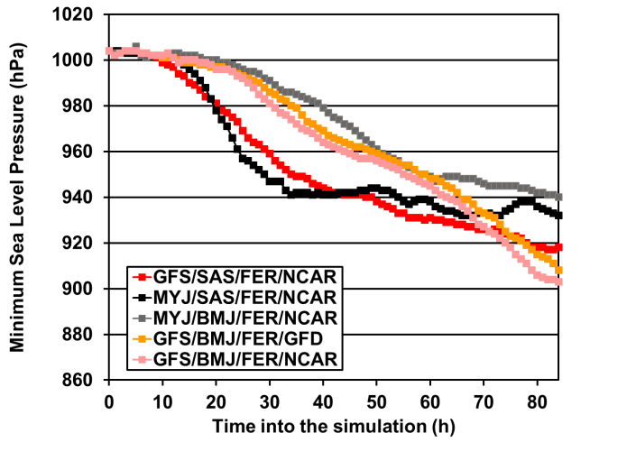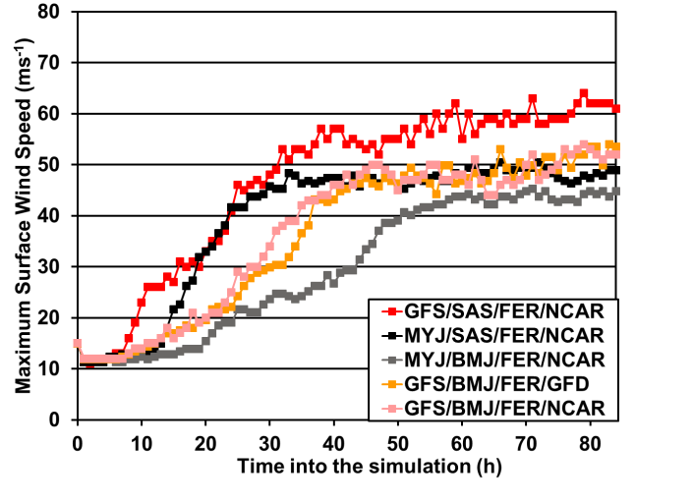
(a) (b)
Figure 1: Left panel (a) is the minimum sea level pressure (hPa). The right (b) is the maximum surface wind speed (ms⁻¹). The red lines are Experiment 1 (GFS/SAS/FER/NCAR), the black lines are Experiment 2 (MYJ/SAS/FER/NCAR), the gray lines are Experiment 3 (MYJ/BMJ/FER/NCAR), the orange lines are Experiment 4 GFS/BMJ/FER/GFD and the pink lines are Experiment 5 (GFS/BMJ/FER/NCAR).

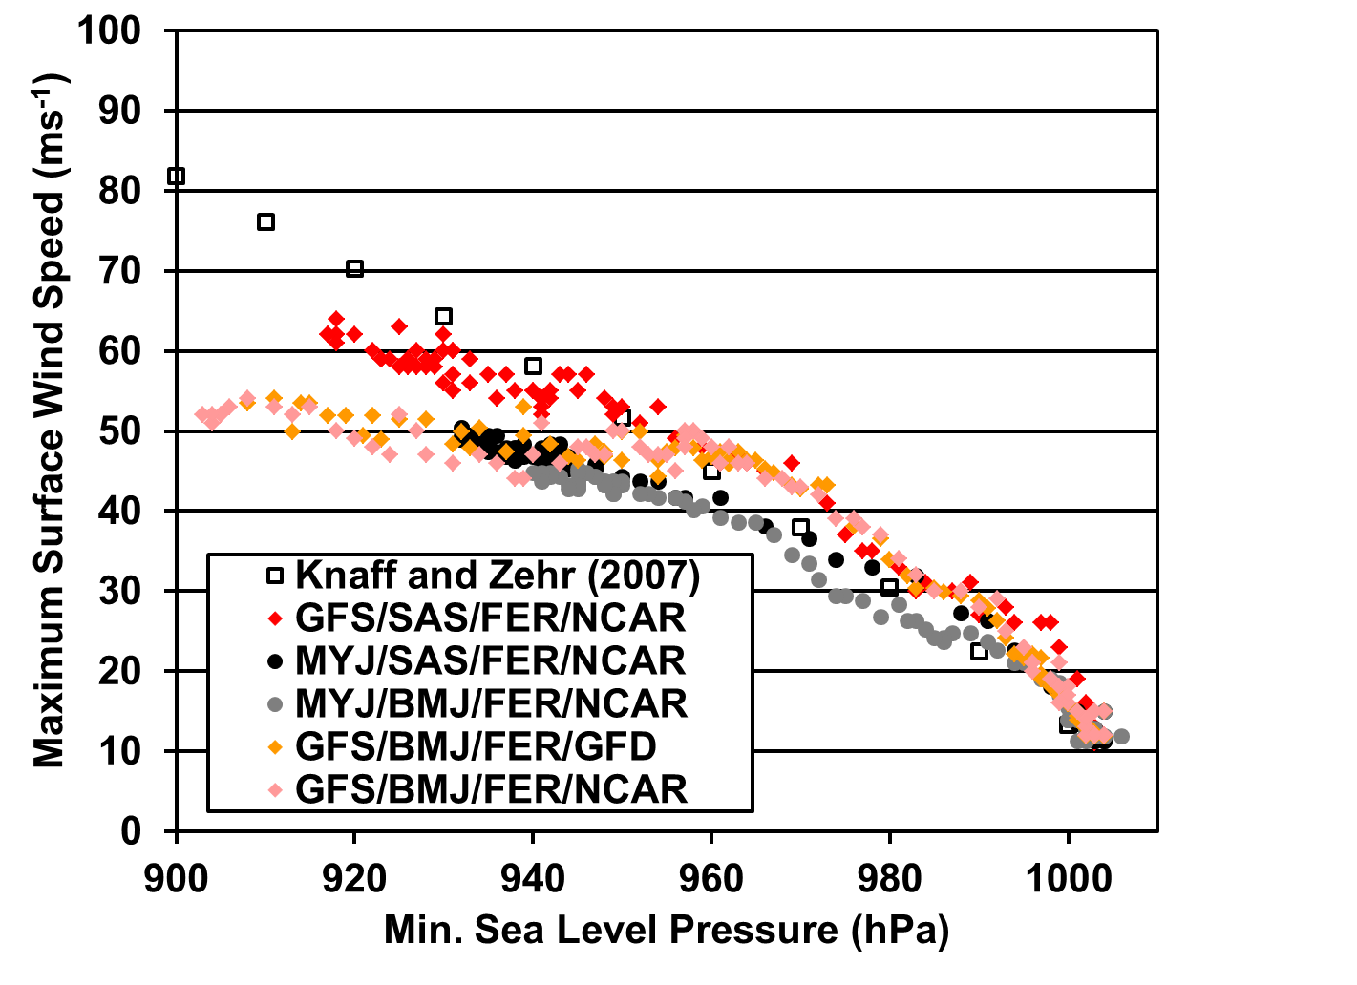
Figure 2: Minimum sea level pressure (hPha) versus maximum surface wind speed (ms⁻¹). The red filled diamonds are Experiment 1 (GFS/SAS/FER/NCAR), the black filled circles are Experiment 2 (MYJ/SAS/FER/NCAR), the gray filled circles are Experiment 3 (MYJ/BMJ/FER/NCAR), the orange filled diamonds are Experiment 4 (GFS/BMJ/FER/GFD), the pink filled diamonds are Experiment 5 (GFS/BMJ/FER/NCAR) and the open squares are from Knaff and Zehr (2007). The open red triangles (Experiment 1, GFS/SAS/FER/NCAR) and the open black circles (Experiment 2, MYJ/SAS/FER/NCAR) are the minimum sea level pressure (hPha) versus the surface maximum azimuthally averaged tangential wind speed.

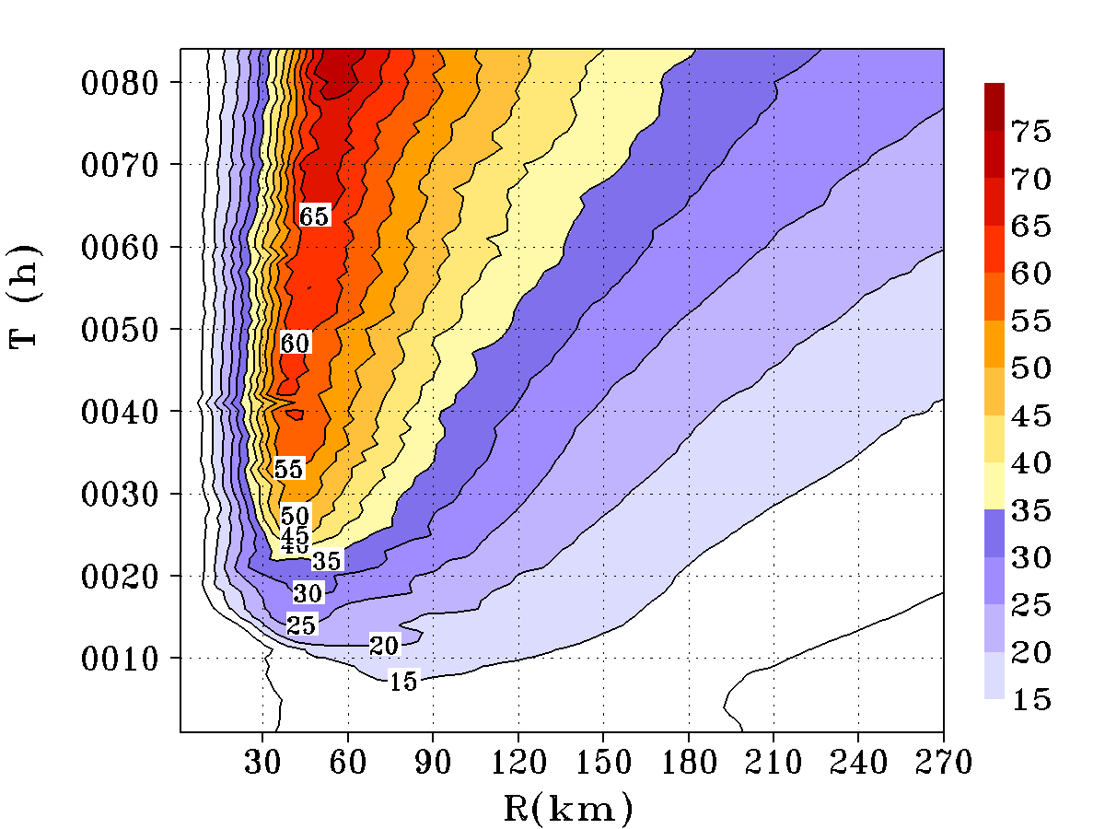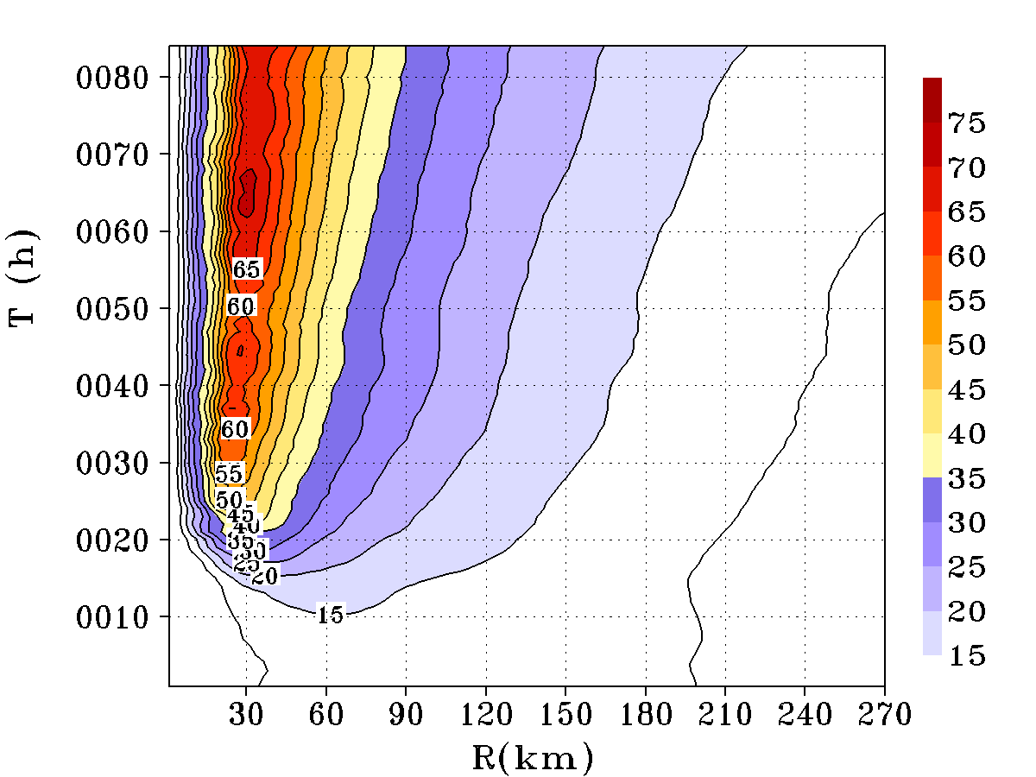
(a)
(b)
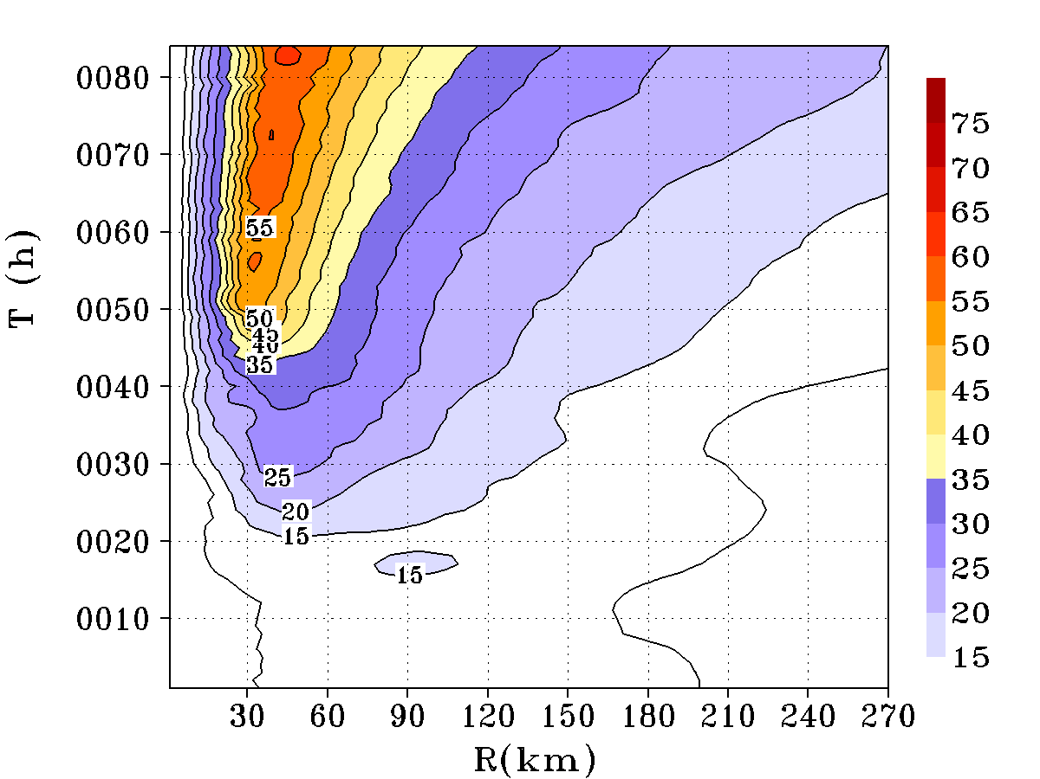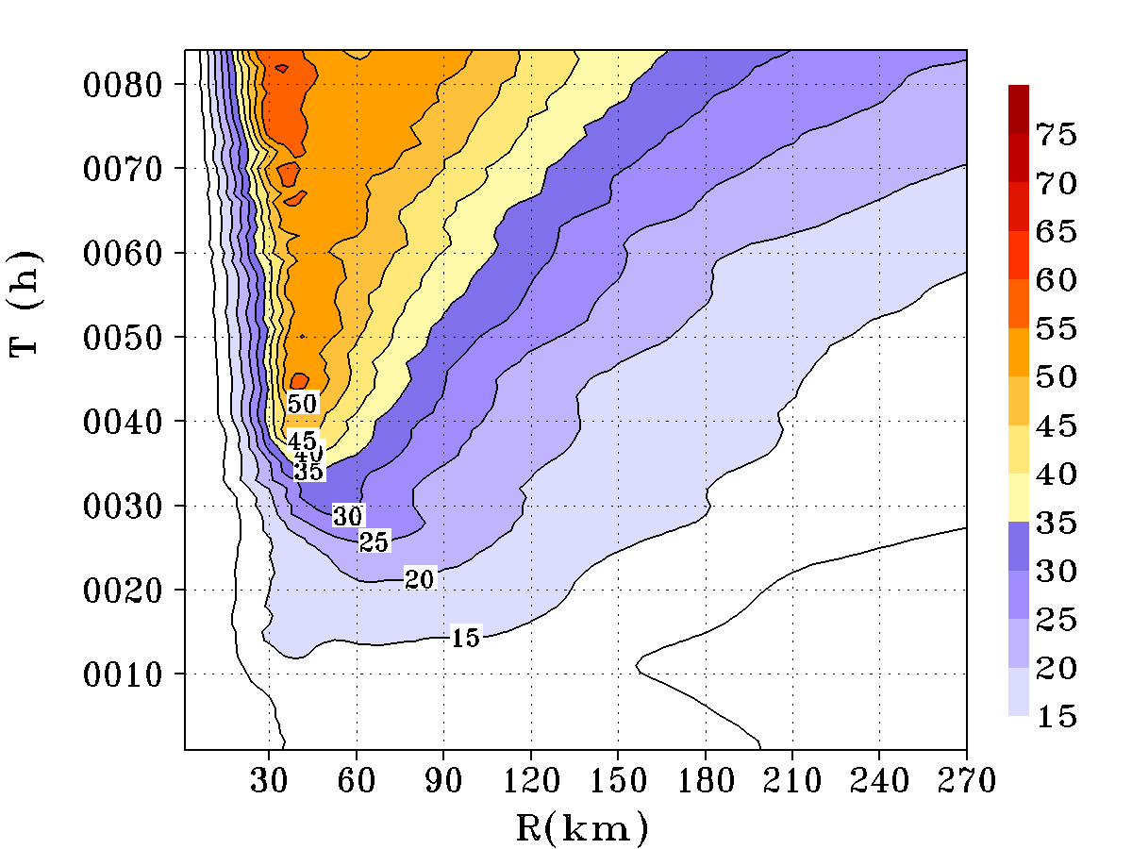
(c)
(d)
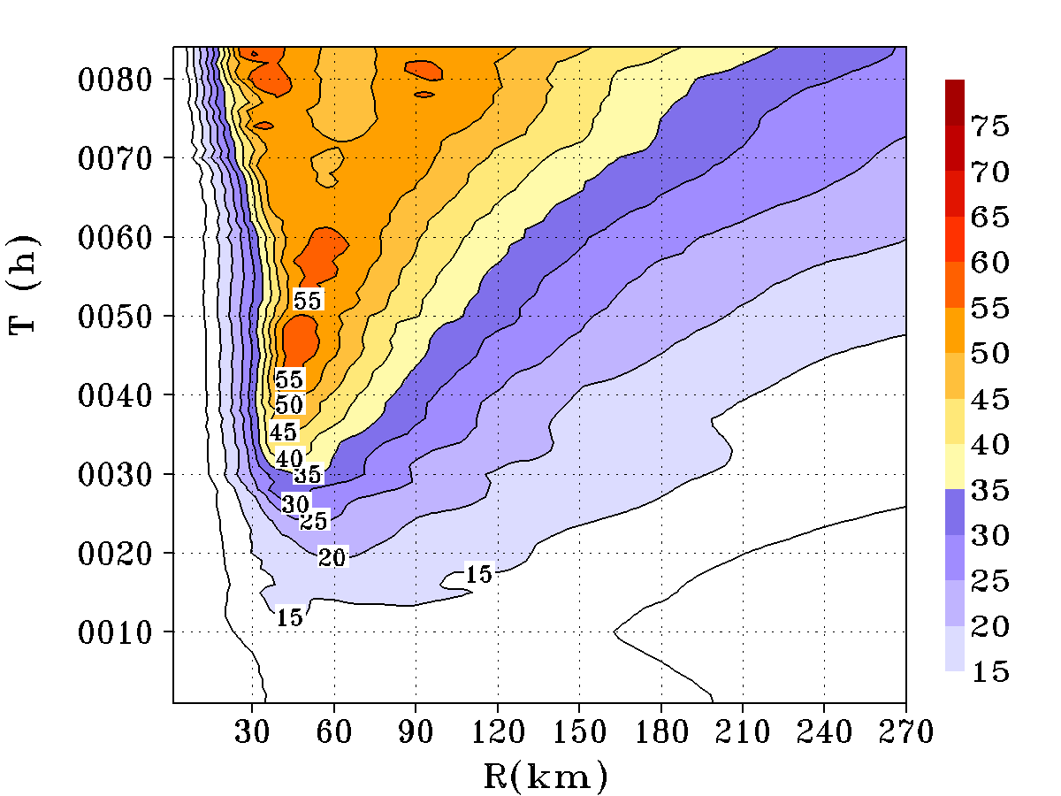
(e)
Figure 3: Hovmöller diagrams of the azimuthally-averaged tangential wind speed (ms⁻¹) for Experiment 1 (GFS/SAS/FER/NCAR) (a), Experiment 2 (MYJ/SAS/FER/NCAR) (b), Experiment 3 (MYJ/BMJ/FER/NCAR) (c), Experiment 4 (GFS/BMJ/FER/GFD) (d) and Experiment 5 (GFS/BMJ/FER/NCAR) (e) at 1 km above the surface. The shaded and contour intervals are 5 ms⁻¹.

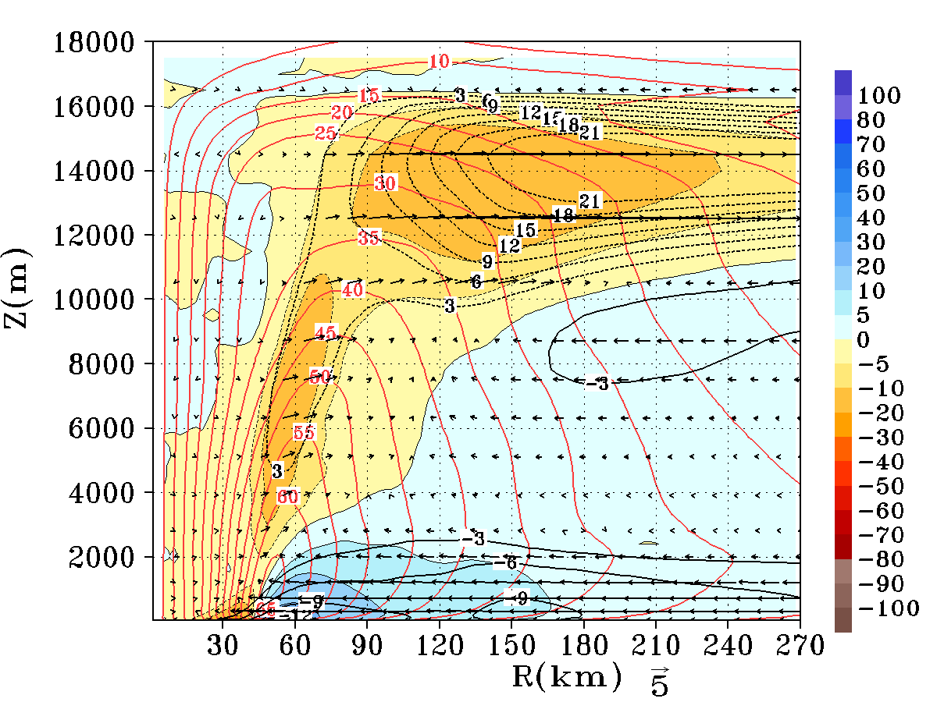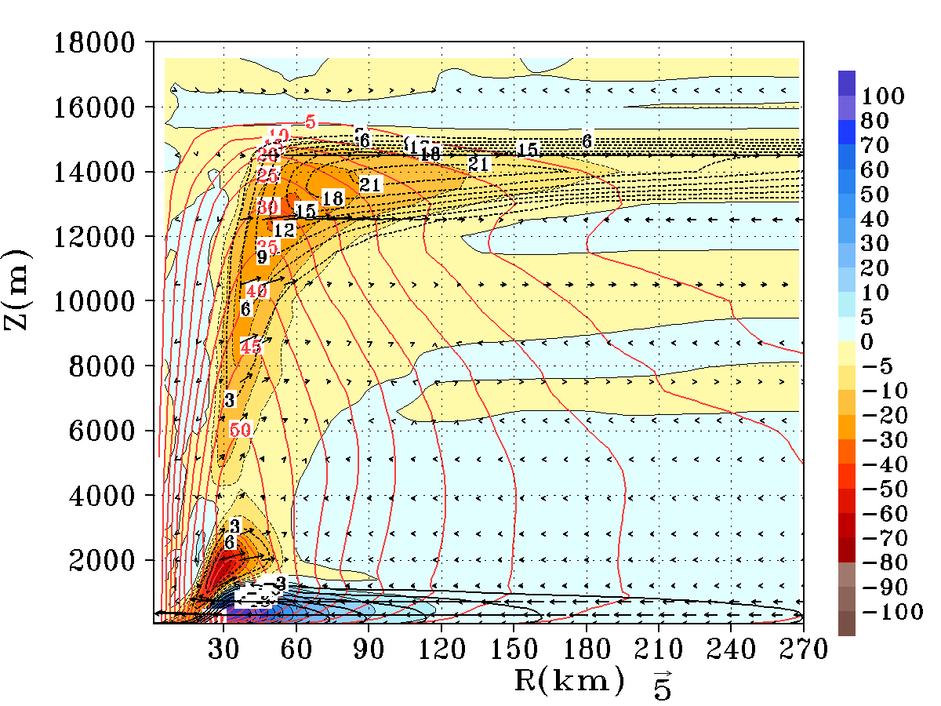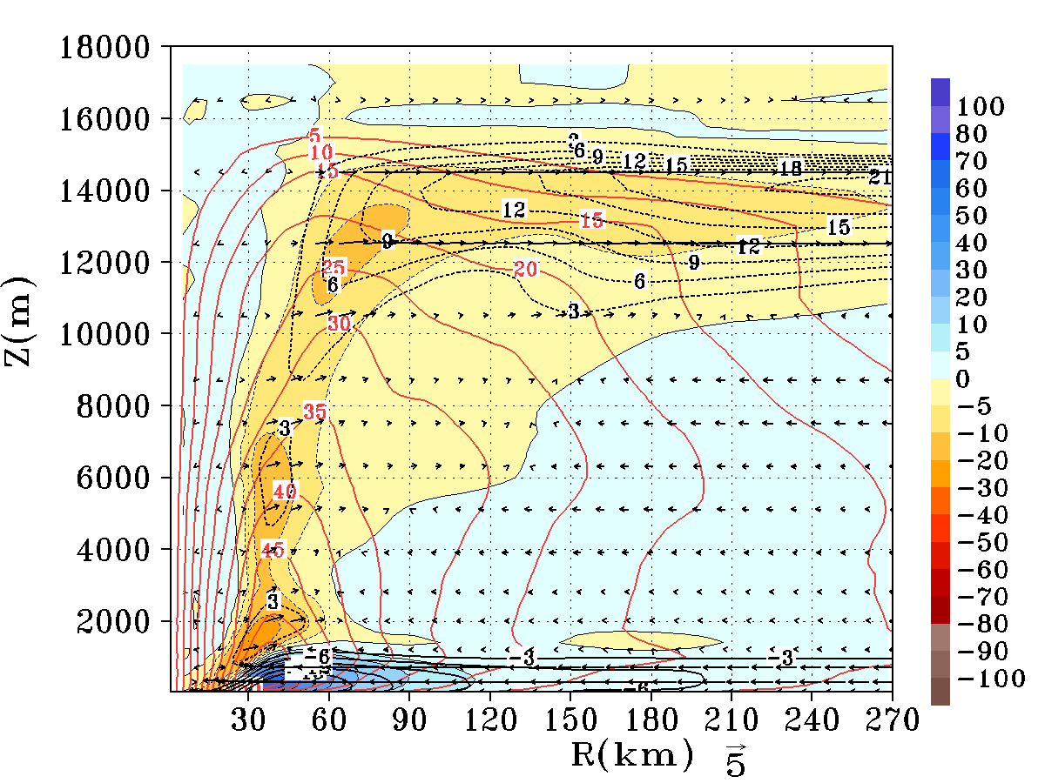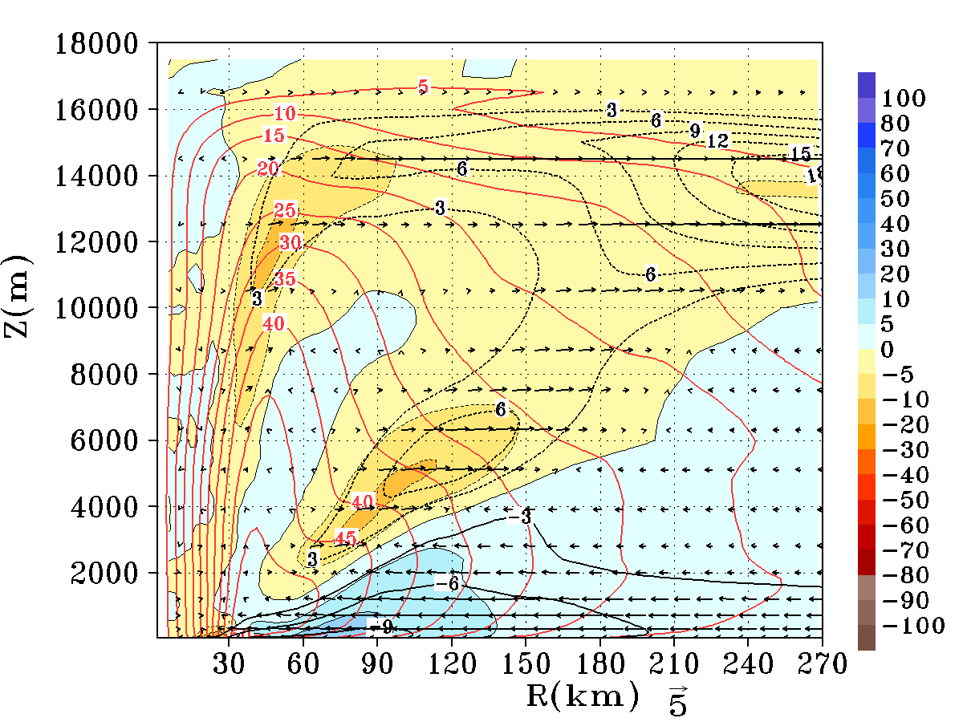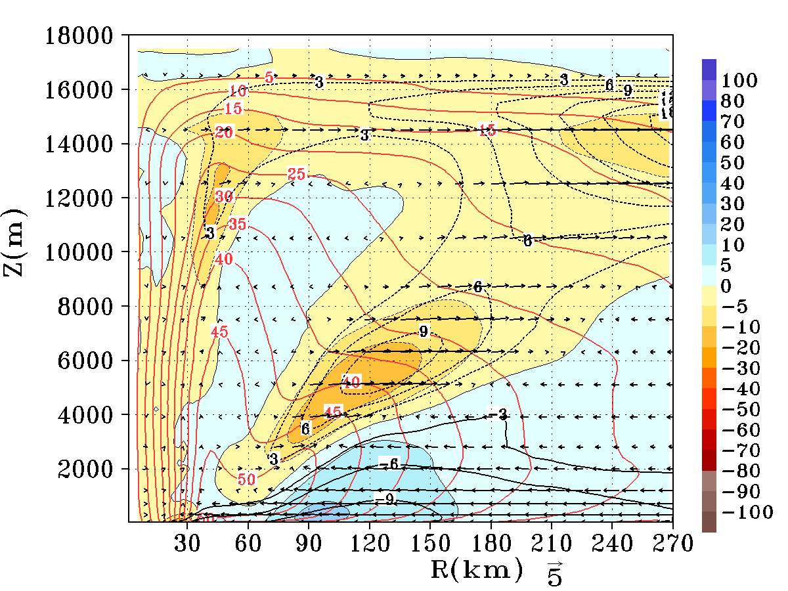
(a)
(b)
(c)
(d)
(e)
Figure 4: Azimuthally and 60-72 h averaged radius-height cross sections of the tangential wind contours (in red color) superposed on top of the secondary circulation vectors, radial wind speed (black contours, ms⁻¹), and the net tangential forcing (frictional effect included) in units of ms⁻¹ h⁻¹ (color shaded) related to the primary circulation term in equation 2 for Experiment 1 (GFS/SAS/FER/NCAR) (a), Experiment 2 (MYJ/SAS/FER/NCAR) (b), Experiment 3 (MYJ/BMJ/FER/NCAR) (c), Experiment 4 (GFS/BMJ/FER/GFD) (d), and Experiment 5 (GFS/BMJ/FER/NCAR) (e). The positive contribution towards the spin-up process is indicated by the blue end of the spectrum.
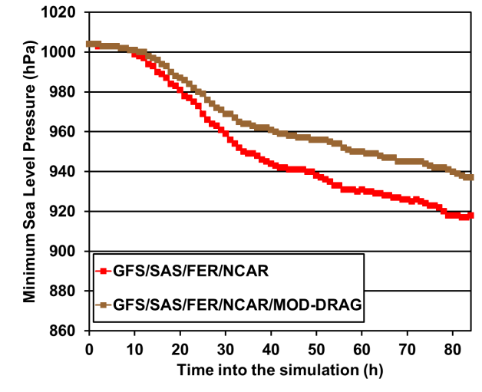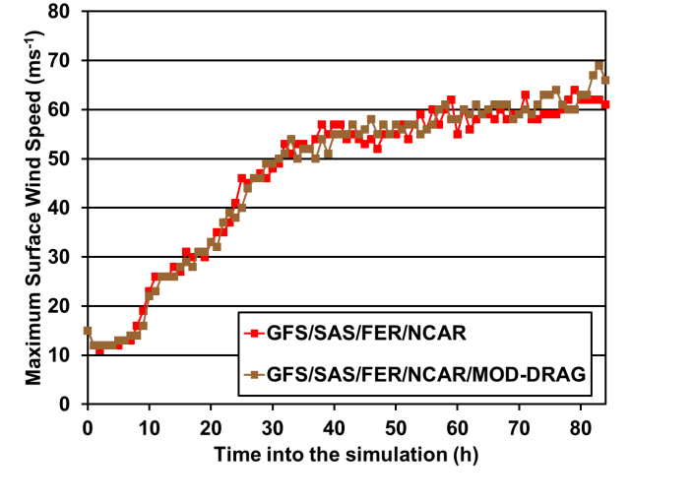
- (b)
Figure 5: Left panel (a) is the minimum sea level pressure (hPa). The right (b) is the maximum surface wind speed (ms⁻¹). The red lines are Experiment 1 (GFS/SAS/FER/NCAR) and the brown lines are Experiment 6 (GFS/SAS/FER/NCAR/MOD-DRAG).

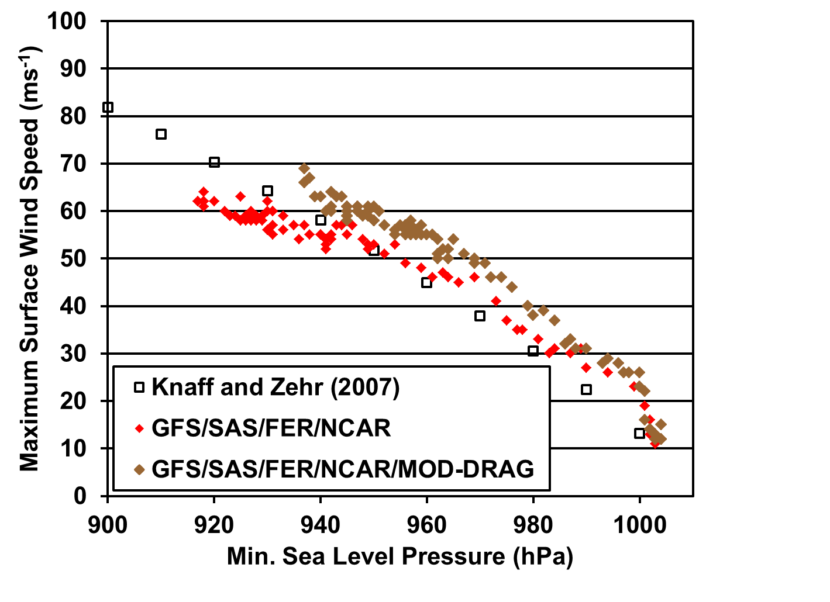
Figure 6: Minimum sea level pressure versus maximum surface wind speed. The red filled diamonds are Experiment 1 (GFS/SAS/FER/NCAR), the brown filled diamonds are Experiment 6 (GFS/SAS/FER/NCAR/MOD-DRAG), and the open squares are from Knaff and Zehr (2007).

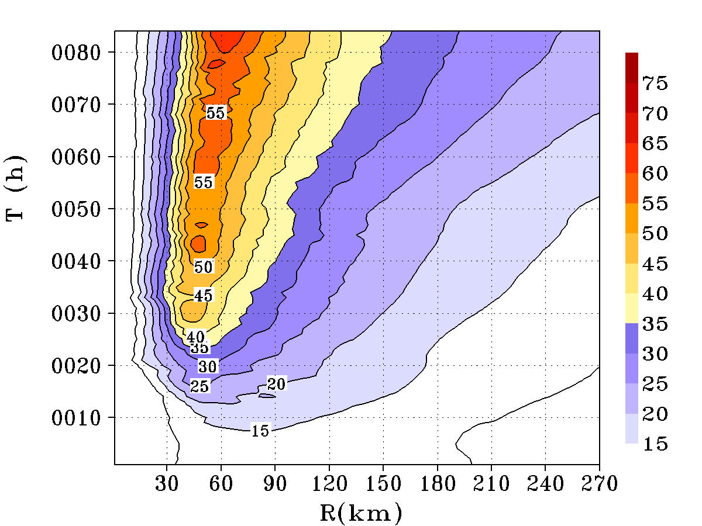
Figure 7: Hovmöller diagrams of the azimuthally-averaged tangential wind speed at 1 km above the surface for Experiment 6 (GFS/SAS/FER/NCAR/MOD-DRAG). The shaded and contour intervals are 5 ms⁻¹.

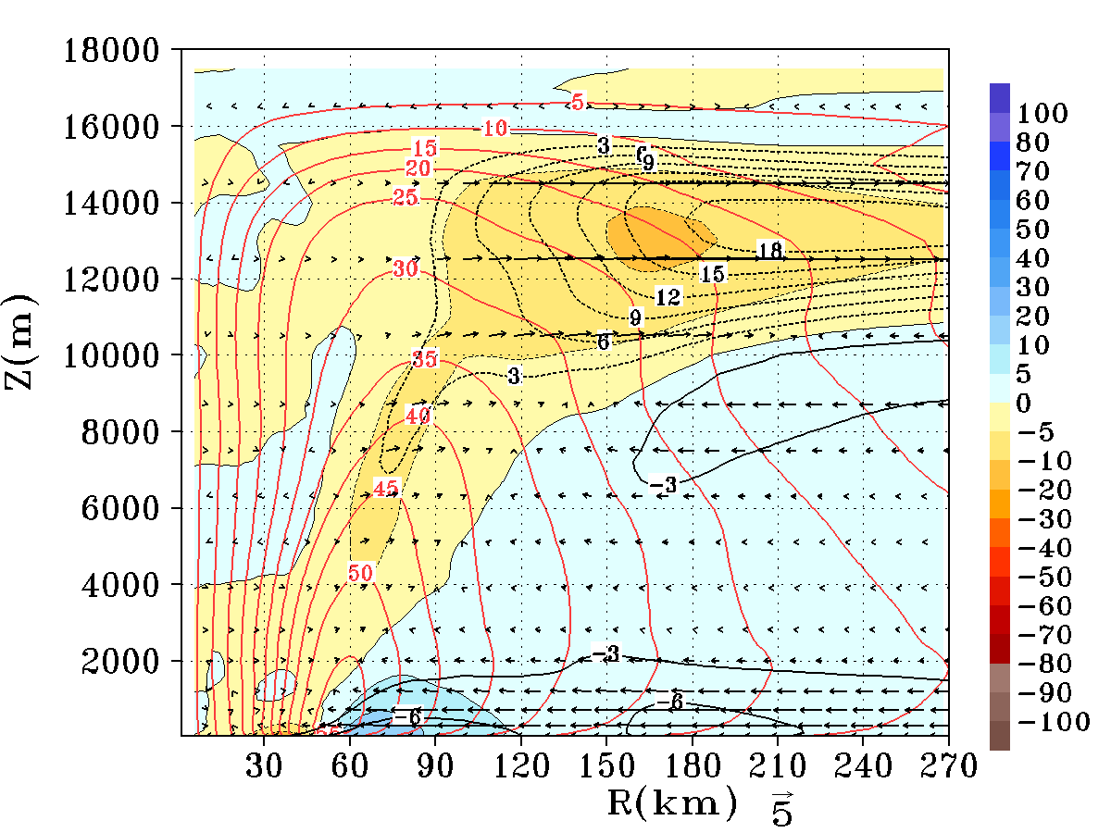
Figure 8: Azimuthally and 60-72 h averaged radius-height cross section of the tangential wind contours (in red color) superposed on top of the vectors of the secondary circulation, radial wind speed (black contours, ms⁻¹), and the net tangential forcing (frictional effect included) in units of ms⁻¹ h⁻¹ (color shaded) related to the primary circulation term in equation 2 for Experiment 6 (GFS/SAS/FER/NCAR/MOD-DRAG). The positive contribution towards the spin-up process is indicated by the blue end of the spectrum.

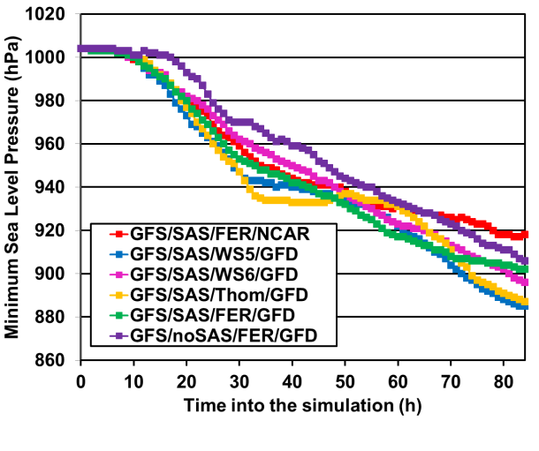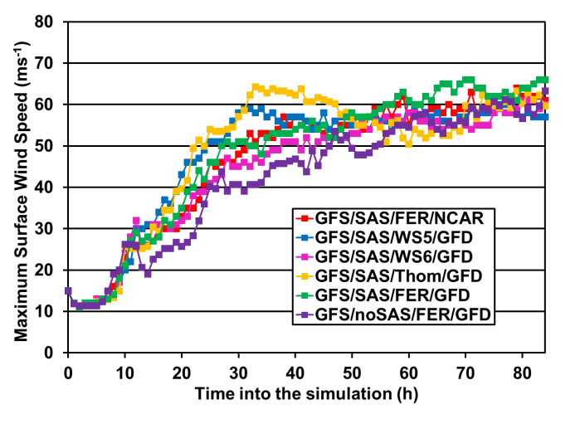
- (b)
Figure 9: Left panel (a) is the PMIN (hPa). The right (b) is the VMAX (ms⁻¹). The red lines are Experiment 1 (GFS/SAS/FER/NCAR), the blue lines are Experiment 7 (GFS/SAS/WS5/GFD), the magenta lines are Experiment 8 (GFS/SAS/WS6/GFD), the dark-yellow lines are for Experiment 9 (GFS/SAS/Thom/GFD), the green lines are for Experiment 10 (GFS/SAS/FER/GFD) and the purple lines are for Experiment 11 (GFS/noSAS/FER/GFD).
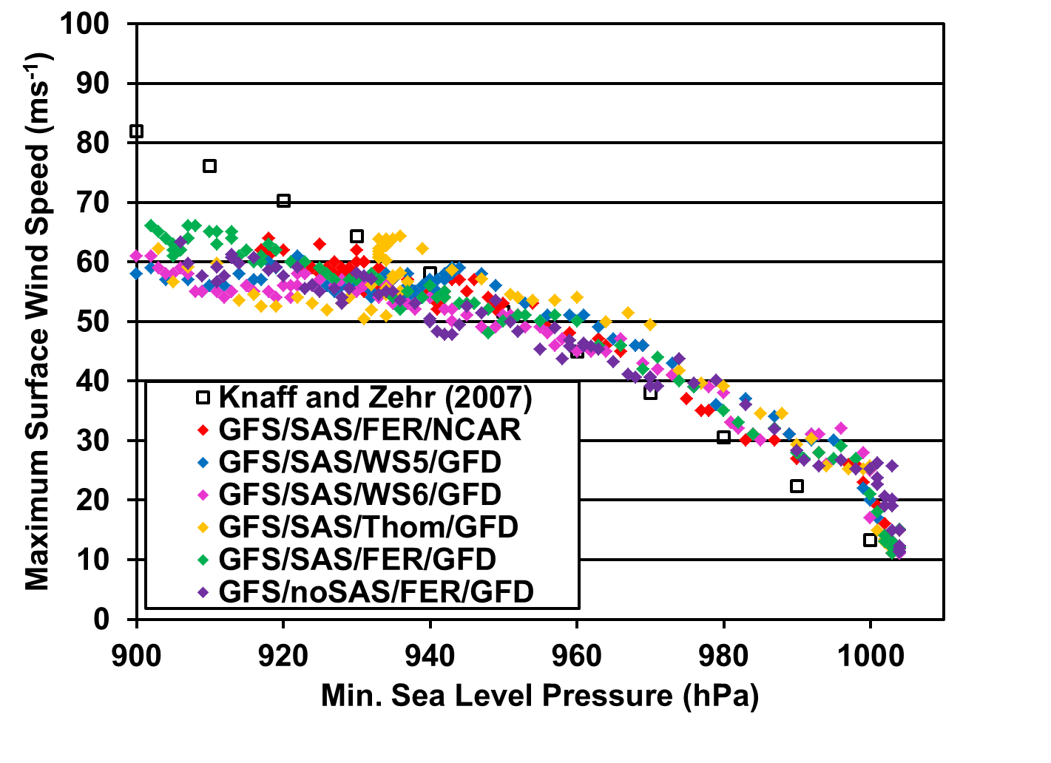
Figure 10: Minimum sea level pressure versus maximum surface wind speed. The red filled diamonds are Experiment 1 (GFS/SAS/FER/NCAR), the blue filled diamonds are Experiment 7 (GFS/SAS/WS5/GFD), the magenta filled diamonds are Experiment 8 (GFS/SAS/WS6/GFD), the dark-yellow filled diamonds are for Experiment 9 (GFS/SAS/Thom/GFD), the green filled diamonds are for Experiment 10 (GFS/SAS/FER/GFD), the purple filled diamonds are for Experiment 11 (GFS/noSAS/FER/GFD), and the open squares are from Knaff and Zehr (2007).
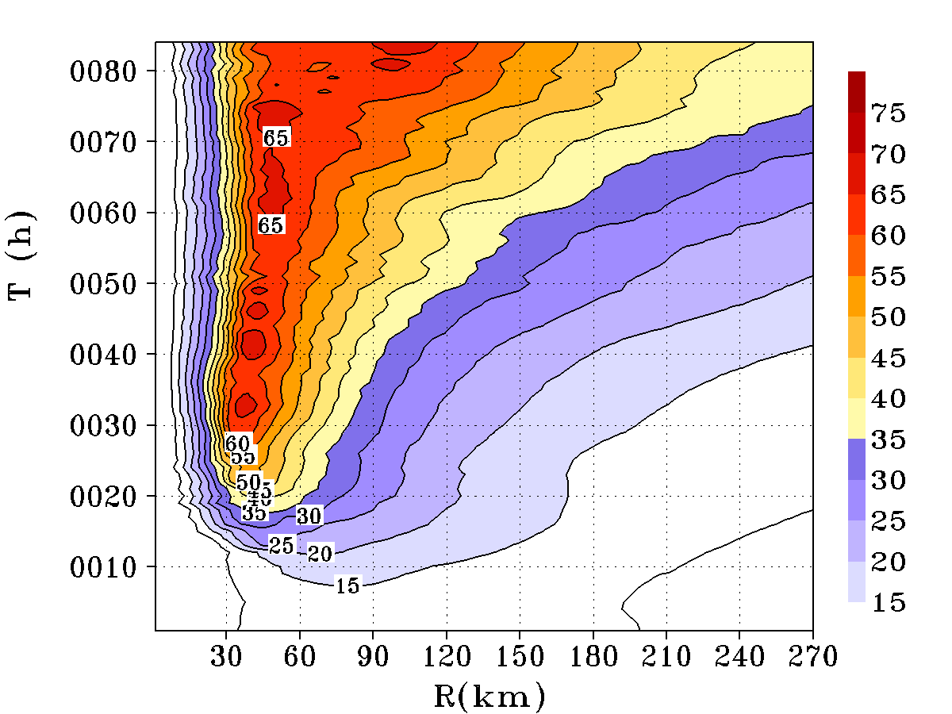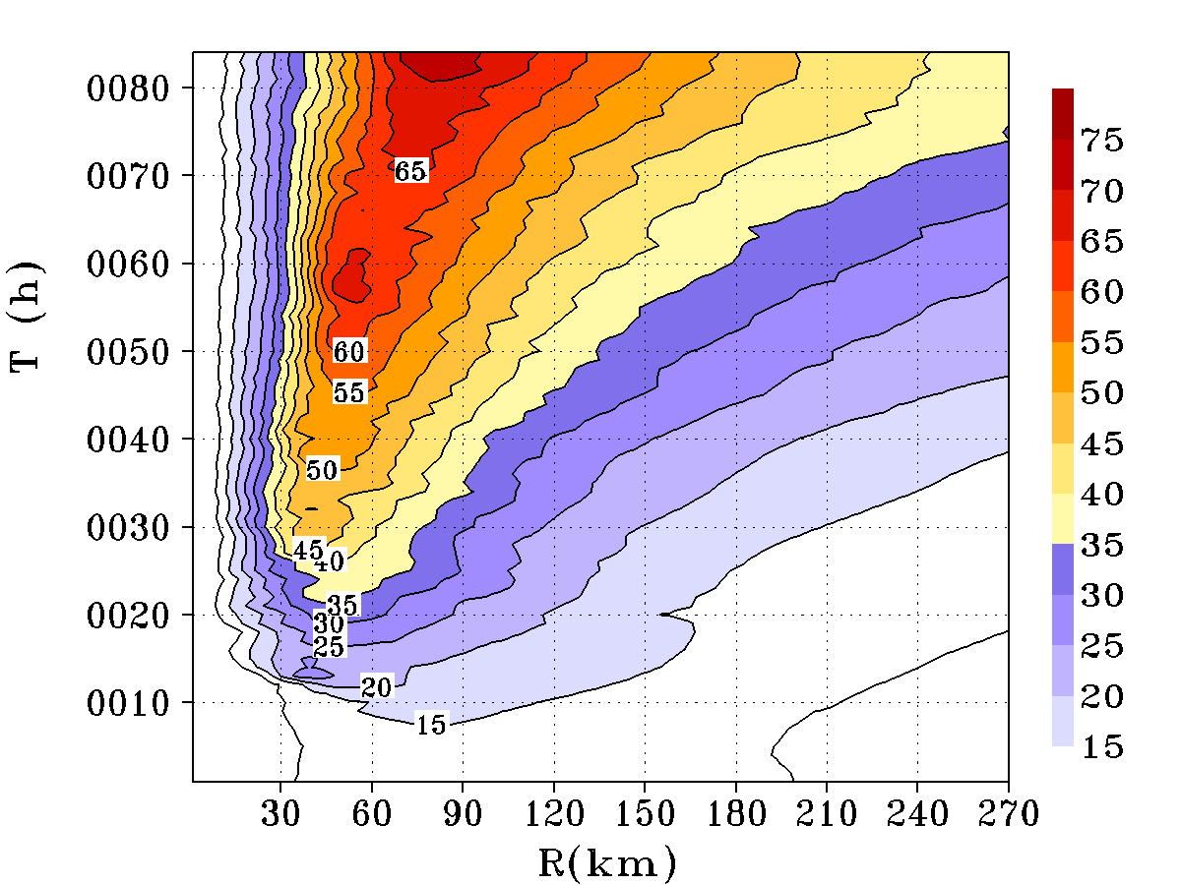
(a)
(b)
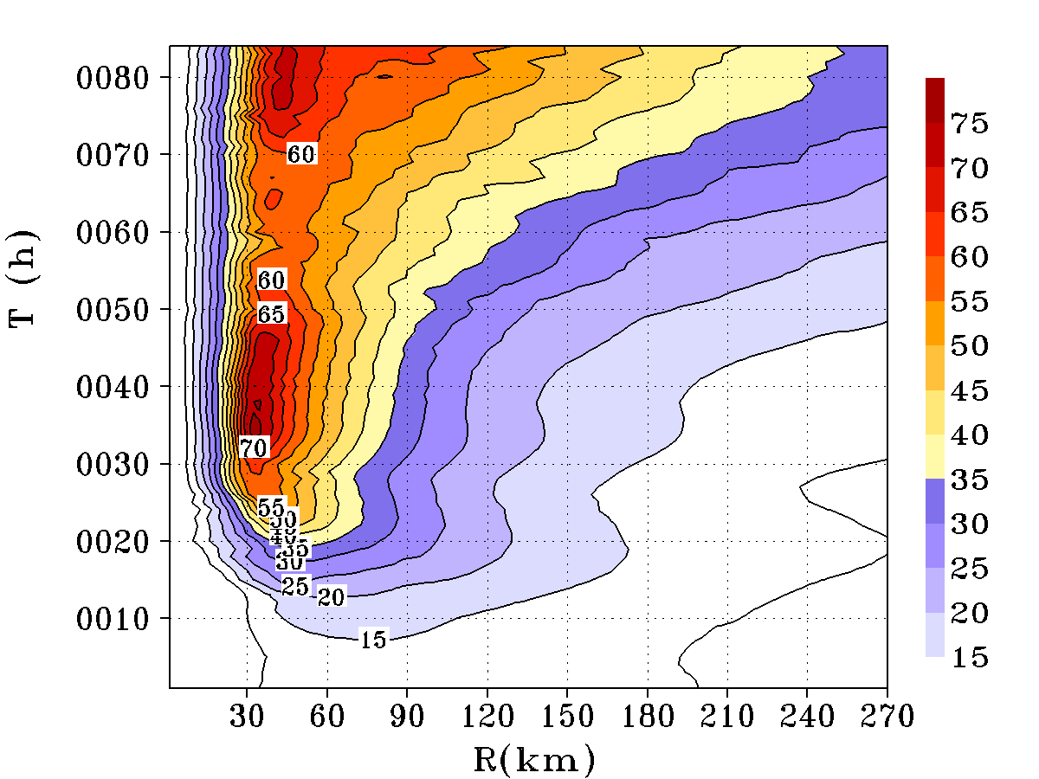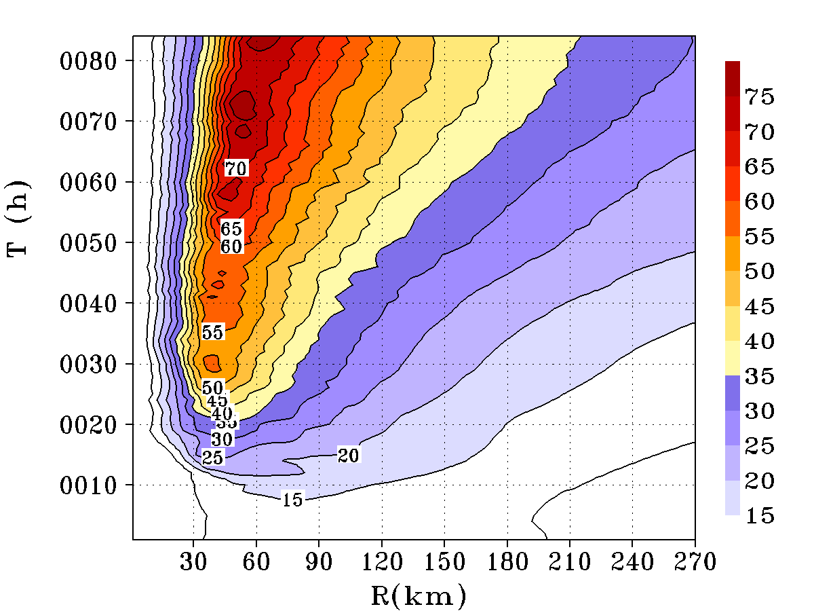
(c)
(d)

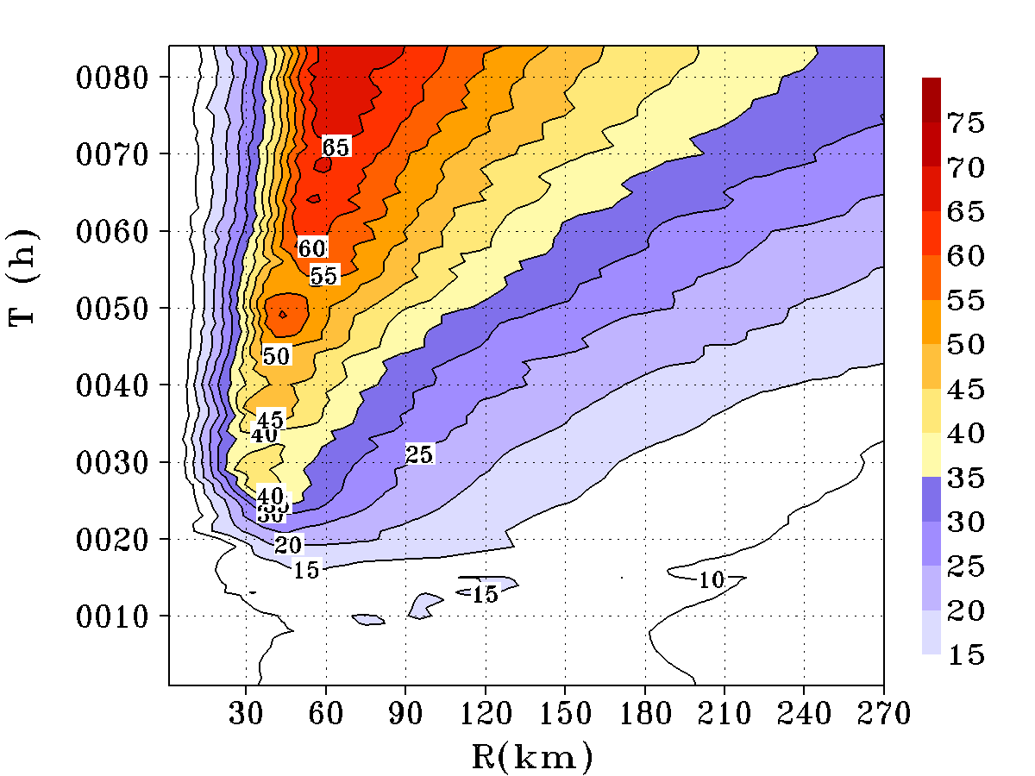
(e)
Figure 11: Hovmöller diagrams of the azimuthally-averaged tangential wind speed at 1 km above the surface for Experiment 7 (GFS/SAS/WS5/GFD) (a), Experiment 8 (GFS/SAS/WS6/GFD) (b), Experiment 9 (GFS/SAS/Thom/GFD) (c), Experiment 10 (GFS/SAS/FER/GFD) (d), and Experiment 11 (GFS/noSAS/FER/GFD) (e). The shaded and contour intervals are 5 ms⁻¹.
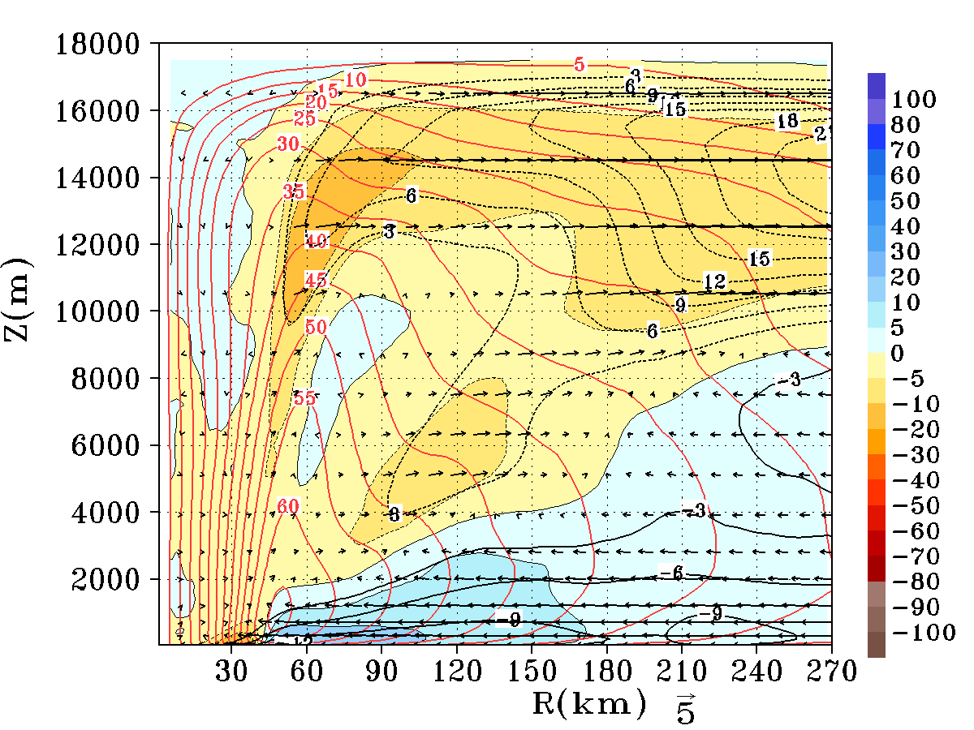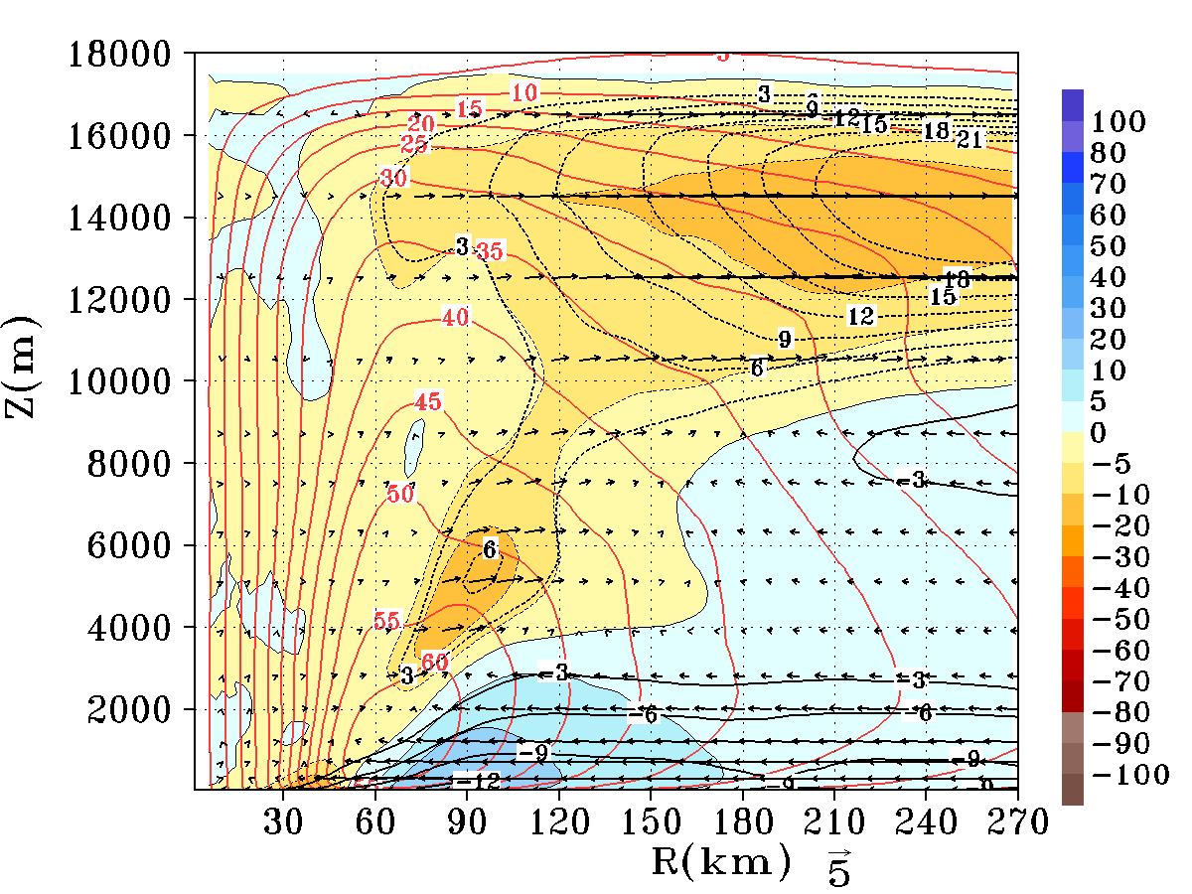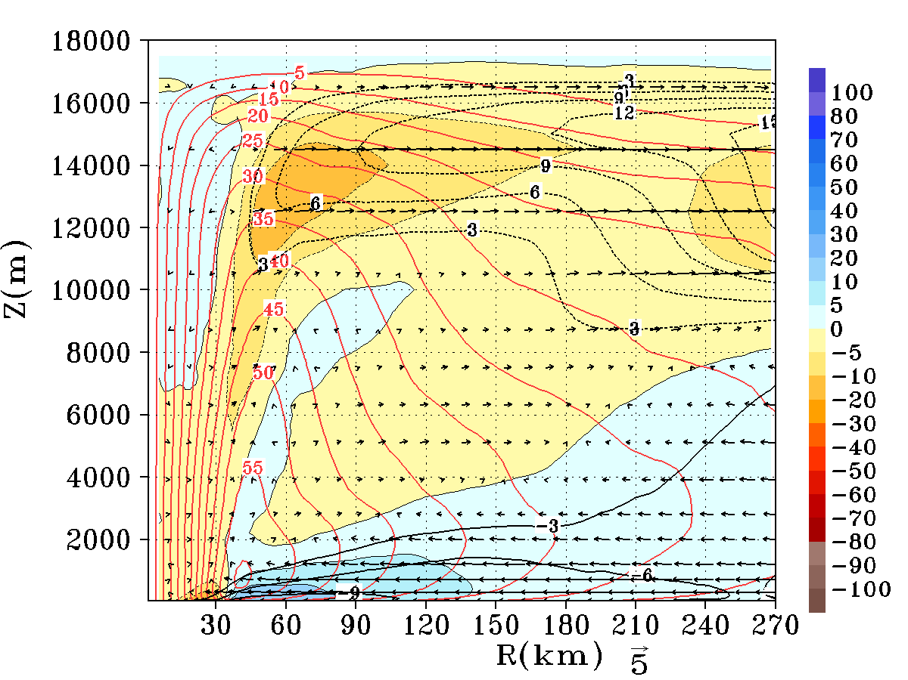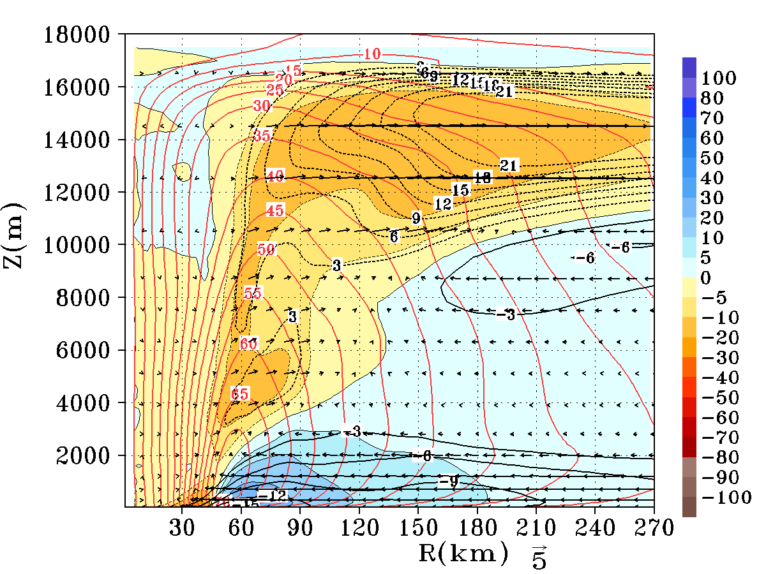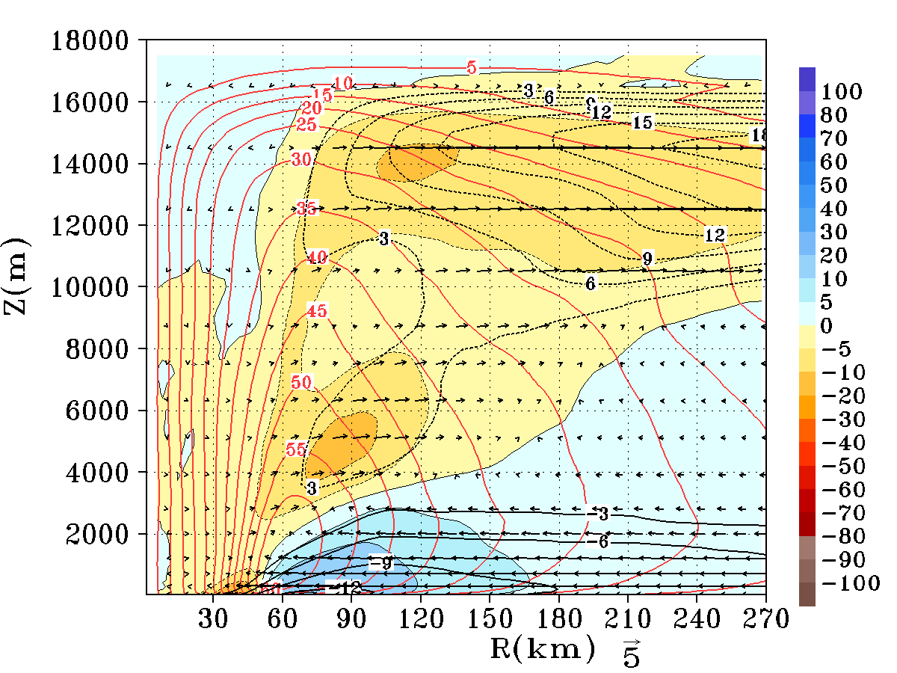
(a)
(b)
(c)
(d)
(e)
Figure 12: Azimuthally and 60-72 h averaged radius-height cross sections of the tangential wind contours (in red color) superposed on top of the vectors of the secondary circulation, radial wind speed (black contours, ms⁻¹), and the net tangential forcing (frictional effect included) in units of ms⁻¹ h⁻¹ (color shaded) related to the primary circulation term in equation 2 for Experiment 7 (GFS/SAS/WS5/GFD) (a), Experiment 8 (GFS/SAS/WS6/GFD) (b), Experiment 9 (GFS/SAS/Thom/GFD) (c), Experiment 10 (GFS/SAS/FER/GFD) (d), and Experiment 11 (GFS/noSAS/FER/GFD) (e). The positive contribution towards the spin-up process is indicated by the blue end of the spectrum.
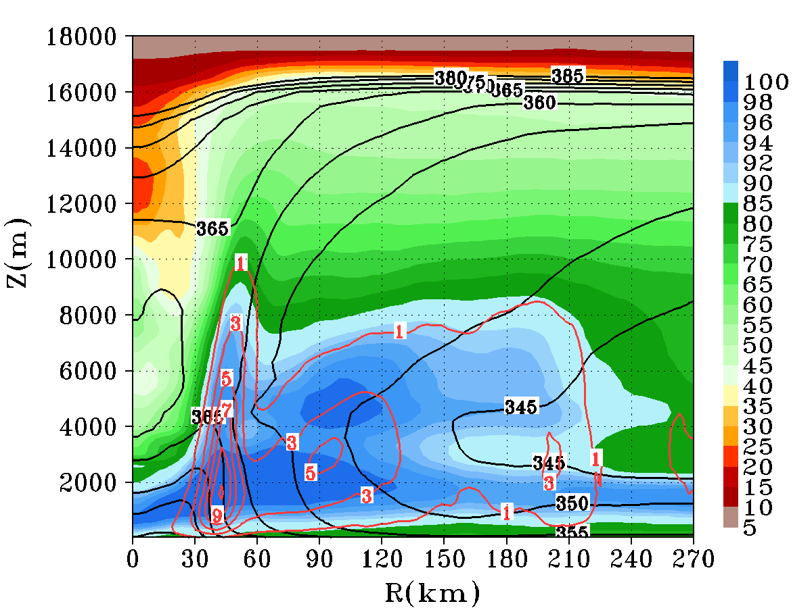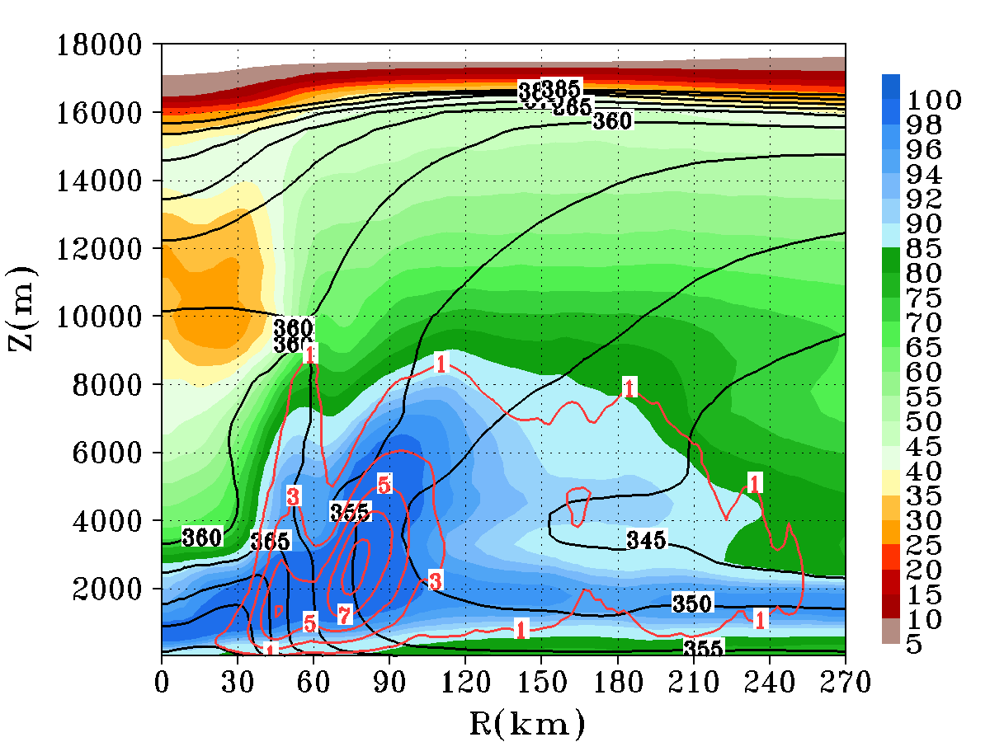
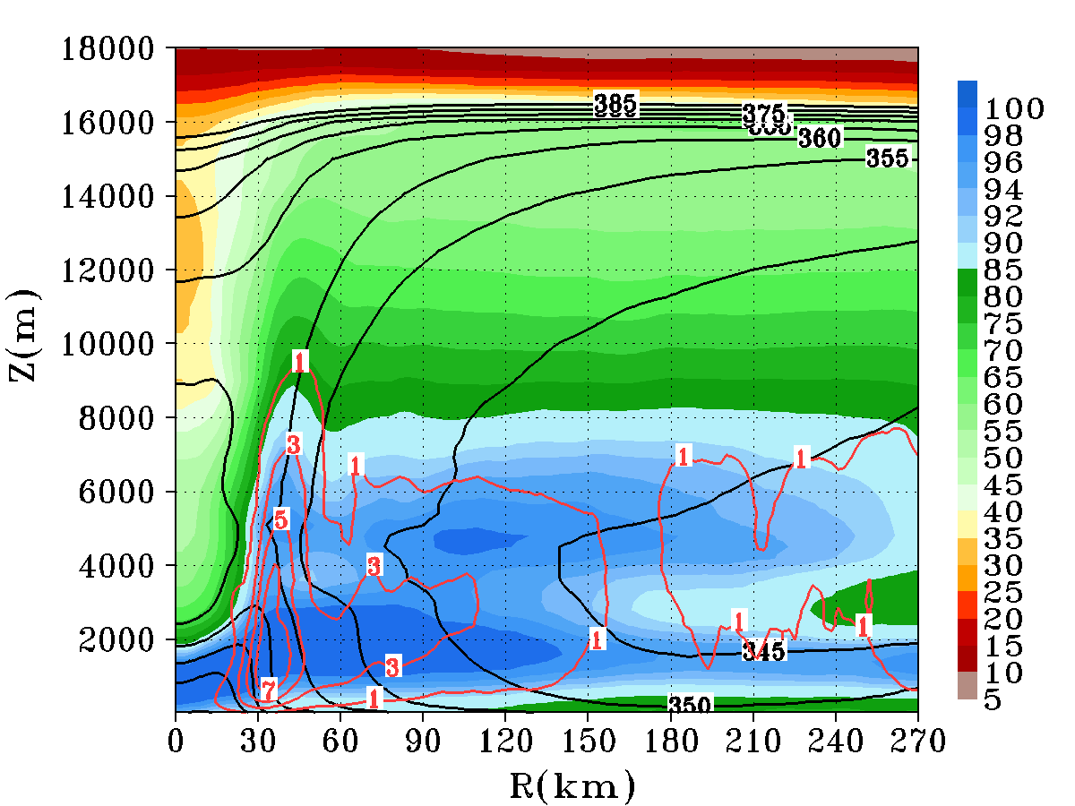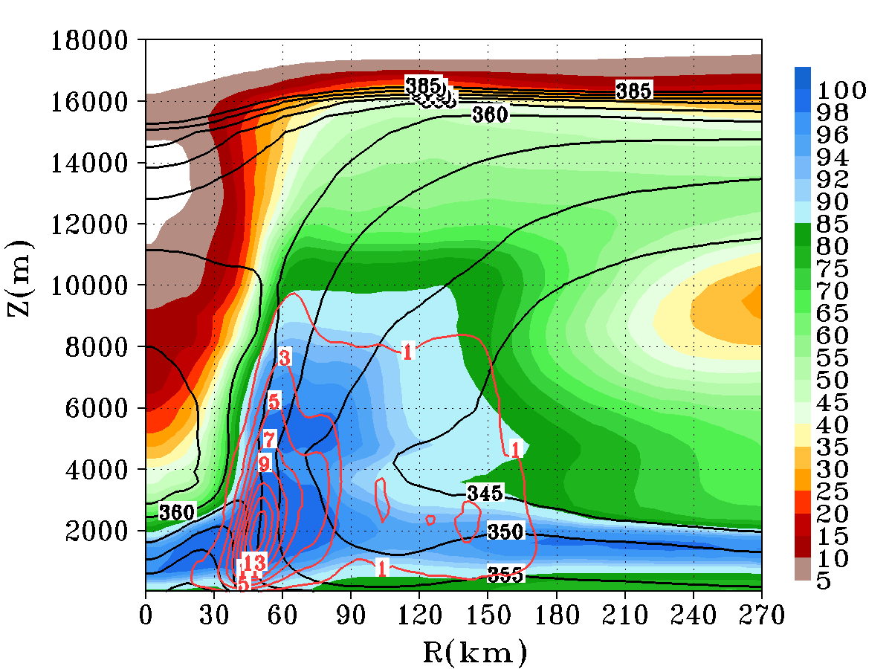
(a)
(b)
(c)
(d)
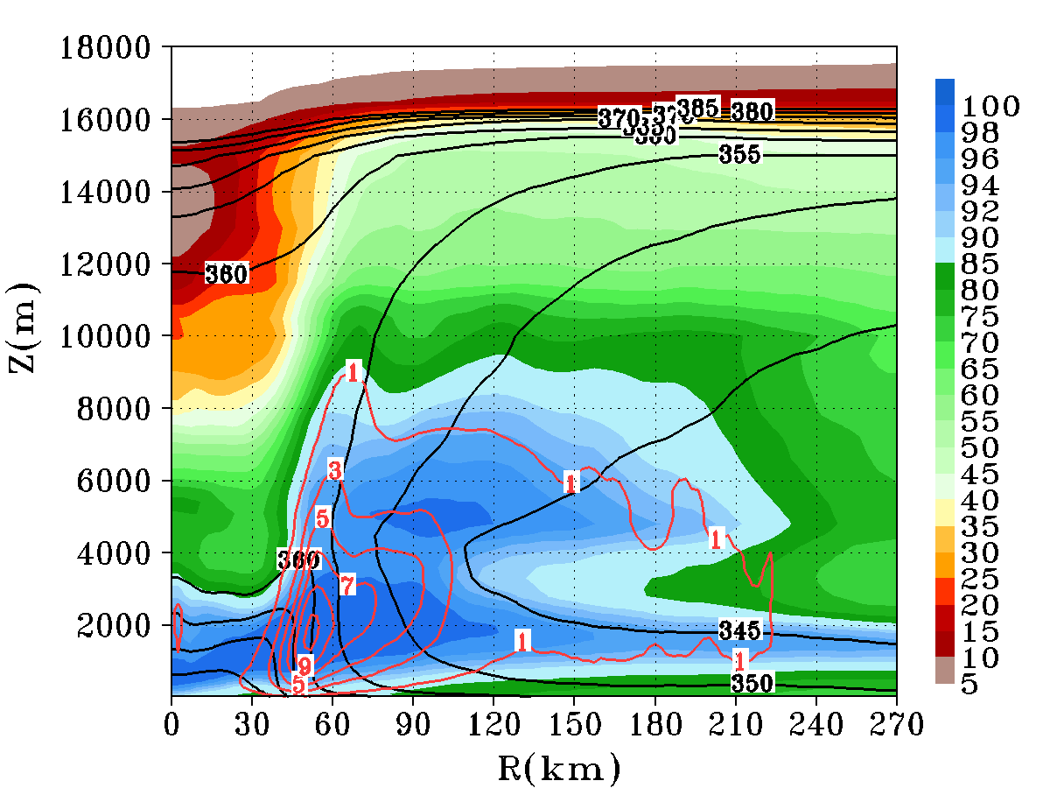
(e)

Figure 13: The azimuthally and 60-72 h averaged radius-height cross section of, relative humidity (shaded colors), (black contours) and moisture fluxes (red contours) for Experiment 7 (GFS/SAS/WS5/GFD) (a), Experiment 8 (GFS/SAS/WS6/GFD) (b), Experiment 9 (GFS/SAS/Thom/GFD) (c), Experiment 10 (GFS/SAS/FER/GFD) (d), and Experiment 11 (GFS/noSAS/FER/GFD) (e).

The HFIP serves as the basis for NOAA and other agencies to coordinate hurricane research needed to significantly improve guidance for hurricane track, intensity, and storm surge forecasts. Details of the plans for the program are available at http://www.hfip.org/.
Strictly speaking, the destructive energy of tropical cyclones is related to storm integrated kinetic energy, which is closely linked to storm structure.
Such undulation is associated with replenishment cycles of the primary eyewall in which the inner-core structure of the simulated vortex undergoes rapid changes due to the development of outer rainbands and their ensuing coalescence into the existing primary eyewall, and/or the formation of a secondary outer eyewall that sequentially undergoes contraction and replaces the primary eyewall.
It is worth mentioning that although the gradient wind balance was used as a guidance to derive the statistical PWR, the actual statistical PWR is not completely constrained by the gradient wind balance due to the statistical regression. Consequently, the statistical PWR may represent some of the overall dynamical relation between the mass and wind field in TC vortices above the BL that is different from the gradient balance approximation. Such dynamical relation may include other information beyond VMAX and PMIN, such as the vortex size and the intensity tendency as a function of environment and geographical location. While it is still unclear what this additional information entails physically and mathematically, to certain degree, the statistical PWR may be regarded as the best fit to the "observed" actual relation between the hurricane mass and wind field. Therefore, it is still useful to use it for model evaluation.

