New Proposal

**RESEARCH PROPOSAL SUBMITTED**

**TO THE**

**NATIONAL OCEANIC & ATMOSPHERIC ADMINISTRATION (NOAA)**

**Joint Hurricane Testbed (JHT) Program**

**TITLE:** Improvement to the Tropical Cyclone Genesis Index (TCGI)

**FUNDING OPPORTUNITY NUMBER**: NOAA-OAR-OWAQ-2015-2004200

**PERFORMANCE PERIOD**: September 1, 2015 – August 31, 2017

**AMOUNT REQUESTED**:

Year 1: U Miami: $27,251; NOAA/AOML: $23,466; CIRA: $41,434; NRL: $15,000; Total: $107,151

Year 2: U Miami: $19,538; NOAA/AOML: $24,585; CIRA: $42,587; NRL: $23,924; Total: $110,634

**SUBMITTING DATE: December 5, 2014**

Jason P. Dunion, PI John Kaplan, Co-PI

University of Miami/CIMAS NOAA/AOML/HRD

4600 Rickenbacker Causeway 4301 Rickenbacker Causeway

Miami, FL 33149 Miami, FL 33149

Phone: 305-720-3060 Phone: 305-361-4406

Email: jdunion@rsmas.miami.edu [John.Kaplan@noaa.gov](mailto:John.Kaplan@noaa.gov)

Andrea Schumacher, Co-PI Joshua Cossuth, Co-PI

Colorado State University/CIRA Naval Research Laboratory

1375 Campus Delivery 7 Grace Hopper Ave, MS #2

Fort Collins, CO 80523 Monterey, CA 93943

Phone: 979-372-4721 Phone: 831-656-4618

Email: [schumacher@cira.colostate.edu](mailto:schumacher@cira.colostate.edu) E-mail: jhc06@my.fsu.edu

**Cooperative Institute for Marine and Atmospheric Studies**

Rosenstiel School of Marine and Atmospheric Science

University of Miami

4600 Rickenbacker Causeway, Miami, FL 33149



To: National Oceanic & Atmospheric Administration From: Peter Ortner

Line Office: Oceanic and Atmospheric Res. (OAR) University of Miami-RSMAS-CIMAS

Attn: Program Manager: Christopher Landsea 4600 Rickenbacker Causeway

Telephone: 305-229-4446 Miami, FL 33149

E-mail: Chris.Landsea@noaa.gov Telephone Number: (305) 421-4619

[portner@rsmas.miami.edu](mailto:portner@rsmas.miami.edu)

CIMAS Adm. Contact: Isabel Castro [icastro@rsmas.miami.edu](mailto:icastro@rsmas.miami.edu)

The attached proposal is being submitted to you for your consideration by a NOAA Cooperative Institute. Should you recommend funding for this proposal, we request that the funding be linked to our current NOAA cooperative agreement, # NA10OAR4320143. The NOAA contact (described below) for this Cooperative Agreement should be contacted immediately if this proposal is accepted for funding.

Title of Proposal: *Improvement to the Tropical Cyclone Genesis Index (TCGI)*

Principal Investigator(s): Jason P. Dunion

Proposal #:

Period of Performance: 09/01/15 – 08/31/17

Funding (by year, if multi-year): $46,789 (Yr 1: $27,251; Yr 2: $19,538)

Task #: III Theme(s): Tropical Weather NOAA Goal(s): Weather-Ready Nation

DUNS #: 152764007 EIN#: 59-0624458 Congressional District: 18

Sponsored Programs Office Contact Person: Bonnie Townsend NOAA Administrative Contact: Shannon Louie

Tel. #: (305) 421-4084 Tel #: 301-734-1091

Fax #: (305) 421-4876 Fax #: 301-713-1459

E-mail: [btownsend@rsmas.miami.edu](mailto:btownsend@rsmas.miami.edu) E-mail: [shannon.louie@noaa.gov](mailto:shannon.louie@noaa.gov)

*Please answer all questions*

1. Is there a former DOC employee working for the CI host institution who represented or will represent the host institution before DOC or another Federal agency regarding this proposal? Yes No

2. Does this award include any sub award to a Minority Serving Institution? Yes No

3. Does the proposed award require any non-federal employees or sub awardees to have physical access to Federal premises for more than 180 days or to access a Federal information system ? Yes No

4. Is PROGRAM INCOME anticipated being earned during performance of this project? Yes No

5. Will a VIDEO be created for public viewing be part of this project? Yes No

6. Will DOC/NOAA owned equipment be provided to any investigator for use outside a Federal location for this project? Yes No

7. Are any permits required to conduct this project? Yes No

(If yes, please provide the name of the issuing agency and the permit #.)

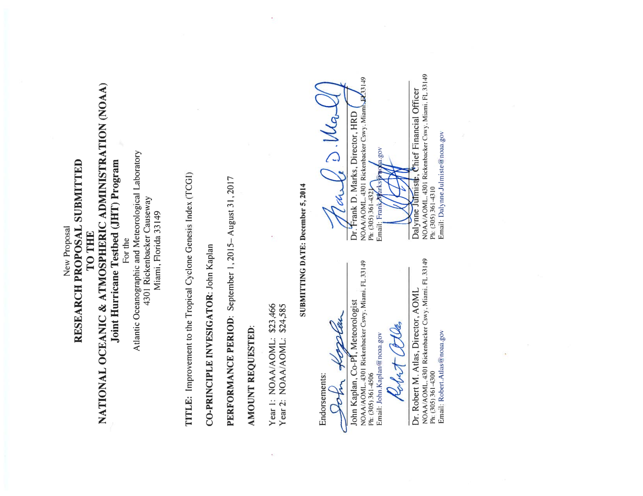

New proposal to

National Oceanic & Atmospheric Administration (NOAA)

Joint Hurricane Testbed (JHT) Program

for

**Improvement to the Tropical Cyclone Genesis Index (TCGI)**

by

Cooperative Institute for Research in the Atmosphere

Colorado State University

1375 Campus Delivery

Fort Collins, CO 80523-1375

**PRINCIPAL INVESTIGATOR:** Andrea Schumacher (CSU/CIRA)

**PERIOD OF ACTIVITY:** September 1, 2015 – August 31, 2017

**AMOUNT REQUESTED:** Year 1: CIRA/CSU $ 39,403

Year 2: CIRA/CSU $ 40,556

CIRA 2-year Total: $ 79,959

**SUBMITTING DATE:** 5 December 2015

**ENDORSEMENTS:**

Andrea Schumacher, PI, Res. Associate

CIRA/Colorado State Univ.

Fort Collins, CO 80523-1375

Telephone: 970-491-8446

Email: [Andrea.Schumacher@colostate.edu](mailto:Andrea.Schumacher@colostate.edu)

Dr. Christian Kummerow Linda Loing, Research Administrator

Director, CIRA Colorado State University

CIRA/Colorado State University Office of Sponsored Programs

Fort Collins, CO 80523-1375 Fort Collins, CO 80523-2002

Telephone: 970-491-8448 Telephone: 970-491-6586

Email: [kummerow@atmos.colostate.edu](mailto:kummerow@atmos.colostate.edu) Email: [Linda.Loing@colostate.edu](mailto:Linda.Loing@colostate.edu)

Co-PI Cossuth’s Title Page here

**Improvement to the Tropical Cyclone Genesis Index (TCGI)**

**Principal Investigator Jason P. Dunion Univ. of Miami/CIMAS**

**Co-Principal Investigator John Kaplan NOAA/AOML/HRD**

**Co-Principal Investigator Andrea Schumacher CSU/CIRA**

**Co-Principal Investigator Joshua Cossuth NRL-Monterey**

**ABSTRACT**

Forecasts for Atlantic tropical cyclone (TC) track have been steadily improving over the past several decades. However, advancements in predicting TC intensity have been much more modest. This relates to our limited understanding of the various synoptic and mesoscale influences that can impact TC intensity, as well as the fact that successful intensity forecasts are highly affected by the accuracy of the associated track forecast. TC genesis represents an intensity forecasting challenge and is perhaps one of the more difficult stages of the tropical cyclone lifecycle to diagnose and predict. The TC Genesis Index (TCGI), a successfully funded JHT project that is currently operating in real-time and is being considered for transition to operations at NOAA/NHC, was designed to help address this forecast challenge. The main goal of this effort was to develop an objective disturbance-centric probabilistic scheme for predicting TC genesis (0-48 hr and 0-120 hr) in the North Atlantic. TCGI is activated when NHC invests are initiated and position/intensity information becomes available on the ATCF f-deck. The TCGI utilizes six predictors that include satellite-derived quantities and parameters derived from the NOAA GFS model, while tropical disturbance tracks are derived from a combination of the NOAA Global Forecast System model and a specially developed BAMG (beta and advection model-genesis) track forecast model that is generated utilizing the operational GFS model forecast fields. Forecast verifications for the 2011-2013 Atlantic hurricane seasons indicate that TCGI had a Brier Skill score (relative to climatology) of 25% for the 0-48 hr forecast and 21% for the 0-120 hr forecast. The 0-48 hr TCGI skill was highly competitive with a homogeneous sample of NHC TWO forecasts for the 3-yr period. This current project proposes several new elements with goals to expand and improve the current TCGI model that include extending the TCGI into the eastern and central North Pacific (EPAC and CPAC) basins, refining (testing) current (new) TCGI predictors, and developing a graphical version of TCGI to compliment the text version that is currently being produced. The updated Atlantic TCGI and new Pacific TCGI will be run in real-time and made available to forecasters for evaluation. This proposed effort is being carried out as part of the University of Miami/CIMAS program (Theme 2: Tropical Weather) and addresses the NOAA long-term goal: “*Weather-Ready Nation*”.

**Improvement to the Tropical Cyclone Genesis Index (TCGI)**

*Principal Investigator: Co-Principal Investigator:*

Jason P. Dunion, University of Miami/CIMAS John Kaplan, NOAA/AOML/HRD

Phone: 305-720-3060 Phone: 305-361-4506

Email: jdunion@rsmas.miami.edu Email: [John.Kaplan@noaa.gov](mailto:John.Kaplan@noaa.gov)

*Co-Principal Investigator: Co-Principal Investigator:*

Andrea Schumacher , CSU/CIRA Joshua Cossuth, NRL-Monterey

Phone: 979-372-4721 Phone: 831-656-4618

Email: [schumacher@cira.colostate.edu](mailto:schumacher@cira.colostate.edu) Email: [jhc06@my.fsu.edu](mailto:jhc06@my.fsu.edu)

**C. Statement of Work**

**1. Project Duration**

This proposal requests two years of funding to expand and improve the Tropical Cyclone Genesis Index (TCGI) that was developed under a previously funded NOAA JHT project.

**2. Project Description**

Tropical cyclone (TC) genesis is an important, yet not well-understood stage of the TC lifecycle. Although much aircraft data has been collected over the years (e.g. by NOAA) that has greatly advanced our understanding of these storms, most of these missions were flown into well-developed systems. Consequently, there is much less known about the processes governing tropical cyclogenesis and the ability of forecast models (e.g. HWRF) to produce the structure and intensity of these incipient systems.  Such a capability is critical, however, given the NOAA National Hurricane Center (NHC), NOAA Central Pacific Hurricane Center (CPHC), and Joint Typhoon Warning Center (JTWC) task of forecasting TC track and intensity throughout their respective basins out to 5 days. This proposed project aims to address two TC genesis-related priority areas of need that were identified by NHC, CPHC, and JTWC: 1) NHC-3/JTWC-8*. Statistically based real-time guidance on guidance to assist in the determination of official track and intensity forecasts. This could include multi-model consensus approaches, provided in probabilistic and other formats*; and 2) NHC-5/JTWC-11. *Techniques or products to support pre-genesis disturbance track, intensity, size, and wind speed probability forecasts*. This proposed effort is being carried out as part of the University of Miami/CIMAS program (Theme 2: Tropical Weather) and addresses the NOAA long-term goal: “*Weather-Ready Nation*”.

The proposal team was previously funded by the NOAA/JHT to develop an objective disturbance-following TC genesis index (TCGI) to provide forecasters with an objective tool for predicting the 0-48 hr and 0-120 hr probability of TC genesis in the North Atlantic basin. Predictors from a variety of sources were tested for incorporation into this new scheme including Dvorak T-number / CI value estimates, environmental and convective parameters currently used in the NESDIS TC Formation Probability (TCFP) product (fixed grid scheme), environmental parameters from the Statistical Hurricane Intensity Prediction Scheme (SHIPS) that are relevant to TC genesis, and total precipitable water (TPW) retrievals from microwave satellites. Six robust TCGI predictors were identified and incorporated into an experimental real-time version of TCGI that was run at Colorado State University/CIRA. Figures 1 and 2 show the performance of TCGI for the 2011-2013 Atlantic hurricane seasons and indicate that TCGI was competitive with NHC’s TWO forecasts, suggesting the utility of this scheme as an objective tool for forecasters. The TCGI code and output was made available to NHC forecasters on 11 September 2013 and NHC forecasters are currently evaluating TCGI for possible transition to operations.

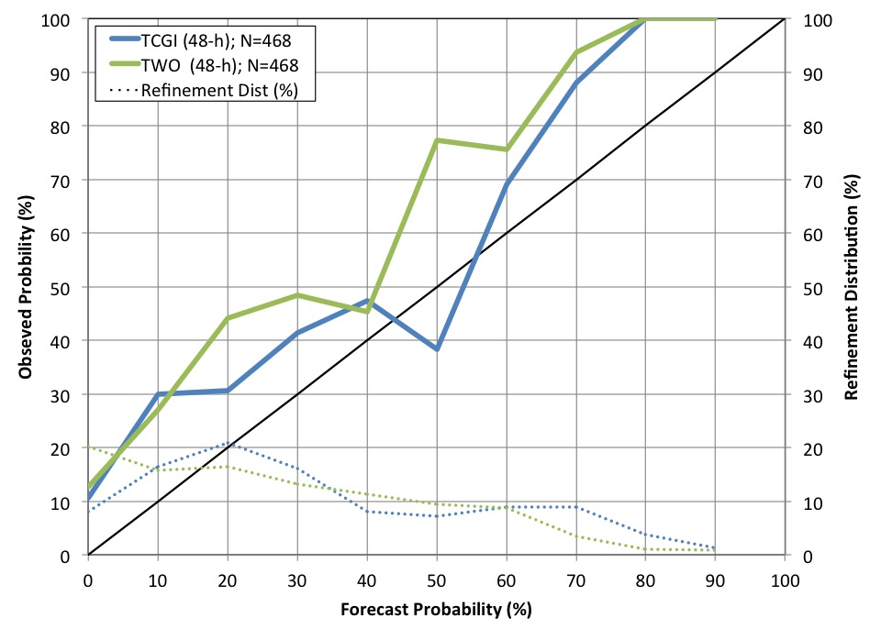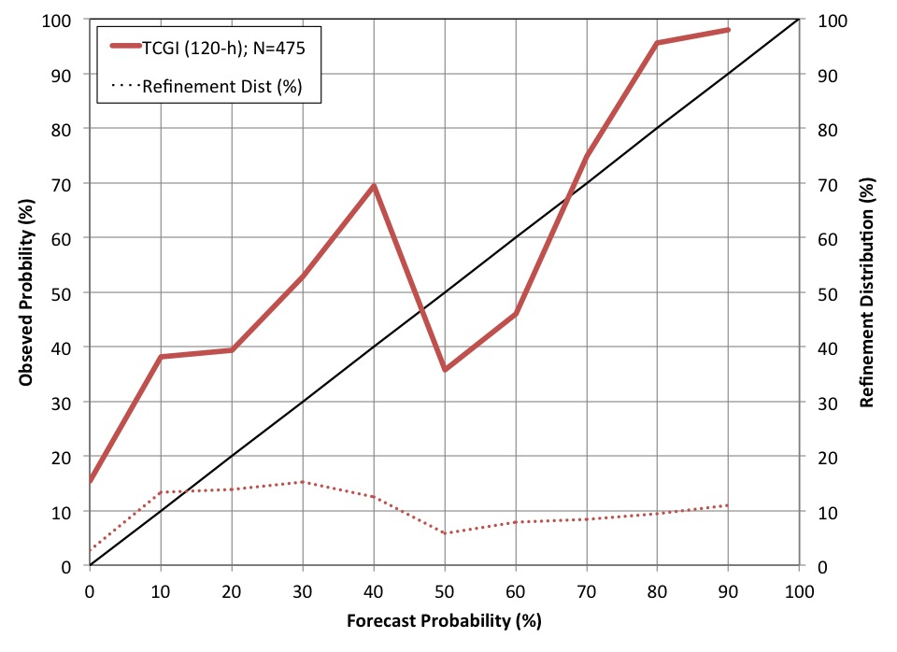

*Fig. 1: Reliability diagrams for TCGI and a homogeneous sample of NHC TWO Atlantic probabilistic TC genesis forecasts for the 2011-2013 North Atlantic hurricane seasons. The verification includes forecasts from 61 developing and 27 non-developing disturbances. The solid blue/green (red) lines indicate the relationship between the 48-hr (120-hr) forecast and verifying genesis percentages, with perfect reliability indicated by the thin diagonal black line. The dashed lines indicate how the corresponding forecasts were distributed among the possible forecast values.*

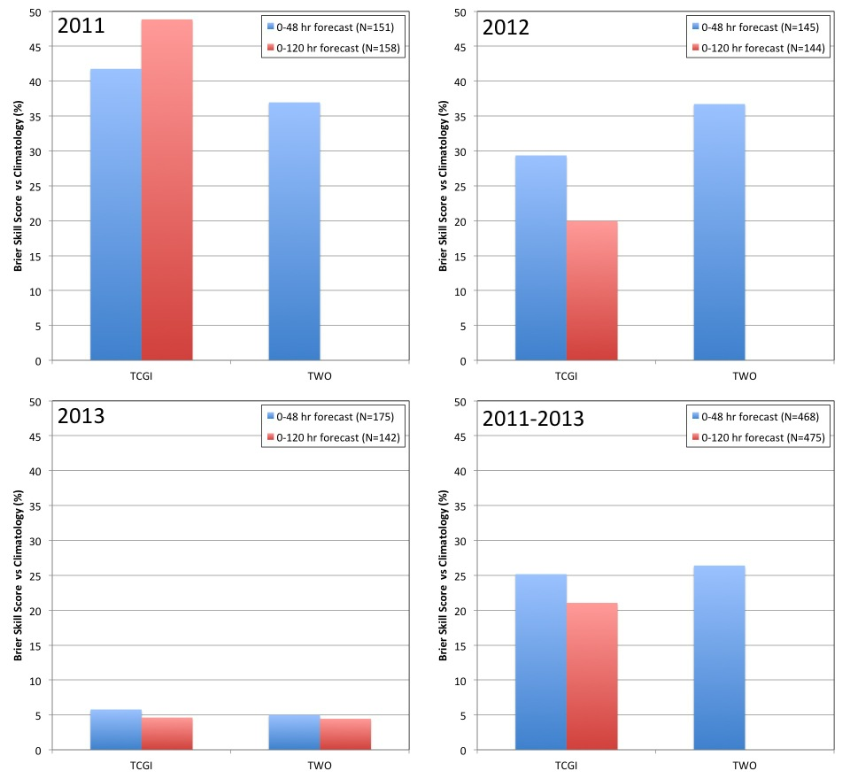

*Fig. 2: Brier Skill Scores for TCGI and a homogenous sample of NHC TWO probabilistic TC genesis forecasts for the 2011-2013 Atlantic hurricane seasons. Skill, measured against the climatological probability of tropical cyclogenesis, was 28% (40%) for the 0-48 hr (0-120 hr) forecast periods as determined from a 2001-2010 dataset of Atlantic invests.*

This project seeks to expand and improve the Tropical Cyclone Genesis Index (TCGI) that was developed under a previously funded NOAA JHT project. Specific proposed efforts are outlined below and include a combination of extending TCGI into the eastern and central North Pacific, refining (testing) current (new) TCGI predictors, and developing a graphical version of TCGI to compliment the text version that is currently being produced.

*a. Expand the North Atlantic TCGI Database to Include 2011-2014*

The current 10-year (2001-2010) North Atlantic tropical disturbance invest database derived from operationally produced Dvorak intensity and centering fixes (Cossuth et al. 2013) will be expanded to include 2011-2014. This updated database will provide a more robust training set for the TCGI predictors and probability computations and will be integrated into the real-time version of TCGI. While the 2014 finalized best track has yet to be released as of this writing, preliminary results in Figure 3 (from Cossuth et al. 2015) show promising results to expand the predictive ability of TCGI through the 2014 season. Despite year-to-year variability in genesis difficulty (Figures 2 and 3, left) and sampling (not shown), multi-year verification shows the Dvorak information to be well calibrated with respect to the historical data (Figures 3, right). Thus, the expansion of the training set to include the latest seasons should not result in significant differences in coefficient development and physical interpretation, but can help identify a broader range of genesis and non-genesis conditions.

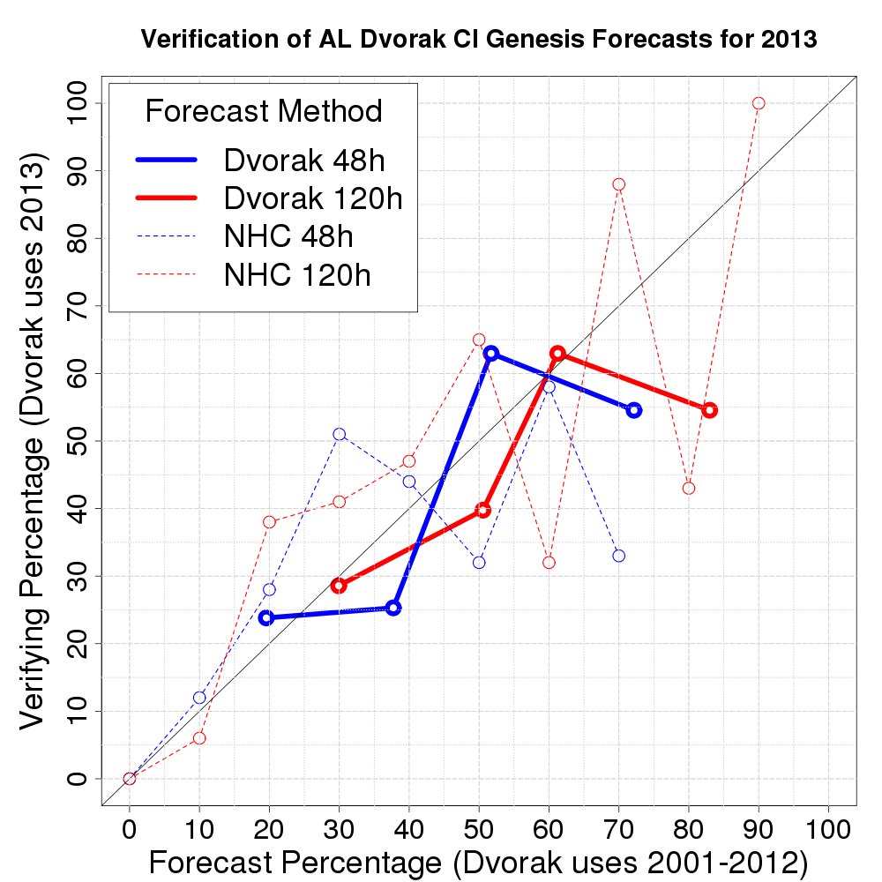 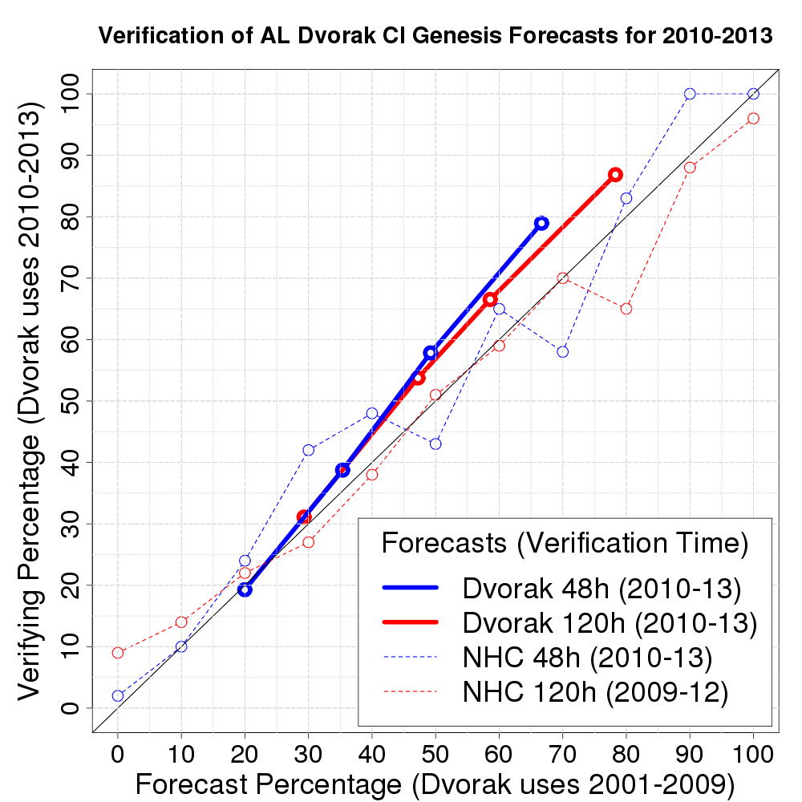

*Fig. 3: Verification of real-time probabilistic genesis forecasts using only TAFB Dvorak CI numbers as predictors (solid lines) compared to NHC TWO forecasts (dotted lines). Note this is a non-homogenous comparison. Left figure verifies only the 2013 season, while the right figure verifies the most recent 4 seasons for which data were available.*

We will use the methodologies described by Dunion et al. 2013 to re-test over 60 potential predictors (as well as new predictors described in Section 2c) to determine which exhibit statistically significant differences (at the 99.9% level) between the mean values of the genesis and non-genesis samples. Sensitivity tests conducted utilizing linear discriminant analysis will then be performed to determine which combination of TCGI predictors produces the most skillful genesis forecasts. The updated version of the Atlantic TCGI will then be tested in parallel model alongside the current TCGI that is being run in real-time at CSU/CIRA and will be transitioned to operations once a period of real-time testing shows it to be more skillful than the existing real-time version.

b*. Development of TCGI for the Eastern and Central North Pacific Basins*

We propose to expand the TCGI to include 0-48 hr and 0-120 hr TC genesis forecasts for the eastern and central North Pacific (EPAC and CPAC) that will encompass all of the Pacific area of responsibilities for Regional Specialized Meteorological Centers (RSMC) Miami and Honolulu. Based on positive results using Dvorak information to develop and verify probabilistic genesis forecasts in the EPAC-CPAC (Figure 4), a Pacific version of TCGI will help augment TC genesis forecasting in these regions. Because of the relative infrequency of CPAC cases, they will be combined with the EPAC training set. Testing will be performed to see if separate EPAC and CPAC versions of TCGI are necessary. This element of the proposal will use a database of NHC and CPHC invest positions and intensities assembled by Co-PI Cossuth to develop a 14-yr (2001-2014) training set of historical TC genesis cases in the EPAC and CPAC. Similar to the approach used to develop the Atlantic TGCI described in Sec. 2a, we will test a variety of Best track, model-derived and satellite-based predictors and objectively identify the combination of predictors that has the most predictive skill for TC genesis in the EPAC-CPAC region.

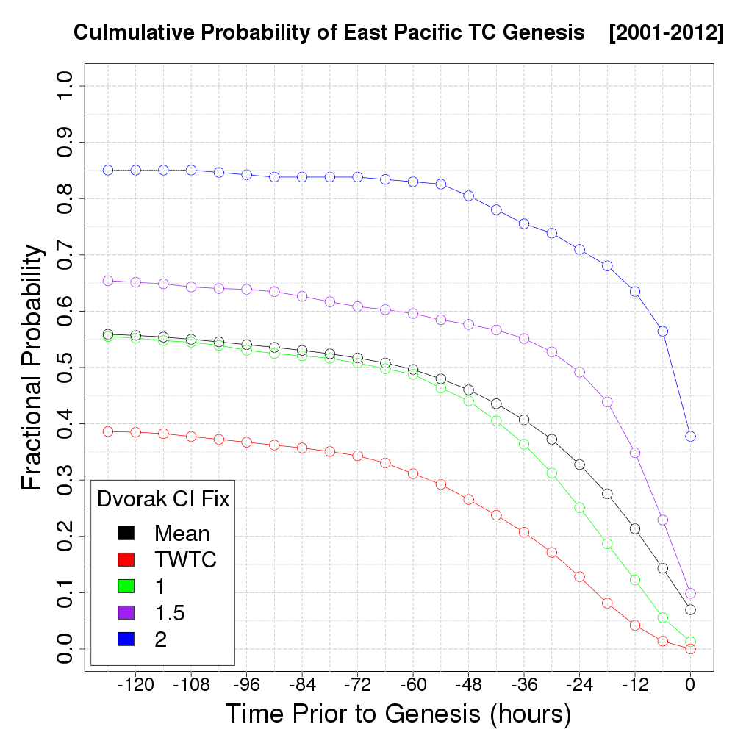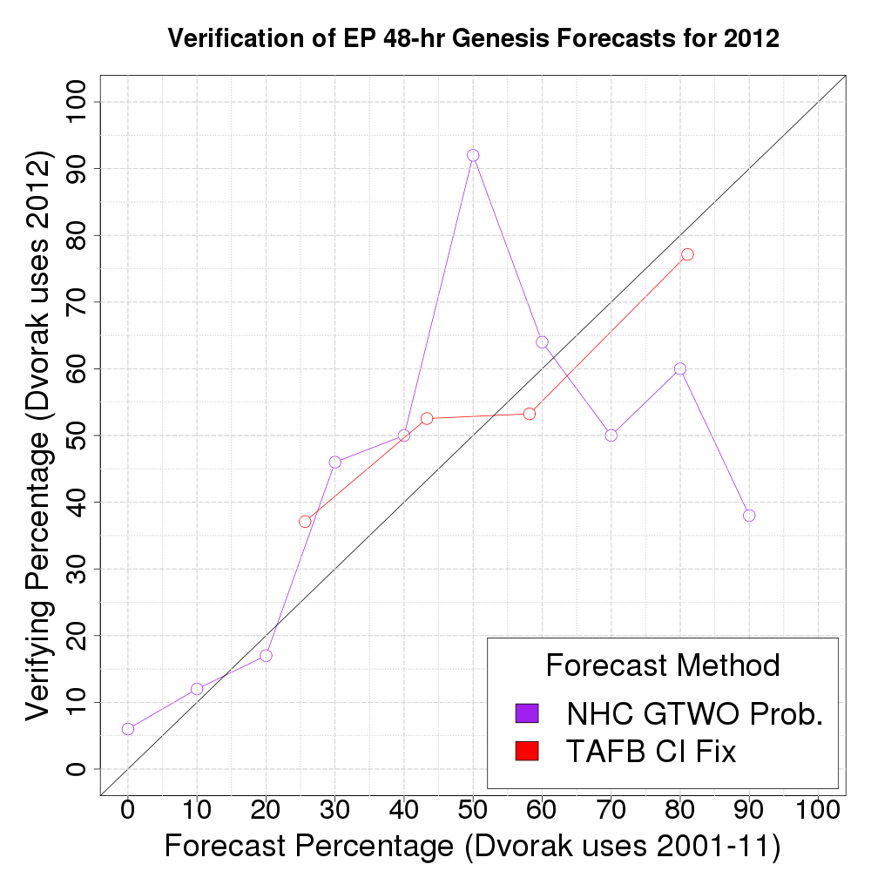

*Fig. 4: (Left) Probabilities of genesis for East Pacific storms (east of 125o) by lead-time and TAFB Dvorak CI number for the 2001-2012 seasons. (Right) Verification of 2012 East Pacific 48-hr genesis forecasts using only TAFB Dvorak CI numbers as predictors (red line) compared to NHC TWO forecast (purple line). Note this is a non-homogenous comparison.*

A real-time version of the EPAC-CPAC TCGI will be run at CSU/CIRA and made accessible on the CSU/CIRA Atlantic TCGI web site. Dvorak information has shown promise in being a useful training set and predictor for probabilistic TC genesis forecasting in JTWC areas of responsibilities (e.g. the western North Pacific (WPAC)) as well (Cossuth et al. 2014; Figure 5). However, a training set of non-developing cases for these regions is only available since 2010 and the limited amount of data makes robust statistical regression of genesis difficult to achieve. Future work can expand TCGI to include JTWC’s area of responsibilities as more seasons and data become available.

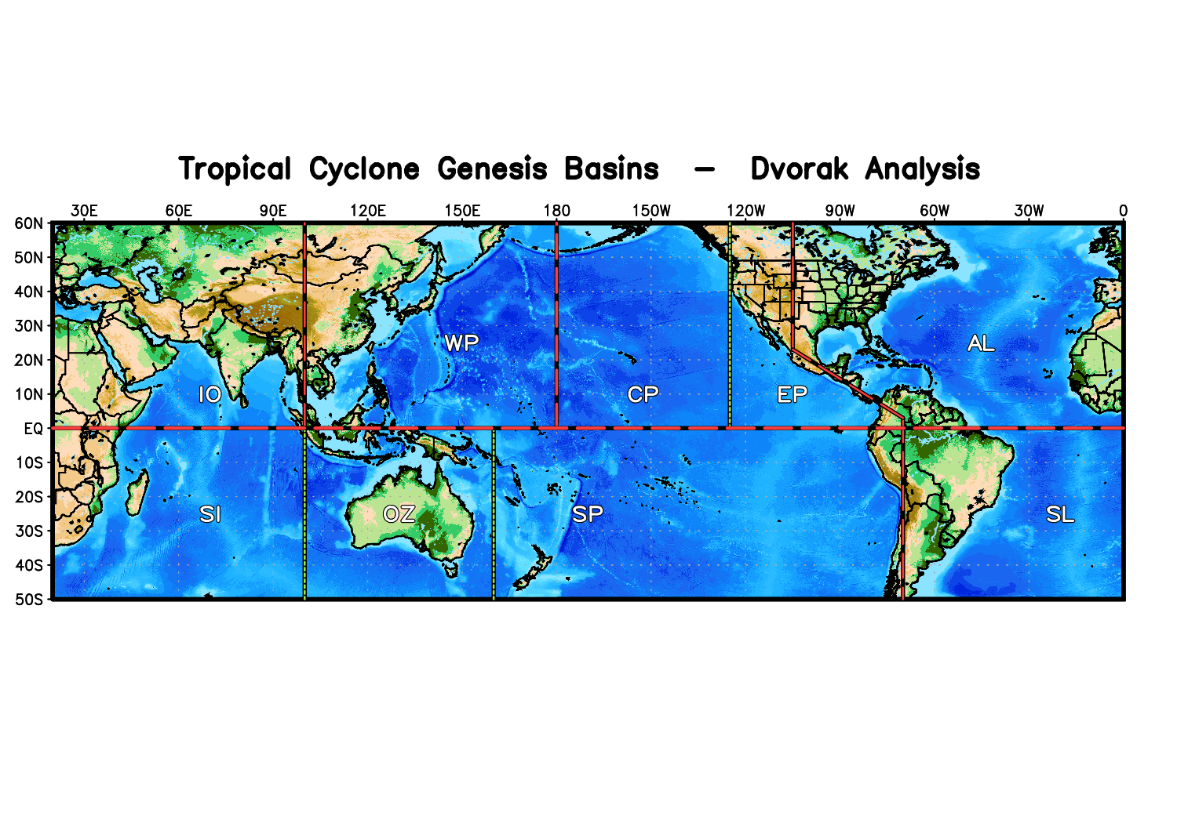

*Fig. 5: Dvorak analysis basins using NHC, CPHC, and JTWC data (from Cossuth et al. 2014).*

c. *Test New TCGI Predictors and Predictor Calculation Methods*

This element of the proposal will include testing new TCGI predictors (e.g. boundary layer moisture, convective instability, and small radius low-level vorticity), as well as methods for optimizing the search areas that are utilized to compute potential TCGI predictors. The latter effort will involve testing variable search area sizes for the model-based predictor value calculations that increase in size during the 0 to 120 hr forecast time period. This may help refine the predictor information at time=0 and account for increasing uncertainty in the position of the tropical disturbance later in the forecast period.

*d. Develop an ECMWF-based TCGI*

The current version of the TCGI uses track information and calculates environmental conditions from the GFS model. To complement the GFS-based TCGI, it is proposed that an ECMWF-based version of the TCGI be developed from ERA-Interim data for the North Atlantic basin. The methodology used to develop this ECMWF-based TCGI will be the same as that used for the current TCGI, with the exception that ERA-Interim data will be used instead of CFSR/GFS data. At this time, CIRA does not have real-time access to ECMWF forecast fields. As such, real-time testing of this product may not be available until after it is installed at NHC (if the project is accepted).

*e. Develop a Graphical Version of TCGI*

To better integrate the TCGI into the time sensitive forecast cycle, this effort will involve developing a graphical version of the TCGI that will complement the text version that is already being produced. This quick look product will provide an overview of active systems of interest, facilitating an efficient evaluation of forecast priorities. Following the visual cues from the GTWO, we propose to implement a basin-wide satellite image overlayed with representations of current tropical systems. System specific information on track and 0-48 hr/0-120 hr genesis probabilities shaded by the low/medium/high color scheme will also be provided.

A conceptual prototype of this product is shown in Figure 6. This plot was generated using Python, a free and open source programming language, and supporting ancillary modules. In this example case, data from GOES, the TCGI and the best track were all ingested, formatted, resampled, and plotted by a Python script. Depending on the requested resolution of the satellite data and generated image, multiple graphics may be produced in less than one minute. If there is demand for JHT to host the graphical version and Python is unable to be used, the TCGI graphic could also be generated in other programming environments (e.g. McIDAS or GrADS).

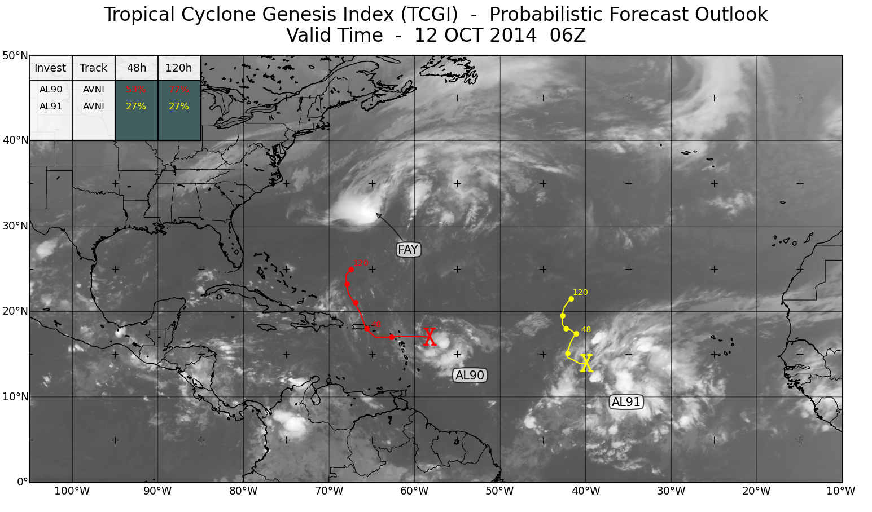

*Fig. 6: TCGI prototype graphic showing Tropical Storm, Fay, AL90, and AL91 on 12 Oct 2014 0600 UTC using real-time TCGI and best track data. The “Xs” mark initial invest position, while the curved lines show the forecast track at 24-hr increments and are colored according to the 0-48 hr TCGI genesis probabilities (using NHC’s operational color scheme). The legend shows the current invests, track source, and 48-hr/120-hr TCGI forecast probabilities.*

**References:**

Cossuth, J. H., R. D. Knabb, D. P. Brown, R. E. Hart, 2013: Tropical Cyclone Formation Guidance Using Pregenesis Dvorak Climatology. Part I: Operational Forecasting and Predictive Potential. *Wea. Forecasting*, **28**, 100–118. doi:[10.1175/WAF-D-12-00073.1](http://dx.doi.org/10.1175/WAF-D-12-00073.1)

Cossuth, J., M. E. Kucas, and C. S. Velden, 2014: Climatological probabilities of tropical cyclogenesis based on Joint Typhoon Warning Center Dvorak analyses, Proceedings, 31st Conf. Hurr. Trop. Meteor., San Diego, CA, Amer. Meteor. Soc.

Cossuth, J. H., R. D. Knabb, D. P. Brown, and R. E. Hart, 2015: Tropical cyclone formation guidance using pre-genesis Dvorak climatology. Part II: Spatio-Temporal Analysis. *Wea. Forecasting*, in preparation.

Dunion, J.P., J. Kaplan, S. Schumacher, J. Cossuth, and M. DeMaria, 2013: Development of a Probabilistic Tropical Cyclone Genesis Prediction Scheme. JHT Year 2 Mid-Year Report. Available from: http://www.nhc.noaa.gov/jht/11-13reports/JHT_Dunion_midyear2.pdf

**3. Work Plan**

In year-1, the 2011-2014 Atlantic and 2001-2014 Pacific Dvorak databases will be assembled, quality controlled, and formatted. Additionally, all potential Atlantic, eastern, and central Pacific TCGI predictors will be identified and tested. Evaluation of all potential predictors will be carried out utilizing tropical disturbance positions that were either determined by the NHC or were forecast using the BAMG (beta and advection model-genesis) that was developed under previously funded NOAA JHT projects. Results from these activities will be presented at the IHC in March 2016. From the late summer to mid-fall of 2016, we will develop and test graphical TCGI products with real-time cases and will also conduct sensitivity to determine the optimal combination of predictors for use in both the revised Atlantic and newly developed Pacific versions of the TCGI. During the end of year-1, we will begin developing code for running real-time versions of the aforementioned new Atlantic and Pacific TCGI schemes. We will also collect the ERA-Interim data and begin development of an ECMWF-based TCGI at the end of year 1. No hardware needs are anticipated for the first phase of this project.

In the spring of year-2 (2017), we will present an overview of year-1 project efforts at the IHC and refine TCGI graphical products based on POC and IHC feedback. During the summer, we will perform real-time tests of the TCGI and make that output available online to forecasters. We will also finish development of the ECMWF-based TCGI by summer 2017. In August 2017, the final code for computing both the Atlantic and Pacific TCGI and the evaluation results of the Atlantic ECMWF-based TCGI will be made available (if the project is accepted) for installation on the operational NCEP IBM computers.

**4. Time Line**

Sep 2015 Funding begins

Sep-Oct 2015 Collect, quality control, and format 2011-2014 AL Dvorak information

Oct-Dec 2015 Collect, quality control, and format 2001-2014 EP/CP Dvorak information

Jan 2016 Complete identification/development of Atlantic TCGI predictors

Feb 2016 Complete identification/development of EPAC-CPAC TCGI predictors

March 2016 Present year-1 results at IHC

April 2016 Collect, quality control, and format ERA-Interim data and begin development of

ECMWF-based Atlantic TCGI

June-Nov 2016 Begin sensitivity testing for optimal combinations of Atlantic and Pacific TCGI predictors

Aug-Oct 2016 Develop and test graphical TCGI products with real-time cases

Dec 2016 Develop code for running real-time version of the Atlantic and Pacific TCGI

March 2017 Present year-2 results at IHC

April 2017 Based on POC and IHC feedback, refine TCGI graphical products.

June-Aug 2017 Perform real-time tests of TCGI graphical products in-house at NHC or online at: http://rammb.cira.colostate.edu/realtime_data/nhc/tcgi/

May-Aug 2017 Perform real-time tests of 0-48 and 0-120 h Atlantic and Pacific TCGI on NESDIS computers at CIRA with output being made available online at: <http://rammb.cira.colostate.edu/realtime_data/nhc/tcgi/>

May-Aug 2017 Finish development/evaluation of prototype ECMWF-based TCGI for Atlantic

Aug 2017 Final code for running both the Atlantic and Pacific TCGI on operational NCEP computers will be provided to NHC/NCEP IT personnel if the project is accepted for operational transition.

**5. Schedule and Needs for Expected Travel**

Fall 2015 PI Dunion and Co-PIs Schumacher and Cossuth travel to NOAA/AOML to work on the new Atlantic and Pacific TCGI schemes

Spring 2016 PI Dunion and Co-PIs Schumacher, Cossuth, and Kaplan travel to Interdepartmental Hurricane Conference to present project results

Fall 2016 PI Dunion and Co-PIs Schumacher and Cossuth travel to NOAA/AOML to work on the new Atlantic and Pacific TCGI schemes

Spring 2017 PI Dunion and Co-PIs Schumacher, Cossuth, and Kaplan travel to Interdepartmental Hurricane Conference to present project results

**6. Estimates of JHT Staff Requirements**

We do not anticipate the need for any significant JHT staffing requirements as the TC Genesis Index will be run and tested at CSU/CIRA.

**D. Budget:**

This is a collaborative project between the University of Miami/CIMAS, the NOAA/AOML/Hurricane Research Division, Colorado State University/CIRA, and NRL/Monterey. The break down for each of these agencies by year is provided below, with the University of Miami/CIMAS budget listed first, followed by the NOAA/AOML/HRD, CSU/CIRA, and NRL/Monterey budgets.

University of Miami/CIMAS Budget Explanation

The University of Miami/CIMAS requests a total dollar amount of $46,789 to fund the research outlined in the project narrative. Explanations of the budget information are given directly below and the costs to conduct the activities described in this proposal are summarized in the budget pages provided. Cost estimates in these budget pages are based on historical events and experience.

**Key Personnel:  PI**

The following individuals have been identified as key personnel to this proposal:

Jason P. Dunion, PI, 1.5/1.0 person months for years-1 & 2

Time quoted for key personnel is the total amount of anticipated effort required to complete the proposed effort over the life of the project, including during periods of no cost extension.  All effort for key persons will be sponsor paid effort.  Fulfillment of the effort commitment will be defined as a total for the entire project period.

**Personnel**

This section identifies the PI’s position and his proposed effort to support this work. For budgets with duration greater than one year, we use a 3% inflation factor to labor rates to account for cost of living adjustment. For the purposes of measuring % effort below, we’ve used a base annual effort of 12 months. We estimate an approximate total effort as follows:

|  |  |  |  |  |  |  |
| --- | --- | --- | --- | --- | --- | --- |
|  |  |  | Year 1 | | Year 2 | |
| **Name** | **Title** | **Classification** | **MM** | **% Effort** | **MM** | **% Effort** |
| Dunion, Jason | PI | Senior Research Associate III | 1.5 | 12.5 | 1.0 | 8.3 |
|  |  |  |  |  |  |  |

**Fringe Benefits**

The UM FY15 fringe benefit rate was calculated at a current rate of 38.2% with an estimated 0.5% increase per year for the outer years.

**Travel**

The travel budgets in the proposal are based on recent history regarding the amount of travel needed to conduct the research project, interact with collaborators, and present the results. UM reimburses actual travel costs for hotel and meal expenses up to a certain maximum rate. All travel must be approved by UM administration and the UM/CIMAS Director. Travel costs include one trip per year for the PI to present project results at the NOAA Interdepartmental Hurricane Conference and one trip per year for the PI to travel to NOAA/AOML/HRD to collaborate with Co-PIs in Miami, FL. The costs are itemized in the Budget Details section that follows.

**Materials & Supplies (N/A)**

**Indirect Costs**

Currently at 40.0%, the indirect cost rate is directly negotiated with the U.S. government and is charged to all budget items.

**Part II: Budget Details**





NOAA/AOML/HRD Budget Explanation

The HRD budget includes a request of 1.25 months of computer programming support in Year 1 and Year 2 for assistance with the development of a revised version of the Atlantic TC Genesis Index (TCGI) as well as the derivation of a new eastern/central North Pacific version. The software costs are to cover the licensing fees for the IMSL software that is used to perform the discriminant analysis. The travel costs in Year 1 and Year 2 are for expenses related to Co-PI travel to the IHC and for collaboration with Co-PIs. The NOAA AOML fringe benefit and indirect cost rates are calculated at 33% and 53% respectively for year-1 and 34% and 54% respectively for year-2. Support for the participation of Co-PI Kaplan is being provided by NOAA base funds.



Colorado State University/CIRA Budget Explanation

The budget includes a request for 3.0 months of support each in Years 1 and 2 for CIRA Co-PI A. Schumacher to assist in development, real-time testing, and operational implementation of an updated Tropical Cyclone Genesis Index (TCGI). Support is also requested for 1.0 month of support each in Years 1 and 2 for CIRA Research Associate N. Tourville to assist with the programming. Travel costs in Years 1 and 2 are for expenses related to Co-PI A. Schumacher travel to the Interdepartmental Hurricane Conference to collaborate with Co-PIs.

|  |  |  |  |  |  |  |
| --- | --- | --- | --- | --- | --- | --- |
|  | **Budget Year 1** | | | **Budget Year 2** | | |
|  | **Rate** | **Months** | **Requested Amount** | **Rate** | **Months** | **Requested Amount** |
| **DIRECT COSTS** |  |  |  |  |  |  |
| Personnel |  |  |  |  |  |  |
| Salaries |  |  |  |  |  |  |
| A. Schumacher | 5,478 | 3.00 | 16,434 | 5,642 | 3.00 | 16,926 |
| N. Tourville | 7,193 | 1.00 | 7,193 | 7,409 | 1.00 | 7,409 |
|  |  |  | ----------- |  |  | ----------- |
| Subtotal – Salaries |  |  | 23,627 |  |  | 24,335 |
|  |  |  |  |  |  |  |
| Fringe Benefits (25.3%) |  |  | 5,978 |  |  | 6,157 |
|  |  |  |  |  |  |  |
| Subtotal - Personnel |  |  | 29,605 |  |  | 30,492 |
|  |  |  |  |  |  |  |
| Infrastructure Charges |  |  | 705 |  |  | 705 |
| Travel (PI to IHC) |  |  | 1,562 |  |  | 1,562 |
|  |  |  |  |  |  |  |
| **Total Direct Costs** |  |  | **31,872** |  |  | **32,759** |
|  |  |  |  |  |  |  |
| **INDIRECT COSTS (30%)** |  |  | **9,562** |  |  | **9,828** |
|  |  |  |  |  |  |  |
| **TOTAL BUDGET** |  |  | **41,434** |  |  | **42,587** |
|  |  |  |  |  |  |  |
| Note: A 3% increase in salary rate goes into effect on July 1st of each calendar year. | | | | | | |

NRL-Monterey Budget Explanation

The Naval Research Laboratory in Monterey requests a total dollar amount of $38,924 to fund the research outlined in the project narrative.

|  |  |  |  |
| --- | --- | --- | --- |
| **NRL Budget Summary** | **2015-2016** | **2016-2017** | **Total** |
| Cossuth | *12,500 (1.5 mo)* | *21,424 (2.5 mo)* | *33,924* |
| Travel | 2,500 | 2,500 | 5,000 |
| **Total Costs** | **15,000** | **23,924** | **38,924** |

Notes:

* NRL is a working capital fund activity governed by the legal requirements of 10 USC Section 2208. NRL is required to fully recover all costs of such work and services on a reimbursable basis. This includes the costs of personnel, overhead operating expenses, and other direct reimbursable costs.
* Cossuth budget is based on the NRL labor rate for a postdoctoral contractor and includes salaries, fringe, and overhead. A 3% inflation increase is incorporated in year 2.
* The travel budget estimates $1250 for two cross-country trips per funding year. Airfare, ground transportation, lodging, and per diem is inclusive. Requested yearly travel includes:
  + Monterey, CA to NOAA AOML in Miami, FL.
  + Monterey, CA to IHC conference (estimated for Charleston, SC).

**E. NOAA Grants and Cooperative Agreement Application Package**

**F. Abbreviated Curriculum Vita (Jason P. Dunion, PI)**

**Professional Preparation**

Ph.D. in Atmospheric Science (ABD), August 2010-present, *Univ. at Albany-SUNY*, Albany, NY

M.S. in Atmospheric and Oceanic Science, 1999, *University of Wisconsin*, Madison, WI

B.A. inGeography/concentration in Geology, 1992, *University of New Hampshire*, Durham, NH

**Appointments**October 2009-Present Meteorologist, University of Miami/RSMAS/CIMAS, Miami, FL

2006-Sept 2009 Meteorologist, NOAA/AOML/Hurricane Research Division, Miami,FL

November 1999-2006 Meteorologist, University of Miami/RSMAS/CIMAS, Miami, FL

**Selected Refereed Journal Publications**

* **Dunion, J.P.**, C.D. Thorncroft, and C.S. Velden, 2014: The tropical cyclone diurnal cycle of mature hurricanes. *Mon. Wea. Rev*., **142**, 3900-3919.
* Rogers, R., S. Aberson, A. Aksoy, B. Annane, M. Black, J. Cione, N. Dorst, **J. Dunion**, J. Gamache, S. Goldenberg, S. Gopalakrishnan, J. Kaplan, B. Klotz, S. Lorsolo, F. Marks, S. Murillo, M. Powell, P. Reasor, K. Sellwood, E. Uhlhorn, T. Vukicevic, J. Zhang and X. Zhang. NOAA's Hurricane Intensity Forecasting Experiment (IFEX): A Progress Report. *Bull. Amer. Meteor. Soc.,* (in press).
* Katzberg, S.J, **J.P. Dunion**, and G.G. Ganoe, 2012: The use of reflected GPS signals to retrieve ocean surface wind speeds in tropical cyclones. *Radio Sci*., (in press).
* **Dunion, J.P**., 2011: Re-Writing the Climatology of the Tropical North Atlantic and Caribbean Sea Atmosphere. *J. Climate*. **24 no. 3**, 893-908.
* Katzberg S.J., and **J.P. Dunion**, 2009: Comparison of reflected GPS wind speed retrievals with dropsondes in tropical cyclones. *Geophys. Res. Lett.*, **36**, L17602, doi:10.1029/2009GL039512.
* Zipser, E.J., C.H. Twohy, S. Tsay, K. L. Thornhill, S. Tanelli, R. Ross, T.N. Krishnamurti, Q. Ji, G. Jenkins, S. Ismail, N. C. Hsu, R. Hood, G. M. Heymsfield, A. Heymsfield, J. Halverson, H. M. Goodman, R. Ferrare, **J. P. Dunion**, M. Douglas, R. Cifelli1, G. Chen, E. V. Browell, and B. Anderson, 2009: The Saharan Air Layer and the fate of African easterly waves-NASA’s AMMA 2006 field study of tropical cyclogenesis. *Bull. Amer. Meteor. Soc*., **90**, 1137-1156.

**Professional Honors**

* Co-Recipient: 2014 American Meteorological Society Special Award to the University of Wisconsin-CIMSS Tropical Cyclone Group for “providing the weather community with valuable tropical cyclone-related satellite information and derived products for over two decades.”
* Co-Recipient (2010): NOAA AIRS Team for outstanding contributions to improving weather forecasting using data from the Atmospheric Infrared Sounder (AIRS)
* 2009 Editors’ Citation for Excellence in Refereeing for Geophysical Research Letters
* 2005 NOAA David Johnson Award for “innovative research using environmental satellite observations on the influence and impact of the Saharan Air Layer on Atlantic tropical cyclones and the role it plays in development, decay, and intensity change of these storms.”2004 Editors’ Citation for Excellence in Refereeing for JGR-Atmospheres

**Professional Service**

* January 2014 – present: Member, NOAA Unmanned Aircraft Systems Program science team
* April 2012: Member, Organizing Committee, 30th Conference on Hurricanes and Tropical Meteorology, 15-20 April 2012, Ponte Vedra Beach, FL
* August 2010: Lead forecaster, National Science Foundation PRE-Depression Investigation of Cloud-systems in the Tropics (PREDICT) field experiment (St. Croix, V.I.)
* June 2008 – present: member, AMS Scientific and Technological Activities Commission (STAC) on Tropical Meteorology and Tropical Cyclones
* May 2006 - present: Host Researcher, Monster Storms Project, JASON/National Geographic
* May 2006 - present: member of the NASA NAMMA science and mission planning team
* May 2004: Smithsonian Scholar, Smithsonian Scholars in the Schools Program; Houston, TX
* May 2000 - present: Member of the American Meteorological Society
* May 2000-January 2004: President of the Greater Miami Chapter of the American Meteorological Society

**Abbreviated Curriculum Vita (John Kaplan, Co-PI)**

**JOHN KAPLAN**

Hurricane Research Division

AOML/NOAA

4301 Rickenbacker Cswy. Miami, FL. 33149

(305) 361-4506

E-mail: John.Kaplan@noaa.gov

**Education:**

B.S. in Meteorology (minor in Mathematics), The State University of

New York at Oneonta, 1983

M.S. in Meteorology, The Pennsylvania State University, 1986

**EMPLOYMENT HISTORY:**

Research Assistant at the Pennsylvania State University

1983-1986.

Research Meteorologist at the Hurricane Research Division of

AOML, 1987- present

**Select Honors and Awards**:

1997 - Department of Commerce Bronze medal- Co-recipient (along with Mark DeMaria of NOAA/NESDIS) for the development of a model for predicting the decay of hurricane winds after landfall, 1997.

2002 - Banner I. Miller award -Co-recipient (along with Mark DeMaria of NOAA/NESDIS) for the first ever model-based skillful operational intensity forecasts of tropical cyclones documented in the two papers published during the years 1998-2001, ‘An Updated Statistical Hurricane Intensity Prediction Scheme (SHIPS) for the Atlantic and Eastern North Pacific Basins’ (WAF, Vol. 14) and ‘On the Decay of Tropical Cyclone Winds after Landfall in the New England Area’ (JAM, Vol. 40).

2011- Department of Commerce Bronze Medal- (Co-recipient along with Mark DeMaria and John Knaff of NOAA/NESDIS) for providing skillful operational hurricane intensity models as demonstrated by the NHC forecast verifications for the 2009 and 2010 seasons.

**Major Accomplishments**:

1989-present. Co-developer (along with Mark DeMaria of NOAA/NESDIS) of the Statistical Hurricane Intensity Prediction scheme (SHIPS). The SHIPS model is currently used operationally by the National Hurricane Center (NHC).

1995-2001. Co-developer (along with Mark DeMaria of NOAA/NESDIS) of an empirical model to predict the decay of tropical cyclone winds after landfall. The empirical decay model is used as part of the DSHIP model.

2001-present. Co- developer (along with Mark DeMaria of NOAA/NESDIS) of an index for estimating the probability of a rapid intensification of Atlantic and E. Pacific tropical cyclones. The rapid intensity index has been transitioned to NHC/TPC as part of the JHT.

2005-2007. Along with co-investigators M. DeMaria and J. Dunion, developed a method for estimating the maximum wind and 34,50, and 64 kt wind radii for landfalling Atlantic and E. Pacific tropical cyclones in real-time utilizing an empirical decay model. This technique has been transitioned to TPC/NHC as part of the JHT.

**Select Publications**:

DeMaria, M., and **J. Kaplan**, 1994: A statistical hurricane intensity prediction scheme (SHIPS) for the Atlantic basin. *Wea. Forecasting*, **9**, 209-220.

**Kaplan, J.,** and M. DeMaria, 1995: A simple empirical model for predicting the decay of tropical cyclone winds after landfall. *J. Appl. Meteor*., **34**, 2499-2512.

DeMaria, M., and **J. Kaplan**, 1999: An updated statistical hurricane intensity prediction scheme (SHIPS) for the Atlantic and Eastern North Pacific basins. *Wea. Forecasting*, 1**4**, 326-337.

**Kaplan, J**., and M. DeMaria, 2001: On the decay of tropical cyclone winds after landfall in the New England region. *J. Appl. Meteor*., **40**, 280-286.

**Kaplan, J.,** and M. DeMaria, 2003: Large-scale characteristics of rapidly intensifying tropical cyclones in the North Atlantic Basin. *Wea. Forecasting,* **18,** 1093-1108.

DeMaria, M., M. Mainelli, L.K. Shay, J. Knaff and **J. Kaplan**, 2005: Further improvements to the Statistical Hurricane Intensity Forecasting Scheme (SHIPS). *Wea. Forecasting*, **20**, 531-543.

DeMaria, J.A. Knaff, and **J. Kaplan**, 2006: On the decay of tropical cyclone winds crossing narrow landmasses. *J. Appl. Meteor*, **45**. 491-499.

**Kaplan, J.,** M. DeMaria, and J.A. Knaff, 2010: A revised tropical cyclone rapid intensification index for the Atlantic and eastern North Pacific basins. *Wea. Forecasting*, **25**, 220-241.

Sampson, C. R., **J. Kaplan**, J. A. Knaff, M. DeMaria, and C. A. Sisko, 2011: A deterministic rapid intensification aid, *Wea. Forecasting***, 26**, 579-585.

Rozoff, C.M., C.S. Velden, **J. Kaplan**, J.P. Kossin, and A. J. Wimmers, 2014: Improvements in the probabilistic prediction of tropical cyclone rapid intensification with passive microwave observations. Submitted to Wea. Forecasting.

**Abbreviated Curriculum Vita (A.B. Schumacher, Co-PI)**

**Education**

Ph.D., Atmospheric Science (Candidate), Colorado State University, Aug 2012-present

M.S., Atmospheric Science, Colorado State University, 2004

B.A., Mathematics/Chemistry, New College of Florida, 2000

**Professional Experience**

|  |  |
| --- | --- |
| 2006 – present: | Research Associate, Cooperative Institute for Research in the Atmosphere (CIRA), Colorado State Univ., Fort Collins, CO |
| 2003 – 2004: | Graduate Teaching Assistant, Dept. of Atmospheric Science, Colorado State Univ., Fort Collins, CO |
| 2001 – 2004: | Graduate Research Assistant, Dept. of Atmospheric Science, Colorado State Univ., Fort Collins, CO |

**Refereed Publications (last 5 years)**

Quiring, S.M., **A.B. Schumacher**, and S. Guikema, 2014: Incorporating Hurricane Forecast Uncertainty into Decision Support Applications. *Bull. Amer. Meteor. Soc*., 95, Issue 1, pp. 47-58.

DeMaria, M., J. A. Knaff, M.J, Brennan, D.B. Brown, R.D. Knabb, R.T. DeMaria, **A.B. Schumacher**, C.A. Lauer, D.P. Robers, C.R. Sampson, P. Santos, D. Sharp, and K.A. Winters, 2013: Improvements to the Operational Tropical Cyclone Wind Speed Probability Model. *Wea. Forecasting*, 28, 586-602.

Sampson, C.R., **A.B. Schumacher**, J.A. Knaff, M. DeMaria, E.M. Fukada, C.A. Sisko, D.P. Roberts, K.A. Winters and H.M. Wilson, 2012: Objective Guidance for Use in Setting Tropical Cyclone Conditions of Readiness. *Wea. and Forecasting*. **27**, 1052–1060.

Quiring, S., **A. Schumacher**, C. Labosier, and L. Zhu, 2011: Variations in mean annual tropical cyclone size in the Atlantic, *J. Geophys. Res*., 116, D09114, doi:10.1029/2010JD015011.

Schumacher, R.S., D.T. Lindsey, **A.B. Schumacher**, J. Braun, S.D. Miller and J.L. Demuth, 2010: Meteorology, Climatology, and the Communication and Interpretation of Weather Information during the 22 May 2008 Weld County, Colorado Tornado. *Wea. and Forecasting*, 25, 1412-1429.

Rappaport, E.N., J.L. Franklin, **A.B. Schumacher**, M. DeMaria, L.K. Shay, and E.J. Gibney, 2010: Tropical cyclone intensity change before U.S. Gulf coast land fall. *Wea. and Forecasting*, 25, 1380-1396.

Sherman-Morris, K., **A. Schumacher**, S. Drobot and K. McNeal, 2010: Hurricane Preparedness and Response among Pet Care Providers along the Gulf Coast: An Investigation of Hurricanes Gustav and Ike. *International Journal of Mass Emergencies and Disasters*, 28 (3).

**Schumacher, A.B**., M. DeMaria, and J.A. Knaff, 2009: Objective Estimation of the 24-h Probability of Tropical Cyclone Formation. *Wea. Forecasting*, 24, 456–471.

**Professional Honors**

* Governor’s Award for High Impact Research (Team Member), CO-LABS, 2012
* Research Initiative Award, Cooperative Institute for Research in the Atmosphere (CIRA), 2011-2012.
* Research Initiative Award, Cooperative Institute for Research in the Atmosphere (CIRA), 2007-2008.
* AMS Industry/Government Graduate Fellowship, American Meteorological Society, 2001-2002.

**Professional Service**

2004 – present: Member of the American Meteorological Society

2009 – 2010: Mentor, American Meteorological Society’s Board on Women and Minorities

**Abbreviated Curriculum Vita (J. Cossuth, Co-PI)**

Naval Research Laboratory Phone: 831-656-4618

7 Grace Hopper Ave, MS#2 E-mail: [jhc06@my.fsu.edu](mailto:jhc06@my.fsu.edu)

Monterey, CA 93943 Work E-mail: [joshua.cossuth.ctr@nrlmry.navy.mil](mailto:joshua.cossuth.ctr@nrlmry.navy.mil)

**Education**

2014 Ph.D. in Meteorology, Florida State University (FSU)

2010 B.S. (Honors) in Meteorology, B.A. in Philosophy, FSU

**Appointments**

2014-Present NRC Postdoctoral Research Assoc., Naval Research Lab, Monterey, CA

2010-2014 Graduate Research Assistant, FSU EOAS Department, Tallahassee, FL

2008-2010 Undergraduate Research Assistant, FSU COAPS, Tallahassee FL

**Awards and Honors**

2014-2017 National Research Council (NRC) Postdoctoral Research Associateship

2013 AMS SatMOC STAC Student Travel Grant to EUMETSAT Meeting

2012-2014 DoD Nat’l Defense Science/Engineering Graduate (NDSEG) Fellowship

2012 Naval Research Enterprise Intern Program (NREIP) Award

2011 NASA Group Achievement Award, GRIP Field Project

2010-2014 FSU Presidential University Fellowship

2010-2011 AMS Graduate Fellowship (Sponsored by SAIC ASEO)

2010 Naval Research Enterprise Intern Program (NREIP) Award

2010 FSU Outstanding Senior Scholar Award

2009-2010 AMS David S. Johnson Endowed Scholarship

2009 FSU Bess H. Ward Honors Thesis Award

2008-2010 NOAA Ernest F. Hollings Scholar

2008 NSF Research Experience for Undergraduates (REU) Award at UC Irvine

**Service**

2014 Working Group Member (TC Structure), WMO IWTC VIII

2014 Session Chair, 31st AMS Conf. on Hurricanes and Tropical Meteorology

2013-2015 Student Member, AMS STAC on Tropical Met. and Tropical Cyclones

2012 Session Chair, IEEE IGARSS 2012

2010-2011 Vice President, FSU Chi Epsilon Pi Meteorology Honor Society

2010 Working Group Member (TC Genesis), WMO IWTC VII

2010 Forecaster, NASA GRIP Field Experiment

**Reviewer**

Trans. Geoscience and Remote Sensing (IEEE) Remote Sensing Conf. Proc. (SPIE)

Journal of Marine Science and Engineering (MPDI) Atmospheres (MPDI)

Weather and Forecasting (AMS) Monthly Weather Review (AMS)

**Recent Publications**

**Cossuth, J. H**., 2014: Book review of "Deluge: Tropical Storm Irene, Vermont’s Flash Floods, and How One Small State Saved Itself.” *Bull. Amer. Meteor. Soc.*, in press.

**Cossuth, J. H.**, 2014: Exploring a Comparative Climatology of Tropical Cyclone Core Structures. PhD Dissertation, Florida State University, 201 pp. [Available online at <http://diginole.lib.fsu.edu/etd/8965/>]

Hart, R. E., and **J. H. Cossuth**, 2013: A Family Tree of Tropical Meteorology’s Academic Community and a Proposed Expansion. *Bull. Amer. Meteor. Soc.*, **94**, 1837–1848. doi:[10.1175/BAMS-D-12-00110.1](http://dx.doi.org/10.1175/BAMS-D-12-00110.1)

Halperin, D. J., H. E. Fuelberg, R. E. Hart, **J. H. Cossuth**, P. Sura, and R. J. Pasch, 2013: An evaluation of tropical cyclone genesis forecasts from global numerical models. *Wea. Forecasting*, **28**, 1423–1445. doi:[10.1175/WAF-D-13-00008.1](http://dx.doi.org/10.1175/WAF-D-13-00008.1)

**Cossuth, J. H.**, R. D. Knabb, D. P. Brown, R. E. Hart, 2013: Tropical Cyclone Formation Guidance Using Pregenesis Dvorak Climatology. Part I: Operational Forecasting and Predictive Potential. *Wea. Forecasting*, **28**, 100–118. doi:[10.1175/WAF-D-12-00073.1](http://dx.doi.org/10.1175/WAF-D-12-00073.1)

In Preparation/Review/Revision:

**Cossuth, J. H.**, R. E. Hart, D. Piech, D. A. Murray, 2014: The climatological relationship between tropical cyclone intensity and core structure using operational metrics. *Mon. Wea. Rev.*, in revision.

**Cossuth, J. H.**, J. Hawkins, S. Yang, K. Richardson, J. Solbrig, M. Surratt, A. Wimmers, and C. Velden 2015: Creating a standardized digital climatology of tropical cyclones as observed by passive microwave satellite sensors, in revision for new journal submission.

**Cossuth, J. H.**, R. D. Knabb, D. P. Brown, and R. E. Hart, 2015: Tropical cyclone formation guidance using pre-genesis Dvorak climatology. Part II: Spatio-Temporal Analysis. *Wea. Forecasting*, in preparation.

**G. Current and Pending Federal Support:**

**Current/Pending Federal Support (PI Dunion):**

**Current Support (PI Dunion)**

1. Title of Proposal: Using NOAA UAS Assets and OSSE/DA Capabilities to Improve Sampling Strategies and Numerical Prediction of Tropical Cyclone Track, Intensity, and Structure

Project Association: Co-PI

Federal Award #: NA14OAR4830172

Percentage Effort: 17% (Year 1); 29% (Year 2); 25% (Year 3);

Prime Offeror: NOAA

Period of Performance: 10/01/2014 - 09/30/2017

Person Months: 2.0 (Year 1); 3.5 (Year 2); 3.0 (Year 3)

Total Award: $1,249,008

1. Title of Proposal: An Observational and Numerical Investigation of Energy Exchange Between a Tropical Cyclone and its Environment at the Outflow Level

Project Association: Co-PI

Federal Award #: NA14OAR4830172

Percentage Effort: 21% (Year 1); 17% (Years 2-3)

Prime Offeror: Office of Naval Research

Period of Performance: 01/01/2014 - 12/31/2016

Person Months: 2.5 (Year 1), 2.0 (Years 2-3)

Total Award: $558,592

1. Title of Proposal: Utilizing NASA Reconnaissance Assets to Investigate Hurricane Upper-level Warm Core Evolution, Inner Core Pulsing, and Near-Environment Moisture Interactions

Project Association: PI

Federal Award #: NNX12AK63G

Percentage Effort: 8%

Prime Offeror: NASA

Period of Performance: 07/01/2012 - 06/30/2015

Person Months: 0.9/yr

Total Award: $325,000

**Pending Support (PI Dunion)**

1. Title of Proposal: Observance of Upper-Level Typhoon Flow Lifecycle Over the West Pacific (OUTFLOW)

Project Association: Co-I

Federal Award #: n/a

Percentage Effort: 8.3% (Year 1); 16.7% (Years 2-5)

Prime Offeror: NASA

Period of Performance: 11/01/2014 - 10/31/2019

Person Months: 1.0 (Year 1), 2.0 (Years 2-5)

Total Requested: $30,000,000

**Current/Pending Federal Support (Co-PI Kaplan):**

None.

**Current/Pending Federal Support (Co-PI Schumacher):**

**Current Funding: July 2014 – June 2015:**

# Project Title: CIRA Support for GOES-R Proving Ground

Supporting Agency: NOAA/NESDIS/GOES-R3 Program

Award Number: NA14OAR4320125 Amd #15

Award Time Period: 7/1/2014 – 6/30/2015

Commitment: 4 months

Award Amount: $ 380,000

Duration: 1 year

1. Project Title: CIRA Support for Research and Development for GOES-R Risk Reduction for Mesoscale Weather Analysis and Forecasting

Supporting Agency: NOAA/NESDIS/GOES-R3 Program

Award Number: NA14OAR4320125 Amd #18

Award Time Period: 7/1/2014 – 6/30/2015

Commitment: 0.5 months

Award Amount: $ 432,240

Duration: 1 year

# Project Title: CIRA Support for Tropical Cyclone Model Diagnostics and Product Development

Supporting Agency: NOAA/NESDIS/ HFIP

Award Number: NA14OAR4320125 Amd #16

Award Time Period: 7/1/2014 – 6/30/2015

Commitment: 1 month

Award Amount: $ 375,595 (CIRA portion)

Duration: 1 year

1. Project Title: CIRA Support to Monte Carlo Model-based Wind Arrival and Departure Estimates

Supporting Agency: NOAA/OAR Hurricane Sandy Supplemental Funding

Award Number: NA14NWS4830056

Award Time Period: 7/1/2014 – 6/30/2015

Commitment: 1.75 months

Award Amount: $ 100,000

Duration: 1 year

1. Project Title: Guidance on Intensity Guidance

Supporting Agency: NOAA/Joint Hurricane Testbed (JHT) Program

Award Number: NA13OAR4590187

Award Time Period: 9/1/2013 – 8/30/2015

Commitment: 2.0 months

Award Amount: $ 35,000

Duration: 2 year

1. Project Title: Upgrades to the Operational Monte Carlo Wind Speed Probability Program

Supporting Agency: NOAA/Joint Hurricane Testbed (JHT) Program

Award Number: NA13OAR4590190

Award Time Period: 9/1/2013 – 8/30/2015

Commitment: 1.5 months

Award Amount: $ 44,000

Duration: 2 year

**Pending Funding:**

1. Project Title: Improvement to the Tropical Cyclone Genesis Index (TCGI)

Supporting Agency: NOAA/OAR/Joint Hurricane Testbed

*Status:* *Proposal has been submitted*

Award Number: - none yet -

Proposed Time Period: 9/1/2015 – 8/31/2017

Proposed Commitment: Year 1: 3.0 months / Year 2: 3.0 months

Requested CIRA Funds: Year 1 $ 39,403 / Year 2: $ 40,556

Proposed Duration: 2 years

1. Project Title: Improvement to Operational Statistical Tropical Cyclone Intensity Forecast Models

Supporting Agency: NOAA/OAR/Joint Hurricane Testbed

*Status:* *Proposal has been submitted*

Award Number: - none yet -

Proposed Time Period: 9/1/2015 – 8/31/2017

Proposed Commitment: Year 1: 1.5 months / Year 2: 1.5 months

Requested CIRA Funds: Year 1 $ 83,013 / Year 2: $ 85,361

Proposed Duration: 2 years

1. Project Title: Post-processing of global models to produce operational tropical cyclone intensity guidance

Supporting Agency: NOAA/NWS

*Status: Proposal has been submitted*

Award Number: - none yet -

Proposed Time Period: 5/1/2015 – 4/30/2017

Proposed Commitment: Year 1: 0.95 / Year 2: 0.95

Requested Funds: Year 1 $ 174,562 / Year 2: $ 174,270

Proposed Duration: 2 years

**Current/Pending Federal Support (Co-PI Cossuth):**

None.