TC Diurnal Cycle Experiment

Principal Investigator: Jason Dunion

Mission Description: Collect precipitation, wind, and thermodynamic observations in the inner core region, near environment (~100-150 km/55-80 nm) and peripheral environment (~150-400 km/80-215 nm) of TCs exhibiting radially propagating TC diurnal pulses.

P-3 Module 1 (Optional coordination with G-IV)
What to Target: Sample the inner core and near environments of the TC.
When to Target: Any strength TC (though TC diurnal cycle signals tend to be stronger in Cat2+ storms); no land restrictions. There are time restrictions for this experiment: in-storm sampling should occur in the time window from ~0200-1200 LST during the early stages of the TC diurnal cycle when the TC diurnal pulse is located at R≤300 km (≤160 nm). Approximate radial locations of TC diurnal pulses relative to local time are shown by the TC diurnal clock below. If possible, this P-3 module should be conducted in coordination with G-IV Module.
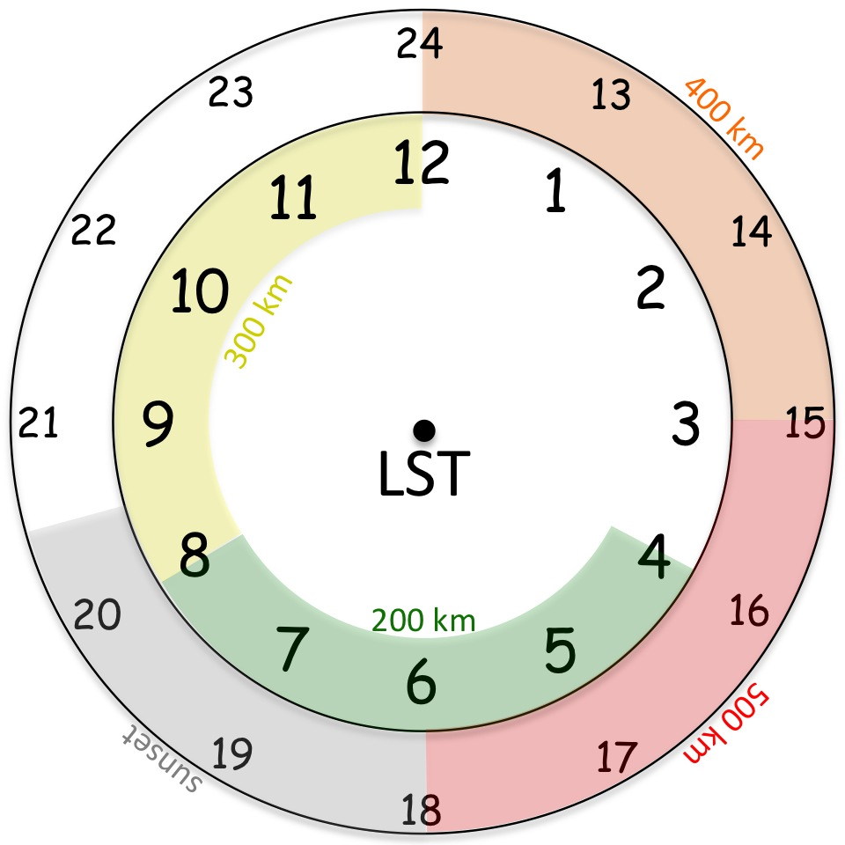
Fig. 1. Conceptual 24-hr TC diurnal cycle clock that estimates the radial location of TC diurnal pulses propagating away from storm.

Pattern: Any standard pattern that provides symmetric coverage (e.g. Rotated Figure-4, Figure-4 butterfly, etc.). Leg lengths should be adjusted as needed to ensure that the aircraft perpendicularly crosses TC diurnal pulses that are indicated by satellite imagery and/or the P-3 LF radar.
Flight altitude: 10-12 kft or as high as possible to provide better vertical sampling by GPS dropsondes that are deployed.
Leg length or radii: Standard leg lengths (105 n mi), but legs should be extended as needed to ensure that the aircraft perpendicularly crosses TC diurnal pulses that are indicated by satellite imagery and/or the P-3 LF radar.
Estimated in-pattern flight duration: ~2.5-5.0 hr
Expendable distribution: Standard distribution of GPS dropsondes except increased density of ~15-20 nm (30-35 km) spacing just ahead of, within, and behind the diurnal pulse convective features that will be identified in real-time using satellite imagery and/or the P-3 LF radar (10-25 GPS dropsondes total). AXBTs are not a mission requirement.
Instrumentation Notes: Use TDR defaults. Use straight flight legs as safety permits.
G-IV Module 1 (Optional coordination with P-3)
What to Target: Sample the near and peripheral environments of the TC.
When to Target: Any strength TC (though TC diurnal cycle signals tend to be stronger in Cat2+ storms); no land restrictions. There are time restrictions for this experiment: in-storm sampling should occur in the time window from approximately 0800-1500 LST during the middle to late stages of the TC diurnal cycle when the TC diurnal pulse is located between R~200-400 km (~105-215 nm). Approximate radial locations of TC diurnal pulses relative to local time are shown in Fig. 1. If possible, this G-IV module should be conducted in coordination with P-3 Module.
Pattern: G-IV Star Pattern (with circumnavigation [optimal], without circumnavigation [minimal]). Leg lengths should be adjusted as needed to ensure that the aircraft perpendicularly crosses TC diurnal pulses that are indicated by satellite imagery and/or the P-3 LF radar (if available).

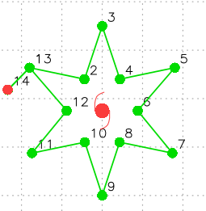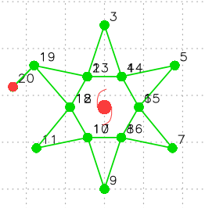

Flight altitude: 40–45 kft
Leg length or radii: 190-215 nm (350-400 km) for the outer points and ~60-90 nm (110-165 km) for the inner points. If a circumnavigation is being performed, a constant radius [typically 60-90 nm (110-165 km)] should be selected. Selection of the inner points and circumnavigation radii should be as close to the edge of the inner core convection as possible (this distance will be dictated by safety considerations) and will require coordination between the HRD ground-based LPS and the G-IV flight director.
Estimated in-pattern flight duration: ~4 hr without circumnavigation and ~5.25 hr with circumnavigation
Expendable distribution: Standard plus mid-points of Star Pattern (25-31 GPS dropsondes total) except increased density of ~15-20 nm (30-35 km) spacing just ahead of, within, and behind the diurnal pulse convective features that will be identified in real-time using satellite imagery and/or the P-3 LF radar.
Instrumentation Notes: Use TDR defaults. Use straight flight legs as safety permits.

