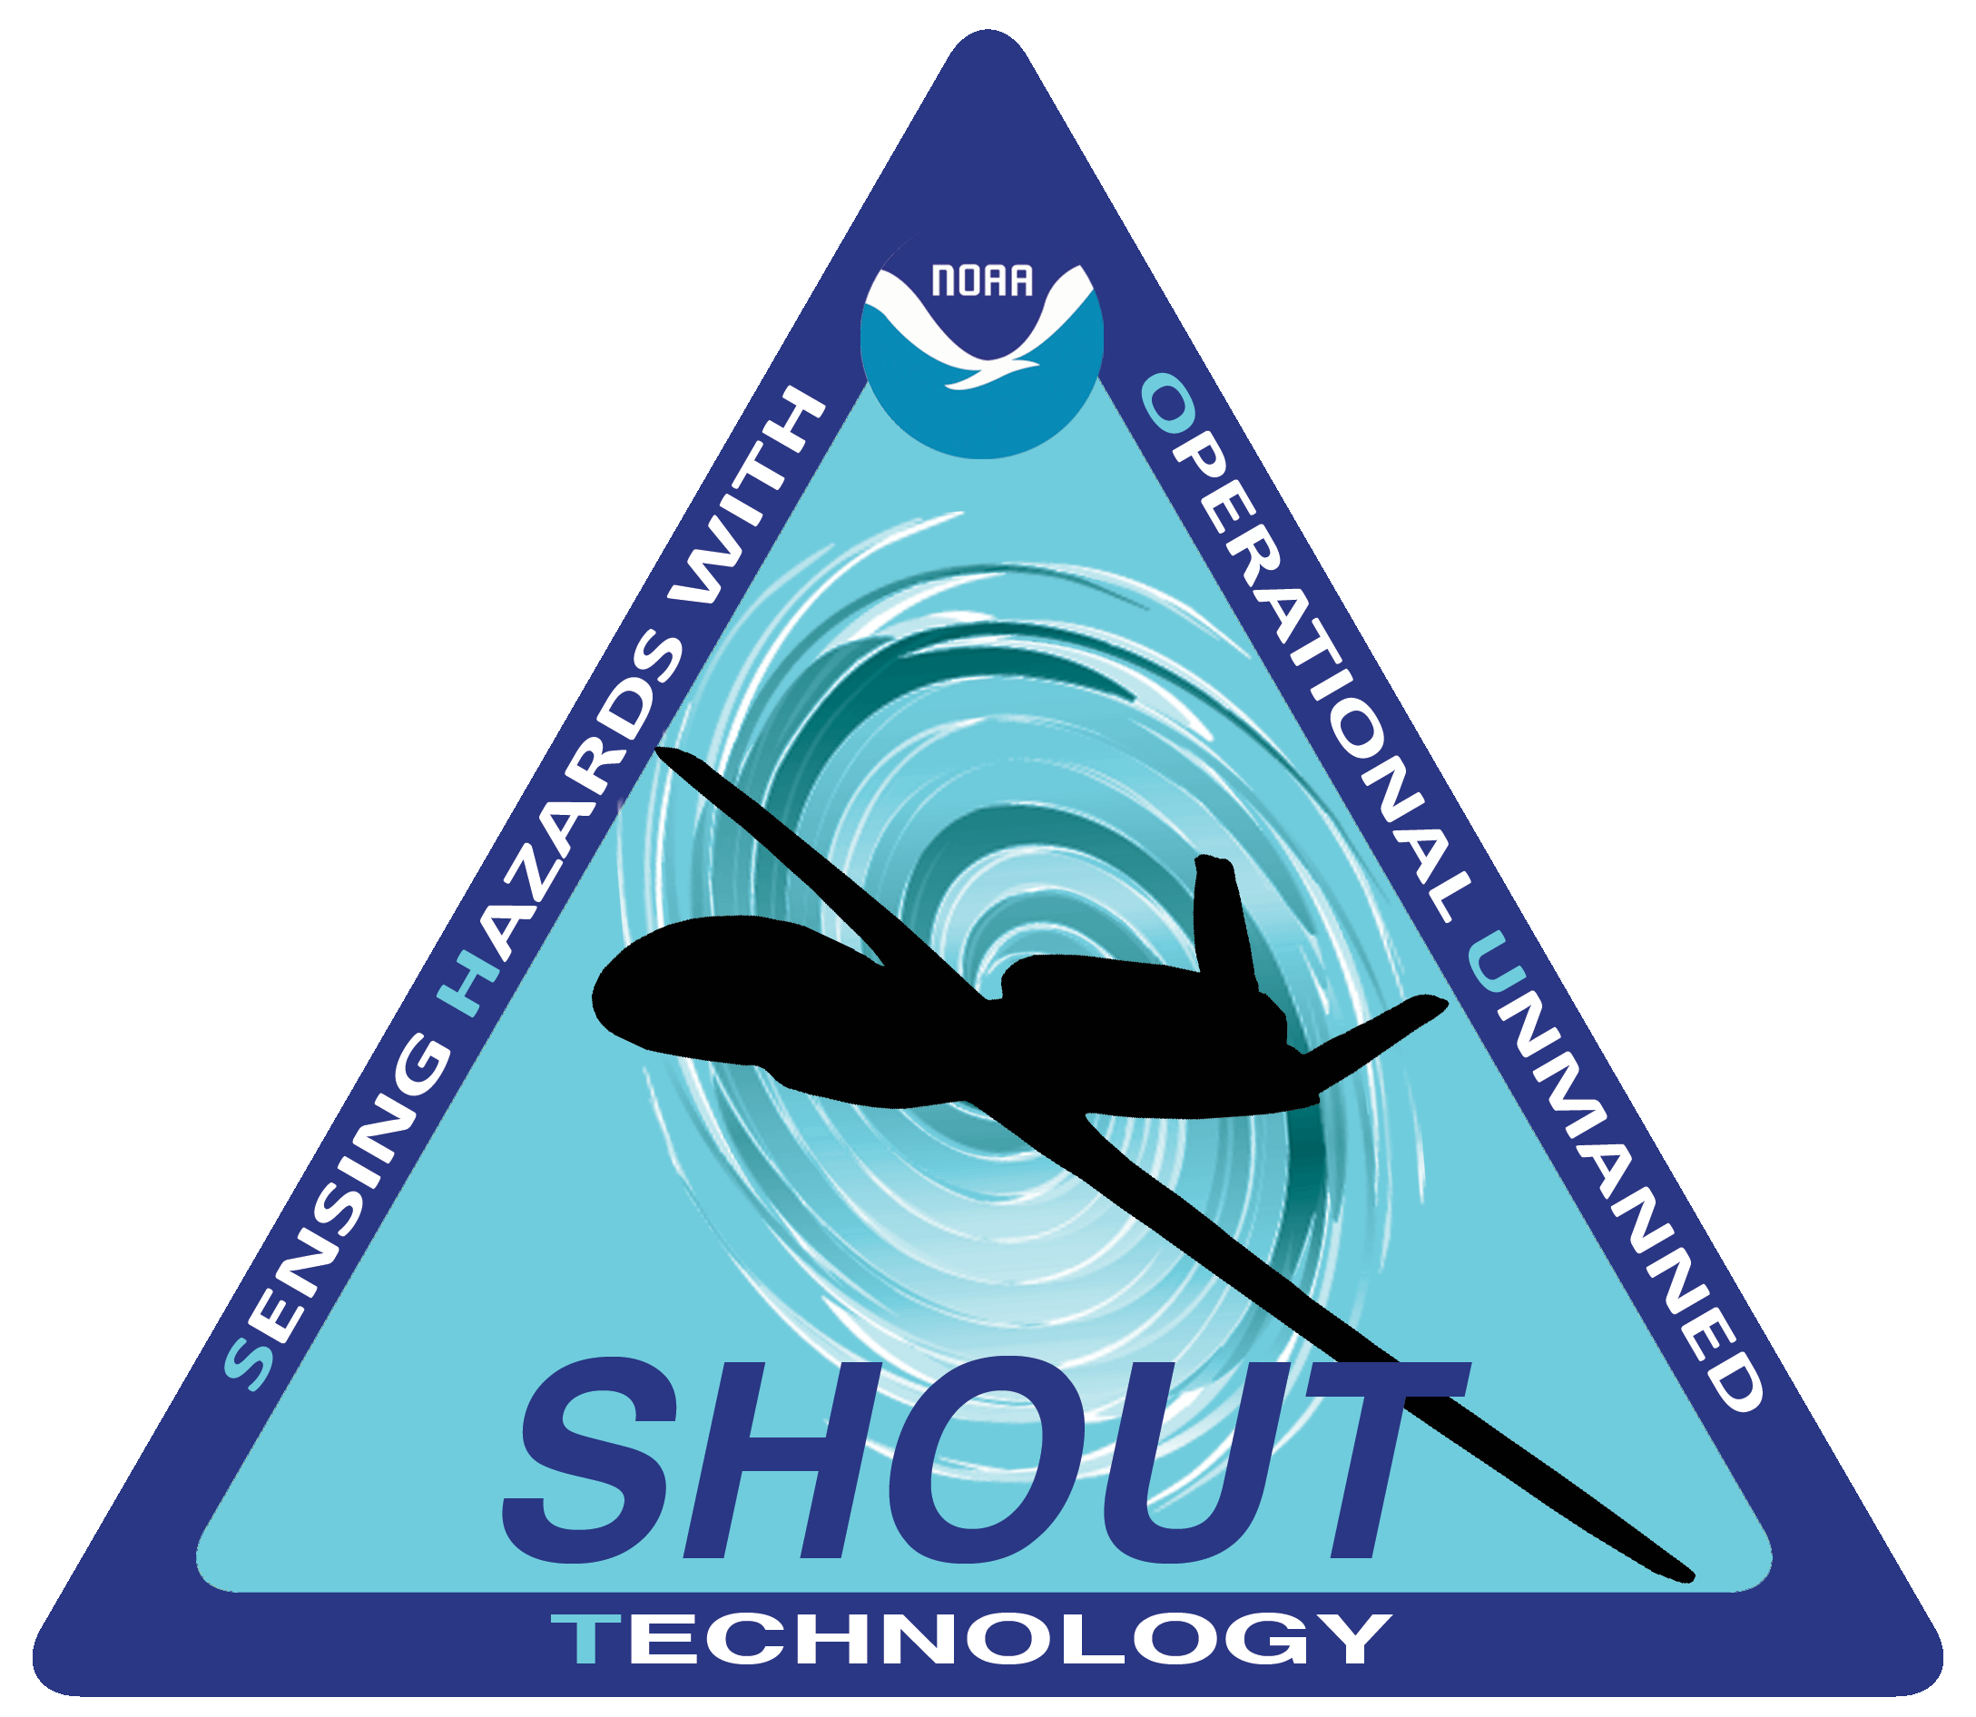

SHOUT
Hurricane Rapid Response
Mission Operations Plan
2016

1. SHOUT SCIENCE OVERVIEW 4
1.1 Identification of Problem 4
1.2 Science Objectives 6.
2.0 PROJECT FACILITIES 7
2.1 Global Hawk Measurement Platform System Capabilities 7
2.2 Instruments 9
2.3 Wallops Flight Facility Operations 11
2.3.1 Runways 12
2.3.2 Tower/Fire and Rescue 12
2.3.3 Airspace Restrictions 13
2.3.4 WFF Weather capabilities 14
2.3.5 Chase Aircraft 15
2.3.6 Hangar D-1 15
2.3.7 Aircraft: Safety 15
2.3.8 Security/ Badging 16
2.3.9 Facilities - Housing 16
3. AIRCRAFT FLIGHT OPERATIONS 16
3.1 Flight planning terms and rules 16
3.1.1 Definitions 16
3.1.2 Daily schedules 17
3.1.3 Flight planning constraints and basic strategies 19
3.1.4 Country Clearances 25
3.2 GH sampling strategies 26.
3.2.1 Basic flight patterns 26
3.2.2 Add-on modules 31
3.3 Over-storm GH sampling strategies 34
3.3.1 Hazard Avoidance Manuevers 34
3.3.2 Determining when to use inner core and convective-burst modules………………………35
3.3.3 Hazard avoidance 36
3.4 Mission Tools Suite (MTS) 42
3.4.1 SHOUT Communications 44
3.4.2 Mission Dashboard 44
3.4.3 Instruments 47
3.4..4 Documents ………………………………………………………………………………………………..…47
4. SHOUT OPERATIONS CENTER (SOC) 48
4.1 Functions of the SOC 48
4.2 Location and layout of the SOC 49
5. SCIENCE MISSION PLANNING PROCESS 59
5.1 Mission scientists’ roles and responsibilities in the SOC 54
5.2 Forecast planning process 60
5.3 Mission selection 59
5.4 Flight planning requirements and interaction with GH pilots 60
5.5 Notification of CARCAH and other agencies 60
5.5.1 Format of the Plan of the Day (POD) input for CARCAH 60
5.5.2 Submittal of the POD and flight plans 66
5.5.3 Daily teleconference with NOAA 62
5.6 Mission Science summaries 62
5.6.1 Daily written reports 62
5.6.2 Daily mission science calendar 63
5.7 Flight reports 63
6. SHOUT GHOC-E OPERATIONS 64
6.1 The GHOC 64
6.1.1 Interior layout 69
6.1.2 Environment 70
6.2 Operations 71
6.3 Mission science and instrument team duties 66
6.4 Requesting changes to the flight plan 66
7. REFERENCES 68

1. SHOUT OVERVIEW

Targeted observations from aircraft in oceanic regions have the potential to improve how well weather models forecast significant meteorological events such as tropical storms, winter storms and major floods. The long duration and large oceanic areas that can be observed using advanced Unmanned Aircraft Systems (UAS) such as the Global Hawk make this an important potential observing platform. The National Oceanic and Atmospheric Administration (NOAA) UAS Program will work with the National Aeronautics and Space Administration (NASA) to conduct missions using advanced UAS to determine their utility in prediction of dangerous storms that can affect the United States. This effort to sense hazards with operational unmanned technology will determine the observing strategies and quantify the contribution that advanced UAS can make to mitigate the satellite data gap.

1.1 Identification of the Problem

Environmental data from satellites have become critically important to the delivery of accurate weather forecasts for the nation. This criticality has become so significant that potential gaps in satellite environmental observations are expected to diminish the quality of the nation’s weather services and reduce the effectiveness of emergency preparations for high impact weather events. The National Weather Service (NWS) is now assimilating vertical atmospheric temperature and moisture profiles from the National Polar-orbiting Partnership (NPP) satellite into the NWS operational global forecast models. Thus, any future problems with NPP data delivery or delays in launching the NPP follow-on satellites (i.e. Joint Polar Satellite System (JPSS)) will create vulnerability for the nation’s weather services. To offset this threat, the U.S. Congress included $111 million in the Disaster Relief Appropriations (DRA) Act of 2013 to test and evaluate options to mitigate the risk of potential polar-orbiting environmental satellite observing gaps. One of the options funded by the DRA Act is the development and testing of a targeted observations project using unmanned aircraft systems (UAS) to collect vertical atmospheric observations and other crucial environmental information to assist weather predictions of high impact weather.

This option is feasible because NASA and NOAA have demonstrated that Global Hawk UAS can overfly storms in the Atlantic, Pacific, and Arctic Oceans and deliver real-time vertical atmospheric profiles and environmental data to scientists. NASA Global Hawk UAS payloads have included infrared and microwave sounders similar to the Cross-track Infrared Sounder (CrIS) and the Advanced Technology Microwave Sounder (ATMS) flown on NPP to provide vertical atmospheric profiles of temperature and moisture for the NWS. CrIS and ATMS data are currently assimilated in the operational National Center for Environmental Prediction (NCEP) Global Forecast System. Environmental information collected by a UAS cannot completely replace the global coverage of a satellite data. However, the long endurance and long range of a Global Hawk UAS does provide new capabilities to reach and stay with high impact oceanic weather events that previously were best observed by satellite. These new observing capabilities may improve high impact weather forecasts even further by providing a valuable augmentation to satellite environmental observations that currently do not include wind profile information.

The NOAA UAS Program has designed a project focused on “Sensing Hazards with Operational Unmanned Technology (SHOUT)” to quantify the influence of UAS environmental data to high impact weather prediction and assess the operational effectiveness of UAS to help mitigate the risk of satellite observing gaps. The NOAA UAS Program will partner with NASA to conduct missions using advanced UAS for operational prototype data collection.

The SHOUT project will begin with a targeted observing effort using NASA Global Hawk platforms and payloads for observing and predicting high impact oceanic weather. As the project matures, other viable unmanned observing technologies may be incorporated into the observing strategies tested as operational prototypes. This mission operations plan outlines the overall SHOUT science objectives and the operations plan for the first phase of SHOUT exploring the impact of observations from the Global Hawk on forecasts of tropical cyclones and hurricanes.

During SHOUT 2105 and SHOUT El Nino Rapid Response 2016 knowledge and confidence was gained in conducting these missions that a move towards a more operational footing was warranted.

In order to optimize opportunities for targeting Tropical Cyclones in 2016 and mitigate the risks associated with a short campaign, SHOUT will adopt more of an operational footing. This will require a creative approach to staffing and operations not previously used during Global Hawk missions. This approach will advance the transition to operations and address staffing and funding efficiencies. Teams will be released when there is no storm on the horizon (per/diem savings vice air tickets). SHOUT will also reduce staffing during operations for mission science and instrument teams.
August 1-September 30, 2016 Mission Ready Rapid Response Standby
- AFRC until deploy for storm
  - On call at AFRC Aug 1-11
  - No deployment on site to WFF before Aug 12
- Option to fly Gulf Storms from AFRC until deployment to WFF
- Schedule required for standby crews prior to release

1.2 Scientific Objectives

The NOAA UAS Program and the Office of Marine and Aviation Operations (OMAO) have collaborated with the Airborne Science Program of the NASA Earth Science Division since 2008 to demonstrate and evaluate UAS flying at high altitudes (i.e. > 50,000 feet) and low altitudes (i.e. < 18,000 feet) for scientific environmental data collection. The Global Hawk UAS collaboration has been particularly successful. The NOAA UAS Program has contributed funding and science support while OMAO has contributed aviation personnel support to the first Global Hawk missions carrying Earth science payloads over the Pacific and Arctic Oceans. NOAA and NASA have also collaborated with the National Science Foundation and the National Center for Atmospheric Research to successfully retrieve in situ vertical atmospheric profiles of temperature, pressure, moisture, wind speed, and wind direction using dropsondes released from the Global Hawk Airborne Vertical Atmospheric Profiling System (AVAPS). NASA has also expanded the Global Hawk performance capabilities to overfly tropical cyclones with remote sensing payloads, to transmit data in real-time to science teams across the United States (US), and to launch missions from one US coast with the mission pilots located at a ground control center across the country on the other US coast.

These accomplishments have advanced the technology readiness of the Global Hawk UAS as a feasible observing platform for operational weather observations. In addition, the long endurance (i.e. > 24 hours) and long range (i.e. > 9000 nautical miles) of Global Hawk UAS offer increased capabilities for targeted observing strategies over the ocean designed to use upstream observations of developing storms to better predict downstream impacts with longer lead times. Thus, the overall goal of the SHOUT project is to demonstrate and test a prototype concept of operations for unmanned observing technology that could be used to mitigate the risk of diminished high impact weather forecasts and warnings in the case of polar-orbiting satellite observing gaps. To achieve this goal, the SHOUT project will have two main scientific objectives:

Objective 1 - Quantify the significance of unmanned observations to high impact weather prediction through data impact studies using Observing System Experiments (OSE) using unmanned observations collected during prototype operational field missions and Observing System Simulation Experiments (OSSE) based on expected unmanned observing capabilities.

Objective 2 - Quantify the cost and operational benefit of unmanned observing technology for high impact weather prediction through detailed analysis of life-cycle operational costs and constraints versus scientific benefit.

The SHOUT mission operations as planned in this document will be critical to collect the required observations to satisfy these goals.

2.0 PROJECT FACILITIES

2.1 Global Hawk Measurement Platform System Capabilities
The NASA GH is one of the first series of GHs built by Northrop Grumman Corp. for the U. S. Air Force and was first flown for science measurements by NASA in 2009. The GH length and wingspan are 13.4 m (44 ft) and 35.4 m (116 ft), respectively. It is capable of flight durations of ~24 h, a range of >20,000 km, and flight altitudes of 16.7-19.8 km. The GH’s ability to autonomously fly long distances at high altitude for extended periods of time and carry large payloads (up to 1200 lbs/545 kg) brings a new capability to the hurricane science community for observing remote locations over the tropical oceans not feasible or practical with other aircraft used for hurricane research and operations.
Normal autonomous control of the GH is conducted via the aircraft’s autopilot system using a preprogrammed mission plan. However, to accommodate the oft-requested changes in flight path by mission scientists, the pilot can alter the flight path at any time and conduct precise manual aircraft navigation with the insertion of custom “way points”. At all times, however, the aircraft is under the control of the onboard mission computer that ensures that the aircraft is under controlled flight. The aircraft takes off and climbs very rapidly to 15-km altitude during which time the instrument investigators check the performance of their instruments. It then gradually climbs to >19 km as it burns off fuel.
Dedicated satellite communication links provide researchers with direct access to their onboard instrument packages during missions. Instrument teams are able to monitor instrument function from the ground control station and evaluate data in real time. More importantly, the instruments can greatly aid flight operations in terms of targeting storm features and providing real-time data to the science leads.

Additional information is below:
Payload capacity: The GH has a maximum gross take-off weight (MGTOW) of 12,134 kg, including a 545 kg payload. From Table 2-1, the total environmental payload weight will be within the stated payload limit.

Instrument | Total Mass(KG) | Total Vol (m3) | Power (Avg/Peak) |  | POC | Payload Zone
 |  |  | DC (W) | AC (W)
Dropsonde | 54.4 | 0.286 | 150/500 |  | Hock/NCAR | 61/16
HAMSR | 49.9 (Instr),24.0 (faring) | 0.122 |  | 70/400 | Lambrigtsen/JPL | 3
HIWRAP | 93.9 | 0.566 | 800/1200 |  | Heymsfield/GSFC | 25/11,12,12,14,or 16.

Table 2-1. Instrument characteristics.

Center-of-gravity: The GH has a narrow center of gravity (CG) range. Fuel transfer between wing and fuselage during flight moves the CG - resulting in a very narrow CG range at takeoff. The weight and balance estimates for SHOUT payloads are within these CG limits. The recent addition of a rear ballast location provides fore and aft contingency options to meet CG constraints.
GH Operations Center (GHOC): GH aircraft and payload control occurs in the Armstrong Flight Research Center (AFRC) GHOC. GHOC has two adjacent rooms: a Flight Operations Room (FOR) and a Payload Operations Room (POR). The FOR contains the aircraft’s Ground Control Station (GCS) and 5 workstations for the command and control (C2) of the aircraft and other flight ops personnel responsibilities. The POR has 14 workstations to support payload and data displays. The GHOC also contains the Ground Payload command, control and communication (C3) System (GPCS), providing global Iridium-based narrowband and Ku-Satcom wideband communications links, data servers, and the associated network for payload C2 and data handling. The GPCS network is outside the AFRC IT firewall allowing PIs to use their own computers to communicate with their instruments. The GPCS server architecture includes an outward-facing server for dissemination of real-time instrument data to other computers. A duplicate of the GHOC has been built at the Wallops Flight Facility (WFF, and is referred to as GHOC-East) and was first used for the 2013 NASA Hurricane and Severe Storm Sentinel (HS3) campaign, 2015 SHOUT and will used again for the 2016 SHOUT Hurricane Rapid Response campaign.
Hazard avoidance equipment: Instrumentation will be flown on SHOUT flights to enhance safe flights near and over severe weather. A high definition camera, a day/night nose camera, and a storm scope provided severe weather detection during 2014 HS3. These instruments and the experience gained from these flights will provide the foundation for good situational awareness near severe weather.
Communications: A unique element of the GH Airborne Payload C3 System (APCS) is the independence of payload communications system from the aircraft communication system. The payload has the full bandwidth of the payload system’s satcom links and the use of payload specific comm protocols. The Iridium satcom links for airframe C2 and for payload C2 use analog phone lines connected to a distant commercial iridium satcom ground station, and also have a backup capability of using iridium antennas at WFF mounted above the lower roof level of Building D-1 where the GHOC-E is located. Thus, the instrument and science leads will be provided with real-time data from the SHOUT instruments during the missions. The GH has two bi-directional SatCom-based payload comm links. (1) A narrow-band system used for basic instrument health, status, and limited data snapshots (4 bonded Iridium links providing global coverage, and some limited instrument C2). (2) A wide-band Ku SatCom link that provides up to a 10MB/s data downlink capability (Ku-band uses commercial satellites). In the POR, instrument teams communicate over dedicated intercom headsets and PC Chat. Principal Investigators also communicate with science leads in the same manner.
On-board processing: The APCS has a high-capacity computer/data storage unit called the Link Module that is integrated with the Ku-Satcom system. All instrument data output onto the APCS Network is stored on the Link Module. Software with this system can perform on-board pre-processing of data prior to it being transmitted to ground servers.
Performance margins of all key flight systems and contingency plans: The GH C2 system uses redundant dual-bonded Iridium links to provide C2 and Air Traffic Control (ATC) communication to the aircraft. A separate Inmarsat SatCom link provides a third C2 and ATC communication link to the aircraft. The aircraft has a fourth C2 link using a UHF-band system while within line-of-sight of the GCS (at AFRC or WFF with the GHOC or GHOC E respectively). The APCS uses 4 bonded Iridium links and the Ku-band Satcom link for payload data comm. The GH also has a separate Master Payload Control System (MPCS) for independent control of individual instrument power, safety enable loops, and as a contingency connection to the APCS system. The MPCS uses 2 bonded Iridium links and is controlled separately by AFRC Mission Control personnel.
The reliability of the GH payload iridium links during the NASA Genesis and Rapid Intensification Processes (GRIP) Mission was very good, with average outages less than 5 minutes and correlated to the passing of a poorly performing Iridium Satellite. This experience was due to the GH APCS system design using the latest hardware and software developments and experience from other AFRC aircraft to provide as reliable a low-bandwidth Iridium solution as possible. Recent testing has demonstrated that the 4-channel Iridium system used with the GH APCS has a 95% reliability with a reconnect downtime of approximately 1.5 minutes. The reliability of the GH wideband Ku-system is excellent when the aircraft is within the footprint of the contracted commercial satellite.
From a contingency standpoint, if the aircraft’s flight control system were to lose all communications with the GCS, an aircraft-based Lost Link Timer initiates which, if the timer times out, will ultimately protect the aircraft with an automatic return to base. The Lost Link time period is programmable by the pilot and varies depending on which stage of the mission the aircraft is in. Resumption of GCS communications resets the Lost Link Timer system on the aircraft. The payload comm (operating independently from aircraft systems, and employing a dedicated payload power bus on the aircraft) would continue to function in the event of a lost link contingency. If the payload system goes into “lost link” for a period of 45 minutes, the MPCS system will, as required by the FAA, automatically disable dropsonde functionality until communication is restored.

2.2 Instruments

2.2.1 Payload

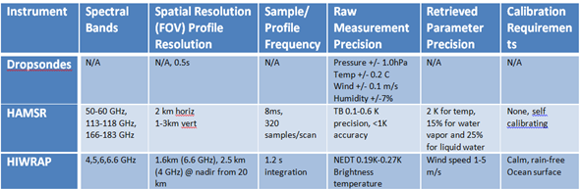

Table 2-2. Instrument characteristics.

Dropsondes: The Airborne Vertical Atmospheric Profiling System (AVAPS) dropsonde (details in Table 2-2) has been used for hurricane research (NASA, NOAA, and the USAF hurricane reconnaissance program) for several decades (Hock and Franklin 1999; Halverson et al. 2006). Dropsondes provide the only in situ, high vertical resolution profiles of basic atmosphere state variables – temperature, pressure, humidity and winds. The GH dropsonde system was built by the National Center for Atmospheric Research (NCAR) and has an 88 sonde capacity. An ER-2 dropsonde system was successfully deployed for CRYSTAL-FACE and CAMEX-4, providing the heritage for GH operations. The GH dropsonde system was successfully flown during the NOAA WISPAR campaign in Feb-Mar 2011 and HS3 in 2012-2014. The dropsonde system is being upgraded structurally to improve reliability for the 2016 SHOUT HRR campaign..
High-altitude Imaging Wind & Rain Airborne Profiler (HIWRAP): HIWRAP (see Table 2-2) is a dual-frequency (Ku- and Ka-band, or ~14 and 35 GHz), dual-beam (30° and 40° incidence angle), conically scanning radar that has been designed for the GH (Heymsfield et al. 2008). HIWRAP uses solid-state transmitters along with a novel pulse compression scheme that results in a system that is considerably more compact and requires less power than typical radars used for precipitation and wind measurements. By conically scanning at 10-20 rpm, its beams will sweep below the GH collecting Doppler velocity/reflectivity profiles, yielding the 3 wind components. The unique HIWRAP sampling and phase correction strategy implemented (frequency diversity Doppler processing technique) will be used to de-alias Doppler measurements. HIWRAP’s dual-wavelength operation enables it to map full tropospheric winds from cloud and precipitation volume backscatter measurements, derive information about precipitation drop-size distributions, and estimate the ocean surface winds using scatterometry techniques similar to NASA’s QuikScat. Winds will be retrieved using a gridding approach similar to well-established ground-based multi-Doppler radar wind analyses.
High Altitude MMIC Sounding Radiometer (HAMSR): HAMSR (see Table 2-2) is an all-weather atmospheric sounder which was designed and built at the Jet Propulsion Laboratory (Brown et al. 2007). HAMSR will monitor the atmospheric state by retrieving 3-dimensional profiles of temperature, water vapor and cloud liquid water. The measurements can also be used to estimate precipitation rates and provide information on hydrometeor distributions. HAMSR has 8 channels near the 60 GHz oxygen line complex, 10 channels near the 118.75 GHz oxygen line and 7 channels near the 183.31 GHz water vapor line. HAMSR scans cross track below the GH and has a ±45° field of view. HAMSR was first deployed on the ER-2 in the 2001 CAMEX-4 campaign and subsequently participated in the TCSP experiment in 2005. HAMSR also flew on the DC-8 during the 2006 NAMMA campaign. HAMSR was recently upgraded to deploy on the GH platform. The effort included a state-of-the-art low noise amplifier for the 183 GHz receiver, an upgraded data system capable of onboard science processing and real-time communication with the GH data network, and a re-designed instrument packaging concept to consolidate the power, data, thermal and receiver sub-systems into one compact housing. These upgrades reduce mass, improve performance and reliability, and reduce field maintenance. The new receiver has an order of magnitude better noise performance than the old receiver. HAMSR was flown on the GH during GRIP, WISPAR, and HS3.

2.3 Wallops Flight Facility Operations
The 2016 SHOUT HRR deployment will take place prior to the peak hurricane season in order to maximize flight opportunities with science flights scheduled to begin 1 August through 27 September 2016. The Wallops Flight Facility (WFF) is the SHOUT deployment site and Kennedy Space Center (KSC) is an emergency divert site should the GH be unable to land at WFF. Wallops has three land parcels called the Main Base, the Mainland, and Wallops Island. Wallops is located at a latitude of 37° 25.8´N, longitude of 75° 28.0´W, and. WFF is on the mainland and the rocket launches are conducted from Wallops Island. Chincoteague is the nearest town (Figure 2-1).
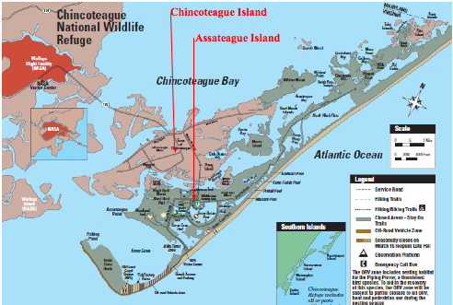
Figure 2-1. Map of the Chincoteague and Assateague region.

2.3.1 Runways
The GH will have exclusive use of the airfield during take-off and landing. Therefore, taxiways or the end of runways can be used to stage the aircraft for the 2 hours prior to take off. WFF will provide a chase vehicle. AFRC personnel will be provided radios and will communicate with the tower in real-time as needed. The ground crew will be provided training for driving on the ramp. The runways have had the lights and signs lowered when they supported ER-2 ops so, upon inspection, no obstructions were noted. There is space at the end of the runways for the GH to turn around and no turning radius issues were noted. Taxiways are 80-85 ft wide and the GH can be towed (with wing walkers) to the staging site. WFF runways (Figure 2-2) are 4-22 (150 ft wide and 8750 ft long), 10-28 (200 ft wide and 8005 ft long) and 17-35. Runway 17-35 is too short to be used so there are 4 runways available to the GH. Runway 10-28 has a 0.65 deg incline (17’ incline over 1500ft) at the approach end of runway 10 (Figure 2-3 and 2-4). An evaluation was performed and confirmed that this part of the runway is useable for GH takeoffs and landings. Runway 04-22 has a barrier that will be taken down for SHOUT Ops.
Runway 04-22 has an arresting gear cable that will be derigged during SHOUT departures and approaches. It should not be called a “barrier” since the GH could potentially roll over it without any problem, but with a risk that it could potentially damage the GH landing gear.

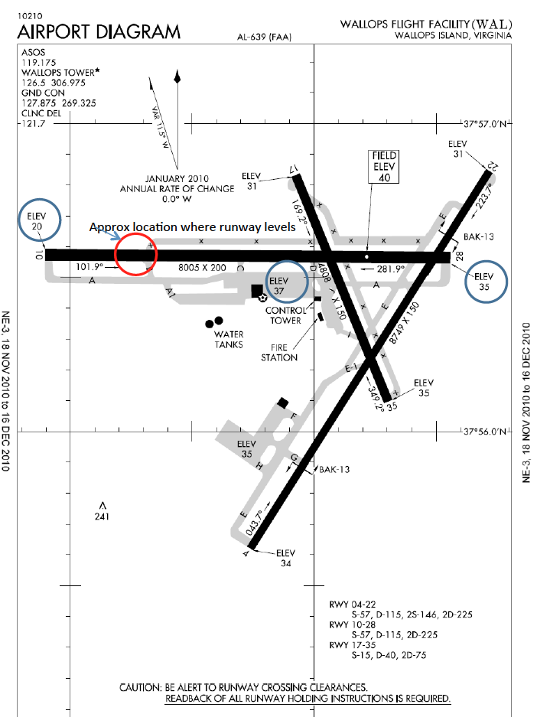
Figure 2-2. Maps of the WFF runways.

2.3.2 Tower/Fire and Rescue
Local radar data video feeds are available for SHOUT use. There is also radar data from PAX River available. Air surveillance radar video is available in the GHOC-E from the SureTrak video that is provided to the right-hand position in the GHOC-E Flight Operations Room (FOR). There are control terminals for intercoms with 100-200 channels that may also be available to SHOUT.
Tower hours are M-F 7-5 pm but personnel can be called in as needed. A tower controller is available to SHOUT, but would remain in the airport tower. The tower has an integrated radar display (SureTrak) that is also capable of skin tracking local aircraft that do not have transponders. The SureTrak radar data is an integration of several sources including the local radar, ASR-8 located on Wallops Island. It is common practice for local VFR pilots to notify the WFF tower when they will be in the area so the number of unexpected intrusions into the airspace during normal operating hours are believed to be only 1-2 times per year. There is also very little traffic between 7-9 am. Closed field Ops (operating without tower support) is not usually done at WFF. This would have to be something that would need to be reviewed with the Test Directors Office. When SHOUT has completed their Go/No-Go constraints they should indicate whether or not tower operations are required. Prevailing winds in August are from the East. Flight plans can be filed at Base Ops or through the tower, if requested. SHOUT will have initial flight plans 48 hours in advance and detailed plans 24 hours in advance.
Fire and rescue support is 24/7. Arrangements will be made for tours when the GHs arrive so the crews can become familiar with the aircraft and any associated hazards. Information can also be provided in advance. Standard operations are that a fire truck will be dispatched to the runway for each take off and landing.

2.3.3 Airspace Restrictions
Line of sight UHF (225-400 MHz) is required for GH command and control. Frequency assignments for the GH UHF and other on-field communications will need to be coordinated with the WFF Spectrum Manager.
Launch conflicts will be worked on a case-by-case basis. Sounding rockets take off 6-10 times per year, Antares eight times per year and occasionally the Minotaur 1. SHOUT can be provided with the schedule for Aug/Sept. The launches have 2-3 hr launch windows and, if possible, GH can take off around the restricted launch area. WFF will provide the trajectory and launch hazard area for typical rocket launches so GH can take this into consideration when planning the standard take off route. GH take off planning will work around scheduled rocket launches; however, in the case of an emergency Return to Base (RTB), a rocket launch can be delayed to allow a safe GH landing. An Antares launch is planned for late August 2016 and may impact lodging availability.
WFF is the emergency divert site for PAX River’s GHs. Although highly unlikely, there could be two GHs needing support for RTB if PAX River and NASA GH have concurrent operations. WFF will notify PAX of the NASA operations and will be aware of any RTBs because PAX must ask WFF for support when this occurs. Also, if the GH has RTB due to lost link, it has redundant UHF line-of-site links so when the GH approaches WFF, at about 150 miles out, the UHF link would be established and landing timing could be controlled.
WFF airspace (R-6604) (Fig. 2-3) would be scheduled with the Test Director’s Office. The plan would be to schedule it for the entire SHOUT stay and then just release the airspace to the FAA when GH is not using it.
The WFF Test Director’s Office will be the point of contact for the Navy-controlled airspace Virginia Capes Operating Area (VACAPES). They will include the GH pilots in discussions regarding the best scenario for reserving VACAPES airspace (Fig. 2-4). AFRC will provide climb and decent data [altitude, time (approx. 30-45min), speed (3500-4000ft/min) and nautical-mile gradient].
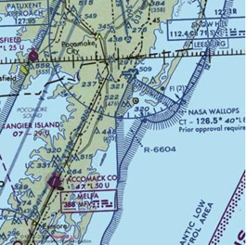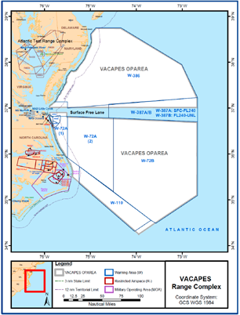
Figure 2-3. WFF Airspace Figure 2-4. VACAPES Flight Range

2.3.4 WFF Weather capabilities
WFF has an in-depth weather and safety program due to their frequent launches. They can provide a standard aviation weather briefing for the mission duration (approx. Aug 12 to Sept 30). WFF has many capabilities SHOUT can take advantage of such as Leading Environment Analysis and Display System (LEADS), that combines satellite and radar information, an S-Band radar called SPANDAR that has a 200 nautical mile range), and two deployable radars (NPOL and Toga). WFF can provide weather data and closed circuit TV that can be fed into the GHOC-E as needed. WFF has lightning detection (LDAR) and 7 field mill systems as well as an ASOS system on the web used by the National Weather Service. In addition, the NASA has a 300 ft wind tower that uses two 25000 ft weather lasers. Weather balloons are launched every day (0Z and 12Z) by NASA to measure winds aloft for NOAA.

The Meteorology office, located in Building E106, is open M-F 7:30 am to 4:30 pm, but can be open at other times if necessary. WFF can provide someone on call when the plane is in the air. The Meteorology office usually provides 10am and 2 pm briefings M-F, but can provide weather briefings with advanced notice, in person or by WebEx or closed circuit TV. SHOUT has weather and modeling support for research areas but would appreciate the Meteorology office support for local weather for T-1 hr pilot briefings and support at takeoff and landing. SHOUT will generally provide its own weekend weather support the mission but will require a TAF from WFF prior to COB on Fridays.

2.3.5 Chase Aircraft
WFF is working to expand their restricted airspace, as it does not currently encompass the WFF runway approach and departure paths. The NASA GH operating at Wallops must climb and descend in a Special Use Airspace warning area called W-386, which is controlled by the U.S. Navy’s VACAPES organization, or provide Equivalent Level of Safety to “see and avoid”. The currently approved solution requires the use of a Chase Aircraft. Airtec will provide contract chase support from St. Mary’s Airport, MD using a Beech Baron Aircraft. Chase procedures will be worked out prior to the mission but are expected to mimic what was used during HS3 and SHOUT 2015. Chase would follow the GH anytime it is below 18,000ft altitude and outside VACAPES airspace.

Day and Night operations are permitted through the COA. Area chase to clear airspace is effective at night, however the GH will generally plan to take off and land during daylight hours for standard operations. An unplanned RTB could potentially occur at night without chase where the GH pilots, who will be the point of contact for SHOUT with the FAA, will work with the FAA to land, in an emergency situation. The WFF tower does have a FAA certified ASR-8 radar and will submit a Notice to Airmen (NOTAM) for unmanned operations in the area of Wallops, VA. Chase operations may be conducted day or night in visual meteorological conditions with an operating control tower and dedicated visual observer on the ground. If an emergency RTB is required, the landing will be conducted at the discretion of the pilot in command. If there is a non-emergency RTB, then the aircraft will hold in W-386 until appropriate personnel are in place.

2.3.6 Hangar D-1
SHOUT will use the hangar and office facilities in D-1 as laid out in Section 4.2. All the spaces in the South wing first and second floors that are reflected in this document have been confirmed for use by SHOUT for mid-August through 30 September 2016. The D-1 hangar is not big enough to support the GH, NASA P-3 and a NAVY project until the NAVY departs 11 August. Space will be constrained until the NAVY deployment departs. GH will arrive no earlier than 12 August and will share hangar space with the NASA P-3 until its departure on 18 August.

There is sufficient parking on the south and D-1 is close to the cafeteria. Cell phone coverage is still an issue at WFF. BRIC radios will be provided again this year to ensure aircraft / hangar communications. SHOUT will have 24hr access and will address security issues regarding access and COMSEC limitations

There are doors on either end and doors open all the way.

2.3.7 Aircraft: Safety
When AFRC has a UAV flying in the range, a Range Safety Officer (RSO) must be on duty to oversee safety and has authority to cancel the flight if needed. The RSO is on duty when the GH is in the range and has access to radar displays. WFF has an Operational Safety Supervisor (OSS) who ensures safety procedures are being followed. The OSS is focused on ground safety and AFRC personnel, with a little local WFF training, can fill this role. WFF will provide a safety person (RSO) who will ensure institutional safety. WFF does not have a TECASS display but does have a SureTrak display. The SureTrak display can be sent to the GHOC-E as well.

WFF will provide safety briefing materials regarding the WFF hangar safety, local ops and local area. An All Hands presentation regarding safety and project operations will be viewed by all participants. This presentation is recorded and each SHOUT team member is asked to view the DVD upon arrival. COMSEC briefings need to be done annually at both AFRC and WFF. ESPO will coordinate and announce COMSEC briefing opportunities as teams arrive.

2.3.8 Security/ Badging
The GH is unclassified so there are no restrictions on pictures of the aircraft; however, due to ITAR restrictions, no photos of the GH should be taken if the aircraft has open panels unless the taking of such photos are approved by AFRC management. The area will be roped off and access to the aircraft itself restricted.
SHOUT/AFRC will be collecting PI information for AFRC and WFF badging in their PI database. Excel products can be customized and access given to WFF to allow them to export an access list. Foreign Nationals from can be given 24/7 access but must be escorted by someone with a permanent NASA badge (civil servant or contractor). Escorts must have Foreign National escort training. Badging level takes more effort if the stay is greater than 30 days. For SHOUT, the stay at WFF will be approximately 60 days and the two stays at AFRC (integration and de-integration) will span greater than 30 days. Therefore, temporary badges will be requested for the 30-180 day type. Access to the hangar and many of the labs will require card reader permission. The badging list will also be used as the basis for the WFF card reader access list.

2.3.9 Facilities - Housing
Local housing is limited near WFF and finding rooms at per diem may be difficult for the end of the summer season. SHOUT has posted hotel options on the http://uas.noaa.gov/shout/ website under lodging. There are nearby Federal wildlife areas and ocean beach areas to explore and the ocean/surf/back bay fishing is great.
3. AIRCRAFT FLIGHT OPERATIONS
3.1 Flight planning terms and rules
In 2016, SHOUT HRR will have 8 - 24 hour flights approved including 8 hours for 1 aircraft range flight, 20 hours for the transit of the GH both to and from WFF, and 196 hours for science (approx. 8 flights over 8 weeks). There are several key items to note for 2016:
• The plan is that pilot shifts will be split between AFRC and WFF.
• Successive GH flights will require approximately a 24-hour turn around time between landing and takeoff. Following completion of a flight, the GH will not be able to takeoff again any sooner than the following day. Assuming the aircraft lands between 7-9 EDT, it should be possible to takeoff again around 7 EDT the following day.
• A hard down day for GH crew will be required after seven consecutive days of operations. This implies a maximum of three consecutive flights with hard down days before the first and after the last. A hard down day implies a 2-day gap in actual flights since preflight cannot be done on a hard down day.
• The project will coordinate flight with the European NAWDEX Project which will operate several aircraft from Iceland between 19 September – 16 October 2016.
Overview - North Atlantic Waveguide and Downstream Impact Experiment (NAWDEX) is an international field experiment with the overarching scientific aim of increasing the understanding and effects of diabatic processes on disturbances to the jet stream near North America, their influence on downstream propagation across the North Atlantic, and consequences for high-impact weather in Europe. One of the key interests of NAWDEX is to enhance the understanding of upstream perturbations such as tropical cyclones (TCs) undergoing extratropical transition (ET) that lead to waveguide changes.

Instrumentation – NAWDEX will include the German DLR Falcon, the French SAFIRE Falcon, the Canadian King Air, and the European G-V HALO flying out of Iceland, as well additional ground based instruments and radiosondes positioned in Canada and Europe. Instruments to be used include a cloud radar, Doppler wind lidars, dropsondes, and radiometers. Of most interest to NCEP, NAWDEX will deploy an average of about 7 dropsondes from each flight of the European G-V HALO, which has a duration of 8-10 hours, a range of ~8,000 km, and a maximum altitude of 15.5 km.

Region of operations – The NAWDEX region of operations will be centered upon Iceland and cover Eastern Canada, the North-Central Atlantic south to about 40N, and all of Northern and Western Europe.

Representatives from the NAWDEX program will be invited to the group telecons and planning calls. They will be on the SHOUT list serve as well.

3.1.1 Definitions
Alert (the decision to ask the pilots to prepare for an upcoming flight date)
The Alert decision is made no later than 48hrs prior to the flight. Notification must be before 1500Z (0800 PDT, 1100 EDT) daily. A notional flight region with specific Flight Information Regions (FIRs) is required at this time. A detailed flight plan with drop locations is required to be submitted prior to 24hrs (1330Z; 0630 PDT, 0930 EDT). Small changes to the detailed flight plan can be made up to 3 hours prior but any changes after that and during the flight are real-time conditional with ATC concurrence. Flight pattern and dropsonde configurations would stay basically the same as the T-24hr plan but some changes such as adjustments for storm center or length of legs can be made. It is recommended that flight plans be designed to include predicted storm motion so plans are as close to actual as possible.
*** This assumes no country clearances require notice prior to these times or that formal country clearances are not required (see Section 3.1.4). ***
Go-No go (the decision before flight regarding the alerted aircraft flights)
A Go-No go science decision is made no later than 15 hrs prior to the flight (before flight support crew goes off shift (e.g. by 0800Z (0100 PDT; 0400 EDT) for a 1100Z; 0400 PDT; 0700 EDT take-off the next day). A Go-No go decision is made when hazardous weather is expected at take-off and/or landing, critical instruments have discovered problems, or any other important issue is raised by the science leads.
Cancel (the decision to cancel a flight)
Flights can be cancelled at any time by the aircrew or science leads. For general purposes science should make the call no later than 4 hrs prior to takeoff. The aircraft crew has full authority to cancel at any time. Last minute cancelled flights may disrupt crew duty hours, and may require a clock restart. If a flight is cancelled for more than two consecutive days, or exceeds the 72 hrs preflight limit, the preflight will have to be redone. The preflight will also have to be repeated if engines have been started or any aircraft panel is removed for access (in some cases this can be waived; it is the decision of the crew chief).

3.1.2 Daily schedules

Table 3-1 lists the daily schedule during the deployment.
Time (Zulu) | Time (EDT) | Time (PDT) | Daily Activity
1230 | 8:30 AM | 5:30 AM | Local weather brief; Mission science weather brief; Mission science planning and status discussion; Go-no-go
1300 | 9:00 AM | 6:00 AM | NOAA IFEX mission science planning and status discussion; Go-no-go;
1400 | 10:00 AM | 7:00 AM | Deadline for POD Submittal to CARCAH & NOAA AOC; ncep.nhc.carcah@noaa.gov (cc: Jim McFadden, Paul Flaherty, Justin Kibbey, Rob Rogers, Paul Reasor, Jason Dunion, Michael Black, Gary Wick)
1400 | 10:00 AM | 7:00 AM | Interagency Coordination Call (SHOUT, IFEX,; Detailed flight plan (T-1) with dropsonde locations to pilots
1500 | 11:00 AM | 8:00 AM | Alerts for next several days out. Draft flight region for 48 hr (T-2) to pilots (cc CARCAH) – FIRs should be properly specified
1600 | 12:00 PM | 9:00 AM | NOAA HRD weather brief and planning (weekdays)
0000 | 8:00 PM | 5:00 PM | Mission planning updates as required

Table 3-1. Daily schedule.

3.1.3 Flight planning constraints and basic strategies

Flight Duration (Planned time from take off until landing)

Flight durations are not to be planned to exceed 26 hrs and should typically be planned for up to 24 hrs. Flight duration may be reduced during the mission if significant weather is forecast along return route to WFF or during landing time.

Flight Limitations (FAA restrictions)

Flight limitations are dictated by the particular COA issued by the FAA. They apply to specific FIRs. Global Hawk takeoffs and landings may be conducted day or night in visual meteorological conditions with an operating control tower and dedicated visual observer on the ground. Pilots will coordinate with chase plane or observers as needed. Because of the dropsonde system on AV-6, the FAA requires that we file a flight plan with dropsonde locations identified 24 hours before the flight. A NOATAM is issued for all dropsonde locations. During the 24 hours leading up to the flight and during flight, we may have limited ability to adjust the flight pattern or dropsonde locations. The flexibility for making changes may vary among different Flight Information Regions. Flexibility was demonstrated to be very good during HS3, but plans should be made as accurately as possible.

No-Fly Day (No flight activities planned)

No-fly days are non-flight days but allow PI access to the aircraft for installs / instrument access / checkouts during prescribed times.

Hard Down Day (No access to aircraft)

This is an aircraft crew no-work day and no access to the aircraft is allowed! No contact with pilots for flight planning is permitted. PIs may still work in their labs as needed. In 2015, aircraft crews will only be permitted to work 7 days in a row, with the 8th being a mandatory ‘hard down’ day. When there are quiet periods in the weather, a hard down day can be scheduled earlier to reset the clock and allow for intensive operations during active periods. Mission scientists should carefully consider these requirements in planning flight operations.

Crew Limitations (Workday standards)

Unlike HS3, SHOUT will only have one grouping of ground crew members at WFF. Aircraft crews are only permitted to work 7 days in a row with a maximum 60 hour work week. Hard down days will be necessary as noted above. To ensure the required ground crew are available when needed, instrument access with power on the aircraft should be scheduled during normal working hours.

FAA requirements

Note that the FAA requires that flight plans be submitted 2 business days in advance for their review. For Saturday, Sunday and Monday flights, that means that flight plans must be submitted by Thursday. At this 2-business-day deadline, the requirement is for boundaries of the flight region and inbound and outbound routes to be identified, with a more detailed plan 24 hrs before flight.

VACAPES Scheduling

Periods for access to the Virginia Capes (VACAPES) Operating Area must be scheduled in advance. Windows of 2-hour length can be scheduled outside of normal business hours (before 9 am) but only 1-hour blocks can be scheduled during the main part of the day. To preserve the greatest operating flexibility, accommodate normal potential takeoff delays, and keep the aircrew on as regular a schedule as possible, SHOUT will typically plan to schedule access to VACAPES between 7-9 AM EDT and employ a nominal takeoff time of 7 EDT.

Flight operation timeline (Operation timeline for planning only...Best possible case!)

Take offs and landings will be after official sunrise and before official sunset. A simplified operation timeline is provided below.

T-48 Alert Initial Flight Plan (Pilots requires 4 hrs before COB)

Instrument access

T-24 FAA Review – (Requires 1 full business day before flight)

Detailed flight plan with dropsonde locations

T-13 Instrument preflight complete – (Delays will affect Takeoff time)

T-12 Begin Preflight and GH Refuel – (Allows towing and 4 hr refuel)

T-4 GH Preflight Complete– (Both mechanical and electrical preflight)

T-3 GH Staged – (Allows for towing, GSE setup)

Final flight plan – (Delivered to flight crew)

T-1 GH Engine start – (GHOC fully staffed)

T-0 GH Takeoff

L-0 GH Land – (Future timelines are offset)

L+1.5 Instrument access (for those not requiring aircraft power)

L+3 GH Post flight – (Required before powered instrument access)

L+4 Instrument access – (First access for instruments requiring aircraft power) and GH preflight for flight the following day if desired

L+24 GH takeoff for next mission if desired (0700 EDT next day takeoff possible if land by ~0900 EDT)

Based on hard down day requirements, a maximum of 3-consecutive flights would be possible with 2-day gaps in flight operations before and after. The following represents the idealized, most aggressive multiple flight sequence possible. This has not yet been approved by the AFRC GH aircraft operations. Day numbers refer to days in the air crew’s duty schedule. Lead times for flight plans will also be dependent on weekends as noted above and greater lead time may be required.

Day -1 1100 Flight Box 1 delivered (pilots not available on hard down days)

Day 0 Hard down day, no pilot access

Day 1 1000 Flight Plan 1 with drop locations delivered

GH Preflight

Day 2 0700 Takeoff for flight 1

1100 Flight Box 2 delivered

Day 3 0700 Landing of flight 1

1000 Flight Plan 2 with drop locations delivered

1100 Instrument access and preflight

Day 4 0700 Takeoff of flight 2

1100 Flight box 3 delivered

Day 5 0700 Landing of flight 2

1000 Flight Plan 3 with drop locations delivered

1100 Instrument access and preflight

Day 6 0700 Takeoff of flight3

Day 7 0700 Landing of flight 3

1100 Instrument access

Day 8 Hard down day

Day 9 No fly day, next possible preflight

Ground Weather Limitations
- Winds < 15kts (cross), 30kts (head), 25kts (tail)
- Min. runway visual range (RVR) – 1 mile
- No standing water reported on the runways
- Any lightning within 5nm will sound an alert and will stop all outside activities until an all clear is given. This will delay any takeoff or landing during that time. In addition, any thunderstorms within 25nm of the projected takeoff or landing flight path will also cause a delay.
- Visual Flight Rules (VFR) conditions at WFF
  - For takeoff, VFR conditions below 7,000 ft
  - For landing, VFR conditions below 3,000 ft
  - Visibility: 3 statute miles
  - Distance from clouds: 500 ft below, 1000 ft above, 2000 ft horizontal

GH can tolerate falling rain after engine start. Before that, GH does not want covers off pitot tubes.

In-Flight Weather Limitations

1) Do not approach thunderstorms within 25 nm during flight at FL500 or below.

2) No flights into significant weather clouds
- When significant convection with frequent lightning present
  - CTH>50 kft, maintain 25 nmi separation
  - CTH<50 kft, maintain 10 kft vertical separation
- When significant overshooting top without frequent lightning present
  - CTH>50 kft, maintain 5 kft vertical separation

3) No flight into forecasted or reported icing conditions

4) No flight into forecasted or reported moderate or severe turbulence

Providing an exact definition of “frequent lightning” for the above rules is difficult since observed lightning frequency may depend on system evolution, detection efficiency, and other factors. However, as a general guideline for SHOUT operations, frequent lightning will be defined as any cluster of strokes in a single area, roughly more than 2 events per 5-minute period and at least 2 consecutive 5-min periods. To be considered “without frequent lightning”, an area should be below this threshold for approximately 10 minutes.

SHOUT Flight Planning Priorities

• The primary objective of SHOUT is to evaluate the impact of the collected data on forecasts of tropical cyclones. All decisions on when to fly and the corresponding flight patterns should be made with this in mind.

• Model-based guidance for targeting GPS dropsonde observations in forecast sensitive regions is expected and should be a major consideration in flight design.

• Flight plans (either different days or within the same flight) are expected to include a combination of environmental elements and sampling over the center of the storm. HS3 demonstrated the ability to modify patterns over the storm center including GPS dropsonde launch locations in real time, but it should be recognized that the pilots do require additional time to communicate and coordinate changes in drop locations with air traffic control (a general rule of thumb is to allow ~30-min for ATC track change approval). Mission science should consider pattern complexity and local air traffic congestion when requesting flight plan changes.

• Because of the forecast impact nature of the objectives, real-time flight plan changes should typically involve just adjustments for storm position and not major changes in focus region unless SHOUT management is consulted.

• The trade-off between sampling larger scales, but only doing a pattern once, versus a smaller-scale pattern that is repeated a second time should be based primarily on expected forecast impact with consideration for challenges in frequent real-time changes in drop locations.

• Collaborative operations with other NOAA aircraft (e.g. the P-3 Orion and G-IV jet) will be a high priority, particularly as they help provide a complete picture of the storm for forecast assessment exercises.

• Pilots of the GH, and WP-3D and G-IV will use the TriAgency Communication Plan to coordinate communication and flight plans. This plan lists all contact information and frequencies needed for coordinating flights.

Additional considerations for flight planning are as follows:

• The 2 business day deadline for giving the FAA one full business day to review the flight plan means that flights on Saturday-Monday need to have plans (notional box and inbound/outbound routes) sent to the FAA on Thursday. For Tuesday flights, the flight plan can be given to the pilots on Sunday for preparation, with FAA review on Monday.

• For estimating times for flight patterns, an aircraft speed of 335KTS can be assumed as a rule-of-thumb.

3.1.4 Country Clearances

No flights through Venezuela Flight Information Regions (FIRs) are allowed. No overflight of Cuba or Haiti is allowed, but we can fly in their FIRs. However, the area between Cuba and Haiti may be too narrow for GH transit (too close to the Cuban and Haitian coast), so access to the Caribbean may have to be from west of Cuba or east of the Dominican Republic. (Fig. 3-2). Additional flight tracks though the Caribbean are being developed and will be briefed by the flight crews to the mission science team. Formal country clearances were not required for SHOUT, but cables were sent to all countries bounding the potential areas of operation.

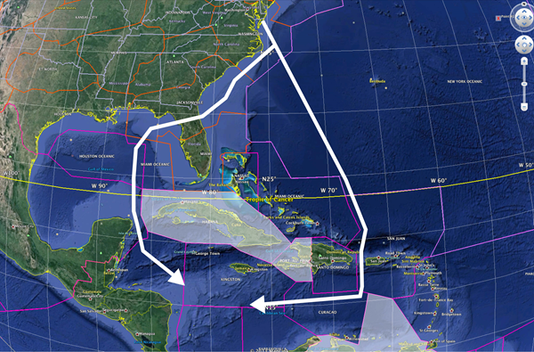

Figure 3-2. Approximate routes to the Caribbean.

3.2 GH sampling strategies

3.2.1 Basic flight patterns

Several basic flight pattern options will be used during the SHOUT field campaign. Specific patterns and sampling strategies will be chosen on a case-by-case basis and will include the following scientific considerations:
- GPS dropsonde sampling in regions determined to be optimal for improving model forecasts is a high priority. These target regions will be objectively determined in real-time and could include the tropical cyclone inner core out to areas several hundred kilometers from the storm;
- Sampling of the tropical cyclone inner core region is a priority for optimizing data collection by both the HAMSR microwave sounder and HIWRAP dual frequency Doppler radar onboard the Global Hawk;
- Sampling of the environment around the tropical cyclone inner core (e.g. ~150-450 km) will provide information regarding possible interactions between the storm and its surrounding environment and will be a priority;

The following flight pattern options are presented in a storm relative framework for reader clarity, but all flight tracks should be designed using an Earth-relative coordinate system that incorporates storm motion information (i.e. storm forward speed and direction). This will help minimize the need for real-time track adjustments as the storm moves during the ~24-hr mission and can be easily incorporated using the NOAA Hurricane Research Division’s (HRD) tkmap flight track software.

i. Butterfly Pattern This pattern provides a good balance of azimuthal and radial coverage, can be radially adjusted as needed to sample both the Tropical Cyclone (TC) inner core and surrounding environment, and depending on aircraft ferry times, can be repeated multiple times with varying radial leg lengths, depending on the targets of interest (Fig. 3-3). Larger butterfly patterns (e.g. radial legs out to R=450 km (240 nm/)) are better suited for attaining a more balanced sampling of both the inner core and surrounding storm environment, while smaller butterfly patterns (e.g. radial legs out to 220 km (120 nm)) can be used to attain more frequent “snapshots” of the tropical cyclone inner core region. The butterfly pattern requires that SHOUT mission scientists continuously monitor the storm center and provide the pilots with position updates. This will help ensure that the Global Hawk transits through (or as close as possible to) the circulation center during each pass through the storm.

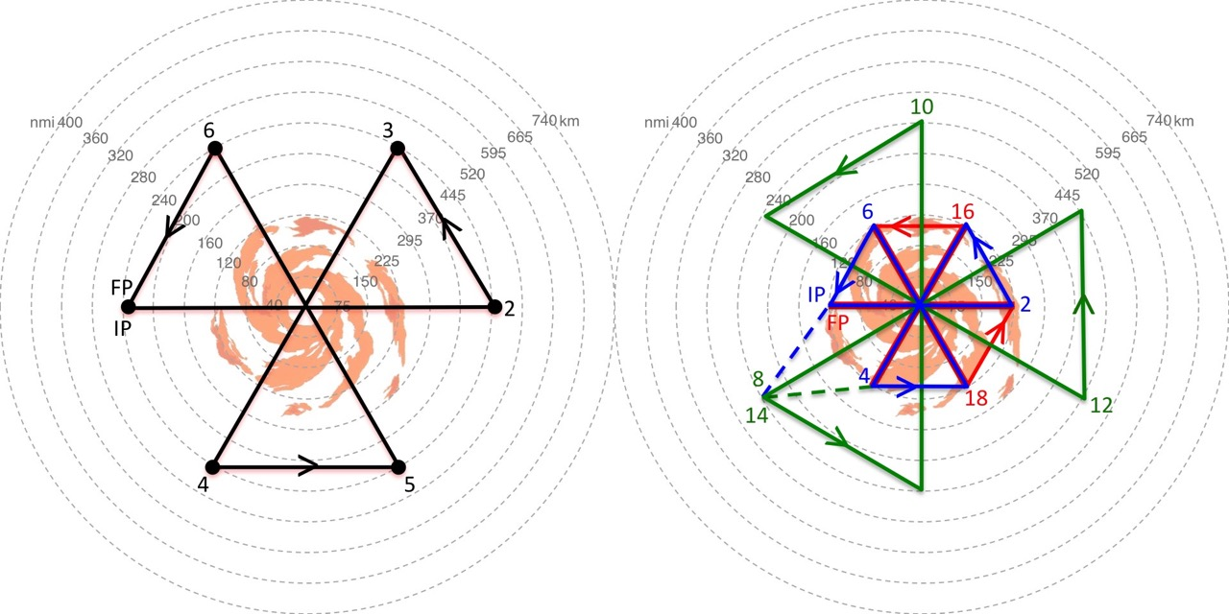
Figure 3-3. Sample butterfly pattern showing (left) a single butterfly with radial legs out to R=450 km (240 nm), 3 center crossings, and an on-station time of ~6.75 hr; and (right) a repeated butterfly pattern that starts with a small butterfly (blue curve) that samples out to R=220 km (120 nm), followed by a larger butterfly (green curve) that samples out to R=450 km (240 nm), ending with another small butterfly (red curve). The dashed lines indicated transits between butterfly patterns in the sequence. Each butterfly pattern includes 3 center crossings and combine for a total on-station time of ~14-hr (3.25, 6.5, and 3 hr respectively);

ii. Rotated Butterfly Pattern This pattern provides excellent azimuthal and radial coverage and can be radially adjusted as needed to sample both the TC inner core and surrounding environment (Fig. 3-4). The rotated butterfly pattern provides excellent spatial coverage of the storm and its surrounding environment at the expense of providing poorer temporal coverage of the inner region (i.e. this pattern is not ideal for providing frequent inner core “snapshots” of the storm). The rotated butterfly pattern also requires that SHOUT mission scientists continuously monitor the storm center and provide the pilots with position updates. This will help ensure that the Global Hawk transits through (or as close as possible to) the circulation center during each pass through the storm.

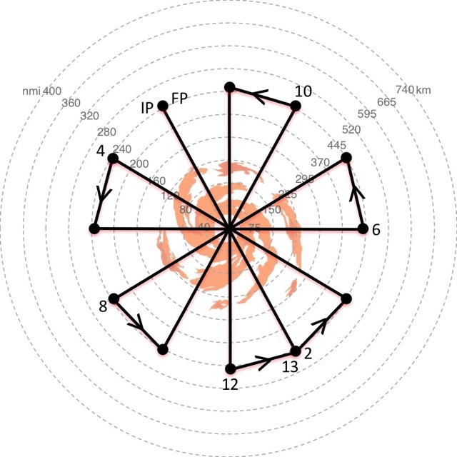

Figure 3-4. Sample rotated butterfly pattern with radial legs out to 450 km (240 nm), 7 center crossings, radial legs that are rotated 30 degrees, and an on-station time of ~12.5 hr;

iii. Figure-4 Pattern This pattern provides very good azimuthal and radial coverage and can be radially adjusted as needed to sample both the TC inner core and surrounding environment (Fig. 3-5). The figure-4 pattern has radial legs that are rotated 45 degrees, which provides enhanced spatial sampling of the TC inner core region. However, this enhanced sampling comes somewhat at the expense of peripheral environmental sampling compared to the butterfly pattern. The figure-4 pattern requires that SHOUT mission scientists continuously monitor the storm center and provide the pilots with position updates. This will help ensure that the Global Hawk transits through (or as close as possible to) the circulation center during each pass through the storm

.

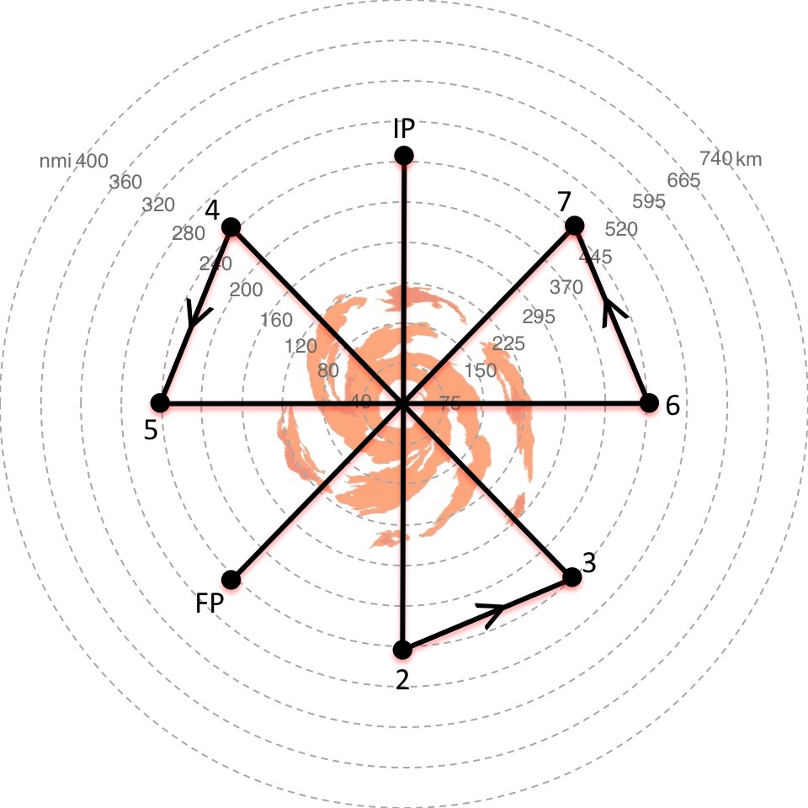

Figure 3-5. Sample rotated figure-4 pattern with radial legs out to 450 km (240 nm), 4 center crossings, radial legs that are rotated 45 degrees, and an on-station time of ~7.5 hr;

iv. Lawn Mower Pattern This pattern provides very good sampling of the large scale environment associated with the storm, though it does not provide extensive azimuthal and radial coverage of the storm’s inner core region (Fig. 3-6). The lawn mower pattern can be adjusted in size depending on the aircraft ferry times, though it will typically be a 10x10 or 12x12 degree box centered on the storm. The extended legs are usually flown in the opposite direction of the storm motion and the pattern itself is usually flown in the opposite direction of the storm motion (i.e. Fig. 3-6 would be used for an east-west moving storm). Depending on fuel considerations, the spacing between the extended legs can be adjusted as needed (e.g. 1.5, 2, 2.5 or 3 degrees) and over storm legs can be added at any point during the mission. This pattern has the following advantages: it does not require precise storm positions, it is relatively easily navigated, and course corrections are easier to implement given the long leg lengths. The alpha pattern indicated in Fig. 3-6 requires that SHOUT mission scientists monitor the storm center and provide the pilots with position updates. This will help ensure that the Global Hawk transits through (or as close as possible to) the circulation center during each of the 2 passes through the storm.

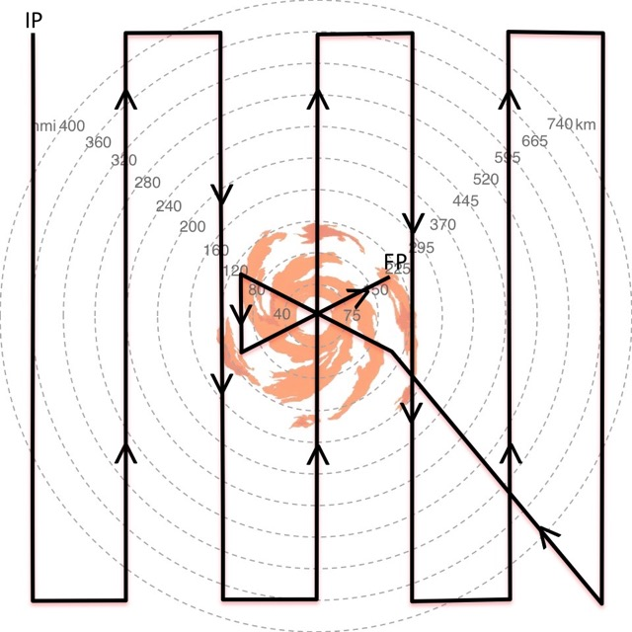

Figure 3-6. Sample 12x12 degree lawn mower pattern with areal coverage of ~1300x1300 km (~700 x 700 nm), leg spacing of 2 degrees, 2 center crossings made during an alpha pattern at the end of the pattern, and an on-station time of ~20 hr;

v. Square Spiral Pattern This pattern provides good sampling of the large scale environment associated with the storm and good azimuthal sampling of the storm’s inner core region. These advantages come at the expense of providing very limited radial coverage in the inner core sampling (Fig. 3-7). The square spiral pattern can be adjusted in size (typically a 10x10 or 12x12 degree box centered on the storm) depending on the aircraft ferry times. Depending on fuel considerations, leg spacing can be adjusted as needed (e.g. 1, 1.5, 2, or 2.5 degrees), the number of circumnavigations can be adjusted up or down, and over storm legs can be added at any point during the mission. This pattern has the following advantages: it does not require precise storm positions, it is relatively easily navigated, and due to its symmetric coverage around the storm it is useful for calculating budgets at various radii.

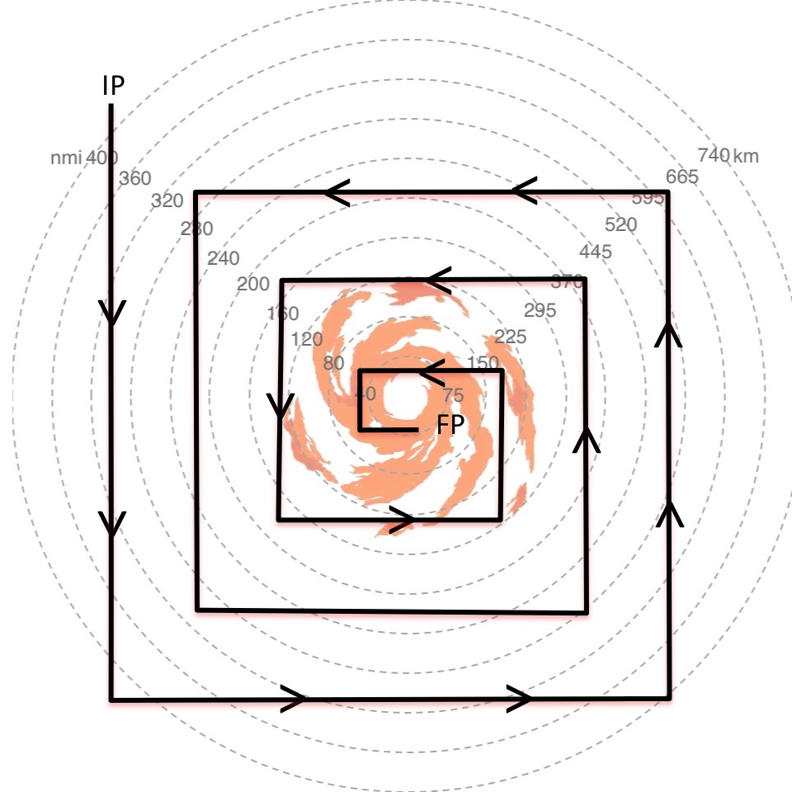

Figure 3-7. Sample 10x10 degree square spiral pattern with areal coverage of ~1110x1110 km (~600x600 nm), leg spacing of 1.5 degrees, and an on-station time of ~13.5 hr;

3.2.2 Add-on modules

Depending on SHOUT objectives, additional short modules may be added to the basic patterns described above (if approved by the FAA or other cognizant agency). These modules should be considered as supplemental components of the mission and should not be conducted if they negatively impact the ability to complete the GH flight pattern. Add-on modules include:
- Inner Core Sampling: a repeating small butterfly or figure-4 pattern (e.g. 110-220 km (60-120 nm) radial legs) across the storm center in order to get more detailed information on inner-core structure.
- Convective Burst Module: targeting of a prominent convective feature in the inner core or rainband region of the storm that will typically make use of HIWRAP retrievals and supplemental GPS dropsondes, Depending on the convective nature of the target and proximity to the inner core, this module could employ a racetrack, lawnmower, or figure-4 pattern (Fig. 3-8).
- Upper-Level Outflow: A set of passes across an outflow channel that utilizes a lawnmower pattern or extension of existing flight lines (Fig. 3-9). This module will typically, utilize supplementary GPS dropsondes, be oriented to sample orthogonal to the outflow jet, and when possible, should sample the jet core and extend beyond the outflow to the quiescent environment. Coordination should be made with the Office of Naval Research (ONR) TCI efforts and could be conducted either during the main mission or ideally, during the ferry to/from the storm.
- Tropical Cyclone Diurnal Cycle: Supplemental GPS dropsondes are launched along radial legs that are orthogonal to a tropical cyclone diurnal pulse. Diurnal pulses will be identified using UW-CIMSS infrared satellite imagery and a 24-hr (local time) conceptual clock will be used to predict the approximate radial location of diurnal pulses as they propagate away from the inner core each day (Fig. 3-10). This module will typically take advantage of a pre-existing radial flight line and will rarely require track adjustments.
- Upper Tropospheric Trough: A set of passes conducted across an approaching upper-tropospheric trough utilizing a mini lawnmower or extension of existing flight lines. Optimally, this module would be conducted during the ferry to/from the storm.
Prior to take-off, the GH flight pattern and targets of interest will be specified and distributed to the pilots, mission scientists, and instrument teams. Any modules that are added to the flight in real-time by the mission science team should be communicated with/distributed to all SHOUT team members.

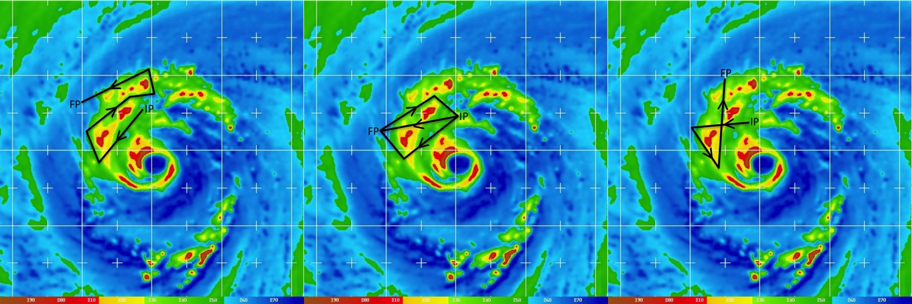

Figure 3-8. Sample convective burst modules (black curves) utilizing (left) mini lawn mower, (middle) race track (with a single overpass of the convection), and (right) figure-4 patterns. Tracks are overlaid on 85 GHz microwave satellite imagery (images courtesy of Naval Research Laboratory (NRL)-Monterey).

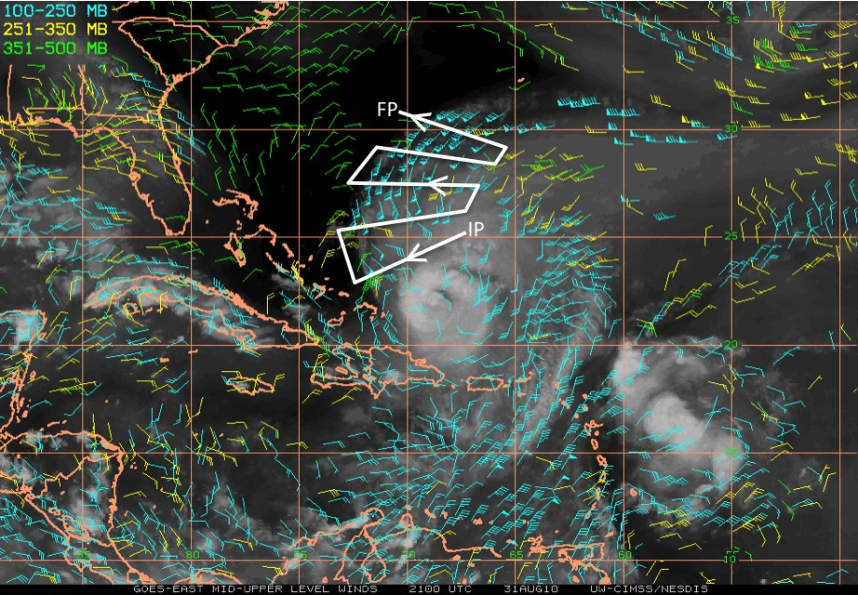

Figure 3-9. Sample upper-level outflow module (white curve) overlaid on UW-CIMSS mid- to upper-level water vapor winds. The pattern targets an outflow channel north of a tropical cyclone with flight legs that are oriented orthogonal to the outflow. Sampling includes a poleward jet core north of the storm and the quiescent environment beyond the western edge of the outflow layer.

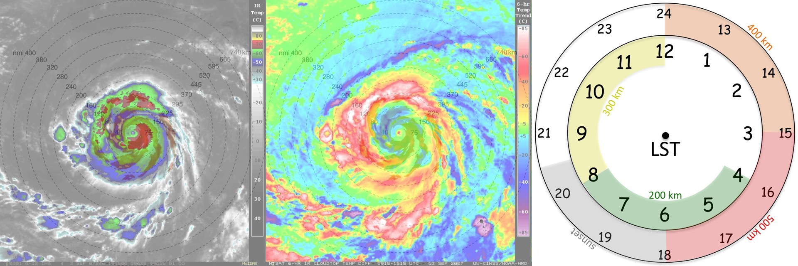

Figure 3-10. GOES infrared (left) and concurrent UW-CIMSS GOES tropical cyclone diurnal cycle satellite imagery (middle). Yellow to red shading in the latter image denotes the radial position of the diurnal pulse. 24-h conceptual clock of the TC diurnal cycle evolution (right). Times listed are local standard time (LST) and colored shading denotes the approximate arrival time of the TC diurnal pulse at corresponding radii from the storm center. Arrival times are estimates and may vary depending on storm size.

Note that turns in a small-scale lawnmower, butterfly, or figure-4 pattern might adversely affect HIWRAP retrievals, as well as dropsonde data collection after turns (particularly at lower levels). If not originally planned ahead of flight, specification of add-on modules will need to be drawn out in using the HRD tkmap flight planning software along with GPS dropsonde locations and communicated to the pilots with sufficient time to coordinate with the FAA or other cognizant agency.

3.3 GH overstorm mission strategies

3.3.1 Hazard avoidance maneuvers

During AV-6 flights, there are two basic options for hazard avoidance if a substantial deviation is required. The preferred method when the GH is outside the tropical cyclone inner core is to deviate around deep convection and discontinue drops (no new flight plan needs to be filed). This allows the pilot to begin the diversion as close as possible to the area of potential hazardous weather and return to the original flight plan as quickly as possible. Drops would resume upon return to the original patteforgrn.

A second option, for when the GH is in the tropical cyclone inner core or outer rain band region, is to deviate around deep convection and continue drops. This method allows continued dropsonde releases, but will require that mission scientists identify the region to be avoided early enough for the pilots to file a revised flight plan (if needed) and get approval for new drop locations. This option might result in deviations around the convection that are somewhat more conservative and may result in missing a somewhat larger portion of the original flight path.

The Mission Tool Suite (MTS) drawing tool can be used to estimate positions of updated lines and determine new waypoints. These new waypoints should be communicated to the pilots (in degrees decimal minutes, e.g., 14° 23.45´´) before completion of the storm crossing prior to the new line (note that MTS now has the option to display coordinates in these units). For example, for the butterfly pattern (Fig. 3-4, left), if the aircraft is heading eastbound across the storm, the new waypoints for the northeast-to-southwest leg should be communicated to the pilots prior to the completion of the eastbound leg. These updates will be needed continuously during the flight and should be communicated to the pilots (typically via the flight-planning list serve (noaa.shout.flight.plan@noaa.gov) or pilot email) by the mission scientist. At any time, if the mission scientists want to change the length of the legs, the number of legs (i.e. butterfly, rotated butterfly, or rotating figure-4), or the headings, they should communicate such changes to the pilots and provide the new waypoints. Such changes in patterns should not be made frequently except to adjust for storm motion unless dictated by hazard avoidance needs. Attempts should be made to keep add-in modules within a single Flight Information Region (FIR). A greater lead time may be needed if the module crosses FIR boundaries.
When determining new waypoints, the mission science team should ALWAYS check the time stamp on the satellite imagery being used to ensure that the information is current.

3.3.2 Determining when to use inner core sampling & convective-burst modules

In general, these modules should not be used in the eyewall of stronger storms in which the area covered by the eyewall is likely small and the trajectory path of updraft air is often helical in nature such that the low-level updraft is located well upstream of the upper cold-cloud top. The inner eyewall feature in these cases can be too small for a convective burst module and would likely be readily sampled by the main flight pattern (e.g. small butterfly, Fig. 3-3). In these cases, the convective burst module would be better suited to the secondary eyewall (if highly asymmetric) or to the outer rainbands. The duration of the module should be kept short (repeated no more than 1-2 times depending on which pattern is used) and once completed, the GH should resume the main flight pattern.

In a mature, more symmetric storm, a butterfly, rotated butterfly, or rotated figure-4 pattern should be utilized, with legs sufficiently long to capture the main precipitation features, including the inner core and rainband regions. Additionally, the legs should extend beyond the edge of storm-related precipitation to allow for GPS dropsonde sampling of the surrounding clear air environment. This is necessary for determining the background environmental temperature that is used to derive TC warm core temperature anomalies.

3.3.3 Hazard avoidance

Key objectives for mission scientists and flight crew are: (1) Safe operation of the GH over tropical disturbances including tropical cyclones and hurricanes, and (2) obtaining data for SHOUT science without compromising objective (1).

Significant turbulence is by far the most probable hazard when flying the GH above tropical storms. That is the reason that past and present flight rules have focused on not overflying storms with tops above FL500 (50,000 ft. pressure altitude) or overflying storms with lightning, regardless of storm top, unless clearing the cloud tops by at least 5k to 10k ft. The existence of lightning is currently being used as an indicator of a storm that is intense enough to be a potential turbulence hazard.

How can we recognize a tropical cyclone with a turbulence hazard for GH overflight? Short answer: We don’t know for sure. However, the evidence is strong that the most important cause of significant turbulence above storm top is a very strong updraft reaching the storm top and penetrating the stable layer usually found there or just above (usually identified as the tropopause, typically at 50,000-54,000 ft). Like a rock dropping into a pond, the updraft penetrating this stable layer generates gravity waves that travel upward and outward from the tropical overshooting top (TOT). The hazard to the aircraft is clear; short-term, strong accelerations in the x, y, and z directions, and marked changes in indicated air speed that can cause control problems.

The obvious problem then becomes how to recognize a storm with potentially hazardous updrafts. This is not easy to do directly because we would first have to overfly with HIWRAP, instantly derive updraft speed below the aircraft, and that would tell the pilots that “they should not have flown there”. So our problem then becomes: What proxies can we use that have a good chance of differentiating a storm with strong updrafts from one without strong updrafts before we overfly it? Potential proxy variables include storm cloud-top heights and TOTs derived from satellites, and lightning flash rate as depicted from global networks.

i. Tentative conclusions from previous NASA field campaigns
- The convective cell that caused serious concern about the safety of the ER-2 in Emily was especially strong for a tropical cyclone environment, probably as strong or stronger than any that was overflown by the ER-2 in 20 previous flights over tropical cyclones. Specifically, what made that cell a safety concern was the magnitude of the vertical velocity of the updraft, at least 20 m/s (4000 ft/minute) at the time the ER-2 overflew it. Such a strong updraft can generate strong gravity waves at and above the tropopause, posing a potential danger to aircraft far above the maximum altitude of the updraft itself or its associated cloud top. Indeed, the ER-2 was probably at least 9000 ft above that cloud top.
- Cloud-top height, by itself, is not an especially good indicator of the intensity of convection and the likelihood of turbulence. Nor is overflying high cloud tops (i.e. > 50,000 ft) of particular concern unless there is other evidence of very strong convective updrafts beneath those tops in the path of the aircraft.
- Lightning, especially lightning with a high flash rate, is well correlated with convective intensity. Lightning with a minimal flash rate (say 1-3 flashes per minute) is indicative of updraft speeds of about 10 m/s in the mixed phase region where charge is being separated, generally at altitudes about 20-25 kft in a hurricane. That is still stronger than typical updrafts (more like 5 m/s). An unresolved issue is whether there is a high and instantaneous correlation between vertical velocity in the middle troposphere (necessary for lightning generation) and near cloud top (more direct concern for overflights).
- Tropical overshooting tops (TOTs) indicate significant vertical velocity at a storm’s cloud-top canopy that penetrate the stable layer at which surrounding cloud tops have spread out (anvil tops). An indirect indication of vertical velocity at cloud top is the magnitude of the brightness temperature difference between the coldest overshooting pixel (TOT) and the immediate surrounding anvil top. One should be especially cautious about overflying TOTs with deficits of 8-10 degrees K or more for newer cells and smaller values when embedded in existing cold cloud tops. Such tops may indicate updraft speeds > 10-15 m/s. However, we need more research on the use of this convective indicator, because it is suggested that the time scale of an individual TOT (if it is more like a small bubble rather than a deep jet) is normally less than 5-10 minutes. This is significant because the TOT that was a problem for the Emily flight during HS3 was only detected in available GOES imagery as a potential hazard 3 minutes before the encounter.

ii. Summary and revised flight rules for storm avoidance

The original Global Hawk flight rules would probably not have been effective in the single event of greatest concern (the Emily encounter). The cloud top had not reached 50,000 ft until about 3 minutes before the encounter. The TOT and lightning data would not have been available until near the overflight time since this was a rapidly growing cell. Avoiding such a cell probably requires continual monitoring of the forward camera and stormscope (if operational), whether or not cloud tops have been exceeding specific limits. However, the 2012 and even the modified 2013 overflight rules as strictly interpreted would have prohibited significant fractions of the successful Global Hawk overpasses of Karl and Matthew that proved not to be hazardous.

We have some newly-developed tools (ACHA cloud-top heights, lightning from long-range networks, and TOTs) to diagnose potential hazardous conditions. However, these must be used carefully and collectively. The focus should not solely be on cloud top height, but also should incorporate indicators of the presence of intense convection, especially if they have persisted in a region of the TC for the past 30 minutes. Notably, these indicators include lightning with flash rates > 1-2 flashes per minute as indicated by current long-range networks, and TOTs, whose critical magnitude may vary with the extent or temperature of the background cloud canopy. Note that MTS does not provide flash rate information. Mission scientists should monitor flashes over multiple time periods to assess approximate flash rate. Any region with both these indicators of intense convection are “red flags” that could trigger the recommendation for avoidance if cloud-top heights are >50 kft or unless they can be overflown by at least 10,000 ft when cloud-top heights are <50 kft.

To have a better chance of avoiding overflight of truly intense “surprise” cells such as the Emily example, knowing that they are not necessarily related to particularly high cloud tops, any region exhibiting a sudden increase in lightning flash rate should be monitored using a combination of the stormscope and the forward video camera if they are operational. If there is evidence of a rapidly growing cell directly ahead of the Global Hawk, the pilots should consider a diversion to avoid it by at least 10-20 nm. The message here is that the satellite and ground-based remote sensing tools may not refresh in time for such cases.

Regions of cold cloud tops that have not exhibited indicators of intense convection as described above should be considered acceptable for overflights as long as the GH stays above cloud top. The occasional TOT or lightning flash should be cause to monitor the region carefully, but not necessarily cause for complete avoidance.

Based upon this analysis, the following rules (see also section 3.1.3) were proposed to GH management and accepted:

- Do not approach thunderstorms within 25 nm during flight at FL500 or below.
- No flights into significant weather clouds
- When significant convection with frequent lightning present
- CTH>50 kft, maintain 25 nmi separation
- CTH<50 kft, maintain 10 kft vertical separation
- When significant overshooting top without frequent lightning present
- CTH>50 kft, maintain 5 kft vertical separation
- No flight into forecasted or reported icing conditions
- No flight into forecasted or reported moderate or severe turbulence

Providing an exact definition of “frequent lightning” for the above rules is difficult since observed lightning frequency may depend on system evolution, lightning detection efficiency, and other factors. However, as a general guideline for SHOUT operations, frequent lightning will be defined as any cluster of strokes in a single area, roughly more than 2 events per 5-minute period and at least 2 consecutive 5-min periods. To be considered “without frequent lightning”, an area should be below this threshold for approximately 10 minutes. Figure 3-11 summarizes the decision tree for GH weather hazard avoidance when the aircraft is flying at or below versus above 50,000 ft pressure altitude. The following lightning guidelines should be used when referring to Fig. 3-11:
- Frequent Lightning
- any cluster of strokes in a single area roughly >2 events per 5-min period & at least 2 consecutive 5-min periods;

- Without Frequent Lightning
- area should be below the “frequent lightning threshold for ~10-min

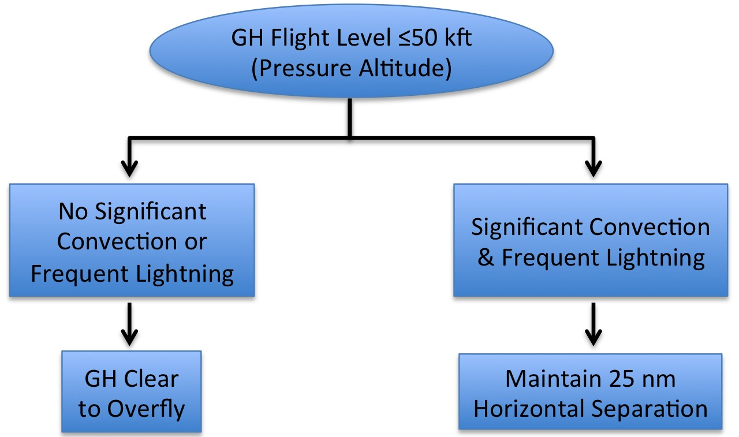

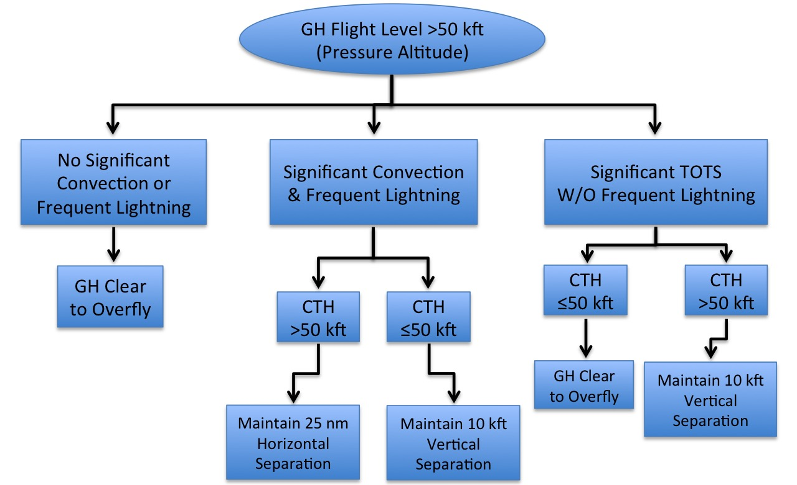

Figure 3-11. Decision tree for GH weather hazard avoidance when (top) the aircraft is flying at or below 50,000 ft and (bottom) when the GH is flying above 50,000 ft.

Notes:

• The lightning data is currently displayed as strokes, so a few might be plotted together that really all belong to a single flash (multiple strokes, milliseconds apart). If there is a cluster of strokes plotted in one minute, but very few in the preceding minutes, then the lightning is not necessarily cause for alarm. It will need to be monitored to see if the subsequent minutes show continued lightning.

• Detection efficiency is greater closer to the East Coast, so for operations in the Central Atlantic, mission scientists should evaluate any sustained lightning activity and assess whether a deviation in track is necessary.

• When overshooting tops exceed ~54-55k ft, but lightning is absent, the 5k ft clearance requirement means that the GH would have to be above ~60k ft for overflight, which won’t be until near the end of the mission, so at most times overflight of such overshooting tops will not be possible. Even if aircraft altitude is sufficient, mission scientists should assess whether greater caution than stated in the flight rules should be taken.

iii. Hazard avoidance flight changes

It is the responsibility of the mission scientist to frequently update the pilots about the possible hazards present in a storm. The mission scientist will generally be providing to the pilots frequent corrections to waypoints in order to align legs across the storm center or to execute a convective module. It is important that the potential for hazardous conditions also be communicated to the pilots along with the waypoints, preferably in advance of each flight leg. Please be particularly cognizant of the requirement to avoid significant hazards, as defined above, by 25 n mi (~45 km) and to maintain appropriate cloud-top clearance at all times. MTS now has a tool for adding range rings centered on an aircraft or a coordinate that will prove very useful for steering clear of potential hazards. Please familiarize yourself with this tool (see section 3.4.2).

In the event that the potentially hazardous convection is very isolated so that the 25 nmi deviation does not prevent operations in most of the eyewall region, one option (Fig. 3-12b, left) is a straightforward deviation to the right or left of the convective cell by 25 nmi. The GH simply deviates around the convection and then resumes the butterfly pattern as quickly as possible. This will generally be the preferred option. Because of the need for straight-and-level flight, setting this course correction prior to beginning the flight leg is ideal if the intense convection is seen early enough and is likely to persist. In the event of expected very persistent (>30 min) lightning, the entire butterfly pattern can be rotated so that the hazardous area is in between the butterfly cross-storm legs. Note, however, that in some situations, the flight legs surrounding the convective event may still require additional adjustments to maintain 25 nmi separation.

In situations in which lightning or overshooting top activity is more widespread (e.g., covering up to half or more of the eyewall, see Fig. 3-12c-f)), then the 25 nmi separation requirement might make sampling the eyewall with the standard modules difficult. In these situations, alternate flight modules can be implemented that sample the portions of the eyewall that are still safe to fly or address other objectives of the flight (dry air intrusions, outer rainbands) until it is safe to return to the default module in the eyewall region. Alternate flight objectives should be discussed prior to takeoff and communicated via the mission scientist listserve (noaa.shout.mission.science@noaa.gov) and the Mission Scientist Exchange message board on MTS so that all mission scientists are clear on the primary and secondary goals of the flight.

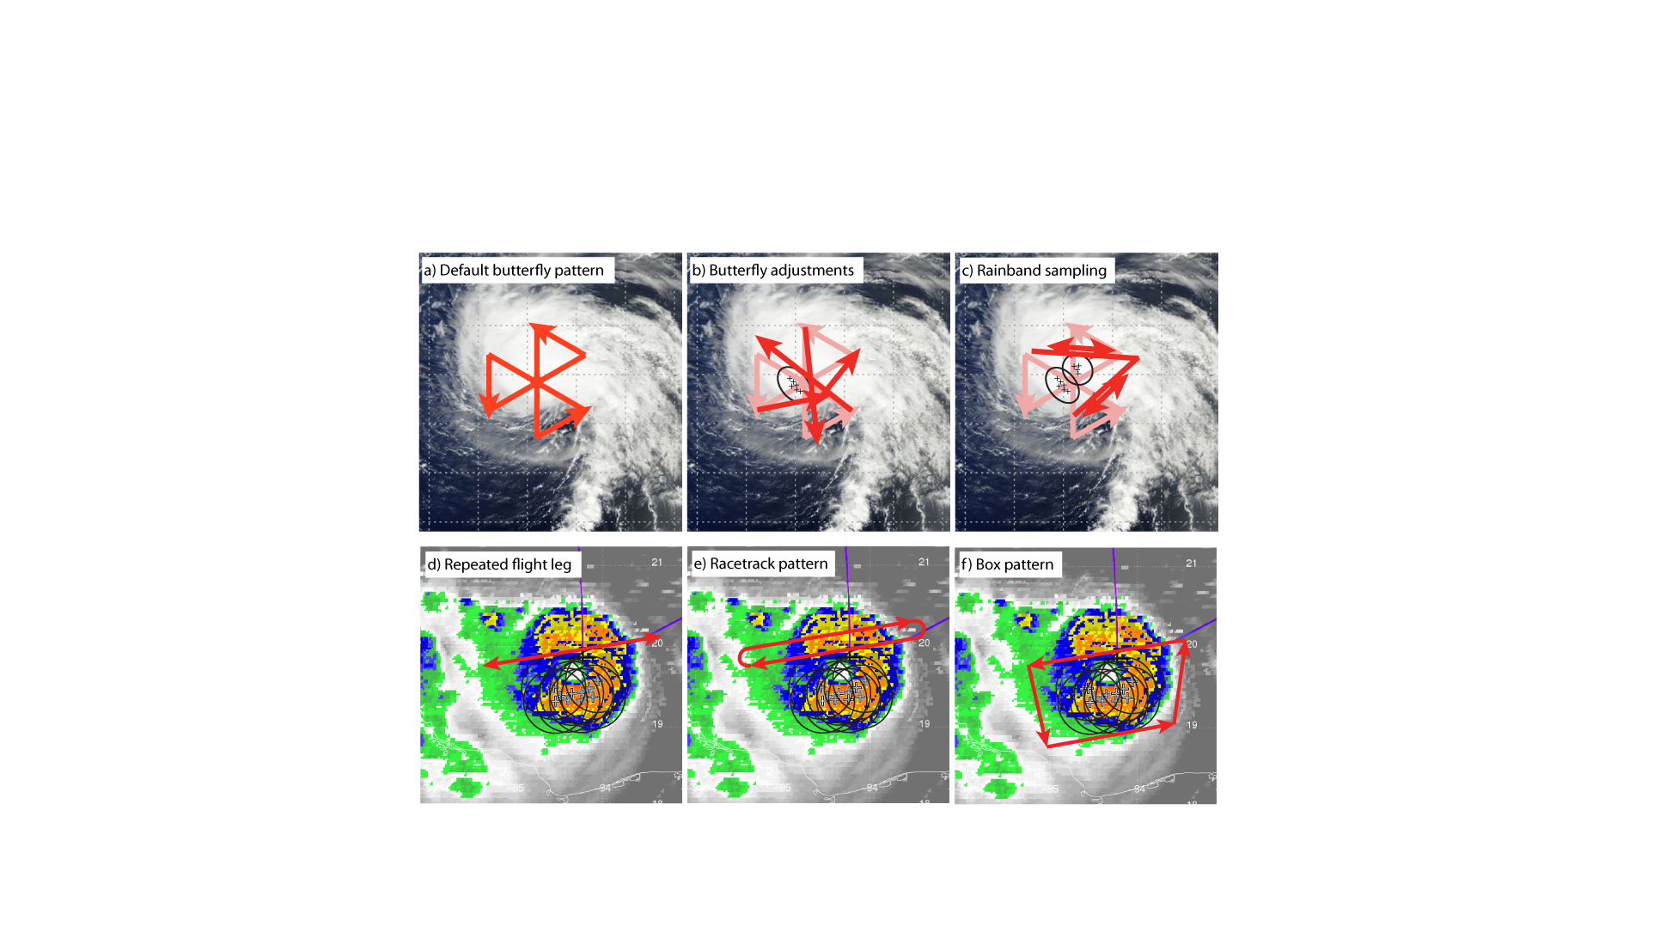

Figure 3-12. Illustrations of possible hazard avoidance maneuvers around isolated significant convection.

3.4. Mission Tool Suite (MTS)

The NASA Airborne Science Mission Tool Suite supports the Airborne Science Program (ASP) and the NASA Science Mission Directorate (SMD) Earth Science Division by providing a suite of web-based capabilities to support Airborne Science Missions. ASP Mission Tool Suite is the ground complement to the NASA SensorNet project, which is developing the airborne networking infrastructure to enable high speed SATCOM of aircraft parameter data, and instrument data during flight missions. The ASP Mission Tools Suite provides a common operating picture for improved situational awareness for all participants in NASA Airborne Science and NOAA missions from scientists and engineers, to managers, as well as the general public. The intent of the system is to encourage more responsive and collaborative measurements between instruments on multiple aircraft, satellites, and on the surface in order to increase the scientific value of the measurements, and improve the efficiency and effectiveness of flight missions. At its most basic, ASP Mission Tool Suite provides a means for visualizing the position of the aircraft and instruments during the course of the mission. Such information is made more useful when compared with or overlaid upon other datasets and model outputs used for mission planning and science data analysis.

Additionally, ASP Mission Tool Suite facilitates communication between mission team members to enable analysis and discussion of multiple data sources to help plan and execute science missions.

The Mission Tool Suite contains a core set of tools that provide Airborne Science Participants with a host of capabilities:
- remotely monitor real-time aircraft locations
- view current and archived flight tracks
- ability to add information overlays from a curated product registry
- customized user workspaces
- team communication and collaboration tools
- integrated single and multi-user chat client
- plotting and graphing
- FIR overlays

All SHOUT mission scientists are expected to have become proficient at using the MTS. Because mission scientists will be responsible for determining new waypoints for center crossings and for hazard avoidance, they must be especially familiar with the MTS drawing tool and the SHOUT products bundle.

To access MTS, go to http://mts.nasa.gov/. To request an account, please send an email to ARC-ASP-MTS@mail.nasa.gov. Please specify NOAA SHOUT as the project that you plan to support and include “Contact: Jason Dunion”. Documentation for MTS can be found at: http://mts.nasa.gov/guide

The following sections describe different sections of the MTS SHOUT workspace.

3.4.1 SHOUT Communications

The SHOUT MTS site contains a communications page that includes announcements, links to NOAA web sites, schedules and report information, and other links. The page also contains a list of message boards. The Mission Scientist Exchange message board is of particular importance. Before flight, messages can address the primary and secondary goals of the flight and any particular issues that are anticipated, such as current detection of hazardous weather and possible avoidance strategies. During flight, mission scientists in the GHOC should update the message board for significant events such as flight deviations, instrument issues, insertion of convective modules, and so on. Doing so will allow mission scientists in other shifts to see what is happening while off duty or to get a history of prior events when they show up for duty. Since such events will usually be entered into the flight report, the active mission scientist can easily cut and paste the same entry into the message board.

3.4.2 Mission Dashboard

The MTS mission dashboard (Fig. 3-13) is used for flight tracking, hazard avoidance monitoring, real-time data product viewing, and x-chat communications. The dashboard allows for tracking a number of aircraft including NOAA, NASA, and Air Force aircraft. For coordinated flights with the WB-57 (carrying the Yankee HDSS dropsonde system), that aircraft should also be tracked.

In addition to aircraft tracks, the dashboard can be used to overlay the tracks of various satellites including GPM, TRMM, TERRA, Aqua, CALIPSO, CloudSat, NPP, and NOAA sounders. SSMI satellites are not currently available.

A SHOUT bundle of products have been created that includes the products listed in Table 3-3. Of particular importance is the Pilot Situational Awareness bundle that includes cloud-top height (CTH) estimates from the CIMSS GOES cloud-top height algorithm (in pressure altitude coordinates), the CIMSS tropical overshooting tops (TOTs) product, and lightning from the ground-based lightning detection networks; as well as combined CTH/lightning and CTH/TOT/lightning products. CTH and TOTs are updated as new GOES imagery becomes available. The combined products will be updated every minute in order to update lightning information even though the GOES imagery may not have updated. The lightning will display large symbols for lightning within the past 5 minutes and small symbols for lightning within the past 15 minutes. Users must regular check the time stamps on the products.

An “ONR TCI Products” bundle has also been created as part of the TCI project’s shared usage of MTS with SHOUT. SHOUT mission scientists will have access to this bundle as well.

Products not included in the SHOUT or TCI bundles can be readily added for display if in the appropriate format. Available formats include KML/KMZ, WMS, and TMS layers. One can also add products from the ASP product registry.

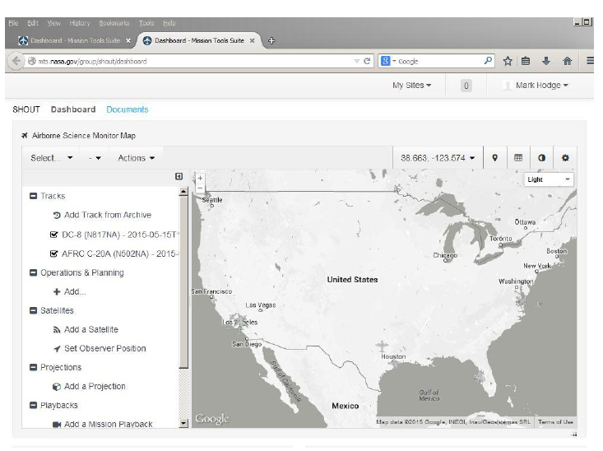

Figure 3-13. MTS SHOUT Mission Dashboard.

Below the Dashboard in the default configuration are two windows (not shown). To the lower left is the x-chat client for real-time communications with other SHOUT participants, NOAA IFEX, ONR TCI members, and CARCAH. Mission Science is responsible for monitoring CARCAH chat and communicating changes to CARCAH. To the lower right is the ASP camera feed that can display data from the GH low-light camera and HD-Vis camera. Camera feeds are dependent upon whether cameras are functioning properly. Other products from the instrument payloads may be added as the experiment progresses.

Source | Product
Pilot Situational Awareness | Cloud top heights, overshooting tops, lightning, and combined products that will provide the critical situational awareness for all flights
GOES standard products | IR,VIS,WV
NRL products | Cloud top heights, TPW, AOD, WV, multisat IR, multisat VIS,TPW anomaly
CIMSS products | GOES winds and derived products, SAL analysis, rapid scan products, overshooting tops, cloud top heights
JPL products | Microwave brightness temperatures
Lightning products | Lightning over last 60,30,15,4,1 minutes
Forecast/Model products | NRL COAMPS-TC analysis/forecasts
US radar products | NEXRAD base reflectivity
Aircraft operations and planning | FIR boundaries, temporary flight restrictions, special use airspace, VACAPES test tracks
Aircraft payload | HAMSR,AVAPS,HIWRAP,LIP
Planned Flight Tracks | Planned tracks for GH (AV6), WB-57, NOAA P-3, NOAA G-IV
Tropical Cyclone Tracking | Active TC tracks, forecasted tracks

Table 3-3. List of products in the MTS Mission Dashboard.

3.4.3 Instruments

Information on the status of instrumentation aboard the GH can be accessed through the mission dashboard. Under the "Payload" grouping on the right side of the screen, select "View Status." This opens a small panel just below the map where you can select the GH aircraft (N872NA). You can then select from a range of aircraft and payload sensors and choose various parameters for customized displays. Please see the MTS documentation for additional information. Please see the MTS documentation for additional information.

3.4.4 Documents

The documents section of the MTS site includes links to a number of folders for SHOUT communication and archival. At the highest level are the HOW-TO folder for MTS, the latest flight plans, and links for SHOUT operations documents. Within the operations folder are additional folders for

• kml flight track files

• CARCAH plans of the day (PODs)

• Contacts and schedules (including mission scientist schedules)

• Files for the dry run (Aug. 10-19)

• Daily flight planning spreadsheets

• Daily team presentations and summaries

• Daily mission science reports

• Operations documents

• Real-time and quicklook products

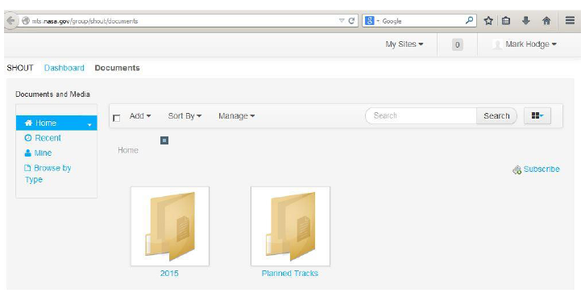

Figure 3-14. MTS SHOUT Documents page.

4. SHOUT OPERATIONS CENTER (SOC)

4.1 Functions of the SOC
An essential function of the SOC is its role as the center of daily planning activities for SHOUT (see Sec. 5 below). These planning activities will provide structure and management for the development of flight plans and conduct of the GH flights, as well as coordination of the NASA GH operations with NOAA flight operations.

4.2 Location and layout of the SOC
Aircraft and science operations will take place out of the D-1 hangar in 2015. The viewing area of the runway near the N-159 hangar may be used to view takeoffs and landings. The map below shows the locations of the two hangars relative to the entrance to WFF and the runways.
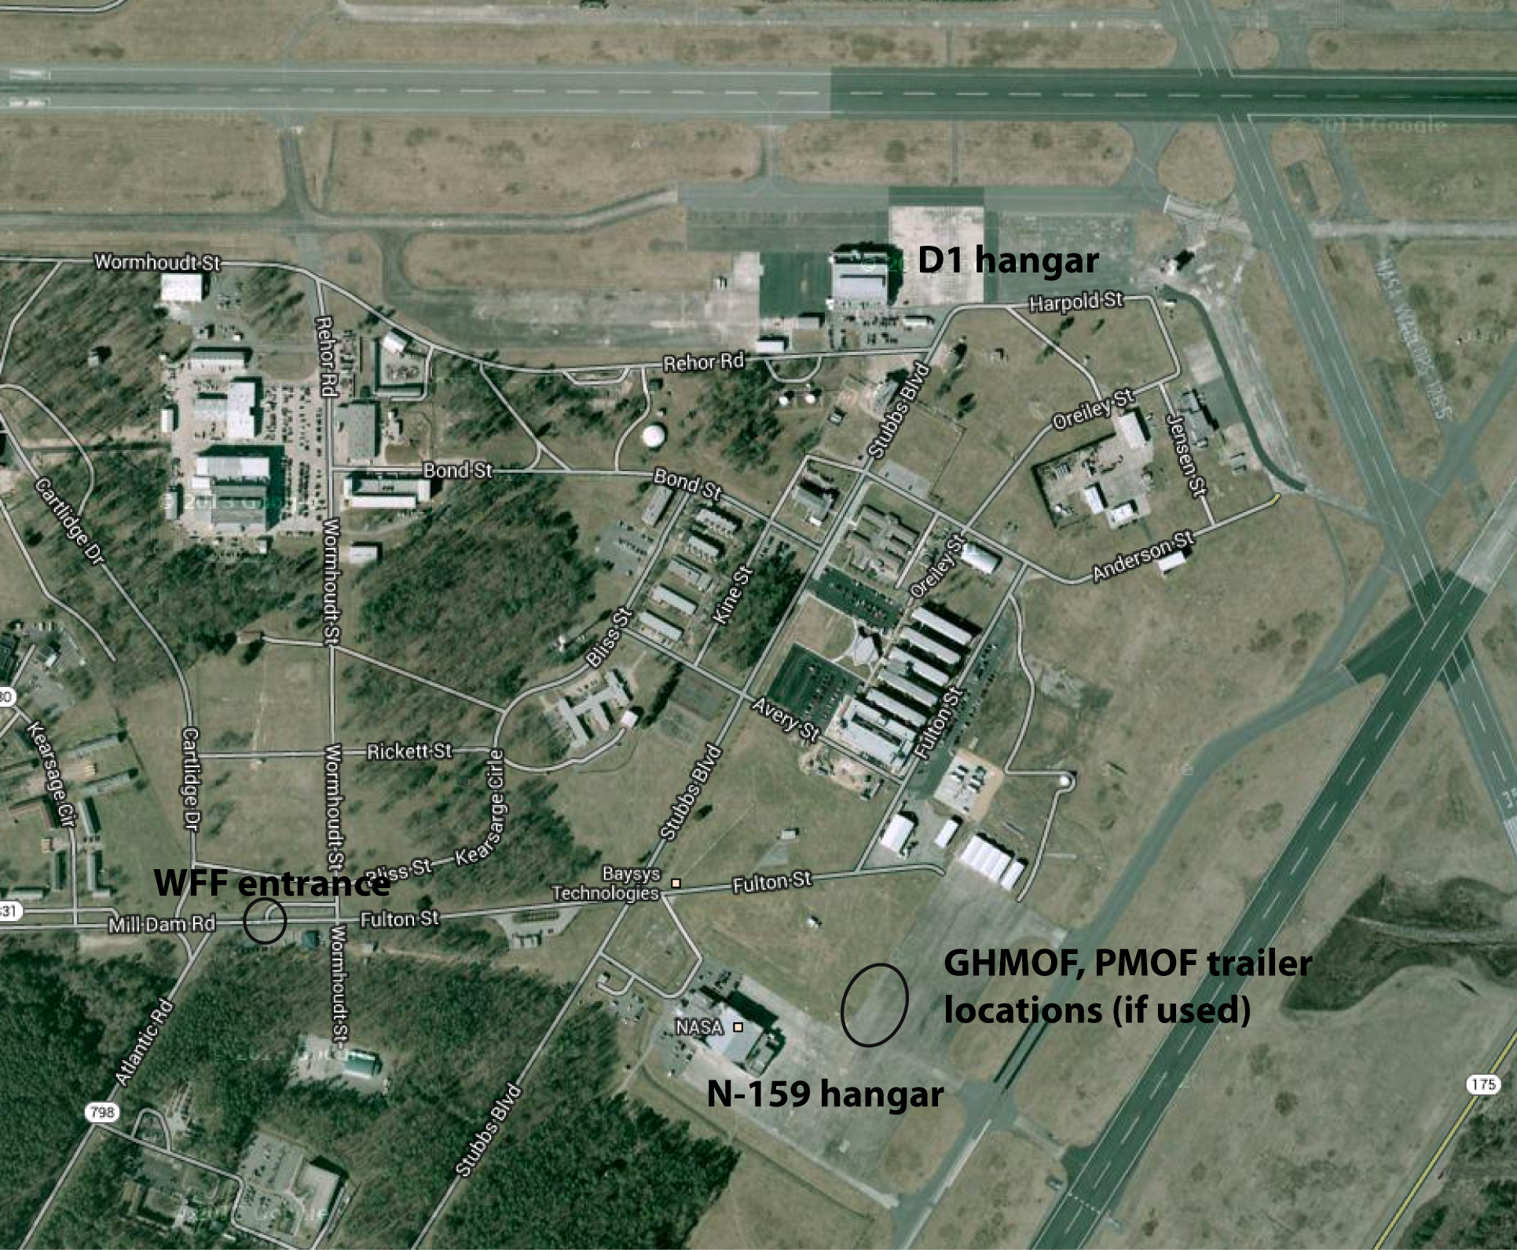
Figure 4-1. Image showing the location of the D1 hangar. Trailer will not be in place.
All instrument teams will use lab space on the ground floor of the hangar in rooms N104, N106, N108. (see hangar layouts below). All forecast briefings, pre-flight, post-flight, and other meetings will be held in the conference room in S115. Access to the aircraft in the hangar bay will be through locked doors that are opened with card readers for approved personnel.

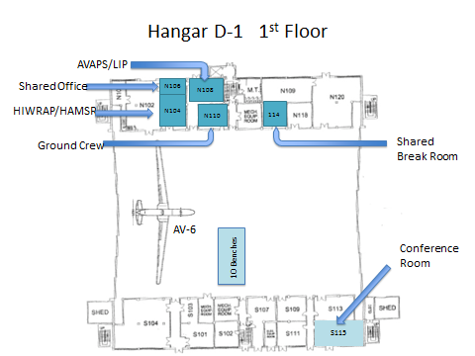
Figure 4-2. Layout of the first floor of the hangar.
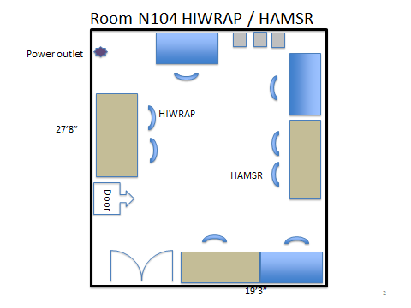
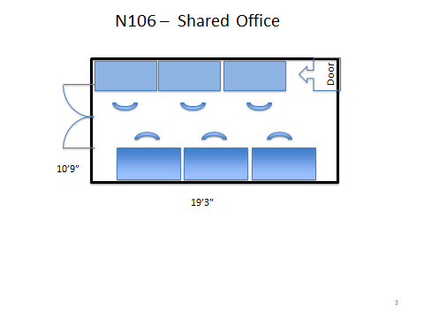
Figure 4-3a. Layouts of the first floor instrument labs and offices.

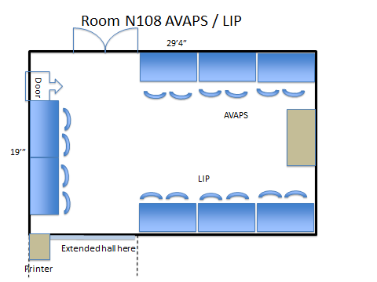
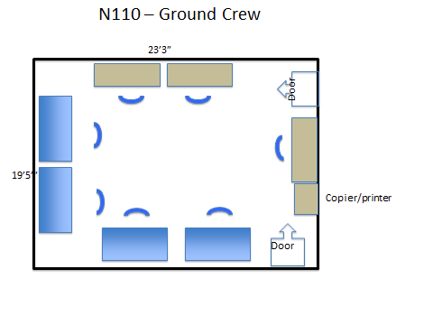

Figure 4-3b. Layouts of the first floor instrument labs and offices.

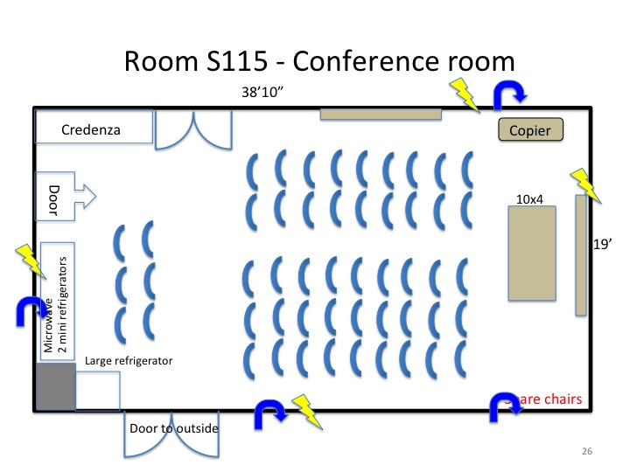
Figure 4-4. The first-floor conference room will be the site of most meetings including forecast, preflight, and postflight briefings.

A small kitchenette is located in N114 and contains a refrigerator, microwave, sink, and soda machine. Another kitchenette is located on the second floor down the hall from the main science and operations rooms.
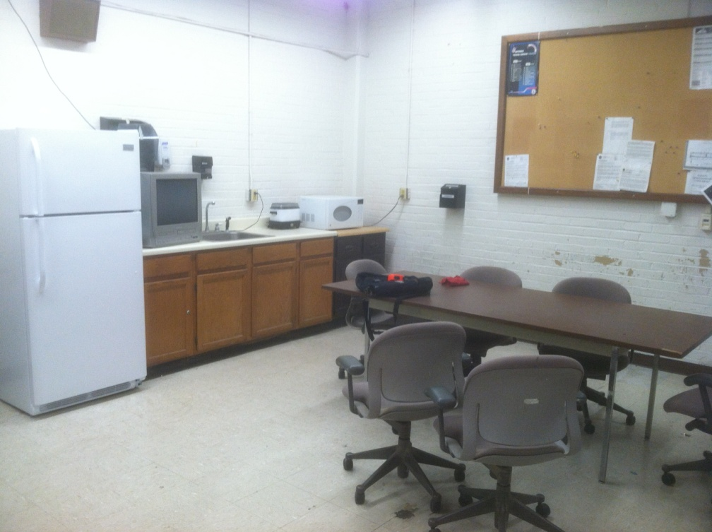
Figure 4-5. Kitchenette (N114).
The southeastern corner of the second floor of the hangar houses NOAA/ESPO, the mission scientists, flight planners, GH management, GH IT, and pilots. The northwestern corner houses the GHOC-East.
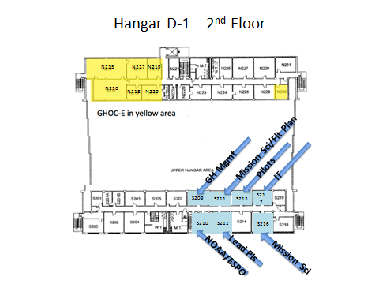
Figure 4-6. Layout of the second floor of the hangar. The GHOC is in the northwestern corner while most science team offices are on the south side.
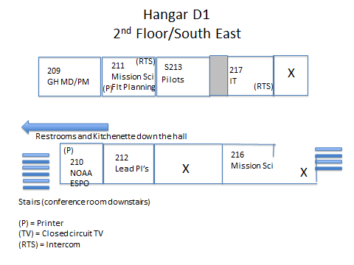
Figure 4-7. Layout of the southeastern corner of the second floor.
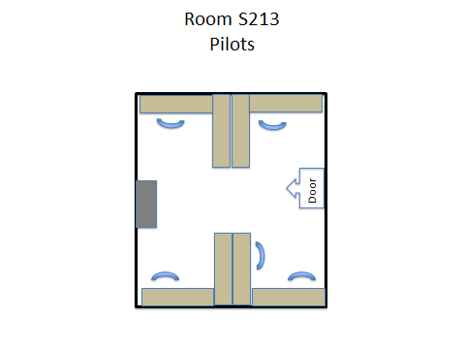
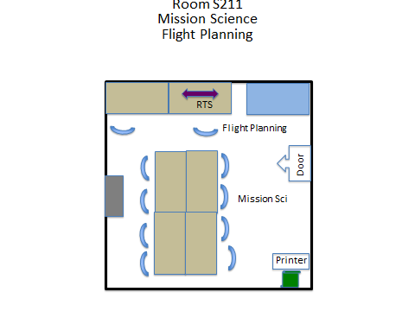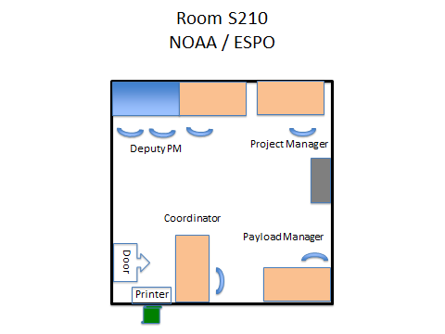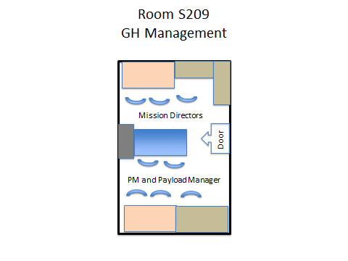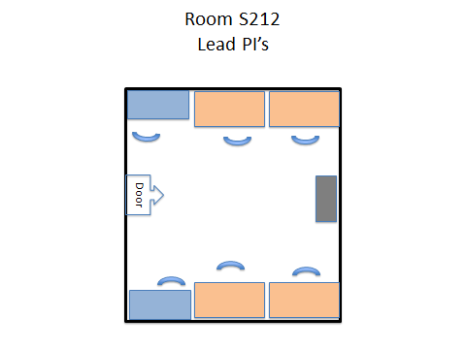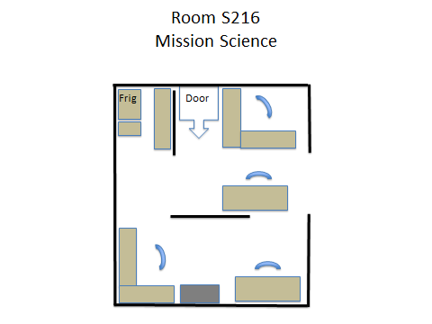

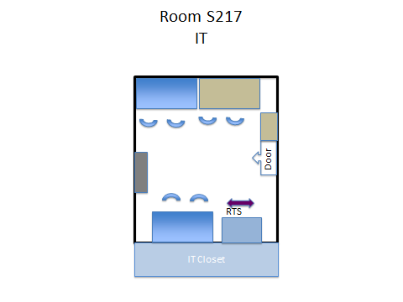
Figure 4-8. Detailed layouts of individual rooms.

5. SCIENCE MISSION PLANNING PROCESS
New this year for SHOUT HRR will be the Remote Mission Scientist position during this field campaign to promote an operational CONOPS.
- Shift-1 will have 2-3 on-site depending on mission schedule (monitoring GH take-offs & early segments of missions, drawing flight tracks, coordinating with IFEX and NAWDEX, etc.)
- Shifts 2 and 3 will have 2 on-site and 1 remote MS on duty
- Remote MS will focus on hazard avoidance & planning…communication with on-site MSs on the XChat SHOUT channel
- Remote can be from 2,000 miles away or from a local hotel room (we’d like to at least have the off-site MS not be in the GHOC)

5.1 Mission scientists’ roles and responsibilities in the SOC
Shift 1 0800-1700 UTC (0400-1300 EDT)
- Get report from previous shift mission scientists (in oral or written form) on changes to flight plans since the last shift. Shift 1 MSs have flexibility on their duty cycle on non-flight days (should start no later than 6am to prepare for day’s activities).
- If previous flight plan developed during 48-72 h stage, update flight plan and dropsonde locations based upon preliminary forecasts
- Attend 1130 UTC (0730 EDT) “cage” meeting with GH management at WFF.
- Lead 1230 UTC (0830 EDT) planning meeting.
  - Brief on weather/forecast changes as required
  - For T-24h, MS makes decision on go/no-go for next day’s flight
  - For T-48h, MS makes decision to submit flight plan to pilots for new alert
  - For T-72h, MS makes decision to issue new alert (not to pilots), to begin flight planning process for the next day
- Verify instrument and aircraft status, and brief GH management and pilots on current plans following planning meeting 1300 Z (0900 EDT). If alerting for a flight, provide pilots with initial plan.
- Submit POD to CARCAH by 1400 UTC (1000 EDT) on the day before the flight. Only need to send when there is a flight planned. Include on email:
To: ncep.nhc.carcah@noaa.gov
cc: Jim.D.McFadden@noaa.gov, Paul.Flaherty@noaa.gov, Justin.Kibbey@noaa.gov, Robert.Rogers@noaa.gov, Paul.Reasor@noaa.gov, Jason.Dunion@noaa.gov, Michael.Black@noaa.gov, gary.a.wick@noaa.gov
• Send final flight plans to noaa.shout.flight.plan@noaa.gov the day before the planned flight.

- Hold 1400 UTC (1000 EDT) coordination meeting with NOAA.
- Attend 1430 UTC (1030) West Coast “cage” meeting with GH management if scheduled.
- Create and submit daily morning Mission Scientist planning report and updated flight planning calendar (xls spreadsheet)
- Discuss events with incoming mission scientist for the 1600-0100 UTC (noon-0900 pm EDT) shift.
- Attend 1600 UTC (1200 EDT) NOAA HRD forecast discussion.
Shift 2 1600-0100 UTC (1200-2100 EDT)
- Get report from previous shift MS (in oral or written form) on changes to flight plans since last shift. Shift 2 MSs have flexibility on their duty cycle on non-flight days (can shift either toward morning or evening shift).
- Work with flight planner to design new flight plan based upon new alerts (72 h ahead of possible flight)
- Support ongoing GH flights as required
- Verify instrument and aircraft status, and brief GH management and pilots, if necessary, on updated plans prior to crew departure (1600 EDT).
- Discuss events with incoming mission scientist for the 0000-0900 UTC (2000-0500 EDT) shift.
Shift 3 0000-0900 UTC (2000-0500 EDT)
- Get report from previous shift MS (in oral or written form) on changes to flight plans since last shift
- Support ongoing GH flights as required
- If previous flight plan developed during 60-72 h stage, update flight plan and dropsonde locations based upon 00 UTC forecast. This updated plan will be used by the morning-shift MS to make the final submittal to the pilots.
- Discuss events or prepare written report for incoming mission scientists for the 0800-1300 UTC (0400 am-1300 EDT) shift. Shift 3 MSs have flexibility on their duty cycle on non-flight days.

5.2 Forecast planning process
• Daily 0830 EDT (1130 UTC) coordination calls are planned and will include a local weather brief led by Wallops staff, a 5-10 min weather brief led by shift 1 MS, and mission science discussion. Forecast briefings are also planned for 1200 EDT (1600 UTC) on weekdays (led by HRD) and at 1530 EDT (1930 UTC) on weekends and holidays (led by TCI). The CARCAH POD is due at 1000 EDT (1400 UTC).
• Local forecasts will be provided by WFF forecasters during weekdays, upon special request for weekends/holidays. On any day where a Global Hawk departure from WFF is scheduled, a WFF meteorologist shall provide a special weather briefing at the T- 1 hour briefing via a CATV system and a conference phone. Since Global Hawk takeoffs are typically scheduled for 0700 ET, the T-1 hour briefing would then be held at 0600 ET.
• If local weather provided by SHOUT scientists, runway directions are 101.9/281.9° for runways 10/28 and 43.7/223.7 for runways 4/22 (see Figure 2.2).
• Forecast time ranges:
- 0-48 h forecasts should focus on cloud system evolution, synoptic environment, track/intensity guidance, guidance for preparation of final flight plan
- 48-72 h forecasts should focus on potential targets for immediate flight planning for submittal of plan 24 h later
- 72-120 h forecasts should evaluate likelihood of potential targets. Should we continue to alert for an ongoing target or are new and better targets likely?

5.3 Mission selection
During mission planning, the following criteria should be considered when selecting a target for flight, particularly when multiple targets are available:
- Relevance
  - Will it address core mission goals?
  - Will it involve a single flight or multiple flights?
  - Relevance to national interests (major landfalling storm?)
  - Additional targets expected soon?
- Storm location and time-on-station (generally should be west of 40°W)
- Partner (IFEX, USAF) flights
- Flight difficulties
  - Too many islands, e.g., Bahamas
  - Too many FIR boundaries
  - Too close to coast

5.4 Flight planning requirements and interaction with GH pilots
Mission scientists should design all flight plans. Flight plans consisting of the general region (and FIRS) and inbound/outbound routes need to be reviewed by the FAA 1 business day prior to takeoff, so this general flight plan, or flight box, needs to be provided to the pilots 2 business days prior to takeoff. Because plans take some time to prepare initially, flight planning should begin within 72 hours of an anticipated flight opportunity. Draft flight plans should use available forecast model products to account for forecasted track and track uncertainty in order to produce the best estimate of the potential flight box.
The flight planning process for every flight will be conducted by the Armstrong Global Hawk pilots. It is easy for mission scientists to get distracted with ongoing flights, so careful attention should be given to whether new flight plans need to be developed for subsequent days. If there is any reasonable chance that a flight might be desired, a preliminary flight box should be drafted and provided to the pilot. Do not let a forecast for bad weather at WFF stop the flight planning process as forecasts may improve.
Draft dropsonde locations need to be provided with the flight plan 24 h prior to flights. AVAPS is capable of deploying up to 88 dropsondes per flight and SHOUT will have 880 dropsondes for the 2015 deployment.
Although draft plans (flight boxes) are due to the pilots 48 h before flight, the flight planning process should begin 72 h before a potential flight so that only small adjustments to the box are needed just prior to the 48-h deadline.
When designing an environmental flight plan, avoid going within 60 nmi of FIR boundaries and 12 nmi from land/islands unless absolutely necessary and try to minimize the number of FIR boundary crossings.

5.5 Notification of CARCAH and other agencies

5.5.1 Format of the Plan of the Day (POD) input for CARCAH
CARCAH will prepare the actual POD. SHOUT will provide input in the format indicated below. This input is not needed if no flight is planned during the period.
CARCAH Plan of the Day (POD)
- POD is due to CARCAH by 1000 EDT (1400Z) each day
- POD should be emailed to ncep.nhc.carcah@noaa.gov
- POD is valid for the next day: day+1 1100z to day+2 1100Z
- POD outlook for 24 hr is valid for: day+2 1100Z to day+3 1100Z
- POD outlook for 48 hr is valid for: day+3 1100Z to day+4 1100Z
- Mission take-off time will dictate which 24-hr period a mission is listed under
- The POD info that is emailed to CARCAH should include:
  - The following information:
- Aircraft and call sign
- Weather target (e.g. NHC invest # or TC name)
- Departure and recovery bases
- Take-off time (dd/hhhhZ)
- On-station time (dd/hhhhZ to dd/hhhhZ)
- Mission duration (hhmm)
- Flight-level(s) (ft)
- # of dropsondes (total anticipated)
- Outlook for 24 & 48 hr (including take-off times)

  - An attached graphic of the flight track (e.g. jpg or png)
  - An attached dropsonde file with drop points (text file)

Sample POD (submitted on 14 Sep at 0945 EDT)
SHOUT Tropical Cyclone Plan of the Day
[Mission Scientist Name]
- Global Hawk (NA872)
- Hurricane Edouard
- MacDill to MacDill
- 15/1400Z
- 15/1500Z to 15/1800Z
- 5.5 hr
- 55,000-65,000 ft
- 60 dropsondes
- The Global Hawk will fly a follow on mission Tuesday with an expected take-off at 16/1400Z. Another follow on mission is anticipated for Wednesday with an expected take-off at 17/1400Z.

5.5.2 Submittal of the POD and flight plans
Mission Science will submit POD to CARCAH by 1330 UTC (0930 EDT) on the day before the flight. These are required only when there is a flight planned. Include on email:
ncep.nhc.carcah@noaa.gov
cc: Jim.D.McFadden@noaa.gov, Paul.Flaherty@noaa.gov, Justin.Kibbey@noaa.gov, Robert.Rogers@noaa.gov, Paul.Reasor@noaa.gov, Jason.Dunion@noaa.gov, gary.a.wick@noaa.gov
Send final flight plans to noaa.shout.flight.plan@noaa.gov the day before the planned flight.

5.5.3 Daily teleconference with NOAA IFEX
Each day, an assigned mission scientist will be responsible for participating in a joint telecon with NOAA IFEX leadership to discuss SHOUT flight plans, get information on NOAA flight plans, and explore options for joint data collection. NOAA flight times are typically tied to operational model initialization times while SHOUT flights will usually take off and land in morning hours.

5.6 Mission Science summaries

5.6.1 Daily written reports
Below is an example mission science summary of the morning planning meeting. The summary should be completed before the end of the shift in which the discussion occurs so that it is available for the next shift to see.

SHOUT Deployment Mission Science Planning Summary
Wed Sept 12, 2012 (0800 EDT)
Mission Scientist: NAME

Aircraft conditions: The dropsonde problem was reproduced. Some sondes had loose plastic caps that became dislodged and interfered with the plunger in the release mechanism that resulted in a stuck sonde. The solution has been to be rigorous with quality checking the state of the dropsondes as they are loaded onto the plane. Approximately 2% of the sondes were found to have loose caps. Otherwise, AV-6 is ready to fly.

WFF WX: Forecaster 1 and Forecaster 2 gave the weather briefing. Weather for take-off Sep 14 6:15 EDT is forecast to be fine (risk level - green) but cloudiness is expected to increase for a return (risk level - yellow). For landing Sep 15 6:15 EDT risk level for winds and cloudiness is yellow and should be monitored.

Targets:
• TS Nadine is the target for tomorrow’s flight. Most models maintain this at tropical storm strength tomorrow strengthening to a Cat-1 hurricane by Saturday afternoon.
- P27L: In the East Atlantic, remains rather weak and disorganized and models forecast weakening over next 60 hrs.
- P28L: This is now arriving at the coast and is forecast to be around 40ºN by Tuesday.

Plan: We proceed with plans for a flight into Nadine with takeoff at 0615 EDT (1015 UTC) on Friday Sept 14. Flight plan is a lawn mower pattern, starting with a W-E pass along 34N, progressing south in 2 degree lat. increments ending with the E-W pass along 24N. This is to give the storm time to move northward through the pattern, centered at 29N 53W in the middle of the flight. The last leg will be cut a little short, so that we can return to 24 N 53 W for a final S-N leg through the center (eye?). Duration is a little more than 24 hours.
After that, the plan is for a hard down day on Sunday and for maintenance on Monday. The earliest possible date for the next flight would be Tuesday (18th) or Wednesday (19th) with P28L being the most likely target. Flight plans should be prepared in the next two days with the plan to share with the pilots first thing on Monday morning.

5.6.2 Daily mission science calendar
Below is an example of the mission science calendar that shows past and current flights as well as future flight options. For each planning meeting, a high-level summary should be provided within the appropriate Excel cell. Windows at the top, left, and top-left corner keep aircraft time lines, briefing dates, and aircraft descriptions, respectively, visible at all times while the main window gradual moves downward and to the right as the deployment progresses.

5.7 Flight reports
- The Mission Scientist Flight Report is the “real-time” record of events during the flight. It is not a “recollection” that is written days after the completion of a flight. Readers should be able to reconstruct the events during a flight from the MS perspective.
- The mission scientist at the start of the flight is responsible for initiating the report.
- See examples under “recent documents”
- Task 1: Initial discussion on the flight plan prior to takeoff
  - Objectives of the mission, obstacles that the flight might encounter (intense convection)
  - Map of flight track and synoptics/mesoscale overview of the storm and its environment
  - Mission scientist schedule (who is working each shift)
- Save frequently
- Note all events of mission importance with the GMT time in front of all statements.
  - Significant meteorological events
  - Payload problems
  - Explanations of flight deviations, etc.
- You can cut images out of various Firefox windows by pressing “Alt” and “PrtScn” simultaneously. <CNTRL> V will paste the image into your document. Alternately, you can use the Windows Snipping tool to select portions of the screen to copy and then save the image. Make sure all images are saved to disk, not just pasted in the document. All images inserted into the report should have at least a brief caption.
- Occasionally do an “instrument” poll to make sure all instruments are working.
- At the end of the flight: last mission scientist uploads the document in mission tools

6. SHOUT GHOC-E OPERATIONS

6.1 The GHOC

6.1.1 Interior layout
Payload Operations Room (POR). Mission scientists and instrument terminals will be designated by the PI for the POD prior to the deployment. Each instrument team (except for LIP) has two seats. It is recommended that the MS1E handle flight planning issues, MS2E handle hazard avoidance and MS3E (during the middle shift) work on the flight report. All three are encouraged to save images and take notes if time permits. The figures below represent the current planned GHOC layout for SHOUT 2015 at both WFF (Fig. 6.1) and AFRC (Fig. 6.2).
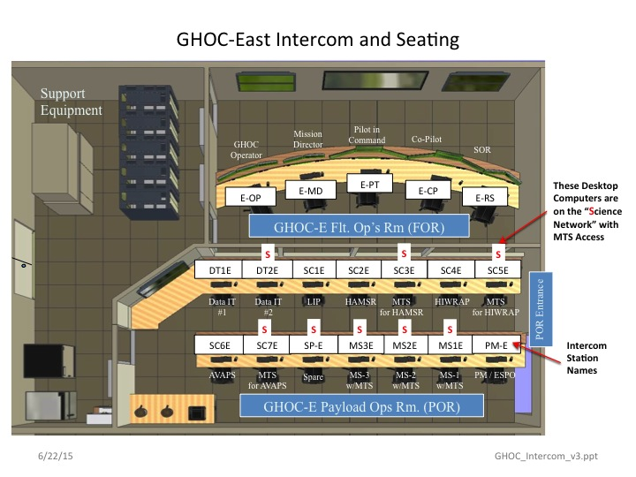
Figure 6.1 Detailed layouts of GHOC-E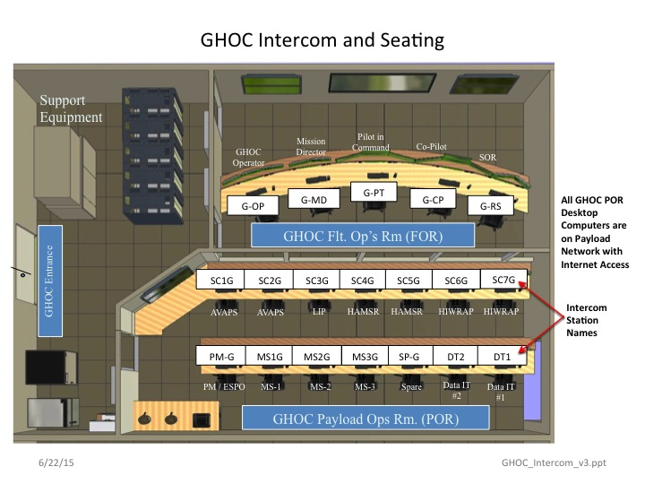
Figure 6-2 Detailed layouts of GHOC

6.1.2 Environment
The room temperature in the FOR and POR can be adjusted up or down as a single zone by WFF if the normal temperature setting is not acceptable.

6.2 Operations
The POR is the science operations area for the GH. Staffing includes the Mission Scientists (MS), the Payload Manager (PM), the IT specialist, and instruments Investigators (IIs).
- The POR needs to be staffed prior to GH engine start. Late arrivals cause late take-offs
- The POR should be staffed by IIs and MSs during the entire flight. Relief periods and furloughs are allowable per agreement and approval of the PM.
- Each station has an intercom & Windows PC. Several phones are available. Internet connectivity is available, but bandwidth limits and rules on appropriate use apply.
- Laptops are allowed (but discouraged) in the POR – must be scanned by NASA IT personnel.
- Cell phones and cameras are allowed, but in the event of an aircraft incident, all recording devices (laptops, tablets, cell phones, cameras, flash drives etc.) will be impounded. It is recommended that these personal items be left out of the POR.
- Quiet should be maintained for creating an operations-friendly work environment. Head-set mics should generally be “off” except for monitoring the GH and communicating with other team members.
- Guests in the POR require the approval of the PM.
- Food and beverages are allowable, but liquids must be in closed containers.
- There is no POR janitorial service. Police your area and pack out trash.

Mission science and instrument team duties
For every flight, there will be up to 3 Mission Scientists (MSs) and 4 instrument teams. While MSs will usually work closely together on all aspects of mission, they will each be given a primary mission responsibility.
• The MSs are the decision makers for all science issues during a GH flight. As such, they must be fully aware of the flight’s objectives, the status of the payloads, the status of the GH and other coordinating aircraft, and the meteorological situation.
• The lead MS is in charge of coordinating with the PM and pilots for a successful mission outcome. This involves re-routing of the aircraft, decisions on shortening flights (e.g., because of instrument failures), storm passes, dropsonde dispersal, etc.
• When possible another MS takes lead responsibility for updating pilots frequently on possible hazardous weather for upcoming flight legs in situations where conditions warrant. The MSs should provide a regular update (~every hour to as short as every flight segment) of weather conditions along the projected flight path to the PM, mission director (MD). This would include cloud tops, lighting, storm location, etc. See section 3.3.4.
• One MS should be in charge of maintaining the flight report, although all MSs can take notes and save relevant data/images.
• The PM is the point of contact between the MD and the IIs. The PM should keep the team apprised of aircraft issues (via headset and chat).
• The MSs and PM are also in charge of updating the team (via headset and chat). Regular updates on the mission progress is necessary for the mission management, mission planner, and later shifts. For example, the forecasters and flight planners follow the flight via MTS, chat, and the headsets.
• The IIs should keep the MSs and PM apprised of instrument performance. Furthermore, the IIs should monitor their real-time products on the mission tools for accuracy and timeliness.
• The IIs are also responsible for notifying the MSs of interesting features that are observed in their data.

6.4 Requesting changes to the flight plan
- Altering the GH flight plan in mid-flight requires coordination amongst the MS, science team (ST), PM, MD, and Pilots (P)
- There are several scenarios for the MSs to keep in mind. 1) A correction that requires immediate action (i.e., a fast developing convective system that will pop over FL500), 2) adjustments to the flight pattern to account for storm motion or insertion of a new module , (3) P or MD adjustments for various reasons, and (4) instrument failures.
- Scenario 1: Hazard avoidance diversion
  - MS notifies MD, PM, and P ( through the PM or MD) of the lat/lon location and other details of the burst. Indicate the module diversion that you prefer.
  - Be aware of regions that you “re-direct” towards. A convective burst seen 60-min prior to arrival may collapse, and a region you re-direct towards may develop.
- Scenario 2: MS changes to flight path
  - MSs should map out the course correction. Things to keep in mind:
    - Drop patterns and other “location” maneuvers and operations planned for after the course correction may need to be eliminated or altered.
    - Landing times will change – mind the fuel.
  - If the MS has decided on a course correction, notify the PM, MD, and P ((through MD, unless requested by P) that a course correction is required. Indicate when a plan put will be finalized and how it will be communicated to the MD and PM.
  - Pass the course correction to the P(through MD, unless requested by P) . This is best done digitally to avoid transcription errors. Lat/lon should be in degrees and decimal minutes (DD MM.decimal minutes). Distances should be in nautical miles. Pilots will be well briefed on the modules, so it is best to stick to those modules and not try to “free-fly” the GH.
  - Discuss the correction with the pilots to make sure that the correct pathway is being implemented.
  - Notify the Science Team of the course adjustment (via headsets and chat).
- Scenario 3: Pilot adjusted course. The Ps or MD may decide on a course correction for aircraft purposes, independent of the science requirements.
  - The Ps and MD should notify the PM and MSs of the course correction. The MSs or PM should pass this along to the science team (via headsets and chat).
  - The MSs should adjust the flight plan to account for this change, if necessary, and they should quickly inspect the new path for weather.
- Scenario 4: Instrument failures. Does the instrument failure mean the science objectives cannot be met?
  - Can the remaining instruments still provide valuable data?
  - Can the GH return to base sooner (unless there is an emergency, the GH would have to return during daylight hours only).

7. REFERENCES
Brown, S., Lambrigtsen, B., Tanner, A., Oswald, J., Dawson, D., Denning, R., 2007: Observations of tropical cyclones with a 60, 118 and 183 GHz microwave sounder. Geoscience and Remote Sensing Symposium, IGARSS 2007. IEEE International 23-28 July 2007, 3317 – 3320.
Halverson, J. B., J. Simpson, G. Heymsfield, H. Pierce, T. Hock, and L. Ritchie, 2006: Warm core structure of Hurricane Erin diagnosed from high-altitude dropsondes during CAMEX-4. J. Atmos. Sci., 63, 309-324.
Heymsfield, G., and coauthors, 2008: Status of the High-Altitude Imaging Wind and Rain Airborne Profiler (HIWRAP), NASA Earth Science Technology Conference, College Park, MD, (http://esto.nasa.gov/conferences/estc2008/papers/Heymsfield_Gerald_B5P2.pdf)
Hock, T., and J. L. Franklin, 1999: The NCAR GPS dropwindsonde. Bull. Amer. Meteor. Soc., 80, 407–420.

