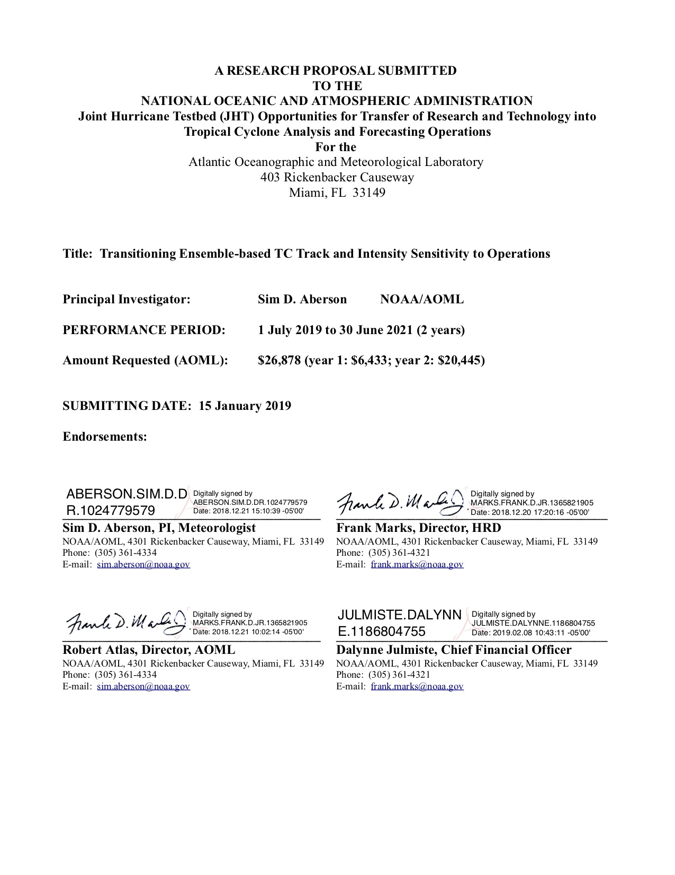

**Title Page**

Research Proposal Submitted for Federal Funding Opportunity

FY2019 Office of Weather and Air Quality Research Programs

NOAA-OAR-OWAQ-2019-2005820

*High Impact Weather Testbed Objective: Joint Hurricane Testbed (JHT-2)*

*Competition ID #2759275*

**Transitioning Ensemble-based TC Track and Intensity Sensitivity to Operations**

***27 December 2018***

|  |  |
| --- | --- |
| **Principal Investigator:**  **Dr. Ryan Torn,** Associate Professor  University at Albany, SUNY  Atmospheric and Environmental Sciences  1400 Washington Avenue, ES 351  Albany, NY 12222  [Tel: 518-442-4560](Tel:518-442-4560)  Email: [rtorn@albany.edu](mailto:rtorn@albany.edu) | **Institutional Representative:**  Ashley Gardner, Research Administrator  Office of Pre-Award and Compliance Services  The Research Foundation for The State University of NY  University at Albany, SUNY  1400 Washington Avenue, MSC100B  Albany, NY 12222  Phone: 518-437-3895 Email: [agardner@albany.edu](mailto:agardner@albany.edu) |

**Performance Period: 1 July 2019 to 30 June 2021 (2 years)**

**Amount Requested University at Albany: $149,880** (year 1: $76,961; year 2: $72,919)

**Team:**

Co-Principal Investigator: Jason P. Dunion (University of Miami/RSMAS/CIMAS)

4301 Rickenbacker Causeway, Miami, FL 33149

Phone: 305-720-3060 Email: jason.dunion@noaa.gov

Co-Principal Investigator: Sim D. Aberson (NOAA/AOML/Hurricane Research Division)

4301 Rickenbacker Causeway, Miami, FL 33149

Phone: 305-361-4334 Email: sim.aberson@noaa.gov

Amount Requested (AOML): $26,878 (year 1: $6,433; year 2: $20,445)

***Total Summary Budget Table for all partners***

|  |  |  |  |
| --- | --- | --- | --- |
|  | **Year 1**  **1 July 2019 – 30 June 2020** | **Year 2**  **1 July 2020 – 30 June 2021** | **Total**  **2 Years** |
| University at Albany | $76,961 | $72,919 | $149,880 |
| NOAA/AOML/HRD | $6,433 | $20,445 | $26,878 |
| **Total Budget** | **$83,394** | **$93,364** | **$176,758** |

**Transitioning Ensemble-based TC Track and Intensity Sensitivity to Operations**

Principal Investigator: Ryan Torn (University at Albany-SUNY)

Co-Principal Investigator: Jason P. Dunion (University of Miami/RSMAS/CIMAS)

Co-Principal Investigator: Sim D. Aberson (NOAA/AOML/Hurricane Research Division)

**Abstract**

Operational Synoptic Surveillance missions have resulted in reduced tropical cyclone (TC) track-forecast errors; however, the basic flight-track design and observational sampling strategies have remained largely unchanged for the past decade despite numerous modeling suite upgrades. This proposal is the culmination of NOAA-funded research carried out over the past four years during the NOAA Unmanned Aircraft Systems (UAS) Sensing Hazards with Operational Unmanned Technology (SHOUT) project and in collaboration with National Hurricane Center (NHC) forecasters, including in real time during the 2018 Atlantic hurricane season. Here, we propose to implement a modern, ensemble-based operational product that NHC forecasters could use to determine the locations for dropsondes and supplemental rawinsonde profiles over land that could subsequently reduce model uncertainty in forecasts of both TC track and intensity, which addresses JHT Priority 2.

The first year of this project will result in an operational product based initially on European Centre for Medium Range Weather Forecasting (ECMWF) and Hurricane Weather Research and Forecasting (HWRF) forecast output, with an eventual extension to the Finite Volume Cubed-Sphere (FV3) ensemble system when it becomes available. In particular, we plan to implement objective forecast metrics that take into account variability in TC position and intensity over the entire forecast, rather than the current approach that considers a single time. In addition, we will implement methods to incorporate the sensitivity output into the current traveling salesmen software package used by NHC to produce objective flight tracks that sample as many of the identified sensitive regions as possible given current operational and platform constraints. Our product suite can also be used to identify valuable supplemental rawinsonde locations as well. This development work will focus on previous high-impact case studies (e.g., Irma, Florence). In addition, PI Torn will continue to provide a daily email summary of the experimental sensitivity output to NHC forecasters upon request during the 2019 season. During Year 2, we will transition our Python-based software package for producing sensitivity maps for quick analysis by NHC forecasters to the NHC computing system and develop a training module on how to interpret the model sensitivity information that could be incorporated into the NOAA Virtual Laboratory (VLAB). By the end of Year 2, we expect the various project deliverables will be available to NHC forecasters (i.e., no input from the proposal team) and is projected to be at NOAA RL 8 or NOAA RL9 (if the project is accepted for operational implementation).

**Statement of Work**

**Overview of problem**

Tropical cyclones (TCs) are among the most deadly and destructive natural disasters (e.g., Rappaport 2014, Rappaport and Blanchard 2016); therefore, it is important to provide timely and accurate forecasts of these events. TC track and intensity forecasts are heavily dependent on output from numerical weather prediction (NWP) systems, which are initialized with the best estimate of the atmospheric state at the time that the forecast is started (i.e., the analysis). This analysis is produced by adjusting a short-term forecast initialized at an earlier time with new observational information via data assimilation. Given that TCs generally occur over the ocean, collecting observations can be cost prohibitive and is typically limited to those provided by satellite and aircraft. As a consequence, it is important to be able to identify what observations to obtain and where to take them to maximally reduce the error and/or uncertainty in the subsequent forecast. These supplemental observations are often referred to as “targeted observations.” The purpose of this proposal is to implement new operational methods that identify sampling strategies so that supplemental aircraft and/or rawinsonde observations would maximally improve TC track and intensity forecasting.

The current operational targeting technique for dropwindsonde observations was developed in the mid-1990s and is based upon the variance of the NOAA Global Ensemble Forecasting System (GEFS) at the targeting time; in tests with a large number of cases, it was found that fully sampling regions of maximum variance with regularly spaced observations (and limiting observations outside these regions) provided the largest track forecast improvement (Aberson 2003, Aberson et al. 2011). When this system was implemented, the GEFS was based upon a bred-mode system which approximated the local Lyapunov vectors of the dynamical system, and the variance maxima were therefore related to the fastest growing modes. The sampling strategy was based upon the then-current data assimilation and initialization in the global model, at the time a three-dimensional variational system with a synthetic vortex inserted at the TC location. Since this time, the ensemble system, deterministic model, and data assimilation system have all been upgraded, and the synthetic vortex has been removed. It is unclear whether the currently operational targeting and sampling strategies developed under these older forecast systems remain appropriate. Furthermore, the current technique is subjective in that it does not necessarily suggest where observations will lead to improvements to a particular forecast metric. By contrast, other methods, like the one being proposed here, provide information on improvements to specific forecast metrics, such as TC track and intensity.

The ensemble-based sensitivity technique (Ancell and Hakim 2017, Torn and Hakim 2018) provides an attractive method of identifying sensitive regions because it is computationally inexpensive, assuming an ensemble of forecasts is already available, and there is a wide range of potential forecast metrics (J) that can be used. Specifically, the sensitivity is computed via:

$$\frac{∂J}{∂x_{i,t-dt}}= \frac{cov(\text{J},x_{i,t-dt})}{var(x_{i,t-dt})}$$

where, **x**i,t-dt is the ensemble estimate of the forecast field at a location i and time t-dt prior to the forecast metric itself. In essence, this equation is a linear regression between an ensemble estimate of the forecast metric and the ensemble estimate of the forecast variable at an earlier lead time. This calculation can be repeated over many different horizontal locations, times, and fields, from which maps of sensitivity can be created. As a consequence, this calculation is trivial to carry out; it can be done on a desktop computer. The method has been shown to provide accurate estimates of forecast sensitivity for a variety of forecast metrics, including African Easterly Waves (Torn 2010), midlatitude cyclones (Lamberson et al. 2016), severe convection (Torn and Romine 2016, Torn et al. 2017), and the orientation of the midlatitude jet (Berman and Torn 2019). Moreover, this ensemble-based method has been used to provide insight into the source of track differences for TCs characterized by large forecast position variability (e.g., Torn et al. 2015; Torn et al. 2018).

Previous applications of this technique suggest that it can be used to identify observations that will have the largest impact on the subsequent forecast, which indicates that this method is suitable for observation targeting. Torn (2014) used ensemble-based sensitivity to identify the subset of dropwindsonde data that would have the greatest benefit to TC genesis forecasts during the PRE-Depression Investigation of Cloud-systems in the Tropics (PREDICT) field campaign. In each of the cases studied, assimilating data from just 3-4 dropwindsondes within the sensitive region had nearly the same positive impact on subsequent TC genesis forecasts as assimilating all of the dropwindsonde data collected during the mission. Furthermore, the impact from the dropwindsonde data in the sensitive region is greater than that of a random sets of dropwindsonde data from the mission, which suggests that the method can identify the locations and fields that have the biggest impact on the subsequent forecast.

The PREDICT-based experiments were carried out after the completion of the field phase; however, there have been other real-time applications of the ensemble-based sensitivity method to improve TC forecasts. During the NOAA Sensing Hazards with Operational Unmanned Technology (SHOUT) field campaign, our group used output from the Hurricane Weather Research and Forecasting (HWRF) and European Centre for Medium Range Weather Forecasting (ECMWF) ensemble forecast systems to compute the sensitivity of TC track and intensity forecasts and hence identify the location of target regions to sample with the NASA Global Hawk aircraft. Prior to each mission, PI Torn carried out the sensitivity calculation for the TC of interest for the day, and provided a written and verbal summary to the other mission scientists who then used this information flight track planning. Preliminary experiments with the GFS and HWRF systems with and without the dropwindsonde data indicate that the Global Hawk dropwindsondes provided a 10-15% improvement in TC track and intensity forecasts, which is significantly higher than the improvement obtained when Global Hawk dropwindsondes were assimilated during past field campaigns (i.e., NASA GRIP; Christophersen et al. 2017; Christophersen et al. 2018; Dr. Jason Sippel, personal communication). One of the hypotheses for the increased value of the dropwindsondes from SHOUT is that the flight track designs during this experiment took into account an experimental version of the sensitivity information that is being proposed here. There is currently ongoing work within the NOAA UAS program to assess the impact of observations collected by the Global Hawk, including dropwindsonde data.

Real-time ensemble-based TC track and intensity sensitivity estimates continued to be experimentally produced during the 2017 and 2018 hurricane seasons and was used in NOAA flight planning operations by forecasters at NHC. These products were primarily based on calculations carried out with the ECMWF ensemble prediction system. Ideally, we would have liked to carry out these calculations on NOAA-based modeling systems (i.e., GFS and HWRF); however, there are good reasons for why the initial implementation focused on applying this method to the ECMWF ensemble prediction system. First, the quality of the ensemble sensitivity results depends on having sufficient ensemble members to compute the ensemble-based regression coefficients. The ECMWF system has 51 members, while the current version of the GFS system only has 21 members. Furthermore, it is more likely that the sensitivity information will be more useful if the ensemble provides skillful probabilistic forecasts (i.e., the ensemble-mean error is equivalent to the ensemble standard deviation). Whereas the GFS TC position forecasts are generally under-dispersive, the ECMWF TC position forecasts have been shown to be skillful both in total distance and in the direction of greatest ensemble position variability (e.g., Hamill et al. 2011).

Starting two days prior to individual synoptic surveillance flights, PI Torn calculated the sensitivity of TC position forecasts to the steering flow at the time of the proposed flight. Each morning, he would then provide to the main flight-track designers at NHC a one paragraph summary of the sensitivity output, how the sensitive regions relate to the major atmospheric features that could influence the TC motion, and how the sensitive regions may have changed relative to previous initialization times. In addition, PI Torn provided a sensitivity graphic that overlaid the sensitive regions on top of the steering flow. During 2017, these calculations were carried out for Hurricanes Irma and Nate, and, in 2018, the experimental targeting guidance was provided for additional number of storms (Hurricanes Hector, Lane, Florence, Olivia, and Michael), which included cases that impacted the Hawaiian Islands.

For many of the surveillance missions, the target regions aligned well with the dynamical expectation for what synoptic features could impact the subsequent TC position forecast and with the distribution of dropwindsondes for that case. Figure 1 shows the sensitivity of the ECMWF forecast of 2018 Hurricane Florence’s position at 0000 UTC 14 September (around the time of landfall) to the zonal component of the wind at 0000 UTC 11 September for the forecast initialized 0000 UTC 9 September (i.e., two days prior to a planned flight on 0000 UTC 11 September). In this particular case, the sensitive region is primarily located around and to the west of Florence’s position, suggesting that Florence’s position forecast is sensitive to the steering flow near the TC along the southern side of the subtropical ridge that was located north-northwest of Florence (centered near 37 N 65 W). In particular, the calculation suggests that making the zonal wind more westerly within the warm color regions would result in Florence making landfall closer to Cape Hatteras, and making the zonal wind more easterly (i.e., stronger trade winds) in the warm color regions would result in a position forecast farther south in South Carolina. As a consequence, the dropwindsondes were deployed around the TC and on the southern side of the subtropical ridge within the sensitive region west of Florence.

A second example of the ensemble-based sensitivity targeting is from 2018 Hurricane Norman in the central North Pacific for 0000 UTC 6 September. For this time, the high-sensitivity (i.e., target) region is to the northwest of the TC along the southern end of the midlatitude trough north of the TC. Increasing the wind speed to the northeast of the TC results in a track forecast that is more to the northeast 48 h later. In addition, the dropwindsondes deployed during this case were able to sample that sensitive region.

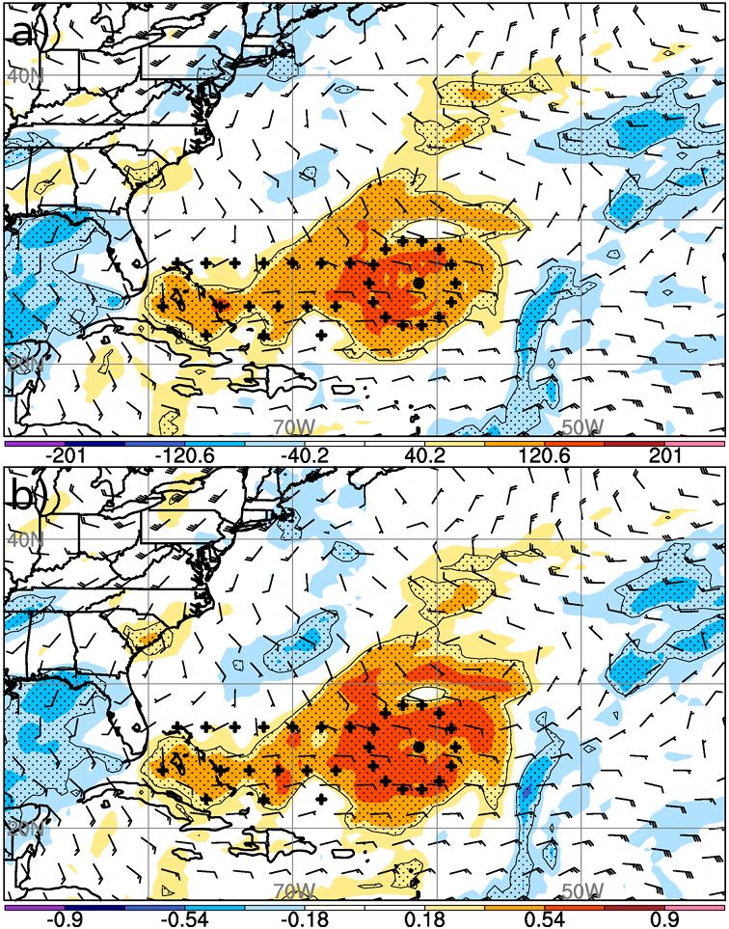

Figure 1: (a) Sensitivity of Florence’s 120 h (0000 UTC 14 September) distance along the major axis to the 48-h (0000 UTC 11 September) zonal component of the steering wind (shading, km). Stippled regions indicate where the sensitivity is statistically significant at the 95% confidence level. The barbs denote the ensemble-mean steering wind. The large dot denotes Florence’s 0-h position, while the crosses denote the dropwindsonde locations. (b) as in (a), but where the forecast metric is the time-integrated track PC.

Although forecasters at NHC have found this ensemble-based guidance to be useful for flight planning operations, the calculation and interpretation is currently done experimentally by PI Torn. As a consequence, it appears that this is the optimal moment to transition this output into a formal operational product that does not depend on PI Torn’s input. The purpose of this proposed effort is to implement an ensemble-based operational product that NHC forecasters could use to determine locations for dropwindsonde observations from operational aircraft and supplemental rawinsonde profiles over land that would sample regions that could subsequently reduce model uncertainty for both TC track and intensity. This proposal addresses JHT Priority 2: “*New applications of ensemble modeling systems for track, intensity and structure forecasting, including development of guidance on targeting supplemental observations (e.g., synoptic surveillance) that take into account hurricane forecaster use as well as data assimilation needs and dynamically-based wind-speed probabilities.”* Based on our experience over the past two years, we believe that this product is currently at NOAA RL 6. We hypothesize that the target regions provided by this method will provide improved guidance on where to supplement the regular observation network. These supplemental observations could include aircraft dropwindsondes, supplemental rawinsonde launches, or even atmospheric motion vectors (AMVs) derived from the rapid-scan mesoscale sectors available on the GOES-R satellite series.

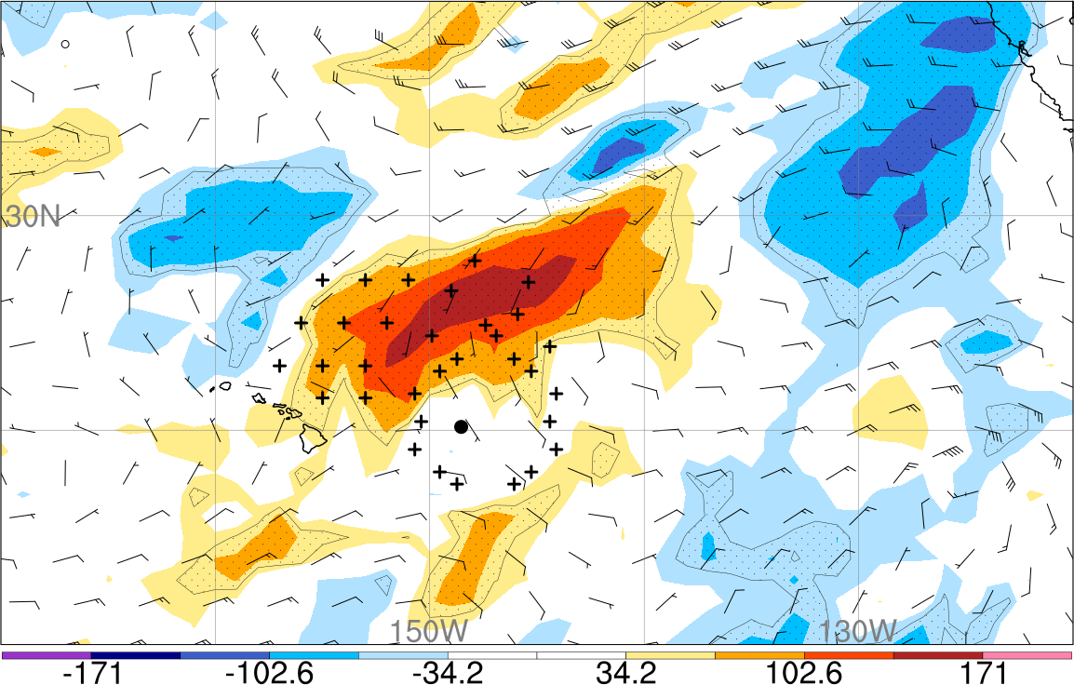

Figure 2: Sensitivity of the Norman’s 96 h (0000 UTC 8 September) distance along the major axis to the 48-h (0000 UTC 6 September) meridional component of the steering wind (shading, km). Stippled regions indicate where the sensitivity is statistically significant at the 95% confidence level. The barbs denote the ensemble-mean steering wind. The large dot denotes Florence’s 0-h position, while the crosses denote the dropwindsonde locations.

**Methodology and Work Plan**

The focus of this proposal is to implement an operational product using the ensemble-based sensitivity software framework that our team has developed over the past four years so that it could be used by NHC forecasters to design synoptic surveillance flight tracks and identify rawinsonde observations that would benefit TC track and intensity forecasts. The following two-year work plan includes a set of tasks that we believe will transition the product into a RL 8/RL 9 product that can work within the current NHC software suite and can be used in real-time by NHC forecasters. Most of the tasks during Year 1 are focused on removing some of the subjective aspects of the methodology and incorporating new features that will help make the product more usable within the NHC suite. By Year 2, the focus of the project will be on setting up the product within the NHC computing environment and working with NHC forecasters to tailor the product to their needs and make it easy to utilize within the operational environment. Given the inherent time pressure that NHC forecasters are under, it is important to implement an operational product that can be quickly accessed and analyzed. One of the potential time-consuming aspects of using this product could be choosing the appropriate forecast metric for optimizing TC position. This includes both how to describe the position of the TC, since the position is described by two values (latitude and longitude) and what time period to choose. Calculating and evaluating the sensitivity for forecast metrics at various lead times can be time-consuming and potentially could provide contradictory information. Furthermore, TC position at one lead time is often correlated with the position at earlier lead times in the forecast (i.e., a forecast that is further east at 48 h is likely to remain further east at 72 h); therefore, it might be beneficial to implement a forecast metric that represents the position variability throughout the entire forecast, rather than focusing on the position at a single time.

One possible way to alleviate the need for assessing the sensitivity for forecast metrics at various lead times is to extend our current position-metric definitions to multiple time periods. In our experimental product, we combined the two components of location (latitude and longitude) by using a forecast metric that is the distance along the major axis of variability. For example, Fig. 3 shows the position variability of the Hurricane Florence forecast described above, where the circles are the position ellipses derived using the technique of Hamill et al. (2011). In essence, this method computes the direction that is characterized by the greatest position variability at a single time by computing the empirical orthogonal function (EOF) of the ensemble position estimates, where the forecast metric is the principle component (PC) of the EOF that describes the most variance. For example, the largest variability for the 120-h forecast (given in magenta) is oriented in the southwest-northeast direction; therefore, the forecast metric we used in the target calculation above is the distance along that direction, which is equivalent to the PC of the position variability.

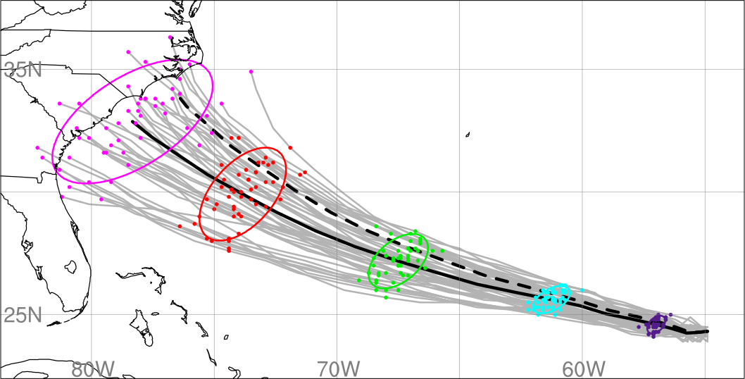

Figure 3: ECMWF ensemble forecasts of Hurricane Florence initialized at 0000 UTC 9 September (gray lines). The dots indicate the location of each ensemble member at 24-h intervals, while the colored circles show a bivariate normal fit to the positions each 24 h, as in Hamill et al. (2011). Purple denotes 24-h locations, cyan denotes 48-h locations, green denotes 72-h locations, red denotes 96-h locations, and magenta denotes the 120-h locations. The thick black line denotes the ensemble-mean track, while the dashed black line is the track associated with the time-integrated forecast metric equal to 1.0.

In order to produce the forecast metric and sensitivity calculations, we plan to assess whether a time-integrated position variability metric can give similar sensitivity guidance as single-time position metrics. In particular, we plan to use a forecast metric that is the PC of the ensemble position forecast over the entire 120-h forecast, rather than just at a single subjectively determined time as we have done previously. As a consequence, the forecast metric takes into account the correlation in TC position among multiple times and removes the need for looking at the sensitivity for multiple times. Fig. 3 shows the Florence tracks for the same case, while the dashed line is the track that is representative of the forecast metric (PC) equals 1.0. In this situation, a forecast metric value of zero denotes a track forecast close to the ensemble mean, while positive (negative) metric values indicate that the TC moves to the right (left) of the ensemble mean track. As a consequence, this approach appears to succinctly summarize the track variability through the entire forecast into a single easy-to-understand value. Fig. 1b shows the sensitivity of this integrated track metric to the zonal wind at 0000 UTC 11 September. Similar to Fig. 1a, which shows the sensitivity of the 120 h position forecast, the sensitivity of the time-integrated track metric to the steering flow is maximized near the storm and immediately to its west; therefore, it appears that this choice of forecast metric could be an efficient way to identify target regions without having to evaluate the sensitivity output for multiple times. This capability is already available within our software package and will be assessed over a larger suite of cases in Year-1 of this project.

Our previous work has computed the sensitivity to the zonal and meridional component of the steering flow. Having to look at these two wind components can be problematic in that it can be time consuming to evaluate two sets of figures. Furthermore, the direction of greatest steering wind variability often has components in both the zonal and meridional direction, similar to the position variability described above. As a consequence, we plan to assess different ways of describing the wind field for sensitivity calculations. This includes looking at the component of the wind that is in the same direction as the largest position variability for the forecast. For example, the Florence example above has the largest position variability in the southwest-northeast direction at all time periods; therefore, we would compute the sensitivity to the component of the wind in that direction. Another possibility is to compute the sensitivity to the vorticity of the steering flow since the vorticity is one way to combine the two wind components into a single scalar field. From there, we can define the target region as locations where the sensitivity to the steering flow vorticity field is maximized. Similar to the forecast metric description above, this capability is already available and has been tested on a small number of cases.

In order to effectively address whether the integrated track metric and revised steering flow descriptions will be useful in an operational context, we will repeat our ECMWF sensitivity calculations for a number of high-profile TC cases from 2017 and 2018. This list of cases will be coordinated with our NHC points of contact, so that the cases are of operational interest. We will compare the target regions from the single lead time metrics to the integrated time metrics. If the regions are similar to one another, than it would indicate that we can move forward with using this metric. Furthermore, we also plan to expand this time-integrated metric to intensity forecasts using HWRF ensemble output.

Transitioning this methodology into an operational product will also require developing a more streamlined software package that can be implemented within the NHC computational environment. The ensemble sensitivity code that can use either ECMWF or HWRF ensemble output uses a combination of c-shell scripting and NCAR Command Language (NCL) plotting software, which could make it difficult for long-term maintenance and enhancement. In response, we plan to rewrite the targeting software into a Python framework, which contains a number of packages that work well for meteorological applications and there are several NHC IT staff members using Python. Furthermore, Python contains all of the unique capabilities of NCL, such as the spherepack routines (through the pyspharm package), that allow us to remove the TC vortex from the background steering flow. Dr. Nick Schiraldi, a University at Albany Data Analytics and Visualization Specialist and an expert Python programmer, will assist in the development of this software that can be moved into the NHC computing environment. Furthermore, we will work with our NHC points of contact to create graphics that are easy to use in a time-constrained operational environment.

In addition to the new Python framework for visualizing the target output, we plan to use the sensitivity fields within the current flight-planning software that was developed for NHC. An automated system for flight-track drawing was implemented at NHC through the Joint Hurricane Testbed in 2004 and has been used operationally since. The system currently uses the subjective targeting technique based on NOAA’s Global Ensemble Forecast System; it was designed flexibly so that it can use any gridded field supplied to it. The system uses a traveling-salesman algorithm to draw the shortest flight tracks based on points of departure and return, aircraft, length of flight, requested resolution of dropwindsonde deployments, land and vortex avoidance or non-avoidance, location of operational rawinsonde releases, etc. As a consequence, we plan to use the sensitivity fields as input into this pre-existing software to draw automated flight tracks. This will be accomplished by writing the gridded sensitivity fields into a file while the graphics are being produced, which can then be input into the NHC flight-planning software. We will work with our NHC points of contact to adapt the conditions in use with the current version of the system to the new sensitivity fields.

During the 2019 hurricane season, we will not have the new software package available for use in operational planning. As a consequence, PI Torn will continue to provide “on-demand” target information guidance based on ECMWF and HWRF ensemble output in a similar manner as was done during 2017 and 2018. In particular, PI Torn will provide a daily written summary of the target guidance for times of interest as well as graphics that can be used in flight planning and to optimize supplemental rawinsonde launches. Prior to the season, PI Torn will coordinate with NHC forecasters to debrief on the process and products from the previous years and discuss ways to improve the usefulness in the upcoming season.

For the 2020 hurricane season, we will work with NHC personnel to have the sensitivity/target calculation performed on NHC computing platforms using the Python-based code that we will implement in Year 1, with the output being available to NHC forecasters in real time. We anticipate that some hurricane specialists will require some supplemental training on how to use the output from this new system. In order to address this, we plan to implement a training module within the NOAA VLAB environment that provides a description of the methodology and examples of how to interpret the output in collaboration. In addition, we will produce output for a set of retrospective cases (determined in collaboration with NHC focal point) that forecasters could use for training purposes. PI Torn will also be available to provide a training session at NHC on how to use the output. Finally, PI Torn will remain “on call” during this season to assist NHC personnel with interpretation of the product output; however, by Year-2 of this project, we expect that all real-time calculations will be done at NHC, rather than on University at Albany computers.

By Year 2 of this project, we expect that some of the drawbacks of the current GFS system will have been addressed. During Spring 2020, it is expected that the operational GEFS system will be transitioned to an FV3-based configuration. This new system is expected to expand from 21 to 30 ensemble members, which will provide more robust analyses of sensitivity values. Furthermore, the FV3 system will have new stochastic model error methods, which is expected to produce more skillful ensemble TC forecasts. As a consequence, it makes more sense to hold off on implementing the targeting method to the GFS system until the FV3-based version is put into operations. The Python code that we plan to transfer to NHC will be written in such a way that it will be easy to incorporate FV3 output. Both ECMWF and FV3 output is in GRIB format, so it should be relatively straightforward to switch in between these models and any future model with GRIB format output.

At the end of Year 2, deliverables will include completion of a software package that will compute the sensitivity of TC track and intensity forecasts using output from the GEFS, HWRF, and ECMWF ensemble prediction systems for the current initialization time within the NHC computing environment. For TC position, the output will be the sensitivity of the integrated position forecast variability to some aspect of the steering flow (either u, v component, wind in the direction of largest position variability, or vorticity of the steering flow). For intensity, the output may be the sensitivity of the integrated intensity metric variability to the wind field at aircraft flight level. For both metrics, the software will include the ability to draw optimal flight tracks based on the sensitivity fields and criteria that we develop with our NHC point of contact. In that way, we expect that this project will be a RL 8/RL 9 product.

It is worth emphasizing that the ensemble-sensitivity methodology is flexible and could be expanded in the future based on ongoing research. NOAA HFIP-funded research that is currently underway in PI Torn’s research group (Title: Evaluating Initial Condition Perturbation Methods in the HWRF Ensemble Prediction System) includes exploring how to use ensemble sensitivity to identify target regions for TC wind field and precipitation forecasts. We estimate that this work is currently at RL 3, but could progress toward RL 6 by the end of that project (August 2020). We plan to implement the Python software package in a very flexible manner, such that if the output proves useful with the test cases, the sensitivity output could easily be modified to work with additional metrics, such as the wind and precipitation field.

**Timeline**

**Year 1 (1 July 2019 – 30 June 2020):**

* Test new time-integrated track and intensity forecast metrics and ways to describe the steering flow
* Begin transition of sensitivity software to Python framework
* Test sensitivity fields in flight design software
* Continue providing on-demand target information to NHC forecasters

**Year 2 (1 July 2020 – 30 June 2021):**

* Transition sensitivity software into the NHC computing environment
* implement NOAA VLAB training module on how to interpret output and examples
* Expand target guidance to include FV3 ensemble information

**References**

Aberson, S.D., 2003: Targeted Observations to Improve Operational Tropical Cyclone Track Forecast Guidance. *Mon. Wea. Rev.,* **131**, 1613-1628.

Aberson, S.D., S.J. Majumdar, C.A. Reynolds, and B.J. Etherton, 2011: An Observing System Experiment for Tropical Cyclone Targeting Techniques Using the Global Forecast System. *Mon. Wea. Rev.,* **139**, 895-907.

Ancell, B., and G. J. Hakim, 2007: Comparing adjoint and ensemble sensitivity analysis with applications to observation targeting. *Mon. Wea. Rev.*, **135**, 4117-4134.

Berman, J. D., and R. D. Torn, 2018: Diagnosing the impact of forecast errors associated with warm conveyor belts on variability in the downstream waveguide. *Mon. Wea. Rev.*, in review.

Bishop, C. H., B. J. Etherton and S. J. Majumdar, 2001: Adaptive Sampling with the Ensemble Transform Kalman Filter. Part I: Theoretical Aspects. *Mon. Wea. Rev.,* **129**, 420-436.

Christophersen, H., A. Aksoy, J. Dunion, and K. Sellwood, 2017: The Impact of NASA Global Hawk Unmanned Aircraft Dropwindsonde Observations on Tropical Cyclone Track, Intensity, and Structure: Case Studies. *Mon. Wea. Rev.,* **145**, 1817-1830.

Christophersen, H., A. Aksoy, J. Dunion, and S. Aberson, 2018: Composite Impact of Global Hawk Unmanned Aircraft Dropwindsondes on Tropical Cyclone Analyses and Forecasts. *Mon. Wea. Rev.,* **146**, 2297-2314.

Hamill, T. M., J. S. Whitaker, M. Fiorino, and S. J. Benjamin, 2011: Global ensemble predictions of 2009’s tropical cyclones initialized with an ensemble Kalman filter. *Mon. Wea. Rev.*, **139**, 668–688.

Lamberson, W., R. D. Torn, L. F. Bosart, L. Magnusson, 2016: Diagnosis of the source and evolution of medium-range forecast errors for extratropical cyclone Joachim. *Wea. Forecasting*, **31**, 1197-1214.

Majumdar, S. J., S. D. Aberson, C. H. Bishop, R. Buizza, M. S. Peng, and C. A. Reynolds, 2006: A comparison of adaptive observing guidance for Atlantic tropical cyclones. *Mon. Wea. Rev.*, **134**, 2354-2372.

Rappaport, E. N., 2014: Fatalities in the United States from Atlantic tropical cyclones: New data and interpretation. *Bull. Amer. Meteor. Soc.*, **95**, 341-346.

Rappaport, E. N., and B. W. Blanchard, 2016: Fatalities in the United States Indirectly Associated with Atlantic Tropical Cyclones. *Bull. Amer. Meteor. Soc.*, **97**, 1139-1148.

Torn, R. D., 2010: Ensemble-based sensitivity analysis applied to African Easterly Waves. *Wea. Forecasting*, **25**, 61-78.

Torn, R. D., 2014: The impact of targeted dropwindsonde observations on tropical cyclone intensity forecasts of four weak systems during PREDICT. *Mon. Wea. Rev.*, **142**, 2860-2878.

Torn, R. D., T. J. Elless, P. P. Papin, and C. A. Davis, 2018: Tropical Cyclone Track Sensitivity in Deformation Steering Flow. *Mon. Wea. Rev.,* **146**, 3183–3201.

Torn, R. D., and G. J. Hakim, 2008: Ensemble-based sensitivity analysis. *Mon. Wea. Rev.*, **136**, 663-677.

Torn, R. D., and G. Romine, 2015: Sensitivity of Central Oklahoma convection forecasts to upstream potential vorticity anomalies during two strongly-forced cases during MPEX. *Mon. Wea. Rev.*, **143**, 4064-4087.

Torn, R. D., G. S. Romine, T. J. Galarneau Jr., 2017: Sensitivity of Dryline Convection Forecasts to Upstream Forecast Errors for Two Weakly Forced MPEX Cases. *Mon. Wea. Rev.*, **145**, 1831-1852.

Torn, R. D., J. S. Whitaker, P. Pegion, T. M. Hamill, and G. J. Hakim, 2015: Diagnosis of the Source of GFS Medium-Range Track Errors in Hurricane Sandy (2012). *Mon. Wea. Rev.,* **143**, 132-152.

**Data Management Plan**

The primary input data for this project are operational gridded forecast data produced by NOAA and ECMWF. These forecasts will be accessed from either the NOAA HPSS system (which all PIs have access to), or through the ECMWF TIGGE archive (https://apps.ecmwf.int/datasets/data/tigge/levtype=sfc/type=pf). Python sensitivity code will produce gridded sensitivity fields (likely in netCDF format) that will be used as input into NHC’s operational traveling salesman software for generating aircraft flight tracks. These sensitivity fields will have embedded metadata that includes the forecast initialization time, TC identification, forecast metric, and field information that would allow any user to understand the data. During the 2019 hurricane season, we will produce sensitivity plots and host these plots on a webpage at the University at Albany, similar to http://www.atmos.albany.edu/facstaff/torn/SHOUT/SHOUT_target.php. By the end of the project, the Python-based sensitivity code will be transferred to NHC if the product is chosen for operational implementation. This code will contain sufficient documentation that will allow NHC staff to maintain and expand the software as needed.

Gridded sensitivity output from the 2017 and 2018 retrospective cases and 2019 real-time demonstration will be archived on University at Albany servers and made available upon request. Once the software has been transferred to NHC, we will work with NHC staff to determine an appropriate policy to allow others to access the sensitivity grids for cases beyond 2019.

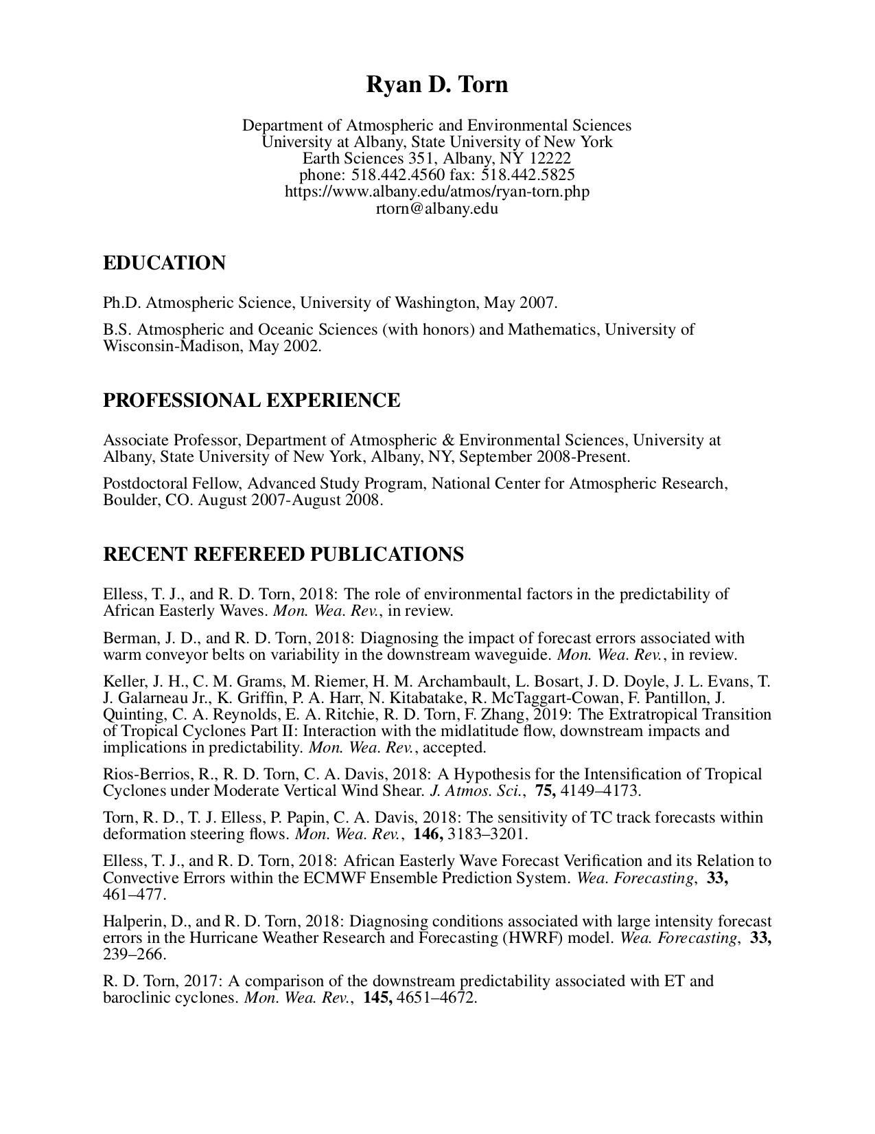



**Abbreviated Curriculum Vita (Jason P. Dunion)**

**Professional Preparation**

Ph.D. in Atmospheric Science, 2016, *University at Albany-SUNY*, Albany, NY

M.S. in Atmospheric and Oceanic Science, 1999, *University of Wisconsin*, Madison, WI

B.A. inGeography/concentration in Geology, 1992, *University of New Hampshire*, Durham, NH

**Appointments**October 2009-Present Meteorologist, University of Miami/RSMAS/CIMAS, Miami, FL

2006-Sept 2009 Meteorologist, NOAA/AOML/Hurricane Research Division, Miami, FL

November 1999-2006 Meteorologist, University of Miami/RSMAS/CIMAS, Miami, FL

**Selected Refereed Journal Publications**

* Dunion, J.P., C.D. Thorncroft, and D.S. Nolan. 2018: Tropical cyclone diurnal cycle signals in a hurricane nature run, *Mon. Wea. Rev*. (in press).
* Blackwell, W. J., S. Braun, R. Bennartz, C. Velden, M. DeMaria, R. Atlas, J. Dunion, F. Marks, R. Rogers, B. Annane, and R.V. Leslie, 2018: An overview of the TROPICS NASA Earth Venture Mission. *Quart. J. Roy. Meteorol. Soc*., **144**, 16-26.
* Bowers, G.S., D.M. Smith, N.A. Kelley, G.F. Martinez‐McKinney, S.A. Cummer, J.R. Dwyer, S. Heckman, R.H. Holzworth, F. Marks, P. Reasor, J. Gamache, J. Dunion, T. Richards, and H.K. Rassoul, 2018: A terrestrial gamma-ray flash inside the eyewall of Hurricane Patricia. *J. Geophys. Res*., **123**, 4977-4987.
* Brammer, A., C.D. Thorncroft, and J.P. Dunion, 2018: Observations and predictability of a nondeveloping tropical disturbance over the eastern Atlantic. *Mon.Wea.Rev*.,**146**, 3079-3096.
* Christophersen, H., A. Aksoy, J.P. Dunion, and S. Aberson, 2018: Composite impact of Global Hawk unmanned aircraft dropwindsondes on tropical cyclone analyses and forecasts. *Mon. Wea. Rev*., **146**, 2297-2314.
* Dunion, J.P., G. Wick, P. Black, and J. Walker, 2018: Sensing Hazards with Operational Unmanned Technology: 2015–2016 Campaign Summary, Final Report. NOAA Tech Memo. OAR-UAS-001, 39 pp.
* Wick, G., J. Dunion, and J. Walker, 2018: Sensing Hazards with Operational Unmanned Technology: Impact Study of Global Hawk Unmanned Aircraft System Observations for Hurricane Forecasting, Final Report. NOAA Tech Memo. OAR-UAS-002, 93 pp.
* Dole, R.J., and Coauthors, 2018: Advancing science and services during the 2015-16 El Niño: the NOAA El Niño Rapid Response Field Campaign. *Bull. Amer. Meteor*. Soc., **99**, 975-1001.
* Doyle, J.D., and Coauthors, 2017: A view of tropical cyclones from above: The Tropical Cyclone Intensity (TCI) Experiment. Bull. Amer. Meteor. Soc., **98**, 2113-2134.
* Christophersen, H., A. Aksoy, J.P. Dunion, and K. Sellwood, 2017: The impact of NASA Global Hawk unmanned aircraft dropwindsonde observations on tropical cyclone track, intensity, and structure: case studies. *Mon. Wea. Rev*. **145**, 1817-1830.
* Abarca, S.F., M.T. Montgomery, S.A. Braun, and J.P. Dunion, 2016: On the secondary eyewall formation of Hurricane Edouard (2016), *Mon. Wea. Rev*. **144**, 3321-3331.
* Folmer, M.J., R.W. Pasken, G. Chen, J.P. Dunion, and J. Halverson, 2016: Modeling studies on the formation of Hurricane Helene: the impact of GPS dropwindsondes from the NAMMA 2006 field campaign. *Meteor.Atmos.Phys*., **128**, DOI 10.1007/s00703-016-0452-2.

**Professional Honors**

* Co-Recipient: 2018 Banner I. Miller Award, American Meteorological Society: for their paper, *“The tropical cyclone diurnal cycle of mature hurricanes, which identified a fundamental process in tropical cyclones and elegantly defined its properties and potential implications using observational data.”*
* Recipient: 2016 Best Paper Award, NOAA Atlantic Oceanographic and Meteorological Laboratory: Dunion et al. 2014, *The tropical cyclone diurnal cycle of mature hurricanes*.
* Recipient (2015): NASA Group Achievement Award for "outstanding achievements of the Hurricane and Severe Storms Sentinel (HS3) airborne mission to investigate the factors influencing hurricane intensity change".
* Co-Recipient (2015): American Meteorological Society Special Award to the Univ. of Wisc.-CIMSS Tropical Cyclone Group for *“providing the weather community with valuable tropical cyclone-related satellite information and derived products for over two decades.”*
* Co-Recipient (2010): NOAA AIRS Team for outstanding contributions to improving weather forecasting using data from the Atmospheric Infrared Sounder (AIRS)
* 2009 Editors’ Citation for Excellence in Refereeing for Geophysical Research Letters
* 2005 NOAA David Johnson Award for “innovative research using environmental satellite observations on the influence and impact of the Saharan Air Layer on Atlantic tropical cyclones and the role it plays in development, decay, and intensity change of these storms.”
* 2004 Editors’ Citation for Excellence in Refereeing for JGR-Atmospheres.

**Professional Service**

* October 2017 – present: Member, NASA Global Hydrology Resource Center (GHRC) User Working Group (UWG), Huntsville, AL
* April 2016: Co-Chair, 32nd Conference on Hurricanes & Tropical Meteorology, San Juan, PR
* January 2014 - present: Member, NOAA Unmanned Aircraft Systems (UAS) Program’s Sensing Hazards with Operational Unmanned Technology (SHOUT) science team
* April 2014: Member, Organizing Committee, 31st Conference on Hurricanes and Tropical Meteorology, 30 March – 04 April 2014, San Diego, CA
* February 2014 - present: Member, Office of Naval Research Tropical Cyclone Intensity (TCI) science team
* April 2012-present: Member, NASA Hurricane and Severe Storm Sentinel (HS3) science team
* April 2012: Member, Organizing Committee, 30th Conference on Hurricanes and Tropical Meteorology, 15-20 April 2012, Ponte Vedra Beach, FL
* August 2010: Lead forecaster, National Science Foundation PRE-Depression Investigation of Cloud-systems in the Tropics (PREDICT) field experiment (St. Croix, V.I.)
* June 2008 – December 2016: member, AMS Scientific and Technological Activities Commission (STAC) on Tropical Meteorology and Tropical Cyclones
* May 2006 - present: Host Researcher, Monster Storms Project, JASON/National Geographic
* May 2006 - present: member of the NASA NAMMA science and mission planning team
* May 2004: Smithsonian Scholar, Smithsonian Scholars in the Schools Program; Houston, TX
* May 2000 - present: Member of the American Meteorological Society
* May 2000 - January 2004: President of the Greater Miami Chapter of the American Meteorological Society

**Sim David Aberson**

Meteorologist, ZP-1340-IV

NOAA/OAR/AOML-Hurricane Research Division

4301 Rickenbacker Causeway

Miami, FL 33004

305 361 4334

**Research Interests:** Tropical cyclone observations and analysis, especially aircraft observations; optimal sampling strategies (including targeting) for improving numerical forecasts; observing system experiments; extreme events in tropical cyclones; diversity, education, and outreach

**Employment history at NOAA:**

August 1988- : Meteorologist (2008: Director, NOAA Hurricane Field Program)

1987-1988: TEM contractor, 40 h per week

1982-1986: Various periods over summers and winter holidays, 40 h per week

1981-1982: Community Laboratory Research Internship, 12 h per week

**Other employment and affiliations:**

2013- : Lecturer, The Pennsylvania State University

2009-2013: Howard University PhD committee lead

**Education:**

2003: Ph.D. University of Maryland College Park, Atmospheric Sciences

1987: M.S. The Pennsylvania State University, Meteorology

1985: B.S. The Pennsylvania State University, Meteorology, Mathematics Minor

**Awards:**

2011 National Aeronautics and Space Administration Group Achievement Award

2008 South Florida Federal Executive Board, Federal Employee of the Year Management Award nomination

2007 National Academy of Science Kavli Frontier Fellow

2006 Department of Commerce Bronze Medal (group award for the Hurricane Research

Division)

2005 GLBT Scientist Award from the National Organization of Gay and Lesbian Scientists and Technical Professionals

2003 Presidential Early Career Award for Scientists and Engineers

National Oceanic and Atmospheric Administration Research Employee of the Year (2003)

National Oceanic and Atmospheric Administration/Environmental Research Laboratories

1999 Outstanding Scientific Paper Award for "The Impact of Omega Dropwindsondes on Operational Hurricane Track Forecast Models," Bulletin of the American Meteorological Society, 77 (5), 925-933 (1996). [Co-authored with Burpee, Lord, Franklin, and Tuleya.]

1993 Department of Commerce Gold Medal (group award for the Hurricane Research Division)

1982-1983 National Forecasting Contest Freshman/Sophomore Division 5th Place

**Committee memberships:**

American Meteorological Society Board on Women and Minorities

American Meteorological Society Committee on Tropical Meteorology and Tropical

Cyclones

American Meteorological Society History Committee

Hurricane Forecast Improvement Project Observations Team Chair

National Oceanic and Atmospheric Administration Diversity Council/Committee

National Oceanic and Atmospheric Administration North American Regional Team

National Oceanic and Atmospheric Administration Diversity, Advancement, and Retention Working Group

National Oceanic and Atmospheric Administration Research Diversity and Inclusion Advisory Committee

NOAA Diversity and Inclusion Management Advisory Council

PhD Committee Chair: Nelsie Ramos, Howard University

PhD Committee member: Daniel Stern, University of Miami

**Student mentorships:**

Kelly Nuñez Ocasio: 2019 NOAA Experiential Research & Training Opportunity

Nadine Schittko: 2016 International (Germany) internship

Kurt Hansen: 2015 NOAA Ernest F. Hollings Undergraduate Scholarship Program

Joseph Patton: 2014 NOAA Ernest F. Hollings Undergraduate Scholarship Program

Kelly Nuñez Ocasio: 2014 NOAA Education Partnership Program Scholarship

Sarah Ditchek: 2012 NOAA Ernest F. Hollings Undergraduate Scholarship Program

Tom Philp: International (United Kingdom) internship

Bryan Williams: 2011-2012 internship

Heather Winter: 2009 NOAA Ernest F. Hollings Undergraduate Scholarship Program

Nelsie Ramos: 2006-2007 NOAA Education Partnership Program Scholarship

LaTricia White: 2005-2006 internship

Dave Kofron: 2004-2005 internship

Kristopher Bedka: 1999 internship

**Refereed publications:**

Christophersen, H., A. Aksoy, J. Dunion, and S. Aberson, 2018: Composite impact of Global Hawk unmanned aircraft dropwindsondes on tropical cyclone analyses and forecasts. Mon. Wea. Rev., 146, 2297-2314.

Tang, J., J. A. Zhang, S. D. Aberson, F. D. Marks, and X. Lei, 2018: Multilevel tower observations of vertical eddy diffusivity and mixing length in the tropical cyclone boundary layer during landfalls. J. Atmos. Sci., 75, 3159-3168.

Aberson, S. D., K. J. Sellwood, and P. A. Leighton, 2017: Calculating dropwindsonde location and time from TEMPDROP messages for accurate assimilation and analysis. J. Atmos. Ocean. Tech., 75, 2083-2092.

Rogers, R. F., S. D. Aberson, M. Bell, D. Cecil. J. Doyle, T. Kimberlain, J. Morgerman,

L. K. Shay, and C. Velden, 2017: Re-writing the tropical record books: The extraordinary intensification of Hurricane Patricia (2015). Bull. Amer. Met. Soc., in press.

Aberson, S. D., J. A. Zhang, and K. Nuñez Ocasio, 2017: An extreme event in the eyewall of Hurricane Felix on 2 September 2007. Mon. Wea. Rev., 145, 2083-2092.

Evans, C., K. M. Wood, S. D. Aberson, H. M. Archambault, S. M. Milrad, L. F. Bosart, K. L. Corbosiero, C. A. Davis, J. R. Dias Pinto, J. Doyle, C. Fogarty, T. J. Galarneau, C. M. Grams, K. S. Griffin, J. Gyakum, R. E. Hart, N. Kitabatake, H. S. Lentink, R. McTaggart-Cowan, W. Perrie, J. F. D. Quinting, C. A. Reynolds, M. Riemer, E. A. Ritchie, Y. Sun, and F. Zhangl 2017: The extratropical transition of tropical cyclones. Part 1: Cyclone evolution and direct impacts. Mon. Wea. Rev., 145, 4317-4344.

Stern, D. P., G. H. Bryan, and S. D. Aberson, 2016: Extreme low-level updrafts and wind speeds measured by dropsondes in tropical cyclones. Mon. Wea. Rev., 144, 2177-2204.

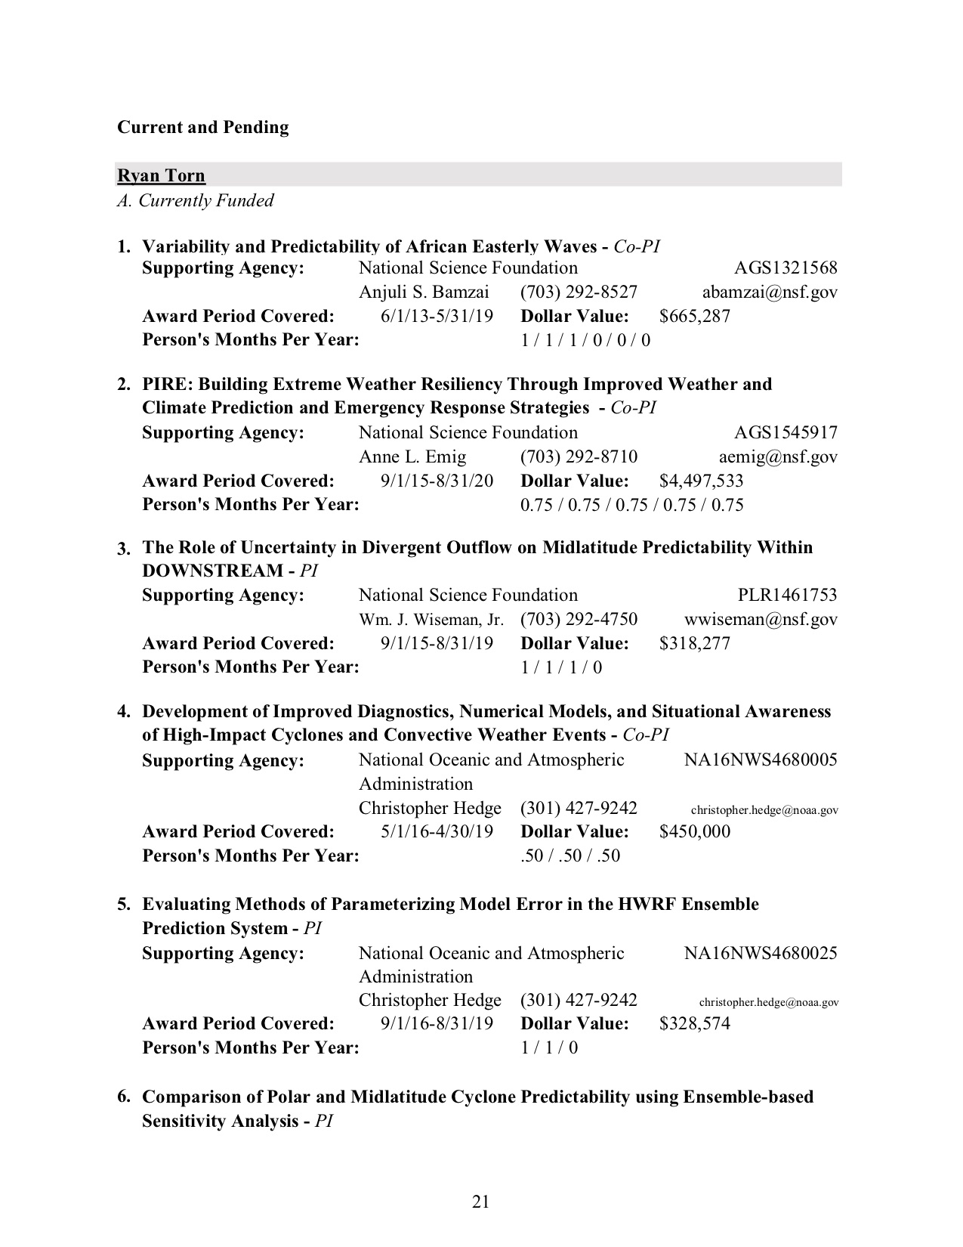

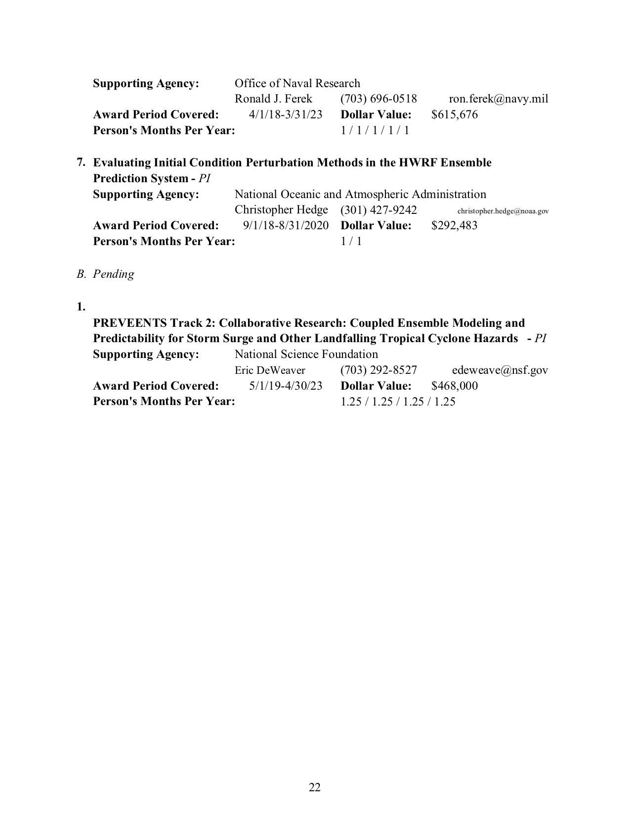

**Current/Pending Federal Support (Co-PI Dunion):**

**Current Support**

1. Title of Proposal: An Observational and Numerical Investigation of Energy Exchange Between a Tropical Cyclone and its Environment at the Outflow Level (proposal exptentsion)

Project Association: Co-PI

Prime Offeror: Office of Naval Research

Percentage Effort: 8% (Year 4); 8% (Year 5)

Period of Performance: 9/1/2017 - 12/31/2018

Person Months: 1.0 (Year 4), 1.0 (Year 5)

Total Award: $396,000

1. Title of Proposal: NOAA UAS 2-yr Dunion salary support/NOAA UAS Field Campaign Support

Project Association: Co-Science Lead

Prime Offeror: NOAA UAS Program

Period of Performance: 08/01/2017 - 07/31/2019

Percentage Effort: 30% (Year 1); 30% (Year 2);

Person Months: 3.6/yr

Total Requested: $225,000

1. Title of Proposal: Time-Resolved Observations of Precipitation structure and storm Intensity with a Constellation of Smallsats (TROPICS)

Project Association: Co-I

Prime Offeror: NASA

Period of Performance: 01/01/2016 - 12/31/2021

Percentage Effort: 8% (Year 1-2); 13% (Year 3); 17% (Years 4-5)

Person Months: 1.0 (Years 1-2), 1.5 (Year 3); 2.0 (Years 4-5)

Total Requested: $1,121,000

1. Title of Proposal: OAR/AOML Contribution to NOAA UAS SHOUT Field Campaign Follow-on Studies

Project Association: Co-PI

Prime Offeror: NOAA UAS Program

Period of Performance: 9/01/2018 - 8/31/2020

Percentage Effort: 8% (Year 1); 8% (Year 2)

Person Months: 1.0/yr

Total Requested : $258,900

**Pending Support (n/a)**

**Current and Pending**

**Sim D. Aberson**

A. *Currently Funded*

None

*B. Pending*

None

**Budget:**

This is a collaborative project between the University at Albany-SUNY, University of Miami/CIMAS, and the NOAA/AOML/Hurricane Research Division. The University at Albany-SUNY version of the proposal and accompanying budget information is being submitted separately. The budget break-down for the University of Miami/CIMAS and the NOAA/AOML/Hurricane Research Division by year is provided below, with the University of Miami/CIMAS listed first, followed by the NOAA/AOML/HRD budget. We request that the UM/CIMAS ($17,627) and NOAA/AOML/HRD ($9,251) portions of the funding both be dispersed to NOAA AOML (totaling $26,878).

University of Miami/CIMAS Budget Explanation

The University of Miami/CIMAS requests a total dollar amount of $17,627 to fund the research outlined in the project narrative. Explanations of the budget information are given directly below and the costs to conduct the activities described in this proposal are summarized in the budget pages provided. Cost estimates in these budget pages are based on historical events and experience.

**Key Personnel:  Co-PI**

The following individuals have been identified as key personnel to this proposal:

Jason P. Dunion, Co-PI, 0.5 person months for Year-1 & Year-2

Time quoted for key personnel is the total amount of anticipated effort required to complete the proposed effort over the life of the project, including during periods of no cost extension.  All effort for key persons will be sponsor paid effort.  Fulfillment of the effort commitment will be defined as a total for the entire project period.

**Personnel**

This section identifies the PI’s position and his proposed effort to support this work. For budgets with duration greater than one year, we use a 3% inflation factor to labor rates to account for cost of living adjustment. For the purposes of measuring % effort below, we’ve used a base annual effort of 12 months. We estimate an approximate total effort as follows:

|  |  |  |  |  |  |  |
| --- | --- | --- | --- | --- | --- | --- |
|  |  |  | Year 1 | | Year 2 | |
| **Name** | **Title** | **Classification** | **MM** | **% Effort** | **MM** | **% Effort** |
| Dunion, Jason | Co-PI | Associate Scientist | 0.5 | 4 | 0.5 | 4 |

**Fringe Benefits**

The UM/CIMAS FY20 fringe benefit rate was calculated at a current rate of 31.9%.

**Travel**

The travel budgets in the proposal are based on recent history regarding the amount of travel needed to conduct the research project, interact with collaborators, and present the results. UM reimburses actual travel costs for hotel and meal expenses up to a certain maximum rate. All travel must be approved by UM administration and the UM/CIMAS Director. Travel costs include one trip per year for the Co-PI to attend the NOAA TCORF/Interdepartmental Hurricane Conference and one trip per year for the Co-PI to travel to NOAA/AOML/HRD to collaborate with the proposal team in Miami, FL. The costs are itemized in the Budget Details section that follows.

**Materials & Supplies (N/A)**

**Indirect Costs**

Currently at 26.0%, the indirect cost rate is directly negotiated with the U.S. government and is charged to all budget items.

**Part II: Budget Details**





NOAA/AOML/HRD Budget Explanation

The HRD budget includes a request of 0.5 months of computer programming support in Year 2 for assistance with the development of the “traveling salesman” software for creating G-IV flight tracks that target the ensemble-based sensitivity regions that will be produced. The NOAA AOML fringe benefit and indirect cost rates are calculated at 33.0% and 53.0% respectively for Year-2. Support for the participation of Co-PI Aberson is being provided by NOAA base funds.

