Lead Project Scientist
Flight ID____________________ Storm ________________ LPS ________________

Preflight
_____ 1. Participate in general mission briefing.
_____ 2. Determine specific mission and flight requirements for assigned aircraft.
_____ 3. Determine from AOC flight director/meteorologist whether aircraft has operational fix responsibility and the mission designation.
_____ 4. Contact HRD members of crew to:
- Assure availability for mission.
- Review field program safety checklist
c. Arrange ground transportation schedule when deployed.
d. Determine equipment status.
_____ 5. Meet with AOC flight director and navigator at least 3 hours before take-off for initial briefing.
_____ 5. Meet with AOC flight crew at least 2 hours before take-off for crew briefing. Provide copies of flight requirements and provide a formal briefing for the flight director, navigator, and pilots.
_____ 6. Report status of aircraft, systems, necessary on-board supplies and crews to MGOC in Miami.
_____ 7. Before take-off, brief the on-board GPS dropsonde operator on times and positions of drop times.
_____ 7. Make sure each HRD flight crew member has a life vest.
_____ 7. Perform a headset operation check with all HRD flight crew members. Make sure everyone can hear and speak using the headset.
_____ 8. Collect “mess” fee ($2.00) from all on-board HRD flight crew members then pocket it and use it to buy yourself something “pretty”.
In-Flight
_____ 1. Confirm from AOC flight director that satellite data link is operative (information).
_____ 2. Confirm camera mode of operation.
_____ 3. Confirm data recording rate.
_____ 4. Complete Lead Project Scientist Form.
_____ 5. Check in with the flight director to make sure the mission is going as planned (i.e. turns are made when they are supposed to be made).

Post flight
_____ 1. Debrief scientific crew.
_____ 2. Gather completed forms for mission and turn in to data manager at HRD.
_____ 3. Obtain a copy of the 10-s flight listing from the AOC flight director. Turn in with completed forms.
_____ 4. Obtain a copy of the radar DAT tapes. Turn in with completed forms.
_____ 5. Obtain a copy of serial flight data on thumb drive. Turn in with completed forms.
[Note: all data removed from the aircraft by HRD personnel should be cleared with the AOC flight director.]
_____ 6. Report landing time, aircraft, crew, and mission status along with supplies (tapes, etc.) remaining aboard the aircraft to MGOC.
_____ 7. Determine next mission status, if any, and brief crews as necessary.
_____ 8. Notify MGOC as to where you can be contacted and arrange for any further coordination required.
_____ 9. Prepare written mission summary using Mission Summary form.

Lead Project Scientist Check List

Storm or Project______________________ Experiment name__________________

Date _______________ Aircraft ______________ Flight ID ____________________

Mission ID________________________________

A. Participants:

HRD |  |  | AOC
Function | Participant |  |  | Function | Participant
Lead Project Scientist |  |  |  | Flight Director
Radar |  |  |  | Pilots
Workstation |  |  |  | Navigator
Cloud Physics |  |  |  | Systems Engineer
Photographer/Observer/Guests |  |  |  | Data Technician
Dropwindsonde |  |  |  | Electronics Technician
AXBT/AXCP |  |  |  | Other

B. Take-off and Landing Times and Locations:

Take-Off: _______UTC Location: _________________

Landing: ________UTC Location: _________________
Number of Eye Penetrations: ______

C. Past and Forecast Storm Locations:

Date/Time | Latitude | Longitude | MSLP | Maximum Wind

D. Mission Briefing:

E. —Equipment Status (Up ↑, Down ↓, Not Available —, Not Used O)

Equipment | Pre-Flight | In-Flight | Post-Flight | # DATs / Cds  /Expendables/Printouts
Radar/LF
Doppler Radar/TA
Cloud Physics
Data System
GPS sondes
AXBT/AXCP
Ozone instrument
Workstation
Cameras

REMARKS:

Mission Summary
Storm name
YYMMDDA# Aircraft 4 _RF

Scientific Crew (4 RF)

Lead Project Scientist
Radar Scientist
Cloud Physics Scientist
Dropwindsonde Scientist
Boundary-Layer Scientist
Workstation Scientist

Observers

Mission Briefing: (include sketch of proposed flight track or page #)

Mission Synopsis: (include plot of actual flight track)

Evaluation: (did the experiment meet the proposed objectives?)

Problems:(list all problems)

Expendables used in mission:
GPS sondes : ________________
AXBTs :__________________
Sonobuoys: _________________
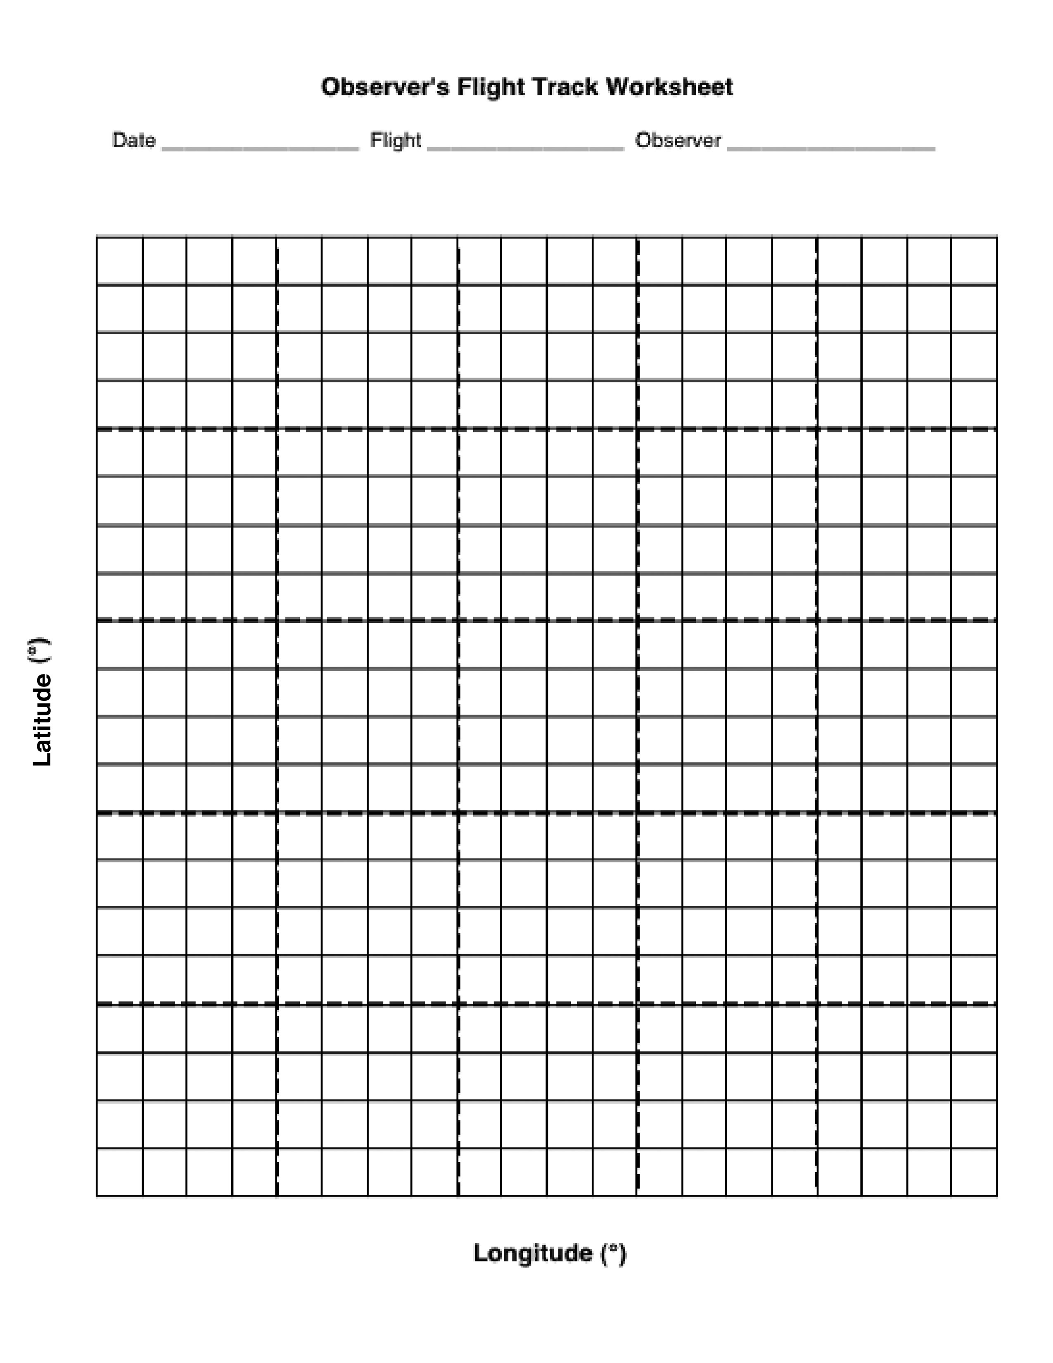

Lead Project Scientist Event Log

Date ________________ Flight ID________________ LPS _____________________

Time | Event | Position | Comments

