MISSION PLAN
FLIGHT ID | 20241105H1 | STORM | AL18 / RAFAEL
MISSION ID | 1018A | TAIL NUMBER | NOAA-42
TASKING | NHC/EMC TDR | PLANNED PATTERN | Butterfly
MISSION SUMMARY
TAKEOFF [UTC] | 2013 | LANDING [UTC] | 0258
TAKEOFF LOCATION | KLAL | LANDING LOCATION | KLAL
FLIGHT TIME |  | BLOCK TIME
TOTAL REAL-TIME RADAR ANALYSES  (Transmitted) | 3 (3) | TOTAL DROPSONDES Deployed (Tx to GTS) | 21 (18)
OCEAN EXPENDABLES deployed (good) | 0 | sUAS (Type) | 0
APHEX EXPERIMENTS / MODULES
HRD CREW MANIFEST
LPS ONBOARD | Aberson | LPS GROUND | None
TDR ONBOARD | Aberson | TDR GROUND | Gamache
ASPEN ONBOARD | N/A | ASPEN GROUND | Sellwood/Goldenberg
NESDIS SCIENTISTS | N/A
GUESTS (Affiliation)
AOC CREW MANIFEST
PILOTS | Keith, Ellis, Taraboletti
NAVIGATOR | Meier
FLIGHT ENGINEERS | Tyson, Wysinger
FLIGHT DIRECTOR | Elgart, Zawislak
DATA TECHNICIAN | MacAllister
AVAPS | Vargas, Dykeman

PRE-FLIGHT
Flight Plan | NHC-EMC tasked NOAA-42 TDR mission into Hurricane Rafael - 1500L / 2000z takeoff from Lakeland and recovering in Lakeland. Timing of the pattern is to be on-station for EMC data collection for the 0000z assimilation window between 2100z and 0300z.  Pattern: Fly butterfly pattern with 105 NM legs  Altitude:  - 10 kft preferred - 8 kft if AF deconfliction is required (pressure  - altitude)Research Modules:  - APHEX Early Stage: Vortex Alignment Module (VAM) - see notes below  Expendables:  - Load 30 dropsondes - see notes below  - All dropsondes transmitted to the GTS  NHC-EMC tasked NOAA-42 TDR mission into Tropical Depression 18 - 1500L / 2000z takeoff from Lakeland and recovering in Lakeland. Timing of the pattern is to be on-station for EMC data collection for the 0000z assimilation window between 2100z and 0300z.  Pattern: Fly butterfly pattern with 105 NM legs  Altitude:  - 10 kft preferred - 8 kft if AF deconfliction is required (pressure altitude)  Research Modules:  - APHEX Early Stage: Vortex Alignment Module (VAM) - see notes below  Expendables:  - Load 30 dropsondes - see notes below  - All dropsondes transmitted to the GTS  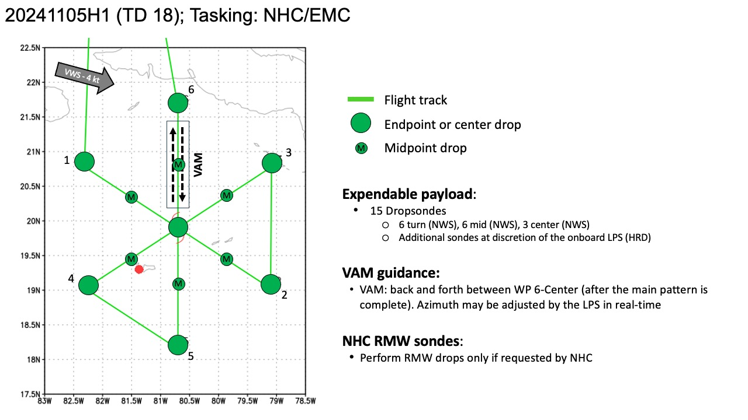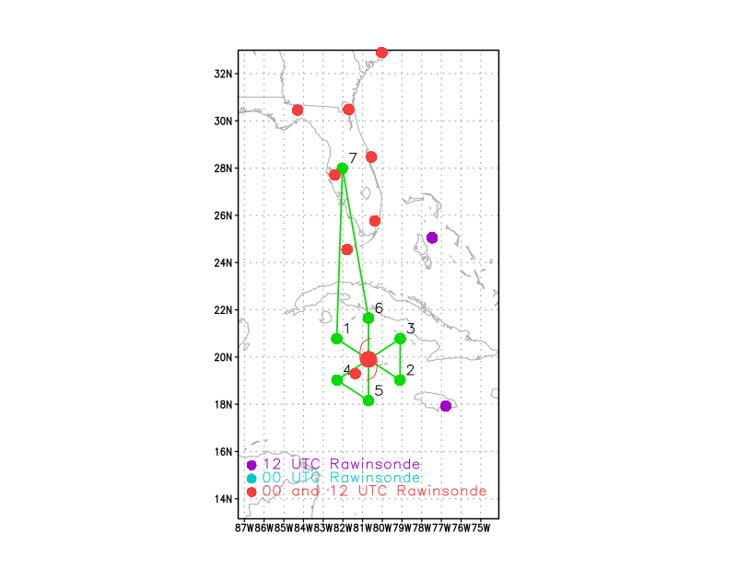
Expendable Distribution | Dropsonde at endpoints, midpoints and center. 6 dropsondes to be released en route to test interference from N42 ground receiver.
DDPreflight Weather Briefing | [Notes from the Flight Crew Preflight Briefing and other relevant notes about the current and forecasted storm state from the most recent NHC advisory (location, intensity, MSLP, movement, possible intensity change during the flight)]  Tropical Storm Rafael Discussion Number 9  NWS National Hurricane Center Miami FL AL182024  400 PM EST Tue Nov 05 2024  Reports from an Air Force Reserve Hurricane Hunter aircraft and  radar data from Grand Cayman indicate that Rafael has developed an  inner wind core during the past several hours. The radar data shows  the development of a ragged eye, and the Hurricane Hunter reported  850-mb flight-level winds of 73 kt about 30-35 n mi northeast of the  center. The aircraft also reported that the central pressure has  fallen to near 989 mb. Based on these data, the initial intensity  is increased to 60 kt. The wind radii have been revised some based  on the aircraft data.  The initial motion is northwestward at 325/13 kt. Rafael is  currently on the southwestern side of a low- to mid-level ridge over  the western Atlantic, and this feature should steer the cyclone  generally northwestward for the next 36-48 h, with the center  passing near the Cayman Islands and over western Cuba. From 48-72  h, the models are in better agreement that the center should turn  more westward as the ridge builds a little westward along the  northern Gulf coast. After 72 h, there remains some significant  spread in the track guidance, due partly to differences in how fast  Rafael will shear apart and due partly to differences in the  forecast strength of the ridge along the Gulf coast. The GFS  weakens the ridge and shows a northward turn, while the ECMWF keeps  a stronger ridge and shows a more westward motion. The  deterministic UKMET has now changed to a northward turn scenario,  but the HWRF, HMON, and UKMET ensemble mean join the ECMWF with a  westward motion. As mentioned with the previous forecast, until  there is a clearer signal on which of these scenarios is more  likely, the forecast compromises between these extremes with a slow  turn toward the north over the northern Gulf of Mexico.  Now that Rafael has developed an inner wind core, conditions are  favorable for steady to rapid strengthening during the next 24 h or  so. The system is expected to reach hurricane strength during  the next several hours as it passes through the Cayman Islands with  additional strengthening before it reaches Cuba. While the peak  intensity forecast is near the high end of the intensity guidance,  there is a chance that Rafael could get stronger than currently  forecast. Once the center is north of 25N in the Gulf of Mexico,  the cyclone is likely to encounter increasing vertical wind shear,  dry air entrainment, and cooler sea surface temperatures, which  should lead to Rafael weakening and eventually shearing apart  vertically. This part of the intensity forecast lies near or just  above the intensity consensus.  Key Messages:  1. Rafael is forecast to be a hurricane when it passes near or over  the Cayman Islands during the next 12 hours, where damaging  hurricane-force winds, a dangerous storm surge, and destructive  waves are expected. Additional strengthening is expected before  Rafael reaches western Cuba and the Isle of Youth on Wednesday. A  hurricane warning is in effect for this region, where damaging  hurricane-force winds, life-threatening storm surge, and destructive  waves are also expected.  2. Tropical storm conditions are expected in the Lower and Middle  Florida Keys beginning Wednesday and Wednesday night.  3. It is too soon to determine what, if any, impacts Rafael could  bring to portions of the northern Gulf Coast. Residents in this  area should regularly monitor updates to the forecast.  4. Rafael will bring areas of heavy rain across portions of the  western Caribbean through early Thursday, including Jamaica and the  Cayman Islands, along with southern and western portions of Cuba.  Flash flooding and mudslides are possible along the higher terrain  in Jamaica and Cuba.  FORECAST POSITIONS AND MAX WINDS  INIT 05/2100Z 19.1N 79.6W 60 KT 70 MPH  12H 06/0600Z 20.5N 80.7W 70 KT 80 MPH  24H 06/1800Z 22.5N 82.4W 80 KT 90 MPH  36H 07/0600Z 24.1N 83.8W 80 KT 90 MPH  48H 07/1800Z 25.0N 85.2W 80 KT 90 MPH  60H 08/0600Z 25.4N 86.5W 75 KT 85 MPH  72H 08/1800Z 25.8N 87.8W 65 KT 75 MPH  96H 09/1800Z 27.1N 90.1W 50 KT 60 MPH  120H 10/1800Z 28.8N 90.7W 40 KT 45 MPH  [Briefly describe the relevant environmental drivers.]  [Copy in GIF of recent (~6 hr) satellite loops (https://www.star.nesdis.noaa.gov/GOES/index.php)]
Instrument Notes | [What instruments are working, not working, not functioning nominally, not installed?]

IN-FLIGHT
Time [UTC] | Event
2113 | Take-off from Lakeland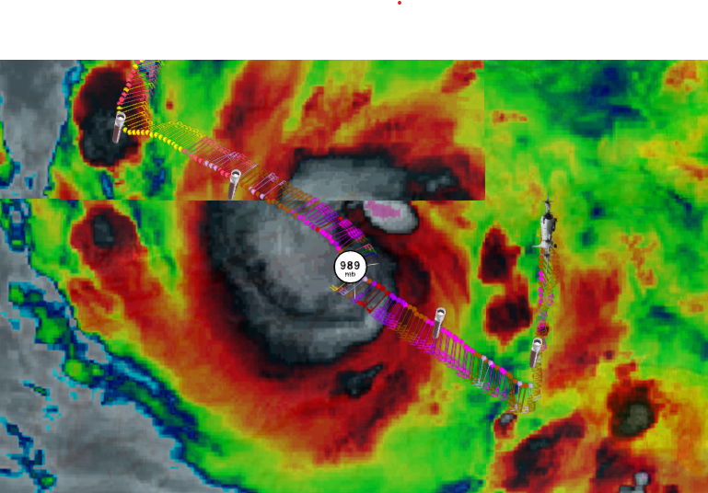
2133 | Issue with aft TDR sweeps until 2048. Aft TDR system restarted.
2049 | 2 drops released for interference test DROP 1 and 2
2109 | 2 drops released for interference test DROP 3 and 4
2125 | 2 drops released for interference test DROP 5 and 6
2214 | IP and sonde dropped DROP 7
2229 | Midpoint NW sonde dropped DROP 8
~224535 | Appears to be good center fix (Gamache initial estimate 19.192,79.74)  Center DROP 9
 | 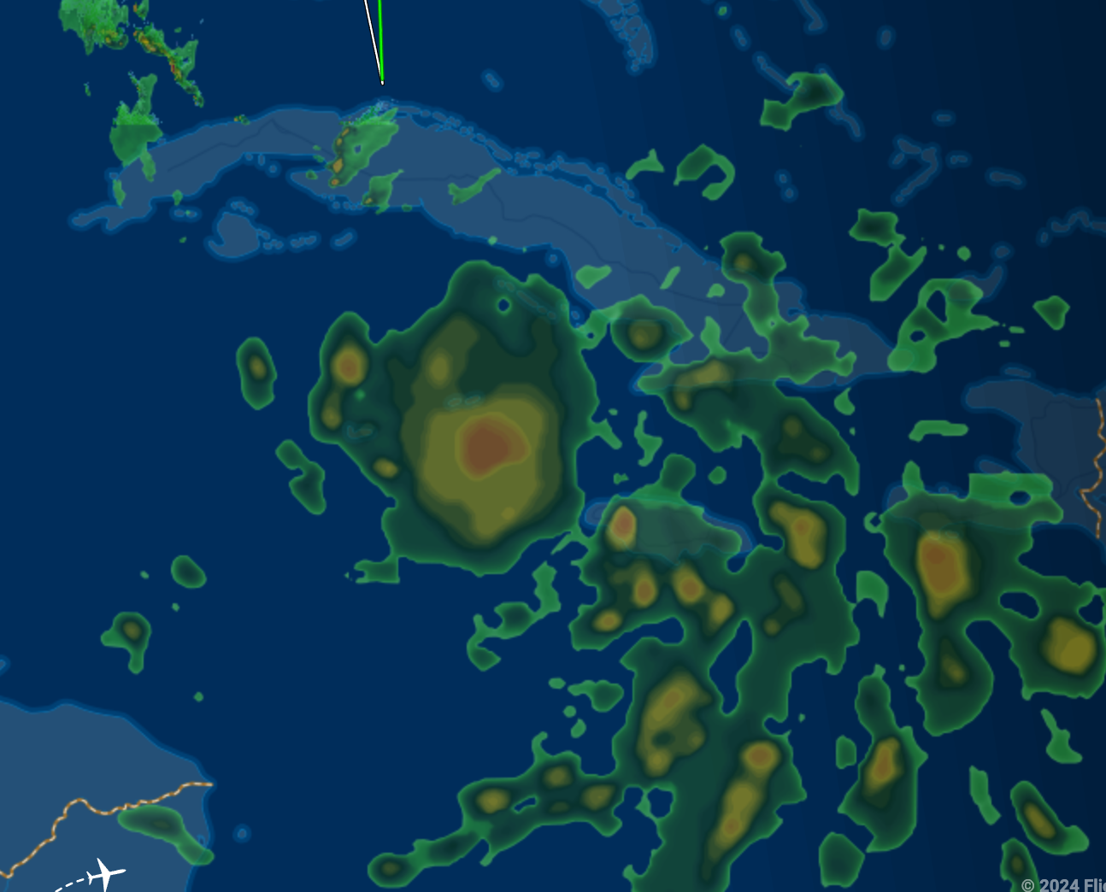
2256 | Midpoint SE sonde Drop 10
2309 | End outbound of first penetration. Drop 11
2311 | 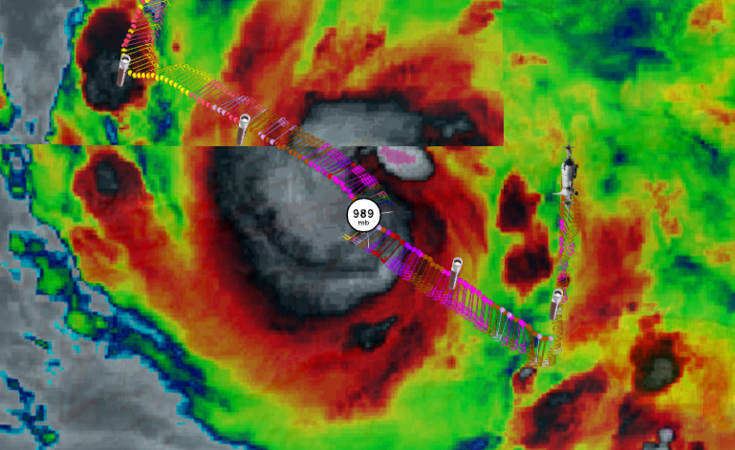23
2334 | Beginning of inbound no. 2 DROP 12
2343 | First analysis 8 km at 90 degrees from TDR analysis
2345 | Midpoint NE drop DROP 13
 | 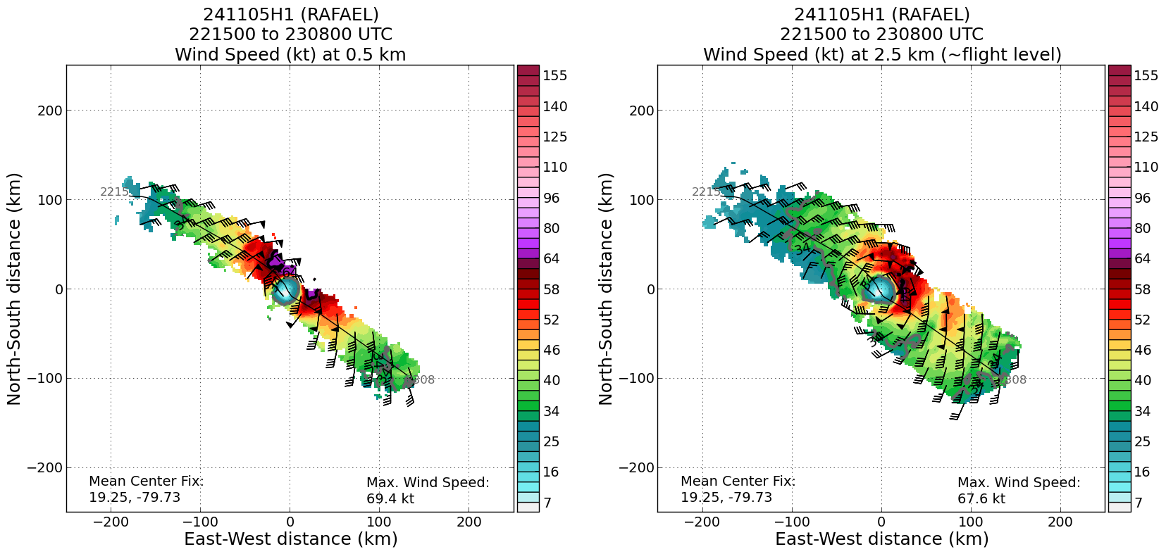
 | 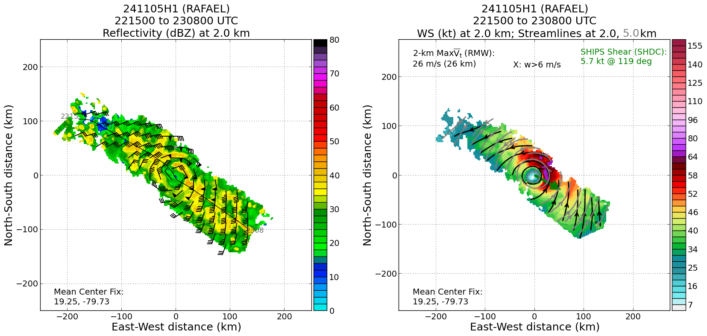
2359 | Center DROP 14 Fast Fall
0000 | Center DROP 15 backup channel 1 good drop
0011 | Midpoint SW DROP 16
2425 | End of outbound on SW side (240) DROP 17
 | << INSERT ADDITIONAL ROW AS NEEDED >>
2446 | Beginning of inbound pass 3 S DROP 18
 | 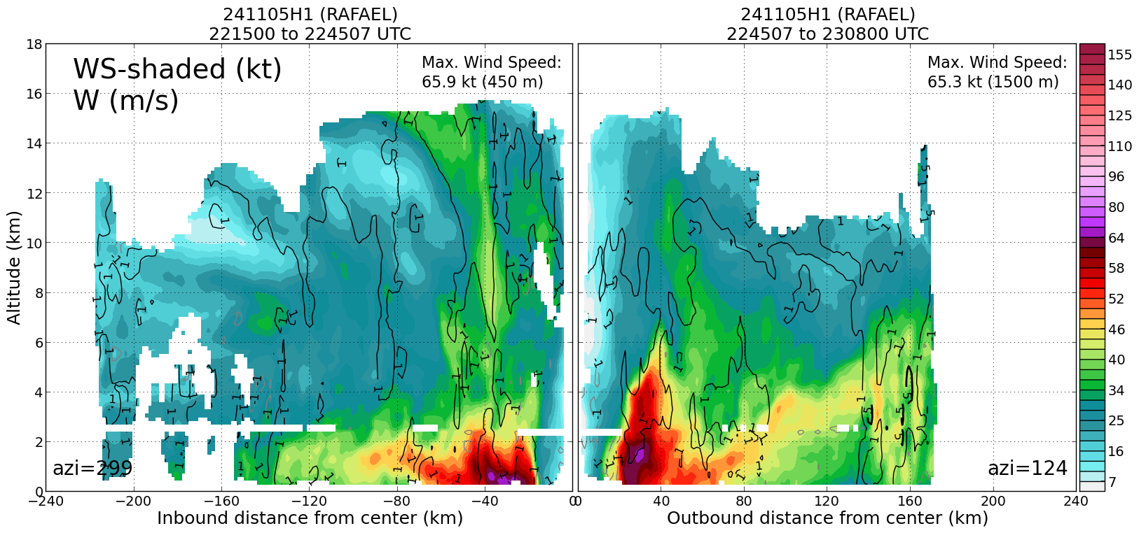
2457 | Midpoint S DROP 19
2508 | Center DROP 20
0122 | Midpoint N DROP 21
0135 | Endpoint N DROP 22 Last Report
0141 | Science complete
 | 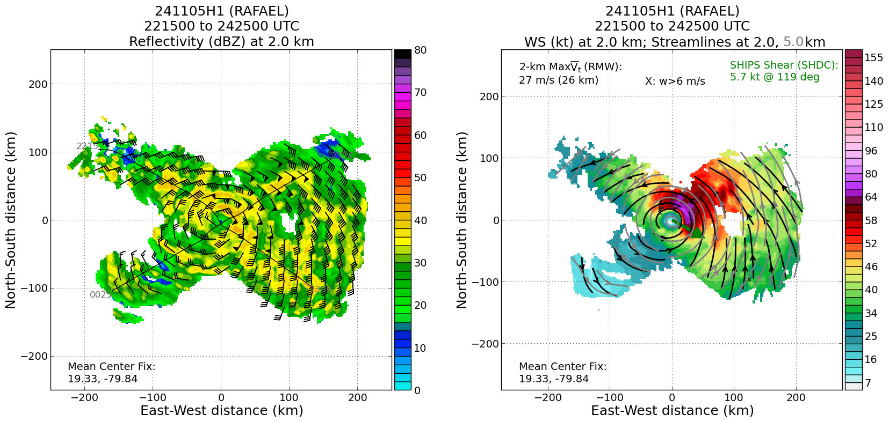
 | 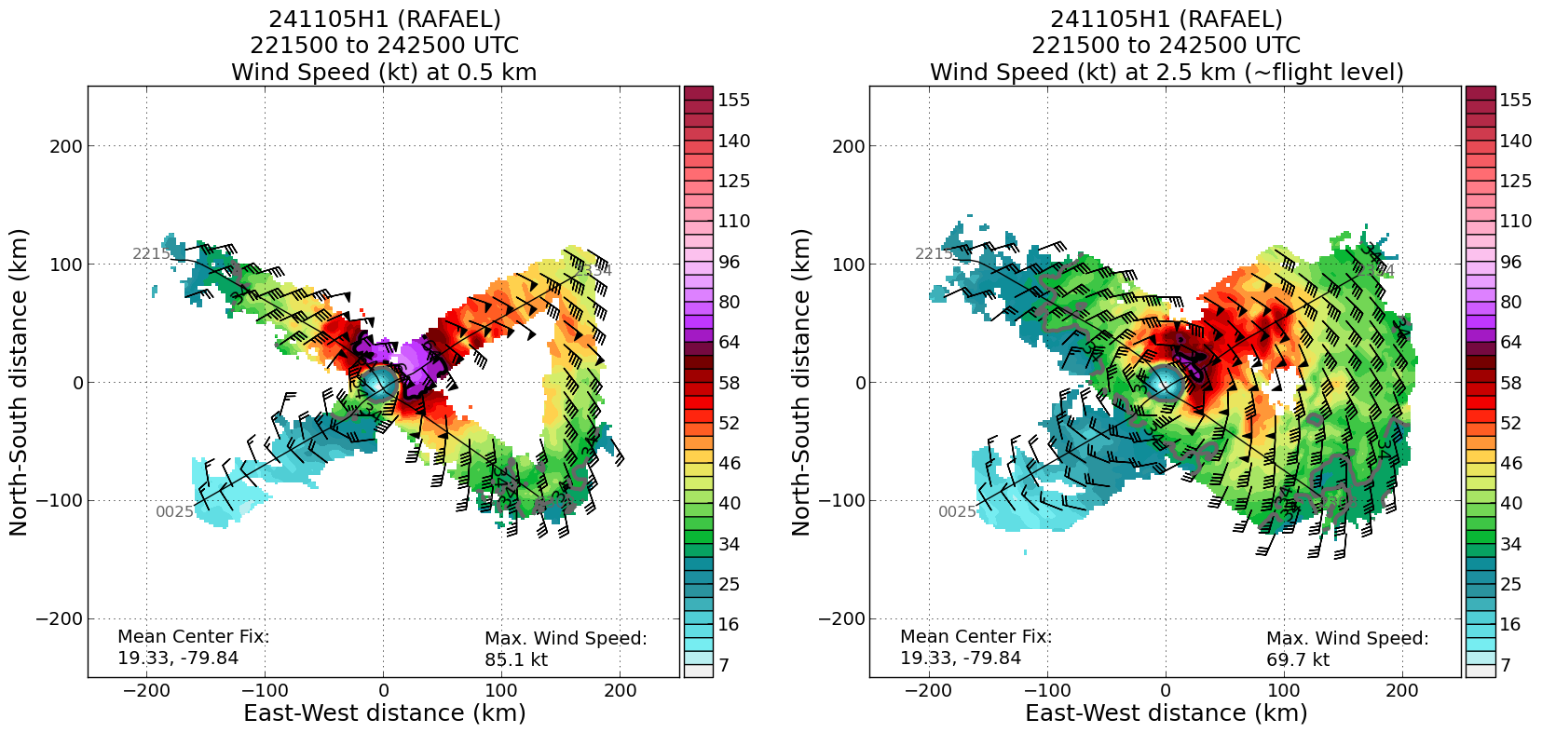
 | 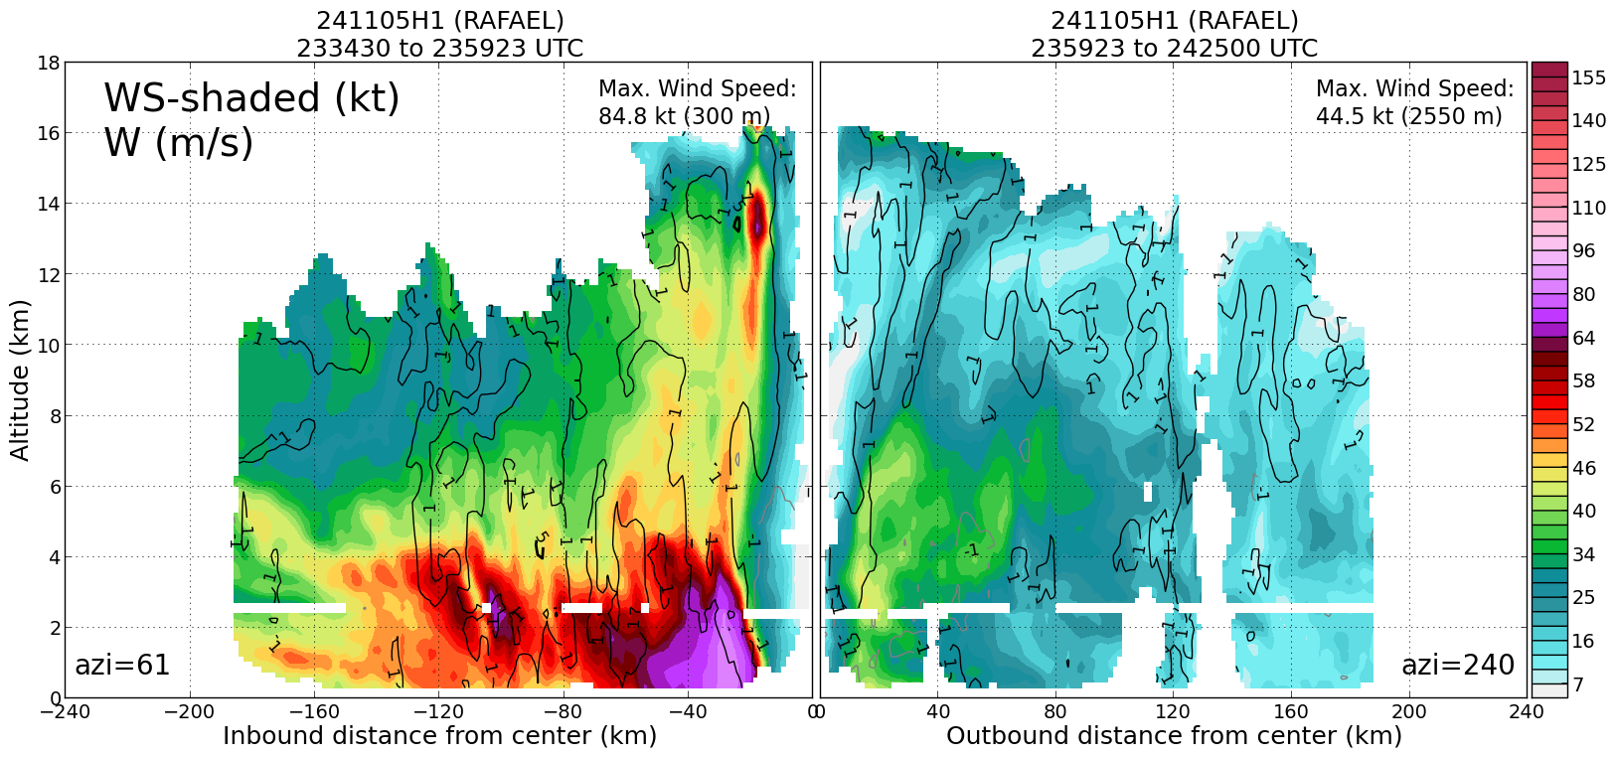
0030 | 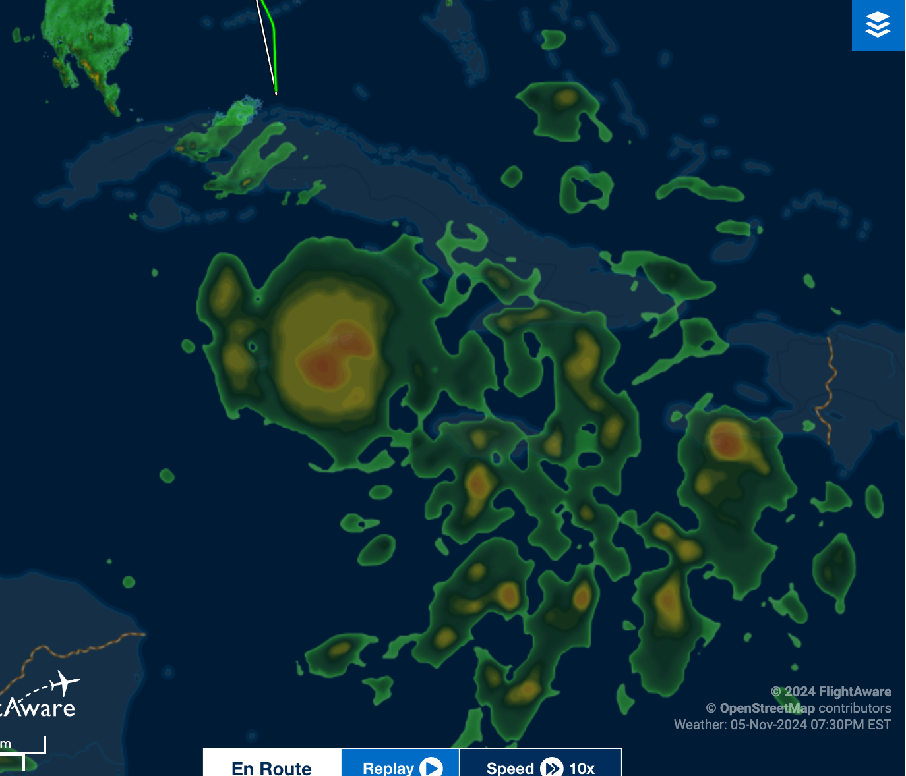
 | Second analysis had same tilt of 8 km at 90 degrees
2535 | Approximate FP
 | Third analysis had tilt of 10 km at 90 degrees
 | 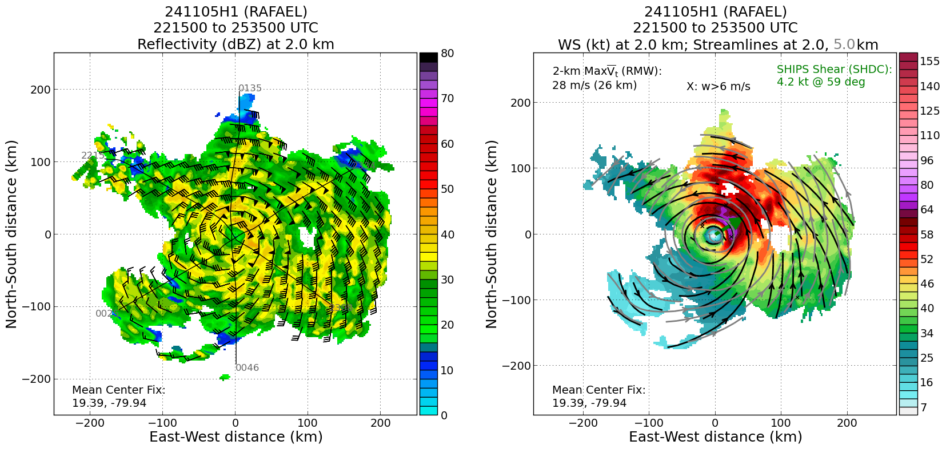
 | 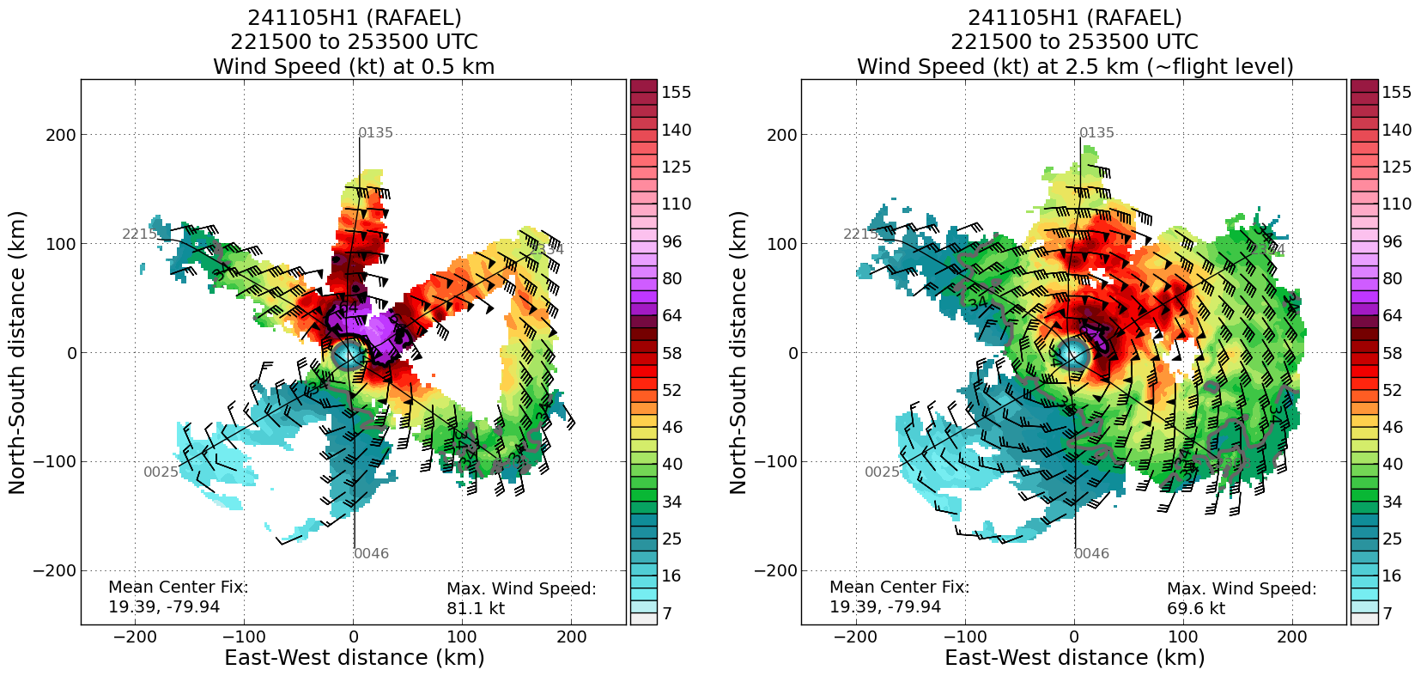
 | 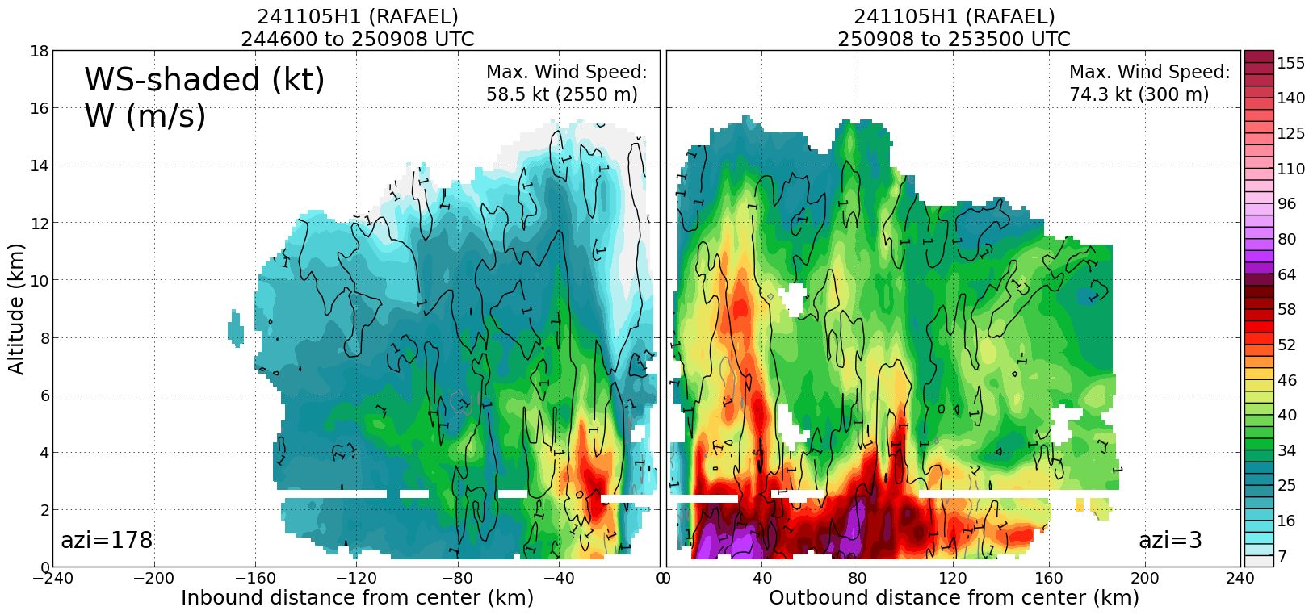

POST-FLIGHT
Mission Summary | [Short description of interesting observations from the flight; what objectives were successful? What was unsuccessful? Was the planned pattern flown? What deviations occurred?  [Don’t forget to fill in Tables on page 1]  [Sonde and ocean expendable accounting: how many total of each? How many are charged to each account?]  22 dropsondes total 21 good 1 bad (fast-fall) 6AOC 16 NWS
Actual Standard Pattern Flown | Butterfly
APHEX Experiments / Modules Flown | Storm was vertically aligned so decided not to fly the VAM.
Plain Language Summary | [Boil down the above into a couple of bullet points in “plain language”. This will help us when we report to management & OAR Public Affairs and prepare storm mission summaries]
Instrument Notes | [Notes about instrument status from during and after the mission]
Final Mission Track | 