MISSION PLAN
FLIGHT ID | 20241009I1 | STORM | AL14/Milton
MISSION ID | 1914A | TAIL NUMBER | NOAA-43
TASKING | NHC/EMC TDR | PLANNED PATTERN | Rotated figure 4
MISSION SUMMARY
TAKEOFF [UTC] | 0755 | LANDING [UTC] | 1637
TAKEOFF LOCATION | KMOB | LANDING LOCATION | KMOB
FLIGHT TIME | 8.7 | BLOCK TIME | 8.9
TOTAL REAL-TIME RADAR ANALYSES  (Transmitted) | 4 (4) | TOTAL DROPSONDES Deployed (Tx to GTS) | 21 (20)
OCEAN EXPENDABLES deployed (good) | AXBT 9 (9) | sUAS (Type) | Black Swift S0- 1
APHEX EXPERIMENTS / MODULES | RICO SUAVE, CHAOS
HRD CREW MANIFEST
LPS ONBOARD | J. Zhang | LPS GROUND | Murillo
TDR ONBOARD | J. Zhang | TDR GROUND | X. Zhang/Reasor
ASPEN ONBOARD | N/A | ASPEN GROUND | Kaplan
NESDIS SCIENTISTS | n/a
GUESTS (Affiliation) | Joshua Wadler (ERAU), Joshua Fromm (Blackswift)
AOC CREW MANIFEST
PILOTS | Rannenberg/Palmer/Taraboletti
NAVIGATOR | Utama/Saunders
FLIGHT ENGINEERS | Ripp/Dittoe
FLIGHT DIRECTOR | Englert/Carpenter
DATA TECHNICIAN | Richards
AVAPS | Brannigan/Hunsinger/Underwood

PRE-FLIGHT
Flight Plan | 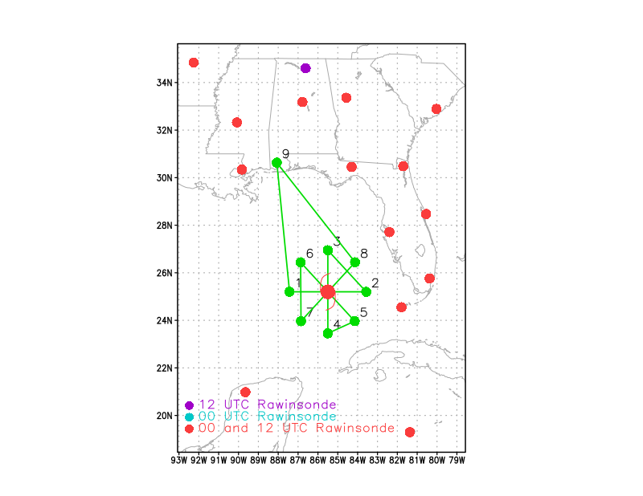  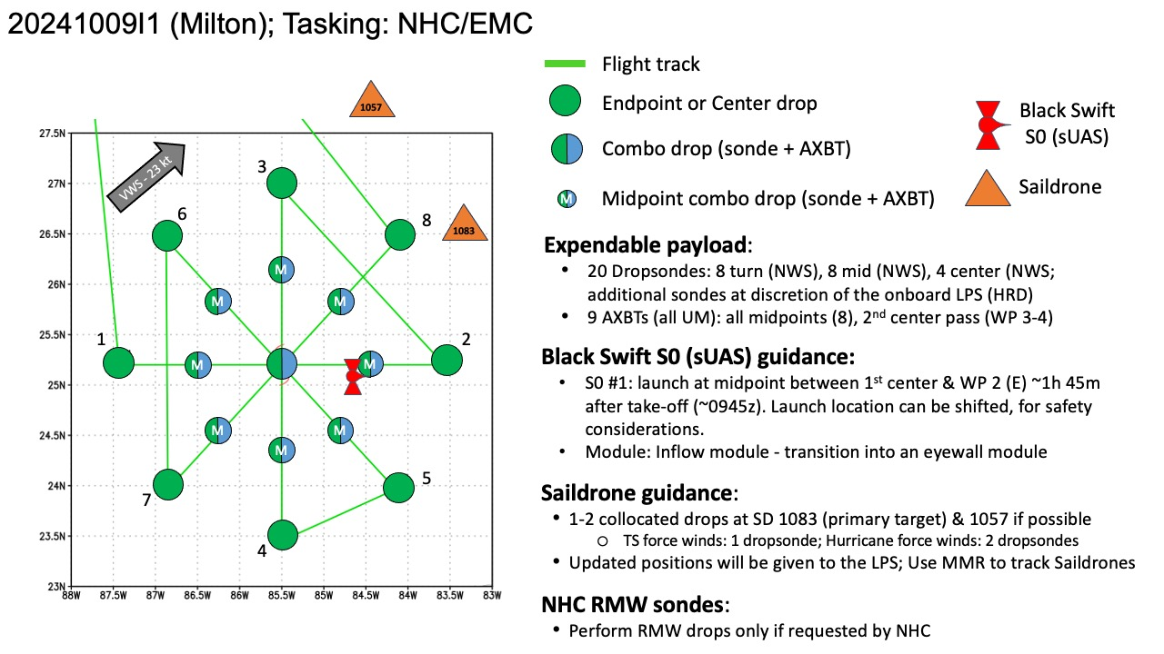  Pattern:  - Fly rotated Fig-4 pattern with 105 NM legs  - Arrival at the IP should be timed to be no earlier than 0900Z  Altitude:  - 10 kft preferred - 8 kft if AF deconfliction is required (pressure altitude)  Research Modules:  - APHEX Mature Stage: RICO SUAVE (Black Swift S0) - see notes below  - APHEX Mature Stage: Distribution of Hazardous Winds - (time permitting) see notes below  - APHEX Ocean Observing: CHAOS (possible Saildrone overflight) - see notes below  - Distribution of Hazardous Winds:  - Start IP1 at 140 NM (instead of 105 NM) from the center at 8-10 kft (time permitting - as long as this change allows for completion of rotated Fig-4 by no later than 1435Z)  - Perform rotated Fig-4 as planned  - At the end of the rotated Fig-4 (WP 8), turn around and head back into the center along the 45 deg azimuth, exiting the center at 315 deg, and staying at 8-10 kft out to 160 NM or until flight level winds drop below 50 kt.  Deploy s0 in the eye during the first pass. Plan B: drop s0 at MP of outbound leg during the 1st pass
Expendable Distribution | - Load 30 dropsondes - see notes below  - All dropsondes transmitted to the GTS  - Load 9 UM AXBTs - see notes below  - All AXBTs transmitted to the AOC ground server  - Load 2 Black Swift S0 sUASs (1 launch planned) - see notes below
Preflight Weather Briefing | NOAA and Air Force Hurricane Hunter aircraft have been investigating  Milton again this evening, providing a number of center fixes,  flight-level wind data, dropsonde measurements, and other valuable  observations. Data from the aircraft confirmed that the hurricane  had regained category 5 intensity, with maximum winds near 145 kt  and the central pressure as low as 902 mb. More recent aircraft  observations showed that the central pressure had risen somewhat, so  the advisory intensity is adjusted slightly down, to 140 kt. This  is also consistent with the latest subjective Dvorak intensity  estimates from both TAFB and SAB.  Center fixes from the aircraft and satellite images indicate that  Milton's heading is gradually turning toward the left and the  initial motion estimate is now about 055/10 kt. The system is being  steered by the flow between a trough digging over the Gulf of Mexico  and a ridge near the Greater Antilles. Milton should move  northeastward on Wednesday with a slight increase in forward speed,  with the center of the hurricane reaching the Florida Gulf coast in  24 hours or so. Thereafter, the system should turn  east-northeastward to eastward and move over the southwestern  Atlantic off the southeast U.S. coast. The official track forecast  is very similar to the previous one, and is generally a little north  of the model trackers, but follows the actual model predicted  cyclone center locations. This is close to a blend of the latest  GFS and ECMWF model solutions. Again, it is critical to remember  that even at 24 hours out, it is still not possible to pinpoint an  an exact landfall location.  Milton is expected to maintain major hurricane strength while it  moves across the eastern Gulf of Mexico and approaches the west  coast of Florida. Although an expected increase in vertical wind  shear should cause some weakening, Milton is expected to still be an  extremely dangerous major hurricane when it reaches shore. Also,  the first stages of extratropical transition may be just underway as  Milton reaches the coast, which could impart some baroclinic energy  and slow the rate of weakening. The NHC intensity forecast is near  the upper side of the intensity model guidance. After Milton moves  over the Atlantic, the global models show the system becoming  embedded within a frontal zone, so the official forecast shows the  system becoming extratropical by 72 hours.  Milton's wind field is expected to grow considerably in size by the  time the center moves over Florida. In addition, a large region of  tropical storm and hurricane force winds could occur on the  northwest/back side of the storm since Milton will be interacting  with a frontal boundary and beginning extratropical transition.  Damaging winds, life-threatening storm surge, and heavy rainfall  will extend well outside the forecast cone. This is a very serious  situation and residents in Florida should closely follow orders from  their local emergency management officials. Evacuations and other  preparations should be completed tonight. Milton has the potential  to be one of the most destructive hurricanes on record for  west-central Florida.  Saildrones (10/09 0630Z):  • SD-1083: 26.225 N, 83.330 W, headed S  • SD-1057: 27.578 N, 84.310 W, headed S (probably too far away/weak winds)  Drifters (10/09 06Z):  • WMO: 7810415 @ 24.564 -86.294 (with barometer)  • WMO: 7810417 @ 24.219 -85.537 (currently at NE eye wall)  • WMO: 7810375 @ 23.946 -87.312 (currently behind the storm)  • WMO: 7810416 @ 23.923 -85.390 (currently at SE eye wall)  • WMO: 7810418 @ 23.576 -85.378 (SE of center)  • WMO: 7810414 @ 23.141 -85.884 (with barometer, further SE of center)  Milton is moving northeastward at 12 kt in the flow between a mid-  to upper-level trough over the northern Gulf and a ridge located  over the Greater Antilles.  [Copy in GIF of recent (~6 hr) satellite loops (https://www.star.nesdis.noaa.gov/GOES/index.php)]
Instrument Notes | MMR went down 0925z at the start of the mission, prior to the IP. P3 orbited for ~30 mins troubleshooting the issue. At 0934 nose radar went down for a short time and came back up. BTs were launched but were a little unstable, readings may be questionable.

IN-FLIGHT
Time [UTC] | Event
0755 | Take-off from KMOB
0803 | TDR started running
0829 | 45 min from IP
0914 | 293 km from the eye
0923 | At IP, Drop 1
0923 | Concentric eyewalls reported
0924 | Drop 1 CH 1 IP1 0923
0925 | Resetting MMR in clear air
0929 | Troubleshooting MMR, resetting now
0934 | Nose radar failed then came back
0940 | Doing orbits while they reset MMR
 | 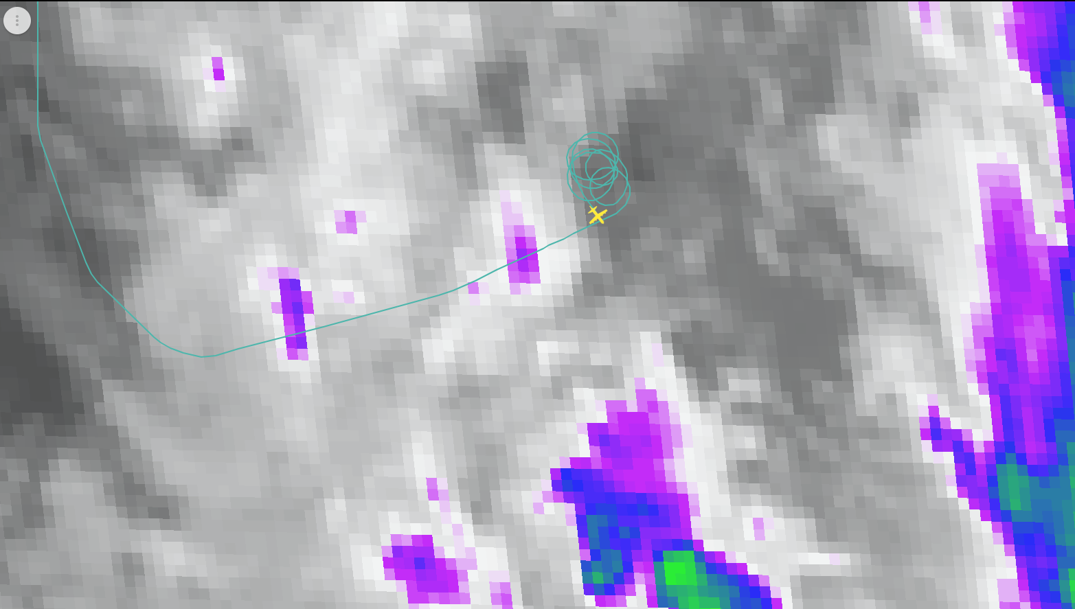
0942 | SD-1083's current position is 26.12N, 83.32W moving south at about 2 kt. SD-1057's position is 27.55N, 84.32W moving south at about 1 kt.
0947 | Running s0 pre-launch checklist
0954 | MMR better now, heading inbound
1000 | Restarting s0 pre-launch checklist
1007 | launch eta 14 min. made it through most of the checklist
1010 | Drop 2 ch 2 MP 1004 combo sonde bt
1014 | entering the outer eyewall
1018 | updrafts and downdrafts in the order of 2-5 m/s
1018 | Lightning
GLM total optical energy plotted
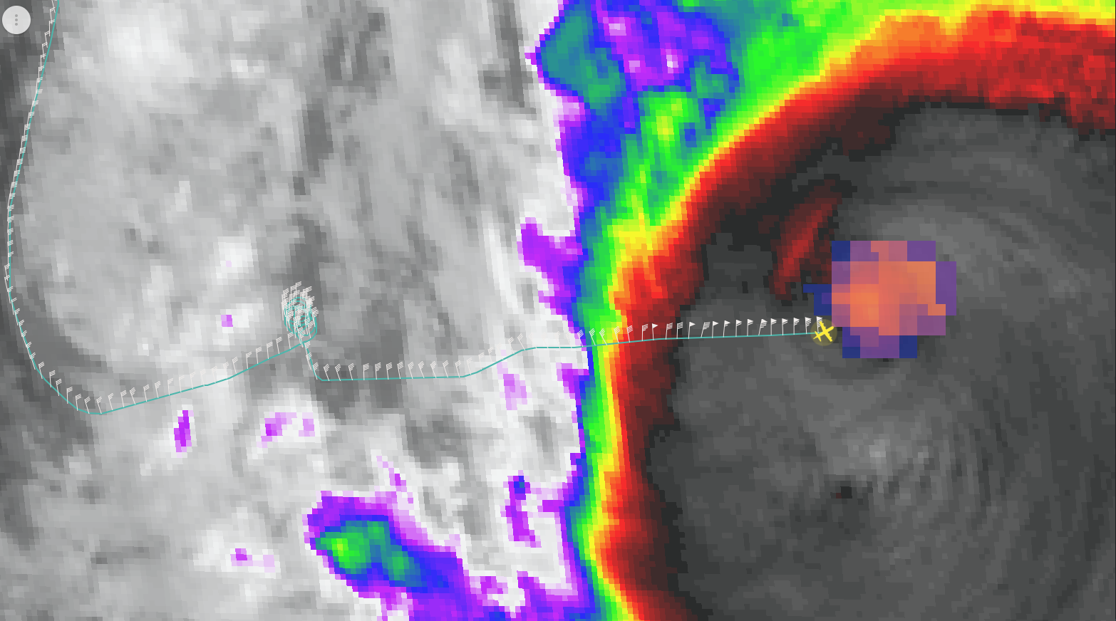
1019 | running s0 launch checklist
1020 | Getting close to inner eyewall
1021 | 10 m/s downdraft
1022 | 10 m/s updraft
1022 | Lots of downdrafts, -15m/s
1022 | MMR down for a min and now back up
1023 | Lots of lightning
1024 | Drop 3 ch 3 CP 1023 combo sonde + s0 eyesonde
1024 | Heading to the other side eyewall
1025 | MMR back
1026 | S0 flying at z = 1500m
1026 | S0 wind 50-60 kts
1026 | Lots of lightning more that yesterday’s flight
1027 | pretty concentric eyewalls from MMR/LF
1028 | NE side out eyewall looks intense from MMR
1030 | S0 reporting 85 kts
1030 | 95 kts at 1.5km z
1031 | 100kts
1031 | P3 FL winds 95-100 kts
1032 | P3 radar altitude ~2.4 km
1036 | s0 reported 127 kt wind in the eyewall
1036 | pushed to 1700 m by updrafts likely
1036 | S0 was at 1500 m
1037 | sonde 3 @1023 24.70N 85.00W, sfc pressure 917mb, 10m wind. 175/41
1037 | Drop 4 ch 4 MP 1036 combo sonde bt
1043 | s0 started descending to 1 km
1044 | ws = 91 kts
1044 | 1st BT 28.96C
1048 | S0 at z=1 km, ws=90 kts
1049 | s0 reported 85-95 kt winds
1049 | BT 2 SST 28.34C but it was after 400 seconds so I am not confident that was initial. Data on it is spotty
1050 | s0 has sampled 1/2 of the eyewall
1051 | Drop 5 Ch 5 EP1 1049
1053 | s0 at 1 km altitude for 9 minutes
1054 | doing 10 minute legs
1054 | will go down to 500 m altitude in a minute
1058 | we started descending s0 to 750 m altitude
1100 | s0 measured winds of 110-125 kts
 | 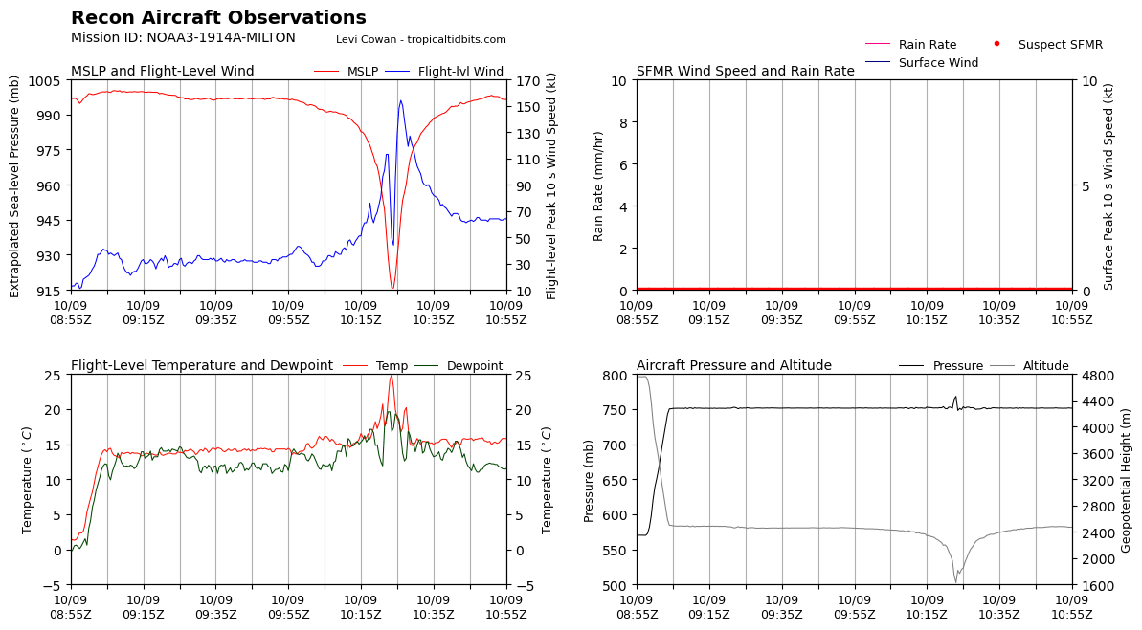
1101 | s0 measured winds of 110-125 kts
1104 | Hitting 10 m/s updraft out here (unexpected)
1105 | Lots of small cell like features
1107 | S0 at 500m altitude now, winds ~105 kts
1120 | Reached 2nd IP
1120 | Drop 6, Ch6, IP2, 1120Z, no launch detect
1122 | Sending s0 to 400 m altitude, likely at outside the RMW now
1123 | We want to sample both inside and outside the RMW regions of the eyewall
1123 | S0 measured winds ~70 kts, reached 400 m altitude
1125 | Drop 7, Ch7, IP2 backup, 1121Z
1127 | P3: 4 minutes to MP of this inbound leg
1132 | S0 at 200 , altitude, winds 55-60 kts
1135 | Drop 8, Ch8, MP, inbound, 1131Z, combo, SST 28.2C
1136 | Going through the outer eyewall, FL winds ~85 kts
1136 | 90 - 95 kts
1136 | Wow 2nd eyewall 100 kts
1137 | Lots of rain, 5 m/s updraft
1137 | Most updraft 1-6 m/s, in the moat region now
1138 | Inner eyewall looks intense from MMR
1139 | s0 reported 80-90 kts winds
1139 | Sending s0 to 100 m
1141 | a good amount of updrafts 5-12 m/s
1141 | some downdrafts now in the order of 3-6 m/s
1142 | S0 at 80-100 m altitude, winds ~80 m/s from s0
1146 | Drop 9, Ch1, Center, 1143Z, combo, SST 27.6C
1146 | s0 is still flying at ~100 m altitude reporting winds of 70-80 kts
1147 | The south side inner eyewall is open from MMR/LF
1151 | TDR analysis  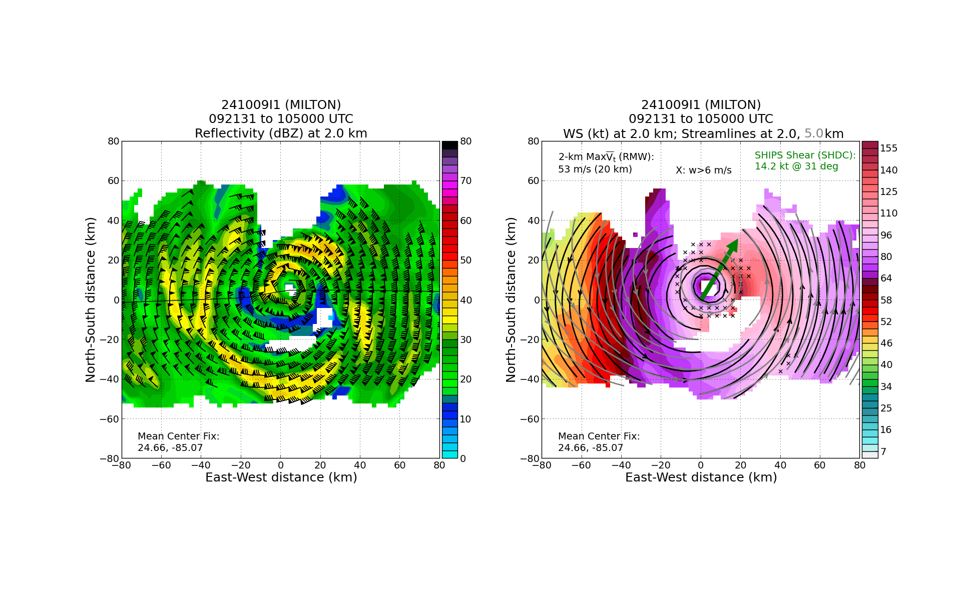
 | 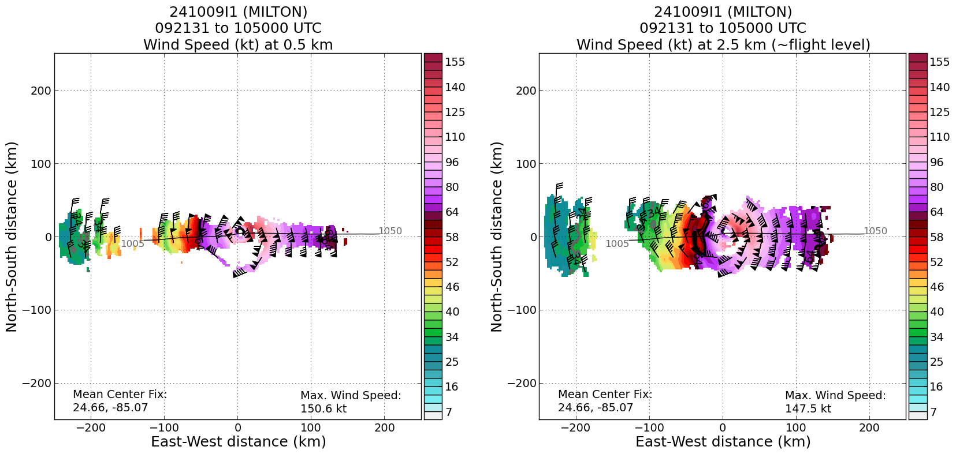
1152 | s0 splashed likely due to downdrafts, duration 88 minutes
1153 | downdrafts pushed s0 to ocean likely from 100 m
1154 | s0 did a full circle underneath the eyewall
1155 | 2 min to MP
 | 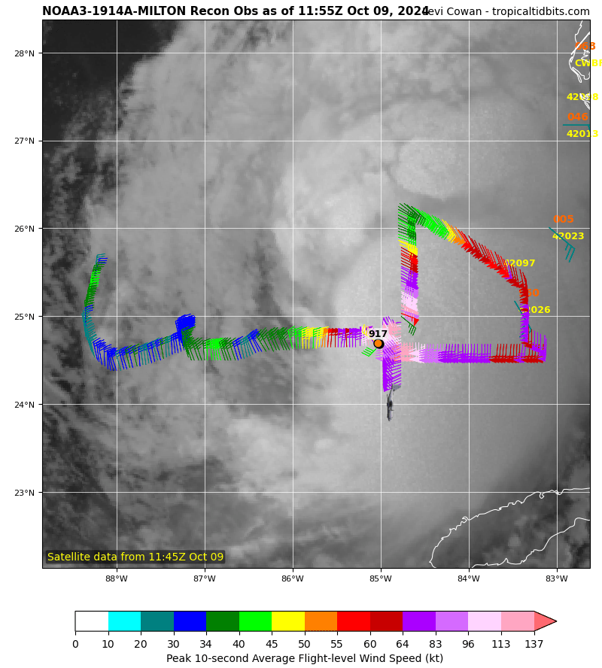
 | 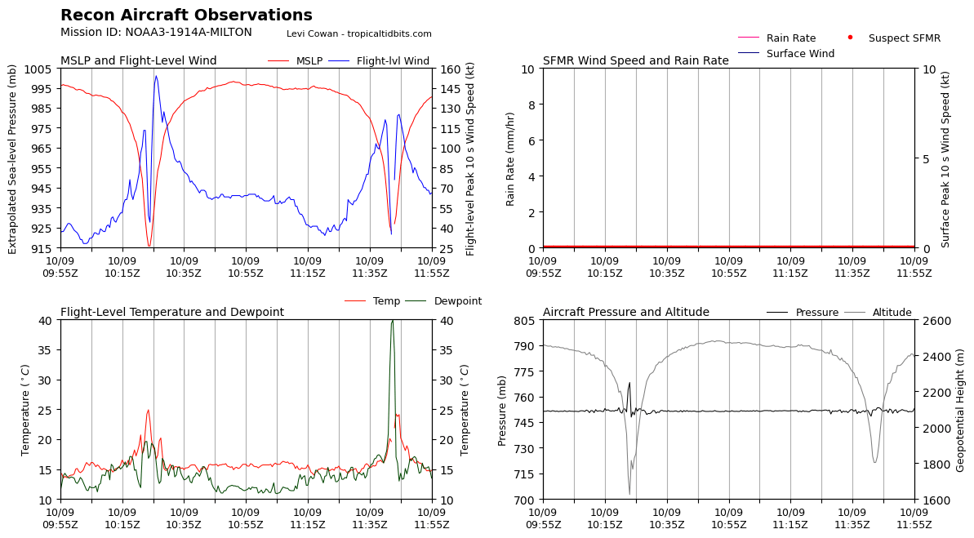
1200 | Drop 10, Ch2, MP, outbound, 1157Z, combo, SST 28.2C but some spotty data.
1205 | @1143. 24.92N 84.77W, Sfc Pressure 931mb 10m wind 211/102 eyewall sonde
 | 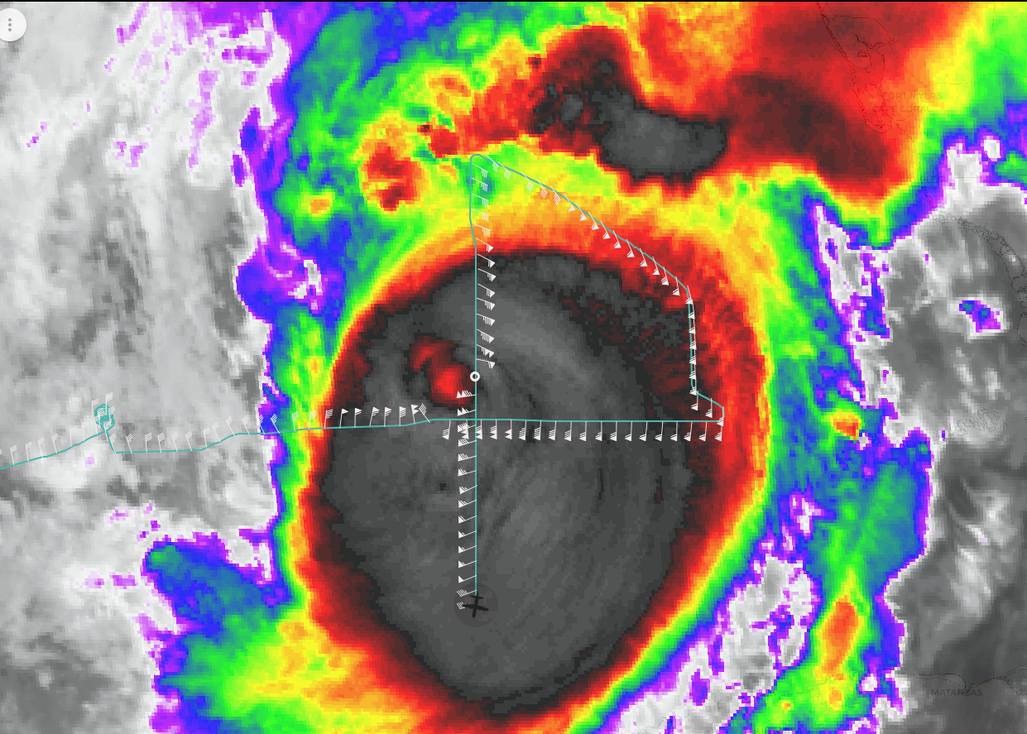
1212 | Reached 2nd EP
1214 | Drop 11, Ch3, EP2, 1212Z
1222 | 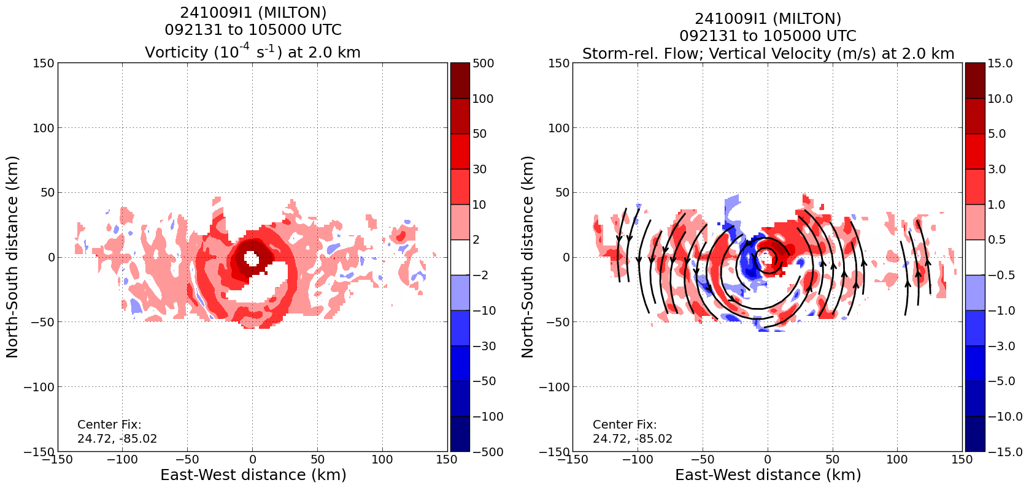  Left panel: Nice vorticity ring at the outer eyewall. Reasor reminded Dave Nolan’s instability paper.  Right panel: the very intense convective downdrafts west side of the eyewall likely killed s0.
1230 | Asymmetric BL radial flow from TDR profile data. East side has deeper inflow layer collocated with stronger low to mid level updrafts  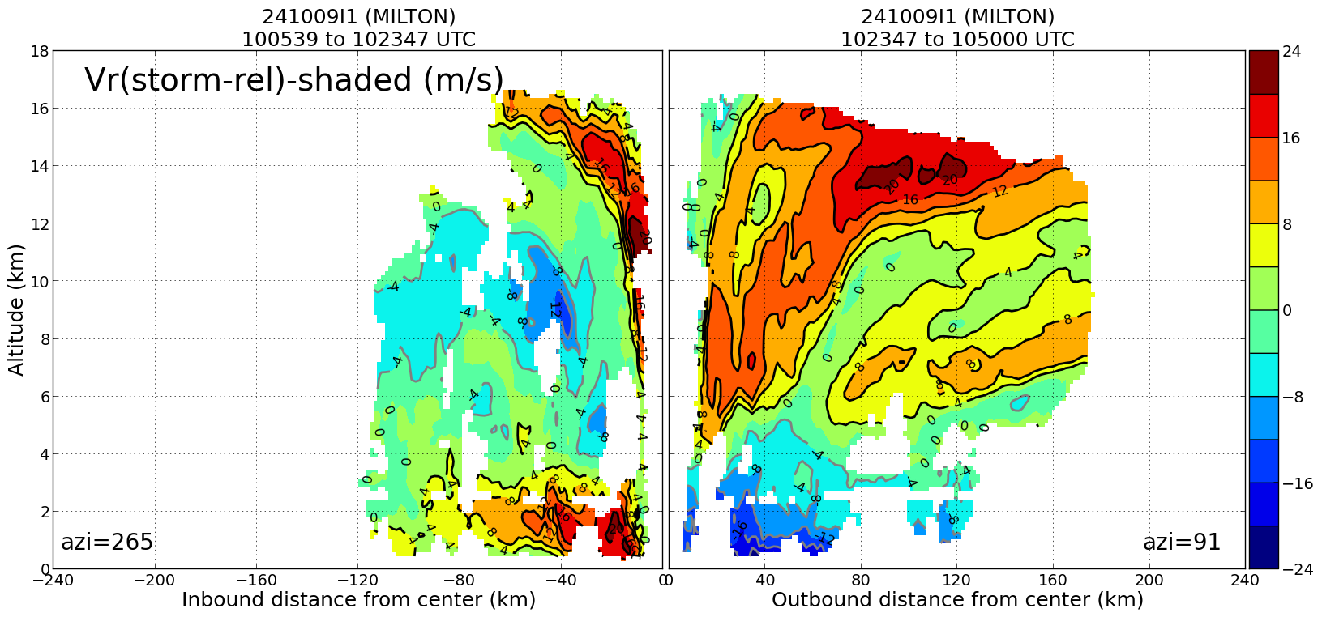
1236 | Drop 12 Ch 4 IP3 1235z SE
1240 | 3 pass started
1245 | Reasor: The symmetric RMW is about 20 km right now ... but there is some hint of a tangential wind max developing between 30-45 km: https://www.aoml.noaa.gov/ftp/pub/hrd/data/RTradar/2024/20241009I1/rzmeans/241009I1_MILTON_0921_1050_vt_rzmean.png
 | 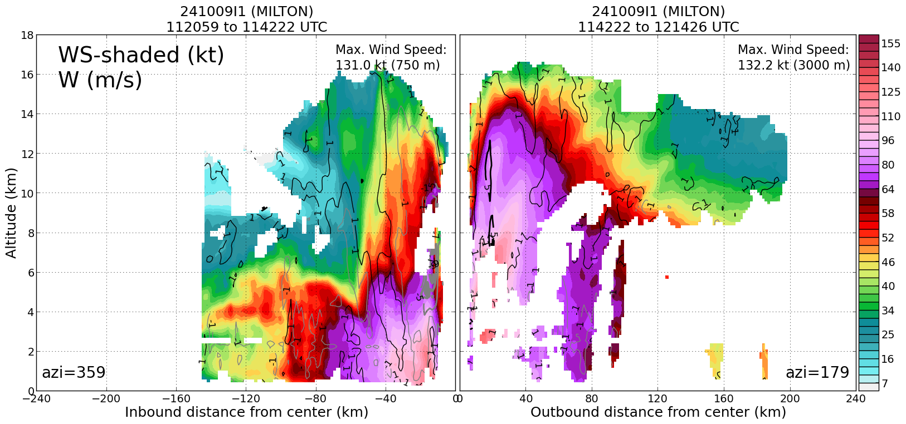
 | 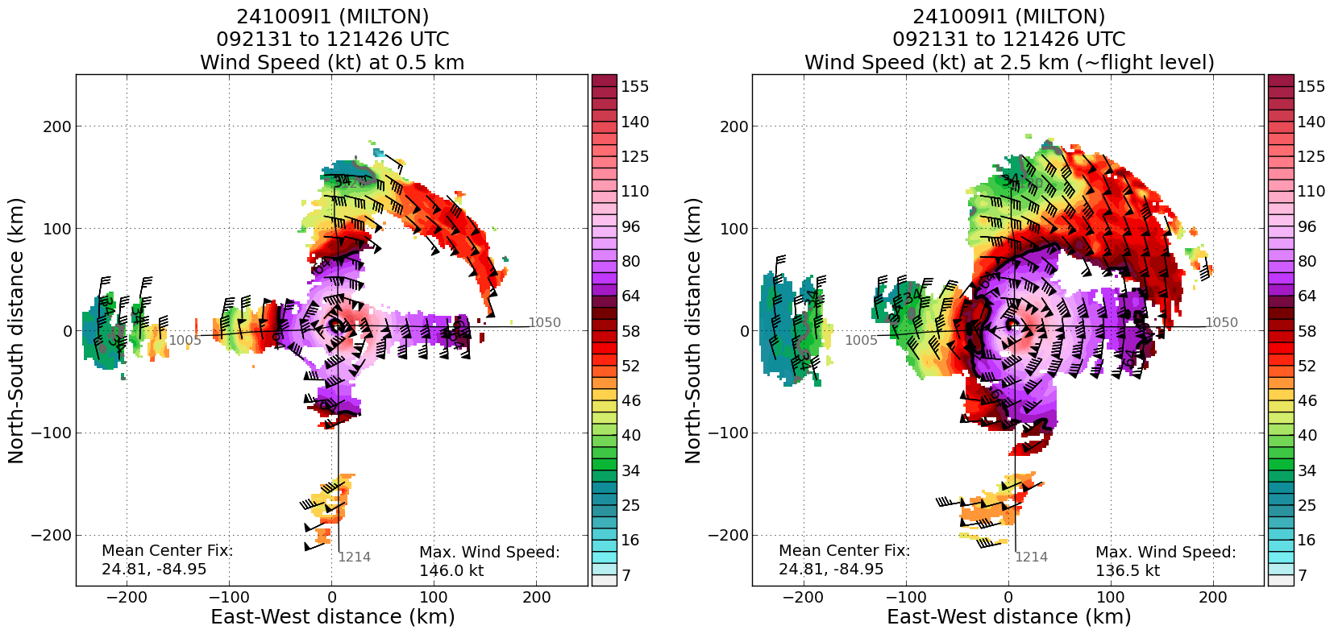
1251 | Drop 13 Ch 5 MP 1246 combo bt
1254 | entering SE side eyewall, Reflectivity relatively low this side
1256 | axbt 27.93C
1259 | The eye structure changed a lot from the first pass
 | 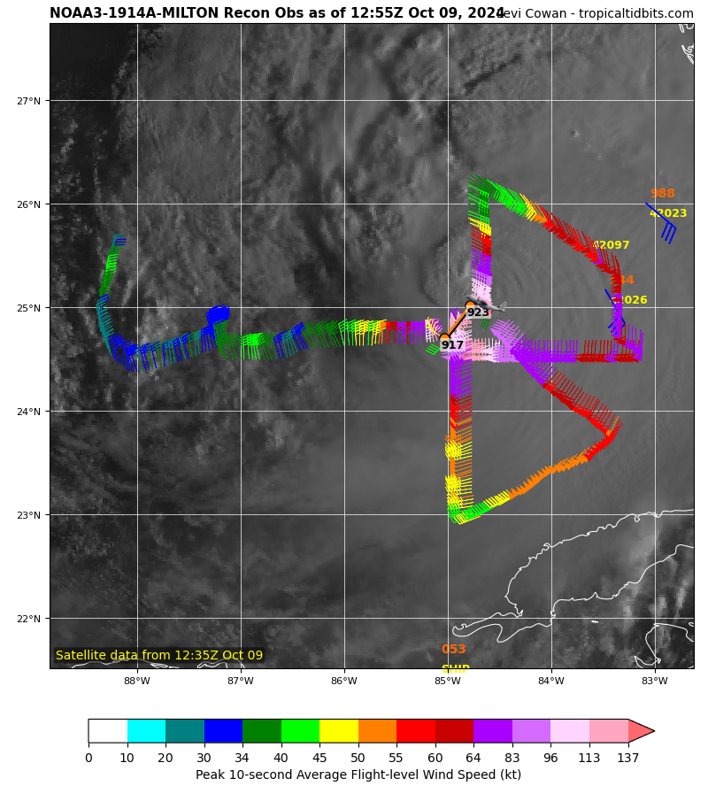
1304 | 5 - 10 m/s downdrafts on this side eyewall
1308 | pretty bumpy in the 'eye’, likely ERC going on
1308 | outer eyewall taking over the inner one on the SW side
1309 | Eye broadening, large area of high winds over 70-80 kts
1309 | Drop 14 Ch 6 CP3 1302z, not really a center drop
1316 | comb MP released
1320 | drop 15 ch 7 MP 1316 combo bt 28.59C
1329 | reached 3rd EP, turning downwind
1329 | Drop 16 Ch 8 EP3 1328z
1333 | WSR-88D estimated center: 25.33, 84.61
1405 | Orbiting
3rd TDR analysis
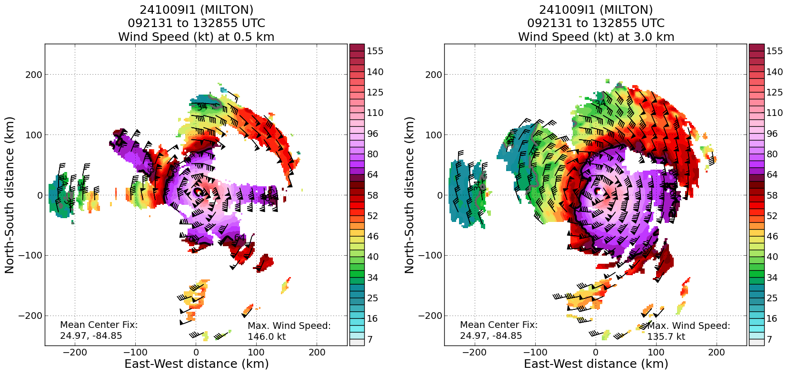
 | 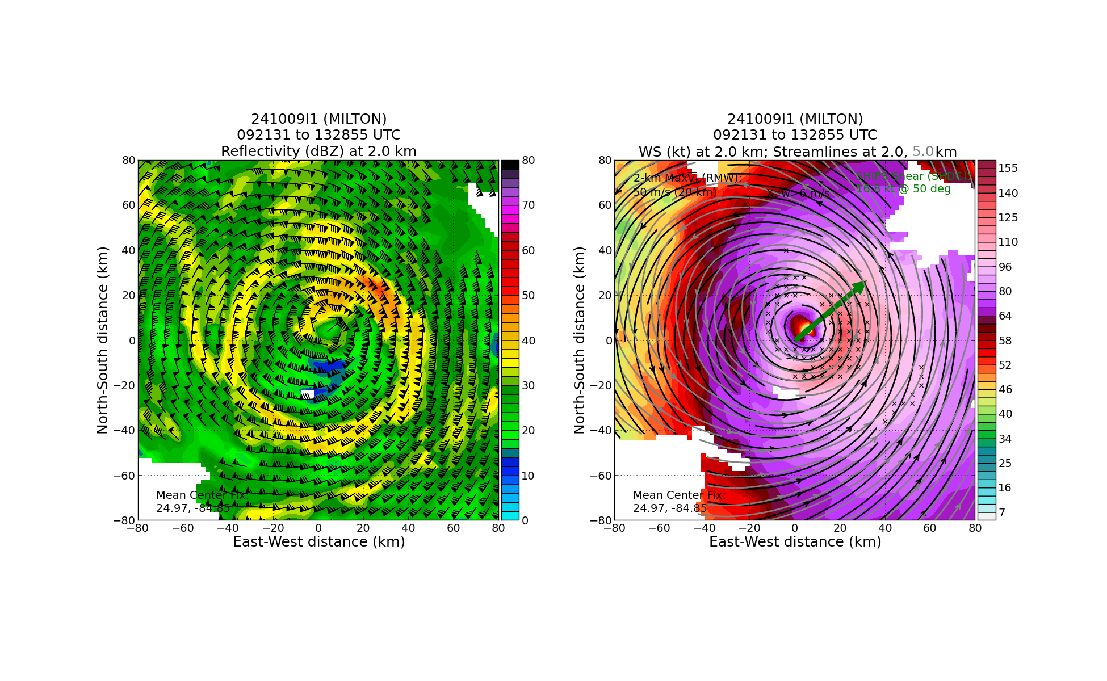
1406 | MMW is not very reliable, change of flight plans
1408 | Do one last inbound leg, target the center point then head NW outbound
1416 | Drop 17, CH1, IP4, 1414Z
1426 | Drop 18, Ch2, MP, inbound, 1424Z
1438 | Drop 19, Ch3, Center, 1438Z, combo, SST 26.4C
1438 | Center time
1444 | Turning W and then heading out
1457 | Center sonde @1438. 25.74N 84.43W, Sfc. P. 932mb, 10m wind 205/07
1458 | Drop 20, Ch4, MP, outbound, 1455Z, combo, SST 28.48C
1504 | 2-3 min from end point
1509 | Drop 21, Ch5, EP4, 1506Z
 | 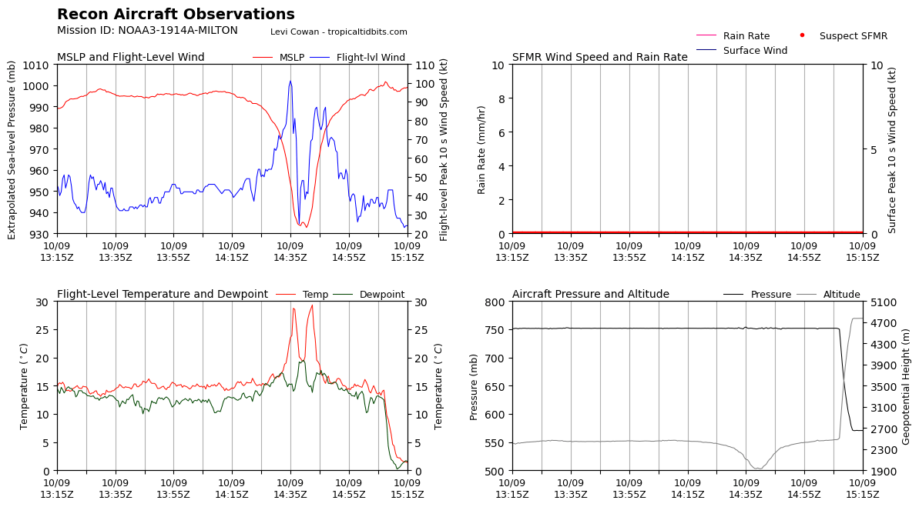
4th TDR pass info, only inbound
TDR center info from 241009I1_1438_xy.nc:
Alt (km) Lat (deg) Lon (deg W)
0.5 25.64 84.41
2.0 25.62 84.47
3.0 25.68 84.49
6.0 25.75 84.41
2-6-km Vortex Tilt: 15.2 km at 23 deg
 | 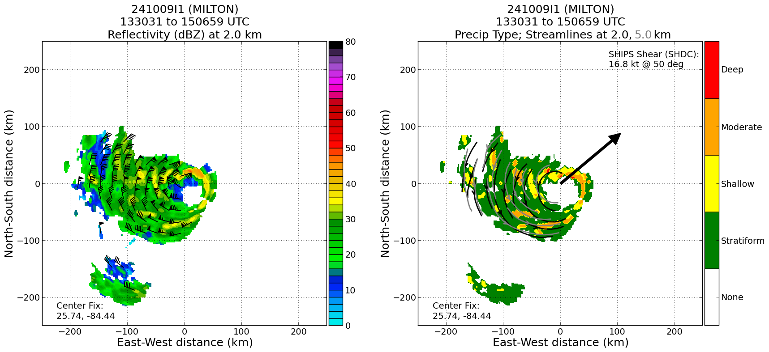
 | 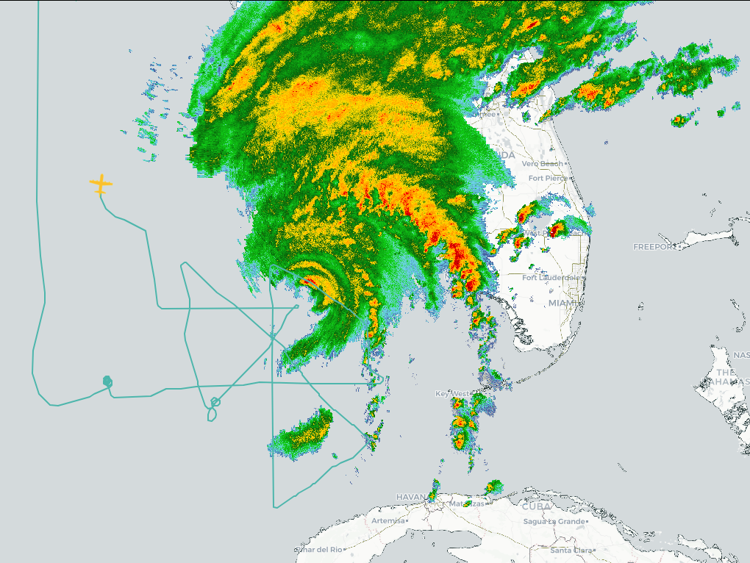

POST-FLIGHT
Mission Summary | Milton’s structure changed during this flight. The TDR analysis revealed a title in the eyewall structure. This was likely due to the southwesterly shear impacting Milton. Strong vertical motion was experienced during passage of the eyewall. Milton’s pinhole eye changed from the first past to the second. During the first pass the S0 was launched and remained in flight for 88 minutes. It measured wind speeds upwards of ~110-125 kts around 750 m. The eye became more ragged and was open to the south at one point. During the 3rd pass the center was missed and the flight hugged the eyewall as they crossed the ‘eye’. It was determined that the MMR was not providing adequate information. The flight experienced a lot of turbulence. Prior to starting the 4th pass there was a discussion about abandoning the mission because of MMR not providing reliable information. In consultation with the ground crew the 4th pass became an abbreviated inbound pass and then the flight headed west to return to Mobile, AL. Because of this the CHAOS module and the Hazardous Winds module weren’t able to be conducted.  Sondes - 21 were launched. One sonde was a late launch detect and wasn’t transmitted.  BTs - 9 were launched though the data was a little spotty.  S0 - 1 launched
Actual Standard Pattern Flown | Abbreviated rotated Figure-4, 3 full passes were performed.
APHEX Experiments / Modules Flown | RICO SUAVE (launched one S0)
Plain Language Summary | The data collected from this flight revealed that Milton is being impacted by shear and dry air. The pinhole eye became ragged and filled in. The TDR analysis depicted a titled eyewall. Milton has weakened some.
Instrument Notes | MMR went down the right before getting to the IP. The nose radar also went down. The AXBTs were launched in combination with sondes to get a good representation of the sea state conditions. One S0 was launched and gathered data for 88 minutes.
Final Mission Track | 