MISSION PLAN
FLIGHT ID | 20241009H1 | STORM | AL14/Milton
MISSION ID | 2114A | TAIL NUMBER | NOAA-42
TASKING | NHC/EMC | PLANNED PATTERN | Butterfly
MISSION SUMMARY
TAKEOFF [UTC] | 2034 | LANDING [UTC] | 0136
TAKEOFF LOCATION | KMOB | LANDING LOCATION | KMOB
FLIGHT TIME | 5.0 | BLOCK TIME | 5.3
TOTAL REAL-TIME RADAR ANALYSES  (Transmitted) | 3 (3) | TOTAL DROPSONDES Deployed (Tx to GTS) | 16 (15)  11 (NWS), 3 (HRD),  2 (GOMO)
OCEAN EXPENDABLES deployed (good) | 2 UM AXBTs (1),  2 ASWDs | sUAS (Type) | 1 Blackswift S0
APHEX EXPERIMENTS / MODULES | RICO SUAVE, CHAOS, TCs at Landfall
HRD CREW MANIFEST
LPS ONBOARD | Sellwood | LPS GROUND | Looney/Holbach
TDR ONBOARD | Sellwood | TDR GROUND | Gamache
ASPEN ONBOARD | N/A | ASPEN GROUND | Dahl
NESDIS SCIENTISTS | Jelenak, Sapp
GUESTS (Affiliation) | Montgomery/Elston Blackswift
AOC CREW MANIFEST
PILOTS | Wood/Keith/Ellis
NAVIGATOR | Meier
FLIGHT ENGINEERS | Tyson/Wysinger
FLIGHT DIRECTOR | Zawislak
DATA TECHNICIAN | McAllister
AVAPS | Dykeman/Keller
AOC ground & visitors | Seibert, DeSolo

PRE-FLIGHT
Flight Plan | 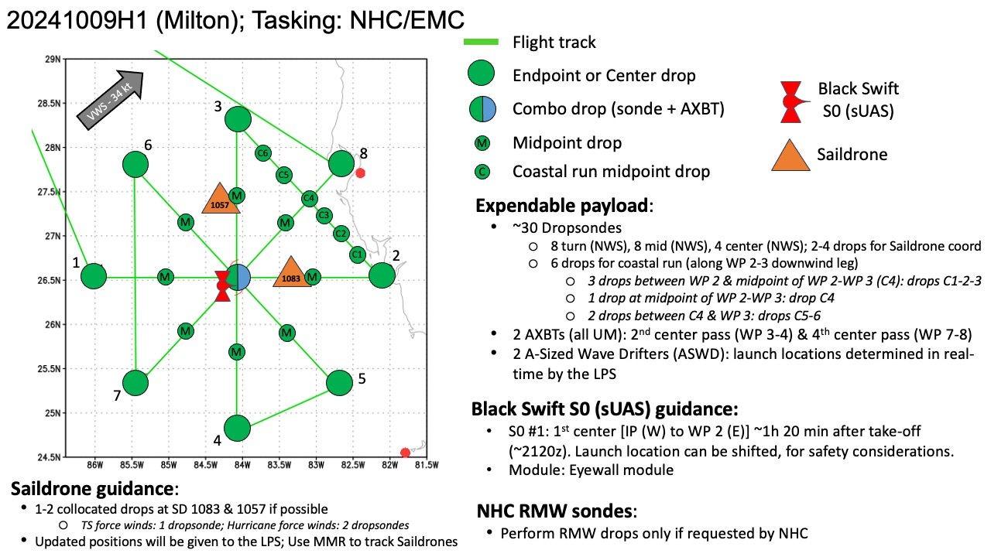  Plan changed due to land:  N-S leg 1, then down wind to SE-NW, then downwind to W-E leg, then back to center and out SW  Remaining 12 n mi offshore
Expendable Distribution | 30 dropsondes (end, mid, center, saildrone, coastal run) , 2 Bts, 2 ASWD, 1 S0
Preflight Weather Briefing | [Hurricane Milton Discussion Number 19  NWS National Hurricane Center Miami FL AL142024  500 PM EDT Wed Oct 09 2024  WSR-88D radar images from Tampa and Key West show that Milton is a  sheared hurricane, with the heaviest precipitation to the north of  the center, and the eye open on the south side. This structure was  confirmed by a recent Air Force Reserve Hurricane Hunter mission,  where the eyewall was reported open to the southwest. The plane  reported that the pressure has risen during the past few hours, with  the latest center drop supporting a minimum pressure of 948 mb.  Based on this pressure, and the reduction of measured flight-level  winds, the intensity is estimated to be 105 kt. The highest  Doppler velocities from the Tampa radar have been between 100 and  105 kt.  Milton's recent motion has been northeastward (035 degrees) at  about 15 kt. Track model guidance continues to insist that the  hurricane will slow down a bit and turn more to the right very  soon, taking the center near or just south of Tampa Bay later this  evening. Milton's center is then expected to cross central Florida  and turn east-northeastward as it emerges over the western Atlantic.  Milton is likely to be right near the threshold of a major  hurricane when it reaches the west-central coast of Florida this  evening. Milton has grown in size today, particularly in the extent  of 34- and 50-kt winds to the northwest of the center, and the  northern eyewall appears most severe at the moment due to  southwesterly shear. As a result, significant wind impacts are  likely to occur north of the center, as well as to the south,  regardless of the exact intensity at landfall. There will likely be  a noticeable gradient of surge heights to the north of the landfall  location, however, the risk of devastating storm surge still  exists across much of the west-central and southwest coast of  Florida given the size of the storm.  Earlier scatterometer data suggested that Milton is already  beginning to interact with a frontal boundary, and global model  guidance suggests that the cyclone will become extratropical in  about 36 hours over the western Atlantic. This is reflected in the  new NHC forecast.
Instrument Notes | Concerns regarding blackswift equipment interfering with dropsondes. Going to try NESDIS stuff off at first while S0 flies and see how the sondes look.

IN-FLIGHT
Time [UTC] | Event
2000 | NHC special advisory:  SUMMARY OF 400 PM EDT...2000 UTC...INFORMATION  -----------------------------------------------  LOCATION...26.9N 83.5W  ABOUT 100 MI...160 KM WNW OF FT. MYERS FLORIDA  ABOUT 100 MI...155 KM SW OF TAMPA FLORIDA  MAXIMUM SUSTAINED WINDS...125 MPH...205 KM/H  PRESENT MOVEMENT...NE OR 35 DEGREES AT 17 MPH...28 KM/H  MINIMUM CENTRAL PRESSURE...950 MB...28.05 INCHES
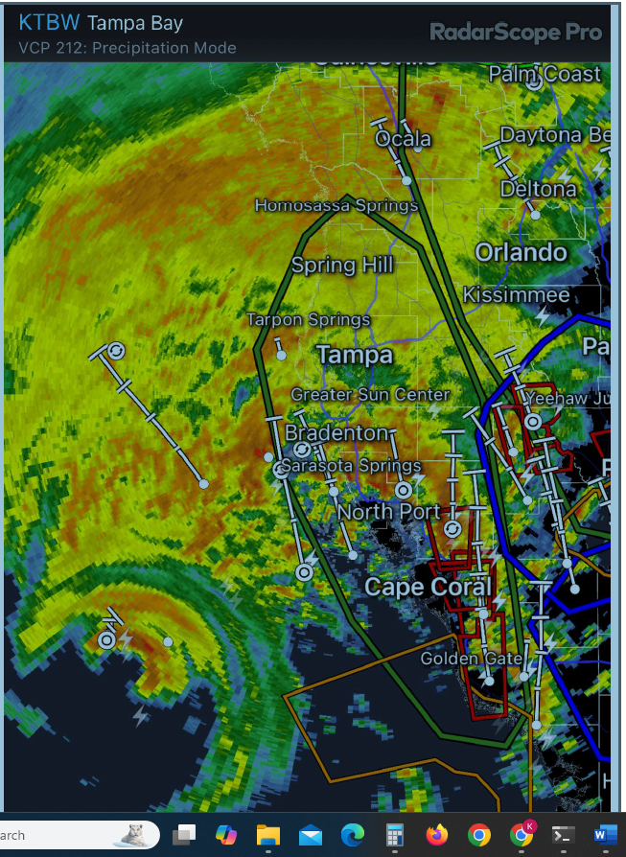
Multiple Tornado warnings in effect
2001 | SD-1083 @ 26.32294 N, 83.33148 W  SD-1057 @ 27.5665 N, 84.3936 W
2022 | Plans changed due to land, but this shows the wave drifter line and the position of 2 saildrones and a glider  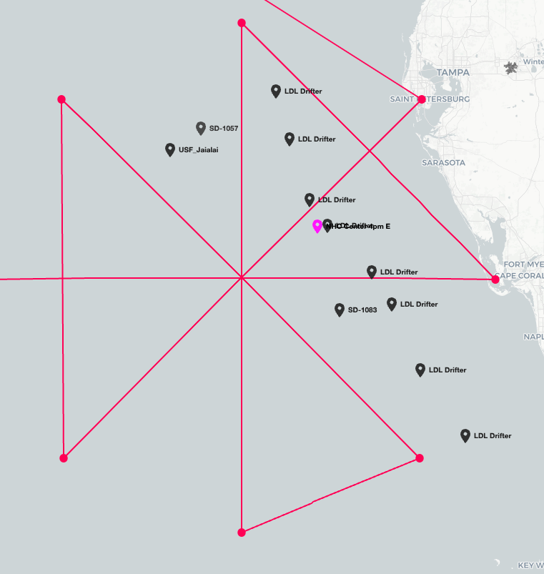  New plan: N-S leg 1, then down wind to SE-NW, then downwind to W-E leg, then back to center and out SW  Remaining 12 n mi offshore  Release S0 and 1st wave drifter (ASWD) on first center  Second wave drifter inbound on SE-NW leg  If significant interference to dropsondes from SO, Blackswift has agreed to end SO prior to along shore pass
2034 | Takeoff out of KMOB
2040 | 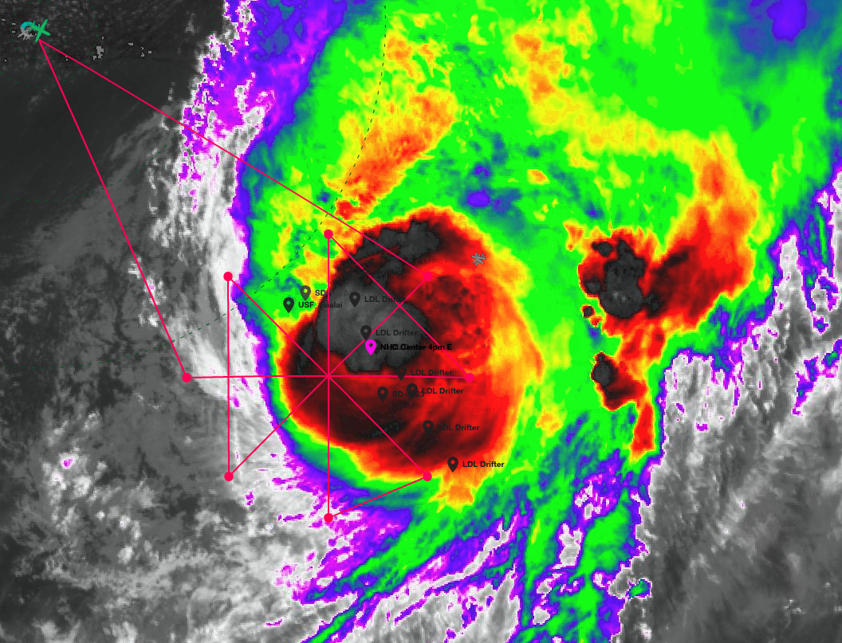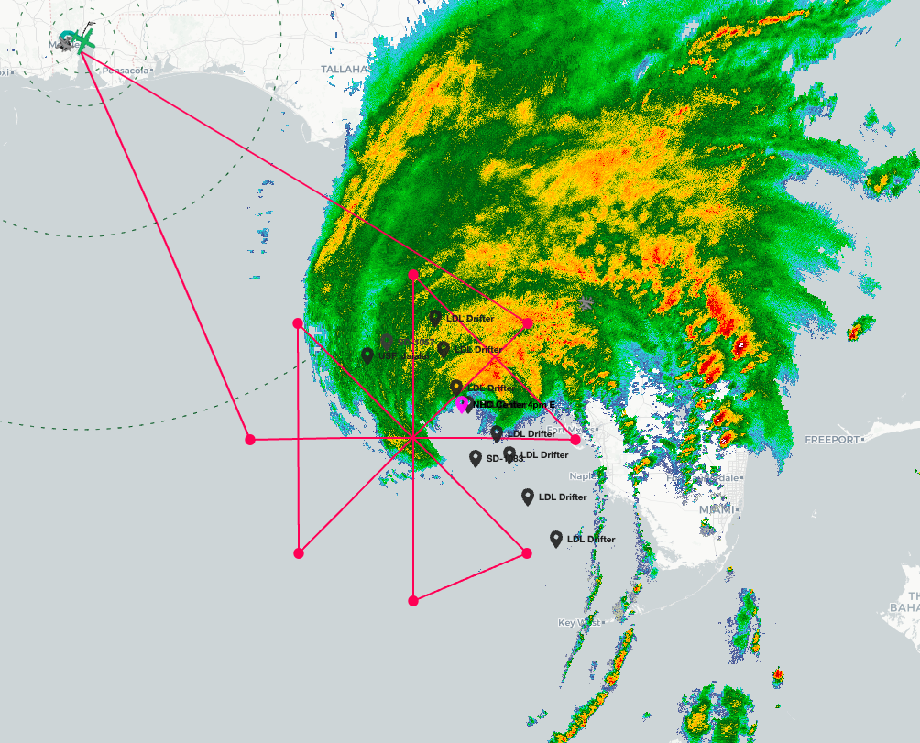  Convection/rain seems to be isolated to primarily the N side. A lot of activity over the Florida peninsula
2044 | TDR up and running
2112 | 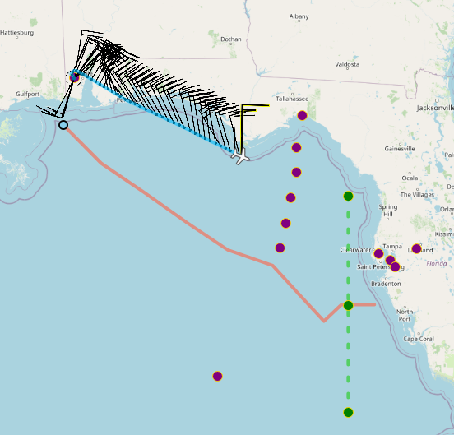
2113 | Request to do 10k ft for first fix from NHC forecaster
2125 | Blackswift equipment turned on
2127 | Blackswift equipment on and S0 initialized
2131 | At 10k ft, ETA to IP: 2139
2138 | Locations of land assets:  Sentinel 1: 27.4979N 82.7135W  Sentinel 2 27.1008N 82.4610W  FCMP T1: 27.4002N 82.5554W  FCMP T5: 27.0783N 82.4336W
2140 | At IP1, IP 28.45N, 83.16W, dropsonde 1, some dropouts starting about halfway down in the sonde. Maybe 25-30%. Still useable.
2152 | Drop #2 Midpoint N, also has some dropout, but not quite as many as the first sonde
2205 | Latest position of SD-1083 26.37875 N, 83.26832 W
2206 | Blackswift s0 deployed
2206 | Drop #3 combo center 953mb 15kt 165deg SST = 28.7 (only one data pt from BT) SD just to the south has an SST of 28.3C. Sonde was still sort of noisy, but QC seemed to handle it ok
2206 | Launch 1st wave drifter 64231470 with barometer
2209 | Starting centerfix with sUAS, winds looking good on airops
2211 | S0 at 1000m, wind direction 250 degrees, heading 208, 12 kts, 96% battery
2218 | S0 center fix: Lon -83.13, Lat: 27.03, heading to eyewall
2220 | Drop #4 Midpoint S. This sonde was a bit messier. Dropouts near the surface make it a little tricky to determine if it actually reported the surface properly. This is something we should discuss how to handle so that we are consistent.
2222 | Going to pass about 20 n mi away from SD-1083 and sonde would drift downwind away from it so we are nixing the sondes
2227 | S0 at 500 m, winds 327/33kts
2233 | Eyewall appears to be starting to move ashore
2235 | Drop #5 Endpoint S, onboard LPS noted that the ocean looks crazy below the aircraft in about 110 kt max at flight-level. Sonde seemed a little cleaner than the midpoint sonde, especially near the surface.
2241 | S0 at 300 m, winds 300/80 kts
2244 | 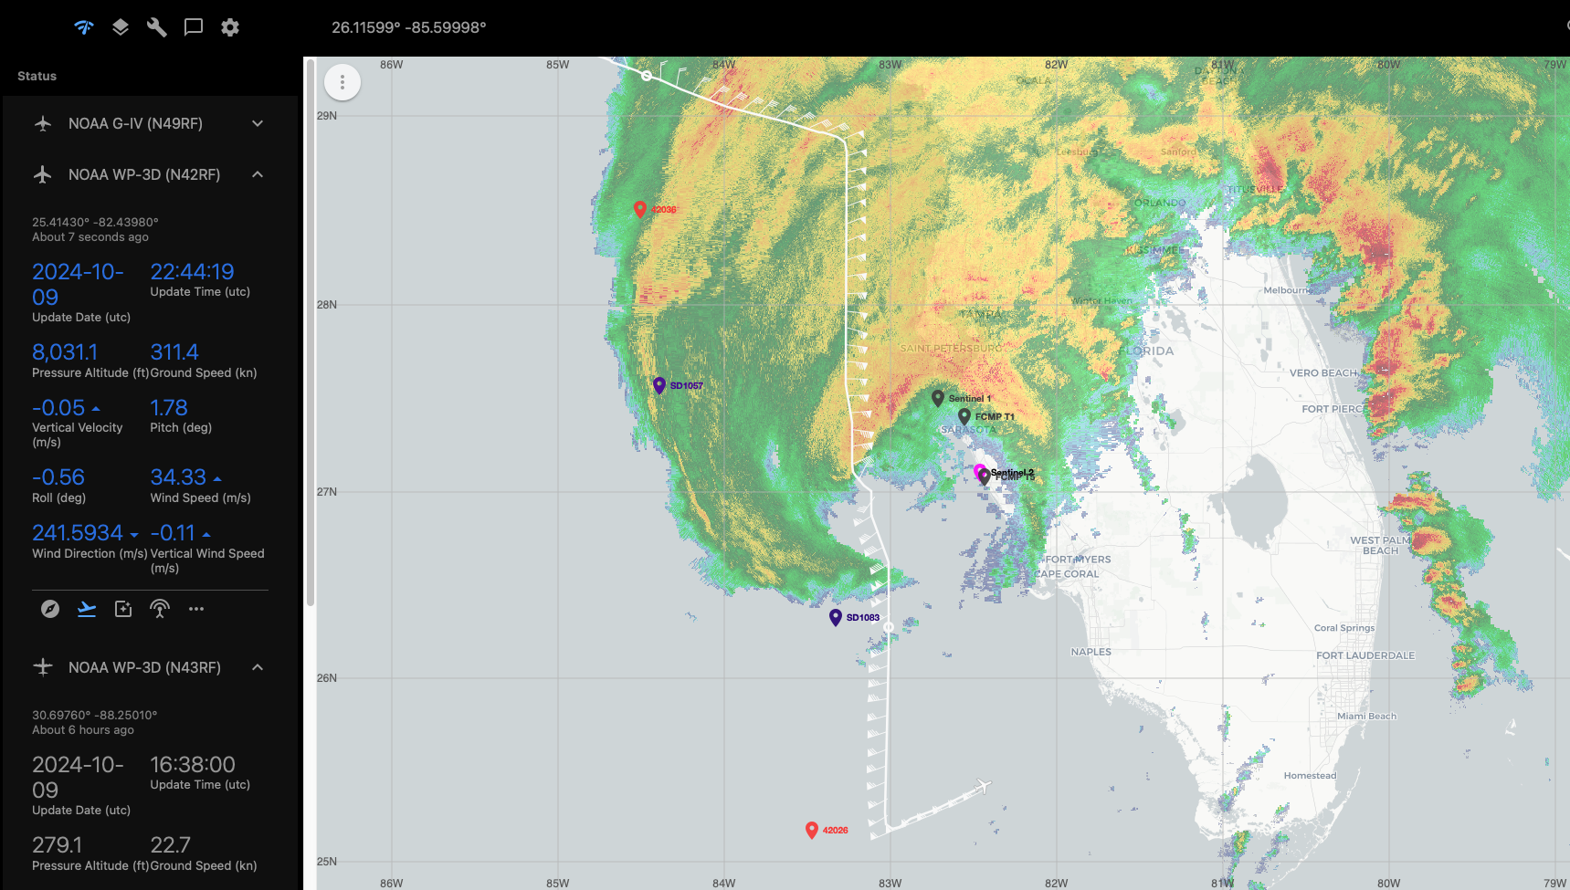
2245 | S0 at 200 m, winds 272/96 kts
2250 | Drop #6 IP, similar to EP 1 sonde in terms of dropouts  S0 at 200 m, winds 055/96 kts
2253 | S0 at 100 m, winds 226/85 kts
2256 | S0 at 100 m, winds 207/55 kts
2257 | Drop #7 first intermediate drop. Looks cleaner near the surface with no dropouts after 154 s. Might coincide exactly with when the black swift equipment was turned off.
2259 | S0 splashed, might have been hit with water issue since it had a sudden stop. 53 min flight
2300 | Blackswift equipment off  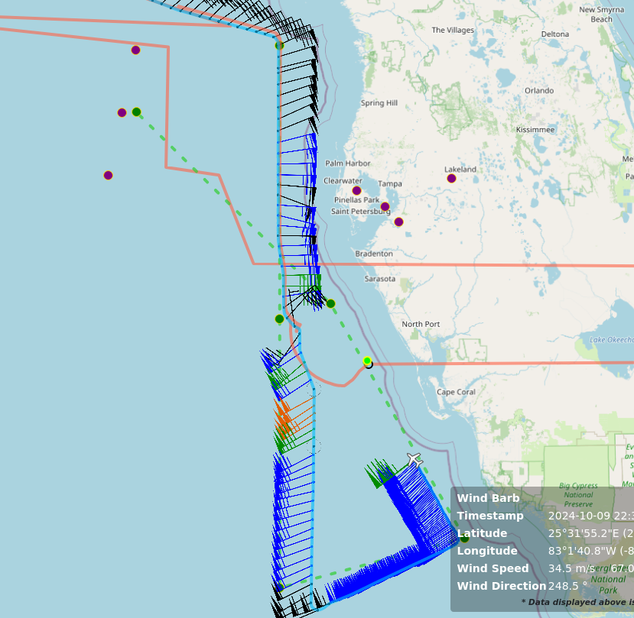
2304 | Drop #8 and 2nd wave drifter 64139600 Midpoint SE. Clean dropsonde all the way down. Seems to confirm suspicions that Blackswift equipment on N42 is interfering with sondes.
2309 | First radar analysis complete
2310 | S0 track was right underneath P3, just about 10 min short of when the P3 got there. Was directly under Teal at the same time.
2312 | Drop #9 SE first intermediate drop, also a clean sonde
2314 | CPA to Sentinel 2 and FCMP T5. About 25 n mi offshore.  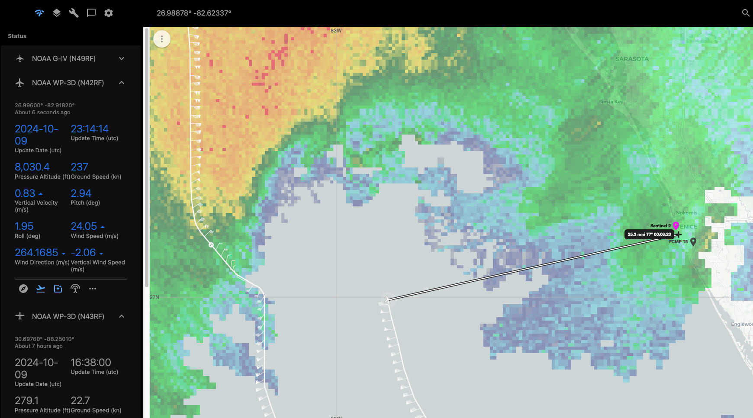
2317 | Mark center
2319 | CPA to FCMP T1 and Sentinel 1, about 27 n mi offshore  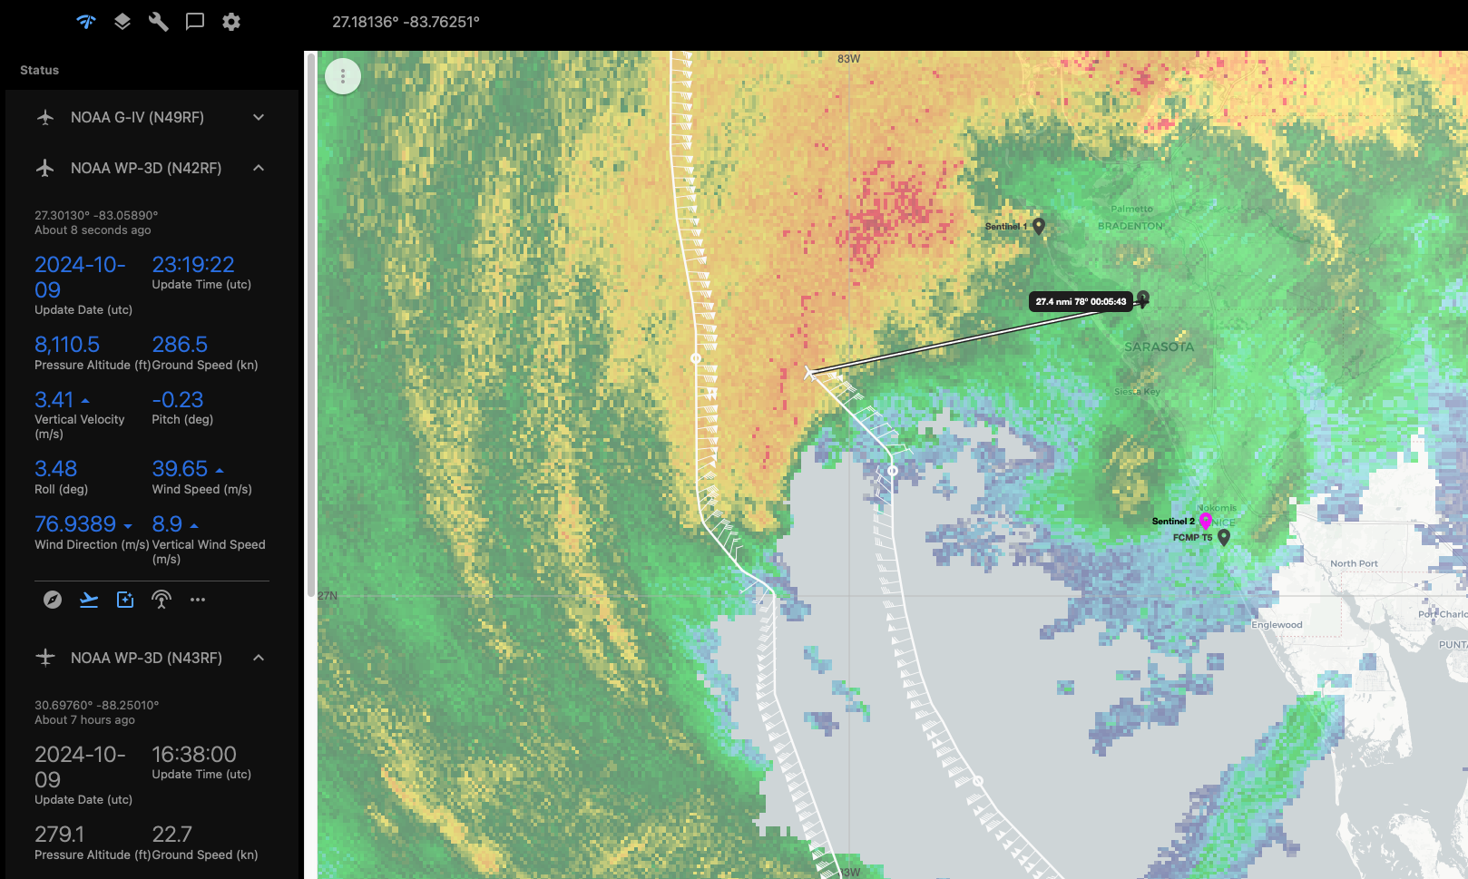
2320 | Drop #10 second intermediate drop BT bad SST is too low
2325 | Plan after this leg is to go in from the west, but might not make it to the center with the storm making landfall.
2328 | Drop #11 third intermediate drop
2331 | Zjelenak noted that iwrap is reporting much lower winds on SE side then what air force hdobs are showing
2337 | Drop #12, intermediate drop
2343 | Updated plan for final leg is to get some TDR data on the west side, fly over the SD, then head back to Mobile. Storm is too far inland to fly W-E.  Updated SD locations:  SD-1057 @ 27.49889 N, 84.48946 W  SD-1083 @ 26.38543 N, 83.21038 W
2344 | Drop #13 endpoint NW
2355 | TDR jobfile to ground server
2356 | Drop #14 #15 rapid drops over SD 1057. Passed about 6 n mi E of SD.  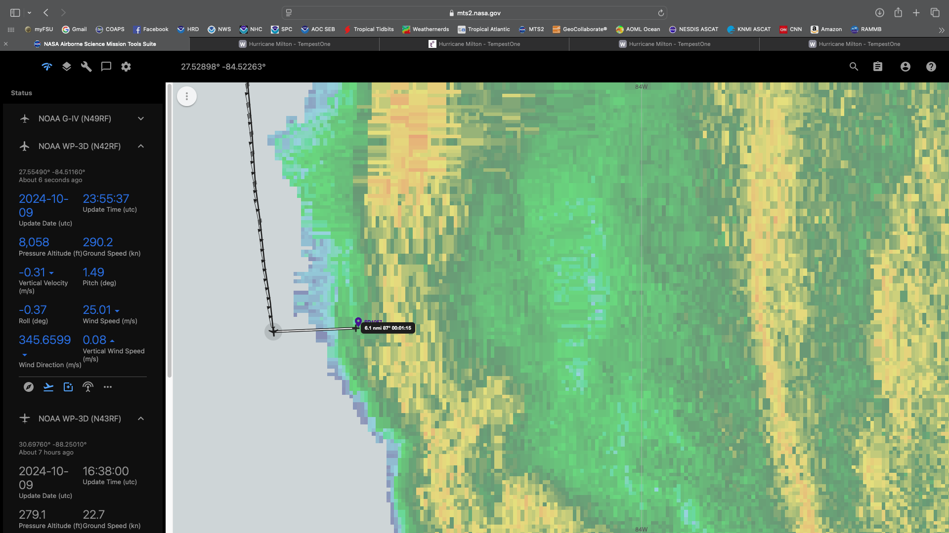
0003 | Storm is moving ashore quickly. Planning 1 more sonde at the endpoint to the SE. Then turn back to NW basically along the same track back to Mobile
0007 | Second radar analysis complete  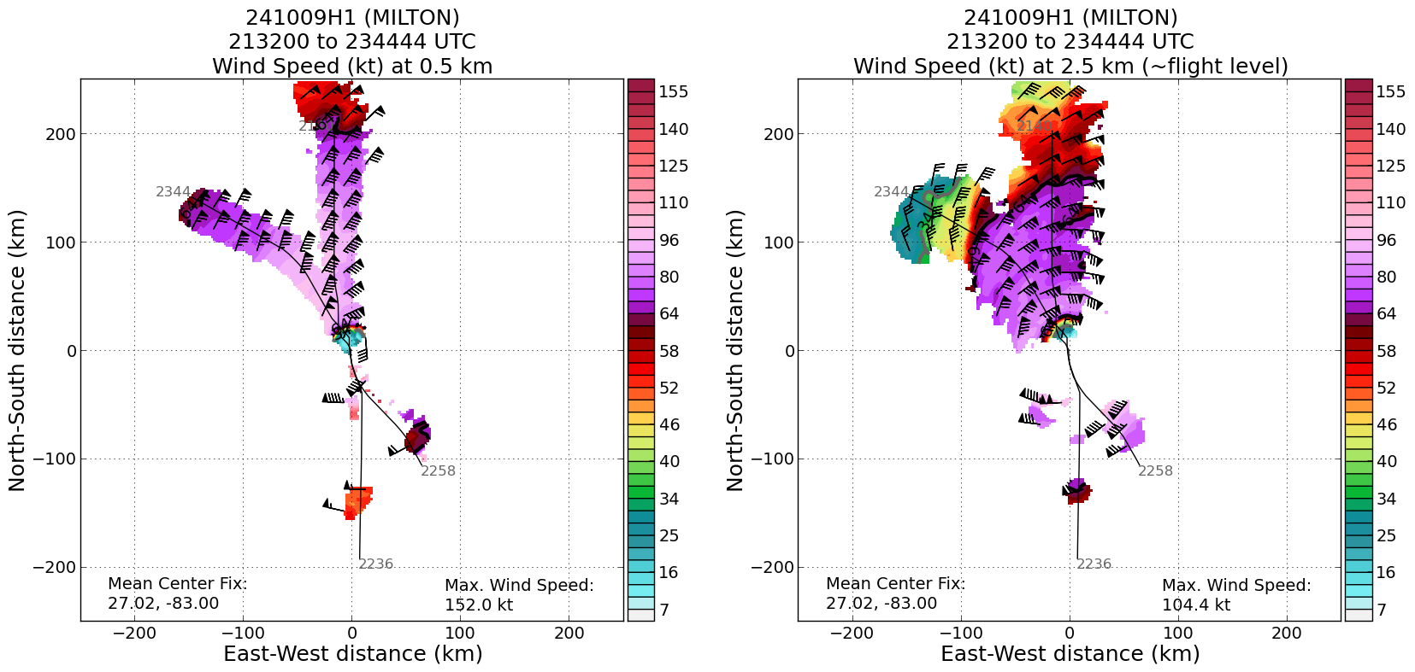
0011 | Drop #16, end of convection painting. Turned about 21 n mi WNW of SD 1083.  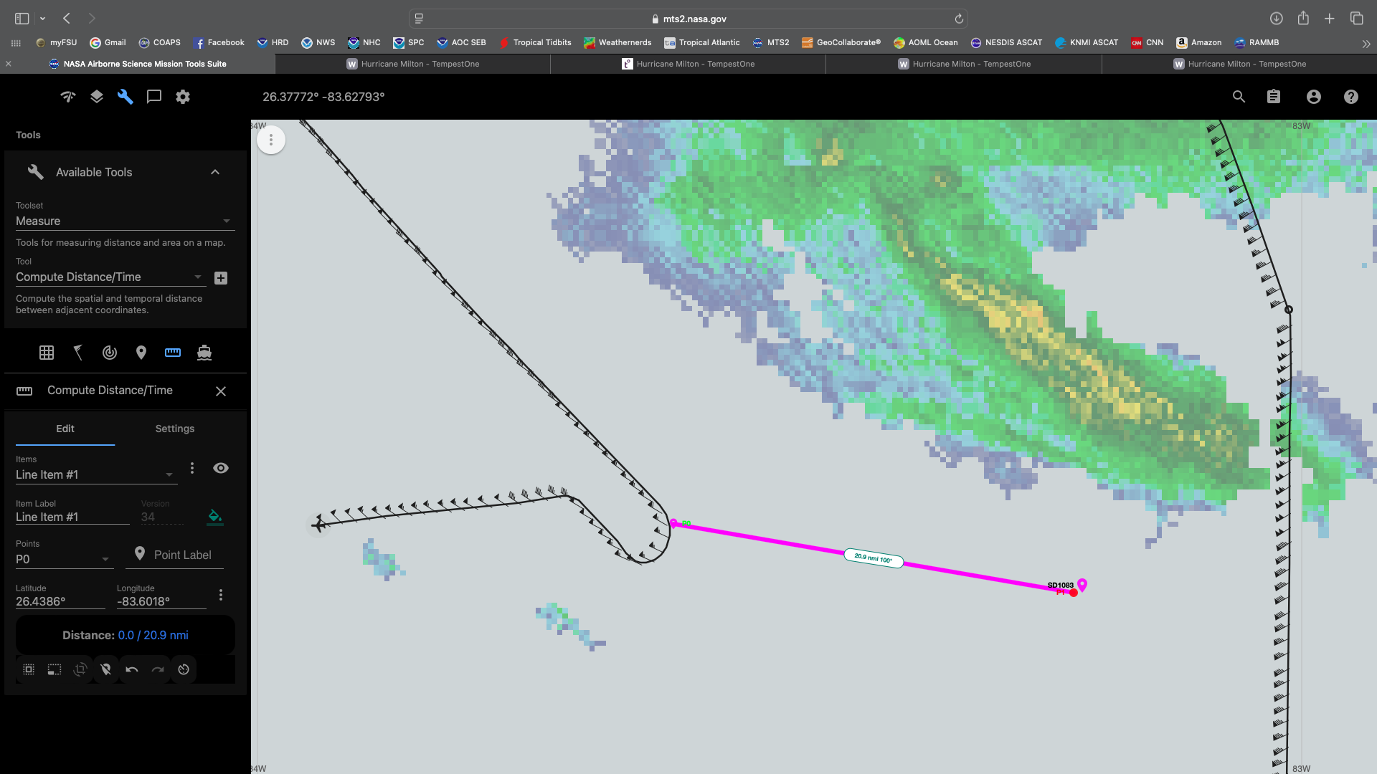
0013 | Science complete
0017 | Nixing NW track and heading straight back to Mobile
0028 | TDR jobfile to ground server
0030 | Milton made landfall near Siesta Key, FL as a category 3 hurricane with max sustained winds of 120 mph, min pressure of 954 mb, moving ENE or 60 degrees at 15 mph
0039 | Third radar analysis complete
0045 | 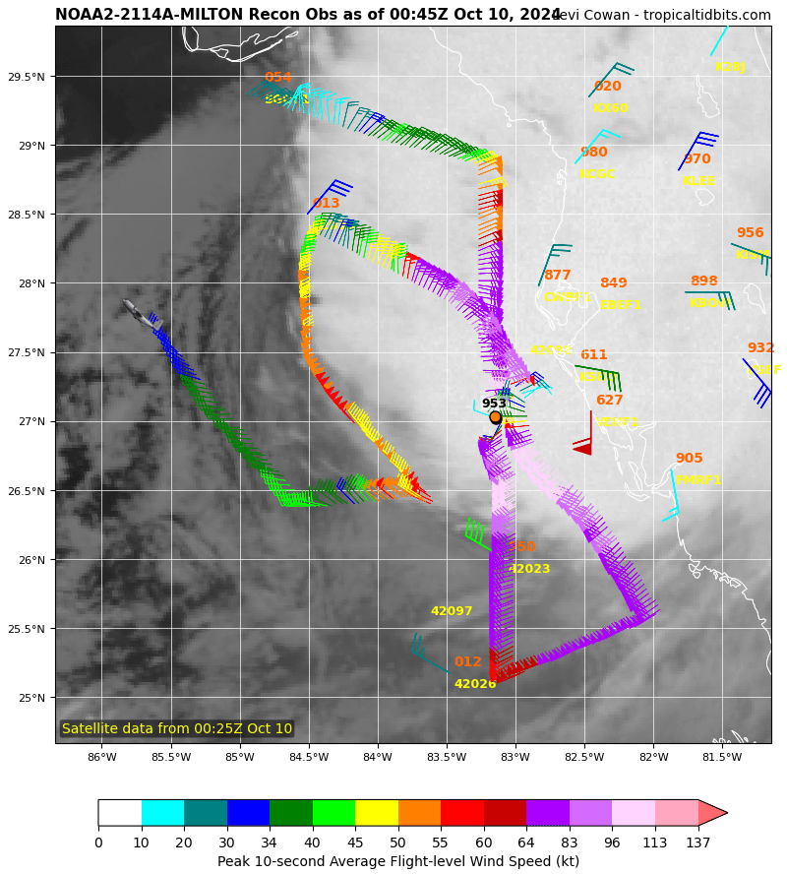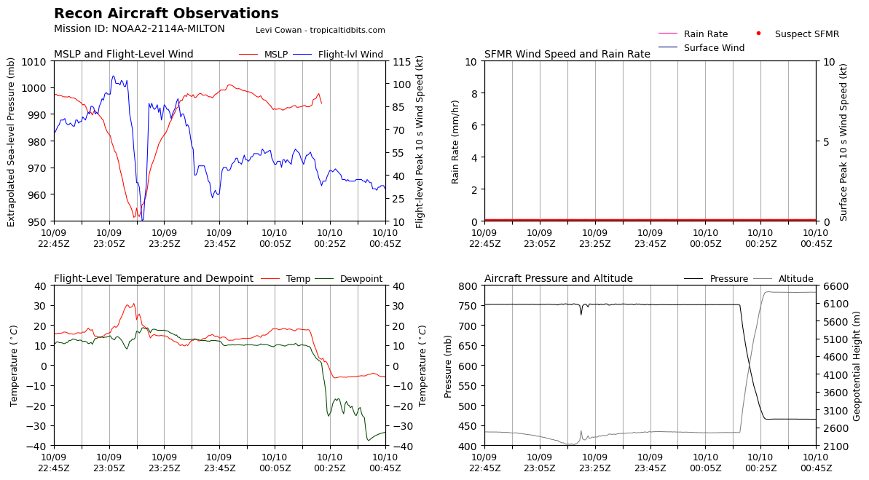

POST-FLIGHT
Mission Summary | Successful NHC/EMC tasked TDR landfall mission into Hurricane Milton. The P-3 sampled Milton for the 4 hours leading up to its landfall near Siesta Key, FL at 0030Z as a category 3 (120 mph) hurricane. Milton was slowly weakening throughout the duration of the flight as it was encountering increasing vertical wind shear.  During the mission, 1 Blackswift S0 completed a 53 minute flight that included a center fix and eyewall sampling, 2 ADWSDs were deployed, a coastal run with extra dropsondes for samling offshore of assets deployed by our landfall partners, and saildrone overflights were accomplished.  Due to the faster movement of Milton than expected, the flight plan was modified to account for the eye being closer to shore. Since it would not be possible to fit a downwind leg in along the coast after the first pass, it was modified to allow the second leg to be through the center parallel to the coast. This still allowed for the coastal run to be accomplished. Additionally, since Milton was making landfall around the time of the third leg, it was decided that they would fly parallel to the outer edge of the rain shield to collect additional TDR data on the western side of the storm before returning to Mobile.  16 dropsondes (11 NWS, 3 HRD, 2 GOMO), 2 AXBTs, 2 ADWSDs, 1 Blackswift S0
Actual Standard Pattern Flown | Modified butterfly
APHEX Experiments / Modules Flown | RICO SUAVE, CHAOS, Landfall
Plain Language Summary | - Successful mission that sampled Milton prior to and as it was making landfall as a category 3 storm near Siesta Key, FL  - Data collected along the coastline will be extremely beneficial for studying the water to land transition with our landfall partners who deployed assets on land along the coastline.
Instrument Notes | Data dropouts in sondes were noted when the Blackswift equipment was turned on. Once the equipment was turned off there were no more data dropouts in the sondes.
Final Mission Track | 