MISSION PLAN
FLIGHT ID | 20241008H1 | STORM | AL14 / Milton
MISSION ID | 1714A Milton | TAIL NUMBER | NOAA-42
TASKING | NHC/EMC TDR | PLANNED PATTERN | Butterfly
MISSION SUMMARY
TAKEOFF [UTC] | 2012 | LANDING [UTC] | 0301
TAKEOFF LOCATION | KLAL | LANDING LOCATION | KMOB
FLIGHT TIME | 6.8 | BLOCK TIME | 7.3
TOTAL REAL-TIME RADAR ANALYSES  (Transmitted) | 4 (4) | TOTAL DROPSONDES Deployed (Tx to GTS) | 26 (20)
OCEAN EXPENDABLES deployed (good) | 3 UM AXBTs (3)  1 ASWD | sUAS (Type) | 1 (S0)  Engine failed
APHEX EXPERIMENTS / MODULES | CHAOS, RICO SUAVE, NESDIS Ocean Winds
HRD CREW MANIFEST
LPS ONBOARD | Sellwood/Aberson | LPS GROUND | Holbach/Looney
TDR ONBOARD | Sellwood/Aberson | TDR GROUND | Hollingshead
ASPEN ONBOARD | N/A | ASPEN GROUND | Dunion
NESDIS SCIENTISTS | P. Chang, Jelenak, Sapp
GUESTS (Affiliation)
AOC CREW MANIFEST
PILOTS | Abitbol/Wood/Keith/Ellis
NAVIGATOR | Meier
FLIGHT ENGINEERS | Tyson/Wysinger
FLIGHT DIRECTOR | Zawislak
DATA TECHNICIAN | McAllister
AVAPS | Dykeman/Keller
Ground Support | Grimes, Moreno, Rivera

PRE-FLIGHT
Flight Plan | 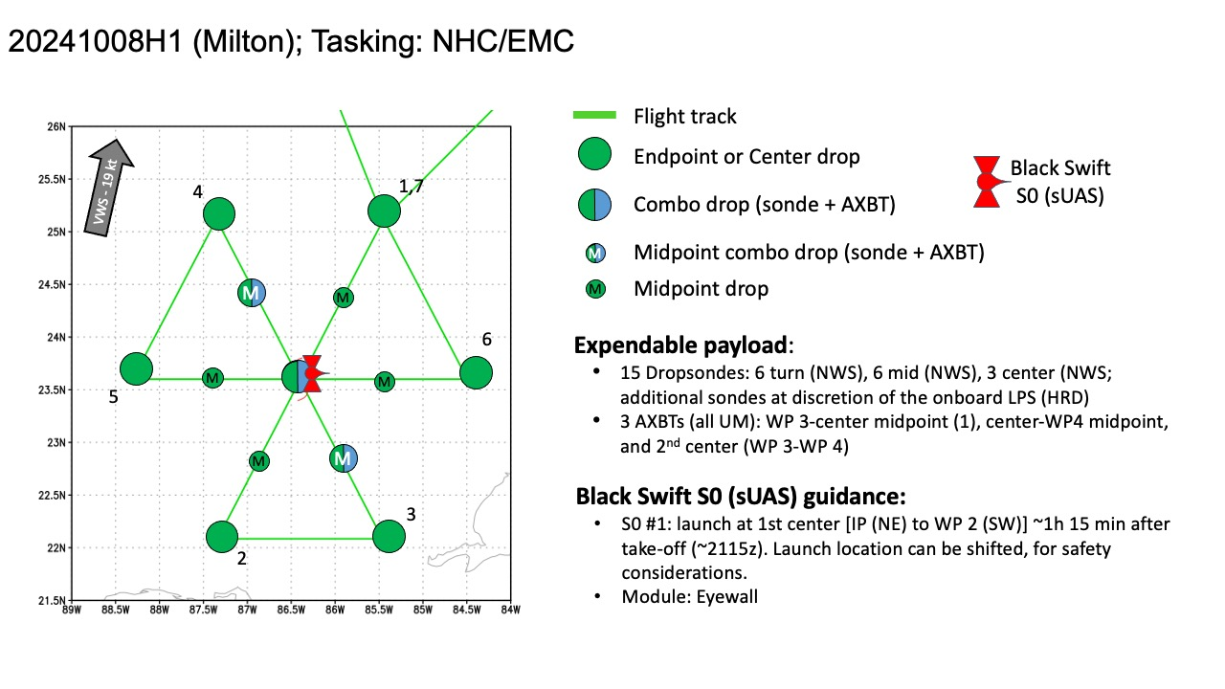  Butterfly with 105 n mi legs.
Expendable Distribution | 15 dropsondes (endpoints, midpoints, centers), 3 BTs, 1 S0  Request from NHC to add RMW sondes. Also planning to add 2 HRD RMW sondes to SW and SE quadrants
Preflight Weather Briefing | Hurricane Milton Discussion Number 15  NWS National Hurricane Center Miami FL AL142024  400 PM CDT Tue Oct 08 2024  The Air Force Reserve Hurricane Hunters found that Milton's central  pressure had fallen to 923 mb in the last pass they made through  the eye a few hours ago. The satellite presentation has improved  since that time, with a thick ring of cold cloud tops surrounding a  10-mile-wide eye. This pattern yielded a T7.0/140 kt from TAFB,  with several of the objective satellite estimates between 140 and  145 kt. Milton has again become a category 5 hurricane, with  maximum winds estimated to be 145 kt. Another Air Force mission is  entering Milton as we speak.  Milton wobbled a bit to the southeast today, but the longer-term  12-hour motion is east-northeastward (075/8 kt). Milton is forecast  to turn northeastward and begin accelerating later today as it moves  between a trough digging into the Gulf of Mexico and a ridge near  the Greater Antilles. Because of the wobble, the track guidance  has been initialized a bit to the south of where many of the raw  model fields think the hurricane was centered at 1800 UTC, and this  has caused the entire guidance envelope to shift a bit south on  this cycle. It is still critical to remember that even at 36 hours  (around the time of potential landfall), NHC's track forecasts  can be off by an average of 60 n mi, which means we still can't  pinpoint an exact landfall location, especially if additional  wobbles occur in the short term. After landfall, Milton is  forecast to cross Florida and emerge over the Atlantic waters on  Thursday.  Milton is expected to maintain major hurricane strength while it  moves across the Gulf of Mexico and approaches the west coast of  Florida. Stronger vertical shear is expected to increase in about  24 hours, but even if this causes some weakening, it will likely not  be enough to keep Milton from being an extremely dangerous hurricane  when it reaches shore. Additionally, the first stages of  extratropical transition may be just underway as Milton is reaching  the coast, which could impart some baroclinic energy and slow the  rate of weakening. The NHC intensity forecast is close to the top  end of the model envelope, which includes the GFS and ECMWF models,  since these models should have a better handle on a potential  positive trough interaction.  Milton's wind field is expected to expand as it approaches Florida.  In fact, the official forecast shows the hurricane and  tropical-storm-force winds roughly doubling in size by the time it  makes landfall. In addition, the stronger-than-normal winds could  occur on the northwest/back side of the storm since Milton will be  interacting with a frontal boundary and beginning extratropical  transition. Damaging winds, life-threatening storm surge, and heavy  rainfall will extend well outside the forecast cone. This is a  very serious situation and residents in Florida should closely  follow orders from their local emergency management officials.  Evacuations and other preparations should be completed today.  Milton has the potential to be one of the most destructive  hurricanes on record for west-central Florida.  Key Messages:  1. A large area of destructive storm surge, with highest  inundations of 10 ft or greater, is expected along a portion of the  west-central coast of the Florida Peninsula. If you are in the  Storm Surge Warning area, this is an extremely life-threatening  situation, and you should evacuate today if ordered by local  officials. There will likely not be enough time to wait to leave on  Wednesday.  2. Devastating hurricane-force winds are expected along portions of  the west coast of Florida, where a Hurricane Warning is in effect.  Milton is forecast to remain a hurricane as it crosses the Florida  Peninsula and life-threatening hurricane-force winds, especially in  gusts, are expected to spread inland across the peninsula.  Preparations to protect life and property, including being ready for  long-duration power outages, should be complete by tonight.  3. Heavy rainfall across the Florida Peninsula through Thursday  brings the risk of catastrophic and life-threatening flash and urban  flooding along with moderate to major river flooding, especially in  areas where coastal and inland flooding combine to increase the  overall flood threat.  4. Tropical storm conditions and a dangerous storm surge with  destructive waves will continue across portions of the northern  coast of the Yucatan Peninsula this evening.  FORECAST POSITIONS AND MAX WINDS  INIT 08/2100Z 22.7N 87.5W 145 KT 165 MPH  12H 09/0600Z 23.8N 86.4W 145 KT 165 MPH  24H 09/1800Z 25.6N 84.7W 130 KT 150 MPH  36H 10/0600Z 27.2N 82.8W 110 KT 125 MPH  48H 10/1800Z 28.1N 80.7W 75 KT 85 MPH...INLAND  60H 11/0600Z 28.6N 77.9W 65 KT 75 MPH...OVER WATER  72H 11/1800Z 29.0N 75.0W 55 KT 65 MPH...POST-TROP/EXTRATROP  96H 12/1800Z 30.6N 68.5W 45 KT 50 MPH...POST-TROP/EXTRATROP  120H 13/1800Z 31.8N 60.0W 40 KT 45 MPH...POST-TROP/EXTRATROP
Instrument Notes | Spotty data on some of the dropsondes, suspect interference from Blackswift equipment.

IN-FLIGHT
Time [UTC] | Event
2012 | Take off KLAL
2014 | Looks like possible flyover or near SD-1083 during ferry at 26.57529 N, 83.32504 W
2034 | Starting dry run of S0 startup
2036 | Dry run simulation complete
2038 | TDR up and running, painting some nice stratiform
2045 | IP1 moved to ~24.151N 86.837W, which is near a wave drifter nearby (23.986N, 86.983W; sig waves 2.8m, SST 29.2C)
2120 | Reset HDOBs and orbiting to prep for wave drifter deployment
2125 | Starting Blackswift checklist
2128 | Released A-sized wave drifter 64231510
2130 | NHC update 904hPa 165mph 22.7N 87.4W motion 75 deg 9 mph
2136 | USAF center 908mb 35kts
2137 | Updated drifter location (pre-deployed) 23.995N 87.020W, sig waves 3.3 m, very close to this drifter
2141 | IP1, drop 1  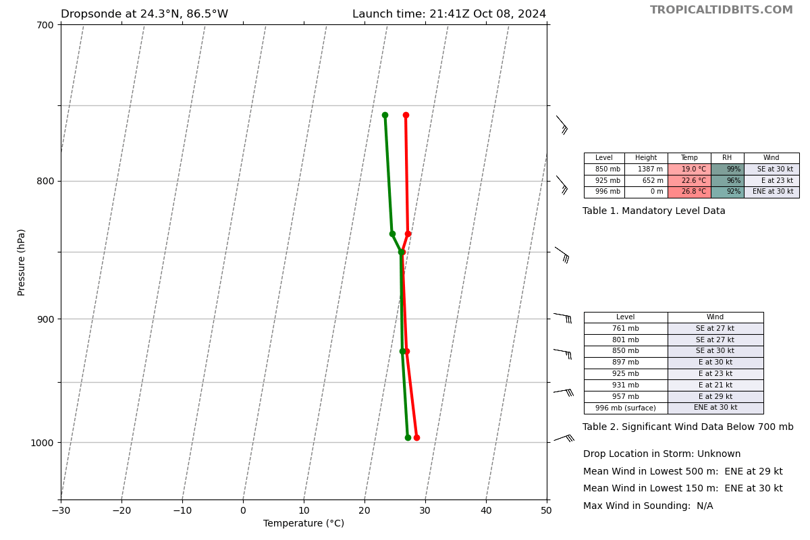
2148 | Had to reset satcom, plan for blackswift in the eye
2155 | Dropsonde 2, MP, looking like double eyewall  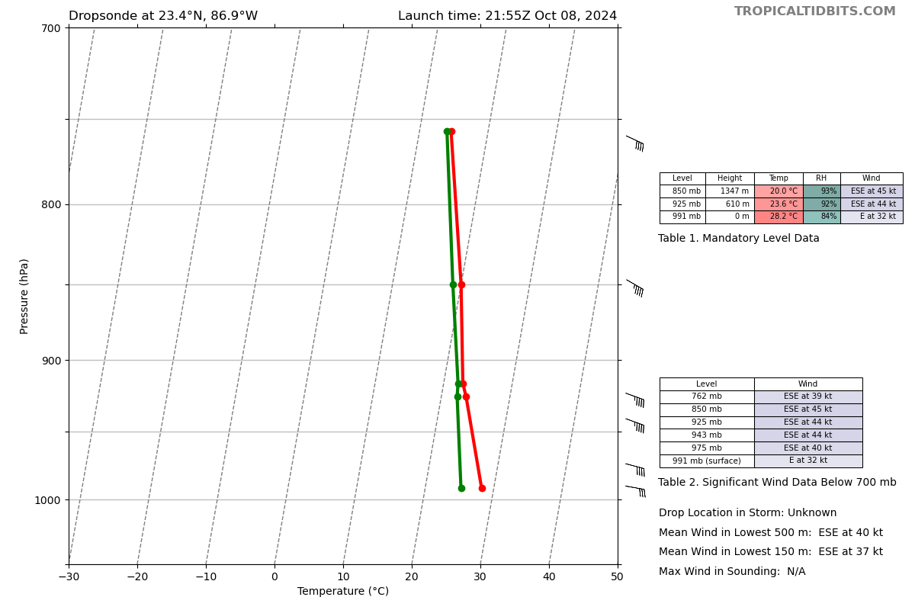
2200 | Onboard scientist noted that there appears to be a double eyewall again. They are close together about 10 n mi across and 16 n mi across
 | 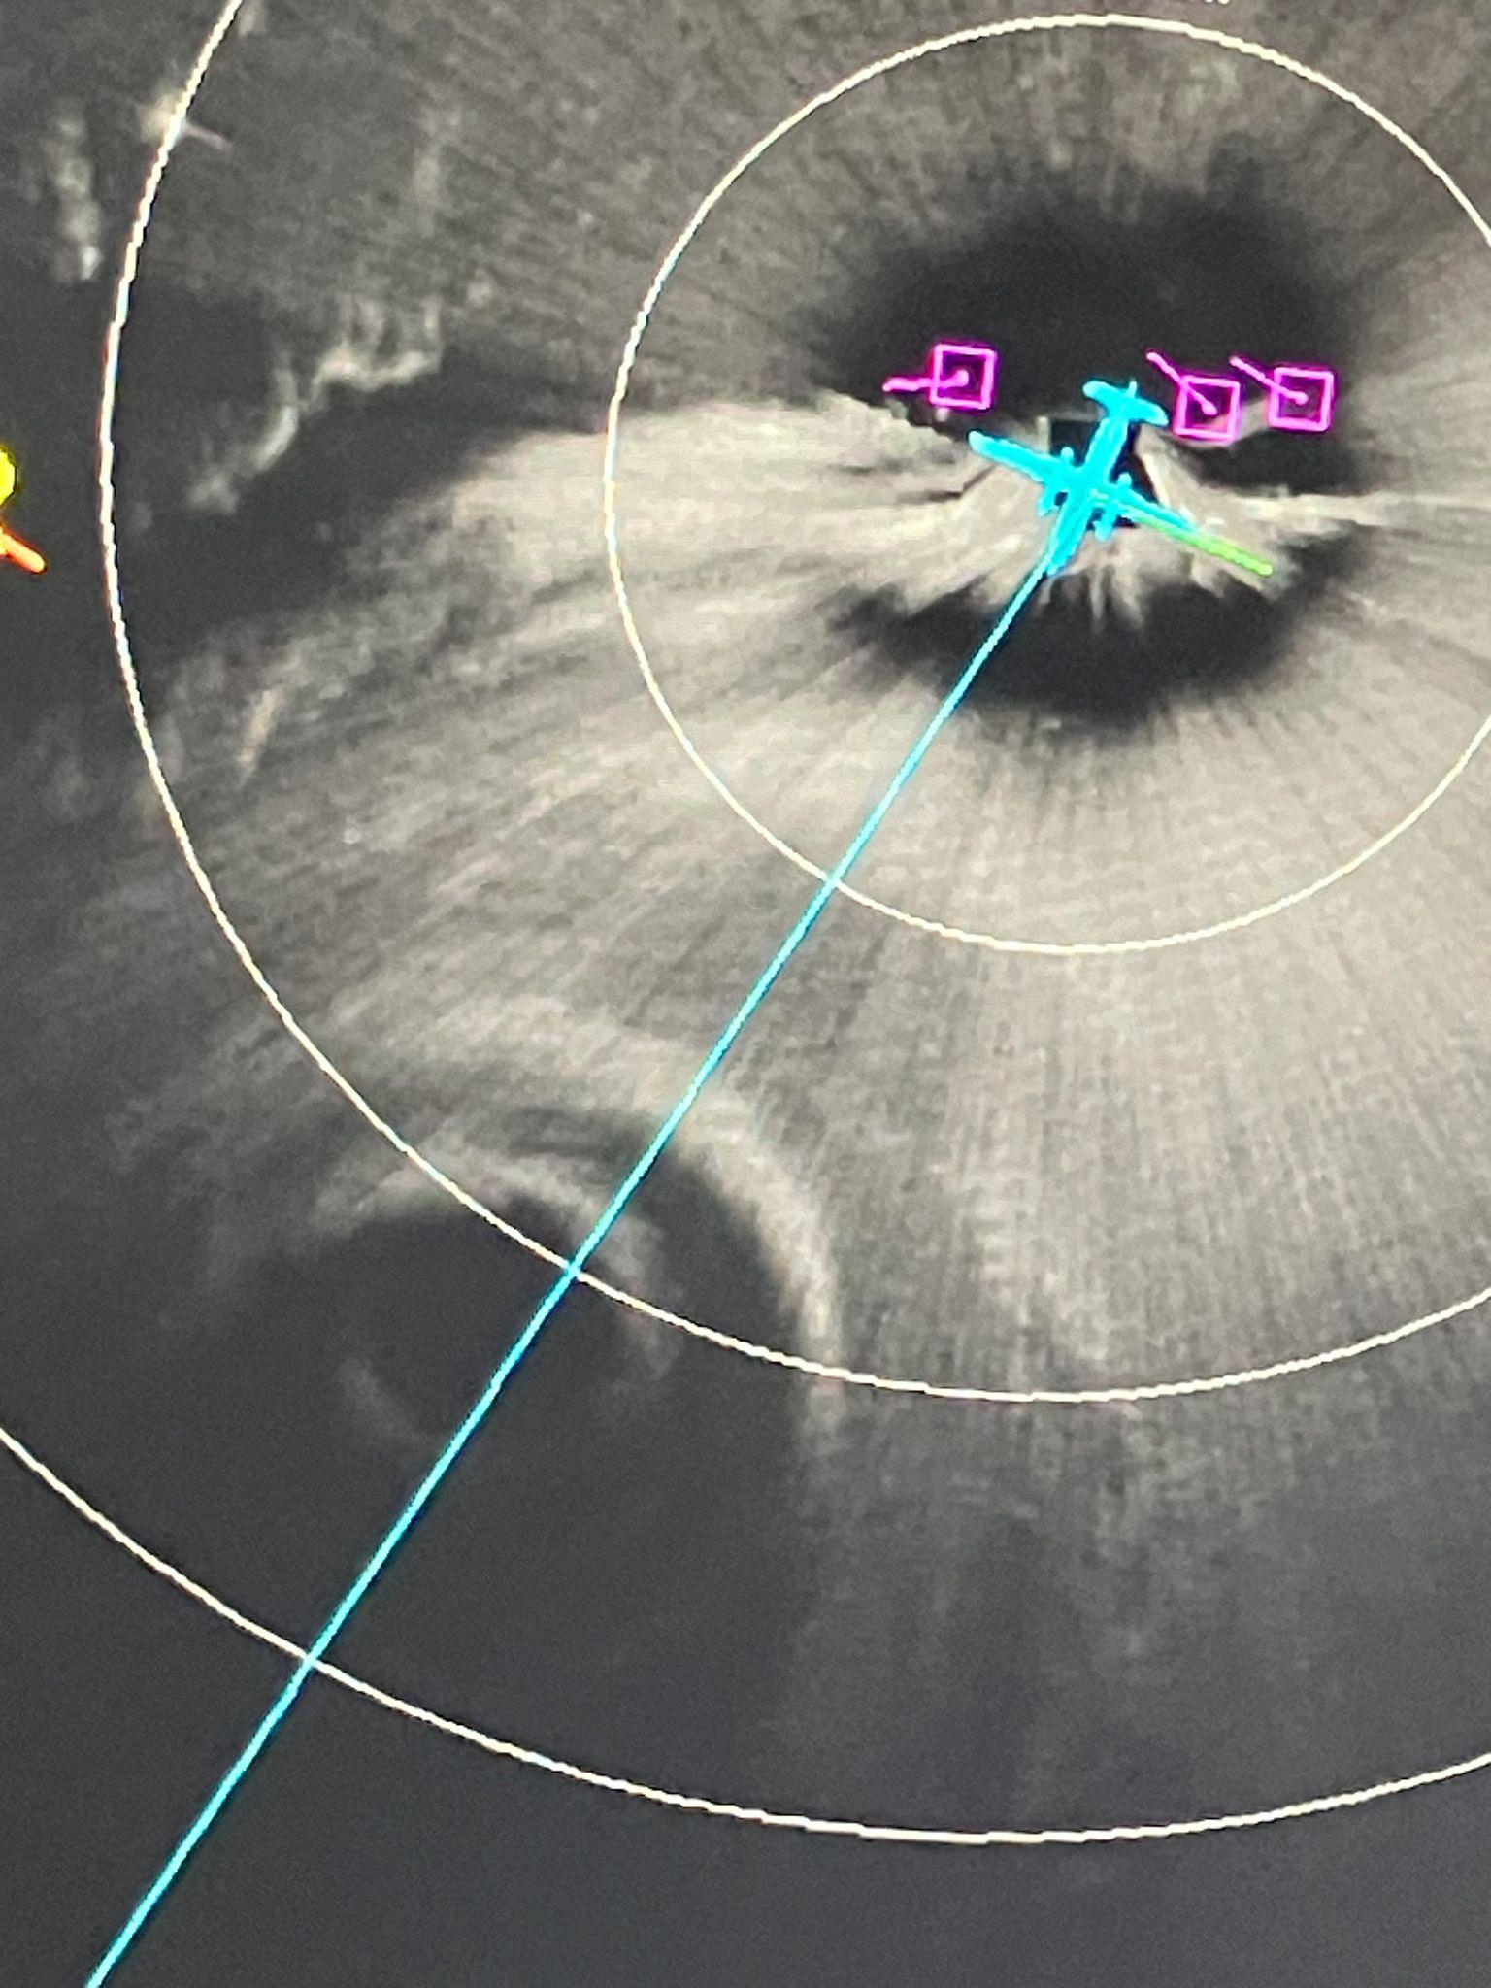
2204 | Drop 3, RMW  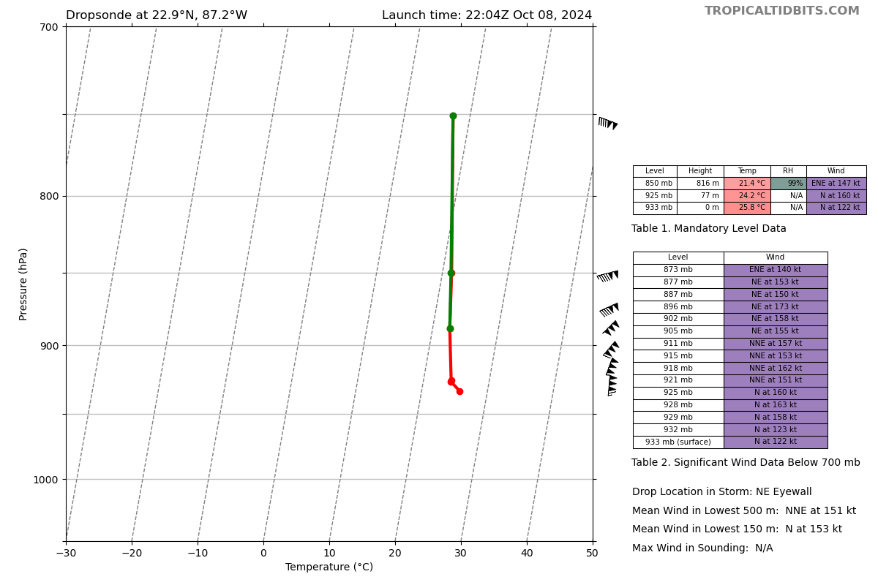
2205 | FL peak around 145 kts, not well aligned with the IR view
2206 | S0 and center drop, dropped 2500 ft, dropsonde 4, extrapolated pressure of 903 mb  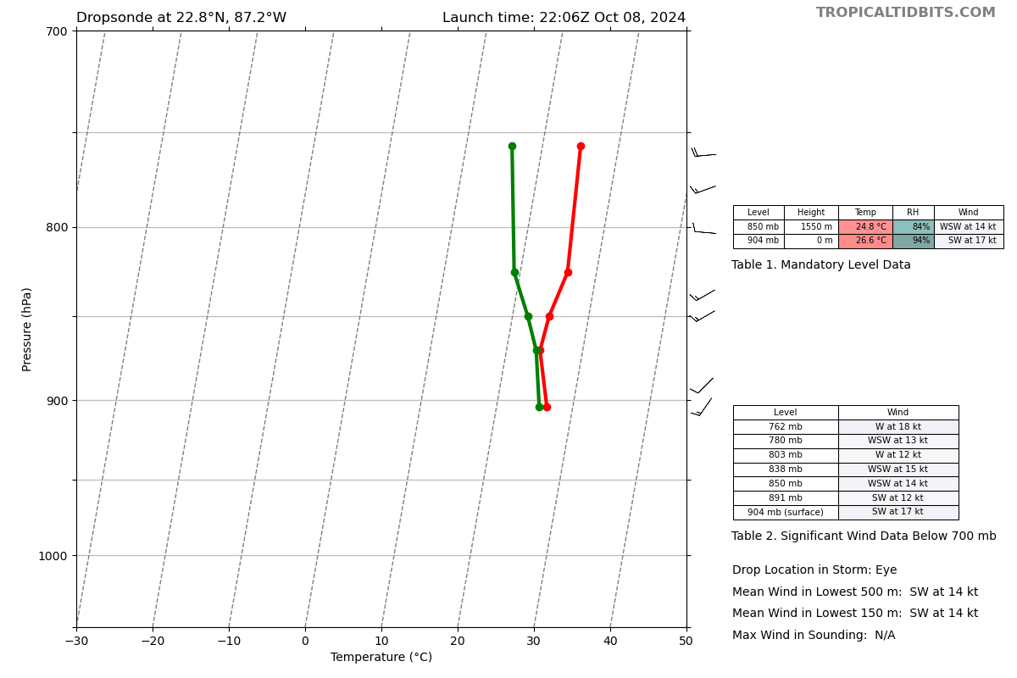
2207 | Dropsonde 5-7, RMW 2 (RMW #3 SW eyewall bad sonde, going to skip and move on)
2211 | S0 splashed, motor didnt turn on, measured 909 mb before splash (4 minutes)
2216 | Dropsonde 8, MP  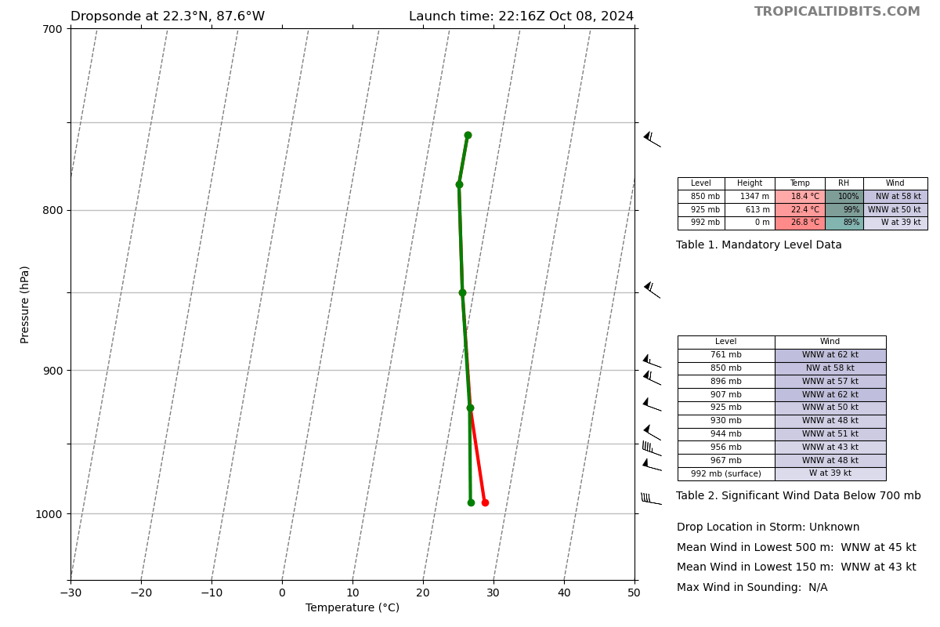
2227 | Dropsonde 9, EP1  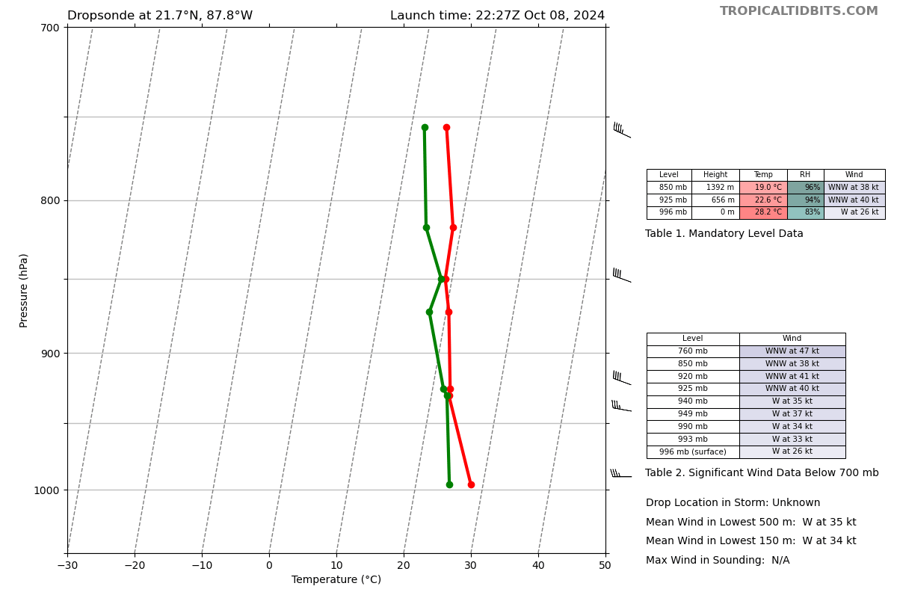
2228 | existing drifter 23.9948182 87.0197643
2228 | existing drifter 23.9948182 87.0197643
2240 | Decision to drop 2nd S0, prelaunch checklist beginning
2236 | TDR jobfile submitted decided to cut the SW-SE downwind leg short to make more time for science as there were very few scatterers for TDR here.
2242 | Aborting 2nd S0 flight. Jason noted that it seems like something interfering with dropsondes, making them bad. Wanted blackswift stuff turned off (blackswift stuff turned off)
2248 | Dropsonde 10, IP2  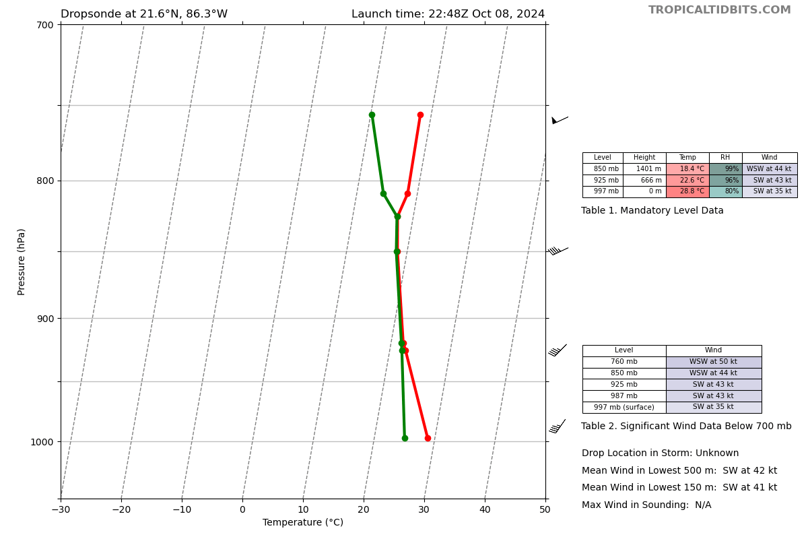
2249 | First radar analysis complete  0.5 22.82 87.21  2.0 22.82 87.23  3.0 22.82 87.25  6.0 22.82 87.27  2-6km tilt 4.0km at 270
2257 | Dropsonde 11, MPi2, BT combo SST of 28.8C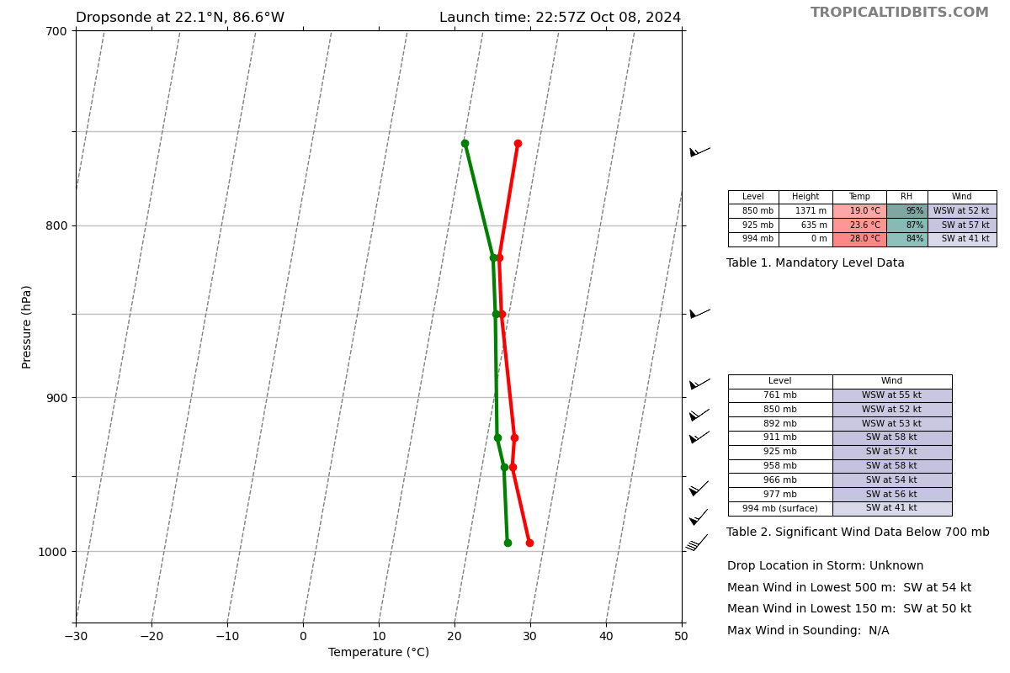
2310 | Dropsondes 12-14, RMWi2, one of them had WL150 of 165 kt and 10-m wind of 160 kt  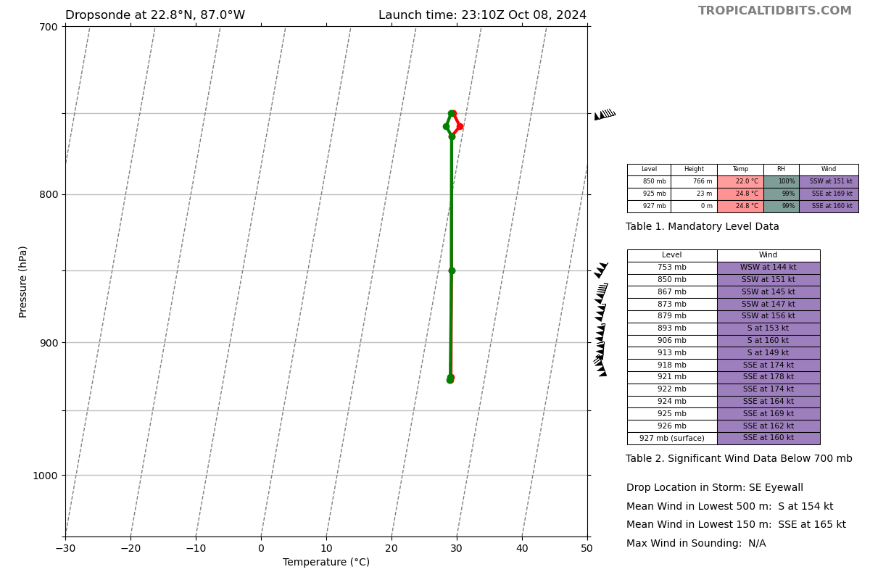
2312 | Center drop #15, BT with late temp of 24.5C. Peter Dodge tribute and ashes release.
2313 | Dropsonde #16 outbound RMW, died after 200 m
2215 | First TDR analysis shows strongest winds are in the SE (front right quadrant)  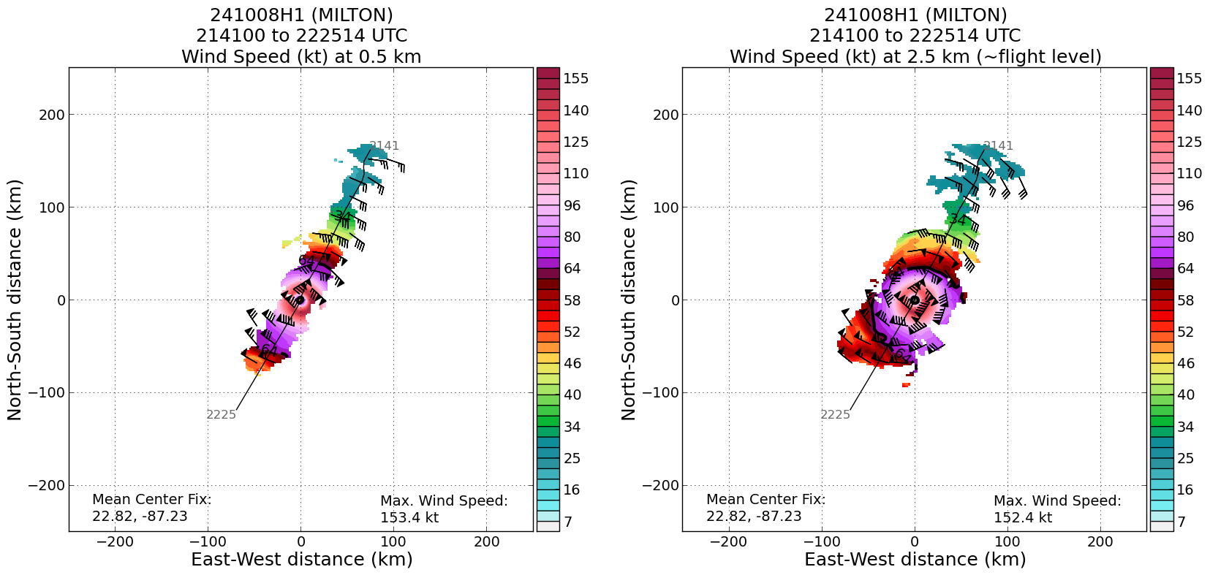  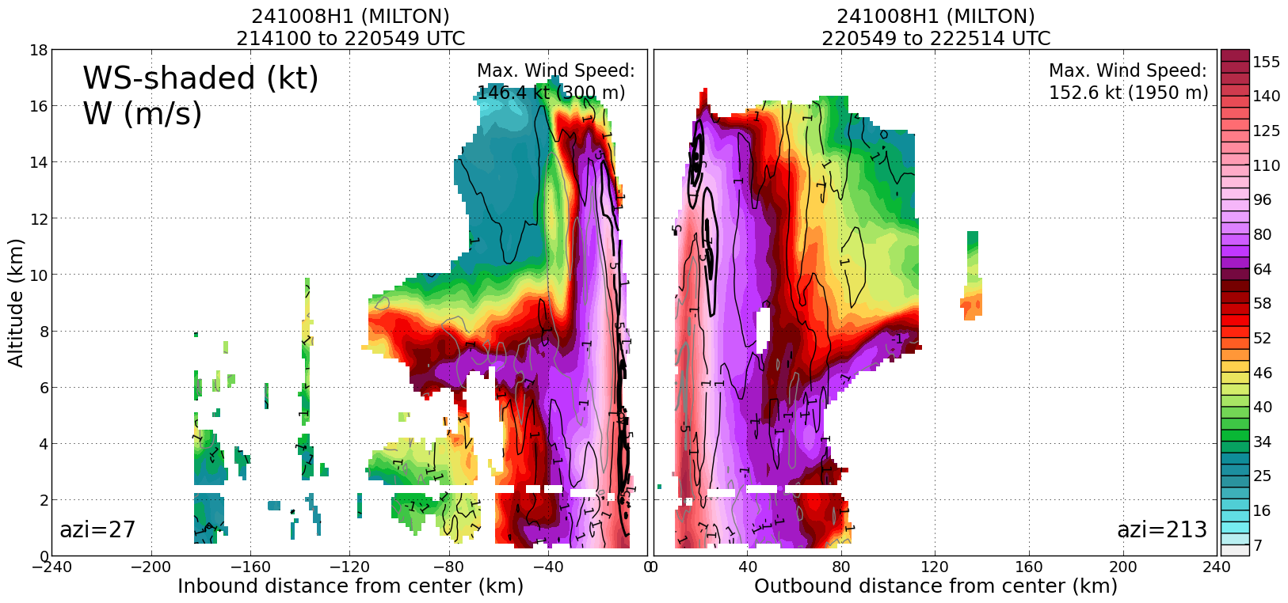
2318 | Birds spotted again in the eye
2324 | Dropsonde #17 midpoint outbound leg 2, BT combo suspect late SST 25.8C after 240 s
2332 | Blackswift turned off at 2300Z. Sondes processed after that were good. Sondes before that were a “total mess”.
2336 | Dropsonde #18 endpoint leg 2  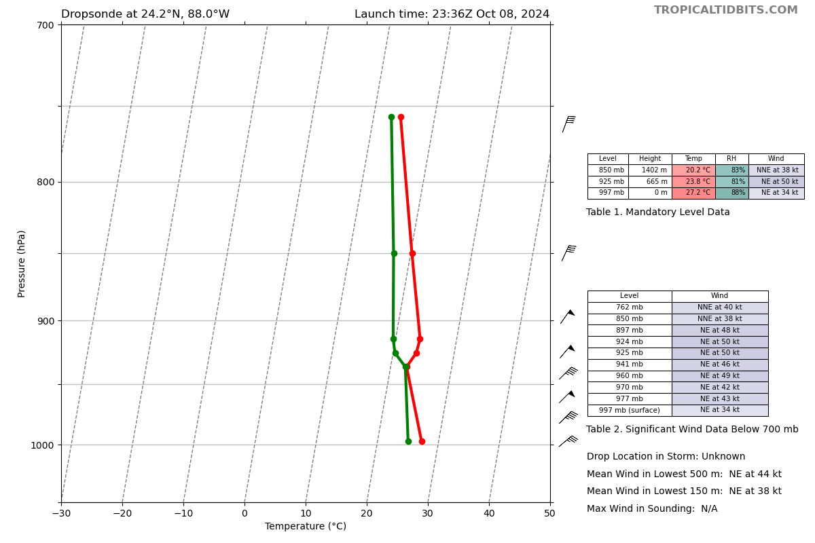
2350 | Planning for extra SFMR/IWRAP leg after completion of butterfly. Likely will head back in E-W then exit to NE.
2352 | Second TDR analysis complete  0.5 22.94 87.02  2.0 22.94 87.02  3.0 22.94 87.02  6.0 22.94 87.06  2-6km tilt 4.0 km at 270 deg
2355 | VDM with special remark for Peter  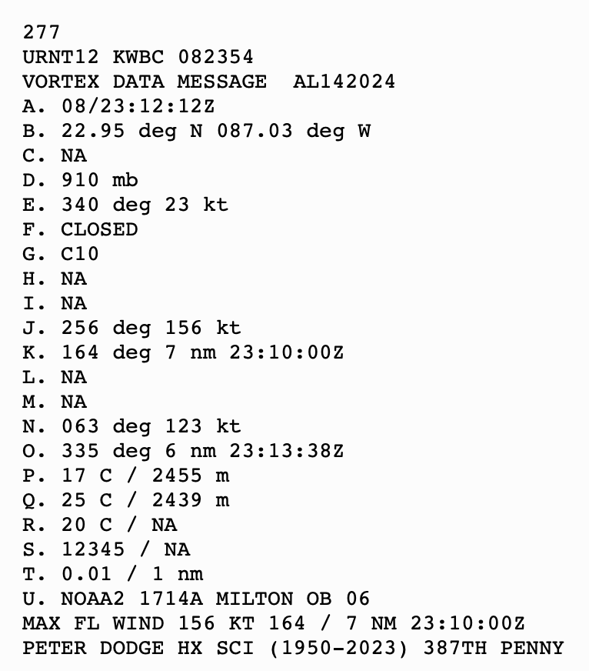
2357 | Dropsonde #19 IP leg 3  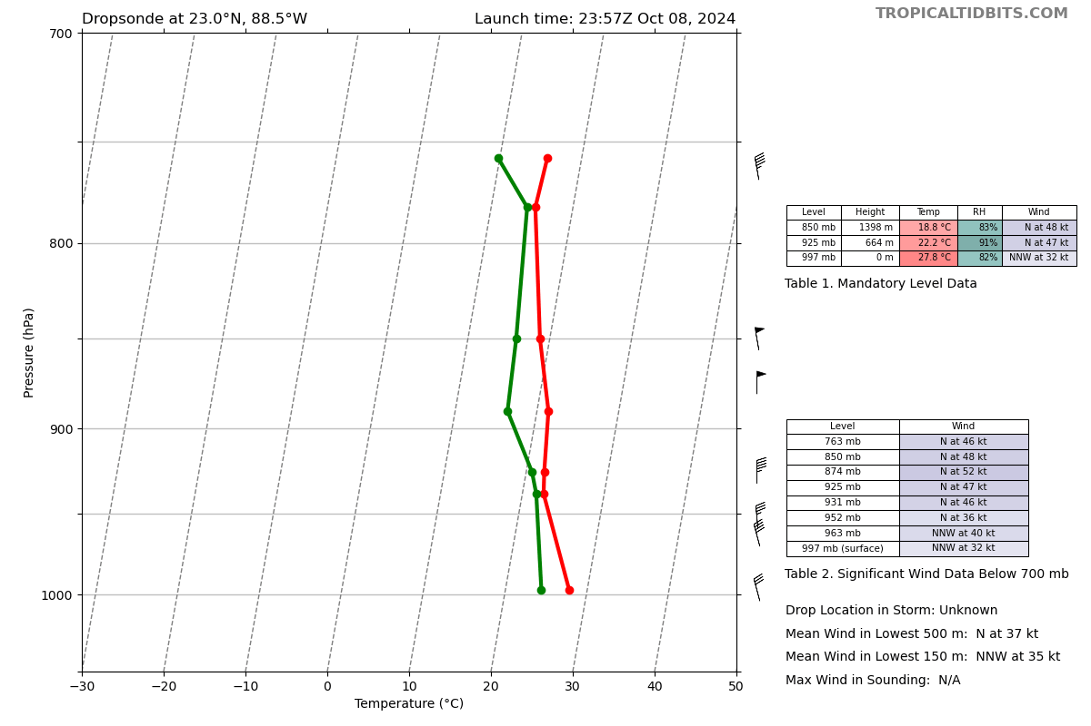
0006 | Dropsonde #20 midpoint leg 3  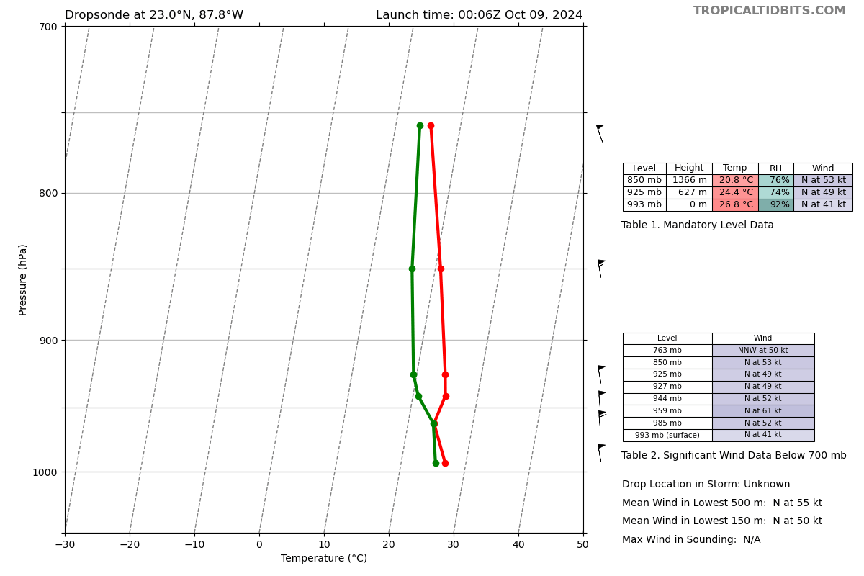
0019 | Dropsonde #21, RMW  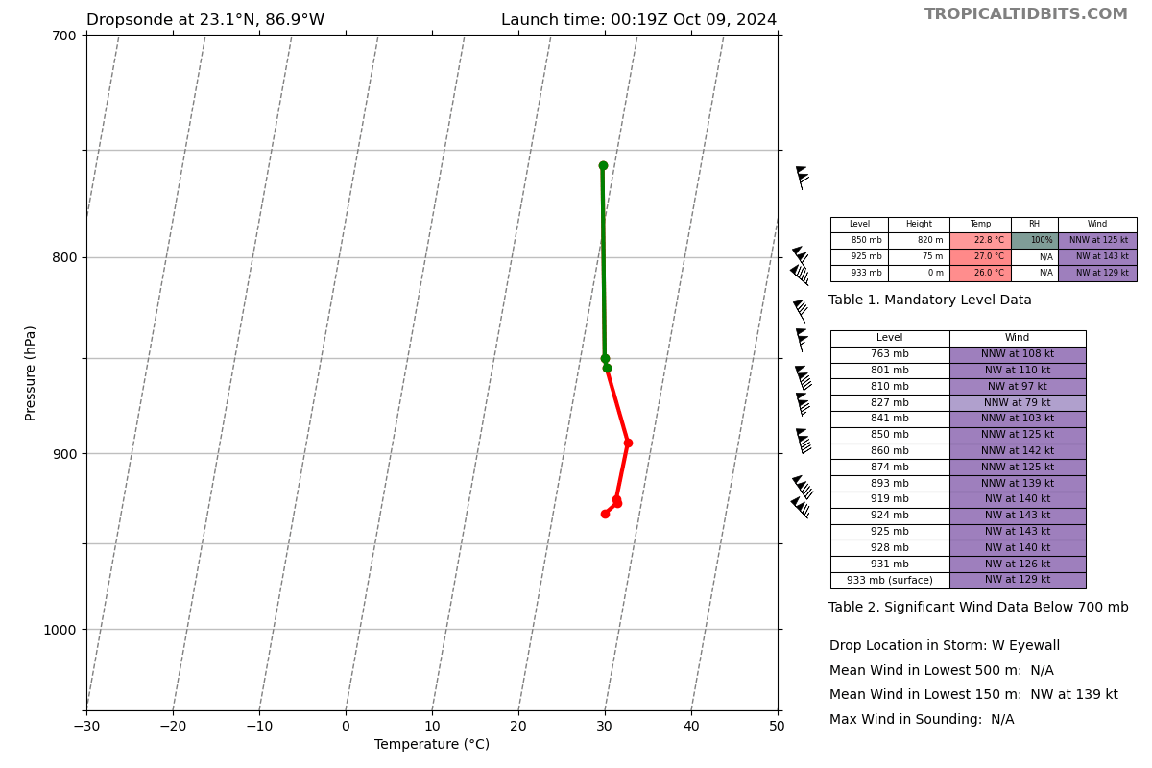
0020 | Dropsonde #22, center  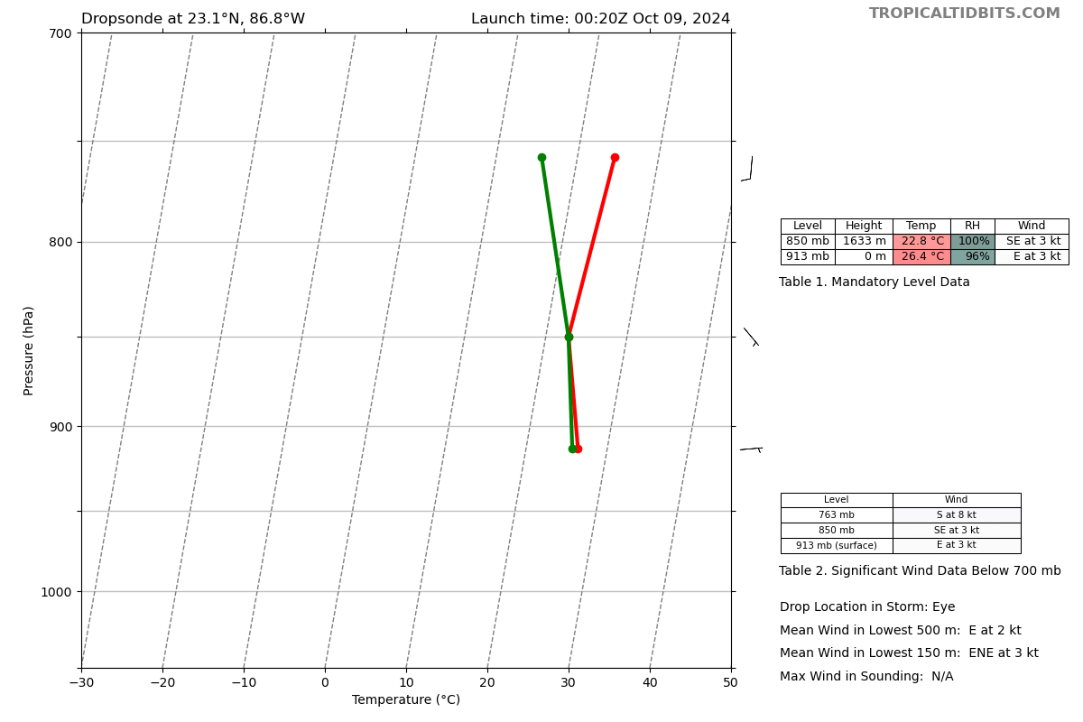
0022 | Dropsonde #23, RMW, 32 m/s downdraft with wind shift  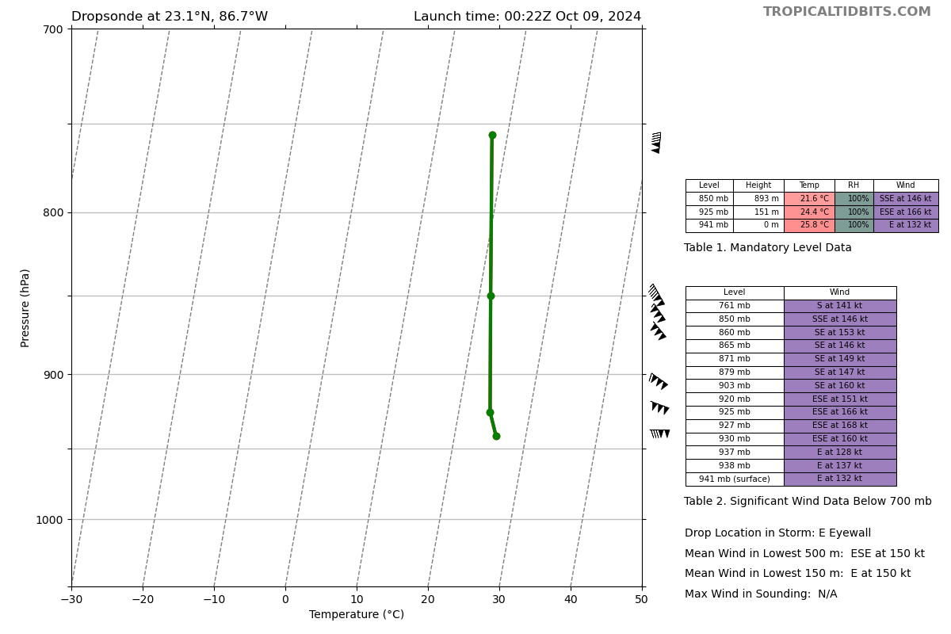
0032 | Dropsonde #24, MP  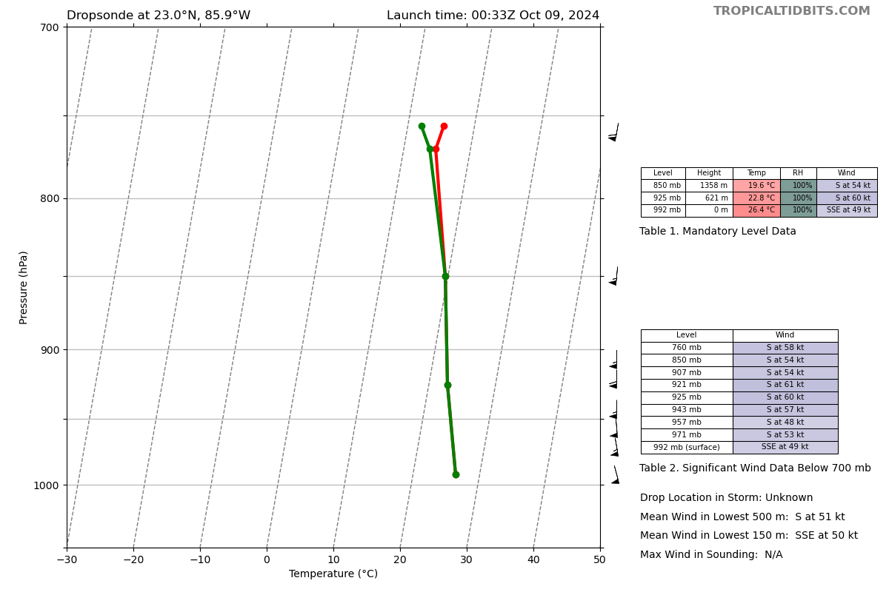
0045 | Dropsonde #25, EP3  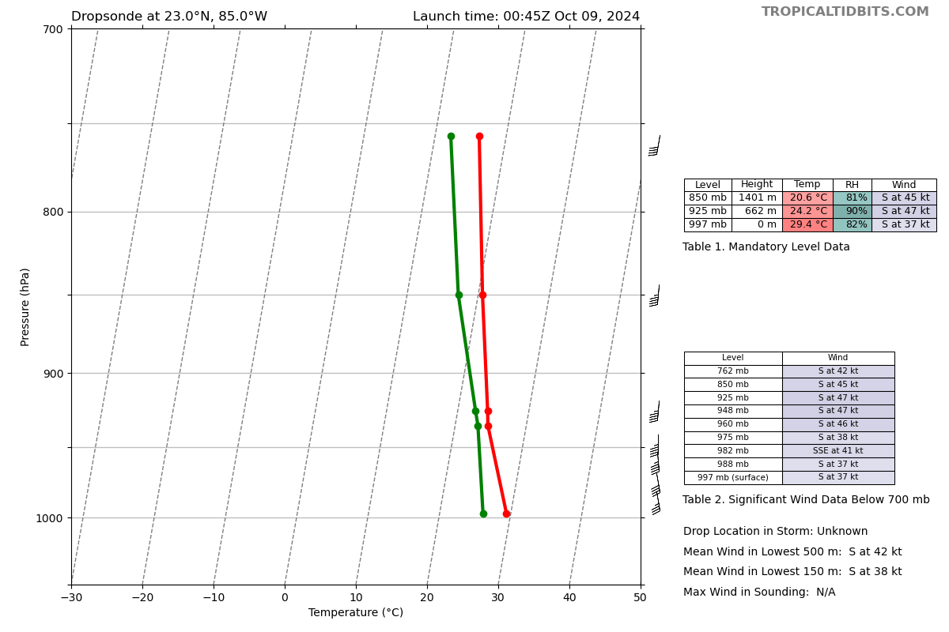
0059 | 0000Z drifter location 23.9977803 87.9878299 3.7m sig wave height SST 29.33  0059Z drifter location 23.9964250 87.1037645 29.35C 4.12m sig wave height
0100 | Heading back inbound from E to center then back out to the N before heading back to Mobile for SFMR/IWRAP comparison.
0106 | 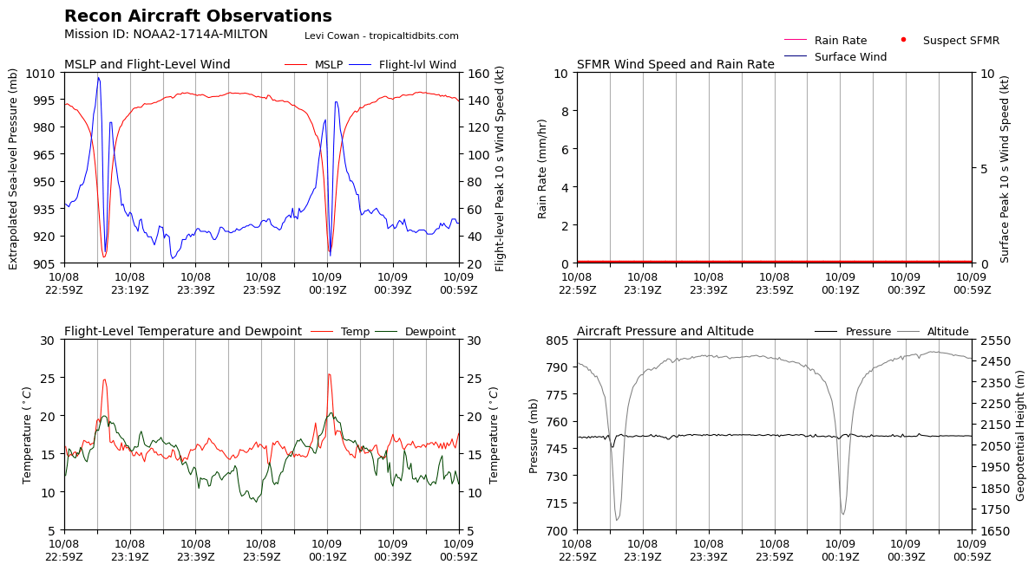
0109 | Third TDR analysis complete  0.5 23.05 86.81  2.0 23.07 86.81  3.0 23,07 86.81  6.0 23.09 86.85  2-6km tilt 4.5km 297 deg
0130 | Flyover near wave drifter with sonde deployed, dropsonde 26  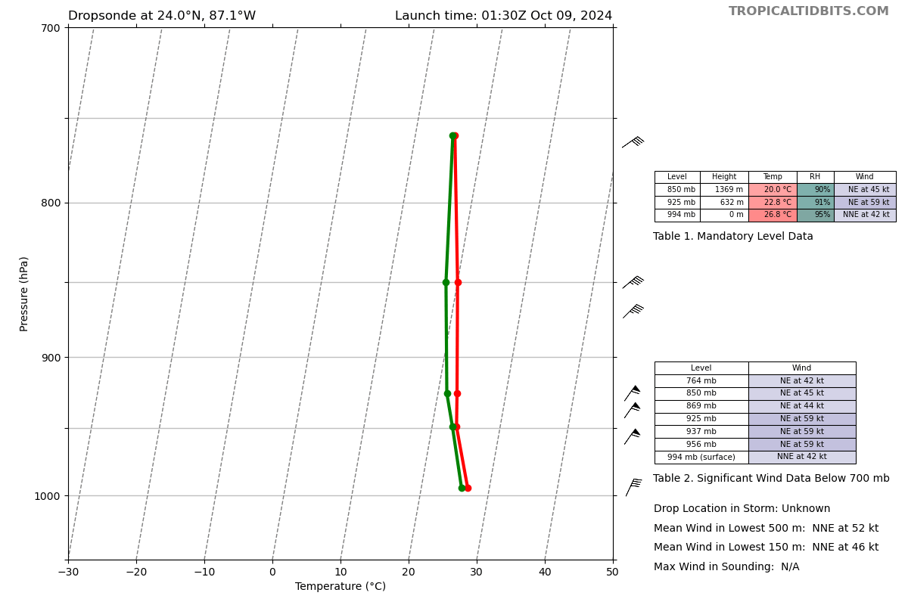
0144 | End of TDR leg, outbound to KMOB
 | 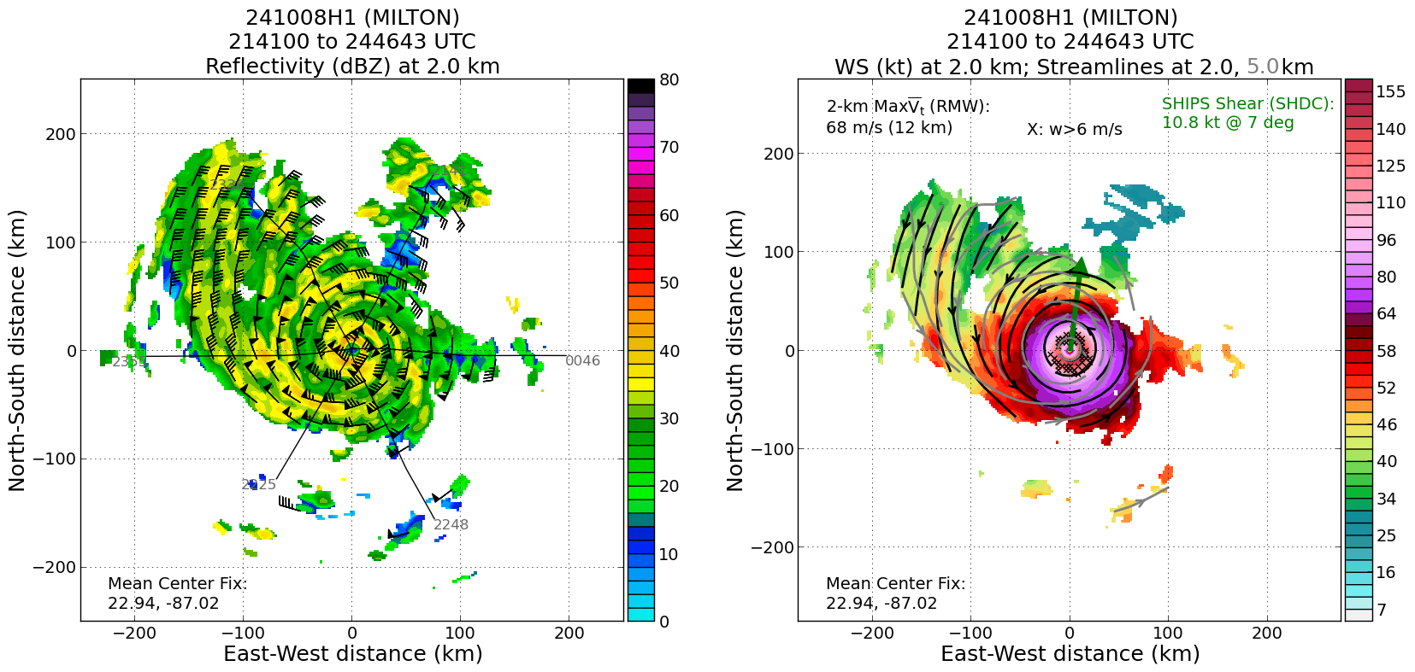
0130 | Drop 26 (GOMO) not transmitted
0153 | TDR turned off
0206 | Fourth TDR analysis complete  0.5 23.17 86.66  2.0 23.19 86.68  3.0 23.19 86.68  6.0 23.19 86.72  2-6km tilt 4.0km at 270 deg  0219 shutdown script

POST-FLIGHT
Mission Summary | The mission was a successful mission into a category 5 Hurricane Milton. It was not quite as strong as the previous night, but increased since this morning. The eye was ~9 n mi wide, again larger than the previous night. The storm was very well aligned (4 km tilt). A butterfly pattern was completed, with one additional pass for SFMR/IWRAP comparisons. A RMW dropsonde measured a 32 m/s downdraft. The same (unconfirmed) flock of birds was noted in the eye. One DWSB was deployed NE of the storm. 26 sondes deployed (1 GOMO, 4 HRD, 21 NWS). The GOMO sonde was deployed near a previously deployed wave drifter N of the center of the storm of the final pass.  1 sUAS (Blackswift S0) was deployed in the first center. However, the engine failed to start and thus it glided to the surface (909 mb last pressure reading). There was discussion that the beginning half of the sondes were having a lot of issues, whereas the latter sondes seemed much better. This was believed to be caused possibly by the blackswift, as the time of sondes becoming better corresponds to all blackswift equipment being turned off.  The storm started to turn slightly to the N towards the end, as it had been traveling S of the forecasted track (motion now to the NE).  Peter Dodge’s ashes were dropped into the eye on the second center pass and a tribute was conducted onboard. A special remark was also added to the VDM message by flight director Jon Zawislak.
Actual Standard Pattern Flown | Butterfly
APHEX Experiments / Modules Flown | CHAOS, NESDIS Ocean Winds, RICO SUAVE
Plain Language Summary | - Successful flight with a wave drifter deployed ahead of the storm  - The sUAS engine did not start and thus became a glider  - Winds measured by the aircraft showed a strong eyewall with possible hints of a secondary eyewall at times.
Instrument Notes | TDR looked really good (Annette did an awesome job processing quickly and efficiently).  20 of 26 dropsondes were transmitted. During the 1st ½ of the mission (until ~2300z), satellite drop outs and spotty data plagued the sondes and they were difficult to process using Aspen. After ~2300z, dropsonde data was much cleaner in Aspen and much easier to process. It’s not clear what happened, but the request was made after the S0 splashed to turn off the Black Swift equipment.
Final Mission Track | 