MISSION PLAN
FLIGHT ID | 20240715I1 | STORM | AEW1 / MAGPIE
MISSION ID | WBWXA MAGPIE02 | TAIL NUMBER | NOAA-43
TASKING | HRD | PLANNED PATTERN | Survey
MISSION SUMMARY
TAKEOFF [UTC] | 1505 | LANDING [UTC] | 2219
TAKEOFF LOCATION | Barbados/TBPB | LANDING LOCATION | Barbados/TBPB
FLIGHT TIME | 7.233 hours | BLOCK TIME | Get from onboard LPS or Flight Director
TOTAL REAL-TIME RADAR ANALYSES  (Transmitted) | N/A | TOTAL DROPSONDES Deployed (Transmitted) | 31 (31)
OCEAN EXPENDABLES (Type) | 4 NRL AXBTs (4 good) | sUAS (Type) | N/A
APHEX EXPERIMENTS / MODULES | Genesis stage/Favorable Air Mass  Early Stage/Stratiform Spiral Module
HRD CREW MANIFEST
LPS ONBOARD | Hazelton | LPS GROUND | Dunion/Looney
TDR ONBOARD | N/A | TDR GROUND | N/A
ASPEN ONBOARD | N/A | ASPEN GROUND | Sellwood/Ko
NESDIS SCIENTISTS | N/A
GUESTS (Affiliation) | Semprish (NRL)
AOC CREW MANIFEST
PILOTS | Rannenberg (Pilot); Wood/Ellis (co-pilots)
NAVIGATOR | Utama/Dunford
FLIGHT ENGINEERS | Stokes/Ripp/Santoni
FLIGHT DIRECTOR | Englert/Zawislak
DATA TECHNICIAN | Richards
AVAPS | Dykeman/Santoni

PRE-FLIGHT
Flight Plan | [Insert image of submitted flight pattern here]  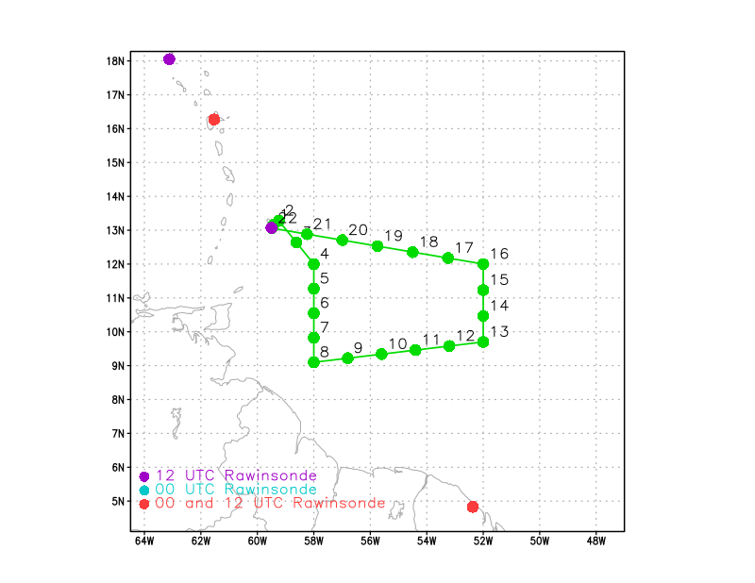  [Insert image of ONR/TCRI detailed pattern image, if available]  [If you want, briefly describe the pattern in words]  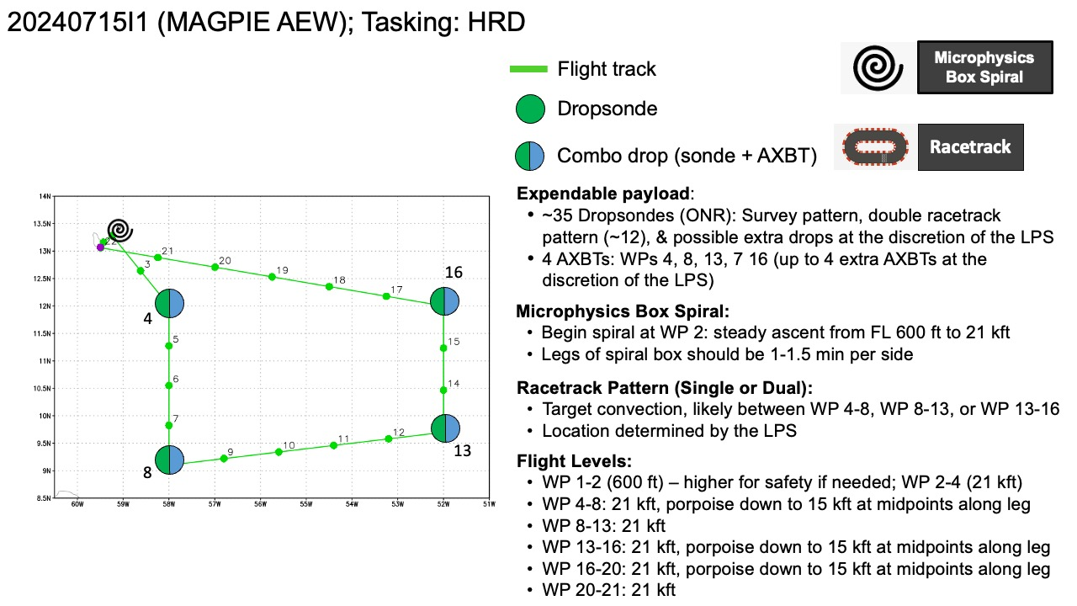
Expendable Distribution | 35 dropsondes, 8 AXBTs
Preflight Weather Briefing | [Notes from the Flight Crew Preflight Briefing and other relevant notes about the current and forecasted storm state from the most recent NHC advisory (location, intensity, MSLP, movement, possible intensity change during the flight)]  [Briefly describe the relevant environmental drivers.]  [Copy in GIF of recent (~6 hr) satellite loops (https://www.star.nesdis.noaa.gov/GOES/index.php)]
Instrument Notes | [What instruments are working, not working, not functioning nominally, not installed?]

IN-FLIGHT
Time [UTC] | Event
1505 | Takeoff Barbados
1508 | Convection noted just west of point 6 and throughout S leg, racetrack seems to look best on S leg, likely between point 11 & 12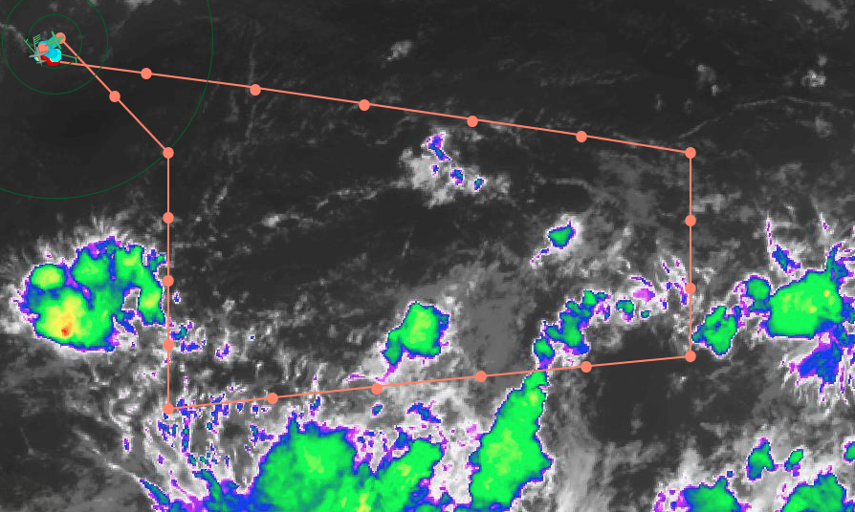
1516 | Flyover of Ragged point, headed to point 2 for spiral up
1522 | Andy took picture of wind with sargassum
1522 | Spiral started
1539 | Going to try to porpoise along points 4-8
1544 | Dropsonde 1, CH1 and end of spiral  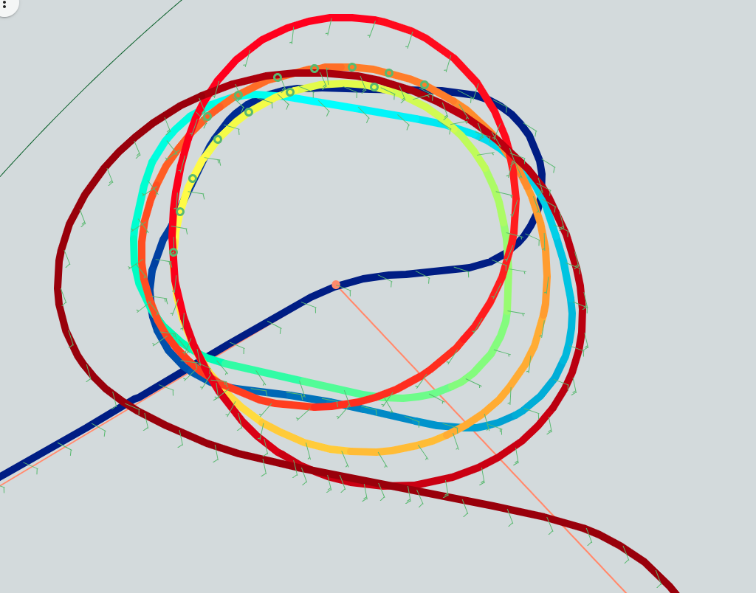  Color showing altitude during spiral  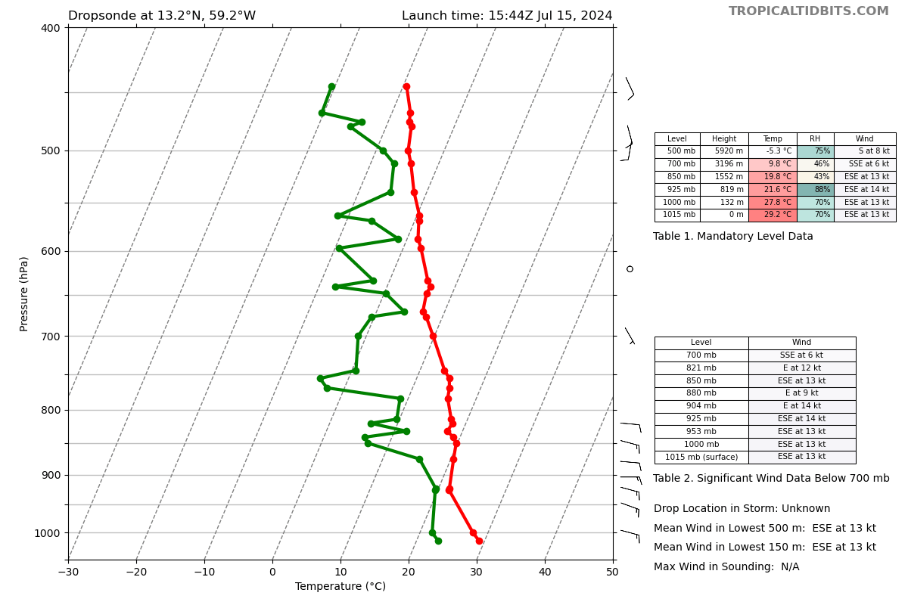
1554 | Dropsonde 2, CH2  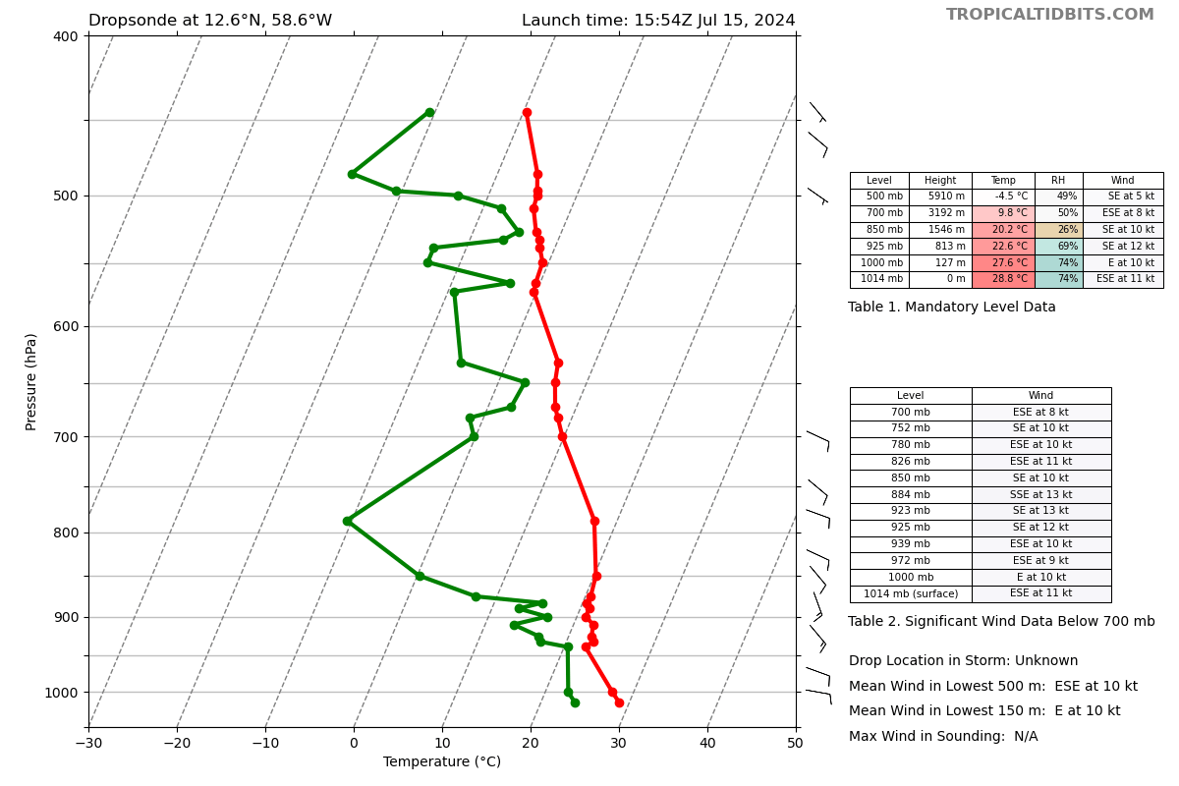
1556 | Drop points 4,5,6 and head from point 2 to 11.0N, 59.2W to hit NW side of convection at 10k ft, then head SE to transect some convection, head to the SW for point 7, staying at 10k ft  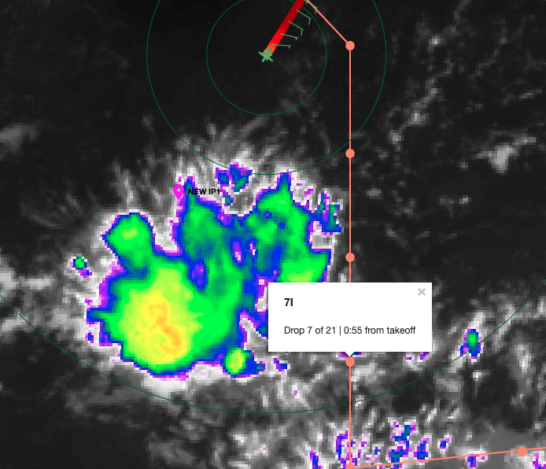
1605 | Combo drop/BT at IP and at point 7 (either side of blob)
1614 | After new IP of 11.0N, 59.2W, head SE to WP7i, then bypass 8, drop WPs 9-11 0.7 deg to the south, so new route is:  IP (11.0N, 59.2) → WP7i → WP9i new (8.5W, 56/8W) → WP10i new (86.5N, 55.6W) → WP11i new (8.8N, 54.4W)
1619 | Starting transcest from IP to WP7
1620 | Convection off west, painting convection
1620 | Dropsonde 3, CH3 (Combo BT1)  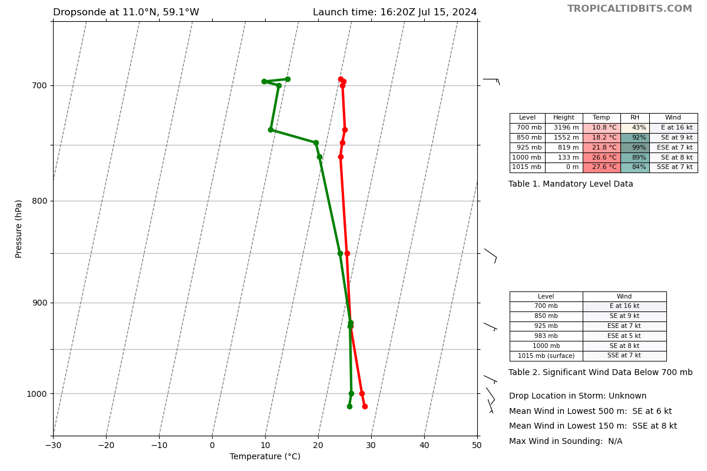
1622 | BT was 29.4C SST  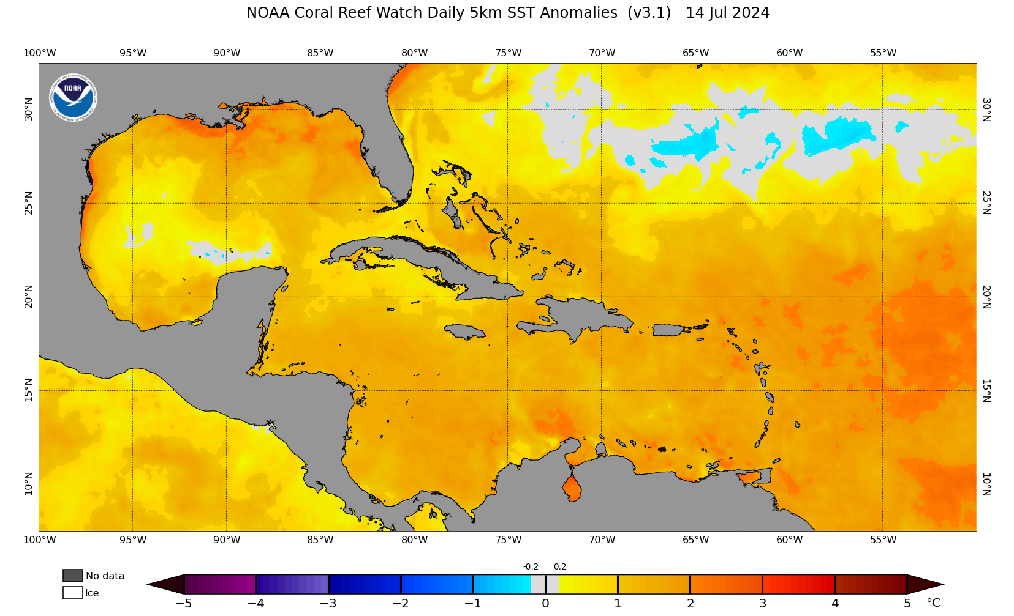  (SST anomalies showing a few degrees C warmer than usual)
1624 | Decaying convection, some stratiform and such, which was expected based on visual  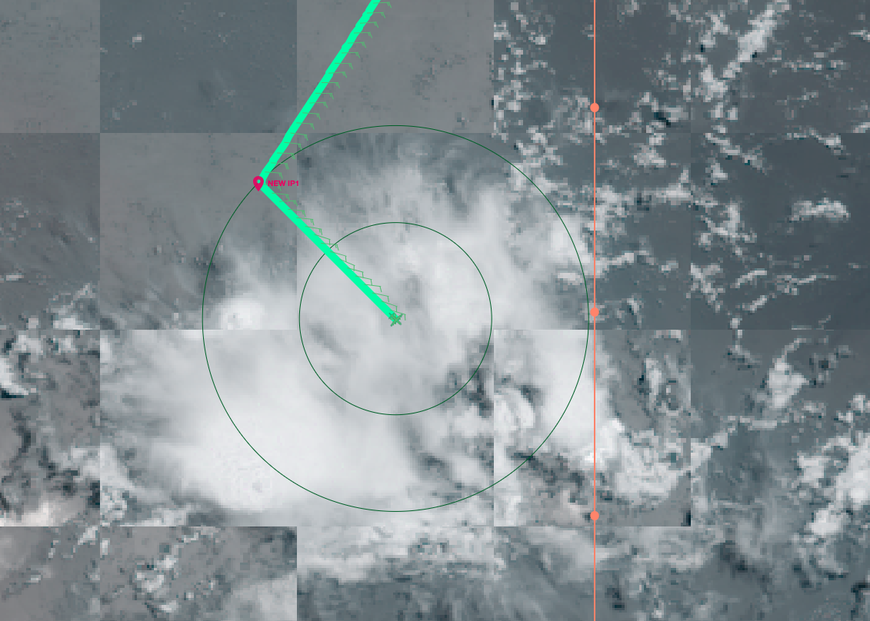
1625 | Some popcorn ~30dbz stuff ~25-40 nm to NE
1632 | Keeping eye on possible racetrack location following WP 11i (8.8N, 54.4W), details to follow
1643 | Dropsonde 4, CH4 (combo BT2), BT2 read 29.3C  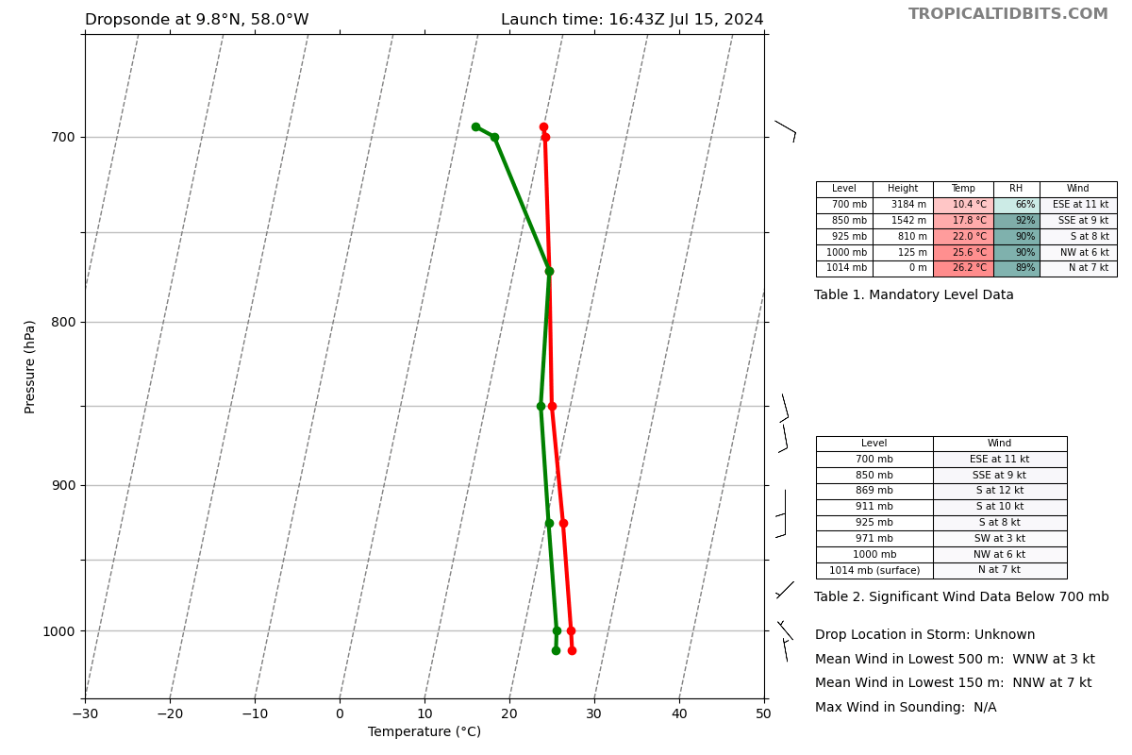
1650 | New BT combo plan for at new 9i and 11i
1709 | Dropsonde 5, CH5 (combo BT3), BT2 read 29.3 C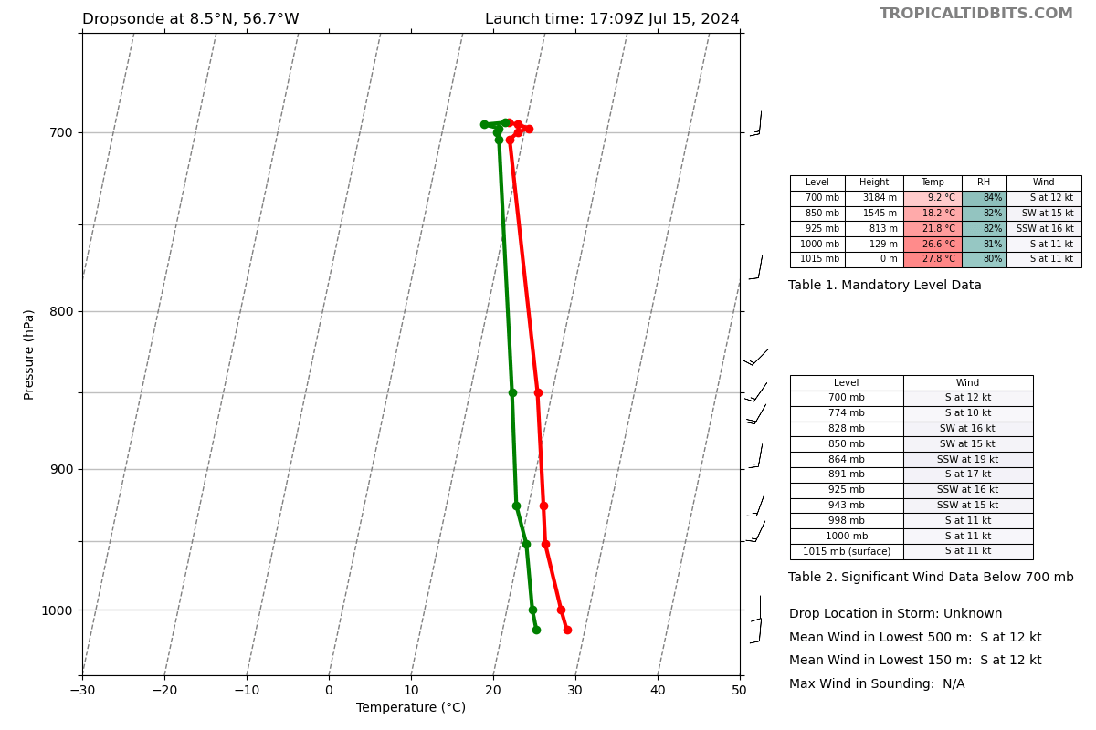
1714 | For racetrack, IP of 9.16N, 54.40W >> WP2 of 10.81N, 53.48W (110 nm) >> turn right 90 deg, go 20 NM for the box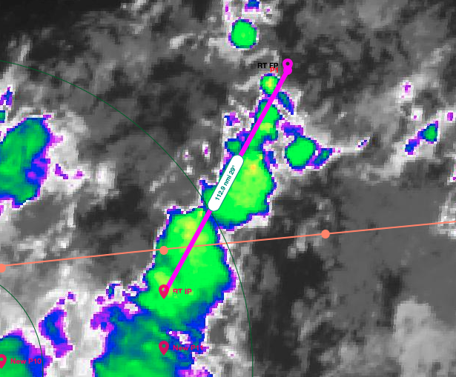
1721 | In stratiform clouds currently
1724 | Dropsonde 6, CH6  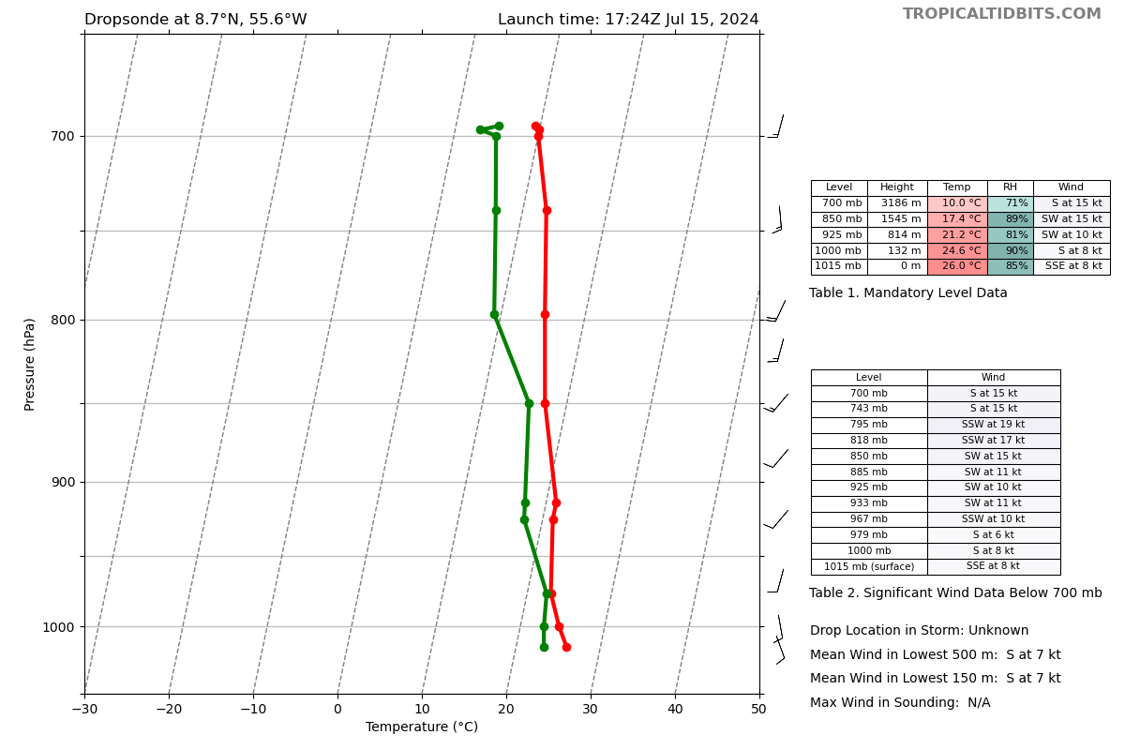
1739 | Dropsonde 7, CH7 (Combo BT), BT SST 29.09  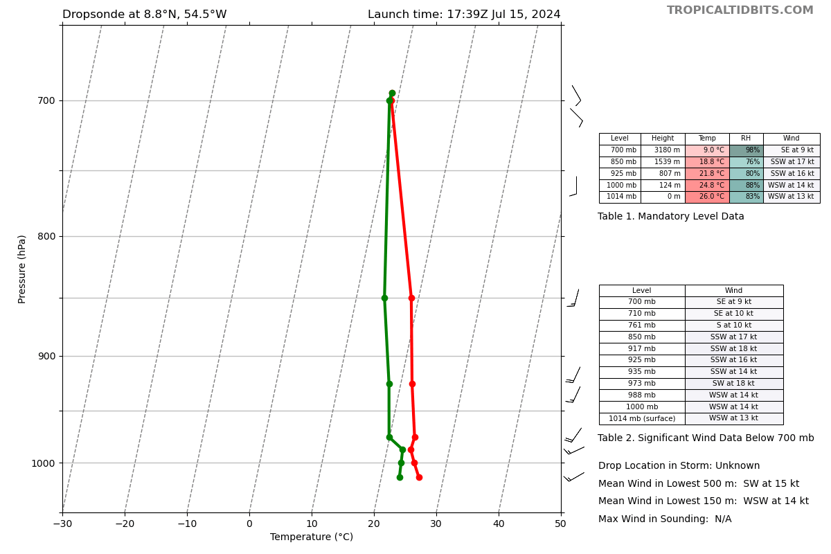
1744 | Racetrack started with 1st drop
1744 | Dropsonde 8, CH8  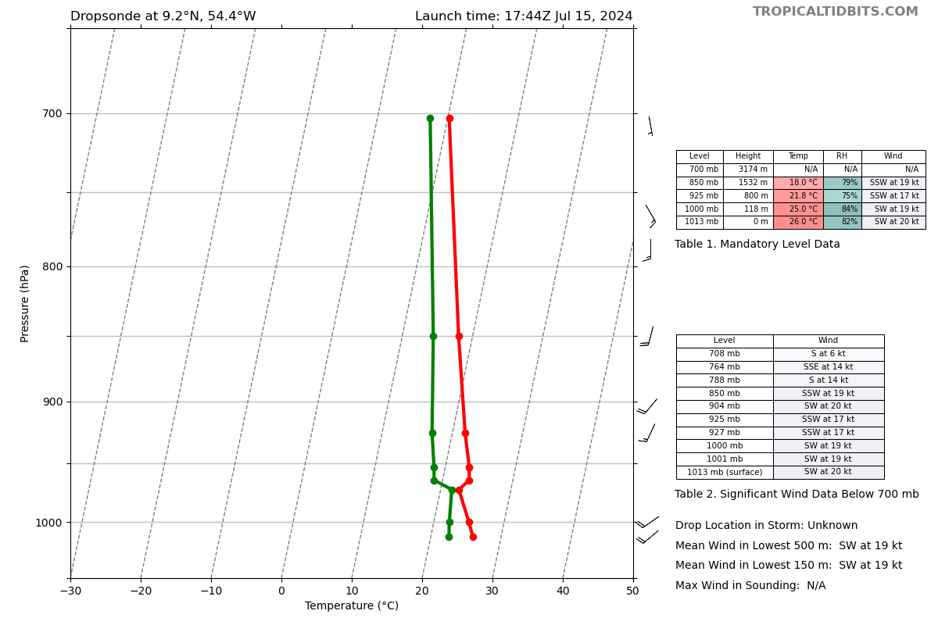
1745 | Heading into precipitation, doesn’t look super deep, might be mostly leftover stratiform, but hard to tell
1748 | Adjusted about 15 deg to the left to follow convection on MMR
1751 | Seeing healthier returns on nose radar
1801 | Dropsonde 9, CH1  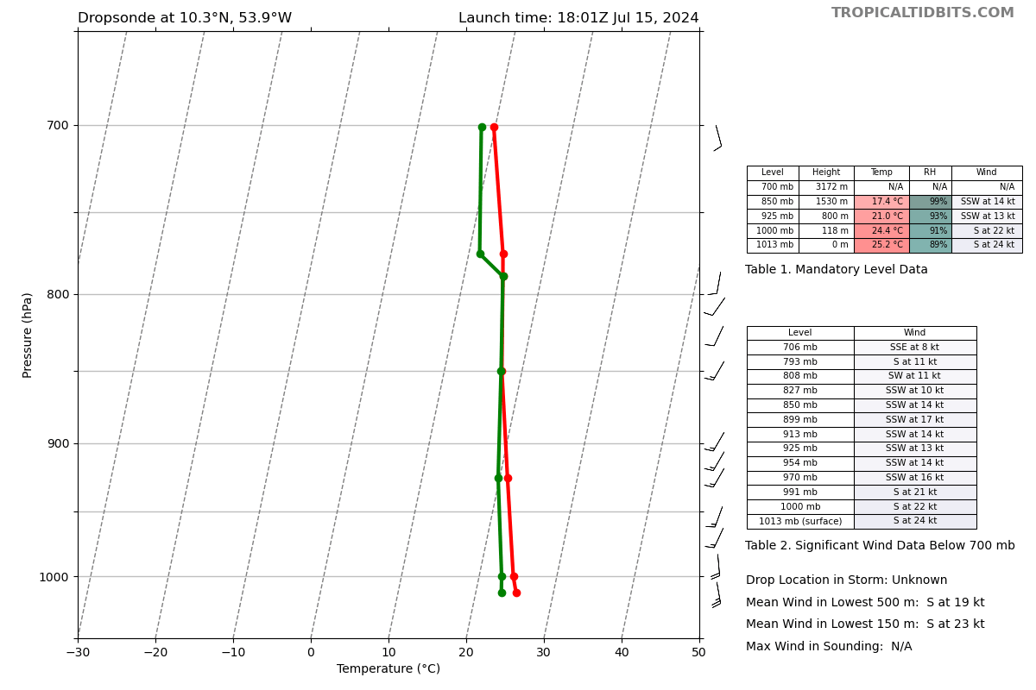
1809 | Following the line of convection very well.  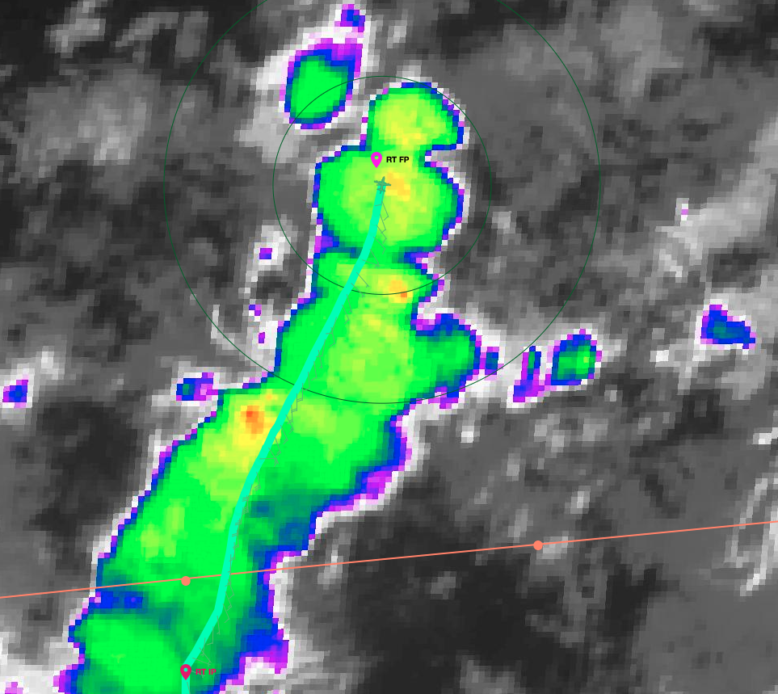
1810 | Dropsonde 10, CH2  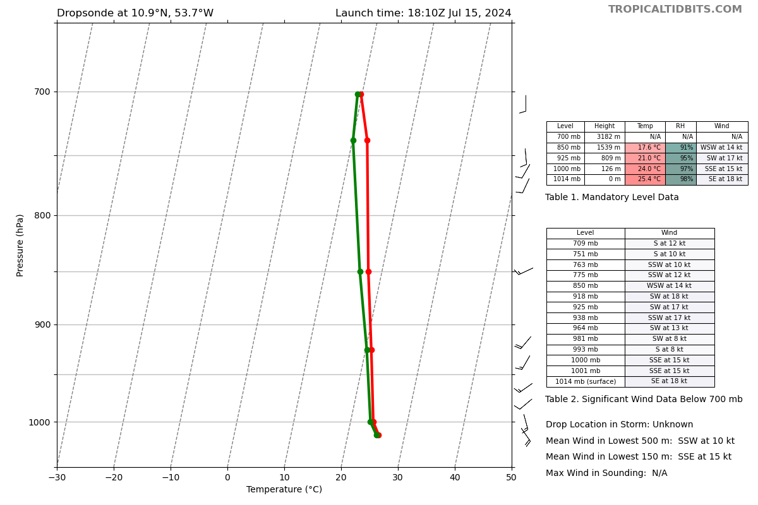
1811 | Dropped sonde at end of leg, about to turn once clear
1813 | TDR dropped out, going to try to reset it once clear
1819 | TDR back up
1827 | Starting the NE-SW leg
1827 | Dropsonde 11, CH3  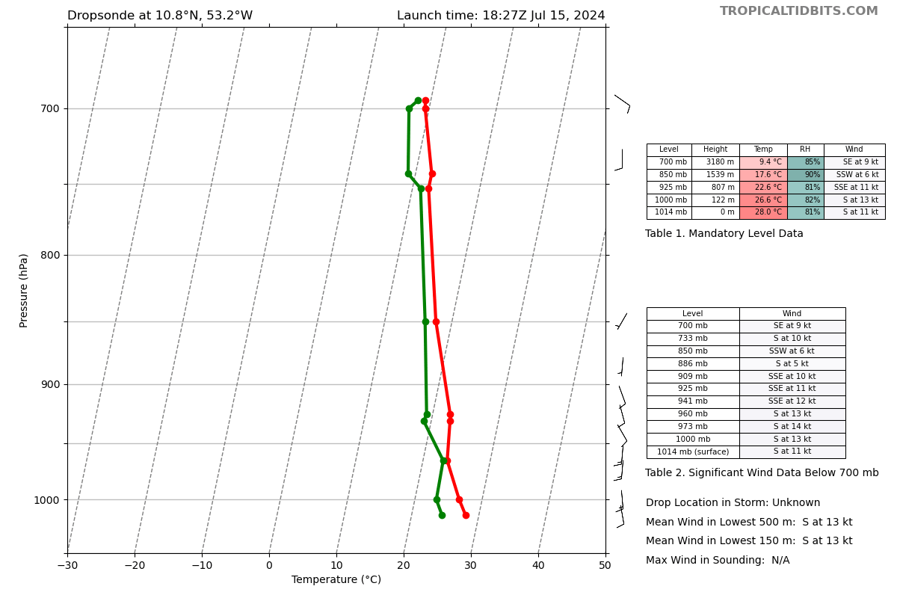
1829 | Convergence in FL winds, southerly inflow converging with the trades
1833 | Solid bump in the P3, able to get a sonde off in the updraft area
1833 | Dropsonde 12, CH4  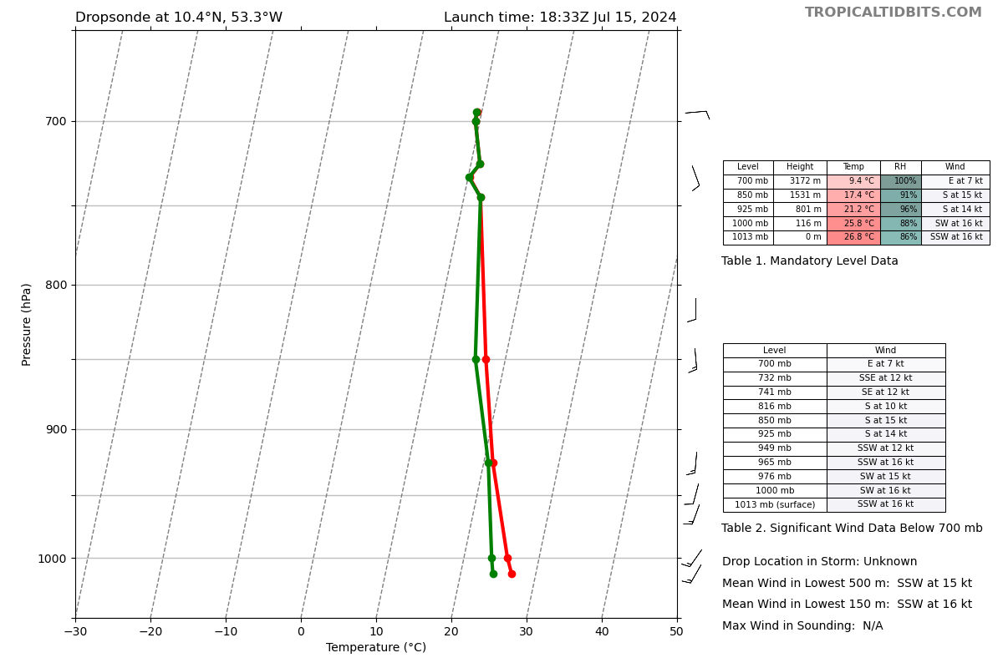
1840 | Dropsonde 13, CH5  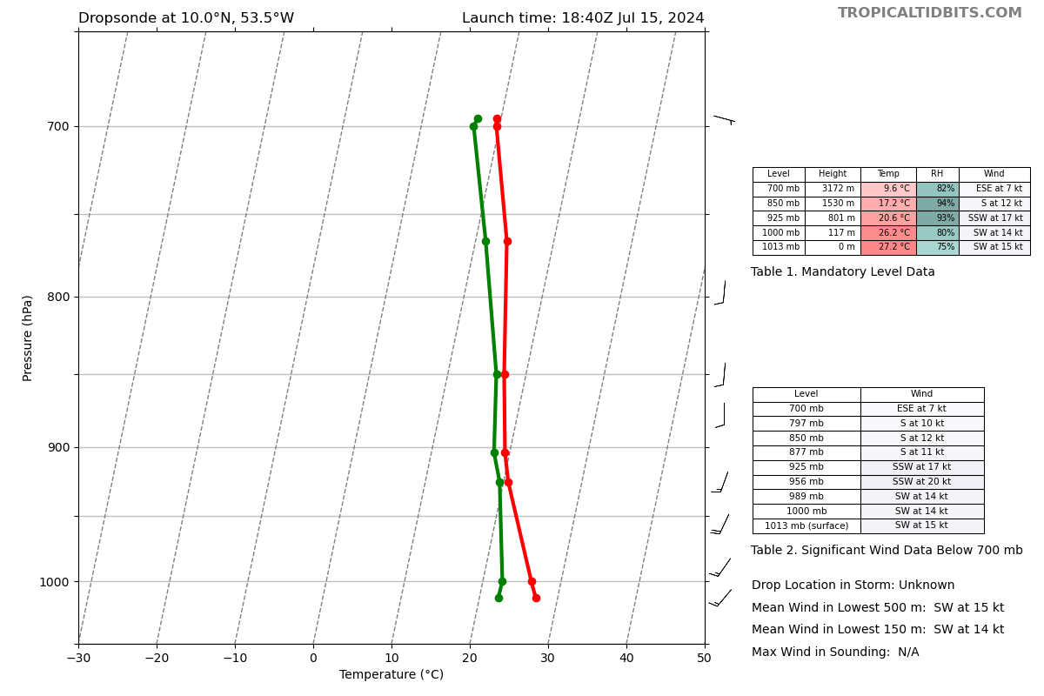
1846 | Dropsonde 14, CH6  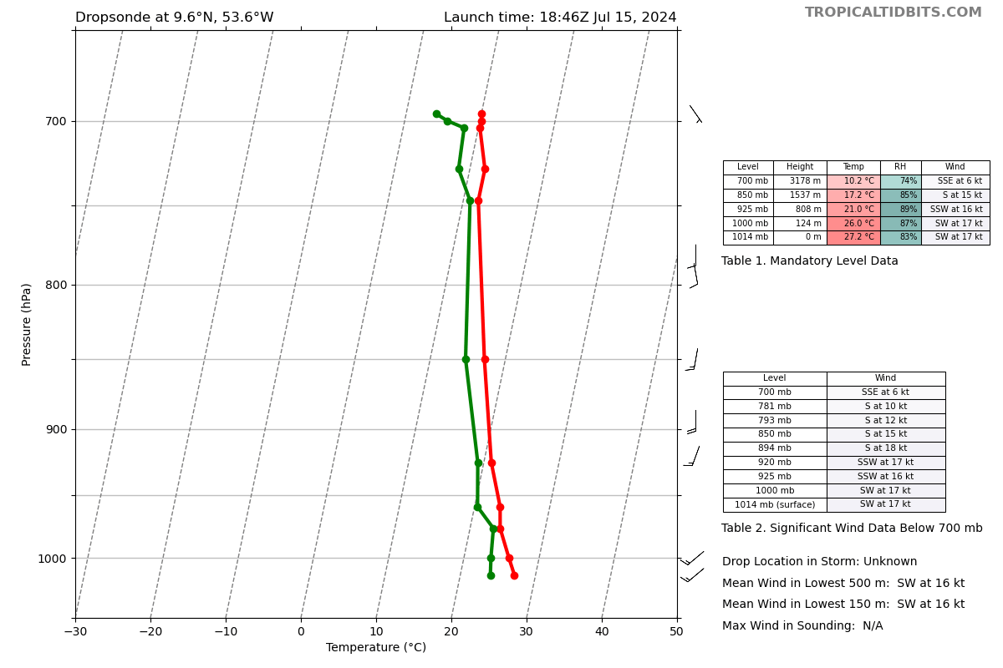
1848 | Dropped sonde and headed back to the next part of the box
1850 | Will need more than 20 nm to get to center line of convection
1900 | Turning into next long pass of racetrack
1900 | Dropsonde 15, CH7  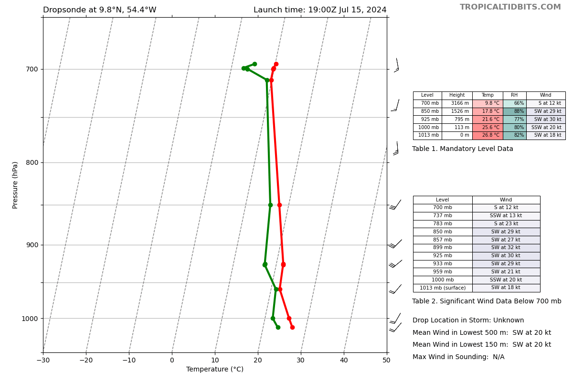
1905 | Pretty decent convective returns in here
1907 | Dropsonde 16, CH8  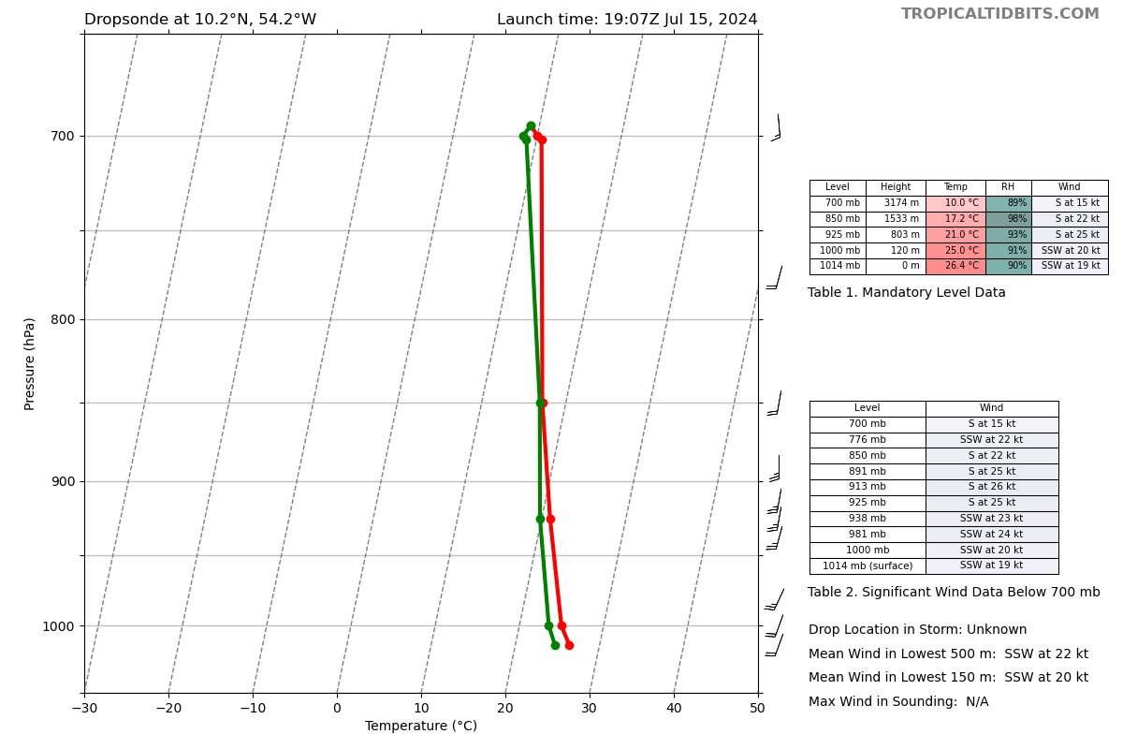
1910 | Extending this leg 25 nm once clear of convection prior to turning left
1912 | Got some westerlies at FL, little MCV or something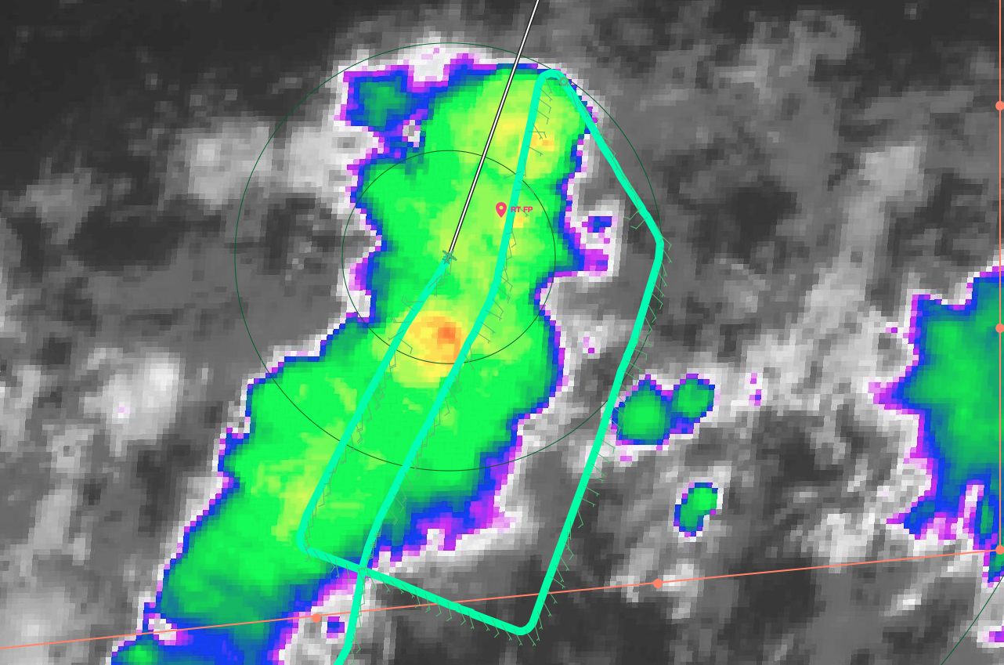
1914 | Dropsonde 17, CH1  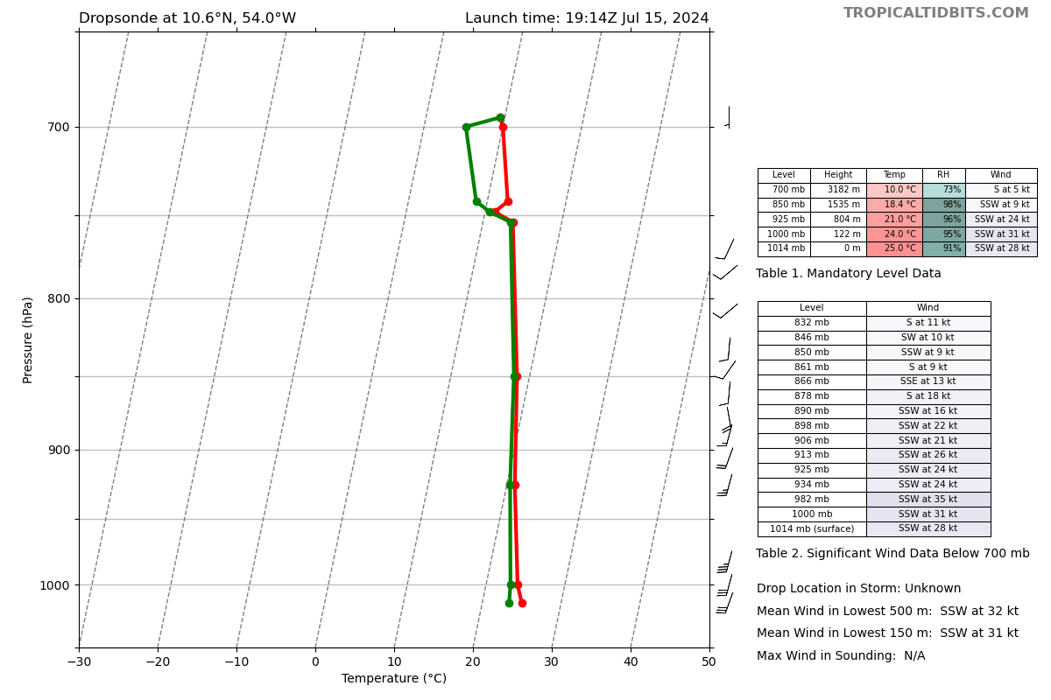
1922 | Dropsonde 18, CH2  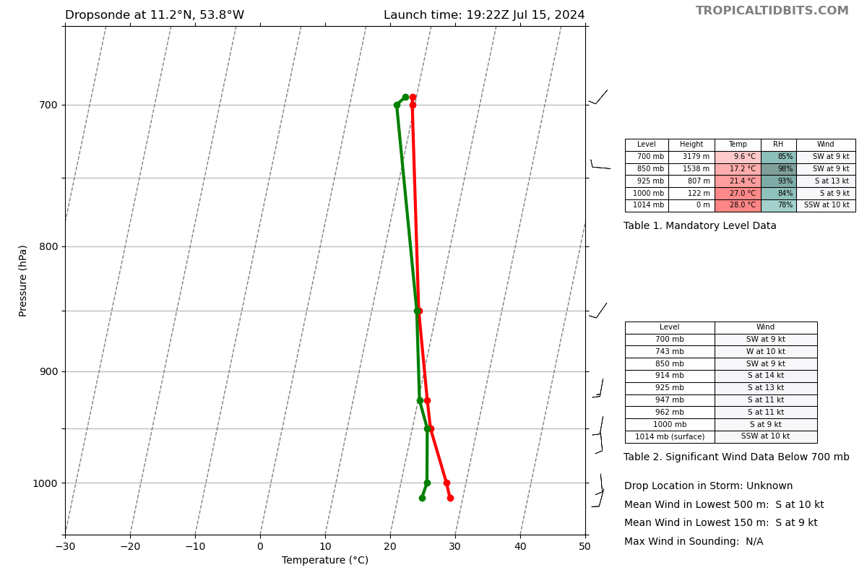
1923 | Reached endpoint and going 25 n mi past before turning
1928 | SFMR being a little weird (55 knots)...during higher rain
1929 | Continue on line to 12.1N before turning, due to getting past cold outflow from dry air getting into convection putting an arch cloud out
1936 | Dropsonde 19, CH3  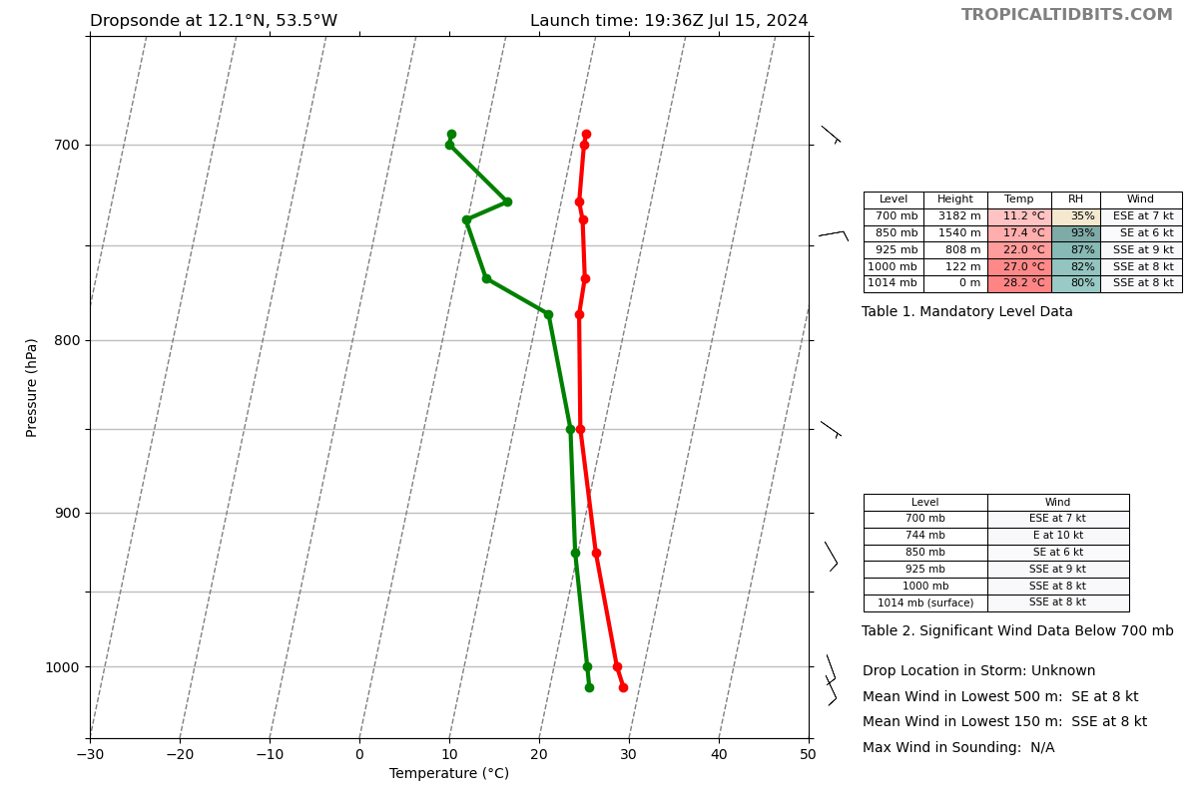
1936 | Shorten leg down to 110 n mi
1942 | Dropsonde 20, CH4  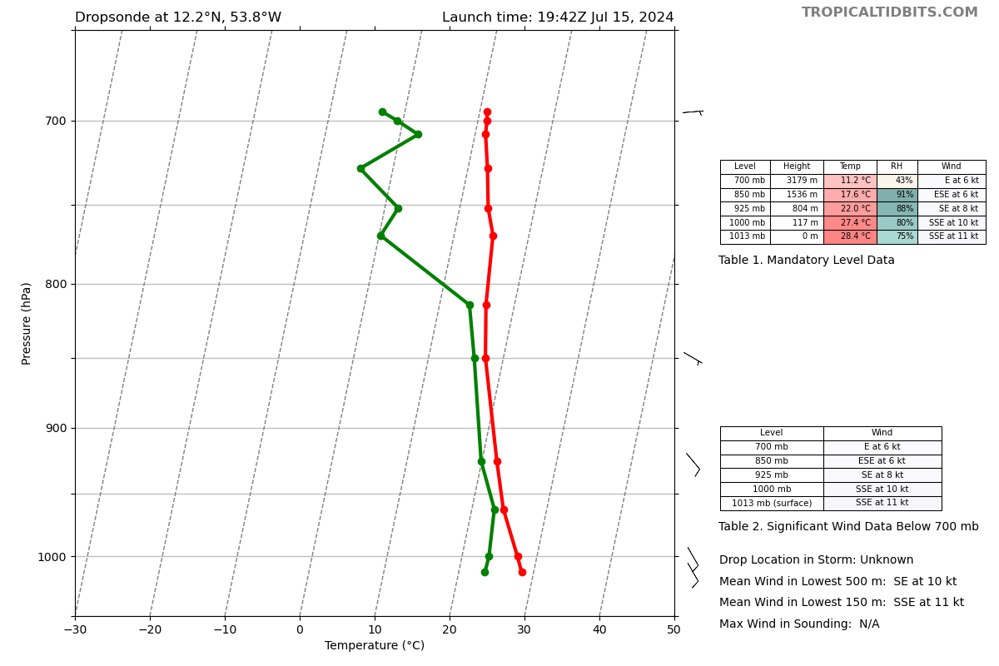
1944 | Couple interesting wind shifts and some interesting skewts
1948 | Dropsonde 21, CH5  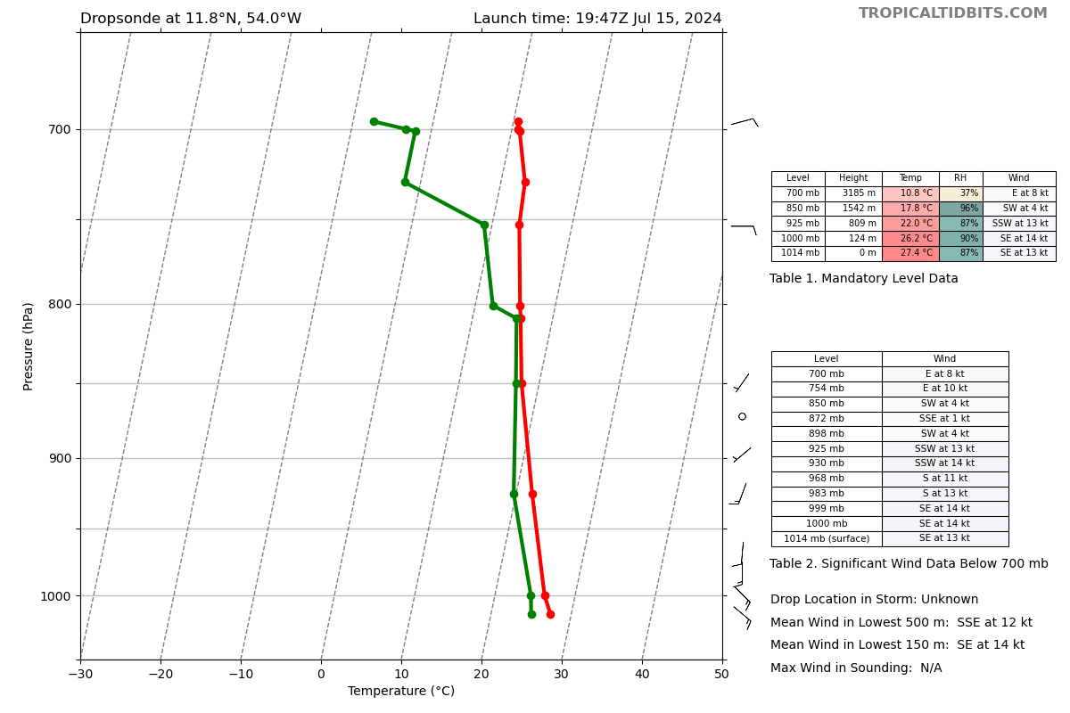
1954 | Dropsonde 22, CH6  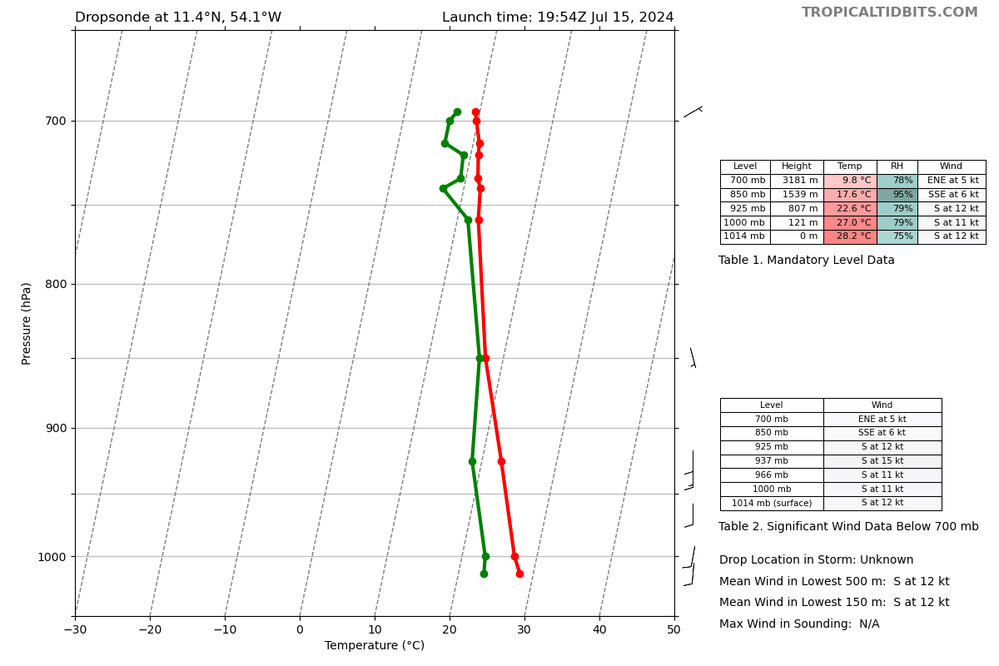
1958 | Due to ending point of racetrack, going to join back to pattern at point 18
2009 | Dropsonde 23, CH7  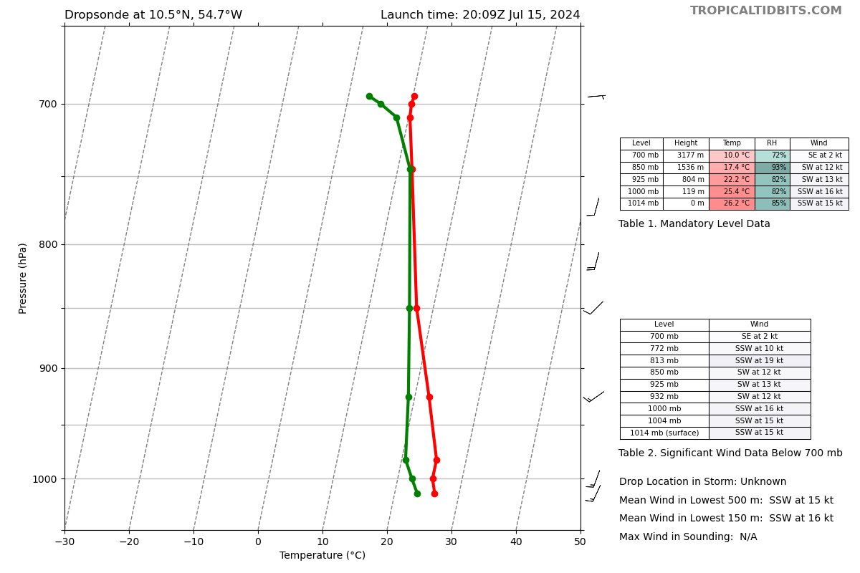
2010 | Endpoint sonde released and turning to the SE
2012 | Shorter leg since the convection is being advected towards them. 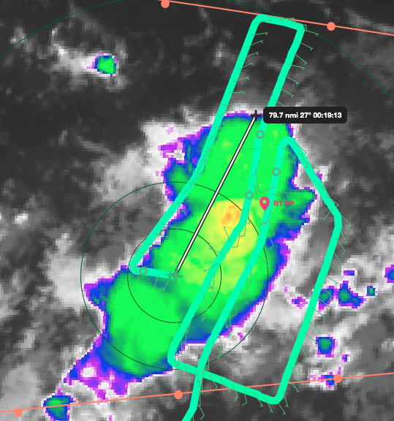
2015 | Dropsonde 24, CH8  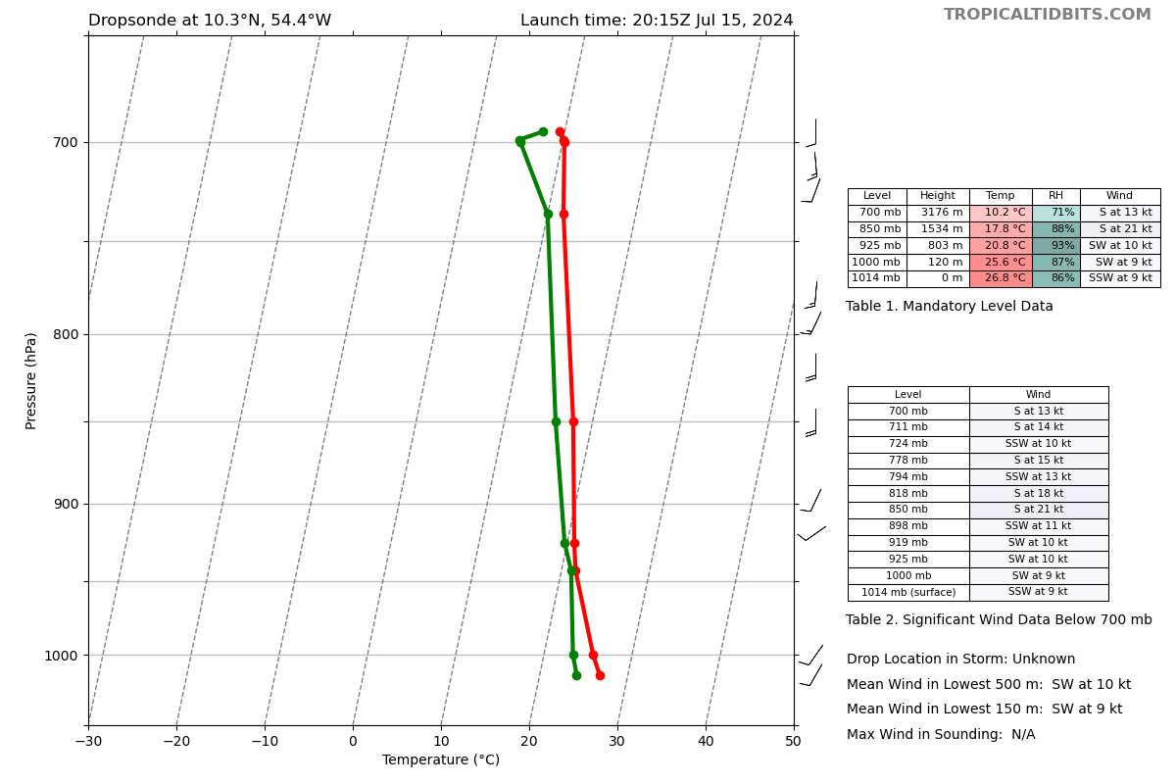
2025 | Dropsonde 25, CH1  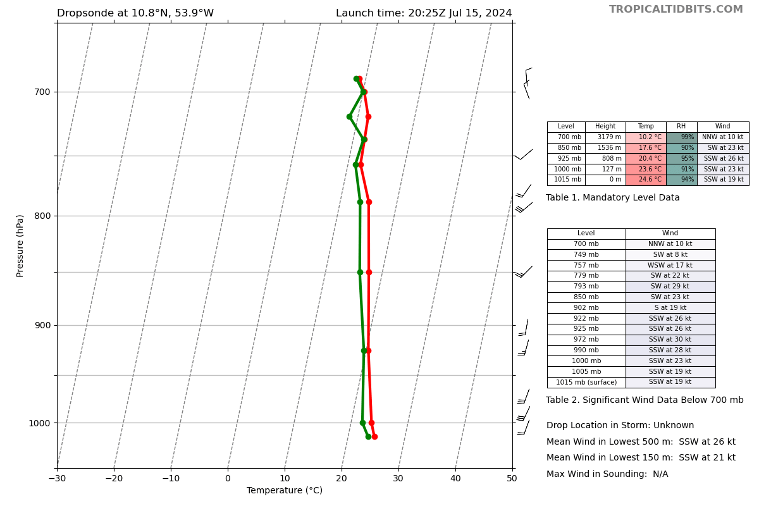
2032 | Dropsonde 26, CH2  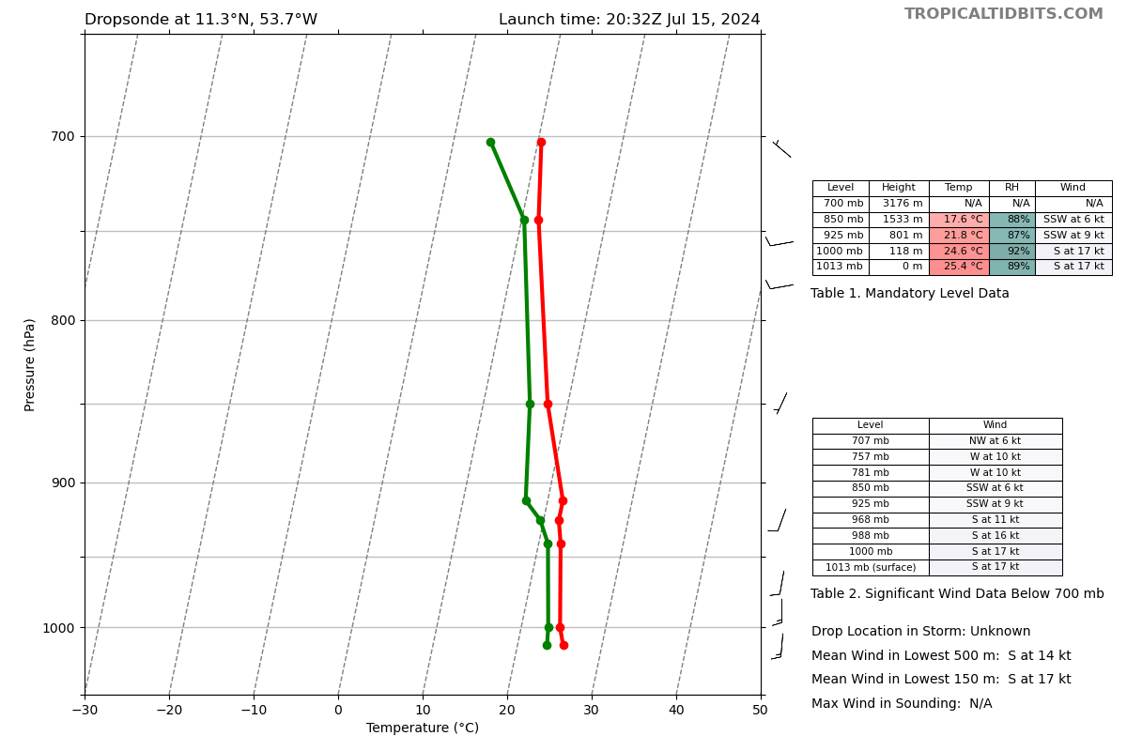
2035 | Finishing up final line, seems like convective is dying out a little more this pass, right at diurnal minimum  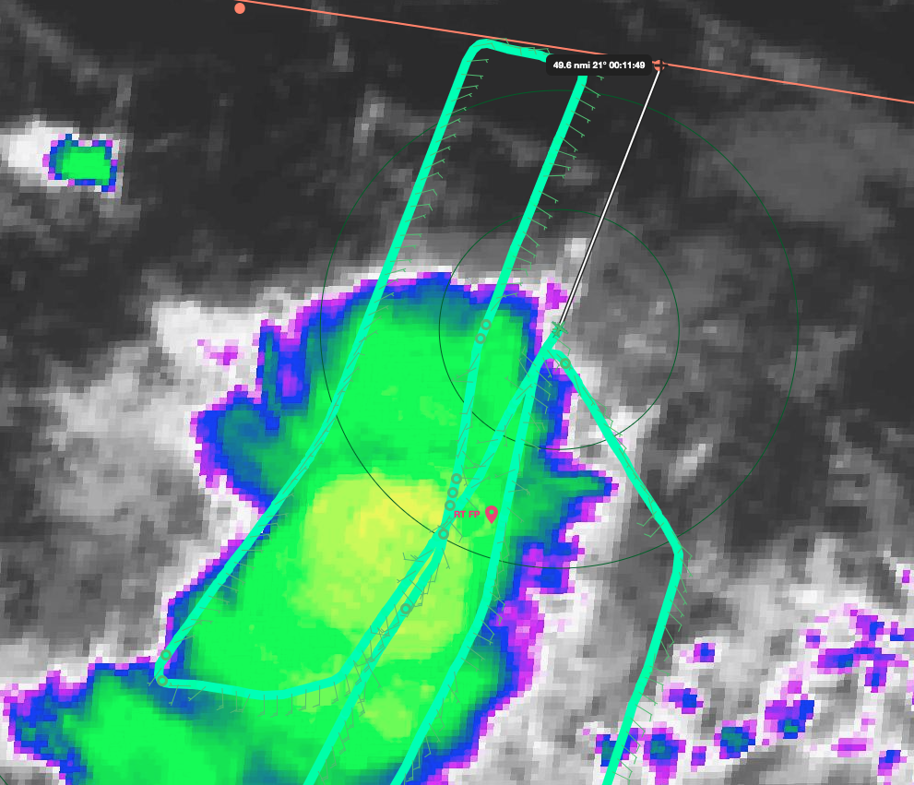
2039 | SFMR showing 45-50 knots in same region as earlier, but in area of higher rain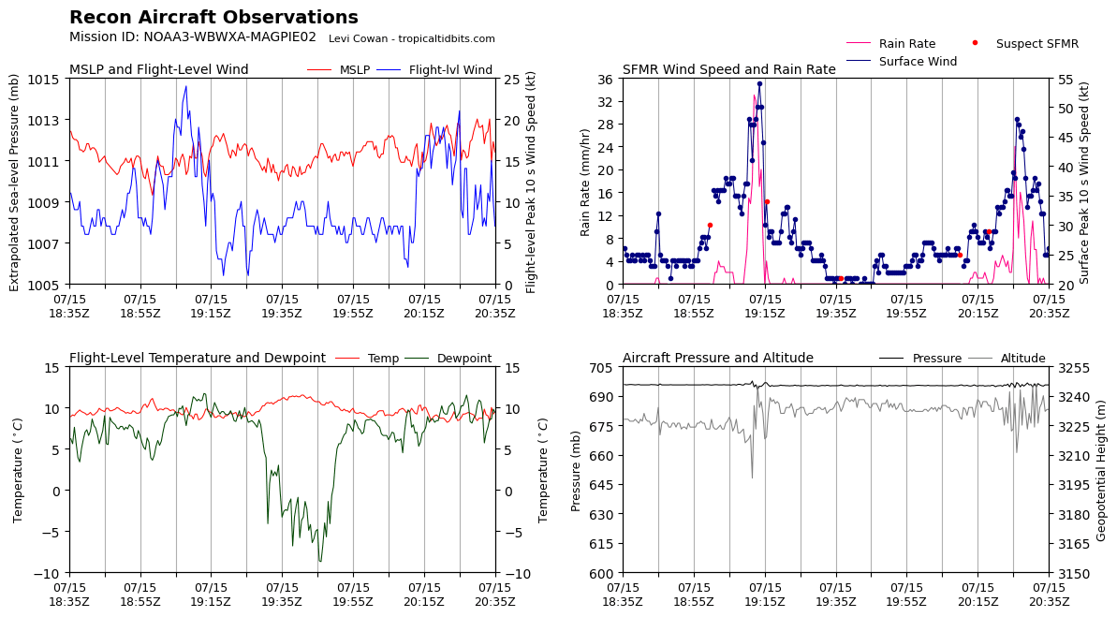
2040 | Dropsonde 27, CH3  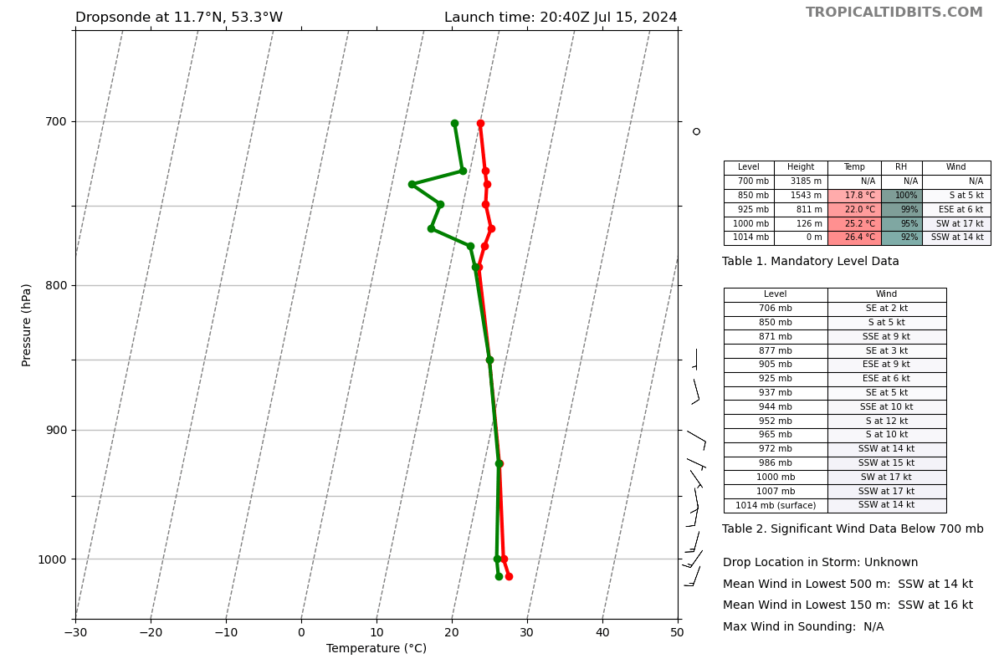
2041 | Finished racetrack, climbing to 21k ft while heading to point 18
2052 | Aircraft having trouble contacting ATC to climb. Still dropping at point 18, but climb once they get clearance
2057 | Data Tech noted higher brightness temps on SFMR than what has been seen in the past, but it’s been that way since it came off bench calibration. Might be worth getting ProSensing to look at the data.
2059 | Dropsonde 28, CH4 (was at 10k ft due to delay getting clearance to climb)  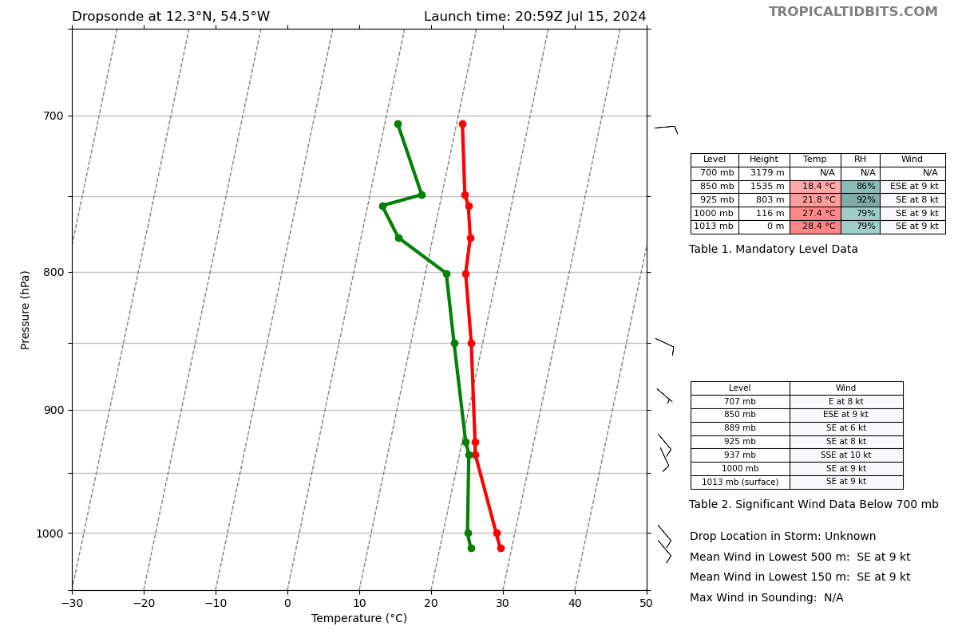
2102 | Most SFMR values were not flagged, but still not trustworthy
2103 | Still waiting for ATC clearance to climb. Going to orbit while talking to them
2110 | Still having issues getting in touch with ATC for the climb to 21k ft. Climbing some to get better radio range
2120 | Headed to point 19
2121 | Drop at point 19 will be slightly late due to boat being right there
2132 | Dropsonde 29, CH5  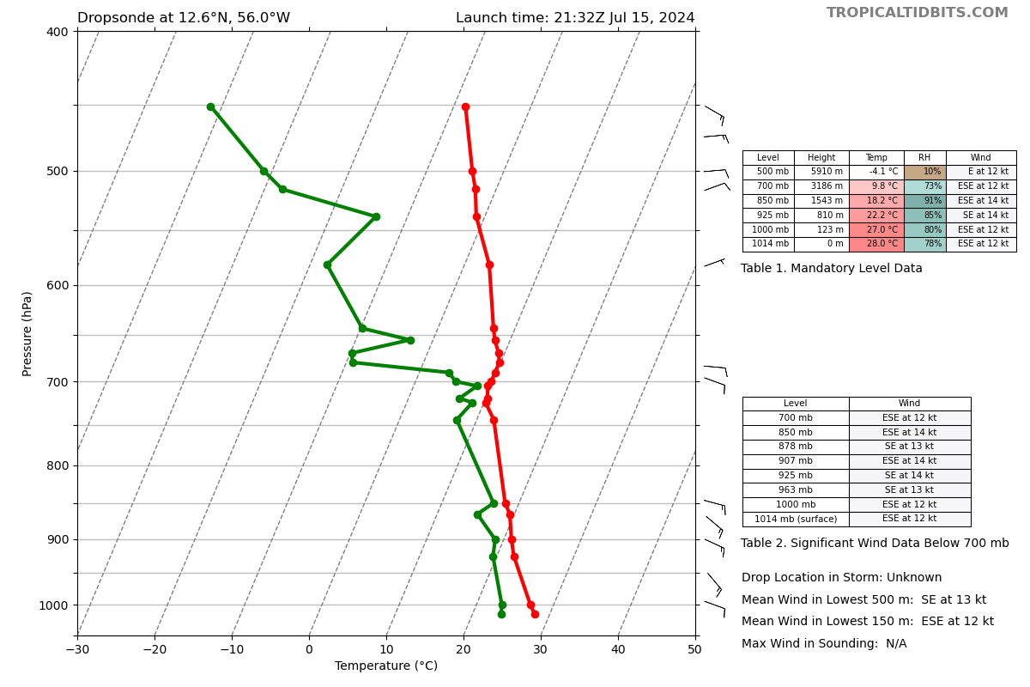
2143 | Dropsonde 30, CH6  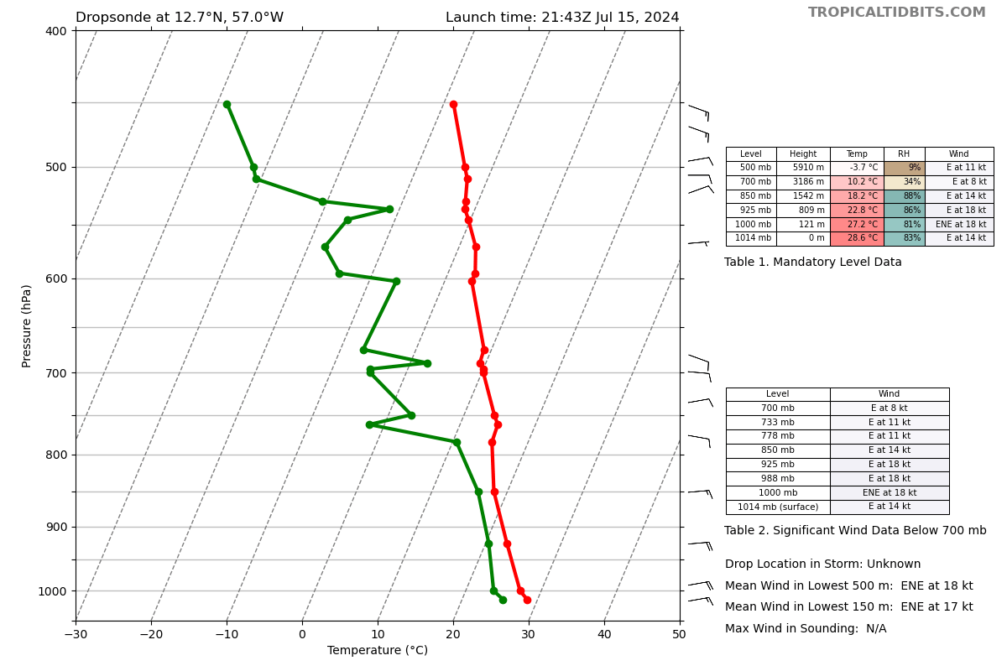
2147 | The cell that the racetrack covered has continued to weaken and loks very outflow dominant  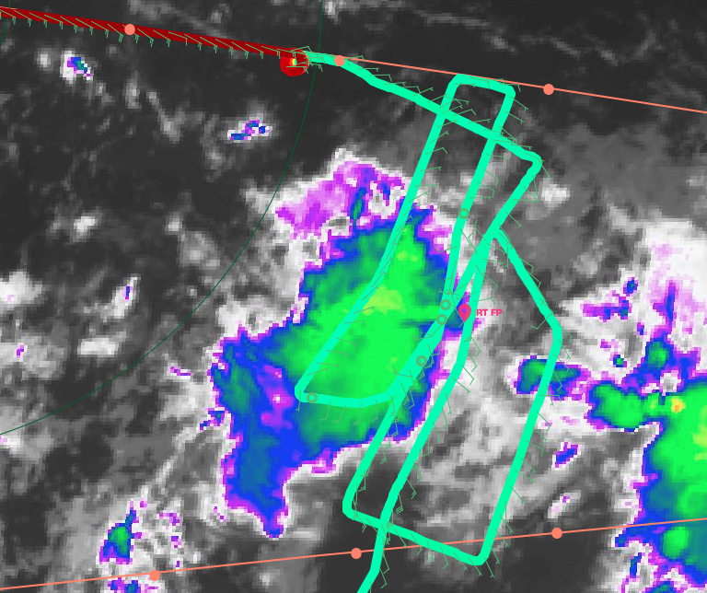
2157 | Dropsonde 31, CH7 (final drop)  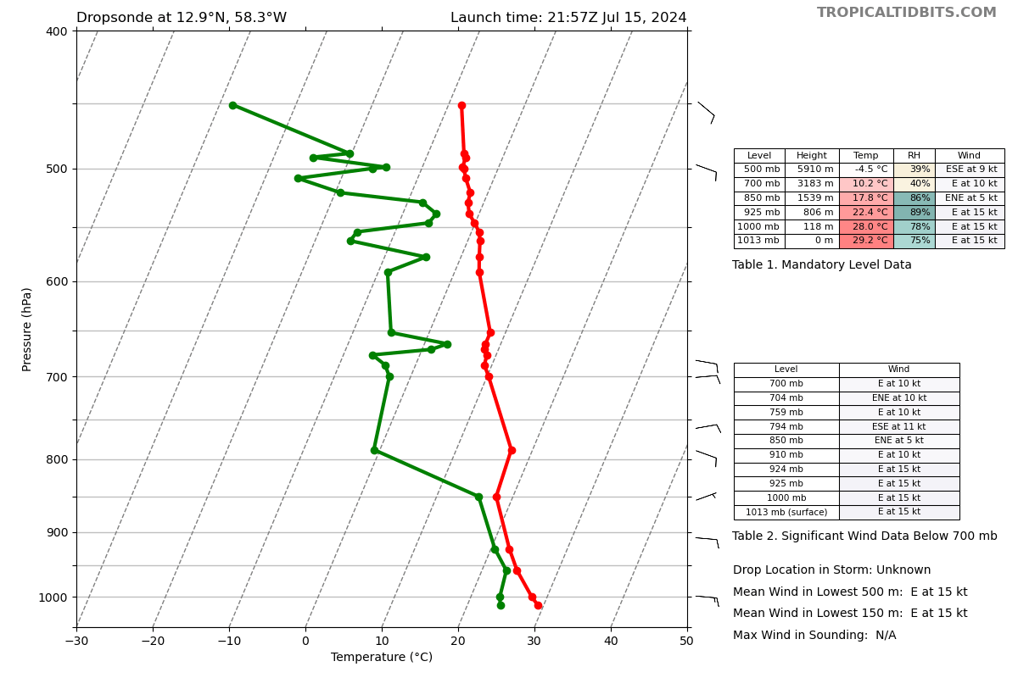
2157 | Science complete
2207 | Total: 31 good sondes, 4 good BTs, all charged to ONR
2210 | Last report has been sent via TAG
2219 | Touchdown back at Barbados

POST-FLIGHT
Mission Summary | During this mission, there was an initial stratiform spiral module right off the coast of Barbados, which was successfully completed. Following, on ground science and MAGPIE PIs noticed some interesting convection to the W of the original line. We were able to adapt the mission from the original plan to investigate the more interesting convection at a lower level (10k ft). An AXBT and dropsonde were deployed on either side of the convection.  Following, the plan was further adapted to fly through additional interesting convection further to the S (0.7˚S) with 2 AXBTs deployed. Due an interesting larger convective system, along with increased interest from the MAGPIE PIs, the plan was further modified to complete a Favorable Air Mass double racetrack pattern centered on the convection. The flight crew utilized satellites and onboard radar to follow the center of the convection and complete the double racetrack pattern while the feature was changing structure and advecting to the NW, while remaining at 10k ft. There were 20 dropsondes deployed during the double racetrack.  After the end of the successful racetrack pattern, the decision was made, based on fuel and flight time, to link back up with the original pattern at point 18 and follow back to Barbados at 21k ft. There was a delay in getting clearance from ATC, in which the plane orbited until clearance was given. At that time, there was a boat at point 19, thus the dropsonde was slightly delayed.  Overall, while the pattern flown was not what was originally planned, it was successful in reaching the desired outcomes and enhancing the observations made.  Totals: Dropsondes: 31, AXBTs: 4
Actual Standard Pattern Flown | Survey
APHEX Experiments / Modules Flown | Genesis stage/Favorable Air Mass  Early Stage/Stratiform Spiral Module
Plain Language Summary | The flight plan was modified during the mission to enhance the observations made for scientific interest. We were able to observe a convective system through its lifecycle as it interacted with dryer saharan air. This was after flying through multiple other smaller convective systems. Overall, 31 dropsondes were deployed (20 within and around the primary convective system studied), 2 dropsondes and AXBTs on either side of a decaying convective system, and 2 AXBTs between the two within additional convection.
Instrument Notes | TDR dropout at 1813, back up by 1819  SFMR had some concerning higher wind speed values around 1910 and 2020 UTC. Data tech reported higher than usual brightness temperatures, but nothing unheard of for that unit
Final Mission Track | 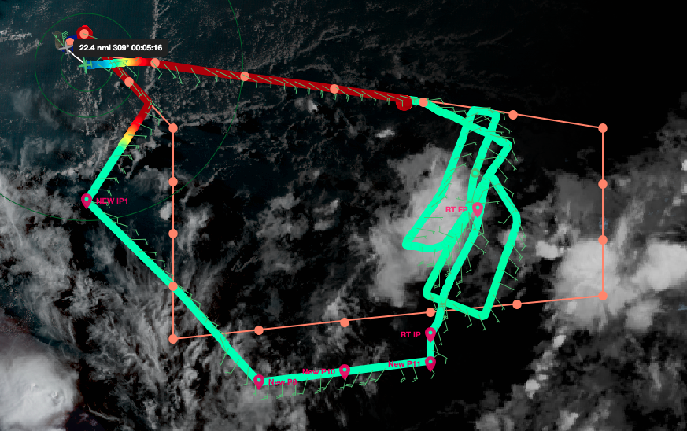  Color shows altitude

