MISSION PLAN
FLIGHT ID | 20240713I1 | STORM | AEW1 / MAGPIE
MISSION ID | WAWXA MAGPIE01 | TAIL NUMBER | NOAA-43
TASKING | HRD | PLANNED PATTERN | Survey36
MISSION SUMMARY
TAKEOFF [UTC] | 1426 | LANDING [UTC] | 2050
TAKEOFF LOCATION | BGI/TBPB | LANDING LOCATION | BGI/TBPB
FLIGHT TIME | 6.4 hours | BLOCK TIME | Get from onboard LPS or Flight Director
TOTAL REAL-TIME RADAR ANALYSES  (Transmitted) | N/A | TOTAL DROPSONDES Deployed (Transmitted) | 36 (34)
OCEAN EXPENDABLES (Type) | 3 NRL AXBTs (3 good) | sUAS (Type) | N/A
APHEX EXPERIMENTS / MODULES | GENESIS STAGE EXPERIMENT; Favorable Air Mass (FAM) Experiment
HRD CREW MANIFEST
LPS ONBOARD | Hazelton | LPS GROUND | Alaka/Looney
TDR ONBOARD | N/A | TDR GROUND | N/A
ASPEN ONBOARD | N/A | ASPEN GROUND | Sippel
NESDIS SCIENTISTS | N/A
GUESTS (Affiliation) | Melvin (MAGPIE student), Venne (French Documentary), Chafton (French Documentary)
AOC CREW MANIFEST
PILOTS | Rannenberg (Pilot); Wood/Ellis (co-pilots)
NAVIGATOR | Utama/Dunford
FLIGHT ENGINEERS | Stokes/Ripp/Santoni
FLIGHT DIRECTOR | Englert/Zawislak
DATA TECHNICIAN | Richards
AVAPS | Dykeman/Santoni

PRE-FLIGHT
Flight Plan | 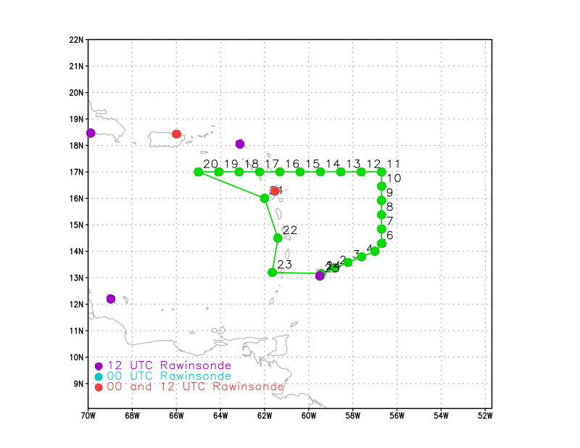  [Insert image of ONR/TCRI detailed pattern image, if available]  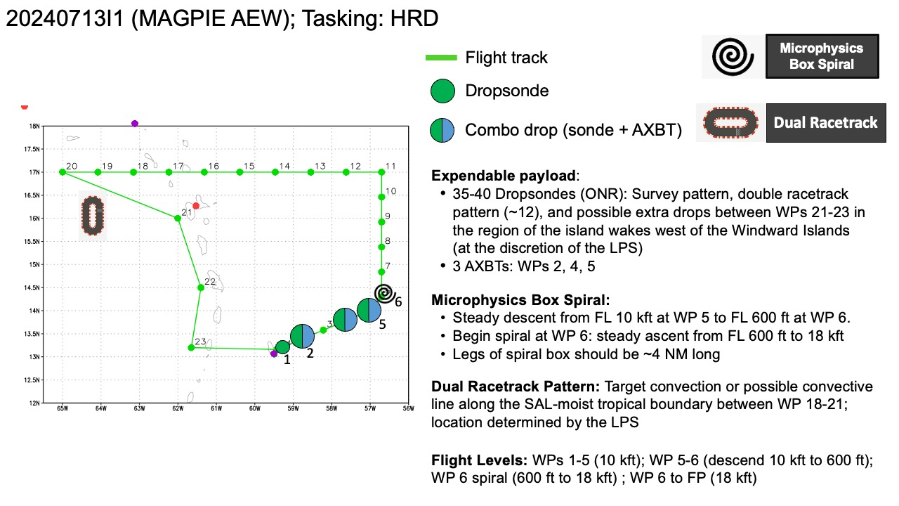
Expendable Distribution | [Describe planned dropsonde, ocean buoy, sUAS deployment locations; e.g., “Dropsondes/AXBT combo drops at endpoints, midpoints, and center”
Preflight Weather Briefing | 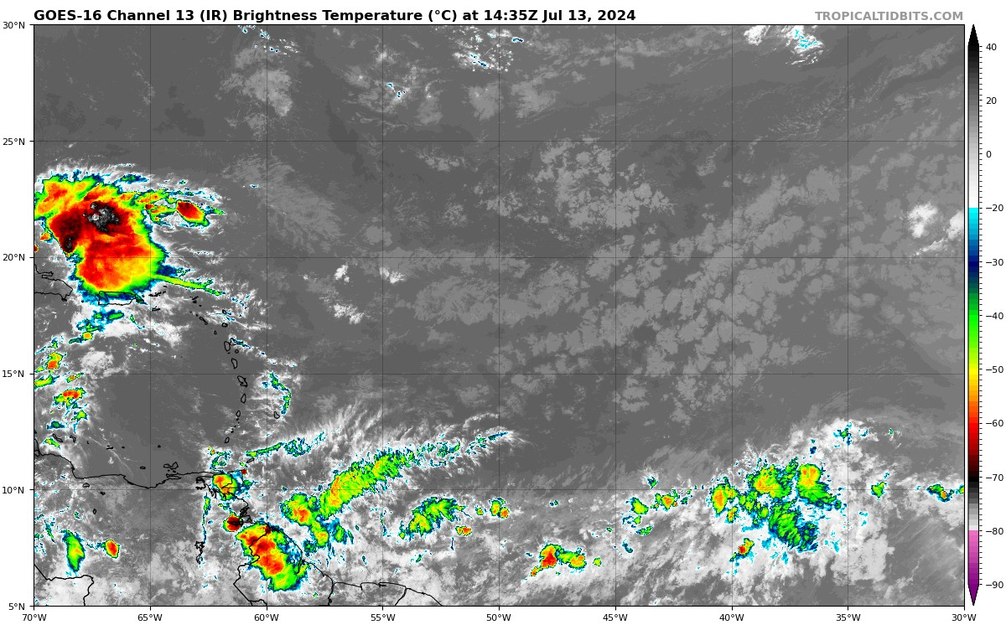  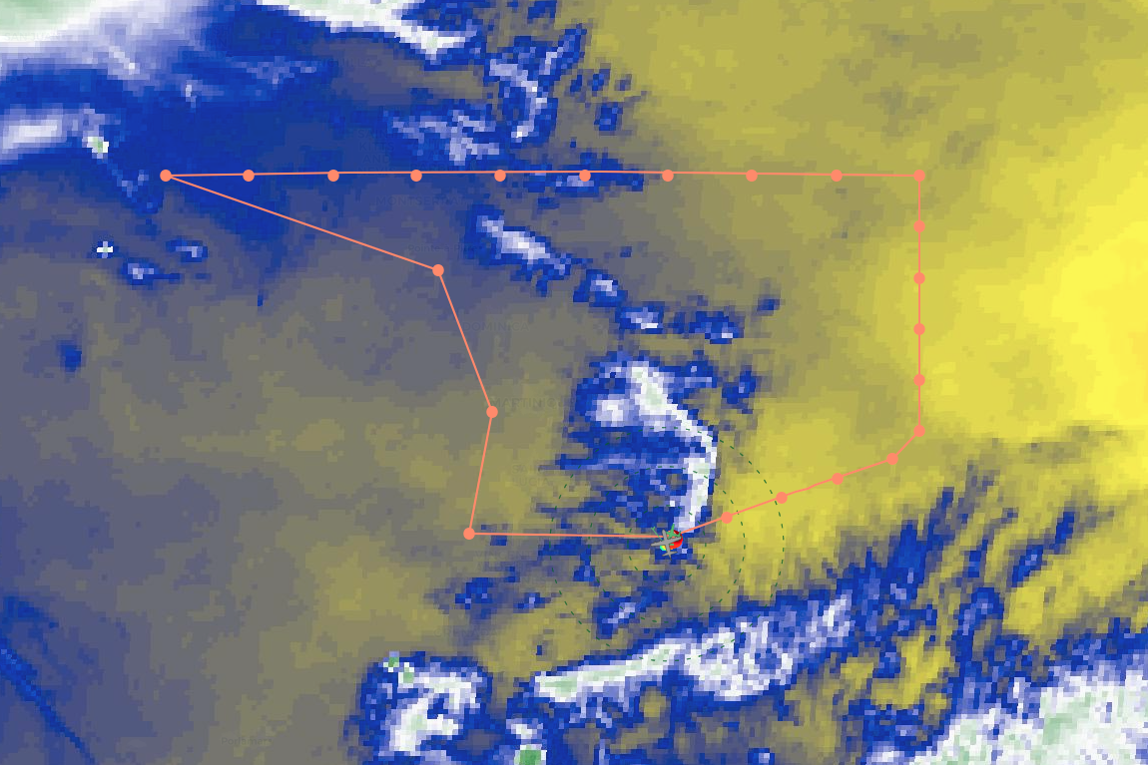  Band 9 from G16  [Notes from the Flight Crew Preflight Briefing and other relevant notes about the current and forecasted storm state from the most recent NHC advisory (location, intensity, MSLP, movement, possible intensity change during the flight)]  [Briefly describe the relevant environmental drivers.]  [Copy in GIF of recent (~6 hr) satellite loops (https://www.star.nesdis.noaa.gov/GOES/index.php)]
Instrument Notes | [What instruments are working, not working, not functioning nominally, not installed?]  First 16 old sondes, rest at new minisondes

IN-FLIGHT
Time [UTC] | Event
1426 | Take-off from TBPB
1427 | Ascending to 7500 ft to begin first leg
1458 | Dropsonde 1 CH1  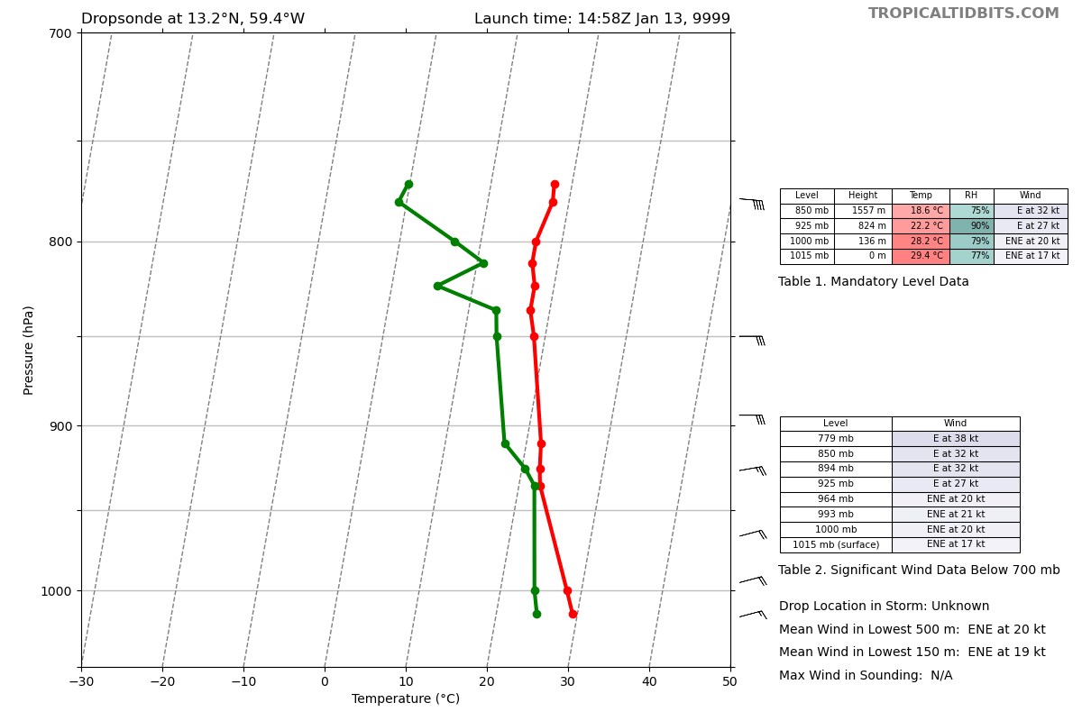
1508 | Dropsonde 2 CH2  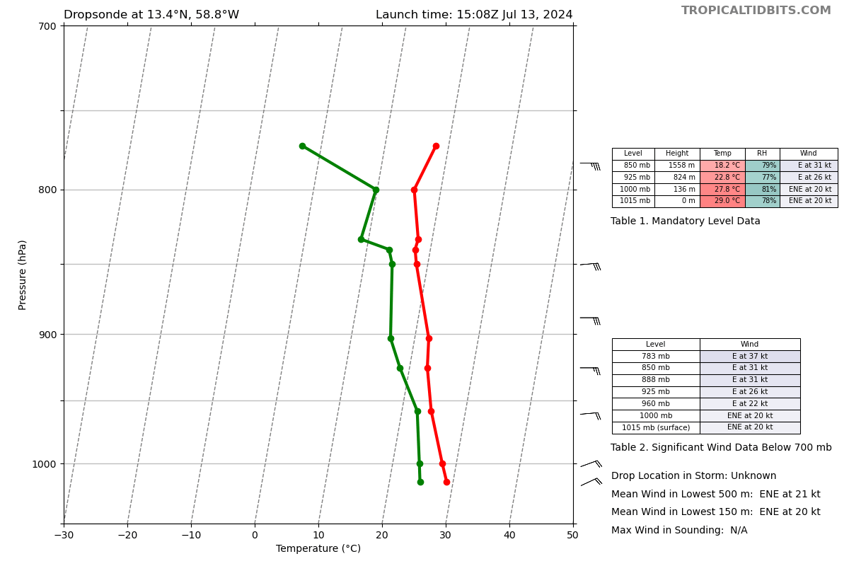
1510 | 29C SST on AXBT (BT1) at point 2
1517 | Shallow clouds at Point 19 - 20, more convection around 17.2 N, 65.62 W, isolated light convection near point 15 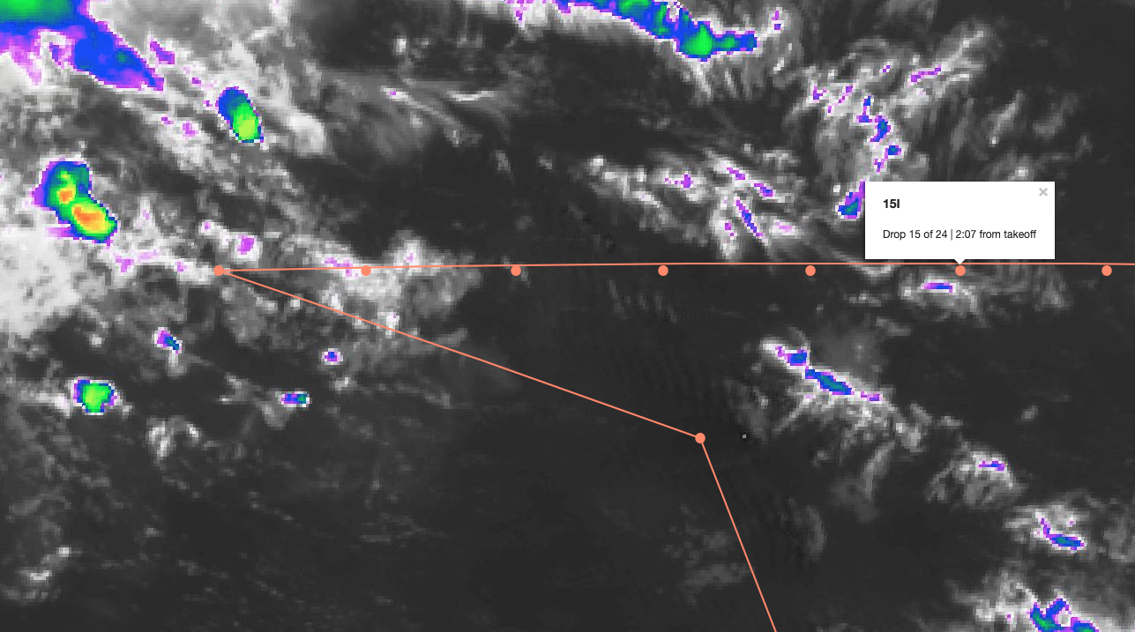  G16, Band 13 (‘Clean IR’)
1519 | Dropsonde 3, CH3  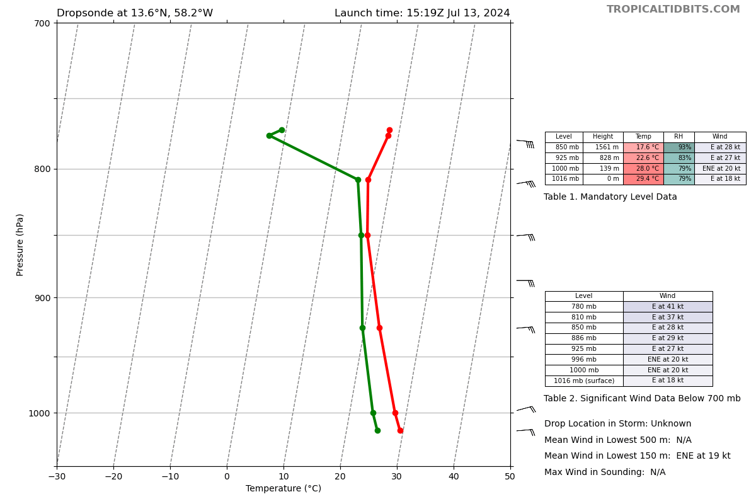
1530 | Drosponde 4, CH4  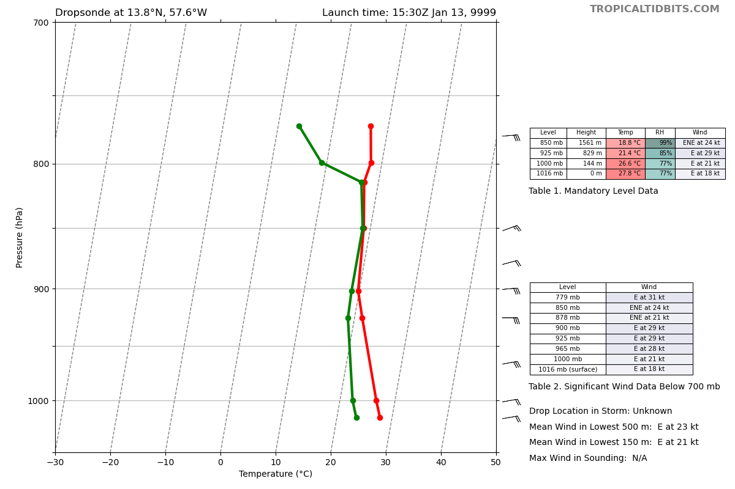
1532 | 29C SST on AXBT (BT2) at point 4
1540 | Dropsonde 5 CH5  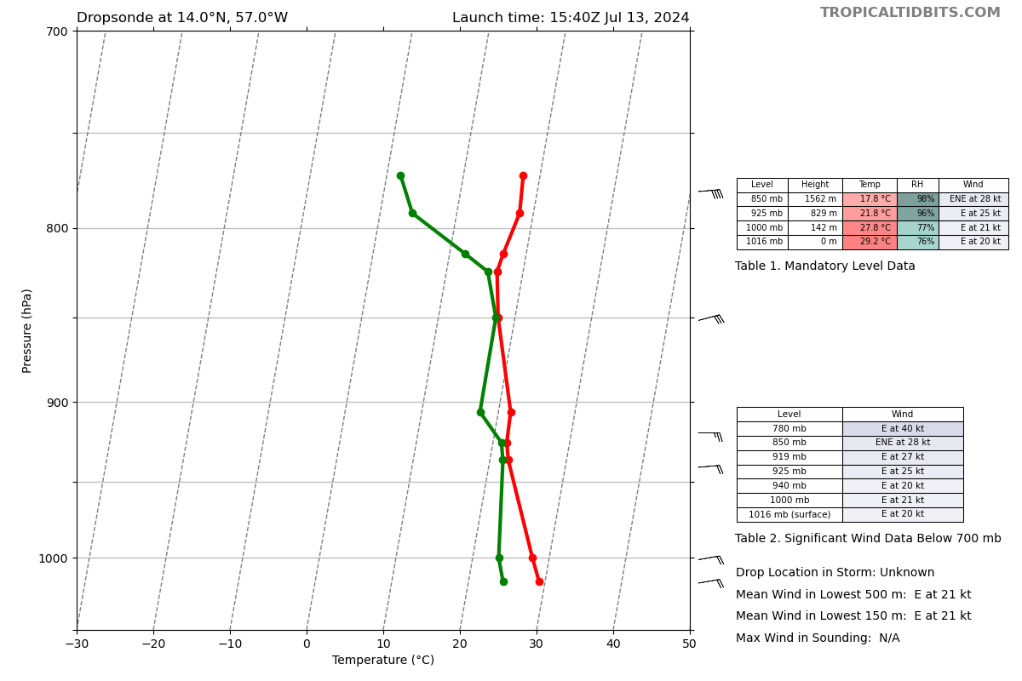
1542 | Descending to 600 ft
1542 | 29.1C SST on AXBT (BT3) at point 5
1549 | Starting spiral up to 21k ft, loiter at 14k ft for ~5 min
1550 | Reporting being able to see Sargassum from P3 while flying that low
1552 | Convection ~75 km WNW of point 20. 11 min ferry there. Still 2.5 hours until there and convection is only ~30 min old, so uncertain on where/how it will be then
1556 | Next drop at top of spiral
1600 | Convection at 16.11N, 64.33W sparked interest of LPS (Andy), FD and LPS considering it as initial guess for racetrack
1606 | Loitering at 14k ft for 5 min, then complete spiral to 21k ft…FD noted “That’s some nice haze”
1610 | Based on visual estimate, at top of the haze
1621 | ‘New’ convection firing 16.5N, 65.2W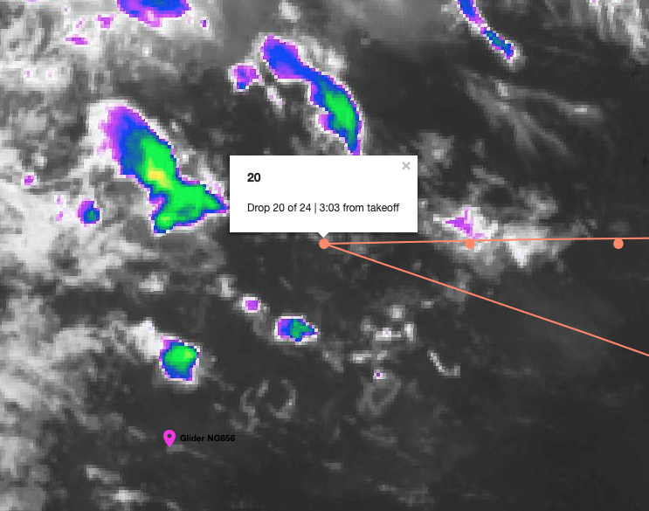  (Glider marked not under current consideration for flyover) - Lev
1621 | Dropsonde 6 CH6  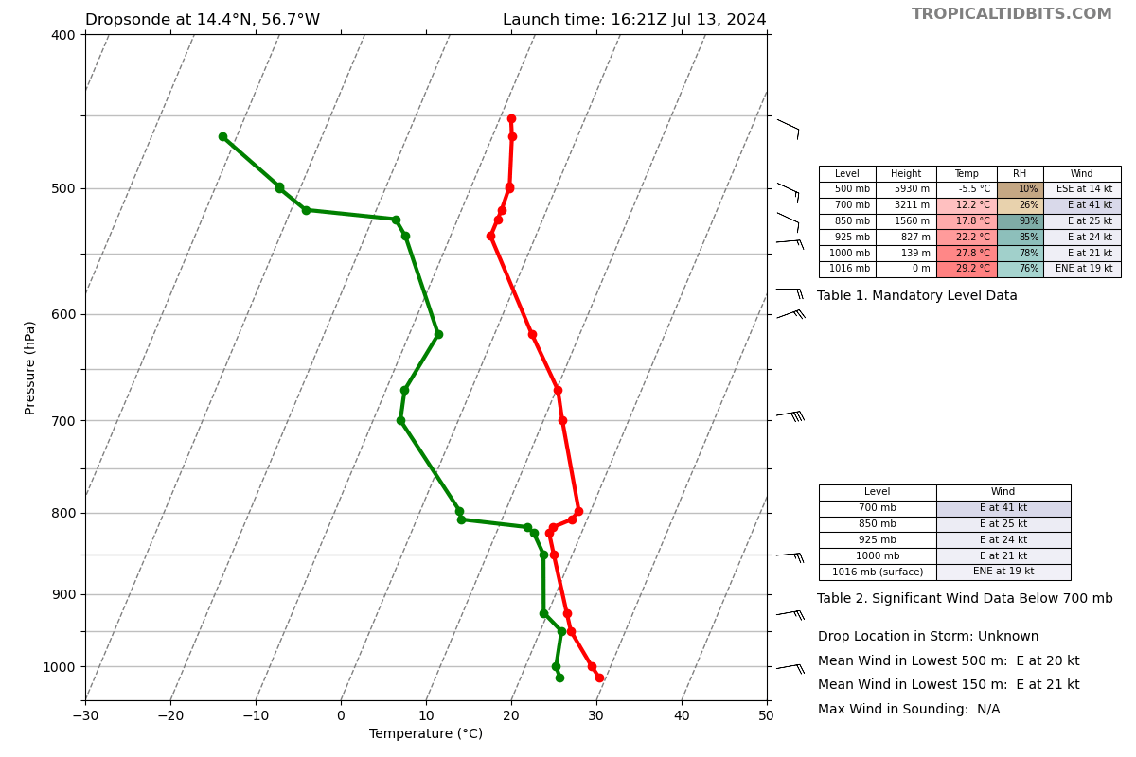
1622 | Finished spiral, did drop 6 and starting S-N leg
1627 | Dropsonde 7 CH7  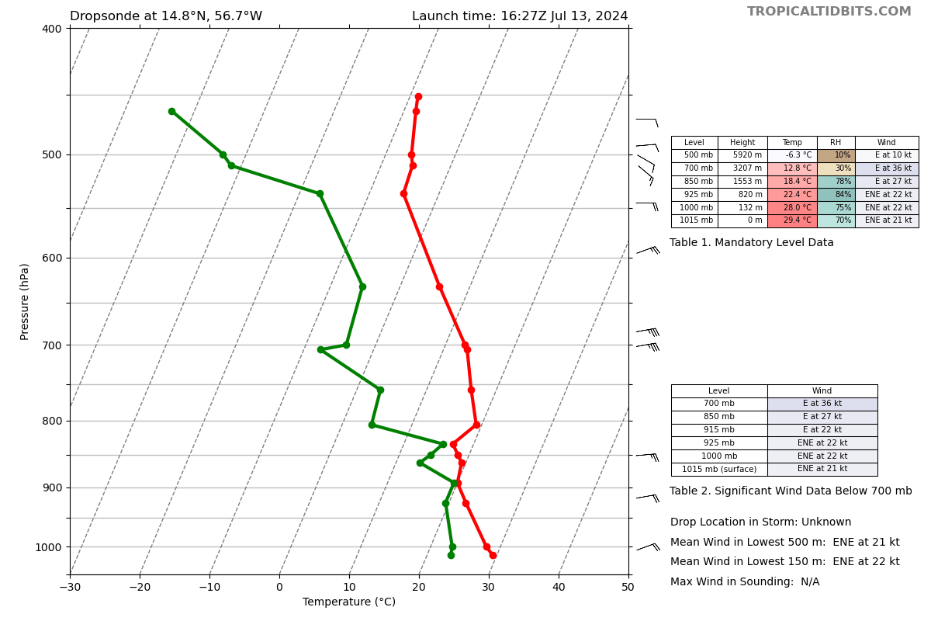
1634 | Dropsonde 8 CH8  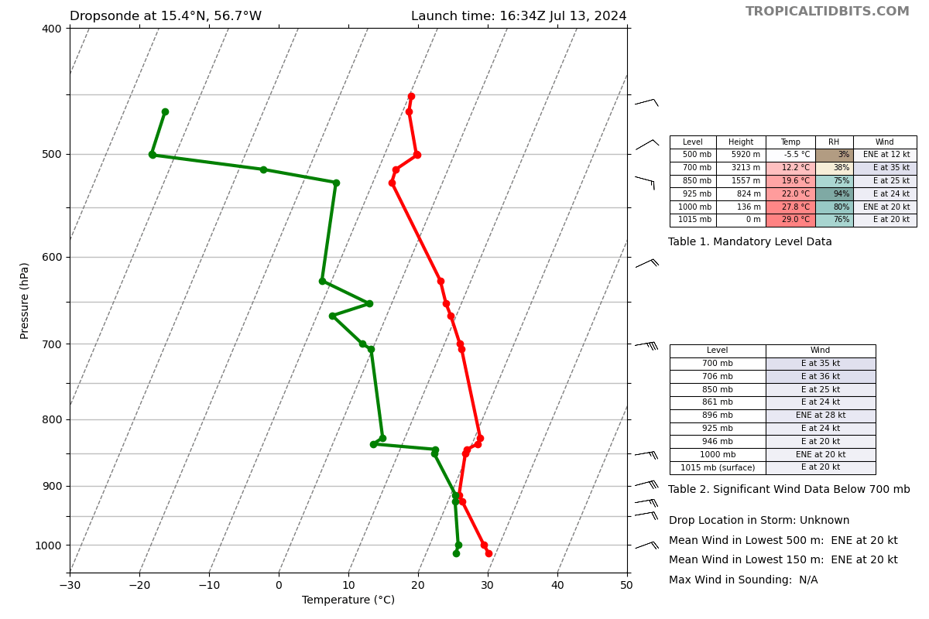
1640 | Dropsonde 9, CH1  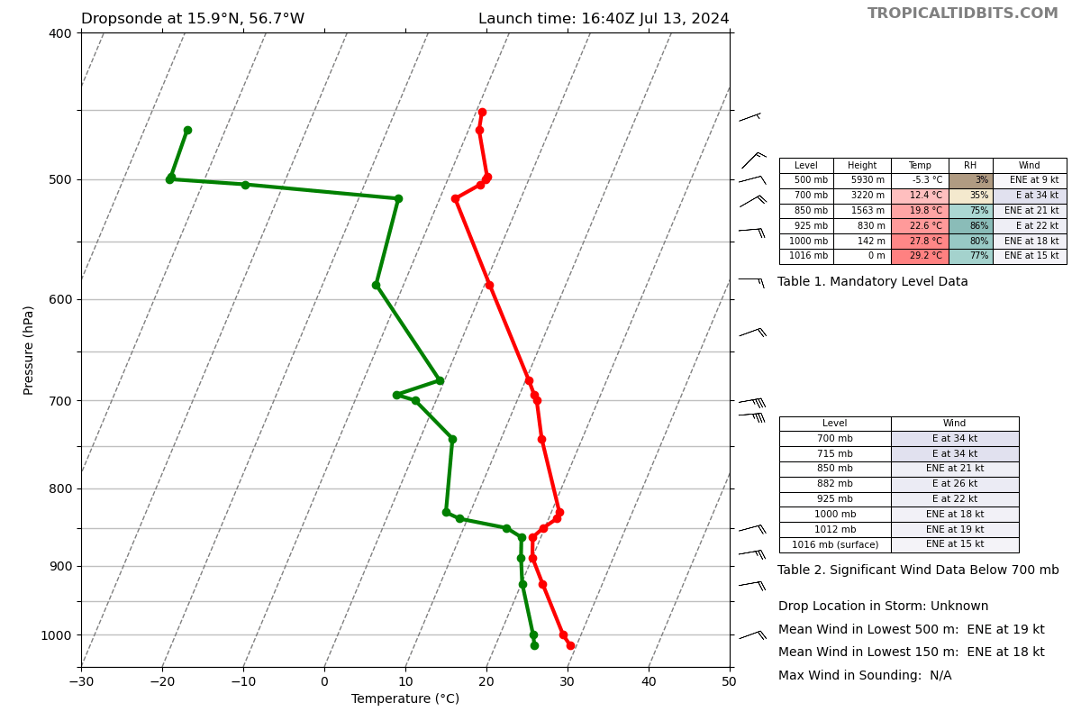
1647 | Dropsonde 10, CH2  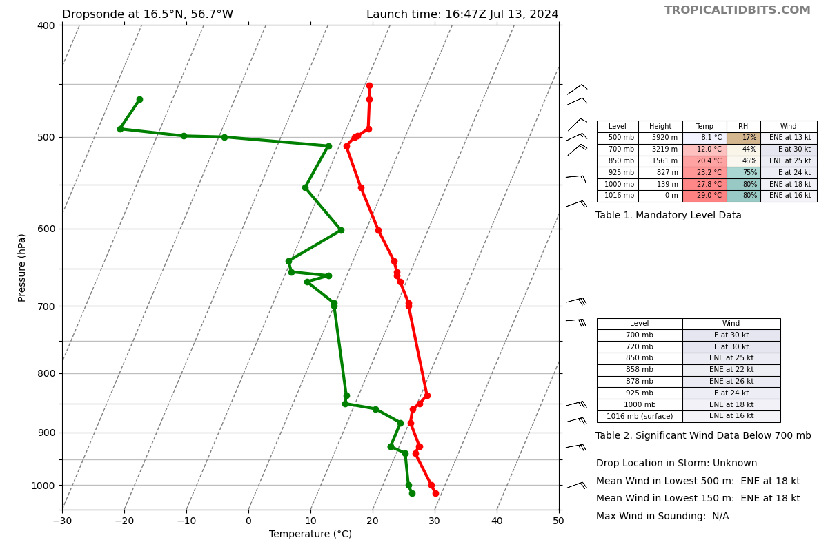
1653 | Dropsonde 11, CH3  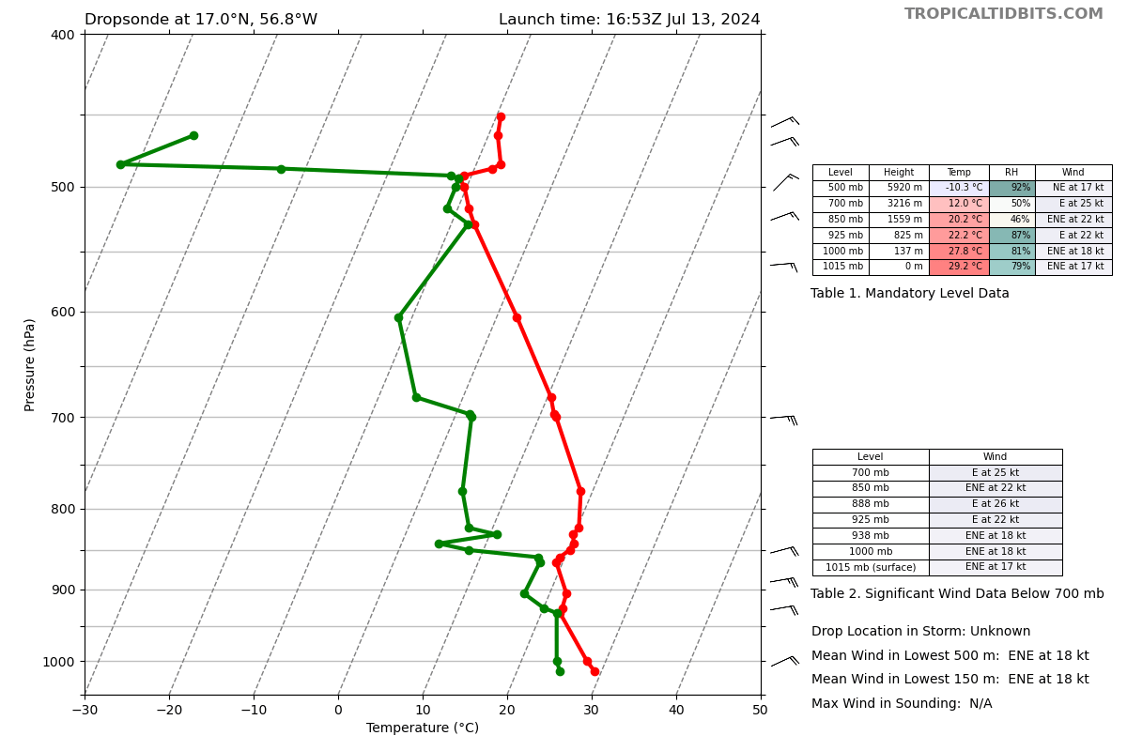
1654
1654 | Turned westbound for E-W leg
1703 | Dropsonde 12, CH4  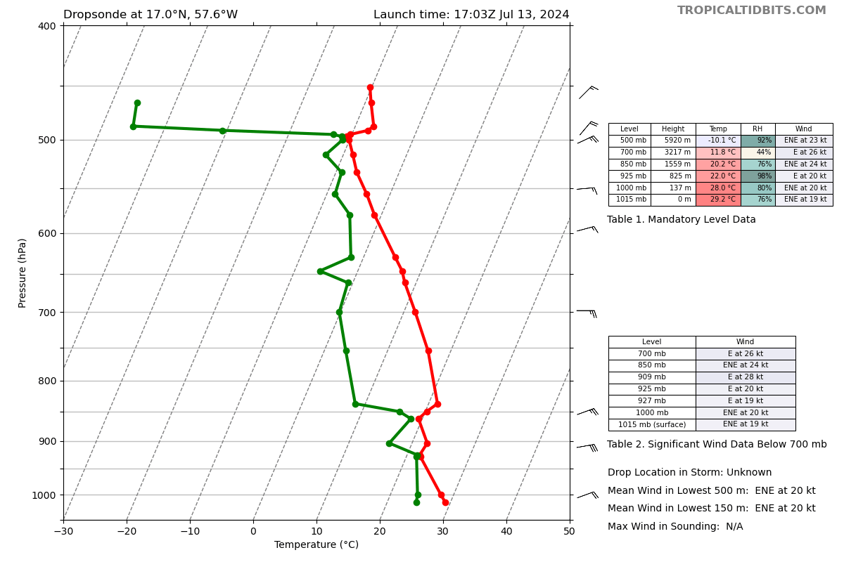
1714 | Dropsonde 13, CH5  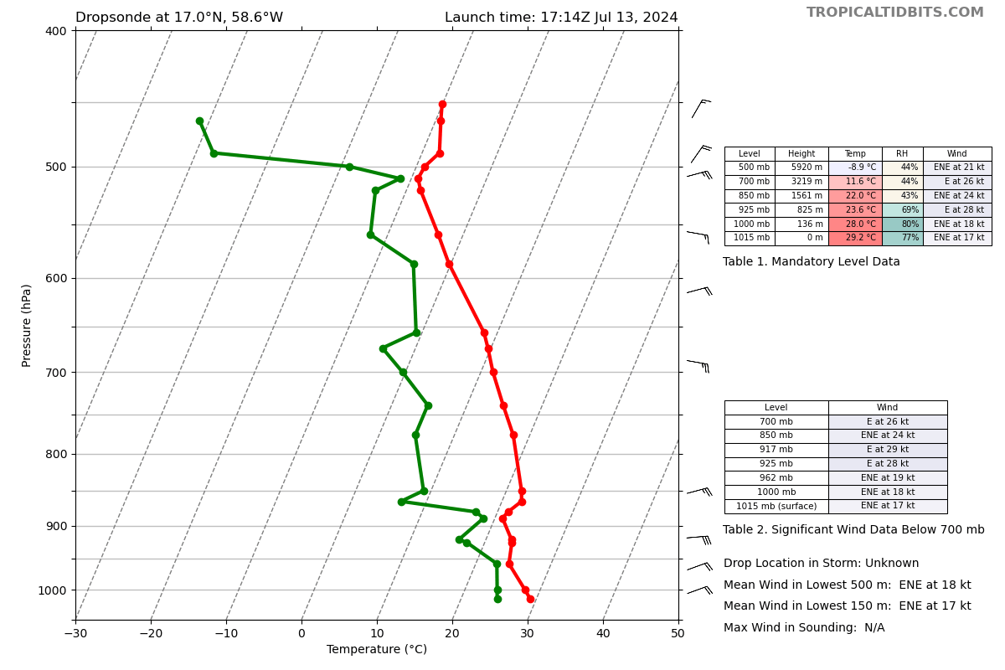
1715 | Drop 14 will be last drop of the old sondes
1719 | Radar from Puerto Rico showing lots of smaller convection to the SW
1724 | Dropsonde 14, CH6 (should be last of older sondes)  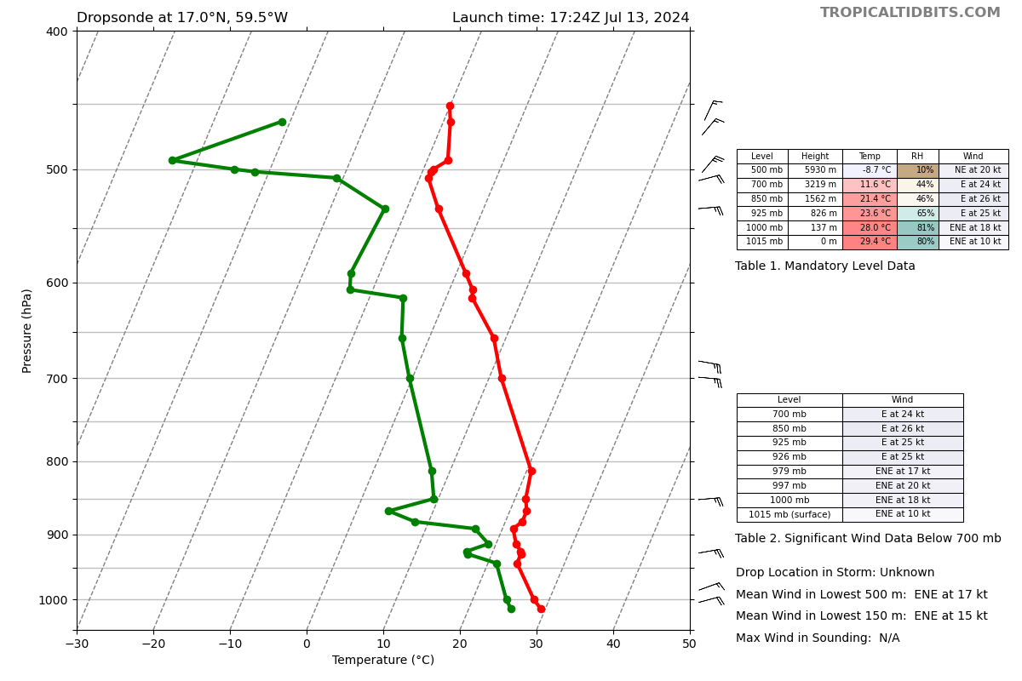
1727 | Plan to dip after sonde release (point 15) at 21k ft down to 14k ft, then back up to 21k ft for next release (just past point 16)
1734 | Dropsonde 15, CH7 (should be start of the minisondes)  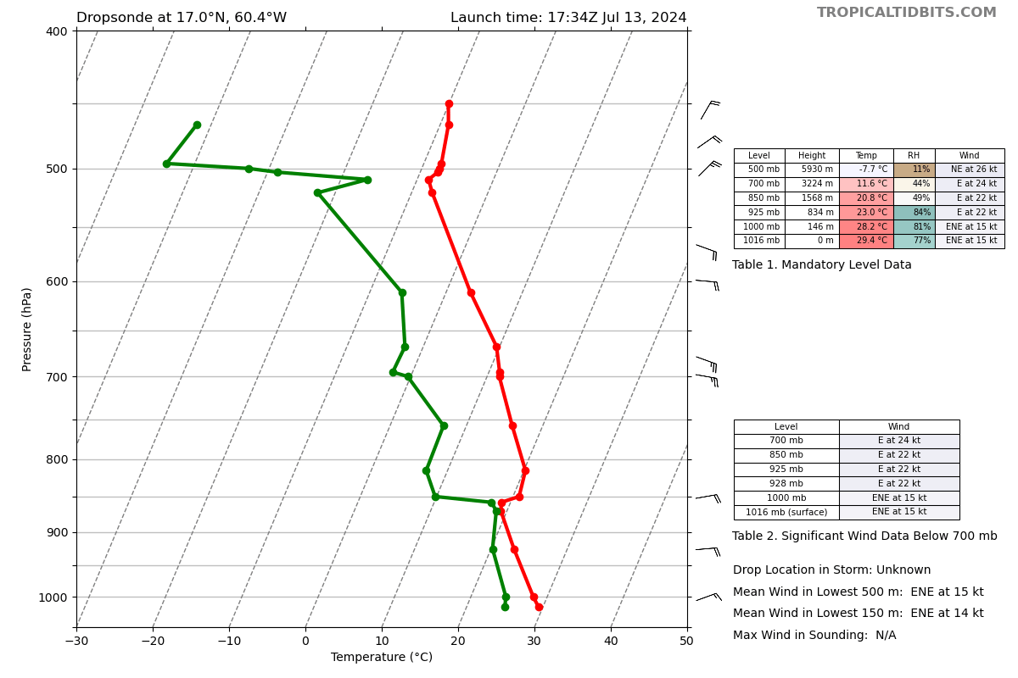
1742 | Climbing back up WP16
1745 | Dropsonde 16, CH8  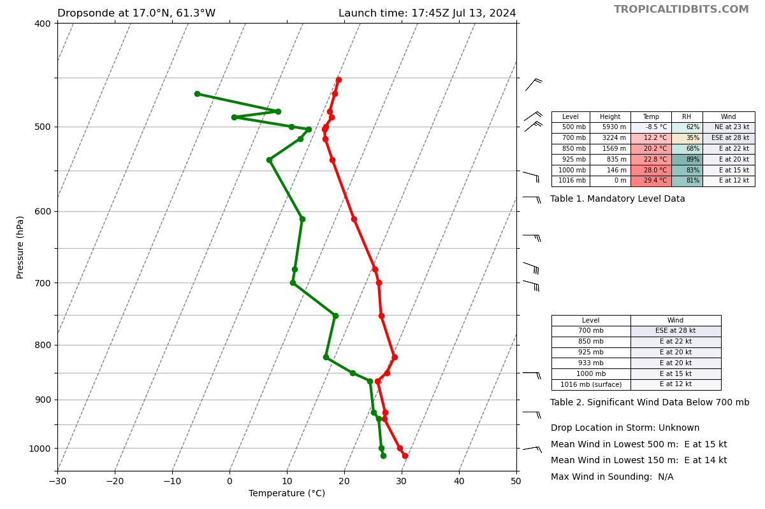
1754 | Dropsonde 17, CH1  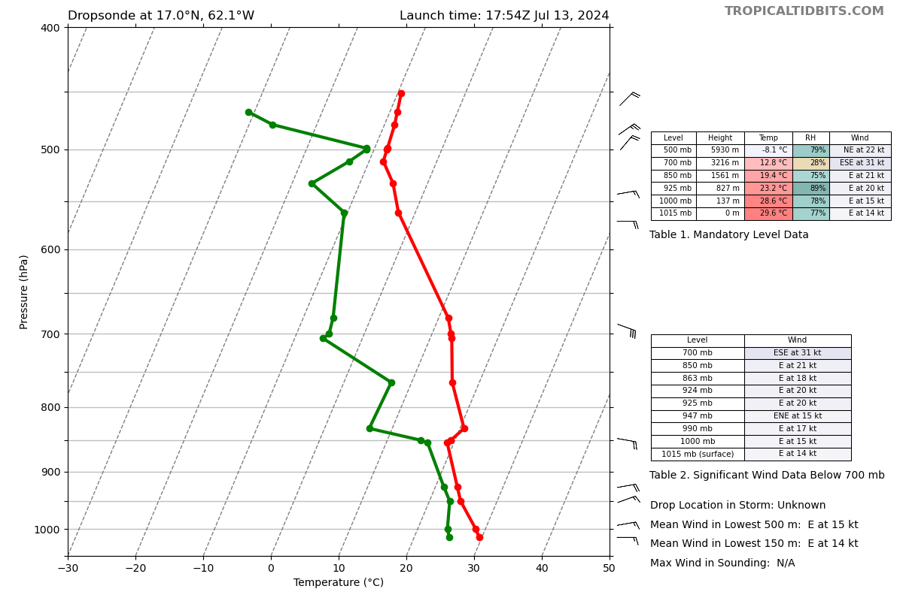
1756 | Racetrack after point 20 is nixed, instead going for the west of the island gap between St. Lucia and St. Vincent (between point 22 and 23)  IP: 13.8N, 62W  EP: 13.7N, 61.5W  Turn to south at EP, then back to IP  IP2: 13.5N, 61.5W  EP2: 13.6N, 62W
1757 | Plan to do a second dip after sonde release (point 18) at 21k ft down to 14k ft, then back up to 21k ft for next release (just past point 19)
1805 | Dropsonde 18, CH2  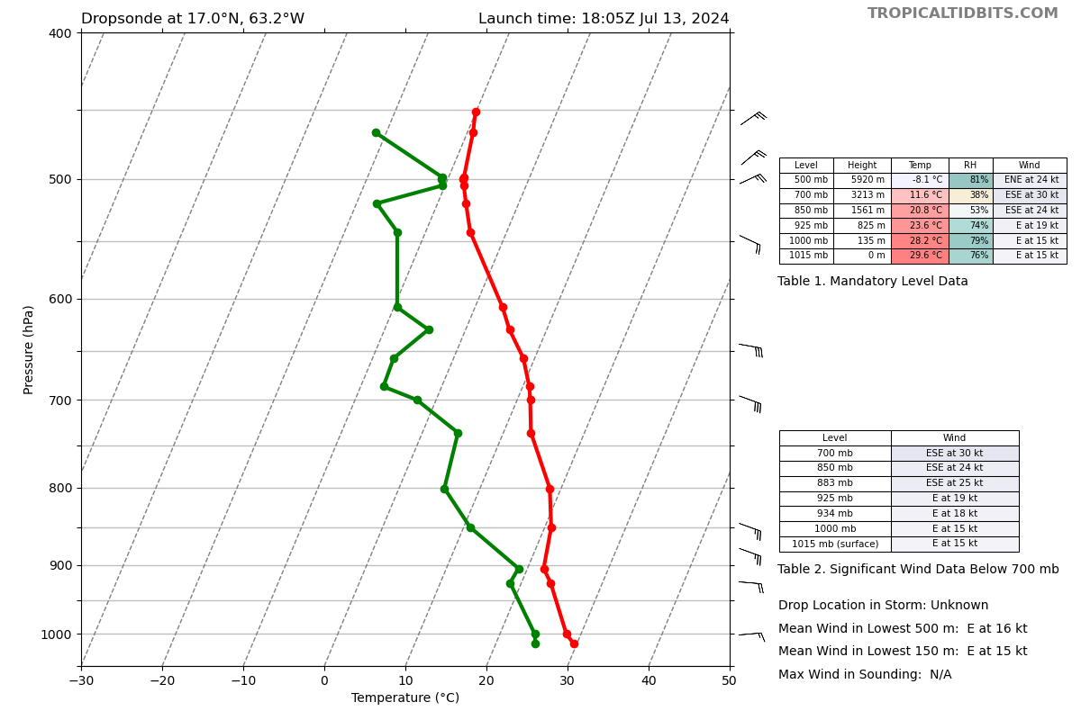
1809 | Change Racetrack to IP2 → EP2 → IP1 → EP1, making it a box
1817 | Dropsonde 19, CH3  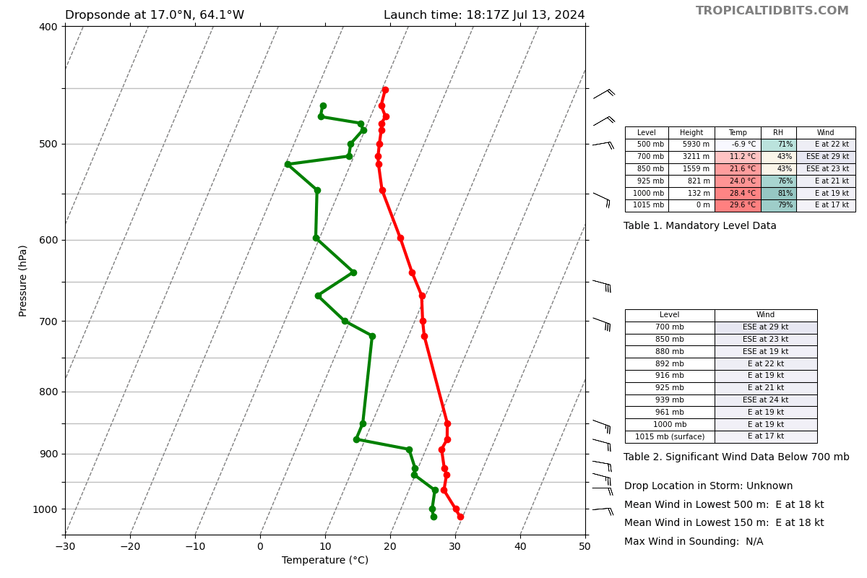
1827 | Dropsonde 20, CH4  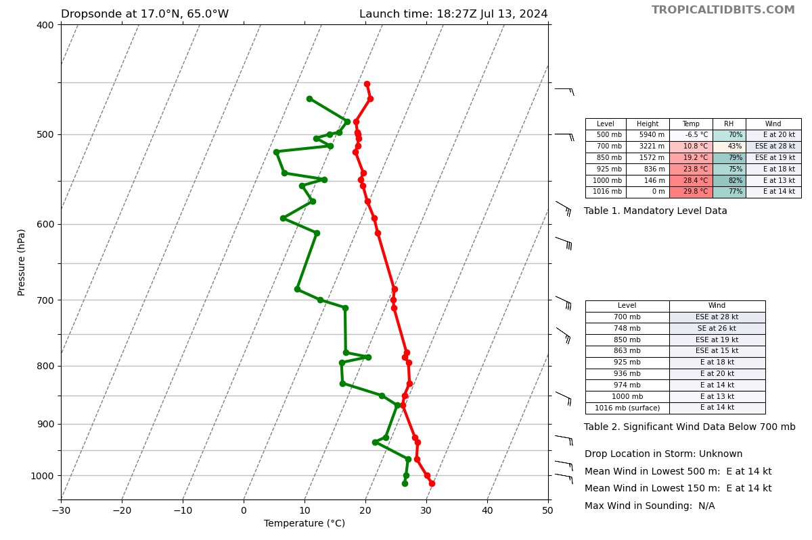
1845 | Add 4 intermediate drops between WP21 & WP22 maintaining altitude
1846 | Add drop at 14.3N along planned track, Add drop at 13.9N along planned track, then start modified racetrack for 2 laps:  13.7N, 61.5W → head south → 13.2N, 61.5W → head west → 13.3N, 62.6W → turn north → 13.7N. 62.6W → head east to original point  Expendables on every corner + 1 mid on longer zonal legs  Loop twice
1900 | Adjust drop 22 to 14.6N to be in the wake of Martinique
1909 | Dropsonde 21, CH5  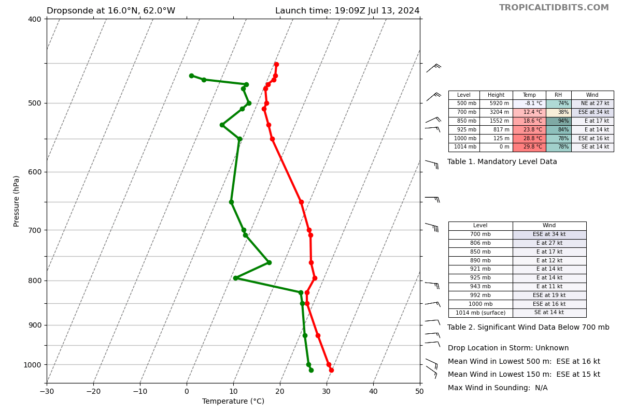
1912 | Dropsonde 22, CH6  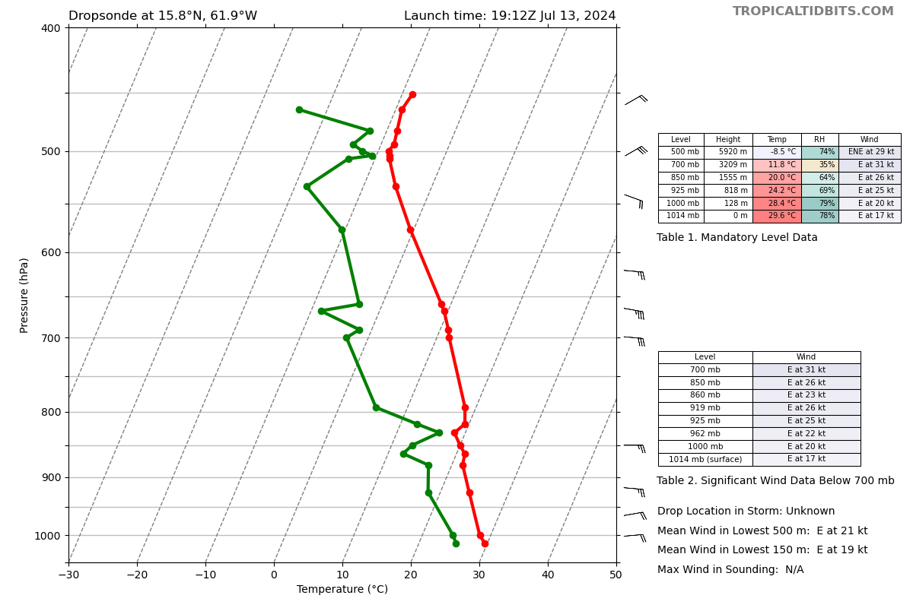
1916 | Dropsonde 23, CH7  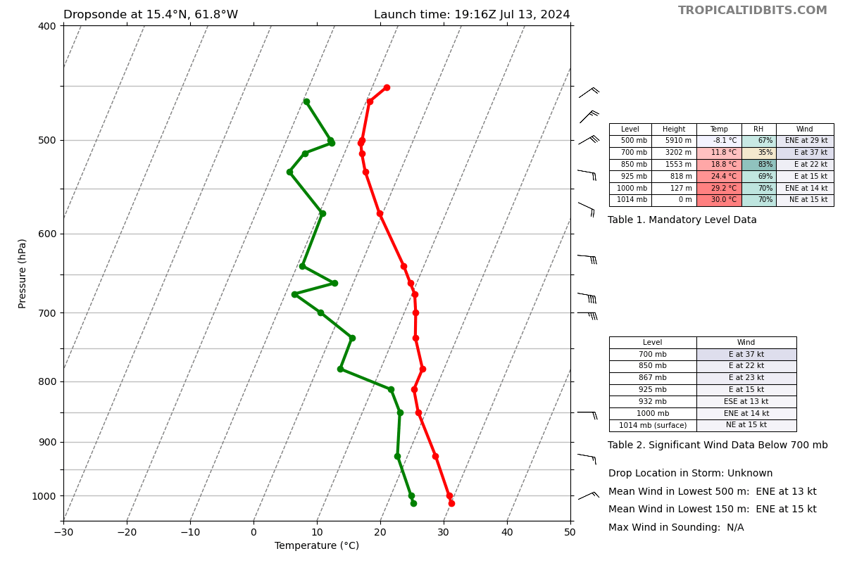
1920 | Dropsonde 24, CH8  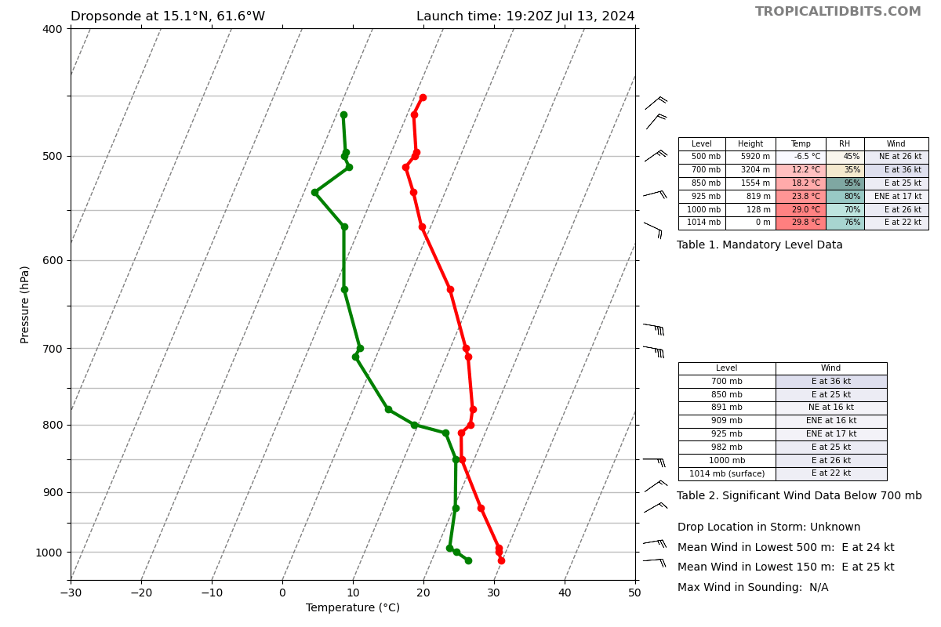
1923 | Dropsonde 25, CH1  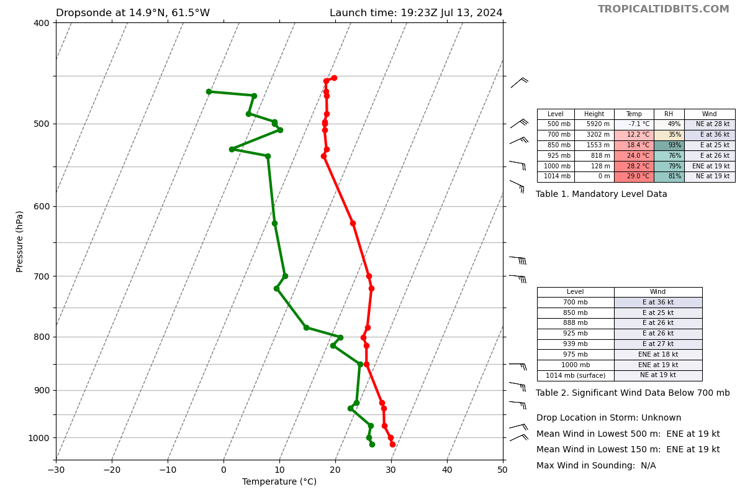
1923 | No convection popping up in the island wake region, if that continues, may only do single racetrack lap
1925 | guidance to do best to fly racetrack at 1k ft above cloud tops (based on visual and radar)
1926 | Dropsonde 26, CH2  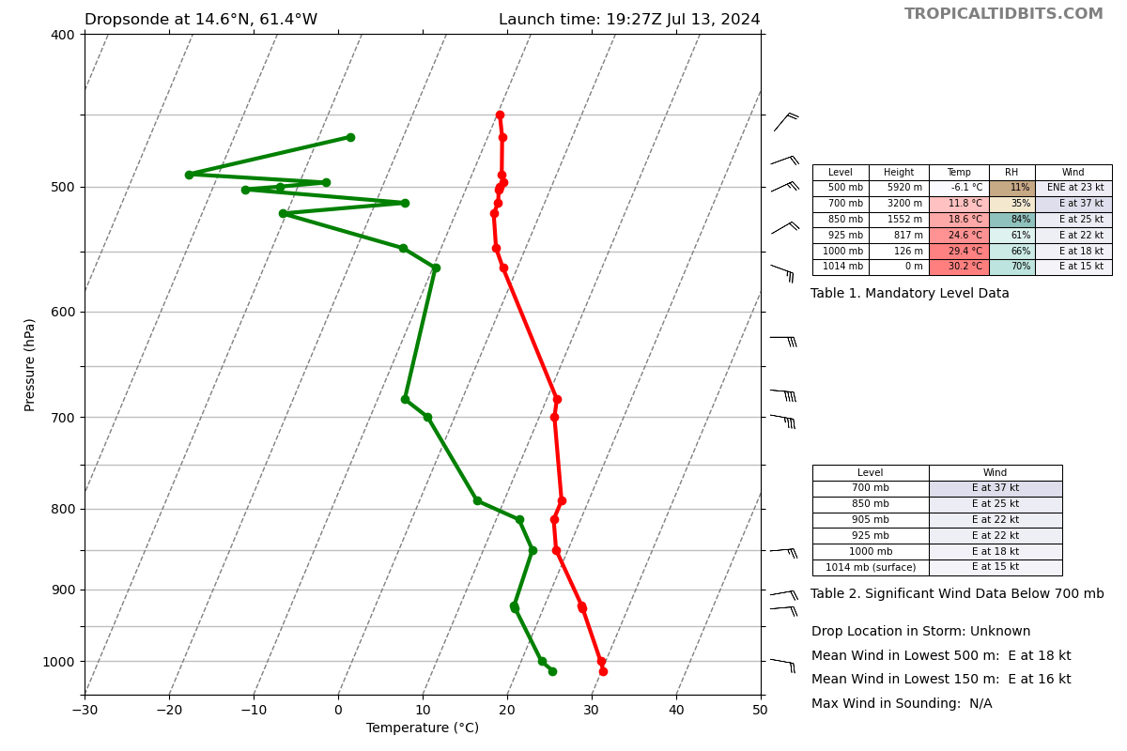
1927 | Cloud top estimate is 15-16k ft
1930 | Dropsonde 27, CH3  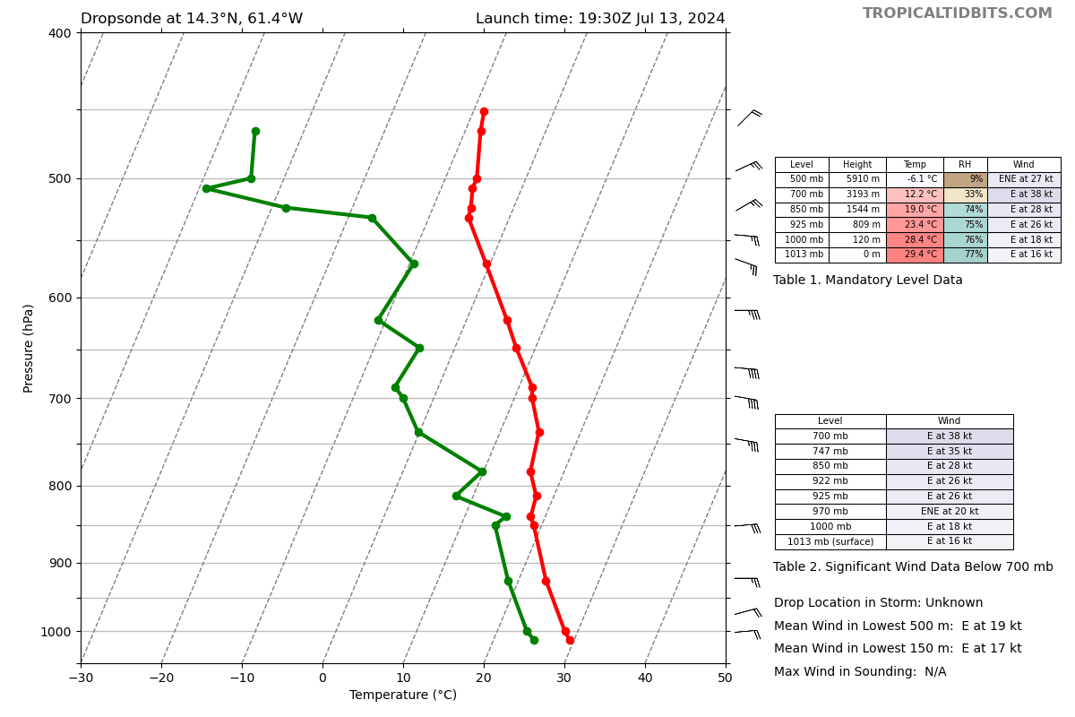
1931 | 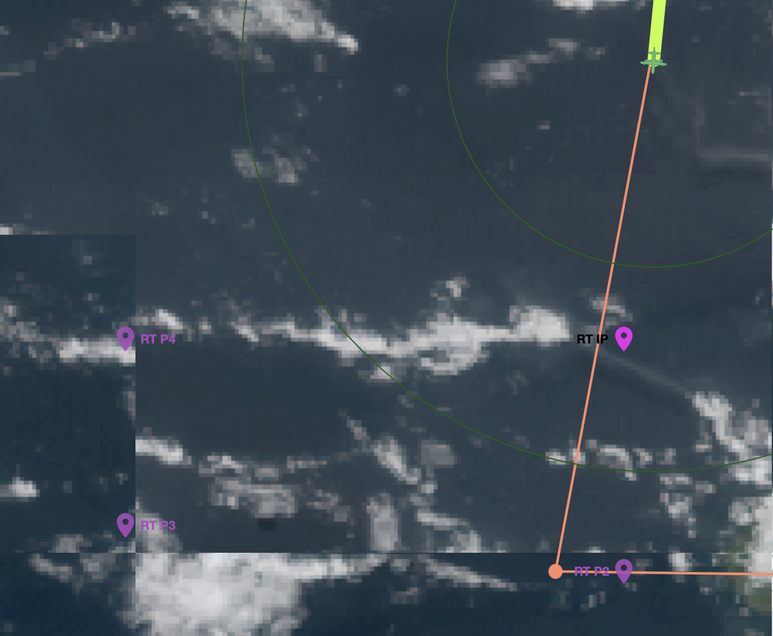  Tiled GOES imagery of racetrack points (likely older visible image from GOES)
1934 | Dropsonde 28, CH3 (should be CH4)  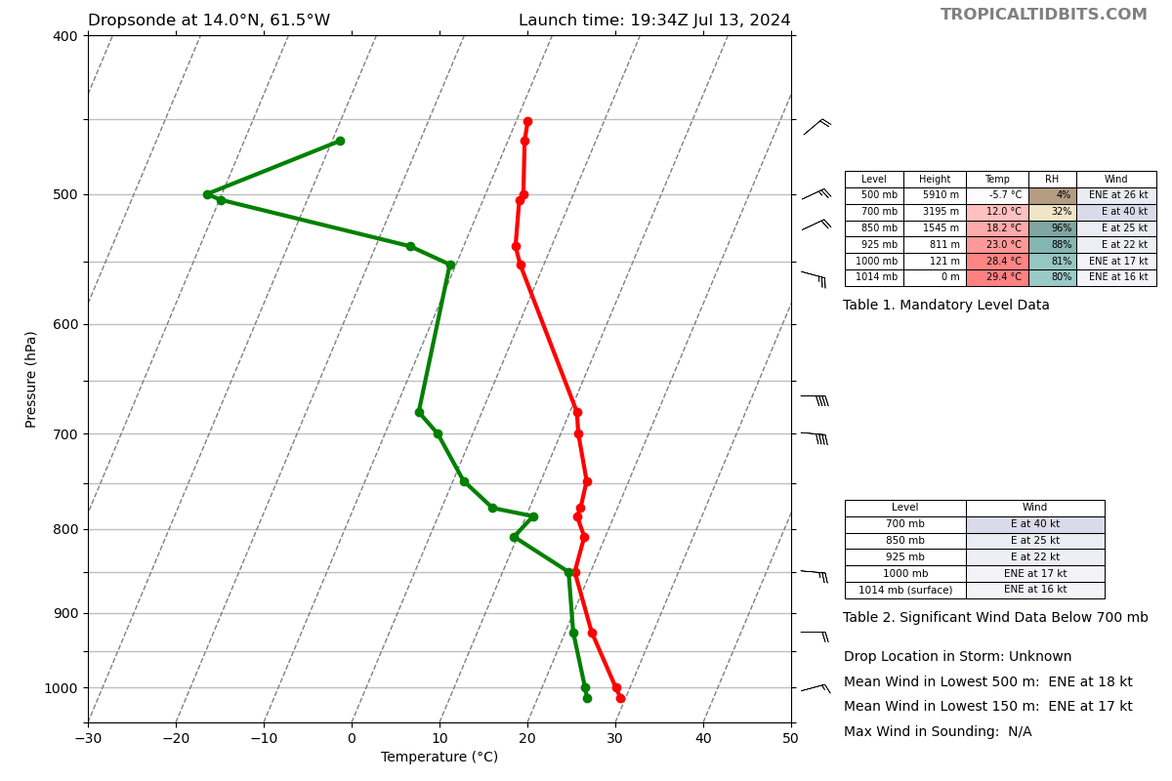
1937 | Dropsonde 29 CH5  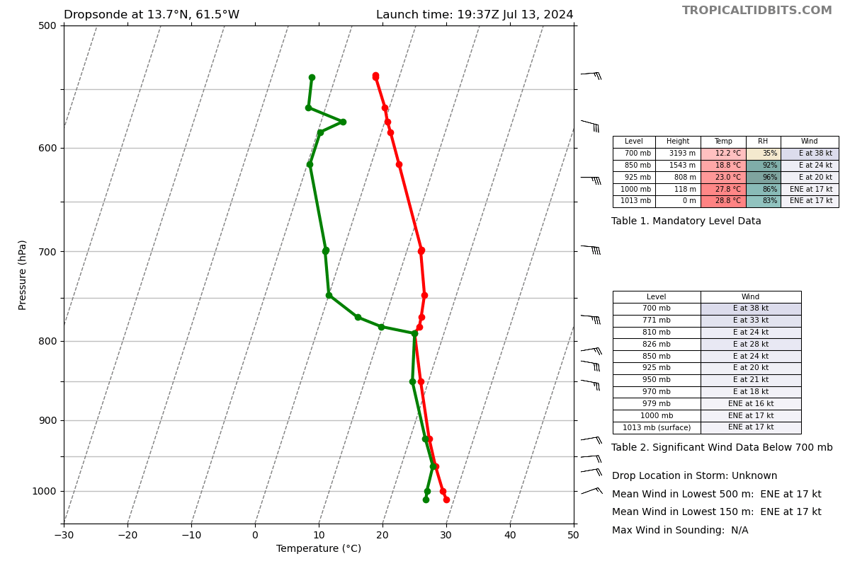
1939 | Descending to 16k ft for the box, no decision yet from ground about 1 or 2 laps around the box
1940 | Not much convection visually
1944 | Dropsonde 30, CH6  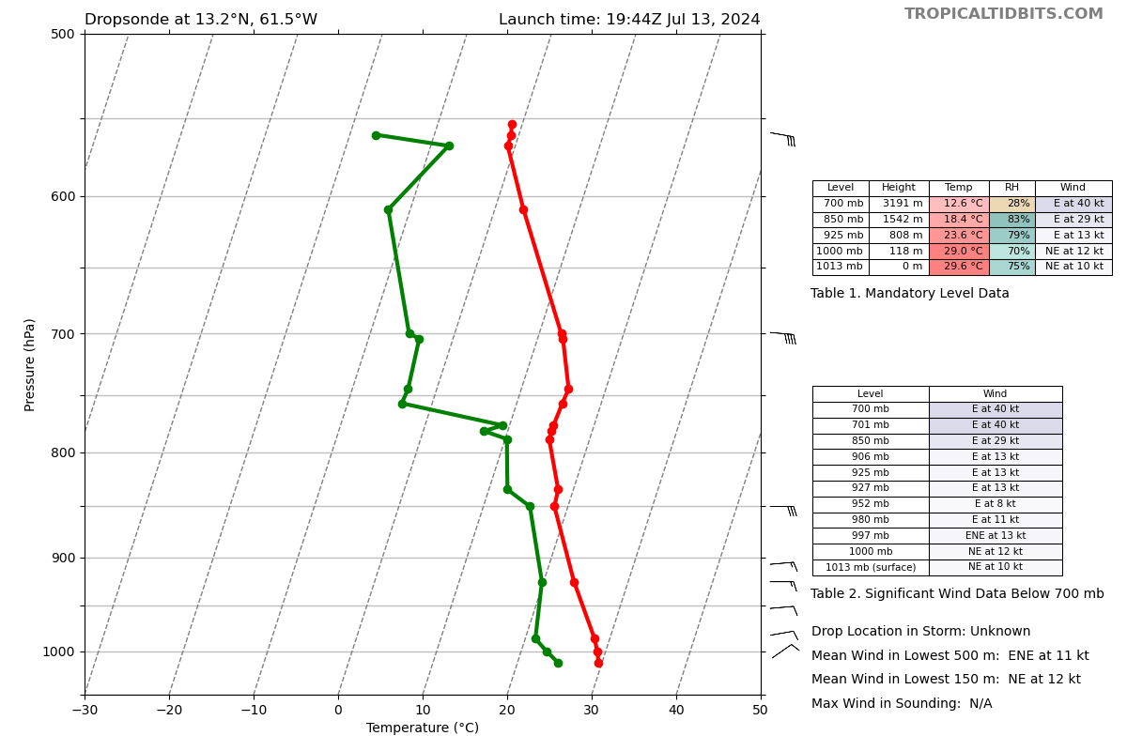
1947 | After lap around box, heading to WP23
1952 | For the racetrack, instead of looping at each drop, can cut the corners and bag WP23, also bag the inbound/outbound legs from Ragged Point
1954 | Dropsonde 31, CH7 (no temp backup on CH8)  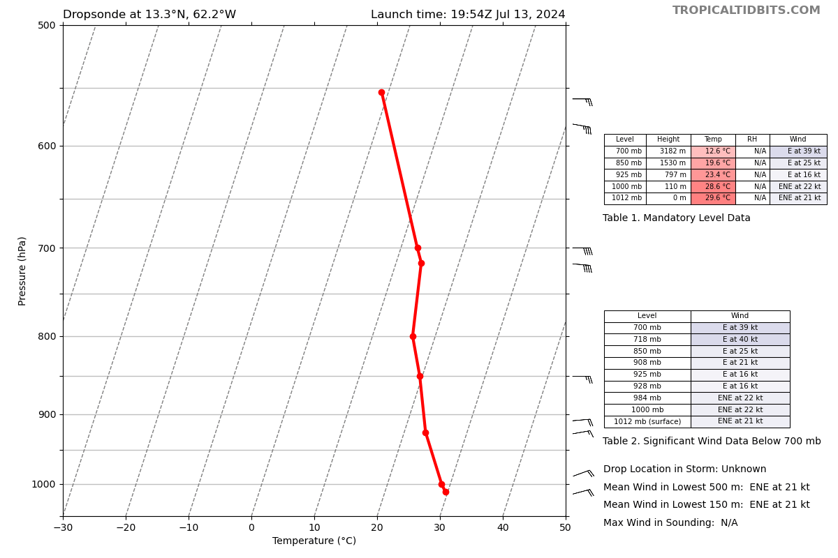
1955 | Dropsonde 32 CH8  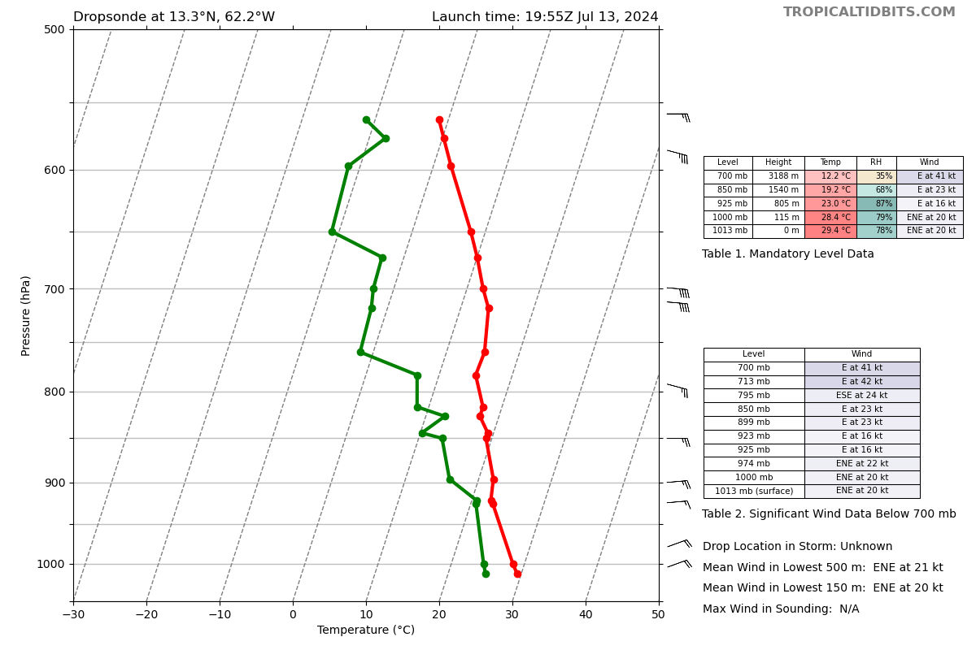
1956 | Last sonde was bad one, so dropped a backup
1958 | Backing up racetrack sondes
1959 | Dropsonde 33, CH1  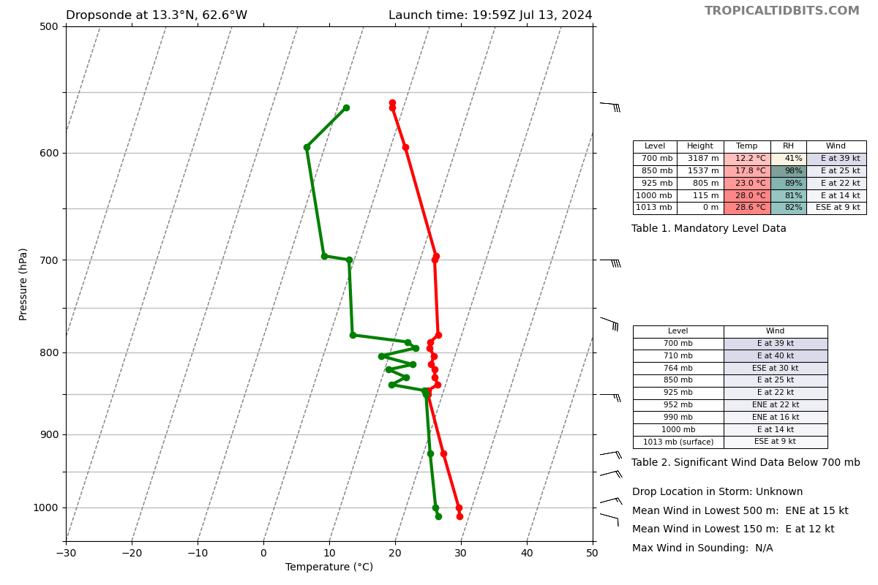
2004 | No go for the second lap around the racetrack. Return to base following finishing the first loop of the racetrack
2004 | Dropsonde 34, CH2  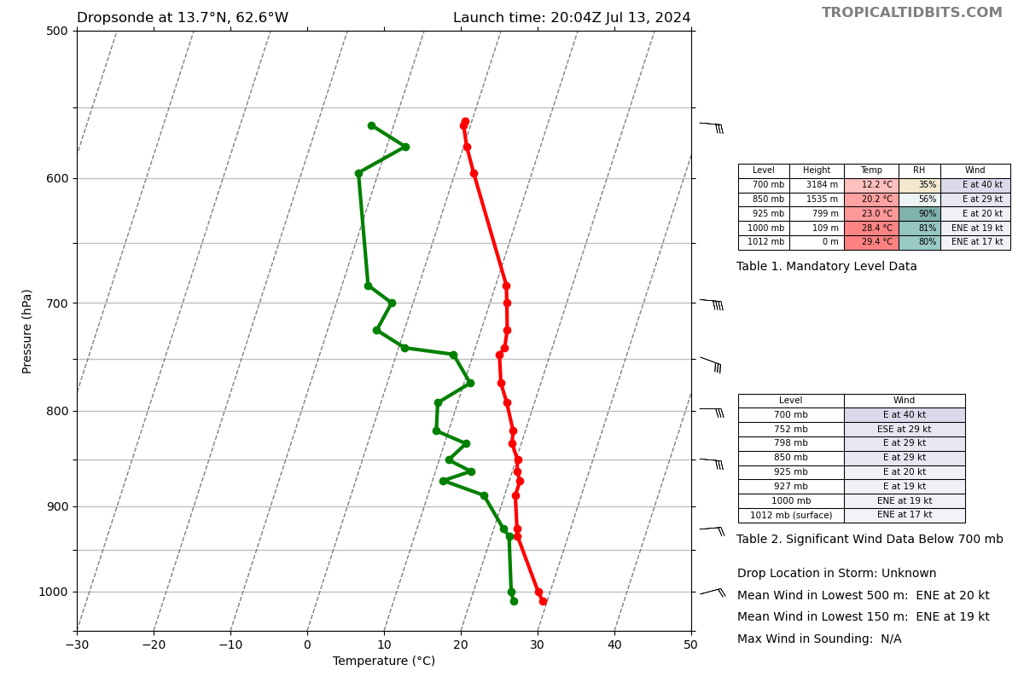
2011 | Dropsonde 35, CH3  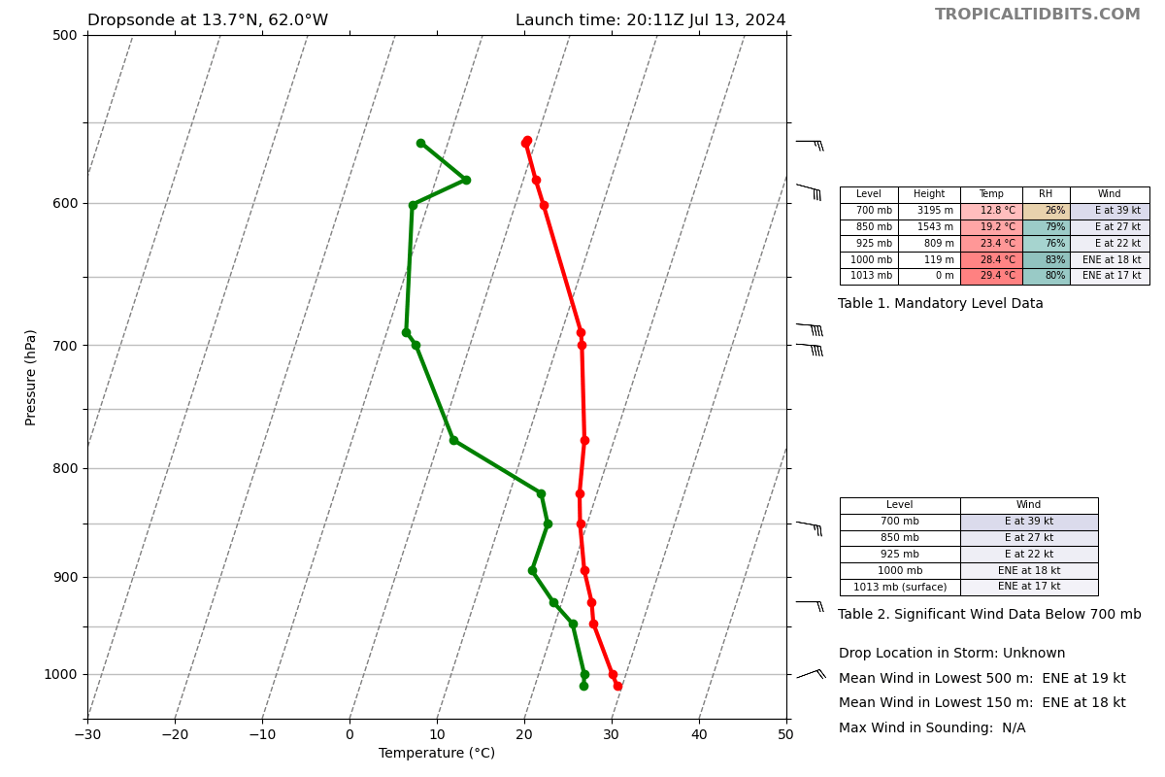
2018 | Dropsonde 36, CH4
2021 | TDR and w-band shut down
2026 | Totals: 36 sondes, 35 good, 1 no temperature, all charged to ONR
2110 | Dropsonde 36 had issues in terms of pressure list

POST-FLIGHT
Mission Summary | The main goal of this mission was to work with MAGPIE to sample an African easterly wave and the Saharan air layer. For most of the mission, the P-3 was above 20 kft (~475 mb) to maximize sampling of the troposphere. The P-3 flew across moisture boundaries between the SAL and its adjacent maritime tropical environment. In addition, MAGPIE and APHEX objectives were met by descending the P-3 between drop points to fly through the SAL. Also, a racetrack module was set up to sample the evolution of a shallow convective line. Very dry air (< 25%) observed in some of the soundings on the northern side of the flight pattern.  Expendables:  - 36 total dropsondes: 34 good, 1 no temperature, 1 pressure out of order, all charged to ONR  - 3 AXBTs: 3 good (all w/ SST)
Actual Standard Pattern Flown | Survey Pattern
APHEX Experiments / Modules Flown | Genesis > FAM > MAGPIE  2024HFP_GenesisStage_Flight_Patterns_FAM.pdf
Plain Language Summary | This HRD-tasked research mission was carried out in collaboration with the MAGPIE program. For most of the mission, the P-3 was above 20 kft (~475 mb) to maximize sampling of the African easterly wave and the Saharan air layer throughout much of the troposphere. The P-3 flew across moisture boundaries between the SAL and its adjacent maritime tropical environment. In addition, MAGPIE and APHEX objectives were met by descending the P-3 between drop points to fly through the SAL. Also, a racetrack module was set up to sample the evolution of a shallow convective line.
Instrument Notes | All instruments worked as expected
Final Mission Track | 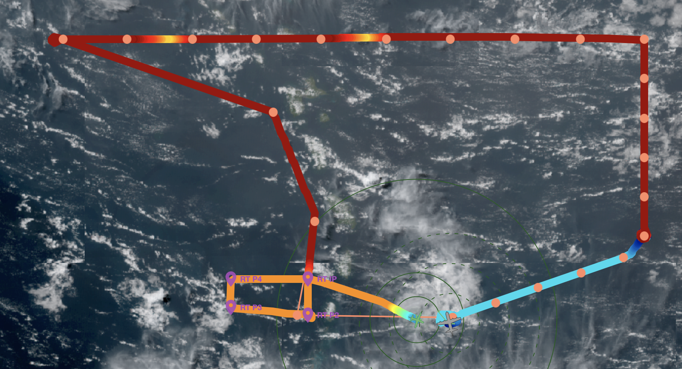  Final flight track with altitude colored

