MISSION PLAN
FLIGHT ID | 20240926I1 | STORM | AL09 HELENE
MISSION ID | 1509A | TAIL NUMBER | NOAA-43
TASKING | TDR | PLANNED PATTERN | Rotated figure 4
MISSION SUMMARY
TAKEOFF [UTC] | 0901 | LANDING [UTC] | 1718
TAKEOFF LOCATION | Lakeland | LANDING LOCATION | Ellington
FLIGHT TIME | 8:17 | BLOCK TIME | 11:47
TOTAL REAL-TIME RADAR ANALYSES  (Transmitted) | 4 (4) | TOTAL DROPSONDES Deployed (Tx to GTS) | 28 (25)
OCEAN EXPENDABLES deployed (good) | 10 UM AXBTs (6)  1 microSWIFT | sUAS (Type) | 2 Blackswift S0 (2)
APHEX EXPERIMENTS / MODULES | NHC TDR tasking; CHAOS; RICO SUAVE
HRD CREW MANIFEST
LPS ONBOARD | J. Zhang/Sellwood | LPS GROUND | Aberson/Montgomery
TDR ONBOARD | J. Zhang/Sellwood | TDR GROUND | Reasor
ASPEN ONBOARD | n/a | ASPEN GROUND | Kaplan, Dunion
NESDIS SCIENTISTS | n/a
GUESTS (Affiliation) | Ken Graham (NWS), Lev Looney (UM)
AOC CREW MANIFEST
PILOTS | Rannenberg/Palmer/Ellis
NAVIGATOR | Meier/Saunders
FLIGHT ENGINEERS | Ripp/Dittoe
FLIGHT DIRECTOR | Zawislak
DATA TECHNICIAN | Richards
AVAPS | Vargas/Hunsinger

PRE-FLIGHT
Flight Plan | 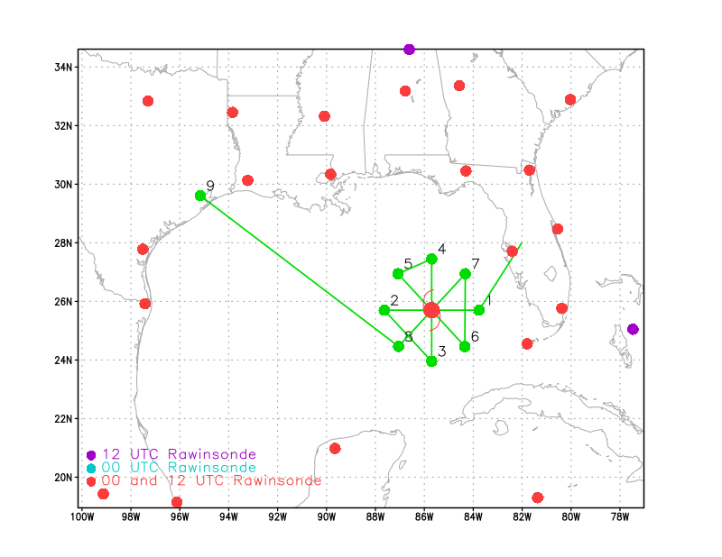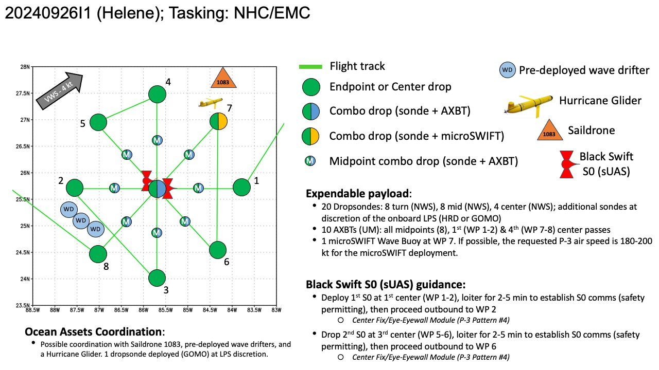  Pattern: Fly rotated figure-4 pattern with 105 NM legs  Altitude:  - 10 kft preferred - 8 kft if AF deconfliction is required (pressure altitude)  Research Modules:  - APHEX Mature Stage: RICO SUAVE - see notes below  - APHEX Ocean Observing: CHAOS - see notes below
Expendable Distribution | Expendables:  - Load 30 dropsondes - see notes below  - All dropsondes transmitted to the GTS  - 10 AXBTs (UM) - see notes below  - All AXBTs transmitted to the AOC ground server if possible  - sUAS  - load 3 Black Swift S0s (2 planned launches) - see notes below
Preflight Weather Briefing | Satellite images show that Helene has a well-organized appearance,  with numerous convective banding features. A ragged-looking eye  feature is also apparent. However, reports from both Air Force and  a NOAA Hurricane Hunter aircraft investigating the system suggest  that the it lacks a well-defined inner core with a somewhat broad  maximum wind field for now. The central pressure has dropped a  little to around 972 mb. Given the slowly falling central  pressure, the intensity is maintained at 75 kt for this advisory.  Helene's structure and intensity will continue to be closely  monitored by Hurricane Hunter aircraft tonight and Thursday.  The hurricane continues moving northward with an estimated initial  motion of 360/08 kt. For the next couple of days, the steering  scenario for this system remains basically unchanged from the  earlier advisory. The flow between a mid-tropospheric trough over  the east-central United States and a ridge over the western  Atlantic should result in Helene accelerating northward to  north-northeastward during the next 24 to 36 hours. This motion  will bring the center of Helene to the northeastern Gulf of Mexico  coast in about 24 hours. The official track forecast through  landfall is very similar to the previous NHC prediction and remains  close to the corrected consensus guidance. After landfall, the  trough to the northwest of the tropical cyclone becomes a cutoff  low, and Helene should turn leftward as it rotates around the low.  In 3-4 days, the system should become a shallow extratropical  cyclone within weaker steering currents.  Helene should be in an atmospheric and oceanic environment over the  eastern Gulf of Mexico that will be very conducive for  strengthening. The system is expected to traverse the Loop Current,  which has especially high oceanic heat content. This, along with  fairly low vertical wind shear and a moist mid- to lower-  tropospheric air mass, should likely result in rapid  intensification before landfall. The official forecast continues  to call for the hurricane to reach category 4 status tomorrow. It  should be noted that the HAFS-A and HAFS-B regional hurricane models  show even more intensification than indicated here.  Helene is forecast to be a large major hurricane when it reaches the  Big Bend coast of Florida. As a result, storm surge, wind, and  rainfall impacts will extend well away from the center and outside  the forecast cone, particularly on the east side. In addition, the  fast forward speed when Helene moves inland will result in a far  inland penetration of strong winds over parts of the southeastern  United States, including strong gusts over higher terrain of the  southern Appalachians. A higher-than-normal gust factor is  indicated in the official forecast while Helene is inland.  [Copy in GIF of recent (~6 hr) satellite loops (https://www.star.nesdis.noaa.gov/GOES/index.php)]  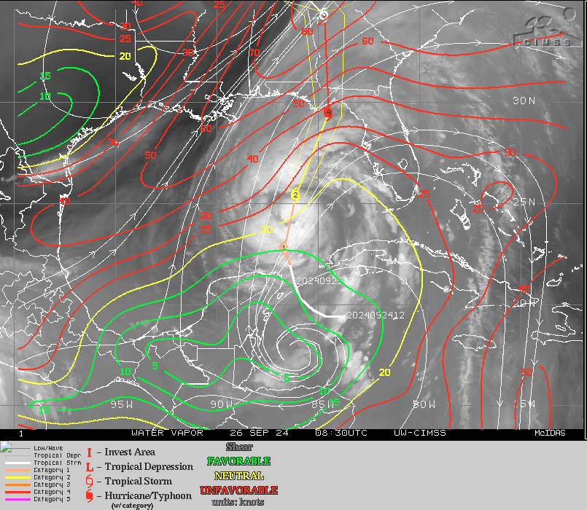  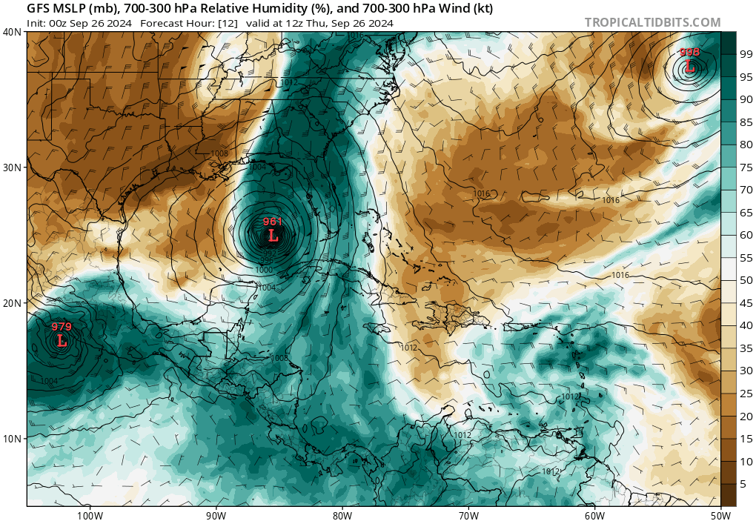  Helene is approaching a very favorable environment with favorable to neutral shear, increased SST and abundant atmospheric moisture
Instrument Notes | All instruments functional the entire flight SFMR in HDOBS turned off.

IN-FLIGHT
Time [UTC] | Event
0901 | Take-off from Lakeland
0905 | 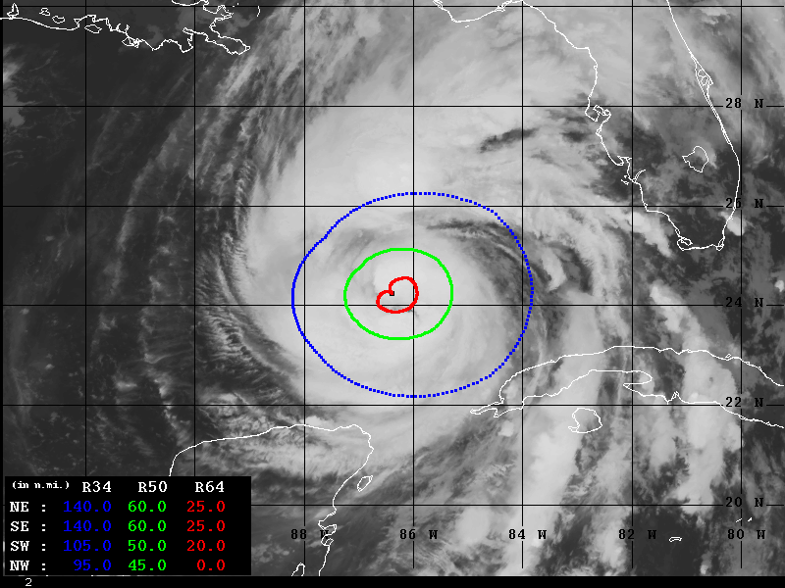  Advanced Dvorak Technique Wind Radii Estimates extending from the center of the storm
0930 | Glider (jaialai) @ 27.748N, 84.357W
0947 | SD-1083: Sig Wave - 2.51m
1018 | Drop 1: IP ENE
1018 | Starting SO checklist
1031 | Drop 2 combo BT 1 midpoint E inbound, no data, no backup SST=25.8C
1038 | Prepping S0 launch
1038 | SO launched
1038 | URNT12 KNHC 261103  VORTEX DATA MESSAGE AL092024  A. 26/10:38:40Z  B. 24.42 deg N 085.97 deg W  C. 700 mb 2794 m  D. 965 mb  E. 040 deg 3 kt  F. OPEN W  G. C32  H. NA  I. NA  J. 299 deg 64 kt  K. 225 deg 48 nm 10:25:00Z  L. NA  M. NA  N. 144 deg 90 kt  O. 046 deg 35 nm 10:48:30Z  P. 10 C / 3036 m  Q. 15 C / 3048 m  R. 7 C / NA  S. 1234 / 07  T. 0.02 / 2 nm  U. AF309 1409A HELENE OB 35  MAX FL WIND 90 KT 046 / 35 NM 10:48:30Z  MAX FL TEMP 15 C 220 / 11 NM FROM FL CNTR
 | 10 m/s updraft on way into eye. FL 105 kt
1042 | S01 dropping to 500m
1042 | Drop 3: Combo Center BT SST=2 28.2C  —-------------------------------------------------------------------------------------------------  URNT12 KWBC  VORTEX DATA MESSAGE AL092024  A. 26/10:42:05Z  B. 24.45 deg N 085.92 deg W  C. NA  D. 964 mb  E. 340 deg 08 kt  F. CLOSED  G. C36  H. NA  I. NA  J. 176 deg 103 kt  K. 093 deg 28 nm 10:34:51Z  L. NA  M. NA  N. 350 deg 65 kt  O. 270 deg 22 nm 10:47:26Z  P. 15 C / 2460 m  Q. 21 C / 2451 m  R. 15 C / NA  S. 12345 / NA  T. 0.01 / 2 nm  U. NOAA3 1509A HELENE OB 99  MAX FL WIND 103 KT 093 / 28 NM 10:34:51Z  TDR center info from 240926I1_1042_xy.nc:  Alt (km) Lat (deg) Lon (deg W)  0.5 24.43 85.88  2.0 24.45 85.90  3.0 24.45 85.90  6.0 24.45 85.86  2-6-km Vortex Tilt: 4.0 km at 90 deg
1043 | Lev: Reading 50 kts from S01
1048 | S01: 61 kts, 80 deg, 500 m
1055 | Lev: S01 >80 kts, 520 m, 55 deg
1056 | Jack Elston: 81 max winds in that last HDOB line
1057 | S01 Descending to 250m
1059 | S01 at 250m, 95 kts, 24 deg
1100 | Drop 4: MP W Combo BT 3 SST=29.5C
1101 | S01 measured 100 kts, Battery 80%
1104 | Lev: 100 kts at 1 deg, 250m
1105 | Jun: HDOBS depicted 106 kts at 250m on HDOBS
1106 | Lev: Lost comms with S01
1108 | Drop 5 Endpoint W
1109 | Lev: S01 25 min flight time. 78% battery
1122 | 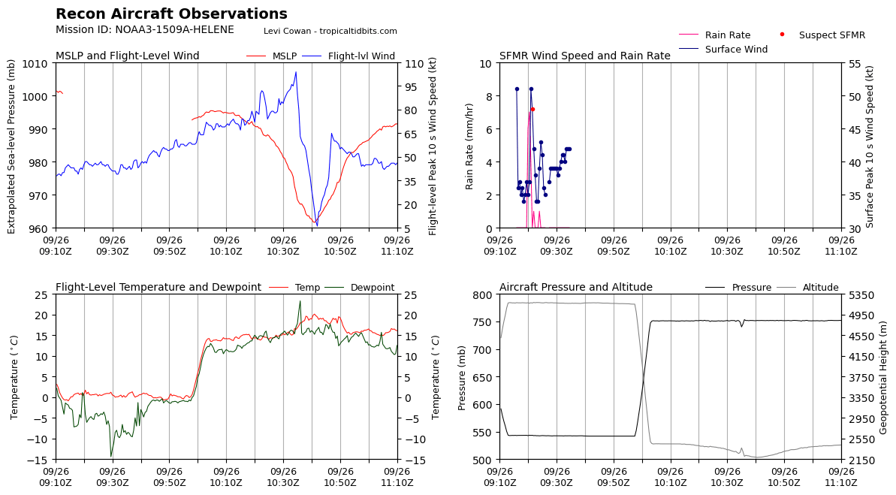
1124 | Running checklist for second SO
1139 | SO checklist complete
1145 | Drop 6: IP S Dropsonde
1155 | 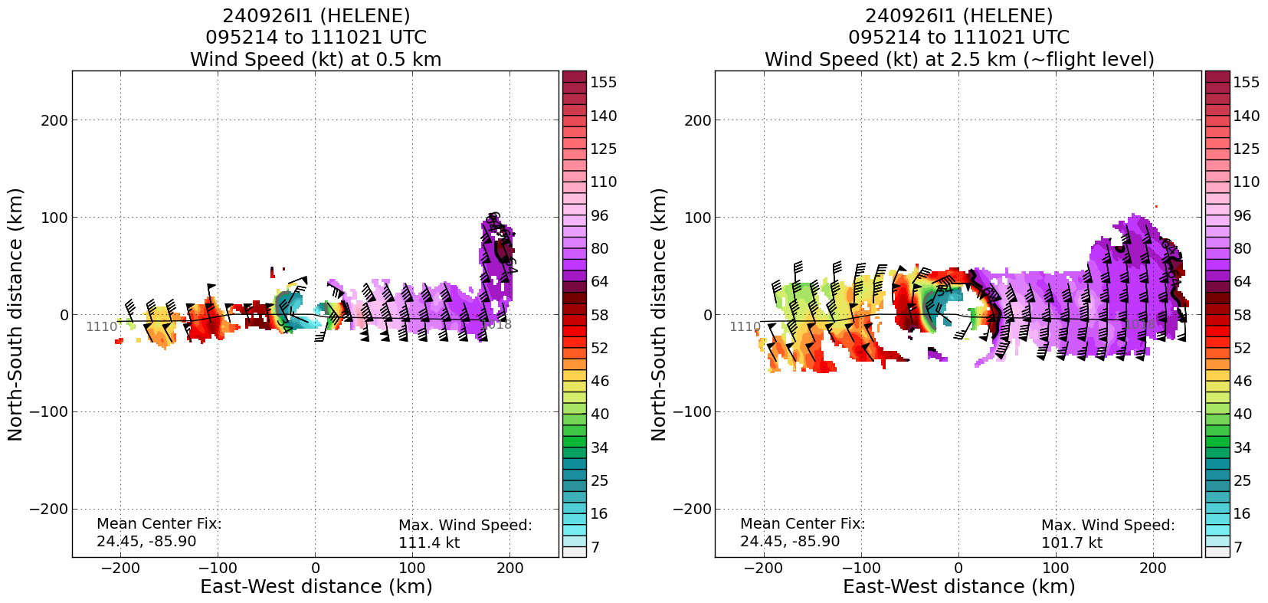
1155 | 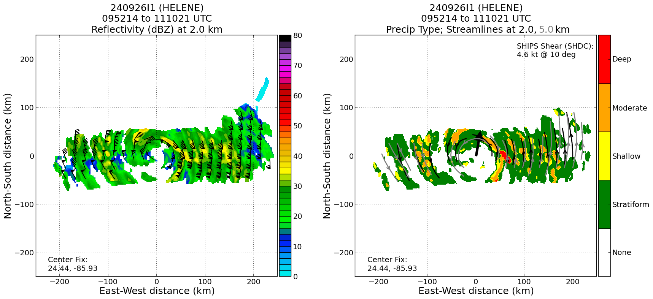
1157 | Drop 7: MP S Combo, BT 4 SST=29.7C
1202 | Drop 8: RMW S, bad PTH, questionable winds, not sent
1204 | Drop 9: RMW , GOMO drifter
1209 | Starting S0 checklist
1213 | Drop 10: Center Combo BT 5, no data  URNT12 KWBC  VORTEX DATA MESSAGE AL092024  A. 26/12:13:08Z  B. 24.84 deg N 085.80 deg W  C. NA  D. 964 mb  E. 130 deg 10 kt  F. OPEN SW  G. C36  H. NA  I. NA  J. 286 deg 79 kt  K. 188 deg 27 nm 12:06:31Z  L. NA  M. NA  N. 104 deg 81 kt  O. 359 deg 23 nm 12:18:33Z  P. 15 C / 2445 m  Q. 21 C / 2448 m  R. 14 C / NA  S. 12345 / NA  T. 0.01 / 2 nm  U. NOAA3 1509A HELENE OB 99  MAX FL WIND 103 KT 093 / 28 NM 10:34:51Z  TDR center info from 240926I1_1213_xy.nc:  Alt (km) Lat (deg) Lon (deg W)  0.5 24.80 85.77  2.0 24.81 85.75  3.0 24.83 85.73  6.0 24.78 85.67  2-6-km Vortex Tilt: 9.0 km at 117 deg
1213 | S0 out
1216 | S02 Descending down to 500 m
1218 | Drop 11: RMW N
1219 | S02 at 500 m, 5 kts, 145 deg, pressure 912.56 mb
1212 | S02 Center fix successful at 500 m
1225 | Drop 12 MP N Outbound BT 4 combo, BT bad
1236 | Drop 13 EP N
1236 | Saildrone 1083 location 27.943N 84.49W
1236 | Glider Jaialai location 84.3566N 27.7478W
1239 | Jun: S0 likely still in the eye, 914mb, battery 70%, 7.6 kts
1244 | Jun: S02 25 kts, battery 65%
1245 | Lev: S02 wind: 350 deg, 25 kts, 500 m
1250 | Lev: S02 headed SW, 70 kts, 325 deg, battery 59%
1251 | Lev: S02 90 kts, 306 deg
1253 | Drop 14 IP NW
1254 | S02 dropping to 250 m, will be at 250 for ~ 7 min, battery 54.6%
1257 | Lev: Still seeing 500 m for S02, having comms issues trying to get low
1259 | Lev: S02 range 67 NM, dropping to 250 m
1302 | Lev: S02 still at 500 m
1304 | S02 at 250 m, 70 kts, 240 deg, battery 45.7%
1306 | Drop 15 Combo MP NW BT 5 27.5C
1311 | S02 at 100 m
1314 | S02 55 kts, 216 deg, 37.5%
1315 | Drop 16 RMW NW
1318 | Drop 17 Center (slightly early wind shift 1 minute later)  TDR center info from 240926I1_1318_xy.nc:  Alt (km) Lat (deg) Lon (deg W)  0.5 99.99 99.99  2.0 25.06 85.59  3.0 25.06 85.55  6.0 25.07 85.51  2-6-km Vortex Tilt: 8.3 km at 76 deg  URNT12 KWBC  VORTEX DATA MESSAGE AL092024  A. 26/13:18:39Z  B. 25.11 deg N 085.67 deg W  C. NA  D. EXTRAP 963 mb  E. NA  F. OPEN SW  G. E13/38/22  H. NA  I. NA  J. 049 deg 55 kt  K. 312 deg 27 nm 13:11:53Z  L. NA  M. NA  N. 231 deg 103 kt  O. 134 deg 36 nm 13:27:23Z  P. 18 C / 2453 m  Q. 21 C / 2451 m  R. 15 C / NA  S. 12345 / NA  T. 0.01 / 3 nm  U. NOAA3 1509A HELENE OB 99  SLP EXTRAP FROM 8000FT  MAX FL WIND 103 KT 093 / 28 NM 10:34:51Z
1321 | S02 descending to 60 m, 30% battery
1327 | Drop 18 RMW SE 110 kts at flight level
1329 | S02, 65 kts, 175 deg, 60 m
1331 | S02 at 40 m
1332 | Drop 19 MP Combo SE outbound BT 8, bad BT
1332 | S02 hit wave is in the water laser read 9m
1349 | 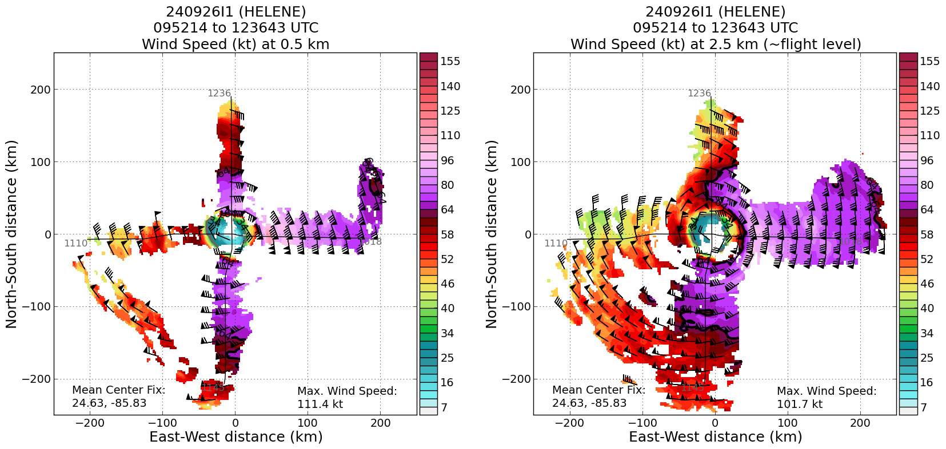
1351 | 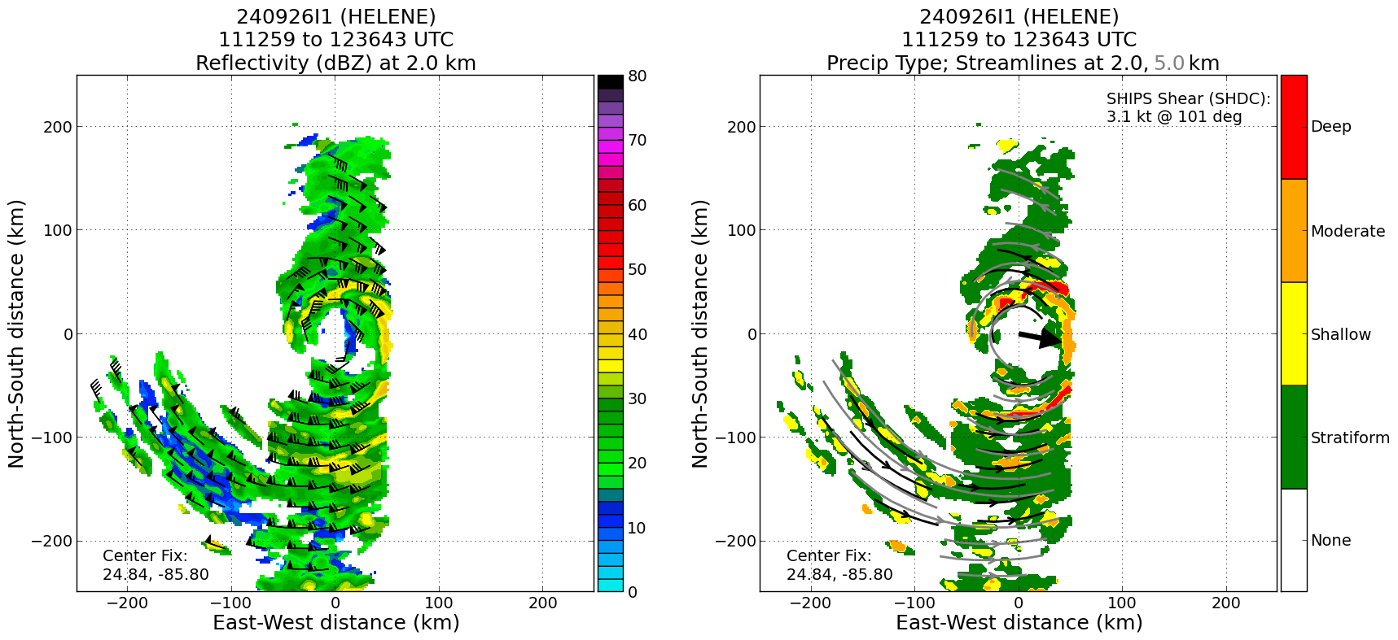
1416 | Drop 21 (1416z) IP NE combo with microSWIFT buoy  1746z update - HFP leadership confirmed with the PI that the microSWIFT is active and currently reporting 7.8 m waves
1416 | URNT12 KNHC 261447  VORTEX DATA MESSAGE AL092024  A. 26/14:15:30Z  B. 25.28 deg N 085.55 deg W  C. 700 mb 2792 m  D. 962 mb  E. 220 deg 8 kt  F. CLOSED  G. C30  H. 66 kt  I. 340 deg 13 nm 14:11:30Z  J. 064 deg 59 kt  K. 338 deg 15 nm 14:11:00Z  L. 76 kt  M. 091 deg 35 nm 14:25:00Z  N. 186 deg 101 kt  O. 090 deg 58 nm 14:31:30Z  P. 14 C / 3043 m  Q. 16 C / 3049 m  R. 12 C / NA  S. 12345 / 07  T. 0.02 / 4 nm  U. AF308 1609A HELENE OB 04  MAX FL WIND 101 KT 090 / 58 NM 14:11:00Z
1428 | Drop 22 MP combo BT 9, bad BT
1434 | Drop 23 RMW NE
 | Elongated eye, eyewall is not continuous (insert shot of MMR)
1442 | Drop 24 Center, eye rectangular in shape, elongated north-south  TDR center info from 240926I1_1441_xy.nc:  Alt (km) Lat (deg) Lon (deg W)  0.5 25.40 85.38  2.0 25.43 85.38  3.0 25.43 85.36  6.0 25.43 85.34  2-6-km Vortex Tilt: 4.0 km at 90 deg
1446 | Drop 25 RMW SW
1457 | Drop 26 Midpoint SW BT 29.6C
1512 | Drop 27 Endpoint SW last sonde
 | NASA N520NA in storm at 30 kft. Unknown what they are doing. CARCAH has no knowledge of them. The aircraft does not see to have expendables. https://www.nasa.gov/aeronautics/g-iii/
 | Paul Reasor: a HUGE change in structure over 12 h (between last night and this morning)
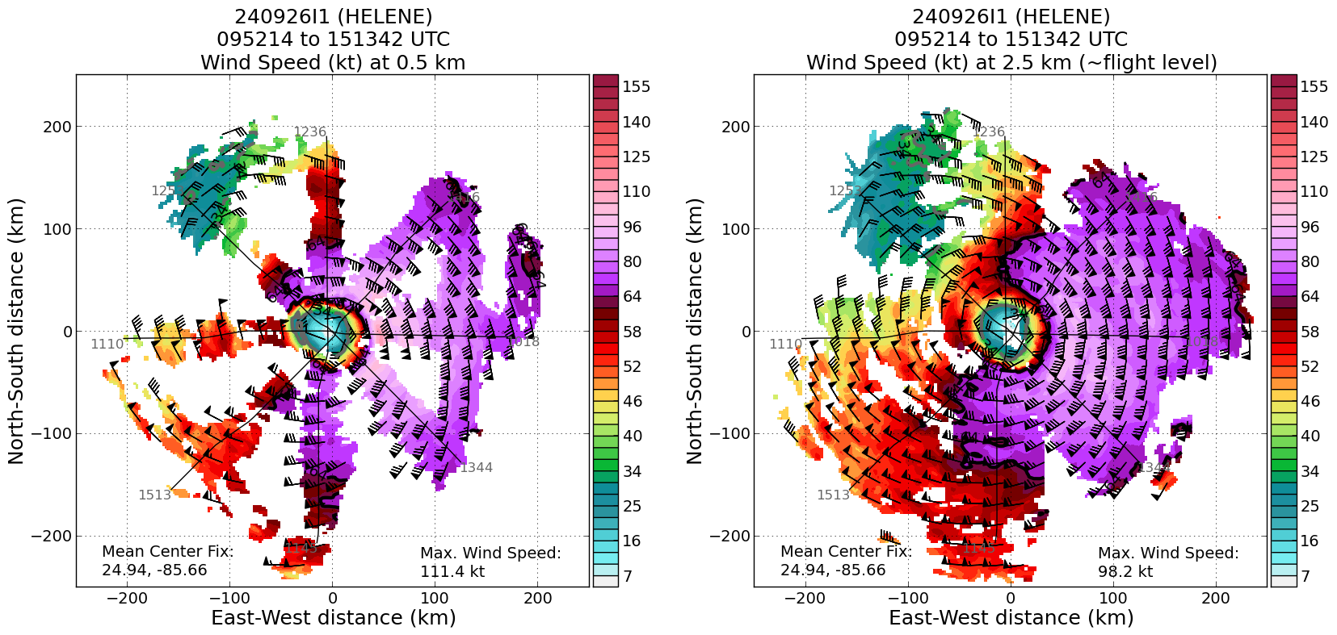
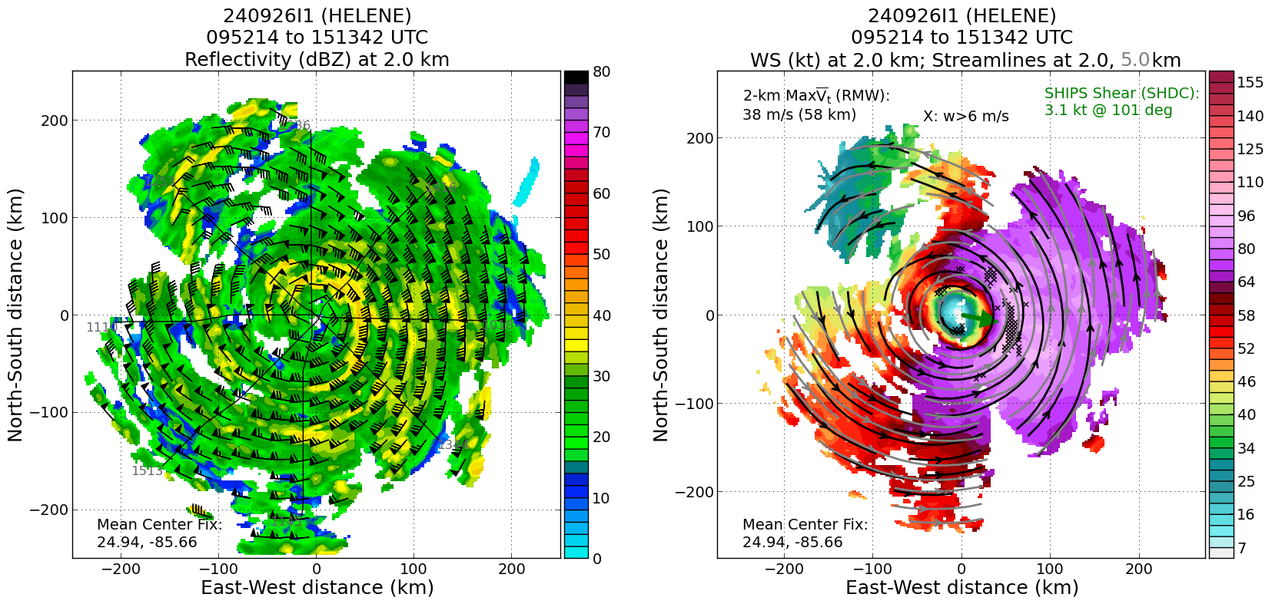
Stats from 2nd S0:
Date and Takeoff Time: 2024-09-26 12:13:42 (ZULU)
Total TOF (min): 73.8 min
S0 Serial Number: 33
Launch Altitude: 1811.8 m [MSL]
Launch Latitude: 24.848690 deg
Launch Longitude: -85.801190 deg
Termination Latitude: 24.457212
Termination Longitude: -86.068121
XXXX | [describe event and paste associated screenshot or gif, if available]

POST-FLIGHT
Mission Summary | 2 successful Blackswift S0 Suas flights lasting 20 and 40 minutes in support of RICO SUAVE experiment. 1 Microswift buoy launched in proximity to ocean glider JaiAlai. An unusual evolution of Helene’s eye was observed beginning with an elongated structure with some indication of a SEF which became nearly rectangular in shape with multiple breaks during the final pass through the storm. A dropsonde was released in the approximate location of 3 previously deployed wave drifters.  Huge structural changes since last flight. Slow deepening and intensification. Large RMW may be impeding rapid intensity changes.  Inexperienced AVAPS operator: (1) very late in closing out sondes, up to 45 min, caused backup in processing, (2) did not report launches for TAG, (3) did not report BT launches, (4) confused Celsius and Fahrenheit, (5) did not send BT data to the ground, (6) did not confirm good data, so two bad sondes were not backed up. This all caused confusion and delay for TAG and ground-based LPS in documenting what happened.  26 NHC & 1 CHAOS dropsondes launched (25 transmitted)  10 UM AXBTs  1 CHAOS microSWIFT wave buoy  2 Black Swift S0 sUAS
Actual Standard Pattern Flown | Rotated figure 4
APHEX Experiments / Modules Flown | CHAOS and RICO SUAVE experiments
Plain Language Summary | Helene was slowly getting its act together before a likely period of rapid intensification before landfall. The eyewall was gradually closing up and contracting. Pressure was slowly decreasing, and wind speeds were slowly increasing through the flight.
Instrument Notes | Instruments worked well.
Final Mission Track | 