MISSION PLAN
FLIGHT ID | 20240926H1 | STORM | AL09
MISSION ID | 1709A | TAIL NUMBER | NOAA-42
TASKING | NHC/EMC TDR | PLANNED PATTERN | Rotated Fig-4
MISSION SUMMARY
TAKEOFF [UTC] | 1952 | LANDING [UTC]
TAKEOFF LOCATION | KEFD | LANDING LOCATION | KEFD
FLIGHT TIME | Fractional hr, Takeoff to Landing Time | BLOCK TIME | Get from onboard LPS or Flight Director
TOTAL REAL-TIME RADAR ANALYSES  (Transmitted) | 4 (4) | TOTAL DROPSONDES Deployed (Tx to GTS) | 24 (20)
OCEAN EXPENDABLES deployed (good) | 8 UM AXBTs (7) | sUAS (Type) | 2 Blackswift s0
APHEX EXPERIMENTS / MODULES | Exact name of the Experiment in the HFP Plan; identify relevant experiments / module even if not a research tasking
HRD CREW MANIFEST
LPS ONBOARD | Hazelton | LPS GROUND | Holbach/Aberson
TDR ONBOARD | Hazelton | TDR GROUND | Gamache/Hollingshead
ASPEN ONBOARD | n/a | ASPEN GROUND | Sippel/Dahl
NESDIS SCIENTISTS | Chang, Jelenak
GUESTS (Affiliation)
AOC CREW MANIFEST
PILOTS | Abitol, Wood, Keith
NAVIGATOR
FLIGHT ENGINEERS
FLIGHT DIRECTOR
DATA TECHNICIAN
AVAPS

PRE-FLIGHT
Flight Plan | 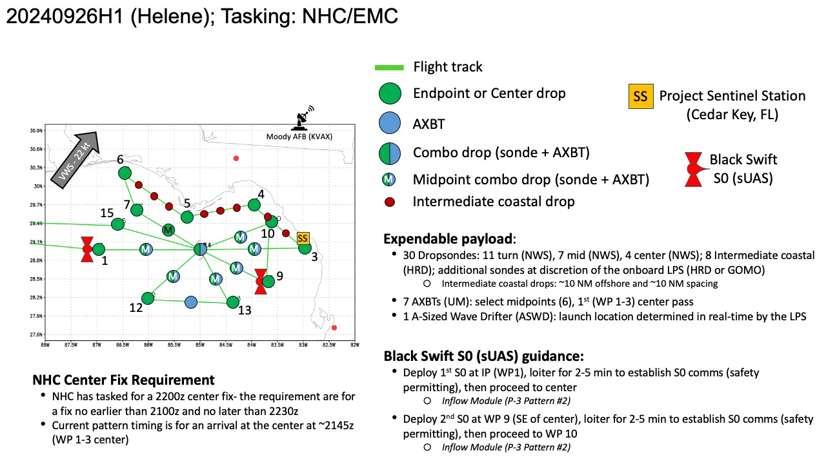  Planned flight pattern is a modified butterfly with a coastal run. 105 n mi legs.
Expendable Distribution | Endpoint, midpoint, and center drops. Coastal drops every ~10 n mi. AXBTs at locations noted in the flight plan.
Preflight Weather Briefing | As of 5pm ET Helene is a category 3 hurricane with max winds of 110 kt and minimum pressure of 951 mb. It is moving north-northeastward at 025/20 kt.  NHC 5pm discussion:  Helene has rapidly intensified today while nearing landfall in the  Florida Big Bend. Doppler radar and aircraft data indicate that the  eyewall is now completely closed and the eye has become more  circular and is clearing out. The aircraft data also indicated  that the inner core has contracted significantly today while the  tropical-storm-force winds have expanded. Based on all of the data,  the initial intensity is set at 110 kt. The latest minimum pressure  based on the aircraft data is around 951 mb. Tropical-storm-force  winds are occurring across portions of west-central and southwestern  Florida, and conditions are expected to deteriorate rapidly in the  hurricane warning area during the next several hours. It should be  emphasized that Helene is at the upper bound of hurricanes in  terms of storm size and impacts are and will occur well away  from the center.  The large hurricane is now accelerating north-northeastward, with  the latest initial motion estimated to be 025/20 kt. This general  motion is expected to continue, taking the core of the major  hurricane to the Florida Big Bend later this evening. After  landfall, a turn to the north over Georgia is expected late tonight  and early Friday, followed by a slowdown or a complete stall over  the Tennessee Valley late Friday and Saturday when Helene merges  with a mid- to upper-level low.  The hurricane has intensified by 30 kt since sunrise and given the  conducive environmental conditions and contracting inner core, it  seems likely that Helene will be at or very near category 4 strength  when it makes landfall in the Florida Big Bend this evening.  The fast forward speed when Helene moves inland will result in a  far inland penetration of strong winds over parts of the  southeastern United States, including strong gusts over the higher  terrain of the southern Appalachians. Accordingly, a  higher-than-normal gust factor is indicated in the official forecast  while Helene is inland.  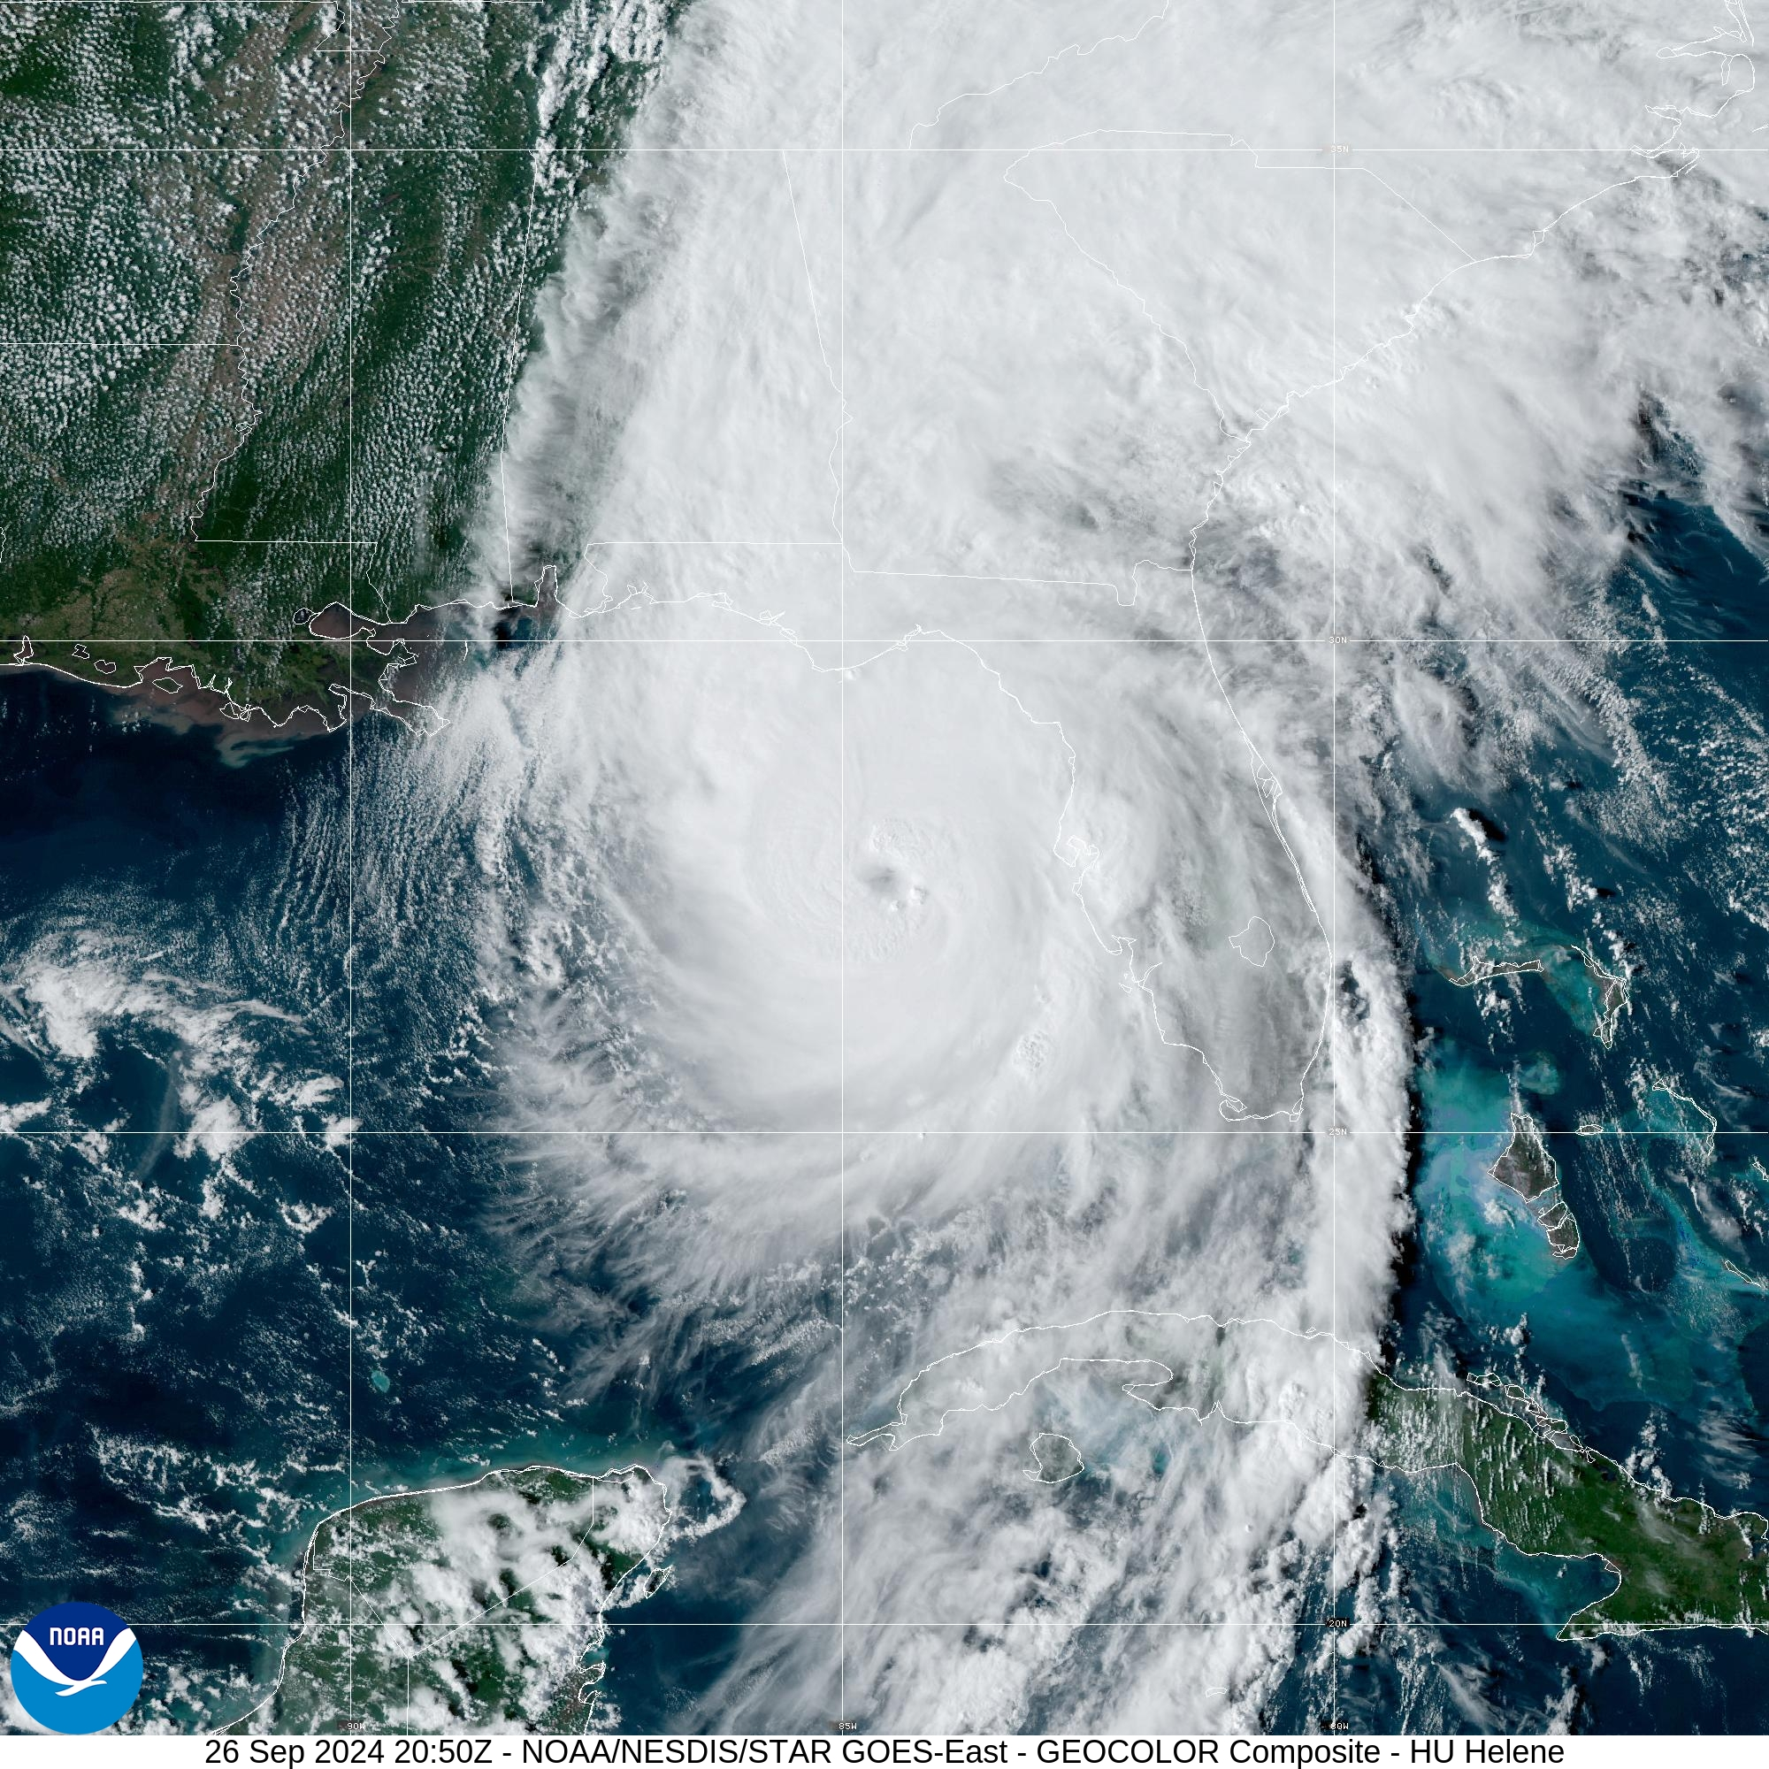
Instrument Notes | [What instruments are working, not working, not functioning nominally, not installed?]

IN-FLIGHT
Time [UTC] | Event
1952 | Take-off from EFD
2038 | Modified flight track:  ahazelton_n42_LPS Looks very soupy for the coastal run, and the TC is further S than anticipated  ahazelton_n42_LPS So we are doing an audible to what's basically a rotated figure 4  Droning_On A second audible is we are doing only 1 sUAS (@ the IP 105nmi west of the center)  ahazelton_n42_LPS We will do a W-E run first, downwind, NE-SW, downwind, S-N, downwind, NW to the center, and from there either out SE or W depending on if we can land in Lakeland or have to go back to Houston  Droning_On It will be an inflow mission ending with (hopefully, time permitting) a partial orbit in the eyewall
2123 | Drop 1 IP west with S0
2130 | S0 at 1000m. Following a trajectory that should get it to the storm center/eyewall. Wind direction 245 deg.
2135 | Drop 2 midpoint, combo drop BT 1, started reporting when T=20C
2142 | Onboard LPS notes an elliptical eye with possible mesovortices
2149 | Drop 3 center, combo drop BT 2 29.5C  URNT12 KWBC  VORTEX DATA MESSAGE AL092024  A. 26/21:50:06Z  B. 27.90 deg N 084.56 deg W  C. NA  D. 948 mb  E. 190 deg 08 kt  F. OPEN W  G. C30  H. NA  I. NA  J. 317 deg 97 kt  K. 220 deg 12 nm 21:47:05Z  L. NA  M. NA  N. 185 deg 136 kt  O. 090 deg 31 nm 21:57:21Z  P. 20 C / 2448 m  Q. 23 C / 2441 m  R. 14 C / NA  S. 12345 / NA  T. 0.01 / 3 nm  U. NOAA2 1709A HELENE OB 99  MAX FL WIND 136 KT 090 / 31 NM 21:57:21Z  MAX FL TEMP 24 C 089 / 13 NM FROM FL CNTR  TDR center info from 240926H1_2150_xy.nc:  Alt (km) Lat (deg) Lon (deg W)  0.5 99.99 99.99  2.0 27.89 84.49  3.0 27.91 84.47  6.0 27.94 84.41  2-6-km Vortex Tilt: 10.0 km at 53 deg
2156 | Drop 4 RMW E
2200 | Drop 5 MP combo drop BT 3 29.4C
2210 | Drop 6 EP
2218 | Lost comms with S0
2220 | NHC upgraded Helene to a category 4 hurricane with winds 115 kt and min pressure 947 based on data from our first pass.
2225 | Drop 7 IP NE
2226 | Regained comms with S0
2234 | Drop 8 MP
2238 | Drops 9, 10, 11, 3-sonde sequence in northeast eyewall
2247 | Drop 12, center combo BT 29.1  URNT12 KWBC  VORTEX DATA MESSAGE AL092024  A. 26/22:46:11Z  B. 28.26 deg N 084.42 deg W  C. NA  D. 944 mb  E. NA  F. CLOSED  G. E14/35/25  H. NA  I. NA  J. 150 deg 127 kt  K. 066 deg 20 nm 22:40:35Z  L. NA  M. NA  N. 298 deg 85 kt  O. 033 deg 1 nm 23:30:39Z  P. 17 C / 2441 m  Q. 25 C / 2306 m  R. 18 C / NA  S. 12345 / NA  T. 0.01 / 2 nm  U. NOAA2 1709A HELENE OB 99  MAX FL WIND 136 KT 090 / 31 NM 21:57:21Z  TDR center info from 240926H1_2246_xy.nc:  Alt (km) Lat (deg) Lon (deg W)  0.5 99.99 99.99  2.0 28.25 84.35  3.0 28.27 84.33  6.0 28.31 84.31  2-6-km Vortex Tilt: 7.2 km at 34 deg
2250 | Turned in eye to reposition. Looked like center was tucked to west side where eyewall curved in. Continued circling due to comms issues  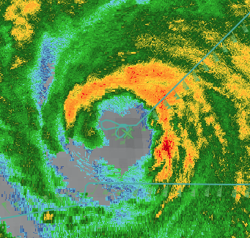
2321 | Onboard LPS noted that eyewall seems to be closing off on the MMR and nose
2322 | Plan is to go out SW, then downwind to S, S to N, downwind to NW, inbound from NW and then either out SE or back out NW depending on time and where they will be landing
2323 | Release of second S0
2326 | Onboard LPS noted lots of small scale and medium scale features in the eyewall
2338 | Droning_On update for s0....100kts at 900m...just entering east eyewall...plan to drop to 700m soon...should get north semicircle of eyewall...maybe more cov  Droning_On 140kts..  sim_home You measured 140 kt, or hoping you do?  ahazelton_n42_LPS It did  ahazelton_n42_LPS I think there was a 148  Droning_On whats crazy is winds are HIGHLY variable...not usually what we see...140, 110, 130, 100...all within a min of flight time...meso vortex action ??  Droning_On we are at 700m..droppong to 500m
2345 | Sonde 13 MP combo BT bad
 | 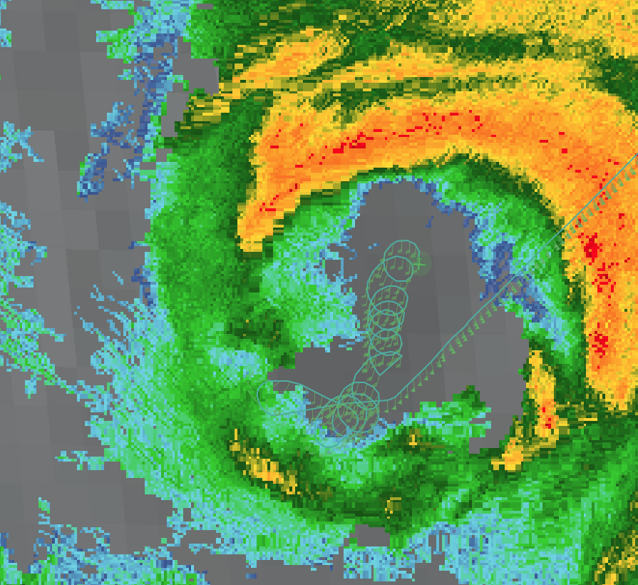
2328 | Inadvertent eye/eyewall mixing module
 | 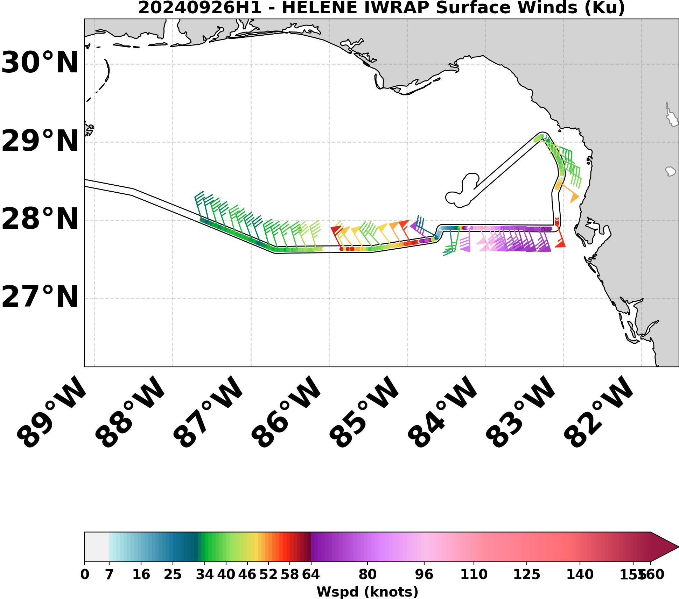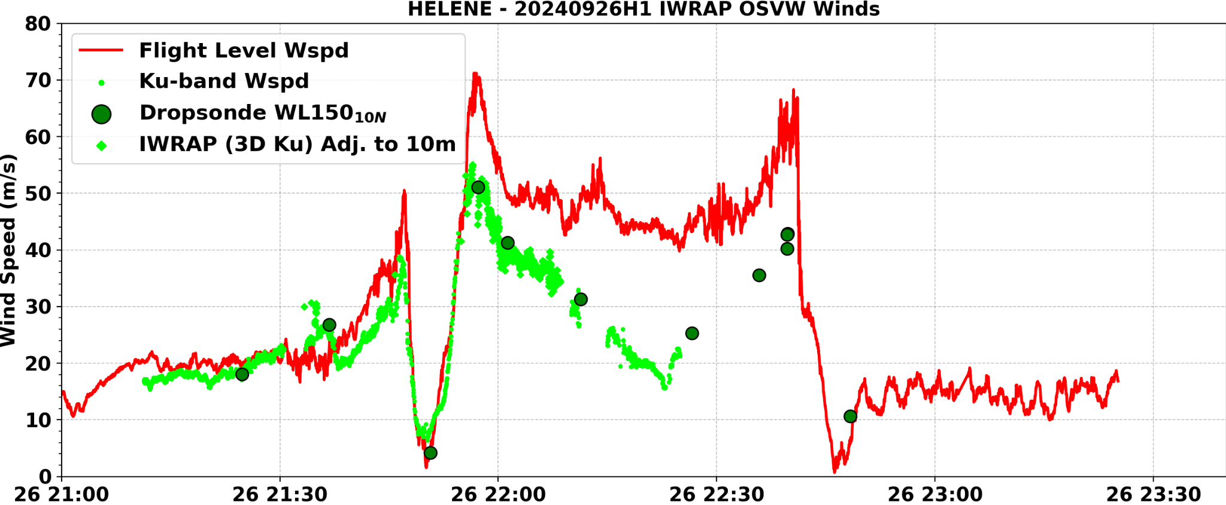
2340 | S0 reported 148 kt at 900 m
2353 | Sonde 14 EP
2347 | Trimming SW leg a little to save some time and there is not much precip out that way
0011 | Sonde 15 IP S
0019 | Sonde 16 MP, bad sonde
0020 | Sonde 17 MP combo BT bad
0030 | No center sonde  TDR center info from 240926H1_2430_xy.nc:  Alt (km) Lat (deg) Lon (deg W)  0.5 99.99 99.99  2.0 99.99 99.99  3.0 99.99 99.99  6.0 28.95 84.09  2-6-km Vortex Tilt: 999.9 km at 999 deg
0031 | Decided not to go out north, going out northeast. Scalloping in eyewall
0032 | URNT12 KNHC 270056  VORTEX DATA MESSAGE AL092024  A. 27/00:32:30Z  B. 28.98 deg N 084.20 deg W  C. 700 mb 2622 m  D. 942 mb  E. 175 deg 11 kt  F. OPEN S  G. C30  H. 101 kt  I. 059 deg 17 nm 00:27:00Z  J. 136 deg 123 kt  K. 056 deg 23 nm 00:25:00Z  L. 79 kt  M. 202 deg 15 nm 00:37:30Z  N. 301 deg 100 kt  O. 199 deg 14 nm 00:37:00Z  P. 10 C / 3045 m  Q. 20 C / 3047 m  R. 14 C / NA  S. 12345 / 7  T. 0.02 / 1.5 nm  U. AF306 1809A HELENE OB 09  MAX FL WIND 134 KT 085 / 28 NM 23:46:30Z
0034 | Sonde 18 RMW NE
0042-3 | Sondes 19-21 RMW NE
0044 | S0 got 138 kt at 150 m
 | Quick turnaround, back in northeast
0047 | Lost comms with S0
0050 | Sonde 22 Center  URNT12 KWBC  VORTEX DATA MESSAGE AL092024  A. 27/00:49:57Z  B. 29.01 deg N 084.17 deg W  C. NA  D. 943 mb  E. 285 deg 09 kt  F. OPEN S  G. E12/40/25  H. NA  I. NA  J. 165 deg 136 kt  K. 068 deg 23 nm 00:43:27Z  L. NA  M. NA  N. 302 deg 87 kt  O. 239 deg 8 nm 00:52:05Z  P. 17 C / 2535 m  Q. 22 C / 2437 m  R. 16 C / NA  S. 1234 / NA  T. 0.01 / NA  U. NOAA2 1709A HELENE OB 99  MAX FL WIND 139 KT 172 / 33 NM 00:35:17Z  MAX FL TEMP 24 C 076 / 16 NM FROM FL CNTR  TDR center info from 240926H1_2449_xy.nc:  Alt (km) Lat (deg) Lon (deg W)  0.5 99.99 99.99  2.0 29.00 84.08  3.0 29.06 84.10  6.0 29.11 84.08  2-6-km Vortex Tilt: 12.0 km at 0 deg
0100 | Sonde 23 MP W
0116 | Sonde 24 EP
 | 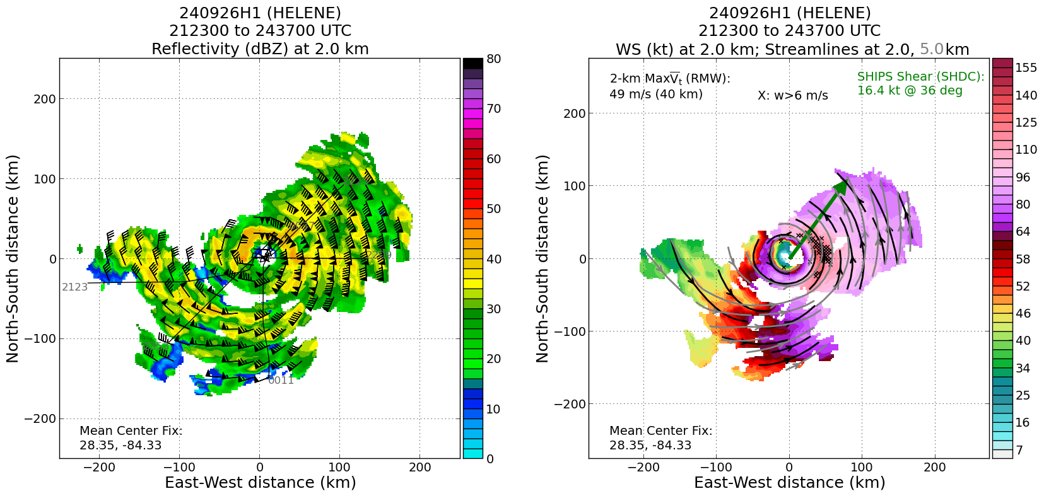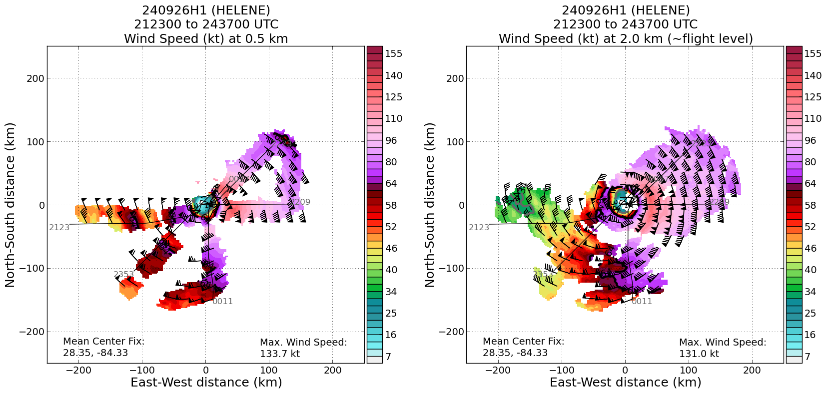

POST-FLIGHT
Mission Summary | [Short description of interesting observations from the flight; what objectives were successful? What was unsuccessful? Was the planned pattern flown? What deviations occurred?  [Don’t forget to fill in Tables on page 1]  [Sonde and ocean expendable accounting: how many total of each? How many are charged to each account?]
Actual Standard Pattern Flown | [Butterfly, Rotated Figure-4, Lawnmower, etc]
APHEX Experiments / Modules Flown | [Linked to HFP Plan; fill in regardless of whether the mission was operationally or research tasked]
Plain Language Summary | [Boil down the above into a couple of bullet points in “plain language”. This will help us when we report to management & OAR Public Affairs and prepare storm mission summaries]
Instrument Notes | [Notes about instrument status from during and after the mission]
Final Mission Track | 