MISSION PLAN
FLIGHT ID | 20240925I1 | STORM | AL09/HELENE
MISSION ID | 1009A | TAIL NUMBER | NOAA-43
TASKING | NHC/EMC TDR | PLANNED PATTERN | Butterfly
MISSION SUMMARY
TAKEOFF [UTC] | 0906 | LANDING [UTC] | 1611
TAKEOFF LOCATION | KLAL | LANDING LOCATION | KLAL
FLIGHT TIME | 07.08 | BLOCK TIME | 10:00
TOTAL REAL-TIME RADAR ANALYSES  (Transmitted) | 4 (4) | TOTAL DROPSONDES Deployed (Tx to GTS) | 17 (16)
OCEAN EXPENDABLES deployed (good) | 8 AXBTs (4), 1 wavedrifter | sUAS (Type) | 2 S0s (11 HdOBS), 8 Streamsondes
APHEX EXPERIMENTS / MODULES | RICO SUAVE, Tail Doppler Radar Dual-PRF in Hurricanes, CHAOS, Distribution of Hazardous Winds
HRD CREW MANIFEST
LPS ONBOARD | J. Zhang/Sellwood | LPS GROUND | Aberson/Montgomery
TDR ONBOARD | J. Zhang/Sellwood | TDR GROUND | Reasor
ASPEN ONBOARD | n/a | ASPEN GROUND | Kaplan
sUAS SCIENTISTS | Jack Elston (Blackswift), Josh Wadler (ERAU)
GUESTS (Affiliation) | Tom Fritz (media), Jennifer Brooks Bingham and Caitlin Durkovich (National Security Council)
AOC CREW MANIFEST
PILOTS | Rannenberg/Palmer/Ellis
NAVIGATOR | Meier/Saunders
FLIGHT ENGINEERS | Ripp/Dittoe
FLIGHT DIRECTOR | Zawislak
DATA TECHNICIAN | Richards
AVAPS | Vargas/Hunnsiger

PRE-FLIGHT
Flight Plan | Pattern: Fly butterfly pattern with 105 NM legs  - Pattern should be adjusted as needed to avoid land  Altitude:  - 10 kft preferred - 8 kft if AF deconfliction is required (pressure altitude)  Research Modules:  - APHEX Mature Stage: RICO SUAVE - see notes below  - APHEX Early Stage: Tail Doppler Radar Dual-PRF in Hurricanes - see notes below  - APHEX Ocean Observing: CHAOS - see notes below  - APHEX Mature Stage: Distribution of Hazardous Winds - see notes below  - Distribution of Hazardous Winds Module  - If possible, during the ferry to the storm fly a straight and level leg starting 150 NM NE of the IP to the IP  - Fly at the same flight level at the planned in-pattern flight level  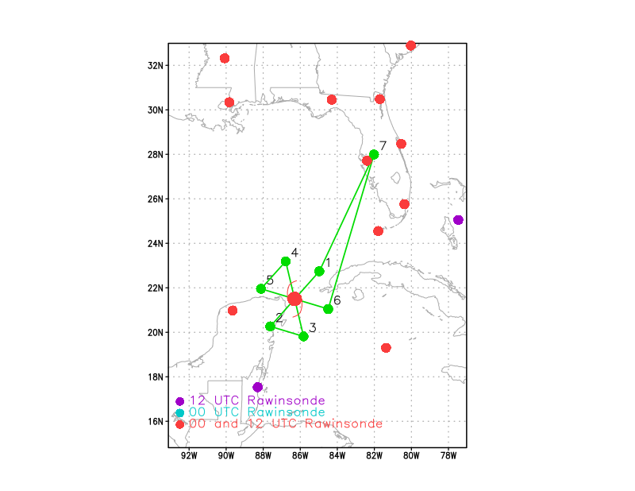  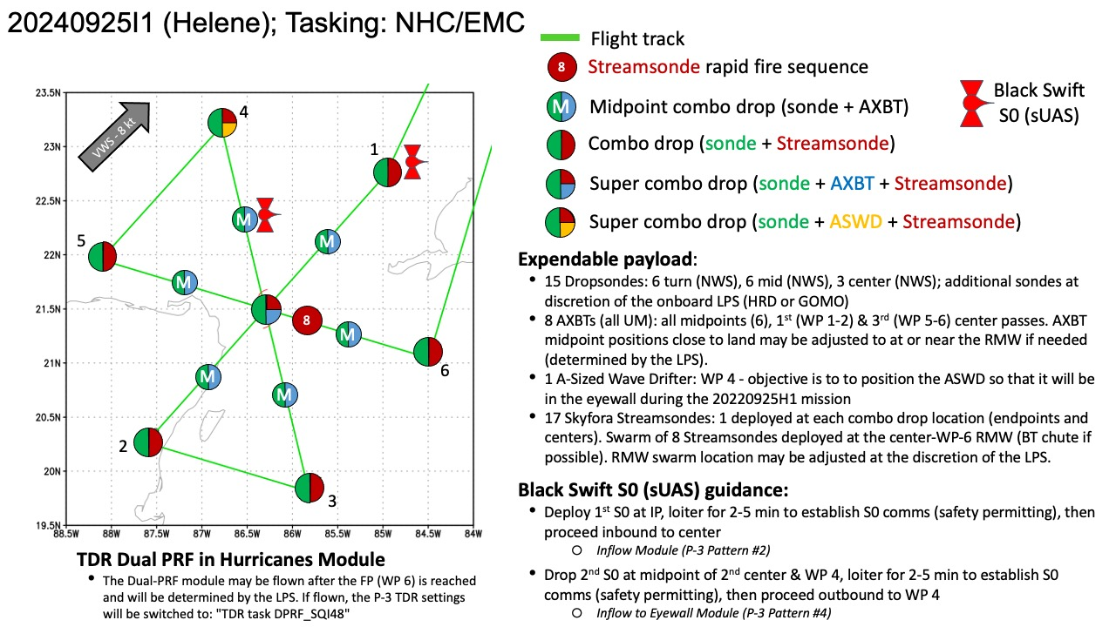
Expendable Distribution | - Load 30 dropsondes  - Release at endpoints, midpoints, centers >> charged to NWS  - Possible extra sondes at the discretion of the onboard LPS >> charged to HRD or GOMO  - All dropsondes transmitted to the GTS  - 8 AXBTs (UM) - see notes below  - All AXBTs transmitted to the AOC ground server if possible  - sUAS: see notes below  - Load 3 BlackSwift s0s (2 planned launches)  - Load 20 Streamsondes
Preflight Weather Briefing | 341  WTNT44 KNHC 250854  TCDAT4  Tropical Storm Helene Discussion Number 8  NWS National Hurricane Center Miami FL AL092024  400 AM CDT Wed Sep 25 2024  Helen has strengthened some since the last advisory. Reports from  an Air Force Reserve Hurricane Hunter aircraft indicate that  the central pressure has fallen to 985 mb, and that the maximum  850 mb flight-level were 58 kt in the northeastern quadrant. A  dropsonde in the northwest quadrant reported a splash wind of 59  kt, but the boundary-layer average suggested sustained winds closer  to 45 kt. Based on these data and increasing satellite intensity  estimates, the initial intensity is increased to 55 kt. Despite  the increased intensity, the aircraft data, along with radar data  from Mexico and Cuba, show that Helen has not yet formed a  well-defined inner core.  The initial motion is 325/8 kt. Helen should turn northward during  the next 12 h or so on the western side of a mid-level ridge, and  then it should accelerate northward to north-northeastward as it  become embedded in the deep-layer flow between the ridge and a  mid-latitude trough/developing cut-off low over the Mississippi  valley. This motion should bring the center near the northeastern  coast of the Yucatan Peninsula this morning, then across the  eastern Gulf of Mexico tonight and Thursday to a landfall along the  northeast coast of the Gulf of Mexico late Thursday or Thursday  night. After landfall, Helene should curve cyclonically around the  cut-off low until it dissipates. The new forecast track is little  changed from the previous track.  Over the next couple of days, Helene will be moving through an  environment of low vertical wind shear, ample environmental  moisture, and over waters of high oceanic heat content. All  guidance forecasts steady to rapid intensification, including the  RI indices associated with the SHIPS model. The latest forecast  calls for a 105 kt intensity by 36 h, and this could be  conservative as some of the guidance is stronger. After landfall,  Helen is forecast to weaken and become post-tropical as it gets  tangled up in the baroclinic system over the southeastern United  States.  Helene's wind field is predicted to grow to a very large size in the  NHC forecast. Therefore storm surge, wind, and rainfall impacts  will likely extend well away from the center and outside the  forecast cone, particularly on the east side. In addition, the fast  forward speed while Helene crosses the coast will likely result in  farther inland penetration of strong winds over parts of the  southeastern United States after landfall.  KEY MESSAGES:  1. Helene is forecast to intensify and be near hurricane strength  when it passes near the northeastern coast of the Yucatan  Peninsula during the next several hours, where a Hurricane Warning  is in effect.  2. Helene is expected to rapidly intensify and grow in size over the  eastern Gulf of Mexico. There is a danger of life-threatening storm  surge along the entire west coast of the Florida Peninsula and  Florida Big Bend. The highest inundation levels are expected along  the coast of the Florida Big Bend. Residents in those areas should  follow advice given by local officials and evacuate if told to do  so.  3. Damaging hurricane-force winds are expected along portions of  coast of the Florida Big Bend, where a Hurricane Warning is now in  effect. Preparations to protect life and property should be  completed by early Thursday since tropical storm conditions are  expected to begin within this area on Thursday.  4. Tropical Storm Helene will bring heavy rain to portions of the  western Caribbean with potentially significant flooding across  western Cuba and the northeastern Yucatan Peninsula. Considerable  and potentially life-threatening flash and urban flooding is  expected across portions of Florida, the Southeast, the Southern  Appalachians, and the Tennessee Valley beginning today through  Friday. This includes the risk of landslides across the southern  Appalachians. Widespread minor to moderate river flooding is likely,  and isolated major river flooding is possible.  FORECAST POSITIONS AND MAX WINDS  INIT 25/0900Z 20.7N 86.2W 55 KT 65 MPH  12H 25/1800Z 21.9N 86.5W 70 KT 80 MPH  24H 26/0600Z 24.1N 86.2W 90 KT 105 MPH  36H 26/1800Z 27.4N 85.0W 105 KT 120 MPH  48H 27/0600Z 32.0N 84.2W 65 KT 75 MPH...INLAND  60H 27/1800Z 35.9N 85.4W 30 KT 35 MPH...POST-TROP/INLAND  72H 28/0600Z 37.0N 87.8W 20 KT 25 MPH...POST-TROP/INLAND  96H 29/0600Z 36.5N 88.0W 20 KT 25 MPH...POST-TROP/INLAND  120H 30/0600Z...DISSIPATED  [Copy in GIF of recent (~6 hr) satellite loops (https://www.star.nesdis.noaa.gov/GOES/index.php)]  IR sat loop depicts several burst areas of convection to the NNW, E, and SW of the center.  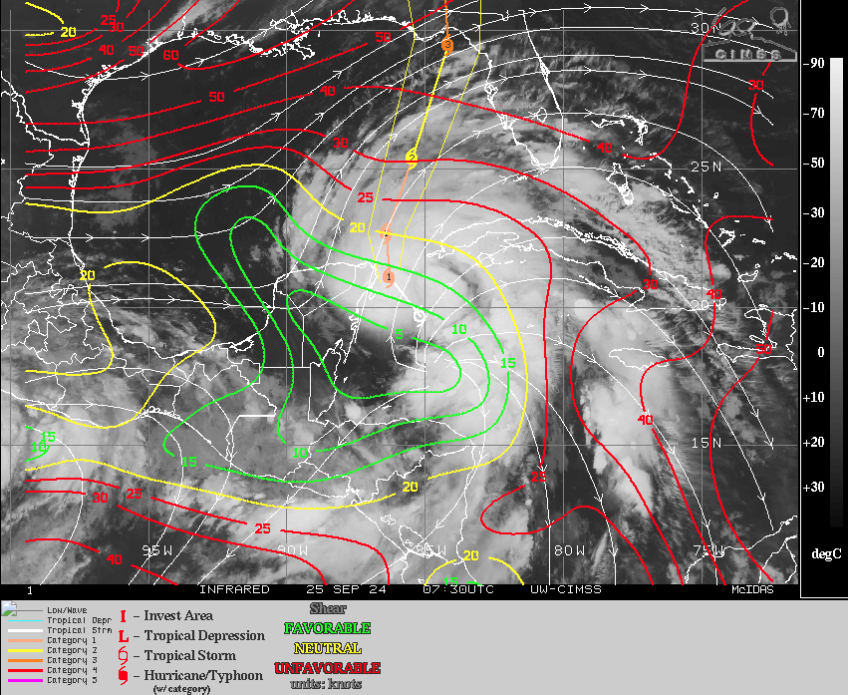  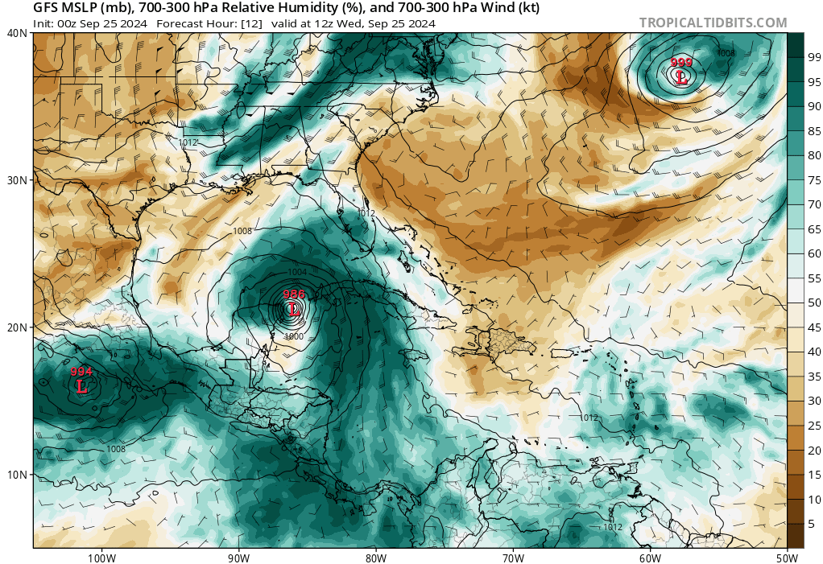
Instrument Notes | All instruments functioning normally

IN-FLIGHT
Time [UTC] | Event
0906 | Take-off from KLAL
0908 | 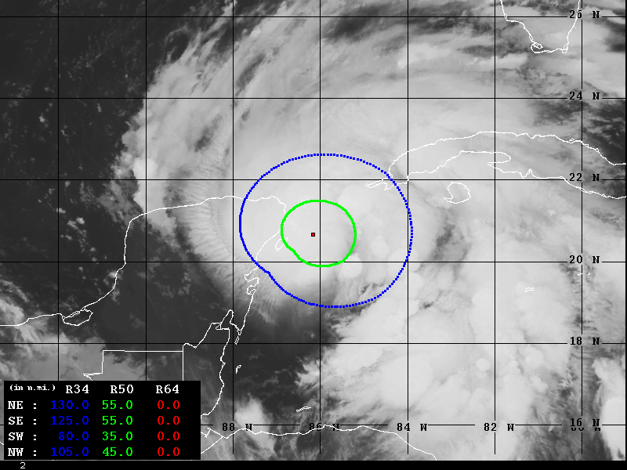  Advanced Dvorak Technique Wind Radii Estimates extending from the center of the storm
0944 | Decided to skip the Hazardous Winds Module due to time limitation for finishing TDR pattern
1011 | Starting descent to science flight level 8000 ft to deconflict with AF
1018 | Running s0 launch checklist while circling
1022 | Onboard LPS is making the decision to drop S0 earlier so that it will be further away from land once it reaches the eyewall
1029 | S0 launched
1031 | S0 airborne
1931 | S0 comms established, descending to 5 kft
1037 | Drop 1, IP dropsonde and streamsonde released
1039 | 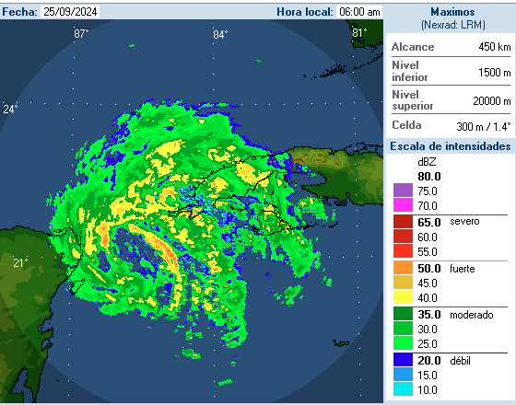  Cuban radar depicts what seems to be an elliptical, banding eye
1042 | SO lost comms suddenly think it went into the water  About 10 min of data, 6 min straight and level, ~30 mile range
1056 | Drop 2, Midpoint AXBT combo, BT no data
1059 | Drop 3 Center Steamsonde combo no AXBT too close to land, sonde had bad T, RH. Can’t tell if wind and pressure are okay, so not sending  Slight track diversion to stay offshore  URNT12 KWBC  VORTEX DATA MESSAGE AL092024  A. 25/10:59:19Z  B. 21.05 deg N 086.19 deg W  C. NA  D. EXTRAP 981 mb  E. NA  F. NA  G. NA  H. NA  I. NA  J. 128 deg 64 kt  K. 027 deg 84 nm 10:39:22Z  L. NA  M. NA  N. 273 deg 61 kt  O. 179 deg 17 nm 11:03:26Z  P. 17 C / 2455 m  Q. 19 C / 2458 m  R. 15 C / NA  S. 12345 / NA  T. 0.01 / NA  U. NOAA3 1009A HELENE OB 99  SLP EXTRAP FROM 8000FT  MAX FL WIND 64 KT 027 / 84 NM 10:39:22Z
1114 | Drop 4 MP SW Streamsonde Combo
1126 | Drop 5 EP SW Streamsonde Combo
1131 | Beginning checklist for second SO
1138 | URNT12 KNHC 251158  VORTEX DATA MESSAGE AL092024  A. 25/11:38:20Z  B. 21.11 deg N 086.22 deg W  C. 700 mb 2954 m  D. 981 mb  E. 065 deg 25 kt  F. NA  G. NA  H. 53 kt  I. 307 deg 30 nm 11:30:00Z  J. 036 deg 51 kt  K. 305 deg 25 nm 11:31:30Z  L. 54 kt  M. 133 deg 28 nm 11:46:30Z  N. 230 deg 64 kt  O. 133 deg 26 nm 11:46:00Z  P. 11 C / 3044 m  Q. 14 C / 3044 m  R. 5 C / NA  S. 12345 / 7  T. 0.02 / 2 nm  U. AF309 1109A HELENE OB 05  MAX FL WIND 64 KT 133 / 26 NM 11:46:00Z
1147 | Second S0 released  Total TOF (min): 105.0 min  S0 Serial Number: 32  Launch Altitude: 2481.0 m [MSL]  Launch Latitude: 19.372816 deg  Launch Longitude: -86.471252 deg  Termination Latitude: 21.446722  Termination Longitude: -85.825280
1148 | S0 Airborne
TDR center info from 240925I1_1059_xy.nc:
Alt (km) Lat (deg) Lon (deg W)
0.5 21.00 86.08
2.0 21.08 86.04
3.0 21.13 86.06
6.0 21.15 86.06
2-6-km Vortex Tilt: 8.3 km at 346 deg
77.6 kt wind at 0.5 km height

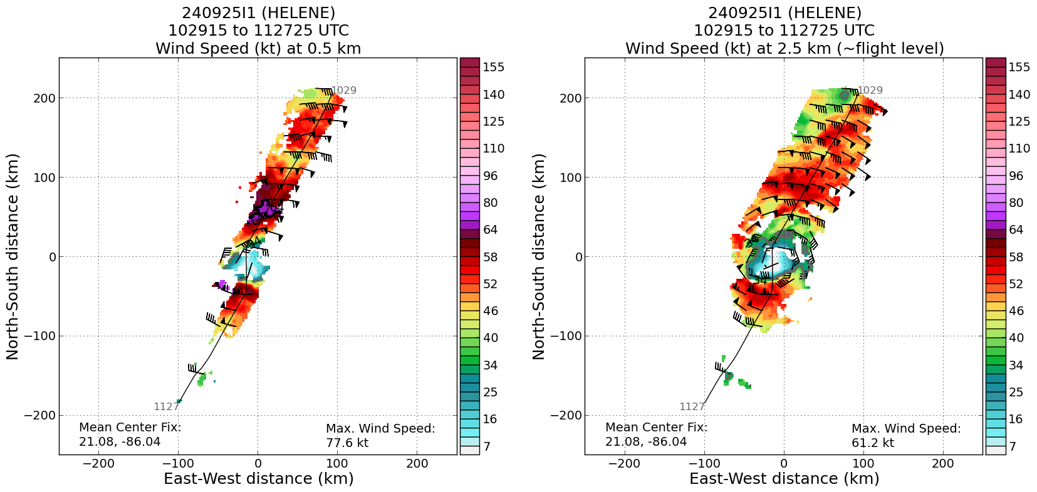
1149 | S0 will drop to 5kft and start inflow module
1149 | Drop 6 Super Combo SW (S0, AXBT, Streamsonde, Dropsonde) BT no data
1155 | Drop 7 Combo SW, BT SST 29.23C
1202 | S02 descending to 1000m
1202 | Jun: Streamsonde software issue, will only drop dropsonde for next for next deployment
1204 | S02 at 1000m
120708 | URNT12 KWBC  VORTEX DATA MESSAGE AL092024  A. 25/12:07:08Z  B. 21.02 deg N 086.21 deg W  C. NA  D. 981 mb  E. 020 deg 04 kt  F. NA  G. NA  H. NA  I. NA  J. 263 deg 64 kt  K. 178 deg 20 nm 12:02:03Z  L. NA  M. NA  N. 088 deg 58 kt  O. 353 deg 52 nm 12:20:14Z  P. 18 C / 2449 m  Q. 16 C / 2457 m  R. 16 C / NA  S. 134 / NA  T. 0.01 / NA  U. NOAA3 1009A HELENE OB 99  MAX FL WIND 64 KT 178 / 20 NM 12:02:03Z  MAX FL TEMP 18 C 178 / 18 NM FROM FL CNTR  TDR center info from 240925I1_1209_xy.nc:  Alt (km) Lat (deg) Lon (deg W)  0.5 21.10 86.07  2.0 21.12 86.07  3.0 21.17 86.09  6.0 21.25 86.17  2-6-km Vortex Tilt: 17.2 km at 324 deg  Increase in tilt, but the mid-level center is elongated, so algorithm may not have found correct center.
1209 | Drop 8, Center
1221 | Jun: S0 at 500m for a couple of minutes
1222 | 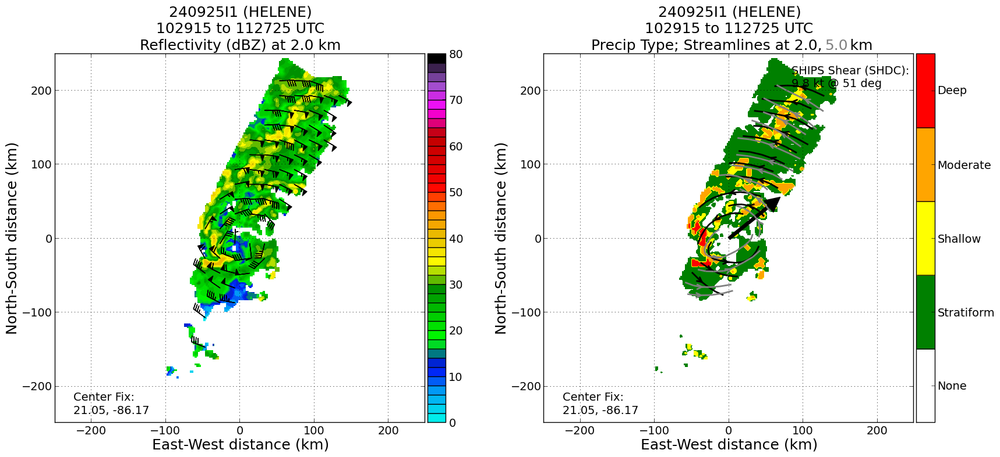  TDR analysis from first pass depicts mostly stratiform with isolated areas of moderate to deep convection.
1226 | 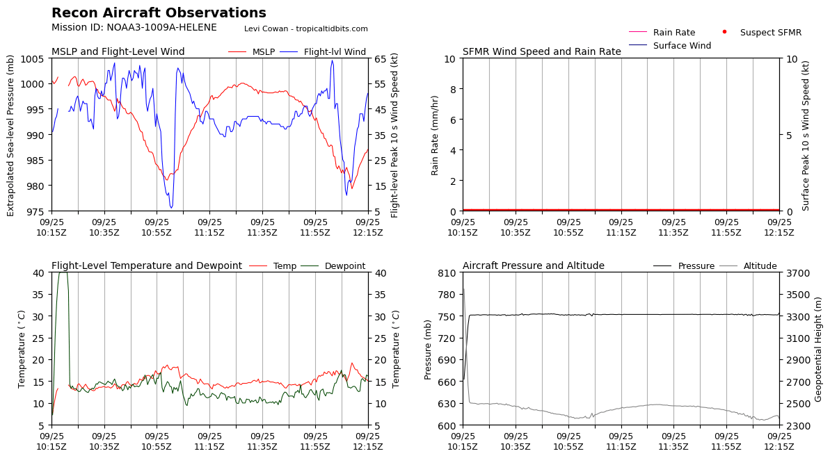
1223 | Drop 9 MP NW Streamsonde AXBT Combo, BT No Data
1229 | S02 at 400m, Range 140 NM
1233 | Jun: 150 NM range, S02
1235 | Wave Drifter Released, providing good data (4.63-m significant wave height)
1235 | Drop 10, EP NW AXBT BT SST 28.28C
1236 | S02 Range 160 NM, record longest range for S0
1243 | Ksell: Attempting to descend to 300m now, S02
1254 | Drop 11 IP NW, Streamsonde Combo
1255 | Jun: 40 min battery left for S02
1310 | Jun: S02 Regained comms at 200m, saw 60kts
1312 | URNT12 KNHC 251354  VORTEX DATA MESSAGE AL092024  A. 25/13:12:50Z  B. 21.33 deg N 086.16 deg W  C. 700 mb 2941 m  D. 982 mb  E. 360 deg 22 kt  F. OPEN NE-SE  G. E36/50/30  H. 47 kt  I. 036 deg 46 nm 13:00:00Z  J. 128 deg 51 kt  K. 042 deg 94 nm 12:46:30Z  L. 60 kt  M. 204 deg 29 nm 13:21:30Z  N. 284 deg 68 kt  O. 205 deg 39 nm 13:24:30Z  P. 10 C / 3049 m  Q. 16 C / 3049 m  R. 6 C / NA  S. 12345 / 7  T. 0.02 / 2 nm  U. AF309 1109A HELENE OB 11  MAX FL WIND 68 KT 205 / 39 NM 13:24:30Z
1320 | Ksell: S0 descending to 100m
1324 | 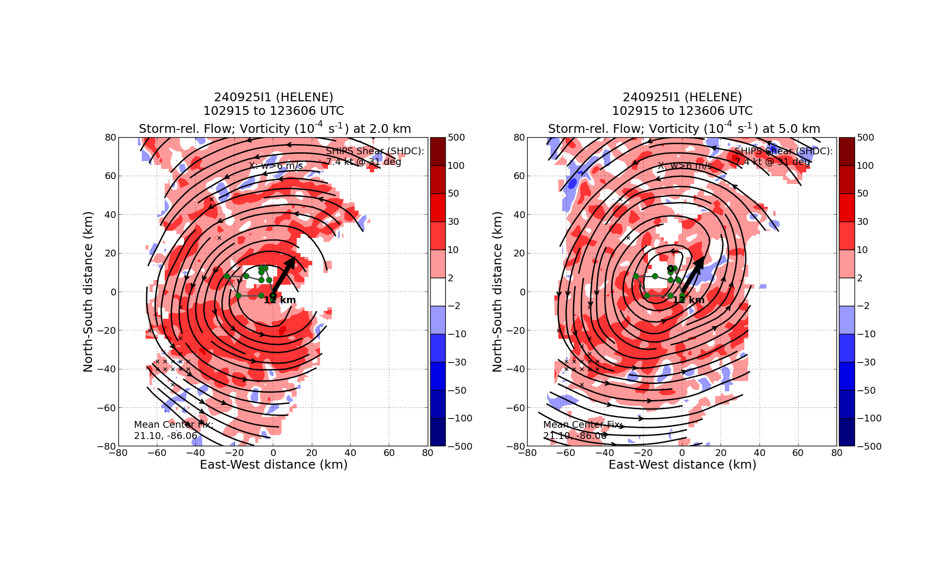  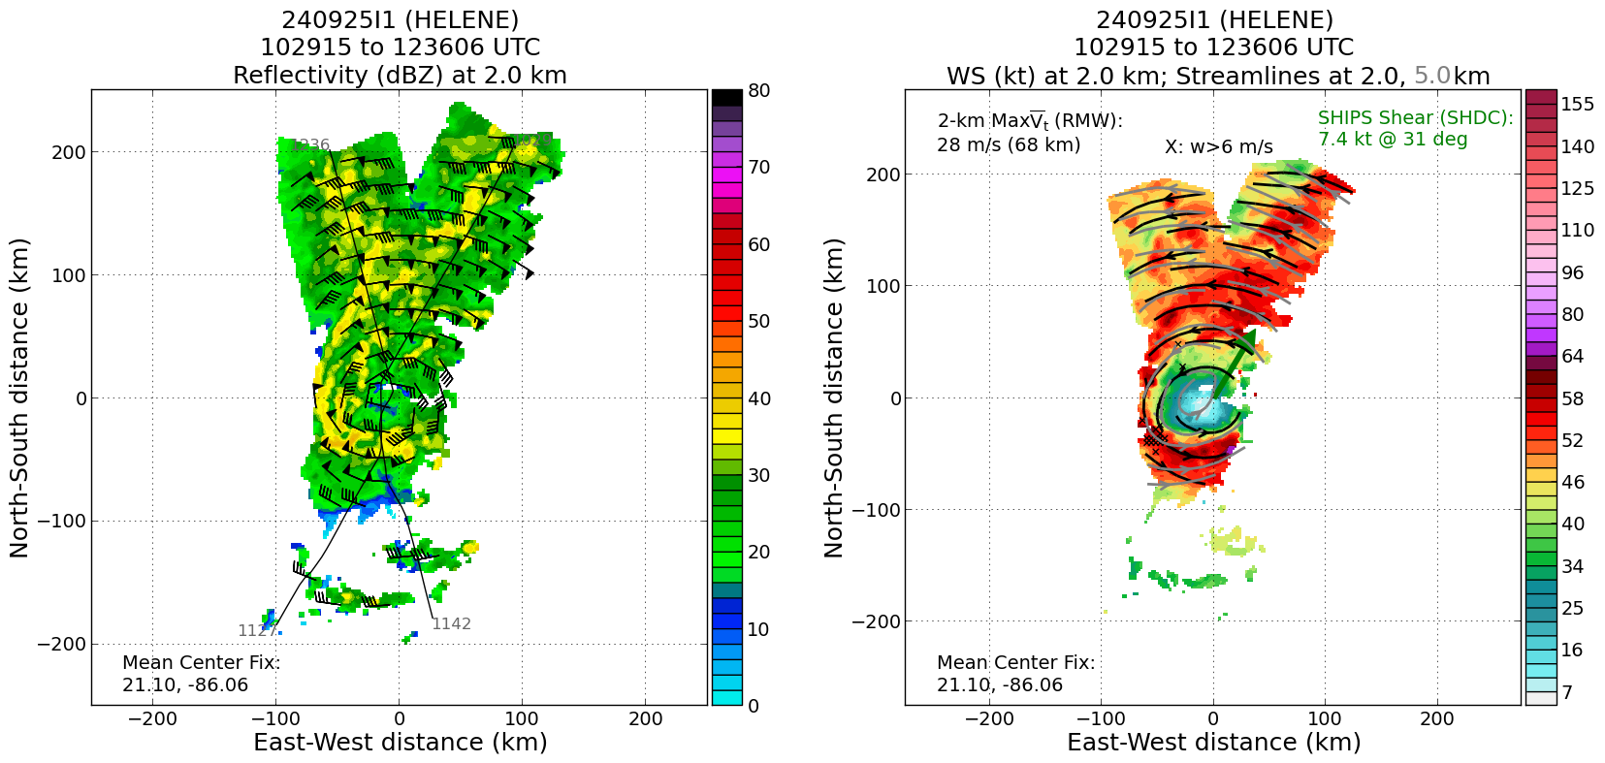
1324 | Drop 12 Center Combo, BT no data  TDR center info from 240925I1_1324_xy.nc:  Alt (km) Lat (deg) Lon (deg W)  0.5 99.99 99.99  2.0 21.35 86.13  3.0 21.35 86.17  6.0 21.34 86.19  2-6-km Vortex Tilt: 6.3 km at 252 deg  URNT12 KWBC  VORTEX DATA MESSAGE AL092024  A. 25/13:23:08Z  B. 21.27 deg N 086.24 deg W  C. NA  D. EXTRAP 983 mb  E. NA  F. NA  G. NA  H. NA  I. NA  J. 011 deg 63 kt  K. 285 deg 33 nm 13:14:55Z  L. NA  M. NA  N. 210 deg 63 kt  O. 101 deg 37 nm 13:31:52Z  P. 14 C / 2453 m  Q. 19 C / 2450 m  R. 13 C / NA  S. 1234 / NA  T. 0.01 / NA  U. NOAA3 1009A HELENE OB 99  SLP EXTRAP FROM  MAX FL WIND 64 KT 178 / 20 NM 12:02:03Z  MAX FL TEMP 20 C 090 / 6 NM FROM FL CNTR
1327 | S0 descent to 50m, there for 5 min
1334 | S0 splashed, record time and range for mission
1337 | s0 splashed after 105 min flight time. record time and range this mission, max range ~160 nm
1338 | Drop 13 MP SE Combo AXBT, BT SST 29.89C
 | Will head back in on same radial for dual-PRF, then outbound NE to do Hazardous Winds Module
1347 | Drop 14 EP SE Combo AXBT, BT SST 29.93C
1349 | Turn inbound, switch to dual-PRF, no realtime radar analyses during this period
1415 | URNT12 KWBC  VORTEX DATA MESSAGE AL092024  A. 25/14:15:52Z  B. 21.40 deg N 086.18 deg W  C. NA  D. EXTRAP 979 mb  E. NA  F. NA  G. NA  H. NA  I. NA  J. 219 deg 78 kt  K. 116 deg 30 nm 14:08:39Z  L. NA  M. NA  N. 137 deg 64 kt  O. 043 deg 97 nm 14:39:58Z  P. 17 C / 2453 m  Q. 19 C / 2439 m  R. 13 C / NA  S. 1234 / NA  T. 0.01 / NA  U. NOAA3 1009A HELENE OB 99  SLP EXTRAP FROM 8000FT  MAX FL WIND 78 KT 116 / 30 NM 14:08:39Z  MAX FL TEMP 20 C 101 / 8 NM FROM FL CNTR
1424 | Drop 15 RMW NE (a second sonde had a launch detect on the aircraft, so data were transmitted).
 | Paul Reasor: As a whole, Helene is tilted to the W (downshear-left) with height ... pretty clear in the swath analyses on that last pass
1436 | URNT12 KNHC 251532  VORTEX DATA MESSAGE AL092024  A. 25/14:36:40Z  B. 21.42 deg N 086.12 deg W  C. 700 mb 2938 m  D. EXTRAP 982 mb  E. NA  F. OPEN N-E  G. C35  H. 50 kt  I. 123 deg 24 nm 14:29:30Z  J. 220 deg 81 kt  K. 121 deg 19 nm 14:31:00Z  L. 56 kt  M. 312 deg 91 nm 15:04:30Z  N. 038 deg 57 kt  O. 308 deg 51 nm 14:52:30Z  P. 12 C / 3047 m  Q. 17 C / 3042 m  R. 4 C / NA  S. 1235 / 7  T. 0.02 / 2 nm  U. AF309 1109A HELENE OB 18  MAX FL WIND 81 KT 121 / 19 NM 14:31:00Z  SLP EXTRAP FROM 700 MB
1442 | Drop 16 EP NE, bad sonde, start hazardous wind module
1446 | Drop 17 EP NE, replacement, LAST
1502 | totals 17 minis + 8 Streamsonde + 8 BTs + 1 wave drifter/float + 2 s0s  11 sUAS HDOBS sent
1510 | Completion of Hazard Winds Module, TDR left on in Dual-PRF mode.

POST-FLIGHT
Mission Summary | Deep radial inflow in azimuthal average.  Flight level winds increased enough to make Helene a hurricane  Record S0 deployment
Actual Standard Pattern Flown | Butterfly
APHEX Experiments / Modules Flown | RICO SUAVE, Tail Doppler Radar Dual-PRF in Hurricanes, CHAOS, Distribution of Hazardous Winds
Plain Language Summary | Helene has begun intensifying after forming a coherent and lightly tilted core. Low- and mid-level centers seem to be wobbling around each other. Record-deployment of Blackswift S0 shows utility of sUAS.
Instrument Notes | All instruments seemed to work except for Streamsondes
Final Mission Track | 