MISSION PLAN
FLIGHT ID | 20240924I | STORM | AL09/Helene
MISSION ID | 0409A | TAIL NUMBER | NOAA-43
TASKING | NHC/EMC TDR | PLANNED PATTERN | Butterfly
MISSION SUMMARY
TAKEOFF [UTC] | 0809 | LANDING [UTC] | 1543
TAKEOFF LOCATION | KLAL | LANDING LOCATION | KLAL
FLIGHT TIME | 7.6 | BLOCK TIME | 7.9
TOTAL REAL-TIME RADAR ANALYSES  (Transmitted) | 5 (5) | TOTAL DROPSONDES Deployed (Tx to GTS) | 15 (15)
OCEAN EXPENDABLES deployed (good) | 3 UM + 2 AOC AXBTs:  5 (2 UM) | sUAS (Type) | N/A
APHEX EXPERIMENTS / MODULES | Exact name of the Experiment in the HFP Plan; identify relevant experiments / module even if not a research tasking
HRD CREW MANIFEST
LPS ONBOARD | J. Zhang/Sellwood | LPS GROUND | Aberson/Montgomery
TDR ONBOARD | J. Zhang/Sellwood | TDR GROUND | Reasor
ASPEN ONBOARD |  | ASPEN GROUND | Kaplan
NESDIS SCIENTISTS | N/A
GUESTS (Affiliation) | Talbert
AOC CREW MANIFEST
PILOTS | Rannenberg, Palmer, Ellis
NAVIGATOR | Meier/Saunders
FLIGHT ENGINEERS | Ripp/Dittoe
FLIGHT DIRECTOR | Zawislak
DATA TECHNICIAN | Richards
AVAPS | Vargas/Hunsinger

PRE-FLIGHT
Flight Plan | 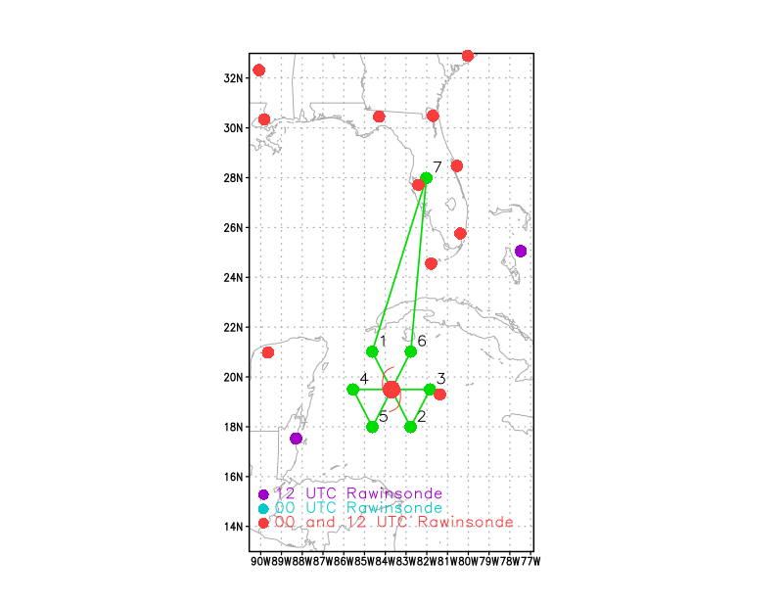  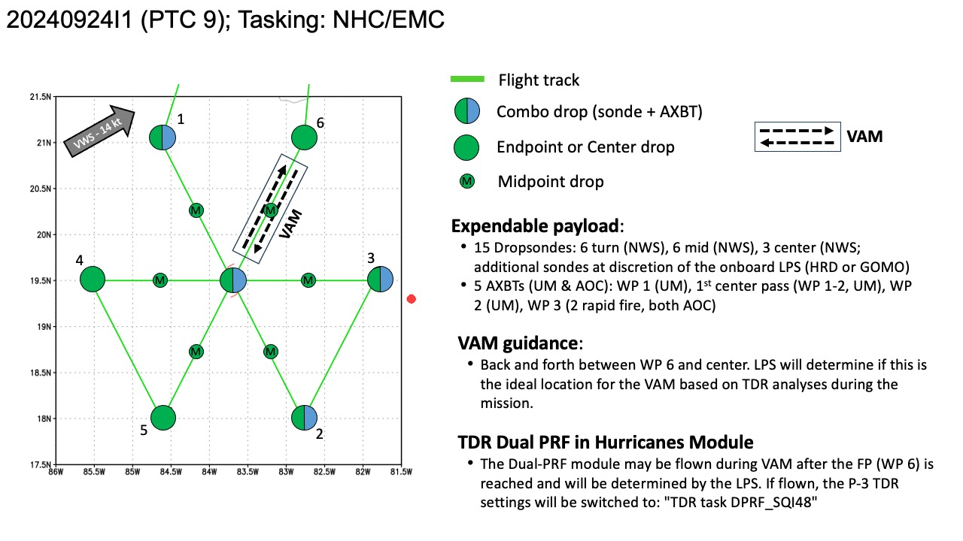  Pattern: Fly butterfly pattern with 105 NM legs  - Pattern should be adjusted as needed to avoid land  Altitude:  - 10 kft preferred - 8 kft if AF deconfliction is required (pressure altitude)  Research Modules:  - APHEX Early Stage: Vortex Alignment Module (VAM)  - APHEX Early Stage: Tail Doppler Radar Dual-PRF in Hurricanes
Expendable Distribution | Expendables:  - Load 30 dropsondes  - Release at endpoints, midpoints, centers >> charged to NWS  - Possible extra sondes at the discretion of the onboard LPS >> charged to HRD or GOMO  - All dropsondes transmitted to the GTS  - 5 AXBTs (3 UM, 2 AOC) - see notes below  - All AXBTs transmitted to the AOC ground server if possible  - sUAS: none
Preflight Weather Briefing | Satellite imagery indicates that there has been little change in  the organization of the system since earlier today. Most of the  deep convection is over the eastern part of the broad circulation.  Animation of proxy-vis GOES images, and radar observations from  Grand Cayman Weather Service suggest that the disturbance still  does not have a well-defined center of circulation, so the system is  kept as a potential tropical cyclone for the time being. The  advisory intensity is held at 30 kt which is in agreement with a  Dvorak estimate from TAFB. An Air Force reconnaissance aircraft is  scheduled to investigate the area in a few hours to provide a  better description of the system's structure along with an updated  intensity estimate.  The initial motion estimate is a rather uncertain 330/5 kt. During  the next day or so, the disturbance is expected to turn  northwestward along the southern and southwestern side of a  mid-level high pressure area. Then, the high is expected to shift  eastward while a mid-level trough drops into the central United  States. This evolution of the steering pattern should cause the  system to accelerate northward to north-northeastward over the  eastern Gulf of Mexico and toward the northeastern Gulf Coast  through Thursday. There is good agreement in the track guidance, and  the official forecast is close to the corrected dynamical consensus  model, HCCA, prediction. This is also very similar to the previous  NHC forecast.  Concurrent G-IV synoptic surveillance mission, AF survey mission, and AF fix or invest mission.  IR Satellite depicts bursts of convection and cold tops with a pretty elongated area of low pressure.  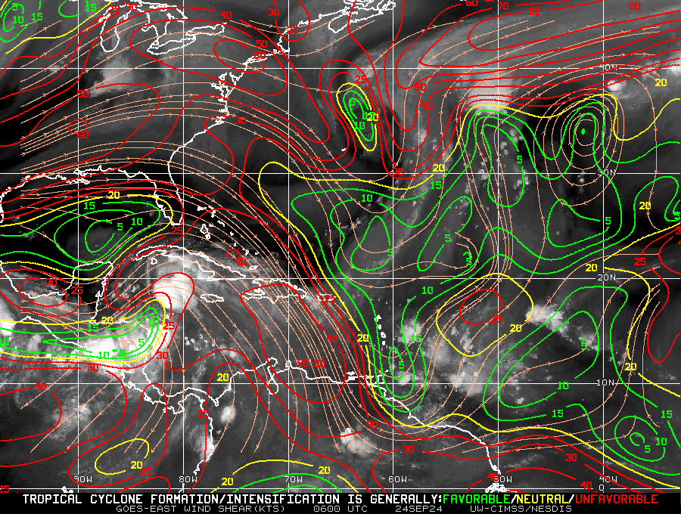
Instrument Notes | [What instruments are working, not working, not functioning nominally, not installed?]

IN-FLIGHT
Time [UTC] | Event
0809 | Take-off from KLAL
0852 | Cuba radar illustrates western outer bands and a very slight hint of circulation.
0941 | 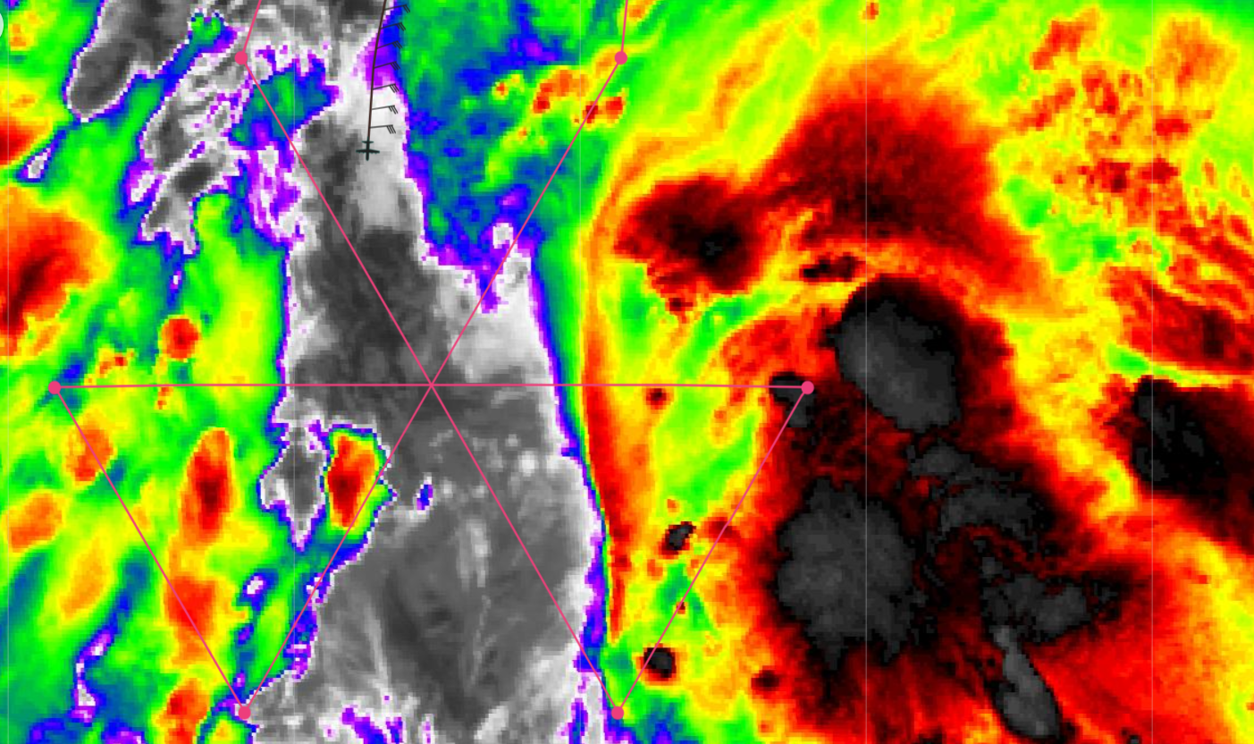  Approaching IP from the N.mm
0942 | Drop 1: Dropsonde AXBT Combo (IP), BT SST 30.5C
0955 | Drop 2: MP NW
1000 | Shifted inbound slightly to the east of the planned track to get more TDR coverage
1003 | Drop 3: Combo Drop, Center, BT SST 30.22C  A. 24/10:03:19Z  B. 19.40 deg N 083.04 deg W  C. 700 MB 3100 m  D. EXTRAP 1000 mb  E. NA  F. NA  G. NA  H. NA  I. NA  J. 083 deg 38 kt  K. 311 deg 42 nm 09:52:48Z  L. NA  M. NA  N. 162 deg 33 kt  O. 134 deg 79 nm 10:23:56Z  P. 12 C / 3076 m  Q. 12 C / 3075 m  R. 8 C / NA  S. 134 / 7  T. 0.01 / NA  U. NOAA3 0409A TDR OB 99  SLP EXTRAP FROM 700 MB  MAX FL WIND 38 KT 311 / 42 NM 09:52:48Z  MAX FL TEMP 13 C 309 / 12 NM FROM FL CNTR  Good wind shift. To be kept unofficial
1016 | Drop 4: MP SE
1028 | 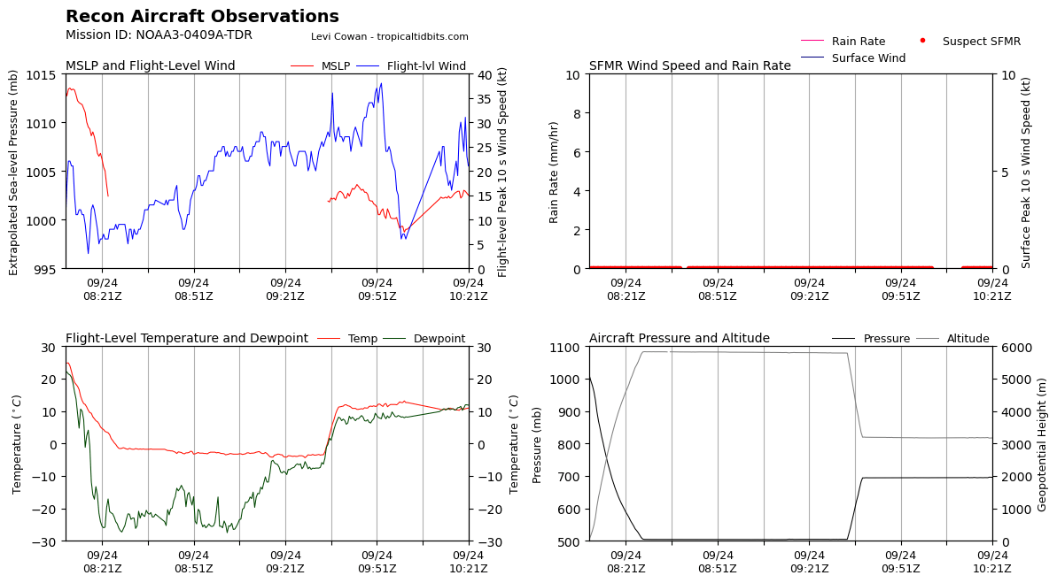
1028 | COMBO DROP 5 EP 1 CH 2 AXBT NO DATA
1049 | Quite bumpy in convection
TDR center info from 240924I1_1003_xy.nc:
Alt (km) Lat (deg) Lon (deg W)
0.5 99.99 99.99
2.0 19.51 83.24
3.0 19.45 83.18
6.0 19.40 83.11
2-6-km Vortex Tilt: 18.5 km at 131 deg
1050 | DROP 6 IP2 CH 1
1101 | Jun_N43_LPS: a bit bumpy, 50 Kt winds at FL 10kft
1111 | 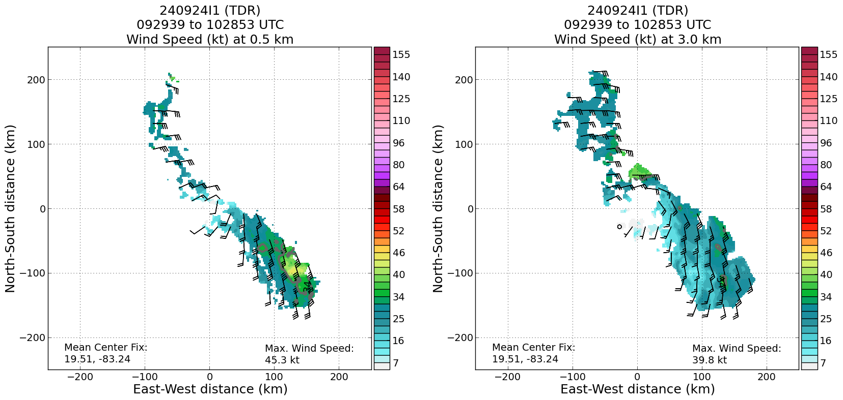
1111 | Drop 7: MP SE AXBT, No Data
1126 | Drop 8: Center AXBT, No Data  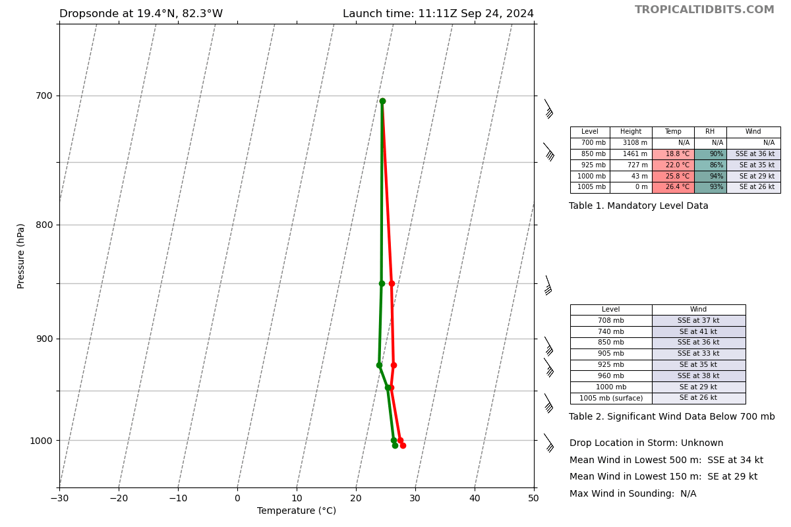
TDR center info from 240924I1_1124_xy.nc:
Alt (km) Lat (deg) Lon (deg W)
0.5 19.56 83.39
2.0 19.52 83.41
3.0 19.49 83.30
6.0 19.54 83.47
1127 | VORTEX DATA MESSAGE AL092024  A. 24/11:23:03Z  B. 19.56 deg N 083.16 deg W  C. 700 MB 3105 m  D. EXTRAP 1000 mb  E. NA  F. NA  G. NA  H. NA  I. NA  J. 150 deg 51 kt  K. 094 deg 97 nm 11:00:51Z  L. NA  M. NA  N. 058 deg 32 kt  O. 279 deg 65 nm 11:37:52Z  P. 11 C / 3062 m  Q. 12 C / 3060 m  R. 9 C / NA  S. 1345 / 7  T. 0.01 / NA  U. NOAA3 0409A TDR OB 99  SLP EXTRAP FROM 700 MB  MAX FL WIND 51 KT 094 / 97 NM 11:00:51Z
1143 | 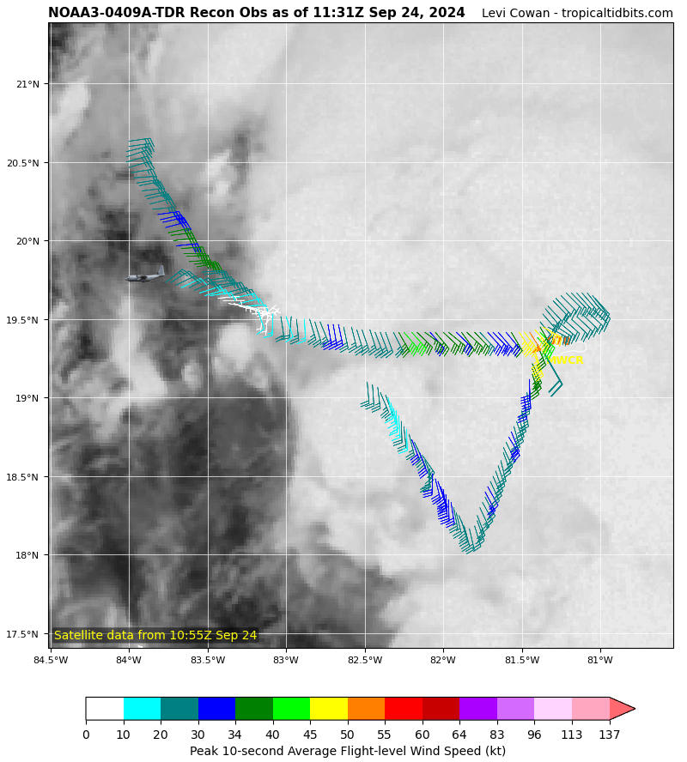  The highest winds are located on the eastern side of the elongated circulation
1140 | Drop 9: MP W
1147 | Drop 10: EP W
1210 | Drop 11: IP3 SW
1222 | Drop 12: MP SW
1231 | Going into a “minefield” of convection
1233 | Drop 13: EP S
1242 | 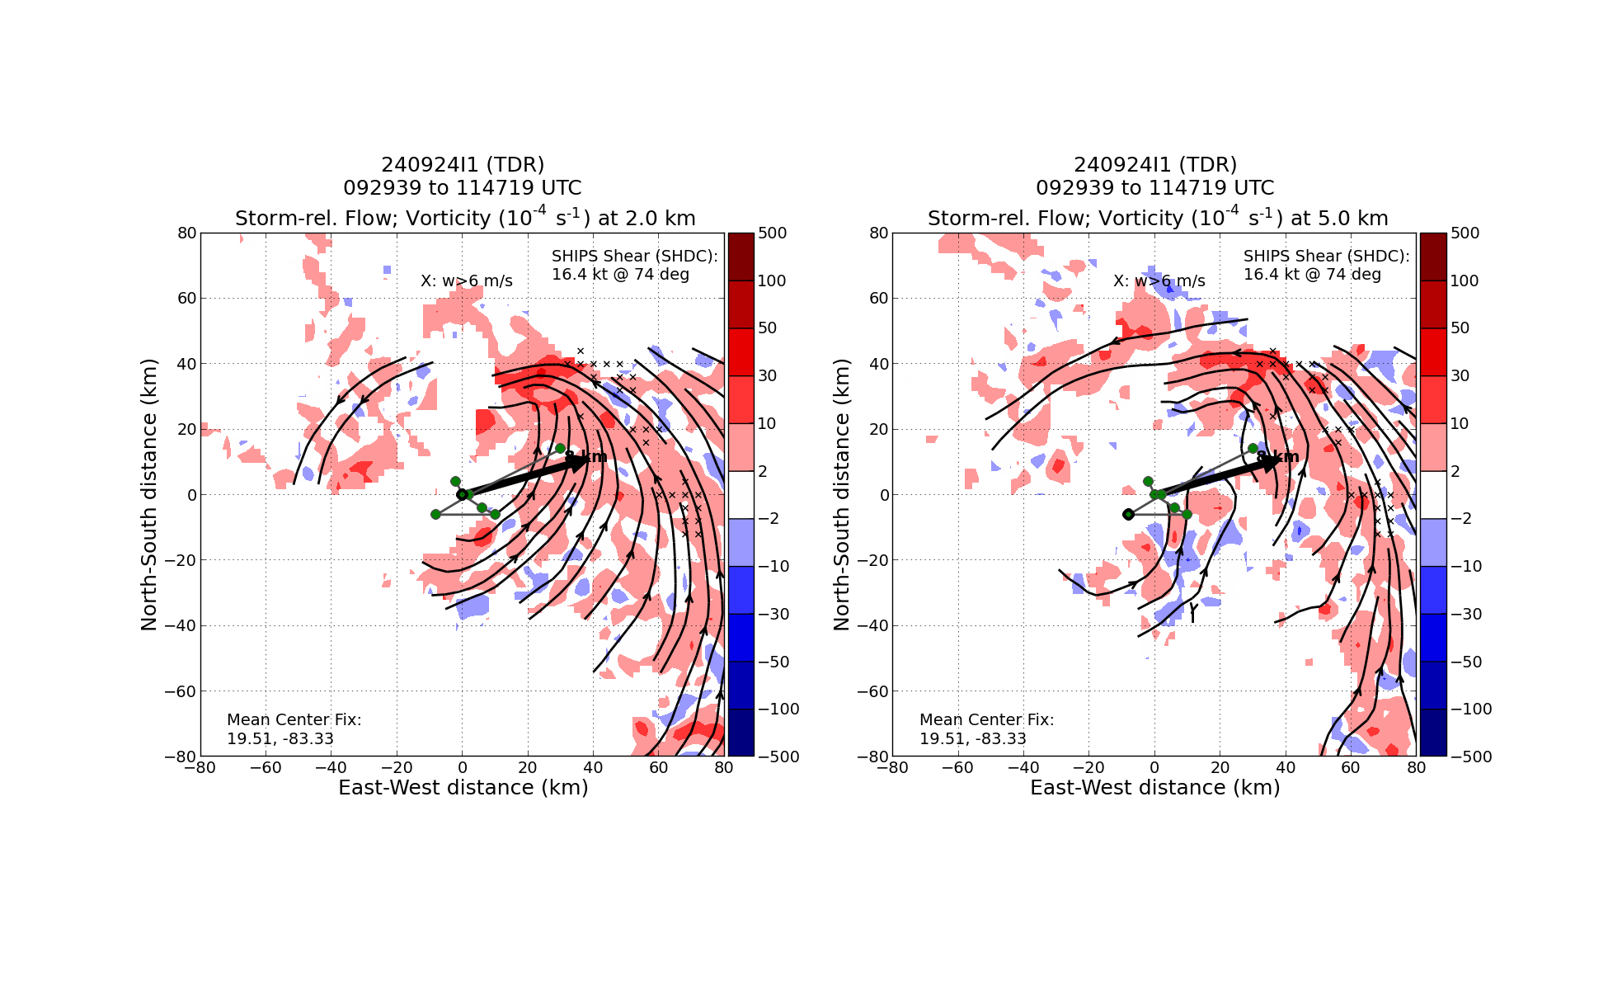
1242 | 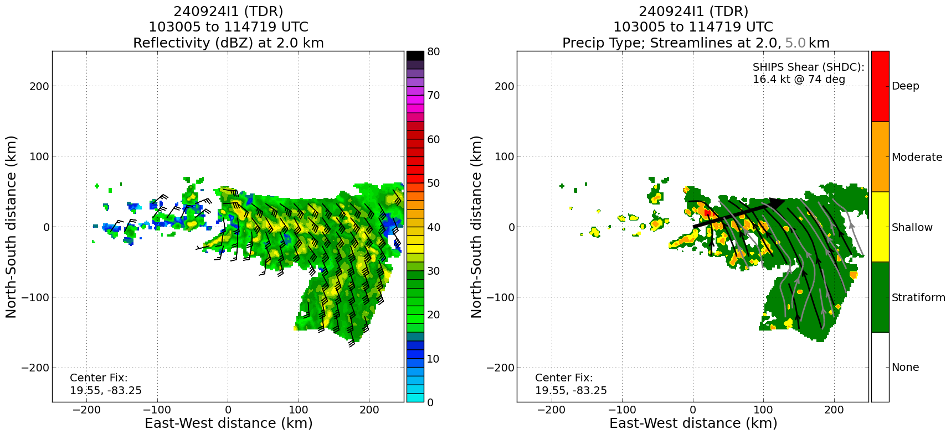  TDR analysis from second pass depicts mostly stratiform with isolated areas of shallow to moderate convection.
1248 | Setting up for VAM, inbound 45 degrees through center, going through convection at end of leg, then turn back inbound
1248 | Drop 14: MP NE
VORTEX DATA MESSAGE AL092024
A. 24/12:33:27Z
B. 19.48 deg N 083.44 deg W
C. 700 MB 3104 m
D. EXTRAP 1001 mb
E. NA
F. NA
G. NA
H. NA
I. NA
J. 219 deg 26 kt
K. 182 deg 12 nm 12:30:44Z
L. NA
M. NA
N. 092 deg 49 kt
O. 026 deg 56 nm 12:48:37Z
P. 12 C / 3060 m
Q. 11 C / 3063 m
R. 10 C / NA
S. 134 / 7
T. 0.01 / NA
U. NOAA3 0409A TDR OB 99
SLP EXTRAP FROM 700 MB
MAX FL WIND 51 KT 094 / 97 NM 11:00:51Z
MAX FL TEMP 12 C 180 / 11 NM FROM FL CNTR
1301 | Drop 15: EP NE
TDR center info from 240924I1_1232_xy.nc:
Alt (km) Lat (deg) Lon (deg W)
0.5 19.52 83.56
2.0 19.52 83.58
3.0 19.49 83.54
6.0 19.54 83.61
1332 | FL Winds 2-3 kts, the location at this time is the center we believe
VORTEX DATA MESSAGE AL092024
A. 24/13:33:54Z
B. 19.45 deg N 083.93 deg W
C. 700 MB 3106 m
D. EXTRAP 1000 mb
E. NA
F. NA
G. NA
H. NA
I. NA
J. 105 deg 49 kt
K. 045 deg 89 nm 13:14:04Z
L. NA
M. NA
N. NA
O. NA
P. 12 C / 3071 m
Q. 14 C / 3069 m
R. 8 C / NA
S. 1345 / 7
T. 0.01 / NA
U. NOAA3 0409A TDR OB 99
SLP EXTRAP FROM 700 MB
MAX FL WIND 51 KT 094 / 97 NM 11:00:51Z
lowest extrap from the pass was 998...marked at 1000 mb
TDR center info from 240924I1_1332_xy.nc:
Alt (km) Lat (deg) Lon (deg W)
0.5 99.99 99.99
2.0 19.50 83.53
3.0 19.56 83.50
6.0 19.70 83.51
2-6-km Vortex Tilt: 22.1 km at 5 deg
Radar analyses and VIS animation suggests that center reformed in convection. This caused increase and re-alignment of centers and tilt
1420 | Start ascent out of pattern
 | 15 sondes, 1 recco sent
1427 | TDR turned off
TDR center info from 240924I1_1348_xy.nc:
Alt (km) Lat (deg) Lon (deg W)
0.5 99.99 99.99
2.0 19.52 83.62
3.0 19.57 83.58
6.0 19.72 83.56
2-6-km Vortex Tilt: 22.8 km at 15 deg

 | Orientation of tilt and motion of center abruptly changed between 3rd and 4th analyses, suggesting reformation in the convection.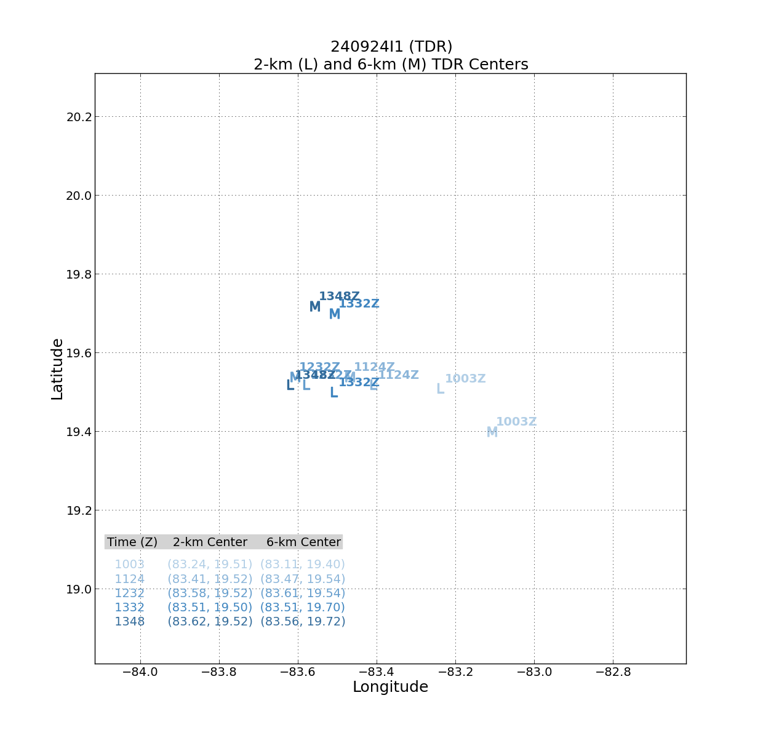
 | Low-level wind (1 km) increased about 5 kt during flight. Flight-level saw a slightly faster increase.

POST-FLIGHT
Mission Summary | Proposed pattern flown with small deviations for convection, with the addition of VAM.  Five TDR analyses, three from operational part of mission, two from VAM, showed re-alignment and possible move of vortex into convection. Data helped to make system a tropical storm.  15 dropwindsondes, all sent to GTS, all NWS  5 BTs, 2 (UM) successful, one UM failed; both AOC BTs failed
Actual Standard Pattern Flown | Butterfly
APHEX Experiments / Modules Flown | VAM
Plain Language Summary | Mission showed development of a disturbance with a broad, elongated center displaced from the convection into an intensifying tropical storm with the center within the convection. This should allow for future intensification
Instrument Notes | All up. MMR and SFMR have known issues. TAG now has ob number available.
Final Mission Track | 