MISSION PLAN
FLIGHT ID | 2 | STORM | AL09 / Helene
MISSION ID | 0709A HELENE | TAIL NUMBER | NOAA-42
TASKING | NHC/EMC TDR | PLANNED PATTERN | Butterfly
MISSION SUMMARY
TAKEOFF [UTC] | 2012 | LANDING [UTC] | 0345
TAKEOFF LOCATION | LAL | LANDING LOCATION | LAL
FLIGHT TIME | 7.5 | BLOCK TIME | 7.9
TOTAL REAL-TIME RADAR ANALYSES  (Transmitted) | 4 (4) | TOTAL DROPSONDES Deployed (Tx to GTS) | 16 (15);  1 bad launch detect  All charged to NWS
OCEAN EXPENDABLES deployed (good) | 7 UM AXBTs:  7 (4) | sUAS (Type) | N/A
APHEX EXPERIMENTS / MODULES | VAM, dual-PRF TDR
HRD CREW MANIFEST
LPS ONBOARD | Alvey | LPS GROUND | Marks
TDR ONBOARD | Hazelton | TDR GROUND | Gamache/Hollingshead
ASPEN ONBOARD | n/a | ASPEN GROUND | Dunion/Sippel/Dahl
NESDIS SCIENTISTS | Chang
GUESTS (Affiliation) | Carpenter/Jones
AOC CREW MANIFEST
PILOTS | Abitbol/Wood/Keith
NAVIGATOR | Dunford/Utama
FLIGHT ENGINEERS | Wysinger/Tyson
FLIGHT DIRECTOR | Englert
DATA TECHNICIAN | McAlister
AVAPS | Paul/Dykman

PRE-FLIGHT
Flight Plan | Pattern: Fly butterfly pattern with 105 NM legs  - Pattern should be adjusted as needed to avoid land  Altitude:  - 10 kft preferred - 8 kft if AF deconfliction is required (pressure altitude)  Research Modules:  - APHEX Early Stage: Vortex Alignment Module (VAM)  - APHEX Early Stage: Tail Doppler Radar Dual-PRF in Hurricanes  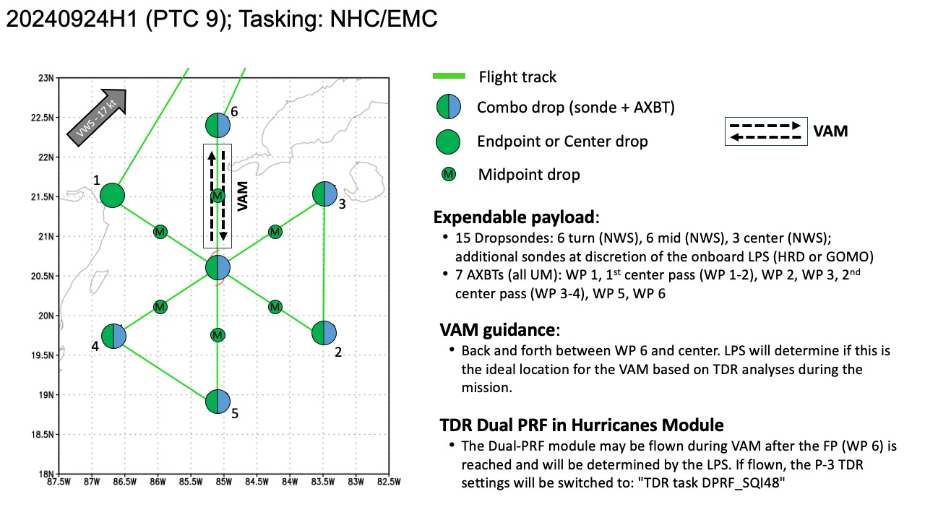
Expendable Distribution | Expendables:  - Load 30 dropsondes  - Release at endpoints, midpoints, centers >> charged to NWS  - Possible extra sondes at the discretion of the onboard LPS >> charged to HRD or GOMO  - All dropsondes transmitted to the GTS  - 7 AXBTs (all UM) - see notes below  - All AXBTs transmitted to the AOC ground server if possible  - sUAS: none
Preflight Weather Briefing | 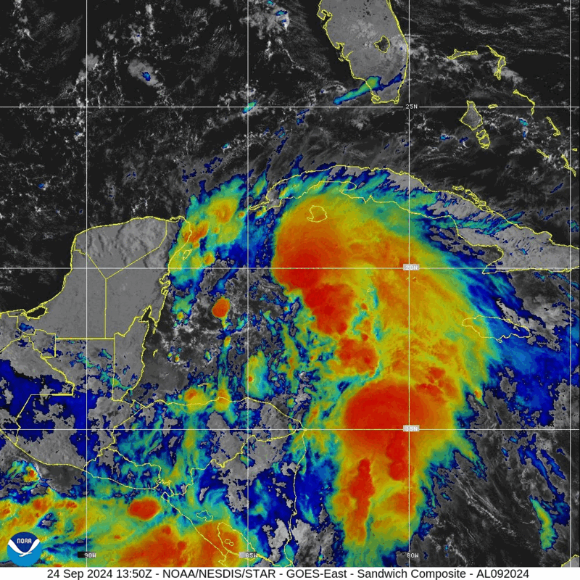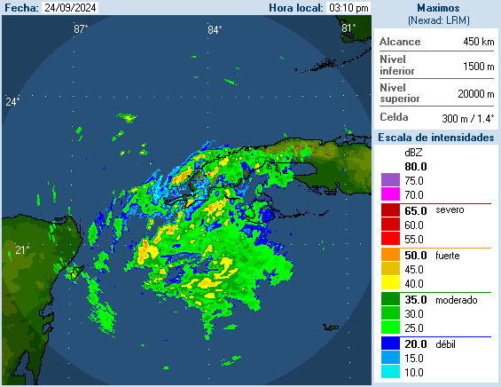  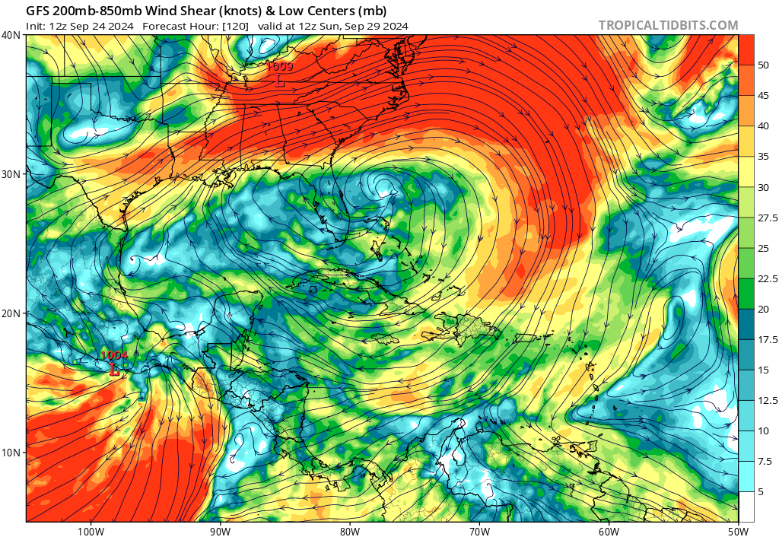  FORECAST POSITIONS AND MAX WINDS  INIT 24/1500Z 19.5N 84.3W 40 KT 45 MPH  12H 25/0000Z 20.3N 85.2W 50 KT 60 MPH  24H 25/1200Z 21.5N 86.3W 65 KT 75 MPH  36H 26/0000Z 23.2N 86.3W 80 KT 90 MPH  48H 26/1200Z 25.9N 85.4W 100 KT 115 MPH  60H 27/0000Z 29.7N 84.3W 100 KT 115 MPH  72H 27/1200Z 33.9N 83.9W 45 KT 50 MPH...INLAND  96H 28/1200Z 39.7N 86.8W 20 KT 25 MPH...POST-TROPICAL  120H 29/1200Z...DISSIPATED
Instrument Notes | All instruments are nominal

IN-FLIGHT
Time [UTC] | Event
2012 | Take-off from LAL
2047 | Decided to move the IP to avoid Mexican airspace, shorten nw-center inbound by about 15-20 nmi, center appears much further S than planned
2117 | TDR up
2124 | TDR aft antenna issue
2133 | TDR back up, start descent to 10 kft
2155 | IP drop #1
2200 | <treya_n42> I'm sure you're seeing this on satellite and cuba radar but looks like precip. is wrapping around upshear perhaps  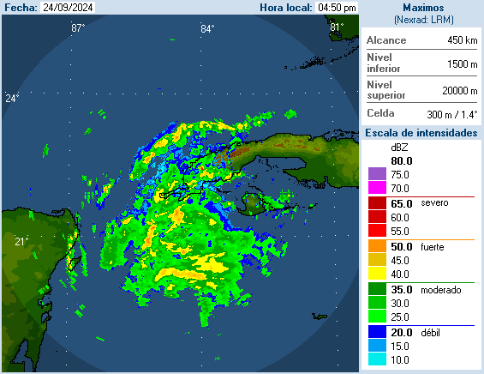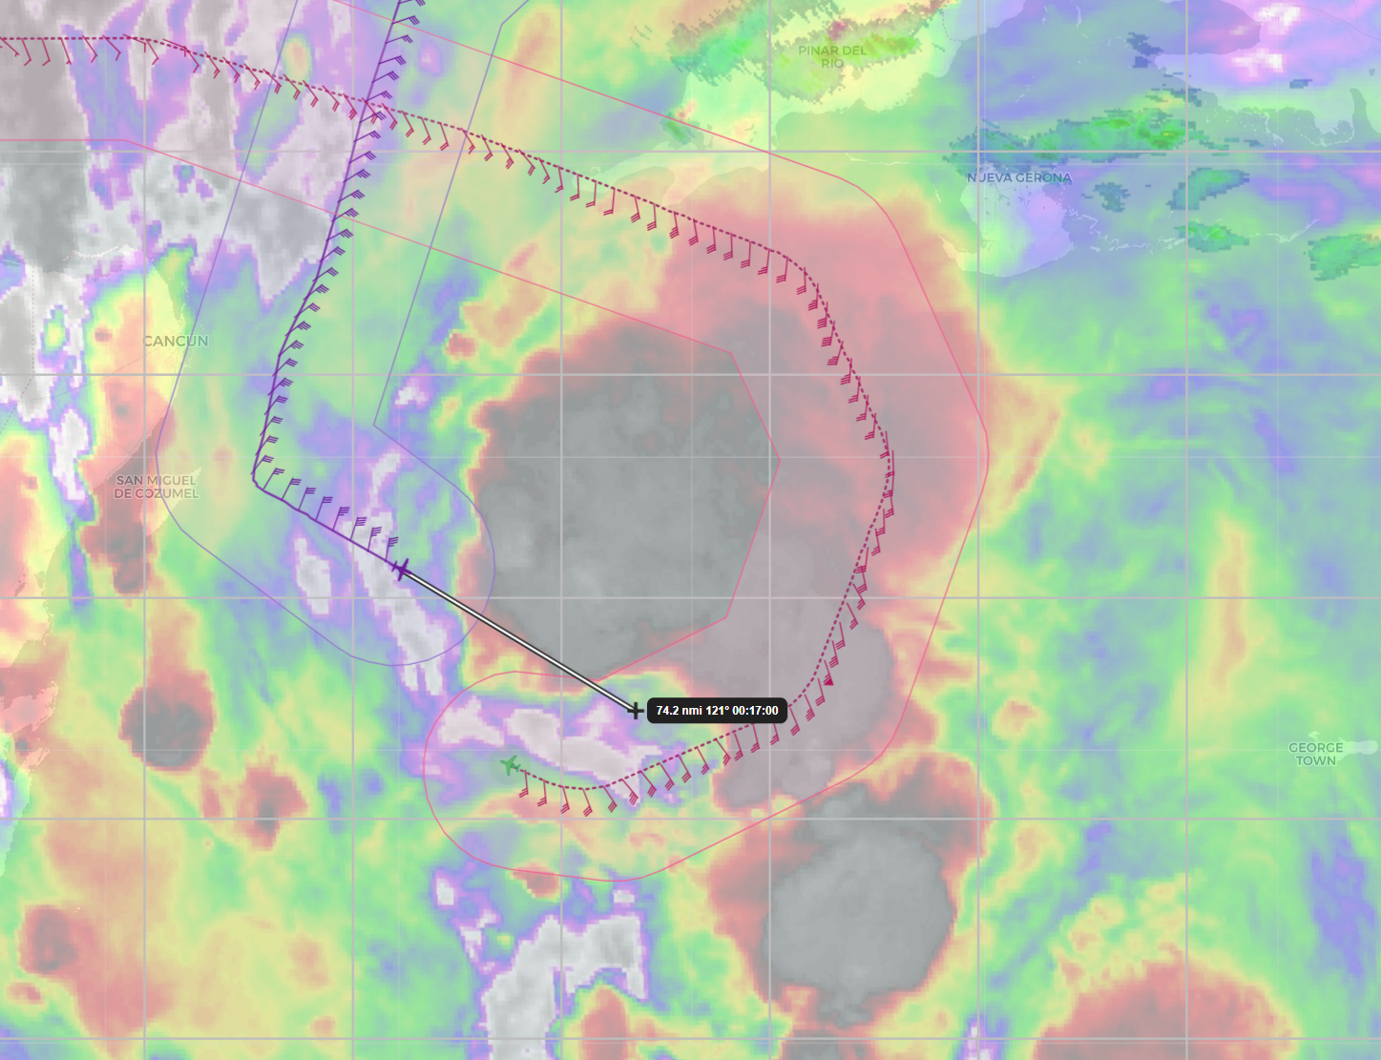  satellite shows coldest tops just to left of track 30-40 nmi ahead
2207 | Midpoint drop #2
2210 | <ahazelton_n42> Center looks like it might be a little NE of our planned one, based on the MMR
2216 | Center, combo drop #3, AXBT #1 (bad), 19.8 N, 85.1 W, ~991 hPa, passed just south of it. Definitely tucked up under the huge anvil.
2229 | Midpoint drop #4, <treya_n42> hitting a couple of bands and then looks like a lot of stratiform on upcoming downwind
2239 | PT#2, combo drop #5, AXBT #2, SST=30.1 C
2242 | Turn TK 360 downwind, <ahazelton_n42> About to turn downwind  <ahazelton_n42> Lots of stratiform precip out here  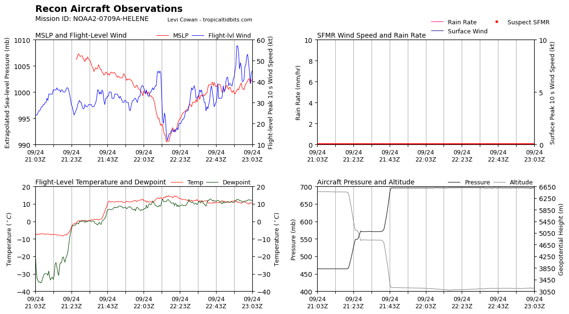
2255 | 1st TDR analysis started
2308 | PT#3, combo drop #6, AXBT #3, SST=30.0 C
2310 | 1st TDR analysis completed  TDR center info from 240924H1_2216_xy.nc:  Alt (km) Lat (deg) Lon (deg W)  0.5 99.99 99.99  2.0 19.81 84.93  3.0 19.86 84.98  6.0 20.02 84.98  2-6-km Vortex Tilt: 24.8 km at 346 deg  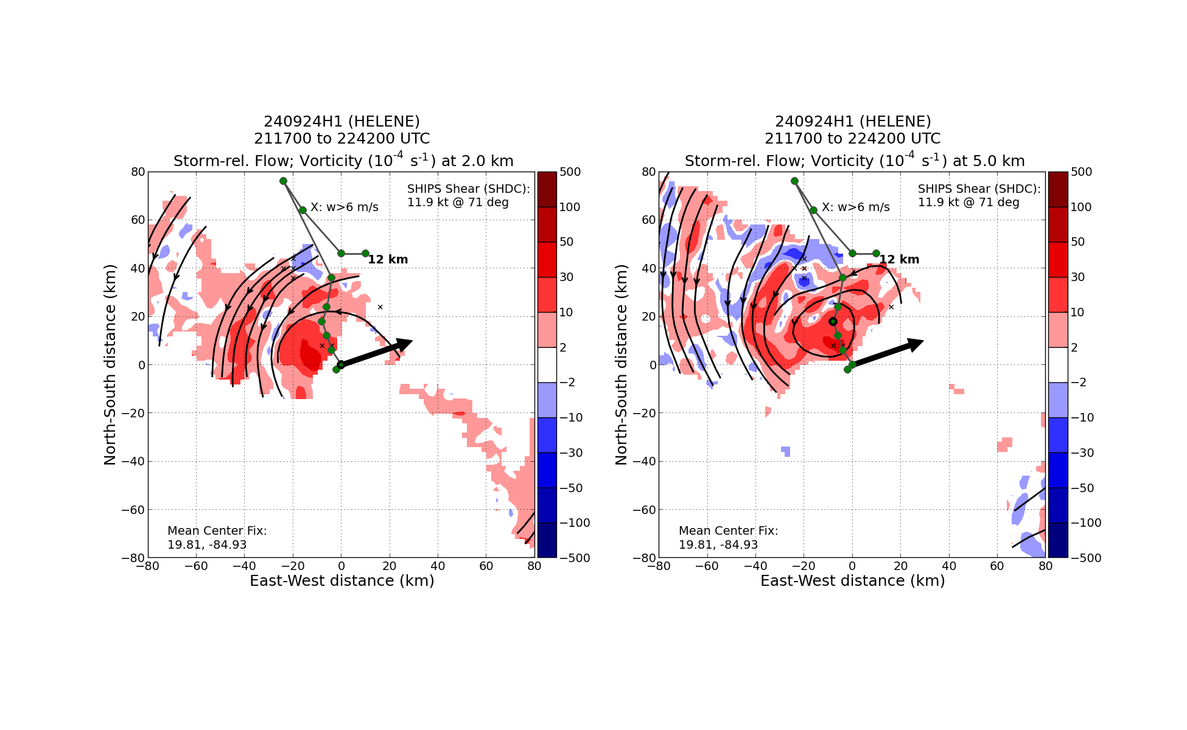  MLC is in the middle of the large convective blowup NNW of the FL center and likely LLC.
2320 | Midpoint drop #7 (no launch detect)
2324 | Midpoint drop #8 - backup
2333 | Center combo drop #9, AXBT #4, SST= , 19.75 N, 85.07 W, 994 hPa <JMC_N42_C3X> we didn't have as clean a fix this time as the first pass, it appears to be getting tucked into a cellular feature
2339 | Major jog to the W in the cross leg after center CPA on this pass. Should be OK for TDR analysis, but profile will be hard to interpret near the center. <treya_n42> marks_hrd, just getting back on line now. They were trying lightly to hunt but it's kinda messy from the tilt still i think.
2349 | Midpoint drop #10
2356 | PT#4, combo drop #11, AXBT #5, SST=31.4 C  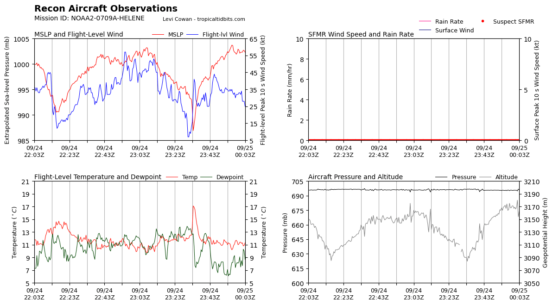
0004 | 2nd TDR analysis started
0018 | PT#5 combo drop #12, AXBT #6 (bad), TK 360 to the center
0021 | 2nd TDR analysis finished  TDR center info from 240924H1_2333_xy.nc:  Alt (km) Lat (deg) Lon (deg W)  0.5 99.99 99.99  2.0 19.73 85.06  3.0 19.82 85.01  6.0 20.21 84.97  2-6-km Vortex Tilt: 55.0 km at 11 deg  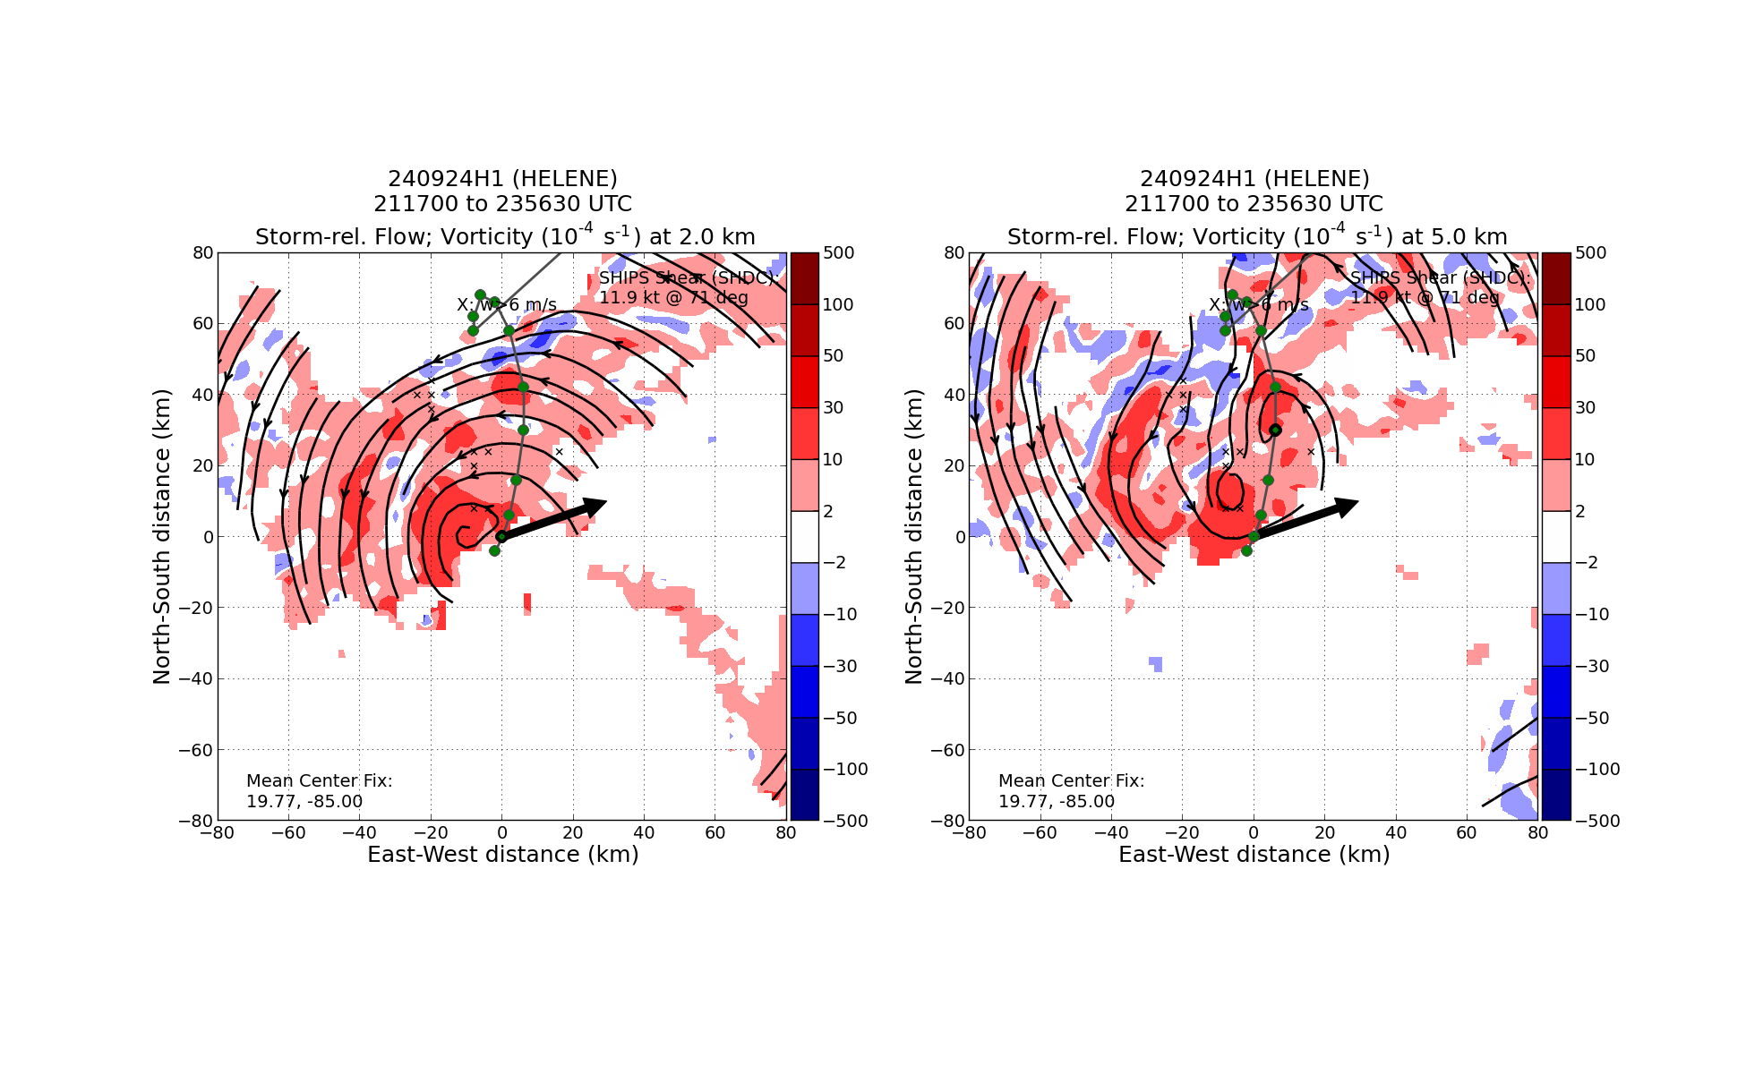  still tilted generally to the N. There appears to be two mid level centers. Could be a very interesting VAM case.
0032 | Midpoint drop #13
0042 | Center drop #14, 993 hPa, 19.60 N, 85.23 W
0053 | Midpoint drop #15
0109 | PT#6, combo drop #16, AXBT #7, SST=30.8 C, Start VAM module leg #1, TK 180 to center
0117 | Start 3rd TDR analysis
0133 | TDR analysis #3 completed  TDR center info from 240924H1_2442_xy.nc:  Alt (km) Lat (deg) Lon (deg W)  0.5 99.99 99.99  2.0 19.79 85.14  3.0 19.81 85.12  6.0 20.26 85.05  2-6-km Vortex Tilt: 53.0 km at 11 deg  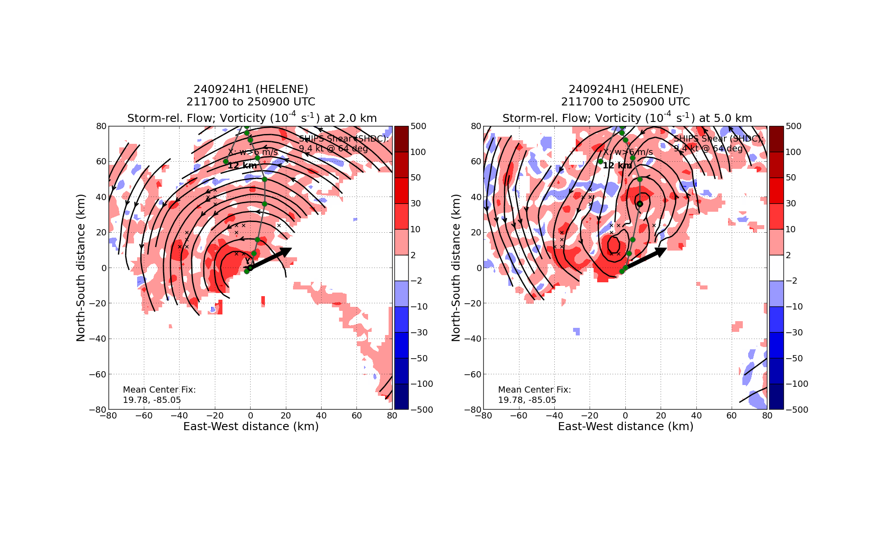  2nd MLC associated with new convective blowup. Which one will dominant is the question. Likely Will spiral around each other until merge.  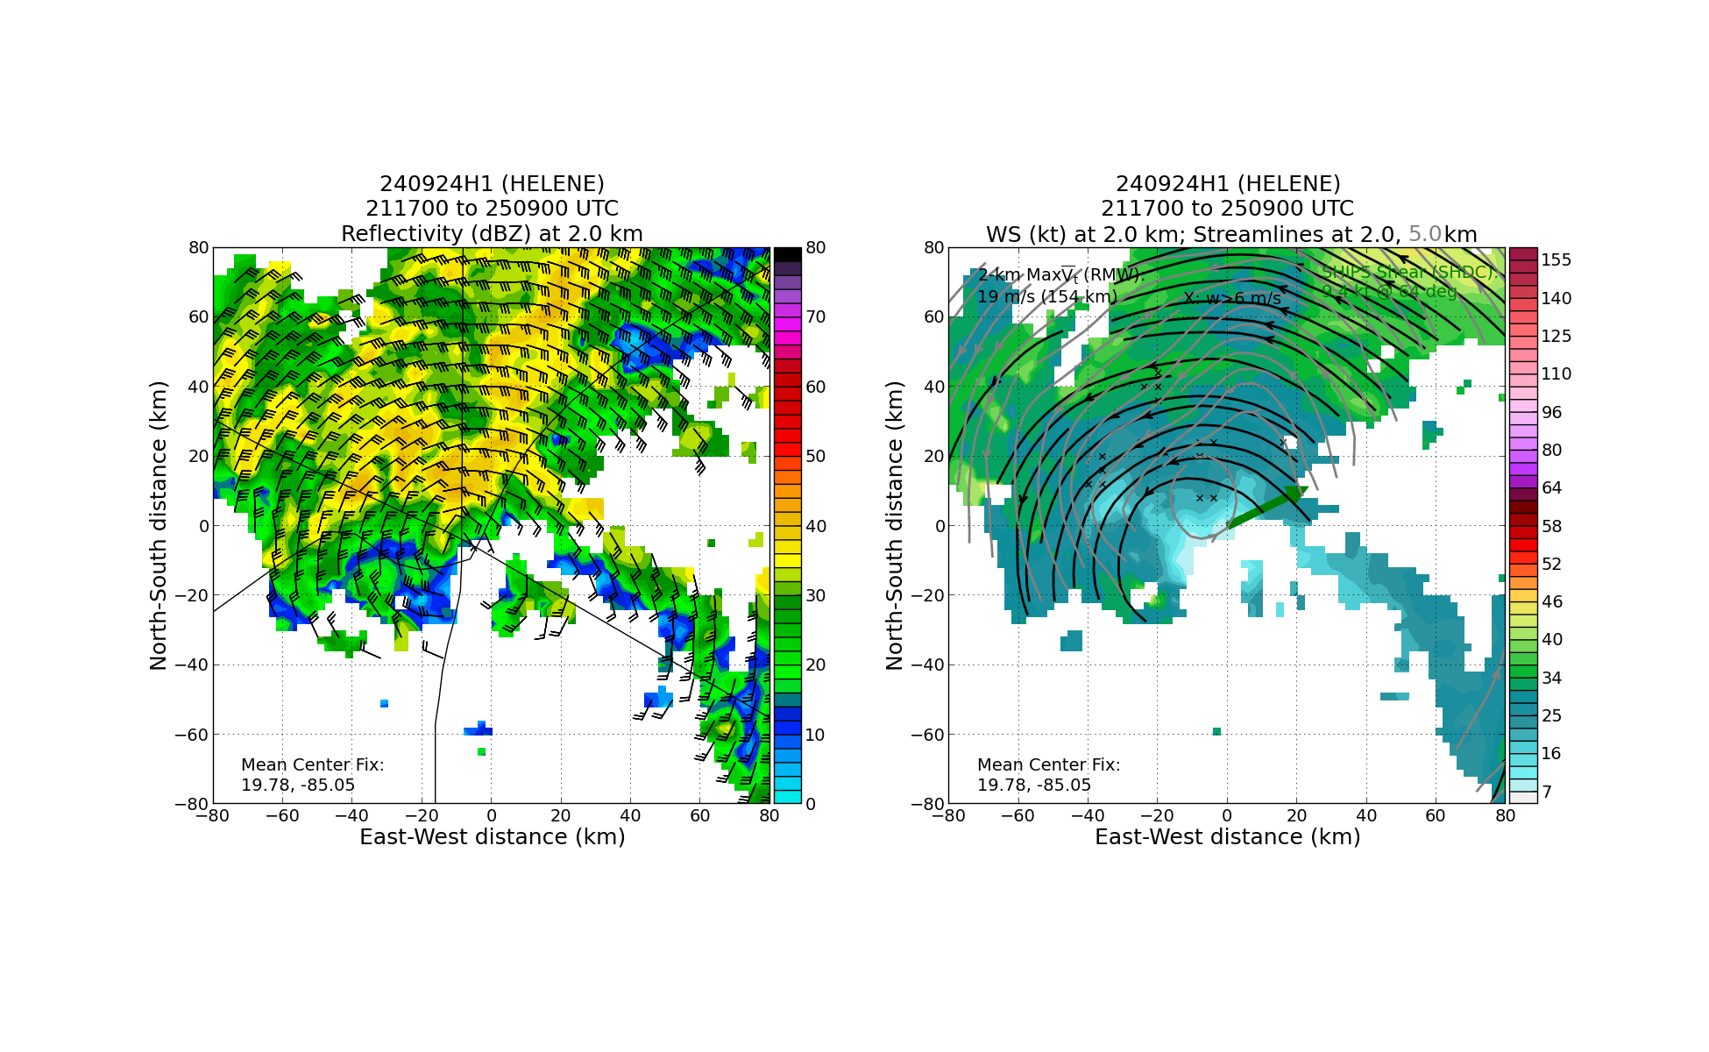
0136 | Center, TK 180 25 nmi before turning N
0143 | End VAM leg #1, switching to dual PRF model on TDR, turn TK 360
0144 | Start VAM leg #2 in dual-PRF mode on TDR
0150 | Center
0153 | Start 4th TDR analysis for VAM leg #1
0204 | End 4th TDR analysis  TDR center info from 240924H1_2536_xy.nc:  Alt (km) Lat (deg) Lon (deg W)  0.5 99.99 99.99  2.0 19.96 85.27  3.0 19.94 85.25  6.0 20.32 85.17  2-6-km Vortex Tilt: 41.3 km at 14 deg  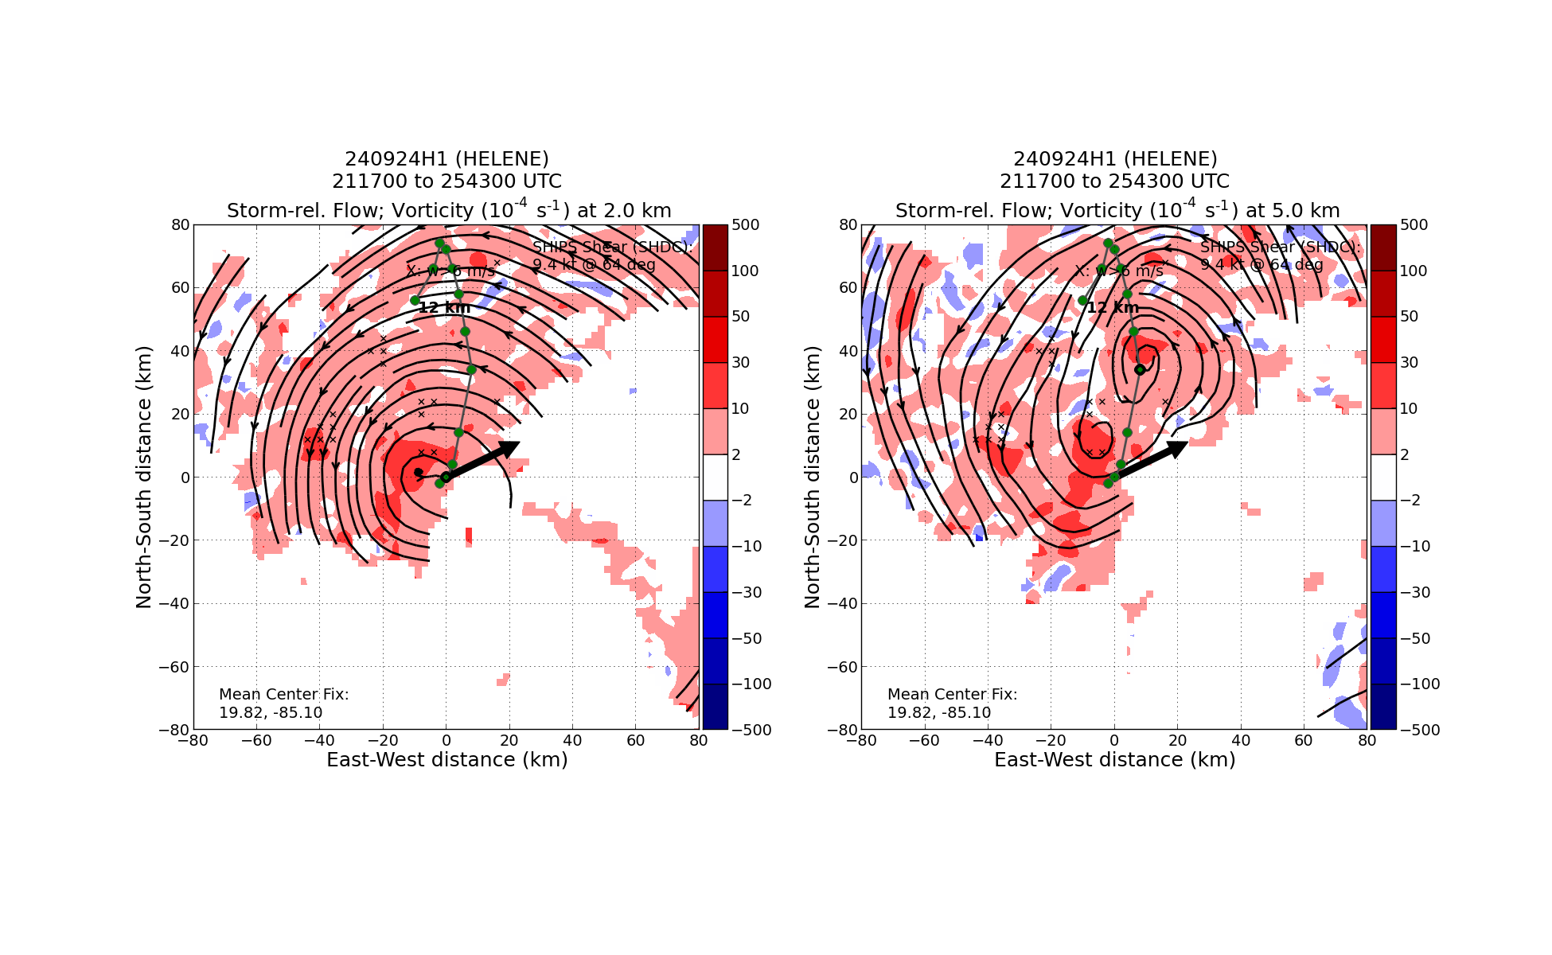  Marks - 2 MLCs persisted through the VAM module. Alvey - due to the way the tilt composites are created it’s plausible that the closer MLC (nearly overlapped with LLC) was not actually there during the latter part of the flight. Individual TDR swaths seem to maybe confirm this  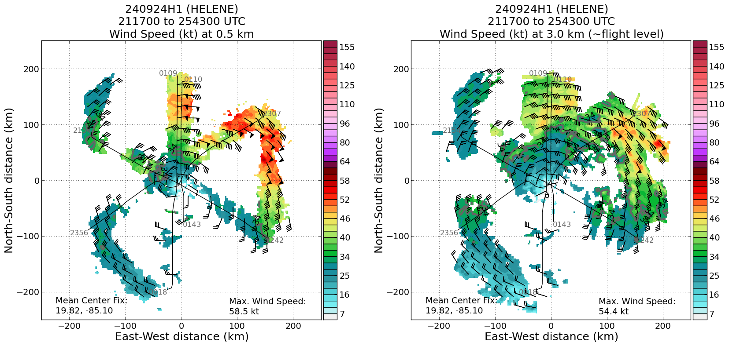  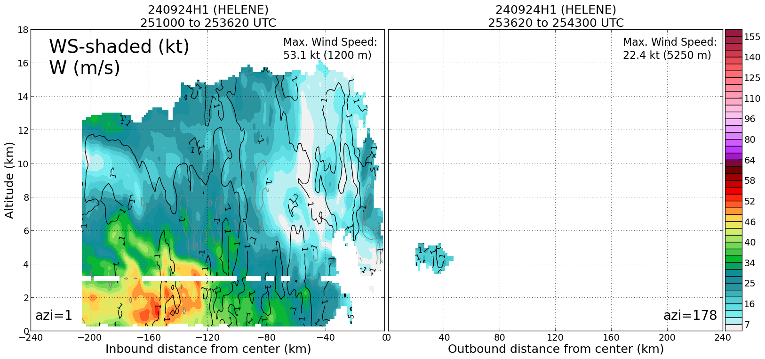
0207 | End VAM leg #2, end of VAM 55 nmi past LLC but keeping TDR going (still a lot more precip. we’re passing through for Dual-PRF post-processing…lots of stratiform)
0208 | End science, turn TK to LAL
 | NHC is using the wind/tilt data (yay!), though not entirely sure I agree 100% with the interpretation, since the storm still appears to have some misalignment 🫤: “Doppler velocity data from a NOAA Hurricane Hunter aircraft indicate no significant vertical tilt of the vortex in the low- to mid-troposphere. This suggests that the vertical wind shear is low.” -Pasch (https://www.nhc.noaa.gov/archive/2024/al09/al092024.discus.007.shtml?)
0345 | Land LAL

POST-FLIGHT
Mission Summary | - Successful operational TDR mission in Tropical Storm Helene with 4 TDR analyses completed and transmitted. Butterfly pattern flow with shortened legs to the NW to stay out of Mexican airspace. TDR analyses showed a relatively broad center circulation that exhibited a 40-50 km tilt to the north from 2- 6 km altitude into a major convective blowup north of the FL center.  - Did a VAM module to the north of the center through two MLCs and LLC.  - Last leg from LLC to the north was done using dual-PRF mode on the TDR  Totals: 16 Sondes 15 good, 1 Bad. All charged to NWS. 7 UM BTs 4 Good.
Actual Standard Pattern Flown | Butterfly
APHEX Experiments / Modules Flown | - APHEX Early Stage: Vortex Alignment Module (VAM)  - APHEX Early Stage: Tail Doppler Radar Dual-PRF in Hurricanes
Plain Language Summary | - Successful operational TDR mission in Tropical Storm Hermine with 4 TDR analyses completed and transmitted.  - TDR analyses showed a relatively broad center circulation that exhibited a 50 km tilt to the north from 2- 6 km altitude
Instrument Notes | TDR slave flakey 2117-2124. Mac reset it and everything was great after ward
Final Mission Track | 