\

MISSION PLAN
FLIGHT ID | 20240911H1 | STORM | AL06 / Francine
MISSION ID | 1306A | TAIL NUMBER | NOAA-42
TASKING | NHC/EMC TDR | PLANNED PATTERN | Butterfly
MISSION SUMMARY
TAKEOFF [UTC] | 0806 | LANDING [UTC] | 1651
TAKEOFF LOCATION | KLAL | LANDING LOCATION | KLAL
FLIGHT TIME | 8.8 | BLOCK TIME | 9.0 hr
TOTAL REAL-TIME RADAR ANALYSES  (Transmitted) | 5 (5) | TOTAL DROPSONDES Deployed (Tx to GTS) | 20 (19)
OCEAN EXPENDABLES deployed (good) | UM AXBTs 9 (9)  2 A-Sized WDs | sUAS (Type) | S0 (2, 1 worked)
APHEX EXPERIMENTS / MODULES | RICO SUAVE, CHAOS
HRD CREW MANIFEST
LPS ONBOARD | Hazelton | LPS GROUND | J. Zhang
TDR ONBOARD | Hazelton | TDR GROUND | Reasor
ASPEN ONBOARD | N/A | ASPEN GROUND | Dunion
NESDIS SCIENTISTS | Jelenak, Saap
GUESTS (Affiliation) | Elston (Blackswift), Wadler (ERAU), Kaisti (Skyfora)
AOC CREW MANIFEST
PILOTS | Rannenberg, Wood, Taraboletti, Ellis
NAVIGATOR | Schaefer, Saunders
FLIGHT ENGINEERS | Tyson, Dittoe
FLIGHT DIRECTOR | Kalen
DATA TECHNICIAN | McAlister
AVAPS | Dykeman, Santoni, Underwood

PRE-FLIGHT
Flight Plan | 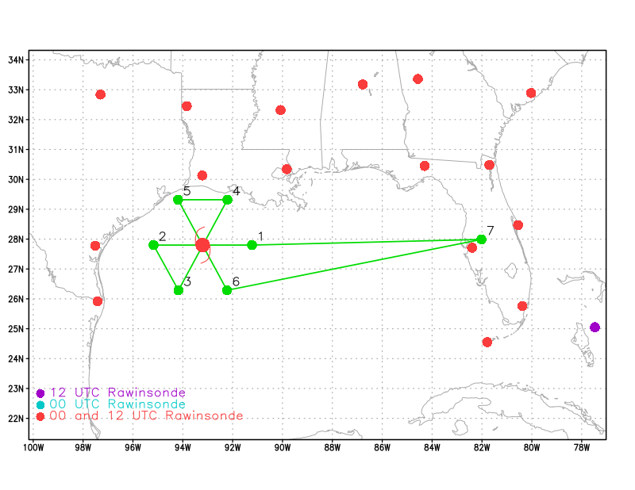  [Insert image of ONR/TCRI detailed pattern image, if available]  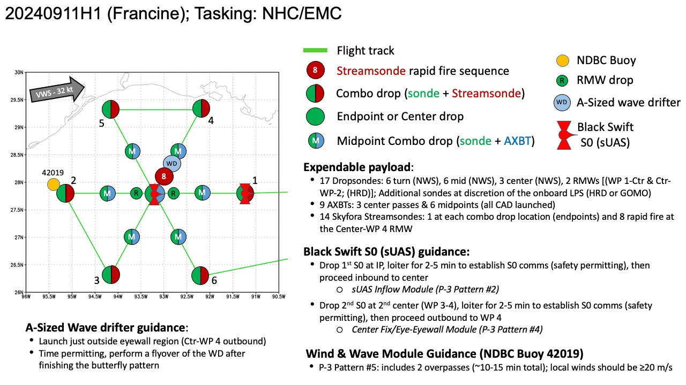  [If you want, briefly describe the pattern in words]  Pattern: Fly butterfly pattern with 105 NM legs  - Pattern should be adjusted as needed to avoid land  Altitude:  - 8 kft preferred (pressure altitude)  Research Modules:  - APHEX CHAOS (Ocean Observing)  - APHEX RICO SUAVE (Mature Stage)  - APHEX Surface Wind & Wave Validation (Mature Stage)
Expendable Distribution | [Describe planned dropsonde, ocean buoy, sUAS deployment locations; e.g., “Dropsondes/AXBT combo drops at endpoints, midpoints, and center”  Expendables:  - Load 30 dropsondes  - Release at endpoints, midpoints, centers >> charged to NWS  - Release 2 RMWs - see notes below >> charged to HRD  - Possible extra sondes at the discretion of the onboard LPS >> charged to HRD or GOMO  - All dropsondes transmitted to the GTS  - Load 20 Skyfora Streamsondes - see notes below  - Load 9 UM AXBTs - see notes below  - Load 3 Black Swift S0s - see notes below  - Load 2 A-sized wave drifters - see notes below  sUAS:  - Black Swift S0 (2) - see notes below  - S0 #1: launch at IP: ~1h 30m after take-off (~0930z)  - Module: sUAS Inflow (P-3 Pattern #2)  - S0 #2: launch at 2nd center (WP 3-4): ~3h 15m after take-off (~1115z)  - Module: Center Fix/Eye-Eyewall (P-3 Pattern #4)  - S0 Operating altitude: 5,000 ft to surface  - Expected S0 duration: 1-1.5 hr
Preflight Weather Briefing | Francine has strengthened and become better organized  overnight. Radar data and earlier reports from the Air Force  Hurricane Hunters indicate the eyewall is better defined, with deep  convection wrapping around the center of the hurricane. The eyewall  has contracted a bit from earlier, although it was open to the south  on the last fix and in more recent GMI passive microwave images.  The microwave data also showed some northeastward vortex tilt with  height, a sign that Francine is experiencing some effects of  southwesterly shear. Based on the earlier peak 700-mb flight-level  winds of 89 kt, the initial intensity is set at 80 kt, with a  minimum pressure of 977 mb based on aircraft data. Air Force and  NOAA Hurricane Hunter aircraft are scheduled to investigate Francine  again this morning.  The hurricane is moving northeastward at 035/9 kt. A slightly faster  northeastward motion is forecast today and tonight as the hurricane  is steered by a mid- to upper-level trough over Texas.  [Briefly describe the relevant environmental drivers.]  Southwesterly shear is expected to increase over the hurricane later today, and interaction with an upper trough should cause drier air to wrap around the  southern portion of Francine as it nears the coast.
Instrument Notes | [What instruments are working, not working, not functioning nominally, not installed?]

IN-FLIGHT
Time [UTC] | Event
0806 | Take-off from KLAL
0955 | ahazelton_N42_LPS> FYI, the Skyfora streamsondes don't seem to be working at the moment according to Lunchables_and_Launchables  <ahazelton_N42_LPS> Due to a software update or something
0956 | Going through s0 checklist
0958 | Hazelton: We're doing a quick orbit and then going to the IP and launching the first s0
1000 | S01 launched
1000 | Drop1, IP (E)
1006 | <JWadler_N42_UAS> s0 losing gps, descending to 700m, then 350 m
1008 | S0 down, splashed gps issue, planning to drop 2nd one outbound
1010 | AVAPS confirmed no skyfora in this flight due software update issue, new software, streamsonde launch not working
1012 | Drop2, MPI1 BT Combo SST 28.30
1019 | Drop3, RMWI1-1 No hum
1019 | Drop4, RMWI 1-2 good drop
1023 | Drop5, center 1 Combo SST 28.6
1025 | pppapin_nhc> Hi everyone, just wanted to chime in saying we are going to monitor the MTS chat again from NHC today (Jack Beven will be the forecaster on Francine today). Feel free to pass along any info you think might be useful for us.
1030 | Working on s0 plans with Josh Wadler, documenting here:  JWadler_N42_UAS> we were initially thinking of the 3rd pass because the p-3 will turn around and come back for a buoy overfly. gives us a chance for iwrap comparison. thoughts now that we have time?  <JWadler_N42_UAS> it will be a lot longer. they said 5 total penetrations  <JWadler_N42_UAS> science on the end  <Jun_HRD> if going back to center then 1 hour at least  <Jun_HRD> 2nd pass center is safe  <JWadler_N42_UAS> 2nd pass is safe, but no chance of iwrap comparison  <Jun_HRD> If they do inbound to center after pt 6 then it should be good  <JWadler_N42_UAS> that's a big benefit of being on 42  <Jun_HRD> You may also do a calculation if dropping center of 2nd pass  <Jun_HRD> which direction to fly so P3 will meet s0  <JWadler_N42_UAS> if we drop on the 5->6 and send it in the western eyewall, it should be in the northern eyewall when we come back  <JWadler_N42_UAS> which is where we will go for the buoy overflight  <Jun_HRD> s0 follows inflow  <Jun_HRD> usually fly counter clockwise  <JWadler_N42_UAS> yes. it would go 3/4 around the eyewall  <Jun_HRD> you can ask Paul Chang or Zorana to fly directly to s0  <JWadler_N42_UAS> yeah, I talked to zorana about it before the mission. she really wants to do it  <Jun_HRD> yeah. I chatted with P. Chang on xchat yesterday during 4 am mission. They all wanted it  <Jun_HRD> We brainstormed some ideas how to catch s0  <JWadler_N42_UAS> hopefully the thing flies  <Jun_HRD> have a plan B  <Jun_HRD> if 2nd didn't work, immediately drop the 3rd one outbound or at end pt or you can drop 2nd during 2nd pass  <Jun_HRD> see if it is working. splash it early before getting to the center of the 3rd pass. If it last long, splash early and drop the 3rd one  <JWadler_N42_UAS> i was thinking that, but the west side is dry with not any precip, so inflow may not be interesting starting from that side  <JWadler_N42_UAS> so we wouldnt drop until center.  Jun_HRD> you may drop the 2nd at 2nd center  <Jun_HRD> if not working, drop 3rd at 3rd center  <JWadler_N42_UAS> ok
1032 | Drop6, RMWO1
1036 | Drop7, MPO1, Combo SST 28.8
1047 | Andy noticed double wind peaks during outbound leg, captured IR and SAL images here  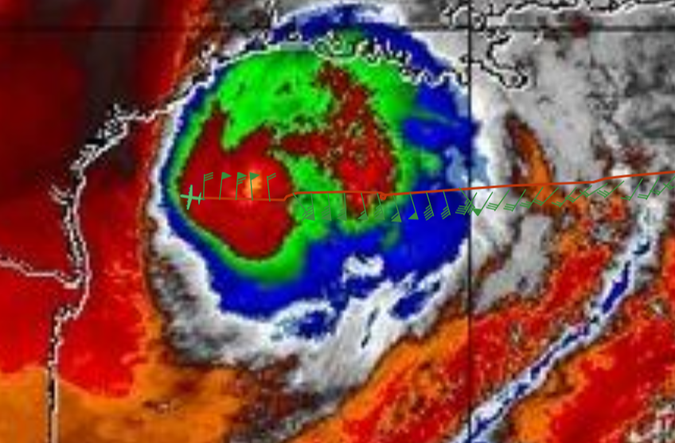  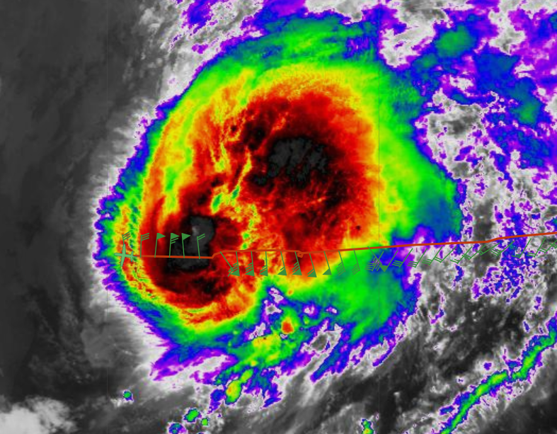
1049 | Drop8 EP1 (W)
1105 | hholbach_hrd> pppapin_nhc, just as a head's up since you are still getting SFMR from the AF, while you already know to not trust it too much, you should be especially cautious of using it after center passes. We are seeing that the rise in ambient temp in the eye causes a rise in the temperature of the radome which has a much larger impact on the retrievals than was previously realized. After N42's first pass this morning the SFMR was incorrectly showing wind speeds 20 m/s higher than FL!  1154: pppapin_nhc> Thanks for the earlier message hholbach_hrd, I have relayed that info to Jack so we will be extra cautious about any SFMR data.
1106 | AVAPS mentioned ‘Switched to old Skyfora software. Giving it a go on this pass.’
1112 | ahazelton_N42_LPS> We're going to do 1 Skyfora at the endpoint, 6 rapid fire near the RMW, then 1 at the endpoint (since there's 8 channels)
1118 | P3 may pass an arc cloud during outbound  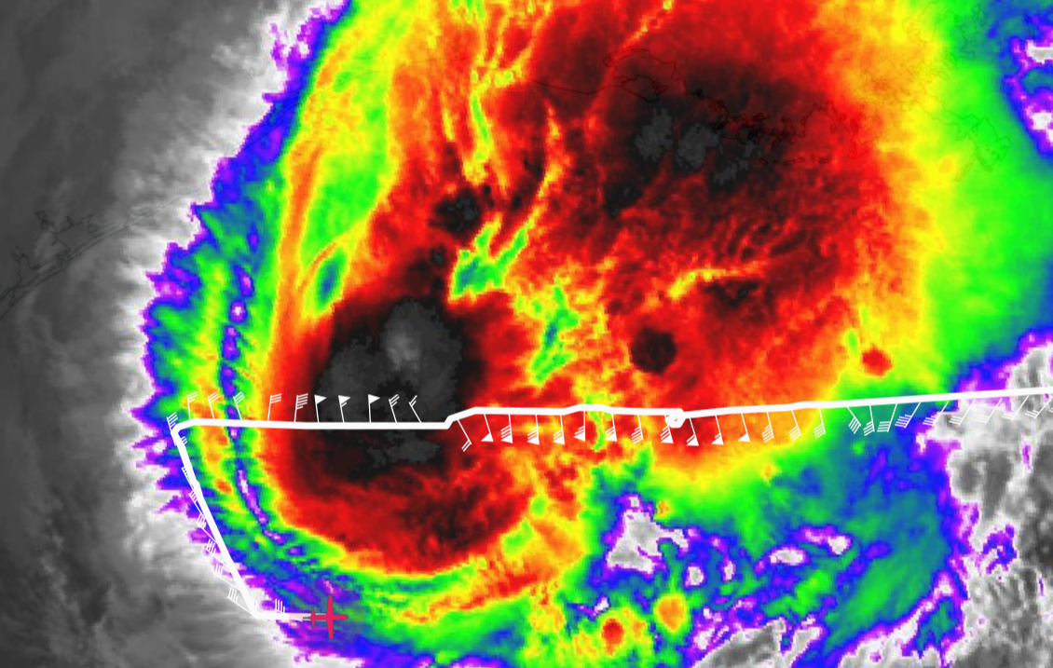
1121 | ahazelton_N42_LPS> We are going to add one RMW sonde on the NE side for comparison with the streamsondes
1121 | Drop9, IP2 Sykfora Combo
1130 | Drop10, MP2, BT Combo SST 28.6
1134 | First TDR analysis, rzmean  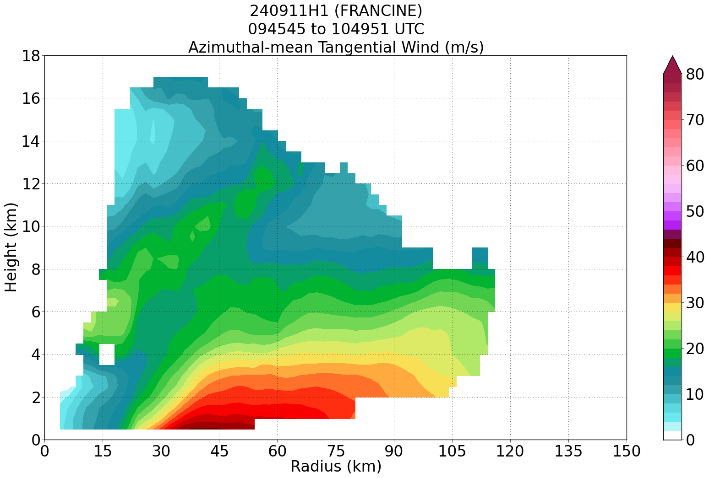
1135 | TDR profile: inflow asymmetry in the BL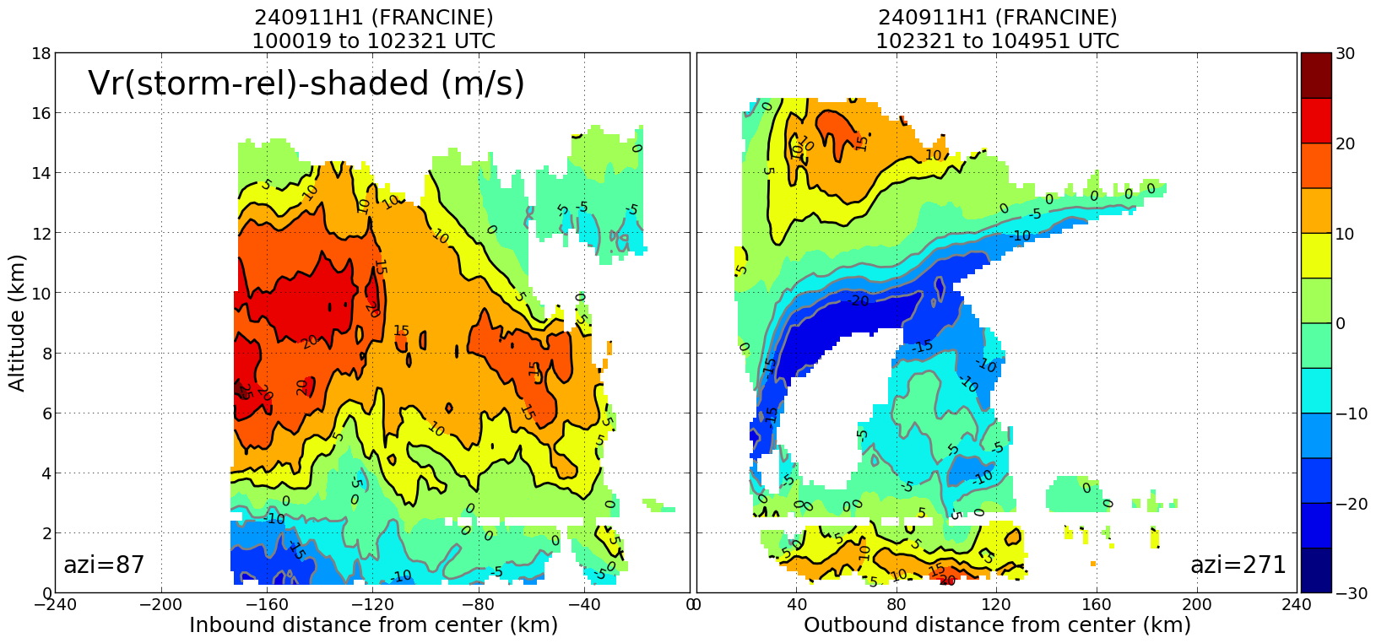
1138 | Tilt to downshear  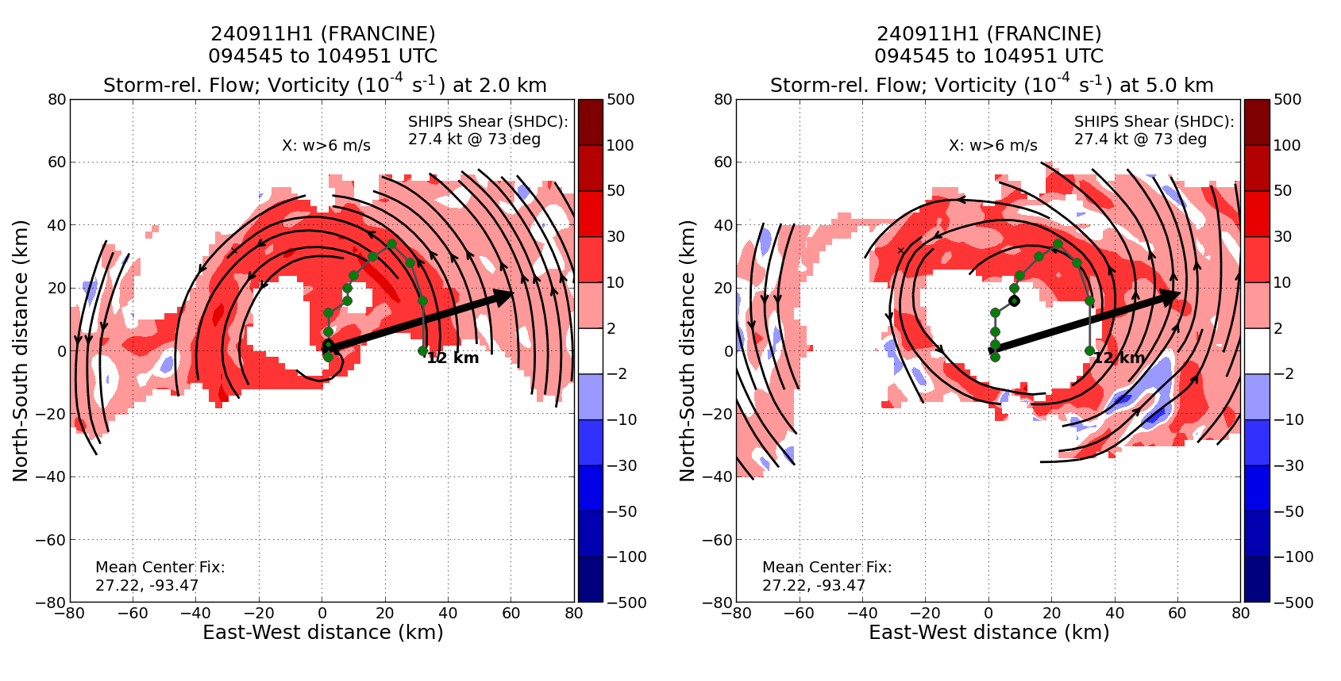
1144 | Drop11, 2nd Center, BT Combo SST 28.4
1151 | Drop12, RMW NE, Six Skyfora combo
1155 | AVAPS noted one of the Skyforas sondes was going up - dropped 6 + sonde
1201 | Mostly moderate convection, but deep convection showed up, more than yesterday, suggesting the storm is strengthening 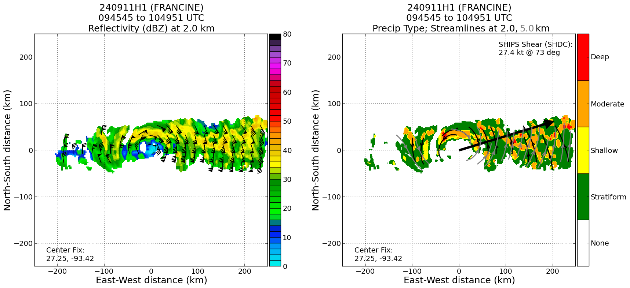
1154 | Water vapor loop, South and SW sides dry upshear  The interaction of Francine with an upper trough may cause drier air to wrap around the southern portion of Francine as it nears the coast.
1156 | Drop13, MPO2 super Combo with BT and Drifter SST 28.2
1208 | Drop14, EP2 w/ Skyfora combo NE
1210 | Pinkish cloud top temp
1212 | Buoy coordination:  <hholbach_hrd> ahazelton_N42_LPS, winds are a little lighter than I would like at the buoy, but the wave data are still good. It doesn't look like it will be too far out of the way to overfly it, so if it looks good to you all up there maybe we can still go for it.  <hholbach_hrd> The lat/lon for 42035 was 29.235N 94.410W in case you need it again; It would be the same plane as before, a 10 min leg lined up with the wind direction centered on the buoy  ahazelton_N42_LPS> What are the winds there right now?  <hholbach_hrd> At 1140Z they were 17.5 kts at 50 deg  <ahazelton_N42_LPS> They said it would eat some fuel (about 50 nmi) to do along the wind. If we did E-W it would be more minimal. What do you think hholbach_hrd?  <hholbach_hrd> E-W would be ok if the wind gradient is small, but if it would still add more than 10-20 mins to the leg it might be best to save that time  <ahazelton_N42_LPS> Yeah, the compromise is minimal time. So we're going to do that  <ahazelton_N42_LPS> I haven't seen much of a gradient up here  <hholbach_hrd> Ok sounds good  <ahazelton_N42_LPS> Trying to save time for the S0 and drifter work at the end
1135 | ahazelton_N42_LPS> Yeah we're going E-W over the buoy then back to the IP for TDR leg purposes  <hholbach_hrd> The alignment with the buoy is looking great!  <ahazelton_N42_LPS> 5 more minutes along this track  <hholbach_hrd> Perfect. You just passed directly over it  <jasond_hrd> hholbach_hrd, looks like 15.5 kt gusting to 19.4 kt at 42035 as 1210z...pretty good  <hholbach_hrd> Yeah this will be a nice comparison pt jasond_hrd  hholbach_hrd> ahazelton_N42_LPS, looks like you've gotten the 10 mins over the buoy. Feel free to go to the IP for the next leg whenever
1146 | Buoy 42035 coordination: 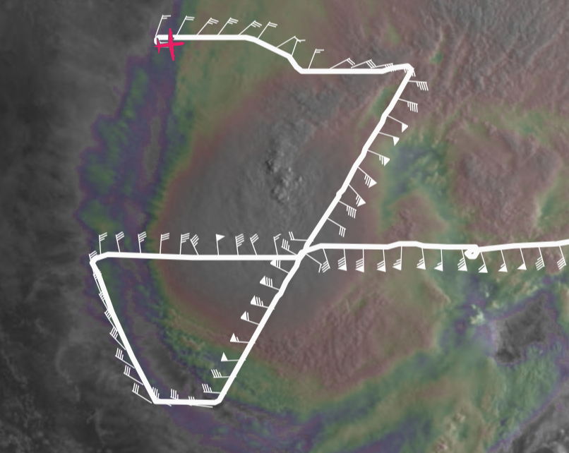
0847 | <pppapin_nhc> Those looking at the TDR... any impressions of how Francine's core structure is evolving? Looking at the TDR tilt view in AWIPS its stacked to 2km, but tilt seems to start increasing to the NE  <pppapin_nhc> by 5km and beyond.  <ahazelton_N42_LPS> Yeah the initial tilt estimate was like 20 km from our first pass  <ahazelton_N42_LPS> But the second one was much smaller  <ahazelton_N42_LPS> Should have new graphics with both legs in soon  <pppapin_nhc> Thanks ahazelton_N42_LPS... sounds like we are seeing the same things.
1256 | Drop15, IP3 SW Skyfora Combo
1304 | 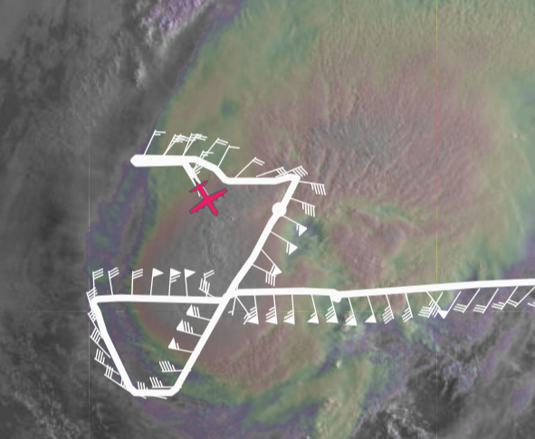
1306 | Drop16, MPI3, BT Combo + A-Sized wave drifter (SN 64139880) SST=27.26 C
1313 | 2nd drifter launched (SN 64139810)  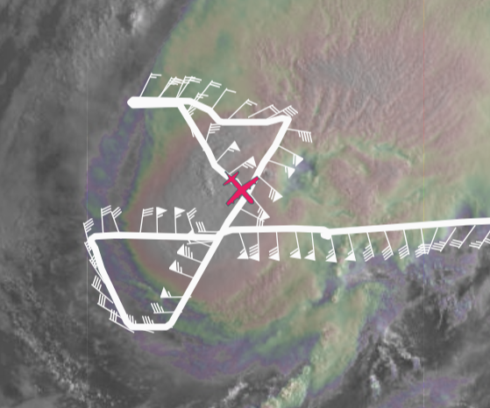
1318 | 2nd s0 launched
1318 | 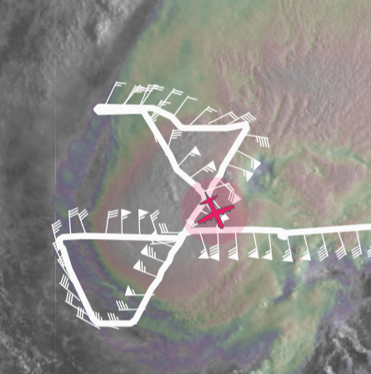
1320 | Drop17, CenterP3 BT Combo SST 29.1
1324 | S0 descent to z=1500 m heading to west eyewall
1326 | S0 transitioned to max winds module, 60 kt, 77 kt winds
1331 | <pchang_VA> how close will you pass by 26.6985284 -92.7217041  <pchang_VA> on the outbound leg?...that's the position of previously deployed drifter  <pchang_VA> its reporting 6.16m waves now  <ahazelton_N42_LPS> That's quite close to where we are right now  <ahazelton_N42_LPS> Actually just did our midpoint sonde too  Flew over wave drifter  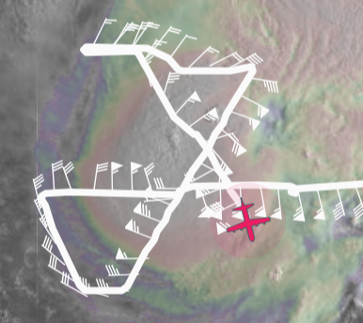  <zjelenakN42> pppapin_nhc we are plotting iwrap ku-band scatterometer winds (black) timeseries with flight level (red) and sfmr (blue) and sondes on following link https://manati.star.nesdis.noaa.gov/research/casey.shoup/for_zorana/hs2024_iwrap_sfmr/20240911H1_timeseries-wind_ku.png  Overflying drifter location 28.2319109 -92.7797335
1334 | s0 started going down to 1000 now, 96kt winds
1334 | Drop18, MPO3 combo BT SST 29.7, over drifter previously deployed
1342 | jasond_hrd> JWadler_N42_UAS, just a heads up that the KUAS HDOB files look like that have date mismatches - today's have a date of 12 Sep...yesterday had mismatches too
1345 | Drop19, EP3 Skyfora Combo SE
1348 | S0 dropping to 500 m
1349 | 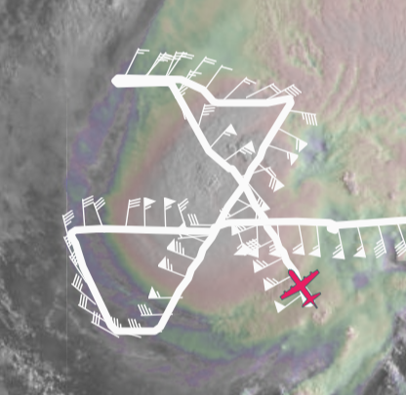  ahazelton_N42_LPS> Heading back inbound for the S0 and drifter work
1353 | From AVAPS Brian: Totals: 19 Sondes, 18 Good 1 no Hum, (15 to NWS, 4 to HRD (the bad hum was an HRD)), 9 good BTs, 10 Skyfora which data still needs to be checked, 2 A-Sized Drifters.  Plus two Blackswift S0s. One good, one no motor start
1359 | Jun_HRD> what is the s0 reading?  <ahazelton_N42_LPS> We're actually turning into the wind a little bit to overfly the S0 better  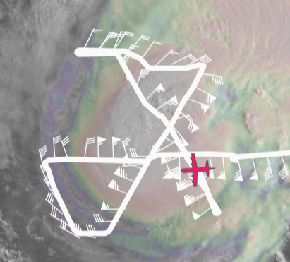
1401 | <ahazelton_N42_LPS> Lost comms with the S0 for now  <Jun_HRD> shouldn't be a range issue right?  llooney> ahazelton_N42_LPS, at the moment of turn?  <JWadler_N42_UAS> no. we are about to go right over it....  <JWadler_N42_UAS> it would have been perfect
1404 | ahazelton_N42_LPS> Heading into the eye now and then the drifter overflight  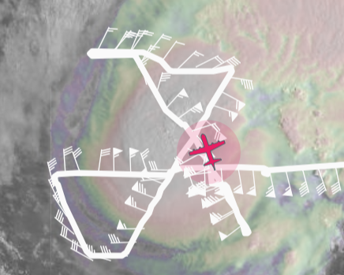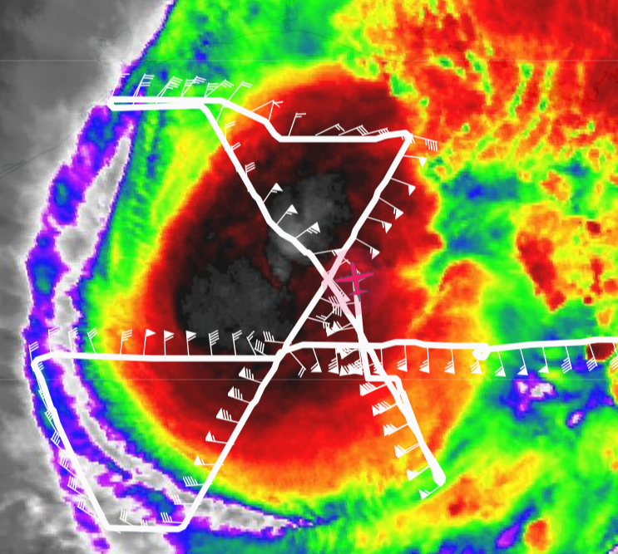
1419 | From AVAPS: Hello TAG friends, we'll be adding one more sonde to the totals, charged to GOMO to drop on the drifter. Releasing shortly, will update when closed.
1421 | TDR composite shows some coverage on S side, not bad  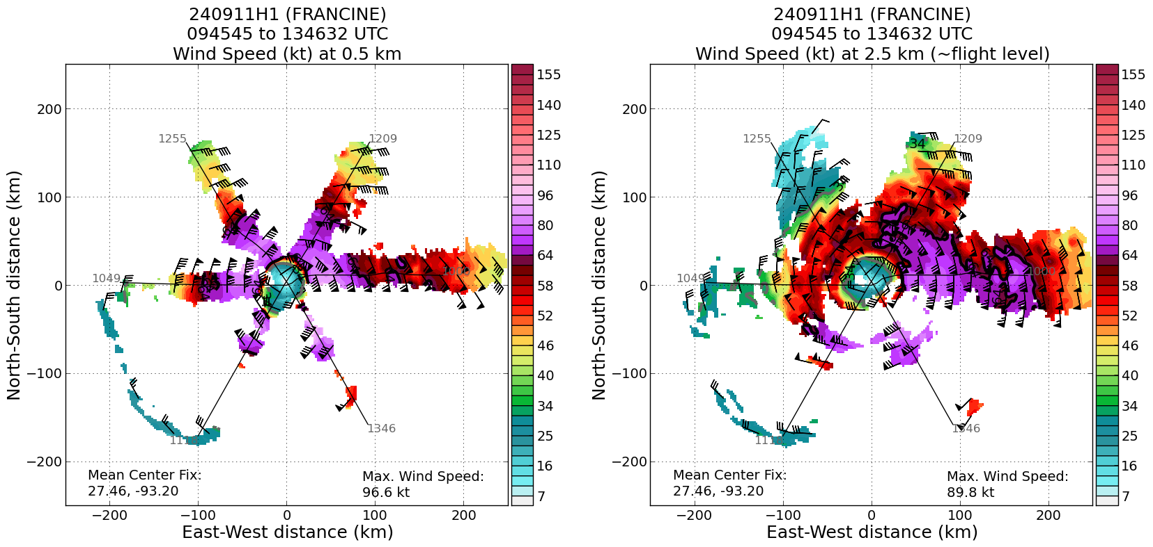
1422 | Drifter overfly  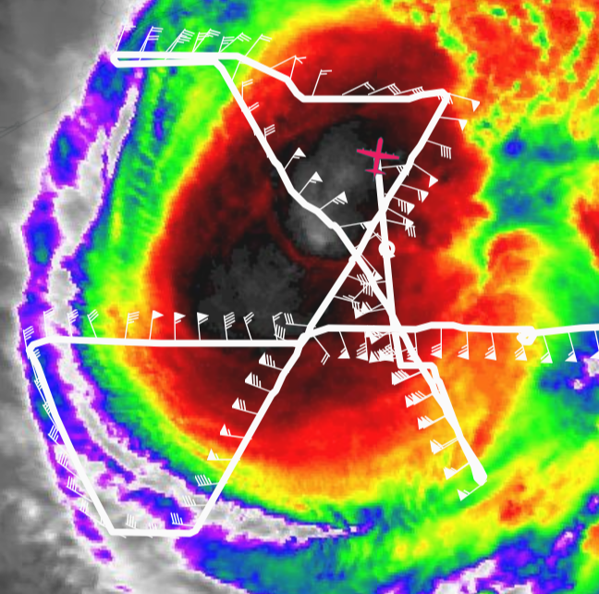
1422 | Drop20, Drifter Drop charged to GOMO  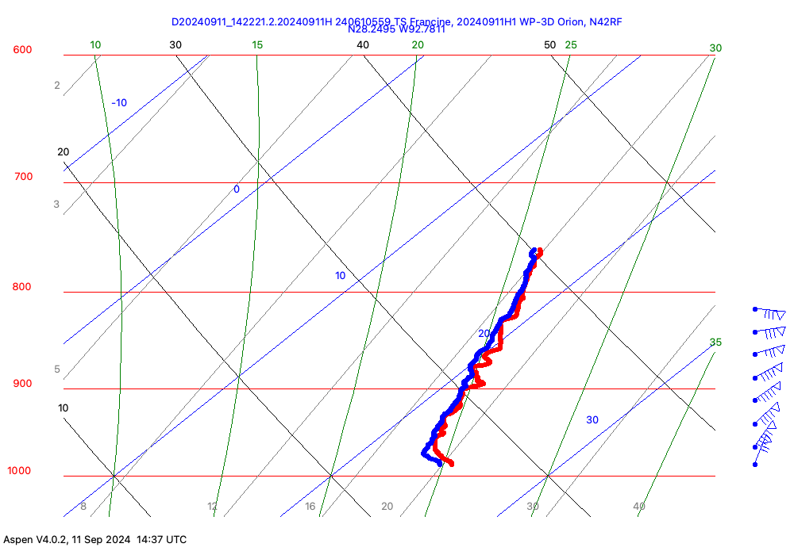
1429 | S0 ‘dead’ no comms - labeled splashed
1435 | ahazelton_N42_LPS> Max TDR wind was 97 kt so far at 0.5 km  <jasond_hrd> that last 1422z sonde had ~99 kt at 965mb...then a quick drop off to the surface (74 kt)
1445 | Flying over wave drifter again (3 times in total)
1506 | Science complete  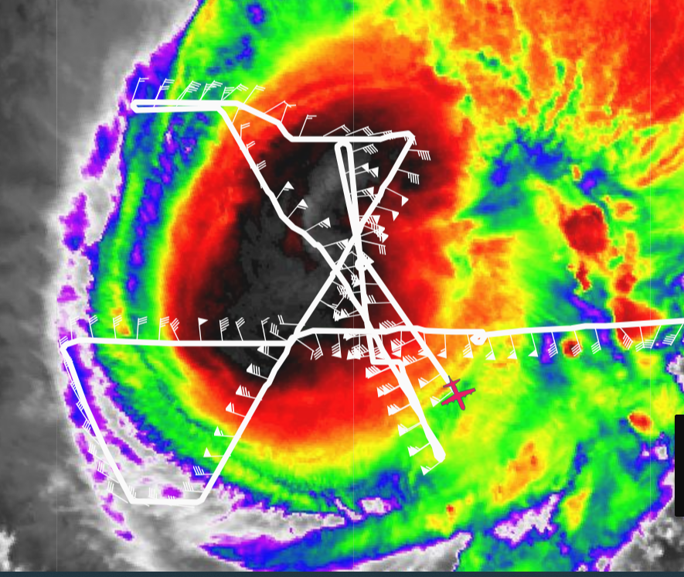
 | 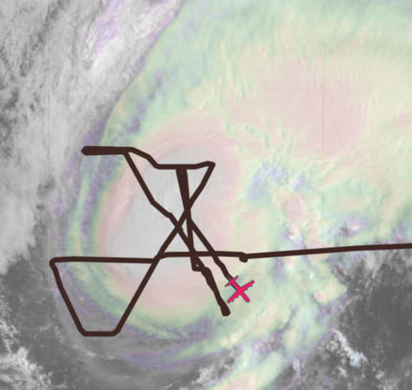
1511 | TDR composite with 4 analyses combined  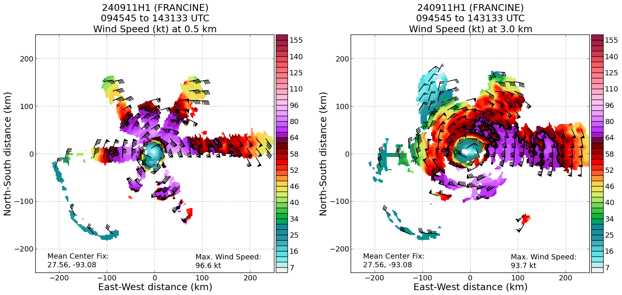
1511 | 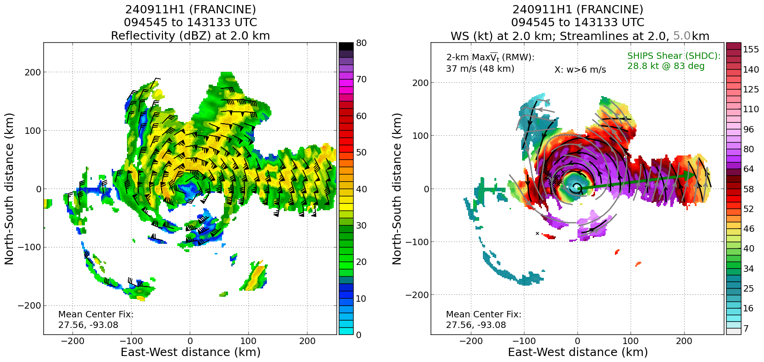
1551  MDI?  Strong BL inflow for sure | 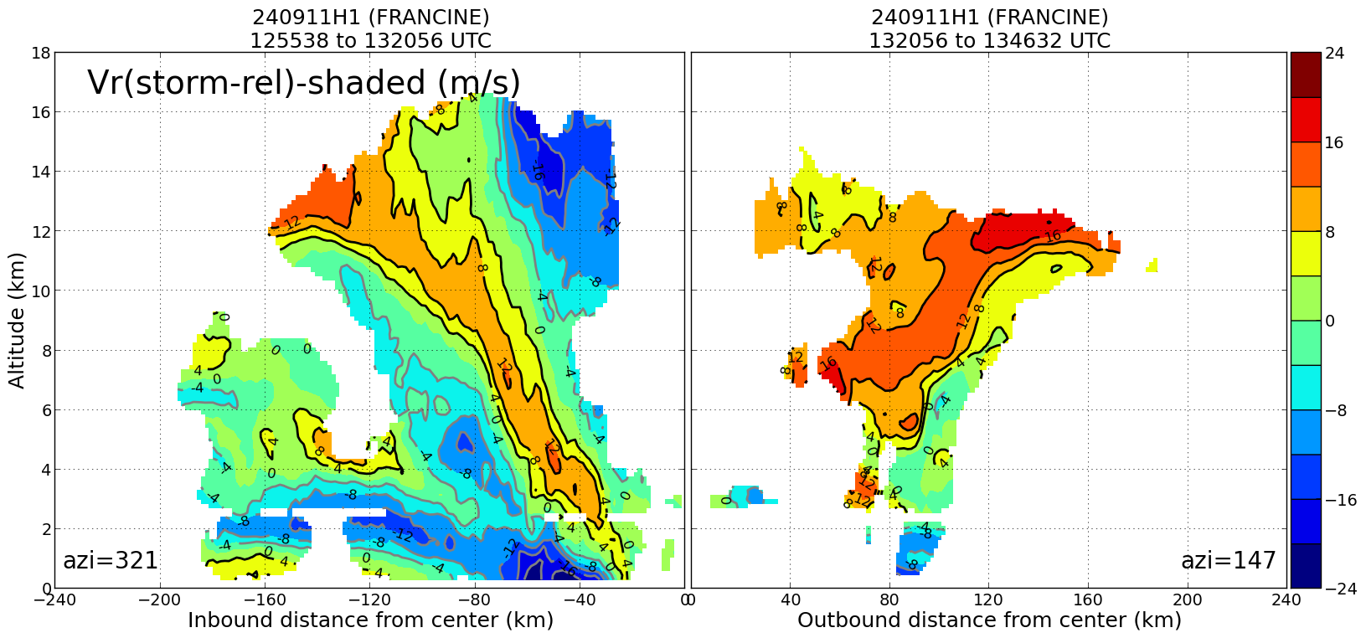
1615 | zjelenakN42> we are still trying to send data to the ground but combination of iwrap scatterometry and doppler winds are very good at 10m we are updating this plot as new data comes https://manati.star.nesdis.noaa.gov/research/casey.shoup/for_zorana/hs2024_iwrap_sfmr/20240911H1_timeseries-wind_ku.png  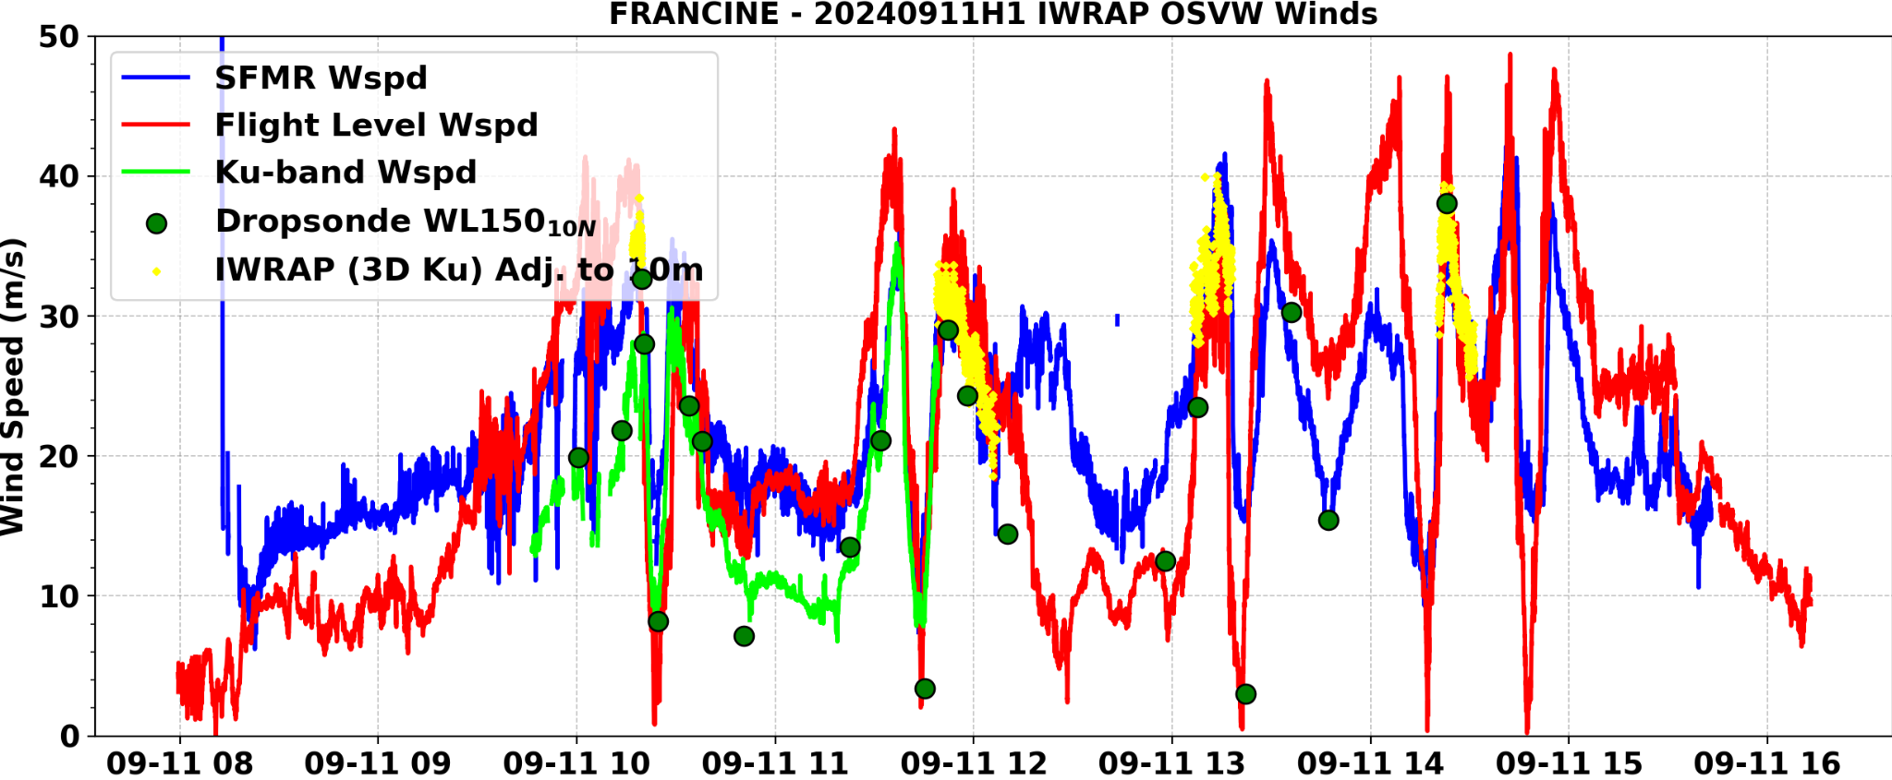

POST-FLIGHT
Mission Summary | We flew a successful mission into Hurricane Francine in the Gulf of Mexico, performing a TDR butterfly pattern as well as several research modules, including a buoy overflight (surface wind and wave validation), S0 launch (mature stage UAS sampling), and a 2 A-Sized wave drifter launches and overflights (ocean observing).  Between these multiple research modules and a TDR pattern that provided excellent coverage of the core of the TC, a lot of valuable data was collected.  The TC was maintaining itself and slowly intensifying despite obvious asymmetry due to shear as well as the presence of some dry air. The southern part of the eye struggled to close off through the flight, and there was a general lack of hydrometeors overall on that part of the storm.
Actual Standard Pattern Flown | Butterfly
APHEX Experiments / Modules Flown | APHEX CHAOS (Ocean Observing)  APHEX RICO SUAVE (Mature Stage)  APHEX Surface Wind & Wave Validation (Mature Stage)
Plain Language Summary | We flew a successful mission into Hurricane Francine to collect radar data for EMC and NHC, and also performed several research modules, including launching an uncrewed system to collect data in the lowest part of the storm.
Instrument Notes | Instruments mostly worked well. We turned off the SFMR HDOBs as requested. One of the two S0s immediately splashed. The other one we successfully got data from in the eyewall for a while. Initially, there was an issue with the new software on some of the Skyfora streamsondes.
Final Mission Track

