MISSION PLAN
FLIGHT ID | 20240910I1 | STORM | AL07 / Francine
MISSION ID | 1006A | TAIL NUMBER | NOAA-43
TASKING | NHC/EMC TDR | PLANNED PATTERN | Butterfly
MISSION SUMMARY
TAKEOFF [UTC] | 10/2011 | LANDING [UTC] | 11/0328
TAKEOFF LOCATION | KLAL | LANDING LOCATION | KLAL
FLIGHT TIME | 7.3 | BLOCK TIME | 7.6
TOTAL REAL-TIME RADAR ANALYSES  (Transmitted) | 3 (3) | TOTAL DROPSONDES Deployed (Tx to GTS) | 15 (15)
OCEAN EXPENDABLES deployed (good) | n/a | sUAS (Type) | Blackswift S0 (1)
APHEX EXPERIMENTS / MODULES | APHEX CHAOS - MicroSWIFT wave buoy  APHEX RICO SUAVE - S0 & Skyfora Streamsondes
HRD CREW MANIFEST
LPS ONBOARD | Aberson/Cione | LPS GROUND | X. Zhang/J.Zhang
TDR ONBOARD | Hollingshead | TDR GROUND | Gamache
ASPEN ONBOARD | n/a | ASPEN GROUND | Kaplan
NESDIS SCIENTISTS | n/a
GUESTS (Affiliation) | Dodge, NCAR/EOL Goodstein, Fromm (Blackswift)
AOC CREW MANIFEST
PILOTS | AC Abitbol, Pilots: Copare, Reeves, Keith
NAVIGATOR | Utama, Meier
FLIGHT ENGINEERS | Weisinger, Ripp, Naeher (sUAS)
FLIGHT DIRECTOR | Carpenter, Englert
DATA TECHNICIAN | Richards
AVAPS | Hunsinger, Paul

PRE-FLIGHT
Flight Plan | 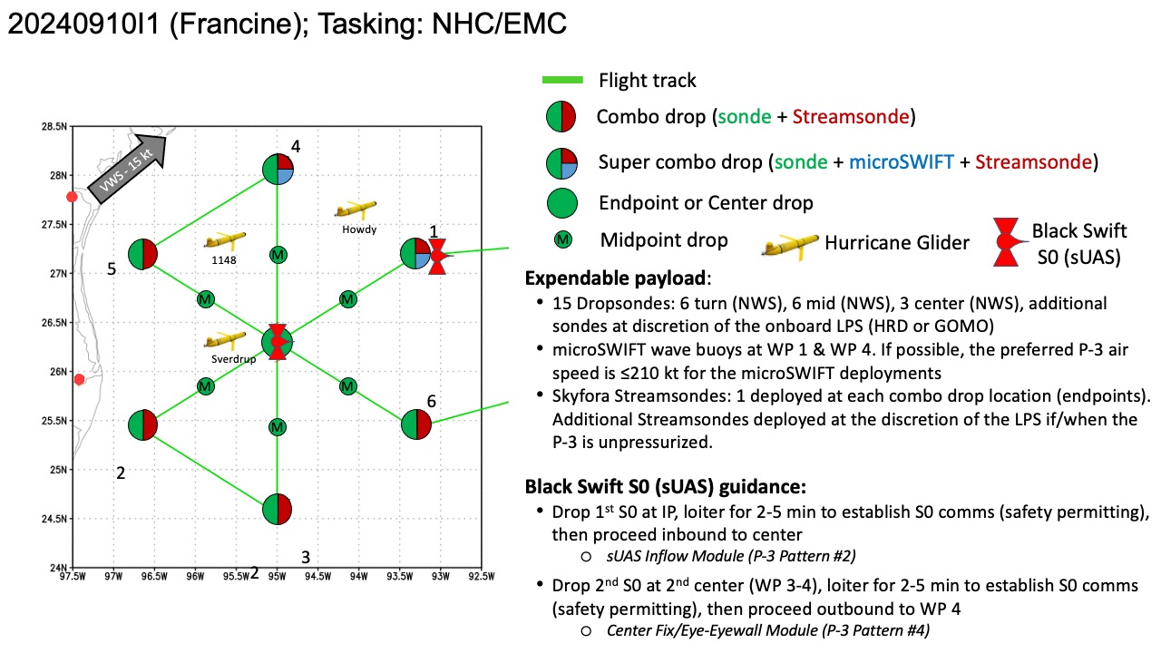EMC TDR mission, 105 nm leg lengths, 8 kft altitude. Add on CHAOS and sUAS modules.
Expendable Distribution | [Describe planned dropsonde, ocean buoy, sUAS deployment locations; e.g., “Dropsondes/AXBT combo drops at endpoints, midpoints, and center”  EMC TDR mission, butterfly pattern, 105 nm leg lengths, at 8 kft. Add on CHAOS and Sondes released at endpoint, midpoints, and each center pass. Skyfora streamsondes at all endpoints. S0 Blackswift at first center pass.  - S0 #1: launch at IP: ~1 h 45 m after take-off (~2145z)  - sUAS Inflow Module (P-3 Pattern #2)  - S0 #2: launch at 2nd center (WP 3-4): ~3h 45m after take-off (~2345z)  - Center Fix/Eye-Eyewall Module (P-3 Pattern #4)  - S0 Operating altitudes: 5,000 ft to surface  - Expected S0 duration: 1-1.5 hr
Preflight Weather Briefing | [Notes from the Flight Crew Preflight Briefing and other relevant notes about the current and forecasted storm state from the most recent NHC advisory (location, intensity, MSLP, movement, possible intensity change during the flight)]  [Briefly describe the relevant environmental drivers.]  On-flight LPS fill this out  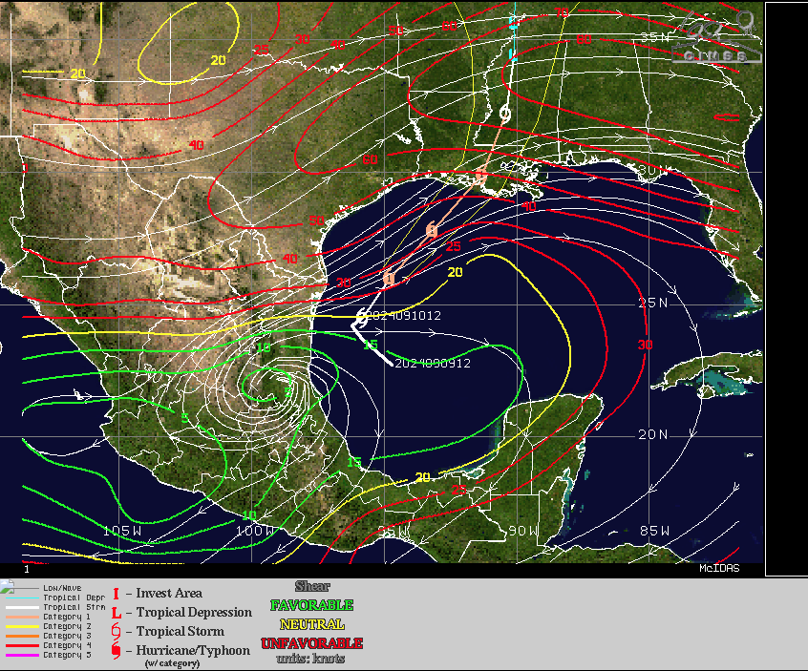
Instrument Notes | [What instruments are working, not working, not functioning nominally, not installed?]

IN-FLIGHT
Time [UTC] | Event
2011 | Take-off from KLAL
2011 | 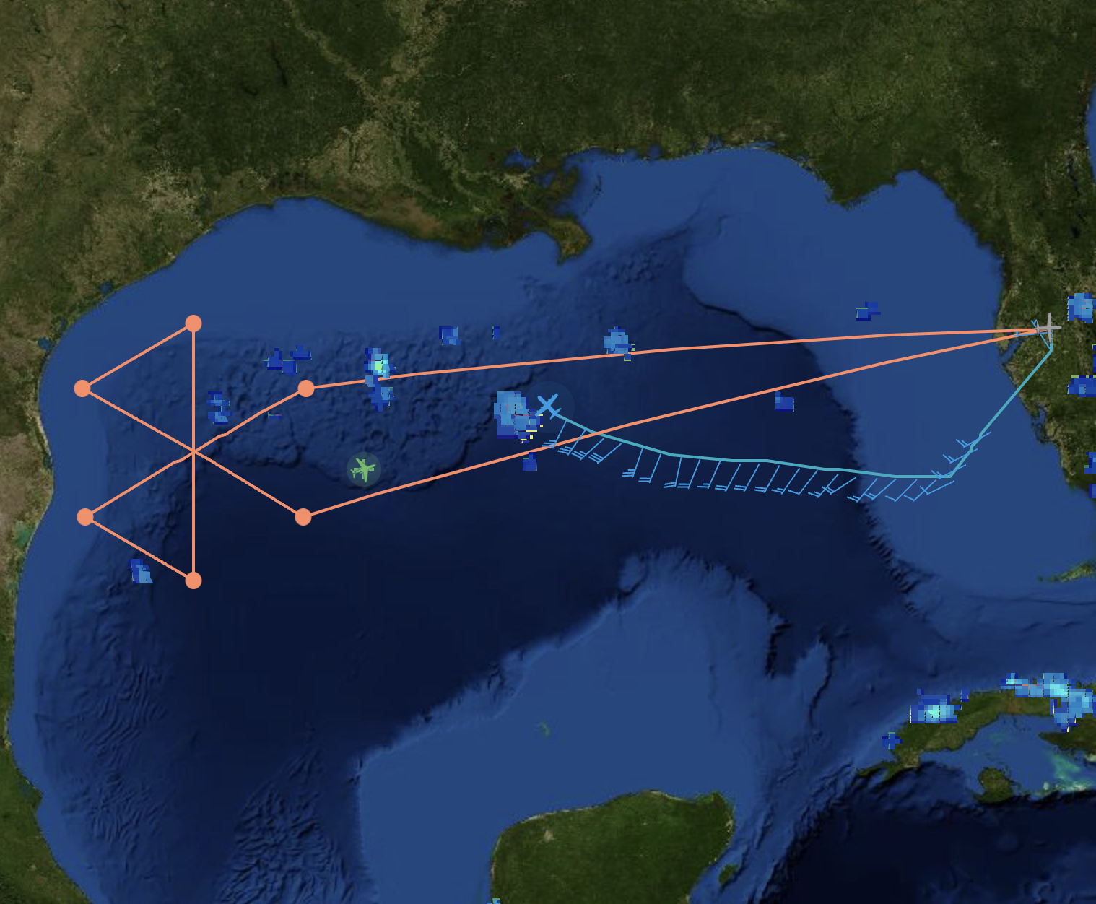  Track diverted from the planned track due to convection
2200 | 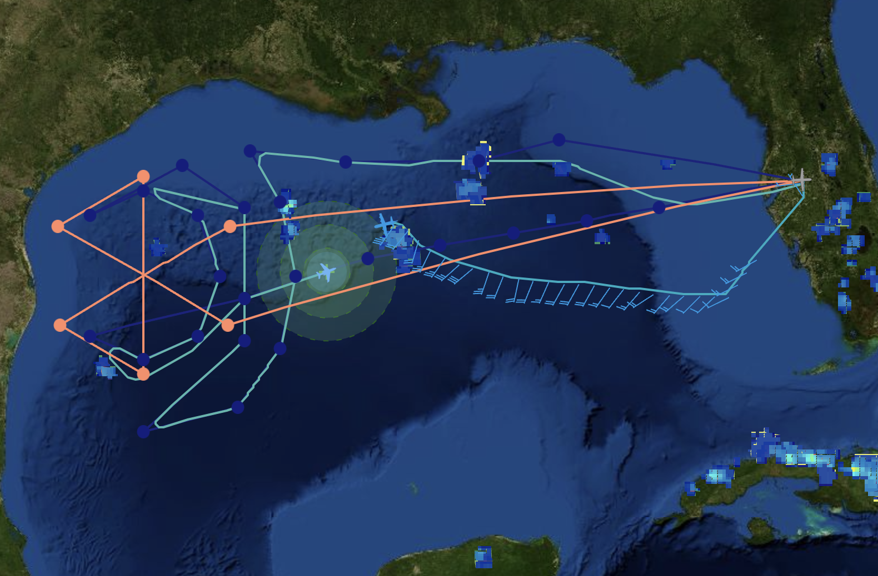  P3 and G4 as close as ~30 nmi at one point.
2229 | Drop #1 IP(NE) combo with streamsonde and microswift buoy
2243 | Drop #2 MP(NE)
2247 | Flight level wind ~ 75 kt, suggesting the storm is strengthening as Air Force measured 63 flight level wind at 18Z
2248 | IR image showed cold top temp  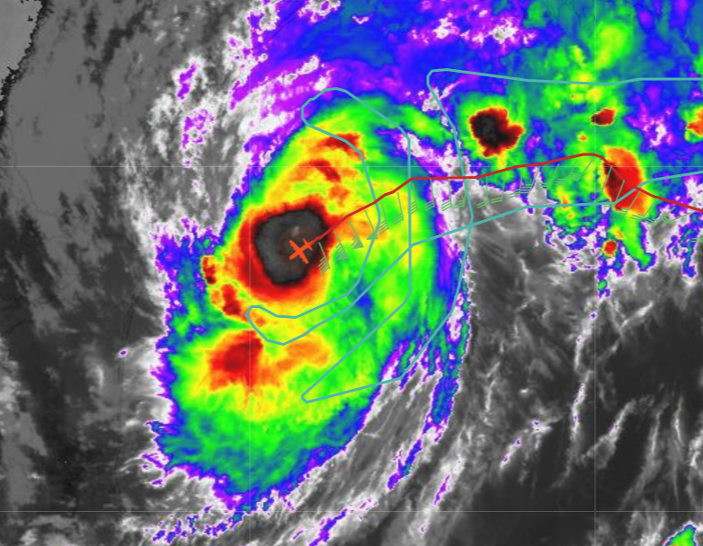
2258 | Drop # 3 Center (1st center) fix (25.80N, 94.85W) 983hPa, 205/11kts
2307 | Drop # 4 MP (SW)
2311 | sUAS ground station reboot
2313 | Drop # 5 EP (SW) combo streamsonde
2314 | N49 landed
2329 | Drop # 6 IP (S) combo streamsonde
2335 | Drop # 7 MP (S)
2345 | Drop # 8 Center (2nd center) como with s0 (983hPa, 135/17kt),  (25.93N, 94.81W)
2347 | S0 dropped in the eye - flying and doing good 58 kts fl max
2358 | S0 Center fix at z=500 m - found wind of 6 kt with pressure of 931 mb
2359 | Drop # 9 (N) MP
0001 | S0 dropping to z=250 m heading to the eyewall and hunting RMW
0006 | 1st UAS HDOB is at the gateway
0007 | Joe Cione: seeing 0-2 kts winds during center hunting
0010 | <Cione> ok we are heading south...to catch S eyewall..so we can sample E eyewall...where we think max winds could be hiding...  <Cione> we are going in at 500m to start...  <Cione> ps i think we nailed the LL wind center..  <Cione> heading 175 deg...
0013 | 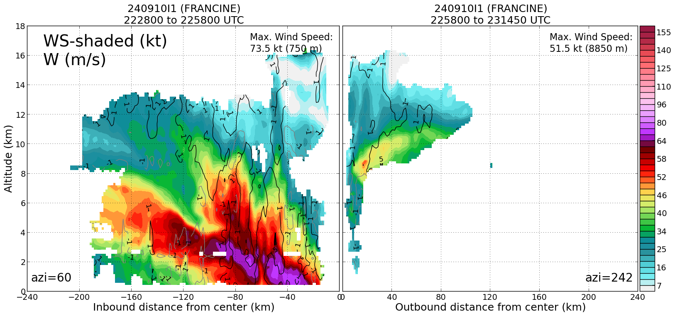  First pass TDR analysis
0012 | Drop # 10 EP (N) combo streamsonde
0035 | Drop # 11 IP (NW) combo w/ streamsonde
0038 | S0 lost comm with range of 130 nm, comms back as P3 turning inbound  S0 measured 55 kt winds likely in eyewall region based on TDR data  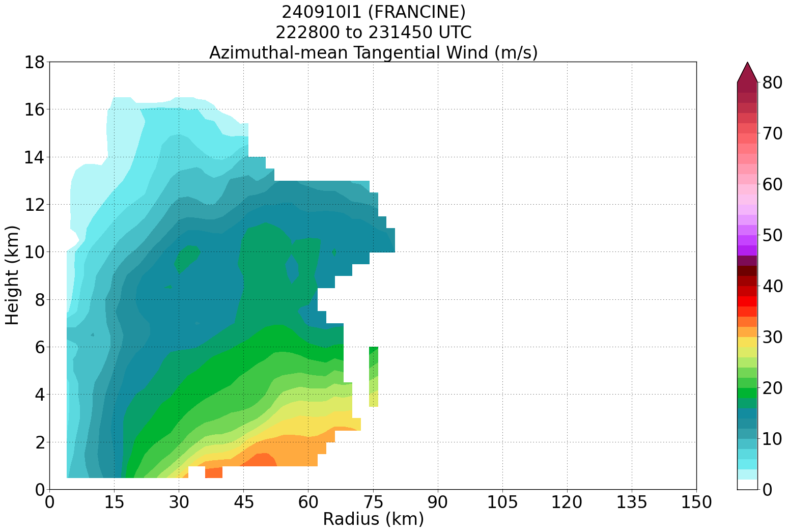
0043 | <Cione> its in the eyewall now...droppping from 500 to 100m...spotty coms so not easy  <Cione> 67kts 500m
0045 | S0 - 72-75 kts at z=500 m
0049 | Drop # 12 MP (NW)
0053 | <Cione> 75kt  <Jun_HRD> TDR swath data show max wind of 65 kt at 500 m altitude on the E to NE side  <Jun_HRD> https://www.aoml.noaa.gov/ftp/pub/hrd/data/RTradar/2024/20240910I1/composites/240910I1_FRANCINE_2228_2314_ws_nhc_planview.png  <Cione> there is a problem resetting the altitude..we are "stuck" at 500m...  <Jun_HRD> s0 data looks reasonable given it is high frequency  <Cione> maybe this flight can be used to compare tdr 1/2 km analysis?  <Jun_HRD> just keep going  <Jun_HRD> collect as many data as possible  <Jun_HRD> 500 m is still in the boundary layer  <Jun_HRD> :)  <Cione> it is...just disappointed can't get lower...still comps with tdr could be great  <Jun_HRD> You got center fix (record)  <Jun_HRD> never perfect  <Cione> yes true. center fix was imoressive..and we did get 75kt winds..  <Jun_HRD> flying a full eyewall circle at a constant altitude is also cool  <Jun_HRD> We flew a full circle but at different altitudes in the past  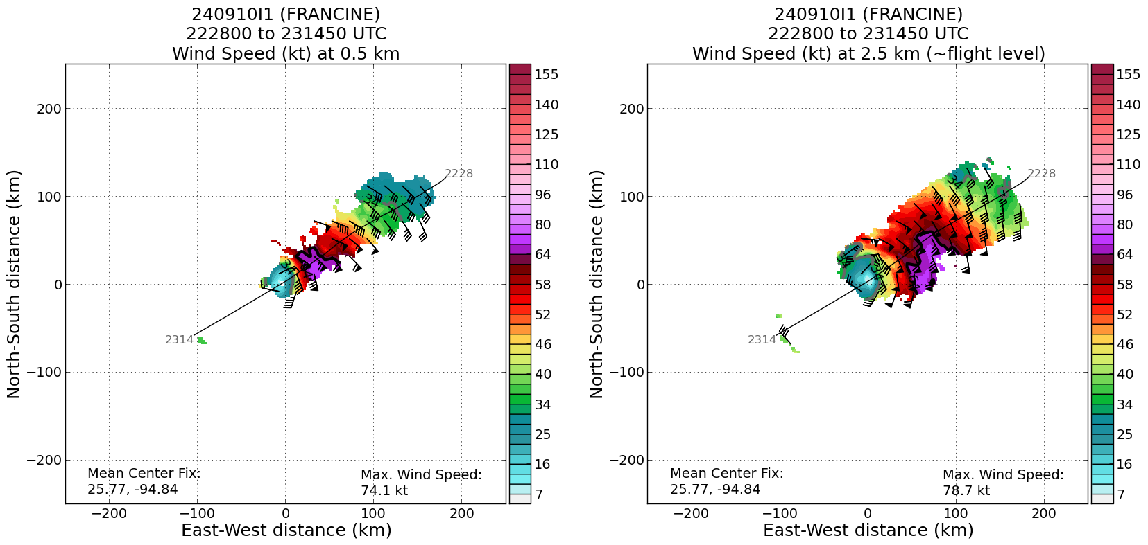
0054 | 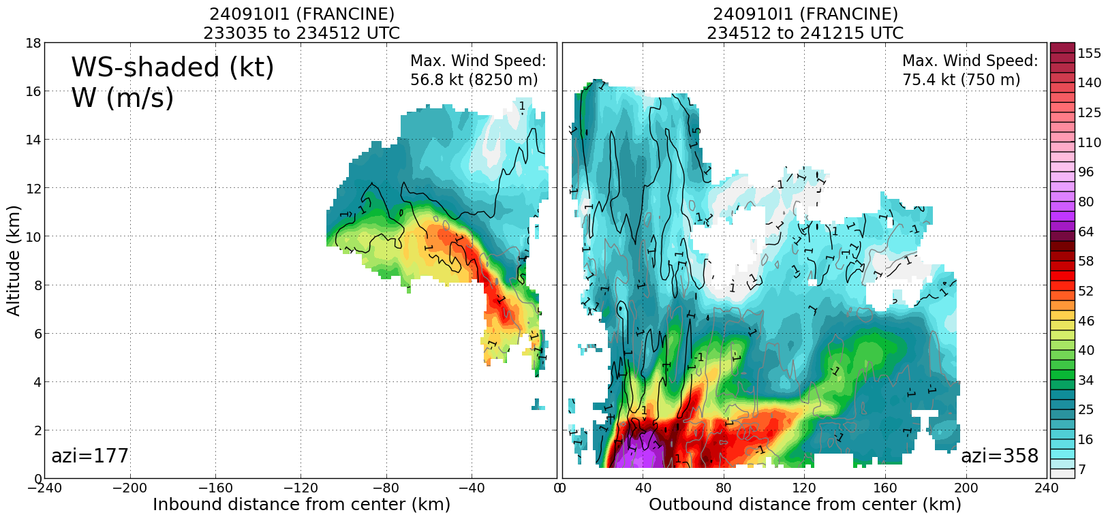  Second pass TDR analysis
0056 | <sim_n43> highest TDR wind at 0.5 km 74.1 kt  <sim_n43> 80 kt fl  S0 data seems match with TDR
0058 | <Cione> we are droppping..finally!  <Cione> 350m  <Jun_HRD> great!  <Cione> 280 m 71kt  wind direction 92 deg
0101 | Drop # 13 Center (3nd pass) (982hPa, 130/9kt) (26.06N, 94.71W)
0105 | <Cione> we are droppping..finally!  <Cione> 350m  <Jun_HRD> great!  <Cione> 280 m 71kt  <Jun_HRD> awesome!!  <Cione> southern eyewall  <Cione> wind direction 92 deg  <Cione> 95m  <Jun_HRD> stay at this height for 10 minutes  <Jun_HRD> for go to 50 and stay constant altitude for flux  <Jun_HRD> 10 minutes constant altitude  <Cione> drop now or get 5 min at 100m?  <Jun_HRD> how many battery?  <Cione> 25%  <Cione> 75 min of fliht so far  <Jun_HRD> 5 minutes at 100 m then go to 50 m or 40 m and stay there  <Cione> in 3 min....i think we go to 50m and leave it....  <Jun_HRD> sounds good  <Jun_HRD> let's do that  <Cione> dropping to 50 in 1 min  <Jun_HRD> 4 minute leg not bad  <Cione> its at 32 m  <Jun_HRD> wow  <sim_n43> hurrican froce wind speed at that altitude. Nice  <Jun_HRD> nice, staying there till splash will be good  <Cione> now in east eyewall...south wind at its back  <Jun_HRD> annetteTC_n43 likely gets hurricane certificate fingers crossed :)  <Cione> not likely she WILL get t  <sim_n43> She definiztely does. Her first three pennies  <Cione> one...Mac too  <Jun_HRD> What is the wind speed from s0?  <Cione> we are gonna get a 1/2 eyewall circumnav if we keep this up...  <annetteTC_n43> Awesome!  <Cione> and a killer center fix...  <Cione> WINNING ! lol  <Jun_HRD> lol  <Jun_HRD> Josh Fromm, awesome job!  <Jun_HRD> center fix is hard  <sim_n43> Nice. It took us tens of thousands of sondes before we got a half circumnav.  <Cione> 81 min and counting..  <Cione> lol sim!
0113 | <Cione> we ar dropping to 40m  <Cione> 28m (!)  <Cione> s0 mind of its own...ol 21m!  <Jun_HRD> wow hurricane force wind  <Jun_HRD> downdrafts help pushing it down a little bit sometimes  <Cione> we are now on NW side eyewall...  <Cione> up and downdrafts...suas alt fluctuating 21-50m...we set it at 40m…  Cione> dropping to 35m  <xuejin_hrd2> Nice
0114 | Drop # 14 MP (SE)
0121 | S0 splashed with duration of 93 minutes  <Cione> we lost it  <Cione> 93 min  <Cione> josh says i got to agressive we maybe had another 7-8 min  <Jun_HRD> 93 m not bad  <Cione> i responded...no guts no glory! lol  <Jun_HRD> lol  <Jun_HRD> congrats  <Cione> that was a great flight....center fix...and 500m comps with TDR...and low level max v/rmw for ~40min
0128 | Drop # 15 EP (SE)
0133 | Science wise: one center fix, one extended TDR comp; one vmax partial circumnavigation in eyewall.

POST-FLIGHT
Mission Summary | Overall this was a very successful mission. The flight got to the IP about 30 mins late after the plan schedule. Three vortex messages, 15 sondes, 3 TDR analyses were sent, one S0, one microswift, and 5 streamsondes were deployed. Three TDR analyses transmitted in time for the assimilation window. Sondes all worked well. The s0 stayed aloft for over 93 minutes. It managed to complete an orbit around the eyewall. Not sure the coordination between sonde dropping and the nearby gliders. The SFMR data was collected but was not transmitted off the aircraft.  Francine is gradually becoming better organized, in terms of increased banding, particularly on the N and NE side of the storm, which is highly convective and high winds quadrant. Francine was upgraded to Cat-1 strength during the 11/0000Z update. The storm's high wind layer was shallow. The MSLP were observed at 982hPa at the third center fix, dropping 1 hPa from previous two fixes.
Actual Standard Pattern Flown | Butterfly
APHEX Experiments / Modules Flown | TDR Mission; Research Module: CHAOS, RICO SUAVE
Plain Language Summary | [Boil down the above into a couple of bullet points in “plain language”. This will help us when we report to management & OAR Public Affairs and prepare storm mission summaries]
Instrument Notes | SFMR data not sent; S0 lost comm with range of 130 nm, comms back as P3 turning inbound; S0 dropping from 500 to 100m...spotty coms.
Final Mission Track | 