MISSION PLAN
FLIGHT ID | 240816N1 | STORM | AL05 /Ernesto
MISSION ID | WC05A | TAIL NUMBER | NOAA-49
TASKING | HRD | PLANNED PATTERN | G-IV star with circumnavigation
MISSION SUMMARY
TAKEOFF [UTC] | 1238 | LANDING [UTC]
TAKEOFF LOCATION | Lakeland | LANDING LOCATION | Lakeland
FLIGHT TIME | Fractional hr, Takeoff to Landing Time | BLOCK TIME | Get from onboard LPS or Flight Director
TOTAL REAL-TIME RADAR ANALYSES  (Transmitted) | 0 | TOTAL DROPSONDES Deployed (Tx to GTS) | 35 (34)
OCEAN EXPENDABLES deployed (good) | 0 | sUAS (Type)
APHEX EXPERIMENTS / MODULES | Exact name of the Experiment in the HFP Plan; identify relevant experiments / module even if not a research tasking
HRD CREW MANIFEST
LPS ONBOARD |  | LPS GROUND | Kaplan
TDR ONBOARD |  | TDR GROUND | NA
ASPEN ONBOARD |  | ASPEN GROUND | NA
NESDIS SCIENTISTS
GUESTS (Affiliation)
AOC CREW MANIFEST
PILOTS
NAVIGATOR
FLIGHT ENGINEERS
FLIGHT DIRECTOR
DATA TECHNICIAN
AVAPS

PRE-FLIGHT
Flight Plan | 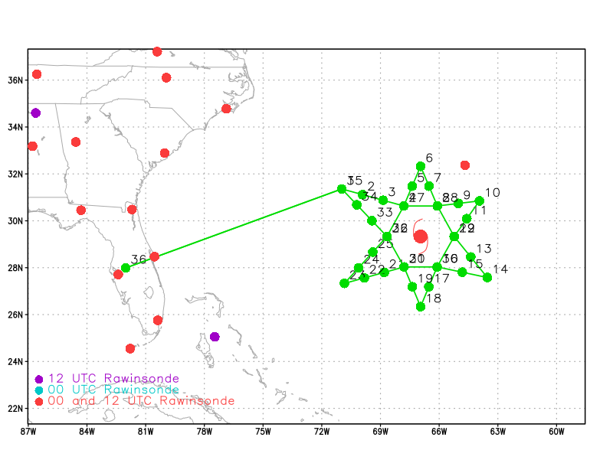  Planned flight pattern for today’s G-IV mission.
Expendable Distribution | Execute drops at the locations shown in the above flight pattern.
Preflight Weather Briefing | NHC 12 Ernesto advisory:  Intensity: 85 kt, 968 mb  Location: 28.9 N 66.5 W  Movement: 30 deg at 11 kt  Though Ernesto is currently situated in a region with very favorable SSTs (29C) the moderate northwesterly vertical shear (~20 kt) and relatively dry mid to upper-level moisture (500-700mb RH of 45% or so) shown in the SHIPS 12z run from today are only marginally conducive for maintaining the storm’s current intensity. These conditions are consistent with the appearance of Ernesto in this morning’s recent satellite imagery (see below images) which indicate that convection is somewhat lacking on the western side of the storm. In light of the above conditions, no significant change in Ernesto’s current intensity is likely during today’s mission.  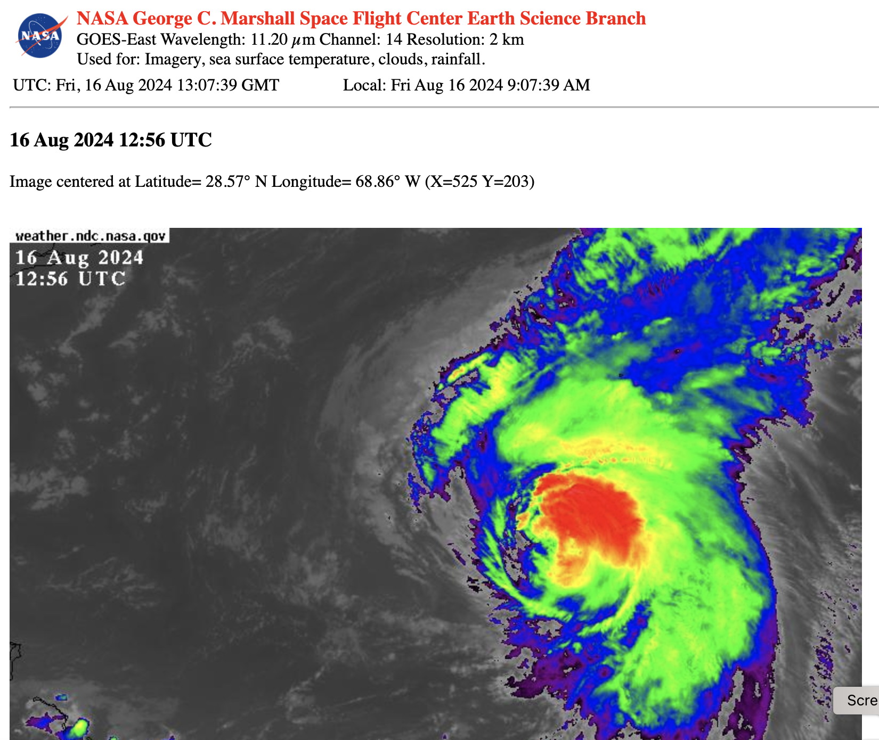  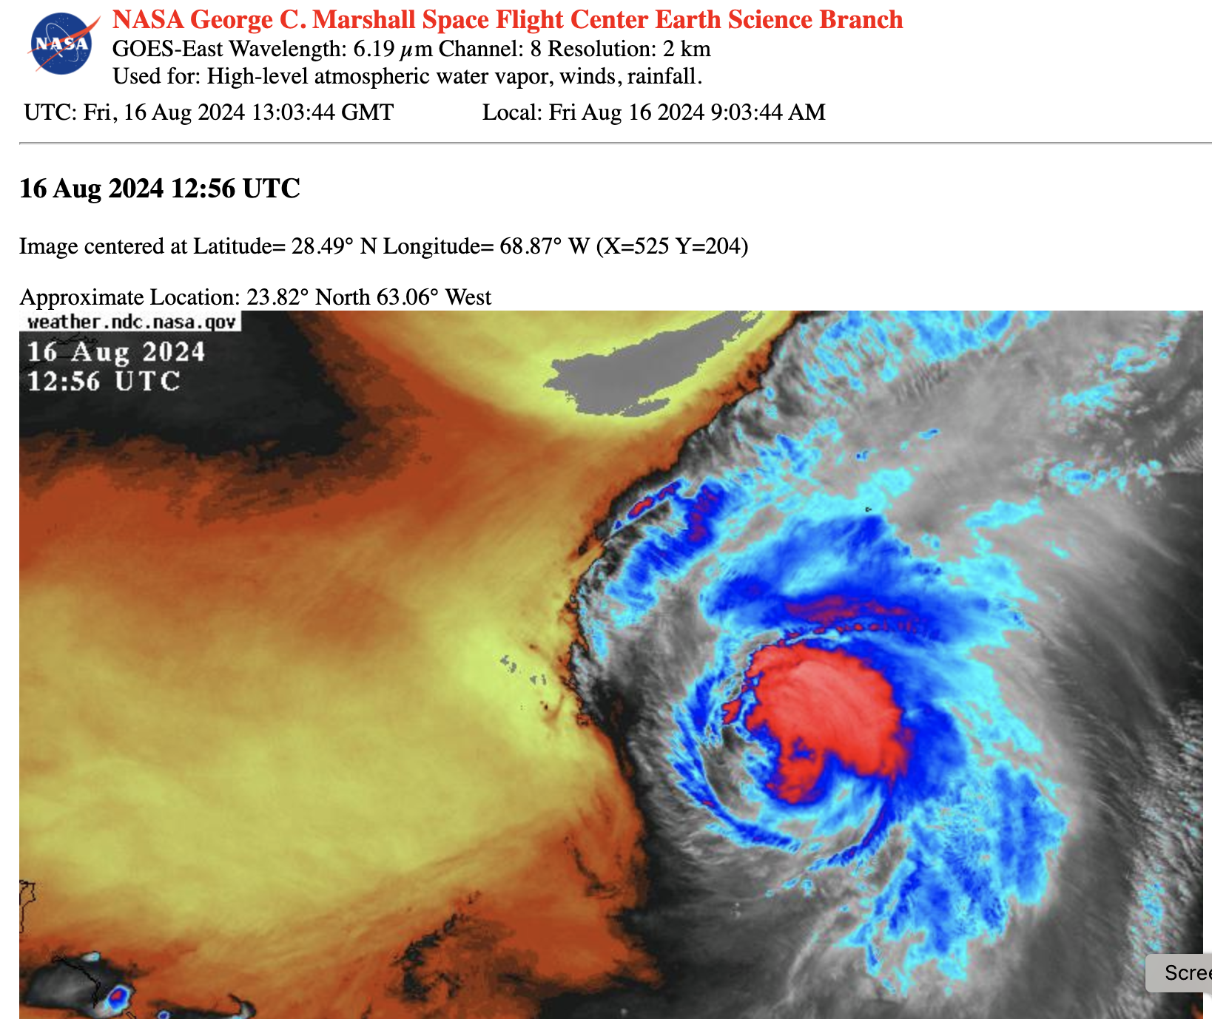
Instrument Notes | [What instruments are working, not working, not functioning nominally, not installed?]

IN-FLIGHT
Time [UTC] | Event
1500 UTC | Plane needed to divert around the convection and went straight from drop 9 to drop 11 with drop at midpoint. Then went straight from point 11 to 13  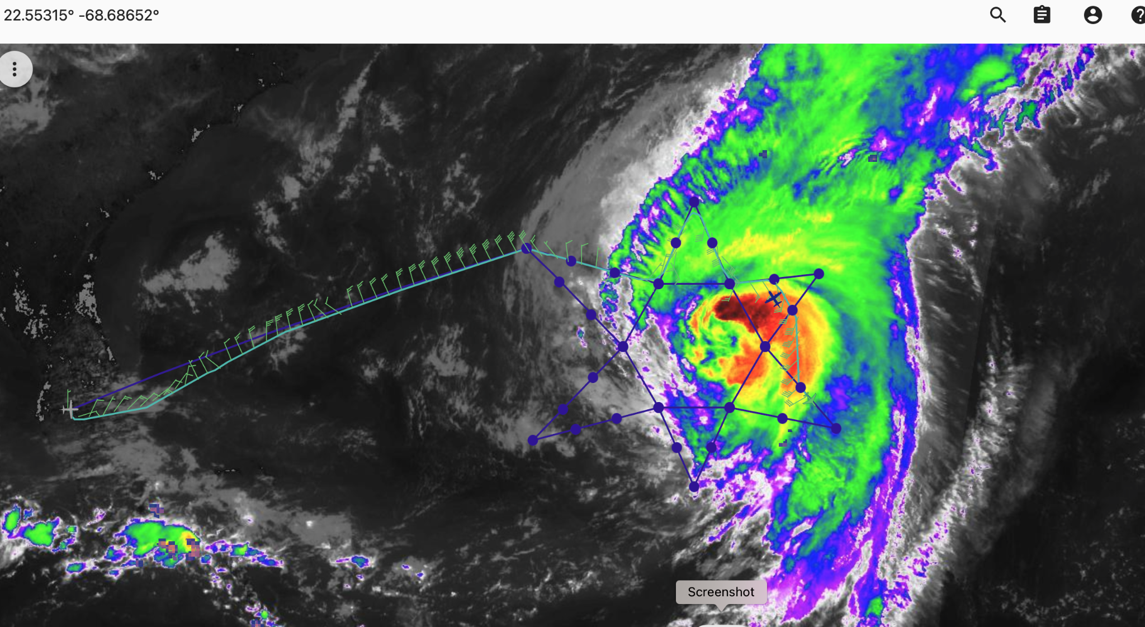
XXXX | [describe event and paste associated screenshot or gif, if available]
1615 | Drop 20. Lost signal at 20 kft
1800 | Aircraft needed to deviate significantly from the original flight pattern for the inner circumnavigation starting at point 26 due to the existence of deep convection along the planned track.
20 z | Plane needed to deviate on the SW side of the circumnav prior to reaching pt 31 and also again near pt 32 when the aircraft went west from pt 32 to Lakeland dropping 3 sondes in route.
1930z | 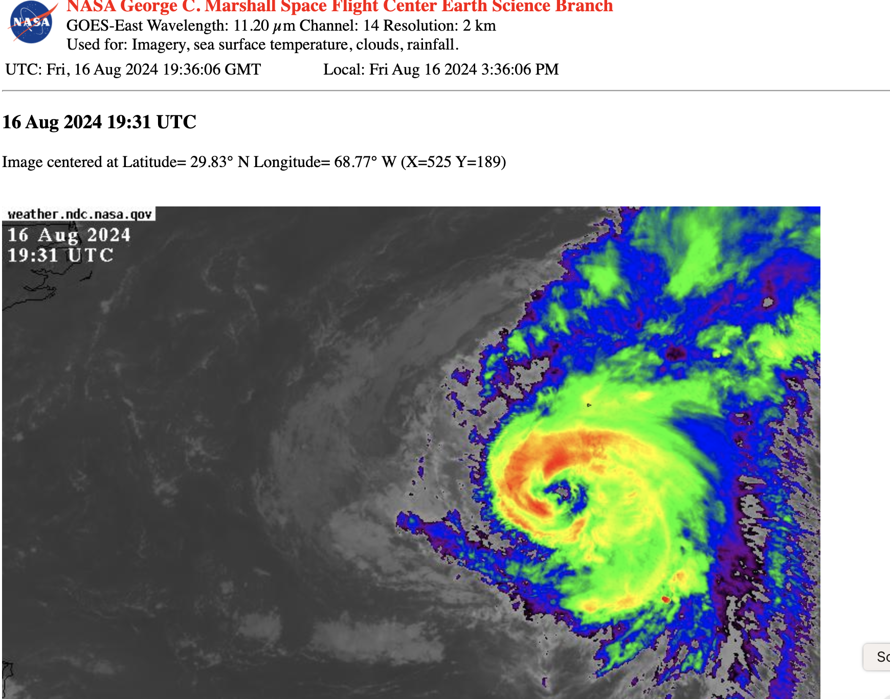  NASA GOES IR imagery of Ernesto at 1931 UTC  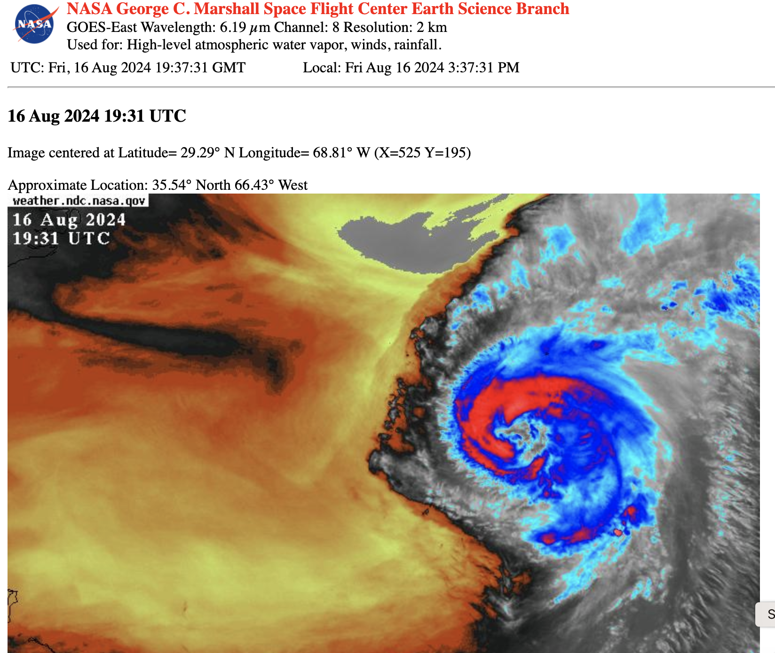  NASA water vapor imagery showing Ernesto at 1931 UTC.

POST-FLIGHT
Mission Summary | Early in the mission it appeared that dry air and westerly shear was adversely affecting Ernesto particularly the west side. However, near the end of the mission convection looked much more symmetric and Ernesto appeared better organized.  The overall mission was successful with 34 of the 35 drops being successful and 1 partially successful. Some of the legs that were part of the original flight pattern needed to be altered and the inner circumnavigation shifted east to avoid deep convection near Ernesto’s center.  A total of 35 sondes were launched, 34 were good and were transmitted to the ground via the GTS and 1 was a partial and was not transmitted.  All sondes were charged to NASA.
Actual Standard Pattern Flown | G-IV star with circumnavigation
APHEX Experiments / Modules Flown | Tropics Satellite Validation
Plain Language Summary | This mission was designed to collect in-situ observations in and around the environment of Hurricane Ernesto to those from the new Tropics Satellite Constellation.
Instrument Notes | All instruments performed as expected.
Final Mission Track | 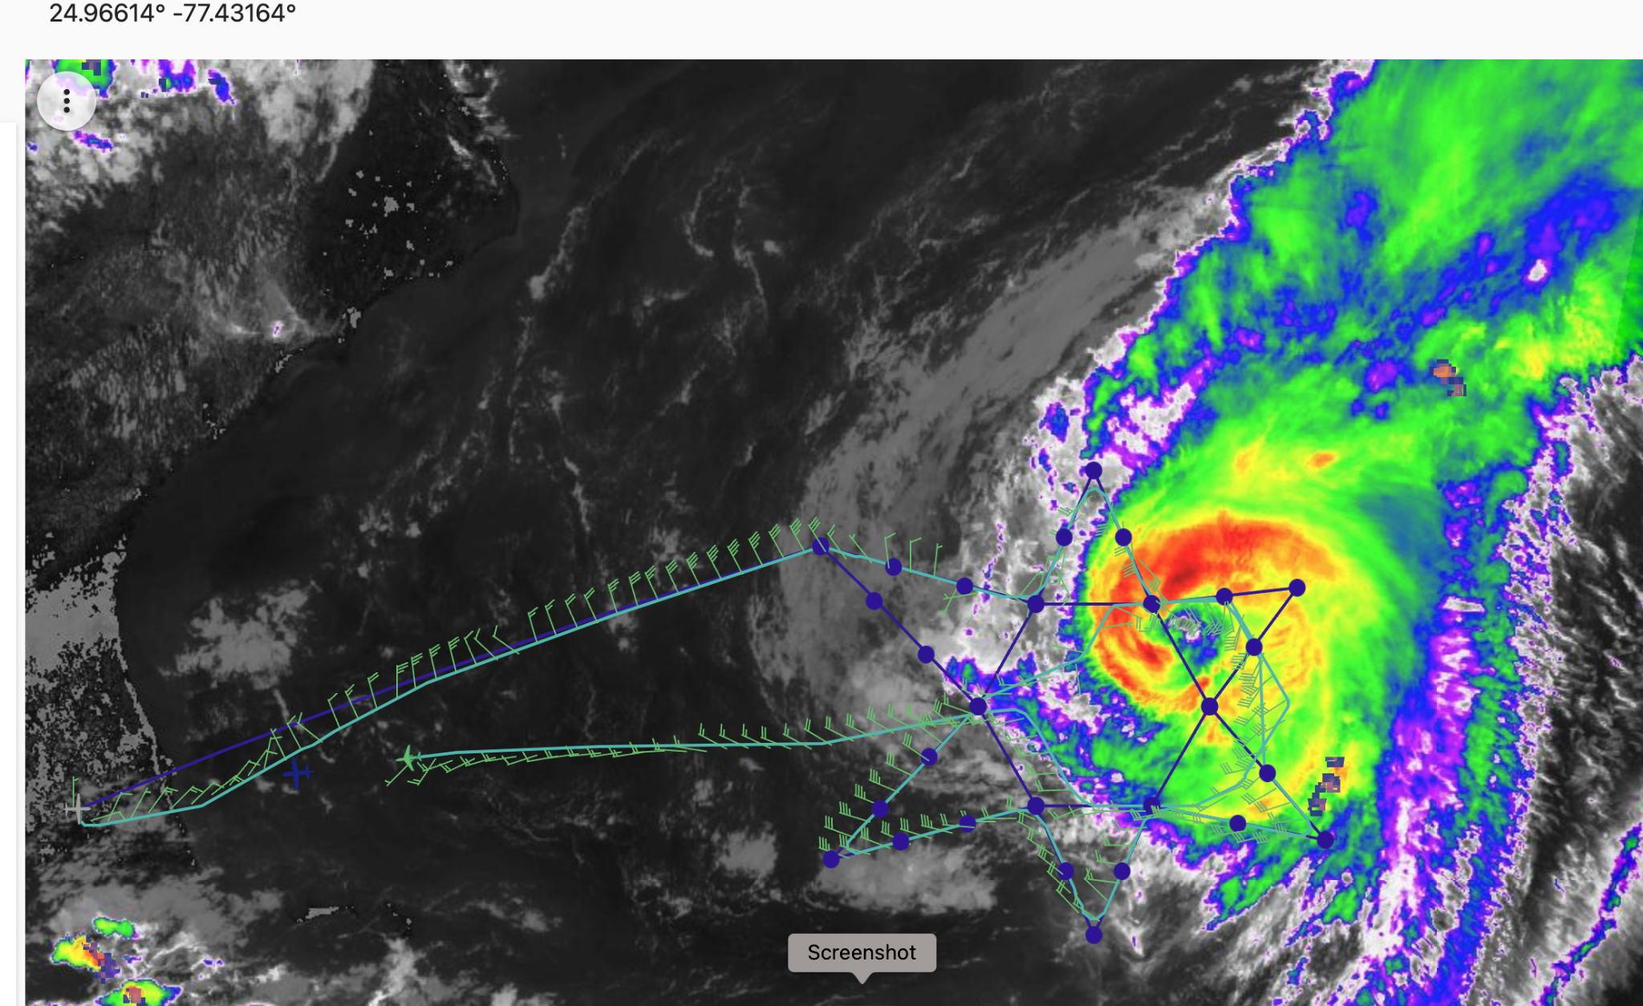  MTS screenshot near the end of today’s mission of the planned flight pattern (blue) and the the pattern actually flown (green) during today’s mission overlaid on top of the latest GOES-IR image of Ernesto

