MISSION PLAN
FLIGHT ID | 20240816I1 | STORM | AL052024/ERNESTO
MISSION ID | WD05A | TAIL NUMBER | NOAA-43
TASKING | HRD | PLANNED PATTERN | Butterfly
MISSION SUMMARY
TAKEOFF [UTC] | 1244 | LANDING [UTC] | 2007
TAKEOFF LOCATION | Wilmington | LANDING LOCATION | Lakeland
FLIGHT TIME | 07:23 | BLOCK TIME
TOTAL REAL-TIME RADAR ANALYSES  (Transmitted) | 0 | TOTAL DROPSONDES Deployed (Tx to GTS) | 18 (17)
OCEAN EXPENDABLES deployed (good) | AOC AXBTs: 3 (0) | sUAS (Type) | 2 (S0)
APHEX EXPERIMENTS / MODULES | RICO SUAVE/sUAS & CHAOS
HRD CREW MANIFEST
LPS ONBOARD | J. Zhang, Montgomery | LPS GROUND | Hazelton/Looney
TDR ONBOARD | n/a | TDR GROUND | n/a
ASPEN ONBOARD | n//a | ASPEN GROUND | Ko
NESDIS SCIENTISTS | n/a
GUESTS (Affiliation) | Mikal Montgomery , Jack Elston (Blackswift), Josh Fromm (Blackswift)
AOC CREW MANIFEST
PILOTS | Abitbol (primary), Wood/Tarabehhi (co pilots)
NAVIGATOR | Schaefer
FLIGHT ENGINEERS | Stokes/Dihoc
FLIGHT DIRECTOR | Kalen
DATA TECHNICIAN | McAlister
AVAPS | Keller

PRE-FLIGHT
Flight Plan | 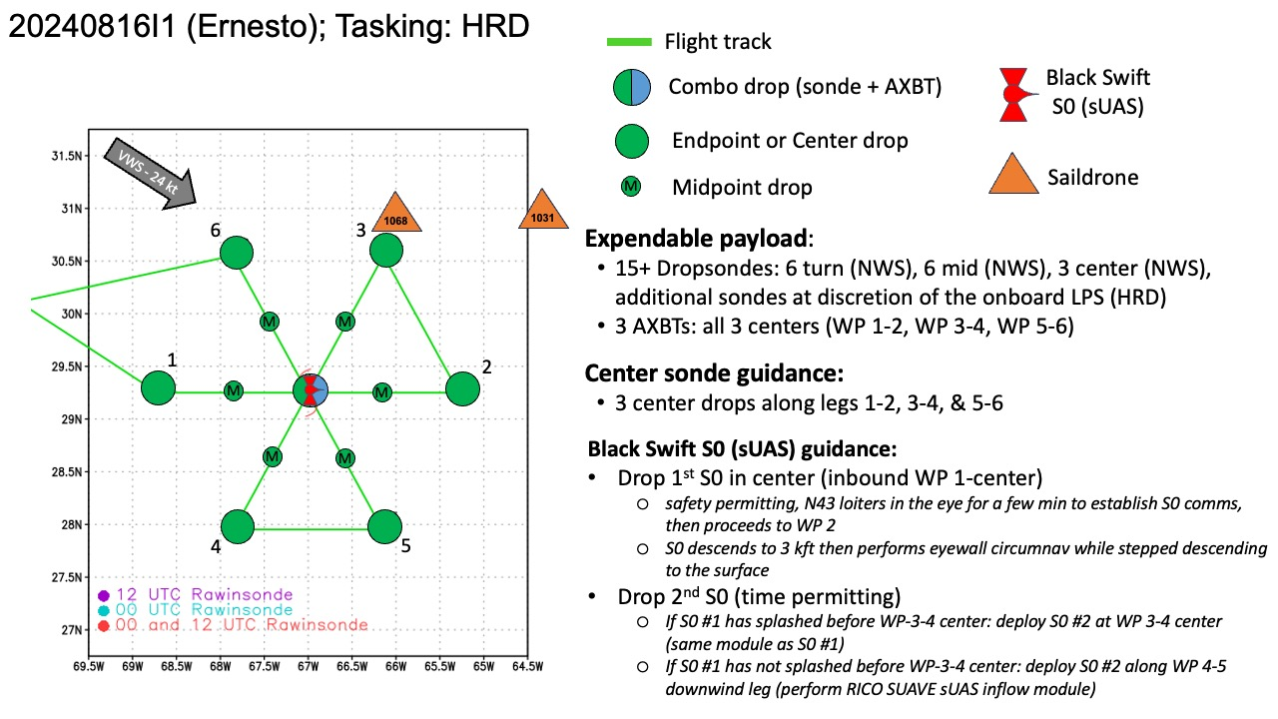Butterfly pattern.
Expendable Distribution | 15 sondes, 2 sUAS, 3 BTs
Preflight Weather Briefing | Ernesto is a bit sheared this morning, as a trough passes by to the north. It is approaching Bermuda as a Category 2 hurricane.
Instrument Notes | No issues.

IN-FLIGHT
Time [UTC] | Event
1244 | Take off from Wilmington
1251 | Lev updated SD-1068 is near WP3 at 30.90363 N, 65.88236 W. Also, SD-1031 (further E) is at 31.16935 N, 64.57732 W
1318 | Lev: SD-1068 is ~130 n mi from the center and is already into 7 m wave
1320 | Dry run: S0 pre-launch checklist, went well
1327 | Jun updated Joe Cione planned s0 flight patterns through Lev. 1st S0 will be launched in the center of first pass (1-2). 2nd S0 will be launched at 4 or 5.
1410 | MW pass (a little old now) shows erosion of the core due to shear  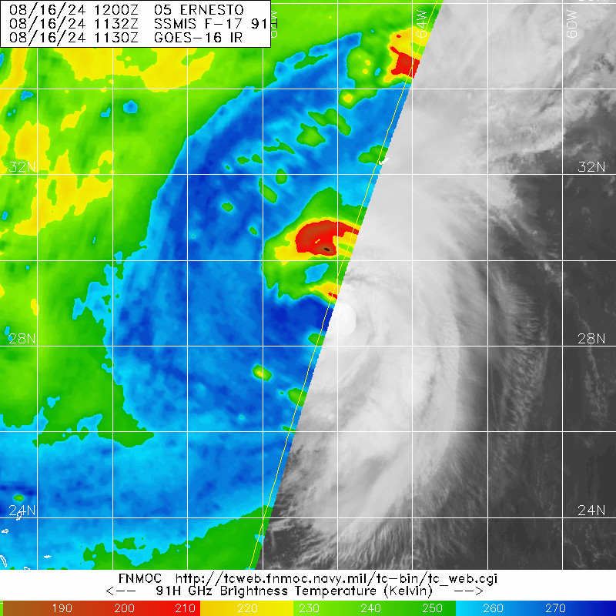
1435 | MMR Issues
1437 | Sonde 1, endpoint west, IP
1446 | Sonde 2, midpoint west
1455 | UAS out, Sonde 3, RMW (ish), Combo  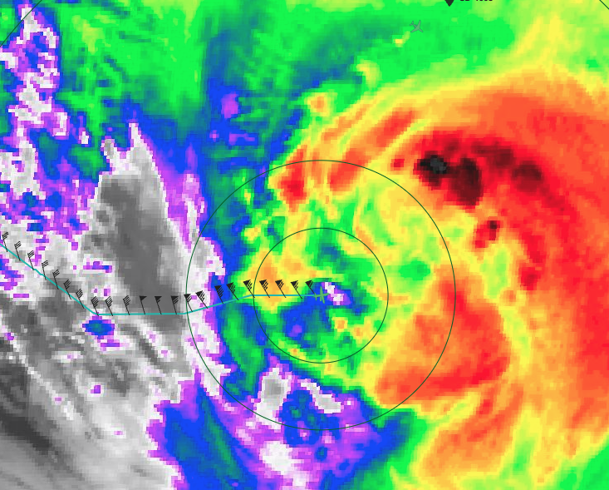
1457 | Established comms with SUAS
1500 | Sonde 4, center, combo drop (BT failed)
1508 | S0 measured > 70 kt
1508 | Sonde 5, RMW E
1510 | Sonde 6
1515 | S0 measured 105 kt/120 kt
1522 | Sonde 7, endpoint E
1534 | S0 still at 60% battery
1534 | Sonde 8, endpoint NE, inbound, splash 30 km from saildrone, measuring 32 kt winds
1537 | Flight within 29 n mi of the saildrone
1545 | 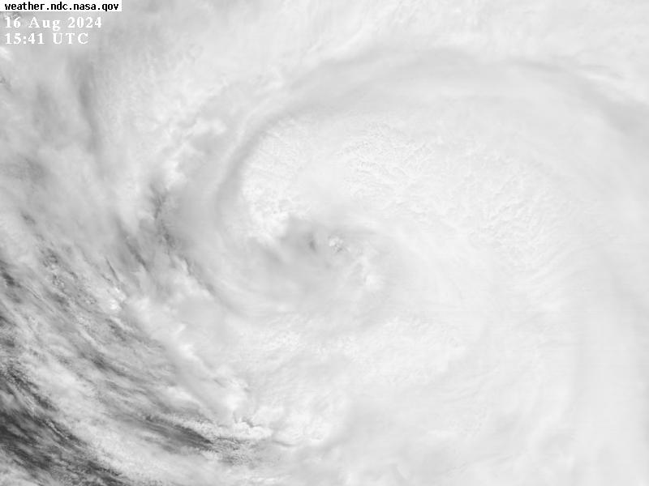
1544 | Sonde 9, midpoint NE
1545 | S0 10 more min at 200 m, then 100m, then center fix
1550 | Sonde 10, RMW NE
1557 | Sonde 11, Center
1610 | Sonde 12, midpoint SW
1611 | Sonde 13, backup for midpoint SW
1612 | S0 1 splashed, 8 m
1617 | Sonde 14, endpoint SW
1623 | S0 2 launched with sonde and BT  Sonde 15  BT failed (all failed today)
1638 | Sonde 16, endpoint SE, inbound
1639 | Bumpy SE side
1647 | Sonde 17, midpoint SE
1655 | S0 #2 measuring 90-95 kt winds
1703 | Sonde 18, center
1737 | Descending S0 #2 to 50 m to try center fix again
1742 | Testing range of S0 #2 (at 50m now) and flying home
1743 | S0 winds 15 kt now
1745 | Lost comms with S0
 | << INSERT ADDITIONAL ROW AS NEEDED >>

POST-FLIGHT
Mission Summary | We flew a successful research pattern in Hurricane Ernesto in the SW Atlantic.  We did two successful sUAS deployments, one starting in the eyewall and circling most of it, and a second one in the inflow further out that spiraled into the eyewall.  We saw winds as high as 120 kt, and a gust to 139 kt.  The first S0 flew for 77 minutes, and the second for 80 minutes.  The storm was clearly feeling the effects of SW shear but was able to fire a little more convection towards the end and symmetrize a bit more.
Actual Standard Pattern Flown | Butterfly
APHEX Experiments / Modules Flown | RICO SUAVE/sUAS & CHAOS
Plain Language Summary | - We flew a successful research mission in Hurricane Ernesto that included the deployment of two uncrewed systems.  - These sUAS sampled winds in the lowest part of the atmosphere where the P3 cannot navigate safely.
Instrument Notes | The MMR was in and out.
Final Mission Track | 