MISSION PLAN
FLIGHT ID | 240815N1 | STORM | AL05 / Ernesto
MISSION ID | WA05A ERNESTO | TAIL NUMBER | NOAA-49
TASKING | HRD | PLANNED PATTERN | GIV Star with circumnavigation
MISSION SUMMARY
TAKEOFF [UTC] | 1200 | LANDING [UTC] | 1923
TAKEOFF LOCATION | Lakeland | LANDING LOCATION | Lakeland
FLIGHT TIME | Fractional hr, Takeoff to Landing Time | BLOCK TIME | Get from onboard LPS or Flight Director
TOTAL REAL-TIME RADAR ANALYSES  (Transmitted) | None | TOTAL DROPSONDES Deployed (Tx to GTS) | e.g., 37 (31)  All sondes charged to NASA
OCEAN EXPENDABLES deployed (good) | 0 | 0 | 0
APHEX EXPERIMENTS / MODULES | Tropics Satellite Validation.
HRD CREW MANIFEST
LPS ONBOARD | NA | LPS GROUND | Kaplan
TDR ONBOARD | NA | TDR GROUND | Collected but not sent to NCEP
ASPEN ONBOARD | NA | ASPEN GROUND | NA
NESDIS SCIENTISTS | NA
GUESTS (Affiliation) | NA
AOC CREW MANIFEST
PILOTS
NAVIGATOR
FLIGHT ENGINEERS
FLIGHT DIRECTOR
DATA TECHNICIAN
AVAPS

PRE-FLIGHT
Flight Plan | [Insert image of submitted flight pattern here]  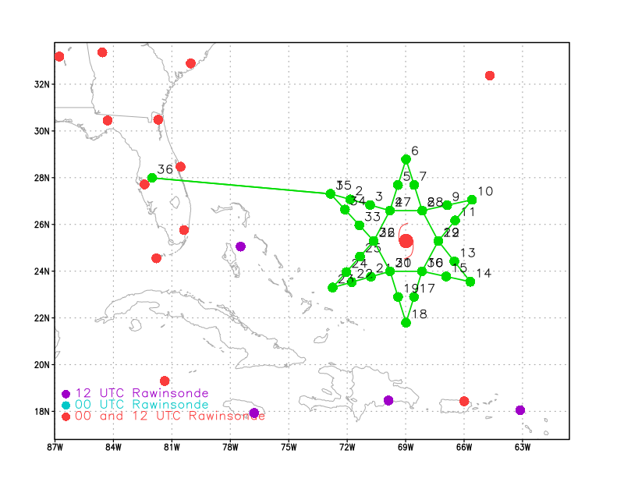  Planned flight pattern for today’s G-IV mission.
Expendable Distribution | Execute the above pattern.
Preflight Weather Briefing | NHC 12 Z: Intensity 75 kt 975 mb  Position 24.5 N 69.3 W  Motion 360 deg at 11 kt  As per the SHIPS 12z guidance the vertical shear looked to be relatively low (~10 kt) and the SSTs quite warm (29.3 C). However, the RH was a little on the low -side (500-700 mb RH) in the mid 50s which likely was inhibiting the rate of intensification. See below screen NASA water vapor imagery shots that appear to indicate the presence of dry air at upper levels on the northern semicircle of the storm.
Instrument Notes | All instruments are working as expected.

IN-FLIGHT
Time [UTC] | Event
1200 | Take-off from Lakeland
1230 UTC | 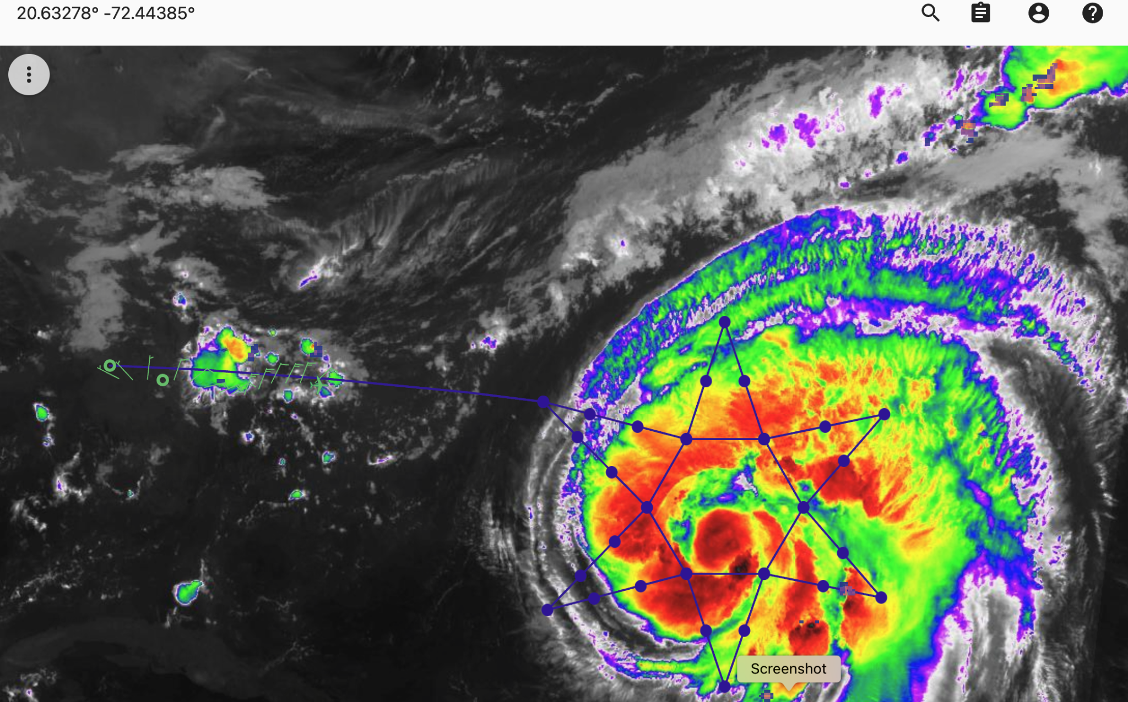  1230 UTC MTS screenshot. GOES-IR overlaid the planned flight track.  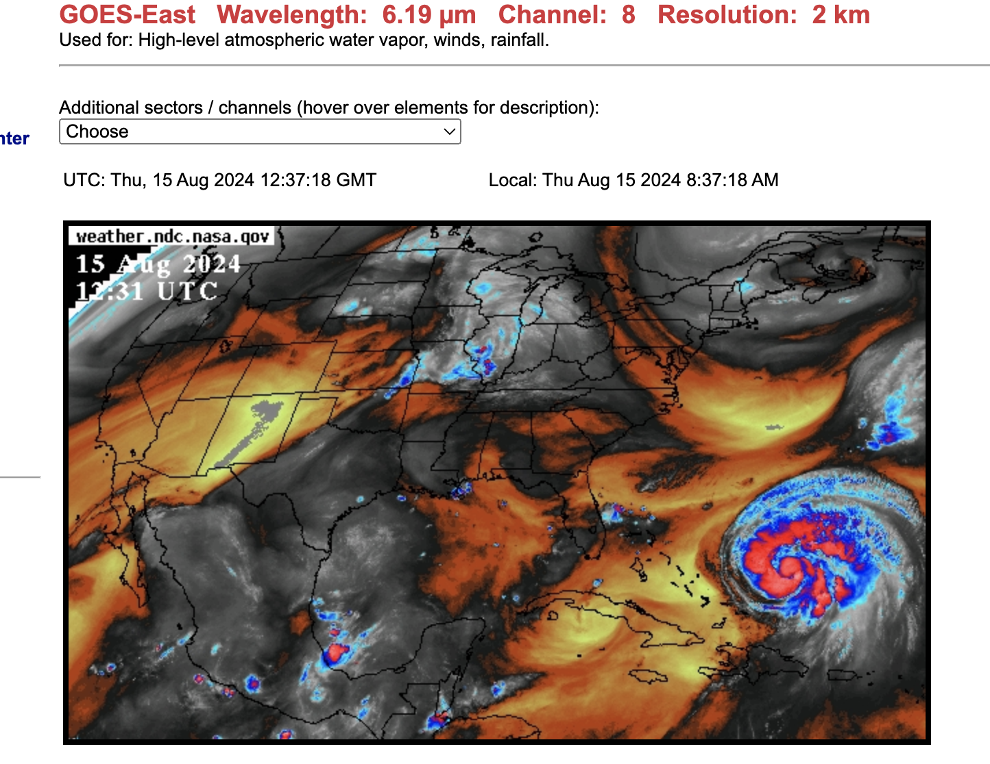  NASA UPPER-LEVEL WATER VAPOR IMAGE OF EDOUARD at 1231z.  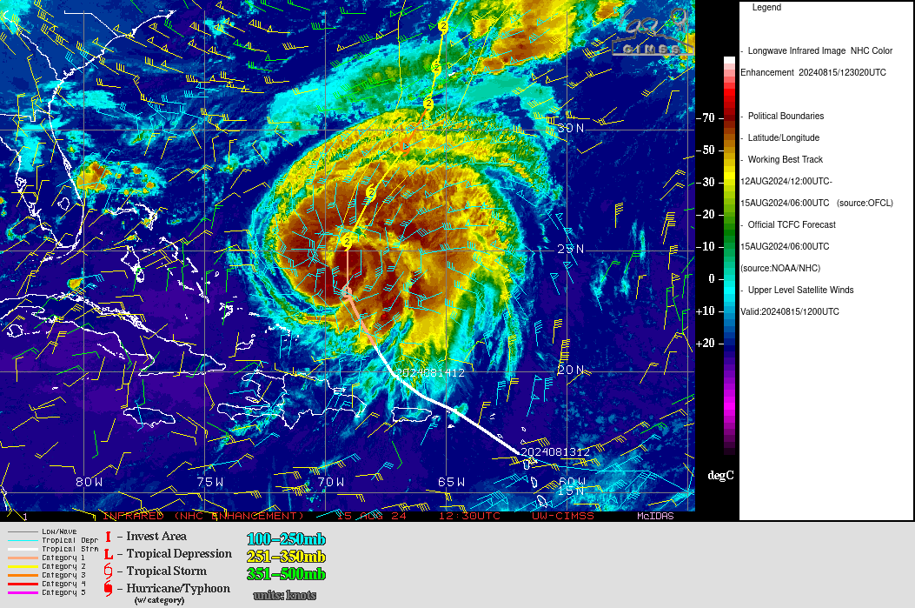  CIMSS upper-level winds and GOES-IR imagery.
1324 | Backup sonde launched at Drop location 2 as initial sonde had no/bad PTH data.
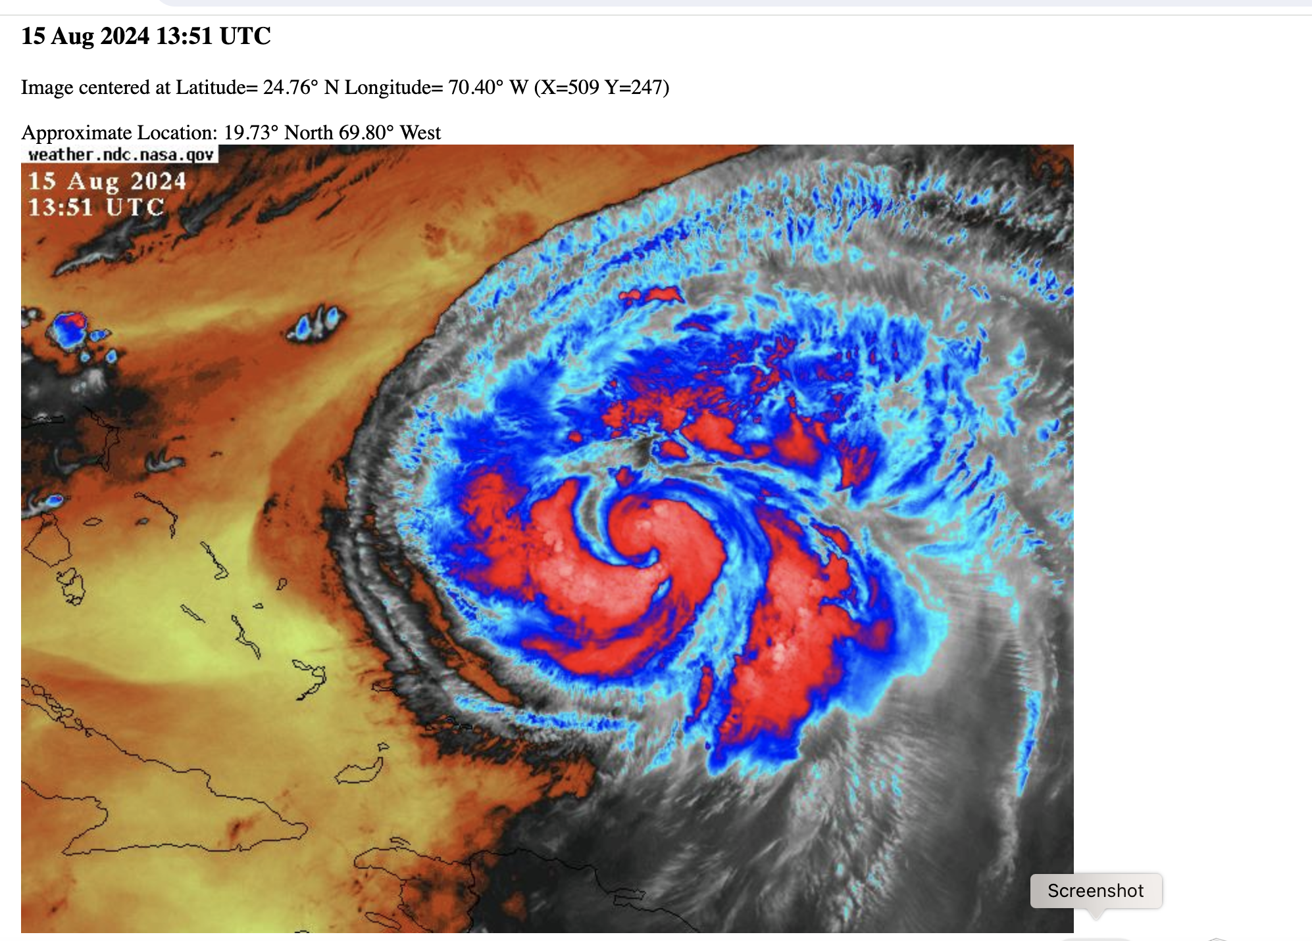

NASA upper-level water vapor imagery 1351 UTC.
Looks like some upper-level dry air might be affecting the convection on the northern semi-circle of Edouard.
1400 Z | G_IV needed to deviate around convection so drop 8 was made at a slightly different location north of planned drop 8 location.
1510 Z | Needed to deviate from planned flight track so G-IV went from point 13 directly to 15 so no drop was made at original drop location 14 and a drop was made at the midpoint of the 13-15 flight leg. Also drop at location 13 lost signal at 37 kft and drop 14 lost signal at 26 kft apparently due to their location near deep convection.
1536z | 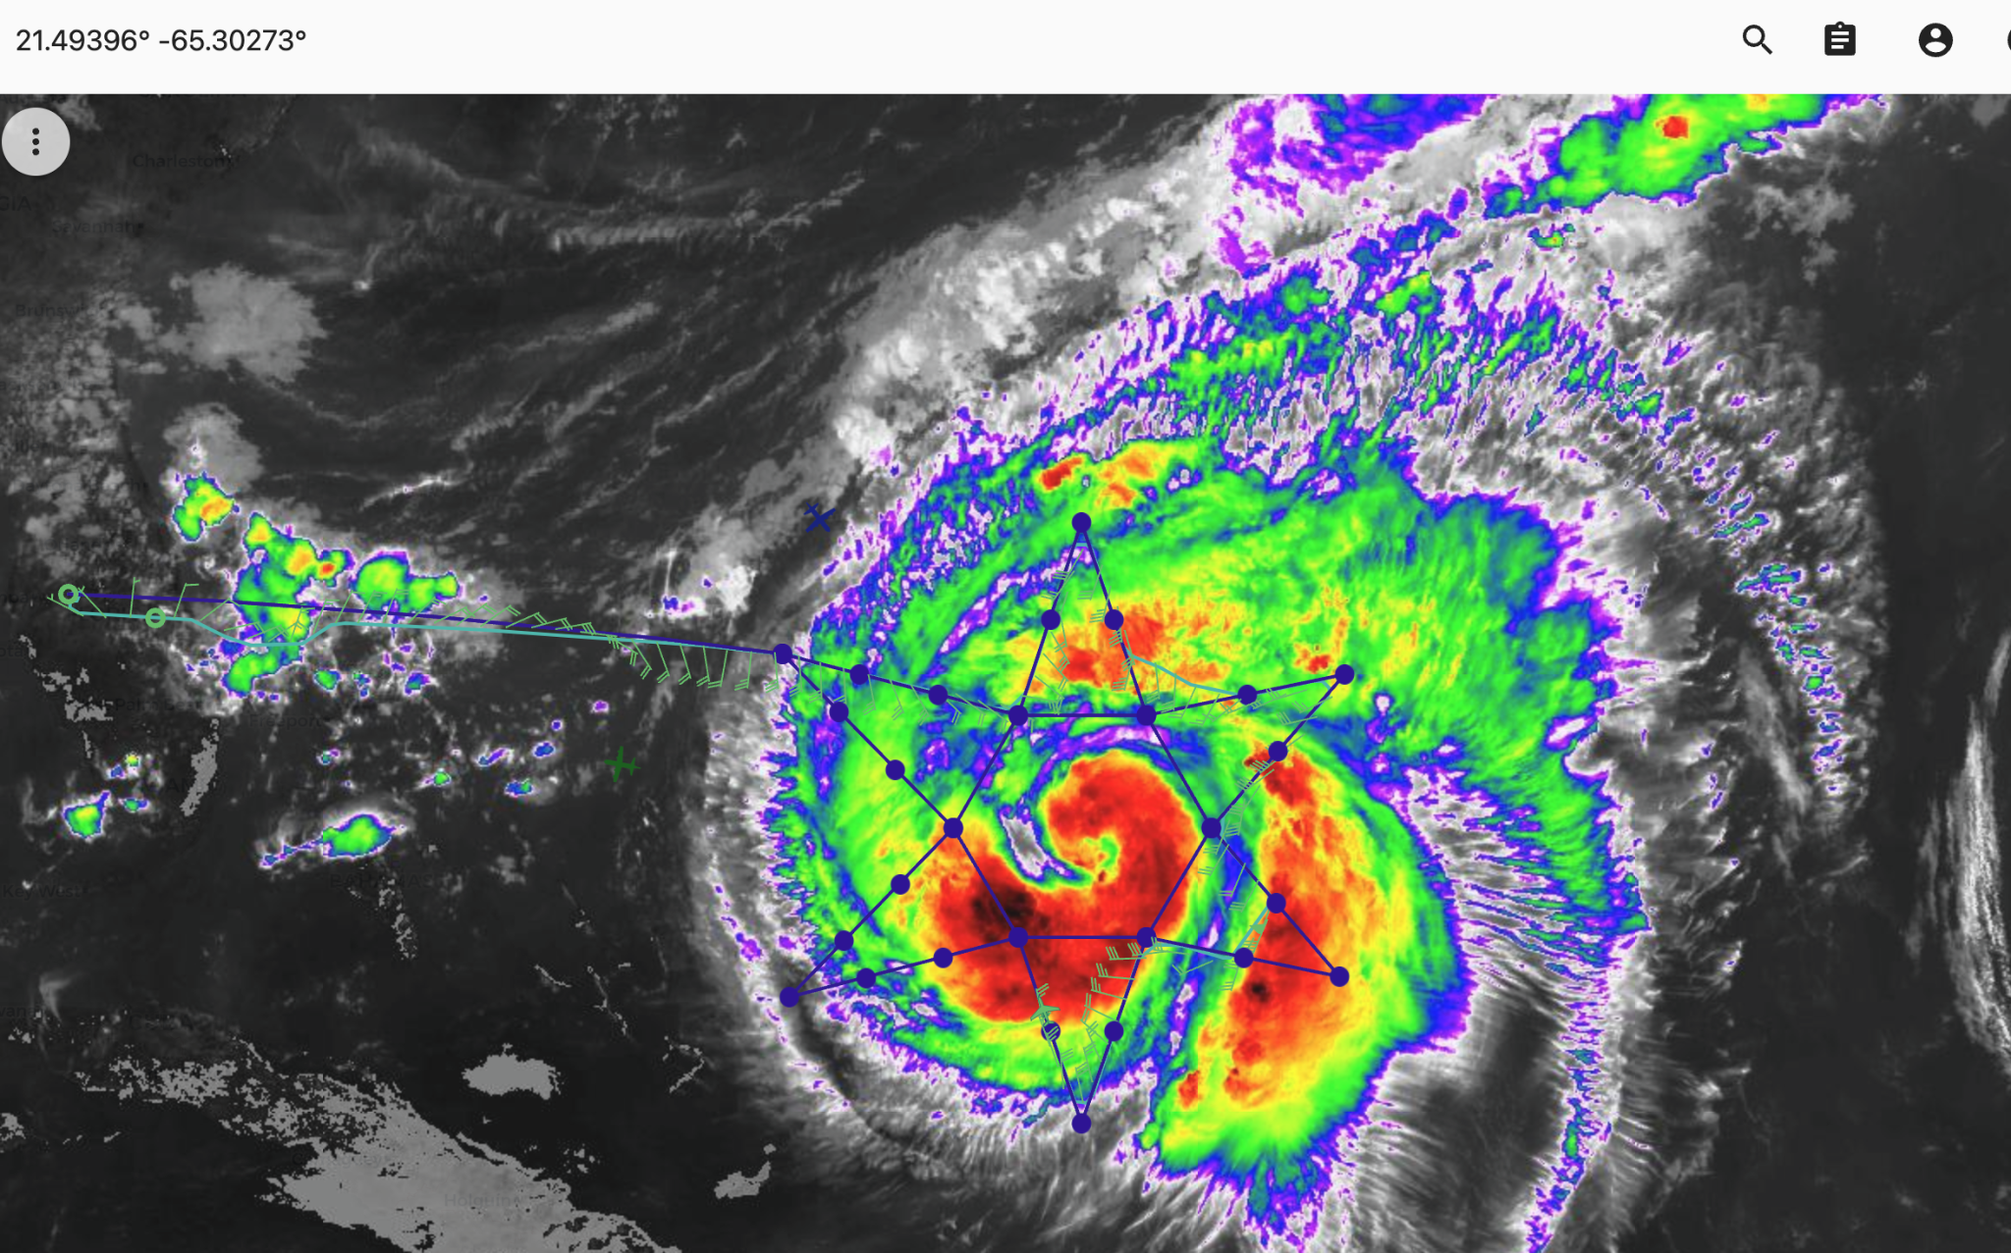  MTS screenshot of Ernesto at 1536 Z. near the time that the plane needed to deviate around the deep convection near the original drop 13, 14 and 15 locations.
1730z | Sonde 30 failed at 30 kft. Only some moderate stratiform precipitation ( No deep convection) was noted by the AVAPS operator.  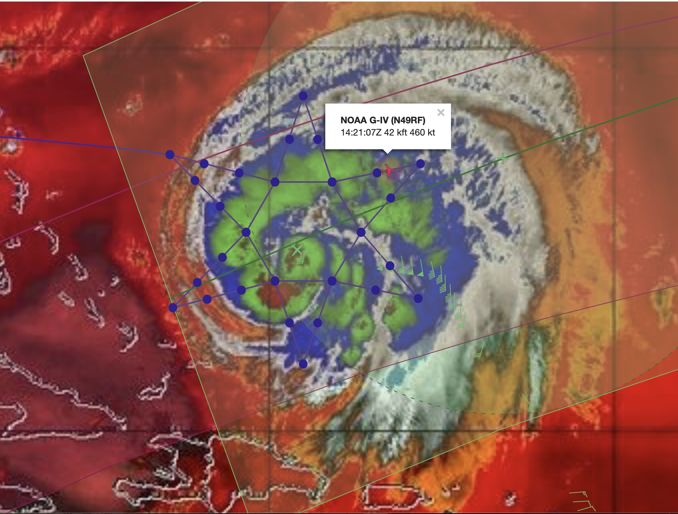  Nadir of the TROPICS-06 overpass lined up nicely with the NE part of the G-IV today. The green + is the location of TROPICS-06, and the green swath shows the area 750 km off nadir. (Source: Brittany Dahl)
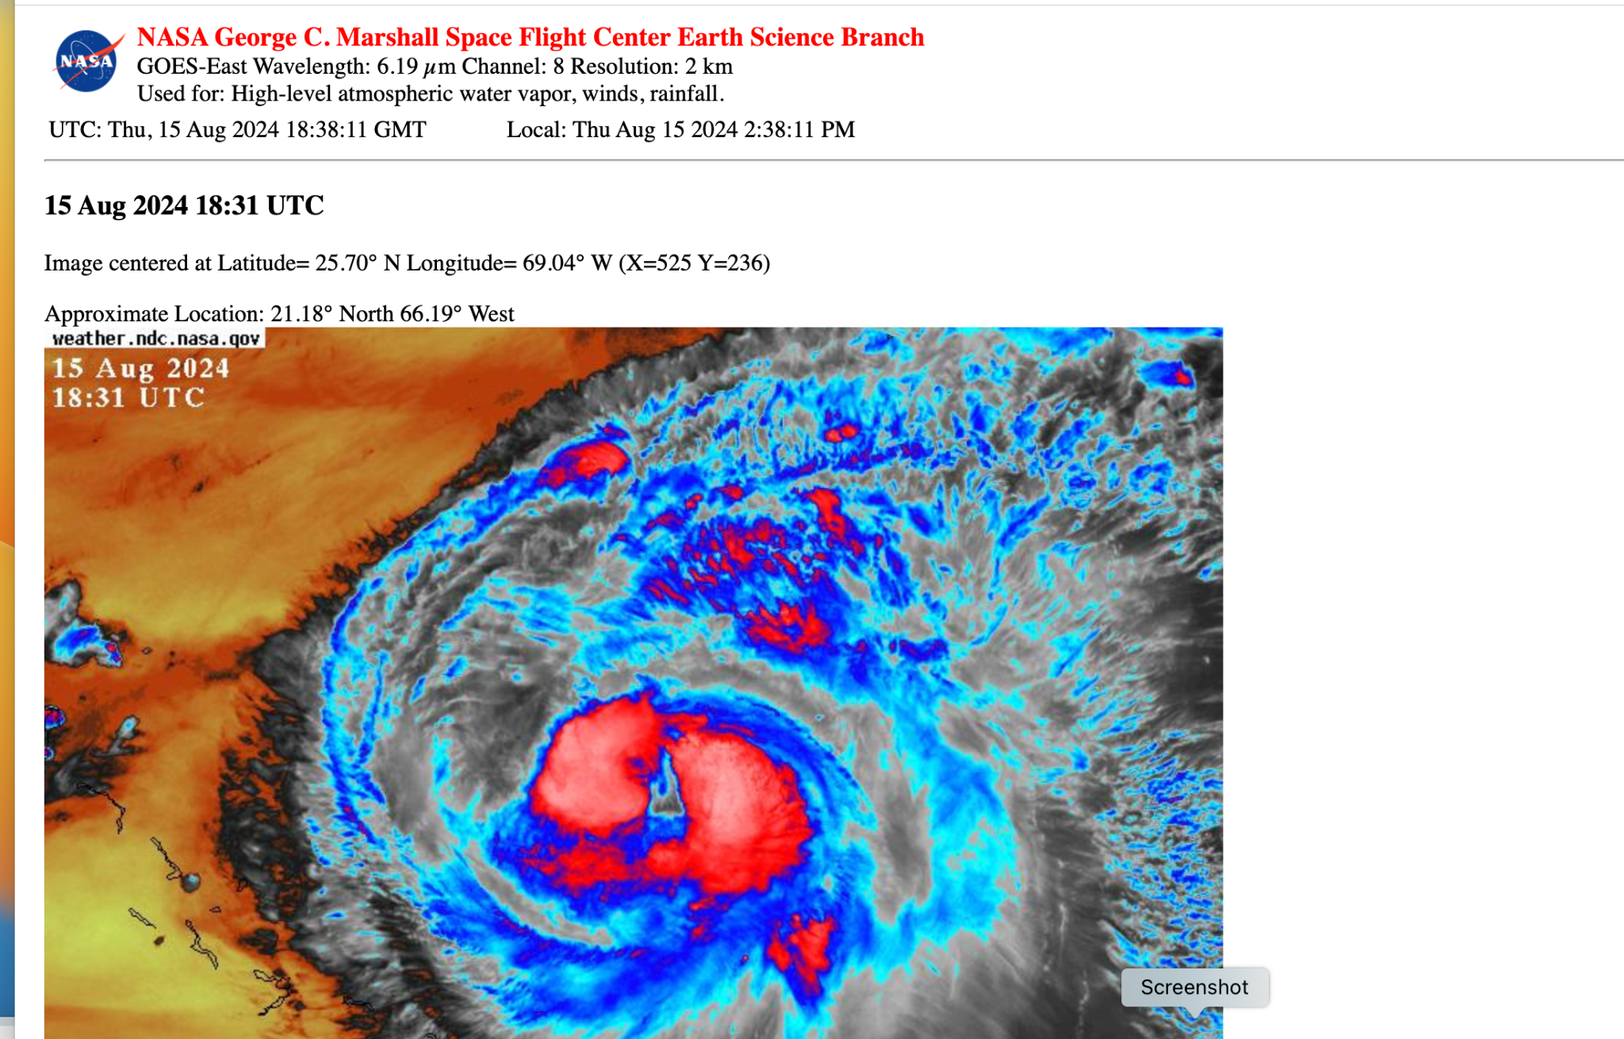

NASA water vapor image of Erensto at 1831 UTC near the end of today’s G-IVmission.
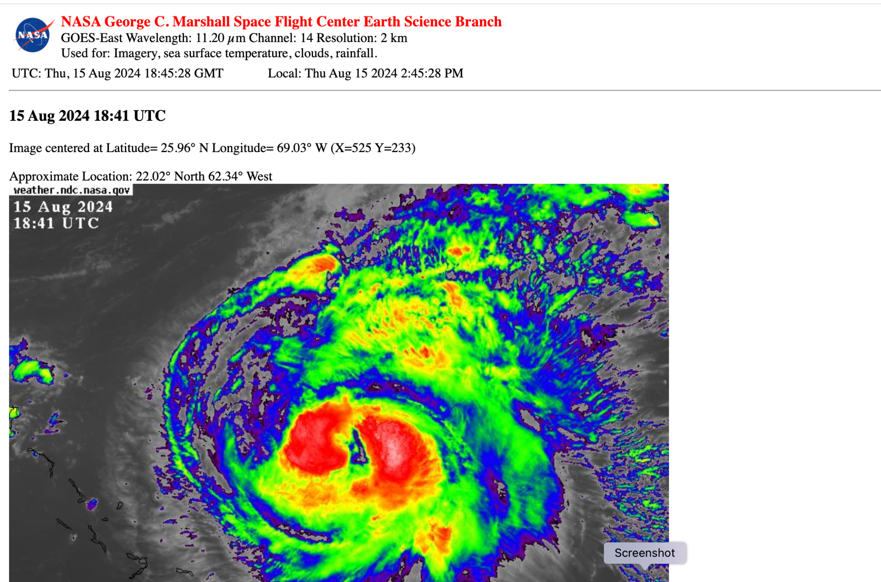

MTS screenshot at 1850 UTC near the end of today’s mission.

POST-FLIGHT
Mission Summary | Today’s mission was flown as planned with the exception of a few slight deviations around deep convection and the objectives of collecting in-situ measurements in the region of the tropics satellite overpass were carried out successfully.
Actual Standard Pattern Flown | GIV Star with circumnavigation.
APHEX Experiments / Modules Flown | Tropics Satellite Validation
Plain Language Summary | Compare G-IV dropsonde measurements of pressure, temperature and wind collected in and around Ernesto to co-located observations from the new 6 satellite Tropics satellite constellation.
Instrument Notes | Instruments generally worked as expected although there was 1 total failure and 5 partial failures of the mini dropsondes.
Final Mission Track | 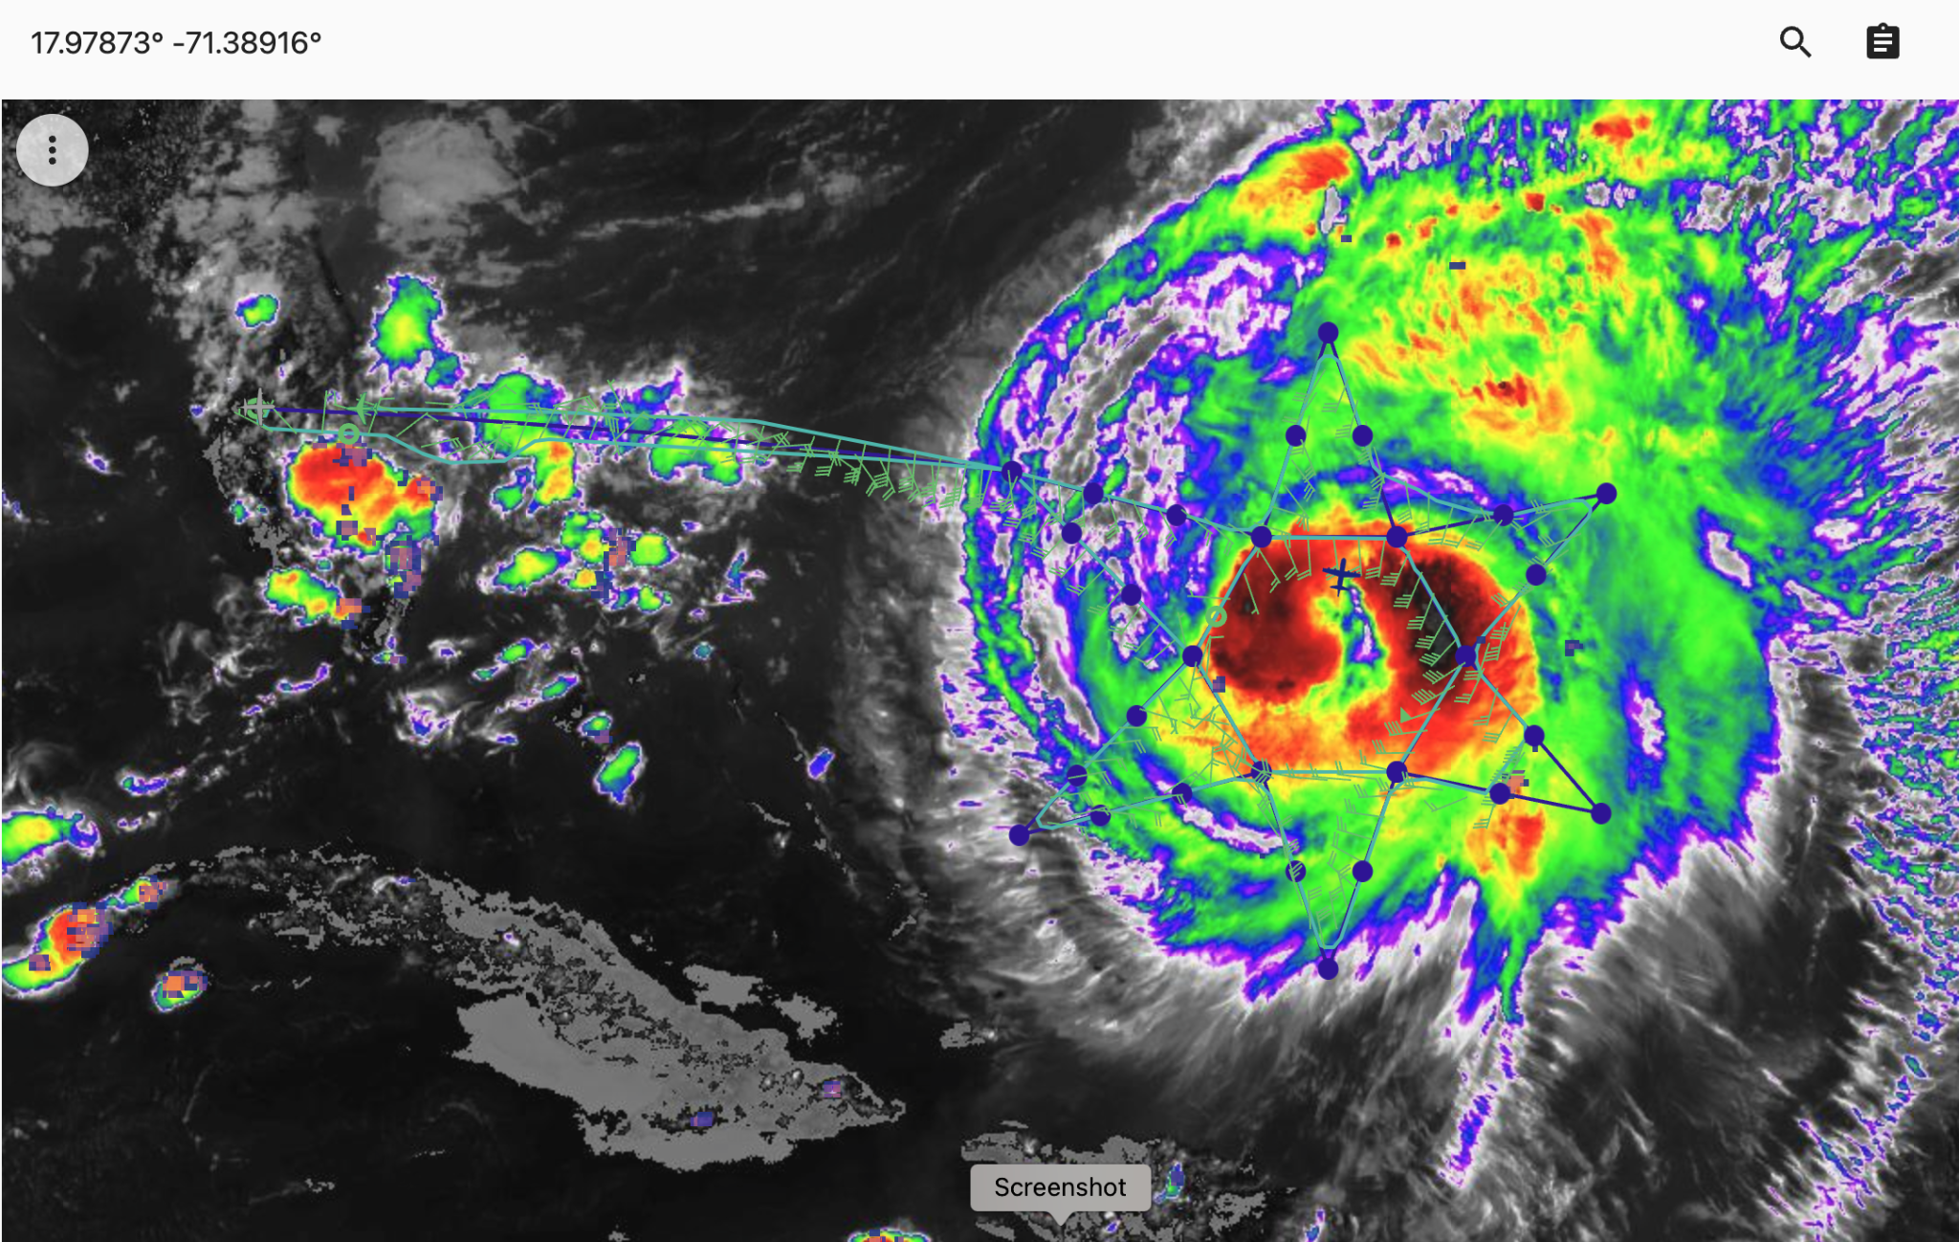  MTS screen shot at 1900Z near the end of today’s G-IV mission. The GIV (green aircraft symbol) planned track is shown in blue and the actual track flown in green. The blue aircraft symbol is NOAA-43.

