MISSION PLAN
FLIGHT ID | 20240815I1 | STORM | Ernesto
MISSION ID | WB05A | TAIL NUMBER | NOAA-43
TASKING | HRD APHEX | PLANNED PATTERN | RICO SUAVE
MISSION SUMMARY
TAKEOFF [UTC] | 1408 | LANDING [UTC] | 2200
TAKEOFF LOCATION | Wilmington | LANDING LOCATION | Wilmington
FLIGHT TIME |  | BLOCK TIME
TOTAL REAL-TIME RADAR ANALYSES  (Transmitted) | 4 passes (0) | TOTAL DROPSONDES Deployed (Tx to GTS) | 22 (21)
OCEAN EXPENDABLES deployed (good) | 3 AOC AXBTs (0) | sUAS (Type) | 2 (Back Swift S0)
APHEX EXPERIMENTS / MODULES | RICO-SUAVE, CHAOS
HRD CREW MANIFEST
LPS ONBOARD | J. Zhang | LPS GROUND | Looney/Dunion
TDR ONBOARD | n/a | TDR GROUND | n/a
ASPEN ONBOARD | n/a | ASPEN GROUND | Sellwood
NESDIS SCIENTISTS | n/a
GUESTS (Affiliation) | Mikal Montgomery , Jack Elston (Blackswift), Josh Fromm (Blackswift)
AOC CREW MANIFEST
PILOTS | Abitbol (primary), Wood/Tarabehhi (co pilots)
NAVIGATOR | Schaefer
FLIGHT ENGINEERS | Stokes/Dihoc
FLIGHT DIRECTOR | Kalen
DATA TECHNICIAN | McAlister
AVAPS | Keller

PRE-FLIGHT
Flight Plan | 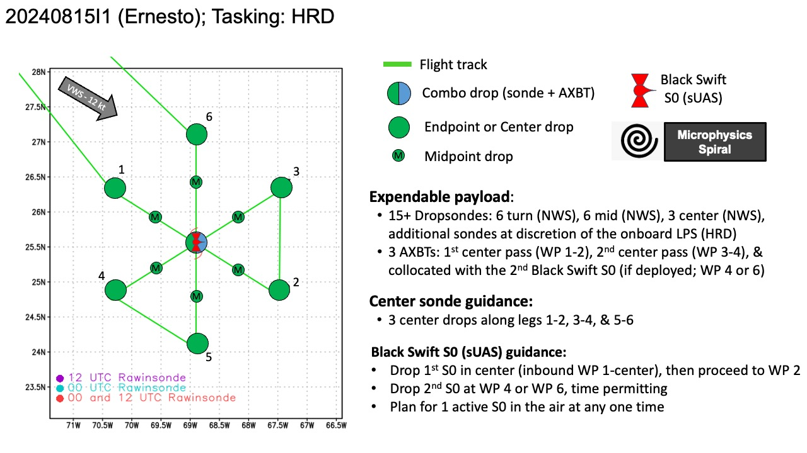
Expendable Distribution | 15 dropsondes  3 AXBTS  2 sUAS (S0)
Preflight Weather Briefing
Instrument Notes | [What instruments are working, not working, not functioning nominally, not installed?]

IN-FLIGHT
Time [UTC] | Event
1408 | Take-off from Wilmington
1431 | Doing dry run for s0 and pre-launch checklist, went well
1441 | Flight orbiting due to some kind of air-space reservation deconfliction, should be back on track soon
1523 | Running another s0 dry run, went well
1525 | 40 min from IP
1532 | ~10 min from reaching the outer convection
1539 | TDR is online and operational
1600 | 10 min from IP, descending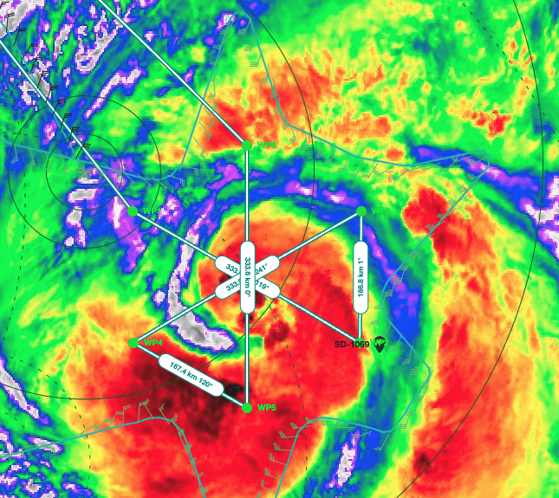
1605 | SD-1069 currently at 24.78177 N, 67.20799 W
1606 | N42 noted that they ran TDR today as well and that data should be up today
1608 | based on IR, some decently dry air starting to wrap around to the S of the center...looks like flight is in a pocket of it now, Center appears to be completely filled in
1610 | SD too far from WP2 to chase, may be near downwind 2-3
1613 | Sonde 1 IP, NW-SE pass
1621 | Pre-launch checklist started
1623 | Sonde #2 MP - NW, likely a bad sonde, backup sonde released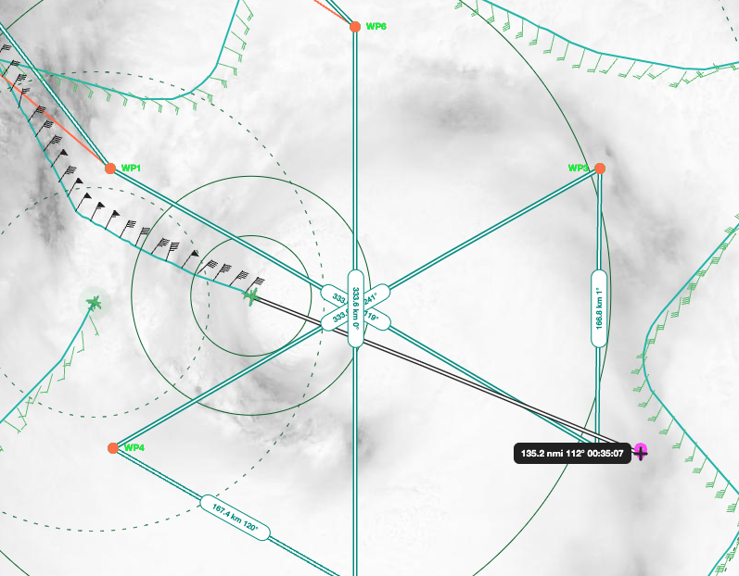
1634 | Supercombo (sonde + BT), sUAS out, S0 #1 has got comms, so far so good; Center sonde 976 mb, 18 kt winds 95 deg
1636 | S0 #1 descending to 1500 m then will start flying toward the eyewall/RMW
1639 | Failed BT
1640 | Sonde 5, RMW SE charged to HR, will be used for comparison to S0 #1 data
1646 | S0 #1 still doing well, 45 kt winds from s0 in air ops
1648 | Drop 6, CH6, mid point SE
1656 | S0 #1 still flying
1657 | Mikal noted 60 kts from S0 #1
1657 | EP1, drop 7, CH7, good drop, SE
1700 | Flight went ~29 n mi W of the saildrone
1702 | G-IV flew within 20 n mi of the P3, just a lot higher (45k ft versus 7.7k ft for P3)  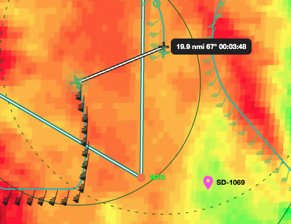
1704 | Shortened outbound leg to help S0 #1 comms, just in case
1705 | S0 #1 doing well, descent to 1000 m, S0 #1 reached 1000 m
1706 | 64+ kts winds from S0 #1
1708 | air ops set very nice now. We can see flight level and S0 #1 winds and tracks
1710 | Plan to go to 500 m, then 250 m, then maybe 10 m, but SD reported 8.9 m waves, so may try for 20 m or 30 m
1711 | Battery at 52%,
1712 | New S0 #1 plan to do 500m, then 250 m, then 100 m, then 50 m, then whatever altitude lower than 50 m
1717 | IP2, drop 8, CH8, good sonde
1725 | Starting descent to 200 m, reached 200 m
1726 | Next S0 dropped at WP5, then fly downwind to SD
1727 | 34% battery left
1730 | 31% battery left
1739 | 20% battery left
1748 | 11% battery, keep at 10-20 m
1750 | Ran out of battery, 76 min flight
1804 | EP2, drop 14, CH6 good sonde
1813 | Running 2nd S0 launch checklist
1815 | Preparing launch 2nd S0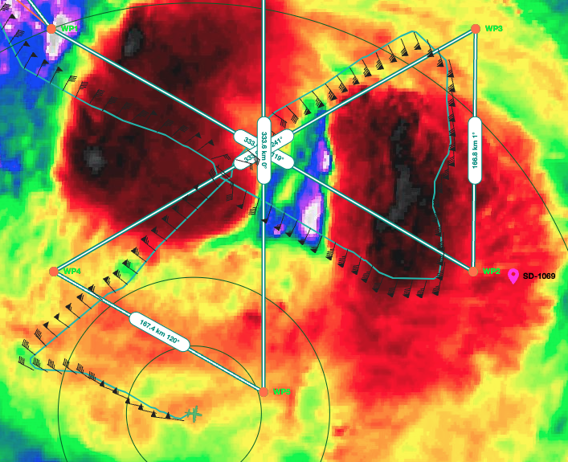  Dry air E of center
1820 | Possible eyewall formation to the E
1822 | Super combo (S0 #2, Sonde, BT) launched. SE of planned WP5 away from some convection
1830 | S0 #2 is flying
1831 | At 1500 m altitude, comms good, doing inflow module with stepped descent
1833 | Unable to see S0 #2 wind in air ops, but can see T and altitude and q. Jack from Blackswift can see winds, so problem in software for air ops
1834 | Going to test range this flight, going to fly all the way N, 180 n mi
1837 | S0 #2 started descending to 1000 m
1843 | S0 #2 still running, range 60 n mi
1841 | Drop 16, MP, CH8, good sonde
1848 | Flying between the eyewall and rainband
1848 | RMW drop 17, CH1, good sonde
1849 | Lev notes almost looks like some of the dry air got ingested and the center is reforming around that. Hard to tell though, and with the current heading, flight may get near it or just west of the center..but then again, the storm could be tilted
1850 | S0 #2 at 750 m, headed to 500m then 250, then 100, then 50, then 20. Range at 74 n mi
1855 | Center drop, drop 18, CH2, good sonde
1858 | S0 #2 at 500 m
1858 | RMW drop 19, CH3, good sonde
1901 | 70% battery left on S0 #2, 96 n mi range
1910 | 126 n mi range fro, S0 #2
1914 | EP3, drop 21, CH5, good sonde
1916 | S0 #2 comms lost at 143 n mi range during turn - regained comms inbound
1920 | Should be at 50 m, comms slow, but present
1922 | Comms believed to be back
1922 | Likely returning low-frequency data would be Jun’s guess
1924 | RMW drop 22, CH6, good sonde (last report labeled)
1930 | S0 #2 splashed, ~67 min flight, battery at 35%
1935 | Doing center fix, then headed through eye wall and outbound for home
1940 | All 3 BTs failed, S0 should give an estimate of SST (confirmed with Jack)
 | 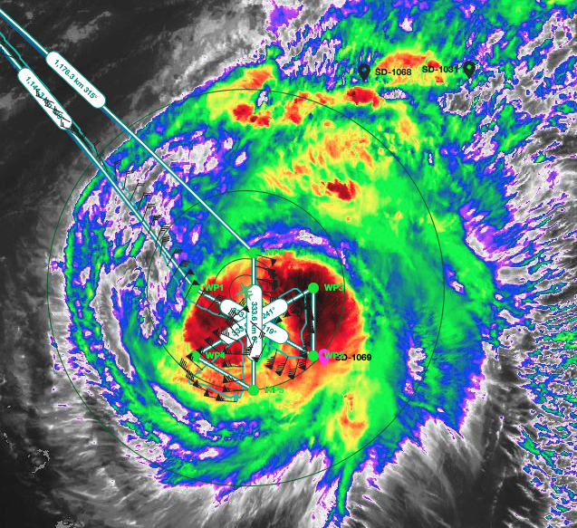
2002 | ETA to KILM 2145
2018 | 22 drops total 21 transmitted
2029 | 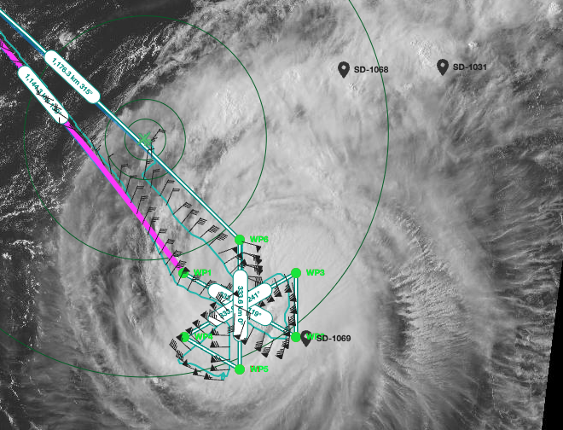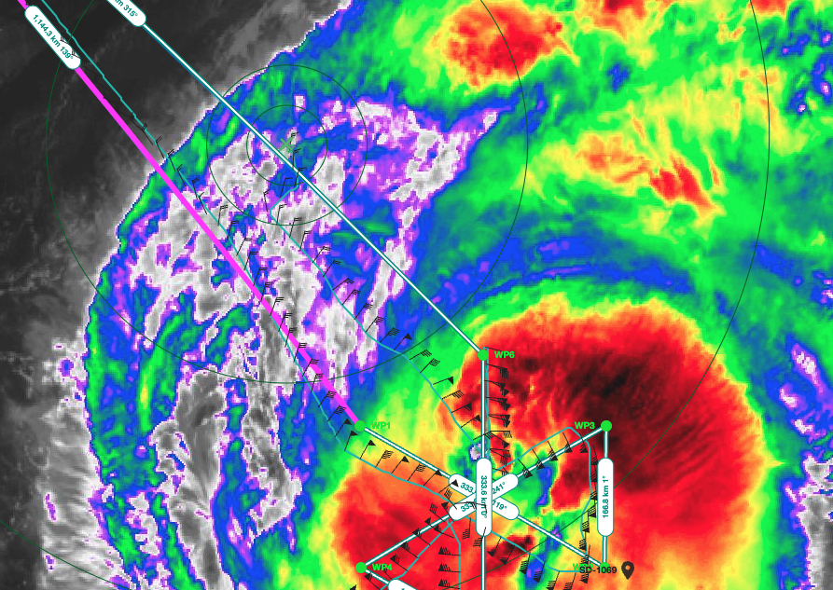  Flight looks to be going through some outflow from the TC
2015 | TDR turned off
2030 | Flying in outflow region heading home - saw gravity waves in cloud structure from the plane

POST-FLIGHT
Mission Summary | [Short description of interesting observations from the flight; what objectives were successful? What was unsuccessful? Was the planned pattern flown? What deviations occurred?  [Don’t forget to fill in Tables on page 1]  [Sonde and ocean expendable accounting: how many total of each? How many are charged to each account?]
Actual Standard Pattern Flown | [Butterfly, Rotated Figure-4, Lawnmower, etc]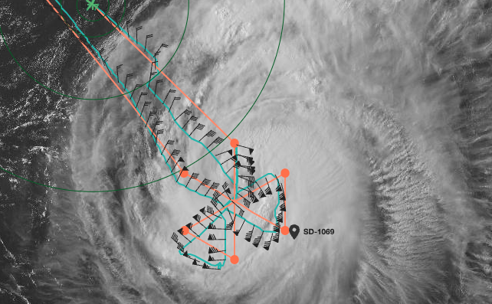  Butterfly
APHEX Experiments / Modules Flown | RICO SUAVE: RMW module and Inflow module
Plain Language Summary | [Boil down the above into a couple of bullet points in “plain language”. This will help us when we report to management & OAR Public Affairs and prepare storm mission summaries]
Instrument Notes | [Notes about instrument status from during and after the mission]
Final Mission Track | [Insert MTS screenshot of final flown track, ideally at the completion of the pattern with satellite imagery]

