MISSION PLAN
FLIGHT ID | 20240814I1 | STORM | AL05/Ernesto
MISSION ID | 1005A | TAIL NUMBER | NOAA-43
TASKING | NHC/EMC TDR | PLANNED PATTERN | Butterfly
MISSION SUMMARY
TAKEOFF [UTC] | 0804 | LANDING [UTC] | 1538
TAKEOFF LOCATION | TBPB | LANDING LOCATION | TBPB
FLIGHT TIME | 7h34m | BLOCK TIME | 7.9
TOTAL REAL-TIME RADAR ANALYSES  (Transmitted) | 3 (3) | TOTAL DROPSONDES Deployed (Tx to GTS) | 16 (16)  15 NHC, 1 HRD
OCEAN EXPENDABLES deployed (good) | N/A | sUAS (Type) | N/A
APHEX EXPERIMENTS / MODULES | Stratiform Spiral Module
HRD CREW MANIFEST
LPS ONBOARD | Sippel, Marks | LPS GROUND | Hazelton
TDR ONBOARD | Sippel, Marks | TDR GROUND | Reasor
ASPEN ONBOARD | n/a | ASPEN GROUND | Sellwood
NESDIS SCIENTISTS
GUESTS (Affiliation)
AOC CREW MANIFEST
PILOTS | Doremus, Palmer, Reeves,
NAVIGATOR | Miller, Meier
FLIGHT ENGINEERS | Tyson, Wysinger, Ripp
FLIGHT DIRECTOR | Englert, Zawislak
DATA TECHNICIAN | Richards
AVAPS | Hollis, Paul

PRE-FLIGHT
Flight Plan | 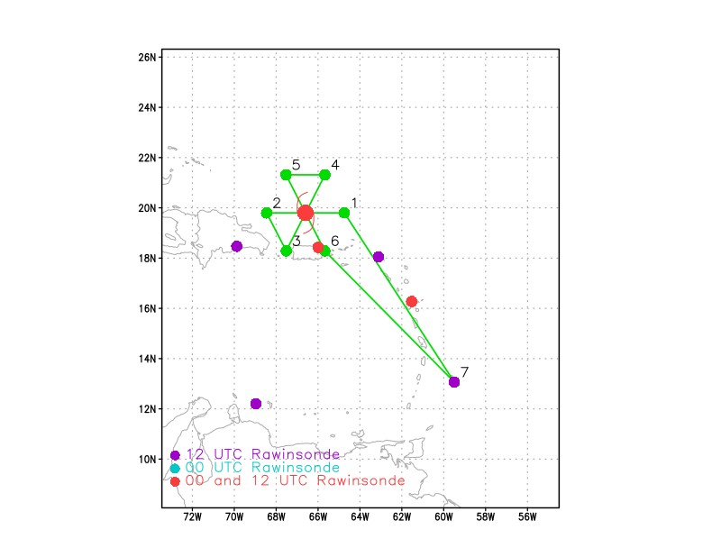
Expendable Distribution | - Load 30 dropsondes  - Release at endpoints, midpoints, centers >> charged to NWS  - All dropsondes transmitted to the GTS  - AXBTs - none
Preflight Weather Briefing | 5:00 AM AST Wed Aug 14  Location: 19.5°N 66.6°W  Moving: NW at 16 mph  Min pressure: 996 mb  Max sustained: 70 mph  FORECAST POSITIONS AND MAX WINDS  INIT 14/0900Z 19.5N 66.6W 60 KT 70 MPH  12H 14/1800Z 21.1N 67.8W 70 KT 80 MPH  24H 15/0600Z 23.6N 68.9W 85 KT 100 MPH  36H 15/1800Z 25.7N 68.8W 95 KT 110 MPH  48H 16/0600Z 27.6N 67.6W 100 KT 115 MPH  60H 16/1800Z 29.5N 66.2W 100 KT 115 MPH  72H 17/0600Z 31.4N 65.5W 95 KT 110 MPH  96H 18/0600Z 35.0N 65.0W 90 KT 105 MPH  120H 19/0600Z 40.5N 62.5W 80 KT 90 MPH  Land avoidance, especially near Points 3 & 6.
Instrument Notes | All instruments are nominal.  0812Z: TDR up  0949Z: reset the MMR

IN-FLIGHT
Time [UTC] | Event
0804 | Take-off from TBPB
0851 | Discussion about possible science to target after operational priorities have been met. This is an excellent opportunity to conduct the Stratiform Spiral Module (SSM). Will target a likely expansive stratiform region to the southeast of the center after completing the planned track (i.e., after EP).
0918 | Picking up first cells in outer rainbands on TDR
0931 | SJU radar shows a spiral presentation with much of the convection to the east and south of the center. It does appear that an inner core is developing but convection has not yet wrapped all the way around to the west and southern side of the circulation. The radar appearance suggests that the storm is still ingesting some drier air from the west. Broad area of stratiform mixed with convective elements spiraling off toward the east. Very intense rainfall over eastern Puerto Rico that will likely continue for several hours.
0940 | drop 1, 0937, ch1, ip1  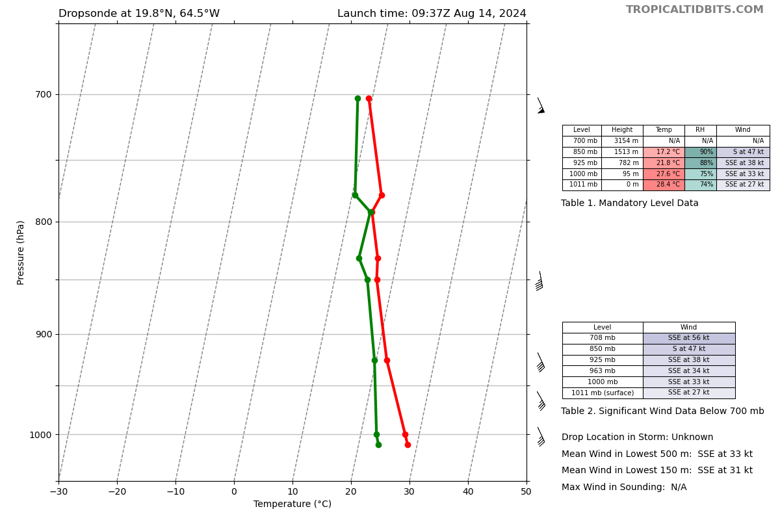
0943 | Discussion about a GOMO sonde near SD-1091 at 19.47806 N, 65.64536 W. This could line up nicely with the P-3 position after completing the operational pattern. SD is drifting N at ~3 kt
0953 | Will adjust midpoint sonde to CPA the Saildrone ~16.5 n mi to the south. GOMO said this was too far away to be considered a collocation, so this sonde is still charged to NWS
1003 | drop 2, 1003, ch2, mp1 (CPA for SD)  splashed at 19.79N 65.69W (32.7 km from SD)  surface 49kts 155deg WL150 55kts  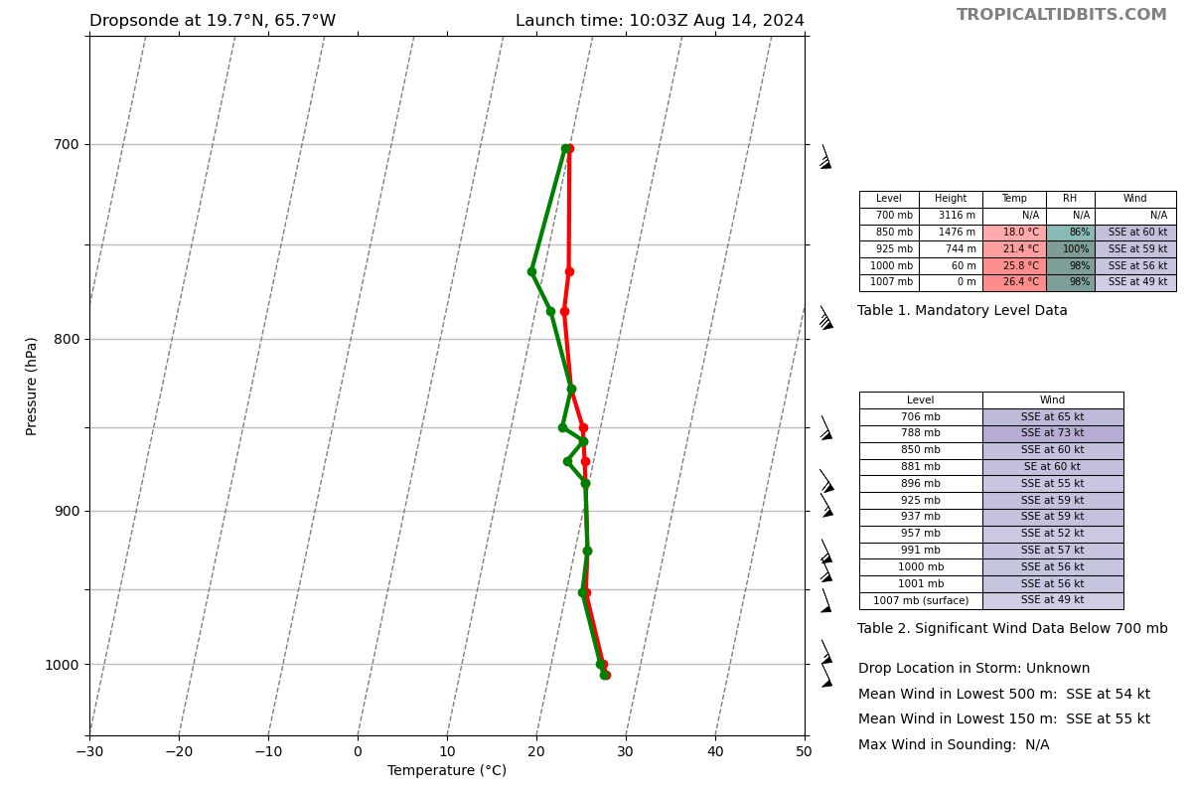
1011 | HAFS forecast shows a vortex tilted to the SE with height, valid about now. The vortex could become more aligned during this mission. Will be interesting to see if this structure is represented in TDR  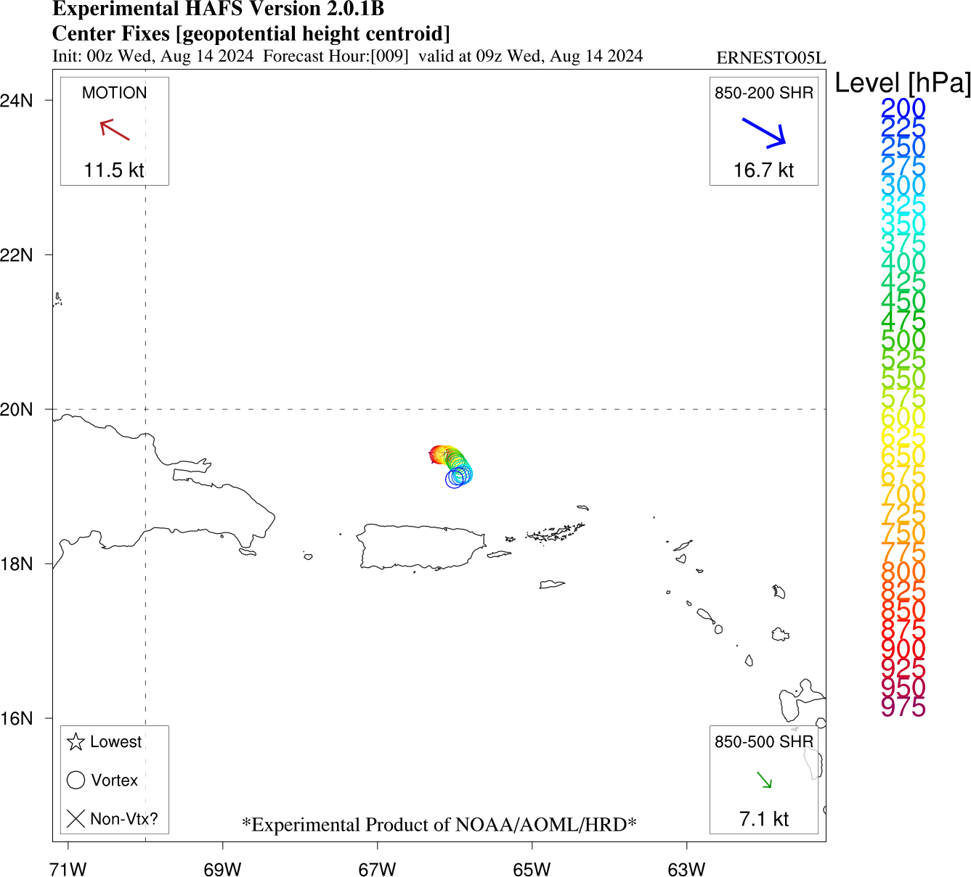
1012 | Approaching band on the east side, heavy stratiform with embedded convective elements with echo tops extending up to 18 km
1015 | FL winds show what appears to be a broad, flat wind field on the east side on this first inbound leg
1016 | MMR is showing the hook like circulation center 30 nmi NNW of our current poisiton
1023 | inside the hook, elliptical elongated N-S, 10 nmi major axis, 7 nmi minor axis  FL center a bit farther west than expected
1023 | drop 3, 1023, ch3, CP1  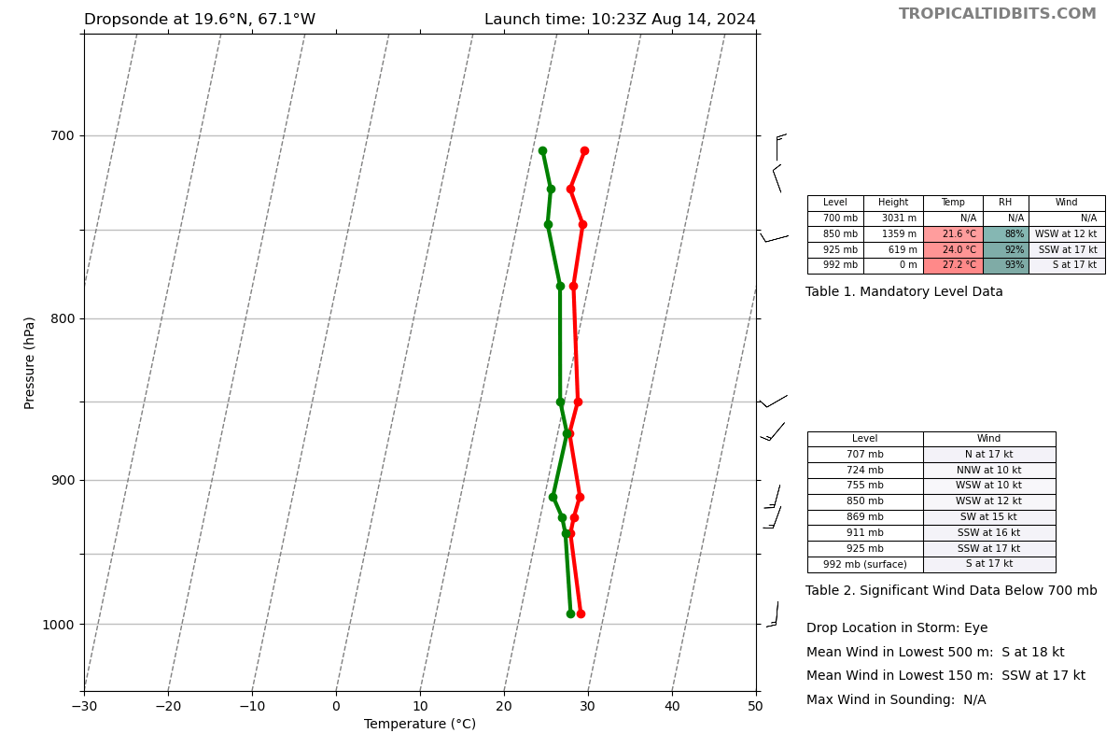
1026 | Not much reflectivity west of the center. TDR shows anvil echoes. Continue this TDR analysis at least through the edge of the cloud shield (~1034Z)
1037 | drop 4, 1035, ch4, mp2  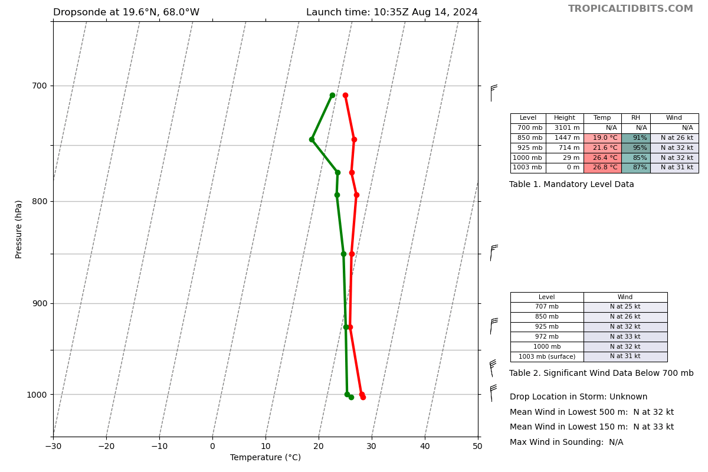
1046 | drop 5, 1046, ch1, EP1  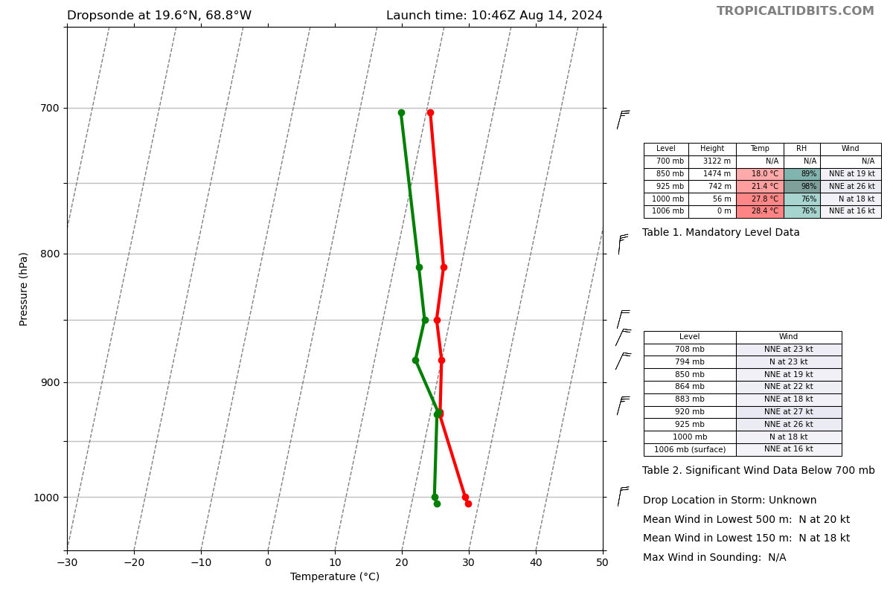
1048 | turning to track 135 to PT #3
1050 | SJU radar shows that a tight inner core has developed. This could be the onset of more significant intensification.
1058 | TDR analysis #1 completed
1102 | Latest TDR analysis shows a center is tilted 21 km to 68deg. The next inbound-outbound leg is oriented in the same direction, so this is a good opportunity to sample the LLC and MLC along the same leg!  For reference, tilt direction was ~150deg a day ago
1109 | drop 6, 1109, ch2, IP2  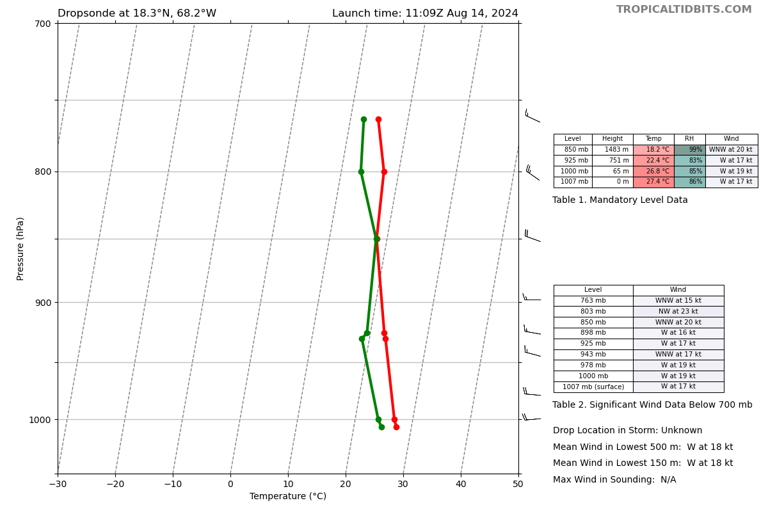
1115 | Lev noted that it looks like on this next downwind leg, flight may go right over an AOML glider (21.3238N, 66.9458W). At this point, no GOMO sonde requested, may be near EP for this leg
1122 | Drop 7, 1122, ch3, MP  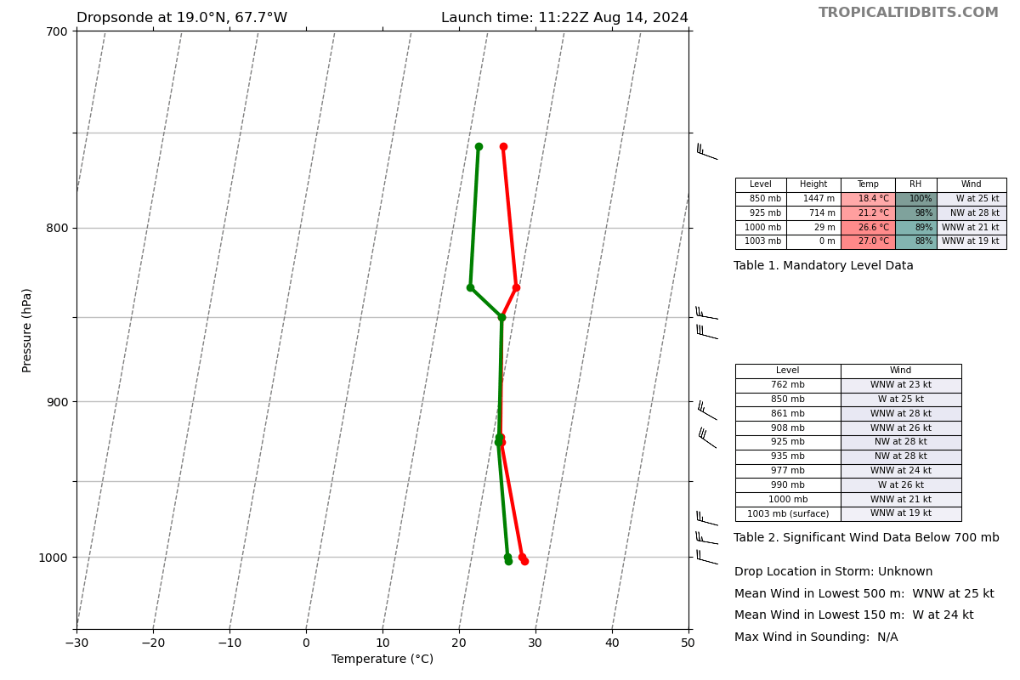
1124 | 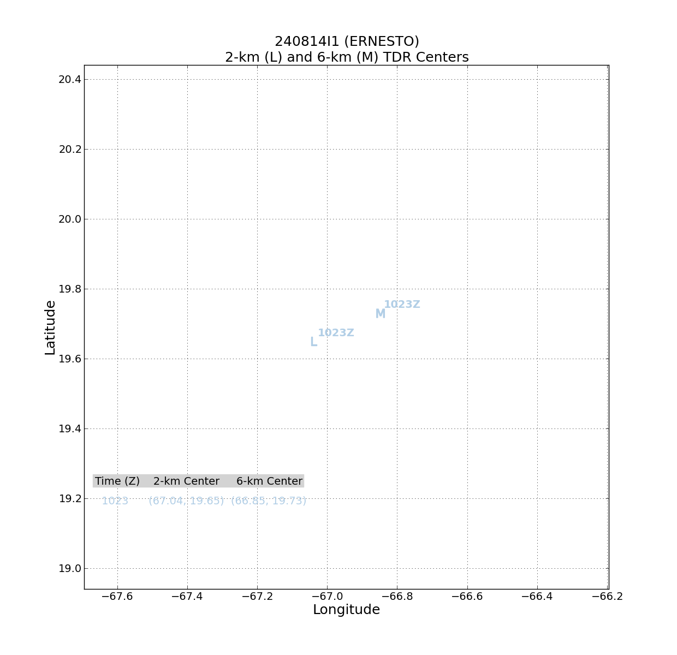  Analyses from first pass are in. Vortex tilt toward the ENE between 2 and 6 km seen. SHIPS shear is from 286 (06 UTC), so this tilt is downshear.
1125 | 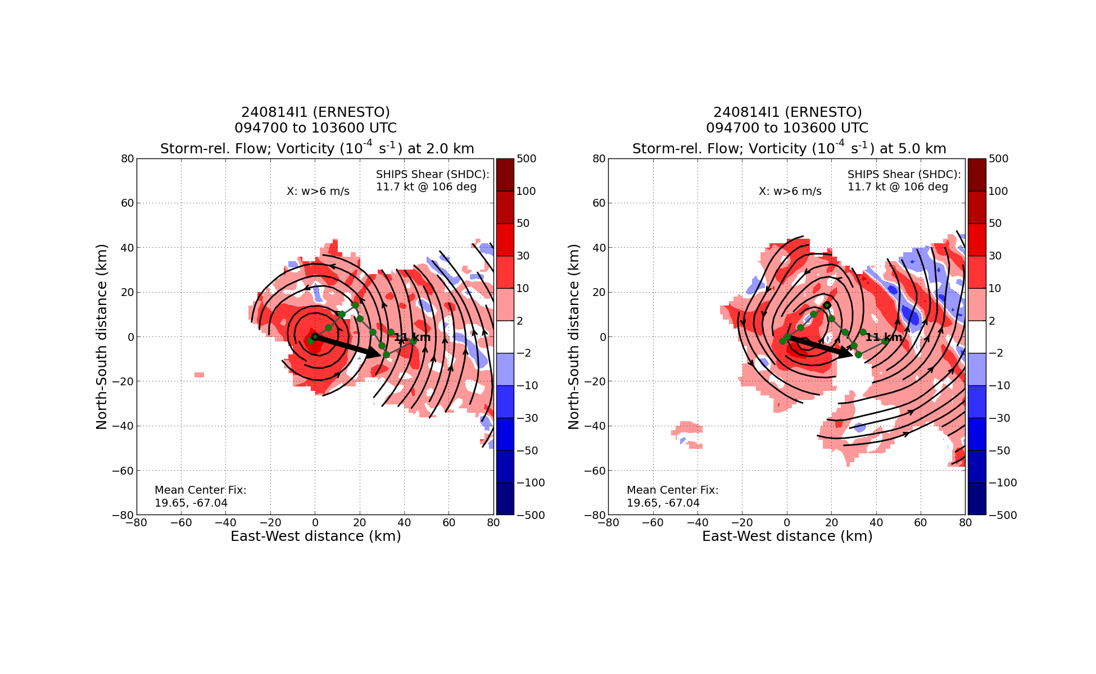  Tilt hodograph shows downshear tilt over a deep layer
1125 | 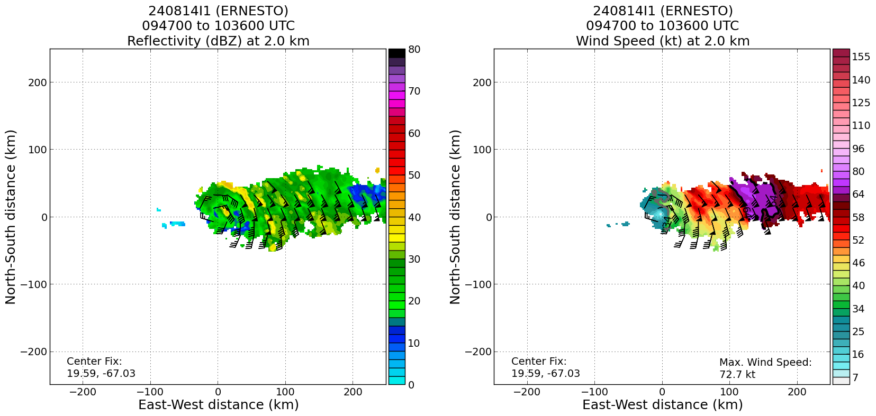  Large RMW on the east side, peak winds at about 120 km
1126 | 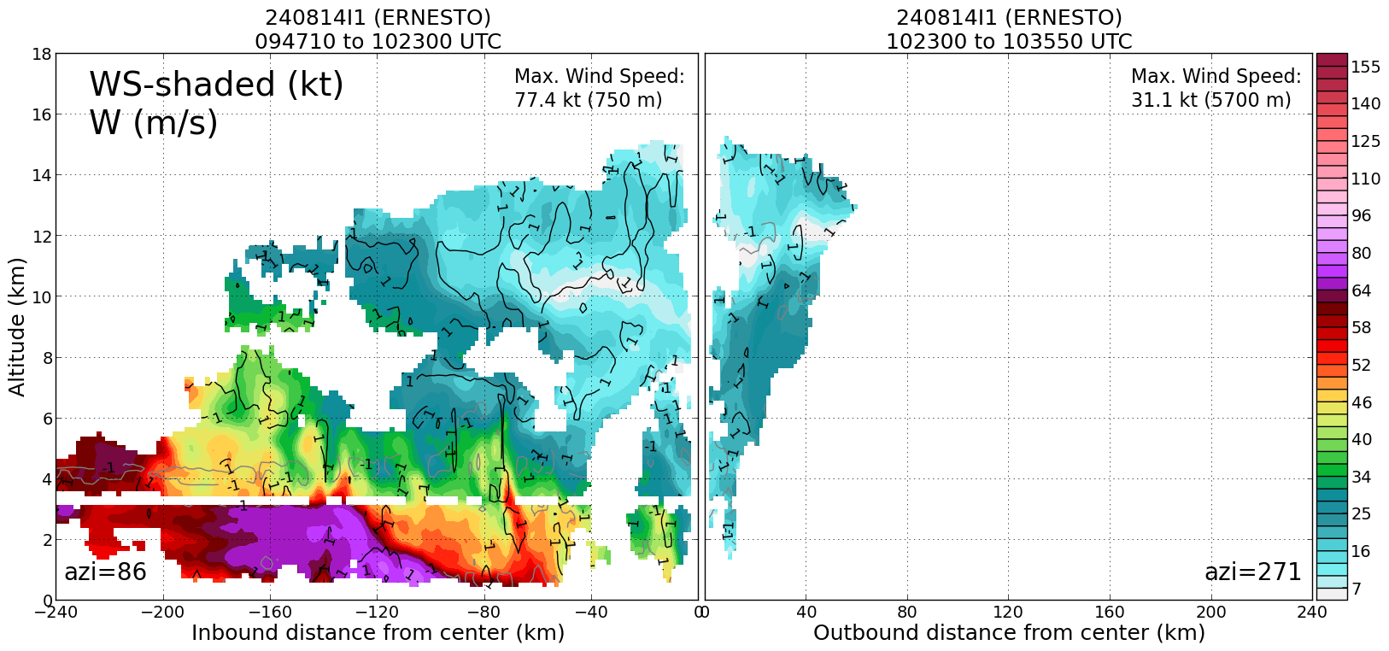  A broad, shallow vortex at the moment
1126 | Starting to build a core per flight. Inner RMW starting up at 3 km
1126 | 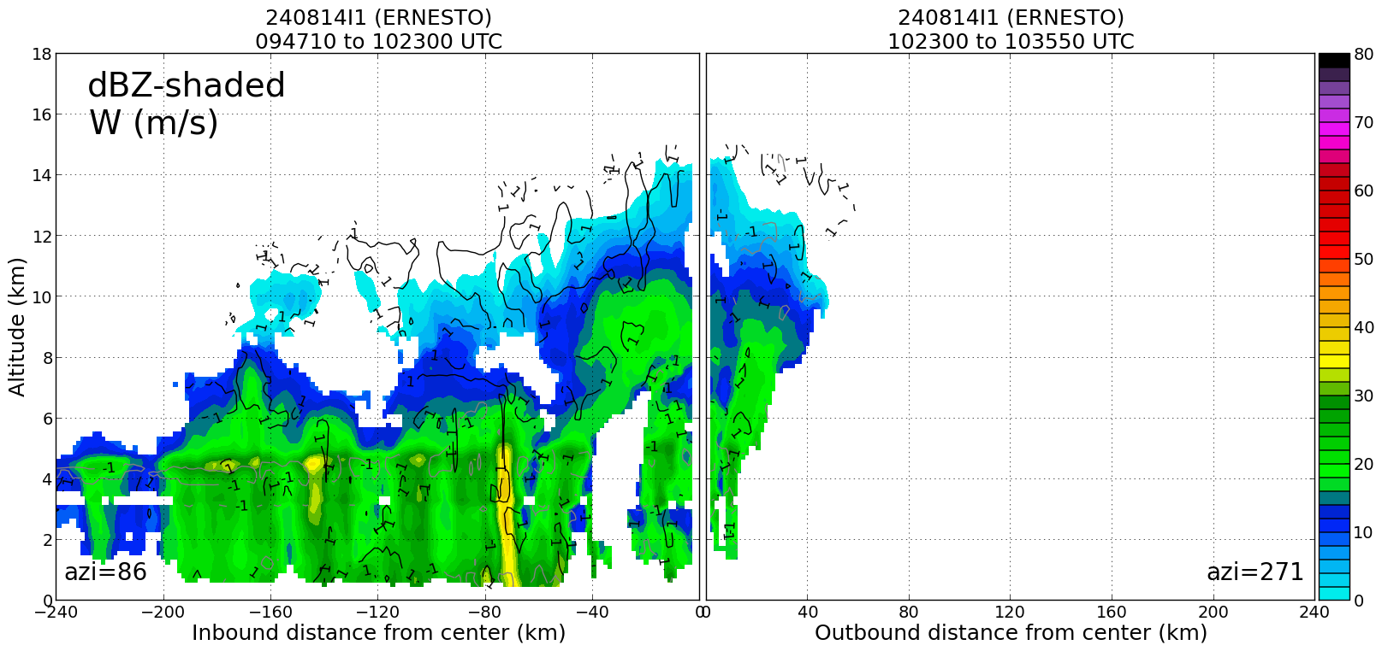  Mostly stratiform precip on the east side, though a narrow core of intense rainfall at about 75 km, coincident with narrow band of stronger winds. Echo tops are reaching 12 km close to the center.
1127 | 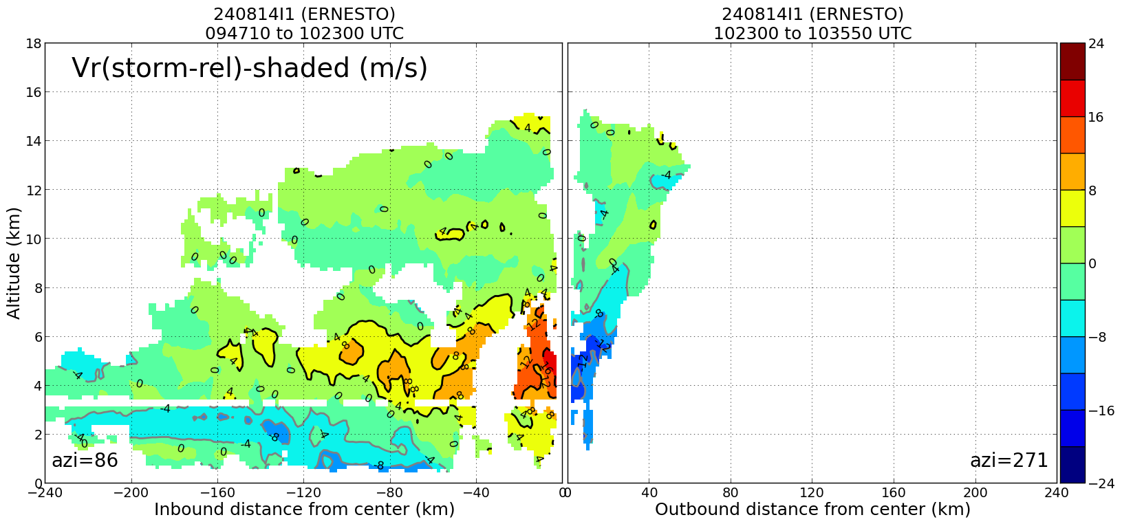Nice inflow seen in lowest 4 km on east (downshear) side
1127 | Strongest winds at 3 km are still out in the rain bands
1133 | CPAing the center, which will be slightly E of where flight is  Center appears to be tucked up in a hook echo on the NE side
1135 | Drop 8, 1135, CH4, center 2  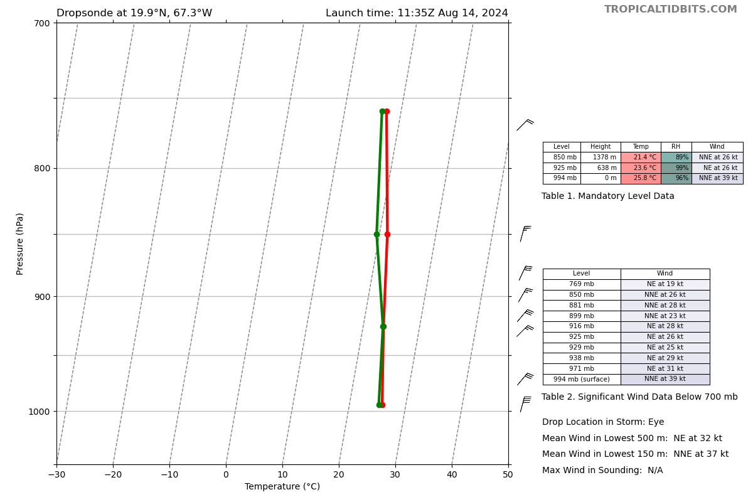
1137 | Flight notes echo tops 18 km just right of the track
1154 | TAG noted TC intensifying, center had 994 mb
1154 | MP drop just outside a rainband, drop 9, 1154, ch1, mp4
1153 | intensifying center had 994mb (992mb extrapolated)
1155 | drop 9, 1154, ch1, MP4  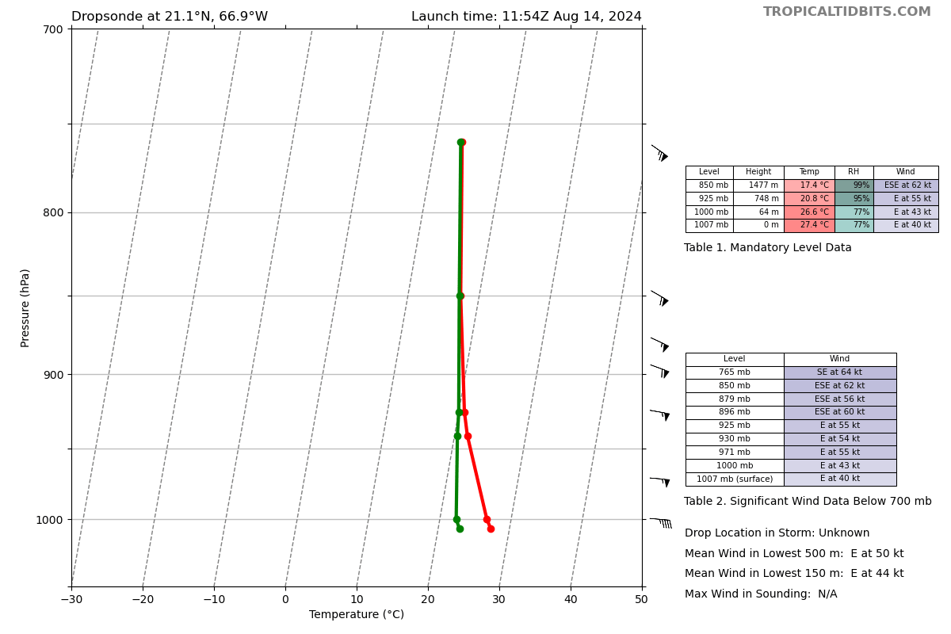
1157 | Flight currently 9.2 n mi E of AOML glider (SG649)
1202 | drop 10, 1201, ch2, EP2  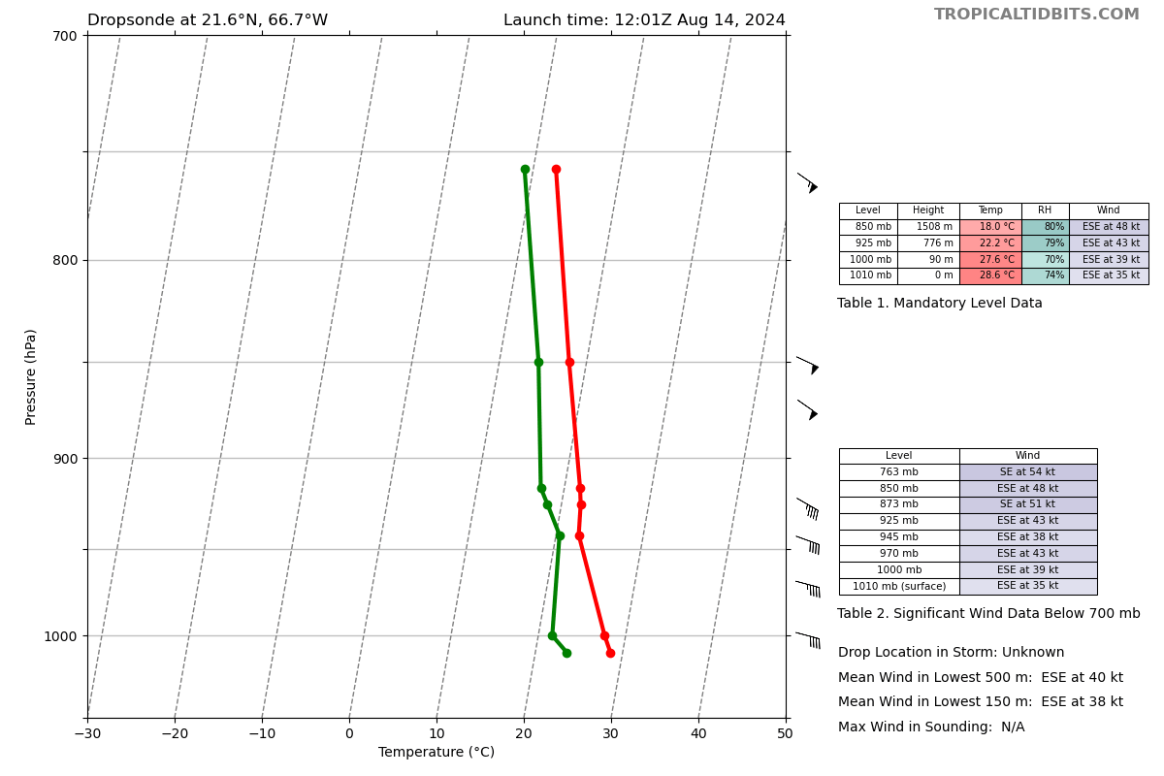
1204 | 8am NHC has 60 kts, center at 19.8N 67.2W
1206 | Aligned downwind leg to fly parallel to an intense rainband ~100 n mi north of the center. Rainband has a broad structure to the NE, narrowing in the counterclockwise direction (NW of center).
1215 | Higher reflectivity 40-60 n mi away to the N/NE. IT supports some cellular structure in that location
1226 | we're gonna have KE_N43_FD (Kerri) send out the last sonde we drop and last report
1228 | drop 11, 1226, ch3, IP3  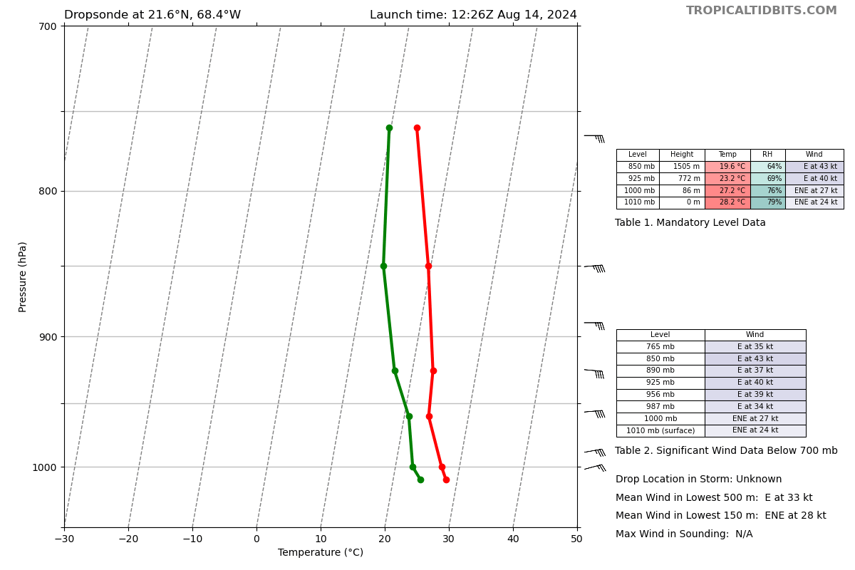
1234 | LPS notes that the vertical wind speed profile is interesting and implies that an inner core is building
1242 | drop 12, 1241, ch4, MP5  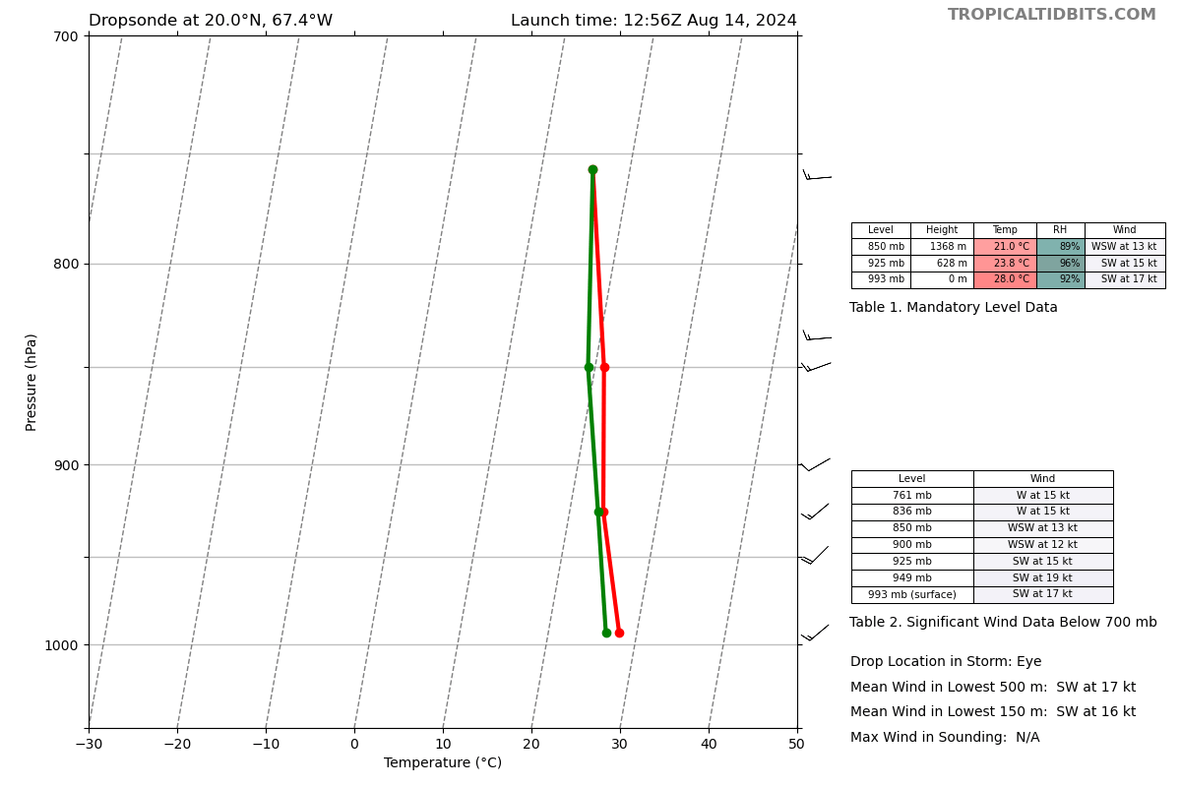
1242 | Analyses from second pass are in  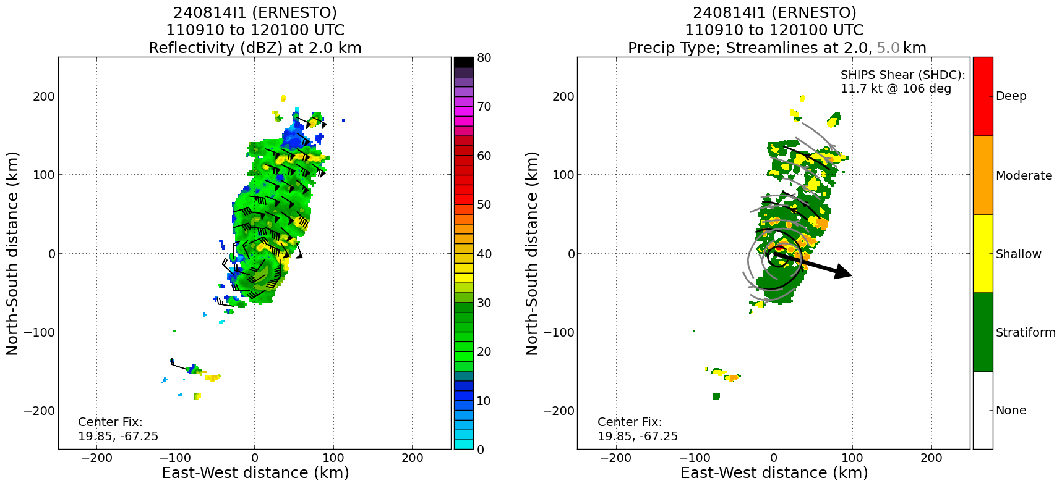  Precip mode shows most of convection is either of moderate or shallow depth. Compare this with the first analysis:  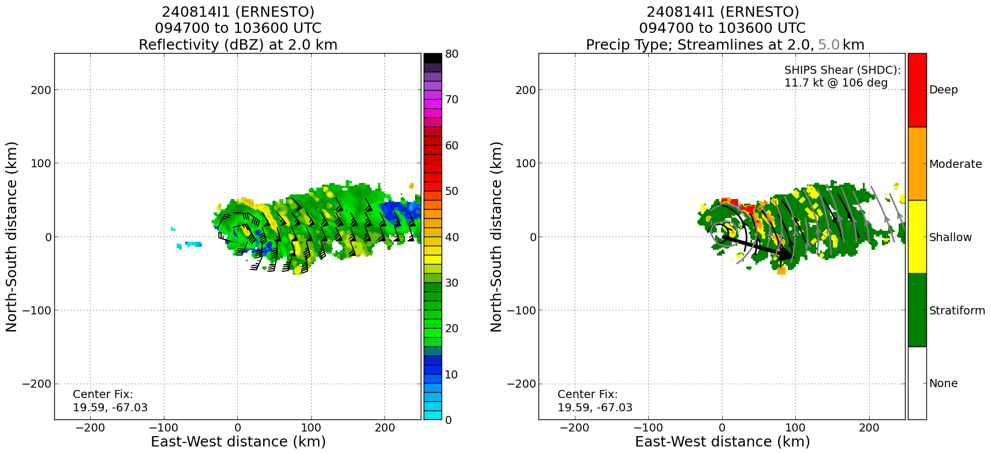  You can see that the “eyewall” in the northeast had a lot of deep convection during the first pass, but it’s now moderate. Don't know if there's been a weakening in the convection/lower of echo tops, perhaps reflecting dry air intrusion, or something about the algorithm/sampling.
1245 | 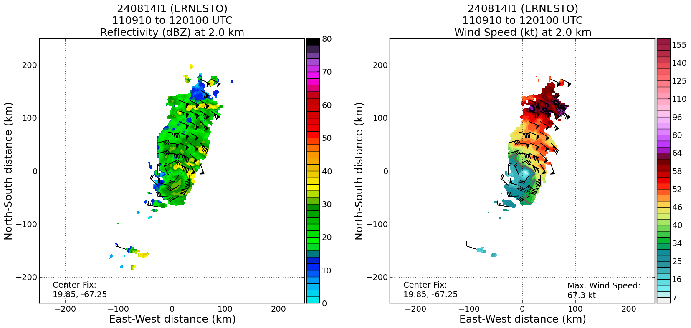  Winds at 2 km show strong winds in NE quadrant well-removed from center, similar to first pass
1247 | 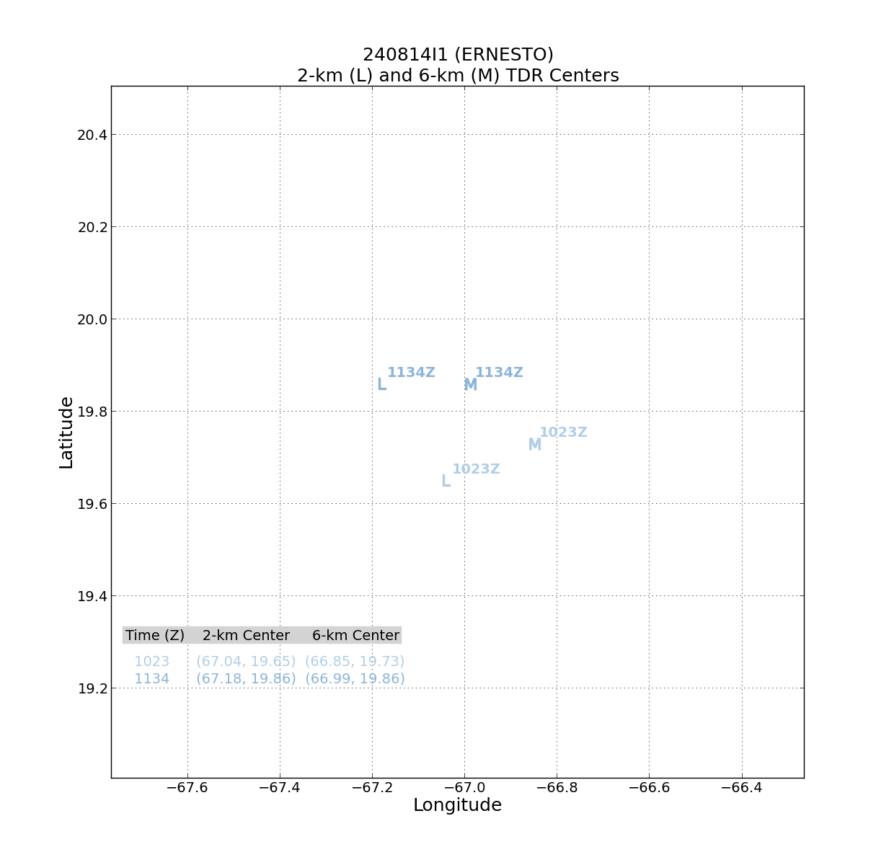  Tilt of similar magnitude, but now toward the east rather than east-northeast
1248 | 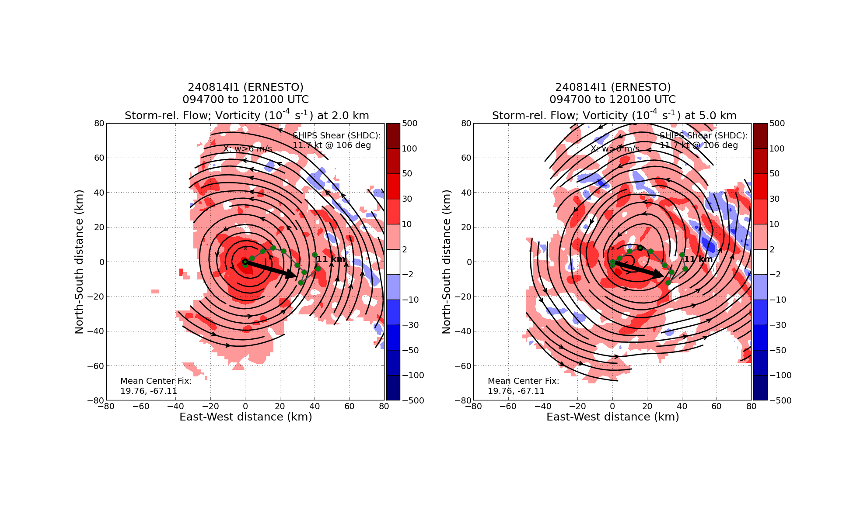  Nice anticyclonic rotation of tilt hodograph, left of shear. Vorticity monopole become evident at center.
1250 | 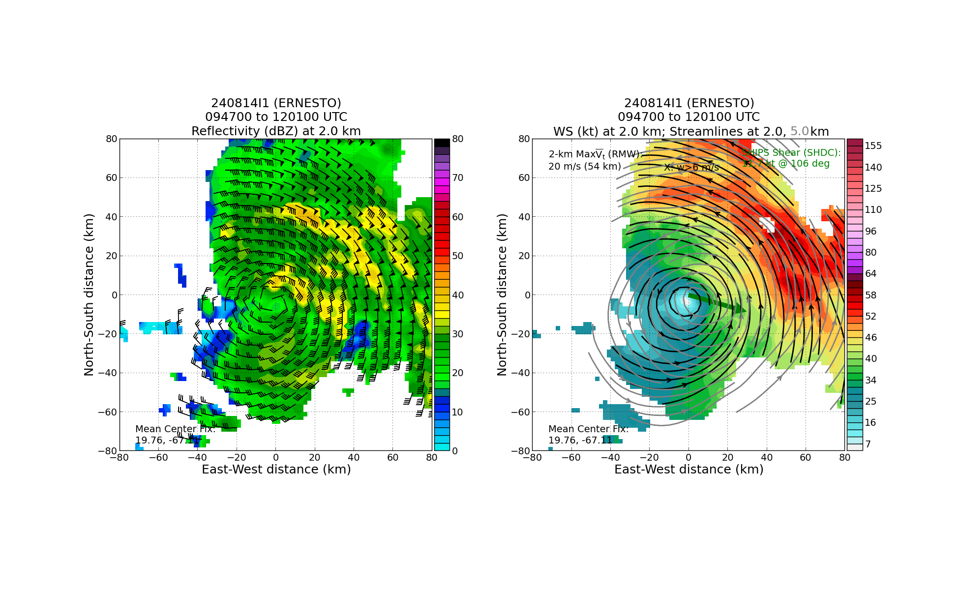  Another perspective of the tilted vortex toward the east, with strongest winds about 60 km from center. Note domain ends at 80 km, so the strongest winds seen above at 120 km radius not shown here.
1251 | Science update - we are targeting a stratiform spiral module after completing the operational pattern (i.e., after the EP southeast of the center). The location that we are targeting for the SSM is ~19.0, 65.5 (just outside of the broad heavy rainfall "band" north of eastern PR.  Note: We were attempting to collocate the SSM and a SD overflight. But, there are timing and aircraft conflict issues that will make that difficult (or impossible) to pull off. I am prioritizing SSM this flight because this is an excellent case for it with the sheared banding on the east side of the storm.
1257 | drop 13, 1256, ch1, CP3  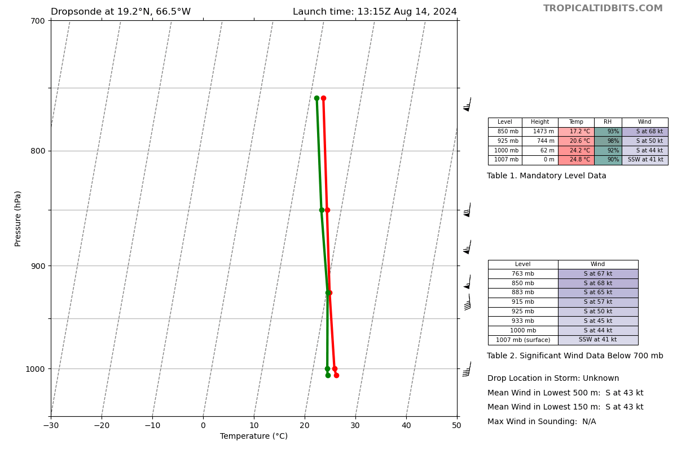
1303 | Although Ernesto is intensifying, IR representation is still ragged and cloud tops have been generally warming this morning. Right in line with diurnal cycle but still important to note as the radar representations are showing alignment and intensification
1314 | Major rainband is pretty cellular looking 15-20 nmi ahead (SE of center). Not a lot of stratiform. SJU radar shows more stratiform behind the heavy band
1316 | drop 14, 1315, ch2, MP6  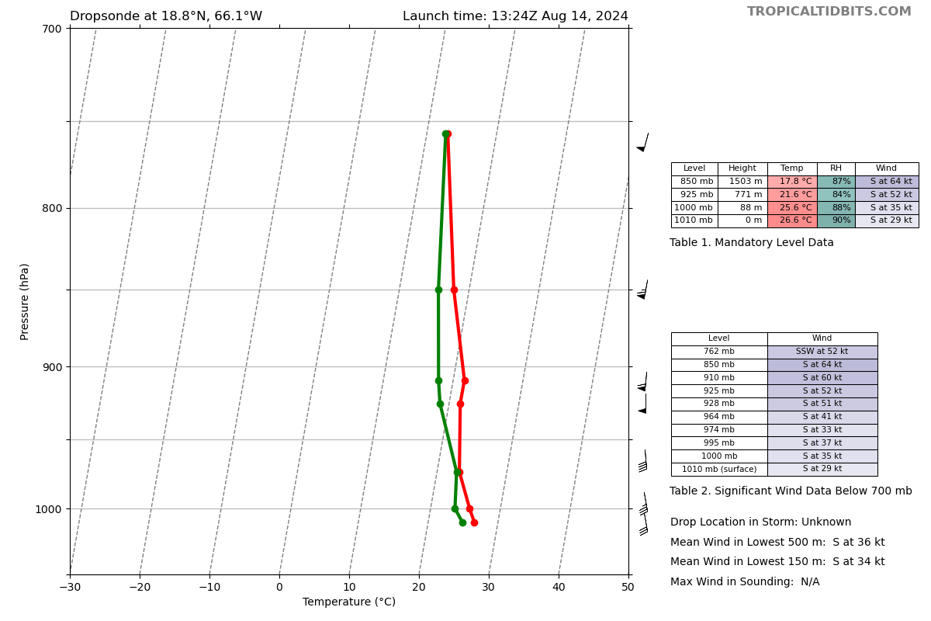
1318 | Inner core is more robust. Eyewall is open on the N side, consistent with shear direction (from N/NW)
1326 | drop 15, 1324, ch3, EP3  Dropped a bit early due to land restrictions
1329 | Starting SSM in main stratiform region. 1 more planned drop at the top of the SSM profile  15000' +1 C  15656 0 C  17000' -1 C  17633 -2 C  18000 -3 C  18560 -4 C  19055 -5 C  19605 -6 C  20240 -7 C  20725 -8 C  21418 -9 C  22181 -10 C  22563 -11 C  23460 -12 C  Sonde released at 1343 at the top of the spiral  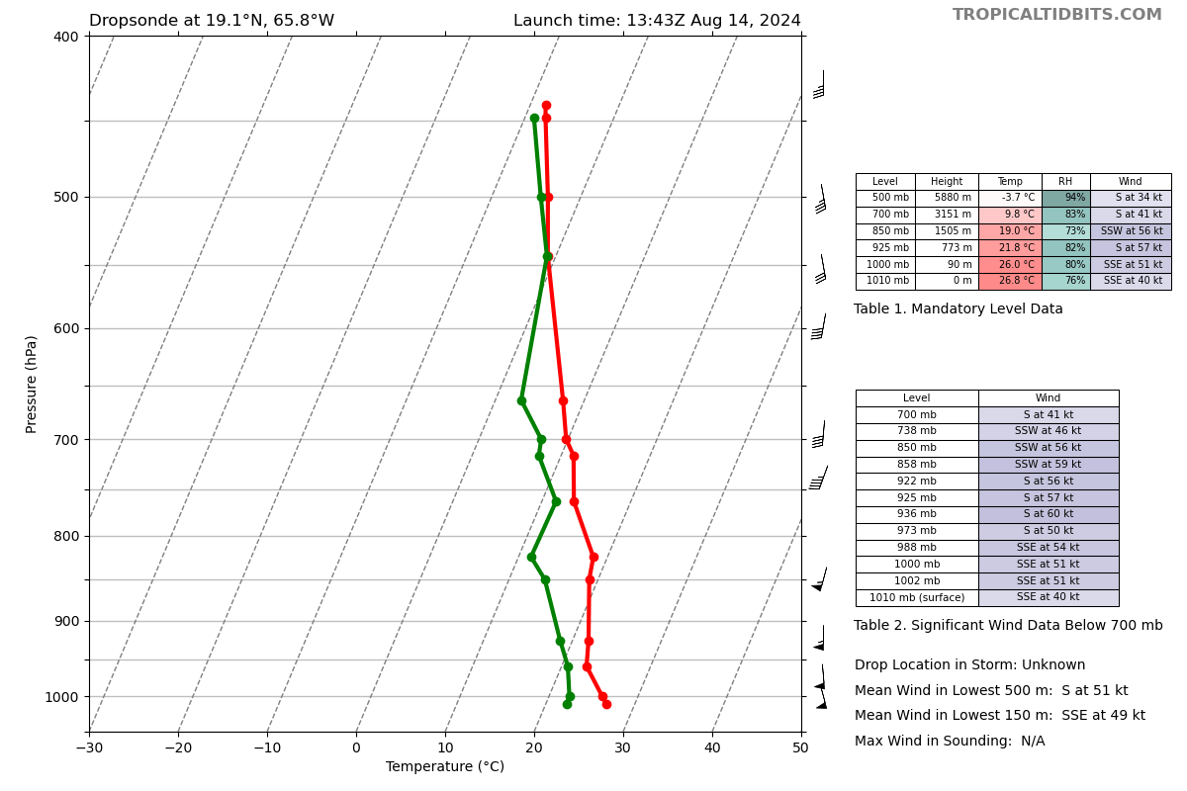  Spiral complete at 1354
1350 | 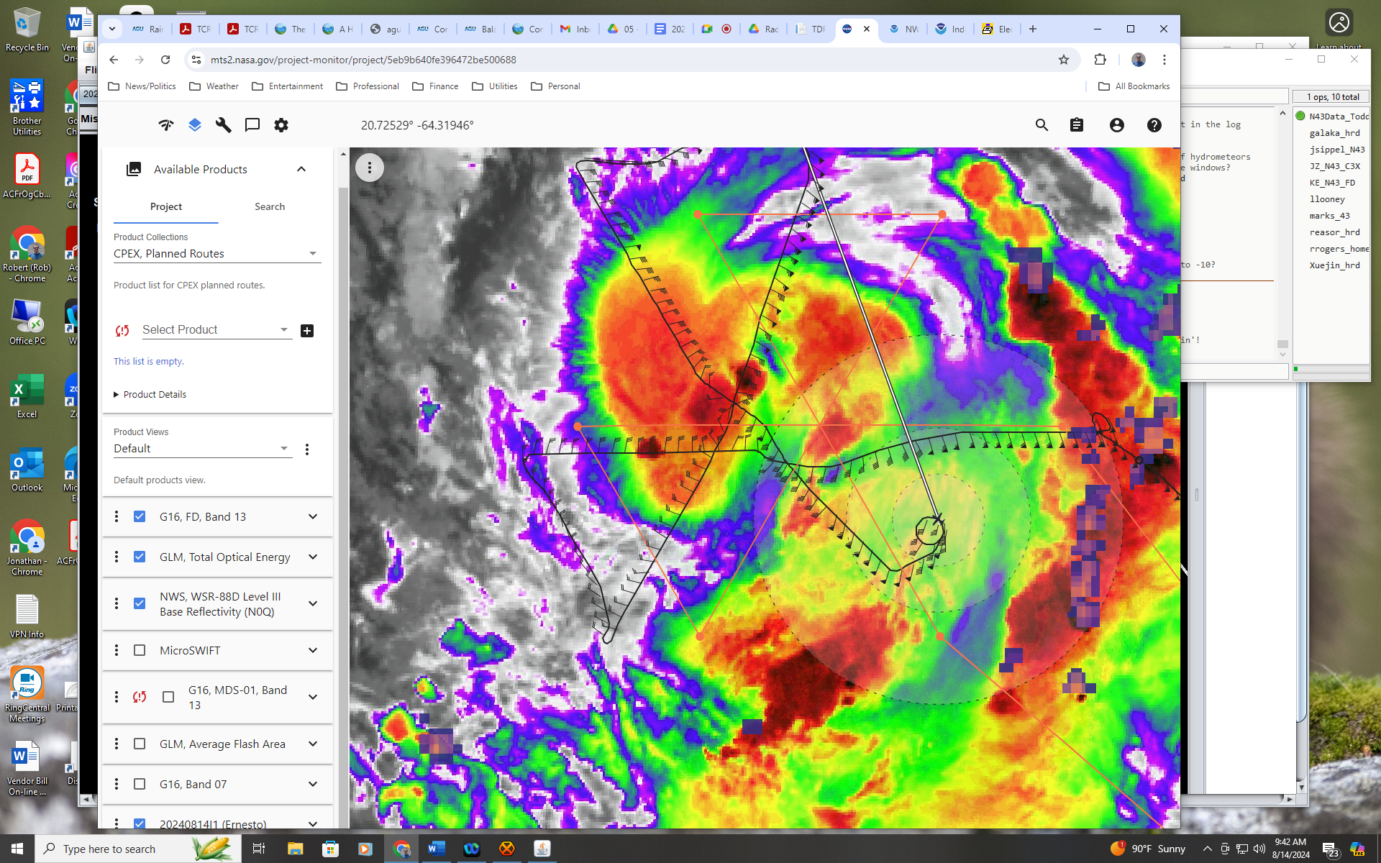  Location of spiral in SE quadrant
1354 | 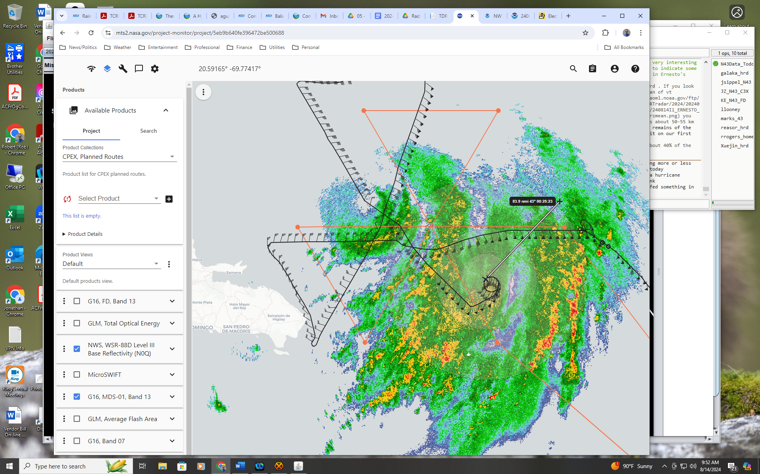  Location of spiral in 88D radar
1404 | Analysis from 3rd pass  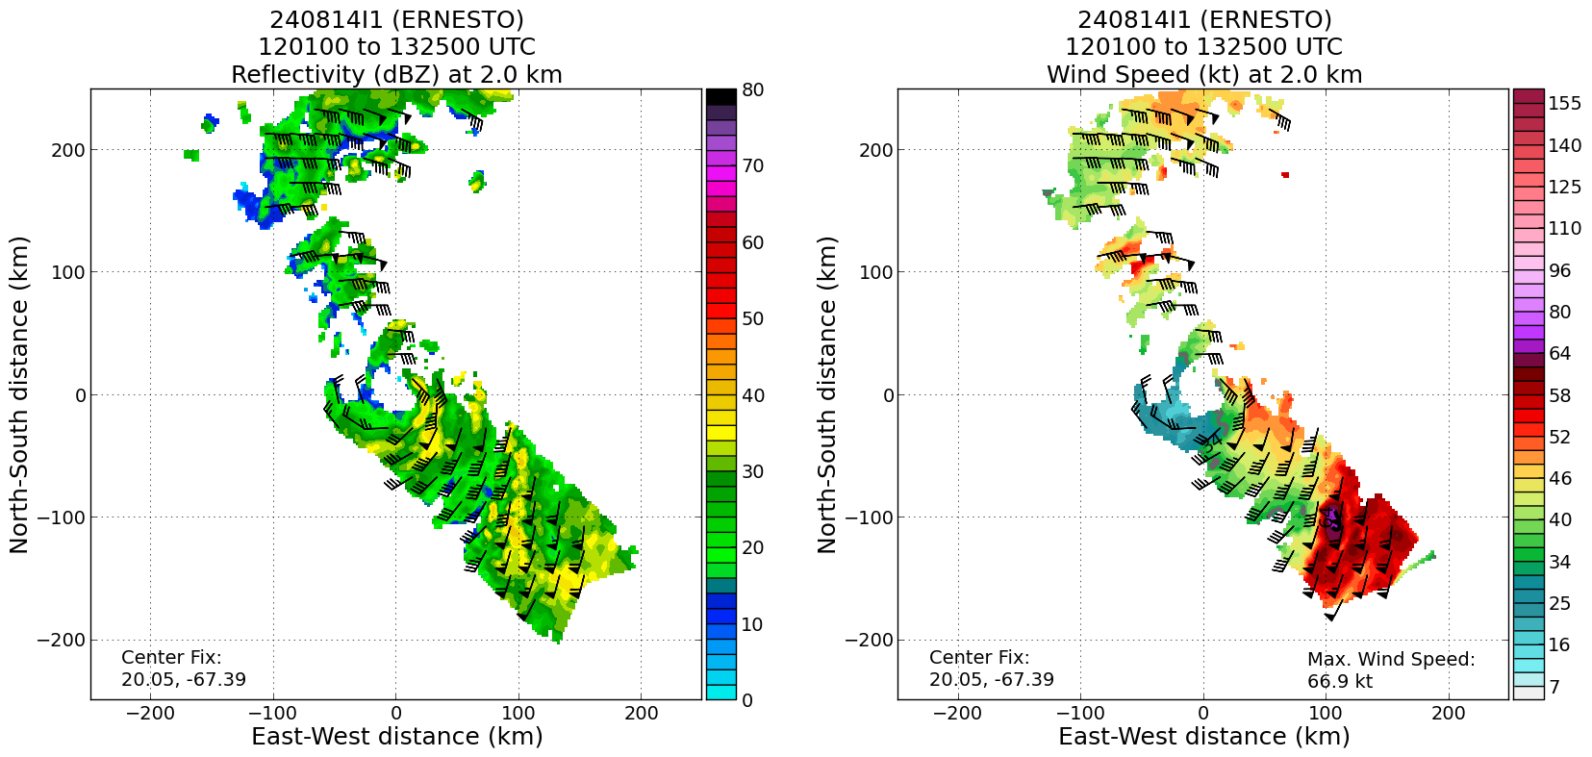  Strongest winds still in outer band (upwind, convective portion of band) in SE quad
1406 | 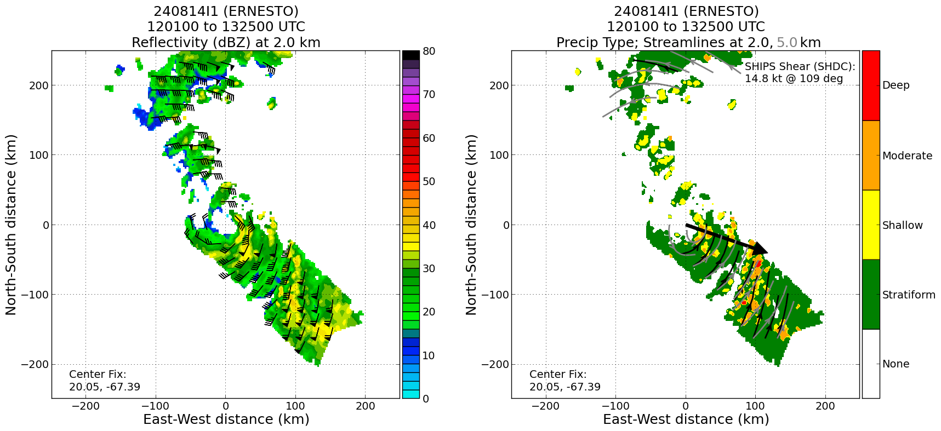  Much of precip in inner core is shallow convection now, all deeper stuff is in upwind portion of outer band. Does this just reflect diurnal cycle?
1407 | 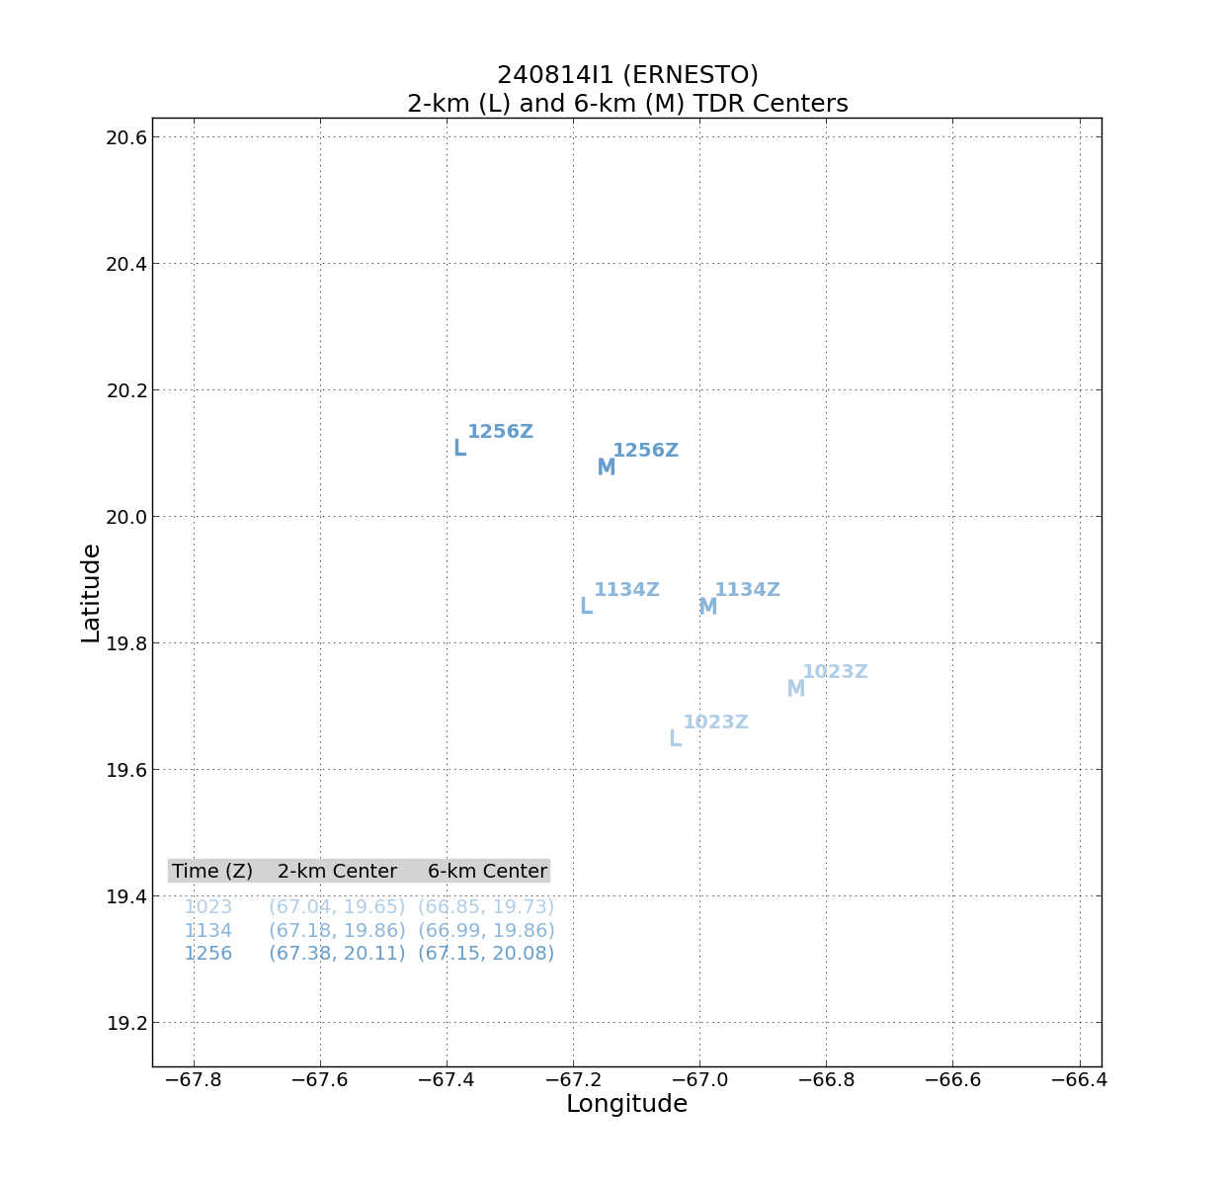  Continued anticyclonic progression of the MLC, now ESE, and a little larger tilt. May reflect influence of upper-level trough
1410 | 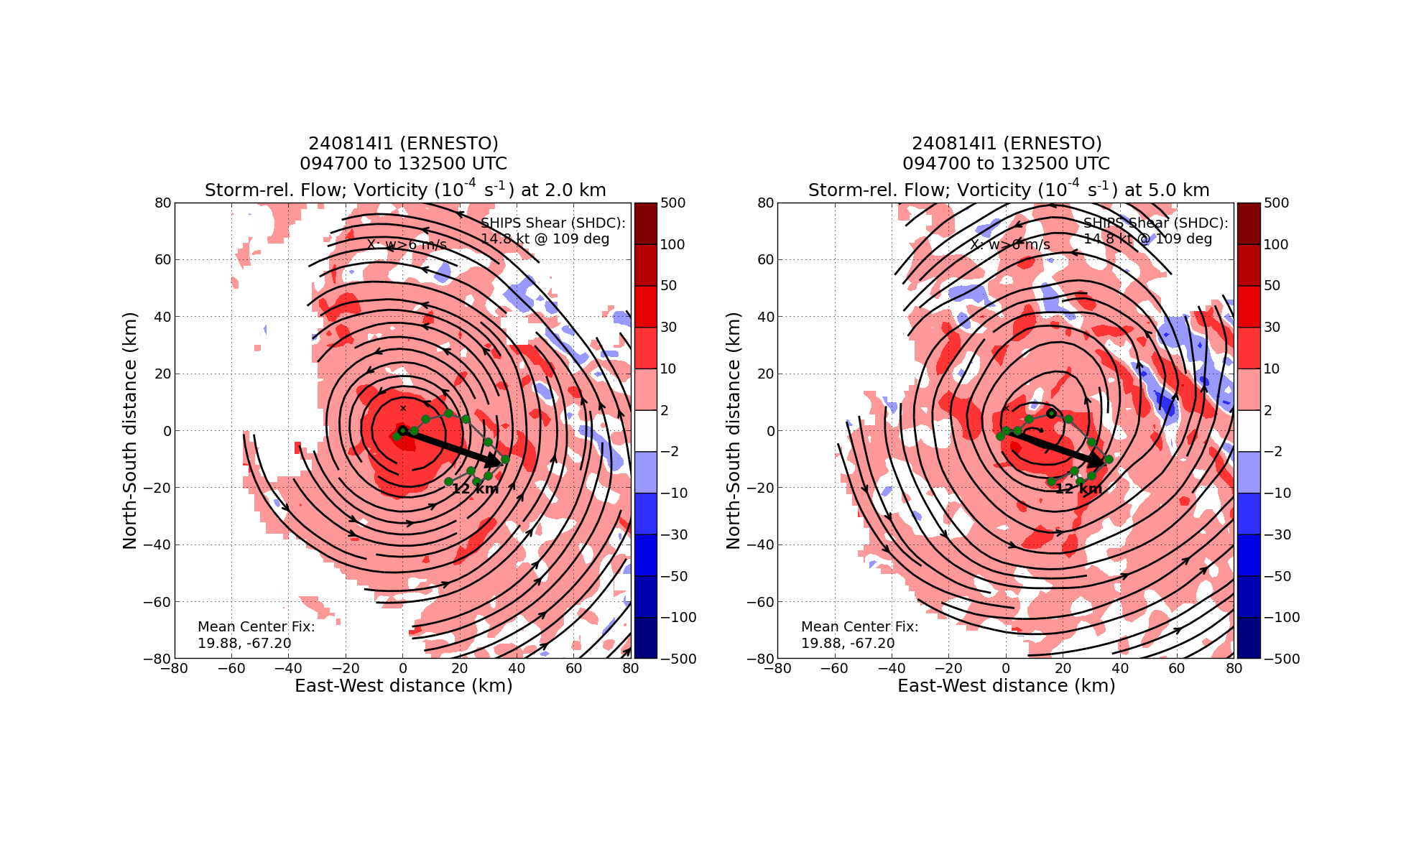  Tilt hodograph shows upper-levels of vortex now getting to the right of the shear vector
1414 | 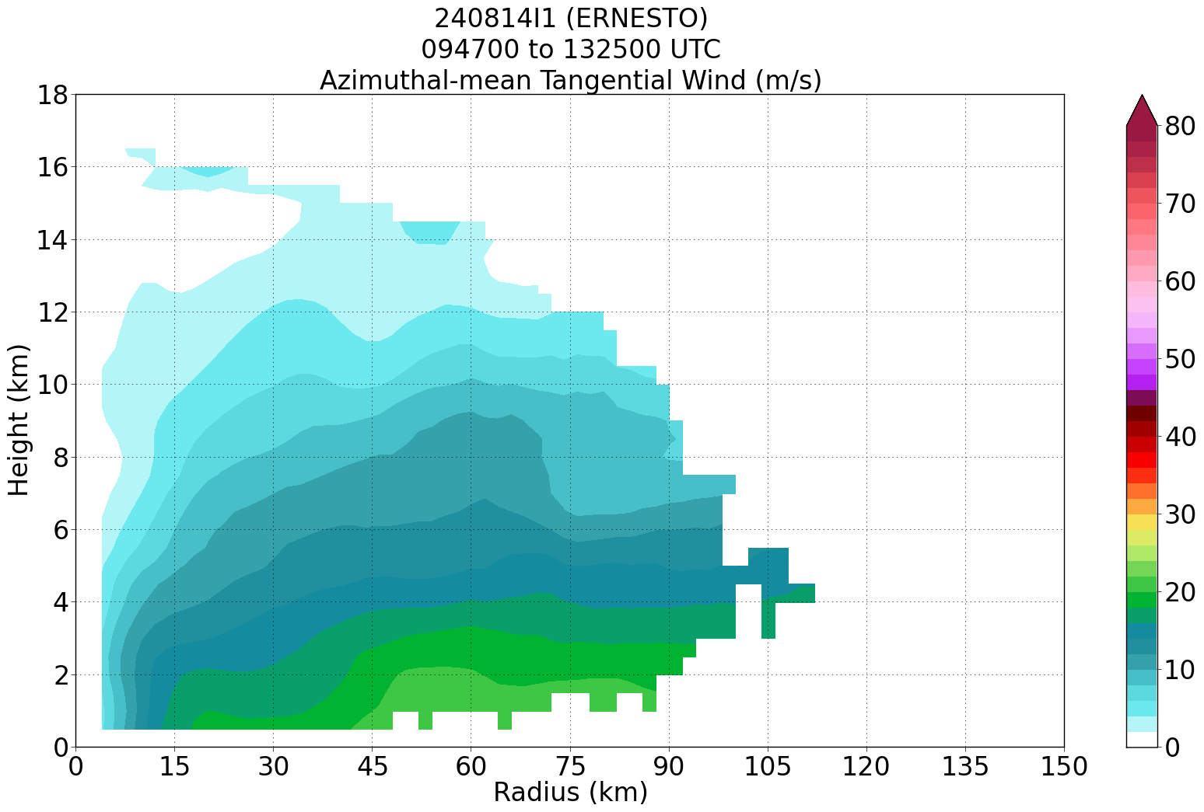  Azimuthally-averaged tangential wind shows a broad, shallow vortex with an RMW of about 65 km. Inner core hasn’t been significantly developed yet. There is still a very broad wind field meaning a lot of angular momentum. Sort of like with an ERC. Interesting to see how long it takes for the storm to intensify.  Seems like any tilt reduction that occurred (and MLC rotated to the ENE of the LLC) last night is being undone in diurnal min + consistent shear. The tilt is increasing again and the MLC is rotating back to the ESE of the center. It's not uncommon to get this oscillation of tilt magnitude and direction tied to the diurnal cycle. This was seen in Hermine too, where the tilt relaxed back to the ambient shear vector as the convection waned into the daylight hours  Discussion about how the storm evolution is likely tied to the diurnal cycle.
1418 | 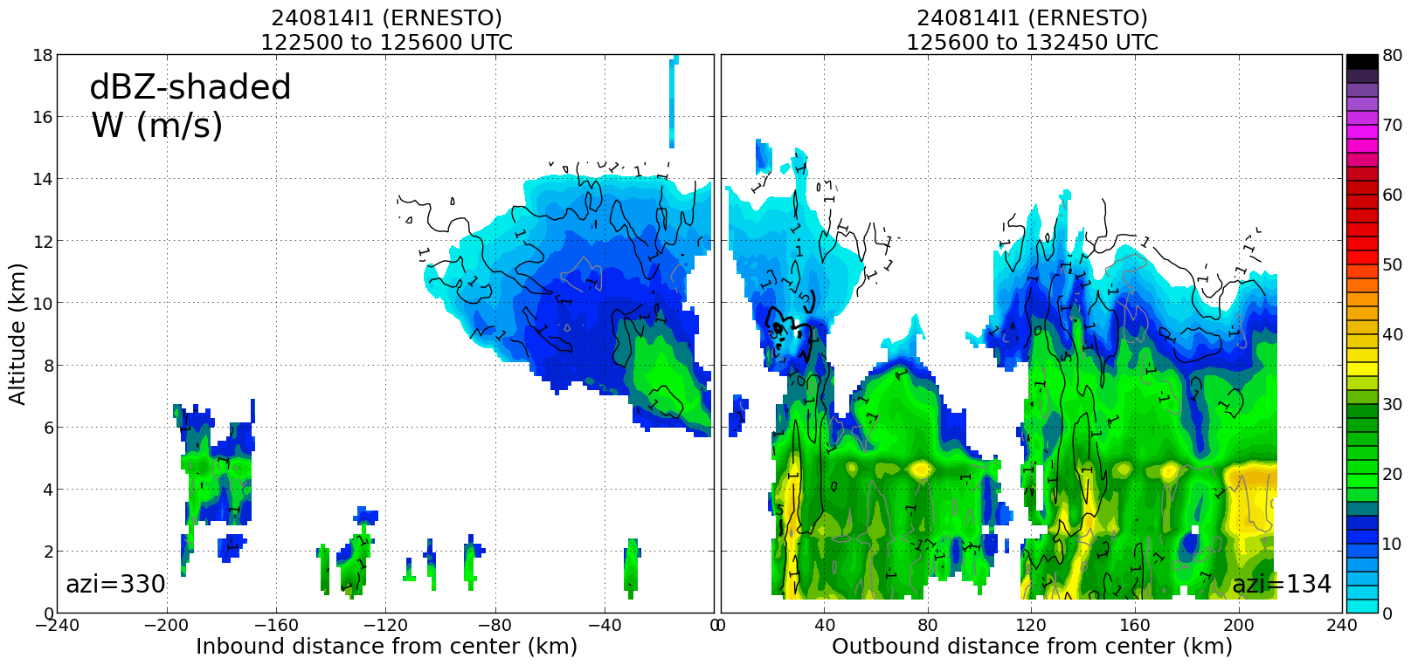  Profile of reflectivity shows mostly stratiform precip but several narrow cores of high reflectivity
1419 | 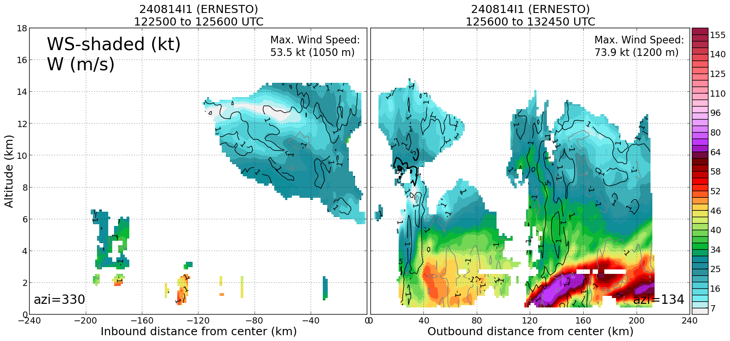  Localized wind speed maxima are tied to the reflectivity cores
1420 | 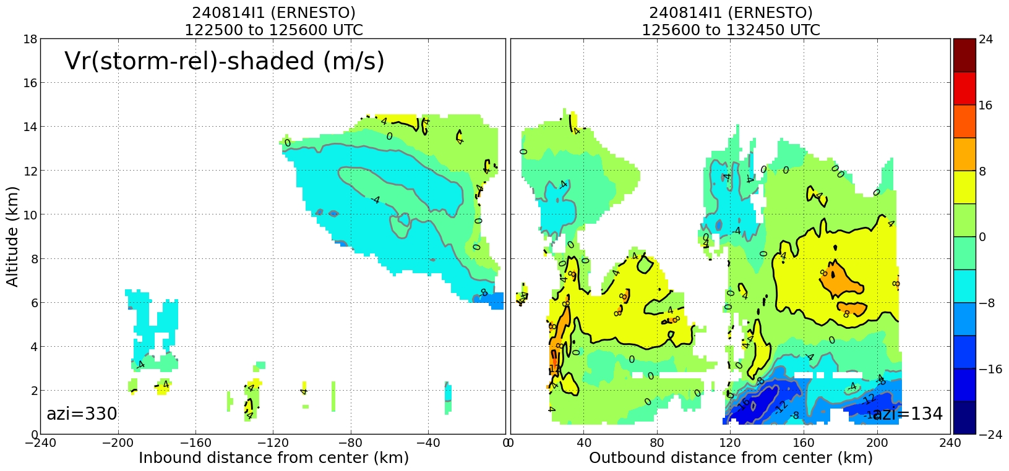  As are inflow maxima (at least in outer bands outside 100 km radius)
1423 | Evolution of a nearby TUTT will be critical to how favorable the dynamic (deep shear) environment will be for Ernesto over the next 1-2 days. The models show this feature weakening before Ernesto interacts with a midlatitude trough. Ernesto could begin more steady-to-rapid intensification after/if the shear associated with this TUTT begins to abate.  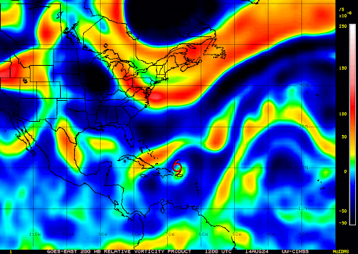
1442
1442
 | << INSERT ADDITIONAL ROW AS NEEDED >>

POST-FLIGHT
Mission Summary | This mission was operationally tasked by NHC/EMC to collect data in Tropical Storm Ernesto (05L). The mission succeeded in meeting the goals of 1) flying an operationally-tasked TDR butterfly pattern and 2) conducting research on stratiform precipitation and hydrometeors via the Stratiform Spiral Module. Also, this mission included testing of onboard TDR automation to identify bugs and enhancements that are to be reported to the TDR software developers.  During this mission, Ernesto slowly became better organized, supported by falling central pressure. However, the storm did not intensify as quickly as some of the guidance suggested, likely due to persistent moderate shear imposed by a nearby tropical upper-tropospheric trough and entrainment of drier air into its developing inner core. Ernesto’s vortex evolution was a bit surprising, as the vortex maintained a vertical tilt of at least 20 km to the east with height throughout the mission. As expected, the storm structure was quite asymmetric, with strongest winds and several rainbands in the eastern semicircle, compared to weaker winds and mostly anvil echos in the western semicircle.  The Stratiform Spiral Module was conducted in an ideal location in the SE quadrant of the storm after the completion of the operational pattern. The aircraft ascended to over 23 kft (-12C), sampling frozen hydrometeors with the microphysics instrument.
Actual Standard Pattern Flown | Butterfly
APHEX Experiments / Modules Flown | SSM  2024HFP_EarlyStage_Science_SSM.pdf  2024HFP_EarlyStage_Flight_Patterns_SSM.pdf
Plain Language Summary | HRD supported a NOAA NHC/EMC P-3 Tail Doppler Radar (TDR) mission into Tropical Storm Ernesto. Upon completion of the operational pattern, HRD/APHEX conducted research via the Stratiform Spiral Module to sample liquid and frozen hydrometeors in the broad stratiform region in the storm’s SE quadrant. During this mission, Ernesto slowly became better organized, although intensification was not as rapid as some guidance predicted.
Instrument Notes | Significant testing of onboard TDR automation during this mission. Paul R. guided Frank M. (onboard) and Rob. R (ground) to test creating and sending the TDR jobfile from the P-3.
Final Mission Track | 