MISSION PLAN
FLIGHT ID | 20240813H1 | STORM | TS Ernesto
MISSION ID | 0805A | TAIL NUMBER | NOAA-42
TASKING | NHC/EMC TDR | PLANNED PATTERN | Rotated Fig-4
MISSION SUMMARY
TAKEOFF [UTC] | 1953 | LANDING [UTC] | 0306
TAKEOFF LOCATION | Barbados | LANDING LOCATION | Barbados
FLIGHT TIME | Fractional hr, Takeoff to Landing Time | BLOCK TIME | Get from onboard LPS or Flight Director
TOTAL REAL-TIME RADAR ANALYSES  (Transmitted) | 4 (4) | TOTAL DROPSONDES Deployed (Tx to GTS) | 17 (17)
OCEAN EXPENDABLES deployed (good) | 5 (0) | sUAS (Type) | None
APHEX EXPERIMENTS / MODULES | CHAOS, SARWIND
HRD CREW MANIFEST
LPS ONBOARD | Aberson | LPS GROUND | Holbach
TDR ONBOARD | None | TDR GROUND | Alvey
ASPEN ONBOARD | None | ASPEN GROUND | Kaplan
NESDIS SCIENTISTS | Chang, Jelenak
GUESTS (Affiliation) | None
AOC CREW MANIFEST
PILOTS
NAVIGATOR
FLIGHT ENGINEERS
FLIGHT DIRECTOR
DATA TECHNICIAN
AVAPS

PRE-FLIGHT
Flight Plan | 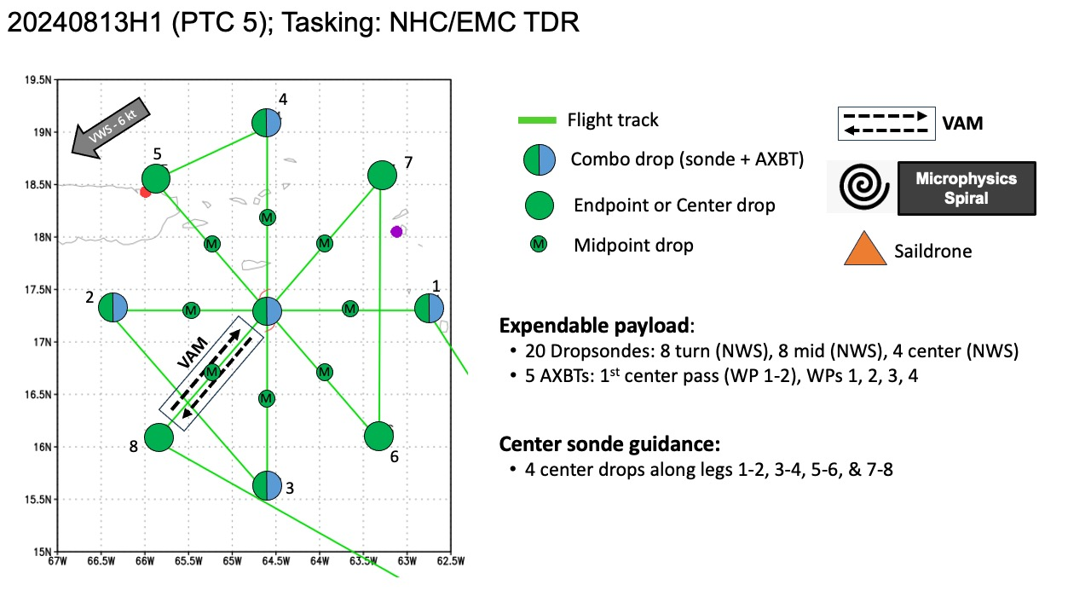  Plan is to fly a rotated figure-4 with the possibility of a VAM module. There is also a saildrone located at 19.12 N, 65.44 W that will be targeted for an overflight if possible.
Expendable Distribution | 20 dropsondes: 8 turn, 8 mid, 4 center  5 AXBTs: 1st center pass, WP 1, 2, 3,4
Preflight Weather Briefing | TS Ernesto is much better organized today with increased convection near the center. There is some indication that dry air is getting into the circulation along with some westerly shear impeding intensification. Max winds are set at 50 kt for the 5pm advisory with a central pressure of 1001 mb. Storm motion is currently estimated at west-northwestward, 300/16 kt. It is expected that Ernesto will continue turning towards the north over the next few days as it moves toward a break in the western Atlantic subtropical ridge. Ernesto is expected to pass over the Virgin Islands this evening then pass northeast and north of Puerto Rico. Intensification is anticipated as Ernesto moves over very warm SSTs and into generally low shear over the next few days.
Instrument Notes | SFMR on previous flight was showing high bias

IN-FLIGHT
Time [UTC] | Event
1953 | Take-off from Barbados
2023 | SD-1091 currently located at 19.12 N, 65.44 W
2032 | NDBC 41056 (caricoos mooring) with wind, wave, and met/ocean (salt too) sensors is nearby planned path
2032 | CARCAH center at 18.0N 64.1W, motion 300/16kts, sfc 50kts, press 1001mb….for 5 pm center
2057 | IP leg 1, combo drop 1, good sonde, bad BT
2104 | Rocks below jutting out of the water, may influence IWRAP
2106 | Banding and partial eyewall on the east side
2109 | Inbound leg 1, drop 2, midpoint, good sonde
2121 | Center leg 1, combo drop 3, ch 3, good sonde, bad BT
2131 | Onboard LPS Aberson noted that two of the BTs started reporting temperature as soon as they left the plane
2134 | Outbound leg 1, drop 4, ch 4, good sonde
2147 | EP leg 1, combo drop 5, ch 5, good sonde. BT bad. Combo drop moved offshore to deeper water to avoid land.
2205 | 1st TDR analysis is giving a 2-6 km Vortex Tilt of 32.8 km at 128 deg. Onboard LPS Aberson notes that the 3-km center is almost 10 km from the VDM center.
2211 | IP leg 2, combo drop 6, ch 6, good sonde, bad BT
2220 | Inbound leg 2, drop 7, ch 7, midpoint, good sonde
2225 | 1st TDR analysis shows a SE tilt with height. Onboard LPS Aberson said that the midlevel center was in stratiform and the lower-level centers were in the clear and that the structure looked similar on this pass.  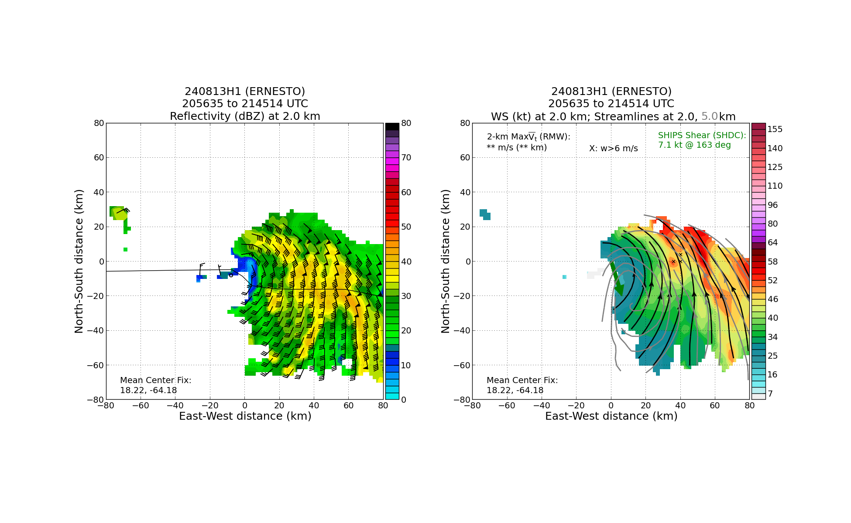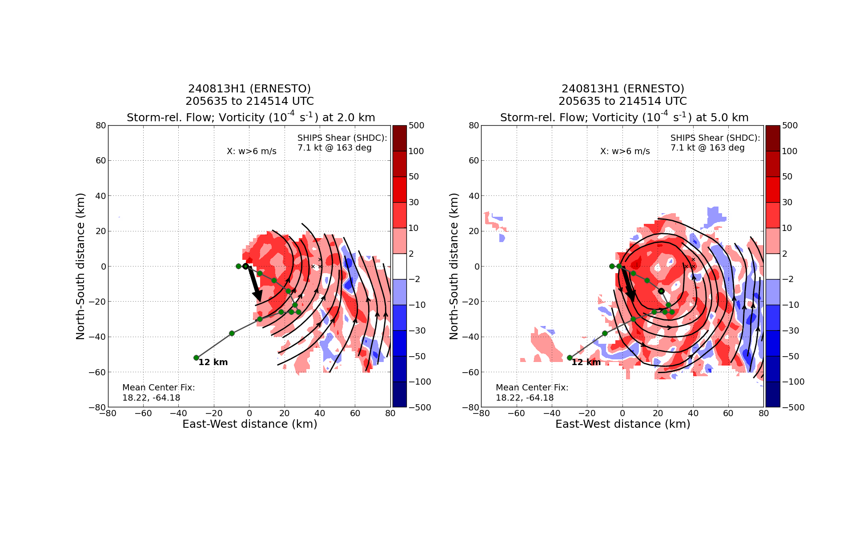
2233 | No center sonde due to proximity to land
2239 | Comparison of SFMR, IWRAP, and FL winds shows that the SFMR is once again too high. One interesting observation from this comparison is that the SFMR bias seemed to change after going through rain.  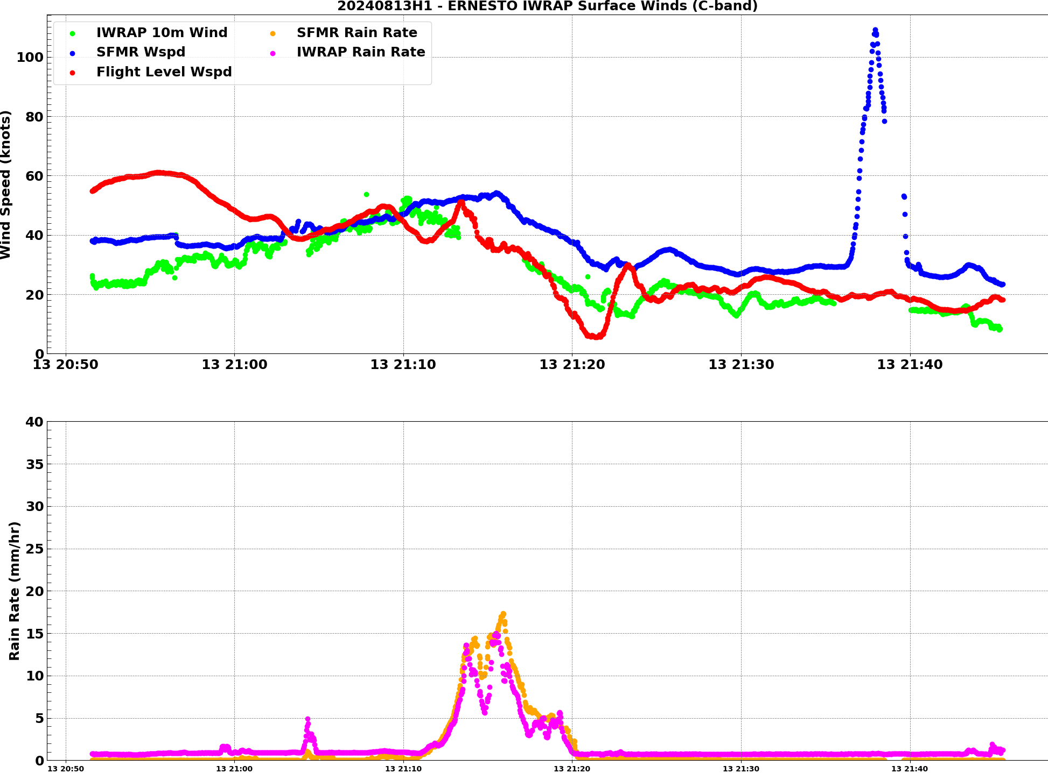  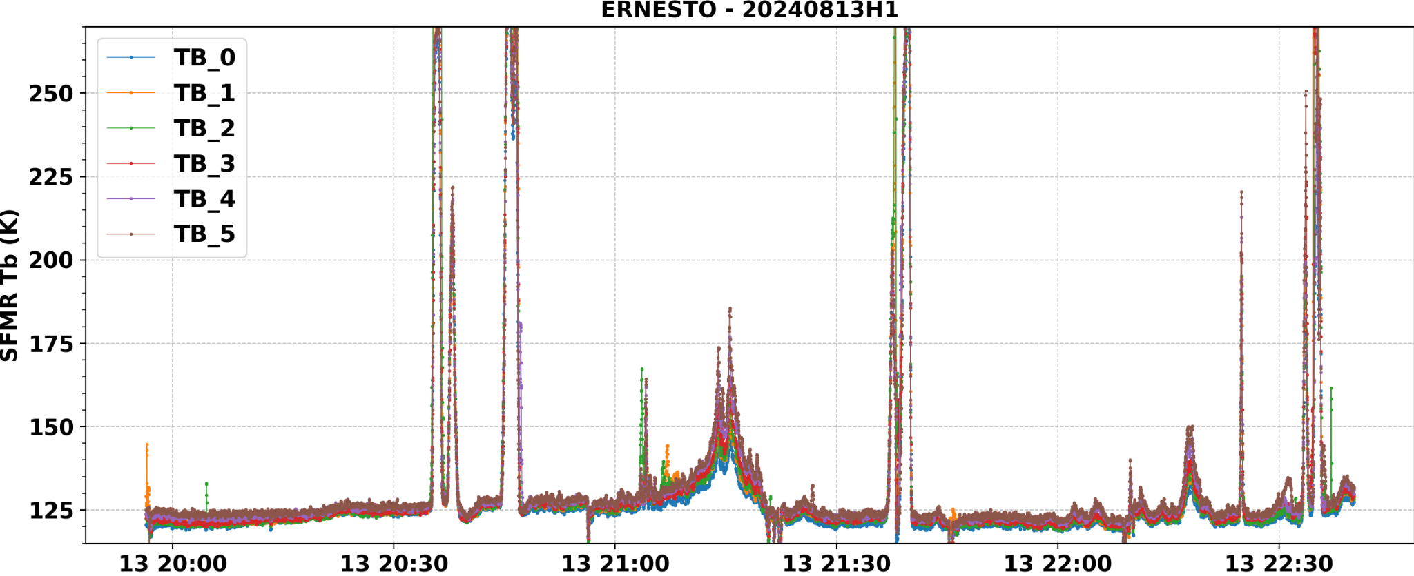
2245 | Outbound leg 2, drop 8, ch 8, midpoint, good sonde
2250 | Convection on east side of San Juan 88D seems to be intensifying
2253 | EP leg 2, combo drop 9, ch 1, good sonde, bad BT
2312 | IP leg 3, drop 10, ch 2, good sonde
2314 | 2nd TDR analysis giving a 2-6 km Vortex Tilt of 31.1 km at 105 deg. Tilt is moving closer to upshear from SE to ESE with all of it above flight level.
2318 | Flyover of SD (within 1 n mi)  2317 SD measurements were 19.6 kts sustained, 22.1 kts gust (3.4 m height). Sig wave 2.9 m, SST of 29.6C, pressure 1008.0 hPa, Air Temp 28.8C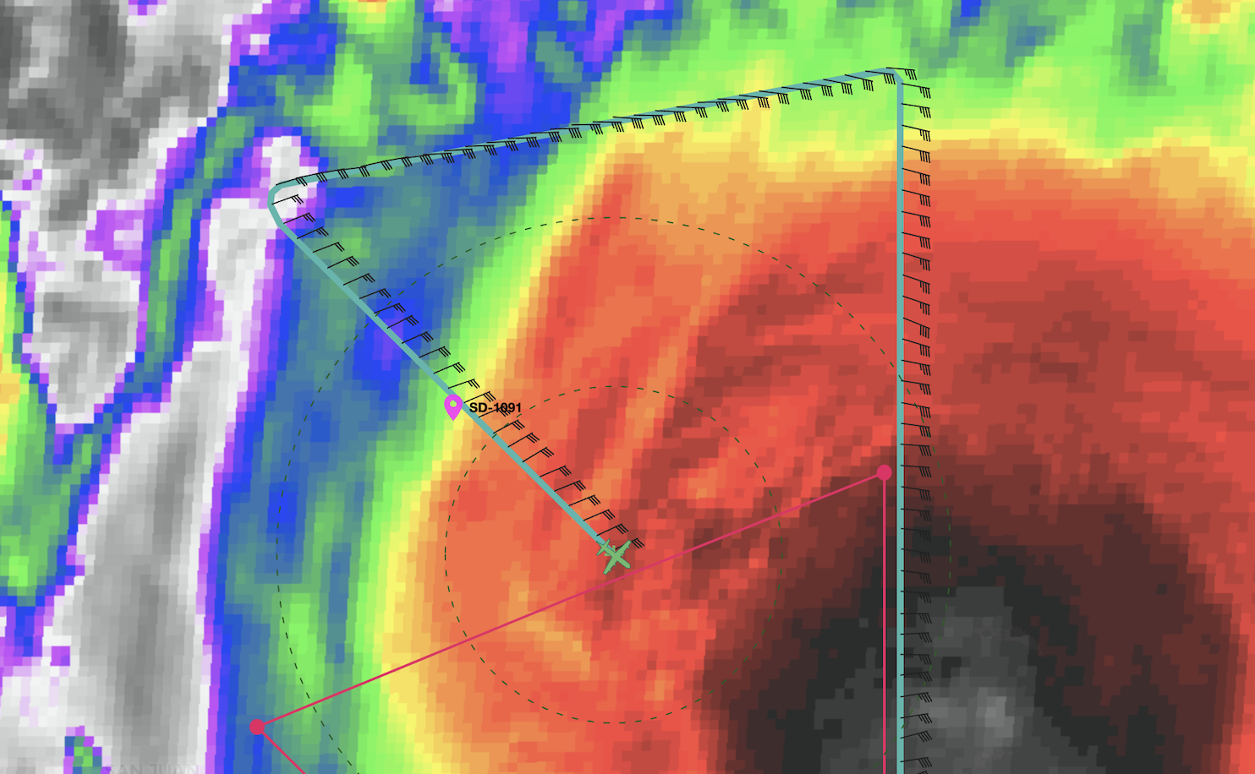  KAIA showing 3m sig wave height  SFMR reporting 17 m/s during SD flyover. Constantly high biased
2323 | Inbound leg 3, drop 11, ch 3, mid point, good sonde
2324 | Discussion about an issue with ob numbering. Appears that a CCA to the vdm that was ob 5 may have thrown off the ob numbering in tag. CARCAH noted that they have not received an ob 7, which should have been drop 6.
2330 | Radar notes pretty close to E tilt on last analysis. Storm may be in the process of aligning.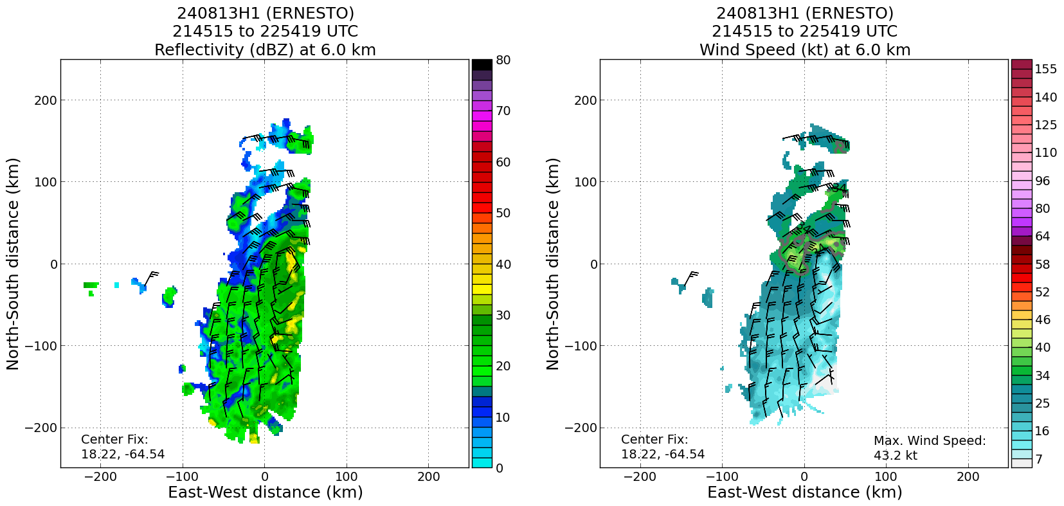
2331 | Onboard LPS Aberson is wondering if the center is in a ring of reflectivity. Could be headed toward alignment.
2335 | Headed to the S to avoid intense convection, working on getting back to that radial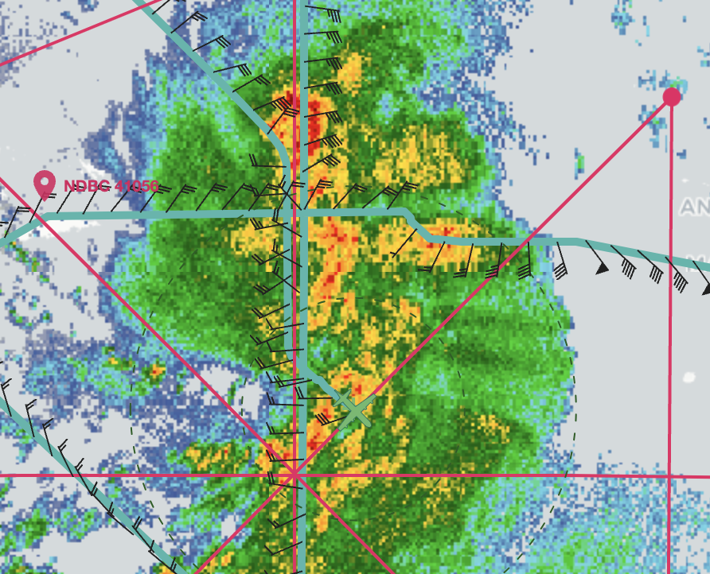
2353 | Outbound leg 3, drop 12, ch 4, mid point, good sonde
0000 | NHC has center at 18.4N, 64.7W, intensity of 55 knots
0004 | EP leg 3, drop 13, ch 5, good sonde
0013 | Downwind leg is between rain bands  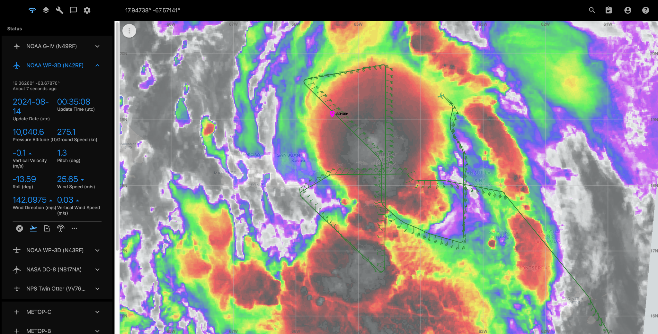
0015 | Very impressive convective burst on radar rotating upshear.
0028 | Further discussion of the TAG ob numbering issue in #carcah:  [20:28] QK-N42-FD CARCAH2_Warren, was it the time we were doing the CCA for the VDM?  [20:28] QK-N42-FD around the same time?  [20:29] CARCAH2_Warren QK-N42-FD, looks like you sent out the originl vdm a bit after 22z, and we were working through the cca till about 2225z when the cca went out  [20:30] QK-N42-FD which is after ob 6, but before the intended ob 7?  [20:30] * pppapin_nhc has quit (Quit: Client has disconnected.)  [20:33] CARCAH2_Warren well, ob 6 has a GTS timestamp of 2203, and ob 8 of 2222z, so the mysterious ob 7 was skipped sometime after the original vdm ob 5 was GTS timestamped out at 2203z and the cca was GTS timestamped at 2225z  [20:33] QK-N42-FD mysterious  [20:34] CARCAH2_Warren QK-N42-FD, the only thing I see as suspicious is that both the original VDM and drop ob 6 have GTS timestamps of 2203z. so _maybe_ TAG got confused and somehow skipped  [20:35] QK-N42-FD i think so
0030 | 3rd TDR analysis gives a 2-6 km vortex tilt of 36.9 km at 103 deg  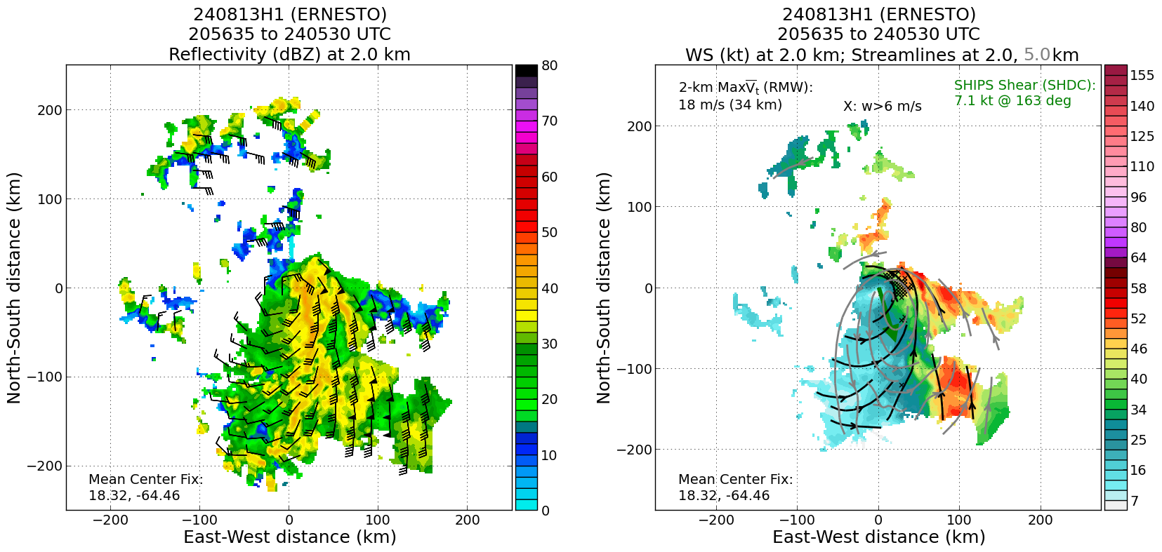
0036 | IP leg 4, drop 14, ch 6, good sonde
0042 | Inbound leg 4, drop 15, ch 7, midpoint, good sonde
0057 | Onboard LPS Aberson said they missed the center again
0105 | Onboard LPS Aberson notes that there are interesting structural changes occurring. There are multiple flight-level centers present on this pass. The radar representation is definitely improving with the center in convection, but there are other centers and it is not spinning up yet.  Ground radar Alvey suggested that the convective burst may be perturbing the flow within a broader cyclonic envelope.
0108 | Outbound leg 4, drop 16, ch 8, midpoint, good sonde
0120 | EP leg 4, drop 17, ch 1, good sonde. SCIENCE COMPLETE
0136 | Final flight track from tropicaltidbits.com  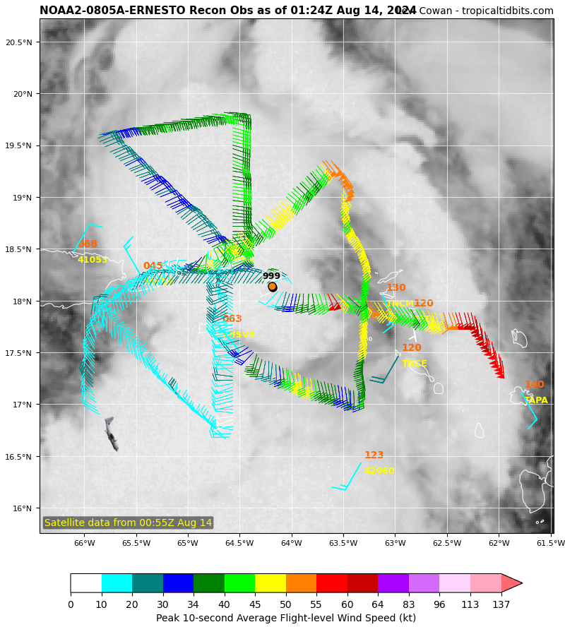
0137 | San Juan 88D radar is showing what looks to be an eyewall forming
0139 | Onboard LPS Aberson said they are seeing deep reds on the MMR, which he hasn’t seen before, especially with the low bias.
0159 | Flight director looked through WMM app and found an ob 7 as a VDM, so TAG must have thought the VDM CCA was ob 7 and skipped it.
0223 | Final TDR analysis  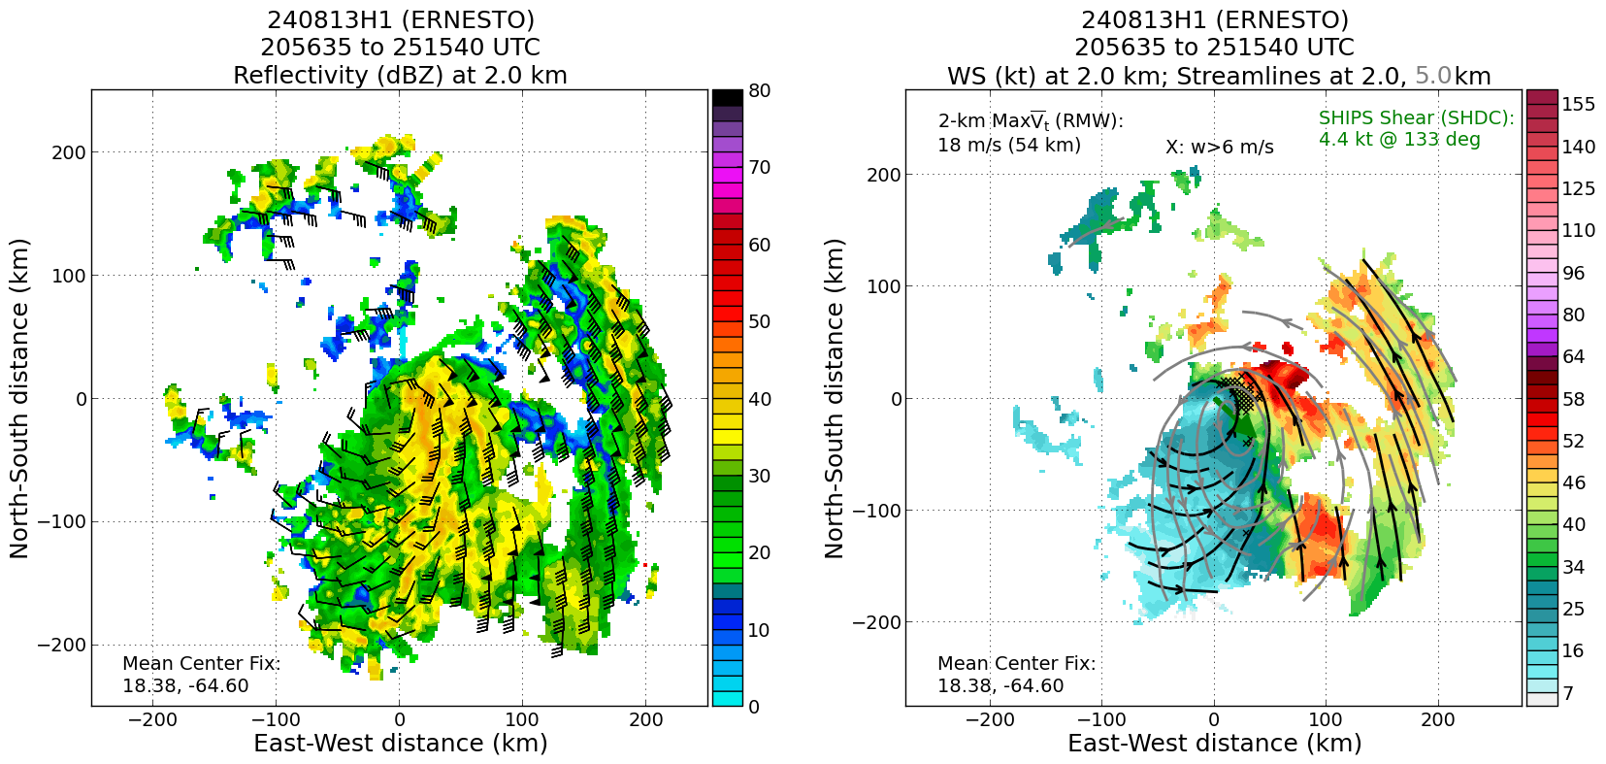  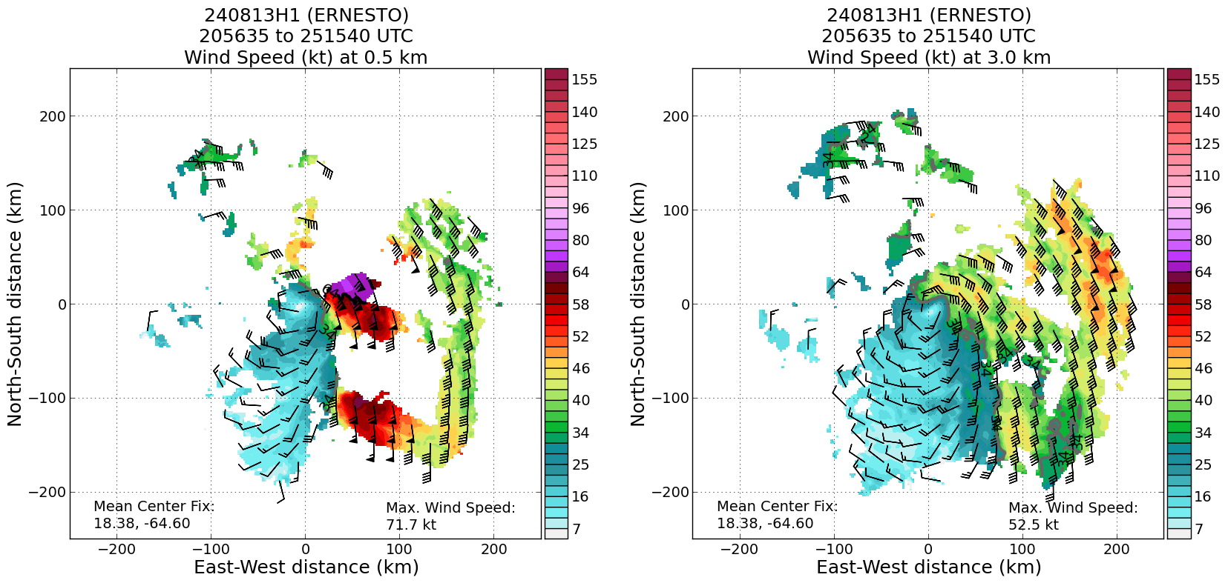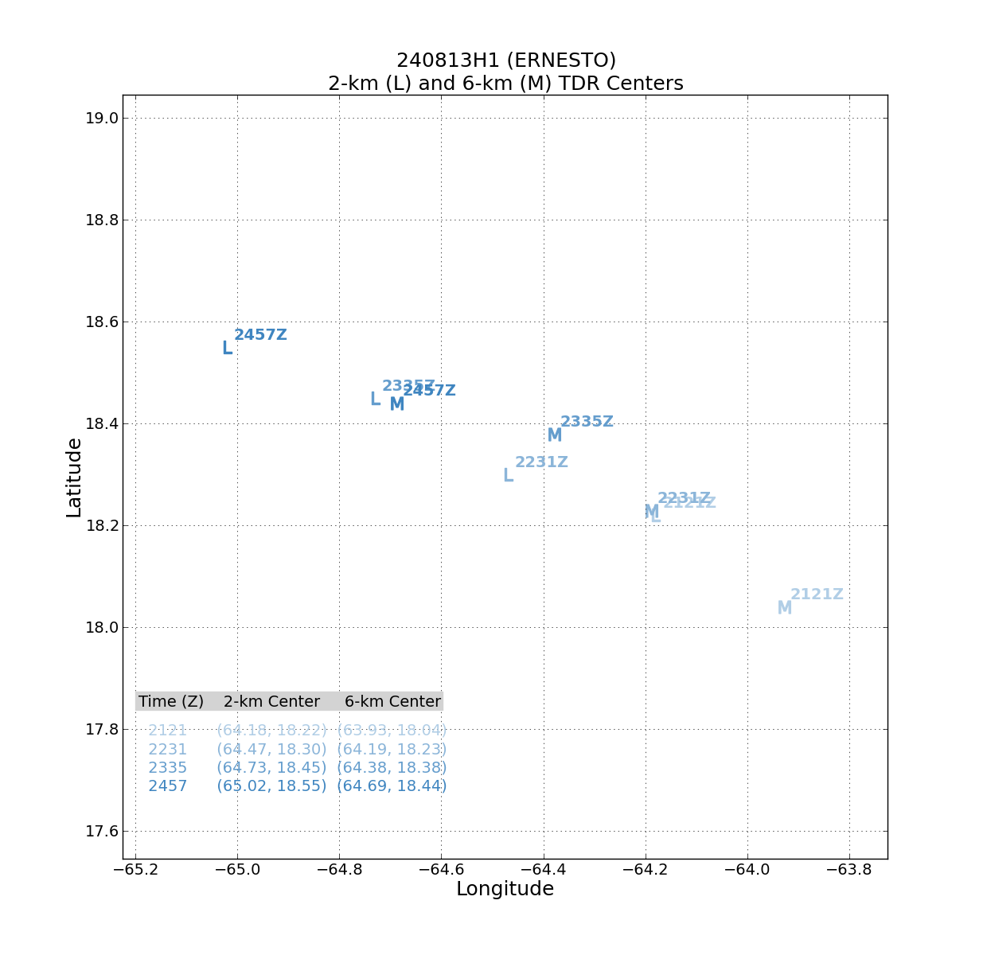  Tilt was slowly shifting from SE to E throughout flight.

POST-FLIGHT
Mission Summary | Successful NHC/EMC TDR mission that collected and transmitted 4 TDR analyses in TS Ernesto. It appeared that Ernesto was attempting to become better aligned as several convective bursts near the circulation center occurred throughout the flight. The majority of the precipitation was located on the E and S sides of the storm likely due to the impacts of some moderate shear and dry air in the nearby environment.  The planned rotated figure-4 was completed mostly as planned with slight deviations near the center of the storm due to convective activity in the core. SD-1091 was overflown, passing within about 1 n mi of it. There was also a SAR overpass during the flight that provided coincident data collection with the airborne instruments. Unfortunately, there was not time for a dedicated VAM module, however the convective burst near the center of circulation was sampled several times throughout the flight.  Data was collected in range of San Juan WSR-88D that may be useful for comparison with the TDR and MMR.  17 dropsondes charged to NWS. All 5 AXBTs released were bad.
Actual Standard Pattern Flown | Rotated Figure-4
APHEX Experiments / Modules Flown | CHAOS, SARWIND
Plain Language Summary | - Successful NHC/EMC tasked TDR mission into TS Ernesto observed a storm that was trying to become better aligned and possibly on the precipice of intensification.  - Coincident aircraft observations were collect over Saildrone 1091 on the NW side of the storm.
Instrument Notes | SFMR was once again retrieving winds that were too high. Issue with TAG when a CCA was submitted for a VDM that threw off the ob numbering.
Final Mission Track | 