MISSION PLAN
FLIGHT ID | 20240804H1 | STORM | AL04 / TD4
MISSION ID | 0404A Debby | TAIL NUMBER | NOAA-42
TASKING | NHC/EMC TDR | PLANNED PATTERN | Rotated-Fig 4
MISSION SUMMARY
TAKEOFF [UTC] | 0859 | LANDING [UTC] | 1534
TAKEOFF LOCATION | Lakeland | LANDING LOCATION | Lakeland
FLIGHT TIME | 06:35 | BLOCK TIME
TOTAL REAL-TIME RADAR ANALYSES  (Transmitted) | 4 | TOTAL DROPSONDES Deployed (Transmitted) | 21 (21)
OCEAN EXPENDABLES (Type) | 3 AOC AXBTs  (3 good) | sUAS (Type) | N/A
APHEX EXPERIMENTS / MODULES | Exact name of the Experiment in the HFP Plan; identify relevant experiments / module even if not a research tasking
HRD CREW MANIFEST
LPS ONBOARD | Aberson | LPS GROUND | Hazelton/Looney
TDR ONBOARD | N/A | TDR GROUND | Reasor
ASPEN ONBOARD | N/A | ASPEN GROUND | Dunion
NESDIS SCIENTISTS | Chang
GUESTS (Affiliation) | Sparks/ Trivedi
AOC CREW MANIFEST
PILOTS | Doremus/Mitchell/ Ellis/ Taraboletti
NAVIGATOR | Miller/ Meier
FLIGHT ENGINEERS | Tyson/ Wysinger/ Ripp
FLIGHT DIRECTOR | Zawislak/ Englert
DATA TECHNICIAN | McAlister
AVAPS | Kotz/Brannigan

PRE-FLIGHT
Flight Plan | 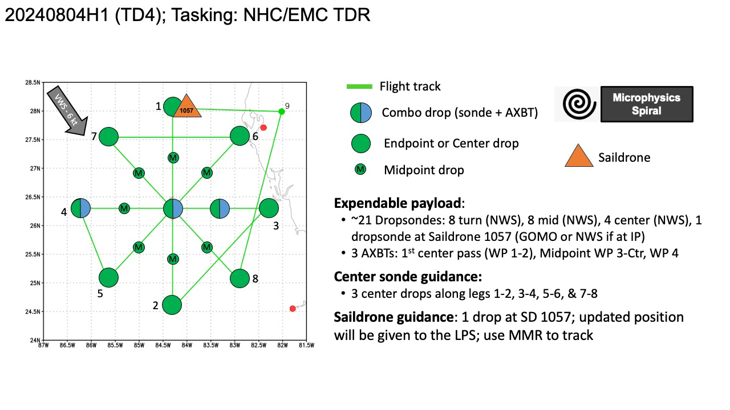  Rotated Figure-4
Expendable Distribution | 21 dropsondes, endpoints, midpoints, centers
Preflight Weather Briefing | 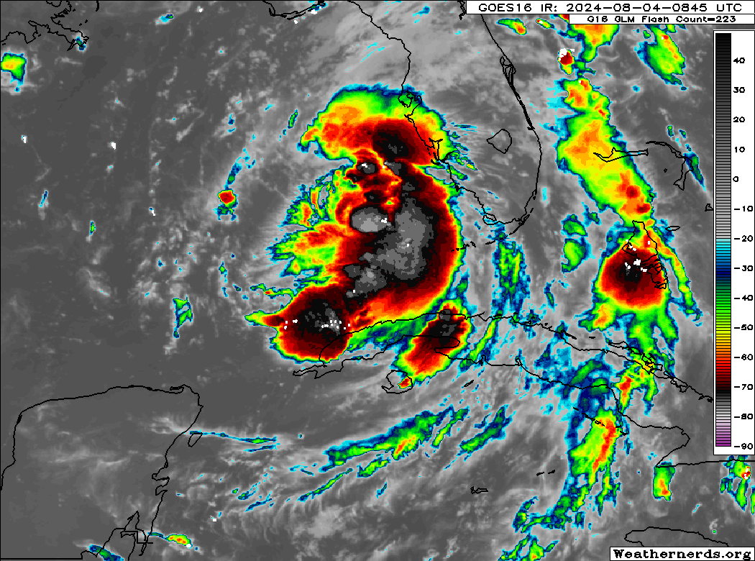  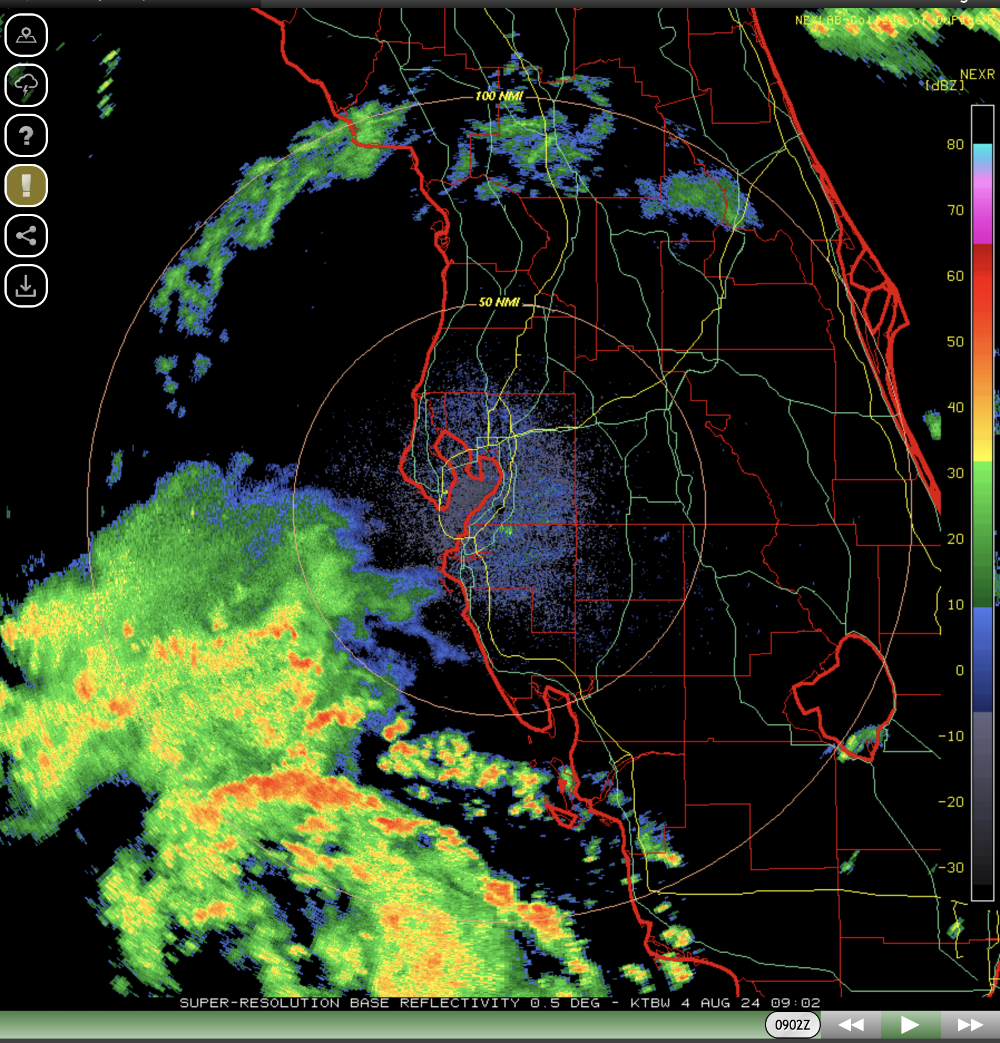  Debby is moving to the north west of Tampa. The storm is slowly intensifying, but not rapidly intensifying yet. The inner-core is starting to develop, but is not closed off yet.  Shear is fairly low today, although there is some dry air to the west of the storm, which may slow the symmetrization process.
Instrument Notes | Instruments seem to be functioning normally

IN-FLIGHT
Time [UTC] | Event
0859 | Take off from KLAL
0911 | 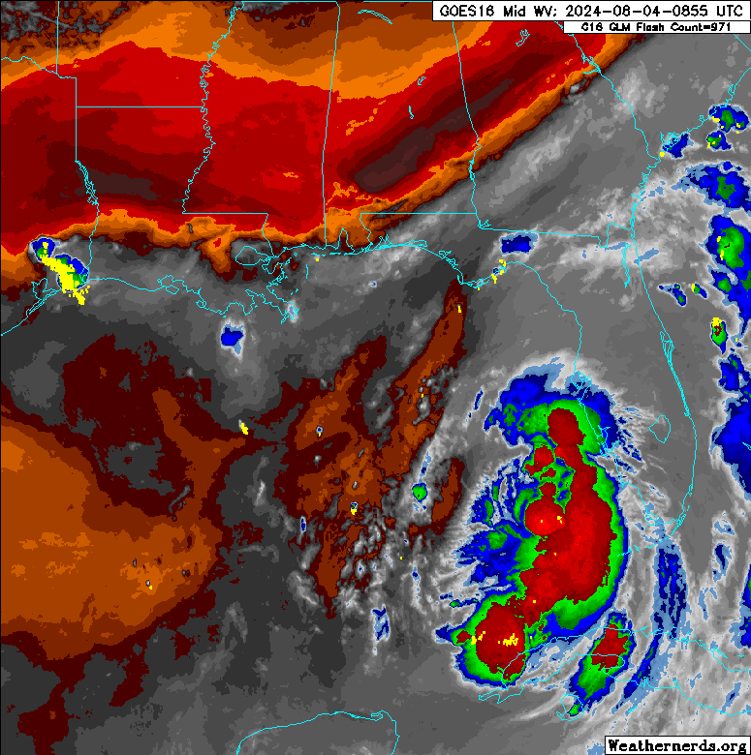  This shows the dry air west of the core
0917 | Going to target SD-1057 to the N before full pattern
0931 | Flyover of SD-1057: Winds of 22-24 knots, gusting 25-28, Pressure: 1010.1, Air temp: 29.2 C, SST 31.4 C, SSS: 36.7, SIG Wave: 1.8 m  SFMR was ~30 kts
0931 | Drop 1 over Saildrone  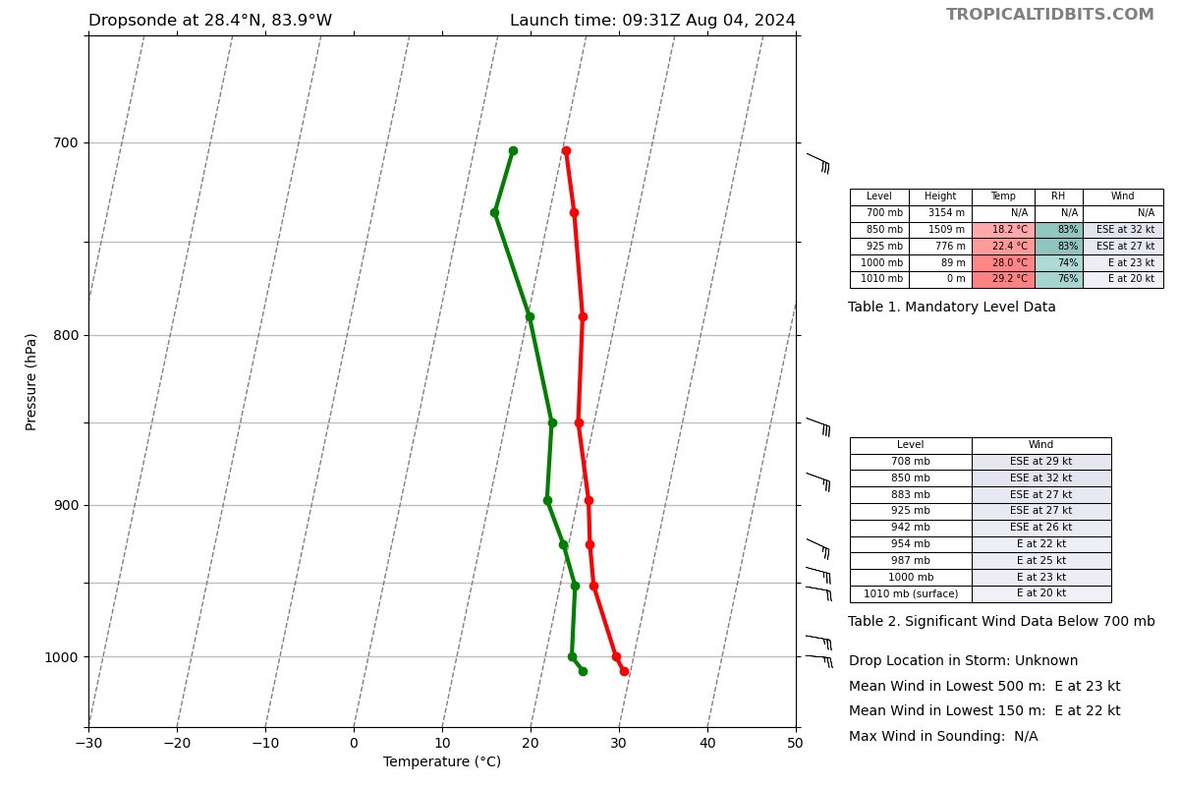  Nearly exact same as SD values  Air temp within 0.2 C , RH within 2%, pressure same, winds exact same
0943 | Looks like flight is going to pass between SD-1083 and NDBC 42099 (wave drifter)
0945 | Flew 17.5 km E of NDBC 42099 (wave buoy) and 32 km W of SD-1083
0947 | Reached IP at 10 k ft @ when entering region of echos
0947 | Drop 2 Endpoint N  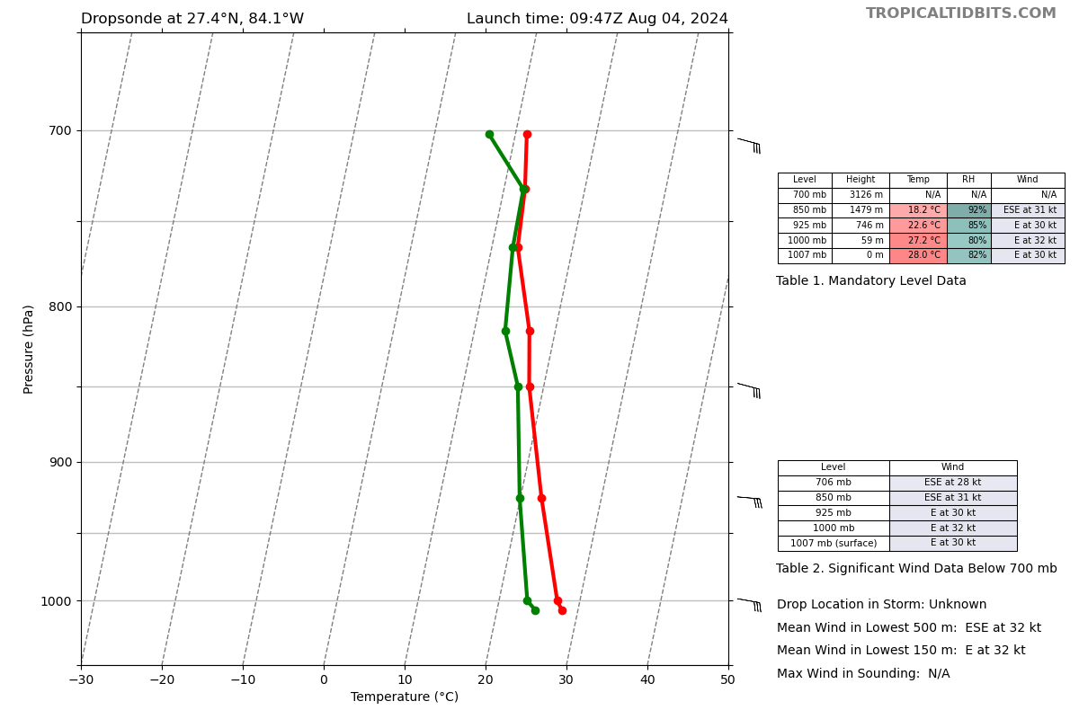
0959 | Drop 3 Midpoint N  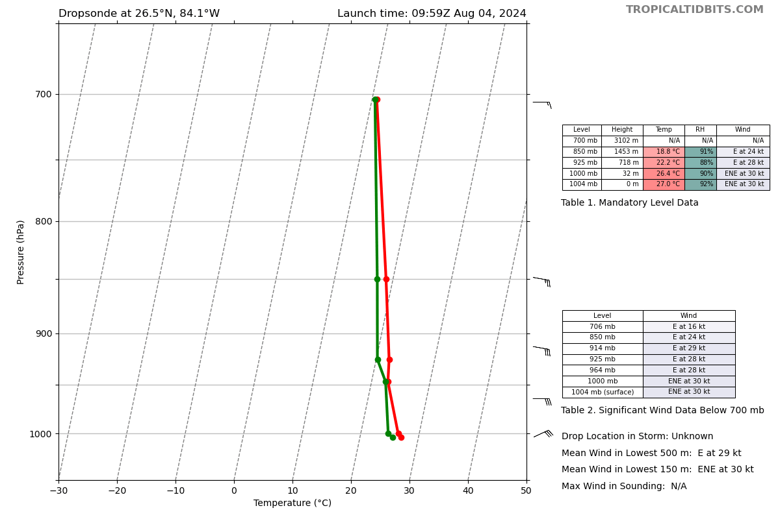
1003 | 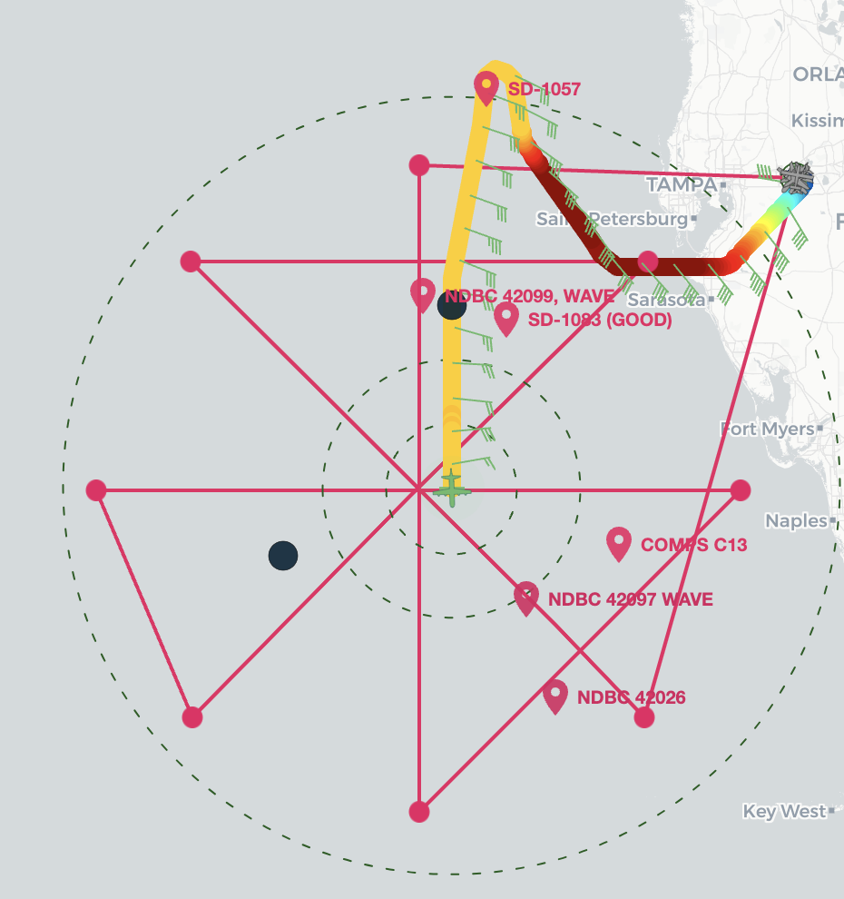  Handful of moorings nearby flight track
1007 | Drop 4 center with AXBT (SST 30.74)  Dropsonde 1003 mb, 090/8 knots  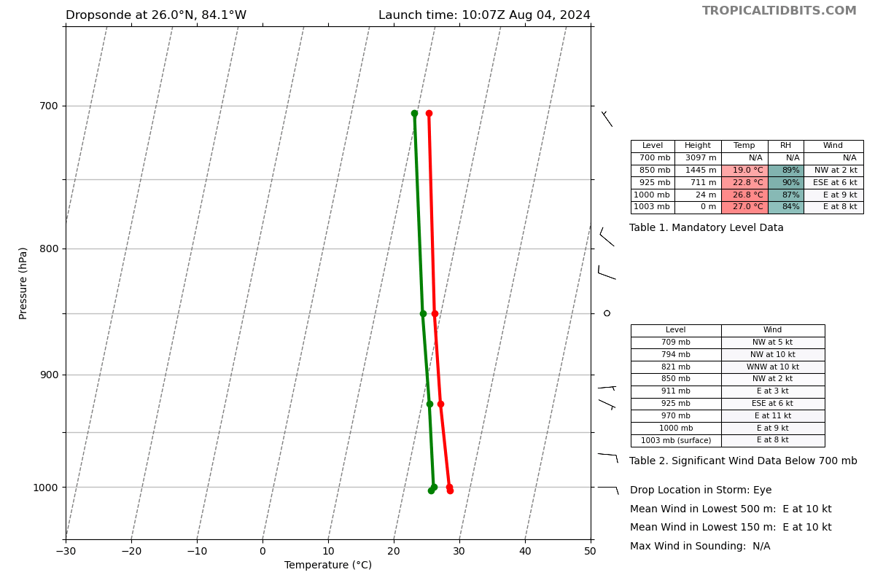
1010 | Looks like on this next leg, may fly over NDBC 42023/COMPS C13 @ 26.012 ° N 83.09 ° W. Has a lot of additional obs and ADCP onboard. Data recorded every 30 min (05 and 35 past the hour)
1016 | May also fly near COMPS C22/NDBC NDBC 42026 @ 25.17 ° N 83.479 ° W, lower winds
1018 | AMVs show limited outflow west of the center due to dry westerly shear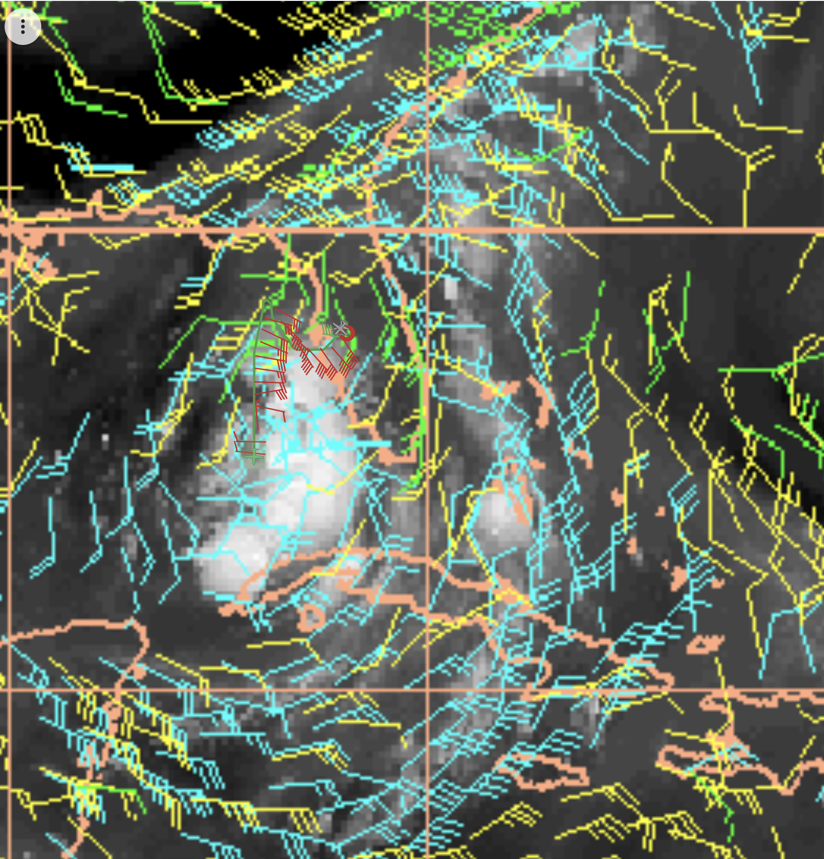
1019 | Drop 5 midpoint S  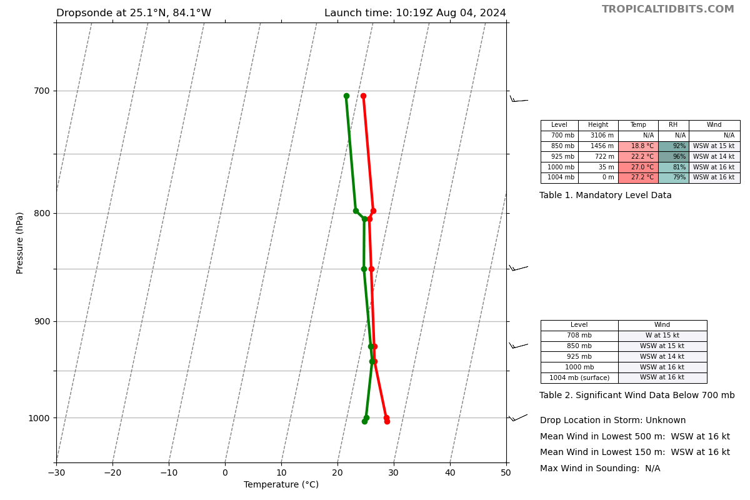
1031 | Drop 6 endpoint S  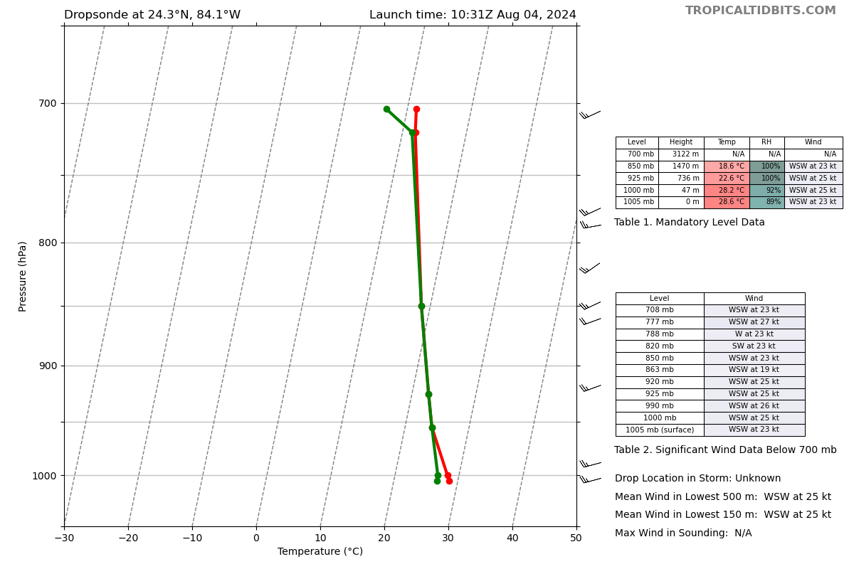
1038 | Highest FL and SFC outbound was at end point to the S, turned early slightly because of convection. Seeing red (likely 45 db) to the right of flight, can see on NEXRAD as well, which shows strongest winds in a band E of the center  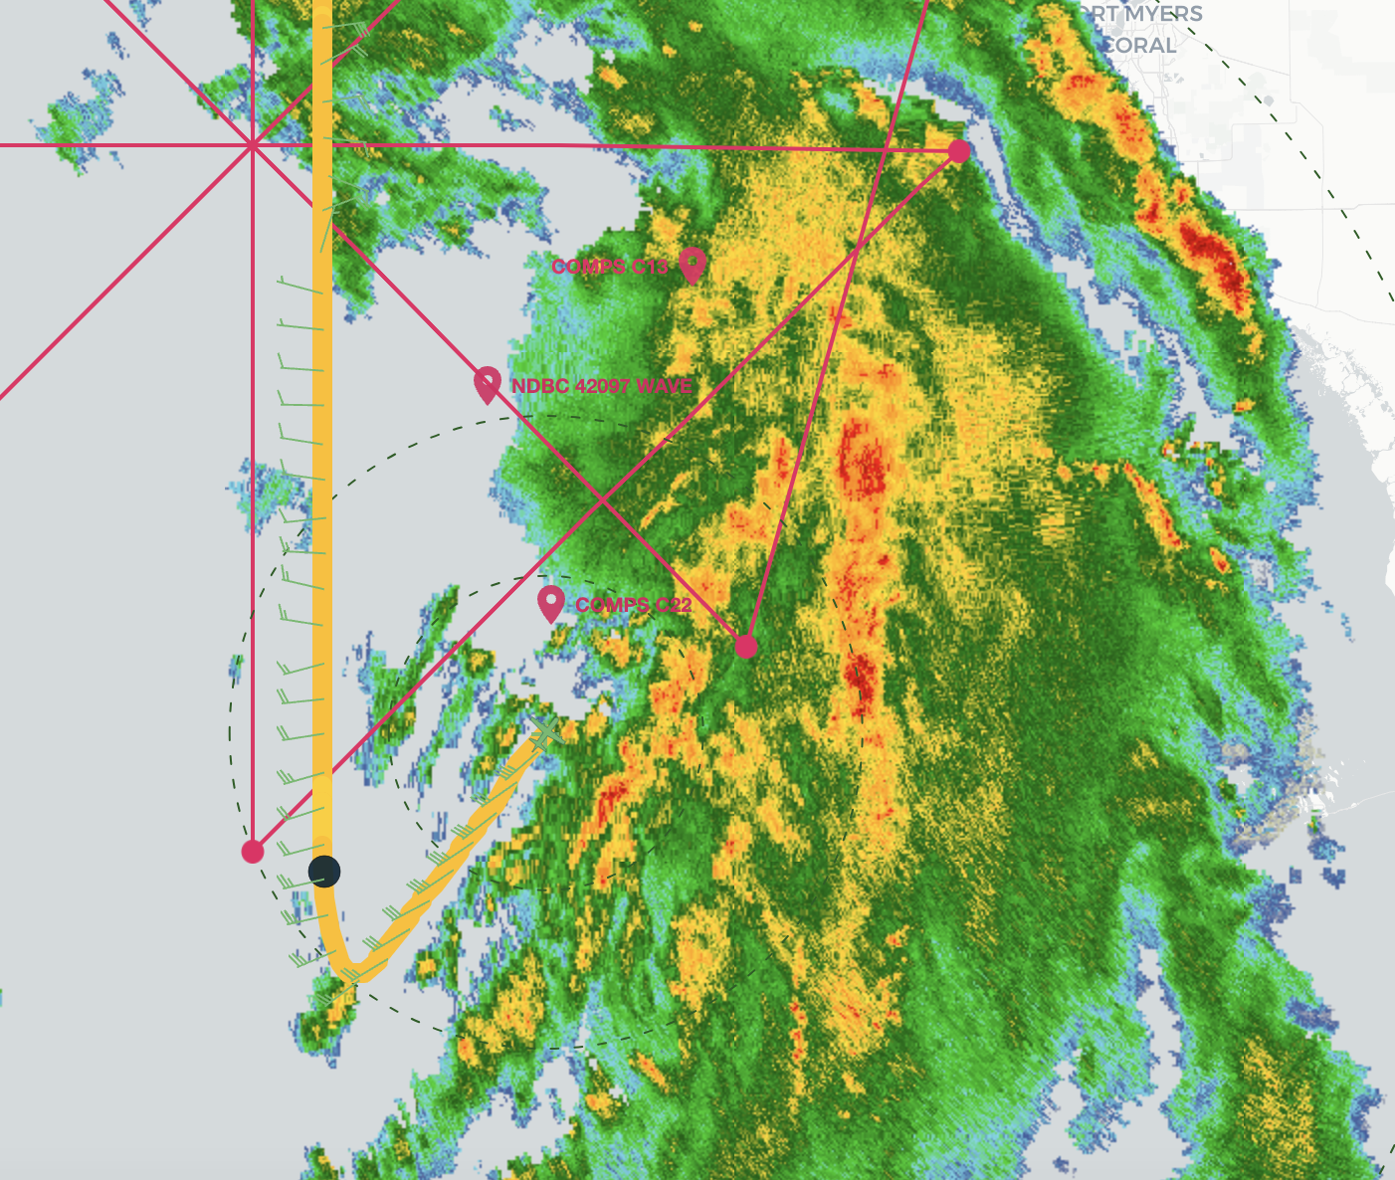
1045 | Flight went ~ 7.8 n mi to the E of COMPS C22. Last data recorded there was 10:35z, which was: Air temp of 28.5 C, Pres 1003.3 mb, RH 75.8%, winds 17.5 knots gusting 23.2 knots, SST 30.5 C, SSS 36.5 PSU
1051 | Zorana stating SFMR is showing 5 m/s high bias compared to KU band, but SFMR also has lower rain rate that c-band, which could cause SFMR to be a little higher
1059 | SFMR showing 55 knots, FL ~60 knots (MTS showing 55 knots)
1102 | >30 C Ocean temp down to 30 m (no measurements deeper) 30 n mi to west of flight
1106 | Drop 7 Endpoint E, beginning inbound  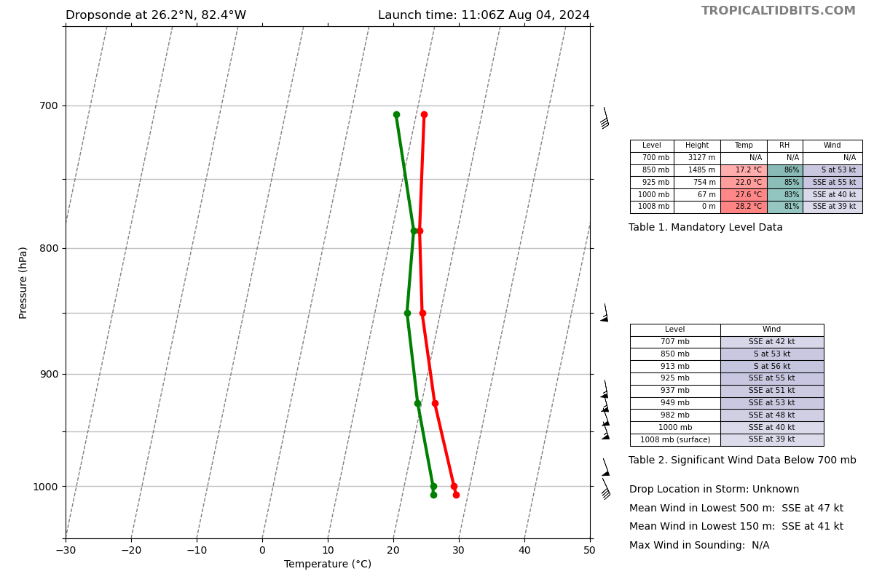
1107 | Seeing a bit of wrapping on radar now, not clear if it’s around the LLC or MLC  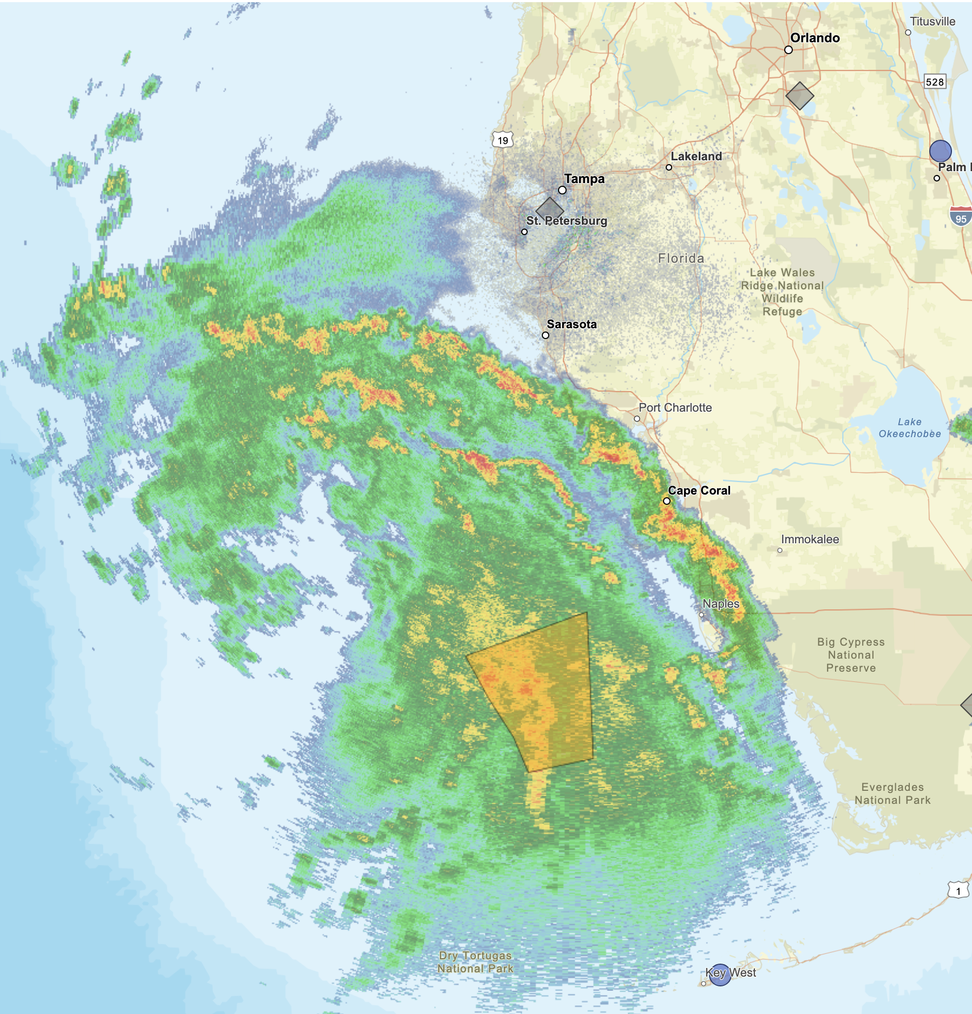
1115 | Flight passing ~13.6 n mi to the S of COMPS C13
1116 | TDR suggests 15 km of tilt to the ENE  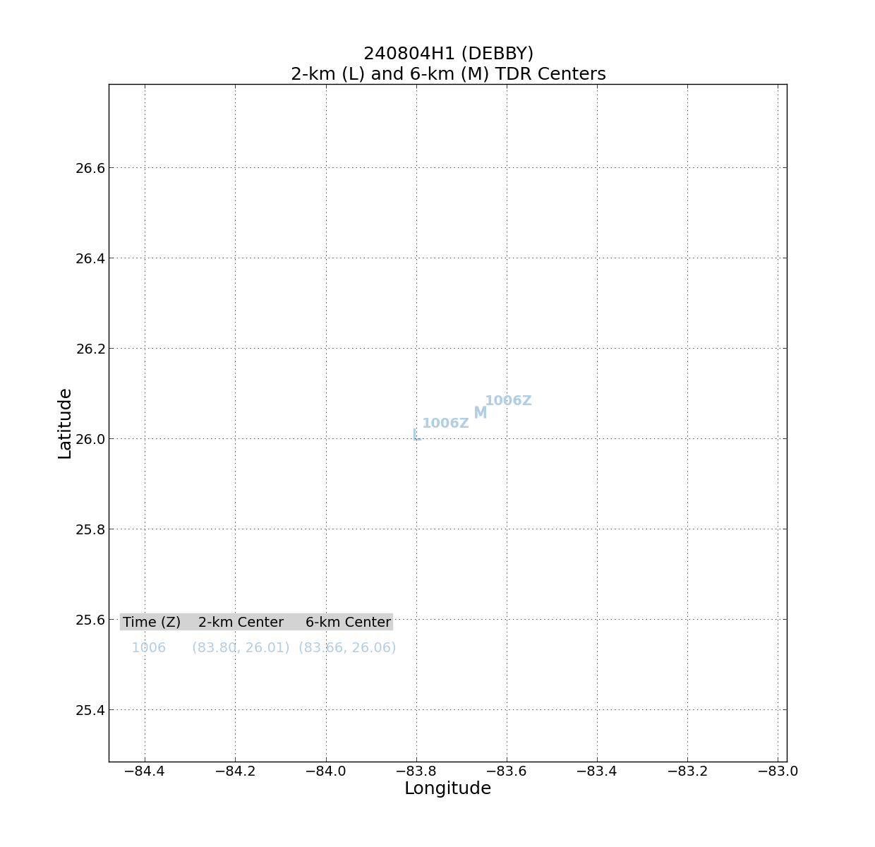
1118 | Drop 8 with AXBT, midpoint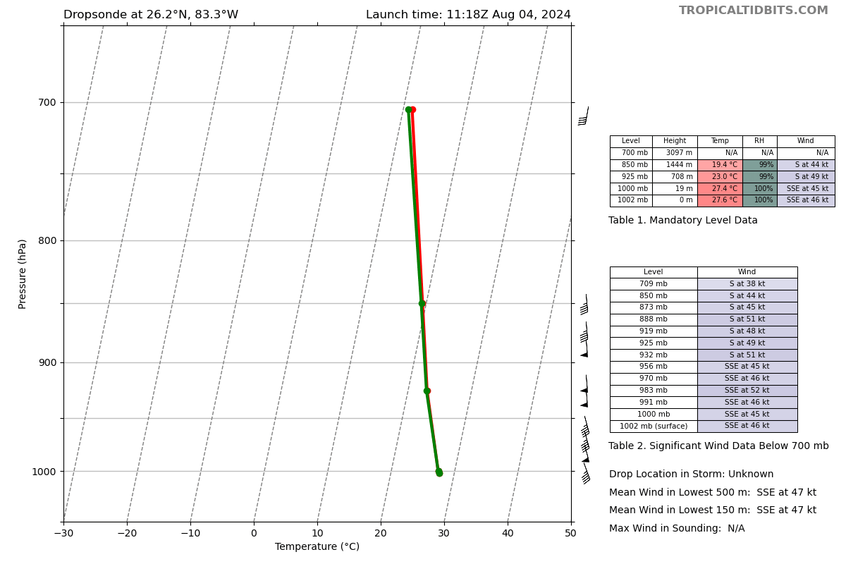
1125 | Drop 9 (was going to be center, but flight got center fix a bit west of that sonde)  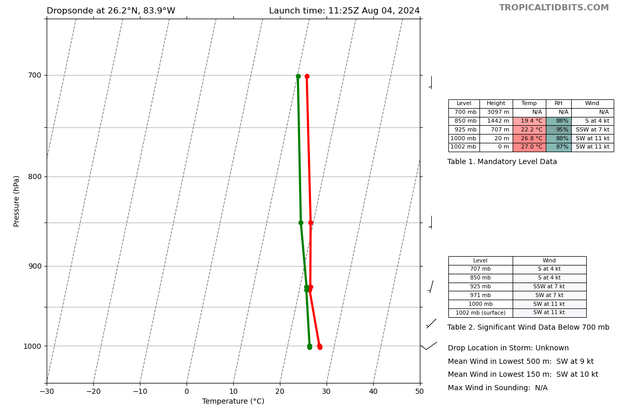
1127 | Center fix was 26.16 deg N 083.96 deg W, but noted it was NOT a great center fix
1129 | FL winds showing a very broad and ill-defined center. Slow switch in FL wind direction (and very weak)
1136 | Drop 10, mid point W  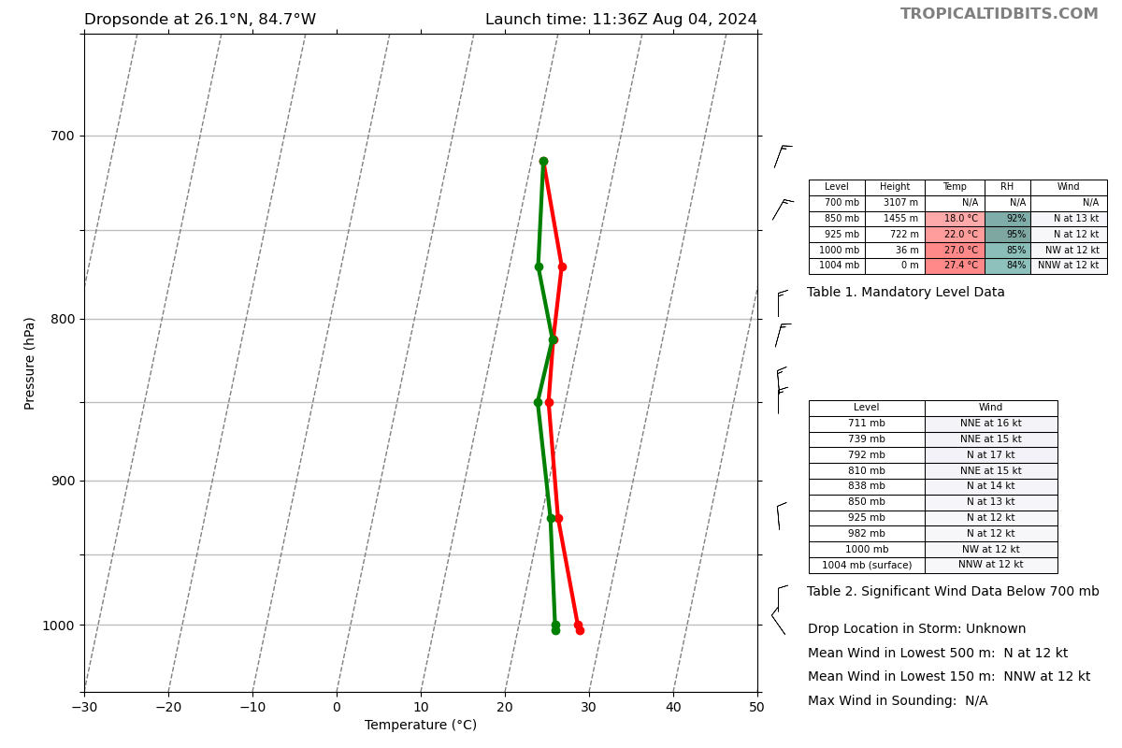
1145 | Drop 11, endpoint W with BT (S of 30.7)  Turned early since clear to the W of the center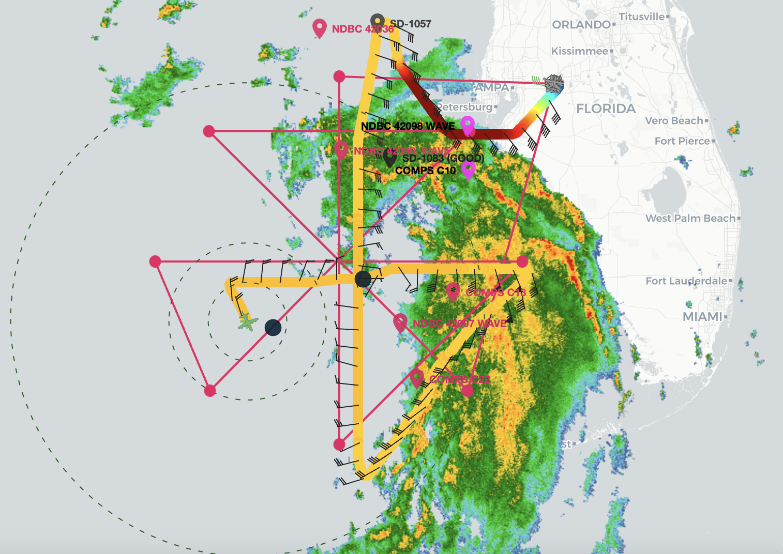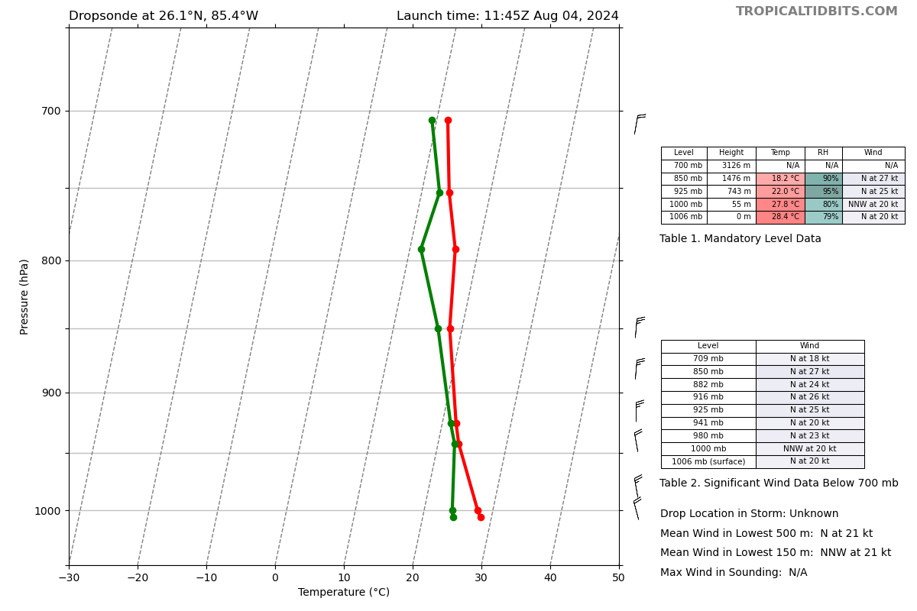
1153 | Flight notes: Lots of shallow cumulus in the western semicircle with very limited vertical development
1158 | Drop 12, IP of inbound leg SW  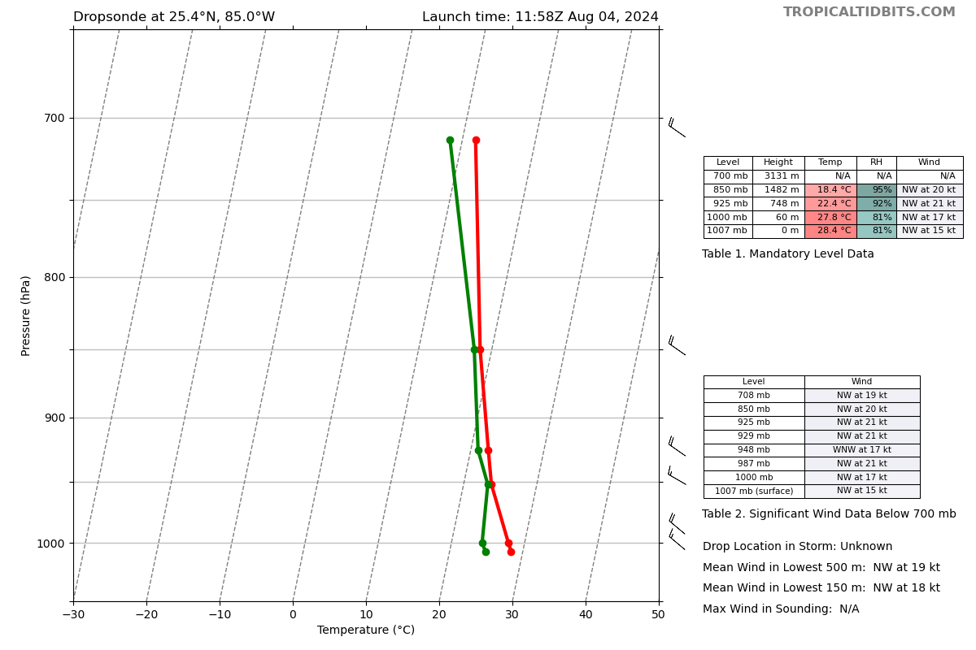
1200 | 12Z NHC update put center at 26.3N 84.2W with intensity of 50 kts
1206 | Drop 13, mid point SW  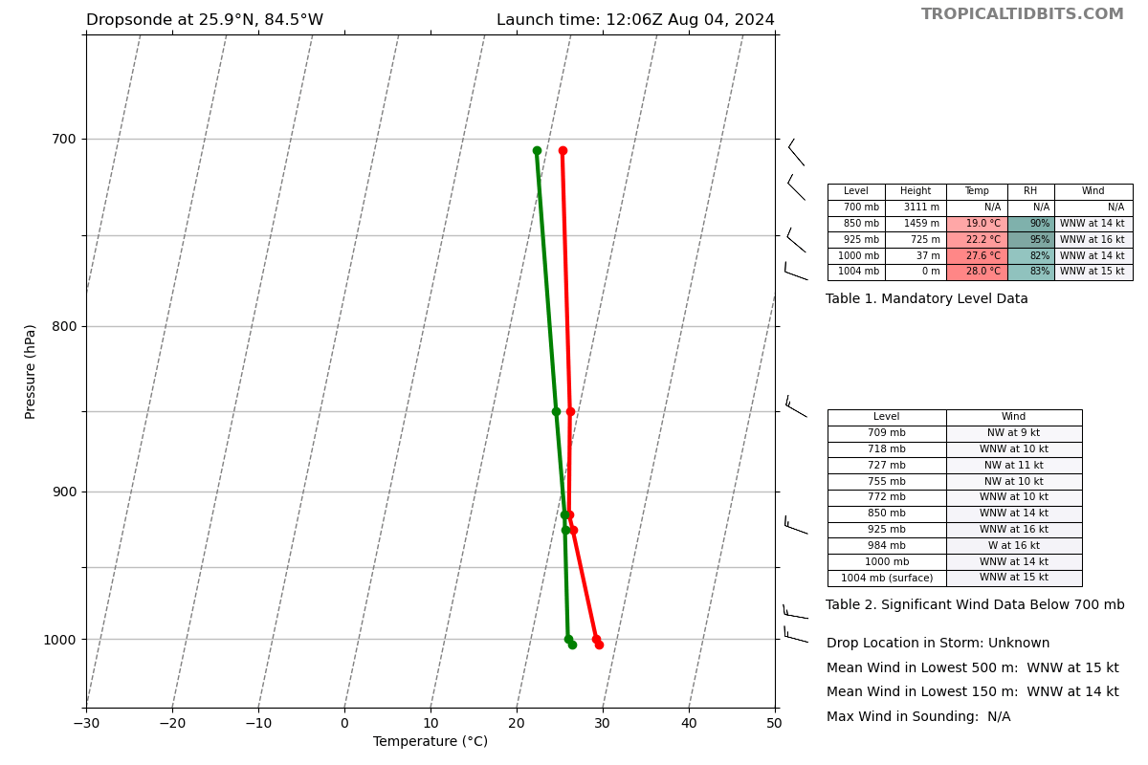
1212 | SD at 27.26756N 83.76468W, pending outbound endpoint and turn, could be close and valid for coordination
1213 | Drop 14, center, but super elongated and likely ill defined center  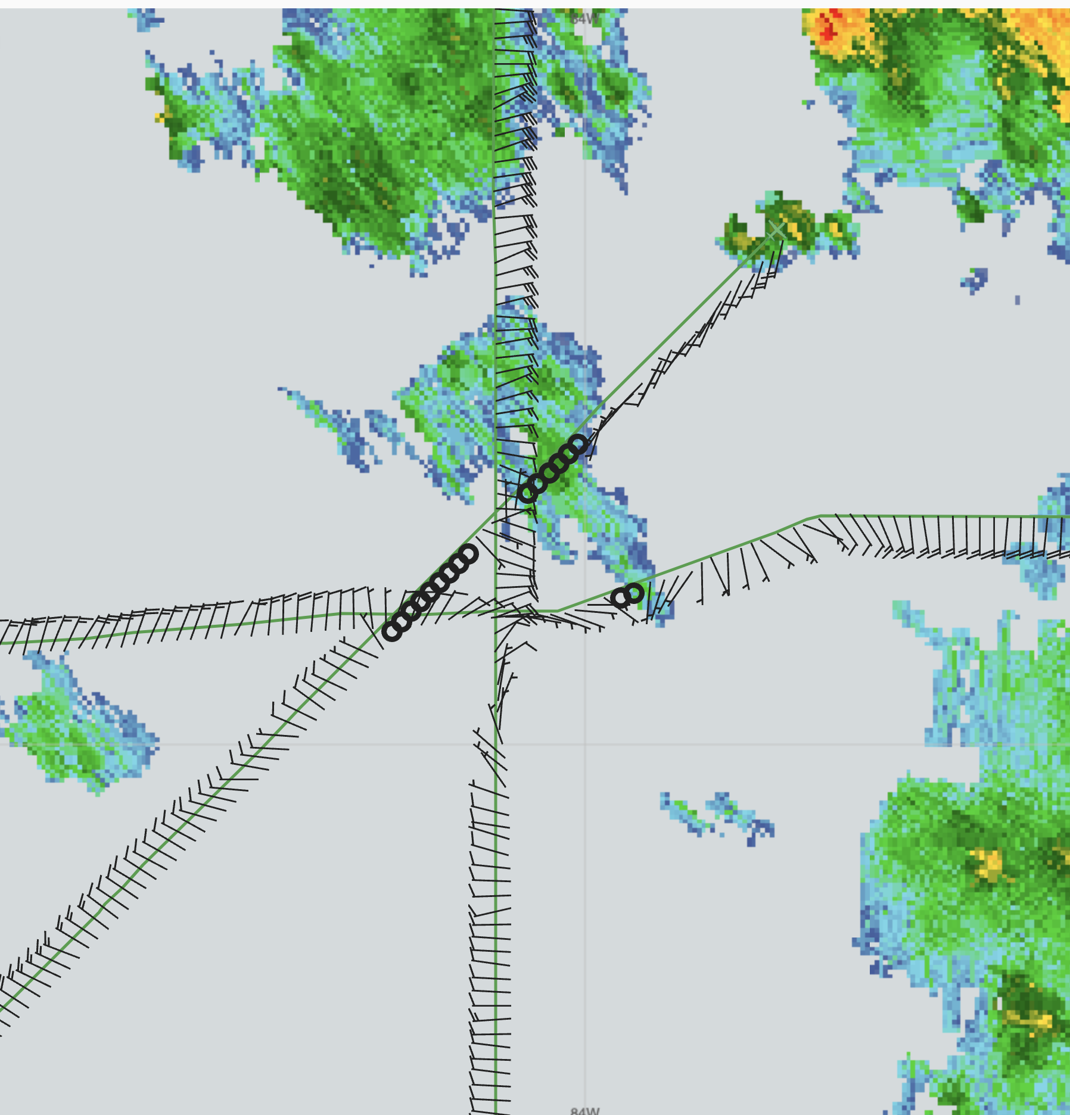  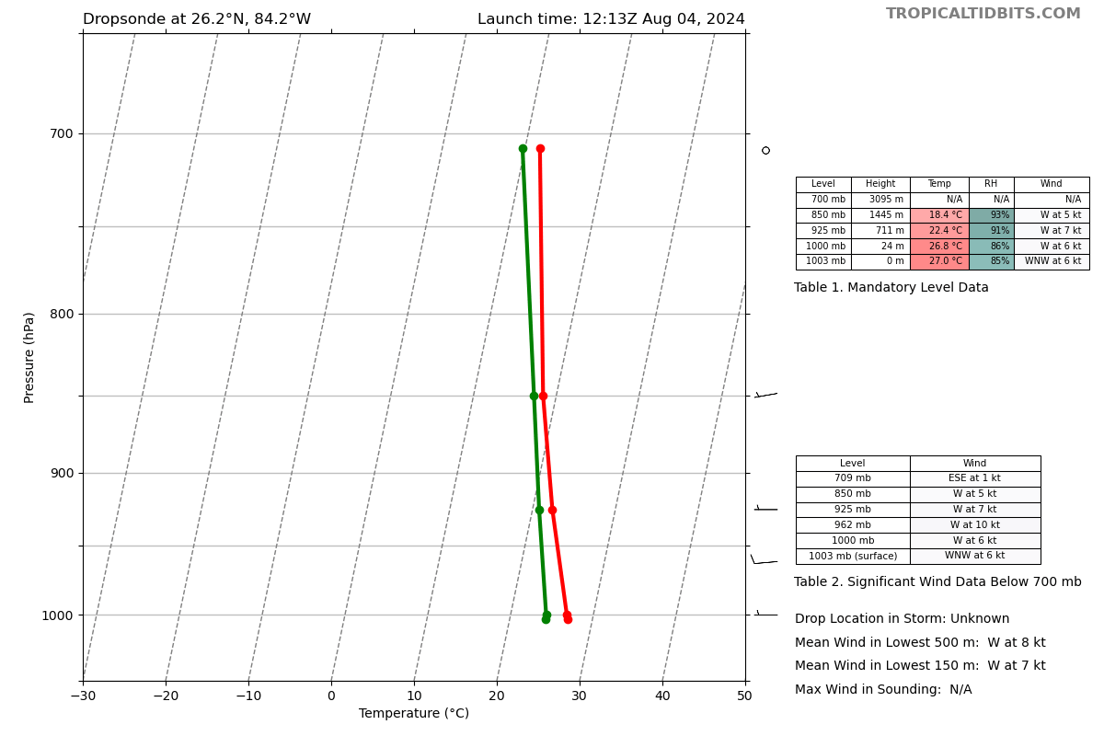
1224 | Looks like there could be a near direct overflight of COMPS C10 near timing of data collection
1226 | Drop 15, mid point NE  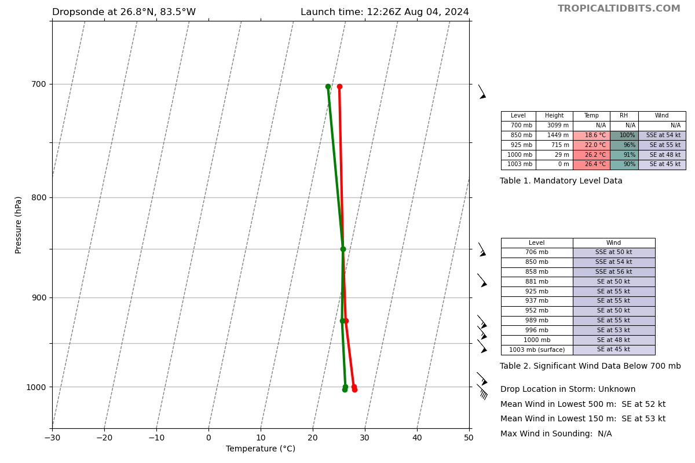
1233 | Drop 16 end point, begin turning to the E-W cross leg  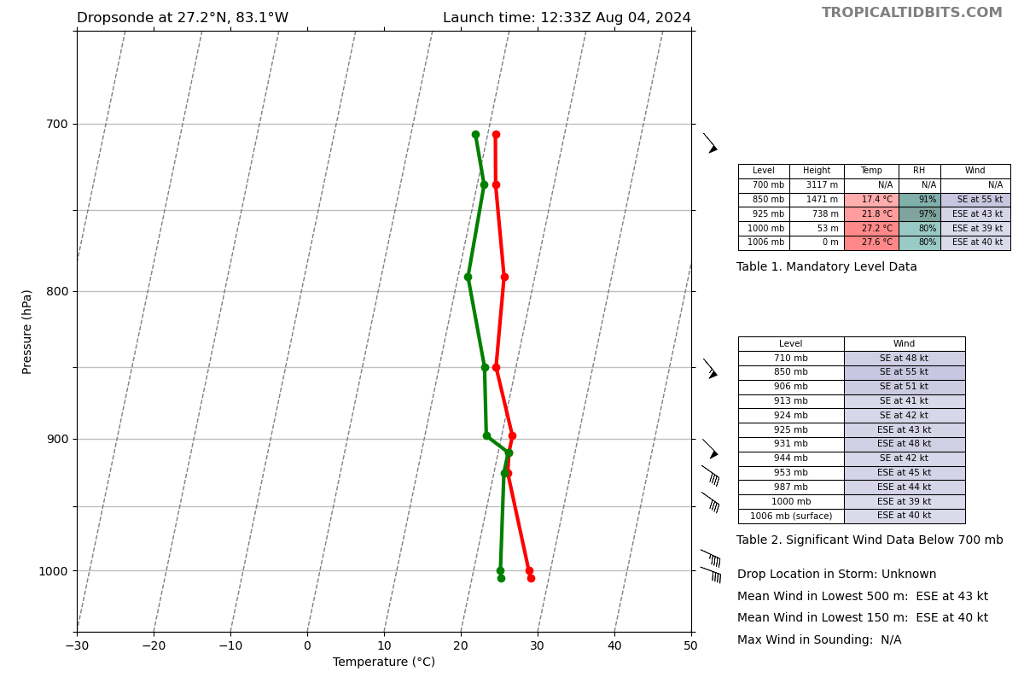
1234 | Flight 6 n mi of COMPS C10 at data collection time  COMPS data: Wind 30.5 kts, gusting 38.3 kts, RH of 99.9%, air temp of 27.4 C, pressure of 1007.3 mb, SST of 31.2C, SSS 35.6 PSU
1245 | SFMR on NOAA and SFMR on AF showing very different peaks in NE..NOAA showing 50-55 with FL of 50. AF showing FL 55-60, SFMR of 35-40
1303 | Some CBs near the MLC attempting to wrap. Wondering if this will tug the LLC to the NE.
1306 | Drop 17, IP on NW-SE final leg  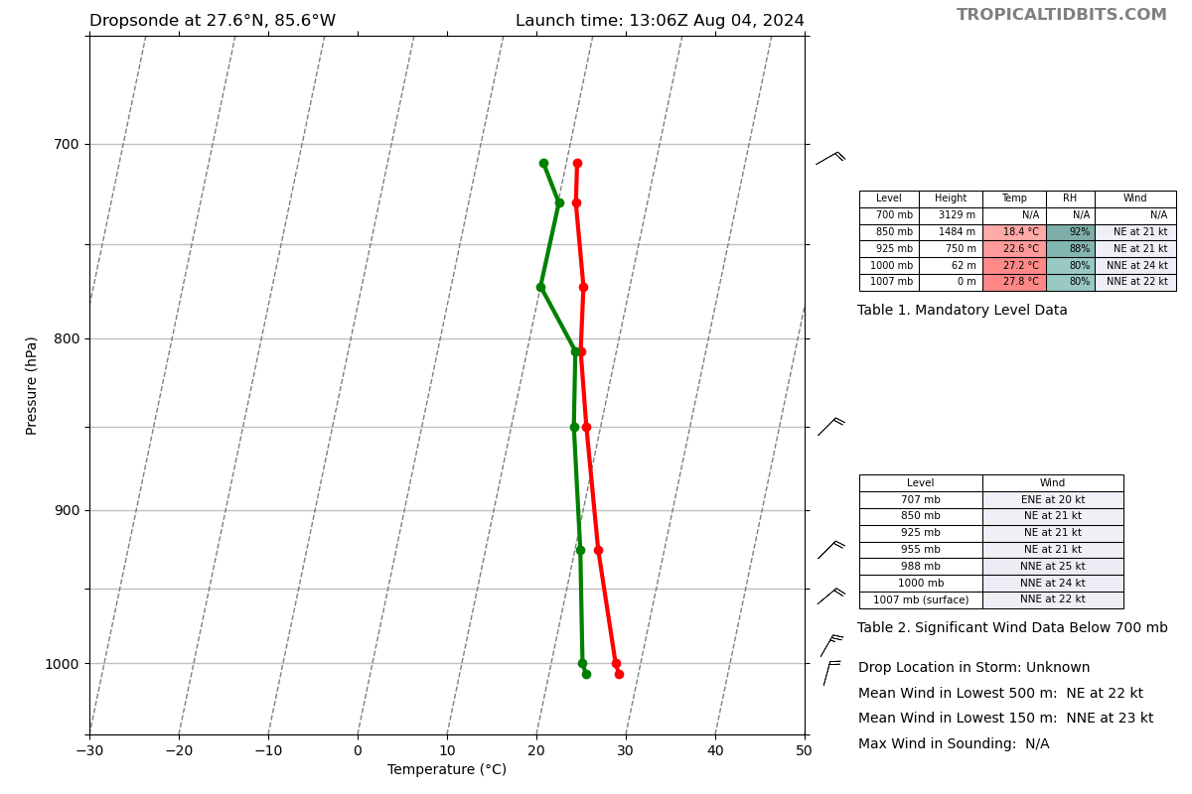
1309 | Looking better on satellite, lots popping up in NW area. Looking more aligned from TDR  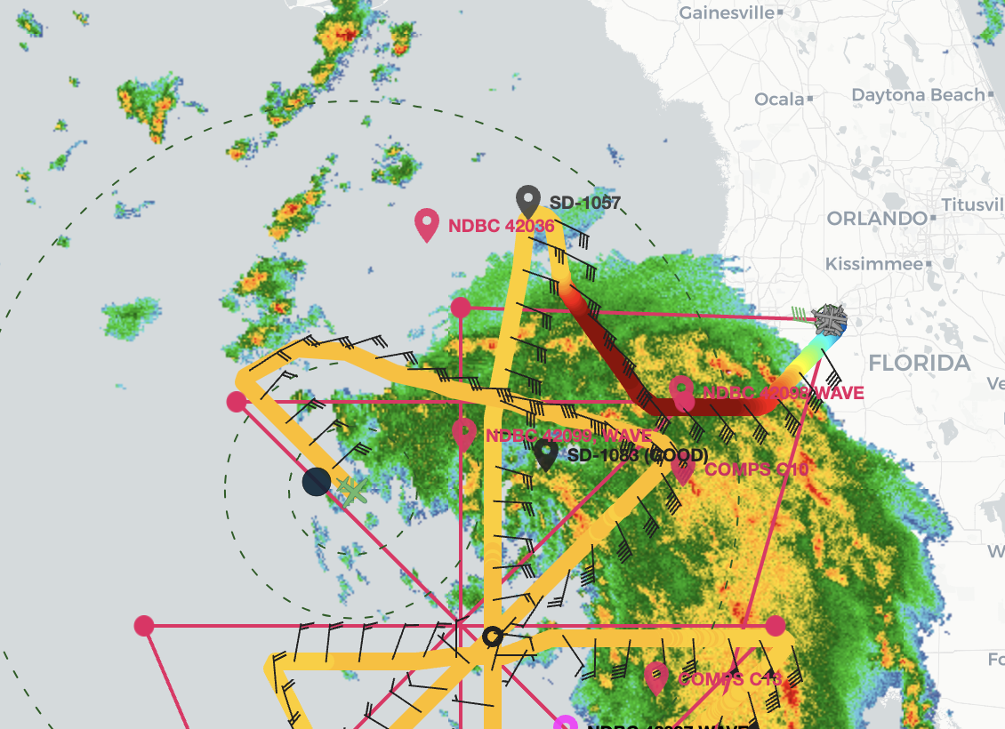
1319 | Drop 18, midpoint NE  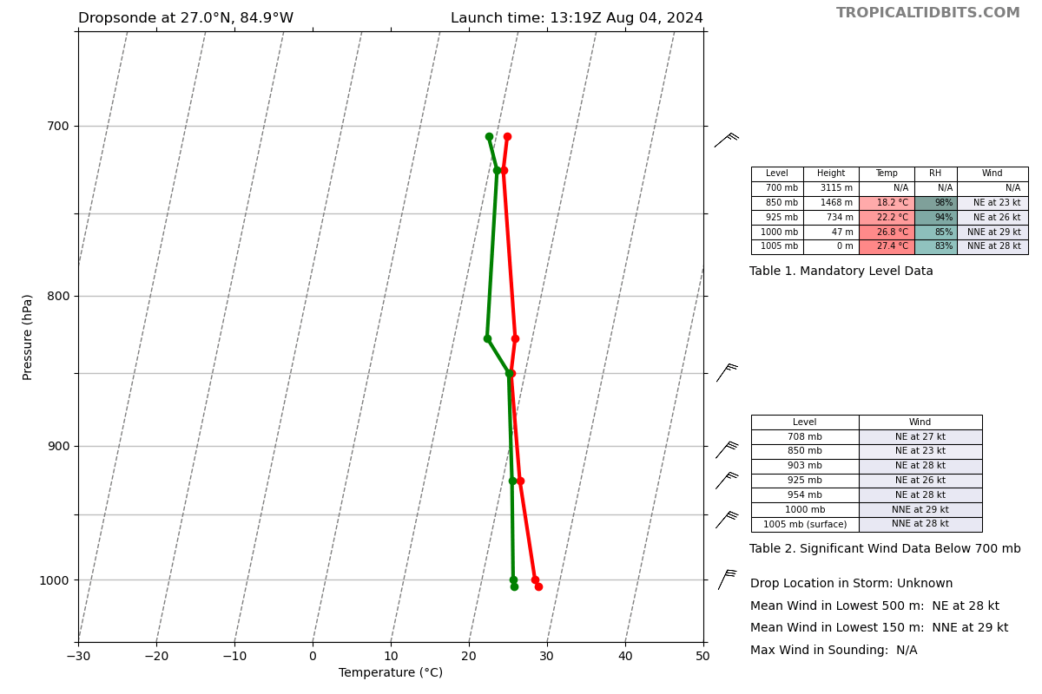
1325 | 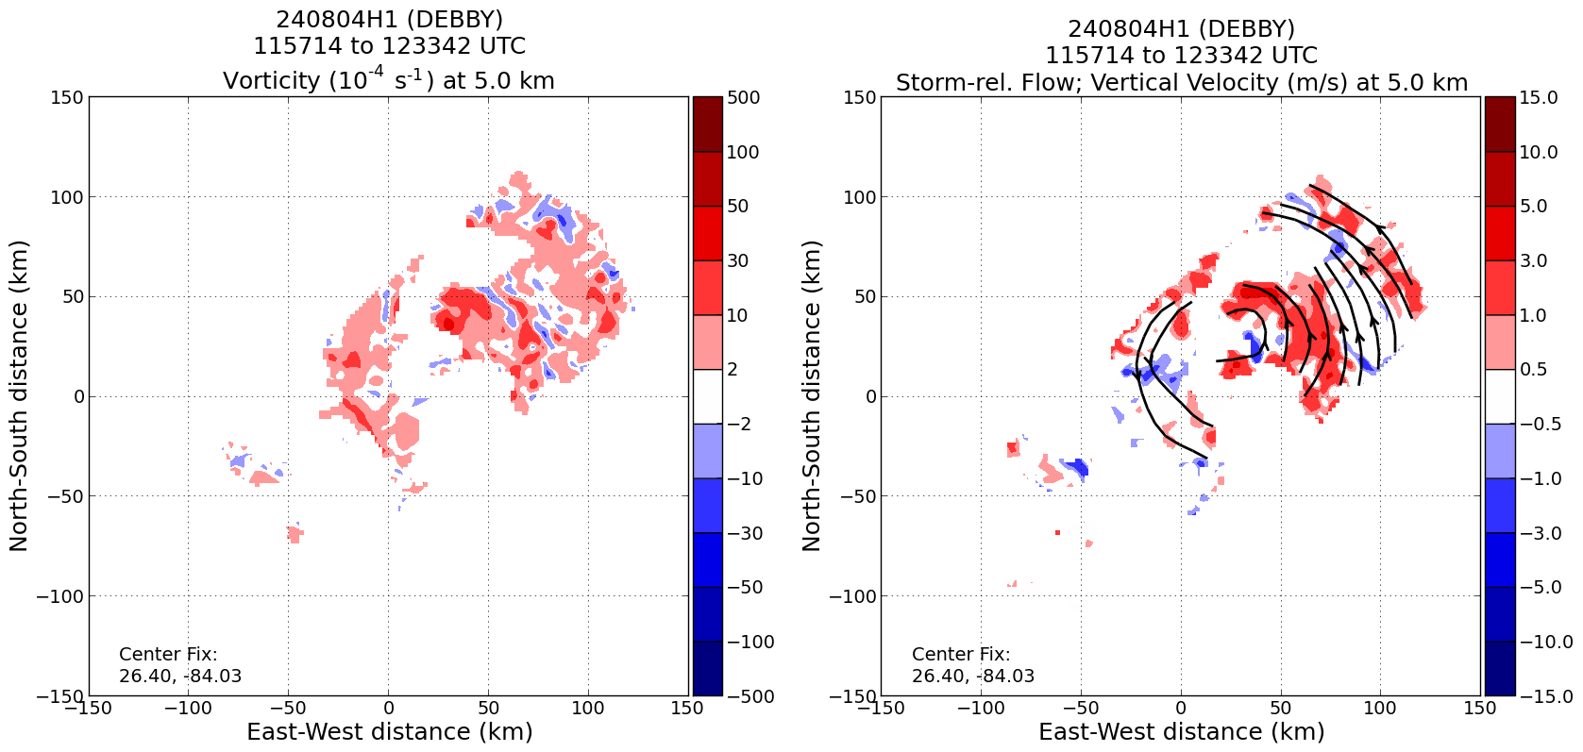  Some vorticity and stronger updrafts near the MLC, to the NE of the LLC. Could be relocating there.
1330 | Drop 19, center (still messy center)  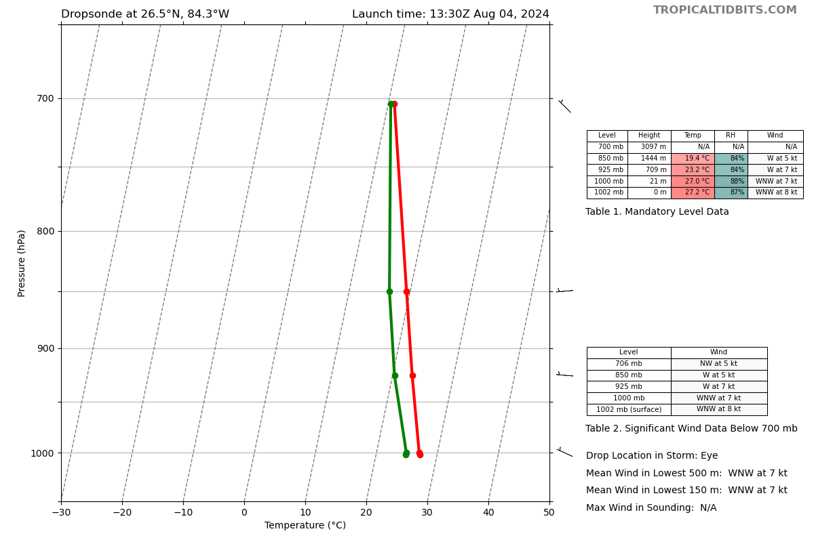
1344 | Drop 20, MP to SE  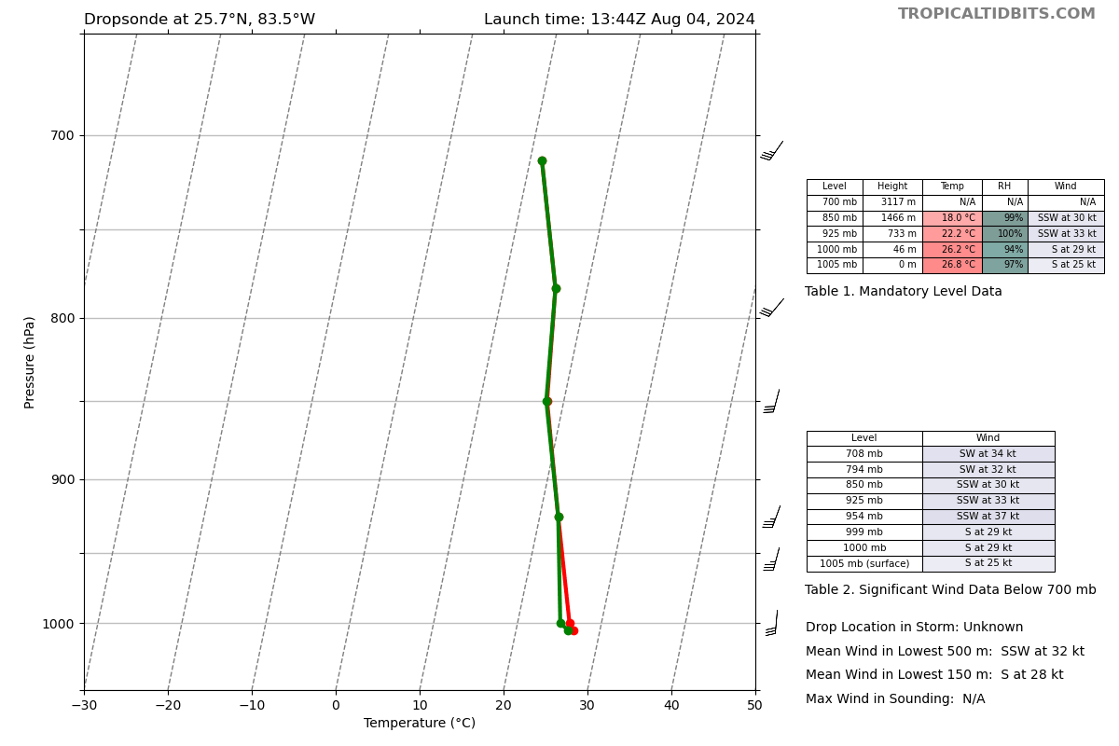
1350 | Onboard LPS reports a possible SAR after completion of the pattern
1356 | Drop 21, EP to the SE  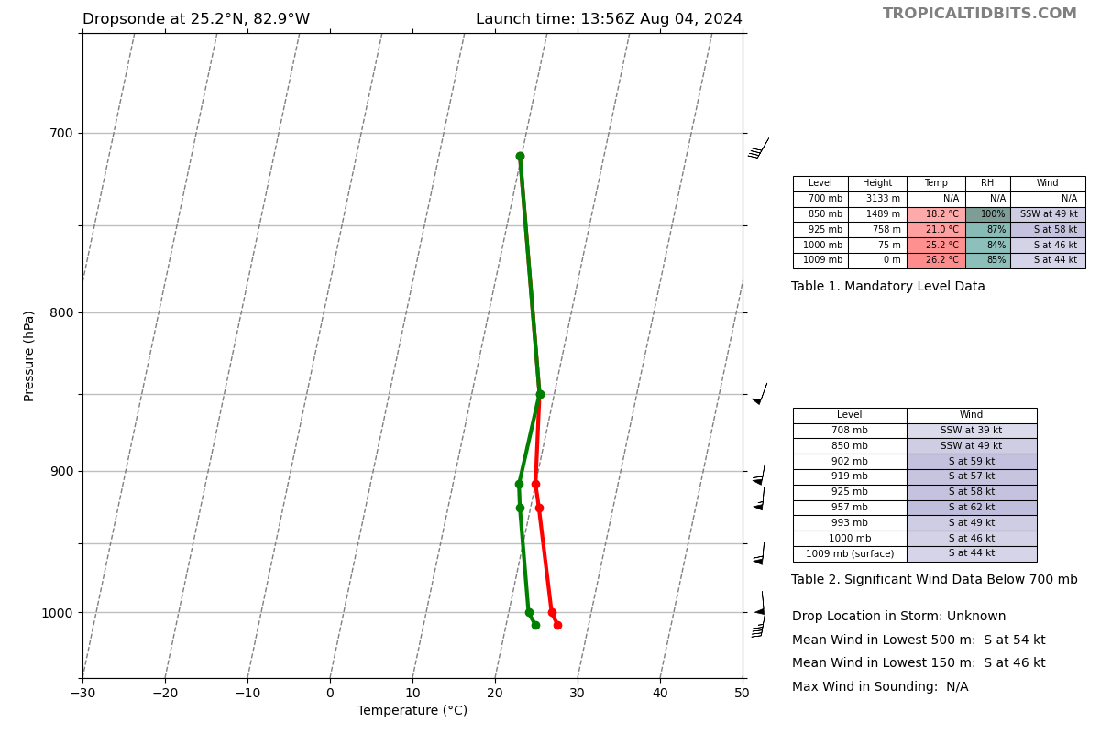
1358 | Air Force plane confirms center relocation  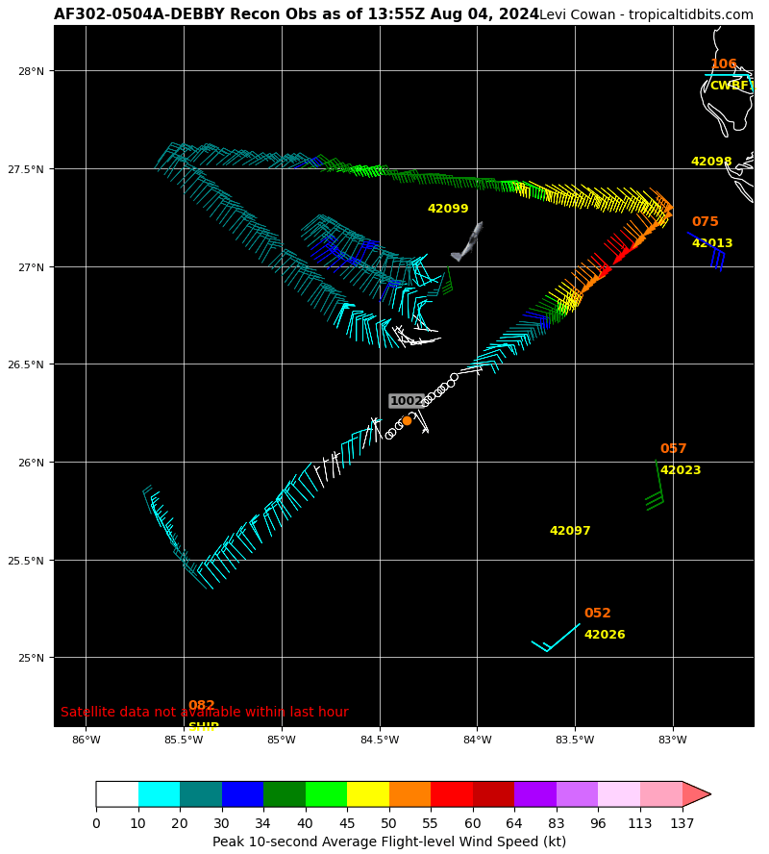
1400 | TDR is up and running and they fly back through the center of the convection
1422 | Currently overtop vessel in distress acting as comms relay until USCG Helo arrives in ~30 min.
 | << INSERT ADDITIONAL ROW AS NEEDED >>

POST-FLIGHT
Mission Summary | We flew a successful TDR mission in Tropical Storm Debby in the Southeast Gulf of Mexico. The storm was slowly intensifying, but some structural issues noted below seem to be preventing RI for now.  -There was some vortex tilt to the NE.  -The west side was pretty dry with precipitation having trouble wrapping upshear.  -The RMW was rather broad, with strongest FL winds found well East of the center  The center was very broad and ill-defined early in the flight. It looked like a more robust MLC was forming by Pass 3, and it appeared to be tugging the LLC in that direction as well.
Actual Standard Pattern Flown | Rotated Figure 4
APHEX Experiments / Modules Flown | CHAOS (saildrone overflight)
Plain Language Summary | We flew a successful mission into Tropical Storm Debby to collect Tail Doppler Radar data.  The storm was slowly getting organized, but was not rapidly intensifying yet, because of some lingering tilted and broad structure.
Instrument Notes | Instruments seemed to work correctly during the flight. There was the note of SFMR estimating ~5 m/s higher than IWRAP
Final Mission Track | 