MISSION PLAN
FLIGHT ID | 20240703I1 | STORM | AL02 / Beryl
MISSION ID | 1302A | TAIL NUMBER | NOAA-43
TASKING | NHC/EMC TDR | PLANNED PATTERN | Butterfly
MISSION SUMMARY
TAKEOFF [UTC] | 0806 | LANDING [UTC]
TAKEOFF LOCATION | STX | LANDING LOCATION | Lakeland
FLIGHT TIME | Fractional hr, Takeoff to Landing Time | BLOCK TIME | Get from onboard LPS or Flight Director
TOTAL REAL-TIME RADAR ANALYSES  (Transmitted) | 3 (3) | TOTAL DROPSONDES Deployed (Transmitted) | 21 (20)
OCEAN EXPENDABLES (Type) | n/a | sUAS (Type) | 2 Streamsondes
APHEX EXPERIMENTS / MODULES | Exact name of the Experiment in the HFP Plan; identify relevant experiments / module even if not a research tasking
HRD CREW MANIFEST
LPS ONBOARD | J. Zhang | LPS GROUND | Fischer
TDR ONBOARD | J. Zhang | TDR GROUND | Rogers
ASPEN ONBOARD | Sellwood | ASPEN GROUND | n/a
NESDIS SCIENTISTS
GUESTS (Affiliation)
AOC CREW MANIFEST
PILOTS | Rannenberg/Wood/Taraboletti
NAVIGATOR | Schaefer/Meier
FLIGHT ENGINEERS | Tyson/Wysinger/Ripp
FLIGHT DIRECTOR | Kalen, Q.
DATA TECHNICIAN | Richards,T.
AVAPS | Patel

PRE-FLIGHT
Flight Plan | [Insert image of submitted flight pattern here]  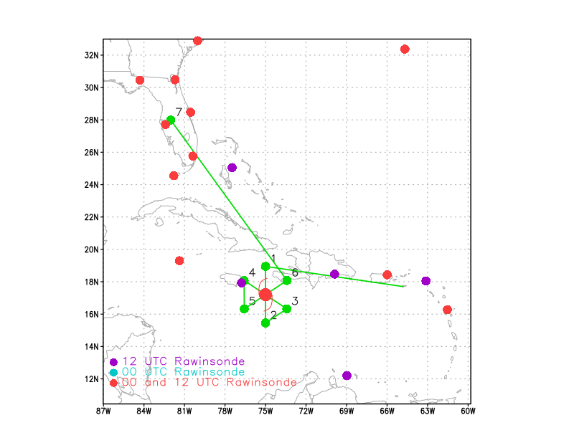  [Insert image of ONR/TCRI detailed pattern image, if available]  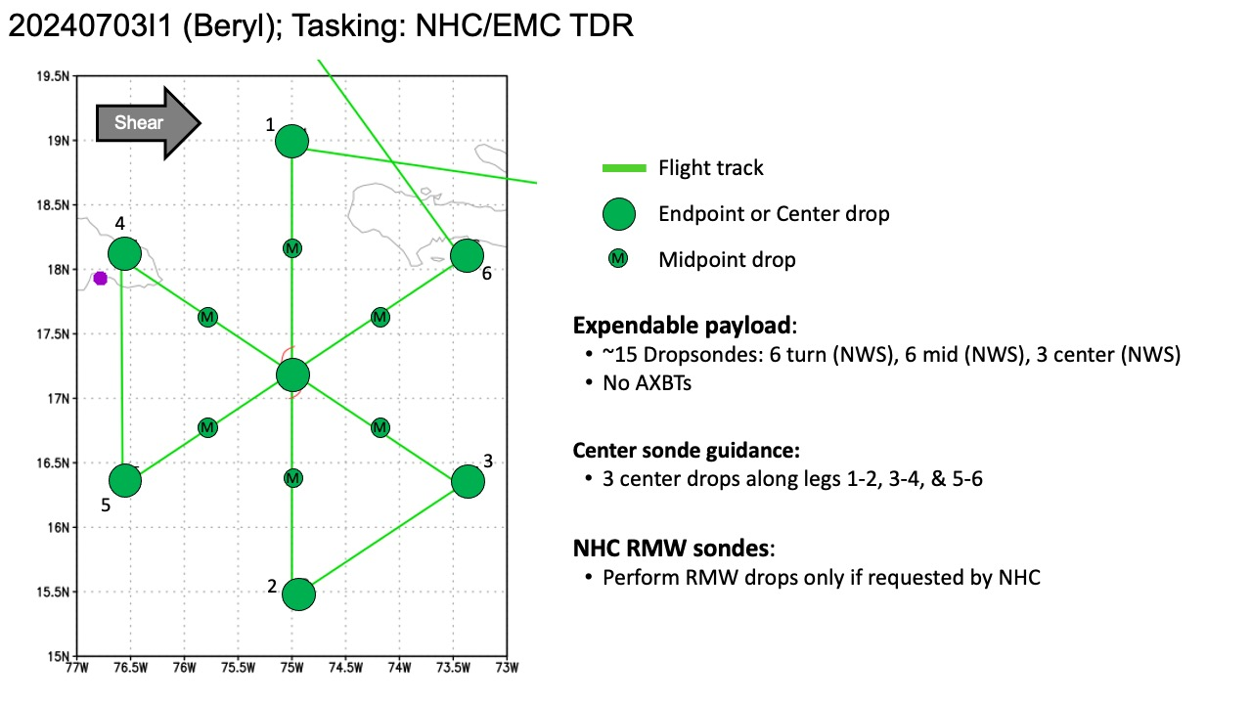  [If you want, briefly describe the pattern in words]  Pattern: Fly butterfly pattern with 105 NM legs  Altitude:  - 10 kft preferred - 8 kft if AF deconfliction is required (pressure altitude)  Potential add-on Modules: (time permitting)  - None
Expendable Distribution | - Load 35 dropsondes  - Release at endpoints, midpoints, centers, RMWs (if requested by NHC) >> charged to NWS  - All dropsondes transmitted to the GTS  - Load 2 Skyfora sondes - deployed at the discretion of the HRD LPS  - No AXBTs
Preflight Weather Briefing | [Notes from the Flight Crew Preflight Briefing and other relevant notes about the current and forecasted storm state from the most recent NHC advisory (location, intensity, MSLP, movement, possible intensity change during the flight)]  Legs with endpoints close to land (north side) will be shortened.  Both NOAA and Air Force Hurricane Hunter aircraft have been  investigating Beryl this evening. Data from the aircraft suggest  that Beryl hasn't weakened very much so far. Flight-level winds  indicate that the intensity is still near 130 kt. Satellite-  derived intensity estimates are below this value, and the  eye has become a little less well-defined on the imagery.  The rapid west-northwestward motion continues, at around 290/19 kt.  A strong mid-level ridge to the north of Beryl should continue to  steer the system on a west-northwestward heading across the central  and northwestern Caribbean for the next few days. This motion  should bring the center near Jamaica in 12 to 24 hours, near the  Cayman Islands in 24 to 36 hours, and near the Yucatan Peninsula of  Mexico in 48 to 60 hours.  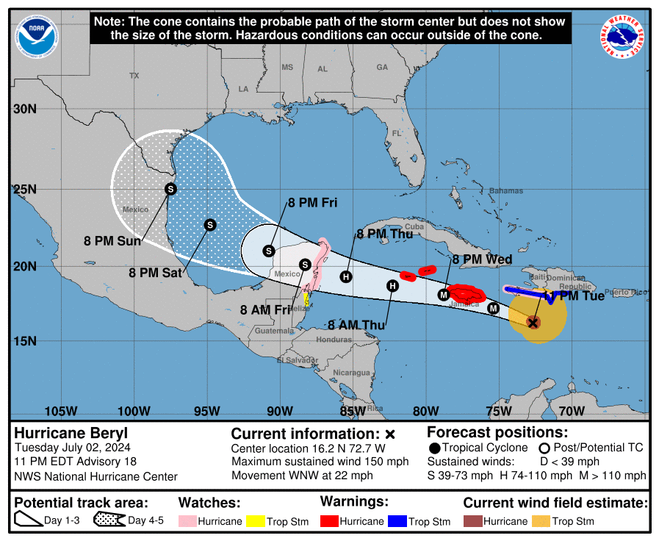  [Briefly describe the relevant environmental drivers.]  There is also considerable uncertainty in the future intensity of  Beryl. Vertical shear, associated with an upper-level low near the  Yucatan Channel, should increase over Beryl during the next day  or so. Therefore some weakening seems likely during the next 48  hours. However, the system should maintain hurricane strength  while it moves over the northwestern Caribbean. Later in the  forecast period, when Beryl moves over the western Gulf of Mexico,  it is not clear how much the cyclone will re-intensify, but it  should at least be close to hurricane intensity around that time.  [Copy in GIF of recent (~6 hr) satellite loops (https://www.star.nesdis.noaa.gov/GOES/index.php)]
Instrument Notes | [What instruments are working, not working, not functioning nominally, not installed?]

IN-FLIGHT
Time [UTC] | Event
0806 | Take-off from STX
0930 | Comms drop out for approximately 20 minutes
0937 | IR snapshot showing the asymmetric convective structure, consistent with northwesterly shear, with a convectively active band on the NE side of the system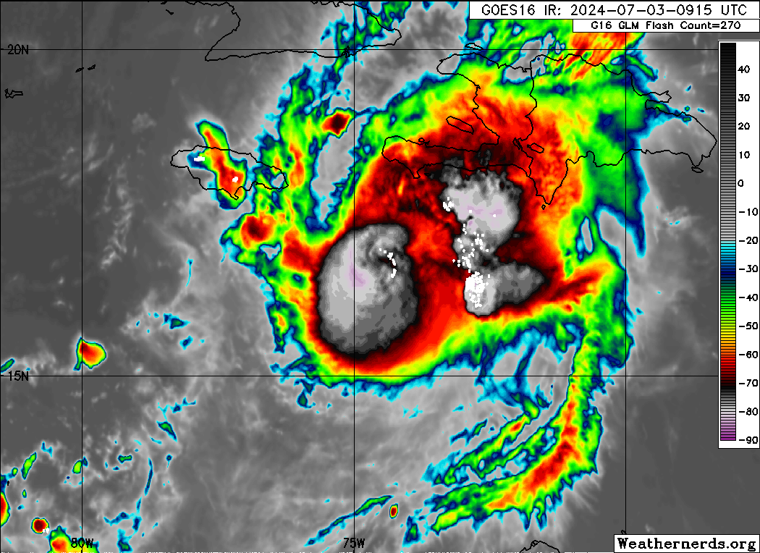
0957 | Plane has to “reaalign inertials, going 090 for 10 mins” - Quinn
1001 | 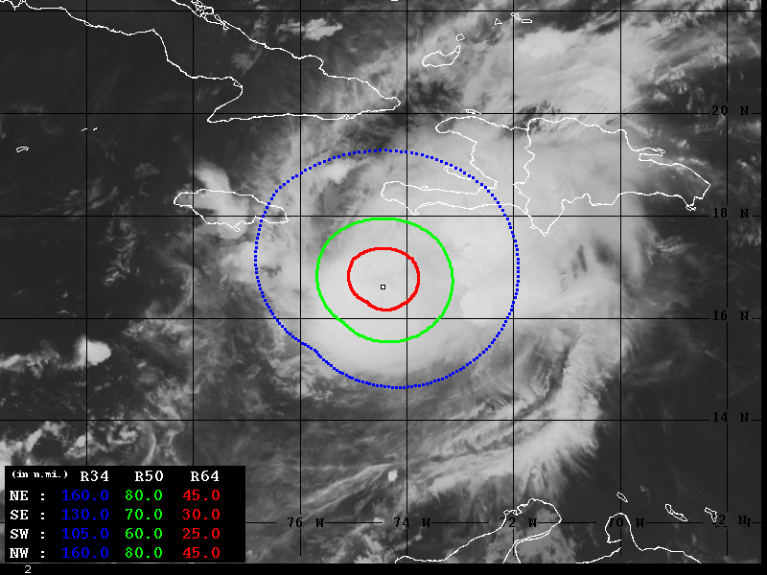  Wind Radii Estimates based on Advanced Dvorak Technique (34-64kt)
1009 | 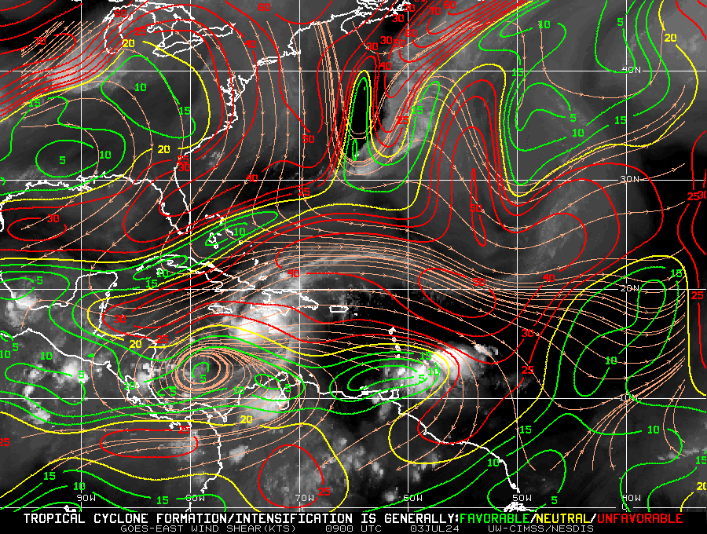  CIMSS VWS showing mod-heavy west-northwesterly shear
1012 | “Proceeding to IP” - Quinn
1028 | Updated flight plan to shorten legs to 90 nmi due to delay getting to the IP because of nav issues.
1053 | Sonde #1 at IP (N side)
1056 | <Jun_N43_LPS> depressurized for streamsonde drop purpose  <Jun_N43_LPS> Using free fall shute for streamsonde as in yesterday's mission
1100 | 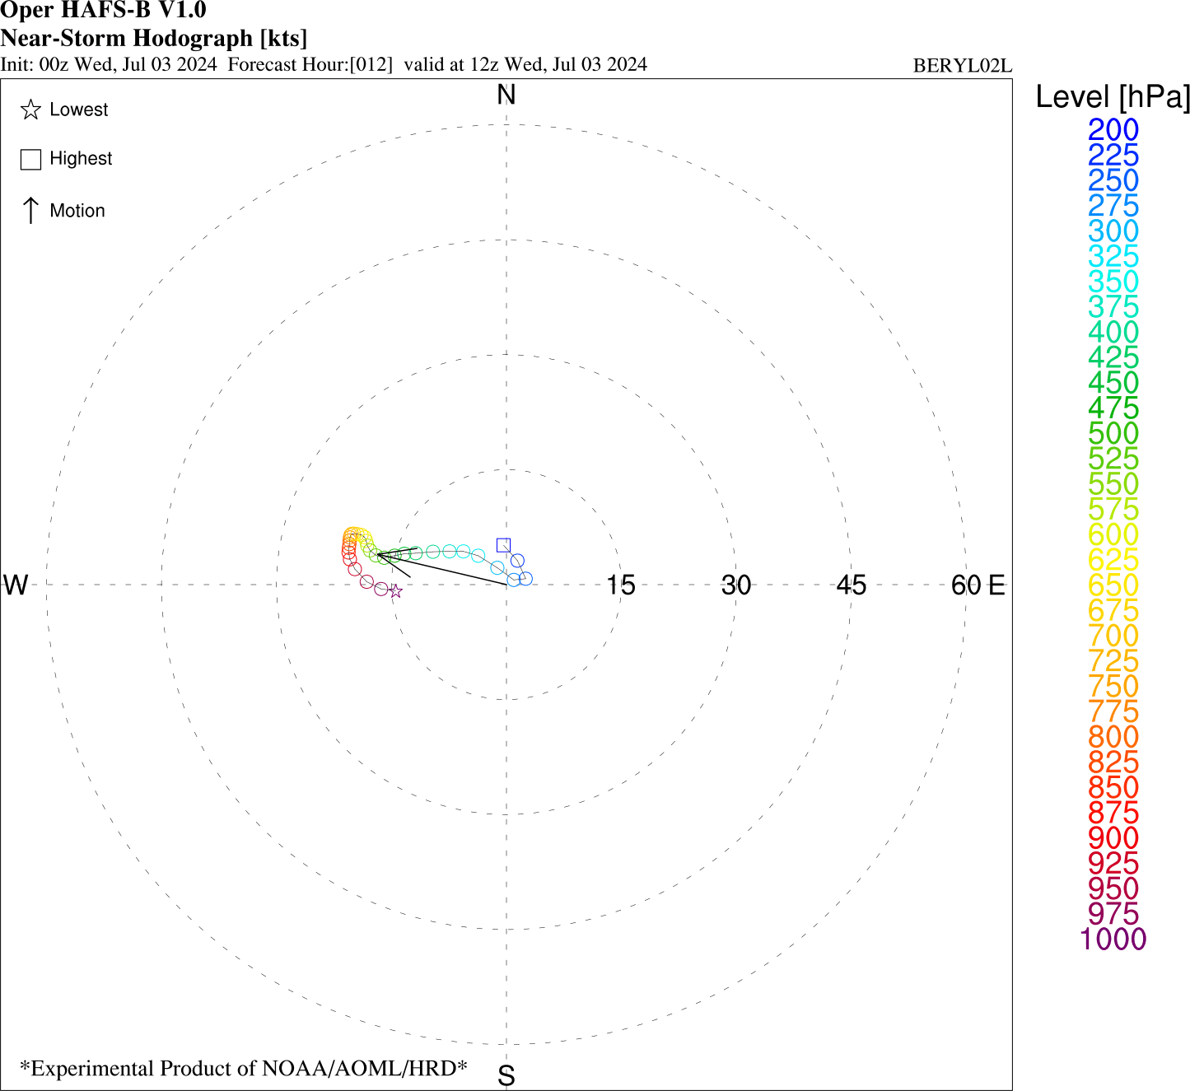Short-term model forecasts valid near this time show appreciable shear, especially in the mid-troposphere (deep-layer shear is weaker)
1105 | 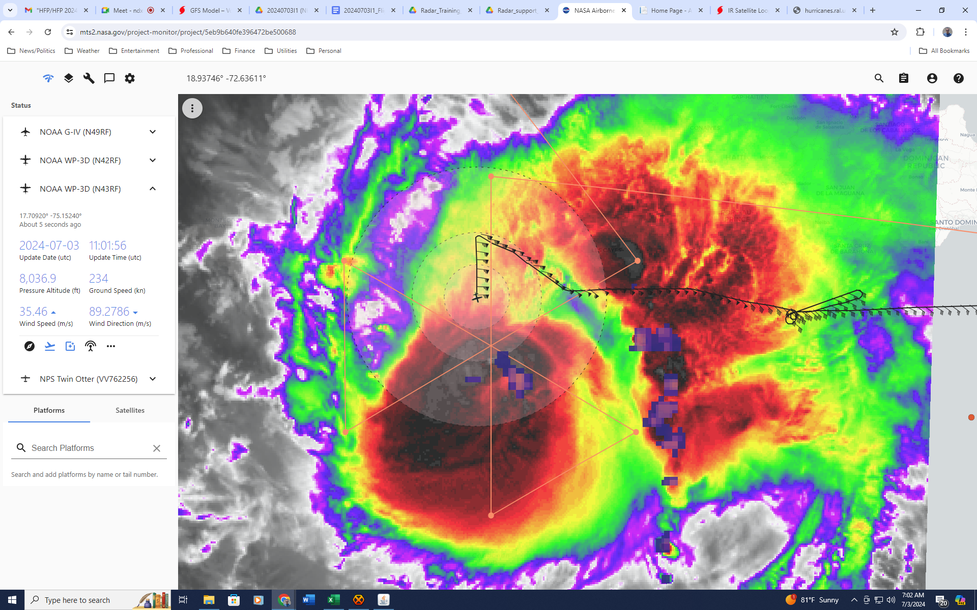  MTS screen grab shows classic depiction of TC rainband in shear – peak shear is in 350-750 hPa layer, from WNW. Rainband is oriented in downshear and downshear left quadrant. Lightning is seen on the upwind side of the rainband, cellular structure there. Downwind, the cloud shield, while still cold, fills in, with less lightning. This is indicative of the along-band variation of rainbands – cellular convective structure on the upwind side of the band, transitioning to more stratiform precipitation on the downwind side of the band, in the downshear-left and left-of-shear quadrants, where the band connects with the primary eyewall  Lightning is also evident in the NE eyewall → downshear left quadrant, where convection is typically maturing after initiating downshear right.
1105 | Sonde #2; Midpoint sonde; N side
1107 | Cuba radar depicts NW band of precip within the vicinity of eastern Jamaica
1107 | 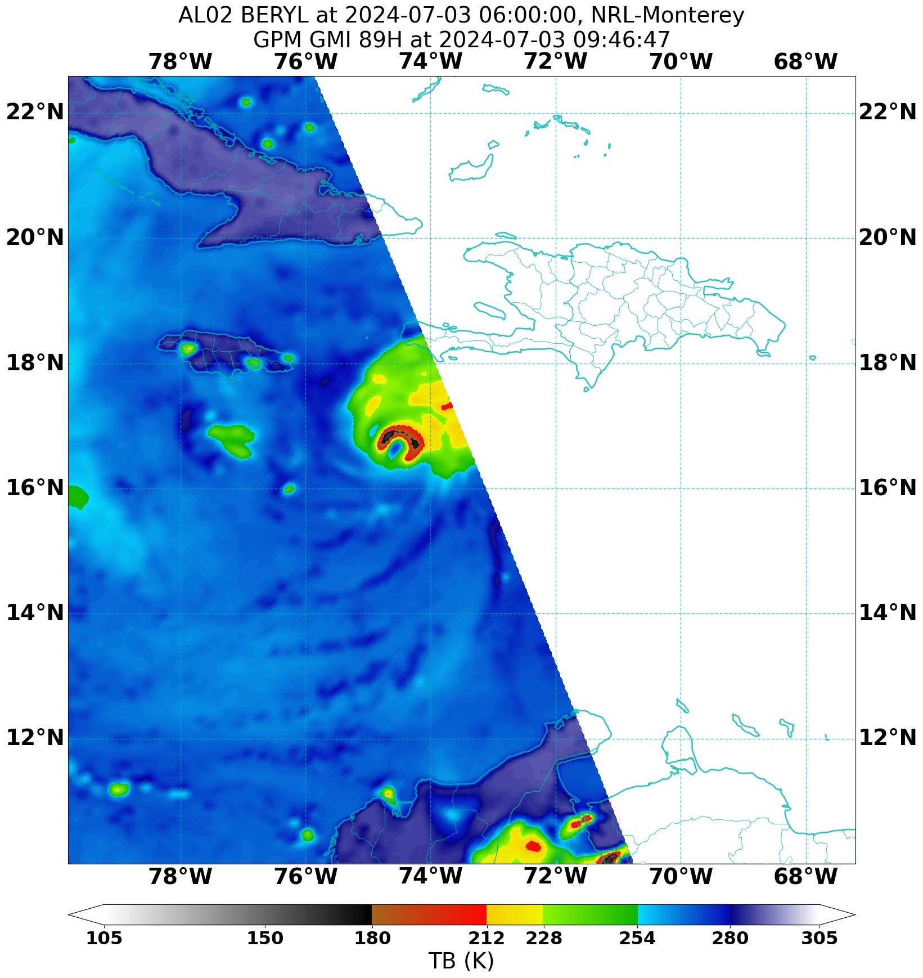  GMI overpass shows very intense, but asymmetric deep convection in the northern eyewall, presumably due to the effects of vertical wind shear.
1115 | Sonde #3; RMW (N side); Streamsonde combo drop
1115 | 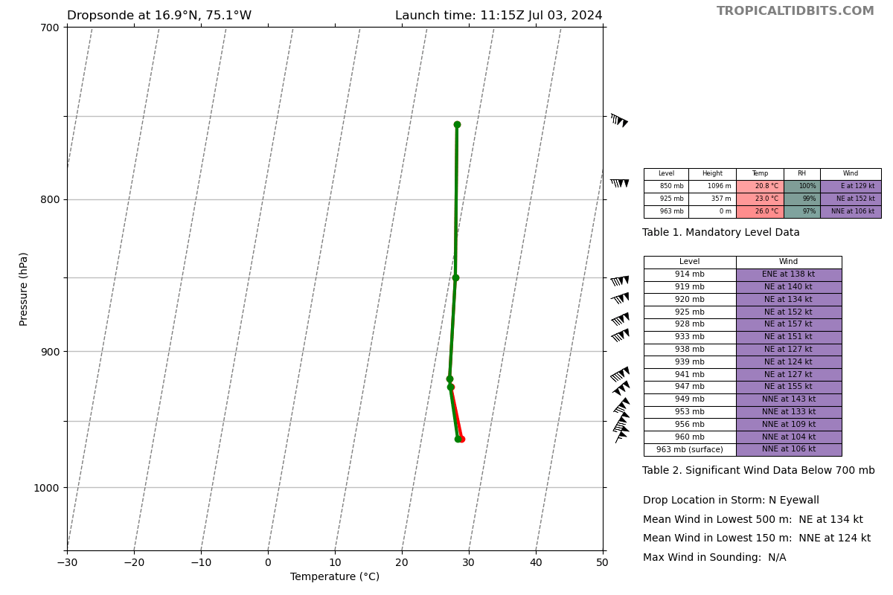Sonde #3 Data
1118 | Sonde #4; 1st center drop
1122 | Sonde #5; RMW (S side); Streamsonde combo drop
1125 | 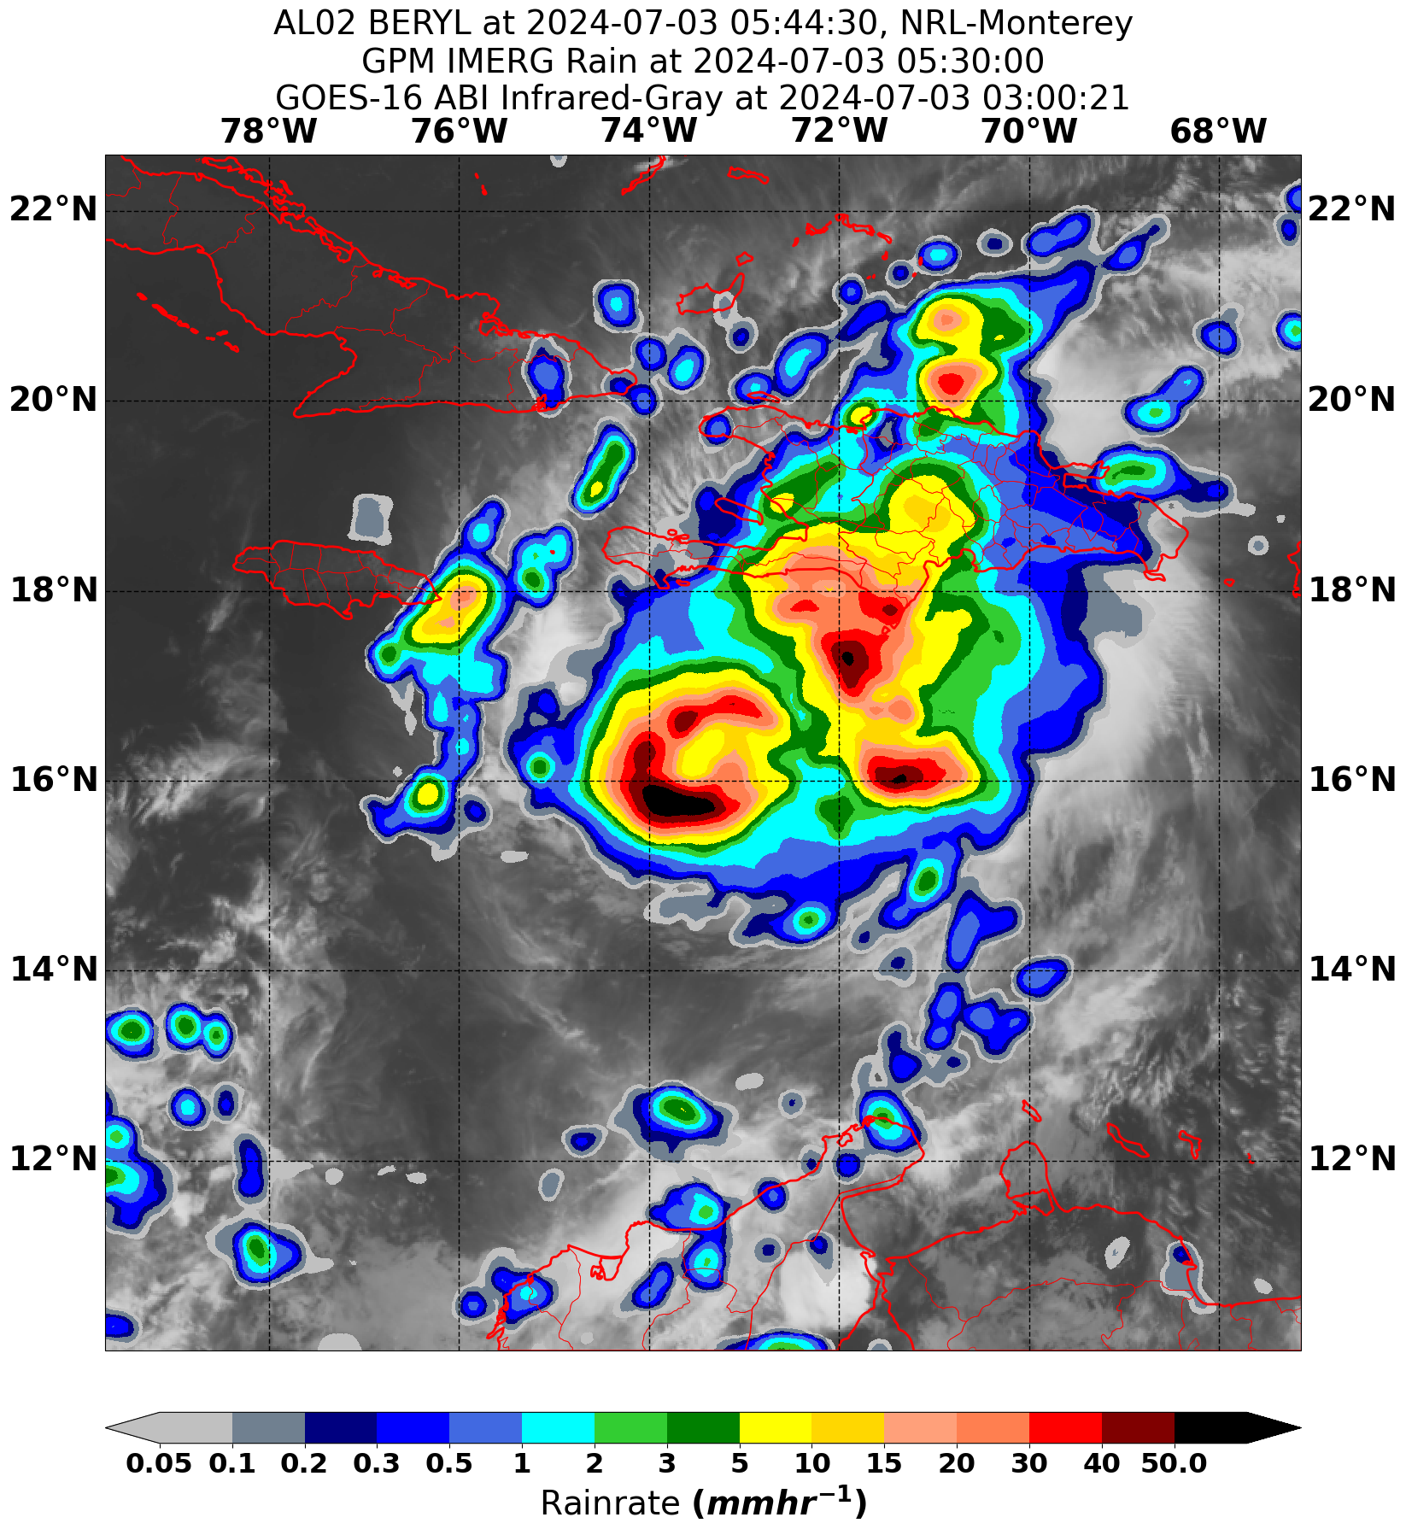  Rain rates highest near the SE quadrant of the eyewall, as well as in an area of convection in a eastern band
1130 | 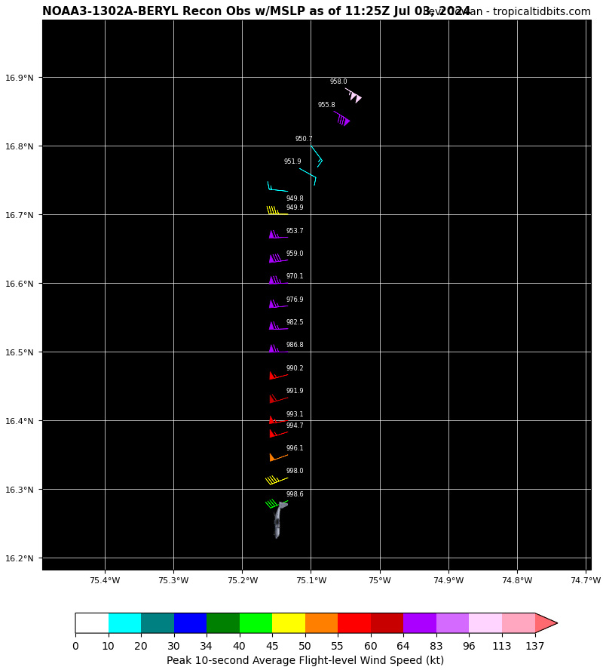  First Pass. NOAA fix: extrapolated surface pressure 949.8 mb, peak inbound N quadrant.
1129 | Sonde #6; midpoint (S side)
1141 | Sonde #7; endpoint (S side)
1157 | Sonde #8; IP (SE - NW pass)
1202 | Sonde #9; midpoint (SE side)
1206 | 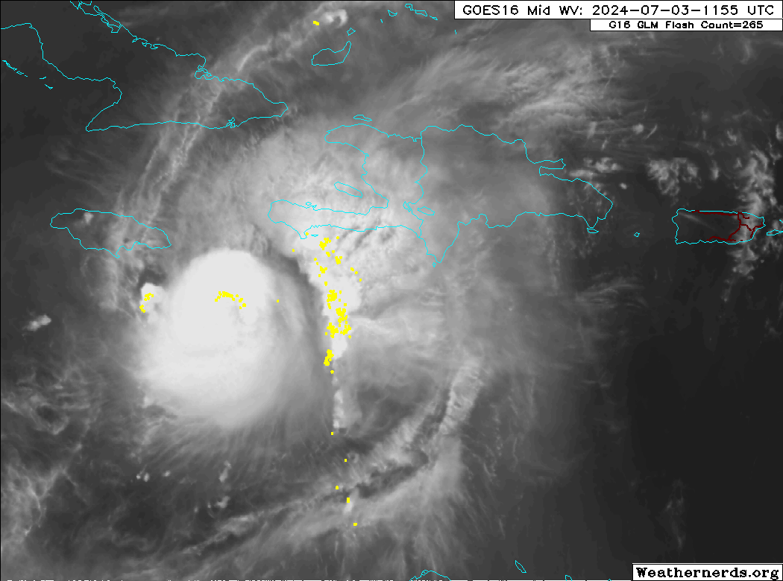  Abundance of lightning strikes along the northern eyewall and outer convective band to the E, as well as a small band on the W
1210 | Sonde #10; RMW SE side
1213 | Sonde #11; Center drop (2nd pass)
1215 | Sonde #12; RMW NW side
1220 | Some convection beginning to fire on the western side 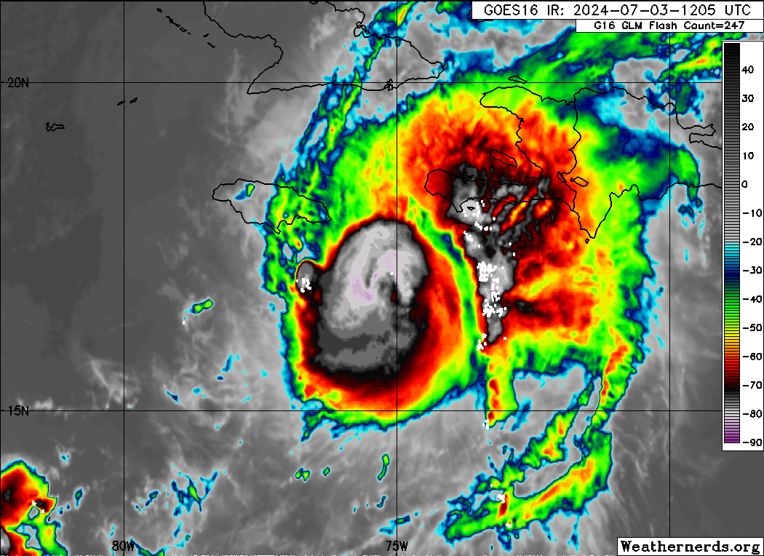
1220 | Outbound leg on NW side will be shortened to 70 nmi
1220 | Sonde #13; Midpoint NW side
1220 | Sonde #13 Data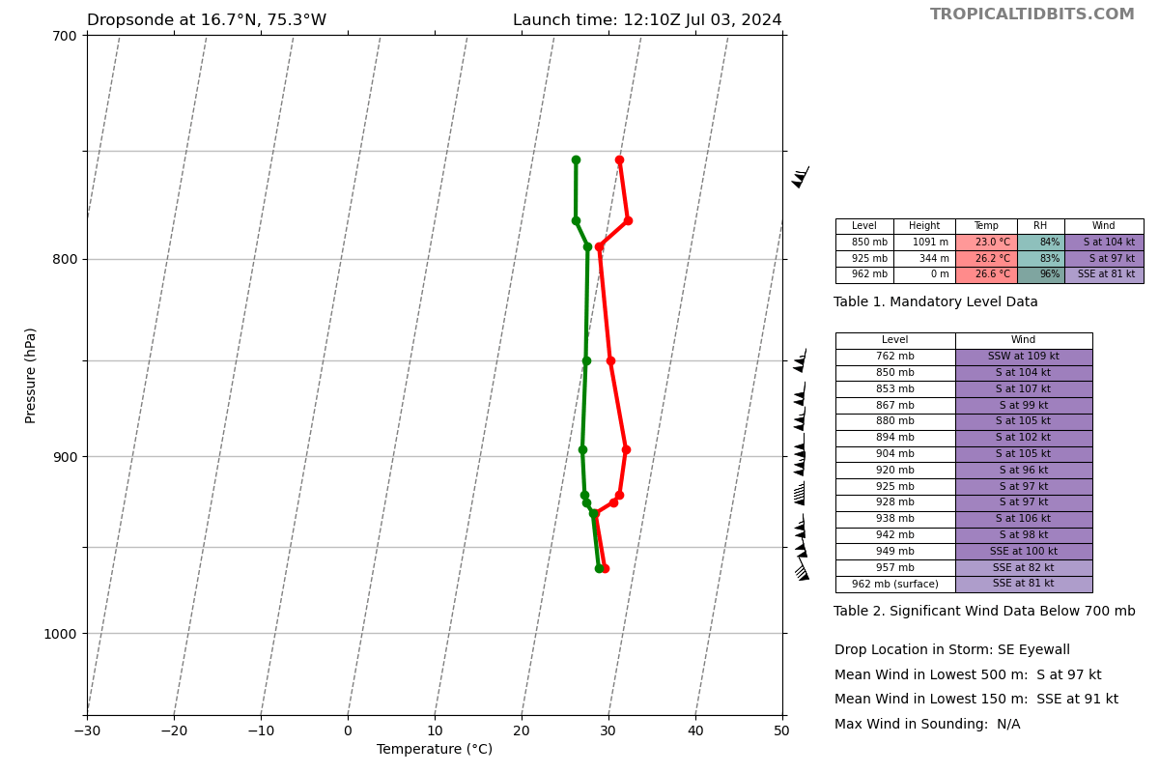
1228 | Sonde #14; End point NW side
1230 | 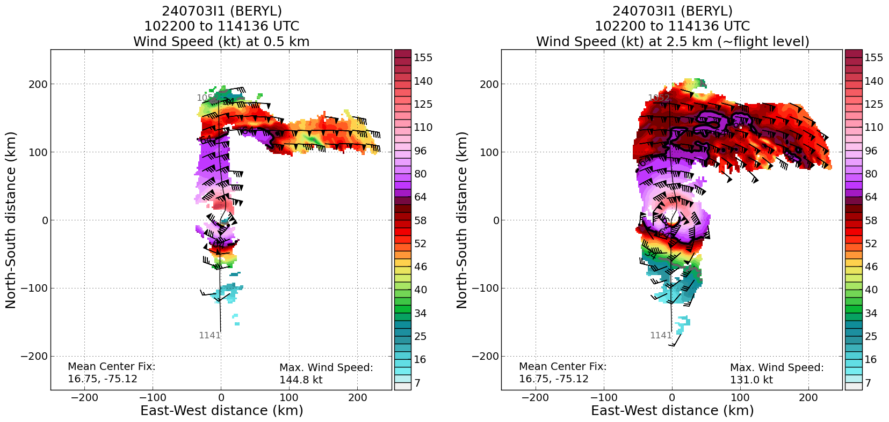  TDR analysis from the first pass shows a strong, but asymmetric vortex, with stronger winds on the north side; consistent with the motion vector. The eyewall is open on the south side. 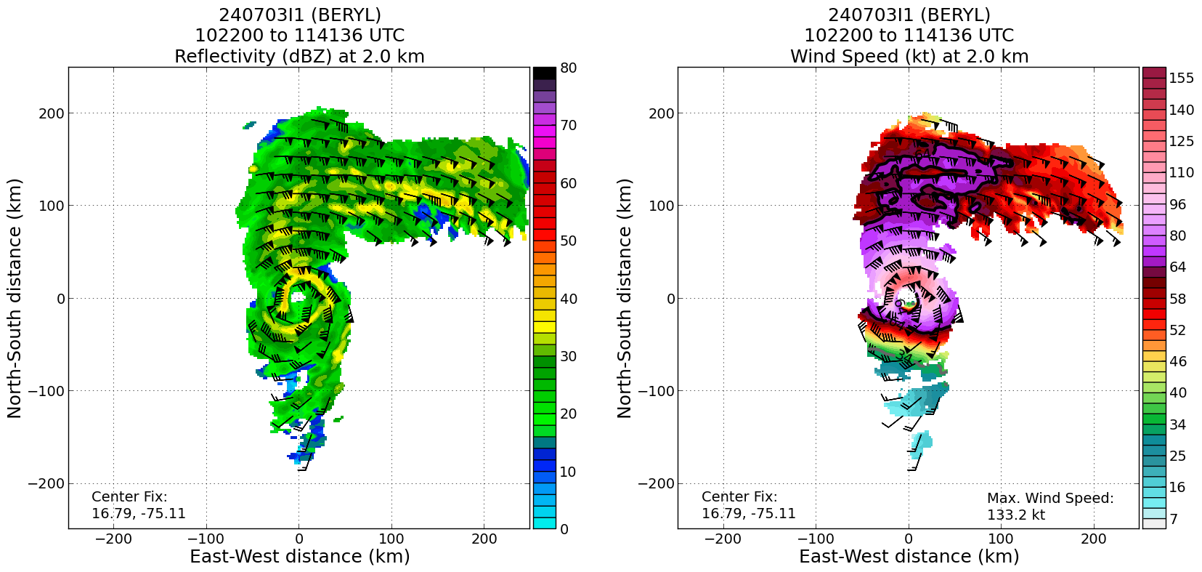
1231 | 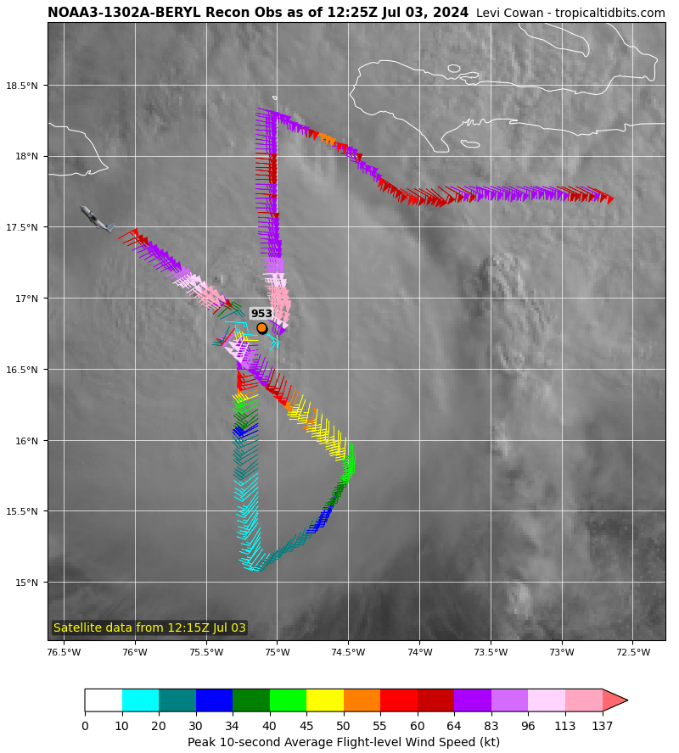
1232 | The first TDR analysis indicates the vortex is tilt left-of-shear, to downshear-left in the upper levels.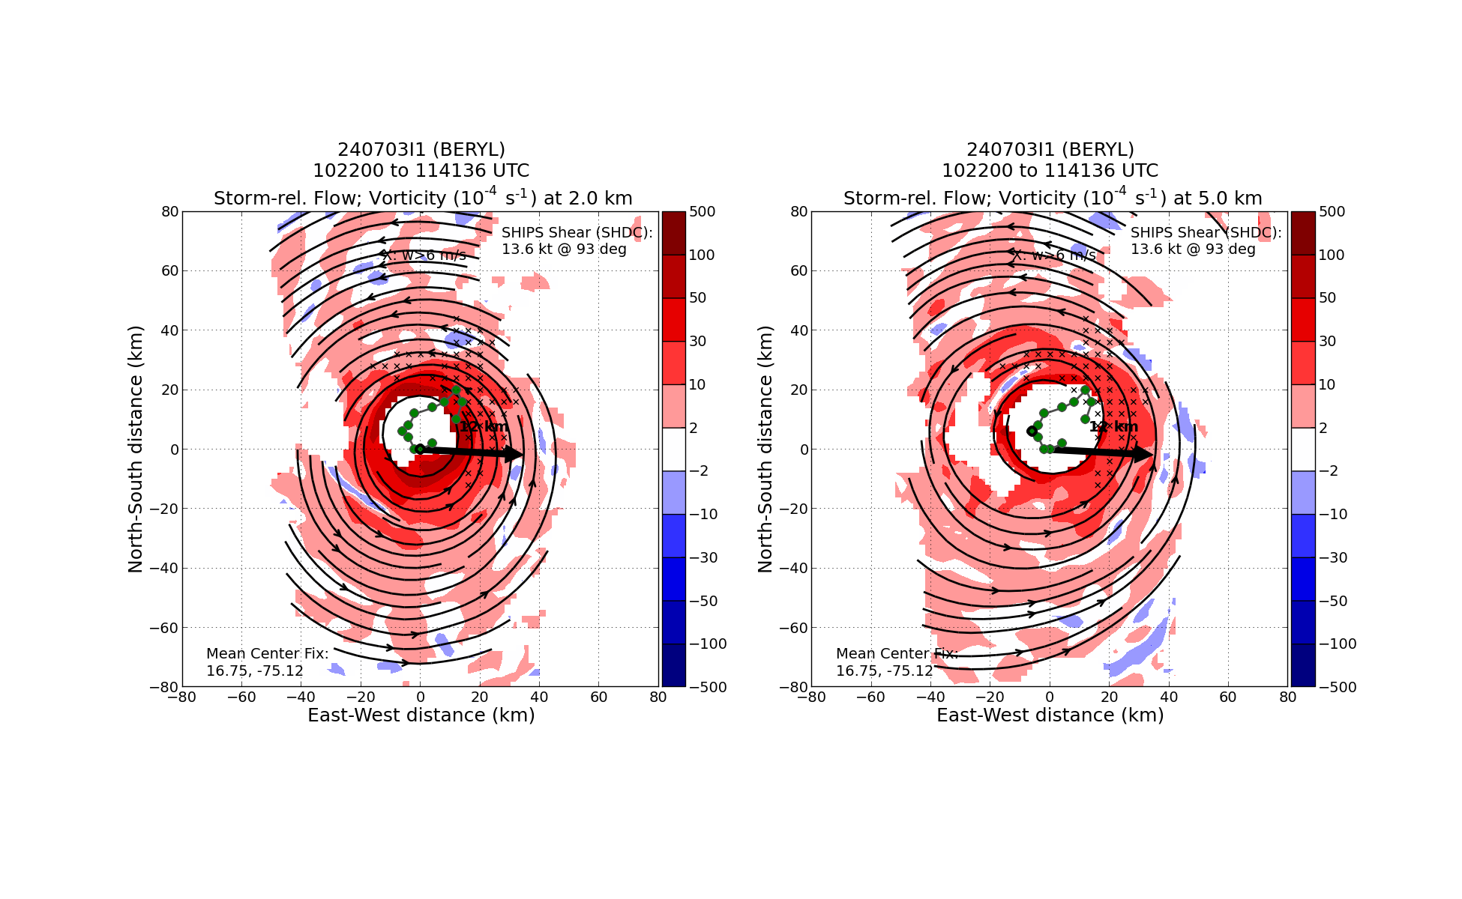
1246 | 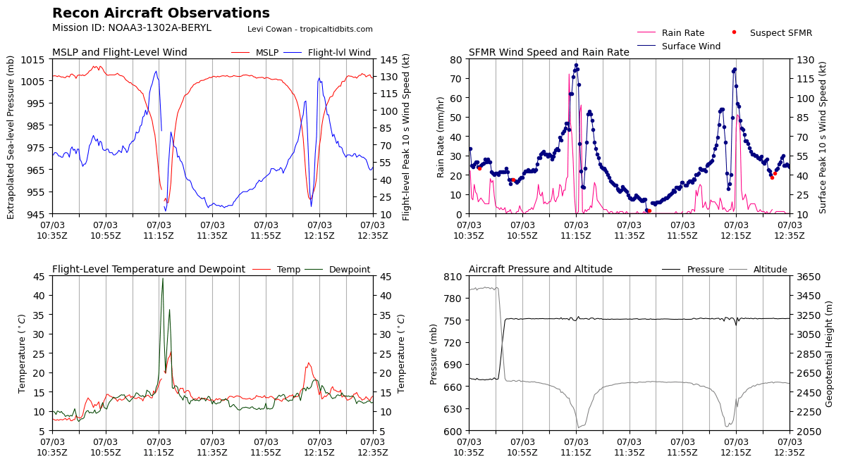  Data from the first two passes.
1254 | Sonde #15; IP SW-NE pass
1303 | Jun verified with AVAPS that both Streamsondes worked. Raw data was seen in the respective folders.
1305 | Sonde #16; midpoint SW side
1306 | Jun reported seeing signs of SEF with a large outer band noted on MMR
1312 | Strong inner core band noted on SW side; FL winds of 60 kt and echo top to 5 km. Perhaps signs of a secondary eyewall forming? We have seen persistent rainband activity on the downshear side. It seems plausible that shear-induced rainbands have attempted to axisymmetrize around the TC center, leading to SEF. The eye has reported to have begun filling with clouds and satellite imagery confirms a more cloudy eye.
1314 | Sonde #17; RMW (SW side)
1318 | Sonde #18; Center (3rd pass); ended up having bad data
1320 | Second TDR analysis shows a robust rainband at about 75 km from the TC center on both the SE (downshear) side as well as the NW (upshear) side. The vortex has also become more tilted, with the tilt estimate from the latest TDR analysis at 12.7 km at 342 degrees.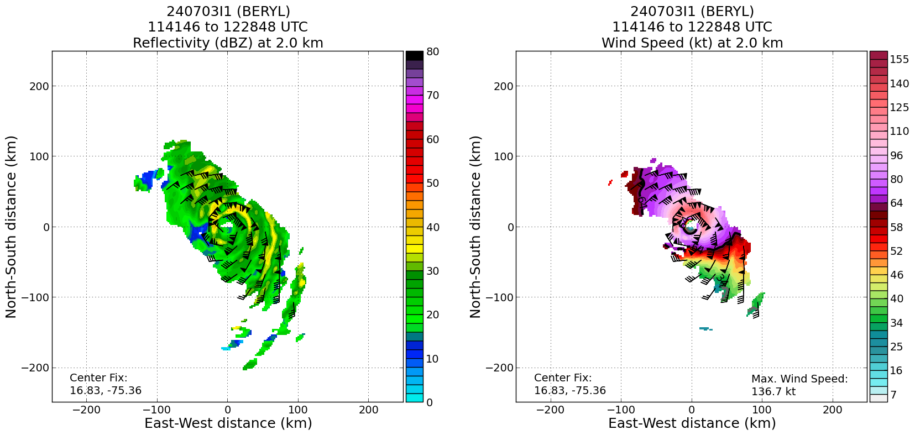
1320 | Profile from the 2nd TDR analysis shows subtle signs of a low-level wind max on the downshear side at approximately 75 km 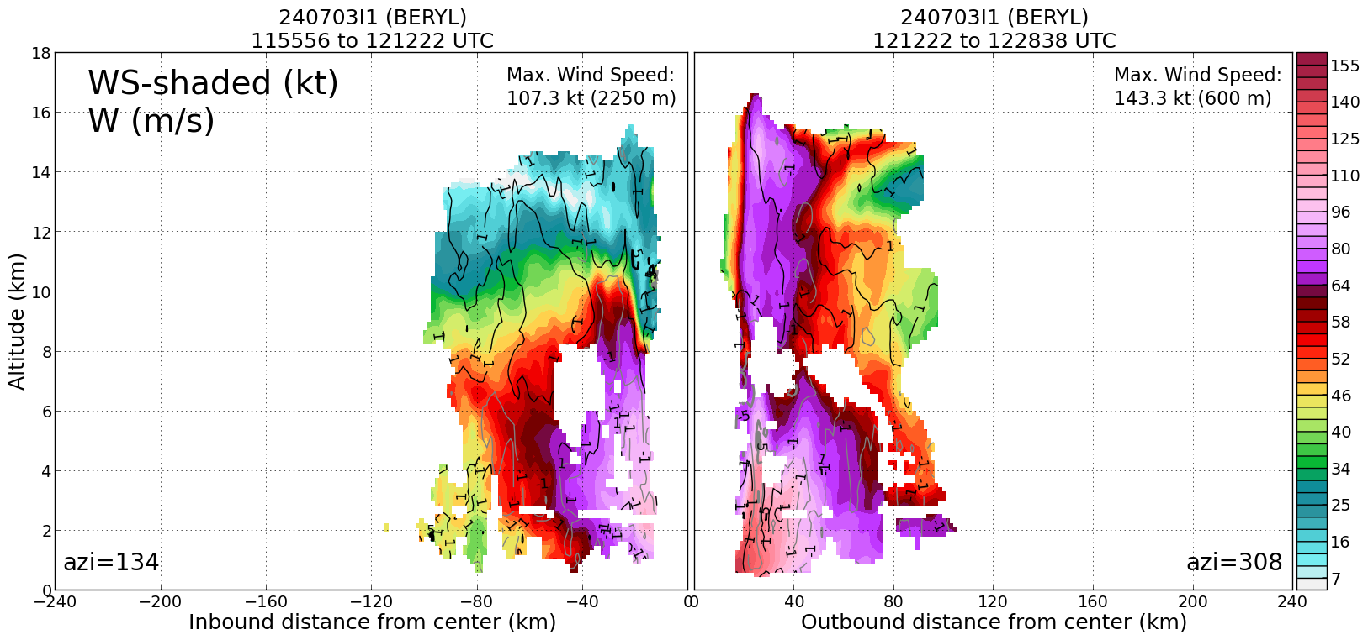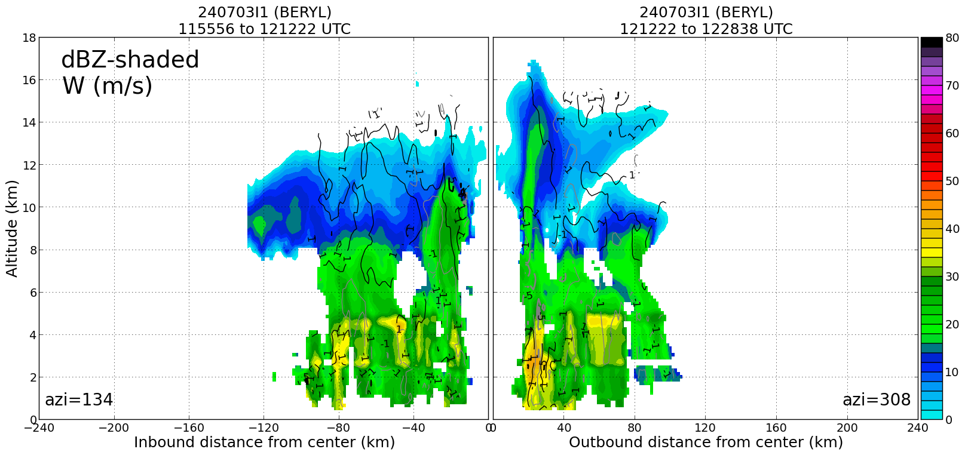
1320 | 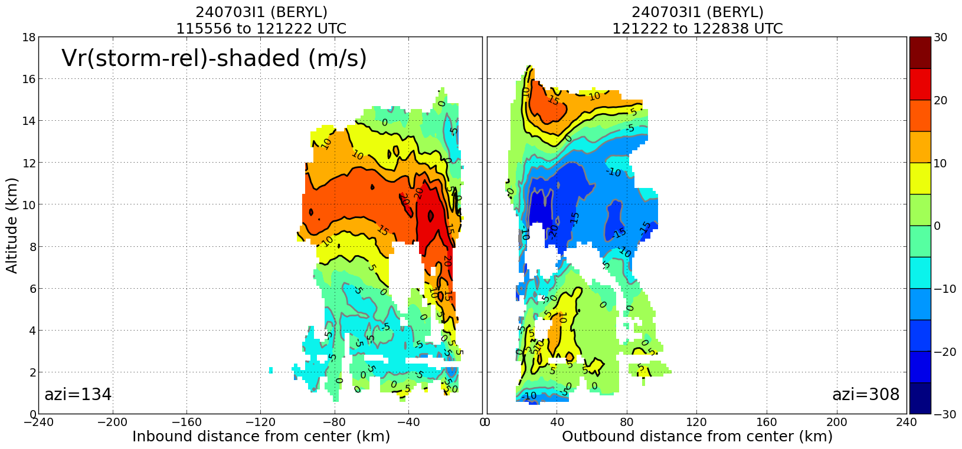 Interestingly, there are signs of strong mid-level shear, with a 15-20 m/s across vortex flow at a height of 10 km.
1321 | Sonde #19; RMW NE side
1329 | Sonde #20; Midpoint NE side
1336 | 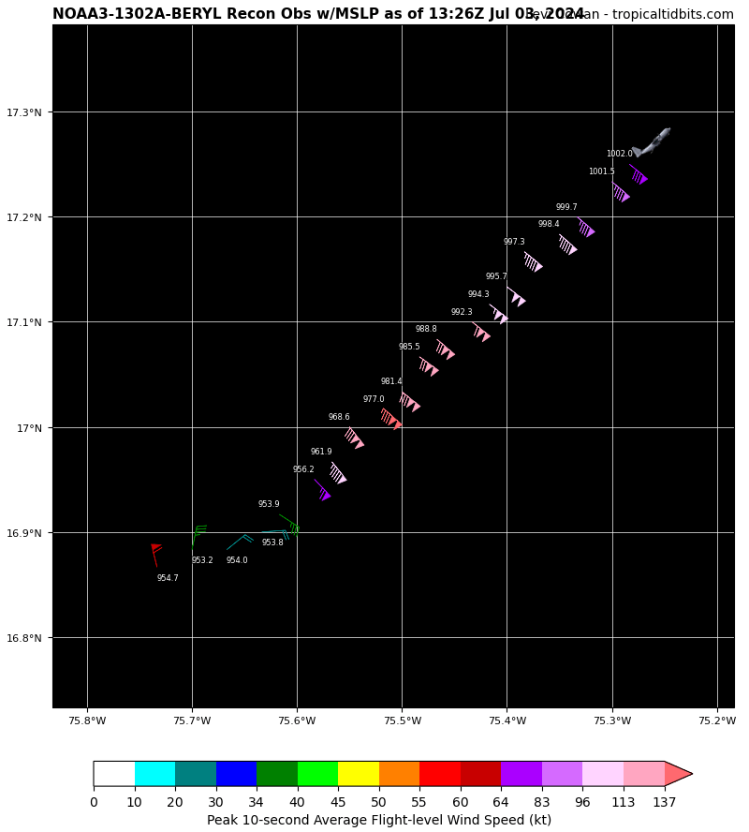  Third Pass. NOAA fix: extrapolated surface pressure 953.2 mb, peak outbound NE quadrant.
1336 | <Jun_N43_LPS> SW side better bumps  <Jun_N43_LPS> We are going through band features  <Jun_N43_LPS> bumpier than eyewall actually  <Jun_N43_LPS> NE side eyewall wasn't bumpy but a lot of rain  <Jun_N43_LPS> very high reflectivity
1337 | 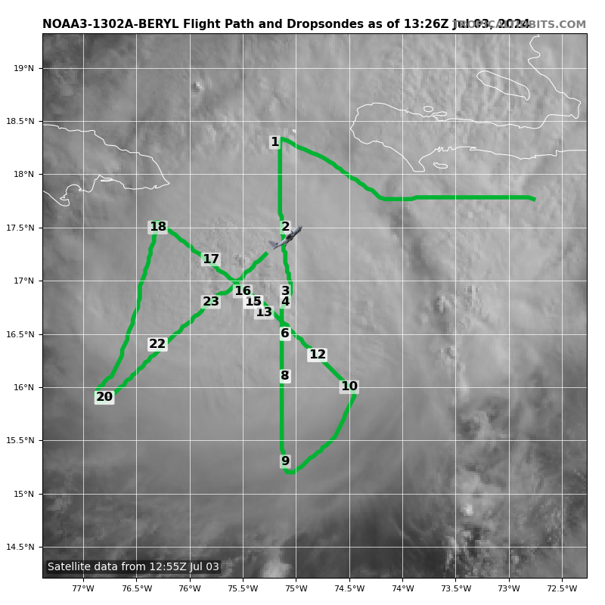
1341 | Sonde #21; endpoint NE side
1351 | 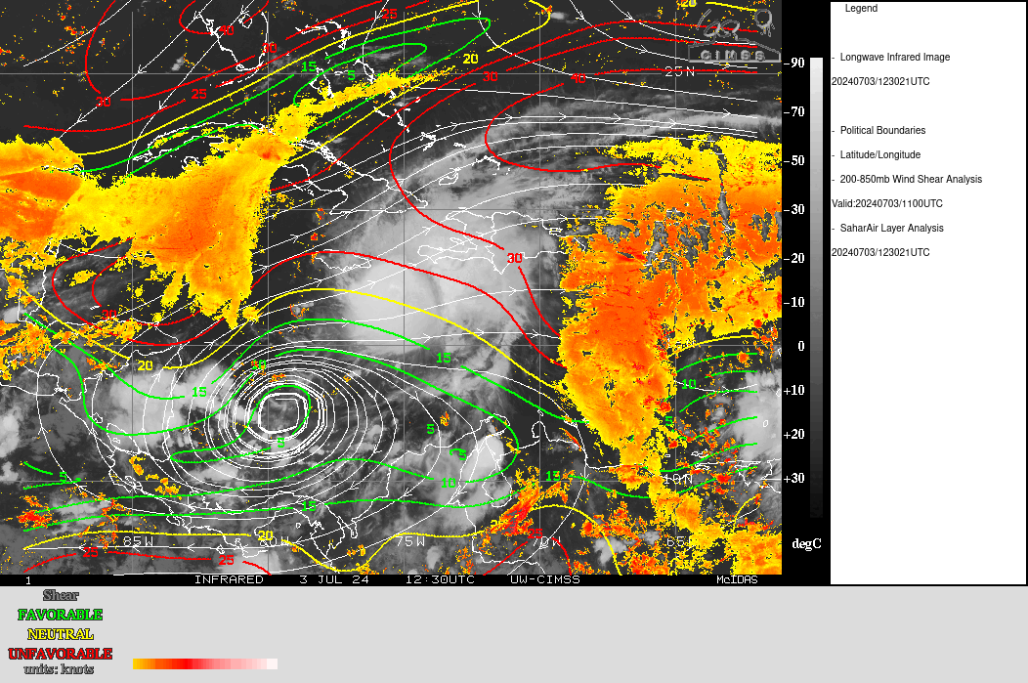  Storm encountering mod w-nw shear with dry air ahead/west of the storm depicted south of cuba
1430 | The third TDR analysis showed the low-level vortex was holding steady with similar peak winds, although the southern eyewall remains open. Interestingly, the 2.0-km reflectivity max in the eyewall was seen in the NW quadrant (upshear).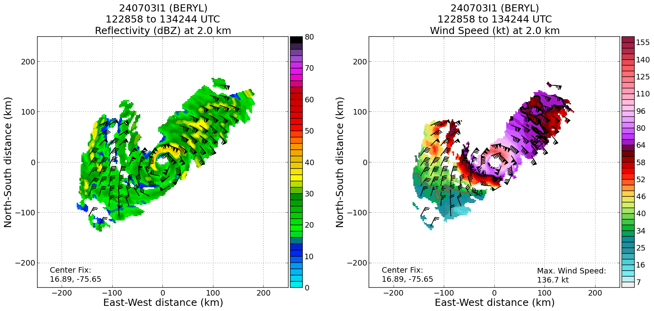
 | << INSERT ADDITIONAL ROW AS NEEDED >>

POST-FLIGHT
Mission Summary | A butterfly pattern was successfully flown in Hurricane Beryl. Due to navigation software issues early in the flight, the IP was delayed until 1053 UTC. As a result, the legs of the butterfly were shortened to 90 nmi.  Beryl was experiencing substantial vertical wind shear from the WNW throughout the flight. Model analyses and radar observations indicated this shear was maximized beneath the outflow layer. The second TDR analysis indicated approximately 15–20 m/s of cross-vortex flow (NW to SE) at a height of 10.0 km. Because the vortex was tilted to the NE by 15–20 km, it seems plausible that the cyclonic flow associated with the mid–upper level vortex was projecting onto the sheared environmental flow in this case, acting to increase the across-vortex flow, with respect to the low-level center. Consistent with this, the uptilt (southern) eyewall was quite weak and not closed on the southern side, potentially from entrainment of environmental air.  The storm maintained intensity during the first two passes, but exhibited some signs of weakening during the third and final pass, with the eye beginning to fill with clouds. However, the maximum TDR-measured winds at a height 2.0 km were fairly steady with time (between 133 to 136 kt), indicating the low-level vortex had not weakened yet, despite some decay of the southern eyewall. The strongest winds were consistently observed in the northern eyewall, consistent with the projection of the westward storm motion onto the vortex flow.  A total of 21 dropsondes were released (20 transmitted) and charged to NWS. A total of two Streamsondes were successfully released on the first center pass (in the eyewall region).  This case provides a nice opportunity to explore the impacts of shear/ventilation onto tropical cyclone convective and vortex structure in a mature hurricane.
Actual Standard Pattern Flown | Butterfly with 90 nmi legs
APHEX Experiments / Modules Flown | [Linked to HFP Plan; fill in regardless of whether the mission was operationally or research tasked]  RICO SUAVE
Plain Language Summary | We flew an operational mission into category-4 Hurricane Beryl as it passed south of the island of Hispaniola and was approaching Jamaica. This mission collected data to be incorporated into NOAA hurricane models and used by forecasters at the National Hurricane Center. This mission involved additional testing of experimental, ultra-lightweight weather instruments, called Streamsondes, that were deployed from the P-3 in the eyewall of Hurricane Beryl. The data collected from this mission also provided excellent research opportunities to better understand how the environment of a hurricane, especially characteristics related to how the environmental winds change with height (i.e., vertical wind shear), can influence the structure and intensity of the storm.
Instrument Notes | 2 of the 2 Streamsondes that were available were deployed (1 in RMW N and 1 in RMW S). Jun verified with AVAPS that both Streamsondes worked. Raw data was seen in the respective folders. 3 TDR analyses were successfully transmitted.
Final Mission Track | 