MISSION PLAN
FLIGHT ID | 20240703H1 | STORM | AL02 / Beryl
MISSION ID | 1602A | TAIL NUMBER | NOAA-42
TASKING | EMC/NHC TDR | PLANNED PATTERN | Butterfly
MISSION SUMMARY
TAKEOFF [UTC] | 1927 | LANDING [UTC]
TAKEOFF LOCATION | St. Croix | LANDING LOCATION | Lakeland
FLIGHT TIME | Fractional hr, Takeoff to Landing Time | BLOCK TIME | Get from onboard LPS or Flight Director
TOTAL REAL-TIME RADAR ANALYSES  (Transmitted) | 3 (3) | TOTAL DROPSONDES Deployed (Transmitted) | Ex. 32 (30)
OCEAN EXPENDABLES (Type) | None | sUAS (Type) | None
APHEX EXPERIMENTS / MODULES | None
HRD CREW MANIFEST
LPS ONBOARD | Aberson | LPS GROUND | Dunion, Dahl
TDR ONBOARD | Aberson | TDR GROUND | Alvey
ASPEN ONBOARD | None | ASPEN GROUND | Dahl, Dunion
NESDIS SCIENTISTS | P. Chang
GUESTS (Affiliation) | None
AOC CREW MANIFEST
PILOTS | Copare, Palmer, Ellis
NAVIGATOR | Utama
FLIGHT ENGINEERS | Stokes, Dittoe
FLIGHT DIRECTOR | Zawislak, Englert
DATA TECHNICIAN | McCalister
AVAPS | Lynch

PRE-FLIGHT
Flight Plan | Worked with N-42 Nav to rotate Butterfly to better avoid Jamaica.  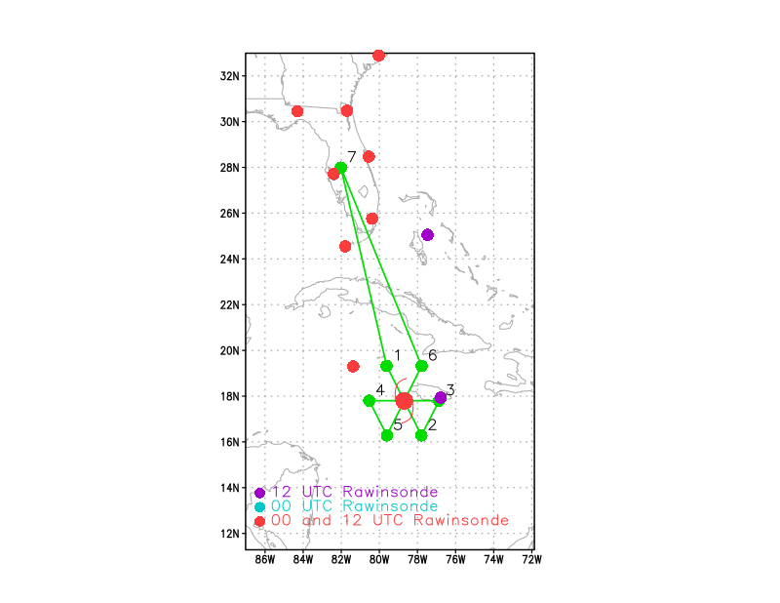  Altitude:  - 10 kft preferred - 8 kft if AF deconfliction is required (pressure altitude)  Potential add-on Modules: (time permitting)  - None
Expendable Distribution | - Load 35 dropsondes  - Release at endpoints, midpoints, centers, RMWs (if requested by NHC) >> charged to NWS  - All dropsondes transmitted to the GTS  - No AXBTs
Preflight Weather Briefing | Rotated the Butterfly pattern 30 deg counterclockwise to better deconflict with Jamaica.  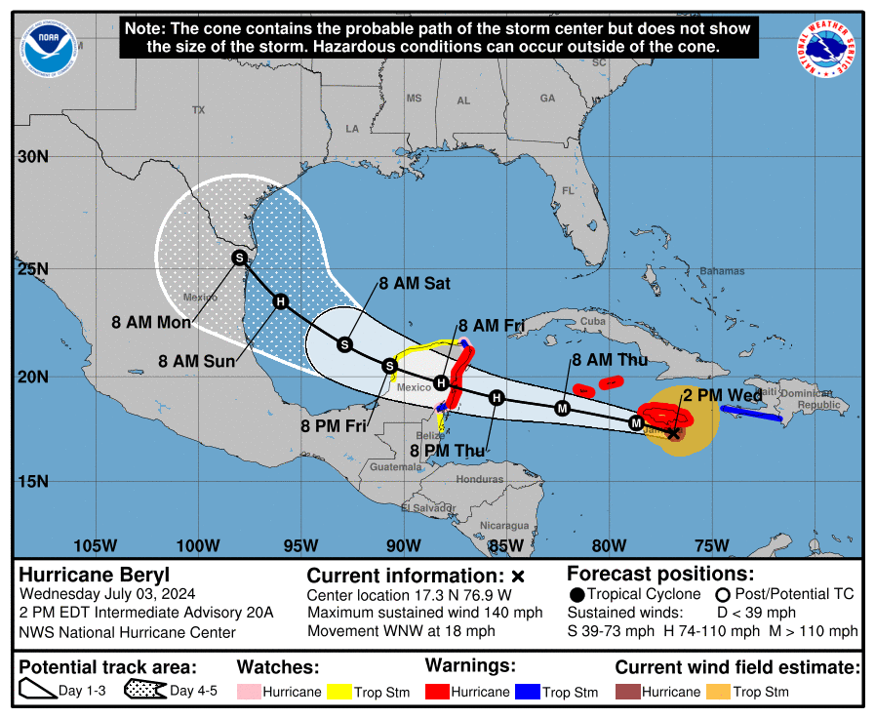
Instrument Notes | All instruments appear to be operating normally. The SFMR on N-42 was performing poorly over the last several days and was swapped out in St. Croix with another AOC SFMR unit (US0001) before take-off.

IN-FLIGHT
Time [UTC] | Event
1927 | Take-off from St. Croix
2015 | NHC current motion & intensity as of the 1500z advisory: 285 deg @16 kt, 125 kt Cat 4
2020 | GOES 16 VIS: Beryl is passing ~10-15 NM south of Jamaica. Huge arc clouds are pushing out from the western semicircle of the storm, indicating that vertical wind shear and mid-level dry air may be tag teaming today.
2110 | 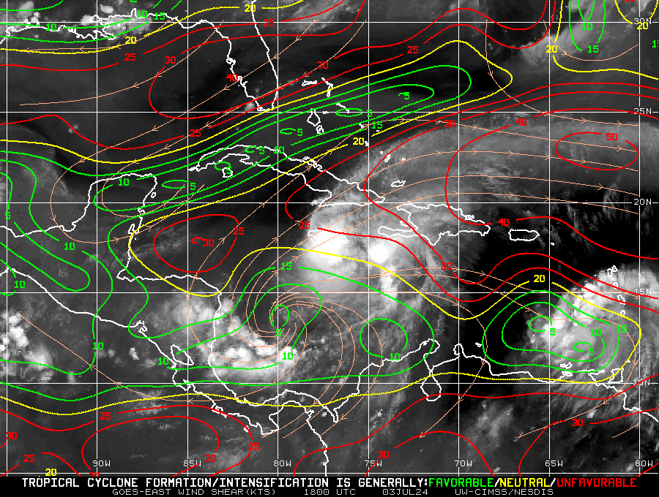  CIMSS vertical wind shear showing a large N-S gradient in wind shear. The 18z SHIPs is diagnosing 18 kts at 286 deg, which looks like a blend of the N-S shear gradient that CIMSS is showing.
2115 | MIMIC TPW from 2200z: showing TPW ≤45 mm (green to blue shading) indicating very dry air from ~600-900 mb. This dry air likely helped kick off the large arc clouds seen today in tandem with the WNW vertical wind shear that’s affecting the storm.  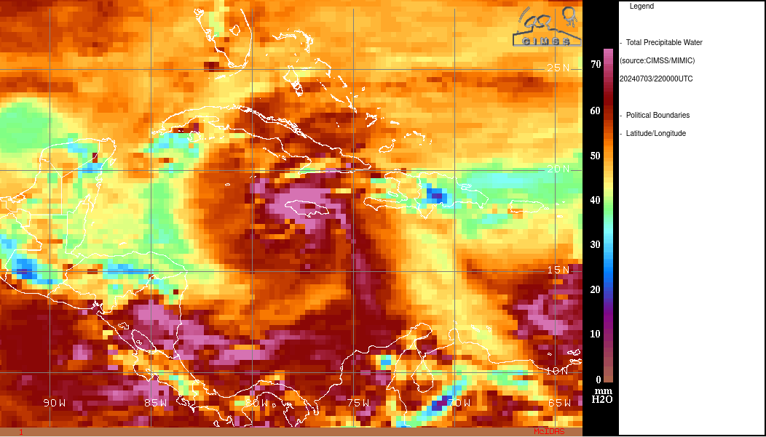
2130 | Interesting case of vortex resilience despite the hostile conditions mentioned above. If anything it looks like the eyewall/inner core structure has improved slightly this afternoon.
2142 | Sim: We've been going through a lot of stratiform (and a little convection). Trey will include this in his first analysis
2223 | Monitoring for possible SFMR issues again.  Zjelenak: need to pay really close attention to this this is the unit that was deteriorating over time last year  zjelenak: this sfmr isn't properly calibrated with height  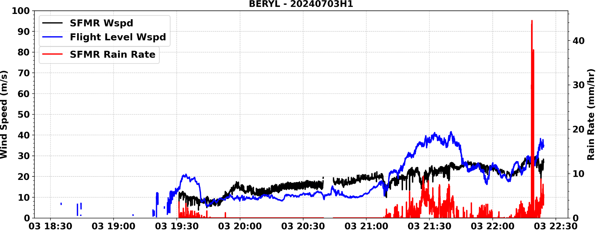  Zjelenak: Hdobs winds are way higher then 1sec winds this is 1sec plot  Sim: at 2223, SFMR winds took a dive where FL winds increased  zjelenak sim_42 at the same time rain rate increased that is know algorithm issue with sfmr
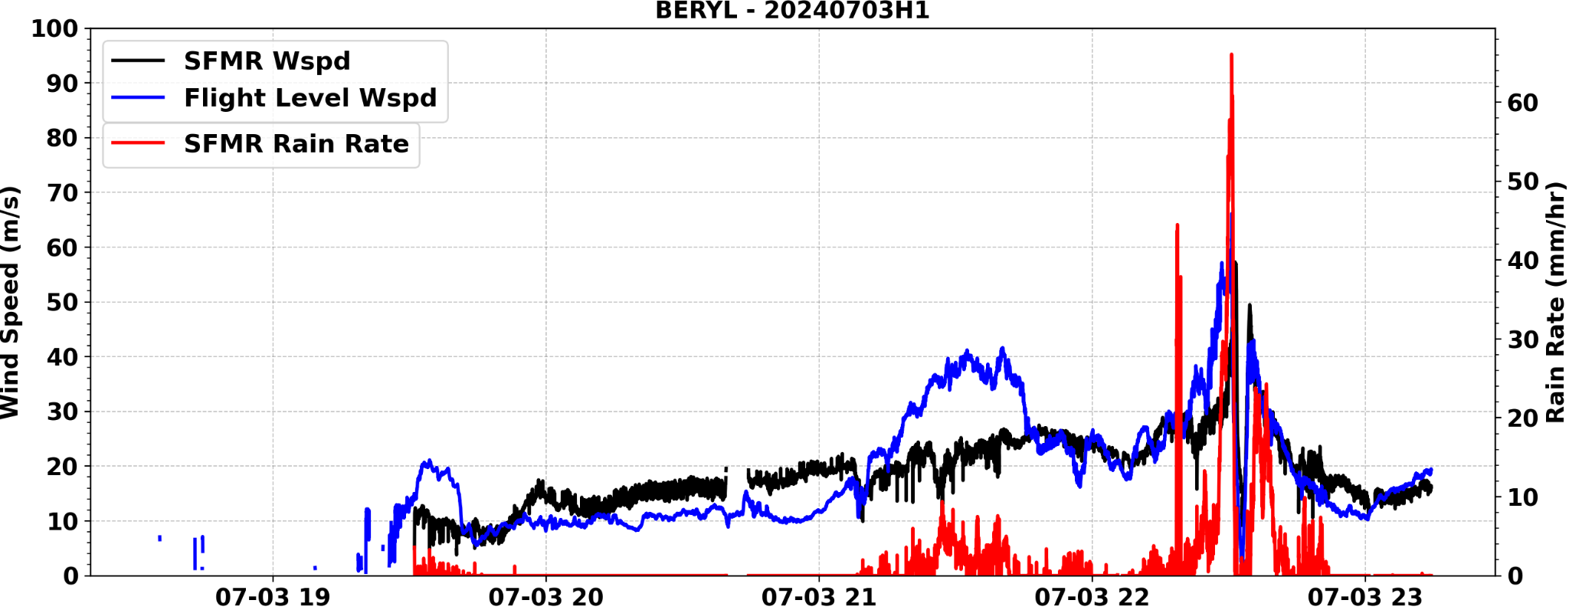
Downwind leg E-W north of the center to get to IP then NW-center-SE
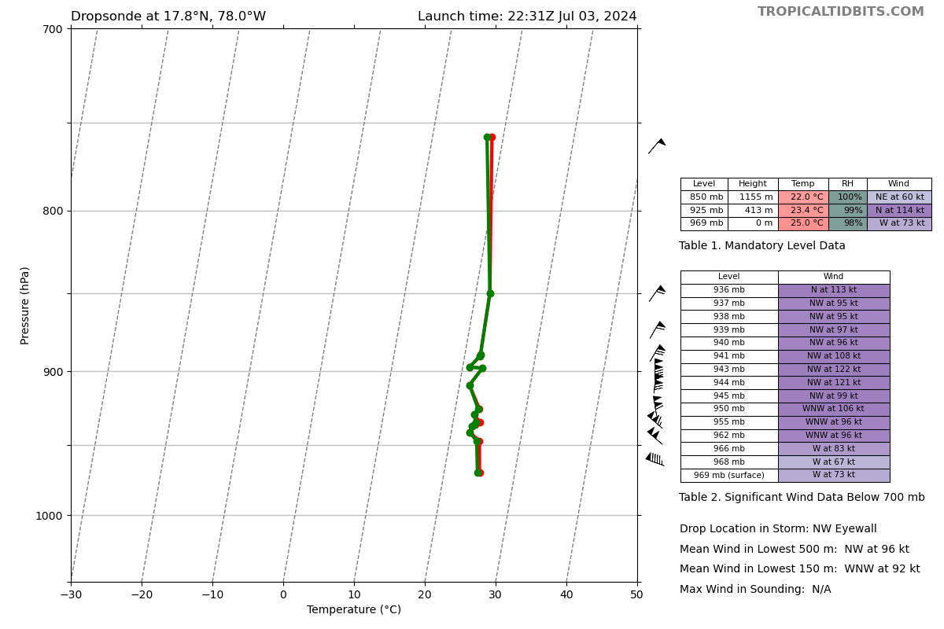
Interesting NW eyewall sonde - looks like it may have gone up & down a few times. Maybe got caught in some convection or misovortices? Sim noted some scallop-like features on the MMR and it was pretty bumpy
2324 | 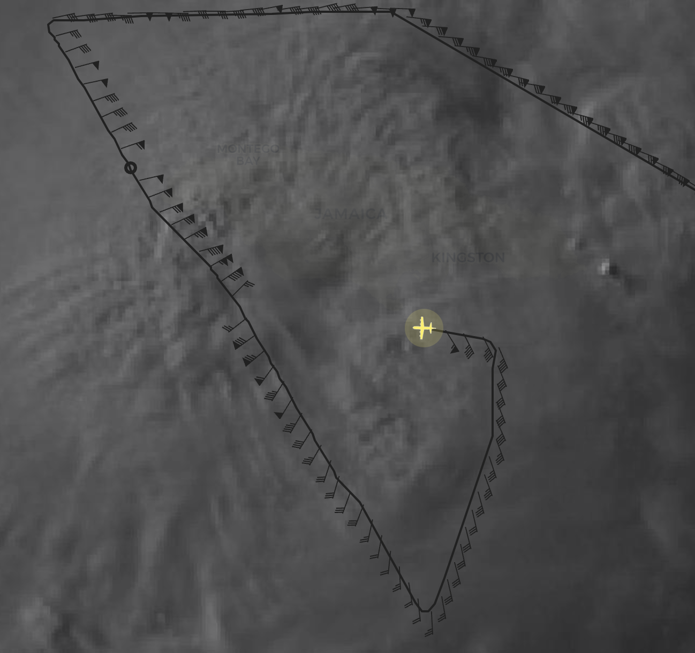
2345 | 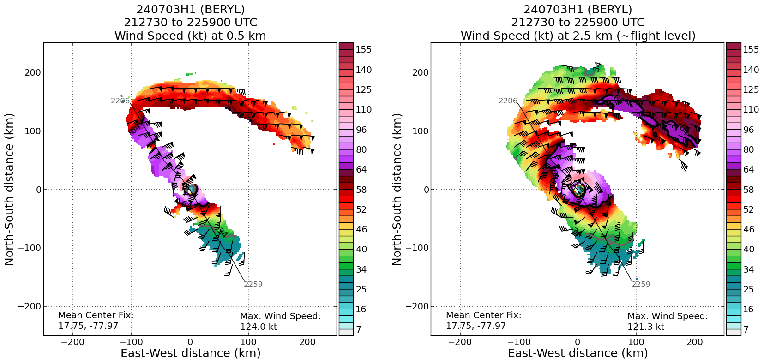  1st radar analysis
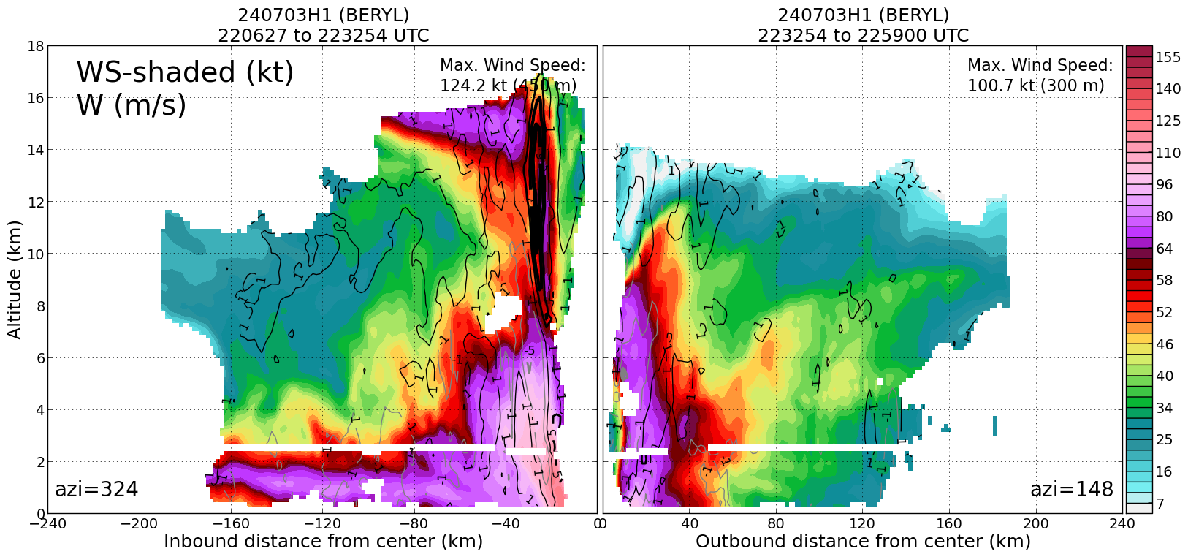
Updrafts in upper levels above 6-7 km and downdrafts in lower trop. consistent with maturation of convection in upshear left quadrant (NW). Interesting wind max above 14 km - not 100% sure if it’s physically real?? Wind looks pretty strong for the outflow layer and quite a sharp gradient but it could definitely be from the strong updraft and the corresponding outflow.
2430 | Looks like an increase in vortex tilt from 4 km to 10 km on that second pass and satellite presentation degrading a bit.
 | 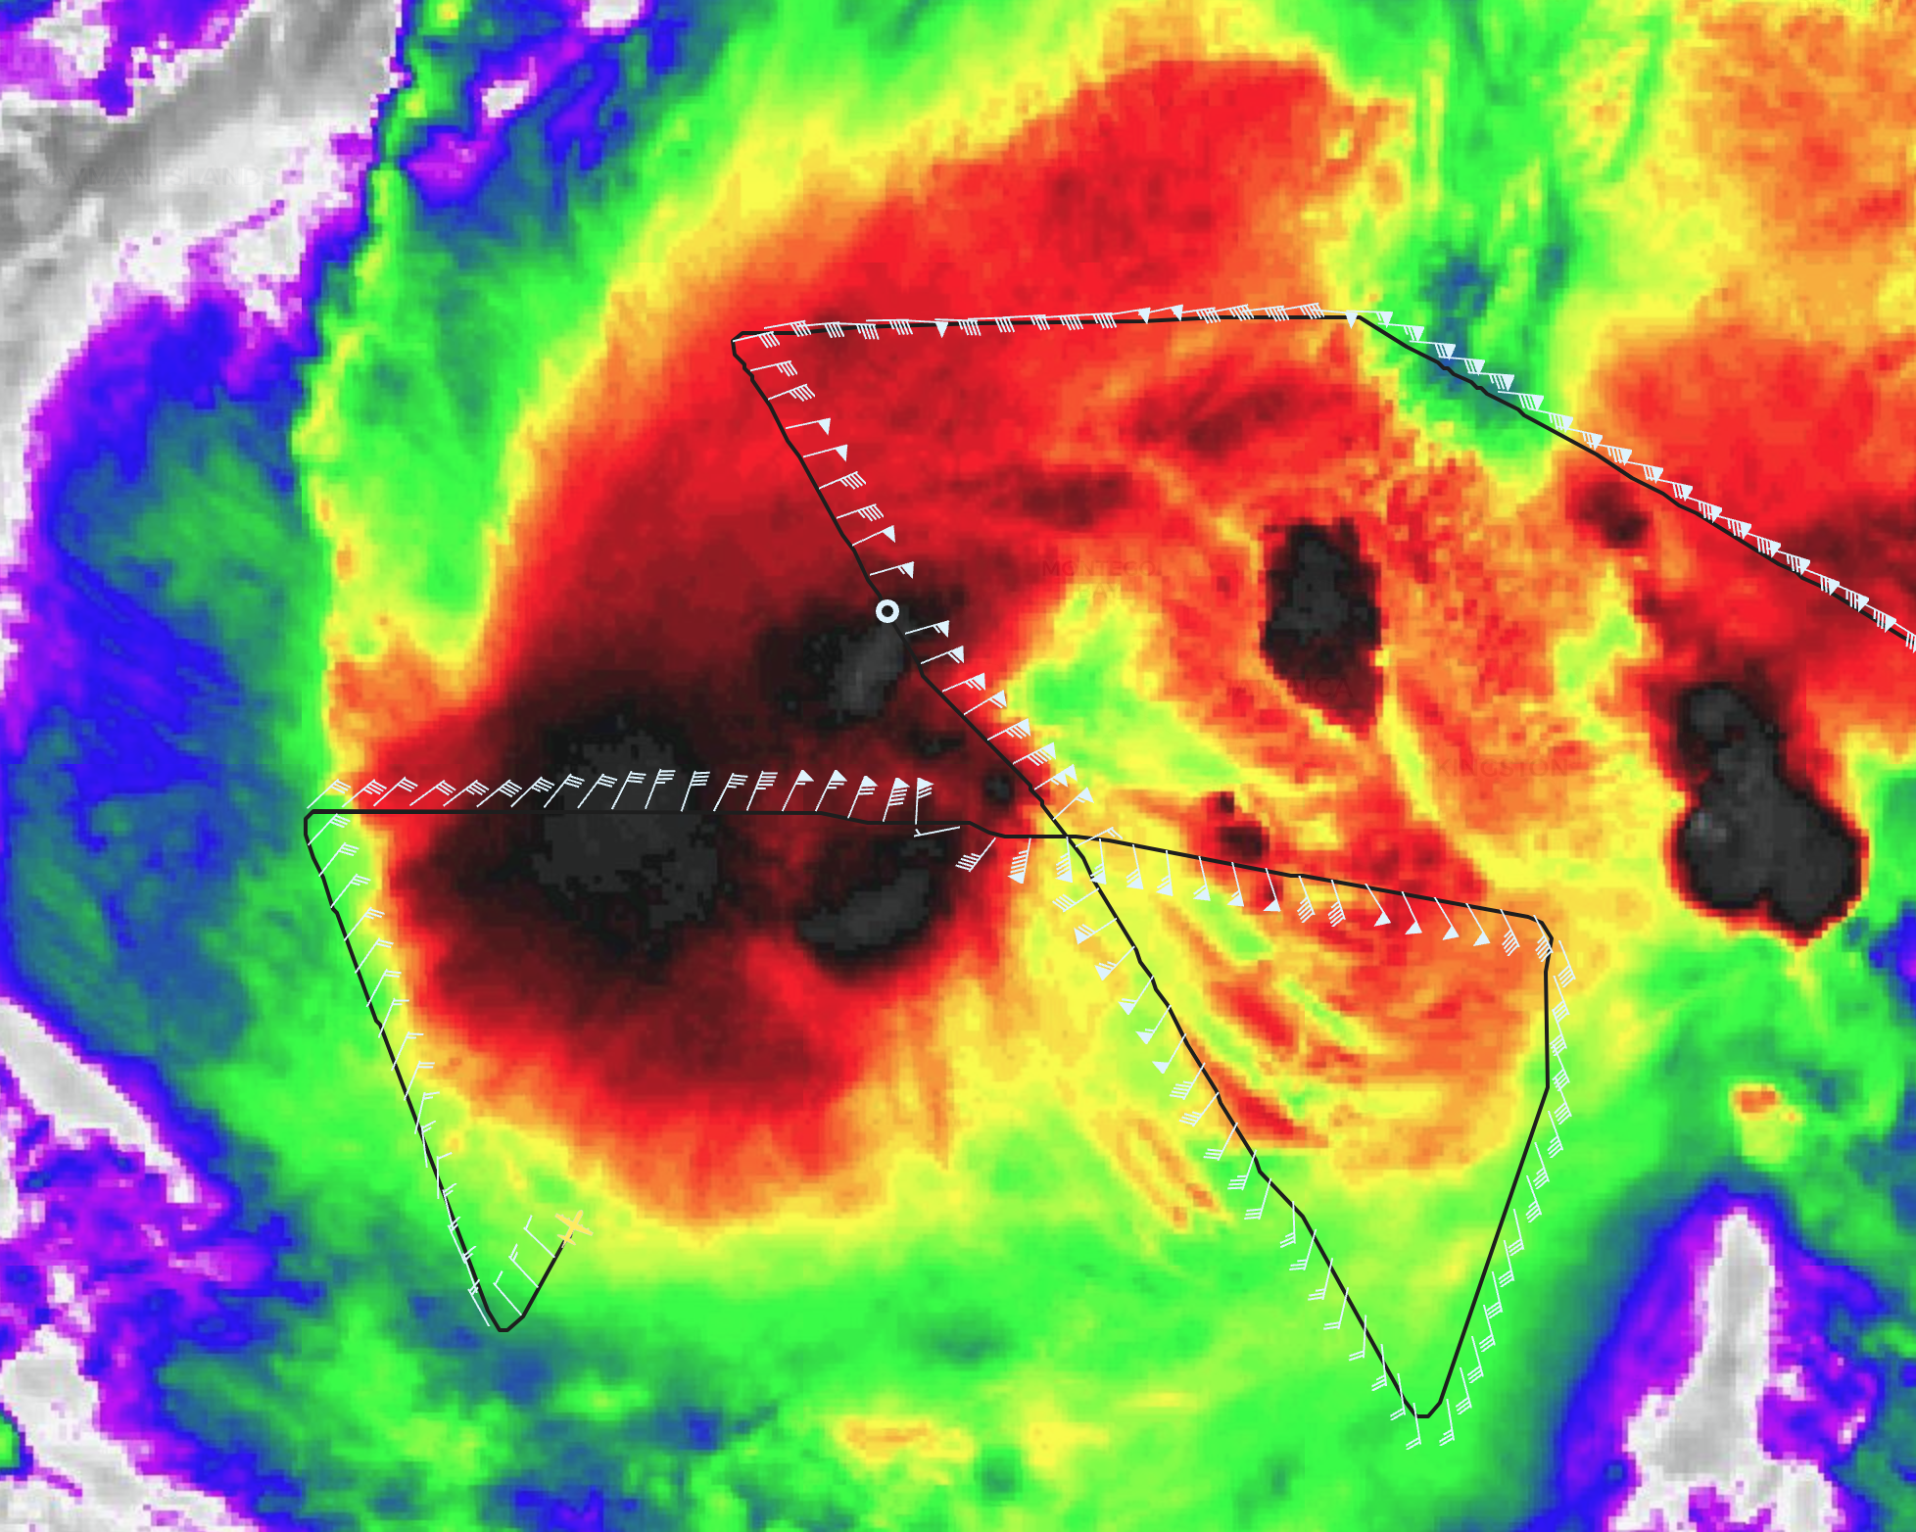
2442 | sim_42 very light winds on this side. We're 40 n mi from the inner edge of the eyewall. Flight-level winds 11 kt.
 | 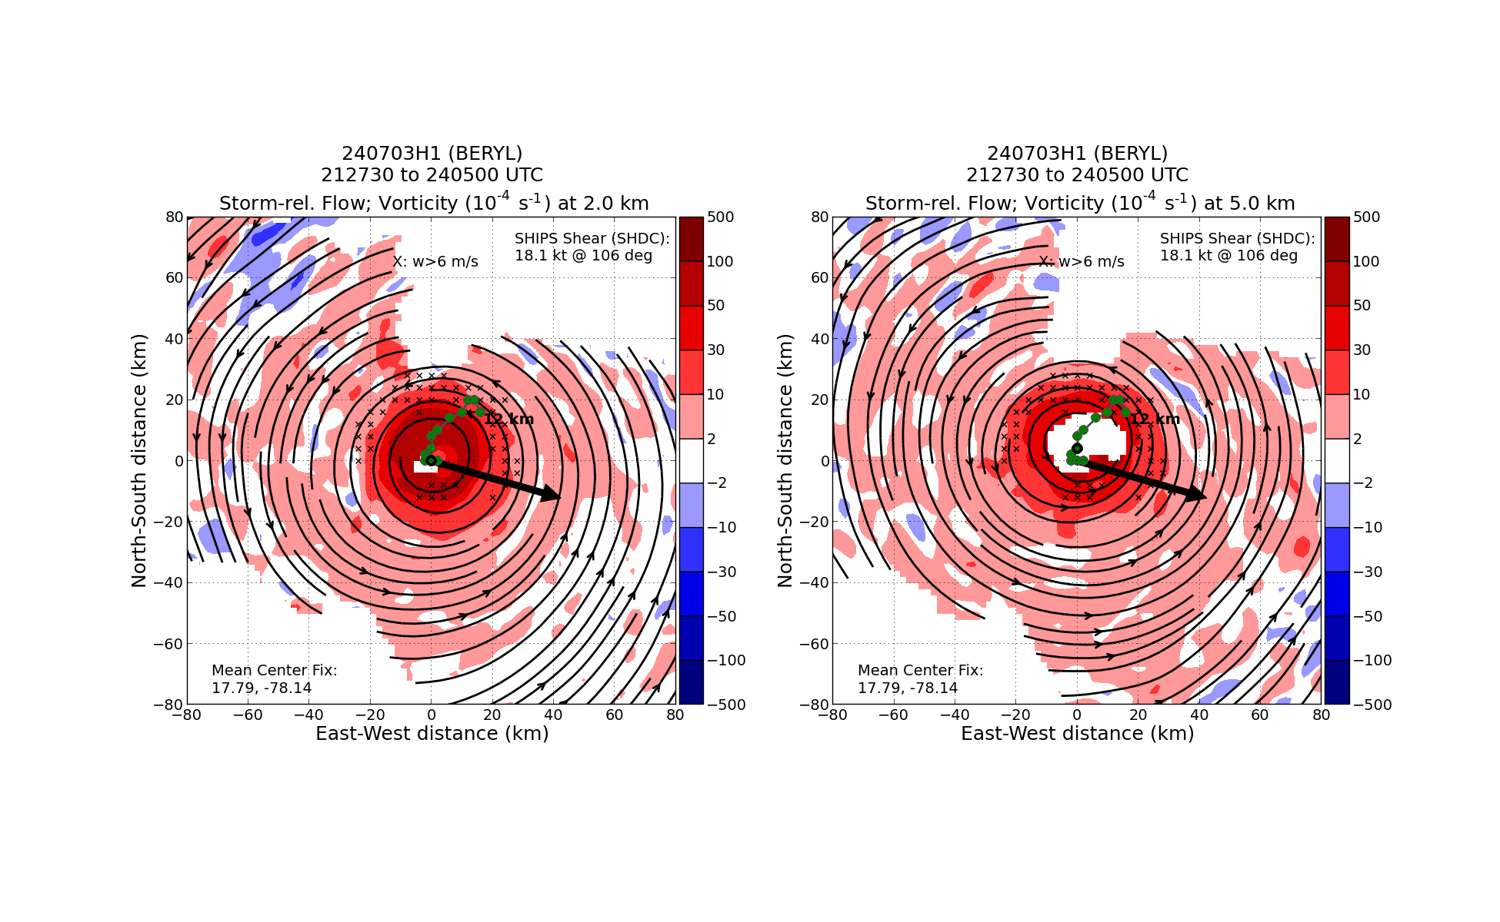
2448 | Scallops in w eyewall - working to avoid
0123 | Final point (WP 6 - NE)
JZ_N42_FD HRD ground folks say they're starting to see tilting of the cente
JZ_N42_FD center in the TDR
JZ_N42_FD also, off station, headed back towards LAL
CARCAH_Steve Yeah, John C is looking at the new tilt product available in AWIPS as well and sees it.

Paul and Michael will appreciate this :D
0149 | Tilt increased again and farther DSL on 3rd pass - 2-6-km Vortex Tilt: 12.7 km at 18 deg
 | 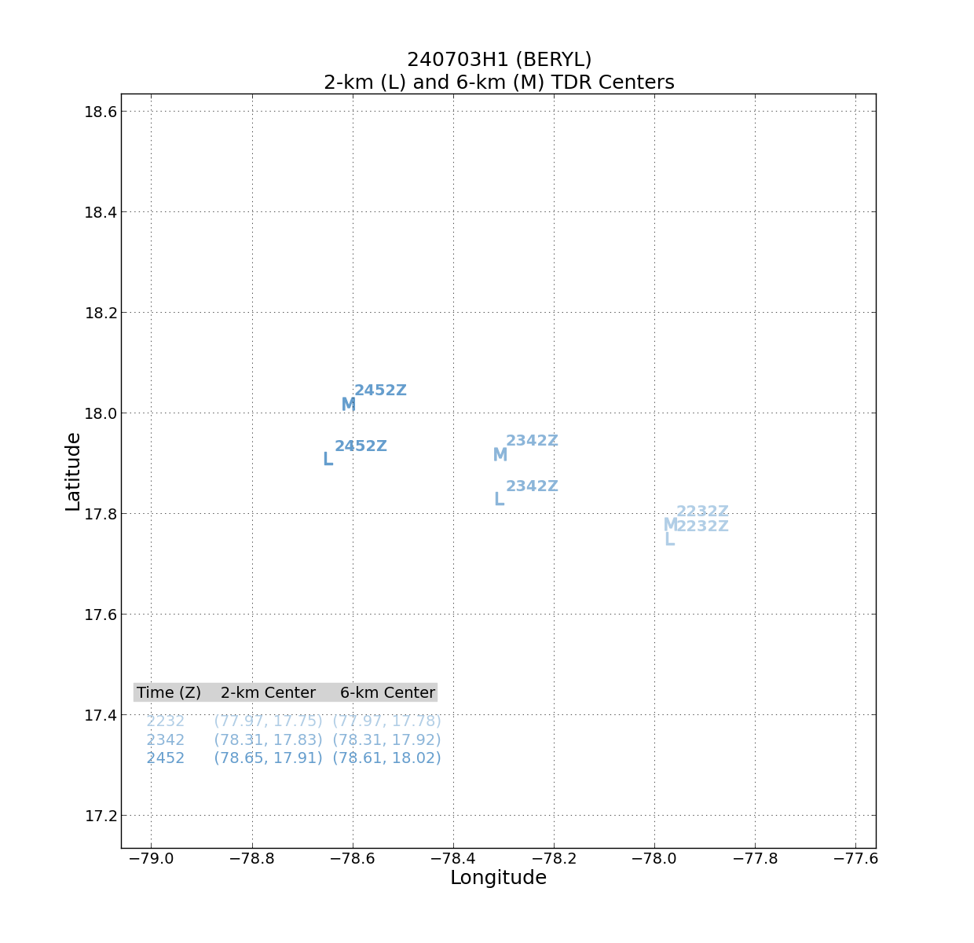
Via NHC forecast discussion: “NOAA's P-3 Tail Doppler Radar
data does suggest that there is some vertical tilt to the vortex,
likely due to moderate westerly vertical wind shear” 🙌

POST-FLIGHT
Mission Summary | We flew a successful TDR butterfly in Hurricane Beryla as it maintained an intensity of moderate Category 4 hurricane. Although it is experiencing moderate vertical wind shear, the vortex appears to be maintaining its intensity for now. From the initial 1st pass to the subsequent 2nd and 3rd passes through the center, the 4 to 10 km vortex appears to be less favorable (larger) and the satellite presentation has begun to degrade (e.g., less convective symmetry and the eye is obscured by clouds).
Actual Standard Pattern Flown | Butterfly
APHEX Experiments / Modules Flown | None
Plain Language Summary | We flew a NOAA P-3 mission into Hurricane Beryl to collect tail Doppler radar data for assimilation into NOAA’s forecast models and for use by forecasters at the National Hurricane Center. Unfavorable winds are weakening and tilting the Beryl while dry air to the west is eroding its cloud field. Although environmental conditions are not ideal right now, Beryl is still a powerful Category 4 major hurricane.
Instrument Notes | NOAA-42’s SFMR was swapped out in St. Croix earlier today with SFMR unit US001. This unit does not appear to be well calibrated and HDOBs being sent off the plane are still not being generated properly. However, this unit appears to be working better than the SFMR unit that it replaced. Aspen appears to be having problems plotting Synoptic Maps using the soundings.sqlite that is concatenated during the mission. The dropsondes that were processed using TAG during the mission appear in the synoptic Map listing, but they all plot at latitude 0 deg and longitude 0 degrees.
Final Mission Track | 