MISSION PLAN
FLIGHT ID | 20240702I1 | STORM | AL02 / BERYL
MISSION ID | 0802A | TAIL NUMBER | (NOAA-43)
TASKING | (EMC/NHC/HRD) | PLANNED PATTERN | Rotated Figure-4
MISSION SUMMARY
TAKEOFF [UTC] | 0831 | LANDING [UTC] | 1553
TAKEOFF LOCATION | STX | LANDING LOCATION | STX
FLIGHT TIME | Fractional hr, Takeoff to Landing Time | BLOCK TIME | Get from onboard LPS or Flight Director
TOTAL REAL-TIME RADAR ANALYSES  (Transmitted) | 4 (4) | TOTAL DROPSONDES Deployed (Transmitted) | 27(27)
OCEAN EXPENDABLES (Type) | n/a | sUAS (Type) | N/A
APHEX EXPERIMENTS / MODULES | Exact name of the Experiment in the HFP Plan; identify relevant experiments / module even if not a research tasking
HRD CREW MANIFEST
LPS ONBOARD | J. Zhang | LPS GROUND | Dunion/Montgomery  Looney CHAOS coord
TDR ONBOARD | J. Zhang | TDR GROUND | Fischer
ASPEN ONBOARD | Sellwood | ASPEN GROUND
NESDIS SCIENTISTS
GUESTS (Affiliation)
AOC CREW MANIFEST
PILOTS | Doremus/Wood/Taraboletti
NAVIGATOR | Schaefer/Meier
FLIGHT ENGINEERS | Tyson/Wysinger/Ripp
FLIGHT DIRECTOR | Kalen, Q.
DATA TECHNICIAN | Richards,T.
AVAPS | Patel

PRE-FLIGHT
Flight Plan | [Insert image of submitted flight pattern here]  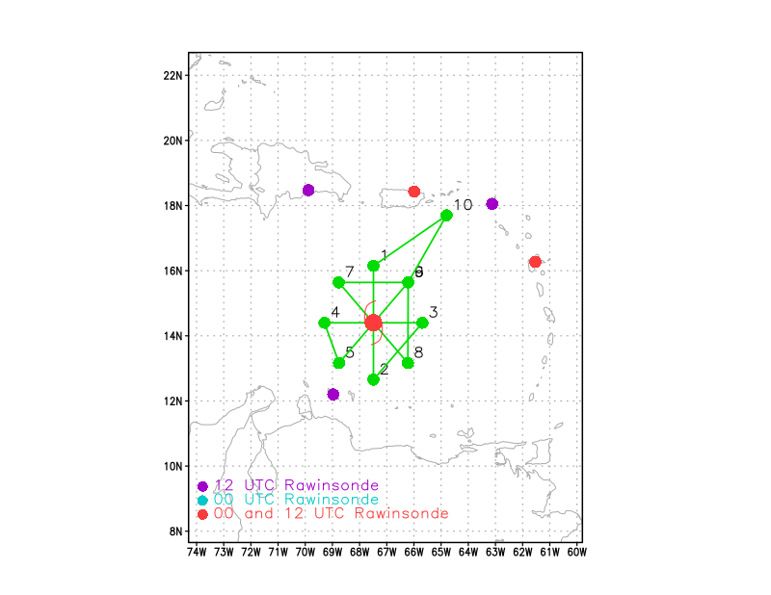  [Insert image of ONR/TCRI detailed pattern image, if available]  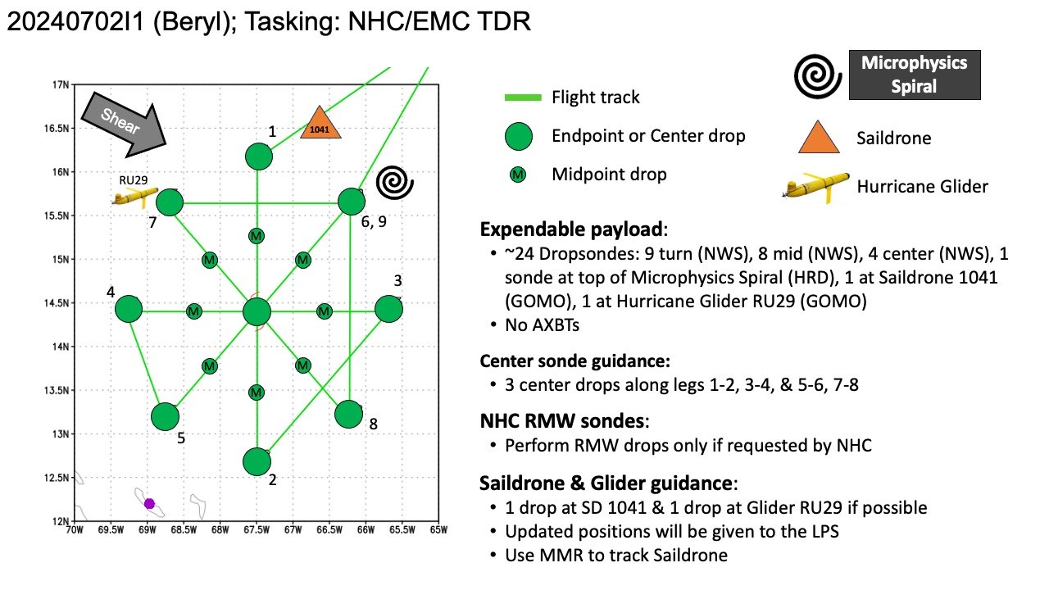  [If you want, briefly describe the pattern in words]  Pattern: Fly Rotated Fig-4 pattern with 105 NM legs  Altitude:  - 10 kft preferred - 8 kft if AF deconfliction is required (pressure altitude)  Potential add-on Modules: (time permitting)  - Early Stage >> Stratiform Spiral (aka Microphysics Spiral)  - CHAOS >> Saildrone and Hurricane Glider coordination
Expendable Distribution | [Describe planned dropsonde, ocean buoy, sUAS deployment locations; e.g., “Dropsondes/AXBT combo drops at endpoints, midpoints, and center”  Expendables:  - Load 35 dropsondes  - Release at endpoints, midpoints, centers, RMWs (if requested by NHC) >> charged to NWS  - 1 sonde deployed at top of the Microphysics Spiral >> charged to HRD  - 1 sonde deployed near Saildrone 1041 >> charged to GOMO  - 1 sonde deployed near Hurricane Glider RU29 >> charged to GOMO  - All dropsondes transmitted to the GTS  - Load 19 Skyfora sondes - deployed at the discretion of the HRD LPS  - No AXBTs
Preflight Weather Briefing | [Notes from the Flight Crew Preflight Briefing and other relevant notes about the current and forecasted storm state from the most recent NHC advisory (location, intensity, MSLP, movement, possible intensity change during the flight)]  Data from a NOAA-P3 Hurricane Hunter aircraft tonight has been quite  helpful in assessing Beryl's structure and intensity. Within the  past hour, the aircraft measured a peak 700-mb flight-level wind of  157 kt in the northeastern quadrant. A typical 90 percent reduction  translates to a maximum sustained wind of 140 kt, which makes Beryl  a potentially catastrophic Category 5 hurricane. This is the  earliest Category 5 hurricane observed in the Atlantic basin on  record, and only the second Category 5 hurricane to occur in July  after Hurricane Emily in 2005.  Beryl continues to move quickly to the west-northwest, even a bit  faster than earlier, estimated from plane fixes to be 290/19 kt. A  well-established subtropical ridge oriented ESE-to-WNW of Beryl is  expected to continue to steer the small but potent hurricane quickly  west-northwestward into the central Caribbean over the next several  days.  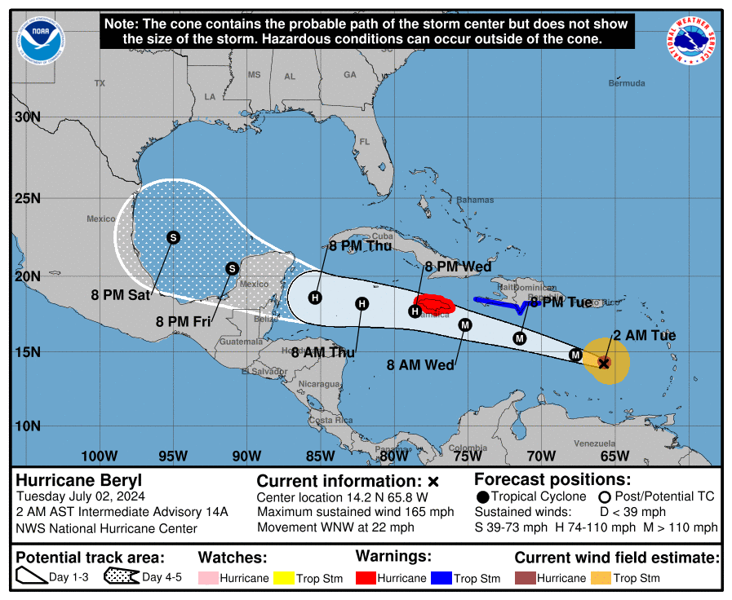  [Briefly describe the relevant environmental drivers.]  It is possible another eyewall replacement cycle (ERC) could begin like we saw last night, with UW-CIMSS MPERC model giving another ERC a 50-75 percent probability based on the last few microwave passes. With that said, after the next 24 hours, both the GFS and ECMWF remain insistent  that significant mid-level westerly shear (above 30 kt) will begin  to undercut Beryl's outflow layer. The HAFS-A/B regional-hurricane  models, which did a good job predicting Beryl's peak intensity  today, are also insistent this shear will start to disrupt the  hurricane after the next 24 hours. There is evidence of this less  favorable upper-level pattern on GOES-16 water vapor imagery upwind  of Beryl's track, and thus a faster rate of weakening is forecasted  from 36-72 hours.  [Copy in GIF of recent (~6 hr) satellite loops (https://www.star.nesdis.noaa.gov/GOES/index.php)]
Instrument Notes | [What instruments are working, not working, not functioning nominally, not installed?]

IN-FLIGHT
Time [UTC] | Event
0831 | Take-off from STX 0831
0831 | Saildrone coordination Sonde updated by Lev Looney
0831 | SD-1041: 16.42209 N, 66.81368 W at 10:15 Z and headed SW at ~4 kts; Extreme measurements in past 3 hrs: Winds (~3m) of 43.6 kts, gusts 53.5 kts, Waves 5.5m, pressure 1010.2 hPa, SST 29.0 ˚C  RU29 Glider: 15.649 N, 68.999 ˚W at 09:08 Z and holding station; SST 29.6 ˚C  NDBC 42059: 15.300 N 67.483 W anchor location, as of 09:50 UTC, wind speed max of 46.6 kts, gusts 54.4 kts, pressure 1000.0 hPa, waves of 7.5 m
0853 | 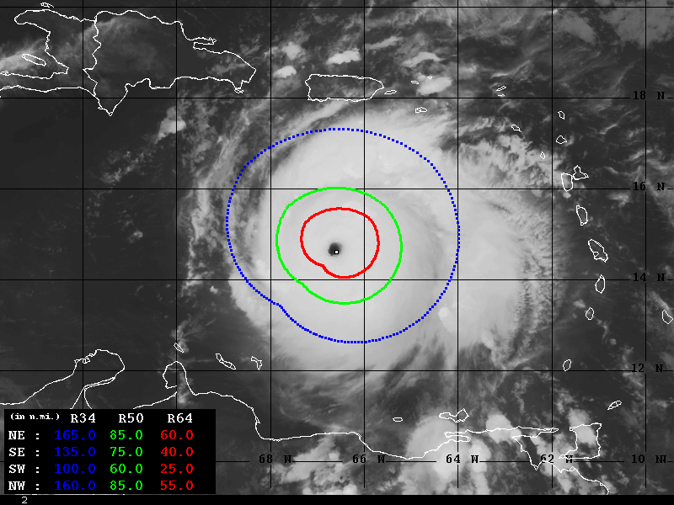  Wind Radii Estimates based on Advanced Dvorak Technique (34-64kt)
0910 | Orbiting to wait for streamsonde computer to reboot  Will drop streamsonde and GPS sonde combo
0914 | Sonde #1 + streamsonde combo - over saildrone 1041
0915 | Sonde 1 used as the IP sonde
0925 | Crossing the rainband on the N side
0923 | Puerto Rico Radar Loop with northern bands of Beryl and northern edge of eyewall depicted
0930 | Sonde #2 MP N
0936 | 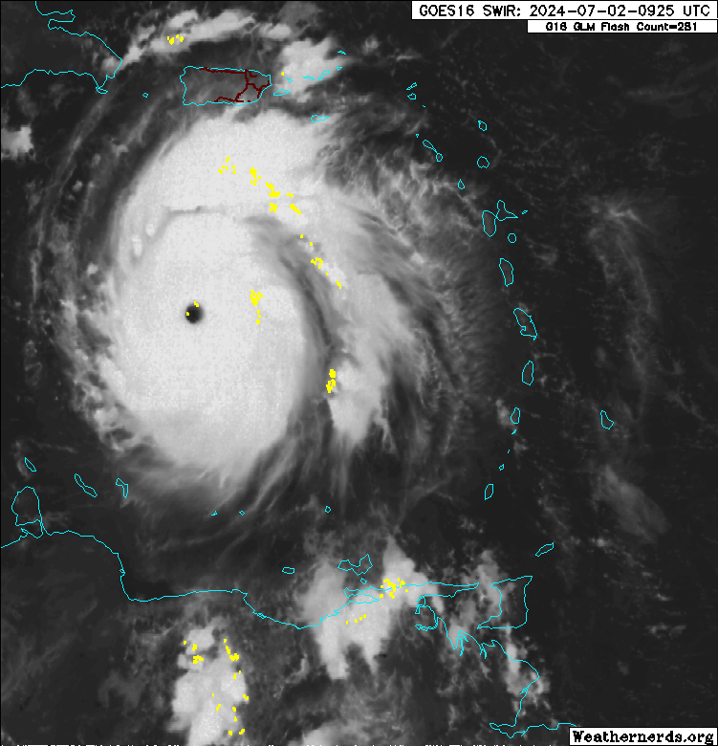  Satellite imagery depicting lightning on northern and western eyewall
0939 | Saw lightening out of the window
0940 | Flight level wind 160 kt + lightning
0941 | Sonde #3 RMW N + 4 streamsondes
0941 | 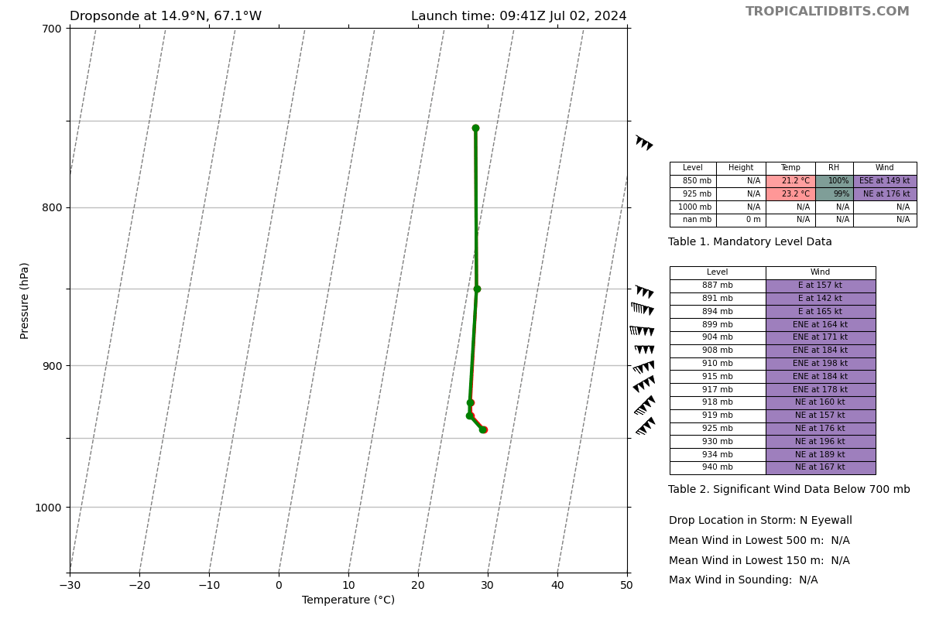  Sonde #3
0944 | Sonde #4 1st center surface pressure 933 mb
0945 | Sonde #5 RMW S + 4 streamsondes
0953 | 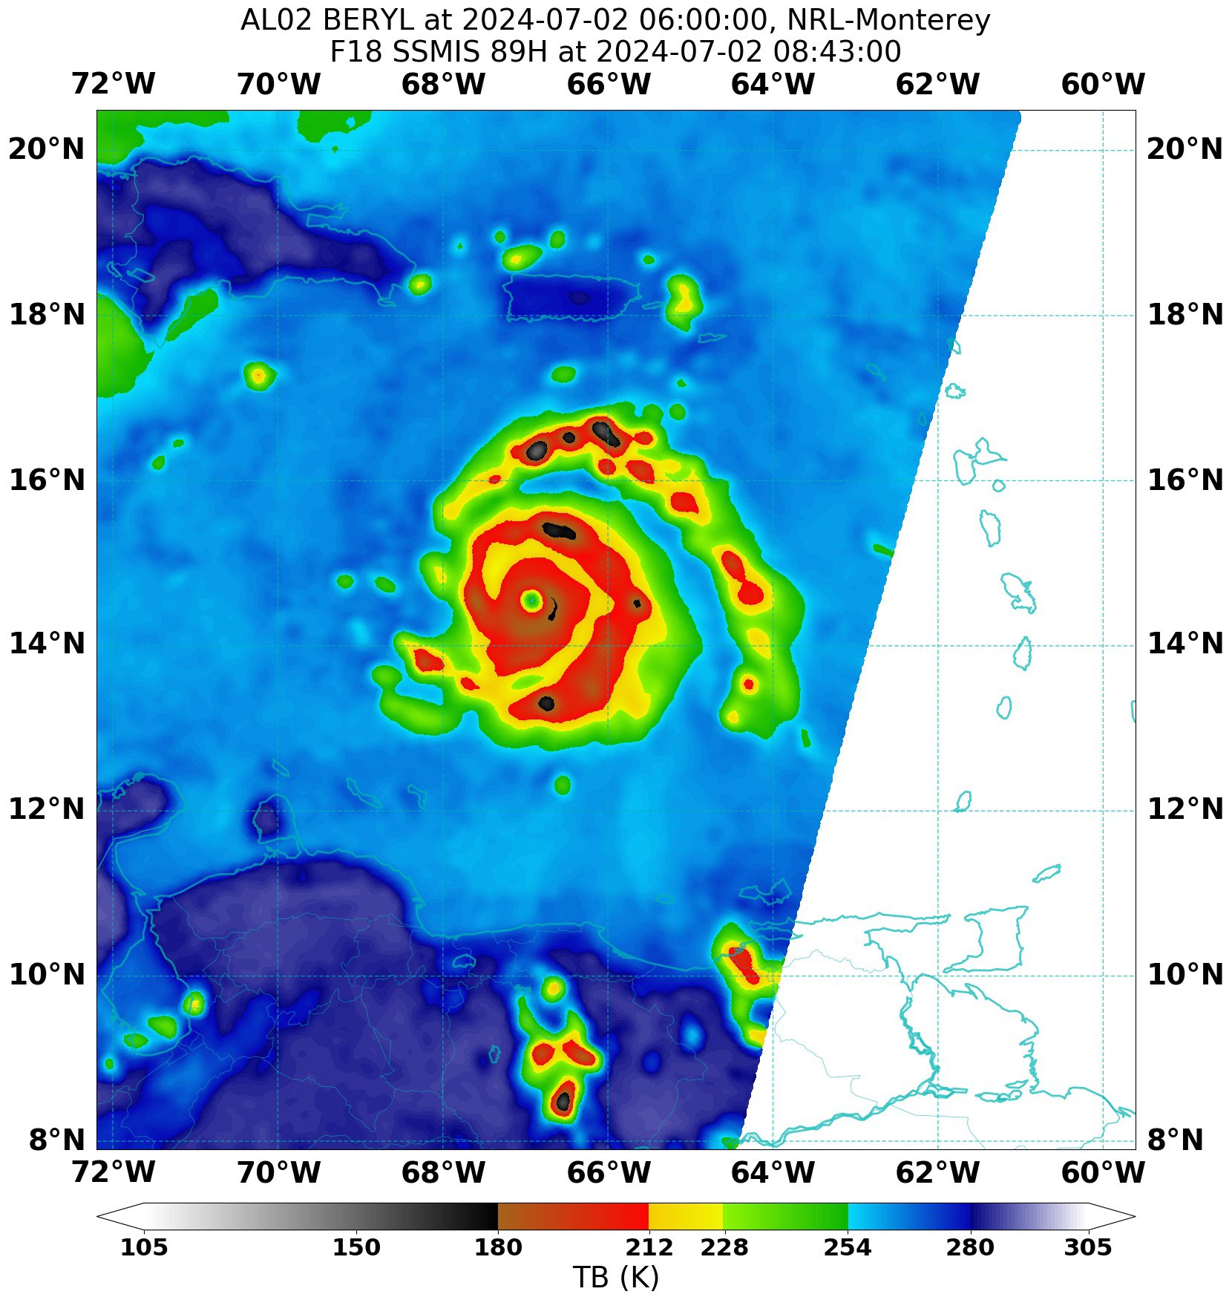
0956 | 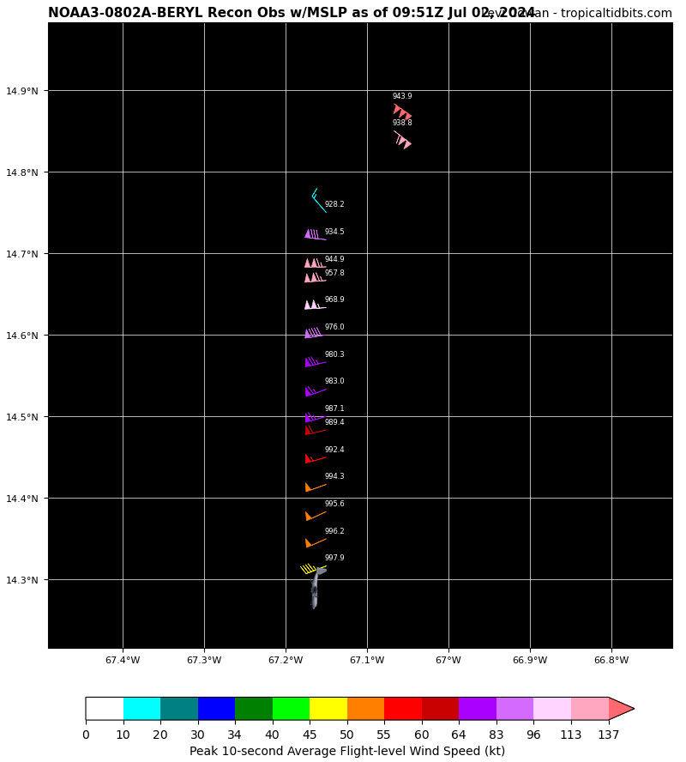  NOAA Fix: extrapolated surface pressure 928.2 mb, peak inbound N quadrant.
0959 | Sonde #6 MP S
1012 | Sonde #7 EP S
1022 | NDBC 42059 still reporting data (~30 min lag) at 11:00 UTC. 1-min winds 60.2 kts increasing, gusting over 77.7 kts, wave height 11.6 m, pressure 992.2 hPa and falling rapidly. Anchor location: 15.300 N 67.483 W  Likely true location ~15.31N, 67.52W  RU29 Glider: 15.6505 N, 68.999 ˚W at 11:08 Z and holding station
1028 | 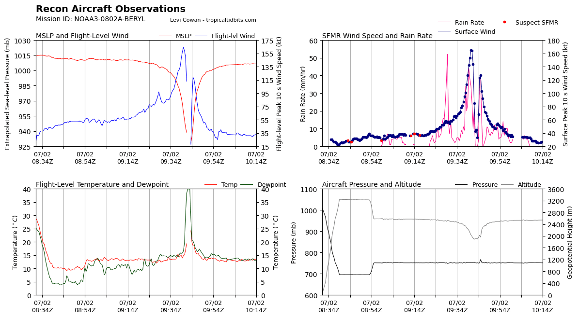Significant pressure drops after the first eyewall pass
1045 | 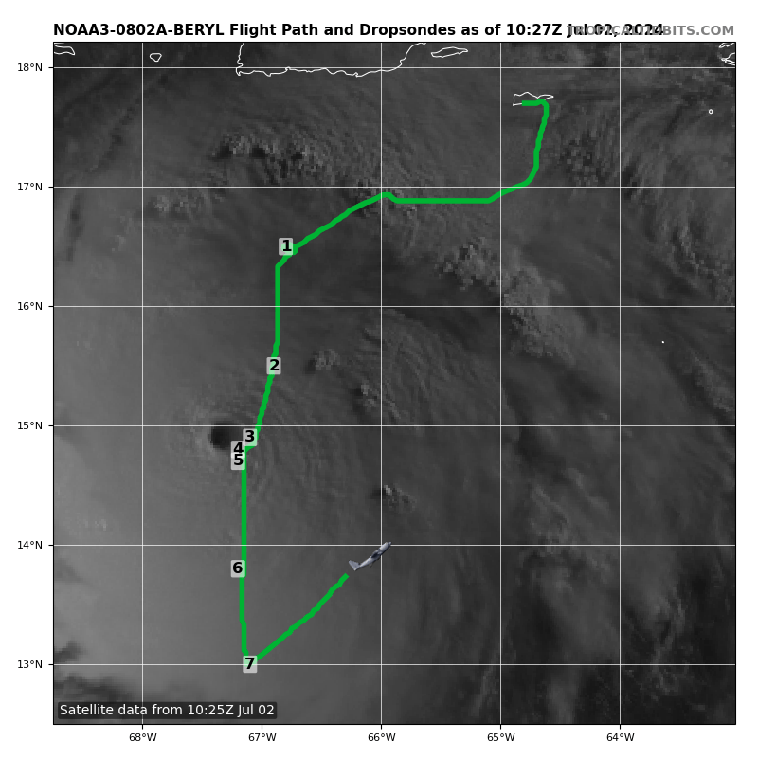
1046 | 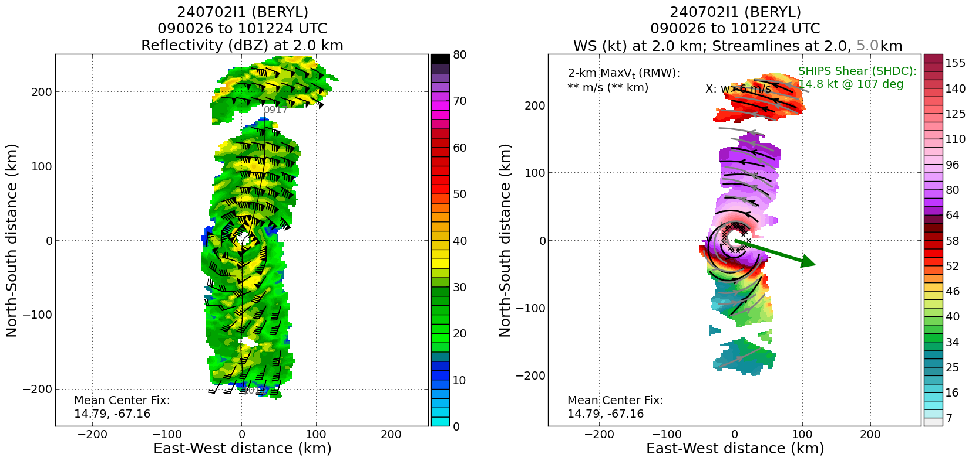
1046 | Sonde #8 IP of E-W pass
1051 | 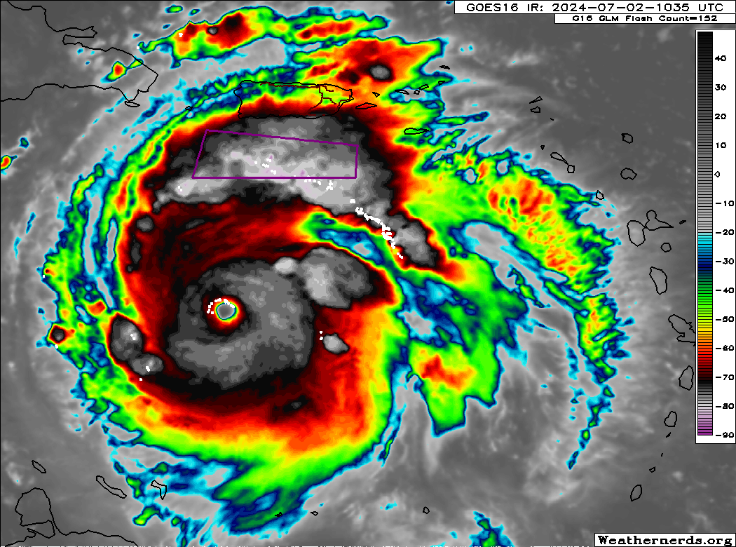  IR Satellite depicting lightning on the NW-N quadrant of the eyewall
1055 | 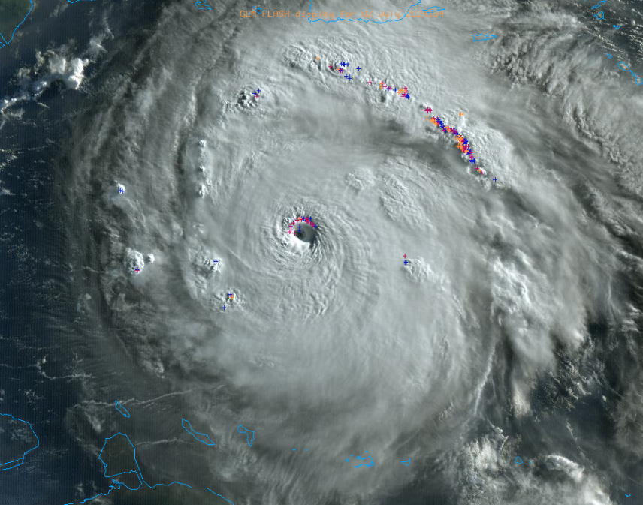
1057 | Sonde #9 MP E
1108 | Sonde #10 RMW E + 4 Streamsondes
1109 | 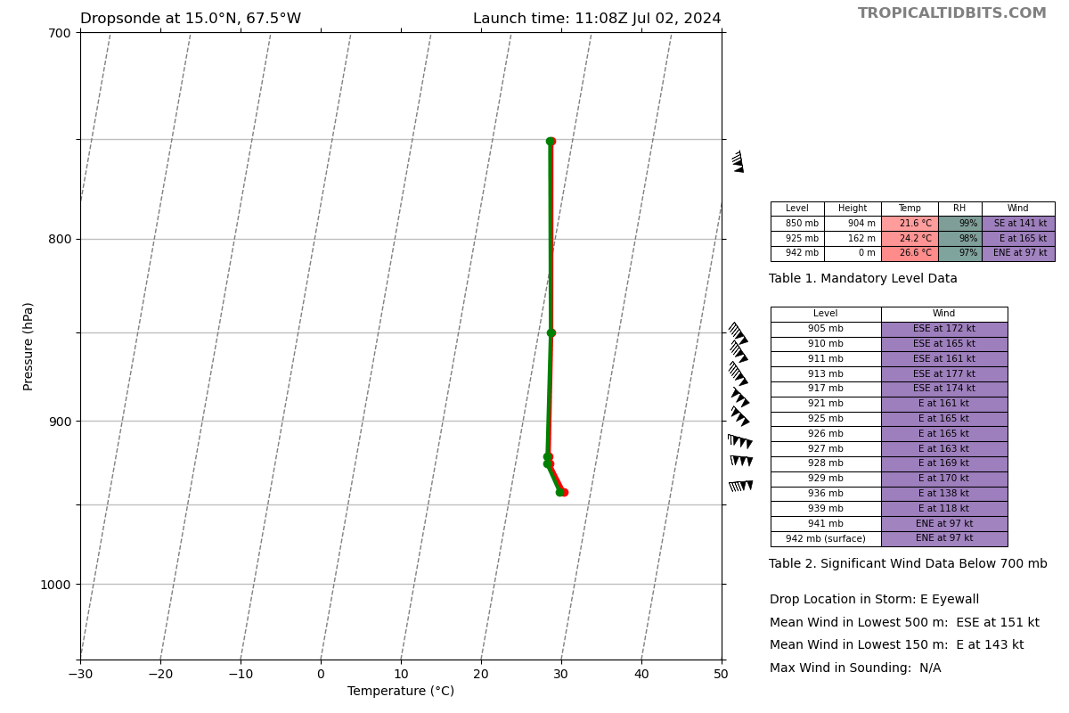  Sonde #10 data
1111 | Sonde #11 2nd center
1114 | Sonde #12 RMW W + 4 streamsondes
1115 | 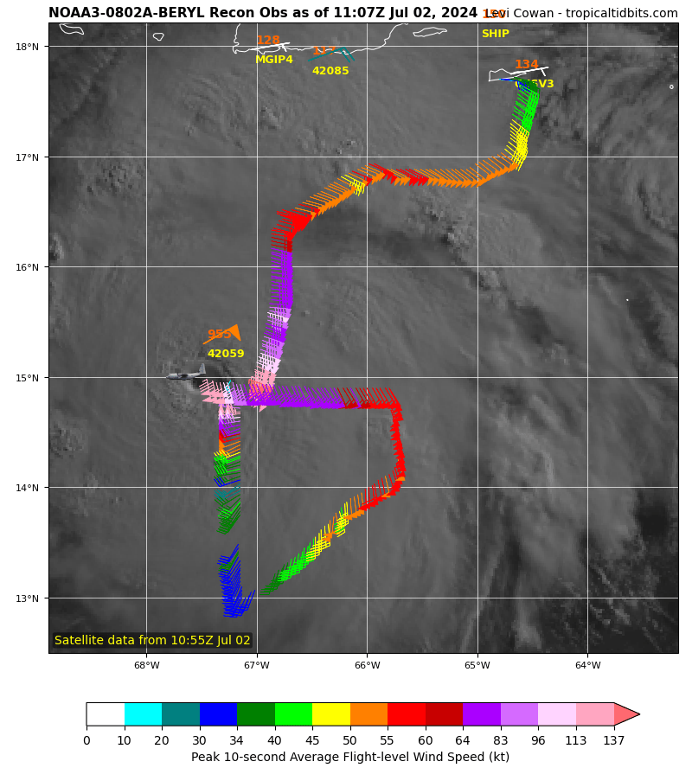  Flight pattern showing the first and second passes.
1115 | 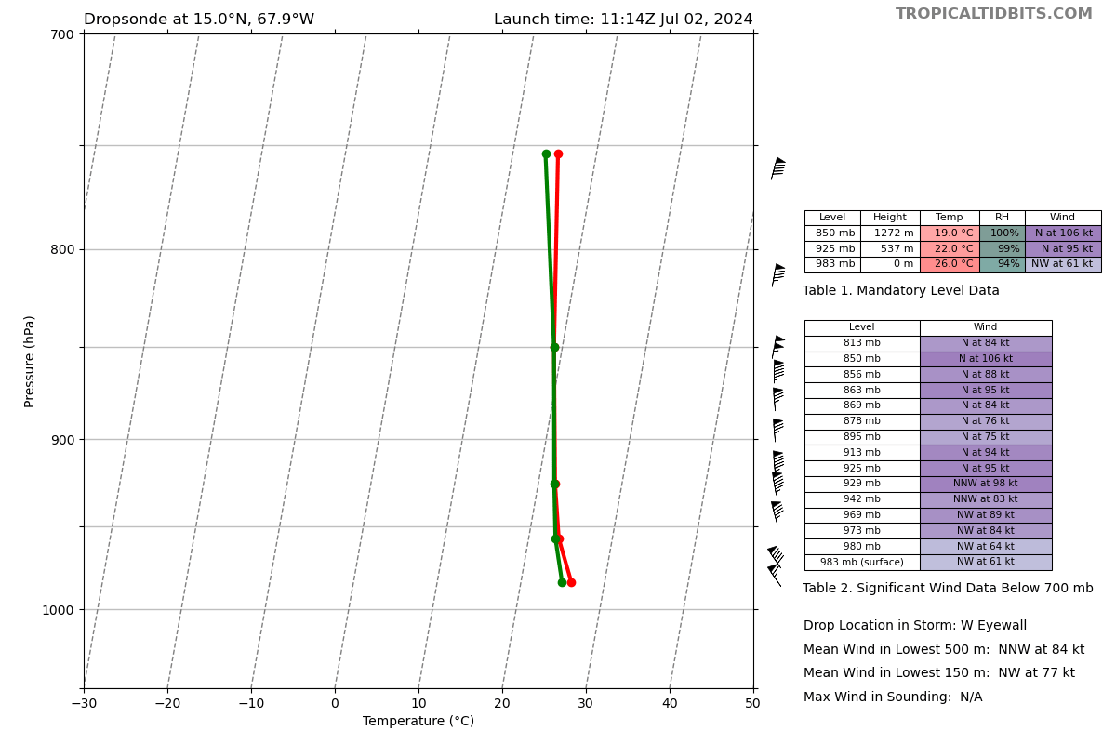  Sonde #12 Data
1122 | Sonde #13 MP W
1121 | AVAPS confirmed 16 out of 17 streamsondes worked based on raw data
1122 | NDBC 42059 still reporting data (~30 min lag) at 11:00 UTC. 1-min winds 60.2 kts increasing, gusting over 77.7 kts, wave height 11.6 m, pressure 992.2 hPa and falling rapidly. Anchor location: 15.300 N 67.483 W  Likely true location ~15.31N, 67.52W  RU29 Glider: 15.6505 N, 68.999 ˚W at 11:08 Z and holding station
1123 | 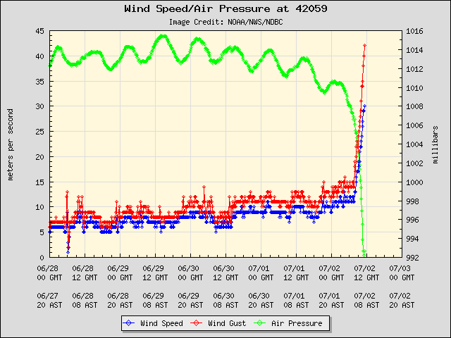
1133 | Sonde #14 EP W
1135 | TC diurnal cycle imagery- diurnal pulse is moving out and “on the clock”  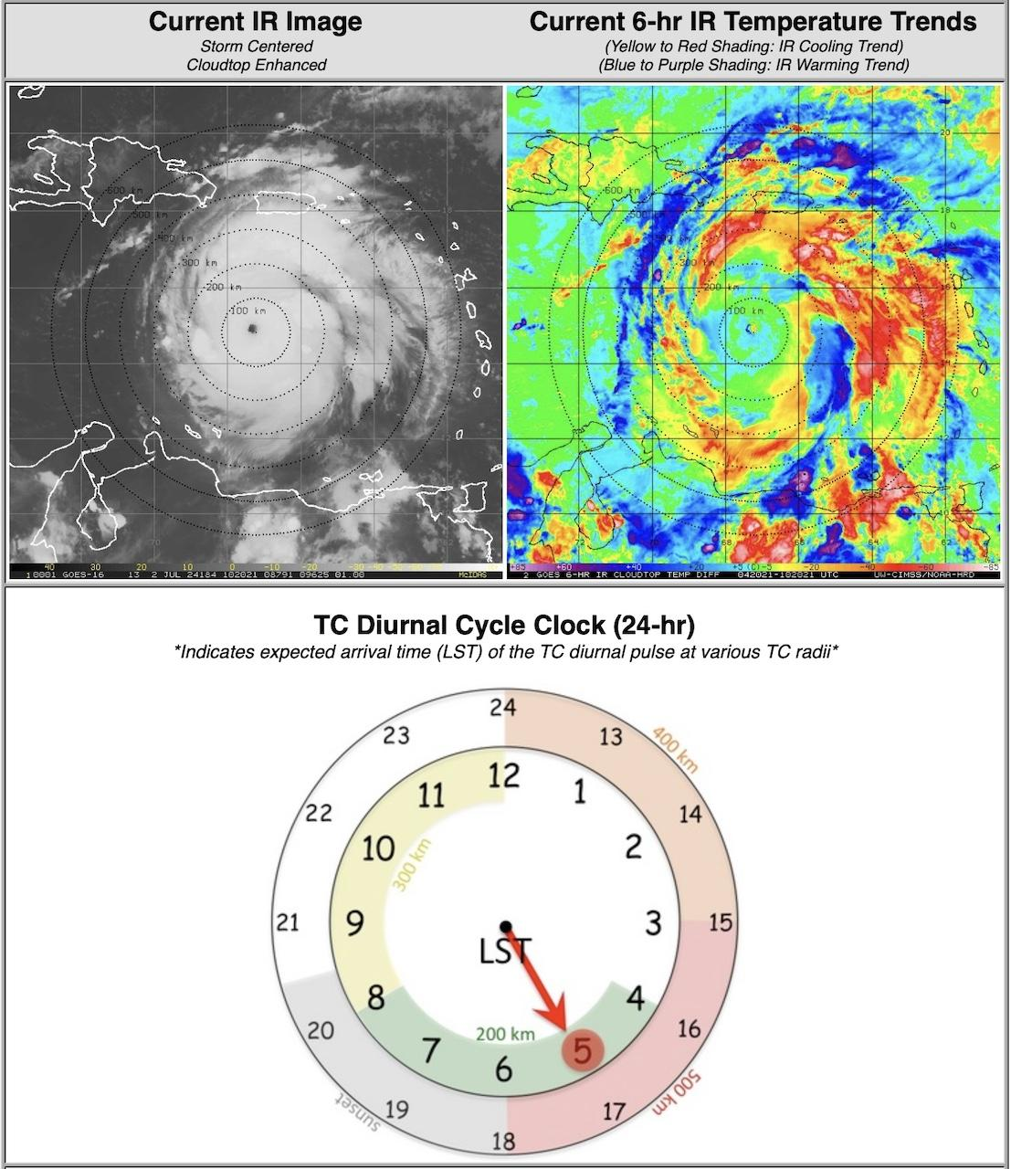
1135 | Convective band at the end of this center-west leg is the diurnal pulse- very convectively active.  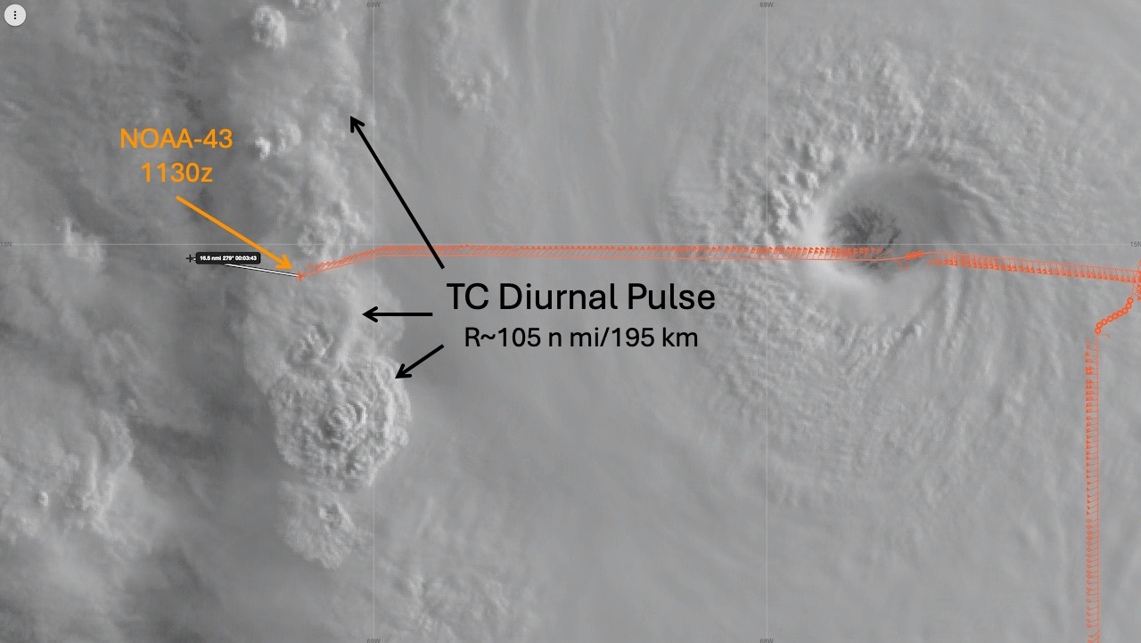
1141 | 2 Streamsondes left; will not deploy this flight due to the pilots discretion and preference of not being depressurized the entire flight - will deploy another day
1145 | 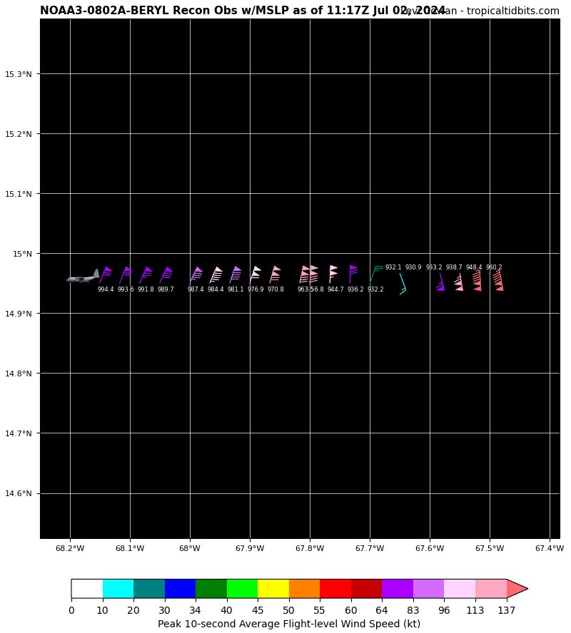  NOAA Fix: extrapolated surface pressure 930.9 mb, peak inbound E quadrant during second pass.
1155 | Sonde #15 IP of SW - NE pass
1204 | Sonde #16 MP SW
1216 | Sonde #17 RMW SW
1220 | Sonde #18 3rd center
1221 | 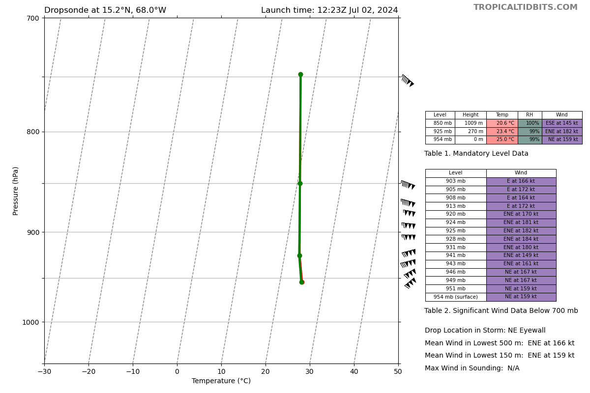  Sonde #18 dropsonde sounding data
1224 | Sonde #19 RMW NE
1238 | Sonde #20 MP NE
1249 | Sonde #21 EP NE
1155 | 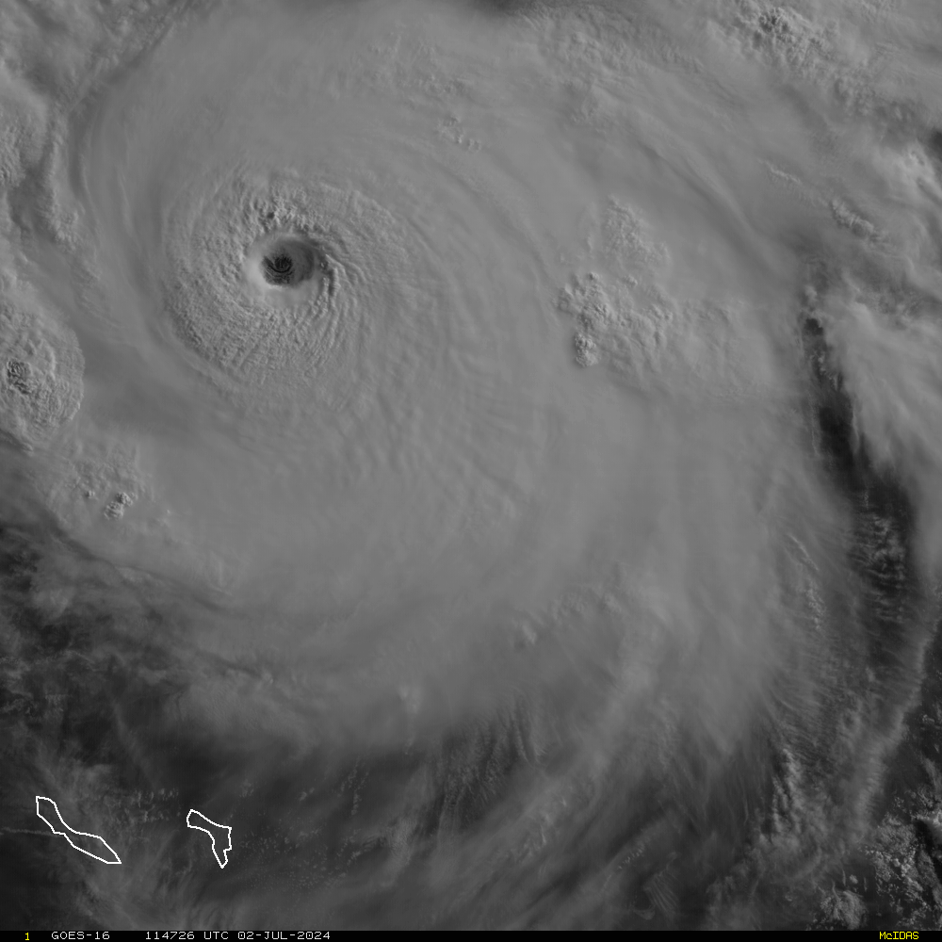  Visible satellite just S-SW of PR
1157 | 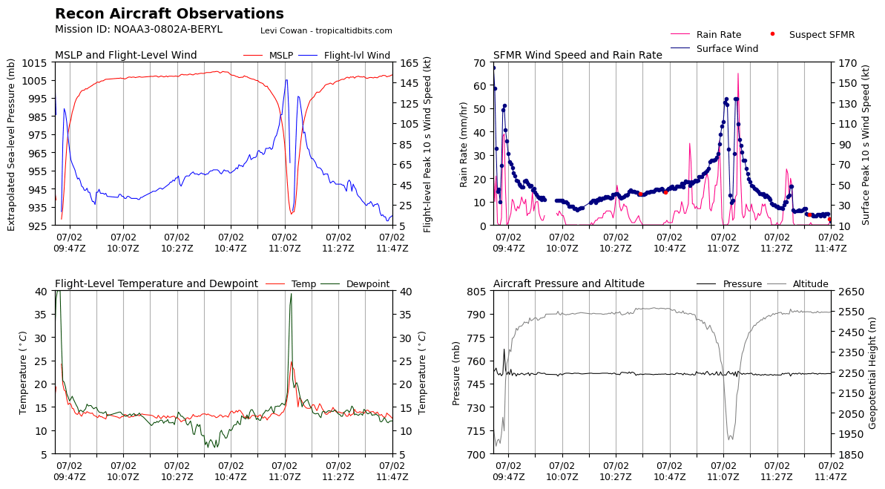
1210 | 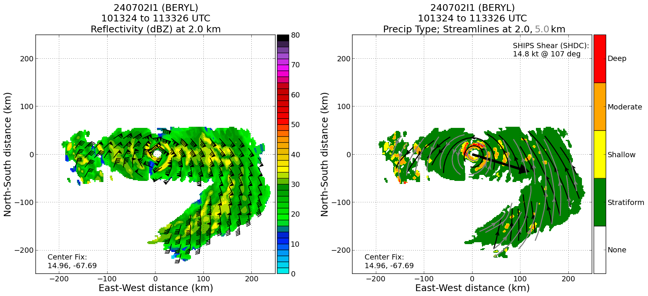
1223 | Circled in the eye to find a spot for next eyewall outbound leg  Saw pink colored dbz eyewall  Penetrated through right next to the very strong eyewall features
1230 | NDBC 42059 has not reported data in >80 minutes. Status unknown (may have sustained damage, but also may just have comms issues due to TC).  Lev talked with NDBC, unsure status at this time, likely took some damage, but hopefully just unable to transmit data due to conditions  RU29 Glider: 15.6505 N, 68.999 ˚W at 11:08 Z and holding station (position updates received every ~2 hours)  Saildrone is at 16.31492 N, 66.87837 W and headed almost due S at 1.5 knots (12:50 Z)
1240 | 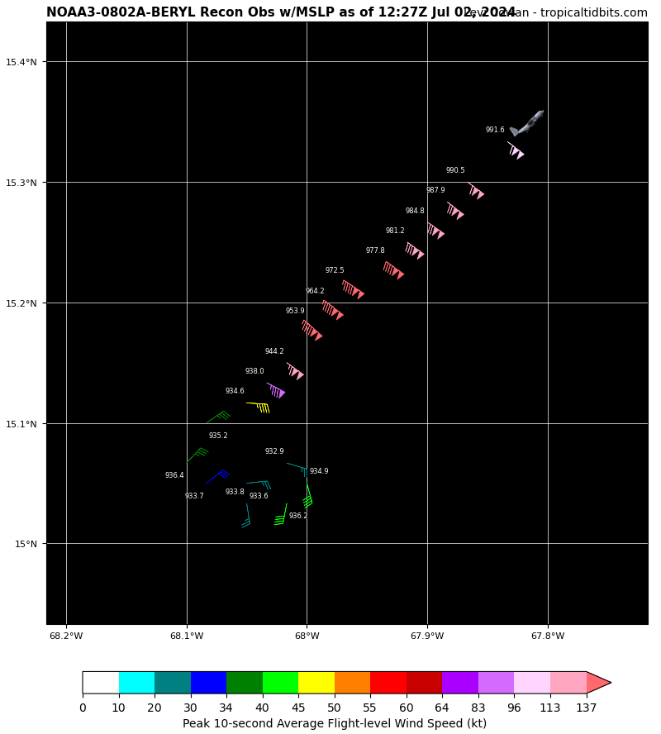  NOAA Fix: extrapolated surface pressure 932.9 mb during third pass.
1240 | 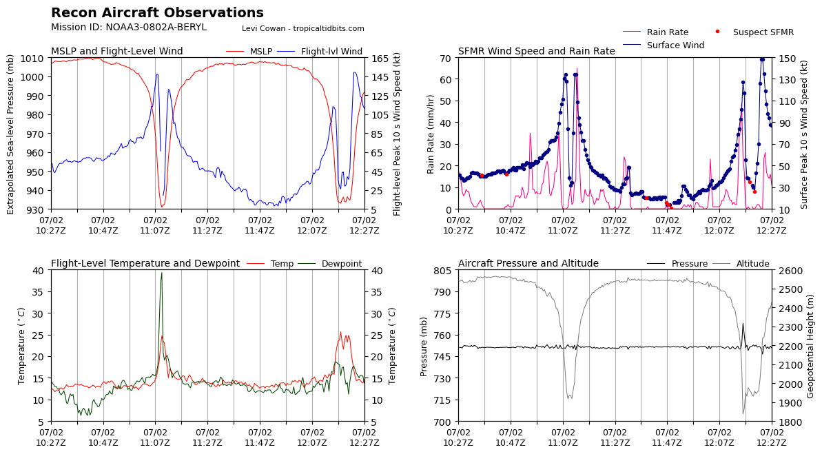
1315 | Glider Location: 15.64833 N, 69.001 W as of 13:11 Z  SD Location: 16.30833 N, 66.87935 W as of 13:14 Z  NDBC 42059: Still no data since 11:10 Z
1327 | Sonde #22 IP of NW-SE pass
1346 | Sonde #23 MP NW glider coordination; Thanks to NAV Jacob for calling the sonde launch to be close to the glider
1356 | Sonde #24 RMW NW
1400 | Sonde #25 RMW SE
1403 | 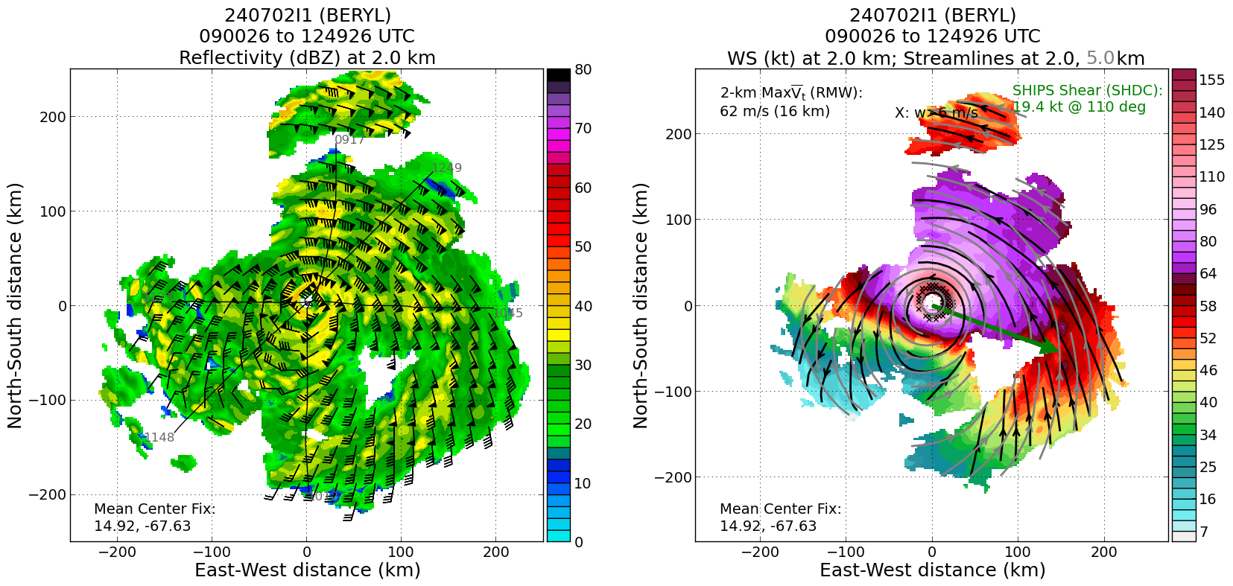
 | 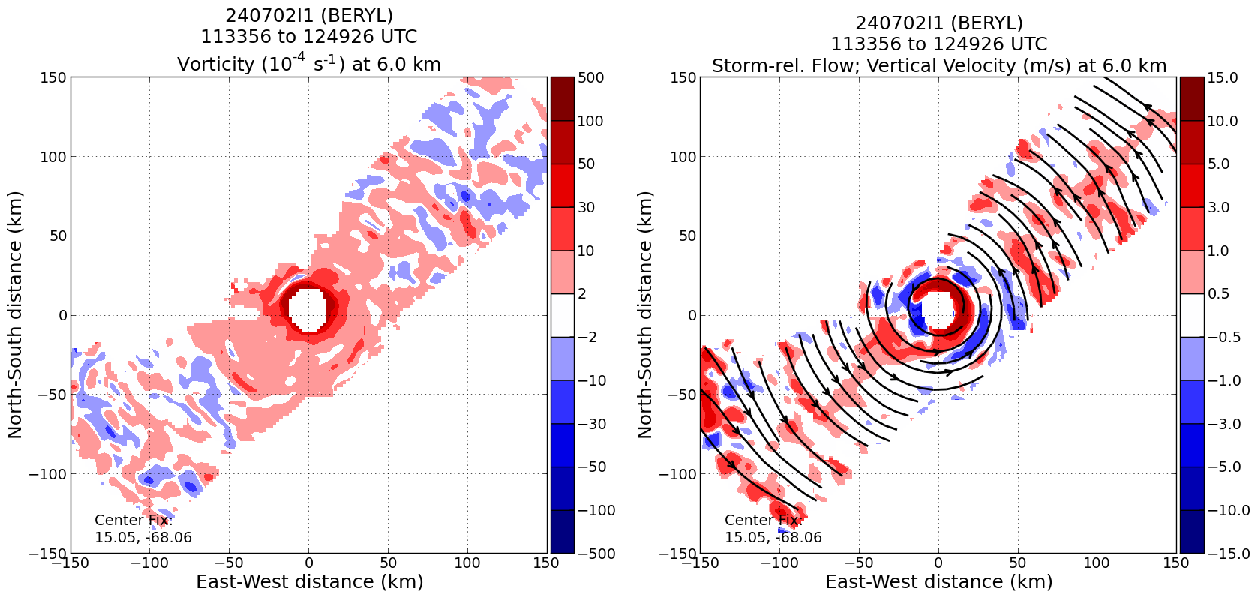
 | 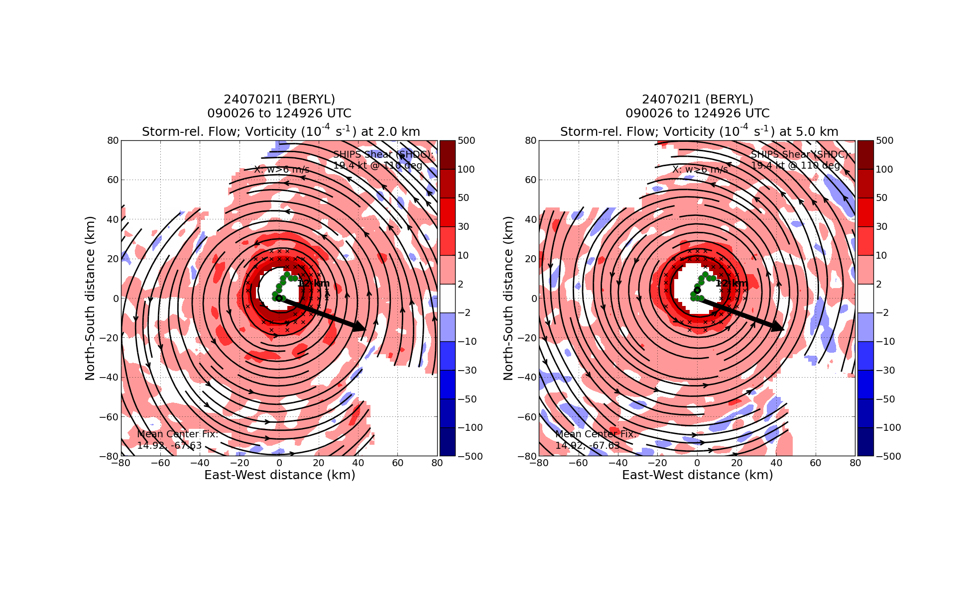
1415 | Sonde #26 MP SE
1413 | 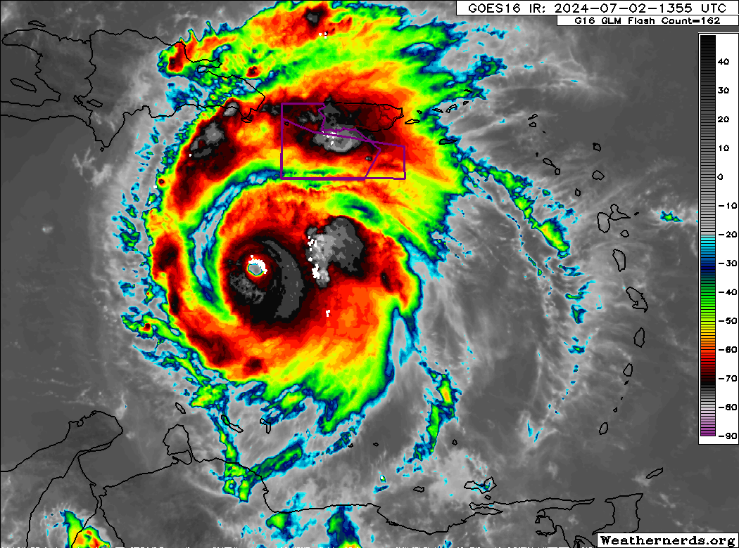  A band of lightning strikes along the N-NE eyewall
1418 | 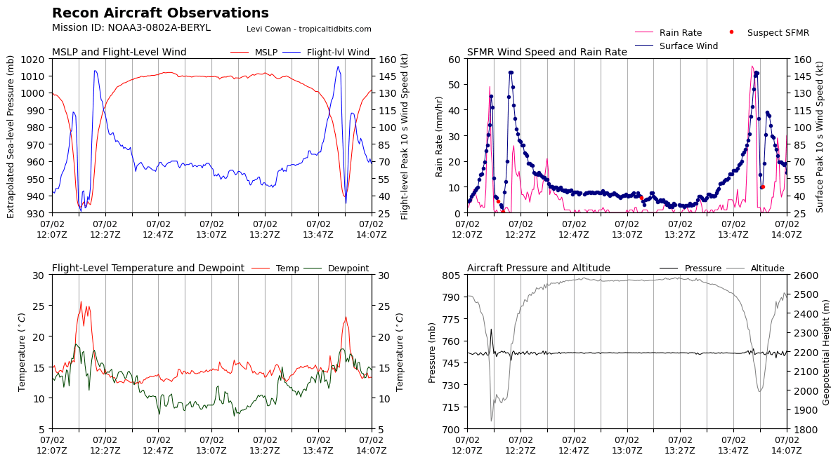  Third and fourth pass observations
1440 | SD-1041 located at 16.28321 N, 66.88149 W at 14:55 Z  Glider coordination was ~2 NM apart, major success.  NDBC 42059 still no data since 11:10 Z
1428 | Sonde #27 EP SE last drop
1553 | All radar analyses transmitted
 | << INSERT ADDITIONAL ROW AS NEEDED >>

POST-FLIGHT
Mission Summary | [Short description of interesting observations from the flight; what objectives were successful? What was unsuccessful? Was the planned pattern flown? What deviations occurred?  [Don’t forget to fill in Tables on page 1]  [Sonde and ocean expendable accounting: how many total of each? How many are charged to each account?]
Actual Standard Pattern Flown | [Butterfly, Rotated Figure-4, Lawnmower, etc]  Rotated Figure-4
APHEX Experiments / Modules Flown | [Linked to HFP Plan; fill in regardless of whether the mission was operationally or research tasked]  CHAOS (multiple patterns flown) and RICO SUAVE
Plain Language Summary | We flew an operational mission this morning into Category 5 Hurricane Beryl as it passed south of Puerto Rico and the U.S. Virgin Islands in the Caribbean. The mission collected data for assimilation into NOAA forecast models and for forecasters at the National Hurricane Center. We also tested experiential ultra lightweight weather instruments called Streamsondes that were deployed from the P-3 and also overflew and coordinated with a NOAA Hurricane Saildrone within TS force conditions and a Rutgers Glider ocean probe that was measuring ocean conditions in Beryl’s northwest eyewall.
Instrument Notes | [Notes about instrument status from during and after the mission]  Deployed 17 out of the 19 available Streamsondes. AVAPS confirmed 16 out of 17 Streamsondes worked based on raw data. 2 Streamsondes leftover. Streamsondes were not deployed this flight due to the pilot's discretion and preference of not being depressurized the entire flight - will deploy another day.  Had issue with TDR data collection during first pass. The SSA ran a “CAM restart” that caused no data to be collected for approximately 1–2 minutes during the outbound portion of the leg. In the hrd-status channel, INE errors were raised. The TDR analysis still ran successfully, just with a small gap in coverage corresponding to the time of the CAM restart. The analysis looked good otherwise.
Final Mission Track | 