MISSION PLAN
FLIGHT ID | 20240701I1 | STORM | AL022024 / Beryl
MISSION ID | 0502A | TAIL NUMBER | NOAA-43)
TASKING | NHC/EMC | PLANNED PATTERN | Butterfly Pattern
MISSION SUMMARY
TAKEOFF [UTC] | 0759 | LANDING [UTC] | 1455
TAKEOFF LOCATION | STX | LANDING LOCATION | STX
FLIGHT TIME | Fractional hr, Takeoff to Landing Time | BLOCK TIME | Get from onboard LPS or Flight Director
TOTAL REAL-TIME RADAR ANALYSES  (Transmitted) | 3 (3) | TOTAL DROPSONDES Deployed (Transmitted) | 22 (22)  1 streamsonde
OCEAN EXPENDABLES (Type) | 0 | sUAS (Type) | n/a
APHEX EXPERIMENTS / MODULES | Exact name of the Experiment in the HFP Plan; identify relevant experiments / module even if not a research tasking
HRD CREW MANIFEST
LPS ONBOARD | J. Zhang | LPS GROUND | X. Zhang/J. Dunion
TDR ONBOARD | J. Zhang | TDR GROUND | R. Rogers
ASPEN ONBOARD | K. Sellwood | ASPEN GROUND | n/a
NESDIS SCIENTISTS | n/a
GUESTS (Affiliation) | n/a
AOC CREW MANIFEST
PILOTS | Doremus/Wood/Taraboletti
NAVIGATOR | Schaefer/Meier
FLIGHT ENGINEERS | Tyson/Wysinger/Ripp
FLIGHT DIRECTOR | Kalen, Q.
DATA TECHNICIAN | Richards,T.
AVAPS | Patel

PRE-FLIGHT
Flight Plan | [Insert image of submitted flight pattern here]  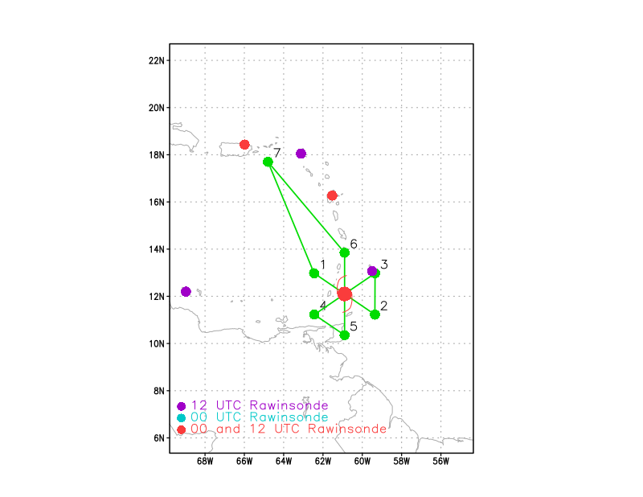  [Insert image of ONR/TCRI detailed pattern image, if available]  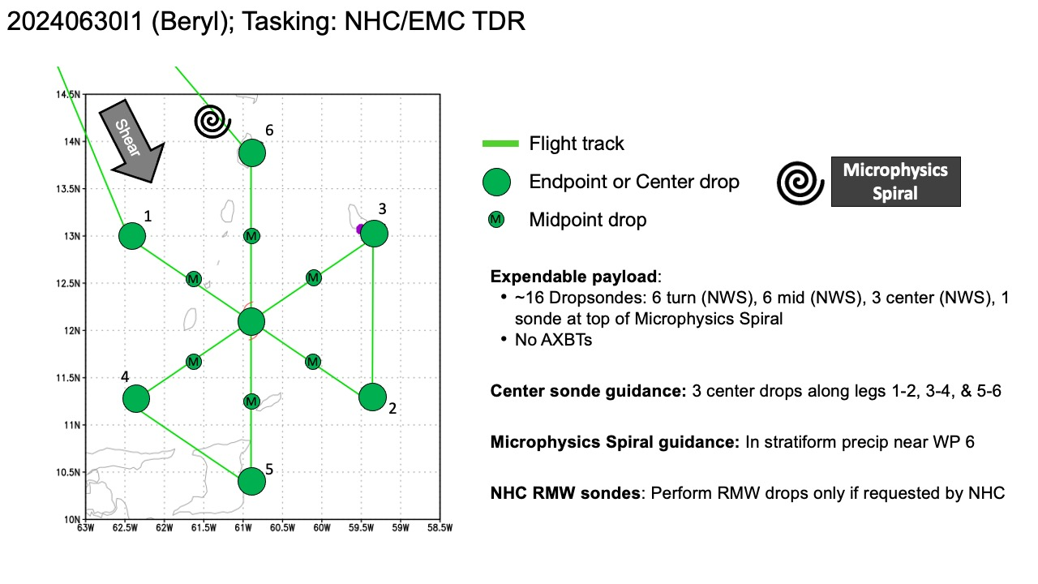  [If you want, briefly describe the pattern in words]  Pattern: Fly Butterfly pattern with 105 NM legs  Altitude:  - 10 kft preferred - 8 kft if AF deconfliction is required (pressure altitude)  Potential add-on Modules: (time permitting)  - Early Stage >> Stratiform Spiral (aka Microphysics Spiral)  What to Target: An area of stratiform precipitation outside the RMW.  When to Target: When stratiform precipitation is identified either by radar or satellite during the execution of a survey pattern at or near the radius of maximum wind (RMW) of a tropical depression, tropical storm, or Category 1 hurricane. When possible, coordination with a ground scientist should be used to improve situational awareness, as they have better access to satellite loops, lightning data, etc. that aid identification of precipitation structure. Additionally, it is recommended that the onboard scientists use radar (lower fuselage, i.e., MMR) looping features and/or storm ID tracks if available.  Pattern: Perform a spiral ascent from low-levels up above the freezing level to make direct hydrometeor measurements with the P-3 cloud and precipitation probes. After a short transect and a dropsonde launch at higher altitude, the P-3 should return to standard flight level via a spiral descent.  The following procedure should be used to select a location to safely complete the spiral ascent/descent:  1.  At typical P-3 flight altitudes (below the freezing level), assess whether a region consists entirely of stratiform radar echo, which can be determined using a combination of the lower fuselage Multi-mode Radar (MMR) and the tail Doppler radar (TDR):  a.  The MMR should present a uniform region of reflectivity, indicative of stratiform rain, with no cellular (convective) echoes within 20 n mi of the aircraft position  b.  The TDR sweeps should indicate no high reflectivity (>40 dBZ) cores above the freezing level (bright band signature), which would suggest convective cores embedded within the stratiform region  2.  A ground scientist should report to the scientist onboard the P-3 that no lightning activity has been detected within the region in the previous 15 minutes, using the detection networks available on the NASA Mission Tools Suite (MTS).  3.  This module may only be conducted in sufficient daylight to allow for visual inspection of aircraft surfaces to be conducted during the spiral.  4.  If these conditions are met, that location should be marked, the airplane repositioned to that location, and the module completed as outlined above.  Flight altitude: The altitude should range from 5 kft to ~25 kft or the maximum safe altitude.  Leg length or radii: Spiral ascents and descents should maintain a roll angle of ~10–20° to maximize utility of the lower fuselage radar for situational awareness during ascents/descents (adjusted for safety considerations at the pilot’s discretion). Ascent and descent rates should be ~5 m s-1 (~1,000 ft fpm) during this module.  Spiral ascents and descents should maintain roll angle of ~10–20° (adjusted for safety considerations at the pilot’s discretion) to confine spiral to a limited geographical area, with an ascent or descent rate of ~5 m/s (~1,000 ft/min).
Expendable Distribution | Expendables:  - Load 30 dropsondes  - Release at endpoints, midpoints, centers, RMWs (if requested by NHC) >> charged to NWS  - 1 sonde deployed at top of the Microphysics Spiral >> charged to HRD  - All dropsondes transmitted to the GTS  - Load 20 Skyfora sondes - deployed at the discretion of the HRD LPS  - No AXBTs
Preflight Weather Briefing | [Notes from the Flight Crew Preflight Briefing and other relevant notes about the current and forecasted storm state from the most recent NHC advisory (location, intensity, MSLP, movement, possible intensity change during the flight)]  There are a few pieces of evidence that show that Beryl is in the  middle of an eyewall replacement cycle (ERC). The clear eye seen on  infrared satellite earlier today has become a little more clouded  over during the past few hours. In addition, data from the last leg  through Beryl from both the Air Force Reserve and NOAA Hurricane  Hunters indicated concentric eyewalls, which also matches current  radar imagery we are receiving from Barbados Meteorological Service.  An earlier SSMIS microwave pass at 2150 UTC also showed a formative  outer moat forming outside the small inner eyewall. In response to  the evolving structure, 700-mb flight-level winds from the NOAA and  Air Force planes are a little lower than observed earlier today, and  the latest round of Dvorak estimates also support a slightly lower  intensity. However, the initial intensity will remain at 115 kt for  this advisory, given a couple of dropsonde observations in the NE  quadrant of Beryl's inner eyewall.  Aircraft fixes indicate Beryl continues to move quickly westward  at 280/17 kt. There isn't much change with the track forecast  philosophy, as a extensive mid-level ridge poleward of Beryl should  maintain its westward to west-northwest motion for the next few days  as it move through the Windward Islands and into the eastern  Caribbean Sea. The ridge does become positioned more northwest of  Beryl towards the end of the forecast period, potentially allowing  the hurricane to slow down gradually once it reaches the  northwestern Caribbean Sea.  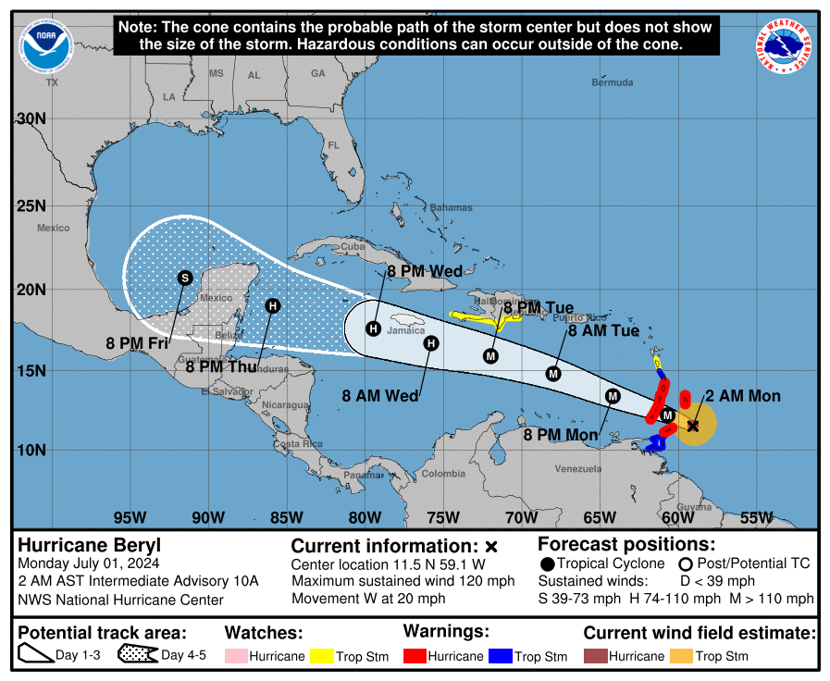  [Briefly describe the relevant environmental drivers.]  Given the evolution to Beryl's inner core structure tonight due to  the aforementioned ERC, it would not be surprising to see a  short-term fluctuation down in Beryl's peak winds, though Beryl is  expected to remain a dangerous major hurricane as it crosses through  the Windward Islands tomorrow morning. In fact, there could also be  a bit of restrengthening after the ERC completes in the eastern  Caribbean, and that is reflected in the short-term forecast. After  48 hours, a subtle upper-level trough to Beryl's north could induce  a bit more westerly vertical wind shear over the hurricane, and some  gradual weakening continues to be shown after 48 hours.  [Copy in GIF of recent (~6 hr) satellite loops (https://www.star.nesdis.noaa.gov/GOES/index.php)]
Instrument Notes | [What instruments are working, not working, not functioning nominally, not installed?]

IN-FLIGHT
Time [UTC] | Event
0759 | Take-off from STX
0900 | The hurricane continues to move at 280/17 kt, but there are signs  that a west-northwestward turn is beginning.  Beryl has a chance today to re-strengthen now that the eyewall cycle  is close to completion and the vertical wind shear remains low.
0915 | Sonde #1 IP sonde
0925 | 1 Streamsonde expected to be dropped during pass, however, flight crew advised against using the dropsonde tube for streamsonde. Free fall chute may damage sensor boom on streamsonde. Currently Jun/Mikal are in discussions with Skyfora to decide if willing to take the risk and deploy.
0933 | Sonde #2 MP NW
0940 | Skyfora gave the go-ahead to deploy the 1 Streamsonde using the free fall chute.
0942 | Sonde #3 RMW NW
0946 | Sonde #4 Center
0948 | 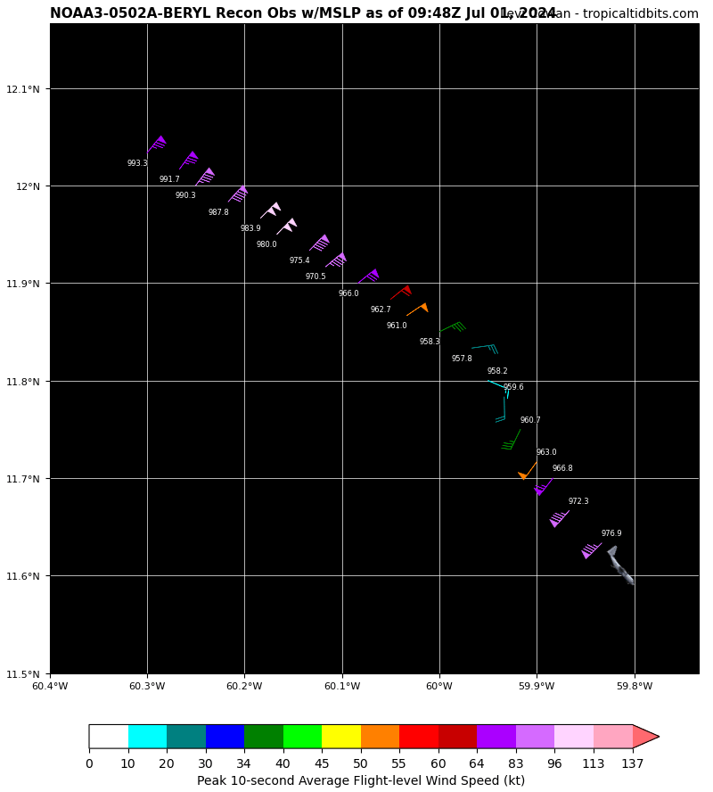NOAA fix: extrapolated surface pressure 957.8 mb, peak inbound NW quadrant.
0948 | Sonde #5 RMW SE
1000 | CIMSS VWS showing light shear that’s backed from NNE yesterday to westerly today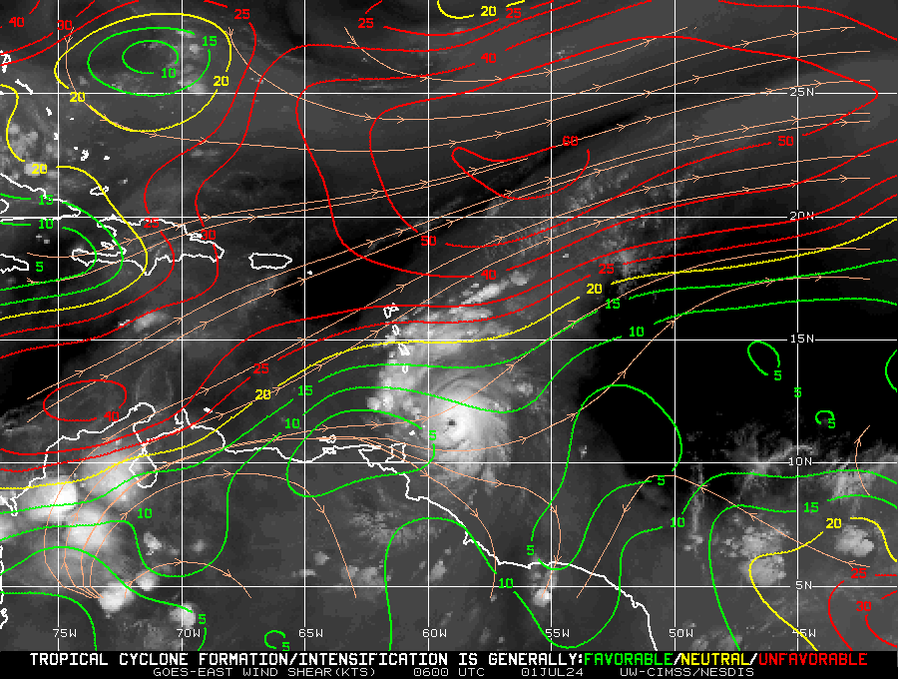
1001 | Sonde #6 MP SE
1009 | 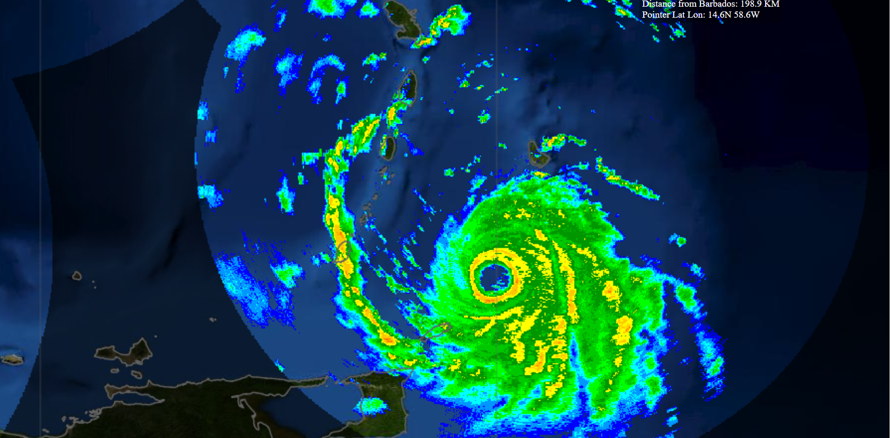Eastern Caribbean radar showing Beryl eyewall ~137KM from Barbados
1012 | Sonde #7 EP SE
1013 | 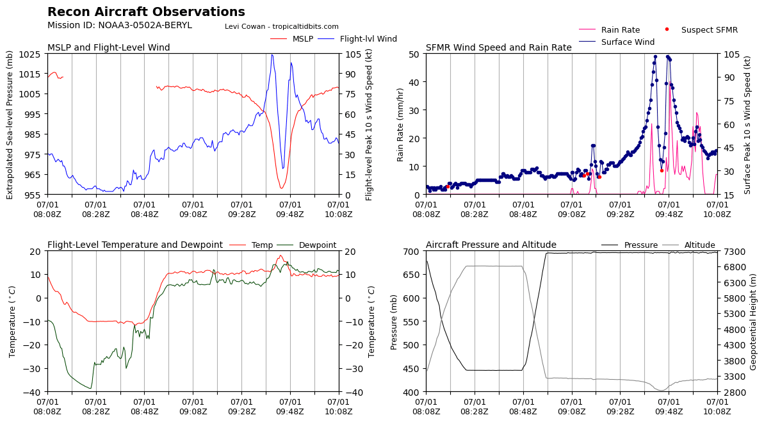
1022 | 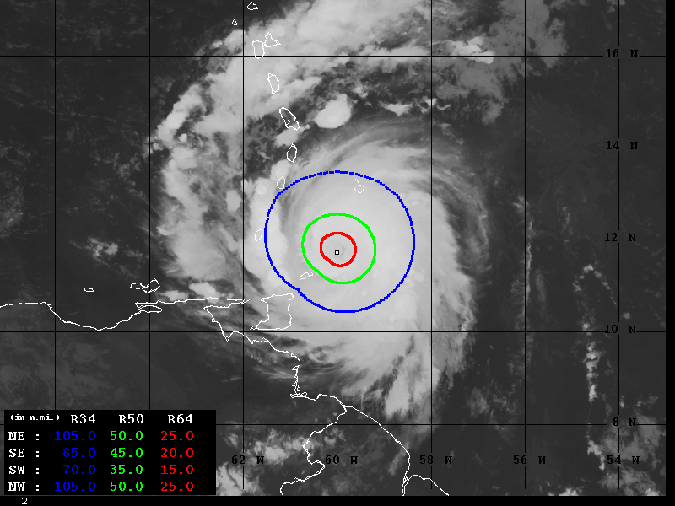Wind Radii Estimates based on Advanced Dvorak Technique (34-64kt)
1032 | 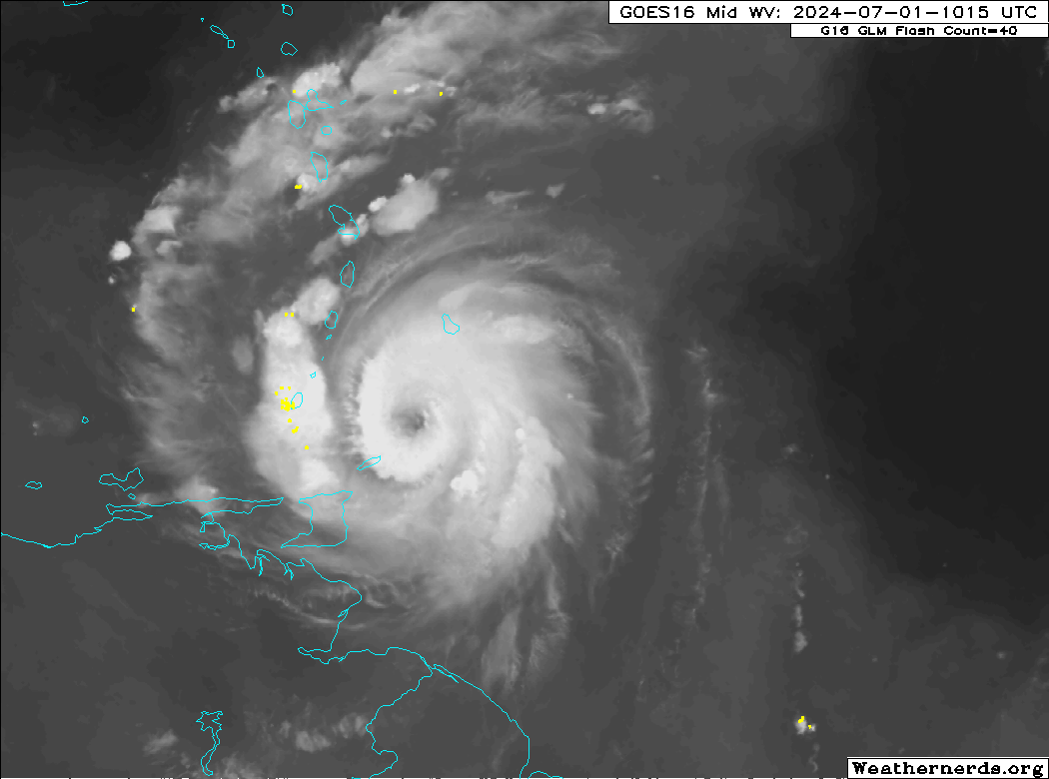
1038 | Sonde #8 IP NE-SW Pass
1043 | Depressurized
1051 | Sonde #9 MP NE
1052 | 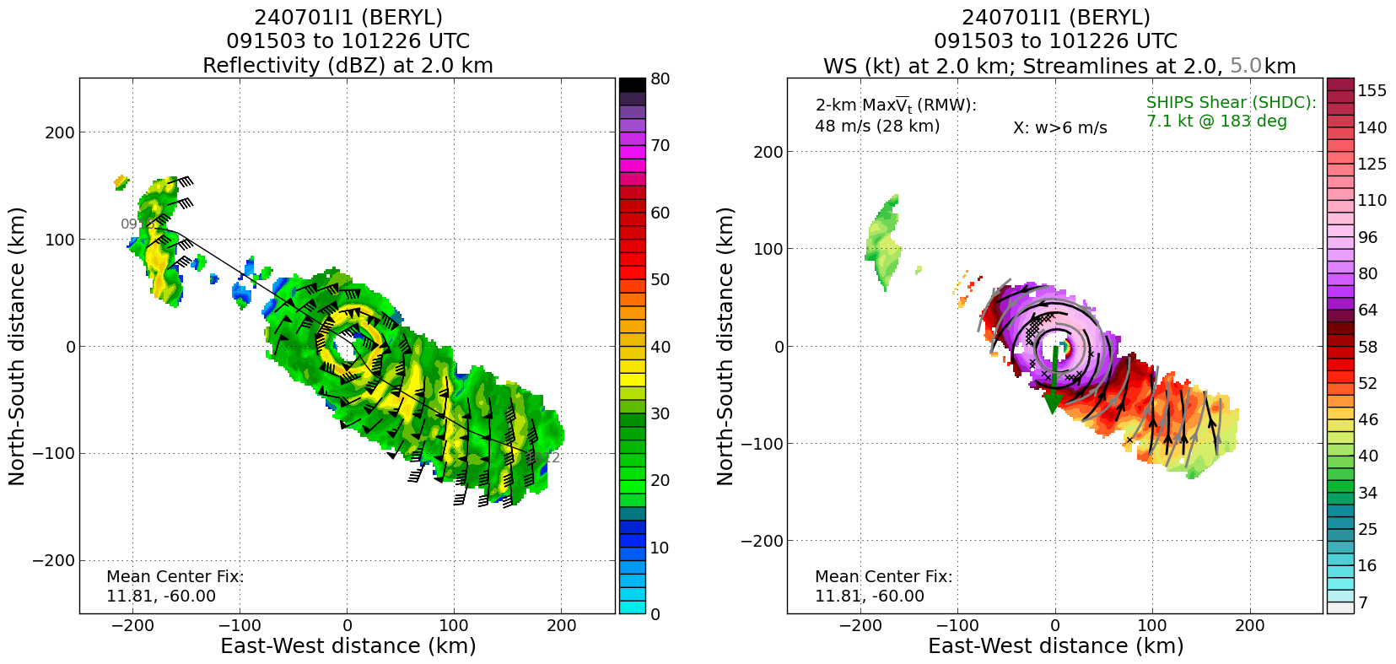
1054 | 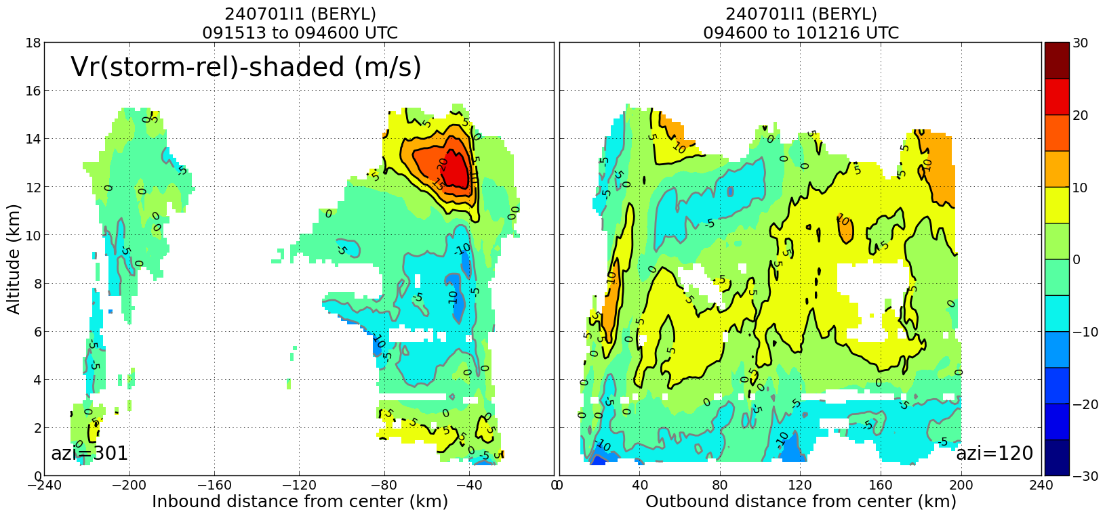  Profile analysis from first NW-SE pass shows an outer inflow maximum in the lowest 2 km at about 100 km, suggestive of a possible outer eyewall on the SE side
1057 | 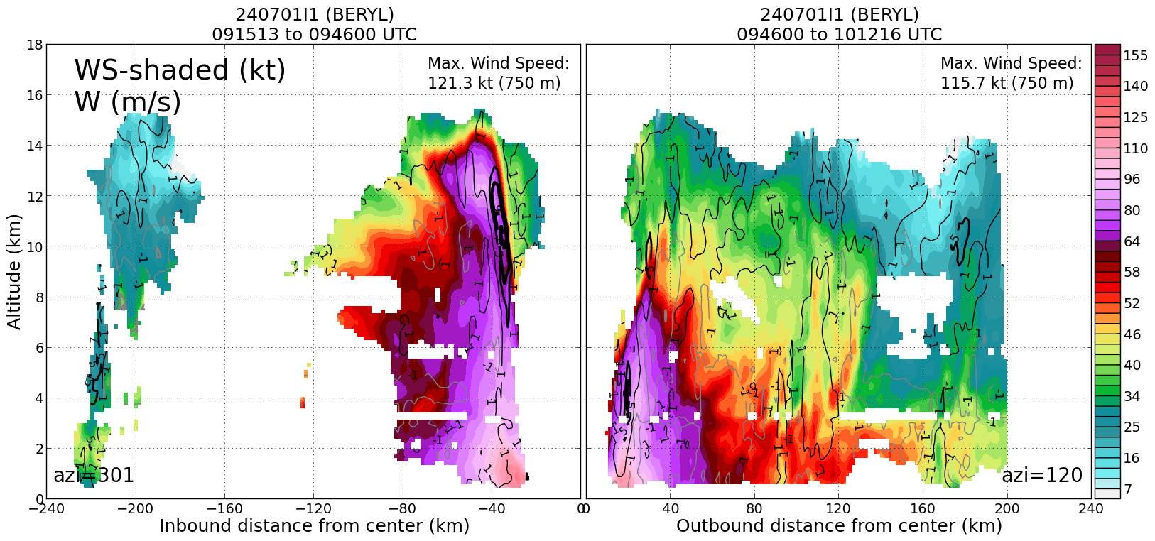  Cross section of wind speed supports the notion of an outer eyewall at about 100 km radius on the SE side
1101 | 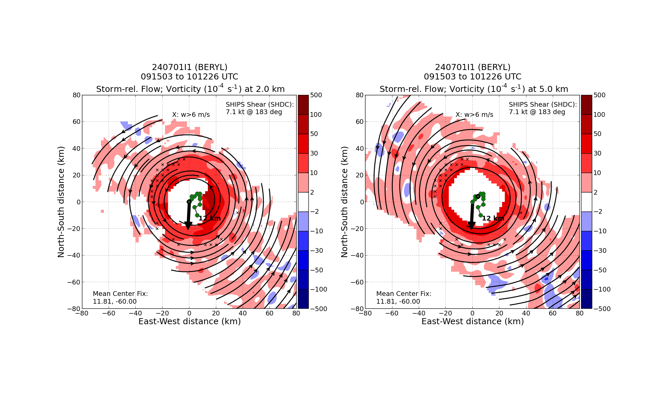  Tilt hodograph shows vortex tilted upshear left up to the midlevels, then downshear above that
1106 | 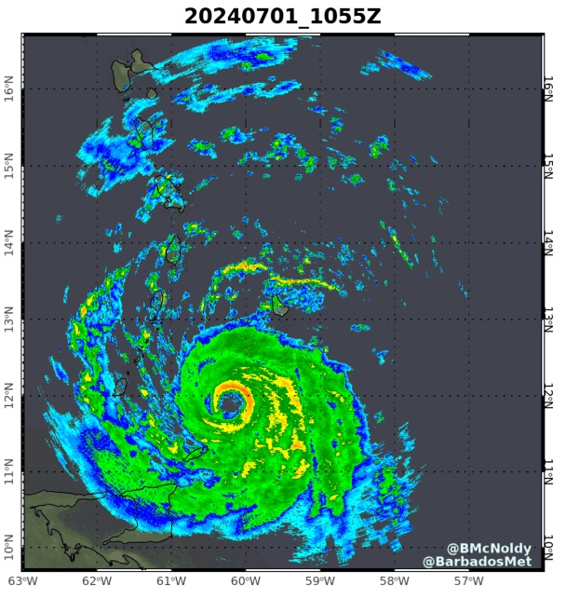  Barbados radar from 1055z showing a nearly closed eyewall
1110 | IR Satellite Loop depicting eyewall regeneration
1112 | Sonde #10 RMW SE, dropped at 1101Z
1112 | Sonde #11 2nd Center, dropped at 1105Z
1112 | Streamsonde dropped in the center at 1105Z
1113 | Sonde #12 RMW SW at 1107Z
1116 | 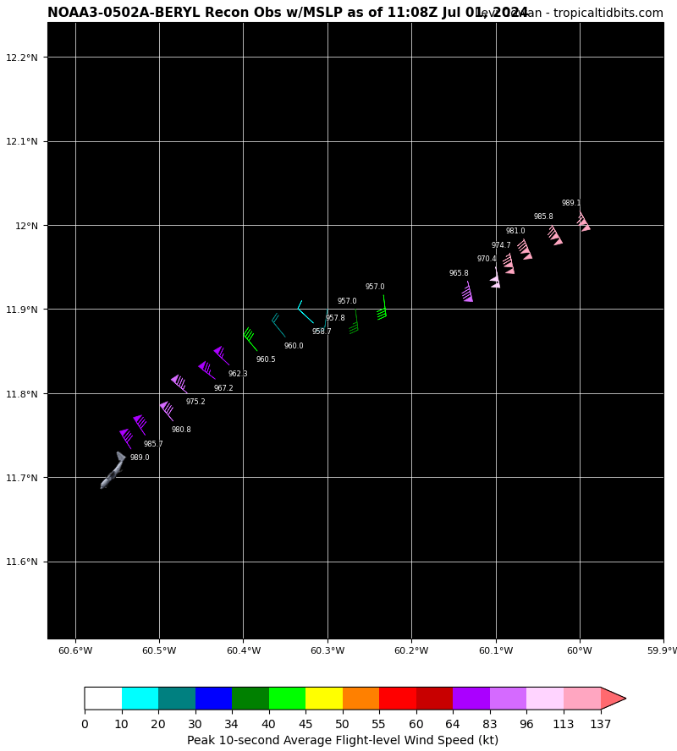Second Pass. NOAA fix: extrapolated surface pressure 957 mb, peak inbound NE quadrant.
1122 | 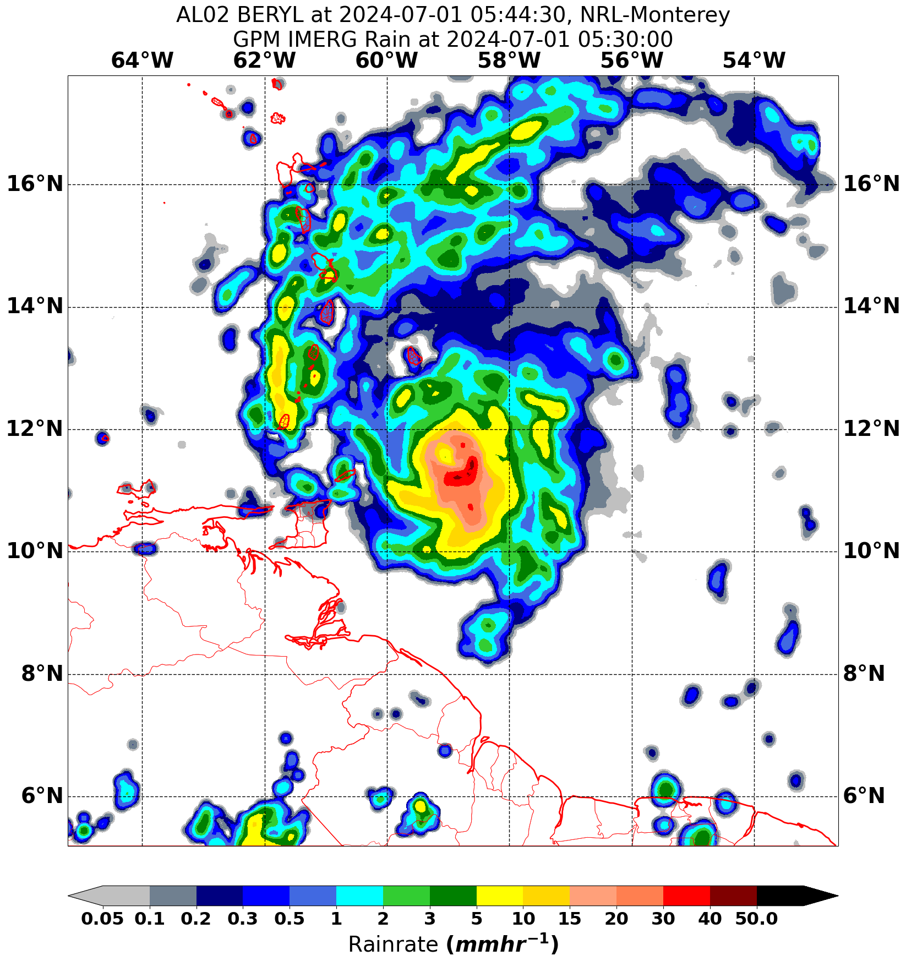Image depicts rainrates are the highest near the SE quadrant of eyewall
1125 | 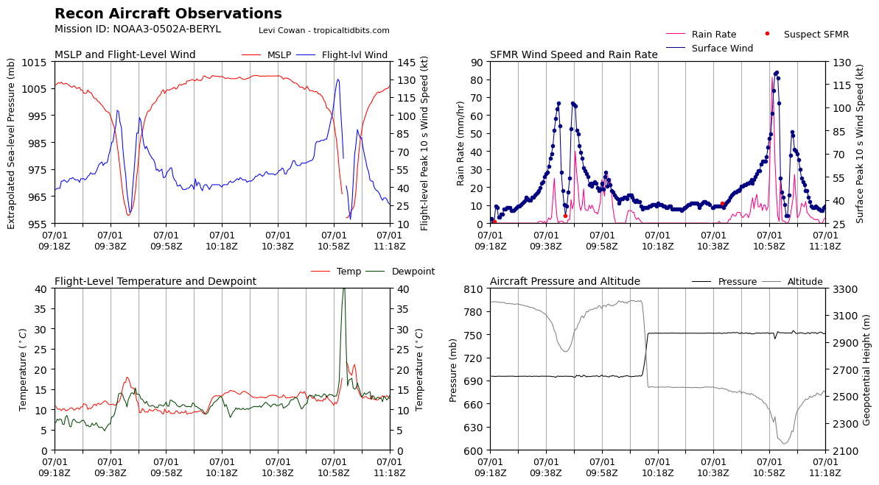Significant pressure drops down to ~957mb when approaching the eyewall during the first two passes
1125 | Sonde #13 MP SW at 1119Z
1126 | Sonde #14 EP SW at 1124Z
1129 | Center drop 960mb 8kt 22 deg
1144 | Rob noticed there's lightning in the inner core, on the NW side at the moment
1149 | 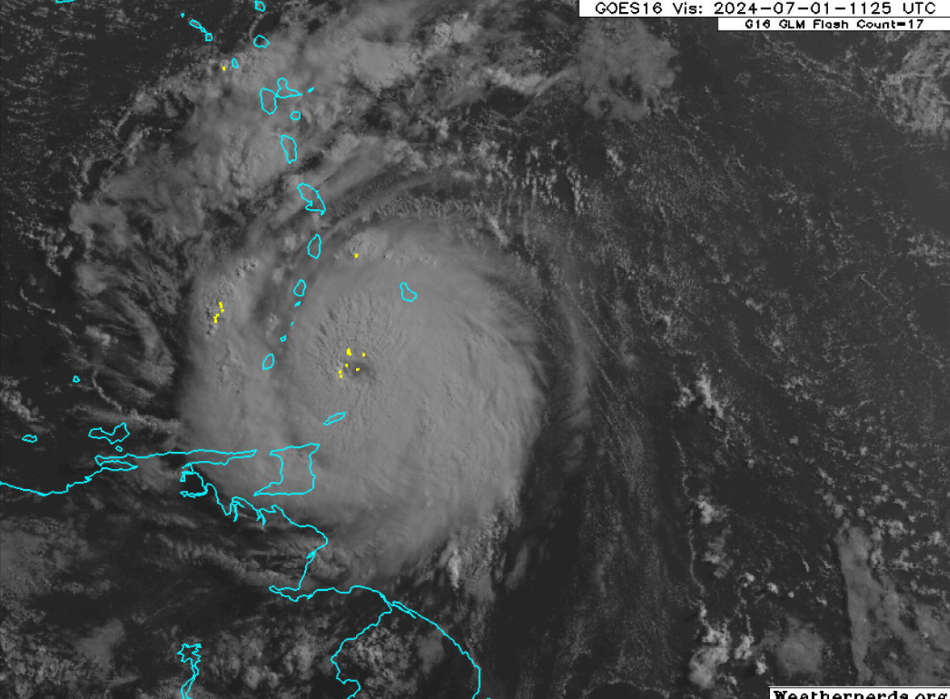Lightning depicted within the primary eyewall as well as in the N and W quadrant
1150 | Sonde #15 IP S-N pass
1157 | Sonder #16 MP S
1207 | 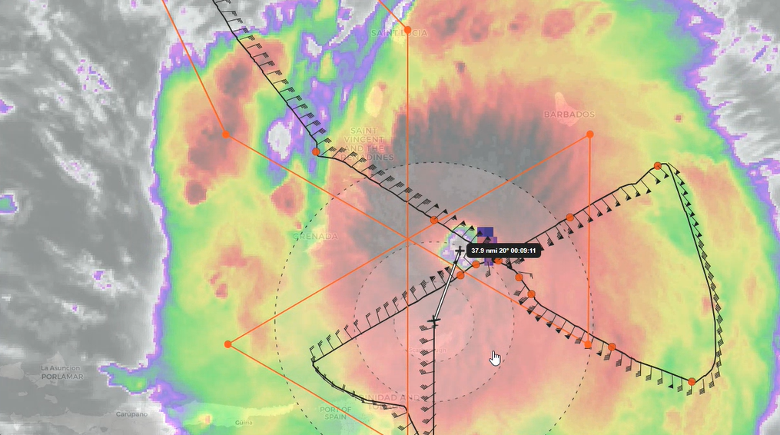Approach from the S for the third pass
1211 | Sonde #17 RMW S
1213 | Sonde #18 3rd center
1220 | 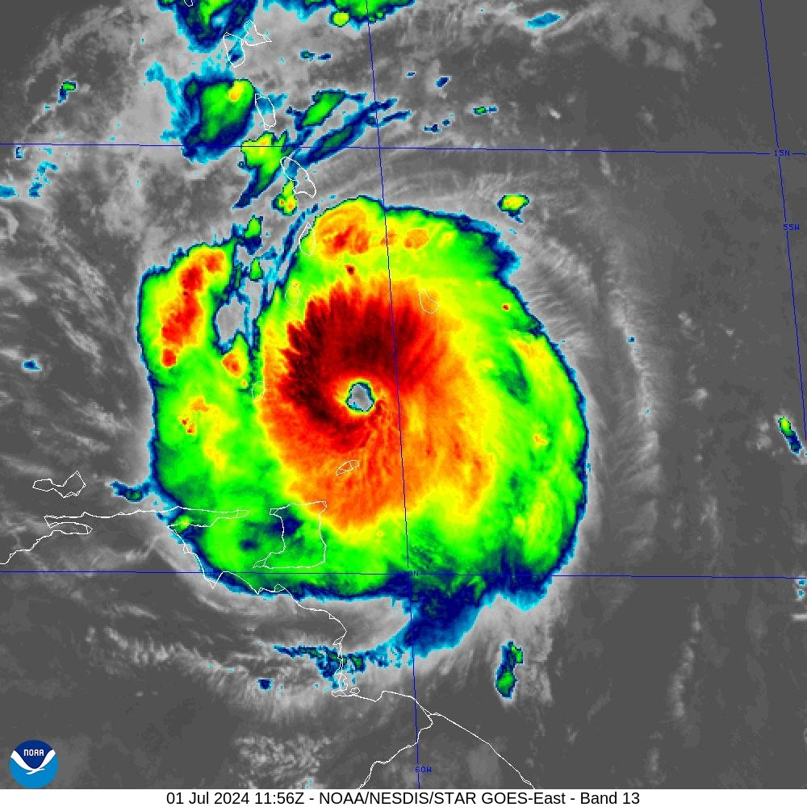
1226 | 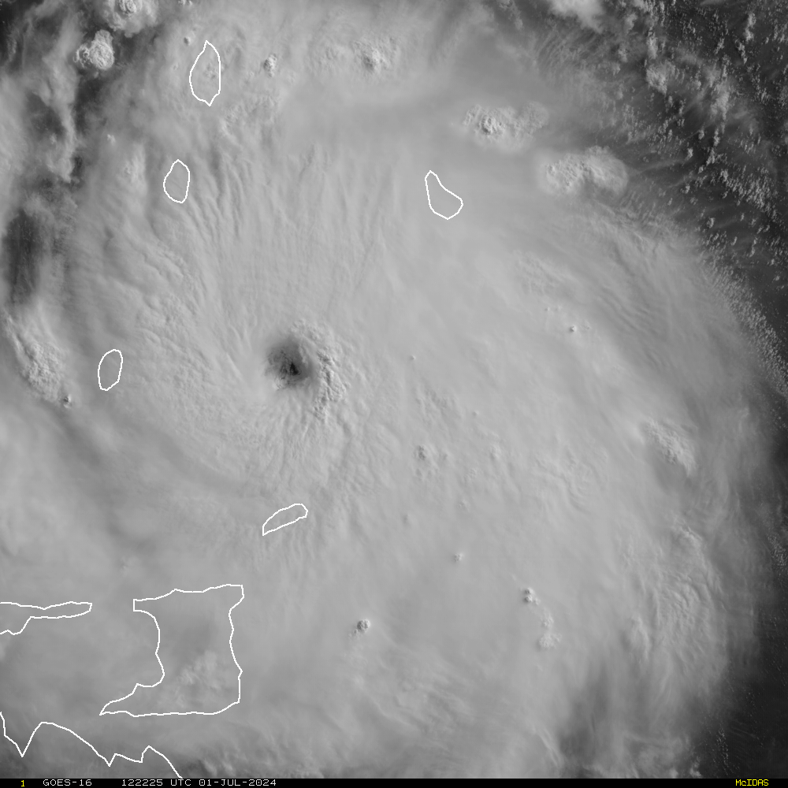Visible imagery of Beryl SW of Barbados
1226 | Sonde #20 MP N
1228 | 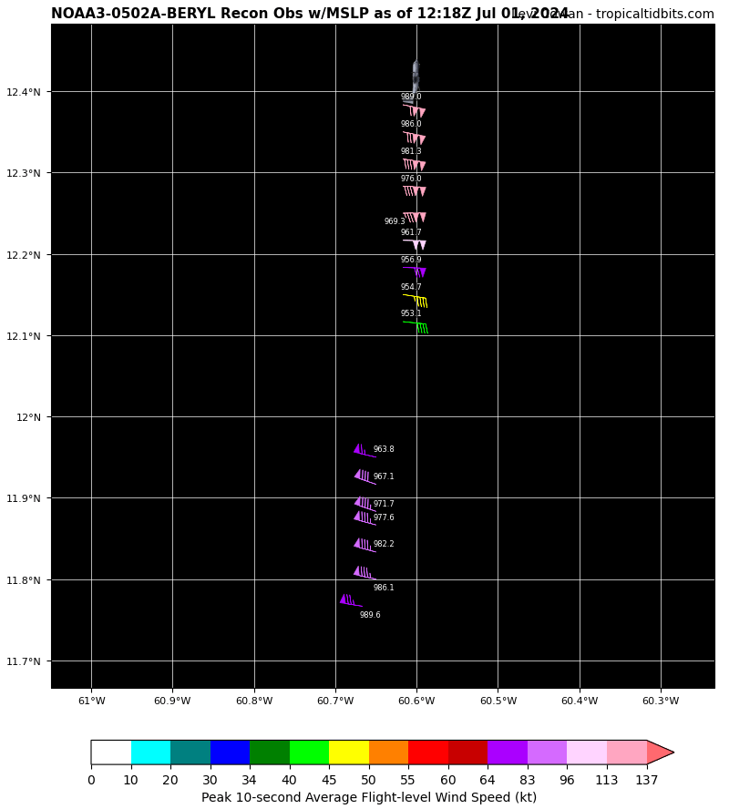  Third Pass. NOAA fix: extrapolated surface pressure 953.1 mb, peak outbound N quadrant.
1233 | 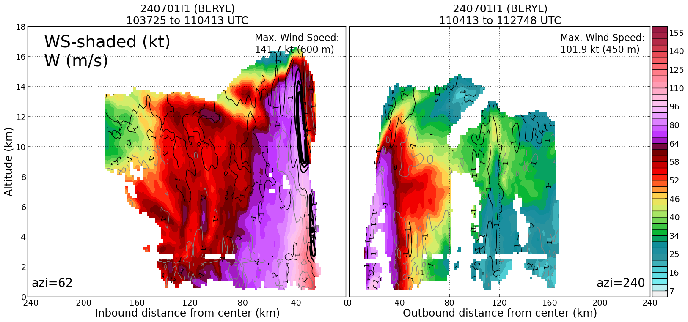  On second center pass, peak winds from TDR profile is 141 kt in NE quadrant, very strong updrafts in NE eyewall
1236 | 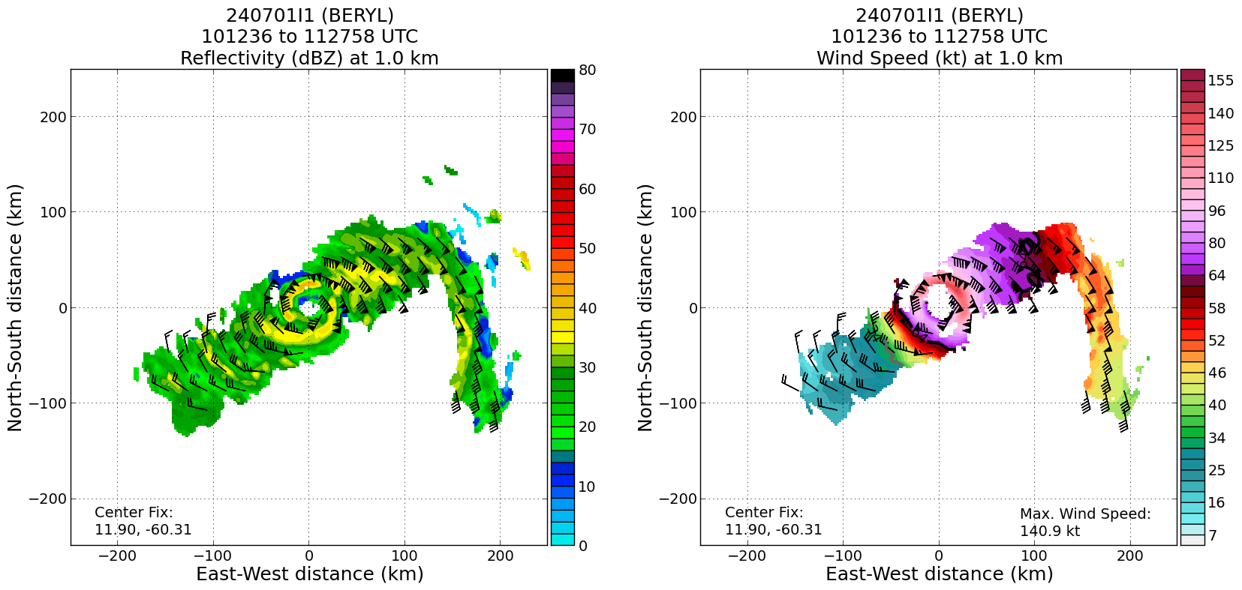  Plan view plot shows 141 kt in NE quadrant, consistent with profile. These winds have increased 20 kt from the previous pass (1.5 h previously)
1242 | N eyewall drop, surface wind 132 kts!
1255 | Butterfly complete - head from FP on north side back toward center. Looking for a good stratiform region to start the spiral.
1301 | Spiral module starting time. Position: 13.05N, 60.63W
1304 | 34dbz, range 28-34dbz, ~40dbz at 5km,  Z=3.5km, T=5.8C,  Z=4.5km, T=1.4C, WS 60knts  Z=5.0km, T=-0.1C  Z=5.5km, T=-3C  Z=6.0km, T=-5.7C  Z=6.2km, T=-7.2C  Z=6.5km, T=-8.2C  Z=6.6km, T=-11.2C  Z=7.1km, T=-10.1C  Z=7.2km, T=-10.9C  Freezing level: 16000 feet  Some missing data between 5000-6000 feet.  “freezing lvl is at 16000 feet so for what you want to capture it looks like it will capture the phase change density etc” “ those levels of altitude will have the data from the sonde.” “solid data from 22000 ft to 6000 ft.” N eyewall drop: 132 kts. Cloud physics probes worked well. QK-N43-FD.
1322 | Sonde #22, Top of the spiral module
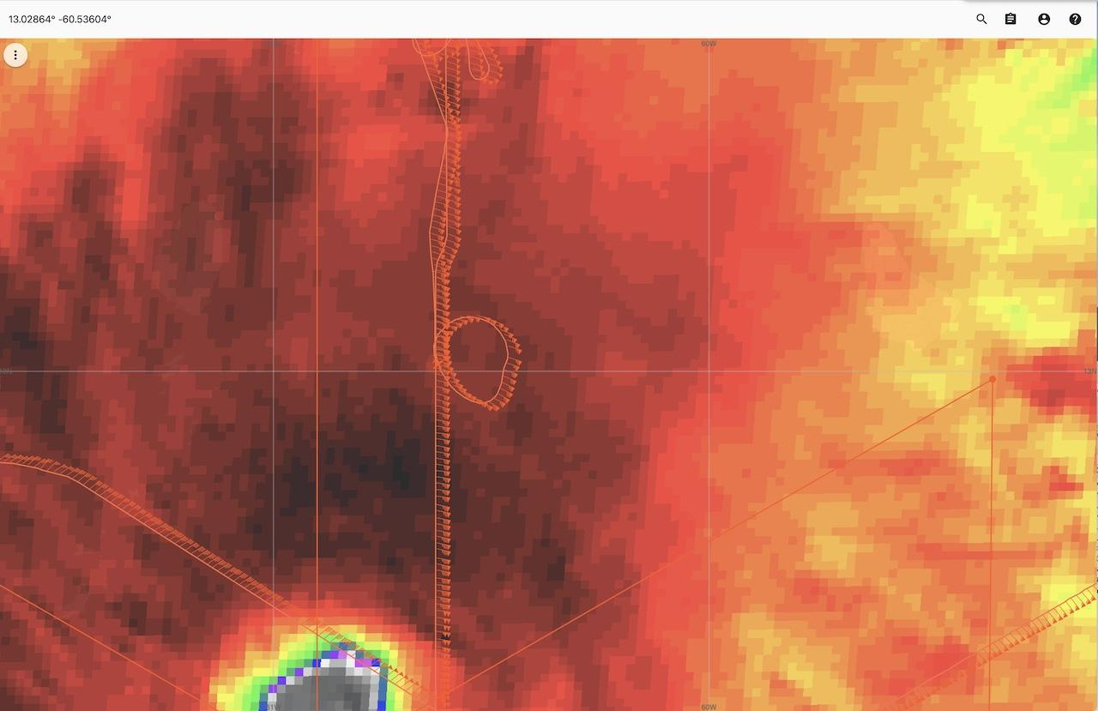
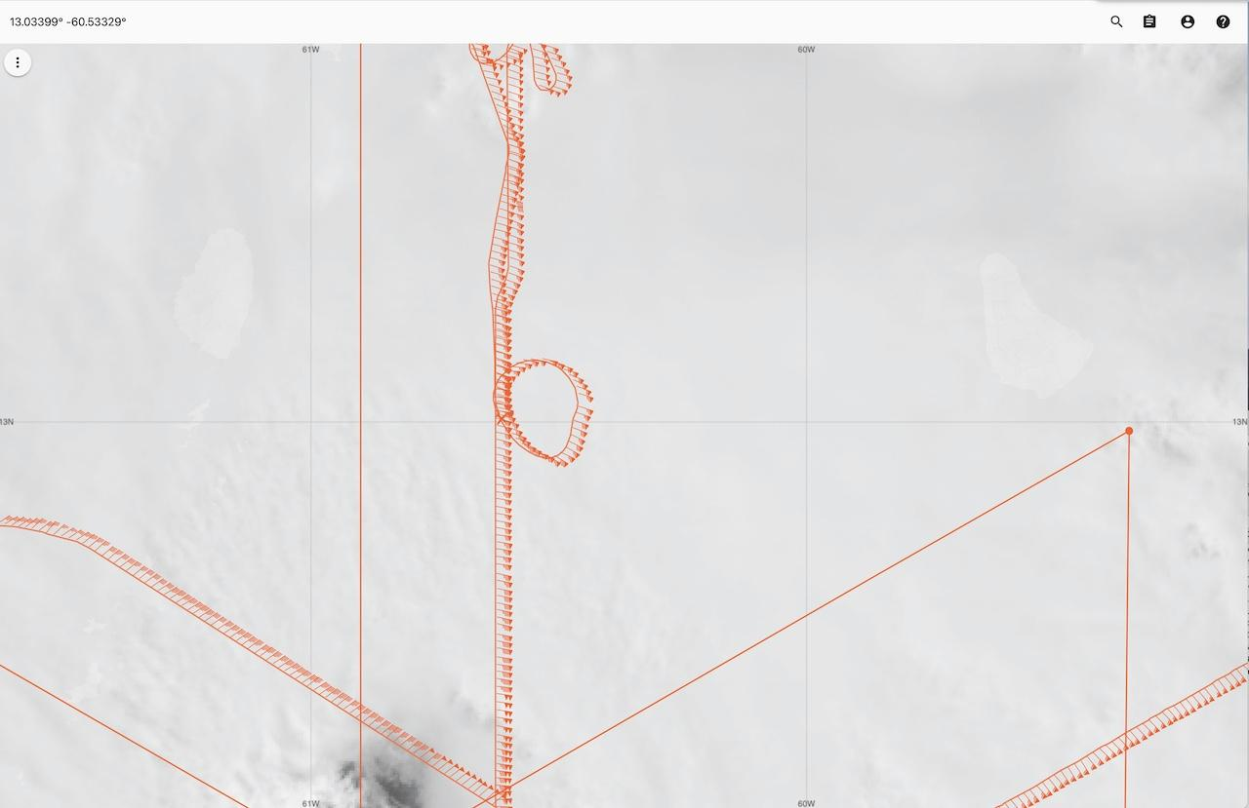
MS Spiral centered at ~13.023N 60.536W
1332 | 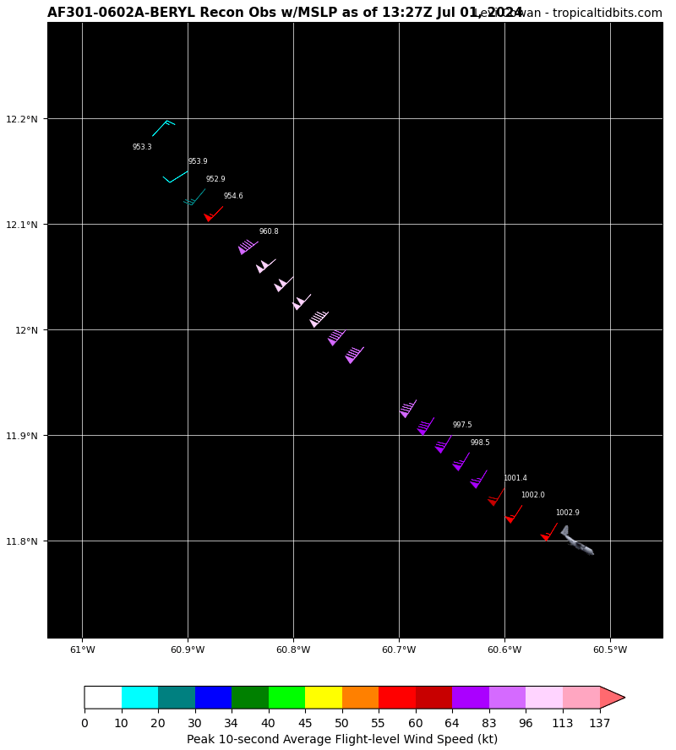AF fix: extrapolated surface pressure 952.9 mb, peak outbound SE quadrant.
1337 | Ending time of spiral module
1338 | 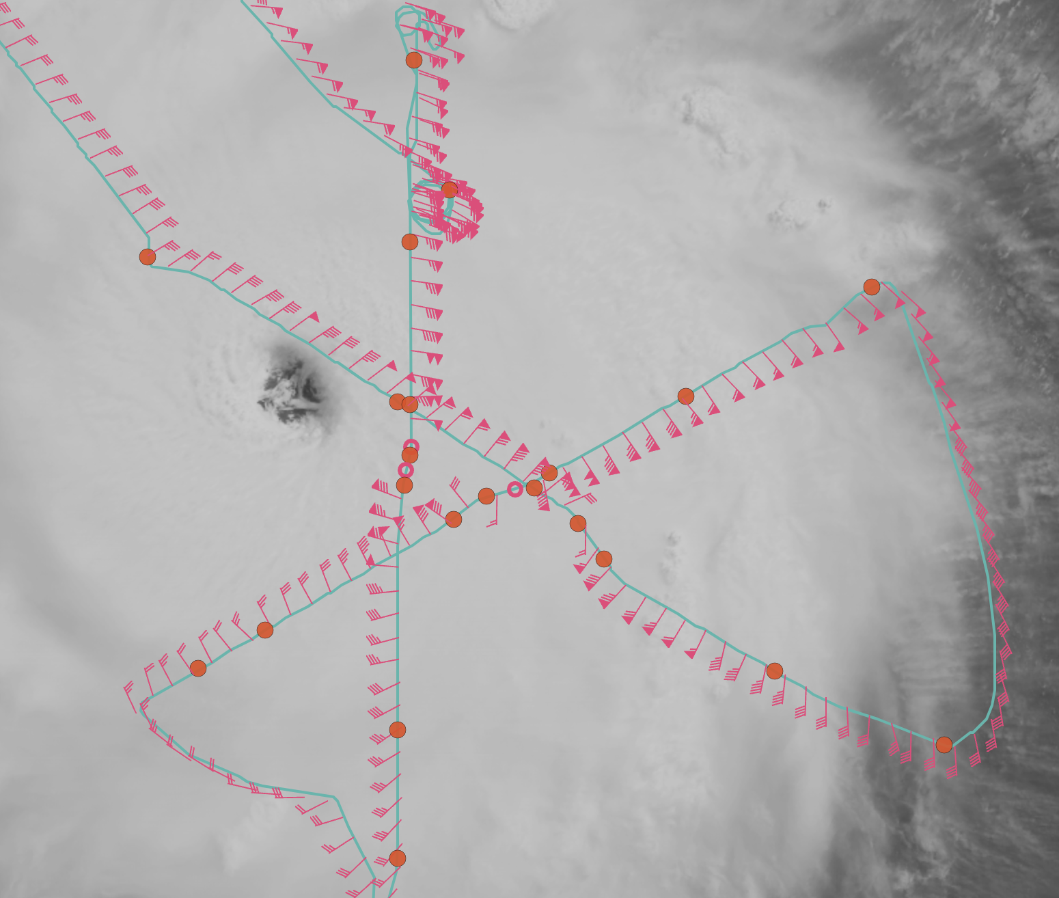
1340 | 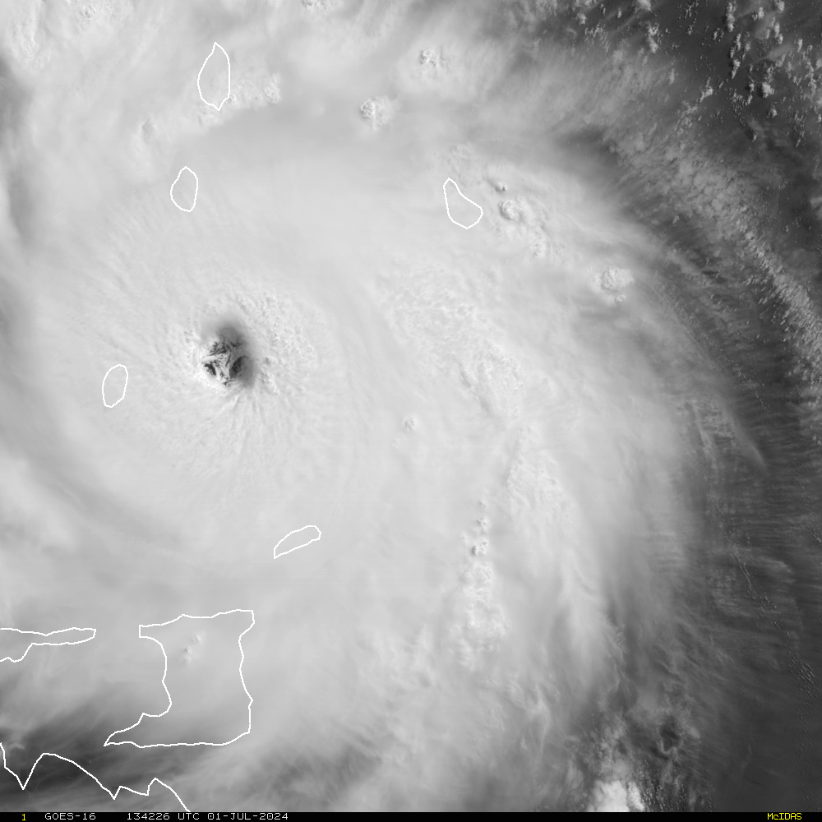
 | << INSERT ADDITIONAL ROW AS NEEDED >>

POST-FLIGHT
Mission Summary | AOML/HRD was supporting operationally tasked NOAA NHC/EMC P-3 Tail Doppler Radar missions into Hurricane Beryl. A butterfly pattern with three center passes was flown. Hurricane Beryl was upgraded to Category 4 again. Northern eyewall maximum surface wind was observed at 132 knots. The APHEX-HRD science teams (See final mission track) successfully performed a Stratiform Spiral module after the butterfly pattern was completed, extending to altitudes up to 7.2km (~22000 ft), with in situ temperatures getting to -11.2 C. The spiral was located close to the northeastern eyewall, perhaps closer to the eyewall than any previous spiral. It will be interesting to see the distribution of hydrometeors, and how they vary with height/temperature, so close to the eyewall. The Emerging Tech team also dropped one Stream Sonde to test the software and launch device. 22 dropsondes, 1 stream sonde, and 1 spiral module dropsonde dropped and ## transmitted. TDR analysis from three center passes were sent to the operational center. Beryl was rapidly intensifying, with peak 2-km winds increasing by 20 kt between the first and second pass (about 1.5 h apart). The mission successfully addressed the operational TDR needs and Spiral module completed successfully. The maximum surface wind of 132 kts was observed at the surface in the north eyewall. Three center fixes were reported.
Actual Standard Pattern Flown | Butterfly
APHEX Experiments / Modules Flown | [Linked to HFP Plan; fill in regardless of whether the mission was operationally or research tasked]  Spiral module, RICO SUAVE
Plain Language Summary | [Boil down the above into a couple of bullet points in “plain language”. This will help us when we report to management & OAR Public Affairs and prepare storm mission summaries]  AOML/HRD supported operationally tasked NOAA NHC/EMC P-3 Tail Doppler Radar missions into Hurricane Beryl. Hurricane Beryl was upgraded to Category 4 again. Northern eyewall maximum surface wind was observed at 132 knots The APHEX-HRD science teams (See final mission track) successfully performed a Stratiform Spiral module in the mission that collected important information on the distribution of rain, ice, and snow particles that will be useful for improving their representation in computer models and potentially improving rainfall and intensity forecasts. The spiral was located close to the northeastern eyewall, perhaps closer to the eyewall than any previous spiral. It will be interesting to see the distribution of hydrometeors, and how they vary with height/temperature, so close to the eyewall. The Emerging Tech team also dropped one Stream Sonde to test the software and launch device.
Instrument Notes | [Notes about instrument status from during and after the mission]  No report of instrument issue except spiral dropsonde data were intermittently reported below 6000 feet.
Final Mission Track | [Insert MTS screenshot of final flown track, ideally at the completion of the pattern with satellite imagery]  