MISSION PLAN
FLIGHT ID | 20240701H1 | STORM | AL02 / BERYL
MISSION ID | 0702A (Ex. 0305A) | TAIL NUMBER | NOAA-42
TASKING | EMC/NHC FIX/TDR | PLANNED PATTERN | Alpha
MISSION SUMMARY
TAKEOFF [UTC] | 2204 | LANDING [UTC]
TAKEOFF LOCATION | STX | LANDING LOCATION | STX
FLIGHT TIME | Fractional hr, Takeoff to Landing Time | BLOCK TIME | Get from onboard LPS or Flight Director
TOTAL REAL-TIME RADAR ANALYSES  (Transmitted) | 6 (5) | TOTAL DROPSONDES Deployed (Transmitted) | 37 (36)
OCEAN EXPENDABLES (Type) |  | sUAS (Type)
APHEX EXPERIMENTS / MODULES | None
HRD CREW MANIFEST
LPS ONBOARD | Aberson | LPS GROUND | Alaka/Sippel
TDR ONBOARD |  | TDR GROUND | Alvey
ASPEN ONBOARD | N/A | ASPEN GROUND | Hazelton/Dahl
NESDIS SCIENTISTS
GUESTS (Affiliation)
AOC CREW MANIFEST
PILOTS | Copare, Palmer, Ellis
NAVIGATOR | Utama
FLIGHT ENGINEERS | Stokes, Dittoe
FLIGHT DIRECTOR | Zawislak
DATA TECHNICIAN | McCalister
AVAPS | Lynch

PRE-FLIGHT
Flight Plan | 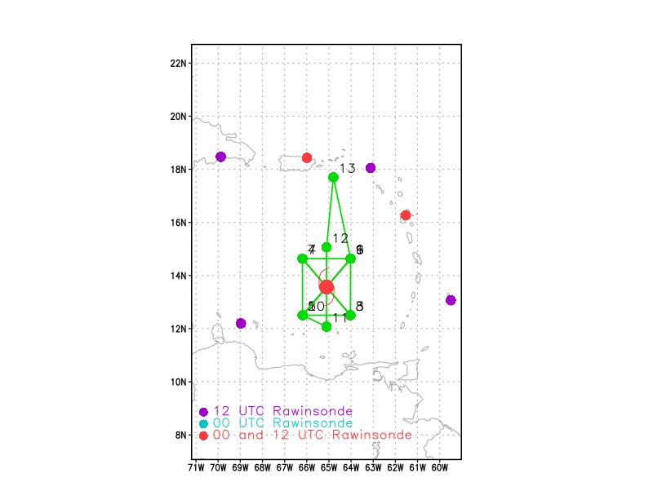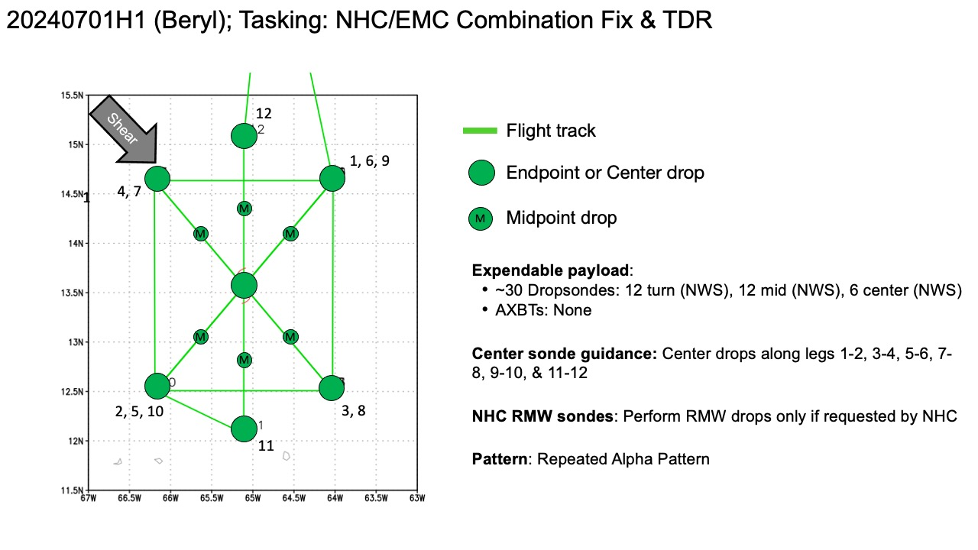  Pattern: Fly repeated Alpha pattern with 90 NM legs
Expendable Distribution | - Load 30 dropsondes  - Release at endpoints, midpoints, centers, RMWs (if requested by NHC) >> charged to NWS  - All dropsondes transmitted to the GTS  - AXBTs: none
Preflight Weather Briefing | Beryl has maintained intensity as a high-end Category-4 hurricane this afternoon. From NHC:  “Beryl has maintained a very impressive satellite appearance this  afternoon. The well-defined, symmetric eye is surrounded by a ring  of infrared cloud tops colder than -70 deg C. The central pressure  of the hurricane was falling throughout the day while the Hurricane  Hunters sampled the storm, with the last aircraft pass showing the  central pressure had fallen to around 946 mb. The latest objective  (ADT/AiDT) and subjective (TAFB/SAB) satellite intensity estimates  still support an intensity between 125 to 130 kt, which lies in  between the earlier reduced flight-level winds and SFMR retrievals  from the aircraft. Thus, the initial intensity of Beryl is held at  130 kt for this advisory.”
Instrument Notes | No problems of note

IN-FLIGHT
Time [UTC] | Event
2204 | Take-off from STX
2240 | 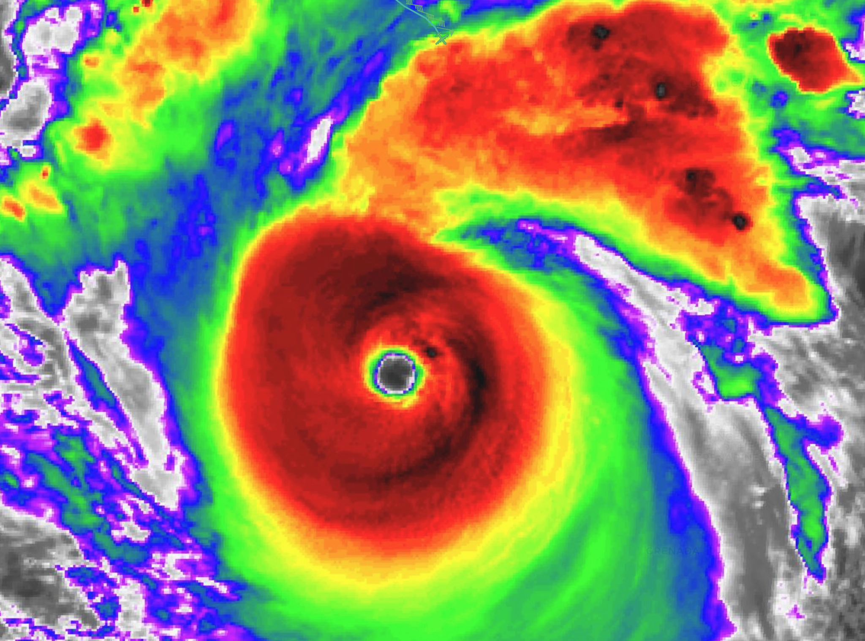
2304 | NE IP
2305 | Sonde 1 - End-point NE launched, splashed 2312
2316 | Sonde 2 - Mid-point NE launched, splashed 2321
2323 | Continued problems with SFMR  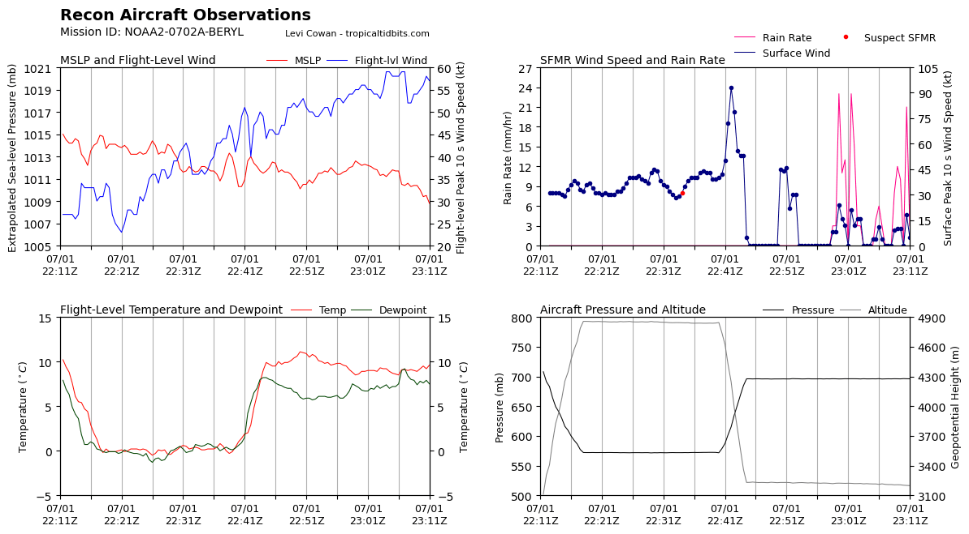
2328 | 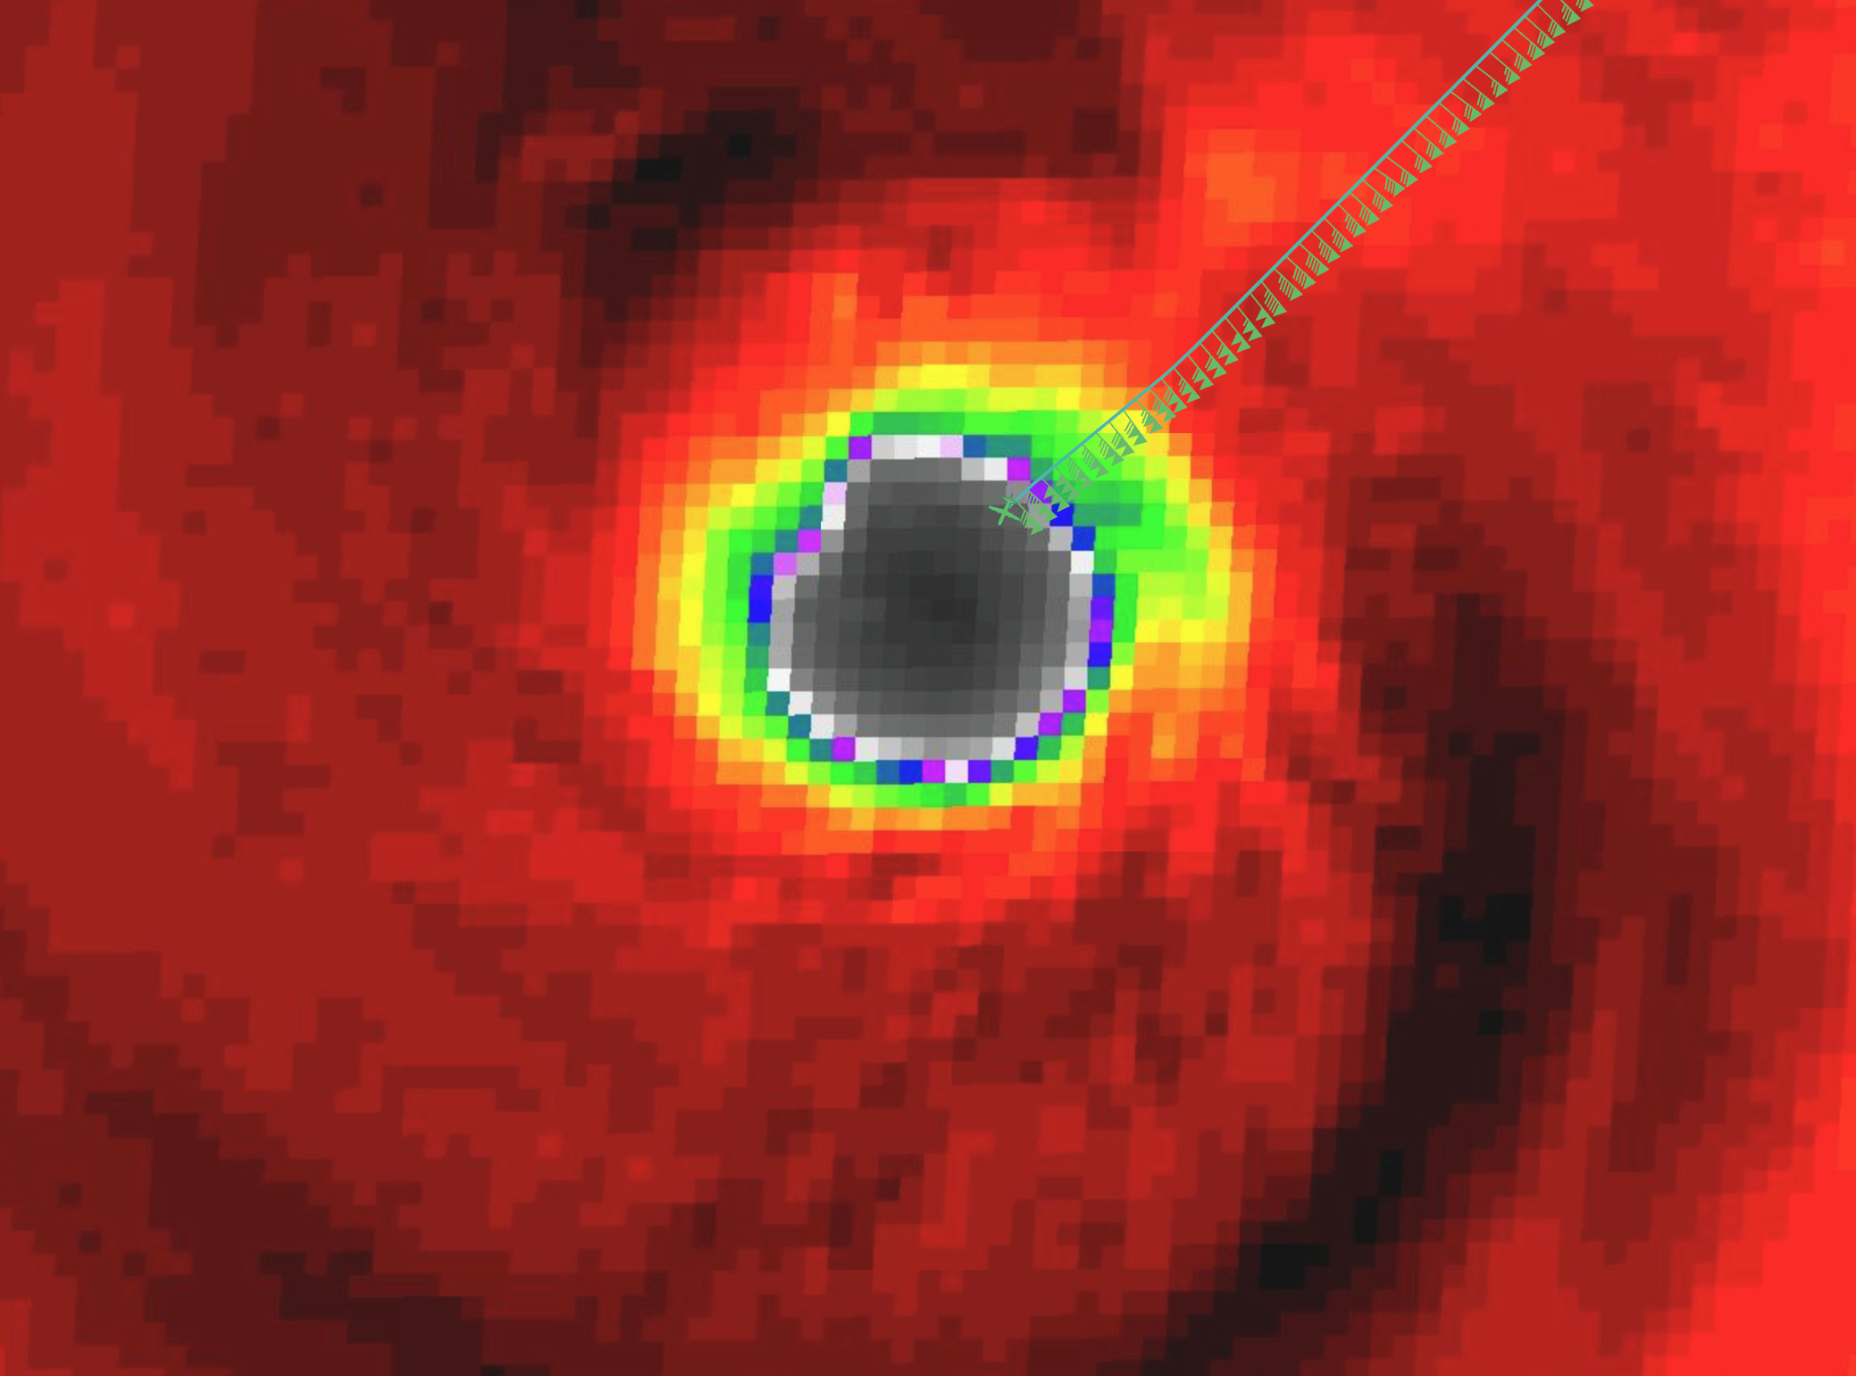
2329 | Aberson: lightning, but low reflectivity in eyewall, graupel on inboud
 | 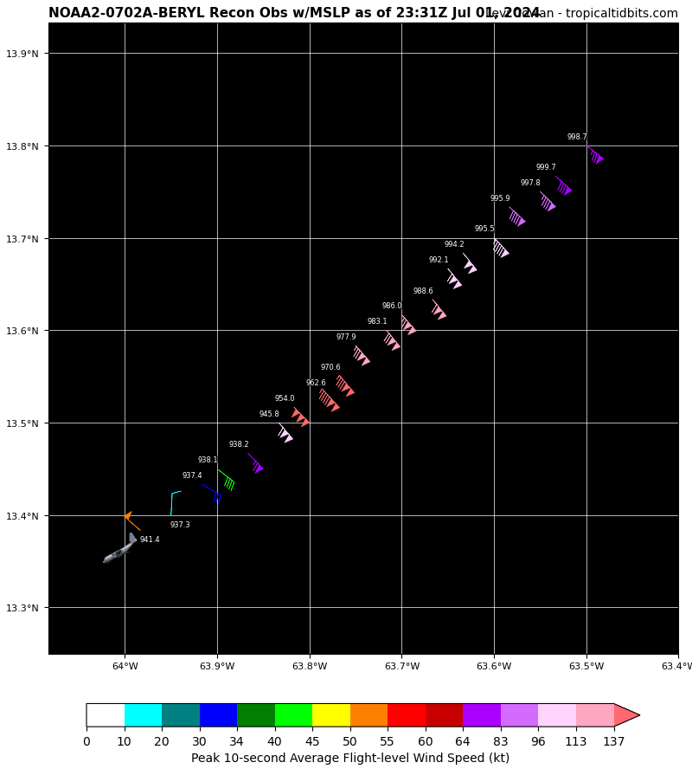
 | 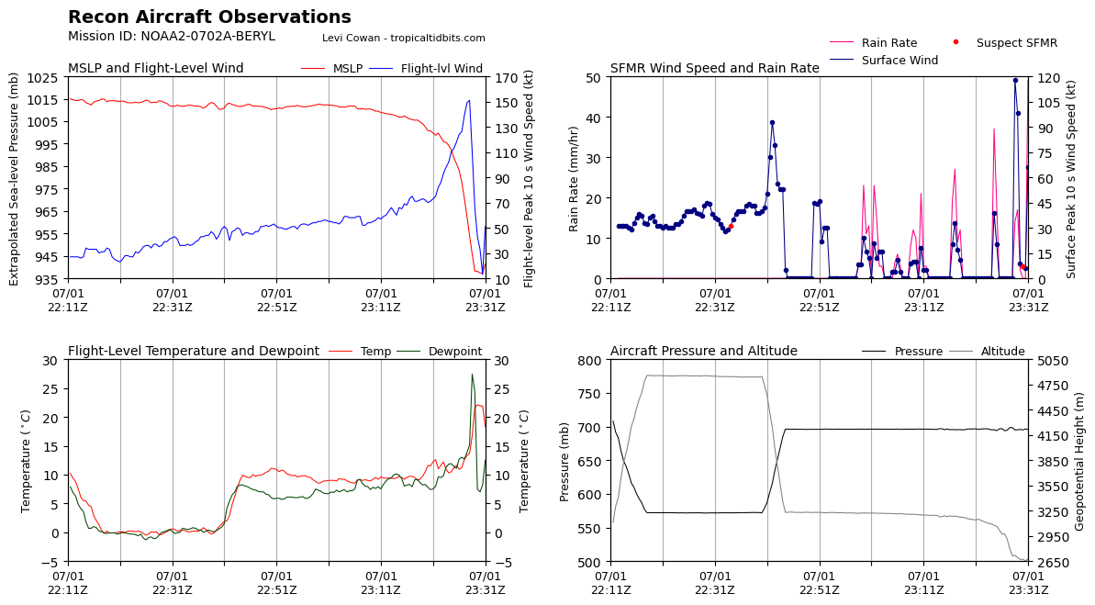
2326 | Sonde 3, NE RMW1 launched, landed in eye
2326 | Sonde 4, NE RMW 2 launched, landed in eye
2326 | Sonde 5, NE RMW 3 launched, 140 kt at surface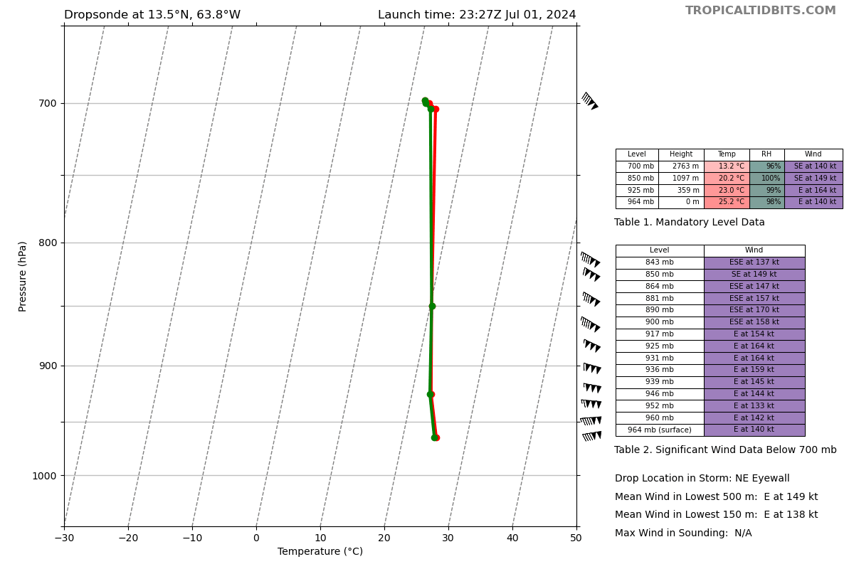
2330 | Sonde 6 Center launched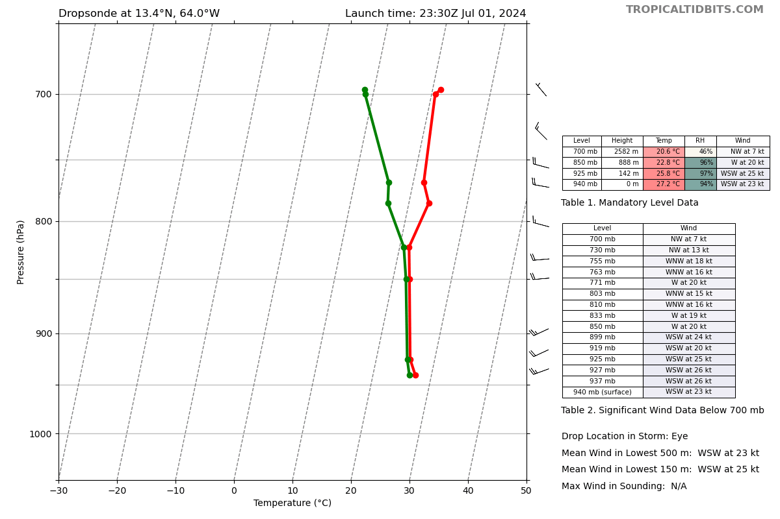
2340 | Sonde 7 - SW RMW lost all data at launch
2341 | Sonde 8 - SW mid point, splashed 2347
 | 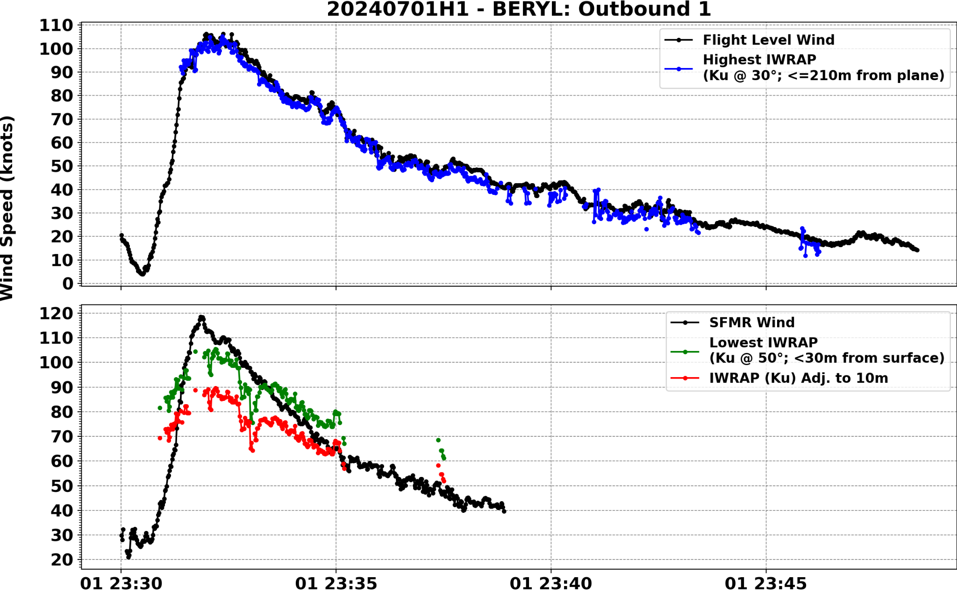
2351 | Sonde 9 - SW end point launched, splashed 2357
 | 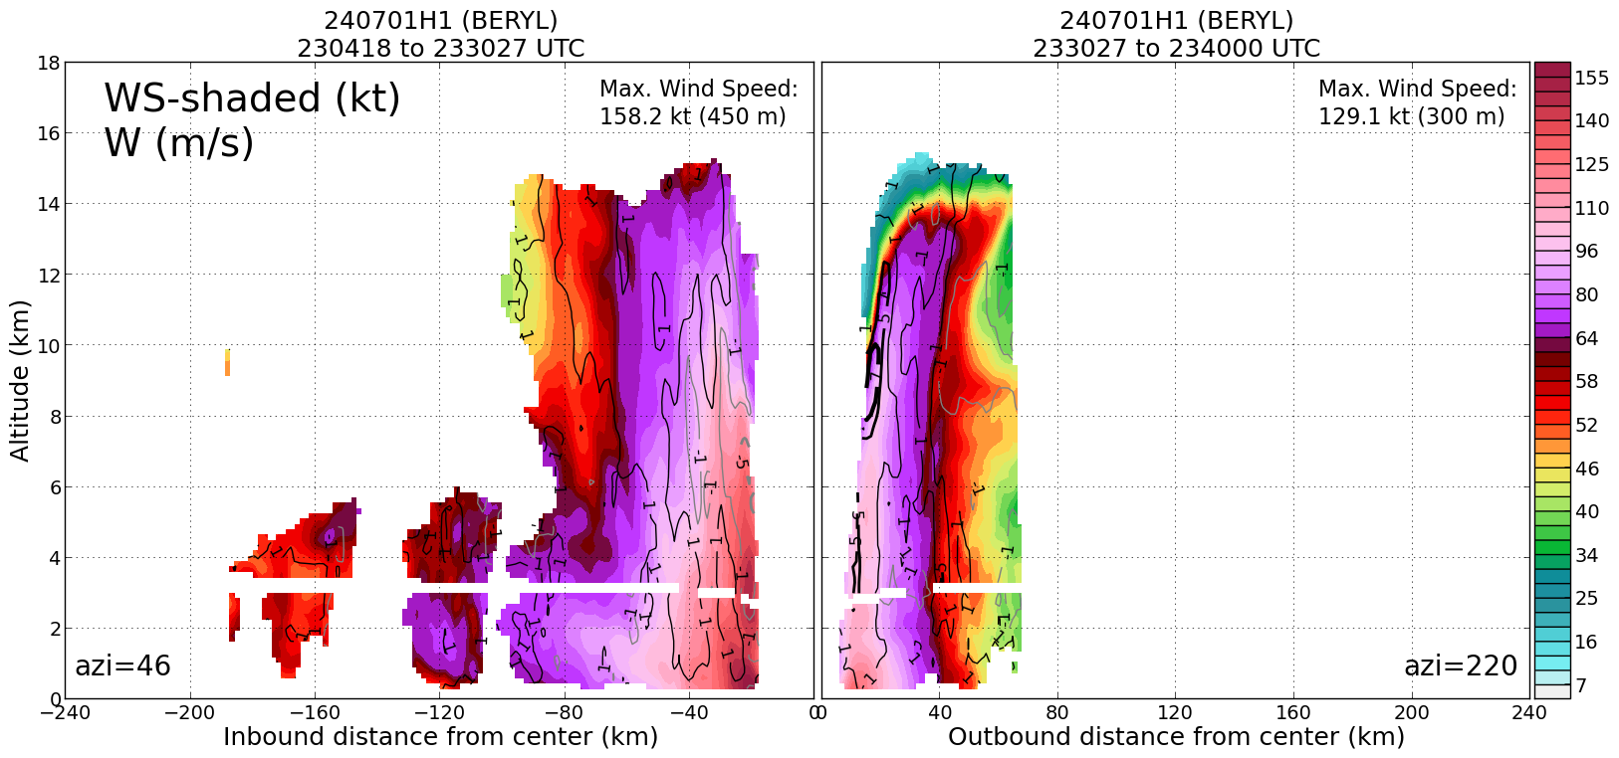
0004 | Aberson: reset radar twice Aft not scanning, hard reset at 0005
0016 | Sonde 10 - SE end point
0015 | RMW appears to be shrinking a bit in IR
0027 | Sonde 11, SE Mid Point
 | 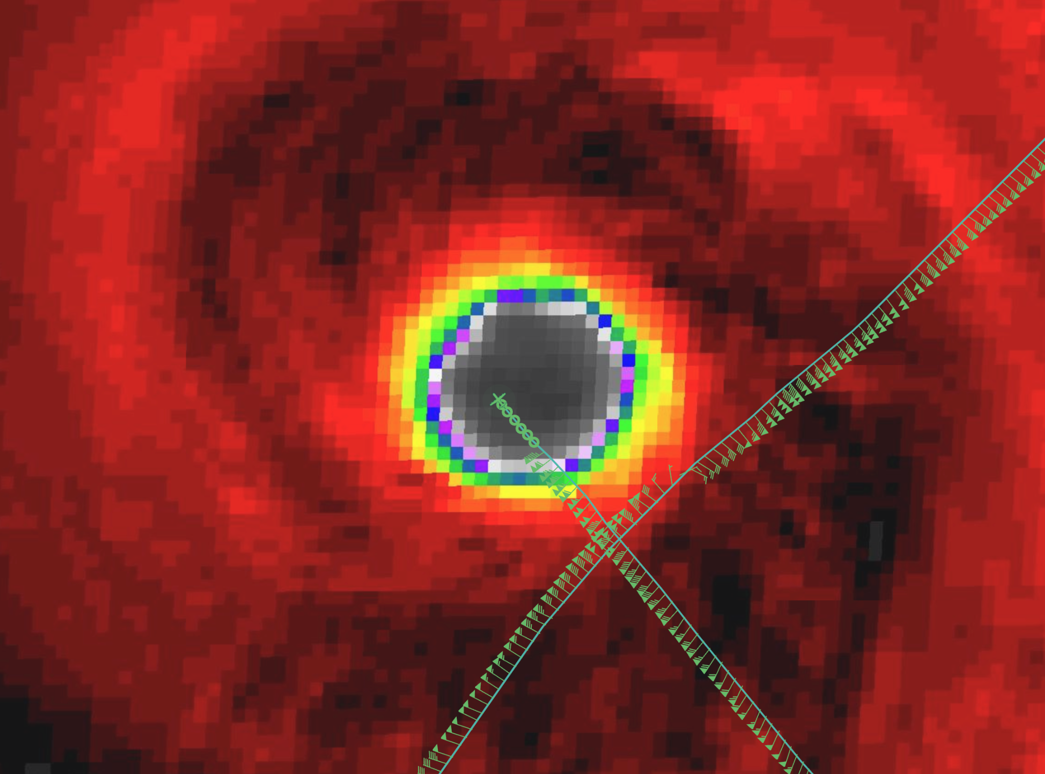
0030 | Abserson notes lightning in eye
0031 | Sonde 12, SE RMW
0034 | Sonde 13, Center
0036 | Sonde 14, NW RMW
0044 | Note: graupel reported on the first inbound leg (NE->SW)
0046 | Sonde 15 NW Mid point
0057 | Sonde 16 NW End point
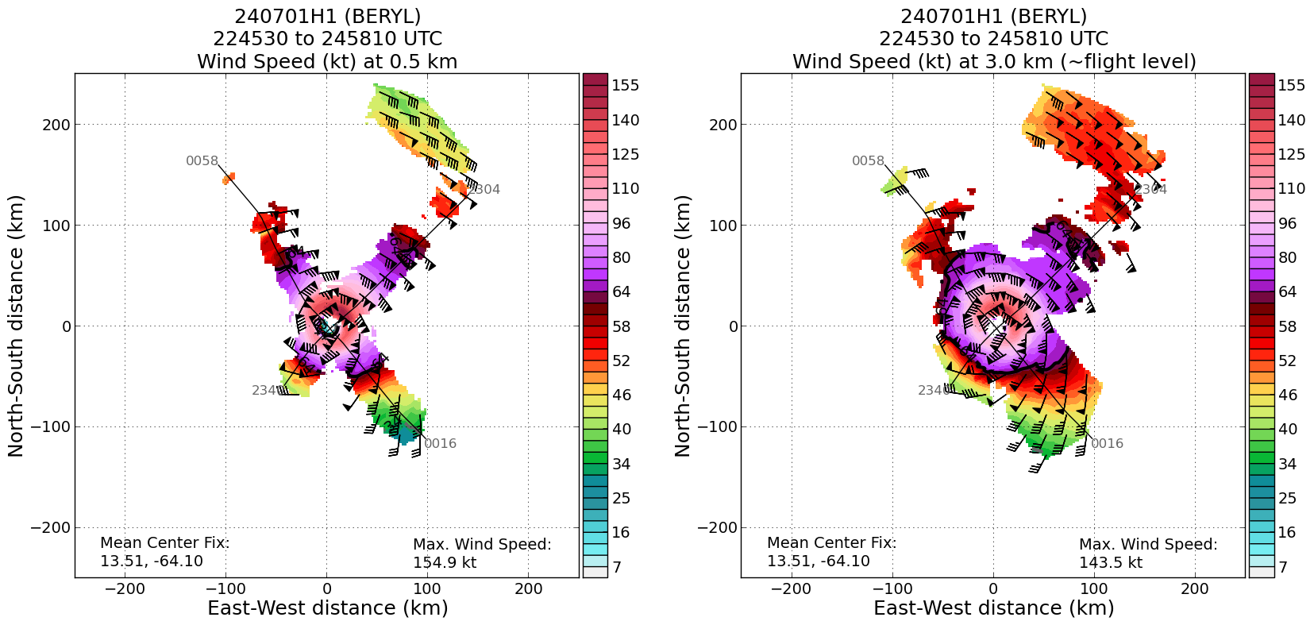
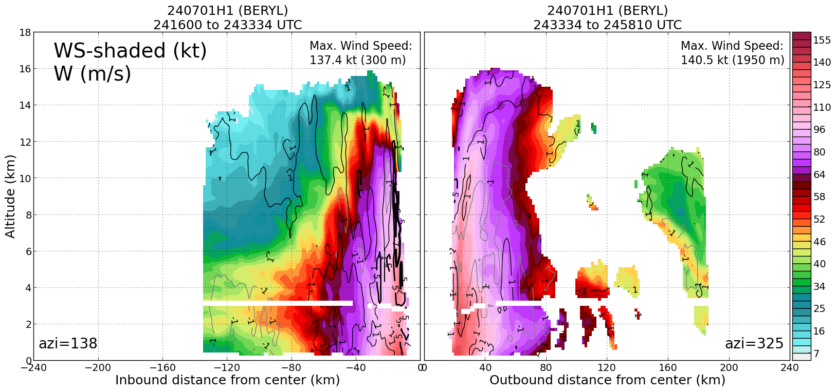
0059 | SFMR HDOB generation not working correctly. NHC has agreed to not send SFMR data for this mission. Similar issue with 0 kt reports in HDOBs as 20240630H1. 1-second data look ok, although the calibration appears to have issues. There is something happening with the generation of the HDOBs leading to these 0 kt reports. AOC is troubleshooting.  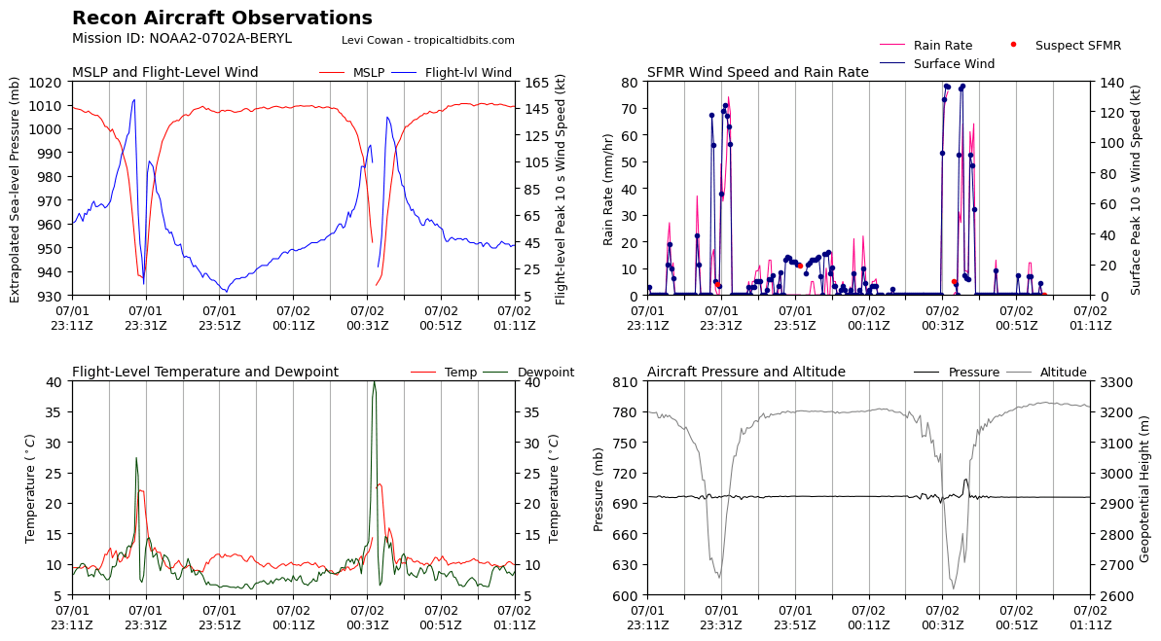
0122
0131 | Sonde 17 SW End Point (turn inbound)
0132 | 2nd TDR analysis is now up on RT: https://www.aoml.noaa.gov/ftp/pub/hrd/data/RTradar/2024/20240701H1/composites/240701H1_BERYL_2245_2458_ws_nhc_planview.png
0140 | Sonde 18 SW Mid Point
0150 | Sonde 19 SW RMW (not sent)
0150 | Sonde 20 Center
0153 | Sonde 21 NE RMW (processed and sent off plane by Aberson)
0203 | Sonde 22 mid point NE (processed and sent off plane by Aberson)
 | 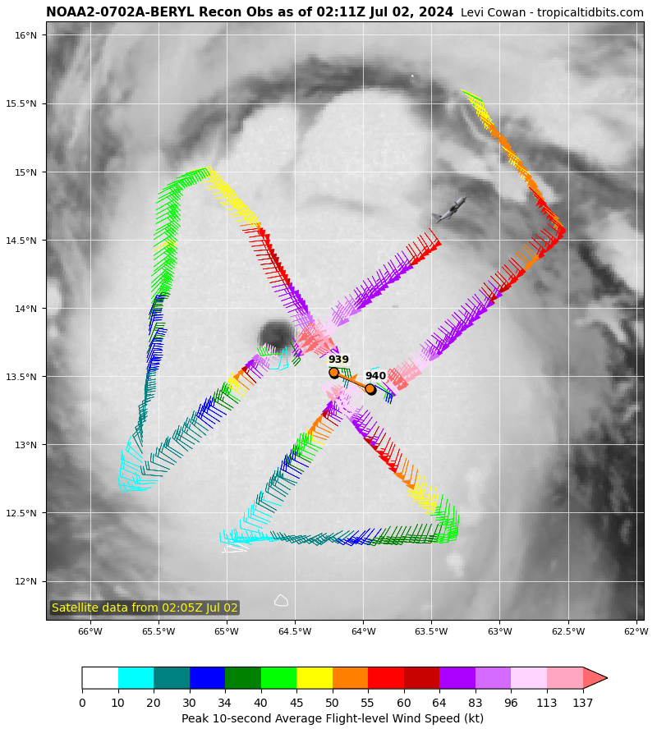
0215 | Sonde 23, End-point NE launched (processed and sent by Aberson)
 | 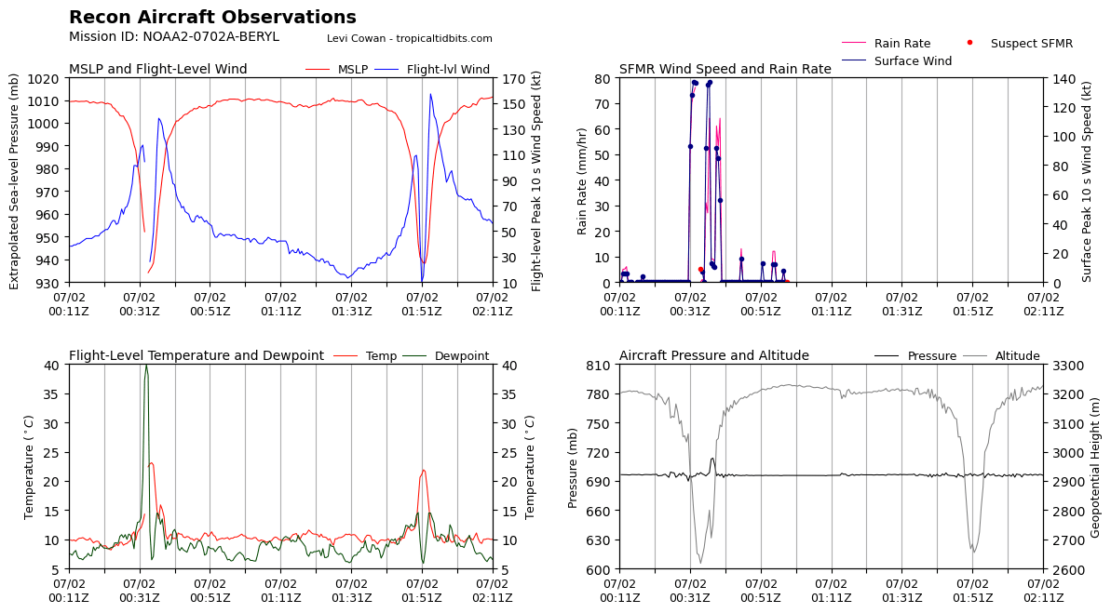
0221 | Hazelton brings up problem that RMW sonde not showing up on NHC website but had been processed in TAG. Same for mid-point.
0238 | Hazelton notes they show up in the TAG history but aren’t showing up at NHC. Discussion with JZ and Aberson followed. Solution is for Sim to process the sondes and Dahl/Hazelton to log it
0247 | 3rd TDR analysis should be up in AWIPS and in RT graphics shortly:  https://www.aoml.noaa.gov/ftp/pub/hrd/data/RTradar/2024/20240701H1/composites/240701H1_BERYL_2245_2615_ws_nhc_planview.png  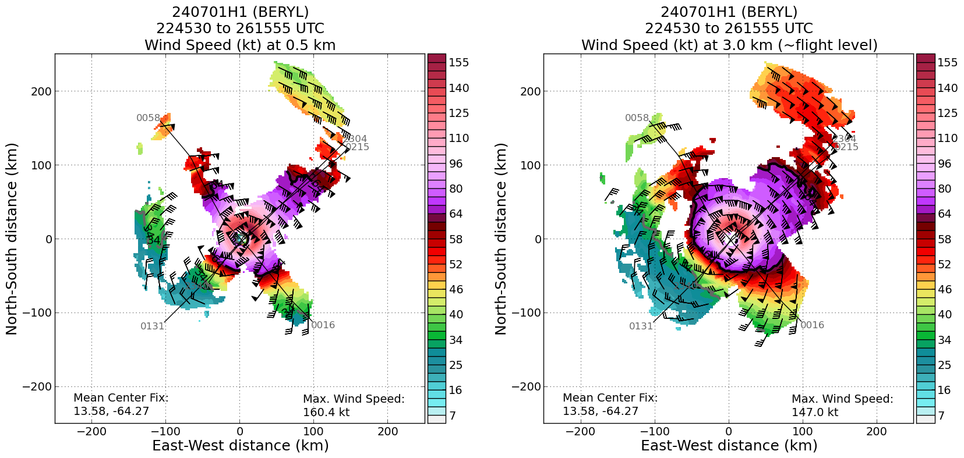  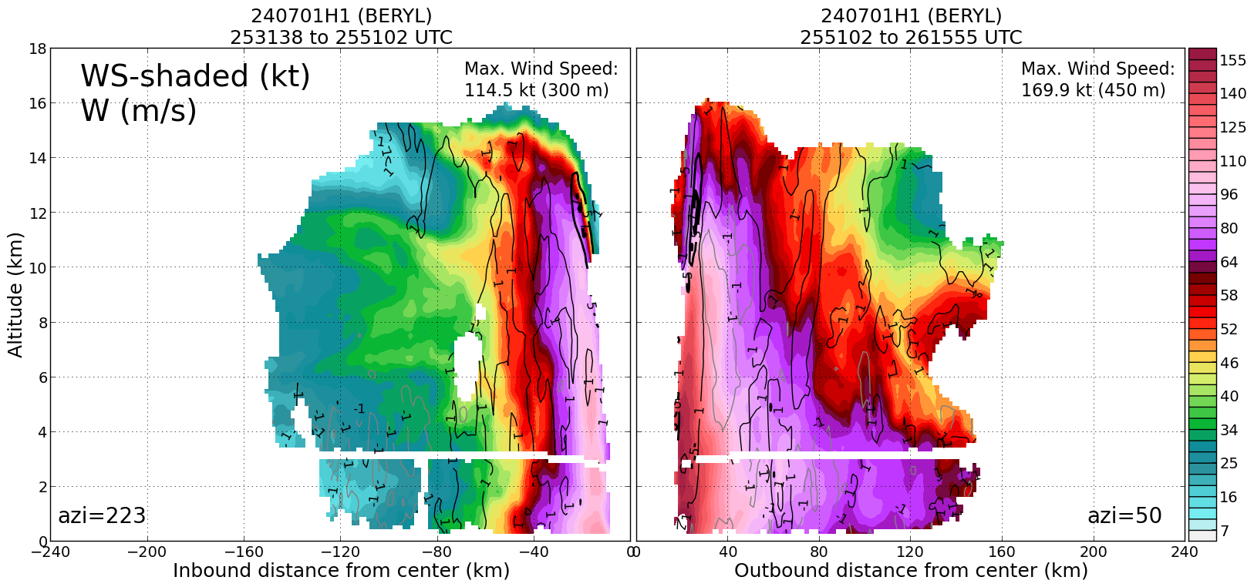
0257 | Evidence of westerly shear to the WNW of Beryl. Seems to be associated with a PV streamer associated with an ULL to the north. This could impart a more hostile environment in the next ~24h. NHC notes this in their 11pm discussion
0259 | NHC upgrades Beryl to Category 5. Below is a discussion written by Forecaster Papin  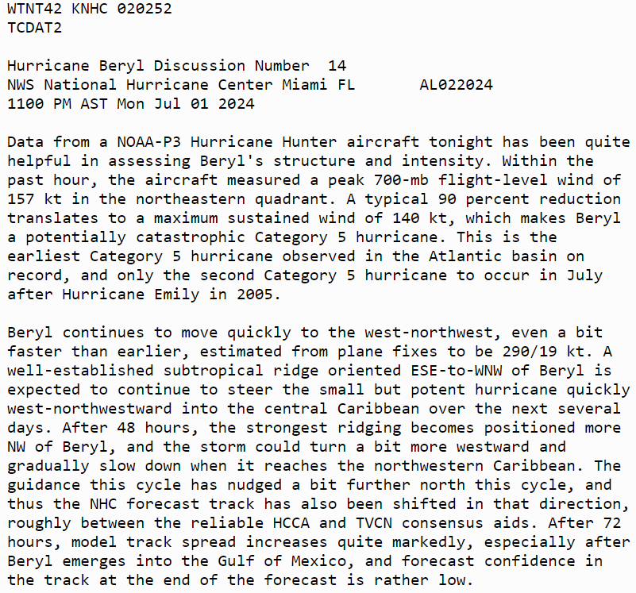
0254 | Sonde 24 launched - NW EP
0305 | Sonde 25 launched - NW MP
0305 | 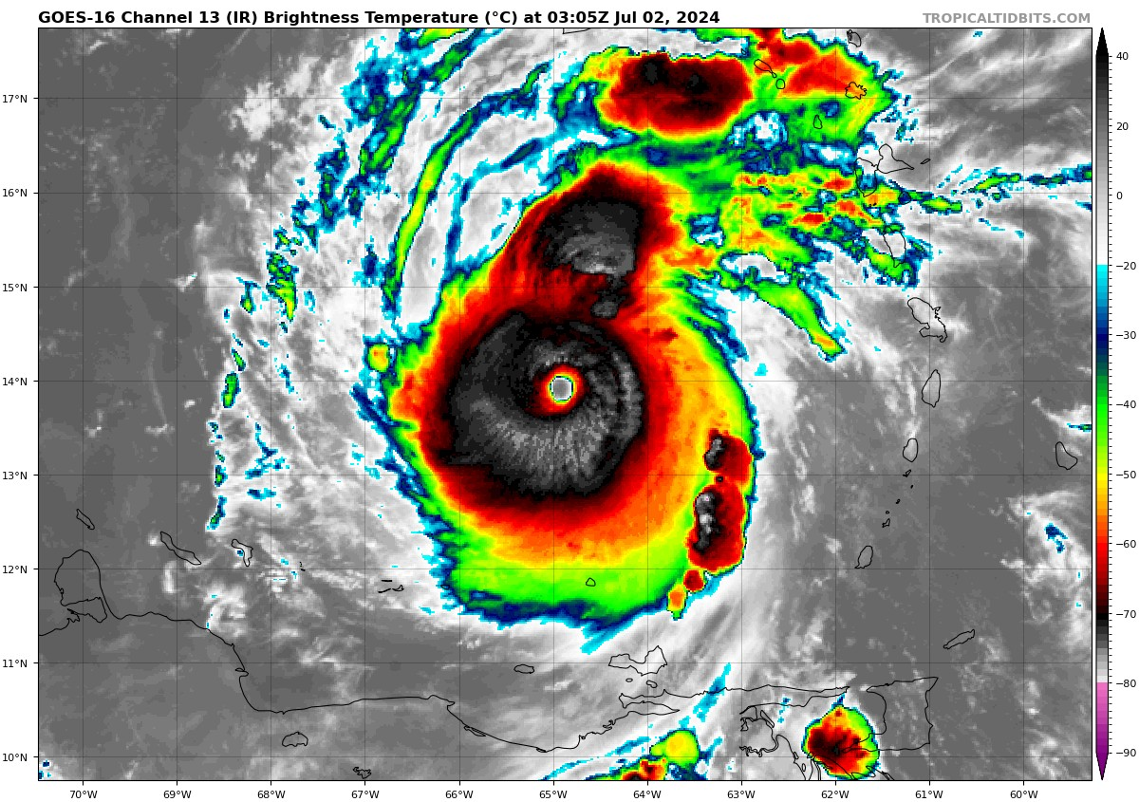
0316 | Sonde 26 launched - NW RMW  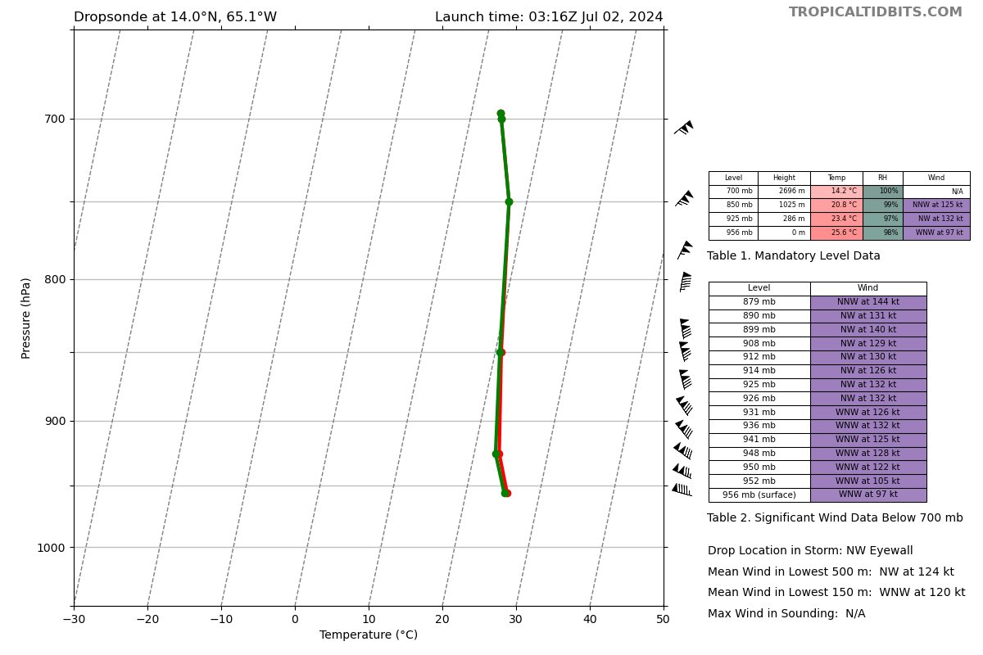
0318 | Sonde 27 launched - CTR
0320 | Sonde 28 launched - SE RMW
0321 | 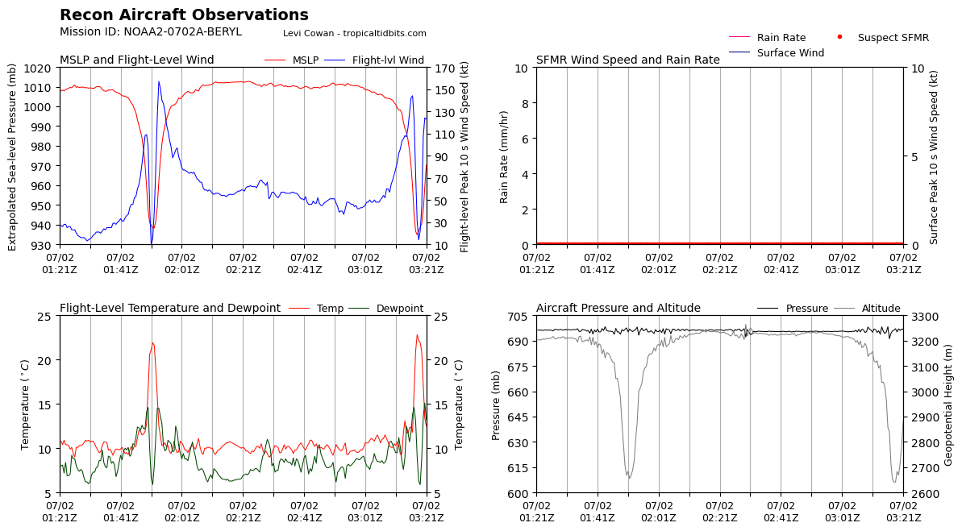  FL winds on the NW side keep going up - about 10 kt from last pass
0341 | Aberson: mmr trouble, loitering
0344 | Sonde 30 - SE End point
0348 | mmr can't be fixed. Orientation wrong, so can't look at track versus heading
0355 | Mmr back online after a hard reset
0410 | NHC changed plans - go to point 9 (NE), to center, then out NW, then home
0414
0433 | Sonde 31 - NE endpoint launch
0443 | Sonde 32 - NE midpoint launch
0456 | Sonde 33 - NE RMW launch
0458 | Sonde 34 - Center launch
0500 | Sonde 35 - NW RMW
 | 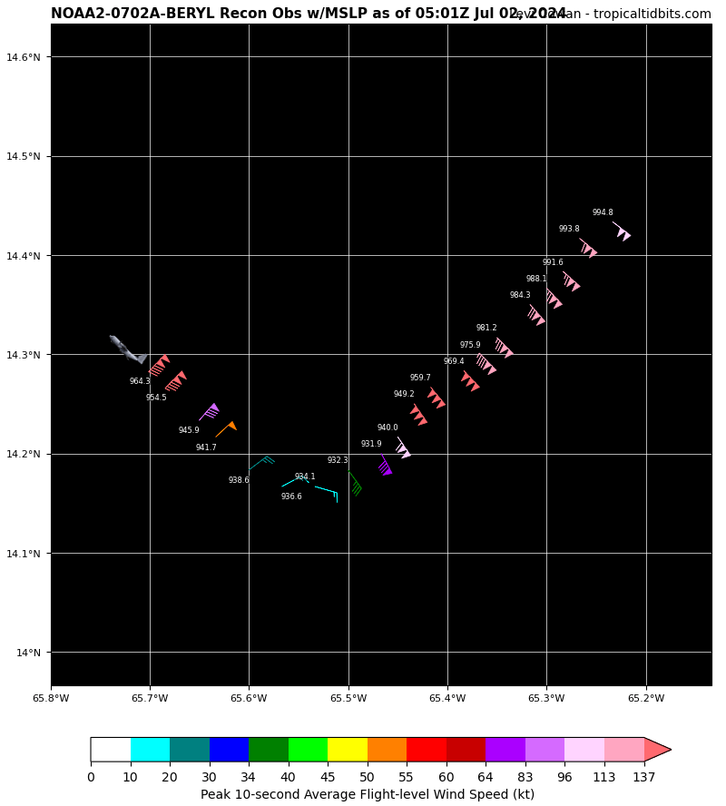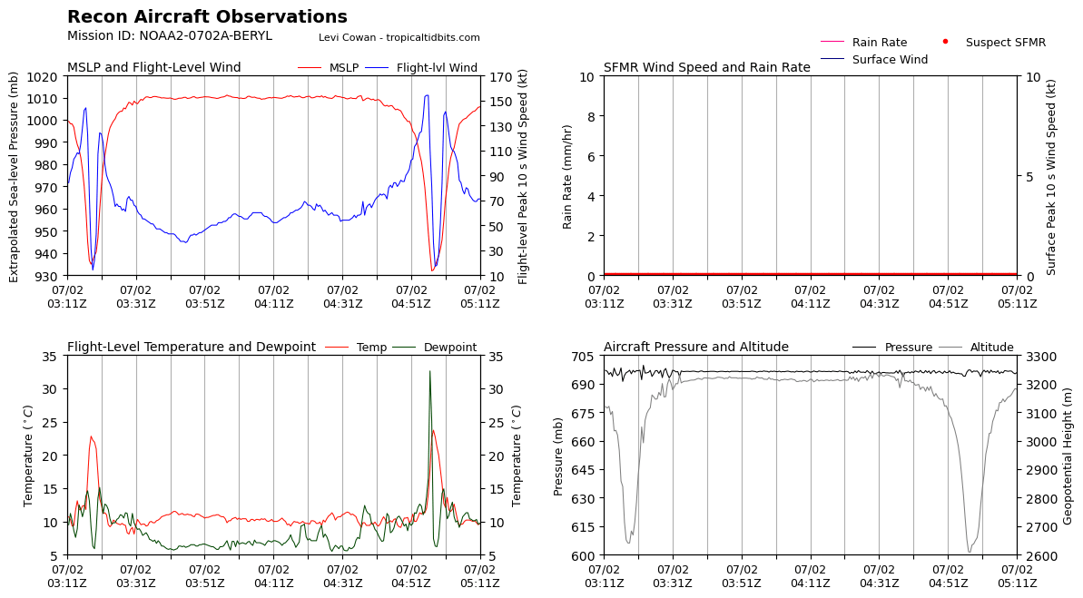
0510 | Sonde 36 - NW midpoint
0522 | Sonde 37 - NW endpoint
 | << INSERT ADDITIONAL ROW AS NEEDED >>

POST-FLIGHT
Mission Summary | Mission met objectives of collecting/assimilating TDR data into the 00Z forecast cycle at EMC. Also, TDR analyses transmitted successfully to NHC AWIPS and assisted in upgrading Beryl to category 5.
Actual Standard Pattern Flown | Alpha pattern
APHEX Experiments / Modules Flown | N/A
Plain Language Summary | We flew a mission into Hurricane Beryl as it intensified to a Category-5 hurricane in the Caribbean. The mission collected data for NHC forecasts and model assimilation. The storm intensified from 130 to 140 kt during the mission.
Instrument Notes | SFMR was bad during this mission - same issue as previous mission.  Problem with TAG arose on third pass with outbound RMW sonde - things seemed to get stuck. Solution was to take processing back to plane with onboard LPS.  Earlier in the mission, TDR has antennae alerts (including “losing all AC data”). SSA rebooted the TDR and it came back online OK.  Could be some calibration issues with HBOBs?
Final Mission Track | 