MISSION PLAN
FLIGHT ID | 20240630I1 | STORM | AL02/Beryl
MISSION ID | 0202A | TAIL NUMBER | NOAA-43
TASKING | EMC/NHC | PLANNED PATTERN | Figure-4
MISSION SUMMARY
TAKEOFF [UTC] | 0900 | LANDING [UTC] | 1643
TAKEOFF LOCATION | TISX | LANDING LOCATION | TISX
FLIGHT TIME | Fractional hr, Takeoff to Landing Time | BLOCK TIME | Get from onboard LPS or Flight Director
TOTAL REAL-TIME RADAR ANALYSES  (Transmitted) | 2 (2) | TOTAL DROPSONDES Deployed (Transmitted) | 35 (35)
OCEAN EXPENDABLES (Type) | 6 ONR AXBTs  (5 good) | sUAS (Type) | N/A
APHEX EXPERIMENTS / MODULES | Exact name of the Experiment in the HFP Plan; identify relevant experiments / module even if not a research tasking
HRD CREW MANIFEST
LPS ONBOARD | J. Zhang | LPS GROUND | J. Dunion/X. Zhang/M. Montgomery
TDR ONBOARD | J. Zhang | TDR GROUND | M. Fischer
ASPEN ONBOARD | K. Sellwood | ASPEN GROUND | n/a
NESDIS SCIENTISTS | n/a
GUESTS (Affiliation) | n/a
AOC CREW MANIFEST
PILOTS | Doremus/Wood/Taraboletti
NAVIGATOR | Schaefer/Meier
FLIGHT ENGINEERS | Tyson/Wysinger/Ripp
FLIGHT DIRECTOR | Kalen, Q.
DATA TECHNICIAN | Richards,T.
AVAPS | Patel

PRE-FLIGHT
Flight Plan | 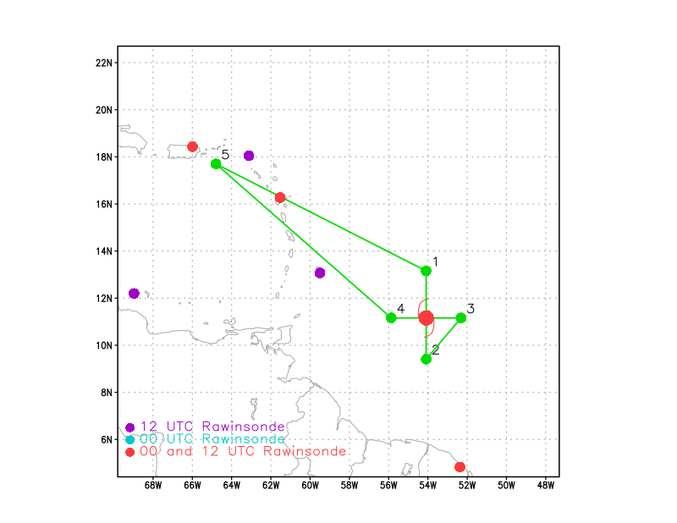  [Insert image of ONR/TCRI detailed pattern image, if available]  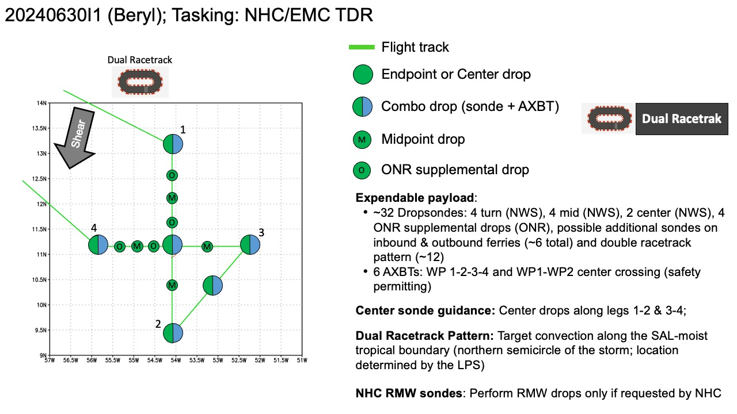  [If you want, briefly describe the pattern in words]  Attached is the proposed Figure-4 pattern for Sunday morning’s NHC-EMC tasked NOAA-43 TDR mission into Tropical Storm Beryl - 0500L / 0900z takeoff from St. Croix and recovering in St. Croix. Timing of the pattern is to be on-station for EMC data collection for the 1200z assimilation window between 0900z and 1500z.  Pattern: Fly Figure-4 pattern with 105 NM legs (120 NM for the WP 1-center leg)  Altitude:  - 10 kft preferred - 8 kft if AF deconfliction is required (pressure altitude)  Potential add-on Modules: (time permitting)  - Genesis Stage >> FAM Experiment: Dual Racetrack pattern
Expendable Distribution | [Describe planned dropsonde, ocean buoy, sUAS deployment locations; e.g., “Dropsondes/AXBT combo drops at endpoints, midpoints, and center”  Expendables:  - Load 35 dropsondes  - Release at endpoints, midpoints, centers, RMWs (if requested by NHC) >> charged to NWS  - Release extra sondes along legs WP 1-Center (2) & Center-WP-4 (2) >> charged to ONR  - Additional drops may be requested at the discretion of the onboard HRD LPS >> charged to ONR  - extra drops during the inbound/outbound to/from the storm are likely  - All dropsondes transmitted to the GTS  - 6 AXBTs - see notes below  - All AXBTs transmitted to the AOC ground server if possible
Preflight Weather Briefing | Beryl continues to strengthen rapidly this evening. Cold convective  cloud tops between -70 to -80 C are now wrapping fully around the  center after earlier being confined to its southern semicircle.  After the prior advisory, a late arriving SSMIS microwave pass  revealed a small closed eyewall now exists. The latest subjective  and objective intensity estimates range between 65 to 80 kt and  based on the continued improved structure on satellite imagery, the  intensity is set at 75 kt, towards the upper end of those estimates.  As earlier mentioned, both the NOAA and Air Force Reserve Hurricane  Hunters will investigate Beryl tomorrow morning, which will provide  our first in-situ data to assess the hurricane.  Beryl has maintained a just north of due west fast motion this  evening, estimated at 280/17 kt. An extensive mid-level ridge  remains positioned poleward of the hurricane, and Beryl should  maintain a westward to west-northwestward motion at a similar speed  over the next couple of days. This track will take the hurricane  over the Windward Islands overnight on Sunday into Monday. A subtle  weakness in this ridging in the 24-48 hour period should help the  hurricane gain a bit of latitude before the ridge builds back in  over the southeastern U.S. by the middle of next week, likely  resulting in a turn back more westward by the end of the forecast  period. The NHC forecast track is just a touch left and slower  compared to the prior advisory, but remains very close to a blend of  the consensus aids HCCA and TVCN.  Unfortunately Beryl has all the ingredients favorable for continued  rapid intensification in the short-term. The light to moderate  easterly shear that had been affecting the system is subsiding,  while the hurricane remains embedded in a large area of deep-layer  moisture and over 28-29 C sea-surface temperatures. The small and  well-organized inner core likely means the hurricane should take  full advantage of these pristine conditions, and both the GFS and  ECMWF versions of SHIPS-RII show rapid intensification indices 7 to  10 times above climatology. Thus, the latest NHC intensity forecast  will explicitly show rapid intensification over the next day, making  Beryl a very dangerous Category 3 hurricane before it moves across  the Windward islands by tomorrow night. Once Beryl enters the  Caribbean, there could be a marked increase in westerly vertical  wind shear as a strong easterly low-level jet, common for this time  of year in the eastern Caribbean Sea, will keep Beryl moving quickly  westward against lighter upper-level upper-level easterlies  partially eroded by a deep-layer trough off the Eastern Seaboard.  Thus some weakening is forecast after 48 hours as Beryl moves  further into the Caribbean. The NHC intensity forecast remains close  to the reliable consensus aids and now shows a peak intensity of 110  kt in 36 hours, though a few of the regional-hurricane models do  peak Beryl stronger than shown here.  [Briefly describe the relevant environmental drivers.]  [Copy in GIF of recent (~6 hr) satellite loops (https://www.star.nesdis.noaa.gov/GOES/index.php)]
Instrument Notes | TDR working, all instruments worked

IN-FLIGHT
Time [UTC] | Event
0900 | Take-off from STX
0900 | Beryl's structure is quickly evolving this morning as it undergoes  rapid intensification. Recent GOES 1-minute satellite imagery  shows the development of an eye, with cooling cloud tops in the  eyewall and a warming eye. The initial wind speed is set to 85 kt.  Now that the core has solidified based on a recent AMSR2 microwave  pass, continued rapid intensification looks likely over the next 24  hours.
0930 | The hurricane is moving slightly north of due west, estimated at  280/18 kt.  Beryl is over SSTs near 29C and within shear less than  10 kt.
0932 | ONR sonde targeted at 63 W is delayed as we are close to islands.  Will drop the 1st sonde at 61W  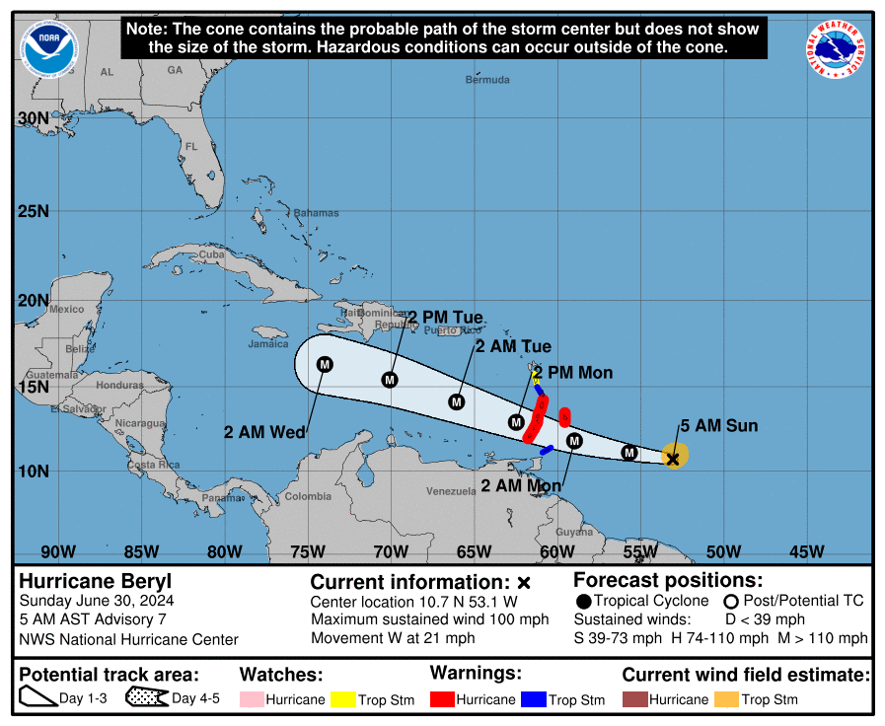
0951 | Sonde #1 ONR ferry
1002 | Sonde #2 ONR ferry
1013
1030 | 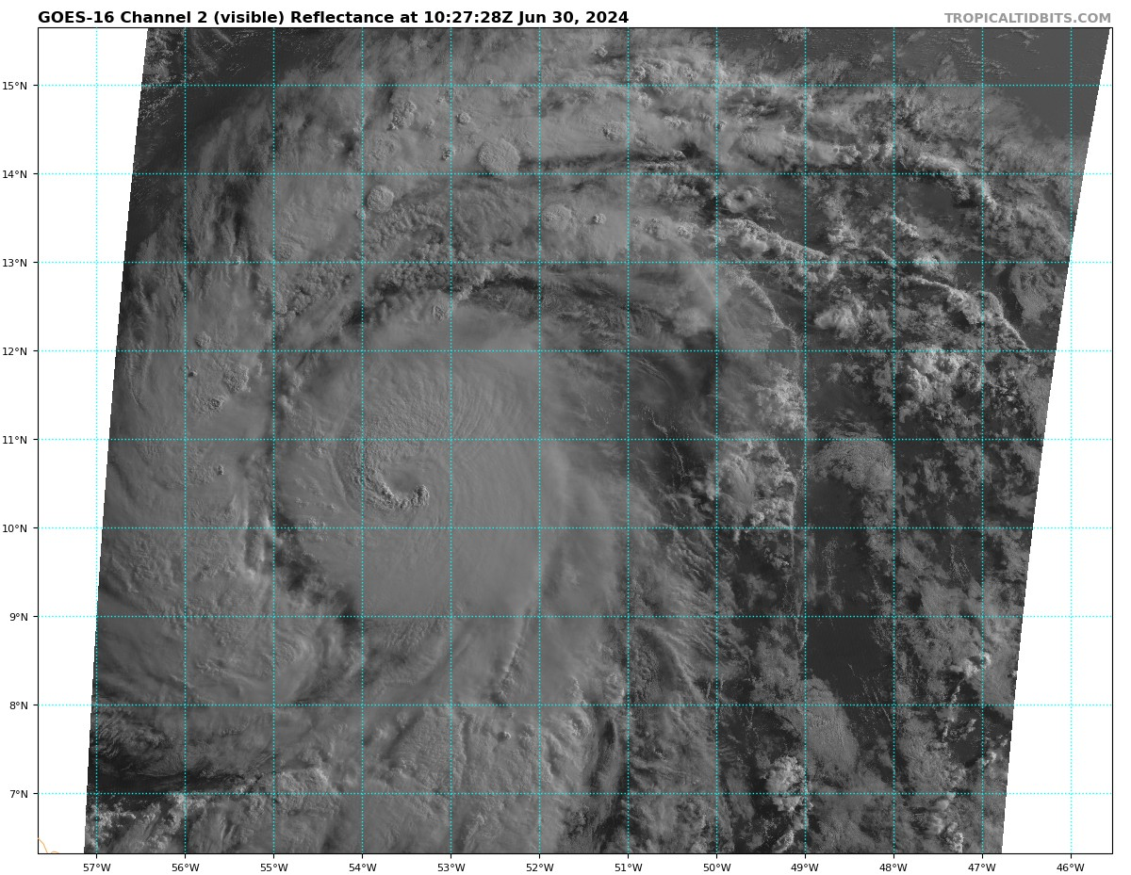  Convective burst, as seen on infrared and visible satellite imagery, has been cyclonically orbiting the eyewall. Recently, this burst has caused the eye to become obscured on satellite imagery.
1039 | Sonde #3 ONR
1128 | Sonde #4 With BT combo, IP
1040
1055 | TC diurnal cycle imagery shows a TC diurnal pulse at R~300 km. The convective band to the NW and N (diurnal pulse could be a target for the dual race track at the end of the pattern.  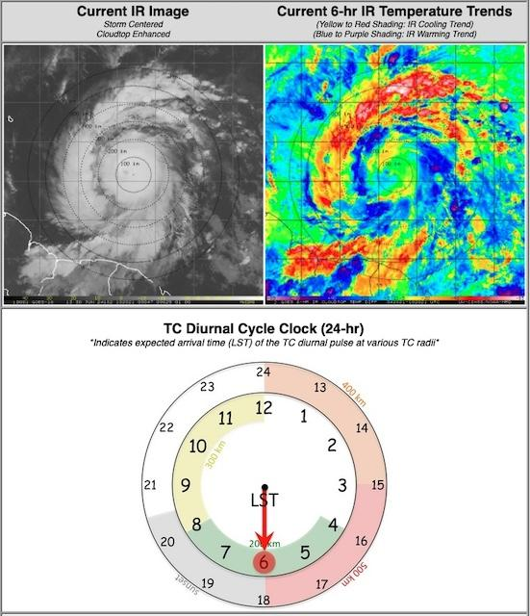
1109 | Lightning strikes occurred within the eyewall as shown on satellite imagery.  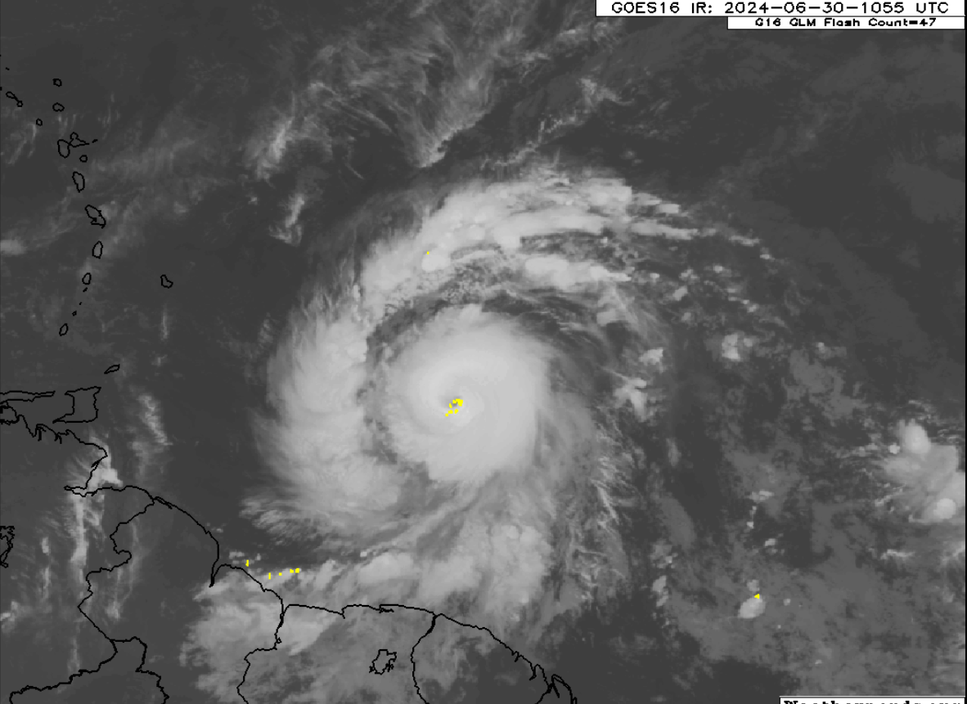
1109 | Depressurized by BT purposes
1111 | CIMSS vertical wind shear shows light shear this morning. SHIPS 06z VWS: 7kt @25 deg.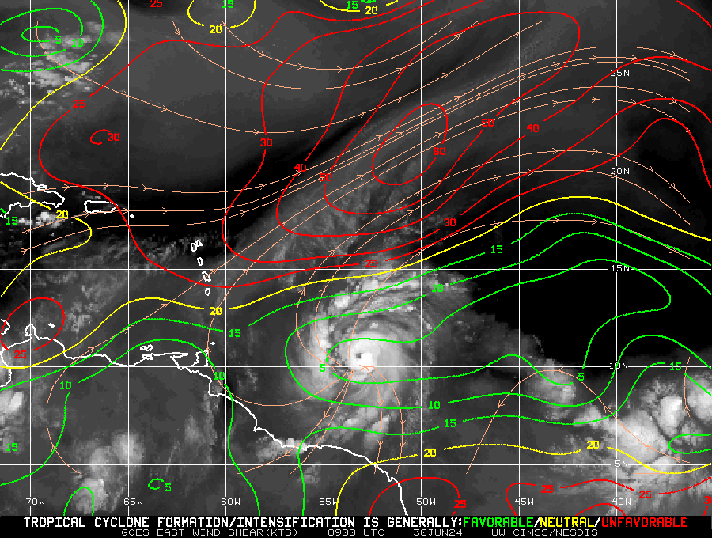
~1115 | AF fix: extrapolated surface pressure 973 mb, peak inbound NW quadrant
1128 | IP: Sonde #4 BT combo SST 28.49C based on .dat file
1036 | Sonde #5 ONR
111z | AF VDM: FL 700 mb, 969 mb, MAX FL wind 108 kt, SFMR 94 kt,
1142 | Sonde #6
1150 | Sonde #7 ONR
1200 | Sonde #8 RMW N
1201 | 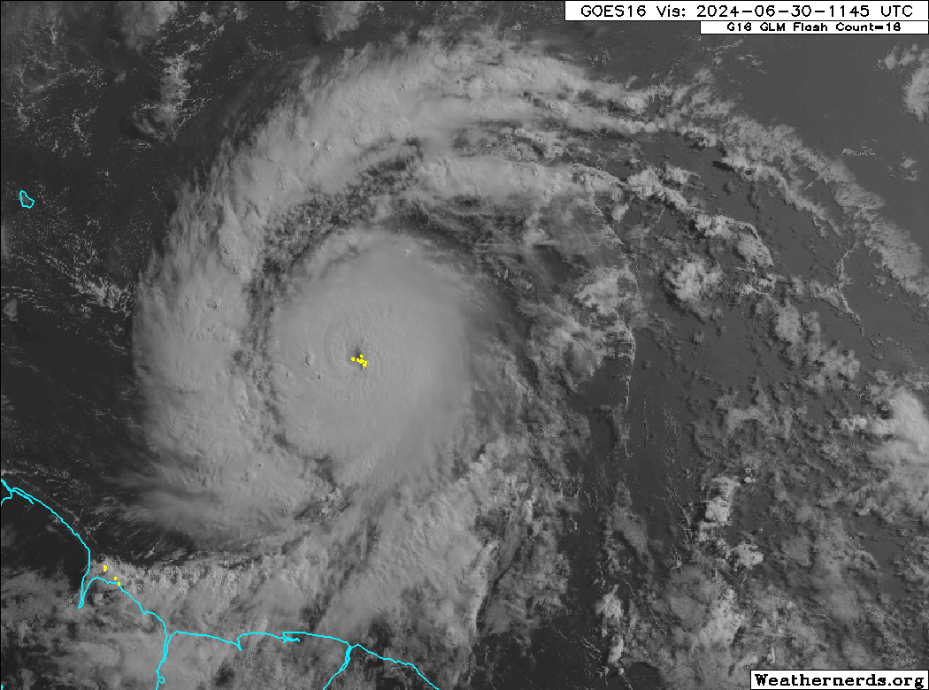Visible satellite imagery of lightning strikes occurring in the center of the eyewall.
1202 | Sonde #9 Center BT combo SST 29.11C  969mb 13kt 110 deg
1204 | Sonde #10 RMW S
1206
1213 | 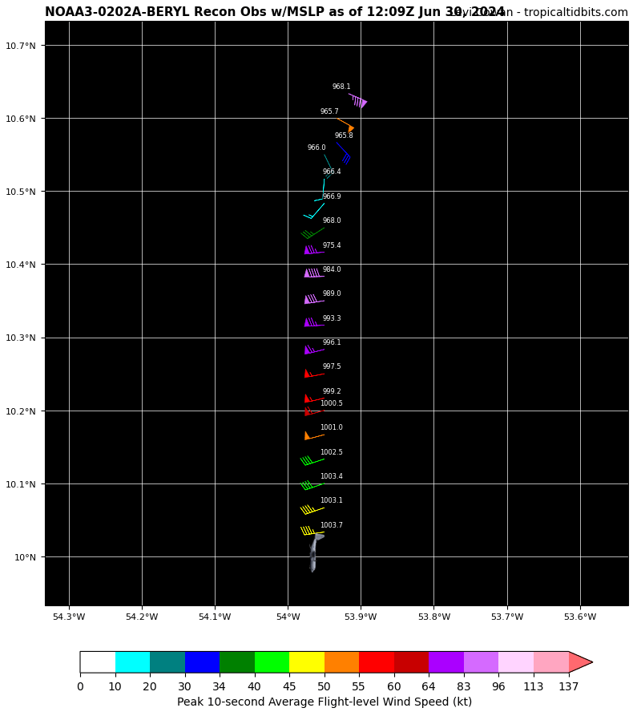  NOAA fix: extrapolated surface pressure 965.7 mb, peak inbound N quadrant.
1216 | Sonde #11 MP S
1228 | Sonde #12 BT combo EP S SST 28.91 C
1238 | 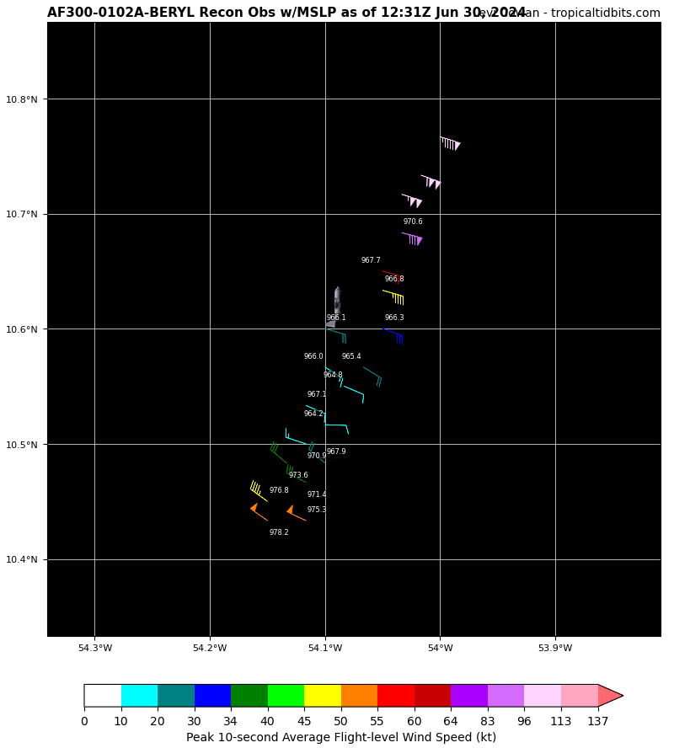AF fix: extrapolated surface pressure 964.2 mb, peak outbound center.
1245 | Sonde #13 combo downwind leg (SE side) SST 28.46 C
1259 | 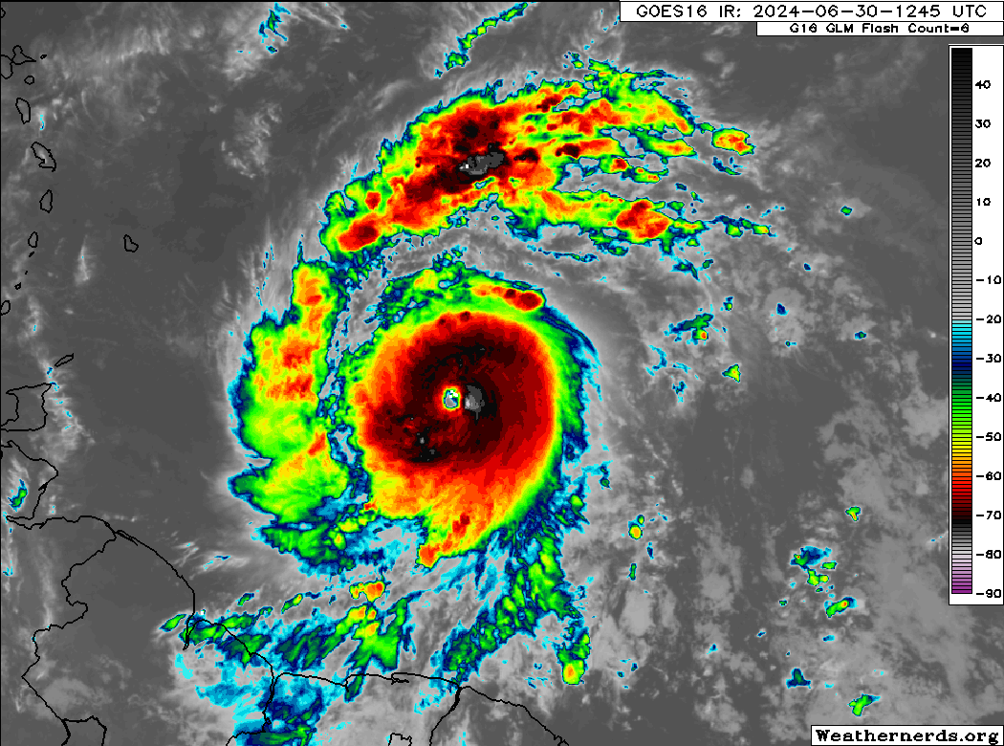Infrared imagery of Hurricane Beryl with a pronounced eyewall.
1259 | Turn E-W IP
1259 | Sonde #14 combo E-W IP SST N/A BT failed
1314 | Sonde #15 MP E
1323 | Sonde #16 RMW E
1325 | Sonde #17 Center
1325 | Hunting storm center for NHC
1330 | Sonde #18 RMW W
1327 | Vortex data Message: 1324, 10.57N, 054.35W
1334 | Sonde #19 ONR extra
1322 | Max FL 110 kt 073/10 NM
1340 | Sonde #20 MP W - NWS
1347 | Sonde #21 ONR extra
1354 | Sonde #22 EP W Combo
1355 | 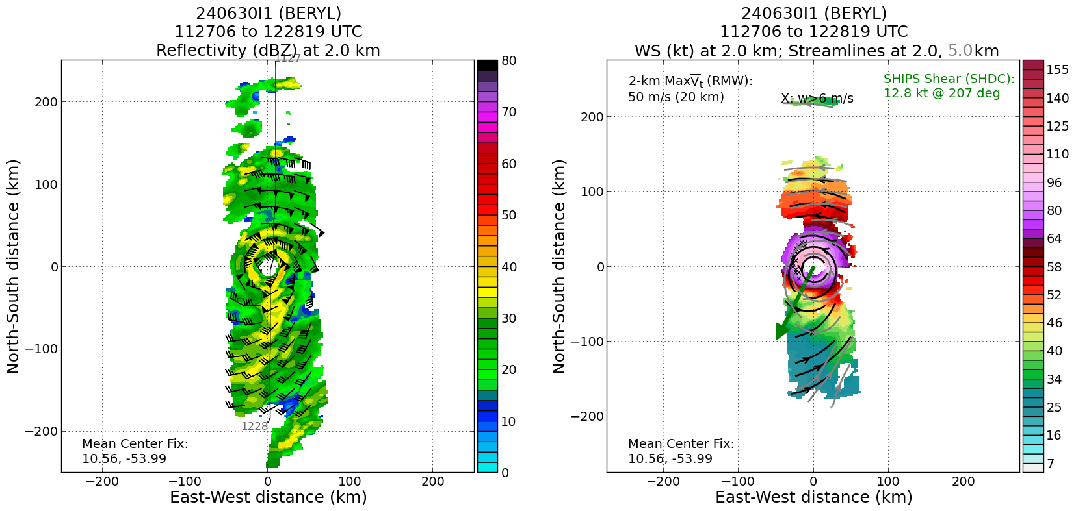
1400 | Heading toward the IP of the box pattern
1404 | Sonde #23 IP of the box NE
1410 | Sonde #24 MP of NE-SW leg short leg
1413 | Sonde#25 EP of NE-SW leg
1417 | Sonde #26 MP1 of SW-NE leg
1422 | Sonde #27 MP2 of SW-NE leg
1426 | Sonde #28 EP of SW-NE leg
1431 | Sonde #29 MP of NW-SE leg
1434 | Sonde #30 EP of NW-SE leg
1438 | Sonde #31 MP1 of NE-SW leg
1443 | Sonde #32 MP2 of NE-SW leg
1453 | Sonde #33 ONR ferry back 1
1526 | Sonde #34 ONR ferry back 2
1602 | Sonde #35 ONR ferry back 3 - last drop
1415 | 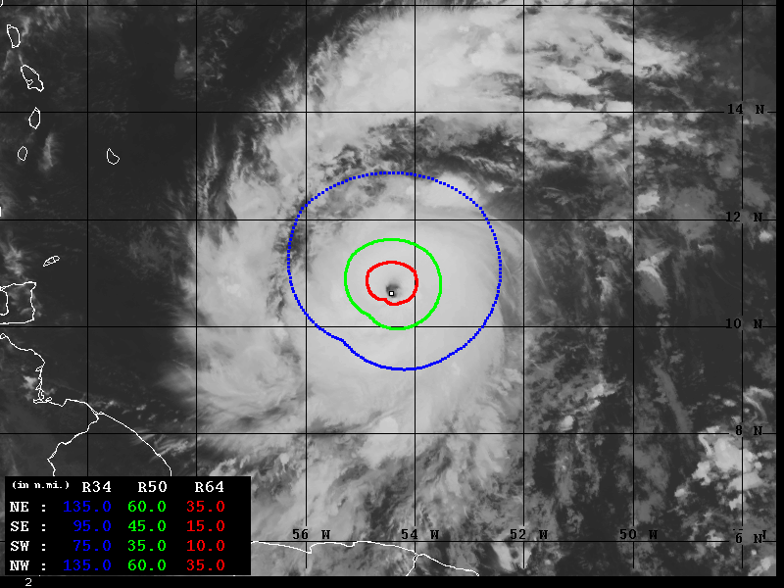Wind Radii Estimates based on Advanced Dvorak Technique (34-64kt)
1424 | Racetrack pattern for MAGPIE  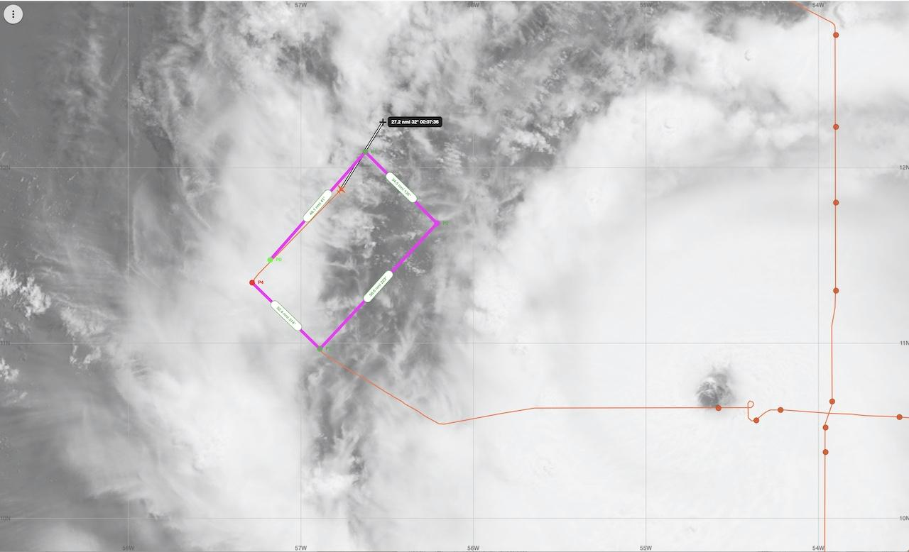
1441 | 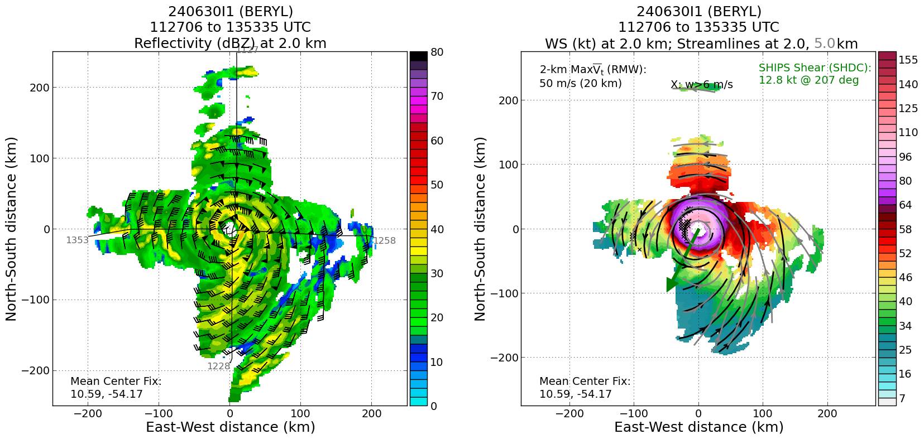
1510 | 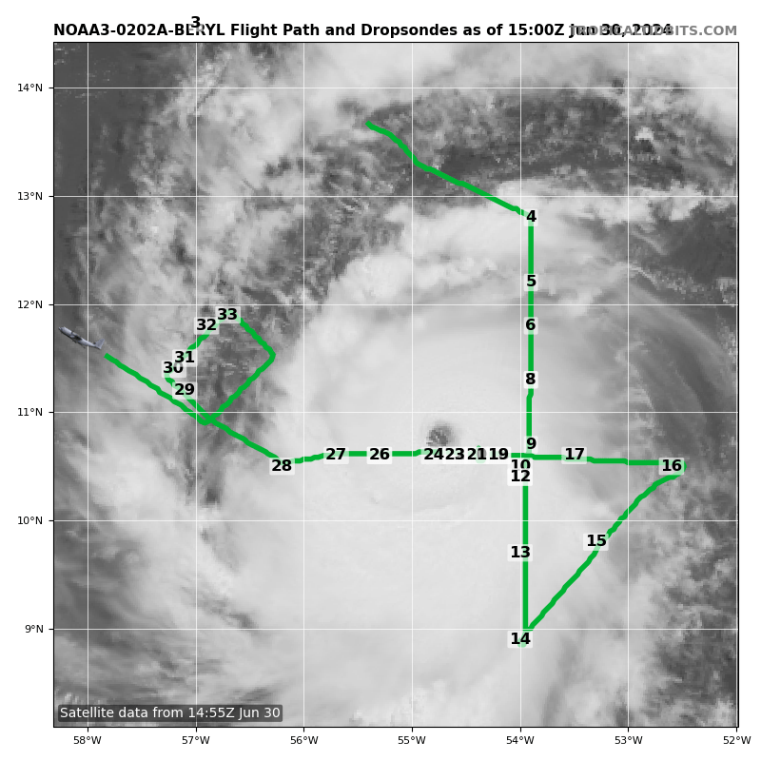
1600 | Based on the data collected by both P3 and AF flights, the minimum pressure has fallen significantly to 964 mb and the maximum wind speed is now up to 105 kt.  Satellite images show that Beryl has a  classic major hurricane pattern with a clear and circular eye and  symmetric convective pattern surrounding it.

POST-FLIGHT
Mission Summary | AOML/HRD was supporting operationally tasked NOAA NHC/EMC P-3 Tail Doppler Radar missions into Hurricane Beryl. Hurricane Beryl is now a Category 3 hurricane. The APHEX-HRD and ONR (MAGPIE) science teams (See final mission track) participated in the mission. 6 BTs and 35 dropsondes dropped and 34 transmitted. 5 BTs were successful. Two-pass radar analyses through the hurricane were sent to the operational center, then a FAM dual racetrack to observe the SAL and rain drop size from w-band. The mission successfully addressed the operational TDR needs. The maximum wind was observed at the FL 110 kts. Two center fixes were reported.
Actual Standard Pattern Flown | Figure-4 and FAM Experiment (Dual racetrak pattern)
APHEX Experiments / Modules Flown | FAM P-3 dual racetrack pattern/Diurnal cyclone box pattern
Plain Language Summary | AOML/HRD was supporting operationally tasked NOAA NHC/EMC P-3 Tail Doppler Radar missions into Hurricane Beryl. The mission was very successful. Airforce and NOAA reconnaissance contributed to the upgrade to Category 3 of Hurricane Beryl. TDR data were provided to the modeling center and National Hurricane Center. NOAA and ONR collected data in Beryl’ environment to study the lowest part of the atmosphere near the ocean and collected data from a special onboard radar that measures small water droplets in the atmosphere.
Instrument Notes | All instruments worked well
Final Mission Track | 