MISSION PLAN
FLIGHT ID | 20230914I1 | STORM | AL13 / Lee
MISSION ID | 3113A | TAIL NUMBER | NOAA 43
TASKING | (EMC/NHC) | PLANNED PATTERN | Butterfly
MISSION SUMMARY
TAKEOFF [UTC] | 0815 | LANDING [UTC] | 1614
TAKEOFF LOCATION | STX | LANDING LOCATION | KILM
FLIGHT TIME | 8.0 | BLOCK TIME | 8.2
TOTAL REAL-TIME RADAR ANALYSES  (Transmitted) | 3 (3) | TOTAL DROPSONDES Deployed (Transmitted) | 22 (20)
OCEAN EXPENDABLES (Type) | 1 AOC/HRD AXBT | sUAS (Type) | n/a
APHEX EXPERIMENTS / MODULES | CHAOS
HRD CREW MANIFEST
LPS ONBOARD | J. Zhang | LPS GROUND | None
TDR ONBOARD | J. Zhang | TDR GROUND | Reasor/Alvey
ASPEN ONBOARD | Dahl | ASPEN GROUND
NESDIS SCIENTISTS | n/a
GUESTS (Affiliation) | n/a
AOC CREW MANIFEST
PILOTS | Copare/Keith/Wood
NAVIGATOR | Utama
FLIGHT ENGINEERS | Tyson/Tufnell
FLIGHT DIRECTOR | Kalen/Lundry
DATA TECHNICIAN | Richards
AVAPS | Warneke/Kotz

PRE-FLIGHT
Flight Plan | 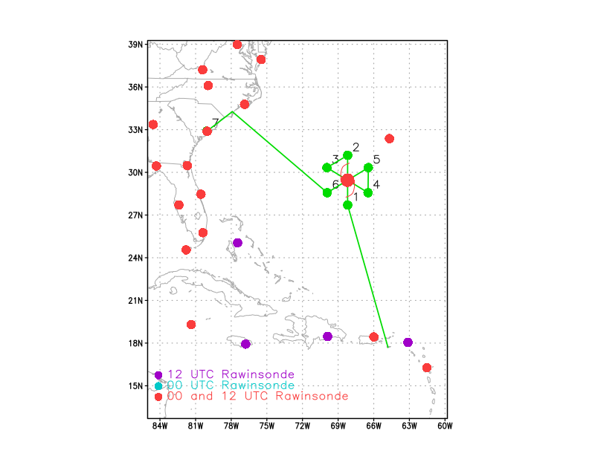  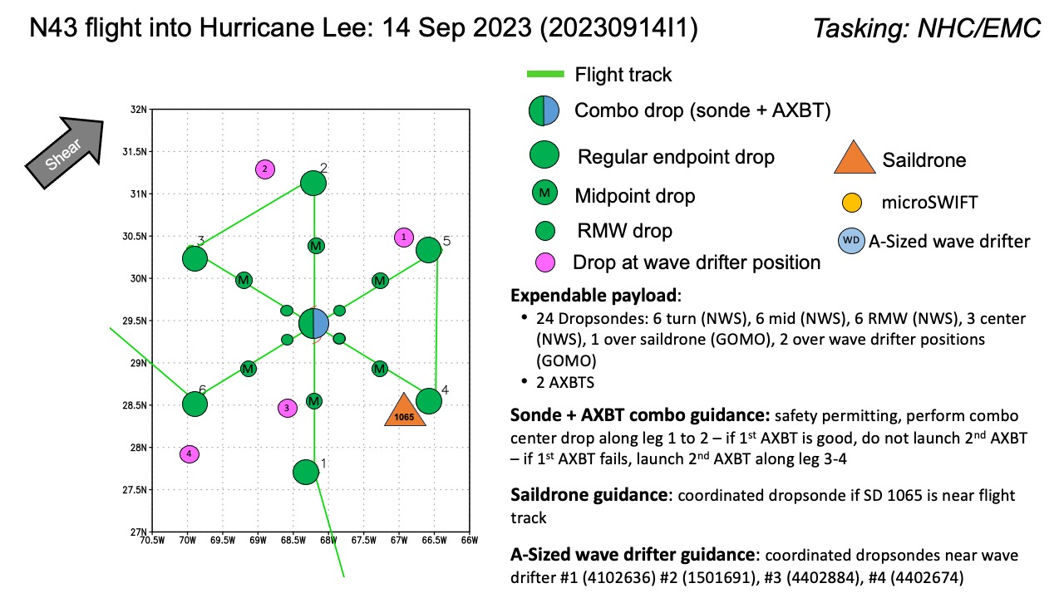  Butterfly pattern, 105 nm leg lengths, 8 kft/10kft altitude. No modules, other than AXBT combo drops, a dropsonde at Saildrone 1065 (CHAOS), and 3 dropsondes at wave drifters each (CHAOS).
Expendable Distribution | Load 30 dropsondes; Release at endpoints, midpoints, centers, RMWs (charged to NWS); 1 dropsonde near Saildrone 1065 if possible (GOMO); 1 dropsonde near wave drifters #1, #2, #3, & #4 if possible (GOMO); Additional drops may be requested at the discretion of the onboard HRD LPS; All dropsondes transmitted to the GTS  2 AXBTs -All AXBTs transmitted to the AOC ground server if possible  Greg Foltz provided saildrones positions:  SD-1036: 25.17119 N, 67.79944 W  SD-1065: 29.05595 N, 67.09478 W - mid point of outbound leg Pts2-3  SD-1057: 30.15529 N, 71.98829 W  N43 NAV estimated that:  we'll pass within 20nm of SD-1036 in approximately 0945z  we'll be passing within 20nm of SD-1057 on the way home exiting the storm
Preflight Weather Briefing | The initial intensity of Hurricane Lee at 5 pm ET lowered to 90 kt based on the aircraft data. Although the core winds have decreased some, the wind field has become quite expansive, with the hurricane-force winds now extending  roughly 100 n mi away from the center. The satellite appearance of  Lee has been relatively steady state through the day and there is  still evidence of concentric eyewalls. Air force and N42 also measured concentric eyewall features with secondary eyewall opening on the west side.  The recent satellite images showed double eyewall signature with the secondary eyewall not closed. There is fairly intense inner-core convection in the secondary eyewall.  There has been a (likely temporary) decrease in forward speed and the initial motion is just west of due north or 350/8 kt.  IR animation shows a large eye with cold cloud tops primarily on the north and northwest sides of the eyewall.  The environment ahead of Lee is expected to gradually become less  conducive for the hurricane as it moves into a region of higher  wind shear, drier air, and over progressively cooler SSTs. These  conditions favor weakening, but since the system is so large the weakening process is predicted to be slow.  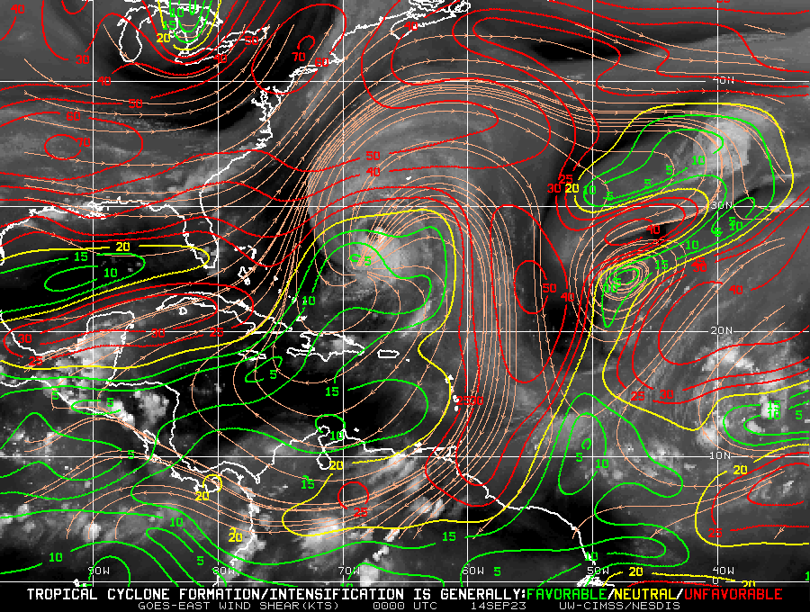  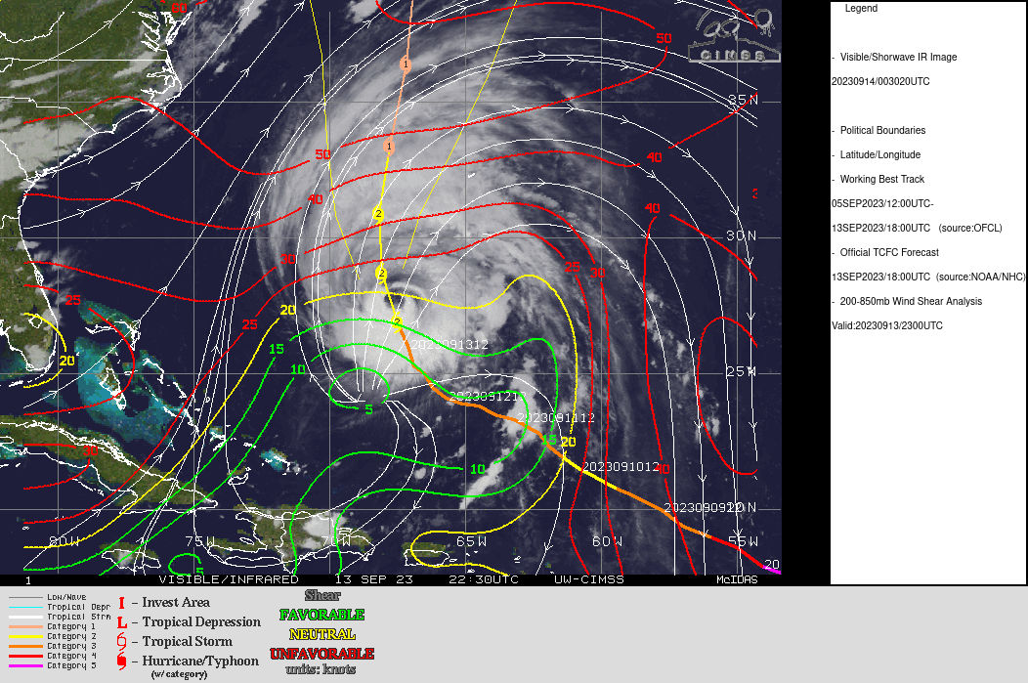
Instrument Notes | TDR: working  SFMR: working  MMR: working  WSRA: not working

IN-FLIGHT
Time [UTC] | Event
0815 | Take-off from STX
0819 | TDR All BITE faults are now cleared
0840 | Got SD locations from Greg Foltz; coordinated wtth NAV and FD for potential drops close to the 3 SDs
0954 | SD-1036 sonde Drop#1 - NAV and FD made it happen, slightly changing track to location the SD - 25.17119 N, 67.79944 W -  Sonde Splash position: 25.39 N, 67.45  Surface Pressure 1004 mb; surface wind 225/31 kt  ydist=24.42km; xdist=38.85kmmD; dist=45.68km ~ 24.7 nmi
1006 | Started descending to 8kft
1024 | IP (pt #1) S-N Pass Drop #2
1028 | Satellite image loop
1037 | Mid-PT S drop#3 - dirfter collocated sonde - sonde no good for RH
1038 | Backup sonde for Mid-PT drop#4
1043 | From N49 FD: pretty rough ride on that inner circle even with the extra offset...dropping into close to the RMW with winds of 140 @ 91 knots at 916mb
1047 | RMW S drop#5
1052 | 1st CENTER drop#6 AXBT COMBO SST= 28.24 degree C AXBT data transimitted to ground  <QK_N43FD> A. 14/10:52:49Z  <QK_N43FD> B. 29.62 deg N 068.15 deg W  <QK_N43FD> C. NA  <QK_N43FD> D. 955 mb  <QK_N43FD> E. 080 deg 02 kt  <QK_N43FD> F. OPEN W - SE  <QK_N43FD> G. C22  <QK_N43FD> H. 55 kt  <QK_N43FD> I. 175 deg 57 nm 10:39:07Z  <QK_N43FD> J. 258 deg 73 kt  <QK_N43FD> K. 176 deg 66 nm 10:36:59Z  <QK_N43FD> L. 62 kt  <QK_N43FD> M. 004 deg 55 nm 11:06:13Z  <QK_N43FD> N. 103 deg 92 kt  <QK_N43FD> O. 004 deg 55 nm 11:06:00Z
Satellite image at center
Both inner and outer eyewalls are not closed. Storm is weakending.
1058 | RMW S drop#7
1105 | Mid-PT S drop # 8 Likely in outer eyewall, flight level wind 90 kts  Outer eyewall has stronger winds than inner eyewall  No launch detected
1106 | Backup Mid-PT sonde drop#9  Hypothesis, ERC going on: After the inner eyewall weakens and eventually disappears, the outer eyewall takes over.  Outer eyewall may merge with the inner eyewall
1106 | 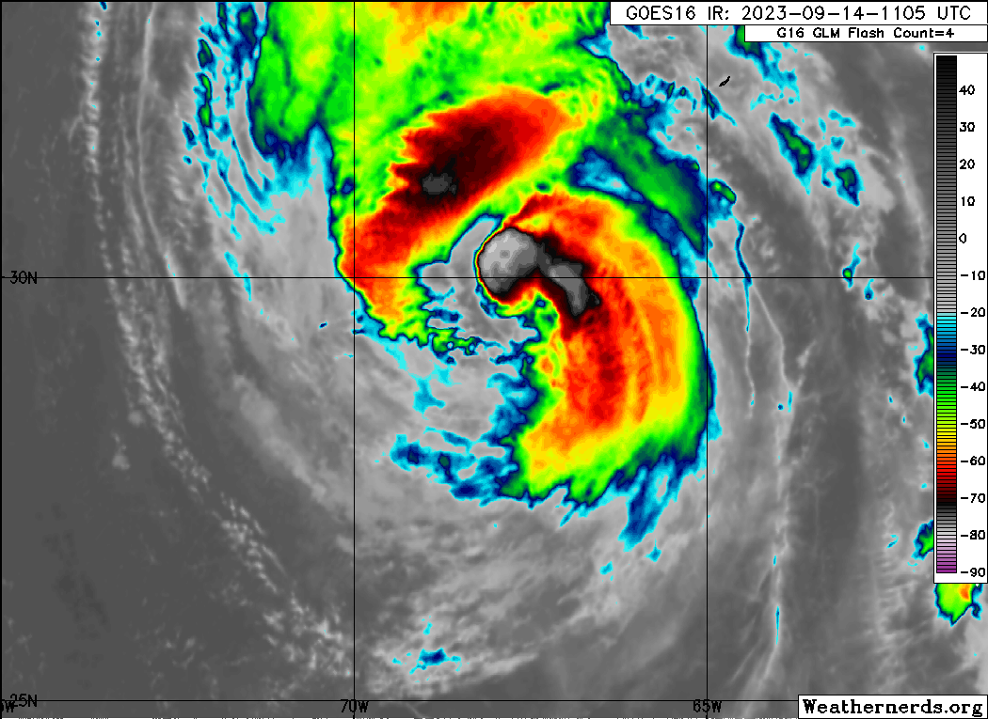  ERC may be ongoing as the outer eyewall is merging with inner eyewall, or they are getting closer to each other
1106 | Hypothesis, broad vortex tends to weaken while narrow tends to intensity Zhang et al. 2023 paper
1114 | End-PT S (pt#2) drop#10  The storm has broad wind field, at the end point the flight level wind is ~70 kt - downwind leg started -
1125 | Flight-level winds 55-75 kts during downwind leg indicating a broad vortex  May test the hypothesis in the profile paper J. Zhang et al. 2023  Check broadness of the wind field and intensity change rate later
1131 | Satellite image during downwind leg  ERC may be ongoing
1139 | IP2(pt#3) NW-SE Pass dropt#11
1140 | Doppler profile analysis of the S-N pass show stronger inflow near the inner eyewall, showing the outer eyewall may take over the inner eyewall soon.  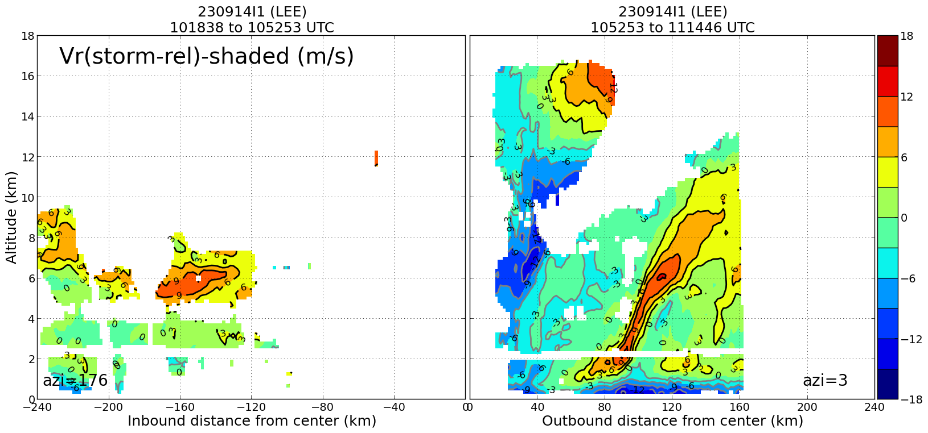
1145 | ERC may be going on, two eyewall started to merge or the outer one took over  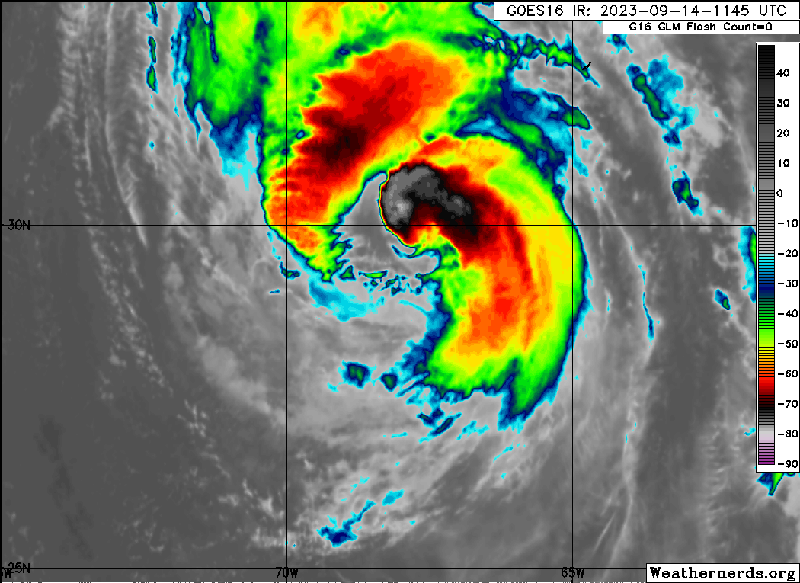
1150 | Mid-PT NW drop#12
1159 | RMW NW drop#13
1202 | 2nd Center drop#14 - did not mark as center as we did not hunt the center , flightlevel wind 25 kt - will not do profile analysis as center is off  Reasor’s Estimated center based on airforce fix 29.78, 68.17 at ~ 1154 UTC  Offical VDM: 29.82, 68.18 at 115440 UTC
1216 | Skipped RMW as there is no double eyewall or wind maxima in this quadrant or leg.
1216 | Decided to drop mid point which is may be close to the new eyewall; and this point is close to the saildrone 1065 - NAV and FD are monitoring the saildrone location
1216 | IR satellite image show two eyewalls getting closer and maybe indicator of new eyewall development  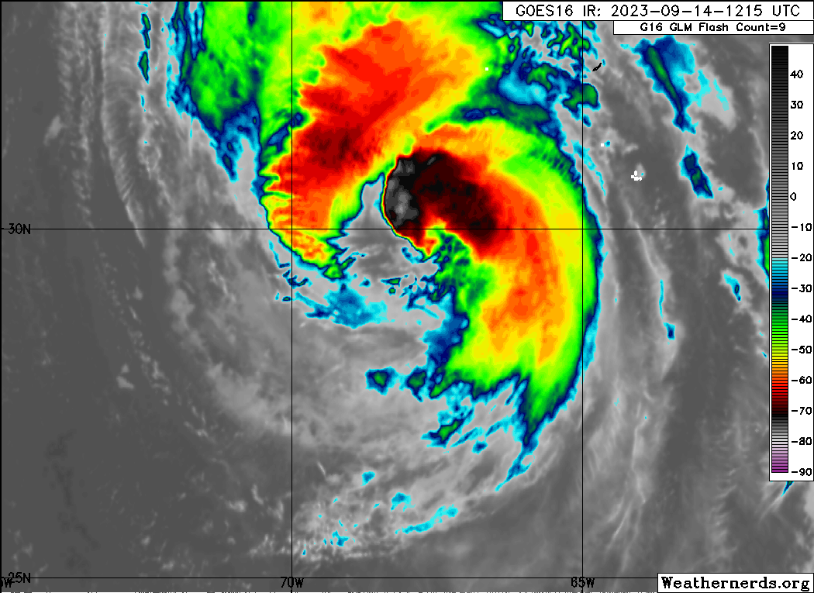
1219 | Mid-PT SE drop#15 which is also the eyewall sonde  And Saildrone coordinattion SD-1065  SD-1065: 29.05595 N, 67.09478 W  Sonde splash point: 29.28 N, 67.02 W  ydist= 24.42km; xdist=8.33km; Distance: 25.8 km = 13.95 nmi
1228 | End-PT SE (pt#4) drop#16
1301 | IP3(pt#5) NE-SW Pass drop#17
 | Satellite imae at IP3
1313 | Doppler radar composite shows double eyewall features although less scatter in the analysis. Final  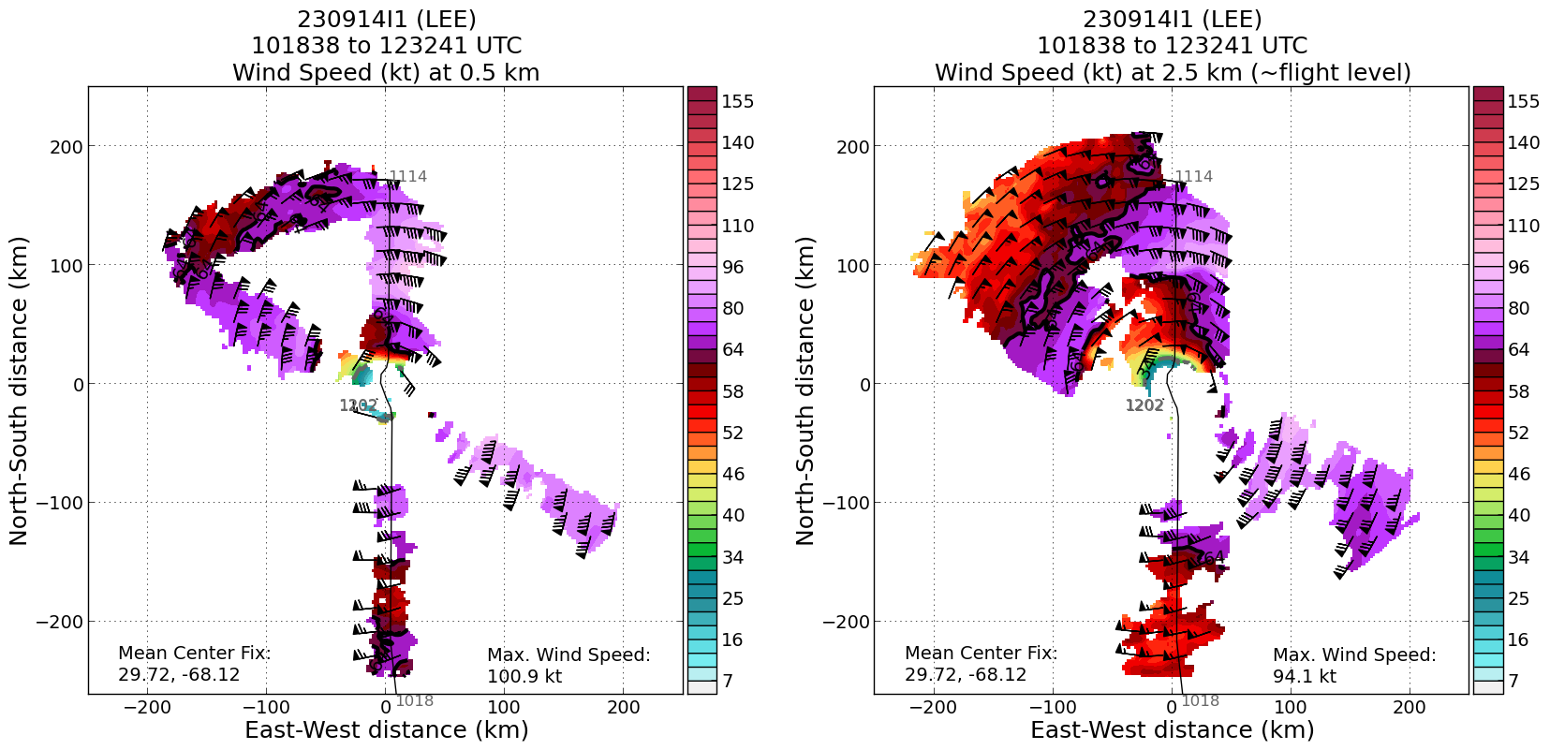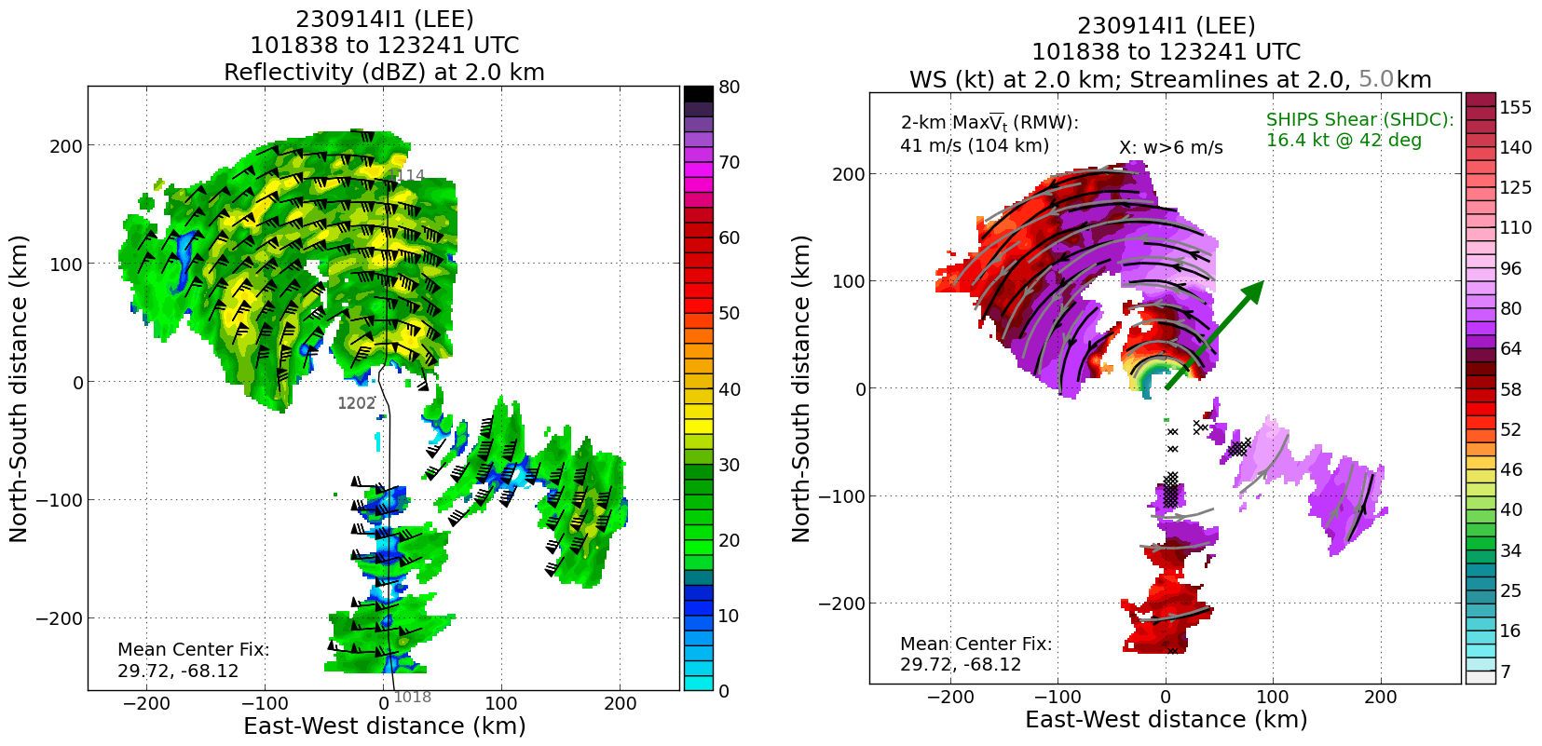
1316 | Mid-PT/eyewall NE drop#18  Very interesting wind features, flight level 80-100 kts but surface wind 60 kts, showing tilted vortex and decoupling, or it is due to ERC
1316 | IR image shows similar structure as before.  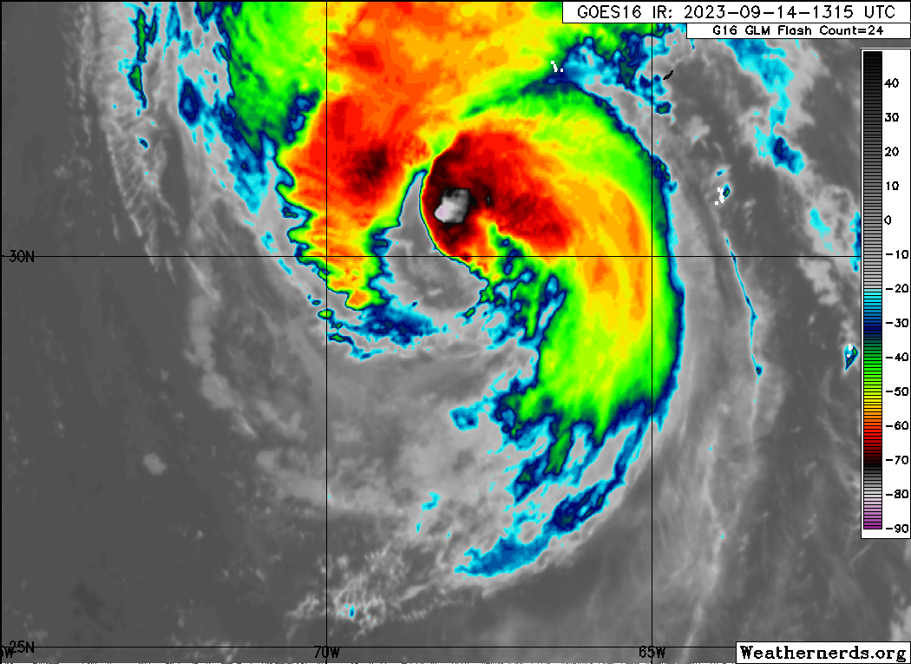
1327 | 3rd cener drop#19 Didn’t do center hunting, so the center may be off. Reasor esimated 30.18, 68.27 from AF winds around 132530  Waiting for AF
1335 | 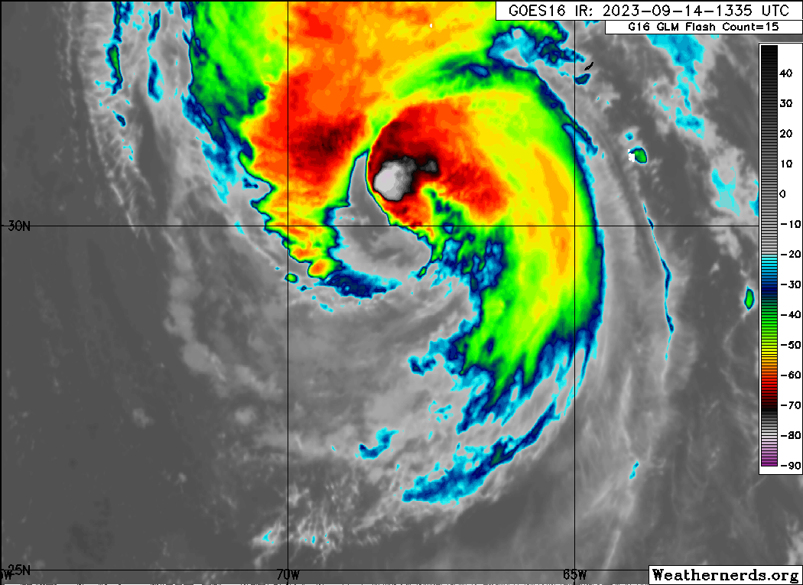
1340 | eyewall/midPT drop#20 we decided to combine mid and eyewall as there seems only one eyewall Likely ERC
Satellite Image at Near Center Time
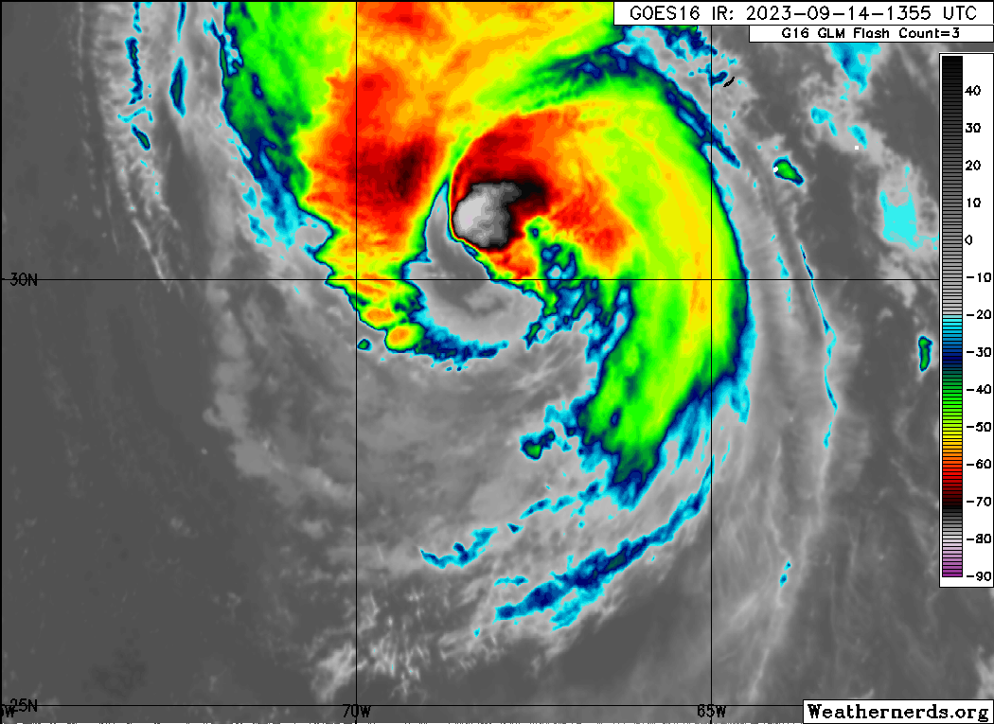
1354 | EndPT SW drop#21 - just end point - will drop one on the way back close to the saildron
1355 | 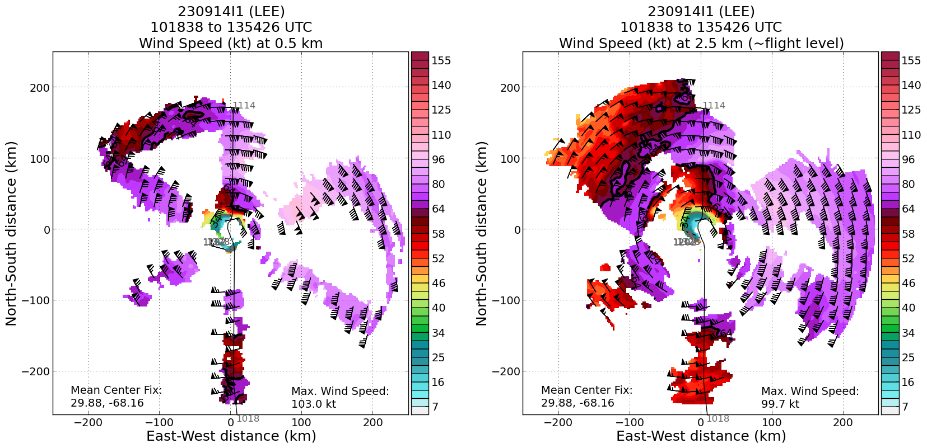
1400 | 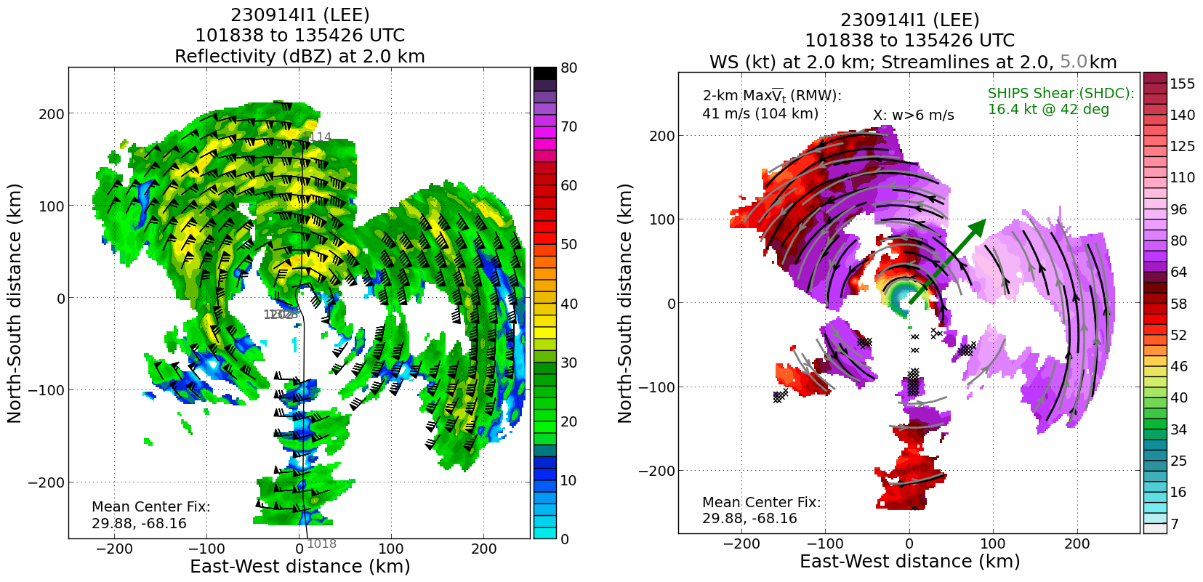
1423 | Drop #22, Saidrone sonde SD-1057  SD-1057: 30.15529 N, 71.98829 W  Sonde splash Position: 29.85 N, 72.02 W, surface pressure 1003, wind 140/39 kt  Distance: ~30 km

POST-FLIGHT
Mission Summary | [Short description of interesting observations from the flight; what objectives were successful? What was unsuccessful? Was the planned pattern flown? What deviations occurred?  [Don’t forget to fill in Tables on page 1]  [Sonde and ocean expendable accounting: how many total of each? How many are charged to each account?]
Actual Standard Pattern Flown | Butterfly
APHEX Experiments / Modules Flown | [Linked to HFP Plan; fill in regardless of whether the mission was operationally or research tasked]
Plain Language Summary | [Boil down the above into a couple of bullet points in “plain language”. This will help us when we report to management & OAR Public Affairs and prepare storm mission summaries]
Instrument Notes | [Notes about instrument status from during and after the mission]
Final Mission Track | 