MISSION PLAN
FLIGHT ID | 20230829I1 | STORM | AL10 /IDALIA
MISSION ID | 1010A | TAIL NUMBER | NOAA-43
TASKING | NHC/EMC | PLANNED PATTERN | Butterfly
MISSION SUMMARY
TAKEOFF [UTC] | 0938 | LANDING [UTC] | 1609
TAKEOFF LOCATION | FLL | LANDING LOCATION | FLL
FLIGHT TIME | 6.5 | BLOCK TIME | 6.8
TOTAL REAL-TIME RADAR ANALYSES  (Transmitted) | 4 (4) | TOTAL DROPSONDES Deployed (Transmitted) | 26 (26)
OCEAN EXPENDABLES (Type) | 5 UM AXBT (5 good),  1 microSWIFT | sUAS (Type) | n/a
APHEX EXPERIMENTS / MODULES | Surface wind and wave validation, stratiform spiral
HRD CREW MANIFEST
LPS ONBOARD | Hazelton | LPS GROUND | Rogers
TDR ONBOARD | Hazelton | TDR GROUND | Reasor, Fischer
ASPEN ONBOARD | X. Zhang | ASPEN GROUND
NESDIS SCIENTISTS | n/a
GUESTS (Affiliation) | Hannah (Knauss Fellow)
AOC CREW MANIFEST
PILOTS | Copare/Wood/Palmer
NAVIGATOR | Miller/Schaefer
FLIGHT ENGINEERS | Darby/Tyson
FLIGHT DIRECTOR | Kalen/Parrish
DATA TECHNICIAN | Richards
AVAPS | Kotz/Santoni

PRE-FLIGHT
Flight Plan | We are planning a TDR butterfly, with possible additions of a wave/surface wind validation overflight module and also a stratiform spiral, time permitting.  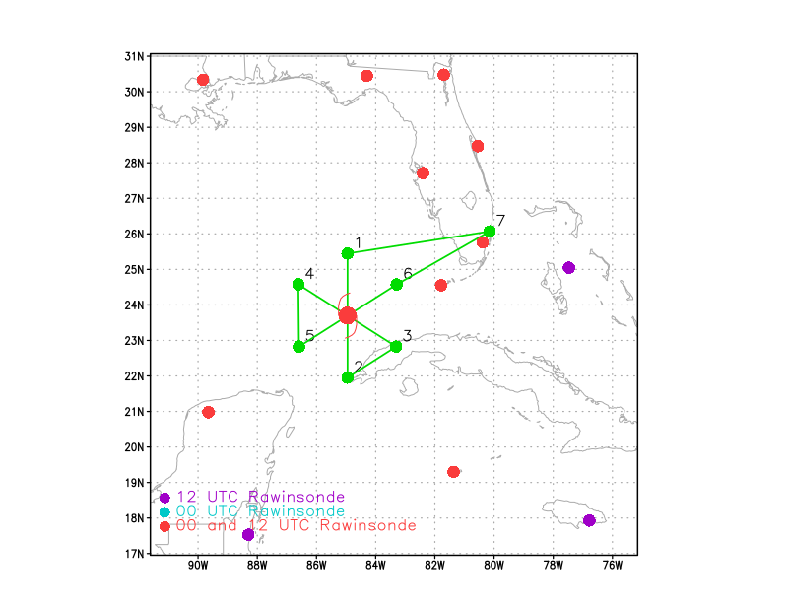  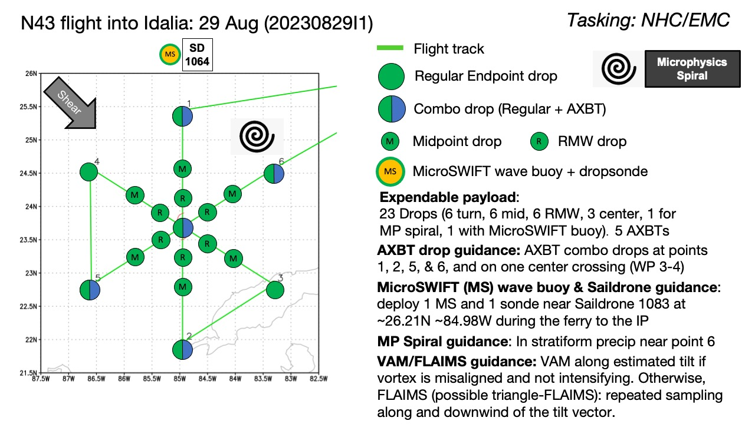
Expendable Distribution | 23 drops planned, all turn, mid-points, all RMW points, 3 center drops, 1 for microphysics spiral if it occurs, 1 with MicroSWIFT buoy. 5 AXBTs, at endpoints N, SW, S, and NE, and one at the center.
Preflight Weather Briefing | Idalia is now a hurricane with winds of 75 mph, and forecast to rapidly intensify over the Eastern Gulf of Mexico.  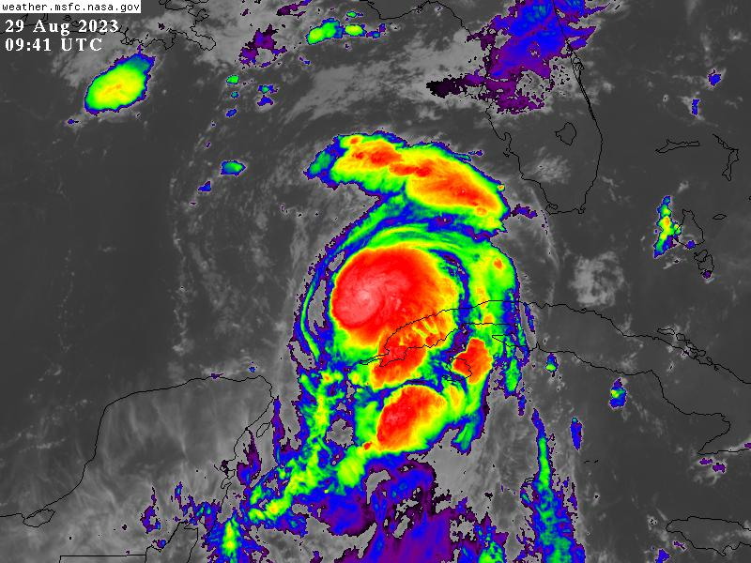  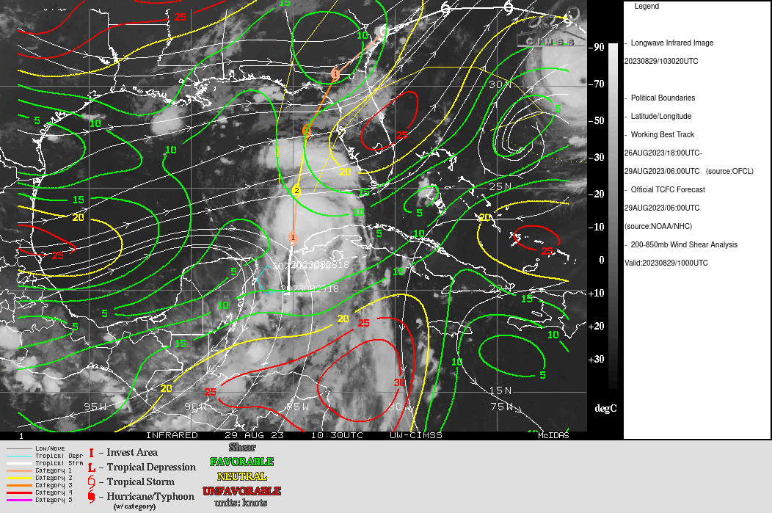  Shear has dropped significantly, to 5-10 kt over the storm.
Instrument Notes | Instruments working, but communications issues remain with getting 3-D TDR analyses off the aircraft. They are getting off, but slowly. Doppler radials are making it to EMC, however.

IN-FLIGHT
Time [UTC] | Event
0938 | Take-off from FLL
1049 | Microswift buoy not responding, not going to drop it. Sonde 1
1101 | Cuba radar shows eyewall beginning to close off
1102 | 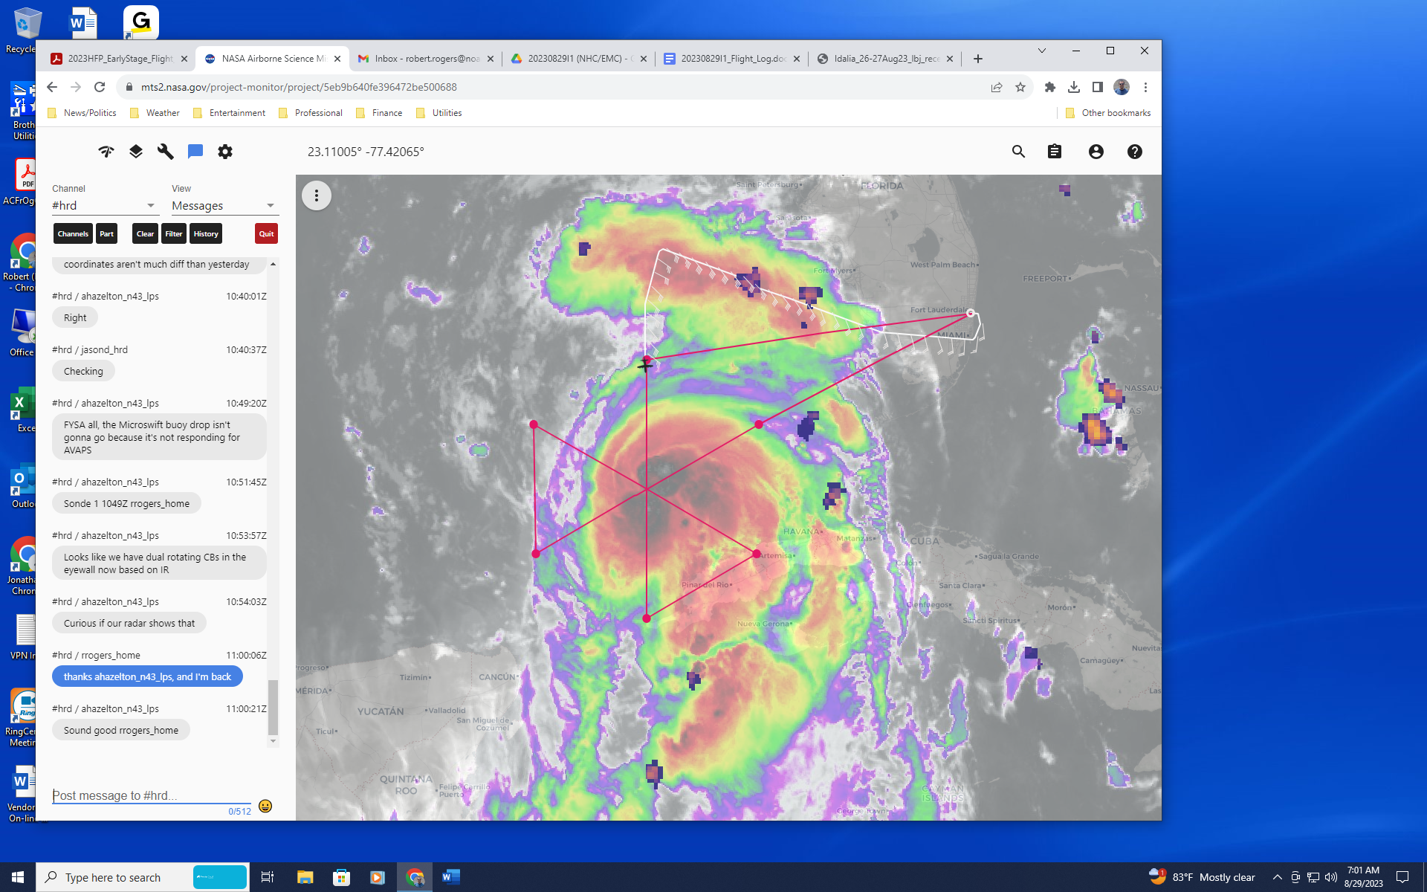  Just passed IP, IR image shows two separate lobes of cold cloud tops within the inner core
1102 | Sonde 2, endpoint N, combo
1113 | Sonde 3, midpt N
1115 | Idalia in range of Key West radar now
1123 | 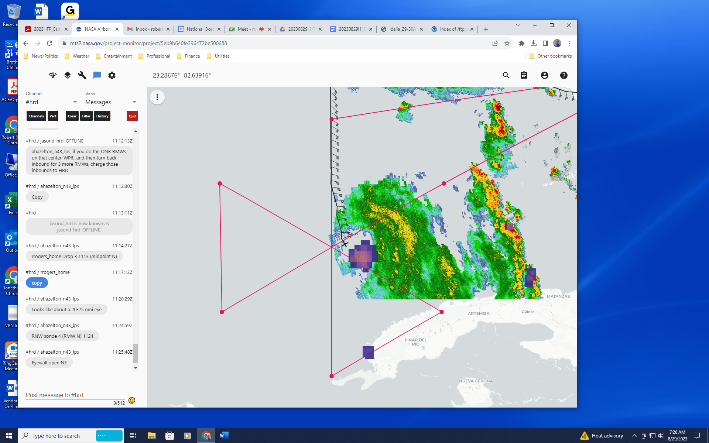  Lightning evident in SE eyewall
1124 | LPS reports 20-25 nm eye, eyewall open to the NE. Different than what ground radar is showing, but LPS reports that there is a spiraling feature to eyewall.
1124 | Sonde 4, RMW N
1127 | Sonde 5, center, Extrapolated pressure is 973.8, we’ll see what center drop shows
1130 | Sonde 6, RMW S, FL winds stronger on S side
1141 | Sonde 7, midpt S
1141 | 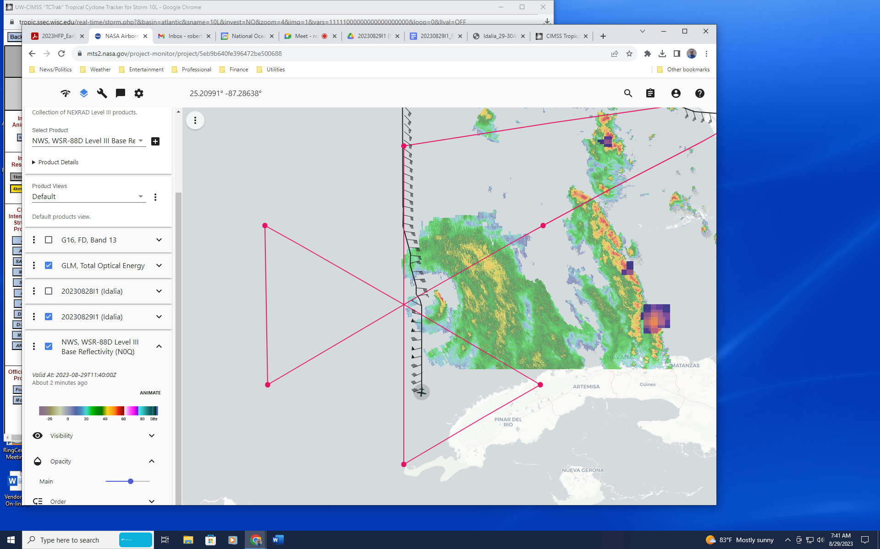
1141 | 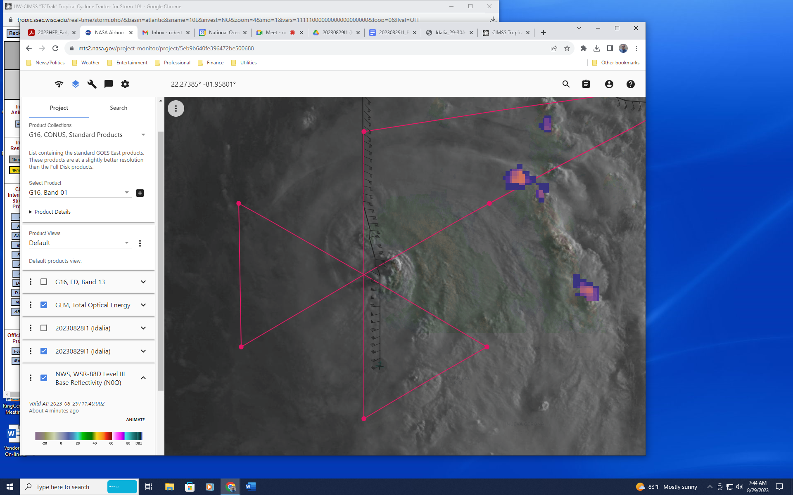  Ground radar and visible satellite imagery showing overshooting tops in the eastern eyewall, probably indicating intensification is occurring
1148 | Sonde 8, endpt S, combo
1158 | 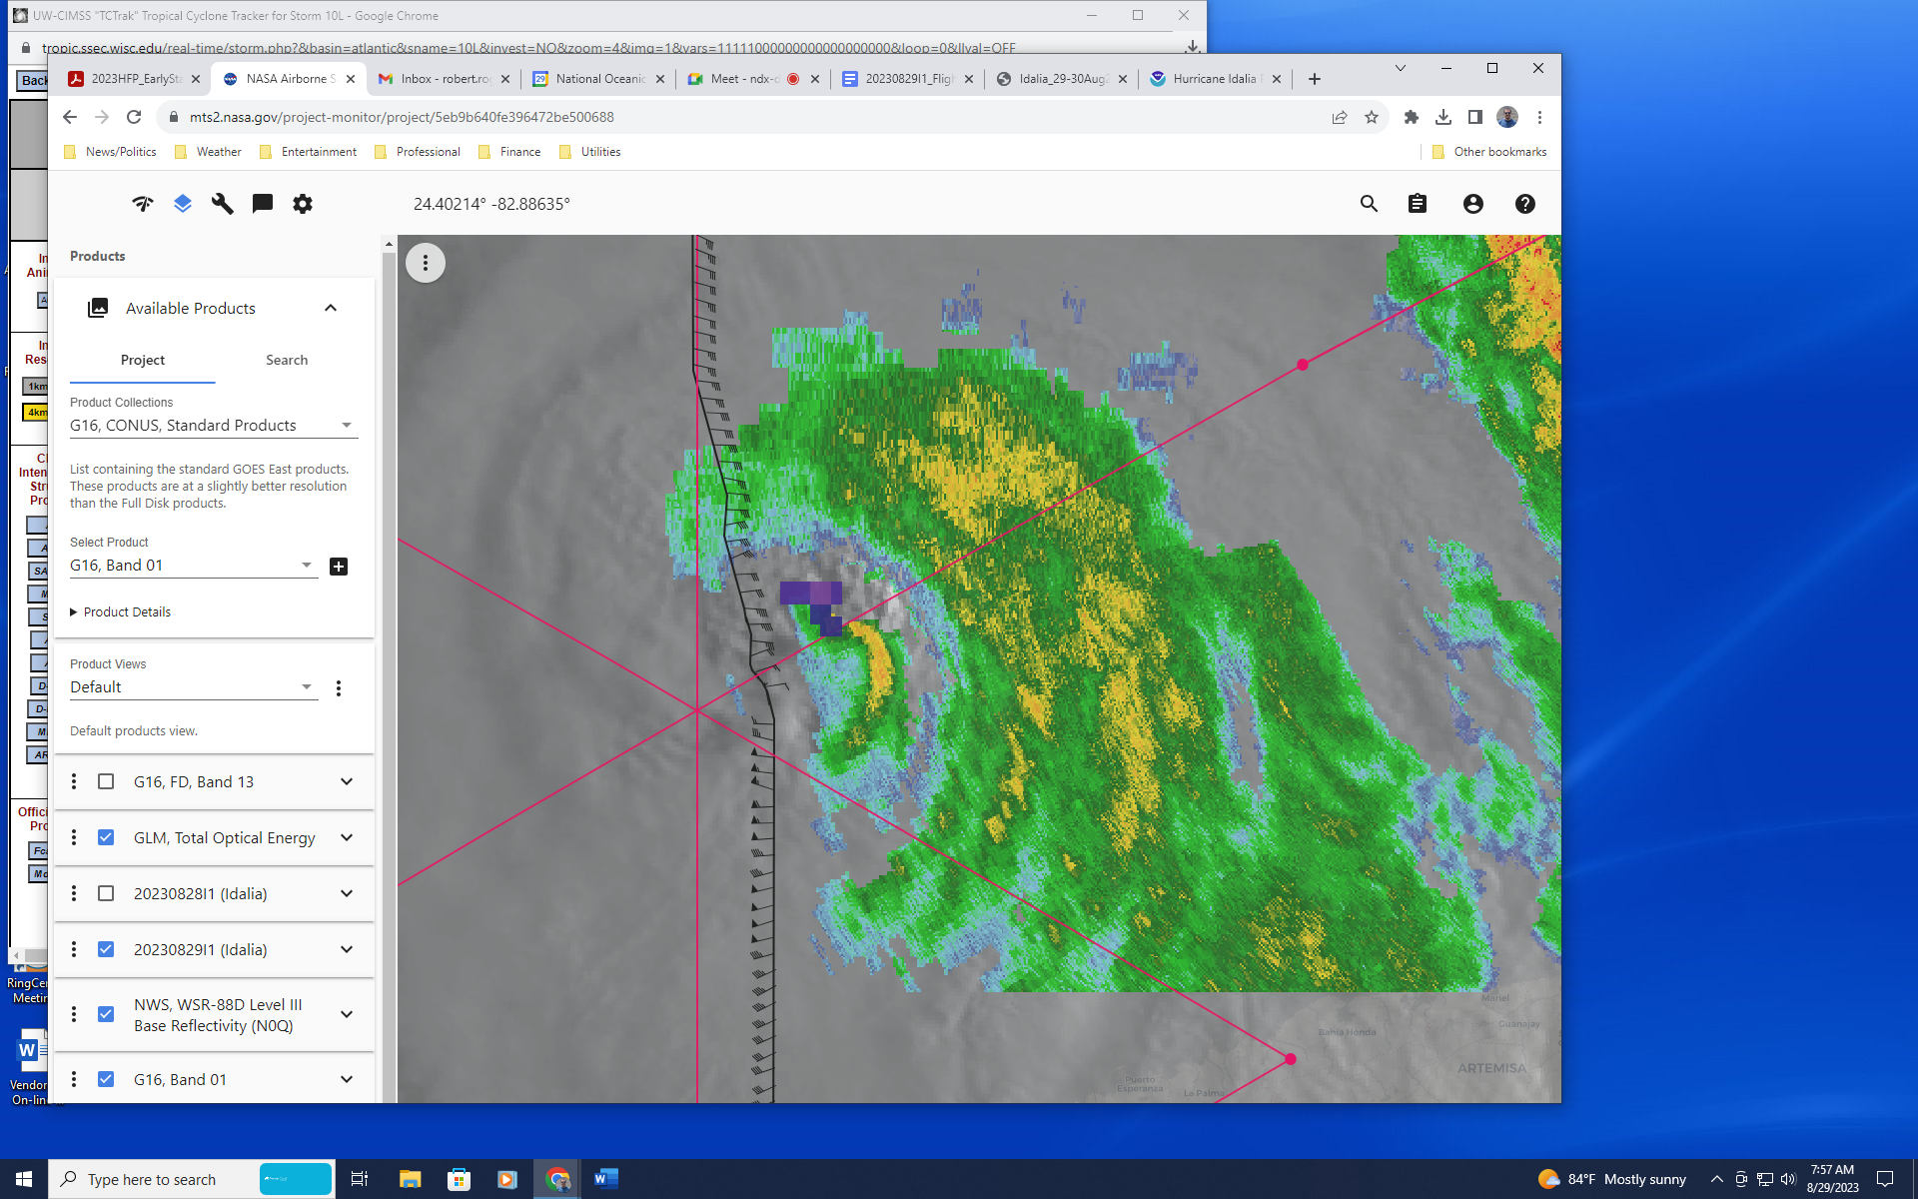  Radar shows hook-like appearance in eastern eyewall, lightning at the location of the hook
1212 | Sonde 9, endpt SE. No midpt drop here because the leg was started fairly far inward, due to avoidance of Cuba overflight.
1216 | From first TDR analysis: 2-6-km Vortex Tilt: 10.0 km at 127 deg, more aligned than last analysis from previous P-3 mission, which had 45 km tilt
1220 | Aircraft on inbound leg, can see hook feature on MMR. Looks like a mesovortex.
1223 | Sonde 10, RMW SE
1226 | In eye, lots of sea spray, can see to surface
1227 | Sonde 11, center
1229 | Transmission problem with TDR data
1232 | Sonde 12, NW eyewall
1236 | 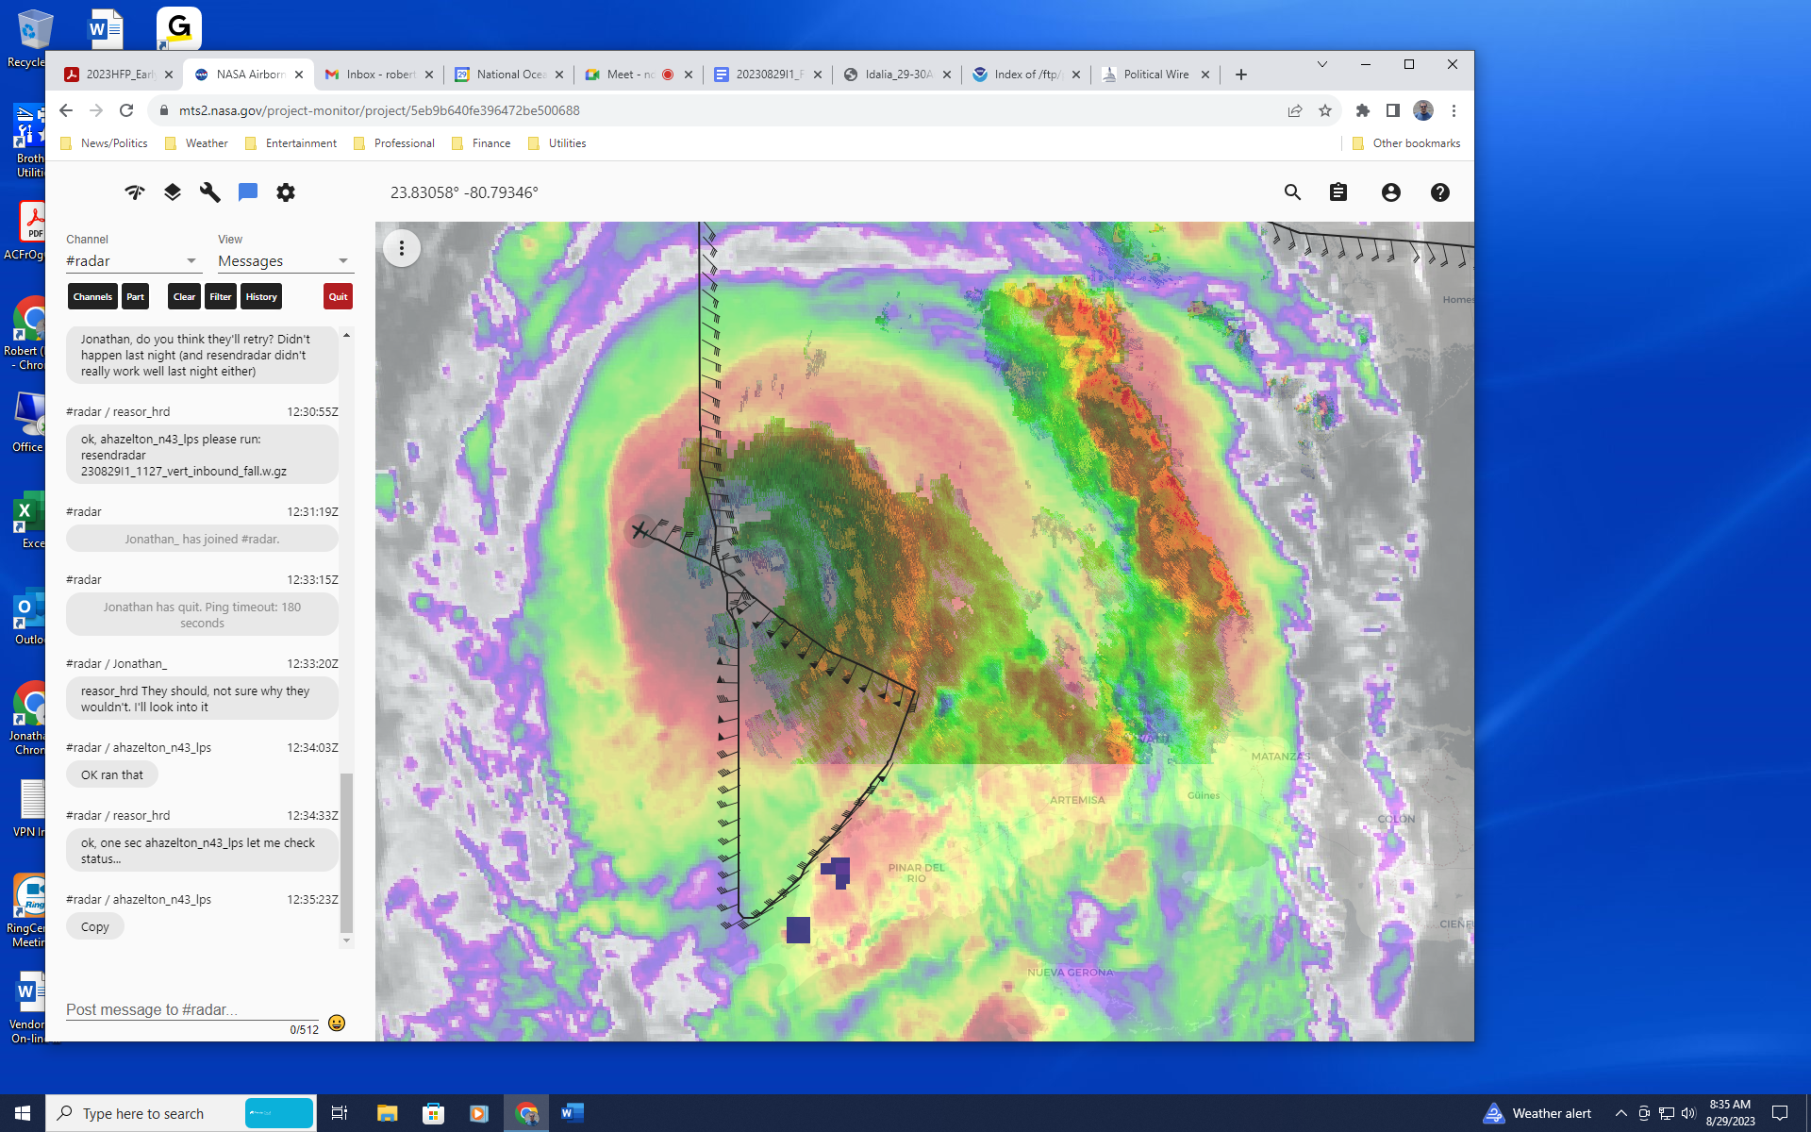  Satellite and radar presentation shows a spiral banded-structure to eyewall, lots of precipitation on the east side.
1239 | Sonde 13, midpt NW
1248 | IR animation from this time shows burst feature (hook identified earlier) occurring in the N eyewall, with a brief period of lightning. Burst seems to have runs its course now, though.
1250 | Sonde 14, endpt NW
1258 | On downwind leg on the west side. After next (and final) SW-NE pass is completed, will reverse track and come inbound from the NE. Drop 3 sondes across the RMW, from the center execute the overflight module (overfly the sondes at a point downwind from launch location). That reverse track will provide a nice opportunity to scope out areas of stratiform precipitation for a possible spiral in the NE quadrant.
1310 | Turn inbound, Sonde 15, endpt SW, combo
1316 | TDR analysis from first pass shows peak winds at 0.5 km of 86 kt in the SE eyewall  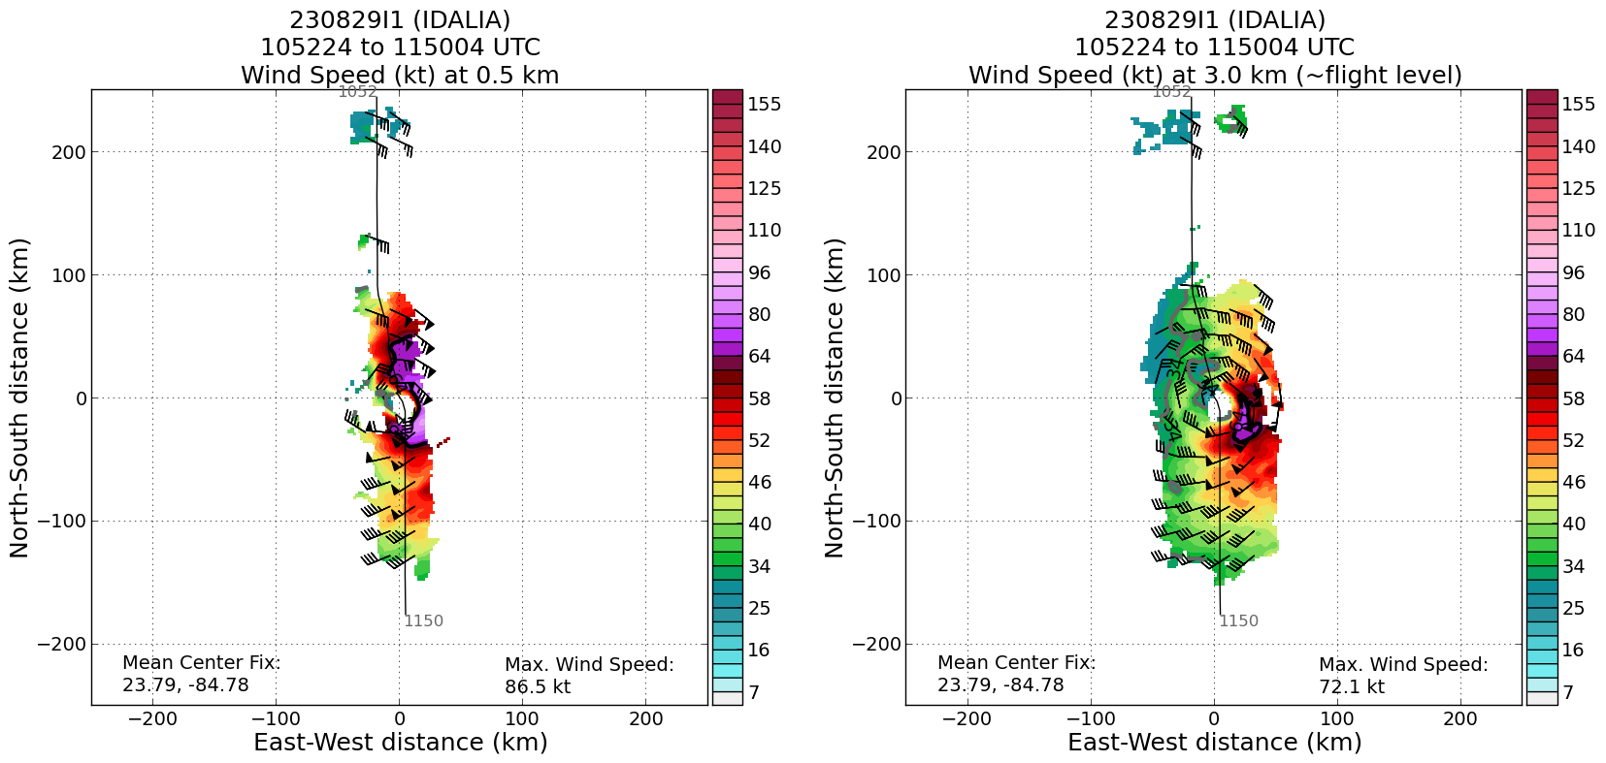  System is mostly aligned up to 9 km, then tilts toward the west  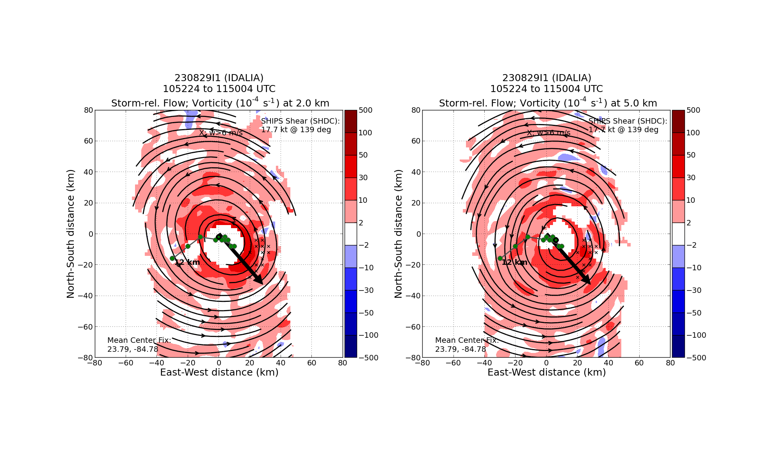  6-km center is about 10 km ESE of 2-km center  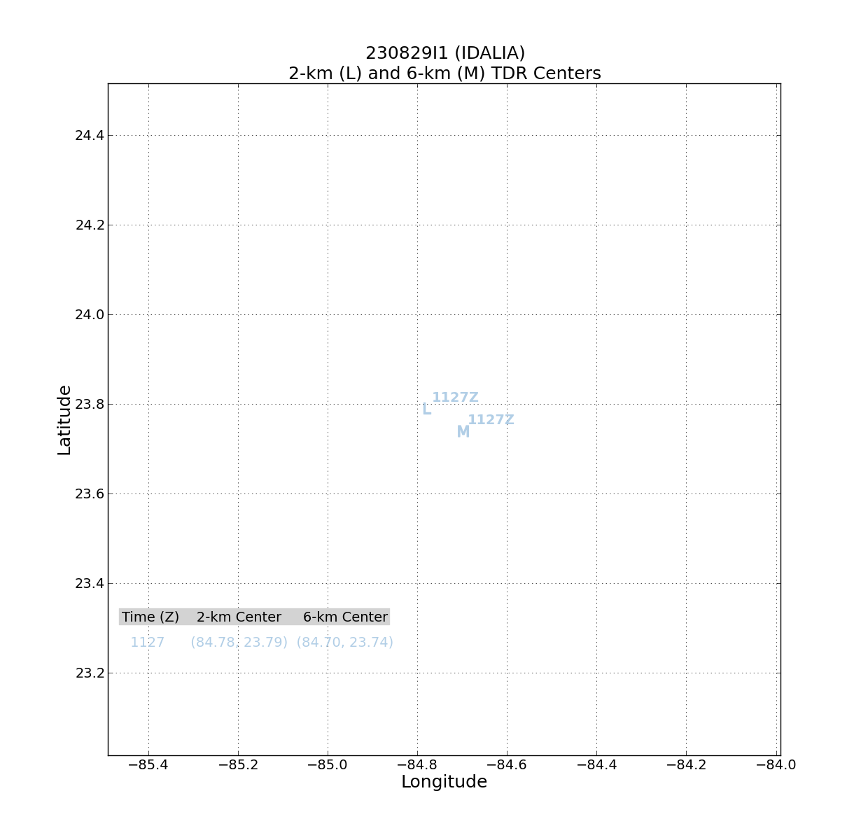
1319 | Sonde 16, midpt SW
1321 | Eyewall is looking elliptical on surface roughness mode on MMR
1322 | Identifying possible targets for microphysics spiral, a region to the NE (25 N 83 W) of the center, on inner edge of a convective band. SHIPS diagnosing 328 for shear vector at 12 UTC, so this would be in the DSL region, where connecting bands are often seen. Potential good candidate for stratiform precip.
1330 | Sonde 17, SW RMW
1331 | Sonde 18, center drop
1334 | Sonde 19, NE RMW
1336 | Another option for spiral is to try a region just outside the main band spiraling into the eyewall. Aircraft will examine that region on this outbound leg to see if it would work later.  Candidate regions for spiral indicated by yellow “x”’s  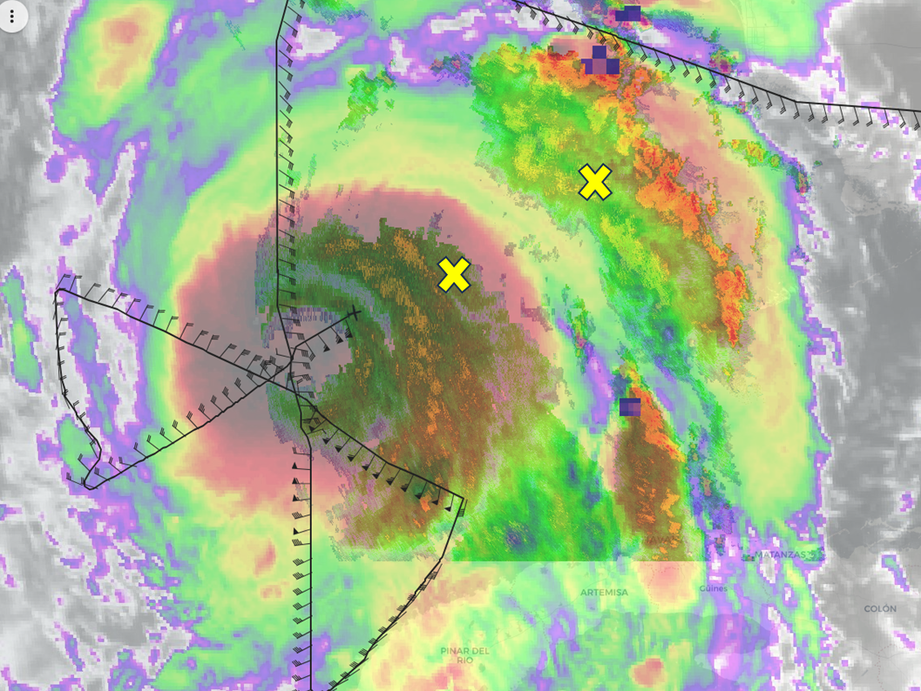
1345 | Sonde 20, midpt NE
1355 | Sonde 21, endpt NE, combo
1402 | 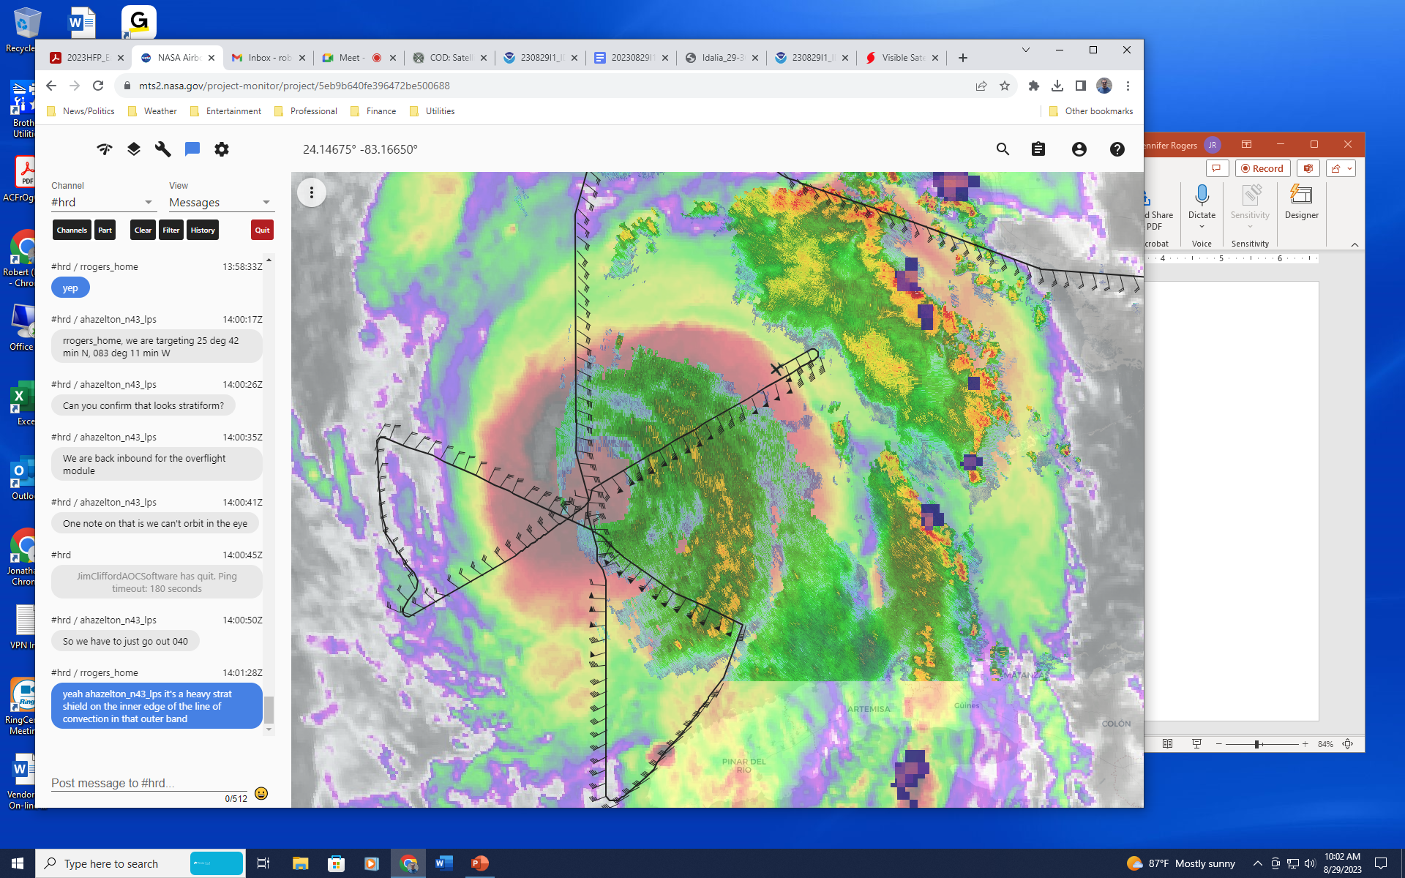  Turned back inbound for sonde overflight module. Drop 3 RMW sondes in NE inbound, then go outbound along track 040 (coming inbound on 060 azimuth)  Will try for spiral on final outbound, at outer point indicated in earlier figure. That location will probably be within range of the dual-Pol from the Key West radar
1415 | 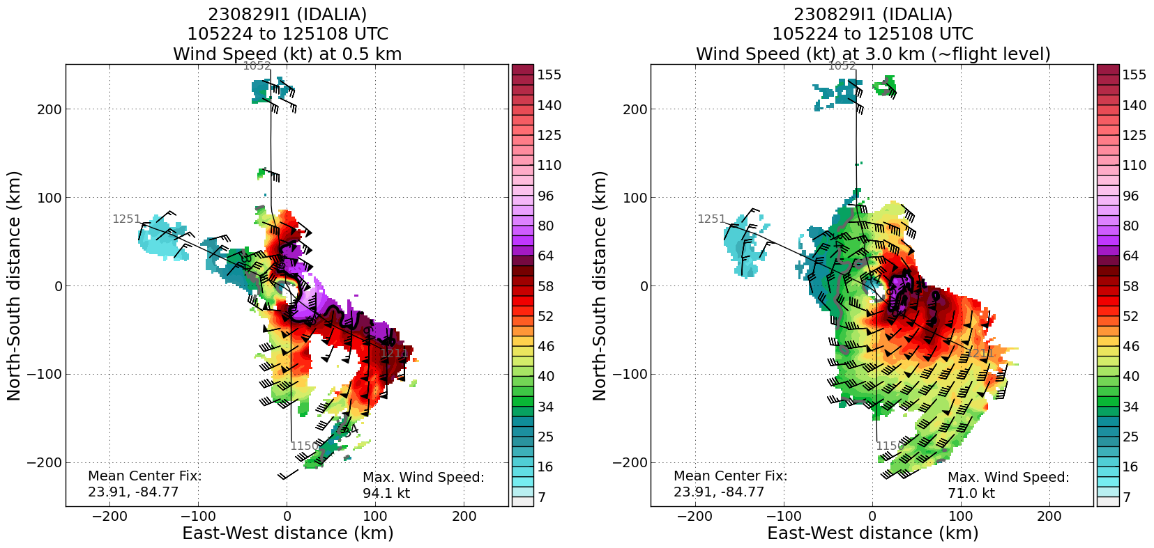  Peak winds at 0.5 km from first to second pass have increased by nearly 10 kt (from 86 to 94 kt).  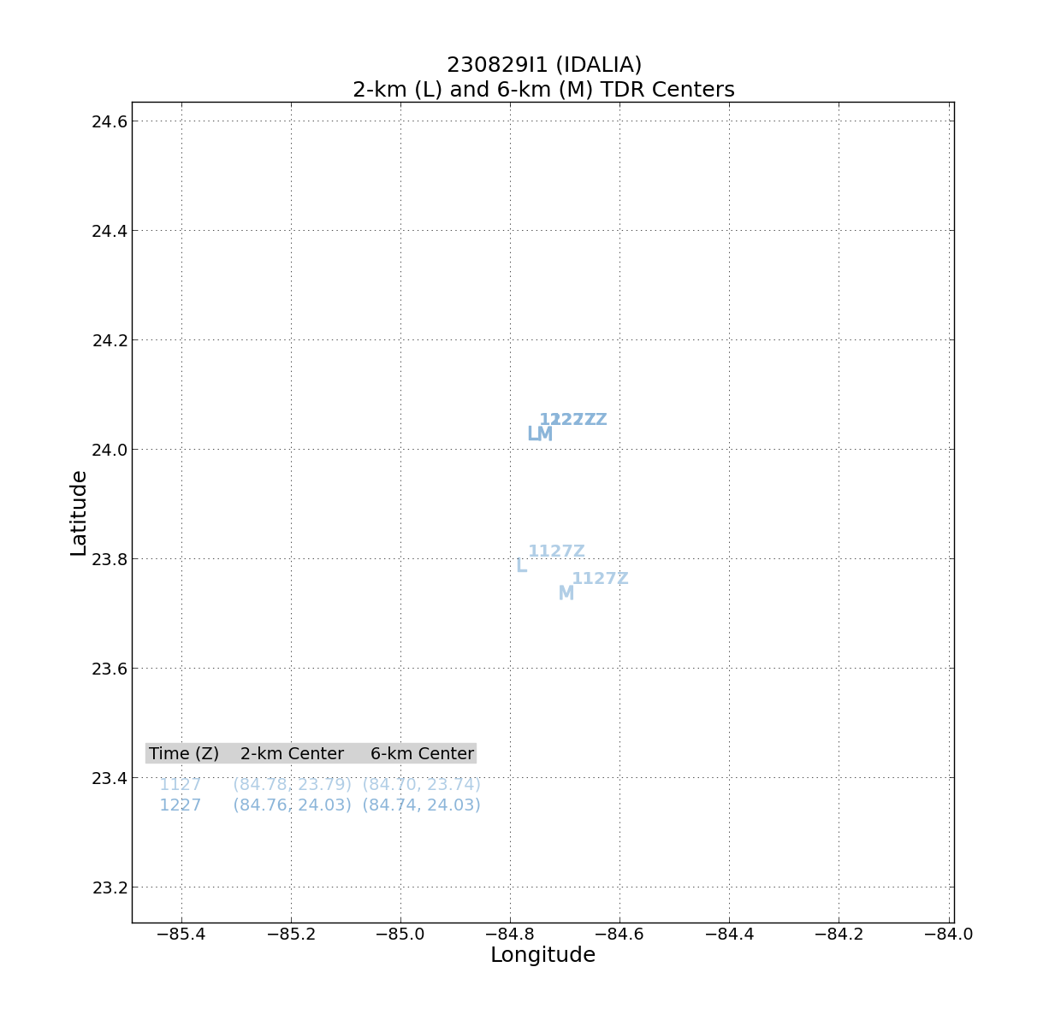  Center plot shows 2- and 6-km centers now completely aligned
 | 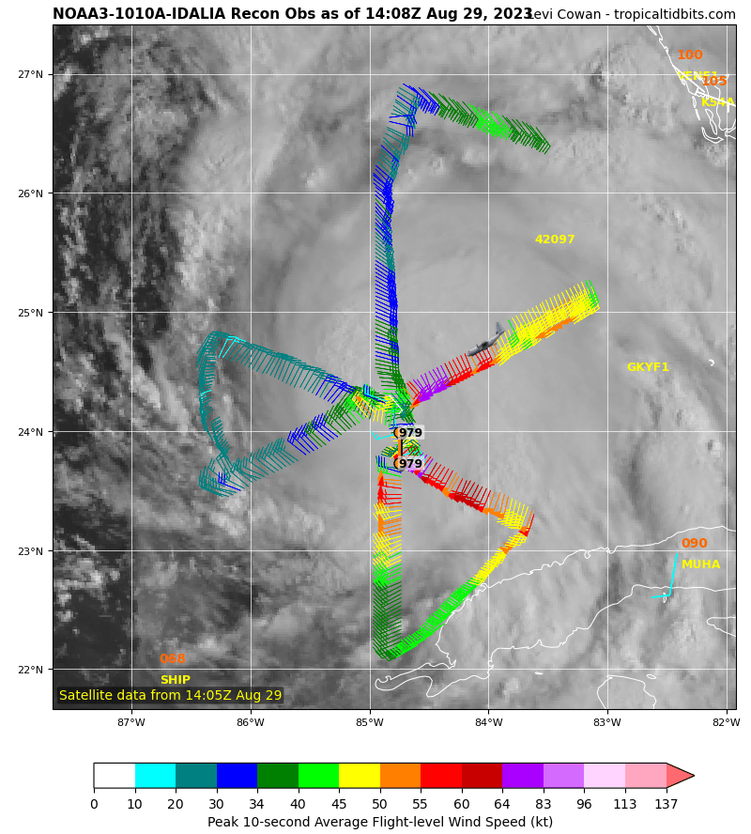
1416 | Sonde 22, 1st RMW on overflight module
1418 | Sonde 23, 2nd RMW
1419 | Sonde 24, 3rd RMW
1423 | Sonde 25, center
1433 | 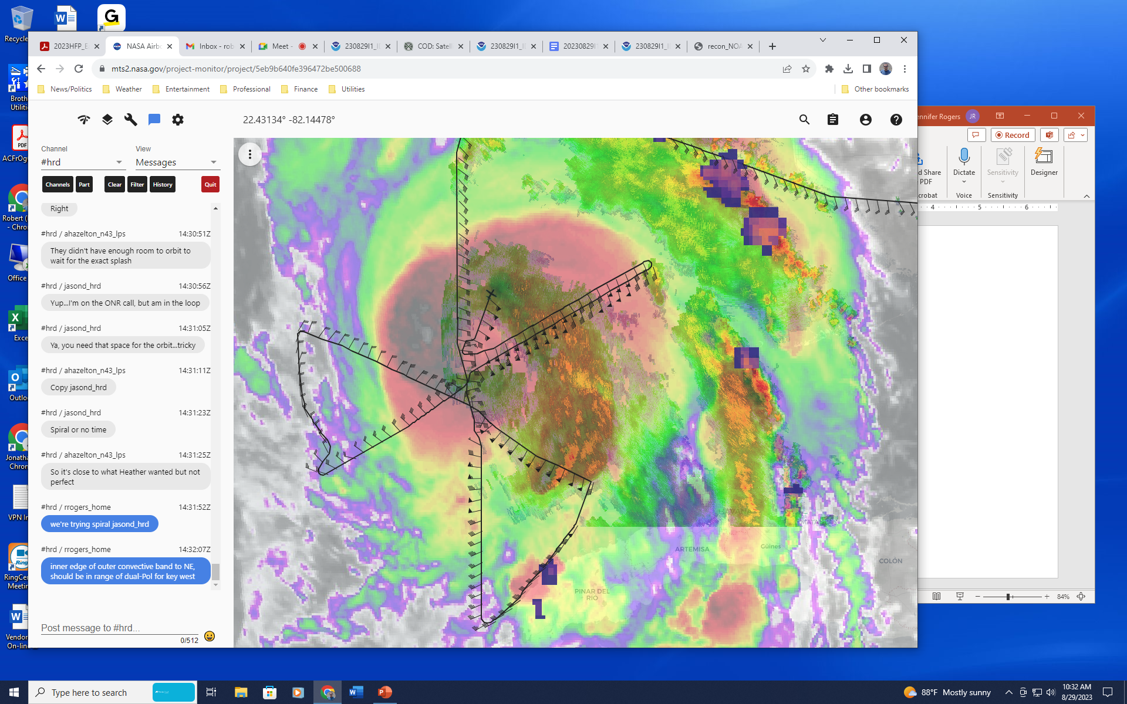  Completed inbound portion of overflight module, now heading outbound after having rotated 40 degrees downwind. This is also essentially a FLAIMS module.
1458 | Begin spiral where aircraft symbol is located  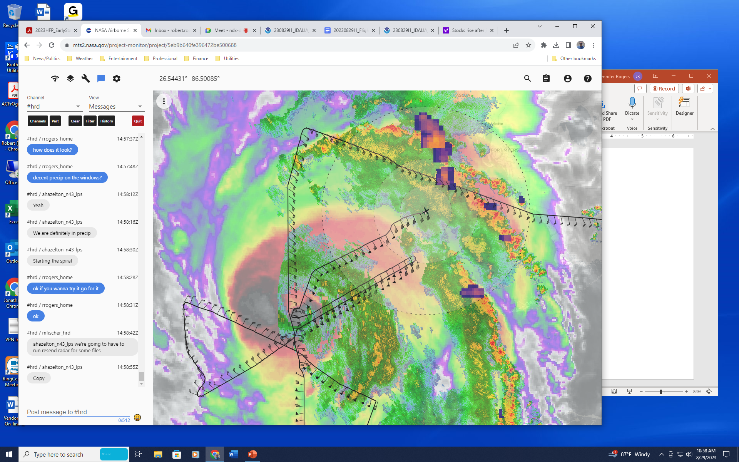
1505 | 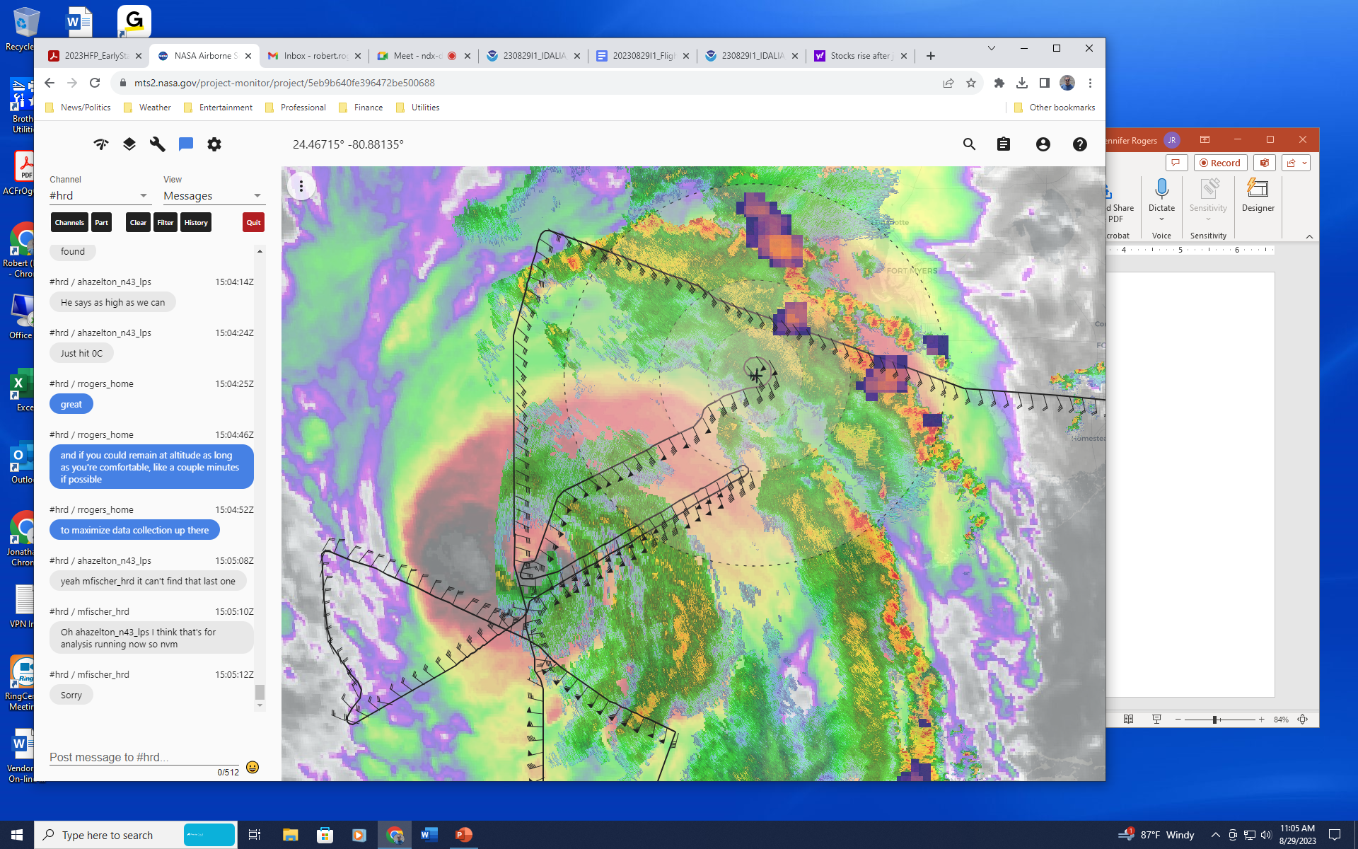  Spiral continues
1509 | Sonde 26, top of MP spiral
1512 | 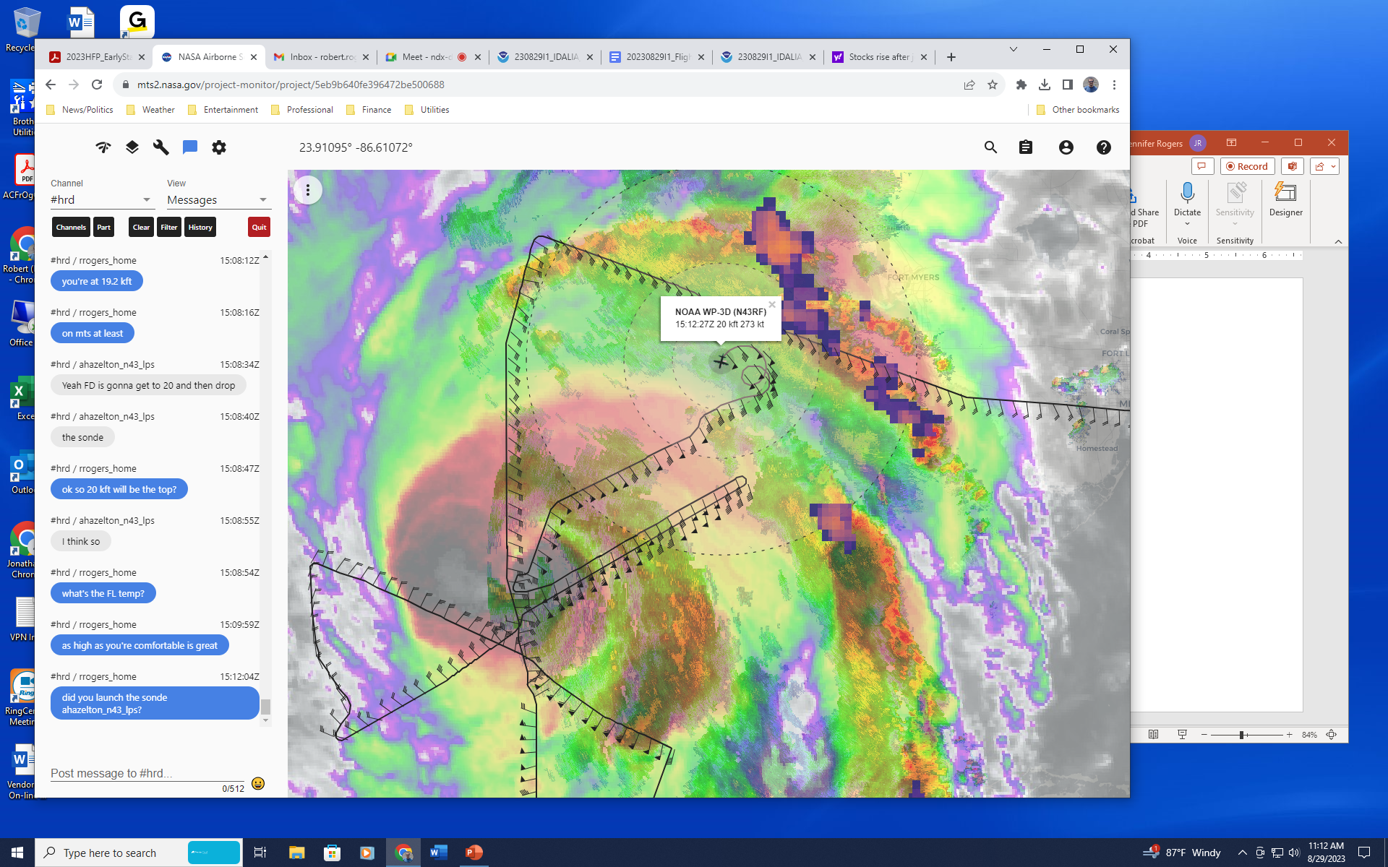  At top of the spiral (20 kft), beginning descent now. Launched sonde at the top at 1509 UTC.
1524 | Science complete, RTB
 | << INSERT ADDITIONAL ROW AS NEEDED >>

POST-FLIGHT
Mission Summary | Overall mission was a success. Flew entire butterfly pattern well within the time window. Doppler radials made it off the plane in time, though there continue to be communication issues with the 3-D analyses and dropsondes.  Also executed the sonde overflight module, which involved reversing track in the NE quadrant, dropping 3 sondes across the RMW, and heading outbound at a point downwind (20-degree downwind) from launch azimuth. Finally, executed a microphysics spiral on the inner edge of a convective band well-removed to the NE of the center (about 150 nm). This location is expected to be barely in range (~90-100 nm) of the dual-Pol of the Key West radar.  MicroSWIFT buoy was not released, however, as it was not responding to the data system. A sonde was released near the Saildrone, though.  26 sondes in total, 16 charged to NWS, 3 charged to HRD, 7 charged to ONR. 5 AXBTs released.
Actual Standard Pattern Flown | Butterfly
APHEX Experiments / Modules Flown | TDR, Sonde overflight, Stratiform Spiral Module
Plain Language Summary | - Successful mission into Hurricane Idalia, which has intensified to a hurricane and is showing signs of steady intensification  - Collected important airborne radar data and transmitted that to the ground for use in improved computer model forecasts  - Flew a module where we overflew splash location of dropsondes to compare measurements of surface wind speed from dropsondes with instrument on plane. Will improve the reliability of the instrument on the plane key for measuring surface wind.  - Flew another module where we spiraled up to 20,000 ft altitude in precipitation to get measurements of ice particles vital in evaluating and improving the representation of these particles in computer models. Such an improvement is important in making better rainfall and potential hurricane intensity forecasts.
Instrument Notes | Instruments worked fine, though communications issues for TDR continued to pervade the mission. The three-dimensional analyses were impacted, though the Dopper radials should have made it off the aircraft.
Final Mission Track | 